A comparison of MCNP6-1.0 and GEANT 4-10.1 when evaluating the neutron output of a complex real world nuclear environment: The Thermal Neutron Facility at the Tri Universities Meson Facility

Monk S.D.^{a,*}, Shippen B.Aª., Colling B.R.^{a,b}, Cheneler D.ª, Al Hamrashdi H.ª, Alton T.ª

ªDepartment of Engineering, Lancaster University, Lancaster, United Kingdom LA1 4YW
^{b}Culham Centre for Fusion Energy, Culham Science Centre, Abingdon, United Kingdom, OX14 3DB

A comparison of the Monte Carlo based simulation codes MCNP6-1.0 and GEANT4-10.1 as used for modelling large scale structures is presented here. The high-energy neutron field at the Tri Universities Meson Facility (TRIUMF) in Vancouver, British Columbia is the structure modelled in this work. Work with the emphasis on the modelling of the facility and comparing with experimental results has been published previously, whereas this work is focussed on comparing the performance of the codes over relatively high depths of material rather than the accuracy of the results themselves in comparison to experimental data. Comparisons of three different locations within the neutron facility are modelled and presented using both codes as well as analysis of the transport of typical neutrons fields through large blocks of iron, water, lead and aluminium in order to determine where any deviations are likely to have occurred. Results indicate that over short distances, results from the two codes are in broad agreement – although over greater distances and within more complex geometries, deviation increases dramatically. The conclusions reached are that it is likely the deviations between the codes is caused by both the compounding effect of slight differences between the cross section files used by the two codes to determine the neutron transport through iron, and differences in the processes used by both codes.

- Introduction

Despite the fact that they are based on similar modelling paradigms, radiation particle transport codes such as MCNP, GEANT and FLUKA rarely return exactly the same results when used to evaluate realistic scenarios. These three codes along with several others have been compared in numerous other works ⁽¹⁻¹³⁾, although the evaluations generally involve relatively small scales and simple scenarios where there are reasonably few complex interfaces where slight differences in cross section files would not cause any great divergence between results. For example, in 1995, Gobatkov and Kryuchkov⁽⁶⁾ compared Monte Carlo codes MCNP and FLUKA along with one dimensional transport codes ANISN, and ROZ6H. They considered neutron transport through various thicknesses of iron and found good agreement (within 10%) up to a thickness of around 1.5m. Similarly Padilla Cabal et al.⁽⁷⁾, characterised a pure germanium based gamma radiation detector using both MCNPX v2.6 and GEANT4-9.2, achieving similar results, again within the region of 10%. Further, in 2007, Yung-shun et al.⁽⁸⁾ modelled neutron propagation through water and concrete. Their results appeared to suggest that the FLUKA and MCNP results varied by up to a factor 2 within the 10eV to 1MeV region. However, within the rest of their simulations, the models all agreed to within 20%. Further, in 2011, Guardiola et al.⁽⁹⁾ used GEANT4 and MCNPX to evaluate the detection efficiency of planar silicon detectors coupled to various boron based converter layers. They report that the maximum efficiency using Boron-10 is around 5% if MCNPX is used, whereas the corresponding figure is 3.3% with GEANT; indicating a ratio of 1.5 between the results achieved. More recently, Van de Ende et al.⁽¹⁰⁾ compared GEANT4-10.00.p02 and MCNPX v2.7.0 in 2016, characterising a boron lined neutron detector and concluded that the results concurred to within 7% at an absolute maximum. In 2014, Hu et al.⁽¹¹⁾ reported on the use of MNCP5 and GEANT4-9.4 to design a Bonner sphere system to characterise the Experimental Advanced Superconducting Tokamak (EAST) device reporting only that the codes agree well, although there are minor discrepancies in some of the bins. Hecht et al^{.(12)} utilise a combination of MCNP6 and the CINDER code, along with GEANT4-9.6.1 to characterise gamma rays following fission. There are many results presented, with the maximum level of discrepancy appearing to be of the order of around 10% (in one case increasing to around 20%). Finally, in 2012, Verburg et al.⁽¹³⁾ determined prompt gamma rays emitted from proton induced nuclear reactions using both MCNP6 (beta 2) and GEANT4-9.5. They report that the codes deviate by as much as a factor of 2 in extremis although through most of the work the models agree within 25%.

In the work described here, a real life complex nuclear facility is used as a medium in which to compare the two Monte Carlo codes; MCNP6-1.0 and GEANT4-10.1. This is the Thermal Neutron Facility (TNF) located at the Tri-Universities Meson Facility (TRIUMF) in Vancouver. Previously work has been undertaken by the primary author⁽¹⁴⁾ in order to model the facility utilising the MCNPX v2.6.0 package, and then comparing these neutron fluence rate simulations with practical results achieved at the facility using activated foils. Engineers at the TRIUMF site had used FLUKA version 1999 to model the output of the Thermal Neutron Facility (TNF), although the accuracy of these simulations was unclear. This work focusses on the use of the MCNP6-1.0 and GEANT4-10.1 codes to model the output of the facility and to compare the codes, suggesting reasons for discrepancies between the two results – specifically primarily related to the neutron transport through iron.

In this work we begin by modelling the neutron fluence rate spectrum at three locations within the TNF facility at the TRIUMF site; the surface of the aluminium target where the spallation neutrons are produced, the entrance to the neutron line where the neutrons thermalised by the water then encounter and the exit of this line where the final position of interest is. The second half of this work involves the modelling of neutron fluence through blocks of various substances; water, aluminium, iron and lead. The neutron fluence rate spectrum is calculated at various depths through the materials to determine the discrepancies between the two codes as the materials are traversed.

- The Tri-Universities Meson Facility (TRIUMF)

TRIUMF is a subatomic physics research laboratory located within the campus of the University of British Columbia in Vancouver⁽¹⁵⁾ . At its heart is a cyclotron which accelerates protons through an air-free chamber between the poles of an electromagnet, the field guiding them in an expanding spiral path. The particles are accelerated by pulses of voltage twice per cycle producing approximately 8.74x10¹⁴ 500 MeV protons per second. When this particle beam reaches the outside of the tank, it is bent into beam lines leading to experimental halls which contain various targets which, when struck by a proton stream, create an intense beam of various particles for use in related experiments. The neutron hall section of the TRIUMF facility is the final destination of the cyclotron-generated proton beam and is based around a horizontally-aligned cylindrical aluminium target (with water cooling channels) submerged in a vertically-aligned, cylindrical tank of water. A simulation of the facility was created in 2002 using a now obsolete version of the FLUKA^{(16,17,18)} code (version 1999), and it is the information in that simulation that has been used to inform these current simulations. It should be noted that the FLUKA licence agreement states that one should not publish simulation results obtained with an obsolete version of FLUKA⁽¹⁹⁾, hence the results are not published here. The geometry used within the FLUKA based TNF model was simplified so it consists of just 5 cylinders and 3 orthogonal box shapes (as shown in Figure 1). This geometry is also utilised here – with additional information attained from two internal TRIUMF documents^{(20,21)}. Here, the description of the facility is quite brief – a more detailed description can be found in the earlier work by Monk et al.⁽¹⁴⁾

Note: MCNP code is written using cm as units of distance and so all co-ordinates referred to here are thus in these units rather than the SI units, metres. Also, the following lists of what is contained in the various materials are in terms of molecular proportions rather than mass proportions.

- The Proton Source is modelled as a circular beam with a geometrical cross section of radius 1.5 cm and consisting of monoenergetic 450MeV protons at a fluence rate of 8.74×10¹⁴ s⁻¹.
- The target (cylinder 1) is modelled as an aluminium/water compound with a density of 2.654 g.cm⁻³ and consisting of 92% aluminium-27, 2.5% oxygen-16 and 5.5% hydrogen-1, 50cm long and with a 10cm radius.
- The water tank (cylinder 2) is modelled as having a density of 1.0 g.cm⁻³ and consists of 33.3% oxygen-16 and 66.7% hydrogen-1.
- The Iron shielding (cylinder 3) is modelled as Fe-56 with a density of 7.5 g.cm⁻³
- The Concrete shielding (cylinder 4) has a density of 2.35 g.cm⁻³ and consists of 55% oxygen-16, 24% silicon-28, 3% calcium-40, 2% aluminium-27 and 16% hydrogen-1.
- The proton beam line (cylinder 5) contains air at an absolute pressure of 10,132.5 Pa (a density of 0.00012 g.cm⁻³)
- The neutron beam line (Box 1) is a rectangular channel of air (modelled as 78% nitrogen-14, 21% oxygen-16 and 1% argon-40) at an absolute pressure of 10,132.5 Pa corresponding to a density of 0.00012 g.cm⁻³
- The neutron beam line shielding (box 3) surrounds the ‘box 1’ section and is made from the same iron as in ‘cylinder 3’ above.
- The universe is modelled as an air box with dimensions of 10 metres × 10 metres × 10 metres. The air is simulated as having a density of 0.0012 g.cm⁻³ and containing 78% nitrogen-14, 21% oxygen-16 and 1% argon-40.

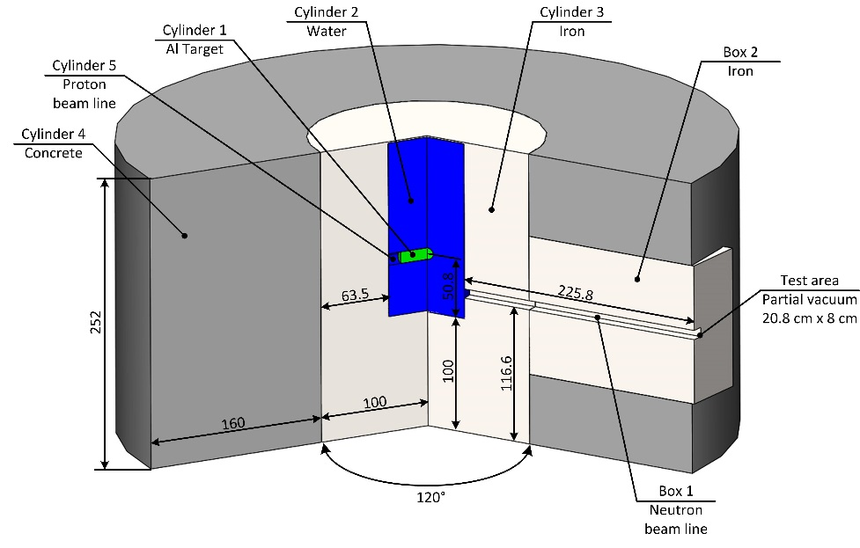

Figure 1: A Schematic of the TNF (units are in cm)

- SIMULATIONSimulation software packages: MCNP6-1.0 and GEANT4-10.1

The majority of codes developed for particle modelling are based on the Monte Carlo method, renowned for its simplicity of simulation algorithm and the capability to solve complex 3-dimensional problems. The neutron field has been evaluated here with the modelling packages MCNP6-1.0^{(22,23,24)} and GEANT4-10.1^{(25,26)}; two of the most widely used codes available today.

MCNP6 is a 2013 Monte Carlo transport code which was derived from a combination of two LANL codes, MCNP5 and MCNPX, although other features were then added to make the new code more powerful than the sum of its parts. The earlier codes themselves were updated from earlier iterations themselves with MCNPX beginning in 1994 as an extension of MCNP4B and LAHET 2.8, and envisaged as an extension of operability to all particles and energies up to 150 MeV. The code relies on numerous ‘cards‘ which are written by the user in order to determine all of the parameters within the MCNP6 model such as the physical geometry of the local environment, the source specification and type of result required. MCNP6 groups interactions within the environment into categories depending on the energies involved. Tabular data, whose evaluation contains a careful consideration of nuclear structure effects, forms a convenient area of “low” energy phenomena. In the intermediate range, above the nuclear structure region (~150 MeV in MCNPX) to a few GeV, the most common modelling methods include intranuclear/ pre-equilibrium/ evaporation models. At even higher energies, other methods involving quantum effects are used, and so the code contains an early version of the FLUKA code to handle high-energy interactions⁽²⁷⁾. Current physics modules include the Bertini and ISABEL models taken from the LAHET Code System™ (LCS), CEM 03, and INCL4. Further, new tally source and variance-reduction options have been developed with libraries for neutrons, photons, electrons, protons and photonuclear interactions. The use of these models can provide the user with control of the physics options. The options controlling the Bertini and ISABEL physics modules are taken from the User Guide to LCS^{(28,29)}. There are slight differences between the models which mostly concern the interactions between the neutrons and other particles within the environment to be simulated. The ISABEL code is an extension by Yariv and Fraenkel^{(30,31)} of the VEGAS code, and the CEM03 model allows neutrons and protons up to 5 GeV and pions up to 2.5 GeV to initiate nuclear reactions. Within this work the material cross sections used are those called with the .80c suffix. These cross sections are found in the ENDF/B-VII.1 library, with room temperature assumed (293k). The current default used is the CEM03 model and it is this model that we use in these simulations⁽³²⁾.

GEANT4 is a library of tools written in C++, specifically designed for simulation-based application development. Required functionality available within the GEANT4 tool kit is selected by placing an instance within the development code. Thus, once the application is developed, a unique simulation designed specifically for the physical environment is obtained. The library is designed with a distributed, hierarchical, object-orientated approach which has been used to ensure that many world-leading experts can work on the development of the code. This enables an accelerated development schedule ensuring fast, reliable and verified simulations. Once developed, the resulting application is a highly-accurate customised simulation which, at a high level, functions in a similar manner to MCNP and other general purpose transport codes. GEANT4 is primarily used for modelling the passage of particles through matter, with particular application areas including high-energy, nuclear and accelerator physics. The tool kit fundamentally comprises of a kernel which implements the transportation capabilities, and a front end guided user interface (GUI) which is used to invoke the GEANT4 kernel as well as customise the given application within developer-defined bounds. Where GEANT4 differs from other simulation packages, such as MCNP, is an ability to rewrite and optimise selected areas of the simulation. This is particularly useful when developing the required simulation physics engine which can be tailored to suit a given task. This allows developers to create custom physics models which mimic the underlying physical processes to a higher degree when compared to models used in other, more generic simulation packages. The GEANT4 model was developed to closely match the parameters specified in the MCNP6 simulation. Thus, both the world geometry and the simulation runtime parameters can be regarded as being fundamentally the same. The only significant difference between the simulations is in the handling of the physics processes where, to aid repeatability, the GEANT4 simulation used a verified tool kit model called QGSP BERT HP⁽³³⁾. This model uses the intra-nuclear-cascade model, Bertini, as it incorporates a library of cross sections for low neutron energies ensuring accurate simulation at these energies. Whilst this model has been experimentally verified, it differs significantly from standard transport models, as used in other simulation codes, which inevitably will influence the estimate of fluence rate to some degree. It should be noted that the Bertini model mentioned here is slightly different to the Bertini model mentioned in the MCNP6 section above.

- Results and discussions

Within all of the results presented in this work, the results are presented in neutron fluence rate with units of cm⁻².s⁻¹.MeV⁻¹. The MCNP6 simulations were run on an Intel Xeon processor running at 3.4GHz with 16GB of RAM; this corresponded to a maximum of 8 days of time running each one. The only variance reduction technique used within the MCNP environment to speed up the simulations was in the use of varying importance depending on the element in the simulation. Generally, variance reduction techniques were not used within the MCNP simulations as it was felt that this might compromise the integrity of the results attained. As the simulations involved the interactions of thermal neutrons with water, the S(α,β)⁽³⁴⁾ tables were also utilised in the MCNP simulations. One of the most interesting components of thermal scattering is "incoherent inelastic" where the neutrons exchange energy with the target molecule or crystalline lattice and all the scattered waves are assumed to combine incoherently without interference effects. The effect is only a low-energy phenomena and the cross sections files provided are for neutrons of 4 eV and less. Very few of the neutrons which leave the exit of the neutron line (2.3% of the total) are within this range and so it would be concluded that this S(α,β) effect is relatively insignificant in these calculations.

The Geant4 simulations were performed on two machines, one using an Intel Xeon 1270 v3 CPU and the Geant4-10.1 virtual machine, the other used an Intel 6700k CPU and Ubuntu. The physics list used for the Geant4 simulation was the QGSP_BERT_HP. This uses the Bertini cascade above 20MeV and the NeutronHP package below 20MeV. Further details of the physics involved can be found in the user manual and other published material^{(35,36,37)}. Whilst MCNP is able to tally the data when the neutron passes through one of the volumes surface, Geant4 does not appear to operate the same way. Instead in the work presented in Figure 2 the energy was printed when the neutron entered the water tank. Similarly, in the work presented in Figures 3 & 4, a small volume was placed to log the passing neutron at the entrance and exit. The number of particle histories in each of the simulations is dependent on factors such as the complexity of the scenario considered, and is noted on an individual basis

Note on GEANT4-10.1 uncertainties: Within the output of the MCNP6 generated data, uncertainties are produced offering a reader a level of confidence in the results. GEANT4-10.1 does not readily offer such information and so instead a simple standard uncertainty approach is taken here, where the uncertainty is estimated to be the square root of the amount of tallied data.

In order to quantify the similarity between results attained by the two codes there are two Figures of Merit used within this work. These are firstly, a maximized average ratio as shown in Equation 1 and secondly, a weighted average maximized ratio as shown in Equation 2. In these equations, a_{i} and b_{i} are the number of neutrons calculated by the two respective Monte Carlo codes in energy bins 1 to i.

$\text{max} \text{average} \text{ratio}=\frac{1}{N}\sum_{i=1}^{N}{\frac{\text{Max}(a_{i},b_{i})}{\text{Min}(a_{i},b_{i})}}$ (equation 1)

$\text{weighted} \text{max} \text{average} \text{ratio}=\frac{1}{\sum_{i=1}^{N}{a_{i}}+\sum_{i=1}^{N}{b_{i}}}\sum_{i=1}^{N}{\left[\frac{\text{Max}(a_{i},b_{i})}{\text{Min}(a_{i},b_{i})}∗(a_{i}+b_{i})\right]}$ (equation 2)

The Max average ratio simply indicates the average ratio between the numbers of neutrons simulated to be in each bin. However, the absolute numbers within each pair of bins is ignored in this figure of merit (i.e an energy bin which is simulated to have 10 neutrons according to a MCNP6 simulation and 5 neutrons according to a GEANT4 simulation, has the same weight or significance as another energy bin which might have predicted neutron numbers of 5,000 and 10,000 according to the two codes). The weighted max average ratio, on the other hand, takes into account the absolute numbers of neutrons simulated to be in each energy bin. The energy bins are very small at the lower energy end and so relatively few neutrons are collected here. Similarly not many neutrons remain at high energies due to the unlikelihood of a neutron traversing the material with no interactions occurring. Thus the energy range of greatest neutron fluence rate is the middle range, and it is here that the weighted max average ratio concentrates on. However, in the scenarios where each energy bin has the same weight (such as the cross section files) the ratio and weighted ratio figures would be the same and so the weighted figure is not mentioned.

- Comparing the codes at three locations within the simulated environment

Within this study, three locations within the neutron facility have been assessed and compared:

- The surface of the water and aluminium target (Cylinder 1 above)
- The entrance to the neutron channel (Box 1)
- The exit of the neutron channel (Box 1)
The calculated fluence rate around the aluminium target is shown in Figure 2, using both MCNP6-1.0 (250 million histories) and GEANT4-10.1 codes (half a million histories) to determine the number of neutrons crossing the surface boundary per cm² per second per MeV of bin width. Visually the two codes used appear to predict relatively similar spectra with slightly higher fluence rate predicted in the MCNP6-1.0 model at the highest energy regions with the GEANT4-10.1 code predicting a higher fluence rate in the 1eV to 1MeV region. It has been shown in an earlier piece of work from Monk et al.⁽¹⁴⁾, that only a relatively small proportion of the total neutron fluence rate observed at this point has come directly from the aluminium target (~37%), with the majority (~63%) having entered the water tank and scattered back to the target surface over the course of time. Further, of the thermal neutrons observed at this point, only 0.02% have directly been produced here with the rest having entered the water tank and scattered back. Of the neutrons of >0.5eV observed here, 61% have been directly produced by the target with the other 39% having scattered back from the water. The max average ratio between the neutron fluence rate predicted by the two Monte Carlo codes is 2.29:1 with the weighted max average ratio 2.58:1.

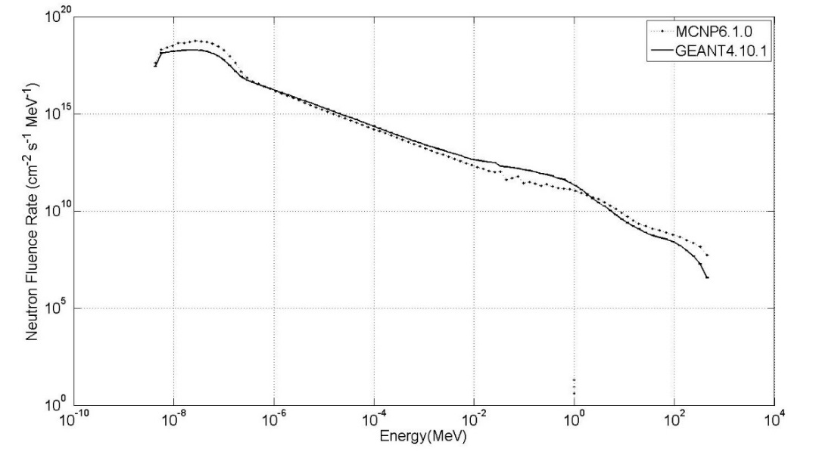
Figure 2: Comparison of MCNP6-1.0 (250 million particles) and GEANT4-10.1 (0.5 million particles) to determine the predicted neutron fluence rate at the outside of the aluminium/water target

Figure 3 illustrates the fluence rate predicted using the MCNP6-1.0 (250 million histories) and GEANT4-10.1 (80 million histories) codes once the neutrons have traversed the water in the TNF facility and reached the entrance to the neutron channel. The two codes appear to indicate a good level of similarity, with even the resonance peak at around the 20-30keV region evident in both simulations. The overall max average ratio for the two codes here is 1.22:1 with the weighted max average ratio 1.19:1. This would appear to indicate that the discrepancy observed in Figure 2 has been reduced. In part this is possibly due to the fact that, as noted in the section above, the majority of the neutrons on the surface of the target have come back from the water tank rather than having been produced directly in the aluminium via spallation. Oxygen and hydrogen cross sections are both well defined in Monte Carlo simulation codes, and it would be expected that deviations between codes when traversing it would be limited.

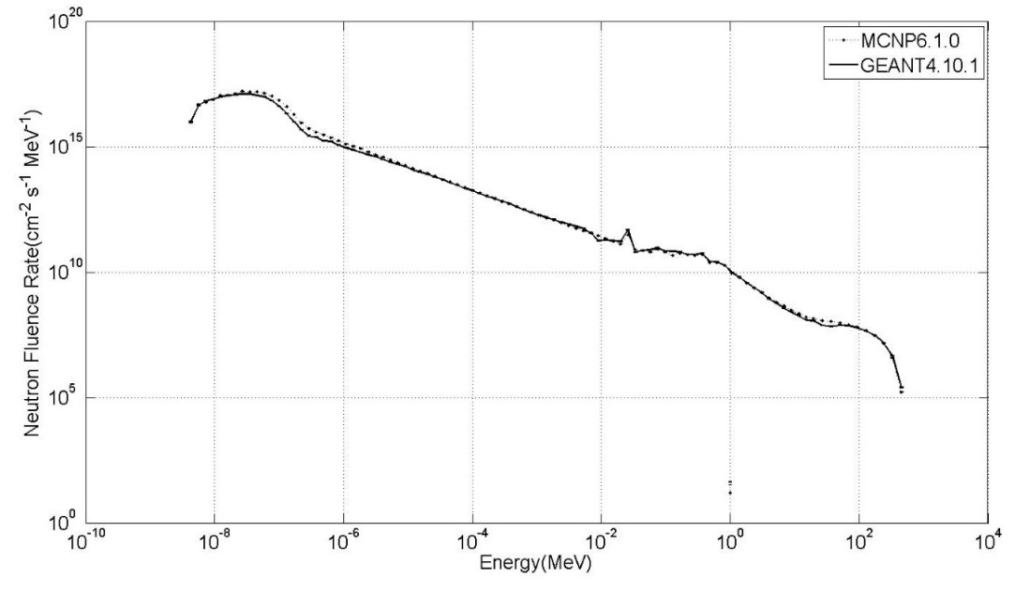

Figure 3: Comparison of neutron fluence at entrance of neutron channel using MCNP6-1.0 (250 million histories) and GEANT4-10.1 (80 million histories)

Figure 4 shows the simulated neutron fluence rate at the exit of the neutron line where the experimentation at the facility is undertaken. Due to the long and complex journey traversed by the neutrons, the max average ratio of the MCNP6-1.0 (250 million histories) and GEANT4-10.1 (180 million histories) codes is dramatically higher than the ratio at the entrance to the neutron channel: 6.07:1. Further, the weighted max ratio is 11.64:1. However, the uncertainties are also visibly larger than in the previous Figures as expected. Indeed the average uncertainty in the GEANT4 results is estimated to be 33% with the average uncertainty in the MCNP6 simulations 18%. The path from the source to the end of the neutron line is long and tortuous, and highly dependent on incoming neutron orientation as this effects how much iron is traversed by the particle as it enters the neutrons line. This is obviously the area of most importance to users of the facility as this is where experimentation and testing will typically occur.

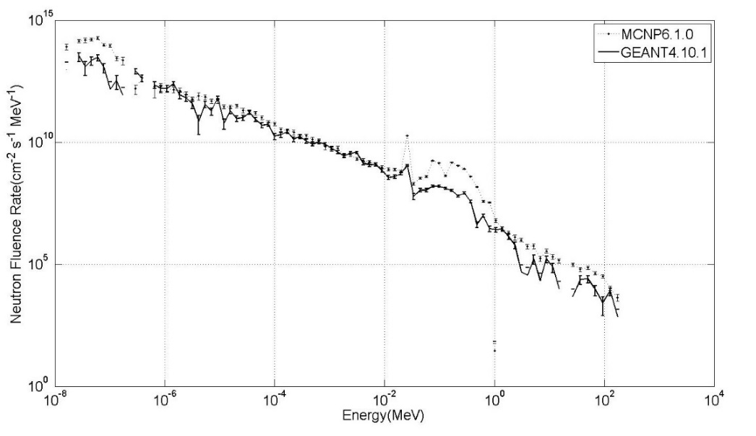
Figure 4: Simulations of the output of the neutron line, using GEANT4-10.1 (180 million histories) and MCNP6-1.0 codes (250 million histories)

The general discrepancy in the overall fluence rate between the two simulation packages may be due to either the cross section files used or the physics process selected for the simulation as briefly discussed above in section ‘SIMULATION SOFTWARE: MCNP6-1.0 AND GEANT4-10.1’. Other work undertaken in this field comparing various transport codes⁽¹⁻¹³⁾ has reported that the results generated with the codes generally concur to within 20% (up to energies of ~20 MeV). However, they tend to describe simple, physically small-scale situations where only a few materials are traversed. Colonna et al. for example⁽¹⁾ report on the comparison between the results achieved using GEANT version 3.21 and MCNP version 4B when simulating neutrons of various energies (1eV, 1keV and 1MeV) through slabs of concrete and iron. The results they achieve suggest little deviation between the codes. According to Guardiola et al.⁽⁹⁾, one of the main differences between the two codes is that when comparing thermal neutron treatments, GEANT4 only includes a free gas treatment where as MCNPX also accounts for the chemical binding in solids and liquids. According to Evseev et al.⁽²⁾, depending on which cross section files are used, the GEANT4-8.2 results vary greatly (by as much as 100%), so this would suggest that cross section file choice is crucial and even a small change in values can cause a great effect in final results. The simulations described here involve an aluminium target converting a beam of protons into neutrons and then their subsequent travel through a large volume of moderating water, vacuum and iron; all situations where a small inconsistency in cross-sectional behaviour can cause a large discrepancy in results. Pioch et al.⁽³⁸⁾ describe the modelling of a simple Bonner sphere with the GEANT4 and MCNPX codes reporting a divergence of up to 18%. It may be reasonable to conclude that a more complex scenario might produce greater discrepancies in fluence rate.

- Determination of effects on neutrons through water, aluminium, iron and lead

In order to determine the effects of large volumes of materials on neutron transport, neutrons created within the aluminium target are then generally subjected to four media which they will traverse before reaching the final output channel:

- Water (67% H-1 and 33% O-16)
- Iron (Fe-56)
- Aluminium (Al-27)
- Lead (Pb-208)
Water, iron and aluminium are all used within the simulations, but lead is not. It is included here as it is a typical material used widely as shielding, and thus is a good choice of alternative material with which to test alongside those used in the thermal neutron facility at TRUIMF. The iron covering of the neutron channel is 2.25m long, which is of the same order as the distance which a neutron might have to traverse before reaching its final destination in this simulation. Prior literature suggests that over short distances, GEANT4 and MCNP6 software packages predict very similar results – but over greater distances these results diverge greatly.

The blocks of material simulated have widths and heights of 400cm x 400cm with a length varying between 50cm and 300cm. The beam source of neutrons is always located at the centre of the 400cm x 400cm face of the block and focused towards the opposite face. The total neutron spectrum over the whole of the opposite 400cm x 400cm facia is determined using the two Monte Carlo codes. Figure 5 shows the results for water at a length of both 50cm and 300cm using the two codes. The cross section files for hydrogen and oxygen are well defined and there are minimal numbers of neutron interactions within the substance and so, as expected, the two codes show very similar results at 50cm and still quite similar results at 300cm. Figure 6 shows the same results using iron-56. Here, although the results returned by the codes are quite similar over 50cm, the results at 300cm are very different. Figure 7 shows results for aluminium-27 (similar to water in terms of lack of deviations between codes) and Figure 8 shows the results for lead-208 (similar to the iron result).

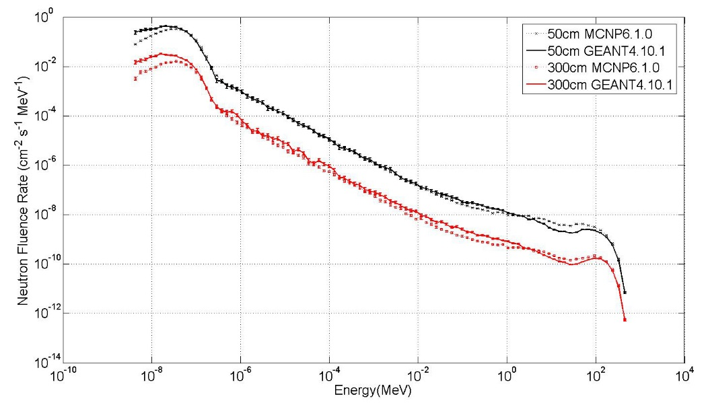
Figure 5: The effect of 50 cm and 300cm of water on a typical neutron energy spectrum according to both MCNP6-1.0 (both 100 million histories) and GEANT4-10.1 (1 million and 16 million histories)
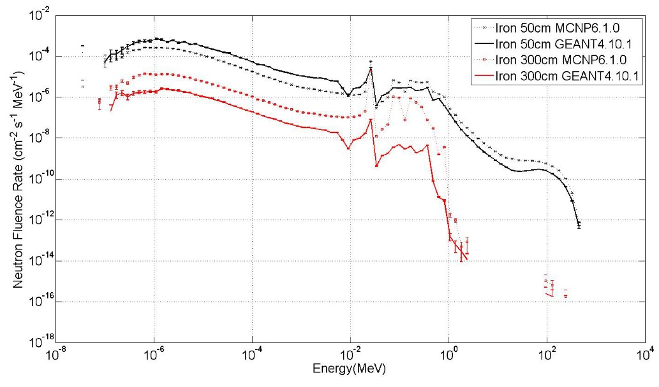
Figure 6: Neutrons through 50cm and 300cm of pure Iron using the GEANT4-10.1 (5 million and 1 billion histories) and MCNP6-1.0 codes (100 million and 600 million histories)
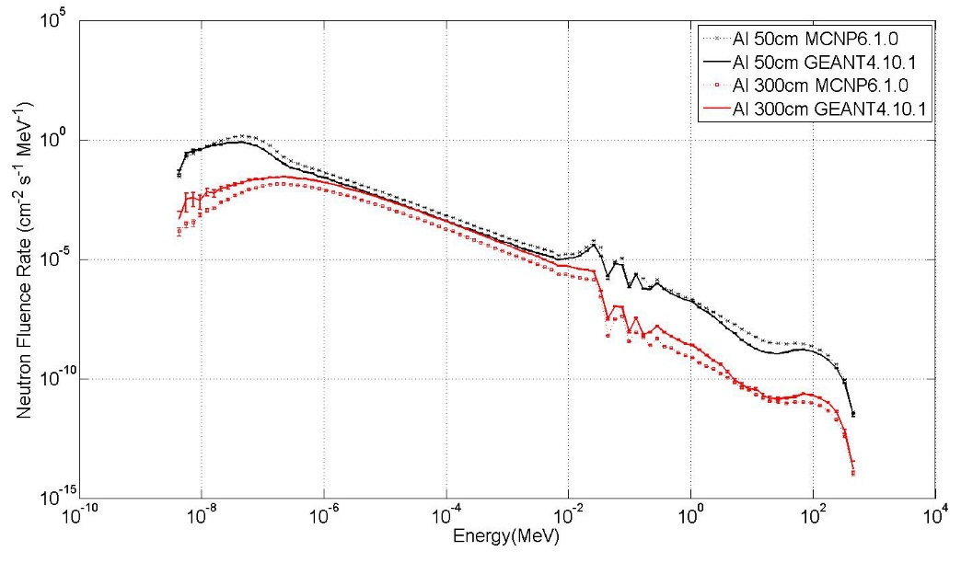
Figure 7: Neutrons through 50cm and 300cm of aluminium using the GEANT4-10.1 (1 million and 3 million histories) and MCNP6-1.0 codes (both 100 million histories)
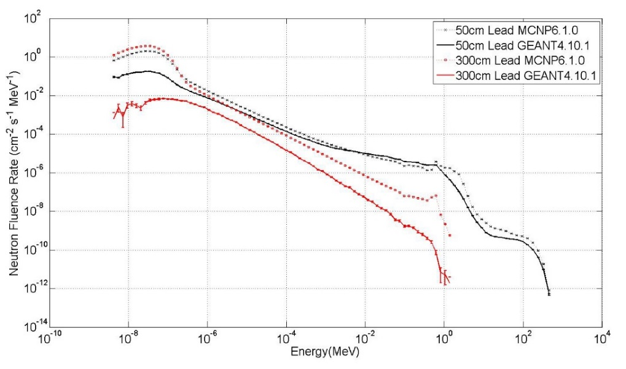
Figure 8: Neutrons through 50cm and 300cm of lead using the GEANT4-10.1 (both 10 million histories) and MCNP6-1.0 codes (both 100 million histories)

To illustrate the full set of data more effectively, the max average ratio is shown for each material for each length in Figure 9, with the weighted max average ratio shown in Figure 10. In the cases of aluminium and water, the deviations are relatively small and do not increase greatly as the length of the block to be traversed increases. However, in the case of lead and iron the deviations grow to large sizes with the distance traversed. The uncertainties in the case of aluminium and water are of the order of the changes in the ratios and so any increase in deviations are difficult to quantify in these two materials other than to say the deviations are relatively insignificant. The differences between the two codes when analysing transport through iron and lead appears to indicate an exponential increase. Exponential dependences on log-linear graphs appear as straight lines – something that is evident in Figure 10 especially. This would appear to suggest a small deviation compounded numerous times as the material is traversed.

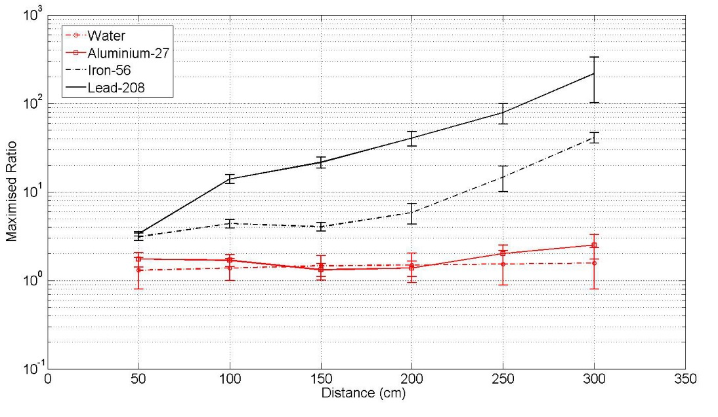

Figure 9: Average max average ratio of MCNP6 and GEANT4 results when calculating the neutron fluence through water, aluminium, iron and lead
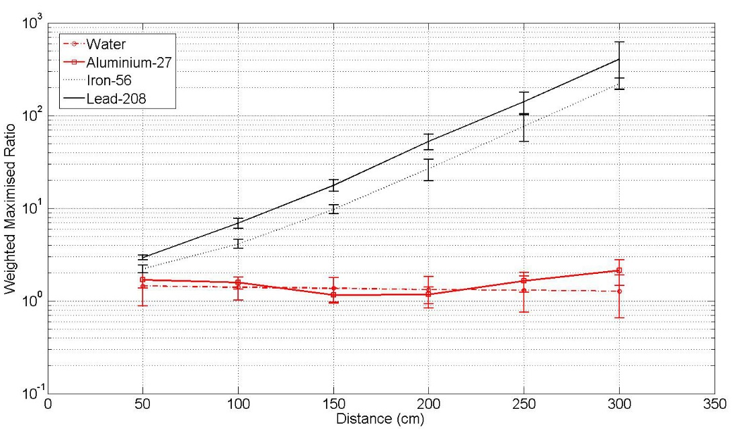
Figure 10: Max weighted average ratios of neutron fluence through water, aluminium, iron and lead according to MCNP6 and GEANT4 software

The cross section files used for the interaction of iron, lead, aluminium, oxygen and hydrogen with incident neutrons within the MCNP6-1.0 simulations are drawn from the ENDF/B-VII.1 database⁽³⁹⁾. The GEANT4-10.1 cross sections are derived from the ENDF/B-VII.1 database but do not appear to be identical from those used by MCNP6^{(40,41)}. Although the two sets of data are presented on different X-axis when extracted from their respective sources, a program was written in National instrument LabView⁽⁴²⁾ utilising interpolation in order to standardise the data sets and allow a simple determination of the ratio of the data files. If X is energy data and Y is cross section data and these X and Y arrays of data (X_{known} and Y_{known}) are to be converted into a dataset with a fixed 35000 X and Y values (X_{unknown} and Y_{unknown}) then the algorithm utilised runs as:

Begin loop1 (X_{unknown} = 1 to 35000)
Begin loop2 (X_{known} = 1 to size of known array)
If X_{unknown} > X_{known} and X_{unknown} < (X_{known+1}) THEN
Y_{unknown} = Y_{known} + ((Y _{known+1} – Y_{known}) / (X_{known+1} – X_{known})) * (X_{unknown} – X_{known})
End loop2
End loop1

The cross sections used by both the MCNP6 and GEANT4 software packages of Aluminium-27, Iron-56, Lead-208, Oxygen-16 and Hydrogen-1 respectively are shown in Figures 11,12,13,14 and 15. The cross sections of the five elements considered are very similar over both packages – but not identical. Table 1 shows the average difference between the cross-section files used by MCNP6 and GEANT4 for each element.

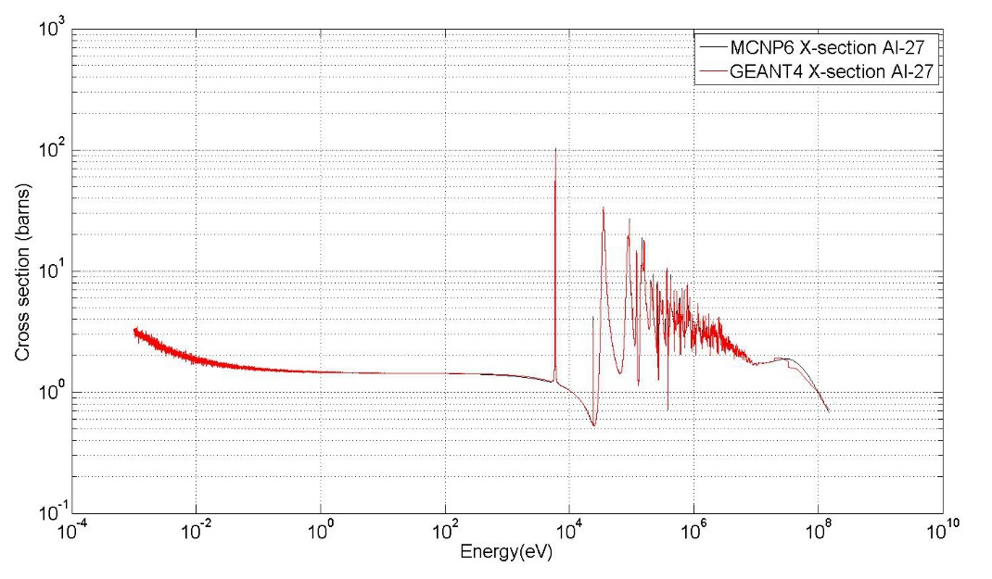
Figure 11: Cross section files for neutrons interacting with aluminium in the MCNP6 and GEANT4 environments

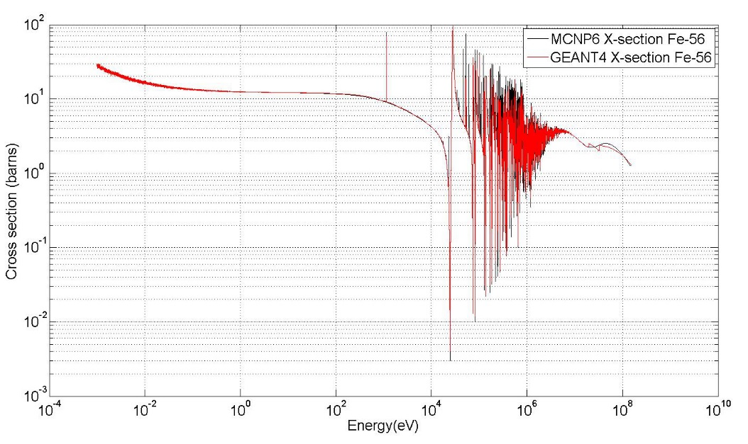

Figure 12: Cross section files for neutrons interacting with iron in the MCNP6 and GEANT4 environment

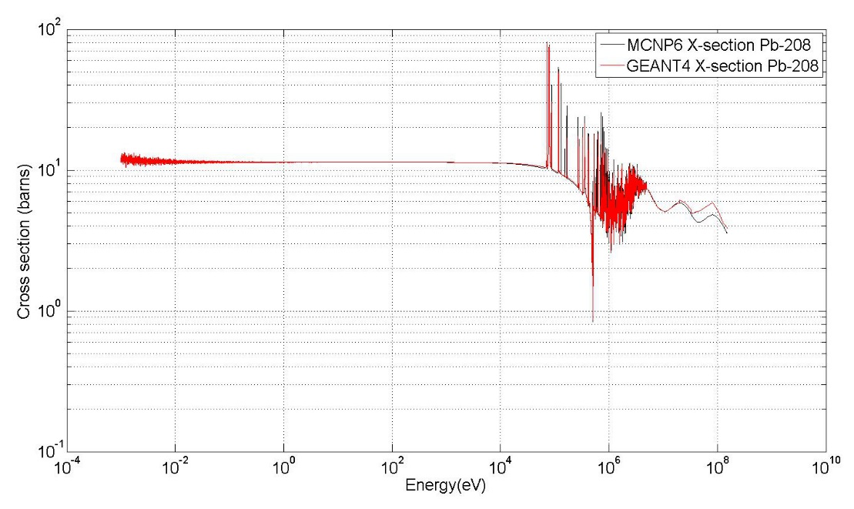
Figure 13: Cross section files for neutrons interacting with lead in the MCNP6 and GEANT4 environments

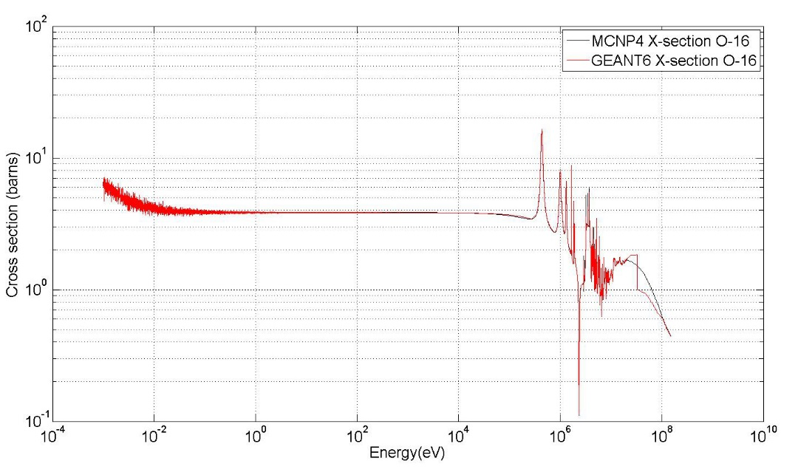
Figure 14: Cross section files for neutrons interacting with oxygen in the MCNP6 and GEANT4 environments

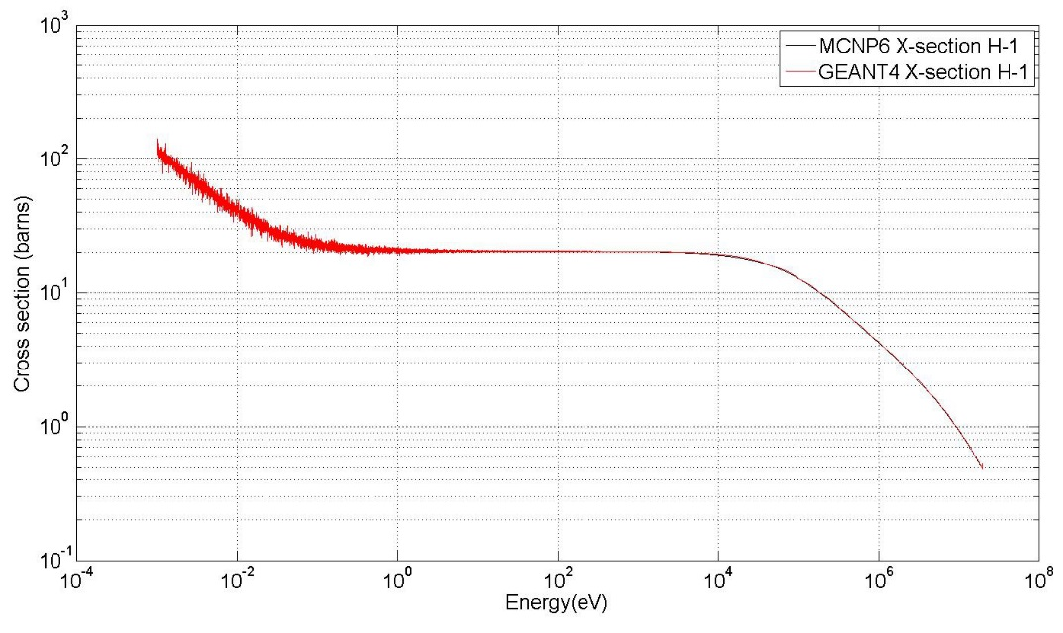
Figure 15: Cross section files for neutrons interacting with hydrogen in the MCNP6 and GEANT4 environments

Table 1: Difference in cross section files used
Element | Difference in cross sections (%)
Oxygen-16 | 2.4%
Hydrogen-1 | 1.6%
Aluminium-27 | 1.5%
Iron-56 | 2.9%
Lead-208 | 1.7%

The neutron cross section of water varies dramatically with incident energy. MCNP6 simulation appear to indicate a rough average macroscopic cross section value of 4 m⁻¹ – a mean free path of 25cm and an absolute minimum of 12 collisions over the course of 3 metres of neutron travel. An average deviation of 2.0% between the cross sections used would predict a maximum deviation of 1.02¹² = 1.27:1. Similarly, Aluminium-27 has an average cross section of 2.15 barns, a number density of 6x10²⁸,m⁻³ and thus a macroscopic cross section of 12.9 m⁻¹ indicating a minimum of 38.7 interactions occur between the neutrons and the aluminium particles. If each interaction produces a deviation of a factor of 1.015 between the two codes – then over the course of 38.7 interactions this could invoke a deviation of 1.015^{38.7}; a factor of 1.78:1.

Extending this theory to the iron-56 case, a number density of 8x10²⁸ m⁻³, an average cross section of 8.44 barns throughout its energy range and a macroscopic cross section of 67.5m⁻¹ indicating a minimum of 202 collisions and deviation of 1.029²⁰² = 322:1. Repeating the process for lead (number density of 3.27x10²⁸ m⁻³, average cross section of 9.7 barns, a macroscopic cross section of 31.7m⁻¹ corresponding to a minimum of 95 collisions and a deviation of 1.017⁹⁵ = 4.96:1. This is a lower than expected difference value, but it does assume the neutron will all travel through the lead in a straight line which is obviously unlikely to be the case. More likely is a tortuous route with great levels of scattering. This would invite a greater estimation of deviation as more collisions suggests more deviation.

All of these calculations roughly back-up the results achieved by the MCNP6 and GEANT4 codes except for the case of lead where the predicted maximum deviation is around 5:1 where as the actual average deviation is around 200:1, and 400:1 if the weighting of the particle numbers is taken into account. In the water case, cross sections are well defined and so behaviour is unlikely to be significantly different in each code. Yung-Shun et al.⁽⁸⁾ used both codes to simulate the transport of neutrons through 10cm of water and found the results achieved using MCNP were greater than those with GEANT4 by between 5% and about 20% depending on exact energies, with the results appearing to converge as the energy increases to 140 MeV.

Although it cannot be stated with any level of certainty that the cross sections are definitely where the deviations arise from, it is very likely that a compounded sum of numerous small deviations are the cause of the discrepancy, rather than one significant difference in the physics models. As suggested above, the deviations between the code simulated fluences appear to vary exponentially with distance. The possibility that the cross section files are the main culprit of these discrepancies is explored further by Mendoza et al⁽⁴³⁾, which features a figure (Figure 6) suggesting that using MCNPX with the ENDF/B-VII.0 cross section files gives visually identical results as using GEANT4 with the same cross section files. Similarly using the MCNPX code with the JEFF-3.1cross section files gives the visually identical output as using the GEANT4 code with the same JEFF-3.1 files. However, The MCNPX results using the ENDF/B-VII.0 and the results using MCNPX with the JEFF-3.1 files are quite different suggesting the cross section files are more important than the codes used in this case. However, they also suggest some other reasons for deviations between the two codes. These systematic reasons are that MCNPX and GEANT4 do not use the same mathematical models to sample the cross section data, MCNPX requires Doppler broadening cross sections while GEANT4 performs the Doppler broadening within the code, and the physics for the thermalisation is not the same in each of the codes.

- Conclusions

In conclusion, visually the differences between the neutron fluence rates simulated by the MCNP6 and GEANT4 codes when evaluating a real life environment such as the Thermal Neutron Facility at TRIUMF are relatively insignificant. However, closer mathematical inspection reveals an average ratio between the codes of approx. 6:1, or even approximately 11:1 when the ratio is weighted towards the number of neutrons in each bin. At two prior locations within the facility (the surface of the aluminium target and the entrance to the neutron line), the simulated fluence rates were also simulated and deviations were significantly less.

A closer inspection of the effects of some of the materials used within the simulation was performed to further investigate the source of the discrepancies and mounting deviation between the code outputs. Using the codes to simulate increasingly long blocks of four materials (water, aluminium, iron and lead) was undertaken in order to determine the effects of the materials on neutrons. The discrepancies were shown to be relatively minimal at short distances (up to around 150cm), but increase in magnitude dramatically over longer distances. Further, within the low Z materials investigated (water and aluminium-27) where only a relatively small number of interactions are likely to occur, seemed to indicate very close agreement between the codes. Although the cross section files used by the two Monte Carlo codes are very similar, it does not appear that they are absolutely identical. The slow increase in these discrepancies appears to follow a pattern indicating propagation of numerous small deviations which are relatively benign when transport distance is small, but which begin to increase significantly when the distances grow. This may be partly due to slight differences in cross section files or perhaps partly due to systematic differences in the processes used by the two transport codes. When comparing MCNPX and GEANT4.9.5, Mendoza et al⁽⁴⁴⁾ considers the differences in mathematical sampling methods, Doppler broadening treatments and the thermalisation physics. Further to this Guardiola et al⁽⁹⁾ suggest that GEANT4 only includes a free gas treatment where as MCNPX also accounts for the chemical binding in solids and liquids. These are all processes which could cause slight discrepancies here too, which when compounded could lead to the differences in code output noted above.

It should also be noted that the results are purposefully presented in way as to show the deviations in as harsh a light as possible where default values and processes in the GEANT4 and MCNP6 codes have been selected in both codes and a maximised ratio chosen in each case with a large number of energy bins. Obviously an experienced user of any code will likely alter setting and select processes and even cross section files depending on the exact scenario which they wish to simulate.

ACKNOWLEDGEMENTS

We acknowledge Ewart Blackmore and Lutz Moritz of the Tri Universities Meson Facility for their help in characterising the field and providing information relating to the FLUKA reconstruction and for permission to reproduce original illustrations. We also acknowledge and are very grateful for the help of Matti Kalliokosci (The Cockcroft institute and Lancaster Universities Physics department) with the GEANT4 modelling.

FUNDING

This work has been funded internally by Lancaster University

REFERENCES

- Colonna, N. Altieri, S. “Simulations of neutron transport at low energy: A comparison between GEANT and MCNP”, Health Physics 82 (6) 840-846 (2002)
- Evseev, I.G. Schelin, H.R. Paschuk, S.A. Milhoretto, E. Setti, J.A..P. Yevseyeva, O. De Assis, J.T. Hormaza, J.M. Diaz, K.S. Lopes, R.T. “Comparison of SRIM, MCNPX and GEANT simulations with experimental data for thick Al absorbers”, Applied Radiation and Isotopes 68 948-950 (2010)
- Pelliccioni, M. Pillon, M. Fluence to effective dose conversion coefficients for neutrons: a comparisom between results obtained by MCNP and FLUKA codes Radiation protection dosimitery 74 (4) 261-266 (1997)
- Enger, S.A. Af Rosenschid, P.M. Rezaei, A. Lundqvist, H. Monte Carlo calculations of thermal capture in Gadolinium: A comparisom of GEANT4 and MCNP with measurements Medical physics 33 (2) 337-341 (2006)
- Araojo, H.M. Kudryavtsev, V.A. Spooner, N.J.C. Sumner,T.J. Muon-induced neutron production and detection with GEANT4 and FLUKA Nuclear instruments and methods in physics research A 545 (1-2) 398-411 (2005)
- Gorbatkov, D.V., Kryuchkov, V.P.“A comparison of computational data, obtained with of well-known radiation transport codes (MCNP, ANISN, FLUKA, ROZGH)”, Nuclear instruments and methods in physics research A, 374 95-104 (1996)
- Padilla Cabal, F. , Lopez-Pino, N. Bernal-Castillo, J.L. Martinez-Palenzuela, Y. Aguilar-Mena, J. D’Alessandro, K. Arbelo, Y. Corrales, Y. Diaz, O., “Monte Carlo based geometrical model for efficiency calculation of an n-type HPGe detector” Applied Radiation and Isotopes 68 2403–2408 (2010)
- Yung-Shun Yeh, Chung-Hsiang Wang, Hong-Ming Liu, Tsung-Che Liu, and Guey-Lin Lin, “Simulating neutron propagations with FLUKA, GEANT4 and MCNP”, 2007 IEEE Nuclear Science Symposium, 2016-2018 (2007)
- Guardiola C, Amgarou K, Garcıa F, Fleta C, Quirion D, and Lozano M, “Geant4 and MCNPX simulations of thermal neutron detection with planar silicon detectors”, Journal of Instrumentation, 6 (2011)
- B.M.Van de Ende, J. Atanackovic, A.Erlandson, G. Bentoumi, “Use of GEANT4 vs MCNPX for the characterization of a boron-lined neutron detector”, Nuclear instruments and methods in physics research A, 820 (2016) 40-47
- Z. M. Hu X. F. Xie, Z. J. Chen, X. Y. Peng, T. F. Du, Z. Q. Cui, L. J. Ge, T. Li, X. Yuan, X. Zhang, L. Q. Hu, G. Q. Zhong, S. Y. Lin, B. N. Wan, G. Gorini, X. Q. Li, G. H. Zhang, J. X. Chen, and T. S. Fan, “Monte Carlo simulation of a Bonner sphere spectrometer for application to the determination of neutron field in the Experimental Advanced Superconducting Tokamak experimental hall”, Review of Scientific Instruments, 85 11E417 (2014)
- A.A. Hecht, R.E. Blakeley, W.J. Martin, E. Leonard, “Comparison of GEANT4 and MCNP6 for use in delayed fission radiation simulation”, Annals of Nuclear Energy, 60 (2014) 134-138
- J.M. Verburg, H.A.Shih, J. Seco, “Simulation of prompt gamma-ray emission during proton radiotherapy”, Physics in medicine and biology, 57 (2012) 5459-5472
- S. D. Monk, T. Abram and M. J. Joyce “Characterisation of the TRIUMF neutron facility using a Monte Carlo simulation code” Radiation Protection Dosimetry (2014), pp. 1–11
- TRIUMF Website at http://www.triumf.ca/ (accessed October 20th 2016)
- FLUKA website http://www.fluka.org/ (accessed 20th October 2016)
- Ferrari,A. Sala,P.R. Fasso, A. Ranft, J. “FLUKA: a multi-particle transport code”, CERN-2005-10, INFN/TC_05/11, SLAC-R-773 (2005)
- FLUKA Manual online (October 20th, 2016) found at http://www.fluka.org/content/manuals/FM.pdf
- Statement of FLUKA obsoleteness (October 20th, 2016) found at http://www.fluka.org/fluka.php?id=release_notes&mm2=3
- Blackmore, E.W. Kopetski, C. August Use of the TNF neutron beam for radiation damage studies, Design note, TRI-DN-02-16 (2002)
- Hodges, T.A. Langstaff, R.R. Lenckowski, M. An aluminium plate beam dump for the TNF in BL1A, VPN, internal document 2 (1995)

- Los Alamos Laboratory MCNPX website http://mcnpx.lanl.gov/ (accessed on 20/10/2016)
- L. S. Waters, ed., "MCNPX™ User Manual, Version 2.3.0, Los Alamos National Laboratory report LA-UR-02-2607 (April 2002).
- X-5 Monte Carlo Team, "MCNP—A General Monte Carlo N-Particle Transport code Version 5, Volume I: Overview and Theory," Los Alamos National Laboratory report LA-UR-03-1987 (April 24, 2003), revised February 1, 2008.
- Agostinelli,S. Allison,J. Amako, K. Apostolakis, J. Araujo, H. Arce, P. Asai, M. Axen, D. Banerjee, S. Barrand, G. Behner, F. Bellagamba, L. Boudreau, J. Broglia, L. Brunengo, A. Burkhardt, H. Chauvie, S. Chuma, J. Chytracek, R. Cooperman, G. Cosmo, G. Degtyarenko, P. Dell'Acqua, A. Depaola, G. Dietrich, D. Enami, R. Feliciello, A. Ferguson, C. Fesefeldt, H. Folger, G. Foppiano, F. Forti, A. Garelli, S. Giani, S. Giannitrapani, R. Gibin, D. Cadenas, J.J.G. Gonzalez, I. Abril, G.G. Greeniaus, G. Greiner, W. Grichine, V. Grossheim, A. Guatelli, S. Gumplinger, P. Hamatsu, R. Hashimoto, K. Hasui, H. Heikkinen, A. Howard, A. Ivanchenko, V. Johnson, A. Jones, F.W. Kallenbach, J. Kanaya, N. Kawabata, M. Kawabata, Y. Kawaguti, M. Kelner, S. Kent, P. Kimura, A. Kodama, T. Kokoulin, R. Kossov, M. Kurashige, H. Lamanna, E. Lampen, T. Lara, V. Lefebure, V. Lei, F. Liendl, M. Lockman, W. Longo, F. Magni, S. Maire, M. Medernach, E. Minamimoto, K. De Freitas, P.M. Morita, Y. Murakami, K. Nagamatu, M. Nartallo, R. Nieminen, P. Nishimura, T. Ohtsubo, K. Okamura, M. O'Neale, S. Oohata, Y. Paech, K. Perl, J. Pfeiffer, A. Pia, M.G. Ranjard, F. Rybin, A. Sadilov, S. Di Salvo, E. Santin, G. Sasaki, T. Savvas, N. Sawada, Y. Scherer, S. Seil, S. Sirotenko, V. Smith, D. Starkov, N. Stoecker, H. Sulkimo, J. Takahata, M. Tanaka, S. Tcherniaev, E. Tehrani, E.S. Tropeano, M. Truscott, P. Uno, H. Urban, L. Urban, P. Verderi, M. Walkden, A. Wander, W. Weber, H. Wellisch, J.P. Wenaus, T. Williams, D.C. Wright, D. Yamada, T. Yoshida, H. Zschiesche, D, GEANT4:A simulation toolkit, Nuclear instruments & methods in physics research section A 506 (3) 250-303 (2003)
- GEANT4 website http://geant4.web.cern.ch/geant4/ (accessed 20/10/2016)
- The Monte Carlo Method: Versatility Unbounded in a Dynamic Computing World Chattanooga Tennessee, April 17-21, CD-ROM, American Nuclear Society, LaGrange Park, IL (2005)
- The Los Alamos Labs guide to LAHET found at http://permalink.lanl.gov/object/tr?what=info:lanl-repo/lareport/LA-UR-89-3014 (accessed 20th October 2016)
- R. E. Prael and H.Lichtenstein, “User Guide to LCS: The LAHET Code System,” Los Alamos National Laboratory report LA-UR-89-3014, Revised (September 15, 1989).
- Y. Yariv, Z. Fraenkel, “Intranuclear cascade calculation of high-energy heavy-ion interactions”, Physical review C, 20 2227 (1979)
- Y. Yariv, Z. Fraenkel, “Intranuclear cascade calculation of high energy heavy ion collisions: Effect of interactions between cascade particles”, Physical review C, 24 488 (1981)
- Kerby, L.M., Mashnik, S.G, “Total reaction cross sections in CEM and MCNP6 at intermediate energies”, Nuclear instruments and methods in physics research B 356-357 (2015) 135-145
- Reference to the QGSP BERT HP model found at http://geant4.cern.ch/support/proc_mod_catalog/physics_lists/referencePL.shtml (accessed October 20th 2016)
- Detail of S(alpha, beta) scattering (accessed December 7th, 2016) found at http://t2.lanl.gov/nis/njoy/ther02.html
- GEANT4 reference manual (accessed 24th February 2016) http://geant4.web.cern.ch/geant4/UserDocumentation/UsersGuides/PhysicsReferenceManual/BackupVersions/V10.1/fo/PhysicsReferenceManual.pdf
- NNS conference record (accessed 24th February 2016) https://indico.cern.ch/event/131444/attachments/95823/136970/Status_of_Neutron_High_Precision_Models.pdf
- Allison, J., Amako, K., Apostolakis, J., Arce, P., Asai, M., Aso, T., Bagli, E., Bagulya, A.,Banerjee, S., Barrand, G. et al., “Recent developments in Geant4”, Nuclear Instruments and Methods in Physics Research Section A: Accelerators, Spectrometers, Detectors and Associated Equipment, 835 (2016) 186-225
- Pioch, C. Mares, V. Ruhm, W. Influence of bonner sphere response functions above 20 MeV on unfolded neutron spectra and doses Radiation measurements 45 (10) 1263-1267 (2010)
- JANIS website - https://www.oecd-nea.org/janis/ (Accessed October 20th 2016)
- M. A. Cortez-Giraldo, F. R. Palomo, E. Garcia-Sanchez, J. M. Quesada, “Evaluation of the Effects of Gamma Irradiation from a ⁹Be Neutron Source in Digital ASIC’s with GEANT4”, Progress in NUCLEAR SCIENCE and TECHNOLOGY, Vol. 2, pp.568-575 (2011)
- GEANT4 support - http://geant4.cern.ch/support/proc_mod_catalog/physics_lists/referencePL.shtm (accessed October 20th 2016)
- National instruments website http://www.ni.com/labview/ (Accessed October 20th 2016)
- Mendoza, E., Cano-Ott, D., Koi, T., Guerrero, C. “New standard evaluated neutron cross section libraries for the GEANT4 code and first verification”, IEEE Transactions on Nuclear Science, 61(4), 2357-2364.(2014)

