A novel dual GLP-1 and GIP incretin receptor agonist is neuroprotective in a mouse model of Parkinson’s disease by reducing chronic inflammation in the brain

Lijun Cao², Dongfang Li², Peng Feng², Lin Li³, Guo-Fang Xue², Guanglai Li², Christian Hölscher ^{1,2}

1. Biomedical and Life Science, Faculty of Health and Medicine, Lancaster University, Lancaster LA1 4YQ, UK
2. Second hospital, Shanxi medical University, Taiyuan, PR China
3. Key Laboratory of Cellular Physiology, Shanxi Medical University, Taiyuan, PR China

short title: DA-JC1 is protective in a PD mouse model

Accepted in NeuroReport

Corresponding author:

Prof. Guanglai Li
Department of Neurology,
The Second Affiliated Hospital of Shanxi Medical University
No. 382, Wuyi Road,
Taiyuan, Shanxi Province, China
Email: smuneu@163.com

Conflict of interest statement
The authors do not declare a conflict of interest.

Funding:
The research had been supported by a grant of the Cure Parkinson’s Trust UK and a grant to CH under the ‘100 Foreign Expert’ of the Shanxi province government.

Abstract

The incretins glucagon-like peptide 1 (GLP-1) and glucose dependent insulinotropic polypeptide (GIP) are growth factors. GLP-1 mimetics are on the market as treatments for type 2 diabetes. Both GLP-1 and GIP mimetics have shown neuroprotective properties in previous studies. In addition, the GLP-1 mimetic exendin-4 has shown protective effects in a clinical trial in Parkinson’s disease (PD) patients. Novel GLP-1/GIP dual-agonist peptides have been developed to treat diabetes. Here we demonstrate the neuroprotective effects of a novel dual agonist (DA-JC1) in the 1-methyl-4-phenyl-1,2,3,6-tetrahydropyridine (MPTP) mouse model of PD. MPTP was injected once-daily (20mg/kg i.p.) for 7 days, and the dual agonist was co-injected once-daily (50nmol/kg i.p.). We found that the drug reduced most of the MPTP-induced motor impairments in the rotarod, open field locomotion and muscle strength test. The number of tyrosine hydroxylase (TH) positive neurons in the substantia nigra (SN) and striatum was reduced by MPTP and increased by DA-JC1. Synapse numbers (synaptophysin expression) were reduced in the SN and the striatum by MPTP, and DA-JC1 reversed this effect. The activation of a chronic inflammation response by MPTP was much reduced by the DA (astroglia and microglia activation). Therefore, dual agonists show promise as a novel treatment of PD.

Keywords: neurodegeneration, growth factor, apoptosis, insulin, incretins, basal ganglia, inflammation

Introduction

Parkinson’s disease (PD) is a progressive neurodegenerative disease that affects motor control, which is caused at least in part by a progressive loss of dopaminergic neurons in the substantia nigra pars compacta (SNpc) and the subsequent degeneration of projection axons and dopaminergic synapses to the striatum. This leads to tremors, muscular rigidity, bradykinesia, and postural and gait abnormalities [1]. There is currently no cure or preventive treatment for this condition. However, the neuroprotective and restorative effect of growth factors such as glia-derived neurotrophic factor (GDNF) in animal models of Parkinson’s disease has demonstrated the potential of using growth factors as a treatment for PD [2]. One problem that has prevented the implementation of this concept is that GDNF and other growth factors do not cross the blood-brain barrier (BBB) [3]. The growth factor Glucagon-like protein 1 (GLP-1) and its analogues have shown neuroprotective effects in several disease models of neurodegeneration, such as Alzheimer’s disease and PD [4,5]. Previous studies demonstrated that the GLP-1 receptor agonist exendin-4 shows neuroprotective effects in animal models of PD [6-9]. Novel dual-agonist peptides have been developed to treat diabetes that not only activate the GLP-1 receptor but also the sister incretin glucose-dependent insulinotropic polypeptide (GIP) receptor [10]. As long-lasting GIP analogues also have been shown to have neuroprotective effects [11-13], the activation of both GLP-1 and GIP receptors may be a superior strategy for protecting neurons. The novel dual- GLP-1/GIP receptor agonists show superior effects in animal models of diabetes compared with liraglutide, the most effective GLP-1 analogue on the market [10]. Some of these dual agonist peptides are already in clinical trials in patients with diabetes, and first results show good effects with fewer side effects compared to GLP-1 mimetics [10]. We therefore tested the effects of a potent GLP-1/GIP receptor agonists in the MPTP mouse model of PD. MPTP (1-methyl-4-phenyl-1,2,3,6-tetrahydropyridine) is a precursor of MPP+, which induces classic symptoms of Parkinson's disease by impairing or killing dopaminergic neurons in the substantia nigra pars compacta [14,15]. MPTP is widely used as a chemical to induce a Parkinson-like condition in animals [8,9,14,16]. Effects of the GLP-1/GIP receptor agonist on MPTP- induced motor impairments, reduction in cell numbers in the substantia nigra, reduction of dopamine synthesis in the striatum, synapse loss, and a reduction of the chronic inflammation response as observed in the activation of microglia and astrocytes. Chronic inflammation facilitates neurodegeneration and is a key element of PD disease progression [17].

Methods

Chemicals

1-Methyl-4-phenyl-1,2,3,6-tetrahydropyridine (MPTP), paraformaldehyde (PFA) and phosphate buffered saline (PBS) were purchased from Sigma-Aldrich (St Louis, MO, USA). Bicinchoninic acid (BCA) protein assay kit was purchased from Applygen Technologies Inc. (Beijing, China). Sodium chloride, ethylene glycol, and 3,3-diaminobenzidine (DAB) were purchased from ZSGB-BIO Co. (Beijing, China). All other reagents used in the research were obtained from Beijing Chemical Factory (Beijing, China). Peptides were synthetised by ChinaPeptides Co., Ltd (Shanghai, China) to 95% purity. The purity of the peptide was confirmed by reversed-phase HPLC and characterised using matrix assisted laser desorption/ionisation time of flight (MALDI-TOF) mass spectrometry.
Peptide sequence of the GLP-1/GIP dual agonist DA-JC1 [10]:

YXEGTFTSDYSIYLDKQAAXEFVNWLLAGGPSSGAPPPSK-NH2
X = aminoisobutyric acid; K = Lys-C₁₆ acyl

Animals and treatment

Adult Male C57BL/6 mice (20-25g) 10±2 weeks old were purchased from the Academy of Military Medical Sciences (AMMS China), were maintained in a constant temperature (22±3°) and humidity (relative 50-55%) under a 12h light/dark cycle in animal house. Animals were allowed free access to food and water. The work was approved by the ethics committee of Shanxi province. All animal procedures were performed in accordance to National Institute of Health (NIH) guideline (NIH publication NO. 85-23. Revised 1985). All efforts were made to minimise animal suffering and to reduce the number of animal used during experimental procedures. Animals were randomly allocated to 4 groups. Control, DA, MPTP, and MPTP+DA. PD was induced by MPTP hydrochloride (Sigma) injection of 20 mg/kg/day MPTP in saline intraperitoneally (ip.) daily for 7 consecutive days. Saline or Dual Agonist (50nmol/kg) dissolved in normal saline were administered 30 min after each MPTP administration. Motor function was evaluated by multiple paradigms, including rotarod, traction test and open-field activity. All groups were n =10.

Behavioral Tests

Open field test
The open field test (OFT) is a common measure of exploratory behavior and general activity in mice principally. The open field is an enclosure, generally square (30cm×30cm) in shape with surrounding walls (20cm) that prevent escape. Distance moved and rearing over time are among many measures that can be tabulated and reported. Commonly, the field is marked with a grid (area 30cm×30cm; grid size 6cm×6cm). The mice were individually placed in one corner of the open field. The crossing numbers (defined as at least three paws in a square) were monitored for 5 min by treatment-blinded experimenter seated quietly approximately 0.5 m distant. The total distance (crossing numbers) travelled during 5min of testing sessions were recorded. The experiment was repeated 3 times for each animal.

Rotarod performance
The rotarod test is a useful method for measuring hypokinesia in a mouse model of PD. The rotarod equipment (YLS-4C, Academy of medical sciences in Shandong, China) consisted of a rotating spindle and five individual compartments was able to simultaneously test five mice. Animals were allowed to walk on rotarod before each MPTP injection to assess sensorimotor coordination. The rotarod test in which animal must balance on a rotating drum, is widely used to assess motor deficit in rodents. Mice were placed on a rod that accelerated smoothly from 5 to 20 rpm over a period of 50s. The length of time that each animal was able to stay on the rod was recorded as the latency period to fall. The experiment was repeated three times for each animal at 10 min rest intervals to prevent stress and fatigue and a maximum trial length of 180s pretrial.

Traction Test
Muscle strength was assessed by a traction test as previously published [18]. Mice were lifted onto a horizontal wire, which the mouse gripped by its forepaws. The mouse was scored as 3 for gripping the wire with both hind paws, 2 for gripping the wire with one hind paw, and 1 for not gripping the wire with either hind paw. The experiment was repeated three times for each animal.

Brain tissue preparation

At the end of the experiment, animals were sacrificed. 5 mice were selected for the immunohistochemistry analysis. For immunohistochemistry analysis, mice were deeply anesthetized with urethane immediately and were intracardially perfused saline, and then fixed with cold 4% PFA. Brains were removed and post-fixed in 4% PFA overnight.

Immunohistochemistry analysis

For DAB staining, brains were embedded in paraffin. Coronal sections (4μm thick ) of the brains were cut on a Leica microtome for immunohistochemical study. The sections were pretreated with 3% hydrogen peroxide (H₂O₂) for 10 min at room temperature to remove endogenous peroxidase activity. Then, section were incubated with primary antibodies (rabbit monoclonal TH, 1:200; anti-tyrosine hydroxylase (TH) rabbit monoclonal antibody [EP1533Y](ab75875) 1:200, anti-Iba goat polyclonal antibody (ab107159), anti-Synaptophysin rabbit monoclonal antibody(ab32127) 1:300 Abcam (Cambridge, England). Anti-GFAP rabbit polyclonal antibody (ba0056) 1:200 Boster biological engineering co., LTD (WuHan, China) were diluted in PBS overnight at 4°C. sections were then incubated with secondary antibodies (biotin-conjugated Rabbit anti-Goat IgG polyclonal (ba1006) and biotin-conjugated Goat anti-Rabbit IgG polyclonal (ba1003) were purchased from Boster biological engineering co., LTD (WuHan, China) 1:1000 for 60min at 37°C. The immunoreactivity was visualiced with 3,3'-Diaminobenzidine (DAB) color reaction. Sections were chosen in accordance with stereological rules: the first section was taken at random and every fifth section afterward. Stereology removes bias and possible sources of systematic errors [19]. The DAB staining was observed with an Axio Scope 1 (Zeiss, Germany) microscope and photographed with a digital camera. Images were analyzed with Image-Pro Plus 6.0 (Media Cybernetics, USA). The mean optical density was evaluated and compared across groups. N=6-8 sections per brain were analysed.

Statistical analysis

All values were presented as the mean ± S.E.M and displayed with the graphic software Prism 5 (GraphPad Software Inc, La Jolla, CA, USA). Error bars shown in figures depict SEM values. Data were analyzed by 1-way ANOVA, followed by LSD post hoc tests with statistical significance level set at P < 0.05.

Results

The dual agonist DA-JC1 DA-JC1 improved the MPTP-induced impairments in sensory-motor control in the Rotarod
DA-JC1 partially protected from MPTP- induced impairments in motor coordination on the RotaRod. The injection of MPTP impaired the ability of mice to stay on the rotating rod. An overall difference was found between groups in a one-way ANOVA (p<0.0001). In subsequent LSD post hoc tests, a difference was found between groups injected with saline or drugs and animals injected with MPTP (p<0.001). Furthermore, a difference was found between MPTP + DA and MPTP group (p<0.05), and a difference was found between control or DA and the MPTP+DA group (p<0.01). DA-JC1 was able to reverse some of the impairments of MPTP. N=10 per group, see fig. 1A.

DA-JC1 improved the MPTP-induced impairments in exploratory and locomotor activity
A one- way ANOVA found an overall difference in the overall distance travelled by mice in 10 min (p<0.001) and in the overall number of rearings (p<0.001). MPTP reduced the exploratory behaviour as shown in numbers of rearings (p<0.05) and the spontaneous locomotion of mice (p<0.05). Treatment with DA-JC1 reversed the impairment in exploratory behaviour and overall distance travelled compared to MPTP group. One-way ANOVA with LSD post-hoc tests, n=10 per group. See fig. 1B.

DA-JC1 improved the MPTP-induced impairments in muscle strength in the traction test.
DA-JC1 partially protected from MPTP- induced impairments in muscle strength as assessed by the traction test. An overall difference was found between groups in a one-way ANOVA (p<0.001). MPTP injection reduced muscle strength compared to saline (p<0.05). DA-JC1 was able to reverse some of the impairments of MPTP, and muscle strength was increased (NS compared to controls, p<0.05 compared to MPTP group). N=10 per group, see fig. 1C.

Histology: DA-JC1 reversed the MPTP-induced reduction in tyrosine hydroxylase positive neurons in the substantia nigra, pc
The dual agonist restored the numbers of neurons that were positive for the dopamine synthetising enzyme tyrosine hydroxylase (TH) in the substantia nigra. An overall difference was found between groups in a one-way ANOVA (p<0.001). The quantification of numbers of dopaminergic neurons in the substantia nigra showed that saline-treated and DA-treated mouse groups had significantly higher numbers of TH positive neurons than the MPTP-treated mouse group (p<0.01). DA treatment on its own had no effect on dopaminergic neuron numbers. However, DA treatment restored numbers of dopaminergic neurons in MPTP-treated mice (p<0.05 compared to MPTP only). One-way ANOVA with LSD post-hoc tests, n=5 per group. See Fig. 2.

The GLP-1/GIP receptor agonist reversed part of the MPTP-induced reduction in Tyrosine hydroxylase levels in the striatum
The GLP-1/GIP receptor agonist restored tyrosine hydroxylase (TH) expression levels in the striatum. An overall difference was found between groups in a one-way ANOVA (p<0.001). The expression level of TH in the striatum was reduced after MPTP treatment compared to controls (p<0.001). However, DA treatment partially restored levels of TH in MPTP-treated mice (p<0.001 compared with control group, p<0.01 compared to MPTP group). One-way ANOVA with LSD post-hoc tests, n=5 per group. See Fig. 2.

DA-JC1 partly reversed the reduction in synapse numbers by MPTP-induced reduction in the substantia nigra and the striatum

DA-JC1 partly reversed the reduction of synaptophysin expression in the SN and the striatum. An overall difference was found between groups in a one-way ANOVA (p<0.001) in both areas. The expression level of synaptophysin in the SN and in the striatum was reduced after MPTP treatment compared to controls (p<0.001). However, DA treatment improved levels in MPTP-treated mice in the SN (p<0.001 compared with MPTP group and with controls). In the striatum, DA treatment increased levels in MPTP-treated mice (p<0.01 compared with MPTP group and with controls). One-way ANOVA with LSD post-hoc tests, n=5 per group. See Fig. 3.

DA-JC1 reduced the MPTP-induced inflammation response in the substantia nigra

DA-JC1 reduced the inflammation response induced by MPTP as shown in activated astrocytes (GFP staining) and activated microglia (IBA-1 stain). An overall difference was found between groups in a one-way ANOVA (p<0.001). The expression level of GFAP and IBA-1 was much enhanced after MPTP treatment compared to controls (p<0.001). However, DA-JC1 treatment reduced the levels in MPTP-treated mice (p<0.001 compared with MPTP group or controls for astrocyte activation, and p<0.01 for activated microglia). One-way ANOVA with LSD post-hoc tests, n=5 per group. See Fig. 4.

Discussion

The results demonstrate that the protease-resistant dual GLP-1/GIP receptor analogue DA-JC1 showed some protection from the impairments induced by 1-methyl-4-phenyl-1,2,3,6-tetrahydropyridine (MPTP) treatment. MPTP is a commonly used chemical to induce a Parkinson-like state in rodents [14,16]. As animals do not naturally develop Parkinson’s disease, the MPTP lesion model is one of several models that are in use to investigate the underlying mechanisms of Parkinson’s disease and also to test new drug candidates for their neuroprotective properties [20].
We show here that DA-JC1 has neuroprotective properties in a mouse model of PD. Previously we have shown that the same GLP-1/GIP dual agonist has protective effects in a mouse model of stroke [21]. We also showed that this novel peptide has protective effects in the mouse model of PD, that motor impairments were reduced by the drug and that apoptotic signaling was reduced while expression of the key growth factor BDNF in the brain was increased [22]. In the present study, mice were clearly impaired in their spontaneous locomotion, sensory-motor coordination and muscle strength after MPTP treatment. These results support our previous findings [22]. Treatment with DA-JC1 was able to prevent or reverse these effects to some degree. In the analysis of key biomarkers, we found that the expression of the dopamine synthetising enzyme tyrosine hydroxylase in the substantia nigra and in the striatum was much reduced by MPTP. This suggests that dopamine synthesis was compromised, which may be the cause for the observed motor impairments. Here we show for the first time that the expression levels of synaptophysin, a marker for synapses, was much reduced by the MPTP treatment, and that DA-JC1 was able to partially prevent or reverse this effect. The reduction of synaptophysin indicates a loss of synapse numbers and a loss of neurotransmission from the substantia nigra to the striatum [23]. A key element of Parkinson’s disease is the development of a chronic inflammation response in the brain. Pro-inflammatory cytokines such as TNF-α have detrimental effects on neuronal function and survival [24,25]. Injection of MPTP also induces a chronic inflammation response in the brain, and blocking this response has neuroprotective effects [26]. We show here that MPTP induced an inflammatory response in our study as well, and that microglia and astrocytes become activated in the substantia nigra. We present for the first time that treatment with the novel dual agonist greatly reduced the inflammation response. This reduction may well be an important contribution to the overall neuroprotective effect of the drug.
While the protection was not complete, the new dual agonist does show promise. The dual agonist activates the GLP-1 and the glucose-dependent insulinotropic polypeptide (GIP) receptor, and several novel protease-resistant analogues have been developed to treat type 2 diabetes [10]. GLP-1 analogues have shown neuroprotective effects in various diseases, such as Alzheimer’s disease, Parkinson’s disease, head trauma or stroke [4,5,27-30]. Furthermore, two previous studies showed good protection of MPTP treated mice using the GLP-1 agonist exendin-4 [8,9]. We also tested the novel GLP-1 receptor agonists liraglutide and lixisenatide and others in this model with good effects [31,32]. These preclinical results are of great importance, as the GLP-1 receptor agonist Exendin-4 has been tested in a pilot study in Parkinson’s patients with promising first results [33,34]. A larger Phase II study is ongoing to verify the protective effect of this drug in PD patients.
GIP also has neuroprotective effects and protects cognition, synapse numbers, synaptic plasticity, and reduces inflammation in the brain [11,12,35,36]. For a review, see [37]. Therefore, a GLP-1/GIP dual-agonist strategy may show better effects. Several dual agonists are being tested in diabetes, and first preclinical and clinical results show that GLP-1/GIP dual-agonists are superior in controlling diabetes compared to the GLP-1 analogue liraglutide [10]. The present study is a proof of concept to demonstrate that these analogues have great potential as a treatment for neurodegenerative disorders. However, these novel dual analogues will have to be tested in other animal models of PD that use different chemicals to induce PD- like symptoms such as 6-OHDA or LPS injection into the brain [6,7], and in transgenic mouse models that express human mutated genes that are known to induce Parkinson’s disease [38,39]. Another important test to be conducted is to treat animals after inducing the PD lesion in order to assess the regenerative effect of the novel drugs. As the novel dual-agonists are already in clinical tests to be developed as a treatment for type 2 diabetes, it would be straightforward to test these drugs in clinical trials in patients with PD.

References:

[1] Langston JW. Parkinson's disease: current and future challenges. Neurotoxicology 2002; 23: 443-450.
[2] Mickiewicz AL, Kordower JH. GDNF family ligands: a potential future for Parkinson's disease therapy. CNS & neurological disorders drug targets 2011; 10: 703-711.
[3] Holscher C. Insulin, incretins and other growth factors as potential novel treatments for Alzheimer's and Parkinson's diseases. Biochemical Society transactions 2014; 42: 593-599.
[4] Perry TA, Greig NH. A new Alzheimer's disease interventive strategy: GLP-1. Current drug targets 2004; 5: 565-571.
[5] Holscher C. Central effects of GLP-1: new opportunities for treatments of neurodegenerative diseases. The Journal of endocrinology 2013; 221: 31-41.
[6] Bertilsson G, Patrone C, Zachrisson O, Andersson A, Dannaeus K, Heidrich J et al. Peptide hormone exendin-4 stimulates subventricular zone neurogenesis in the adult rodent brain and induces recovery in an animal model of Parkinson's disease. Journal of neuroscience research 2008; 86: 326-338.
[7] Harkavyi A, Abuirmeileh A, Lever R, Kingsbury AE, Biggs CS, Whitton PS. Glucagon-like peptide 1 receptor stimulation reverses key deficits in distinct rodent models of Parkinson's disease. Journal of neuroinflammation 2008; 5: 19(11-19).
[8] Li Y, Perry T, Kindy MS, Harvey BK, Tweedie D, Holloway HW et al. GLP-1 receptor stimulation preserves primary cortical and dopaminergic neurons in cellular and rodent models of stroke and Parkinsonism. Proceedings of the National Academy of Sciences of the United States of America 2009; 106: 1285-1290.
[9] Kim S, Moon M, Park S. Exendin-4 protects dopaminergic neurons by inhibition of microglial activation and matrix metalloproteinase-3 expression in an animal model of Parkinson's disease. The Journal of endocrinology 2009; 202: 431-439.
[10] Finan B, Ma T, Ottaway N, Muller TD, Habegger KM, Heppner KM et al. Unimolecular dual incretins maximize metabolic benefits in rodents, monkeys, and humans. Science translational medicine 2013; 5: 209ra151.
[11] Faivre E, Holscher C. Neuroprotective effects of D-Ala2GIP on Alzheimer's disease biomarkers in an APP/PS1 mouse model. Alzheimer's research & therapy 2013; 5: 20-28.
[12] Duffy AM, Holscher C. The incretin analogue D-Ala(2)GIP reduces plaque load, astrogliosis and oxidative stress in an APP/PS1 mouse model of Alzheimer's disease. Neuroscience 2013; 228: 294-300.
[13] Holscher C. The incretin hormones glucagonlike peptide 1 and glucose-dependent insulinotropic polypeptide are neuroprotective in mouse models of Alzheimer's disease. Alzheimer's & dementia : the journal of the Alzheimer's Association 2014; 10: S47-S54.
[14] Nakamura S, Vincent SR. Histochemistry of MPTP oxidation in the rat brain: sites of synthesis of the parkinsonism-inducing toxin MPP+. Neuroscience letters 1986; 65: 321-325.
[15] Gerlach M, Riederer P, Przuntek H, Youdim MB. MPTP mechanisms of neurotoxicity and their implications for Parkinson's disease. European journal of pharmacology 1991; 208: 273-286.
[16] Kopin IJ, Markey SP. MPTP toxicity: implications for research in Parkinson's disease. Annual review of neuroscience 1988; 11: 81-96.
[17] Tansey MG, Goldberg MS. Neuroinflammation in Parkinson's disease: its role in neuronal death and implications for therapeutic intervention. Neurobiology of disease 2010; 37: 510-518.
[18] Luo FC, Wang SD, Qi L, Song JY, Lv T, Bai J. Protective effect of panaxatriol saponins extracted from Panax notoginseng against MPTP-induced neurotoxicity in vivo. J Ethnopharmacol 2011; 133: 448-453.
[19] Bondolfi L, Calhoun M, Ermini F, Kuhn HG, Wiederhold KH, Walker L et al. Amyloid-associated neuron loss and gliogenesis in the neocortex of amyloid precursor protein transgenic mice. The Journal of neuroscience 2002; 22: 515-522.
[20] Morin N, Jourdain VA, Di Paolo T. Modeling dyskinesia in animal models of Parkinson disease. Experimental neurology 2014; 256: 105-116.
[21] Han L, Hölscher C, Xue G-F, Li G, Li D. A novel dual Glucagon-Like Peptide-1 and Glucose-dependent Insulinotropic Polypeptide receptor agonist is neuroprotective in transient focal cerebral ischaemia in the rat. Neuroreport 2015; 27: 23-32.
[22] Ji C, Xue GF, Lijun C, Feng P, Li D, Li L et al. A novel dual GLP-1 and GIP receptor agonist is neuroprotective in the MPTP mouse model of Parkinson's disease by increasing expression of BNDF. Brain research 2015. DOI: 10.1016/j.brainres.2015.09.035
[23] Boncristiano S, Calhoun ME, Howard V, Bondolfi L, Kaeser SA, Wiederhold KH et al. Neocortical synaptic bouton number is maintained despite robust amyloid deposition in APP23 transgenic mice. Neurobiology of aging 2005; 26: 607-613.
[24] Nagatsu T, Mogi M, Ichinose H, Togari A. Changes in cytokines and neurotrophins in Parkinson's disease. Journal of neural transmission Supplementum 2000; 60: 277-290.
[25] Greig NH, Mattson MP, Perry T, Chan SL, Giordano T, Sambamurti K et al. New Therapeutic Strategies and Drug Candidates for Neurodegenerative Diseases: p53 and TNF-{alpha} Inhibitors, and GLP-1 Receptor Agonists. Annals of the New York Academy of Sciences 2004; 1035: 290-315.
[26] Wu DC, Jackson-Lewis V, Vila M, Tieu K, Teismann P, Vadseth C et al. Blockade of microglial activation is neuroprotective in the 1-methyl-4-phenyl-1,2,3,6-tetrahydropyridine mouse model of Parkinson disease. The Journal of neuroscience 2002; 22: 1763-1771.
[27] Sato K, Kameda M, Yasuhara T, Agari T, Baba T, Wang F et al. Neuroprotective effects of liraglutide for stroke model of rats. International journal of molecular sciences 2013; 14: 21513-21524.
[28] Darsalia V, Mansouri S, Ortsater H, Olverling A, Nozadze N, Kappe C et al. Glucagon-like peptide-1 receptor activation reduces ischaemic brain damage following stroke in Type 2 diabetic rats. Clin Sci (Lond) 2012; 122: 473-483.
[29] Tweedie D, Rachmany L, Rubovitch V, Lehrmann E, Zhang Y, Becker KG et al. Exendin-4, a glucagon-like peptide-1 receptor agonist prevents mTBI-induced changes in hippocampus gene expression and memory deficits in mice. Experimental neurology 2013; 239: 170-182.
[30] McClean PL, Holscher C. Lixisenatide, a drug developed to treat type 2 diabetes, shows neuroprotective effects in a mouse model of Alzheimer's disease. Neuropharmacology 2014; 86C: 241-258.
[31] Liu W, Jalewa J, Sharma M, Li G, Li L, Hölscher C. Neuroprotective effects of lixisenatide and liraglutide in the MPTP mouse model of Parkinson’s disease. Neuroscience 2015; 303: 42-50.
[32] Zhang YF, Chen YM, LI L, Hölscher C. Neuroprotective effects of (Val8)GLP-1-Glu-PAL in the MPTP Parkinson’s disease mouse model. Behavioural brain research 2015; 293: 107-113.
[33] Aviles-Olmos I, Dickson J, Kefalopoulou Z, Djamshidian A, Ell P, Soderlund T et al. Exenatide and the treatment of patients with Parkinson's disease. The Journal of clinical investigation 2013; 123: 2730-2736.
[34] Aviles-Olmos I, Dickson J, Kefalopoulou Z, Djamshidian A, Kahan J, Fmedsci PE et al. Motor and Cognitive Advantages Persist 12 Months After Exenatide Exposure in Parkinson's Disease. Journal of Parkinson's disease 2014; 4: 337-344.
[35] Faivre E, Gault VA, Thorens B, Holscher C. Glucose-dependent insulinotropic polypeptide receptor knockout mice are impaired in learning, synaptic plasticity, and neurogenesis. J Neurophysiol 2011; 105: 1574-1580.
[36] Faivre E, Holscher C. D-Ala2GIP facilitated synaptic plasticity and reduces plaque load in aged wild type mice and in an Alzheimer's disease mouse model. Journal of Alzheimer's disease : JAD 2013; 35: 267-283.
[37] JI C, Xue GF, LI G, Li D, Hölscher C. Neuroprotective effects of glucose-dependent insulinotropic polypeptide in Alzheimer’s disease. Rev Neursci 2015; DOI: 10.1515/revneuro-2015-0021.
[38] Giraldez-Perez R, Antolin-Vallespin M, Munoz M, Sanchez-Capelo A. Models of alpha-synuclein aggregation in Parkinson's disease. Acta neuropathologica communications 2014; 2: 176.
[39] Bobela W, Zheng L, Schneider BL. Overview of mouse models of Parkinson's disease. Curr Protoc Mouse Biol 2014; 4: 121-139.

Figure captions:

Fig. 1A: The GLP-1/GIP receptor agonist partially protected from MPTP- induced impairments in motor coordination on the RotaRod. An overall difference was found between groups in a one-way ANOVA (p<0.0001). In subsequent LSD post hoc tests, a difference was found between groups.
B: The dual agonist peptide partly reversed the MPTP-induced impairments in exploratory and locomotor activity. The test was conducted on day 7. An overall difference was found between groups in a one-way ANOVA (p<0.0001). In subsequent LSD post hoc tests, a difference was found between groups.
C: The dual agonist improved on the MPTP-induced impairments in muscle strength in the traction test. An overall difference was found between groups in a one-way ANOVA (p<0.0001). In subsequent LSD post hoc tests, a difference was found between groups. *=p<0.05, **=p<0.01; ***=p<0.001, N=10 per group.

Fig. 2: The GLP-1/GIP receptor agonist partly reversed the MPTP-induced reduction in tyrosine hydroxylase positive neurons in the substantia nigra, pc., and in the striatum.
An overall difference was found between groups in a one-way ANOVA (p<0.0001). In subsequent LSD post hoc tests, a difference was found between groups. *=p<0.05, **=p<0.01; ***=p<0.001, N=5 per group.

Fig. 3: The GLP-1/GIP receptor agonist partly reversed the reduction in synapse numbers by MPTP-induced reduction in the substantia nigra and the striatum. An overall difference was found between groups in a one-way ANOVA (p<0.0001). In subsequent LSD post hoc tests, a difference was found between groups. *=p<0.05, **=p<0.01; ***=p<0.001, N=5 per group.

Fig. 4: The GLP-1/GIP receptor agonist reduced the MPTP-induced inflammation response in the substantia nigra. An overall difference was found between groups in a one-way ANOVA (p<0.0001). In subsequent LSD post hoc tests, a difference was found between groups. *=p<0.05, **=p<0.01; ***=p<0.001, N=5 per group.

A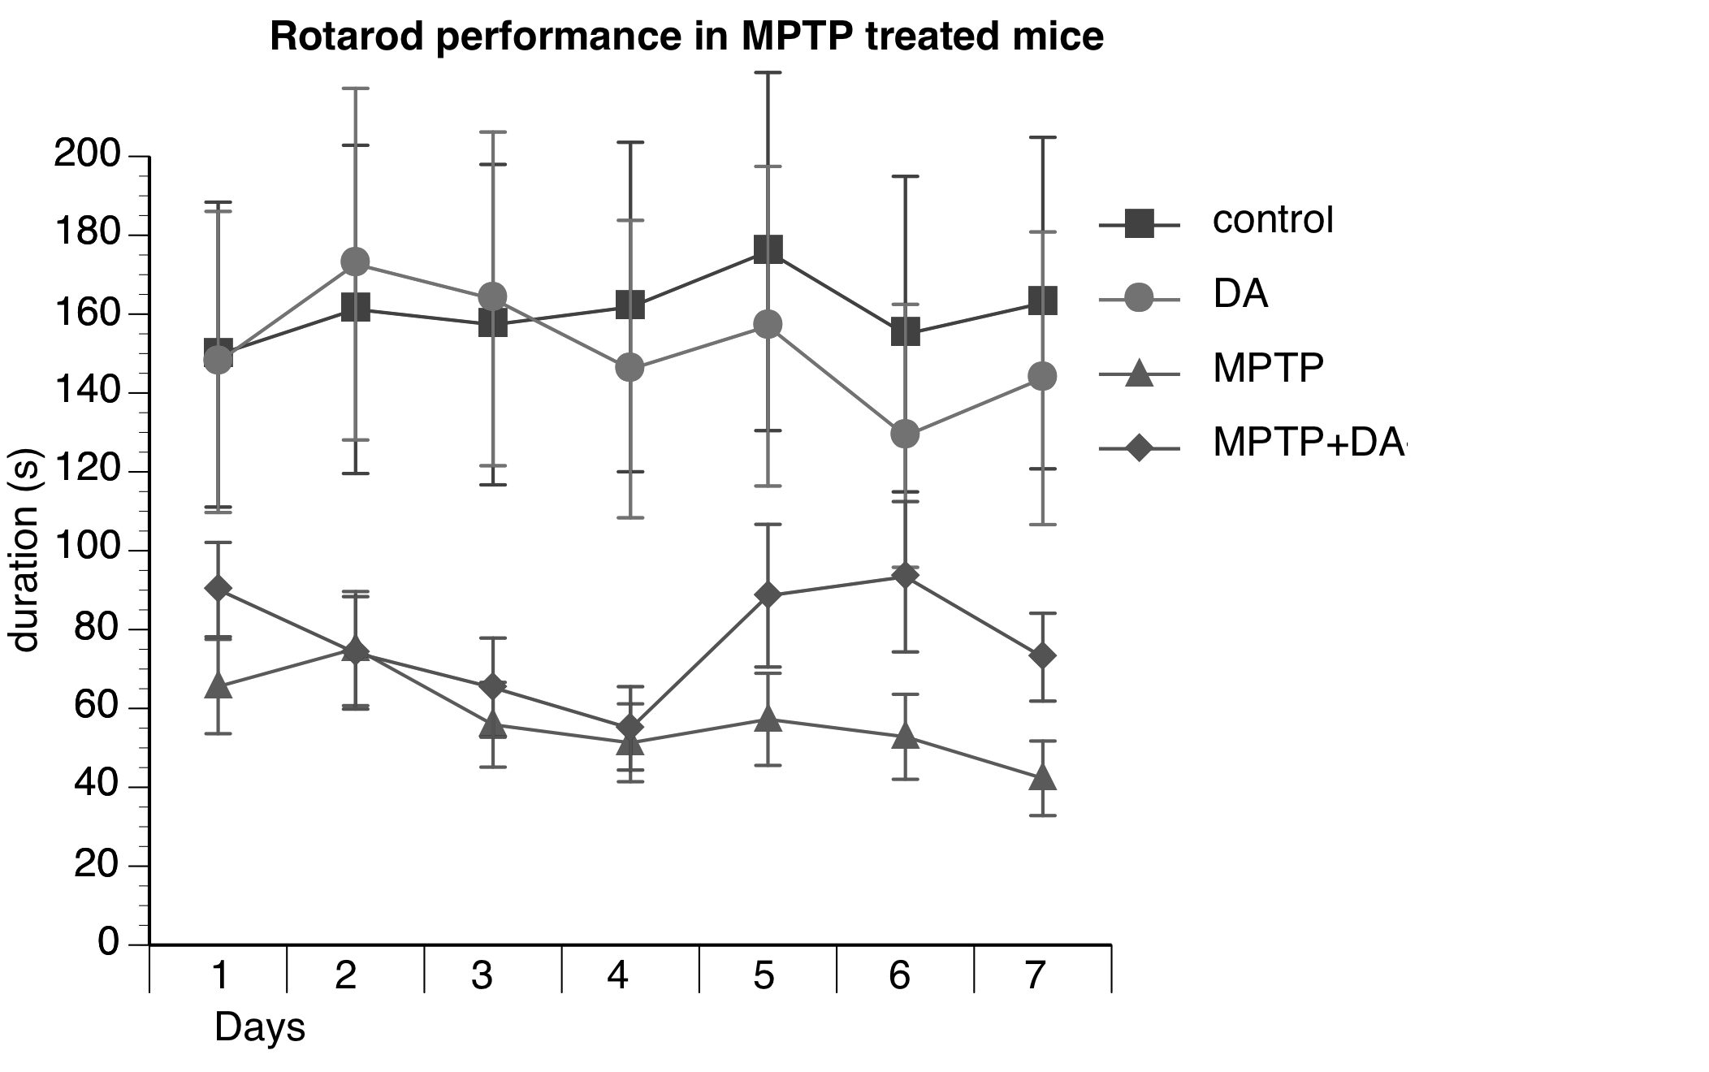

B

C

Fig. 1

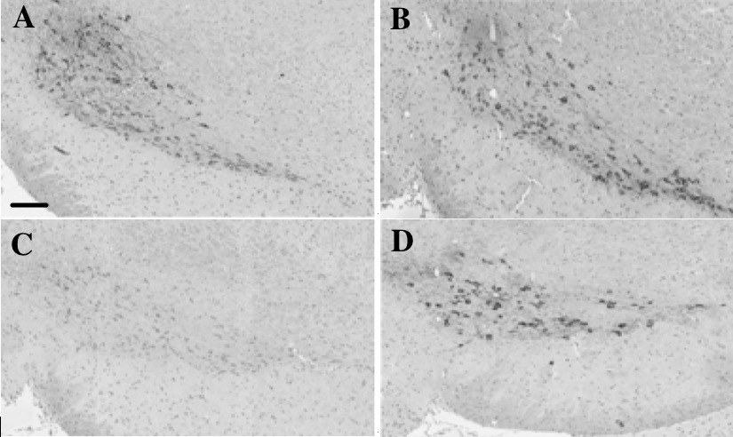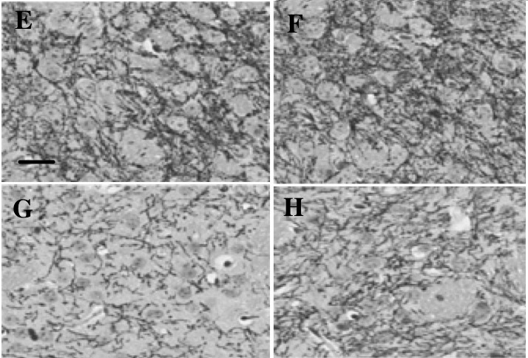

Fig. 2

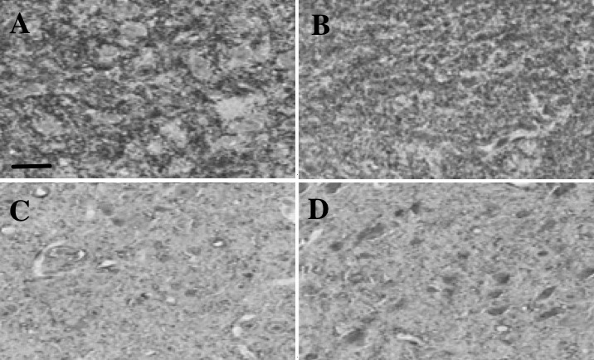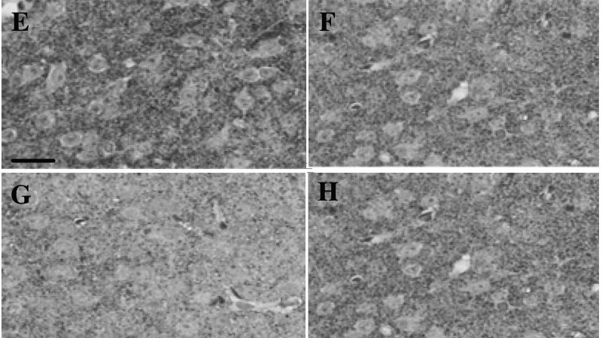

Fig. 3

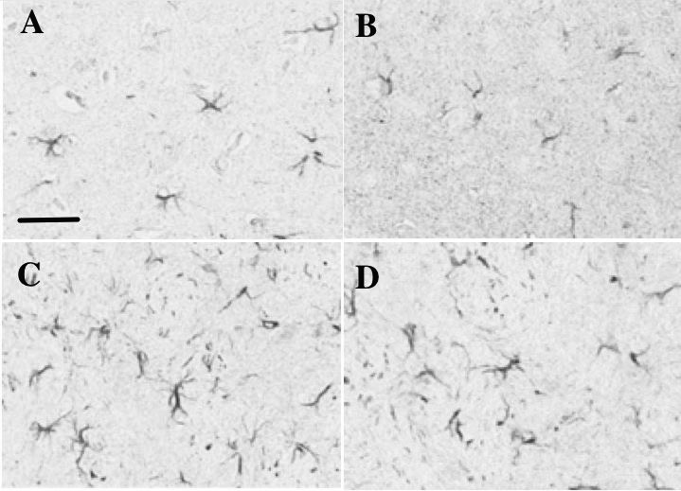
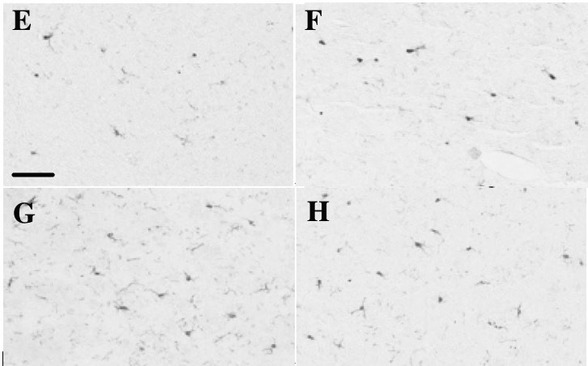

Fig. 4

