Pore water colloid properties
in argillaceous sedimentary rocks

C. Degueldre, V. Cloet²
¹ NES, PSI, 5232 Villigen, Switzerland
² NAGRA, Hardstrasse 73 5430 Wettingen, Switzerland

Keywords: groundwater colloids, clay colloids, sedimentary pore water.

Abstract
The focus of this work is to evaluate the colloid nature, concentration and size distribution in the pore water of Opalinus Clay and other sedimentary host rocks identified for a potential radioactive waste repository in Switzerland such as Effingen Member, “Brauner Dogger”, and the Helvetic Marls. Because colloids could not be measured in representative undisturbed porewater of these host rocks, predictive modelling based on data from field and laboratory studies is applied. This approach allowed estimating the nature, concentration and size distributions of the colloids in the pore water of these host rocks.

As a result of field campaigns, groundwater colloid concentrations are investigated on the basis of their size distribution quantified experimentally using single particle counting techniques. The colloid properties are estimated considering data gained from analogue hydrogeochemical systems. The study includes hydrogeochemical systems ranging from argillaceous rock (mylonite) features in crystalline fissures to sedimentary geological formations. The colloid concentrations were analysed as a function of the alkaline and alkaline earth element concentrations in the water. Extrapolation for the salt concentration of the studied sedimentary formation water is suggested based on the properties of these colloids.

Laboratory batch results on clay colloid generation from compacted pellets in quasi-stagnant water are also reported. Experiments with colloids in batch containers indicate that the size distribution of a colloidal suspension evolves toward a common particle size distribution for both initial conditions: starting from an almost colloid-free liquid phase on top of a pellet or from a very concentrated colloidal suspension. The final suspension size distribution was found to be a function of the attachment factor (α) of the colloids.

Finally, calculations were performed using a novel colloid distribution model based on colloid generation, aggregation and sedimentation rates to predict under in-situ conditions what makes colloid concentrations and size distributions batch- or fracture-size dependent. The data presented so far are compared with those of the systems quantified in the field campaigns and in the laboratory tests.
The colloid occurrence, stability and mobility have been evaluated for the water of the considered potential host rocks. In the pore water of the considered sedimentary host rocks, the clay colloid concentration is expected to be very low (<5x10⁵ ml⁻¹ for >100 nm or [col] < 1 μg l⁻¹, extrapolated to size from 10 to 100 nm and for an attachment coefficient (α) of ~0.99 which restricts their relevance for radionuclide transport.

1. Introduction
In environmental science, colloids are investigated for their role in transport of contaminant in aquifers (McCarthy & Degueldre, 1993). The colloid properties studied under in-situ conditions include not only their total concentration but most importantly their size distribution (Degueldre et al., 1996). The focus of this work is to evaluate the colloid properties in the pore water of Opalinus Clay and other potential host rocks identified for deep geological disposal of radioactive waste such as Effingen Member, “Brauner Dogger”, and Helvetic Marl (Nagra 2014; Mazurek et al. 2012, Pearson et al., 2003). In contrast to the homogeneous Opalinus Clay, some of these host rocks might form fracture networks where hydraulic flow locally governs fluid transport. In the safety assessment studies, colloid mobility in the Opalinus Clay has been evaluated and colloids were found to be of minor relevance (Voegelin & Kretzschmar, 2002). However this has to be assessed for the other potential host rocks. Based on the science of groundwater colloids and especially the experience gained at Wellenberg, Switzerland, the colloid mobility in fractured clay rocks with regard to colloid borne radionuclide transport is reconsidered. This work gives the expert’s view on the colloid data required for the long-term safety assessment of a repository.

In this work colloid concentrations are estimated from the size distribution measured using single particle counting techniques or on the basis of a model. The colloid properties are investigated based on analogy to hydrogeochemical systems encountered in sedimentary formations described in previous studies. The present work combines field, laboratory and modelling studies.
The field studies concern geochemical formations ranging from various crystalline to sedimentary rocks (Degueldre et al., 2000). Section 2 summarizes the former field studies. The colloid concentrations are analysed as a function of the alkaline and alkaline earth element concentration in the water. Extrapolation for the salt concentration of the considered sedimentary formation water is suggested based on the properties of the attachment factor of these colloids. The attachment factor (a number between 0 and 1) is a function of the chemistry of the system and describes the fraction of collisions which actually lead to an aggregation event.
At the laboratory level, studies of colloid generation at a clay bed / water interface and colloid sedimentation from suspensions are performed under quasi-stagnant conditions. The generation of clay colloids from a compacted pellet in quasi-stagnant water is currently studied. Experiments with colloids in batch containers indicate that the size distribution of a colloidal suspension evolves toward a common particle size distribution for both extremes of initial conditions: starting from an almost colloid-free liquid phase on top of a pellet or starting from a very concentrated colloidal suspension (Bessho & Degueldre, 2009). The size distribution and the morphology of the colloids or aggregates at pseudo-equilibrium have been studied experimentally for example using scanning transmission X-ray microscopy (Degueldre, et al., 2009) and a model has been developed to understand their behaviour in batches (Degueldre et al., 2009b, García-García, et al., 2009, Bessho & Degueldre, 2009).
Model calculations are performed together with experimental tests, to investigate colloid generation and sedimentation rates. This takes into account mechanisms in the water phase in order to understand what makes properties batch-size dependent under in-situ conditions. The data presented so far are compared with those of the hydrogeological systems studied earlier.

2. Colloid field studies
Field studies have been performed in formations ranging from crystalline (fractures filled with clay minerals) to sedimentary, with groundwaters going from weakly mineralised to saline and colloid going from the nanometre to the micrometre scale. The colloid data gained from these analogue hydrogeochemical systems are used for comparison.

2.1 Geological formations
The crystalline systems comprise recent granitic formations. The Central European Basement is first considered, with studies in the Black Forest of Southern Germany, in the Northern and in the Alpine area (Grimsel) of Switzerland. It also includes older granitic systems such as the Scandinavian and Canadian shields. The rock is mainly composed of quartz, feldspar and mica. Minerals currently found in the granitic fractures are: illite, biotite/muscovite, quartz and chlorite, calcite, iron oxy-hydroxides, with some pyrite. Their organic content is rather low (Degueldre et al., 1996).
The Swiss Crystalline studies (Degueldre et al., 1996) collect data of the Menzenschwand uranium mine, the Bad Säckingen spring, the Bad Zurzach thermal well, the Leuggern borehole and in the Alps both Grimsel Test Site and the Transitgas Tunnel. The depth ranges from about 100 to 1680 m in a 60 Ma old granite. The Experimental Underground Laboratory at Äspö (Sweden) lies in a 2 Ba old granite at a depth of 50 - 1562 m (Laaksoharju et al., 1995). In Manitoba, Canada (Vilks et al., 1991), waters were collected at depths down to 1150 m in the Whiteshell research facility that is underlain by the Lac du Bonnet granite batholith. The clay minerals in the water bearing fractures include: biotites, muscovites, chlorites and illites.
The Yucca Mountain (Nevada, USA) formation may also be described as crystalline with amorphous mineralizations and low organic concentrations. It consists of a thick accumulation of Miocene silica ash-flow tuffs of volcanic origin. The rock consists mainly of quartz, feldspar and zeolite with local gel layers (Levy, 1992).
Morro do Ferro, Minas Gerais, Brazil, is an altered (weathered) formation issued from volcanic activities in subtropical area containing some organic content. The rocks were predominantly carbonatite with layers deeply weathered to laterites. As its name suggests, Morro do Ferro is characterised by magnetite dikes and breccia with hydraulic conductive zones (Holmes et al., 1991, Miekeley et al., 1992).
Partially metamorphosed and non-metamorphosed sedimentary rocks were also considered. They generally contain more organic compounds than the formations described above.

Wellenberg (Degueldre, 1997) is located in Central Switzerland and comprises a slightly metamorphosed marl formation. The investigated aquifer lies in the marl formation at 360 m depth. In Markham Clinton, Nottinghamshire, UK, colloids from the glacial sand aquifer (120 m depth) were investigated (Longworth et al., 1989). At Gorleben, Central Germany, the system is composed of porous sediments with lignite intercalations (Kim et al., 1992). Aquifers are located between 50 and 300 m and are composed of glacial sand, "Brown-Coal" sand, silt, marl and clay.
The Cigar Lake uranium deposit is a sandstone-hosted ore body located in the Athabasca Sandstone Basin of the northern Saskatchewan, Canada (Vilks et al., 1993). The ore is located at the contact between sandstone and altered basement rock, and is separated from the sandstone host by zones of clay-rich altered sandstone. Finally, the Bagombé fossil reactor zone, Gabon, is located some 30 km south of the Oklo deposit. The sedimentary formation of sandstone is over-lain by a thick series of marine-derived, organic rich pelites associated with limestones (Peterson et al., 1996).
The Mont Terri underground laboratory (about 300 m below the surface) is located in the Jura Mountains of northwestern Switzerland. The tunnel intercepts various sedimentary formations according to the classical marine carbonate stratigraphic sequences: Triassic, Lias, Dogger (Aalenian and Bathonian-Bajocian) and Malm formations.

All these sedimentary rocks consist of clay minerals such as illites, smectites … along with sand, oganics and calcite.

2.2 Hydrochemistry
As prerequisite for comparison of colloid properties, the hydrochemical properties of the groundwaters studied must be well described and understood. Tables 1a-c show the most important hydrogeochemical parameters. The individual water properties may be summarised as follows.

In the Transitgas tunnel (Pfeifer et al., 1992), 9 springs were investigated in the mixed water zone. Locally, hydrothermal waters (spring 10 - 14), with temperatures ranging from 18-28ºC were sampled. In the shallow zone (spring 15 - 16), groundwater temperatures are around 4-6ºC. Similar waters are found in the uranium mine in Menzenschwand. At the Grimsel Test Site, a deep groundwater was collected at constant temperature of 12ºC. From the bore holes in Leuggern, Zurzach and Bad Säckingen, crystalline waters were sampled at the well head the latter with a certain hydrothermal signature. At Whiteshell and in Äspö, mixed waters are sampled in tunnels. In Yucca Mountain, Nevada (J13 water) and at Morro de Ferro, waters were pumped from the aquifer and collected at the well head temperature.
In the sedimentary aquifers, the water properties were the following. At Gorleben, in Bagombé, at Cigar Lake and in Markham, waters are pumped. At Wellenberg, deep waters flow artesianly. Finally, at Mont Terri, Opalinus Clay pore waters (OPA) from a bore hole were sampled and analysed (Degueldre et al., 2003).
These groundwaters range from oxic to anoxic, Na (Bad Säckingen) or Na-Ca rich (Äspö) to K-rich (Poços de Caldas) or with large Mg contribution (Markham, Wellenberg), depleted in organic (Zurzach) to organic rich (Gorleben). Their chemical type goes from shallow Ca-HCO₃ (Transitgas tunnel zone 3) to more complex Na-SO₄-HCO₃-Cl (Zurzach) or K-Ca-SO₄-F-HCO₃ (Poços de Caldas). For the waters considered, the salt concentrations are ranging over 4 orders of magnitude, the total hardness over two orders of magnitude and the pH from 6 to 10. Organic carbon (OC) is low (<10⁻⁵ M) in most of the Swiss crystalline groundwaters and is of the order of 6x10⁻⁵ M in the sedimentary environment (e.g. Wellenberg). Its concentration in the Gorleben water may reach 10⁻² M because the waters originate from the brown coal formation (OC consisting mainly of humic and fulvic acids e.g. Marquardt et al., 2004). In the Opalinus Clay pore waters at Mont Terri the TOC reached 2.5x10⁻³ M.

The pore waters of the evaluated sedimentary rocks (Opalinus Clay, Effingen Member, “Brauner Dogger” and Helvetic Marls see Table 1c) are all Na-Cl type and exhibit a Na concentration ranging from ~0.2 to 0.7 M . Their Ca concentration goes from 0.01 to 0.1 M. In these waters, K concentration is lower than that of Na and does not play a significant role, however, the Mg concentration is comparable to that of Ca which may also contribute significantly to the attachment of colloids.
The hydrogeochemical steady state in the aquifer is broken down in some cases. For example, mixing of Na-Ca-HCO₃-(Cl) (recharge) and Na-Ca-(Mg)-Cl-(HCO₃) (saline) waters are observed at Äspö. A similar situation is also locally observed at Bad Säckingen. An important parameter to assess the status of the aquifer is the temperature of the water reservoir estimated by the geo-thermometer. Comparison of the water temperature with that evaluated by the geo-thermometer gives information about the status of the thermal steady state of the water. Large differences between temperature at the source and that evaluated from the geo-thermometer are also observed in the hot waters collected in the hydrothermal zone of the Transitgas Tunnel. These suggest gradients, transients and/or equilibrium gap in the local aquifer.
Table 1a: Comparison of crystalline groundwater chemistry
Note: Depths in m; p: -log , Alk: alkaline elements, AlE: Alkaline Earth elements, OC: organic carbon, Transit: Transit gas tunnel; Mix: mixed waters, Hydroth: hydrothermal, Shall: Shallow zones.
Site  Depth (m) | Transit Mix  CH  200 | Transit  Hydroth  CH  200 | Transit  Shall  CH  200 | Bad Säckingen  D  200 | Menzen  schwand  D  240 | Grimsel  CH  450 | Zurzach  CH  470 | Leuggern  CH  1680
Water | NaCa- SO₄HCO₃ | Na- SO₄ | Ca-HCO₃ | Na- Cl | NaCa-HCO₃ | NaCa-HCO₃F | Na- SO₄HCO₃Cl | Na-SO₄HCO₃Cl
pH | 8-9 | 9.2 | 9.2 | 6.5 | 6.5 | 9.6 | 8 | 7.8
pe | 6 | 0 | 6 | 6 | 6 | -3 | -3 | -3
pAlk | 4.1 | 2.5 | 4.1 | 1.3 | 3.9 | 3.2 | 1.9 | 1.9
pAlE | 3.6 | 4.0 | 3.4 | 2.3 | 3.4 | 3.9 | 3.4 | 3.6
pOC | 5.0 | 5.0 | 5.0 | 4.4 | 4.5 | 5.7 | 5.8 | 5.7

Table 1b: Comparison of old crystalline and sedimentary groundwater chemistry
Site  Depth (m) | Morro do Ferro  Bz  70 | Äspö  S  75 | Yucca Moun-tain  USA  300 | White-shell  CA  1150 | Bagom-bé  Ga  10 | Gor-leben  D  80 | Mark-ham  UK  100 | Wellen-berg  CH  350 | Cigar Lake  CA  430 | Mont Terri  CH  300
Water | CaK-SO₄₋HCO₃ | NaCa-HCO₃ | Na-SiO₂-HCO₃ | NaCa-Cl | NaCa Mg-HCO₃ | OC-(Na-HCO₃) | Mg-HCO₃ | Na-HCO₃ | Na-HCO₃ | Na-Cl-(OC)
pH | 6.1 | 7.5 | 6.9 | 8.9 | 6.0 | 8.5 | 7.8 | 8.5 | 6.5 | 7.9
pe | 1 | -4 | 6 | - | 1 | 0 | 7 | -5 | - | 1
pAlk | 3.5 | 1.5 | 2.7 | 0.4 | 4.0 | 2.3 | 3.6 | 1.7 | 3.0 | 0.5
pAlE | 4.3 | 2.0 | 3.4 | 0.7 | 4.0 | 3.9 | 2.8 | 4.1 | 3.3 | 1.5
pOC | 4.4 | 4.0 | 4.1 | - | 4.0 | 2.6 | - | 4.2 | 3.0 | 2.5

Table 1c: Hydrochemical properties of sedimentary rock pore water compared to sea water. Ref: reference Opalinus Clay pore water (Organic content in extracted pore water not reliable)
Site | Sea water | Effinger Member | “Brauner Dogger“ | Helvetic Marl | Opalinus Clay
Water | Na-Cl | Na-Cl | Na-Cl | Na-Cl | Na-Cl
pH | 8 | 7.0 | 7.2 | 7.5 | 7.2
pe | - | -3 | -3 | -3 | -3
pAlk | 0.3 | 0.3 | 0.8 | 0.7 | 0.8
pAlE | 1.2 | 0.05 | 1.7 | 2.5 | 1.7
Reference | [SMOW] | (Mäder 2009a) | (Mäder 2009b) | (Mäder 2010) | (Mäder 2009b)

2.3 Colloid analyses techniques
Colloid characterisation has been performed by single particle and bulk analysis. The colloids from diluted solutions were detected in the laser beam of a single particle unit and analysed with respect to size according to the intensity of scattered light. Single particle analysis was carried out without separation, by dilution in-line in ultra-pure water. Information on the technique is found in Degueldre et al., 1996. Colloid concentration was firstly displayed in a cumulative distribution. Filtration and ultrafiltration were also carried out taking into account the limitations of this technique. Separations were combined with other analytical techniques. After ultrafiltration through a membrane of 3 nm pore size, colloids were counted on Scanning Electron micrographs (SEM). Gravimetry was used after series filtrations for given cut-off (pore sizes). Photoacoustic spectroscopy was also carried out after filtration series. These techniques allow colloid concentration and distribution evaluation as well as colloid speciation using energy dispersive X-ray (EDX) spectroscopy.
Colloid concentration (in term of colloid number per volume unit: N_{i} in l⁻¹) obtained for various sizes (d_{i} in nm and i being the size class) may be described by a model. When a detailed and accurate size distribution is determined, it can be represented by the Pareto power law:
δN_{i} ·δd_{i}⁻¹ = A d_{i}^{-b} (1)
with
N_{i} = A· (1-b)⁻¹ d_{i}^{1-b} (2)
The parameters A and b are empirical constants for given size ranges and N_{i} is integrated from a maximum size to d_{i}. They may be easily quantified by plotting the log of the normalised colloid concentration as a function of the log of their size. The slope of the plot b, reflects then the stability, and is large for a “stable” population of small colloids. The colloid concentration given in mass per volume unit (e.g. g l⁻¹) is then deduced taking into account an average density for the size range and assuming spherical colloids. Assuming spherical geometry for colloidal particles with a density _{col} (g cm⁻³), the colloid concentration, [col] in g l⁻¹, can be approximated by
[col] =  N_{i} m_{i} =  N_{i} _{col} V_{i} (3)
with m_{i} the average mass of the colloidal particle and V_{i} is the average volume of the particles in a given size class i.

2.4 Results from field campaigns
Colloid occurrence in the aquifer is postulated to be a consequence of the colloid “stability” in the aquifer. The system is first supposed to be constant in time (no hydrogeochemical changes) and no local changes such as in the transit gas tunnel (Mixed 1-9, Hydrothermal 10-14, Shallow 15-16 zones), but mostly such as in the Leuggern (LEU) and Zurzach (ZUR) waters.
Colloid phases range from clay (Grimsel Test Site (GTS), Bad Säckingen (BDS), Menzenschwand (MZD), Markham (MARK), Bagombé (BAG2),Wellenberg (WEL6), Cigar Lake (CIL139)), silica (Yucca Mountain (J13)), iron oxy-hydroxide and organic rich phases (Morro do Ferro (MF12)), calcite and clay coated with organic (Äspö), to clay associated with organic phases (Gorleben (GO532)).
Comparison of all results is performed for 100 nm size, for reasons of accuracy. Factors decreasing the colloid stability include an increase in alkali metal (Na⁺, K⁺) concentration and in water total hardness (Ca²⁺, Mg²⁺). The trend of colloid concentrations as a function of salt and hardness of the water is shown in Fig. 1, both alkaline elements and alkaline earth elements yielding destabilisation (flocculation) of colloidal suspensions. The colloid concentrations range from 10⁹ ml⁻¹ in the low mineralised (GTS) to 10⁵ ml⁻¹ in the highly mineralised water (Bad Zurzach (ZUR) or Bad Säckingen (BDS)) for 100 nm size. The effect of calcium coagulant may be limited due to colloid charges, mostly in weakly acidic oxic water loaded with positively charged iron oxy-hydroxy colloids. With these species, cations are not able to act as coagulant. This effect is observed in the Poços de Caldas mine (MF12) where iron oxy-hydroxide colloids are stabilised at pH 3-5 in the surface waters. Pyrite oxidation decreases the pH, increasing locally the stability of these positively charged iron colloids. Under these conditions, calcium does not act any more as a coagulant for iron rich colloids in these waters. It must also be noted that artefacts such as calcite particles may be generated during water sampling. Consequently, colloid concentrations from calcium-rich waters are sometimes affected by these artefacts. This explains the absence of measured colloids in groundwaters at Whiteshell and Äspö (Fig. 1). Finally, the colloid concentrations from Opalinus Clay groundwaters are not reported since they are not artefact free. The Opalinus Clay (OPA) pore water is documented in the complete study from Mont Terri (Degueldre et al., 2003). The water of bore hole A1 is a Na-Cl-(OC) water in which colloid concentration for 100 nm reach concentrations of some 10⁶ ml⁻¹ nm⁻¹. However, the colloid concentration is always affected by the sampling itself. If the colloid sampling is not carried out after sufficient out-flow to dilute artefacts, the colloid concentration may be affected by 3 orders of magnitude as reported in the case of the Wellenberg water (Degueldre et al., 1999). The dilution is not possible in the case of the Opalinus Clay pore water samples since the sampling volume is restricted to about 50 ml over 3 months.
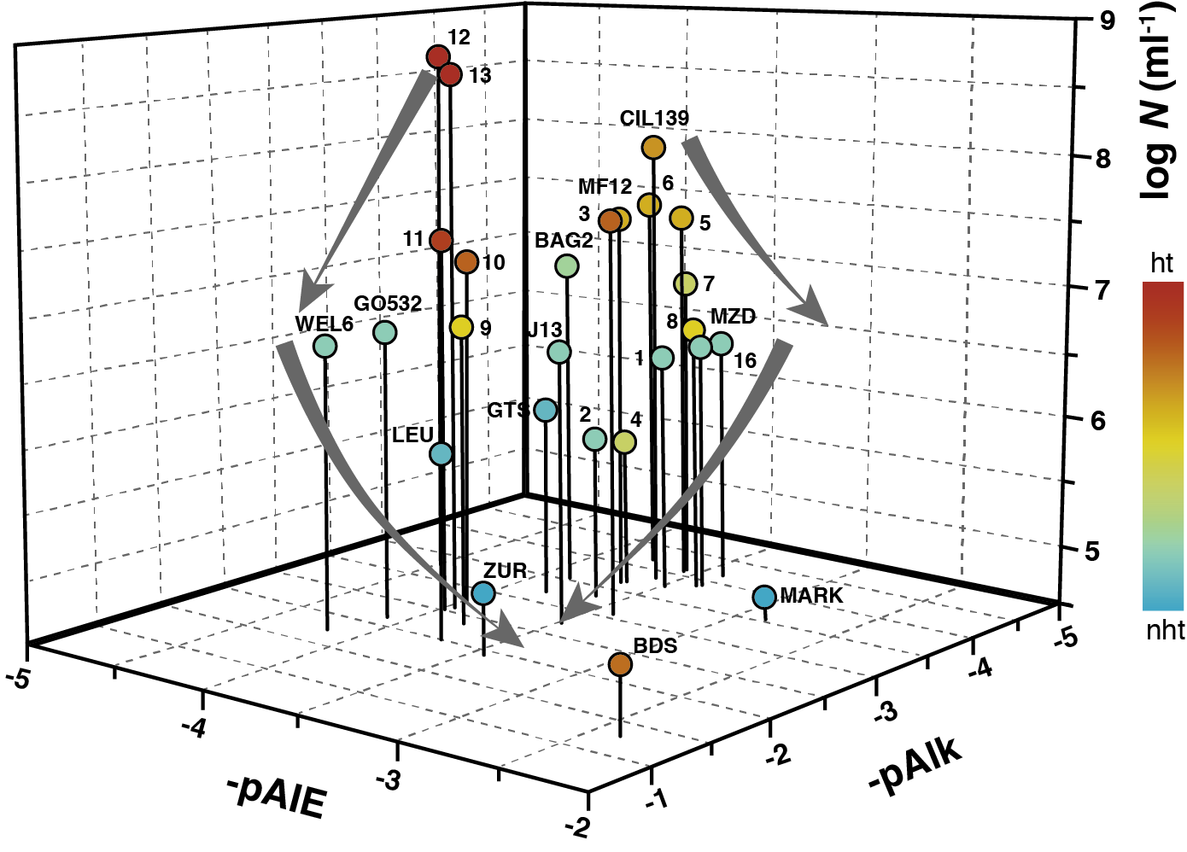
Fig. 1: Comparison of the cumulative colloid concentrations as a function of alkaline and alkaline earth element concentrations.
Conditions: colloid size > 100 nm, precision on colloid concentration: 10%, the arrows denote the decrease of concentration or stability, locations: see text, p = -log[X], ht: hydrothermal, nht: non-hydrothermal waters.

3. Colloid studies in the laboratory
The trend observed in Fig. 1 has to be discussed on the basis of the effect of the physico-chemical properties of alkaline and alkaline earth elements on the stability of model colloids. This trend was tested in the laboratory for montmorillonite colloids selected as an example of clay colloids.

3.1 Experimental methods
3.1.1 Colloid aggregation from their suspensions in batches
Measurements of the colloid attachment factor (a) were performed in batch with model montmorillonite colloids for 100 nm size. The clay material was a commercial bentonite Wyoming MX-80, which consists of 83% montmorillonite with the following structural formula (Karnland et al., 2006):
(Na_{0.54}Ca_{0.11}K_{0.01}) [(Al_{3.11}Ti_{0.01}Fe³⁺_{0.36}Mg_{0.47})(Si_{7.93}Al_{0.07})O₂₀] (OH)₄·nH₂O
The supplied ‘‘Na-montmorillonite” material was used after freeze-drying and milling (Gonzalez Sanchez et al., 2008).

The effects of Ca²⁺, Mg²⁺, Na⁺, K⁺ concentrations at given pH were studied in batch experiments. The attachment factors were obtained by measuring the colloid concentration during the coagulation process and elimination by sedimentation in static batches.
A Single Particle Counting (SPC) unit was used to monitor the colloid concentration of the samples in various size ranges (Degueldre et al., 1996; ). The concentration of colloids measured by each SPC channel was normalized to the size range of the channel. Suspensions with the same water/solid ratio as in the sedimentation experiments were prepared. The concentrations of Na⁺, K⁺, Ca²⁺, and Mg²⁺ in the generation and sedimentation experiments from Na-montmorillonite were systematically measured. The concentrations of Na⁺, K⁺, Ca²⁺, and Mg²⁺ were tested to account for cation-exchange reactions between the ions in solution and the counterions balancing the negative charge on the montmorillonite (Berend et al., 1995).

3.1.2 Colloid generation, aggregation and sedimentation in batches
For the colloid generation experiments, clay pellets of 2 g were compacted and then inserted in a Plexiglas batch, see Bessho & Degueldre, 2009. Generation test vessels were filled very slowly with 200 ml 10⁻³, 10⁻², and 10⁻¹ M NaCl solution in order to prevent colloid generation by flow. Sedimentation test vessels were filled with 2 g montmorillonite suspended in 200 ml 10⁻³, 10⁻², and 10⁻¹ M NaCl solutions. The experimental setups were carefully protected from movement and vibrations. Figure 2 presents the Wyoming MX-80 bentonite (2 g per batch) 0.01 M NaCl suspension in generation and sedimentation mode from t = 0 to t = 500 h, in the 4 cm diameter batches.

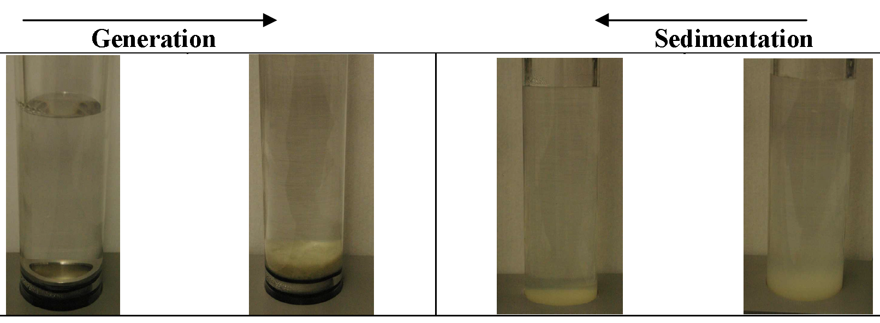
Fig. 2: Colloid generation and colloid sedimentation toward pseudo-equilibrium. The strong swelling of the clay must be noted.

The first size distribution in generation experiments is recorded for the NaCl solution used to fill the vessels, which corresponds to time 0 in the plots. In the sedimentation experiments, the first sample was taken after 3 min. Periodic sampling was performed in order to monitor the colloid concentration as a function of time and for various sizes. The samples were always taken from the middle of the vessels. The evolution of the colloid concentration profiles in the middle of the vessels for generation and sedimentation experiments was compared at time zero and after 2300, 6000, and 7000 h for Na-montmorillonite in contact with 10⁻³, 10⁻², and 10⁻¹ M NaCl solutions, respectively.

3.2 Results from laboratory tests
3.2.1 Colloid aggregation from their suspensions in batches
The colloid attachment factor (a) was deduced by measuring the 100 nm colloids of montmorillonite, which acts as a model compound for clay minerals. The attachment factors are obtained by measuring the colloid concentration during the coagulation process and elimination by sedimentation in static batches. Measurements of the colloid attachment factor (a), which is the ratio of colloids that attach to those that collide, were performed with the model montmorillonite colloids for 100 nm size. The effects of Ca²⁺, Mg²⁺ (pAlE) and Na⁺, K⁺ (pAlk) concentrations were studied in batch experiments.

Figure 3 shows that the attachment factor of model colloids increases towards unity when increasing alkaline and alkaline earth element concentrations respectively. This test clearly demonstrates that the salinity and the hardness of the water play an important complementary role on the colloid stability. The attachment factor of these clay colloids approaches unity for total salt concentrations of about 10⁻² M and 10⁻⁴ M in alkaline earth elements.

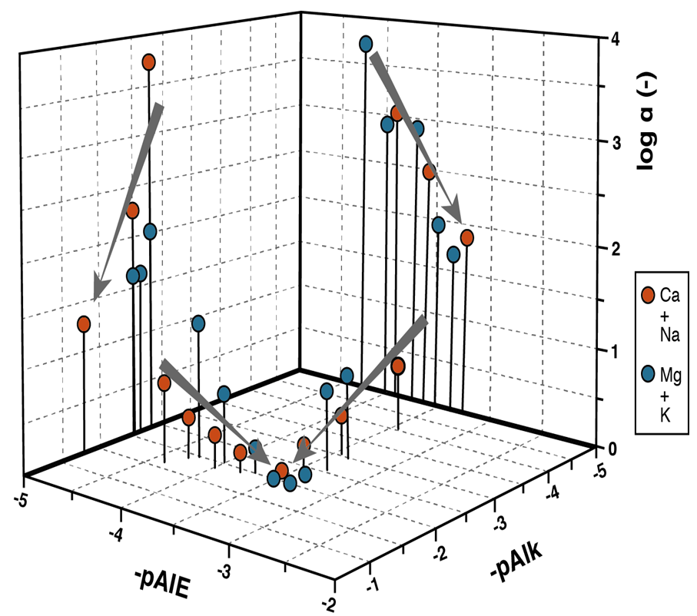
Fig. 3: Effect of pAlE and pAlk at pH 8 on the colloid attachment factor. Conditions: montmorillonite, colloids size 100 nm; the trend shows the decrease of colloid stability when the salt concentration increases.

Table 2 summarizes the attachment factor of colloidal Na- montmorillonite as a function of the Na concentrations.

Table 2: Clay (montmorillonite) attachment factor as a function of the Na concentrations. Data as estimated from Fig. 3
NaCl  (M) | α  (-)
10⁻³ | 10^{-5.0}
10⁻² | 10^{-3.5}
10⁻¹ | 10^{-1.0}
10⁻⁰ | 10^{-0.0}

3.2.2 Colloid generation, aggregation and sedimentation in batches
Previous studies showed that the amount of generated colloidal particles increases with increasing flow followed by a return to former concentration after transient e.g. Degueldre, 1997, and that colloidal particles are generated at flow rates as slow as 0.49 ml per day and under quasi-static conditions (Missana et al., 2003). The present data show that colloids can be generated even in the absence of flow. This is not surprising since the mechanism of colloid formation is actually clay swelling, followed by particle detachment, and subsequent self-diffusion of colloidal particles from the colloid source toward the solution. Therefore, the mass gradient in the swollen montmorillonite front is in equilibrium and when colloidal particles are removed by flow shear forces (convection if any) or by self-diffusion, new particles are generated to reestablish the equilibrium. The larger particles (e.g. >500 nm) are found to sediment as a consequence of the gravity force. The smaller particles remain in suspension and sediment once they form larger aggregates. Sedimentation of small colloidal particles is slow. However, an increase in ionic strength enhances aggregation prior to sedimentation. Thus, when the ionic strength increases, the aggregation rate accelerates and heavier aggregates sediment faster. Similar results were obtained for various bentonites, Bessho & Degueldre (2009).

The evolution of the colloid concentration profiles in the middle of the vessels for generation and sedimentation experiments was compared at time 0 and after 2300, 6000, and 7000 h for Na-montmorillonite in contact with 10⁻³, 10⁻², and 10⁻¹ M NaCl solutions, respectively. Figure 4 shows the normalized concentrations of the colloidal size fractions for Na-montmorillonite particles. Comparing the evolution of the concentration of Na-montmorillonite colloidal particles, it can be observed that the concentration profiles in generation and sedimentation batches approach each other over time (Fig. 4). Hence, the concentration of particles in dispersion reaches pseudo-equilibrium with time. However, it requires significantly more time to reach pseudo-equilibrium at lower electrolyte concentrations, mainly due to a slower aggregation and sedimentation process.
The concentration of colloids in milligrams per liter in the size range 50–5000 nm can be estimated from the pseudo-equilibrium profiles shown in Fig. 4, taking into account that the colloid concentration remains fairly constant. Assuming spherical geometry for colloidal montmorillonite particles with a density of 1.5 g cm⁻³, the mass concentration in grams per liter of colloids in pseudo-equilibrium can be approximated using Eq (3) for each size fraction as determined by SPC. The radius of the particles is determined from the average of each size class. Because of these approximations, mass of colloids is only a rough estimation rather than an exact value.
The pseudo-equilibrium concentrations of dispersed particles are observed to be independent of the type of experiment: generation or sedimentation (Fig. 4). This implies that both generation and sedimentation experiments are valid ways of testing pseudo-equilibrium colloid concentrations generated from a clay source (e.g., the bentonite). Moreover, these pseudo-equilibrium concentrations are constant with time. However, the pseudo-equilibrium concentration of colloidal particles is affected by the cationic form of montmorillonite. Ca-montmorillonite colloidal particles experience a weaker repulsion which restricts the generation and favors aggregation as expected in the presence of divalent electrolytes e.g. Quirk (1994).
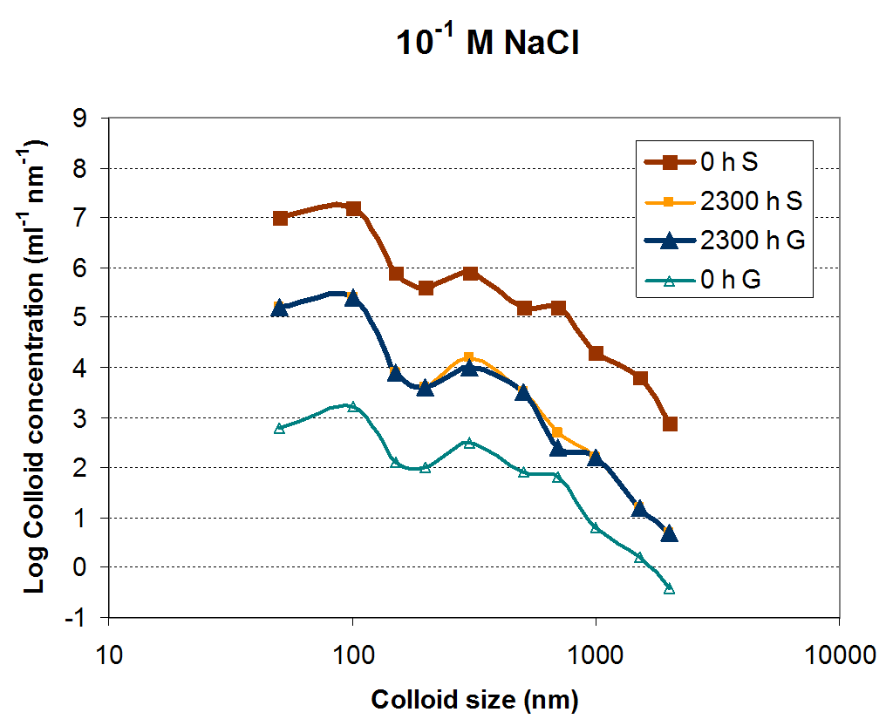
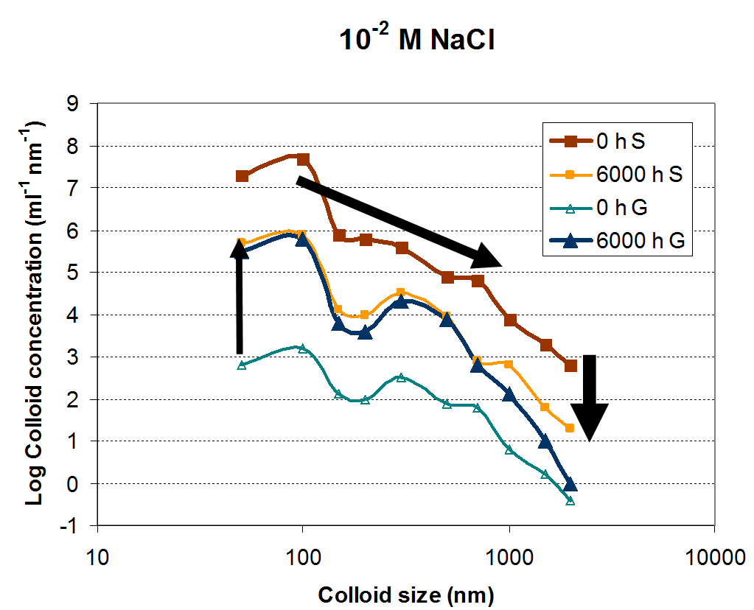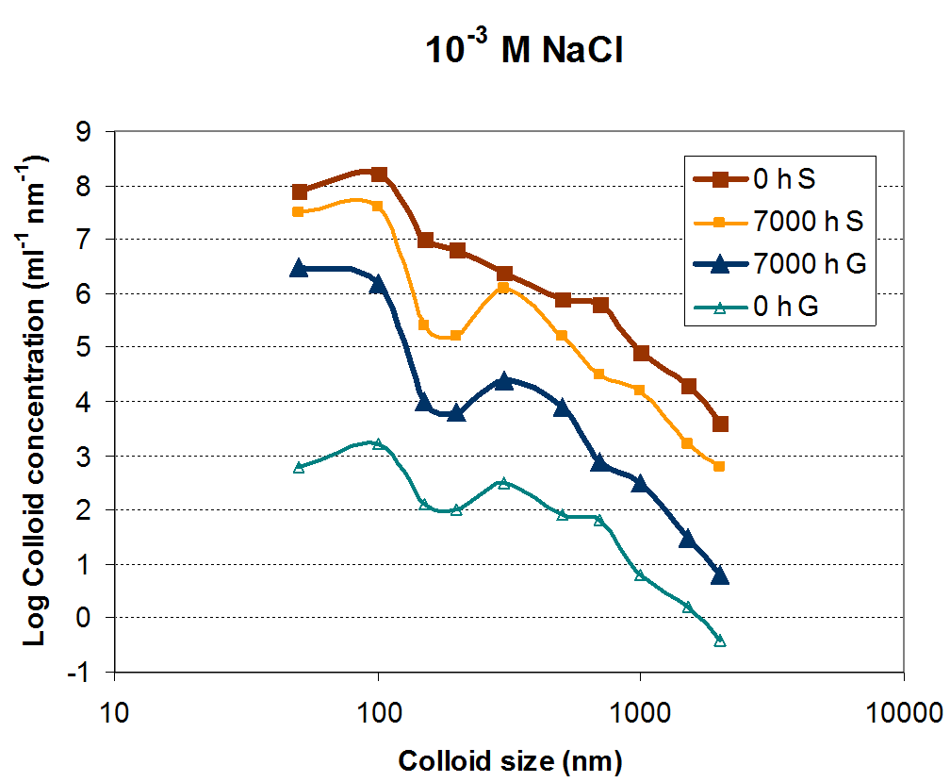

Fig. 4: Pseudo-equilibrium profiles in generation (G) and sedimentation (S) experiments as a function of time and NaCl concentration.
Legend: generation, aggregation, sedimentation.

The pseudo-equilibrium concentrations for Na-montmorillonite in contact with 0.001 M NaCl solution are determined as an average of the colloid concentrations in generation and sedimentation experiments, since this system did not reach pseudo-equilibrium during the course of the experiment. Table 3 summarizes the pseudo-equilibrium concentrations of colloidal Na- montmorillonite for each ionic strength studied.
The concentration of Na-montmorillonite colloids in pseudo-equilibrium decreases with increasing ionic strength (Table 3) as expected according to colloid stability theory. Since repulsive forces are responsible for both generation and sedimentation processes, both types of experiments lead to similar colloid concentrations in pseudo-equilibrium, as shown in Fig. 4.

Table 3: Normalised concentrations of colloidal Na- montmorillonite at pseudo-equilibrium as a function of ionic strength. Extrapolated value in brackets.
NaCl  (M) | Measured N_{(100nm)}  (ml⁻¹ nm⁻¹)
10⁻³ | 10⁷
10⁻² | 10^{5.8}
10⁻¹ | 10^{5.3}
(1) | (10^{4.8})

4. Modeling colloid generation - sedimentation pseudo-equilibrium
The model developed here describes the life of the colloid population in a batch in quasi-stagnant conditions.

4.1 Colloid suspension modeling
The model needs to keep track of the concentration of colloids N_{i}(t,z) for each size i at a time t and a position z above the colloid bed. The particle diameter or size, can immediately be obtained for each size class:
(4).
The particle concentration depends on the height above the colloid bed (z) due to the sedimentation of particles; large particles sediment faster and tend to accumulate at the bottom, whereas Brownian motion distributes small particles of a few nanometres more evenly across the whole column height. Therefore, the process rates depend on the variable z, too. The resulting kinetic equation for each size class i is the following:
(5)
and are the vertical particle fluxes in -direction due to sedimentation and diffusion, respectively, and are respectively the birth () and death () rates of particles of class due to aggregation (). Figure 5 depicts the processes.
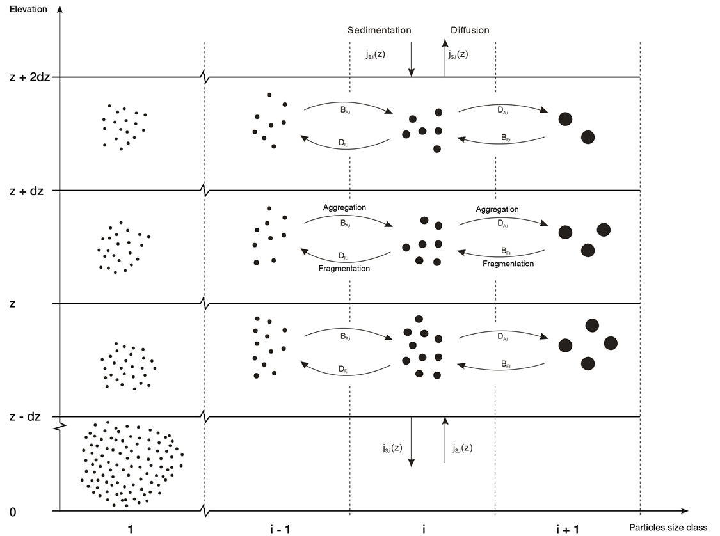

Fig. 5: Processes describing the colloid live to build up a colloid population.

Since these fluxes (1D diffusion and sedimentation) are always in vertical direction, they can be treated as scalars (positive when pointed upwards, negative when pointed downwards). The two flux terms are defined by Dörfer (2002):

(6)
(7)
where is the steady-state sedimentation velocity and is the diffusion coefficient of size class particles. The steady-state sedimentation velocity is achieved when the hydrodynamic drag force on the colloid equals the gravitational force. For a spherical particle it is given by:
(8)
where is the liquid (water) density, the colloid density, is the earth acceleration and is the dynamic viscosity of the suspension (Ekdawi & Hunter 1985). The sedimentation speed is a constant in time and in the height and is negative because the positive -axis of the system is pointed upwards (Watson et al., 2005). The diffusion coefficient for a spherical particle is given by:
(9)
where is the Boltzmann constant and is the absolute temperature.
The mechanism for colloid aggregation follows the theory by von Smoluchowski, 1917. This approach treats colloidal aggregation analogous to the kinetics of bimolecular chemical reactions: two particles approach each other, collide, and react (i.e. aggregate), giving one particle with the combined volume of the reacting particles. The rate of this process is expressed similar to the reaction rate of chemical kinetics:, where is the rate constant and and are the concentrations of the aggregating colloids. The rate constant is written as , where is the collision density of the two colloid types and is the attachment factor (between 0 and 1, function of the chemistry of the system) that describes the fraction of collisions which actually leads to an aggregation event.
At (on the liquid/air or liquid/solid interface), Eq. (5) must be modified: at the surface of the suspension, there are no more vertical particle fluxes, as no colloids leave or enter the suspension across the surface. Therefore, the condition
(10)
for all times and for all size classes, is imposed at .

These conditions could be modified for more complex system, for example for a fissure in a rock where the generation could also take place from the upper solid phase e.g. a clay rock. In such a case, Eq. 10 is not null anymore. This case must be treated in a separated study.

The boundary condition at at the bottom of the suspension is the key point in the model, since it describes the generation of colloids from a colloid bed at any time. Like at the upper boundary, the aggregation kinetics does not change at the lower boundary, but the vertical particle fluxes are different.

At the lower boundary, the following three processes take place:
- The usual sedimentation flux (settling out of the particles),
- Colloid detachment from the bed followed by
- Spontaneous diffusion to the suspension, (for the 2 last processes)

The total particle flux of each size class is therefore:
j_{i}(t,0) = j_{S,i}(t,0) + j_{T,i}(t) (11)
The spontaneous diffusion is simply driven by the second principle of thermodynamics and the generation is coupled with detachment freeing the colloids from the interface as suggested by Kretzschmar et al., 1999.

In this work the hypothesis is made that there is constant particle diffusion from the pellet surface after detachment, which is described analogously to diffusion as described by Fick’s first law (Eq. (7)). According to this law, the diffusion flux of particles is proportional to the concentration gradient of the particles. But what is this gradient at the interface between the suspension and the just detached colloids from the bed? According to experimental observation, a colloidal suspension evolves to some kind of equilibrium state: a suspension with a high content of colloids as well as almost colloid-free water in contact with a clay pellet evolves toward a common concentration profile. This suggests that the concentration gradient at the pellet surface has a fixed, constant value which is a function of the chemistry of the system. In other words the detachment rate including detachment of colloids from a colloid bed and self diffusion into the suspension is a constant. For a given solution physical-chemistry (ionic strength: i and temperature: T) and a given clay colloid bed the flux becomes:.

The detachment rate is constant for a constant chemistry of the solution and for a constant temperature, it is however analytically difficult to describe the process since the short distance forces are poorly understood as noted by Israelachvili, 1992. The spontaneous diffusion is of course a function of particle size; smaller particles diffuse faster than large ones as described by Eq 6. It is consequently proposed that their detachment rate is proportional to the diffusion coefficient of the colloids, , and to their size distribution on the colloid bed, following a Pareto distribution law:.
Combining these statements, the diffusion of colloids at the colloid bed is:
(12)
where is the proportionality factor, a parameter that must be selected (and fitted) and that reflects the physical-chemistry of the system. The parameter has the same unit as a concentration gradient. It translates for size i the concentration change from the colloid bed towards the suspension over 1 size unit from the surface. D_{i} is also adapted to the size of the colloids (Eq. 9).

Model calculations were carried out using the FiPy partial differential equation solver package. More information on the FiPy partial differential equation solver can be found in previous publications (Guyer et al., 2009).

4.2 Colloid modeling results

Results of colloid concentration trend toward pseudo-equilibrium are given in Fig. 6.
Calculations are carried out starting (t = 0) for a colloid suspension batch of height Z with a simple colloid size distribution model. The conditions for the suspension are: T = 300 K, ρ_{W} = 1.0 g cm⁻³, Z = 20 cm, z = 10 cm, η = 0.01 P, ρ_{col} = 1.8 g cm⁻³, b = 4 (i [0,30]); N_{i}(t=0) =
10³ cm⁻³nm⁻¹, b = 0 (i [0,30]), g = 981 cm s⁻²; q = 10⁹ cm⁻⁴ , σ_{col-W}= 6.5 μJ cm⁻² (Janczuc et al., 1990).
At time 0, the normalized distribution at the elevation z (e.g. 10 in Fig. 6) is colloid size independent corresponding to an unstable suspension from where large colloids are eliminated by sedimentation. Over the first 3000 h the size distribution changes are mainly due to large colloid sedimentation. After 10’000 h the horizontal profile for the small colloid is changing due to colloid generation at the bottom interface and diffusion toward the elevation where the calculation is performed (e.g. at mid elevation of the batch). The small colloid concentration increases during time period after 10’000 h. This increase is however a function of the attachment factor (α) that drives the aggregation behavior of the small colloids together. Aggregates are eliminated by sedimentation and this elimination is determined by the value of α. When the size distribution profile is time independent, pseudo-equilibrium is reached in the suspension. This pseudo-equilibrium is however elevation dependent in the batch, reflecting the extrinsic nature of a colloid suspension.

Comparing the figures gained for increasing attachment factors it is clear that the colloid concentration decreased at pseudo-equilibrium (Table 4) and that the latter is reached faster. Since the attachment factor increases with the dissolved salt in the groundwater, it is clear that the colloid concentration in the system decreases as reported.

Table 4: Pseudo-equilibrium concentrations of colloidal Na- montmorillonite as a function of ionic strength. Calculated values are compared to the experimentally determined colloid concentrations. Extrapolated values in brackets.
NaCl  (M) | Measured N_{(100nm)}  (ml⁻¹ nm⁻¹) | Calculated N_{(>100 nm)}  (ml⁻¹) | α  (-)
10⁻³ | 10⁷ | 5x10⁸ | 10^{-5.0}
10⁻² | 10^{5.8} | 5x10⁷ | 10^{-3.5}
10⁻¹ | 10^{5.3} | 5x10⁶ | 10^{-1.0}
(1) | (10^{4.8}) | 5x10⁵ | 10^{-0.0}

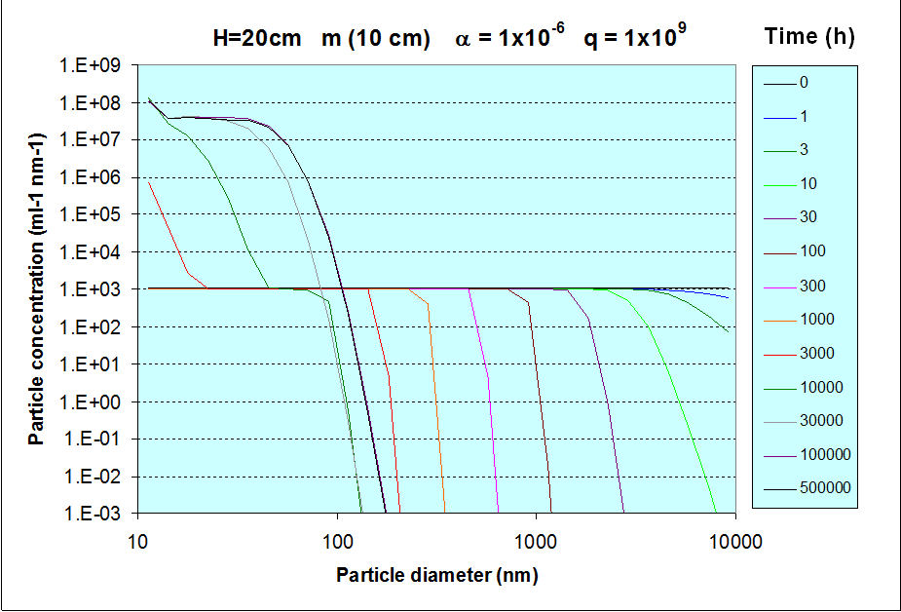
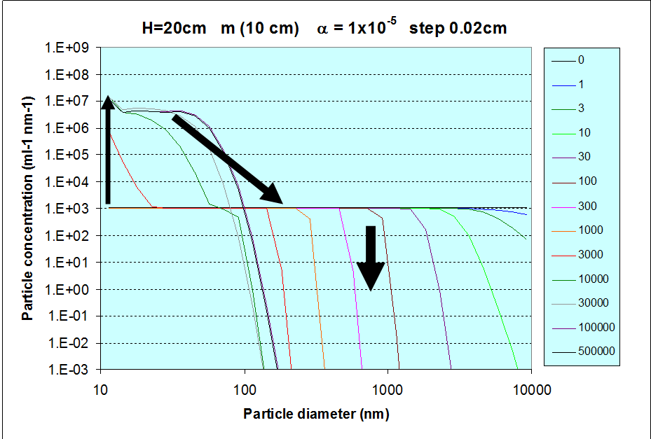
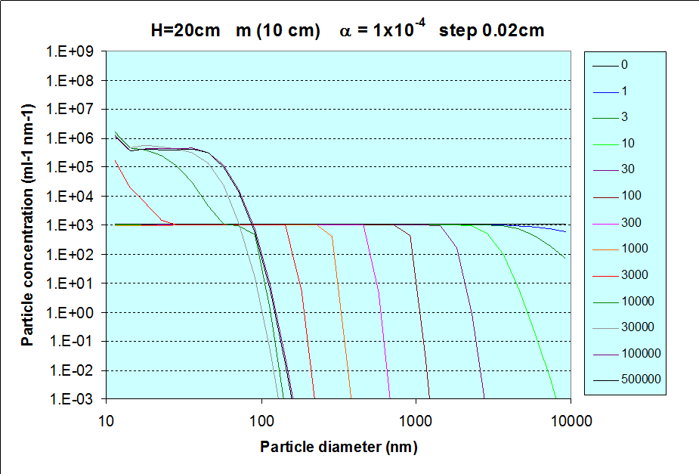

Fig. 6: Evaluation of the colloid concentration as a function of time and for given attachment coefficients. Note the decrease of colloid concentration at pseudo-equilibrium as a function of α. Bentonite-water surface free energy data from (Janczuc et al., 1990).
Legend: generation, aggregation, sedimentation.

5. Discussion on the field, laboratory and model data

The values of attachment factor (α) for clay colloids in these groundwaters are estimated in Table 5 together with the normalized colloid concentrations N_{(100nm)} (ml⁻¹ nm⁻¹) for the size of 100 nm as measured from batch and as estimated from model calculations. Presently, the concentration size distributions of the colloids in the domain 10-100 (modeling) and 50-100 nm (experimental) are rather flat and it makes sense to assume a size independent normalised concentration. It is also clear that the concentration of clay colloids (e.g. 100 nm) decreases when the ionic strength increases. This is due to the increase of the attachment factor.

All the colloid concentration (normalized or not) results for 100 nm converge to the same statement:
● in the field study the colloid concentration for >100 nm ranges
from 10⁹ (hydrothermal) to 10^{7.5} (non-hydrothermal) (for pAlk > 3 and pAlE > 4) to 10⁵ ml⁻¹ (for pAlk ~2 and pAlE ~ 3) see Fig. 1,
● in the laboratory study (batch) the normalized concentration ranges
from 10⁷ (for pAlk ~3) to 10⁵ ml⁻¹ nm⁻¹ (for pAlk ~1) see Fig.4,
● the modeling result for the normalized concentration passes
from 10⁷ (for α = 10⁶ corresponding to pAlk ~3) to 10⁵ ml⁻¹ nm⁻¹ (for a =10⁴ corresponding to pAlk ~2) see Fig.6.

Table 5: Groundwater colloid main parameters and concentration.
Conditions: Modeled N values with _{col} = 1.2 g cm⁻³. Extrapolated data (10^{x}).
pAlk | Measured N_{(100nm)}  (ml⁻¹ nm⁻¹) | Modeled N_{(100nm)}  (ml⁻¹ nm⁻¹) | α  (-)
3 | 10⁷ | 10⁷ | 10⁻⁶
2 | 10⁶ | 10⁵ | 10⁻³
1 | 10⁵ | (10⁴) | 10⁻¹
0 | (10⁴) | (10³) | 10⁻⁰

Clearly, what ever the approach is: field measurements, laboratory tests or model calculations, there is a convergence of properties: the colloid concentration for the given size, i.e. 100 nm, decreases when the salinity of the water increases.

6. Colloid properties in the studied sedimentary rock pore waters

In view of long term safety of a geological repository for radioactive waste, the concentration and stability of colloids may play an important role in the migration of radionuclides in host rocks in which water-conducting features may be present. Obtaining an understanding of these colloid properties in undisturbed pore water is however a challenging task. Therefore, modelling efforts are crucial to gain an insight in these properties and evaluate the impact of colloids on the migration of radionuclides through the host rock.
The pore water chemistry of the potential host rocks (Opalinus Clay, Effingen Member, “Brauner Dogger” and Helvetic Marls) has been studied in detail (Degueldre et al. 2003, Pearson et al. 2003, Mäder 2010, Mäder 2009a, Mäder 2009b) and is summarized in Table 6. The porewaters exhibit Na⁺ concentration ranging from ~0.2 to 0.7 M (pAlk 1-0) (seeTable 1C). The Ca²⁺ concentrations range from 0.01 to 0.1 M (pAlE 2-1). In these waters K⁺ concentration is lower than that of Na⁺ and does not play a significant role, however, Mg²⁺ concentration is comparable to that of Ca²⁺, which may also contribute significantly to the attachment of the colloids (see Fig.2). Because of its marine origine, the ionic strength of the host rock porewaters (ranging between 0.2 mol.kg⁻¹ H₂O for Helvetic Marls to 0.76 mol.kg⁻¹ H₂O for Opalinus Clay) is very similar to that of sea water (0.7 mol.kg⁻¹ H₂O) (Cloet et al. 2014).

For the salinity of the pore water expected in the potential host rocks, the order of magnitude of the normalized groundwater colloid concentration would be around 10⁴ to 10³ ml⁻¹ nm⁻¹. It must be noted that since the size distribution is flat between 10 to 100 nm (model data) and 50 to 100 nm (experimental data) the concentration in this size class may be easily estimated. The colloid mass concentrations [col] (ppb) for sizes going from 10 to 100 nm for the potential host rocks were calculated (using Eq. 3) and are given in Table 6.

Table 6: Groundwater colloid main parameters in the potential host rocks
Conditions: [Col]₁₀¹⁰⁰ colloid concentration for sizes ranging from 10 to 100 nm
Water | Sea water | Effinger Member | “Brauner Dogger” | Helvetic Marl | Opalinus Clay
Type | Na-Cl | Na-Cl | Na-Cl | Na-Cl | Na-Cl
pH (-) | 8 | 6.8-7.3 | 7.2 | 7.5 | 7.2
pAlk | 0.2 | 0.3 | 0.7 | 0.7 | 0.7
α (−) | 10⁰-10⁻¹ | 10⁰-10⁻¹ | 10⁻¹ | 10⁻¹ | 10⁻¹
N_{(100nm)} (ml⁻¹nm⁻¹) | - | ≤10³-10⁴ | ≤10⁴-10⁵ | ≤10⁴-10⁵ | ≤10⁴-10⁵
N_{(>100nm)} (ml⁻¹) | - | ≤10⁵ | ≤5x10⁵ | ≤5x10⁵ | ≤5x10⁵
[col]₁₀¹⁰⁰ (ppb) | - | ≤0.1 | ≤0.5 | ≤0.5 | ≤0.5

It must be noted that the colloid concentrations given in Table 6 are conservative and that the rather large Ca concentration in the groundwater increases the attachment factor which in turn reduces the colloid concentration in the pore water of the potential host rocks.

Given the hydrogeochemistry of the host rock porewaters and the presented studies on colloid properties, colloid stability in the porewaters is considered to be low. The high salinity and the low concentration of organic matter in the sedimentary rocks both provide chemical conditions that limit colloid stability (see section 2.2 and section 3). Despite the fact that clay colloids can be formed even without a flow field (see section 3.2.2) and fractures in the “Effingen Member” formation can not be excluded, the pore size in the sedimentary host rocks is small and the pore connectivity is low, thus providing an excellent physical filter for the colloids. This filter will prevent the transport of any colloids that could be formed and hence prevent migration of radionuclides attached to the colloids.

7. Conclusions
Based on the colloid data gained from various hydrogeochemical systems, from laboratory batch tests and from modeling investigations, the colloid properties in pore water from specific sedimentary rocks have been evaluated.

The hydrogeochemical systems ranged from various crystalline formations with clay filled water bearing features to argillaceous rocks. It has been shown that the groundwater colloids are made mostly of clay particles and that their concentrations decrease when salinity increases. Their concentration was found to be around 10⁵ ml⁻¹ for size of 100 nm and water salinities of 2x10⁻² M NaCl.

The generation of clay colloids from a pellet compacted in quasi-stagnant water has been studied. Experiments with colloids in batch containers indicate that the size distribution of colloidal suspensions evolve toward a common particle size distribution for both extremes of initial conditions: starting from an almost colloid-free liquid phase on top of a pellet, as well as starting from a very concentrated colloidal suspension. The size distribution and the morphology of the colloids or aggregates at pseudo-equilibrium have been studied experimentally for example using scanning transmission x-ray microscopy and a model has been developed to understand their behaviour in batches. The understanding of the generation of colloids at a clay bed / water interface under quasi-stagnant conditions is crucial in environmental science not only for the build up of the formation (sedimentology) but also for the study of the transport of contaminants in aquifers. For the more saline solution 10⁻¹ M NaCl, the colloidal concentration in batch is estimated to be around 10⁶ ml⁻¹ for size of 100 nm.

Experiments are performed together with model calculations, to investigate colloid generation and sedimentation rates taking into account mechanisms through the system in order to understand under in-situ conditions what makes properties system-size dependant. The data presented so far are compared with those of the systems studied earlier. Extrapolated for the more saline solution 10⁻¹ M NaCl, the colloid concentrations in batch are estimated to be around 1-5 x10⁵ ml⁻¹ for size of 100 nm.

Colloid mobility in the Opalinus Clay has been evaluated and colloids were found to be of minor relevance because of their extremely low concentration. In addition to Opalinus Clay, other potential host rocks have been identified for an L/ILW repository (Effingen Member, “Brauner Dogger”, and Helvetic Marls). In contrast to the homogeneous Opalinus Clay, some of these host rocks might form fracture systems where hydraulic flow governs fluid transport. However, the model presented in this work suggests that the clay colloid concentration is expected to be very low (<5x10⁵ ml⁻¹ for 100 nm or [col] < 1 μg l⁻¹, extrapolated to size from 10 to 100 nm) which also restricts their impact on radionuclide transport.

References
Berend I, Cases J.M, Francois M, Uriot J.P, Michot L, Masion A, Thomas F, Mechanism of adsorption of water, Clays Clay Miner. 1995; 43: 324–336.
Bessho K, Degueldre C, Generation and sedimentation of colloidal bentonite particles in water Appl. Clay Sci.. 2009; 43: 253-259.
Cloet V., Schwyn B., Baeyens B., Curti E., Diomidis N., Johnson L.H., Leupin O.X., Mibus J., van Loon L., Wieland E. Einfluss der Salinität des Porenwassers der Wirtgesteine auf die Langzeitsicherheit der Tiefenlager. Nagra Working Report. 2014; NAB 14-09, Nagra, Wettingen, Switzerland
Degueldre C., Pfeiffer H.-R., Alexander W., Wernli B., Bruetsch R. Colloid properties in granitic groundwater systems. I: Sampling and characterisation, Appl. Geochem. 1996; 11: 677-695.
Degueldre C, Groundwater colloid properties and their potential influence on radionuclide transport. Mat. Res. Soc. Symp. Proc., 1997; 465: 835-846. Material Research Society, Pittsburg, PN.
Degueldre C, Scholtis A, Pearson F.J, Laube A, Gomez P, Effect of sampling conditions on colloid and ground water chemistry, Ecologae geol. Helv. 1999; 92: 105-114.
Degueldre C, Triay I., Kim J.I, Vilks P, Laaksoharju M, Miekeley N, Groundwater colloid properties: a global approach, Appl. Geochem., 2000; 15: 1043-1051.
Degueldre C, Scholtis A, Laube A, Turrero M.J, Thomas B, Study of the pore water chemistry through an argillaceous formation: a paleohydrochemical approach, Appl. Geochem., 2003; 18: 55-73.
Degueldre C, Raabe J, Wold S, Investigations of clay colloid aggregates by scanning transmission x-ray microspectroscopy in their suspension, Appl. Geochem., 2009a; 24: 2015-2018.
Degueldre C, Kastoriano M, Kunze P, Bessho K, Colloid generation/elimination dynamic processes: toward pseudo-equilibrium? Coll. Surf. A, 2009b; 337: 117-126.
Dörfer H.D. Grenzflächen und colloid-disperse Systeme: Physik und Chemie, Springer, 2002.

Ekdawi N, Hunter R.J, Sedimentation of disperse and coagulated suspensions at high particle concentrations Coll. Surf., 1985; 15: 147-159.
García-García S, Degueldre C, Wold S, Frick S, Determining pseudo-equilibrium of montmorillonite colloids in generation and sedimentation experiments as a function of ionic strength, cationic form, and elevation J. Coll. Interf. Sci., 2009; 335: 54-61.
Gonzalez Sanchez F, Van Loon L.R, Gimmi T, Jakob A, Glaus M.A, Self-diffusion of water and its dependence on temperature and ionic strength in highly compacted montmorillonite, illite and kaolinite, Appl.Geochem. 2008; 23: 3840–3851.
Guyer J., Wheeler D., Warren J., FiPy: Partial Differential Equations with Python. Computing in Science and Engineering. 2009; 11: 6-15.
Holmes D, Pitty A, Noy D. Geomorphological and hydrogeological features of the Poços de Caldas caldera, and the Osamu Utsumi mine and the Morro do Ferro analogue study sites, Brazil. Nagra, Technical Report NTB-90-23, Wettingen, Switzerland, 1991.
Israelachvili J.N, Intermolecular and surface forces, 2nd editions Academic Press, London 1992.
Janczuc B, Chibowski E, Bialopiotrowick T, The surface free energy components of homoion1c bentonite from contact angle measurements, Mater. Chem. Phys. 1990; 26: 375-394.
Karnland O, Olsson S, Nilsson U, Mineralogy and sealing properties of various bentonites and smectite-rich clay materials, SKB Technical Report, TR-06-30, 2006.
Kim J, Zeh P, Delakovitz B, Chemical interactions of actinide ions with groundwater colloids in Gorleben aquifer systems. Radiochim. Acta, 1992; 58/59: 147-154 .
Kretzschmar R, Borkovec M, Grolimund D, Elimelech M, Mobile Subsurface Colloids and Their Role in Contaminant Transport, Ad., Agronomy, 1999; 66: 121-193

Laaksoharju M, Degueldre C, Skårman C. Study of colloids and their importance for repository performance assessment. SKB Technical Report 95-24, Stockholm, 1995.

Levy S, Natural gels in the Yucca Mountain Area, Nevada, USA. Appl. Clay Sci. 1992; 7: 79-85.

Longworth G, Cross C, Degueldre C, Ivanovich M, Interlaboratory study of sampling and characterisation techniques for groundwater colloids. Harwell Laboratory Report AERE R 1989; 13393, Harwell, UK.

Mäder U, Reference pore water for the Effinger Member (Standortregion Südjura) for the provisional safety analysis in the frame of the sectoral plan. Nagra Working Report, NAB 09-13, 2009a

Mäder U, Reference pore water for the Opalinus Clay and “Brown Dogger” for the provisional safety-analysis in the framework of the sectoral plan- interim results (SGT-ZE). Nagra Working Report NAB 09-14, 2009b.

Mäder U, Reference pore water for the Helvetic Marls for the provisional safety analysis in the frame of the sectoral plan. Nagra Working Report, NAB 09-15, 2010

C.M. Marquardt, A. Seibert, R. Artinger, M.A. Denecke, B. Kuczewski, D. Schild, T. Fanghänel; The redox behaviour of plutonium in humic rich groundwater, Radiochim. Acta, 92 (2004) 617–623

Mazurek M, Waber H.N, Mäder U.K, Gimmi T, De Haller A, Koroleva M. Geochemical synthesis for the Effingen Member in boreholes at Oftringen, Gösgen and Küttigen. Nagra Technical Report NTB, 2012; 12-07.

Nagra, SGT Etappe 2: Vorschlag weiter zu untersuchender geologischer Standortgebiete mit zugehörigen Standortarealen für die Oberflächenanlage; Geologische Grundlagen; Dossier VI Barriereneigenschaften der Wirt- und Rahmengesteine. Nagra Technical Report NTB, 2014; 14-02.
McCarthy J, Degueldre C, Colloidal particles in groundwater and their role in the subsurface transport of contaminants. In IUPAC series: Environmental Particle, 1993; 2: 247-315.

Missana T, Alonso U, Turrero M.J, Generation and stability of bentonite colloids at the bentonite/granite interface of a deep geological radioactive waste repository, J. Contam. Hydrol. 2003; 61: 17–31.
Miekeley N, Counthinho de Jesus H, Porto da Silveira C, Degueldre C, Chemical and physical characterisation of suspended particles and colloids in waters from the Osamu Utsumi mine and Morro do Ferro analogue study sites, Poços de Caldas. J. Geochem. Explor. 1992; 45: 409-437

Pearson F.J, Arcos D, Bath A, Boisson J.Y, Fernández A.M, Gaebler H.E, Gaucher E.C, Gautschi A, Griffault L, Hernan P, Waber H.N. Geochemistry of water in the Opalinus Clay formation at the Mont Terri Rock Laboratory – Synthesis Report. Reports of the Federal Office of Water and Geology (FOWG), Geology Series 2003; 5.

Peterson K, Arlinger J, Bruetsch R, Degueldre C, Hallbeck L, Laaksoharju M, Lutz T, Pederson C, Bacteria, colloids and organic carbon in groundwater at the Bangombé site in the Oklo area. SKB Technical Report 1996; 96-01, Stockholm.

Pfeifer H.R, Sanchez A, Degueldre C, Thermal spring in granitic rocks from the Grimsel Pass (Swiss Alps) the late stage of a hydrothermal system related to Alpine orogeny. Water Rock Interaction, Kharaka & Maes (Eds) Balkema, Rotherdam, 1992; 1327-1331.

Quirk J.P, Interparticle Forces: A Basis for the Interpretation of Soil Physical Behavior, Adv. Agron. 1994; 53: 121–183.
Vilks P, Miller H, Doern D, Natural colloids and suspended particles in Whiteshell Research Area, Manitoba, Canada, and their potential effect on radiocolloid formation. Appl. Geochem. 1991; 6: 553-574.

Vilks P, Cramer J, Bashinski D, Doern D, Miller H, Studies of colloids and suspended particles, Cigar Lake uranium deposit, Saskatchewan, Canada. Appl. Geochem. 1993; 8:605-616.
Voegelin A, Kretzschmar R, Stability and mobility of colloids in Opalinus Clay, NAGRA NTB 2002; 02-14.

von Smoluchowski M, Versuch einer Mathematischen Theorie der Koagulationskinetik Kolloider Lösungen, Zeit. Physical. Chem., 1917; 92: 129-168.
Watson A.D, Barker G.C, Robins M.M, Sedimentation in bidisperse and polydisperse colloids, J. Coll. Interf. Sci., 2005; 286: 176-186

Corresponding author: claude.degueldre@psi.ch; Ph: +41 56 310 4176

