Reversing the Polarity with Emoticons

Phoey Lee Teh¹, Paul Rayson², Irina Pak¹, Scott Piao², Seow Mei Yeng¹
¹Department of Computing and Information Systems, Sunway University, Bandar Sunway, Malaysia
phoeyleet@sunway.edu.my, (ipak1992, stephaniee29s)@gmail.com,
² School of Computing and Communications,
Lancaster University, UK

(p.rayson, s.piao)@lancaster.ac.uk

Abstract. Technology advancement in social media software allows users to include elements of visual communication in textual settings. Emoticons are widely used as visual representations of emotion and body expressions. However, the assignment of values to the “emoticons” in current sentiment analysis tools is still at a very early stage. This paper presents our experiments in which we study the impact of positive and negative emoticons on the classifications by fifteen different sentiment tools. The “smiley” :) and the “sad” emoticon :( and raw-text are compared to verify the degrees of sentiment polarity levels. Questionnaires were used to collect human ratings of the positive and negative values of a set of sample comments that end with these emoticons. Our results show that emoticons used in sentences are able to reverse the polarity of their true sentiment values.
Keywords: Sentiment, Emoticon, Polarity, Emotion, Social Media

- Introduction
An emoticon is a symbol which includes “emotion” and “icon” [1]. Mobile and online text messaging platforms often include emoticons. It also known as “Emoji” or “Facemarks”. In this paper, we study the effect of positive and negative emoticons by testing fifteen different sentiment tools in order to investigate the impact of the emoticons on the sentiment classification of the short messages by different sentiment analysis tools. In addition, we simulated 30 comments, similar to the comparison of sentiment tools, with each simulated comment containing “smiley” ☺, “sad” emoticon ☹, and without emoticon. We collected the opinion of “like” and “dislike” values for different variations of text in order to examine the impact of emoticon on the polarity of the text. Overall, our evaluation results show that emoticons are able to reverse polarity of the sentiment values.
- Related Work
There have been some publications studying the behavioral usage of emoticons in text messaging, social media and the art of communication from social workplace. For example, Zhang et al. [2] stated that emoticons are strongly associated with subjectivity and sentiment, and they are increasingly used to directly express a user’s feelings, emotions and moods in microblog platforms. Yamamoto [3] verified the multidimensional sentiment of tweet messages by examining the role of the emoticon. Derks et al. [4] observed 150 secondary school students and studied the frequency of emoticons used to represent non-verbal face-to-face expressions. Ted et al. [5] studied the effect of emotions on emotional interpretation of messages in the workplace. Garrison et al. [6] studied the emoticons used in instant messaging. Tossell et al. [7] studied the emoticons used in text messaging sent from smart phones, particularly focusing on the gender difference in using emoticons. Another study by Reyes and Rosso [8] stated that emoticons are one of the features which are related to identifying irony within text.
- Data and Experiment
In our earlier study [9] we showed that sentiment tools should consider the number of exclamation marks when detecting sentiment. In that study, we tested different numbers of exclamation marks, and our experiment showed that different numbers of exclamation marks have an impact on sentiment value of the text. We further argued that emoticons have a significant value for identifying the sentiment of comments on products based on testing of fifteen existing sentiment analysis tools. In this paper, we employ a similar method to explore the fifteen sentiment tools (Table 2) for positive and negative emoticons to investigate if the scores of polarity show any difference. We recorded the scores of: 1) unformatted text (e.g: I like it), 2) comments that end with positive emoticon (e.g: I like it :-)), and 3) comments that end with negative emoticon (e.g: I like it :-(). We focus our experiment on these three types of comments, which can help to reveal the impact of the positive and negative emoticons. The impact is observed by comparing sentiment scores for three different types of comment.
Furthermore, we explore whether or not the emoticons affect the sentiment values of the comments assigned by human raters by conducting a survey. The data of comments on products used for the questionnaire survey were collected from online retails sites such as Ebay, Amazon and Lazada. Altogether, our corpus consisted of 1,041 raw comments were collected covering 10 different types of products, including 1) Beauty and Health, 2) Camera, 3) Computer, 4) Consumer Electronics, 5) Fashion, 6) Home appliance, 7) Jewellery and Watch, 8) Mobiles and Tables, 9) Sport goods, and 10) Toys and Kids. All of the collected comments were analyzed with Lancaster University UCREL’s Wmatrix system to identify the emotional words that have the high frequencies of occurrence. Based on this, we manually categorized and extracted emotional words. Next, we designed the questionnaire with these 30 comments, using a 7- point Likert-type scale, where we repeated the questions to each of the listed comments. We collected the opinions of “like” and “dislike” values for different variations of text, employing similar approach to that which we used in comparing the sentiment tools. For example, three variants of the comment “I love it” were generated: a) “I love it”, b) “I love it☺”, and c) “I love it☹”, then respondents were asked to express their opinions at the levels of “like” and “dislike” about them. As a result, we collected rating data from 500 respondents. Figure 1 presents the fifteen strongest positive and negative comments with emotional words.
- Evaluation Results
The human rating data of the sentiment of comments of the 500 respondents were computed and analysed. Seven-point scale is used for both positive and negative comments, in which the mid-point of 4 represents neutral sentiment.
Figure 1 illustrates the mean scores with a chart. The four grey lines in the chart, denoted by M1, M2, M3 and M4, represent respectively the positive texts with positive emoticon, positive texts with negative emoticon, negative texts with positive emoticon, and negative texts with negative emoticon (see Table 1). Those comments on the X-axis are those simulated with both positive and negative emotions at the end of the messages that were given to the 500 respondents to assign sentiment values on the “like” and “dislike” scale.
With the neutral line N (see the red line) of the sentiment scale point 4 as the benchmark, the M1 line indicates that the mean sentiment rating scores of all the comments fall under the range of “slightly like” to “like” scales (corresponding to the numerical range of 4.22 – 5.24 points). In contrast, the whole M2 line falls below the neutral line N towards the “dislike” scale. This is an interesting and unexpected result, because M2 consists of positive texts but some of them have manual sentiment ratings that are even lower than the line M3 which consists of negative texts. On the other hand, line M3 appears as the second top level (although below line N) for many comments in the range of 3.2 to 5.11 sentiment scale points. For instance, the message “I hate it” ending with a smiley has a score of 3.2 and “I can afford it” ending with smiley has a score of 5.11. We categorize line M3 as “sarcastic” line since it mixes negative comments with the positive emoticon.

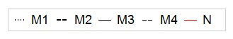
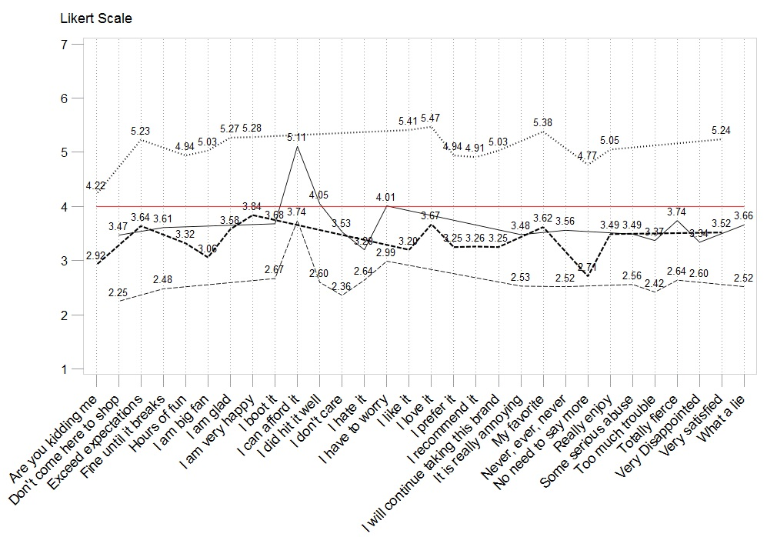
Fig. 1. Like and Dislike scores for positive and negative comments that end with emoticons
Table 1. Description of the lines
Line | Comment Polarity | Emoticon Used
M1 | Positive | Positive
M2 | Positive | Negative
M3 | Negative | Positive
M4 | Negative | Negative

With respect to lines M3 and M4 in Figure 1, which illustrate the negative comments, emoticons seem to reduce the overall values of “like” and “dislike” from range 2.3 – 5.11 to 2.36 – 3.74. Here again, changing emoticons appears to significantly affect the overall sentiment value of expressions. Overall, line M3 shows that negative comments with positive emoticons appear to have a higher positive overall rating compared to the positive comments with negative emoticons (line M2). Our observation leads to the following tentative conclusions:
- Negative emoticons can have an important impact on the overall sentiment of the positive comments and can potentially alter the sentiment.
- Various types of emoticons form an important factor that should be considered by the sentiment analysis tools.
We extracted scores for an example phrase “I like it” from fifteen freely available online sentiment analysis tools, as shown by Table 2. Our checking of the results shows that 9 out of the 15 tools include the value of expression of emoticons in their sentiment polarity classification process, which affects the positive or negative sentiments of the comments compared to the original text-only messages without smileys. For example, in our experiment Twitter Sentiment Analyzer, Lexalytics, Sentiment Analysis Engine, Sentiment Search Engine etc. produced negative sentiment scores for this message. These results also support our claim regarding the importance of emoticons for sentiment analysis. It is interesting that both Sentiment Analysis Engine and Sentiment Search Engine classified the message “I like it :-(” as totally negative when a negative emoticon was used. It shows that most of the sentiment tools included in our study consider emoticons as a relevant factor when determining the sentiment polarity of the text. However, they appear not to take account of the positive/negative interactions between text and emoticons, which we have highlighted in this study.
Table 2. Comparison of results of fifteen sentiment analysis tools.
Tools | Website | Score for “I like it :-)” | Score for “I like it :-(” | Score for “I like it”
Twitter Sentiment Analyzer | http://textsentiment.com/twitter-sentiment-analyzer | 0.705762 | 0.648023 | 0.565229
Lexalytics | https://www.lexalytics.com/demo | +0.5 | -0.75 | 0
Sentiment Analysis with Python NLTK Text Classification | http://text-processing.com/demo/sentiment/ | Pos: 0.6  Neg: 0.4  Overall: Positive | Pos: 0.4  Neg: 0.6  Overall: Negative | Pos: 0.5  Neg: 0.5  Overall:Positive
Sentiment Analysis Engine | http://www.sentimentanalysisonline.com/ | Very Good  1 | Very Bad  -1 | Neutral  0
Sentiment Analysis Opinion mining | http://text2data.org/Demo | Positive 0.178 | Positive 0.099 | Positive 0.167
Sentiment Search Engine | http://werfamous.com/ | 0.39 | -0.42 | 0.08
Text sentiment analyzer | http://werfamous.com/sentimentanalyzer/ | +50% | -75% | 0%
Meaning cloud | http://www.meaningcloud.com/ | Positive  100% | Positive  90% | Positive  100%
Tweenator Sentiment Detection | http://tweenator.com/index.php?page_id=2 | Positive  88.3% | Positive  33.57% | Positive  75.65%
LIWC | http://liwc.wpengine.com/ | Positive  33.3 | Positive  33.3 | Positive  33.3
SentiStrenght | http://sentistrength.wlv.ac.uk/ | Positive 2  Negative -1 | Positive 2  Negative -1 | Positive 2  Negative -1
TheySay | http://apidemo.theysay.io/ | Positive  72.70% | Positive  72.70% | Positive  72.70%
Selasdia Intelligent Sales Assistant | http://get.sendible.com/sendiblemonitoring/?gclid=CK6wm-27gcsCFZEK0wodDyoM5w | Positive | Positive | Positive
Sentiment Analyzer | http://sentimentanalyzer.appspot.com/ | +100% | +100% | +100%
EmoLib | http://dtminredis.housing.salle.url.edu:8080/EmoLib/en/ | Positive | Positive | Positive
- Conclusion
This study investigates the issue of the inconsistency of the sentiment value of messages and comments with respect to the positive and negative emotions. Using human raters, we have verified that the emoticons play a major role that can affect the overall sentiment value of a social media message or online review comment. Furthermore, our experiment reveals that most of the current sentiment tools that consider emoticons in their sentiment polarity classifications do not consider the interaction between conflicting positive/negative sentiment values of textual contents and emoticons when assessing the overall sentiment. In light of our experimental results, we propose that current sentiment tools should be improved by considering all these factors in their classification algorithms.
- Bibliographical References
- Kim, J., & Lee, M. (2015). Pictogram Generator from Korean Sentences using Emoticon and Saliency Map. In HAI ’15 Proc. of the 3rd International Conf. on Human-Agent Interaction (pp. 259–262). ACM New York, NY, USA ©2015.
- Zhang, L., Pei, S., Deng, L., Han, Y., Zhao, J., & Hong, F. (2013). Microblog sentiment analysis based on emoticon networks model. In Proc. of the Fifth International Conf. on Internet Multimedia Computing and Service - ICIMCS ’13 (pp. 134–138). ACM New York, NY, USA ©2013.
- Yamamoto, Y. (2013). Role of Emoticons for Multidimensional Sentiment Analysis of Twitter. In The 14th IIWAS. (pp. 107–115). ACM New York, NY, USA ©2014.
- Derks, D., Bos, A. E. R., & Grumbkow, J. Von. (2007). Emoticons and social interaction on the Internet: the importance of social context. Computers in Human Behavior, 23(1), 842–849.
- Ted, T., Wu, L., Lu, H., & Tao, Y. (2010). Computers in Human Behavior The effect of emoticons in simplex and complex task-oriented communication : An empirical study of instant messaging. Computers in Human Behavior, 26(5), 889–895.
- Garrison, A., Remley, D., Thomas, P., & Wierszewski, E. (2011). Conventional Faces: Emoticons in Instant Messaging Discourse. Computers and Composition, 28(2), 112–125.
- Tossell, C. C., Kortum, P., Shepard, C., Barg-Walkow, L. H., Rahmati, A., & Zhong, L. (2012). A longitudinal study of emoticon use in text messaging from smartphones. Computers in Human Behavior, 28(2), 659–663.
- Reyes, A., & Rosso, P. (2013). On the difficulty of automatically detecting irony: beyond a simple case of negation. Knowledge and Information Systems, 1–20.
- Teh, P. L., Rayson, P., Piao, S., & Pak, I. (2015). Sentiment Analysis Tools Should Take Account of the Number of Exclamation Marks !!! In The 17th IIWAS. (pp. 4–9). ACM New York, NY, USA ©2015.

