2-D Particle-in-Cell Simulations of High Efficiency Klystrons

David A. Constable, Chris Lingwood & Graeme Burt
Engineering Department
Lancaster University
Lancaster, United Kingdom, LA2 0RH

Igor Syratchev
CERN
Geneva, CH-1211, Switzerland

Rodolphe Marchesin
Thales Electron Devices
Velizy-Villacoublay, 78141 France

Andrey Yu. Baikov
Moscow University of Finance and Law
Moscow, 113447, Russia

Richard Kowalczyk
L-3 Communications Electron Devices
San Carlos, CA 94070, USA

Abstract: Currently, klystrons employing monotonic bunching offer efficiencies on the order of 70%. Through the use of the core oscillation electron bunching mechanism, numerical simulations have predicted klystrons with efficiencies up to 90%. In this paper, we present PIC simulations of such geometries operating at a frequency of 800 MHz, with efficiencies up to 83% predicted thus far.

Keywords: klystron; high-efficiency; Magic2-D; KlypWin; TESLA; KLYS-2D; core oscillation.

Introduction
Proposed large scale particle accelerators, such as the Compact Linear Collider (CLIC) [1] and the Future Circular Collider (FCC) [2], are expected to require RF drives on the order of 20-100 MW. In comparison, the Large Hadron Collider (LHC) [3], has a total RF drive of approximately 5 MW. Given the order of magnitude increase, the efficiency of the RF sources should be maximized, in order to reduce their operating costs.

Klystrons are an attractive candidate for the RF drive in particle accelerators, with tubes operating at a frequency of 1 GHz providing MW level output power. Currently available devices have maximum efficiencies of approximately 70%. In terms of efficiency, the limiting factor with a klystron lies with the shape of the electron bunch as it arrives at the output cavity, and the velocity of the slowest electron leaving the cavity gap. To ensure that the efficiency is maximized, the spatial and phase profile of the bunch should be such that after being decelerated by the final cavity, each particle in the bunch should have the same velocity.

A proposed mechanism of attaining such a bunch is through the Core Oscillation Method (COM) [4,5]. In a traditional klystron, electrons are monotonically moved to the centre of the bunch along the length of the device. This leads to outliers in the bunch which have experienced a smaller kick from the cavity fields, focusing them well after the core of the bunch. Therefore, not all particles are contained within the bunch, and thus, do not contribute positively to the output signal. The core oscillation method allows for the slower bunching of the outliers by deferring the bunching at the core by allowing the core (centre) to de-bunch between successive cavities. This behavior can be observed in Figure 1, which shows electron trajectories modelled in KlypWin for an eight cavity klystron. The de-bunching of the core can be seen between cavities, as a contraction and expansion of the bunch. While the core oscillation method results in klystrons of increased physical length, their efficiencies are predicted to approach 90% [4,5].

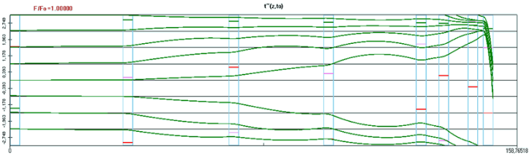
Figure 1. Illustration of the core oscillation mechanism, in an eight cavity klystron, predicted by KlypWin.

A multi-beam klystron (MBK) employing core oscillations, has been proposed to meet the RF demands of FCC [6]. A summary of the operational parameters of the proposed MBK are shown in Table 1. Due to the complex azimuthal geometry of an MBK, such a tube must be simulated in 3D.

Through the use of a General Similitude Principle (GSP), an MBK can be transformed to a different klystron, with different operational parameters (length, cavity frequencies, number of beams, etc.), while preserving the beam and output characteristics of the device [6,7]. The reduced complexity allows the simulation of the klystron in a 2D PIC code.

In this paper, we present numerical simulations of 800 MHz, single beam klystrons, employ the core oscillation method, which have been transformed through the GSP method. The parameters of an MBK which has been designed in the 1-D code, KlypWin [4], and has undergone the GSP transformation (tube GSP 08-04), are given in Table 1, for comparison. Comparison between this, the 2-D codes, TESLA [8], KLYS-2D [9], and the Particle-in-Cell code, Magic2-D will be considered.

Numerical Simulation
When simulated in Magic2-D, the GSP 08-04 klystron is predicted to have an efficiency of 83%, in good agreement with KlypWin, KLYS-2D and TESLA. These initial results demonstrate the viability of COM, offering an improvement on the maximum efficiency of current state of the art, commercial multi-beam klystrons (70%), operating with similar relativistic perveance [5].

Table 1. Summary of MBK and single-beam GSP klystron parameters.

Klystron Type | MBK | GSP  08-04  Magic2-D | GSP  08-04  TESLA | GSP  08-04  KLYS-2D
No. of Cavities | 8 | 8 | 8 | 8
No. of Beams | 16 | 1 | 1 | 1
Beam  Voltage (kV) | 46.291 | 133.85 | 133.85 | 133.85
Beam  Current (A) | 36.291 (total) | 12.551 | 12.551 | 12.551
Rel.  Perveance (µK) | 0.213 | 0.213 | 0.213 | 0.213
Length (m) | 3.54 | 5.6 | 5.6 | 5.6
Input  Power (W) | 5 | 6.5 | 6.3 | 7
Output  Power (MW) | 1.46 | 1.39 | 1.35 | 1.34
Efficiency  (%) | 86.8 | 82.7 | 80.4 | 80.7

For the GSP 08-04 klystron, no reflected electrons are predicted by the three codes, indicating the stability of this tube. Figure 2 shows momentum and position phase-space plots of the electron bunches around the final two cavities of the GSP 08-04 tube, with the gaps of the cavities visible, along with the spent beam. Here, the momentum of the bunch at the final cavity is seen to drop close to 0, while maintaining a slab-like RZ distribution.

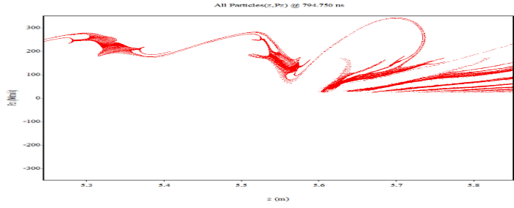
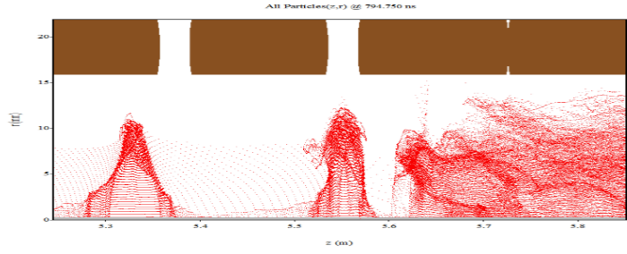
Figure 2. Region around the seventh and eighth cavities of the GSP 08-04 klystron, with a) momentum, and b) position phase-space plots, from Magic2-D.
Figure 3 depicts the modulation current (the ratio of the current at the radial plane and the total beam current) of along the length of the 08-04 tube. The maximum occurs at a ratio of ~1.80 at the final cavity, indicating that most of the available electrons are contained within the bunch approaching the final cavity, as confirmed by Figure 2c.

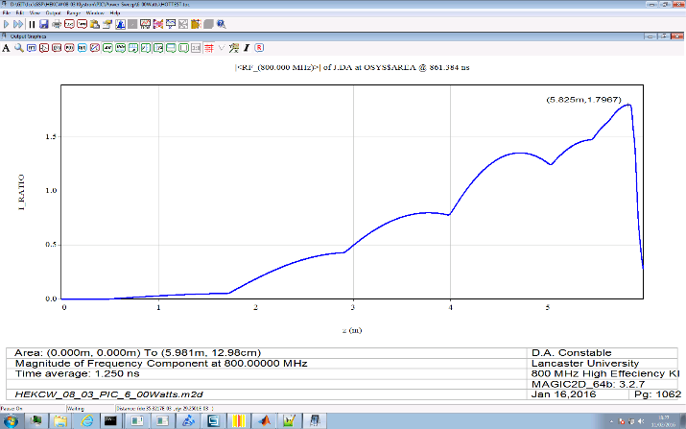
Figure 3. Current ratio along the length of the GSP 08-04 klystron, from Magic2-D.

Summary
PIC simulations of single-beam klystrons utilizing the core oscillation bunching method are encouraging thus far, predicting stable efficiencies of up to 83%. This illustrates the potential of COM, offering an increase in efficiency in comparison to commercial klystrons. Our current research focus is on refining current geometries and examining new configurations to further increase their efficiency, while mitigating the issue of reflected electrons, with an eye to eventually move to full 3-D simulations of the MBK.

References
- Aicheler, M., et al., “A Multi-TeV linear collider based on CLIC technology: CLIC Conceptual Design Report,” CERN-2012-007, 2012.
- Koratzinos, M., “FCC-ee accelerator parameters, performance and limitations,” 37th Conference on High Energy Physics (ICHEP), Valencia, 2014.
- Ciapala, E., et al., “Commissioning of the 400 MHz LHC RF system,” 11th European Particle Accelerator Conference (EPAC), Genoa, Italy, 2008.
- Baikov, A. Yu., et al., “Simulations of conditions for the maximial efficiency of decimeter-wave klystrons”, Technical Physics, 59(3), pp. 421-427, 2014.
- Baikov, A. Yu., et al., “Toward high-power klystrons with RF power conversion efficiencies on the order of 90%”, IEEE. Trans. Elec. Dev., 62(10), pp. 3406-3412, 2015.
- Syratchev, I., “High-efficiency klystron development”, International Workshop on Breakdown Science and High Gradient Technology, Beijing, China, 2015.
- Baikov, A., private communication.
- Cooke, S. J., et al., “Validation of the Large-Signal Klystron Simulation Code TESLA”, IEEE. Trans. Plasma Sci., 32(3), pp. 1136-1146, 2004.
- Marchesin, R., private communication.

