Corrosion Behaviour of AGR SIMFUELS

Nadya Rauff-Nisthar ¹, Colin Boxall ^{1*}, David Hambley ², Zoltan Hiezl ³, William Edward Lee³, Cristiano Padovani ⁴ and Richard Wilbraham ¹

¹ Engineering Department, Lancaster University, Lancaster LA1 4YR, UK,
² National Nuclear Laboratory, Central Laboratory, Sellafield, Seascale, Cumbria CA20 1PG, UK
³ Department of Materials, Imperial College London, London SW7 2BP, UK,
⁴ Radioactive Waste Management Ltd., Curie Avenue, Harwell, Didcot OX11 0RH, UK

Pure UO₂ pellets and, for the first time, AGR SIMFUEL pellets simulating 25 (pellet interior) and 43 GWd/tU burn-up (rim structure) have been fabricated. Using combined electrochemical and Raman spectroscopic studies, we have investigated the effect of the AGR SIMFUEL dopants on the structure of the UO₂ crystal matrix and studied the effect of H₂O₂ on the SIMFUEL surface as a simulant for the effect of α radiolysis of water within intruding groundwater in the near field. Preliminary results of electrochemical studies of AGR SIMFUEL samples held in direct contact with the AGR fuel cladding material, 20/25/Nb stainless steel, in modified simplified groundwater (10 mmol dm⁻³ NaCl, 2 mmol dm⁻³ NaHCO₃, pH 6.8) indicate that the open circuit potential of the coupled system is (i) negative of that adopted by the isolated SIMFUEL and (ii) positive of that adopted by the isolated cladding in electrolytes of the same composition. This implies that the SIMFUEL is protected against corrosion at the expense of the steel cladding, an observation that is currently the subject of further work in our laboratories.

Introduction

The direct disposal of spent nuclear fuel into a geological repository is part of the nuclear waste policy of several mature nuclear states (USA, Sweden, Spain and Finland are prominent examples). The vast majority of this fuel is from light-water moderated reactors (LWR) and a significant amount of research has been carried out to support the direct disposal concept in terms of the physical and aqueous durability of the container, the cladding and the irradiated UO₂-based fuel.
In the UK, the majority of spent nuclear fuel (SNF) is from indigenous Advanced Gas-cooled Reactors (AGRs). AGRs, whilst using UO₂-based fuel, employ CO₂ as coolant and are graphite moderated. Further, the fuel assembly cladding is comprised of 20/25/Nb stainless steel rather than zircalloy as is the case in Pressurised Water Reactors (PWRs). Consequently, AGR fuel has unique characteristics that need to be evaluated before disposal in an expected anoxic UK geological repository.
It is expected that, at some point after repository closure, the disposal canisters within which the SNF is sealed will fail, allowing for ingress of groundwater. This may come into contact with the 20/25/Nb cladding and the spent UO₂ fuel pellets, initiating corrosion processes on either or both. At this failure point, anticipated as being many thousands of years into the future, many of the fission products will have decayed away, as will the associated ß ̸ γ radiation field, leaving an α-field derived from long-lived α-emitting actinides. Alpha radiolysis of the invading groundwater as it comes into contact with the UO₂ fuel pin will generate hydrogen peroxide as one of several end species (1).
Hydrogen peroxide concentrations in the near-field are expected to be in the region of 10 µmol dm⁻³(2). This locally oxidising environment may convert U(IV) to U(VI), so allowing U to pass into solution, with the possibility of re-precipitation of oxidized U(VI) back onto the fuel pellet surface, generating secondary mineral phases such as schoepite. The peroxide minerals studtite (UO₂)O₂(H₂O)₄ and metastudtite (UO₂)O₂(H₂O) are stable in H₂O₂-bearing environments even at low [H₂O₂]. Studtites have been found in Chernobyl lavas (3), formation possibly occurring at the expense of more common transformation phases. As such, studtite layers may form a barrier for retarding SNF corrosion and could retain radionuclides either within their structure or by surface adsorption. Whether more or less corrosion obtains in the presence of the studtites is a generic research question for all UO₂-based SNF, not just AGR SNF, which needs to be explored.
Further, the 20/25/Nb cladding of AGR fuel may also show susceptibility to near field corrosion. The direct contact of the steel to the fuel pellet surface means that these putative steel corrosion reactions may couple with processes occurring on the UO₂ surface, so altering the corrosion behaviour of both cladding and fuel pellet. To our knowledge, this coupling has been unstudied hitherto; we therefore present some preliminary results pertaining to this system – the first from an AGR SIMFUEL-20/25/Nb steel system in direct contact.

Experimental

Materials

All chemicals were of AnalaR grade or better and supplied by Sigma-Aldrich Ltd. (Gillingham, Dorset, UK). All solutions, including groundwater simulants, were prepared using doubly deionised water. Double deionised water was prepared using a Direct-Q 3 UV Millipore water purification system (Millipore, Watford, UK) to a resistivity of 18.2 MΩ.cm. Unless otherwise noted, electrolyte solutions were de-aerated by purging with high purity nitrogen (BOC, UK) before all electrochemical measurements.

UO₂ and SIMFUEL Pellets and Slices

UO₂ pellets and SIMFUEL pellets simulating 25 GWd/tU and 43 GWd/tU burn-up were fabricated at the UK National Nuclear Laboratory (Springfields, Preston, UK). SIMFUEL pellets were prepared by sintering powder precursors containing the dopant compositions given in Table I. Compositions were calculated using FISPIN nuclear inventory calculation code (developed by the National Nuclear Laboratory UK and distributed by AMEC (4)) and are representative of a fuel pellet that has aged for 100 years after removal from the reactor.

TABLE I. Compositions of AGR SIMFUEL pellets of different burn-ups
Dopant | wt% 25 GWd/tU | wt% in 43 GWd/tU
UO₂ | 95.705 | 92.748
Nd₂O₃ | 0.761 | 1.284
ZrO₂  MoO₃  RuO₂  BaCo₃  CeO₂  PdO  Rh₂O₃  La₂O₃  SrO  Y₂O₃  CsCO₃  TeO₂ | 0.793  0.614  0.512  0.328  0.297  0.195  0.080  0.156  0.081  0.095  0.311  0.073 | 1.276  1.027  0.892  0.576  0.499  0.425  0.115  0.256  0.126  0.149  0.495  0.130

As described in Hiezl et al. (5) both the UO₂ and SIMFUEL pellets were prepared by first formulating a 60 g blend of each composition. These were milled overnight with a ZrO₂ milling medium. In order to pre-compact the powder into granulates, a pressure of 75 MPa was applied. 0.2 wt. % zinc stearate was added as the binder and the material was slowly mixed for 5 minutes using a rotary mixer. The granulates were then pressed into green pellets by applying a pressure of 400 MPa using a uniaxial machine. All pellets were sintered at a heating rate of 5 °C/min to 300 °C, and then 15 °C/min to 1730 °C. The sintering time was 300 minutes which was followed by cooling, with a cooling rate of 15 °C/min until room temperature had been reached. The furnace (supplied by Cambridge Vacuum Engineering) atmosphere contained 99.5 vol% H₂ and 0.5 vol% CO₂. The finished pellets were cut into slices ranging from ~1–3 mm thick using a Struers Accutom-2 precision cut-off machine with a Struers MOD13 diamond cut-off wheel.

Raman Spectroscopy

As received sample slices were characterised before and after immersion in all electrolytes, including the groundwater simulants, by 785 nm, micro-Raman spectroscopy (Voyage System, B&W Tek, USA) using a laser power below 5 mW in order to avoid any thermal conversion of UO₂ to U₃O₈ (6). All spectra presented here are the average of 15 spectra taken from the sample in question.

Cyclic Voltammetric and Open Circuit Potential Measurements

Undoped UO₂, 25 GWd/tU and 43 GWd/tU SIMFUEL electrodes were fabricated by mounting pellet slices onto a brass head using silver loaded epoxy. This assembly was then placed in a cylindrically shaped mould and sealed in epoxy resin in order to produce a suitable working electrode. Pre-treatment of the resultant working electrode consisted of polishing using 600 grit SiC paper under water to avoid uranium dust formation.
All electrochemical studies were carried out on a Metrohm Autolab potentiostat model PGSTAT 10 using GPES control and data acquisition software. Cyclic voltammetric (CV) studies on the UO₂, 25 GWd/tU and 43 GWd/tU SIMFUEL electrodes immersed in simple 0.1 mol dm⁻³ Na₂SO₄ aqueous electrolytes and groundwater simulants were conducted at a voltage scan rate of 100 mV s⁻¹ over a potential range of -1.8 to 0.4 V. Unless stated otherwise, the starting potential was -1.8 V. A three electrode cell was employed using a platinum mesh counter with a saturated calomel electrode (SCE) as the reference electrode. Due to resistive nature of the UO₂ and SIMFUEL electrodes, IR compensation was used during voltammetric measurements.
Open circuit potential (E_{OC}) measurements on UO₂, 25 GWd/tU and 43 GWd/tU SIMFUEL electrodes immersed in 0.1 mol dm⁻³ Na₂SO₄ aqueous electrolytes and ground-water simulants were conducted over a period of 3 hours using a simple 2 electrode cell with SCE reference. Unless otherwise noted, all solutions were sparged with N₂ or Ar gas.

Results & Discussion

Figure 1 shows the results of micro-Raman spectroscopy measurements on undoped UO₂, 25 GWd/tU and 43 GWd/tU SIMFUEL. Three bands are common across all three spectra. The dominant band at 440 cm⁻¹ is associated with the fundamental U-O stretch of the cubic fluorite structure (7). Given its intensity, all spectra have been normalised with respect to this peak. The less intense, broad peak centered at 1250 cm⁻¹ is a longitudinal optical (LO) phonon band and is therefore sensitive to lattice distortions (7). A third band is observed between 470 – 600 cm⁻¹. Such a feature has been previously reported by He and Shoesmith (8) in studies of PWR SIMFUELs and is indicative of lattice distortions as a result of: (i) dopant incorporation (simulating burn-up) and their associated oxygen vacancies: and (ii) O²⁻ ion incorporation into the interstitial sites in the UO₂ fluorite matrix, forming UO_{2+x} (7). The spectra of Figure 1 reveal an increase in the intensity of the band in the range 500 – 700 cm⁻¹ indicating an increase in lattice distortion with simulated burn-up, as the UO₂ cubic fluorite lattice structure becomes more distressed and moves towards a tetragonal structure.
Figure 2 shows the results of cyclic voltammetric studies of undoped UO₂, 25 GWd/tU and 43 GWd/tU AGR SIMFUEL electrodes immersed in 0.1 mol dm⁻³ Na₂SO₄ aqueous electrolytes. Three features are common to the forward going sweep for each sample studied: a peak at ~-0.6 V vs. SCE; a second peak at ~-0.1 V vs. SCE; and the onset of a wave at ~0.3 V vs. SCE. Once again by comparison with studies on PWR SIMFUELs, these features can be attributed to, respectively: the oxidation of UO_{2+x} species at grain boundaries to a stoichiometry close to UO_{2.33}; the oxidation of the UO₂ electrode matrix involving the incorporation of O²⁻ ions into the interstitial sites in the UO₂ fluorite matrix, forming UO_{2+x}; and the oxidation of these UO_{2+x} sites to form U(VI) species such as soluble UO₂²⁺ or insoluble UO₃.yH₂O, depending upon pH (9). The current associated with all three oxidation reactions increases with dopant density, demonstrating that the anodic reactivity of these UO₂/AGR SIMFUELs increases with simulated burn-up.
In studies of PWR SIMFUELs, such non-stoichiometric sites have been shown to provide donor-acceptor U(IV)/U(V) sites which catalyse the cathodic reduction of O₂/H₂O₂ (9)(10), one of the key cathodic half reactions that may couple with anodic UO₂ oxidation to U(VI) during UO₂/fuel corrosion (12). As Figure 2 shows that these non-stoichiometric locations also increase the anodic reactivity of our SIMFUELs, it is reasonable to conclude that UO_{2+x} locations could simultaneously and preferentially support both cathodic and anodic reactions that might couple during the corrosion of AGR spent fuel i.e. they will act as localised corrosion sites. This conclusion is entirely consistent with similar conclusions made from analogous studies on LWR SIMFUELs (7).

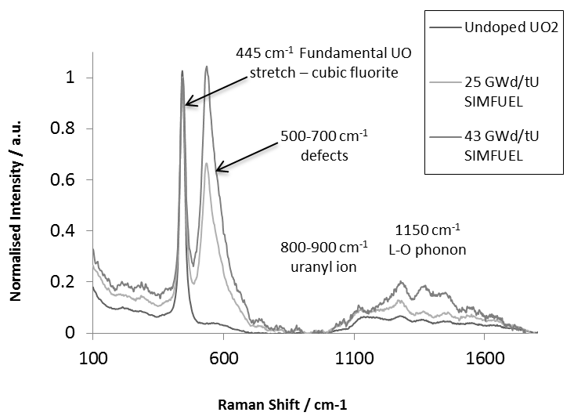

Figure 1: Effect of Fuel Burn-up on Raman Spectra

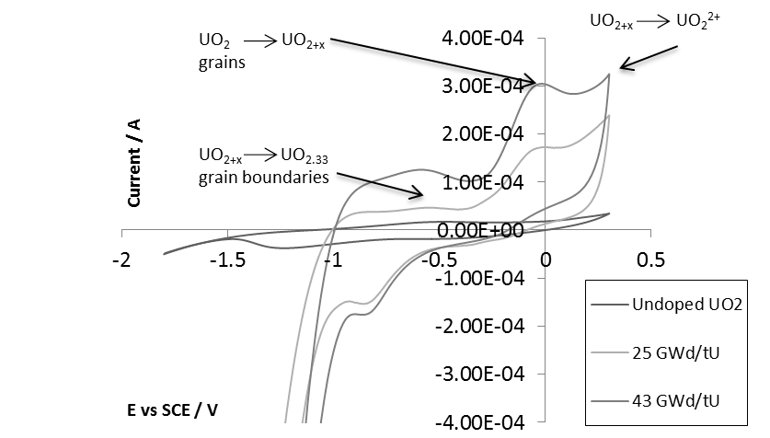

Figure 2: Cyclic Voltammetry of UO₂, 25 & 43 GWd/tU SIMFUELs, Ar sparged in 0.1 M Na₂SO₄

The height of the peak at ~-0.6 V in the CVs of 25 GWd/tU and 43 GWd/tU AGR SIMFUEL electrodes in Figure 2 suggests a significant population of these UO_{2+x} sites at grain boundaries. Again by comparison with LWR studies, this is expected and could arise due to incomplete sintering during SIMFUEL/fuel fabrication or, in the case of real AGR fuel, produced by in-reactor irradiation (7). Shoesmith et al have concluded that, for LWR spent fuel, this means that grain boundaries could corrode more rapidly than the stoichiometric grains themselves and that, consequently, radionuclides residing in grain boundaries will be instantly released on contact with groundwater (7). Based on the results of Figure 2, it seems reasonable to export this conclusion directly to AGR spent fuel; we shall return to this point below.
However, fission product release from the grains themselves may also be a problem for AGR spent fuel. The data of Figure 2 indicates that AGR SIMFUELs may be more susceptible to electrochemical oxidation than PWR SIMFUELs; in particular the peak associated with the in-grain UO₂ to UO_{2+x} oxidation (onset -0.2 V vs SCE, peak potential E_{P} = ~-0.14 V) is ~3 x larger for AGR SIMFUELs than PWR SIMFUELs of similar simulated burn-up (not shown (13)). Again, we shall return to this point below.
To study the effect on these AGR SIMFUELs of an oxidative stress derived from electrolyte composition rather than an external electrode bias applied by use of e.g. a potentiostat, extended duration Raman studies were conducted on 25 GWd/tU SIMFUELs in 1 mmol dm⁻³ H₂O₂ in O₂-free deionised water. The resulting Raman spectra, recorded in situ, are shown in part in Figure 3 and reveal that, after as little as 5 hours exposure, there is an increase in the intensity of the peak at 540 cm⁻¹, associated with the formation of defect sites in the UO₂ fluorite lattice. This spectral/structural change is then maintained for the next 1061 hours of the study, indicating that it corresponds to an equilibrium state. Supporting this conclusion, the E_{OC} reaches an equilibrium value of +0.19 V vs SCE after as little as 3 hours (not shown).
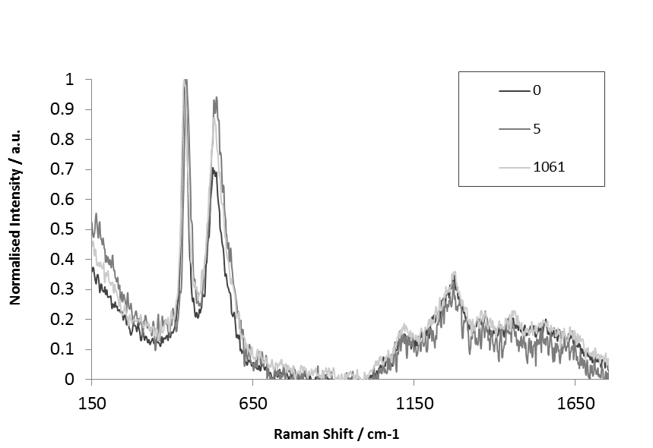

Figure 3: In situ Raman Spectroscopy of a 25 GWd/tU SIMFUEL after 0, 5 and 1061 hours exposure to anoxic solution of 1mmol dm⁻³ H₂O₂.

The CV data of Figure 2 indicate that this potential corresponds to the voltammetric wave associated with in-grain oxidation of UO₂ to UO_{2+x}, an observation consistent with the evolution of the Raman spectra of Figure 3.
Whilst illustrating broadly the effect of peroxide on these AGR SIMFUELs, the peroxide concentrations used in Figure 3 are two orders of magnitude greater than those that might be expected to be encountered in a UK geologic repository concept. Thus, Figure 4 shows open circuit potential measurements conducted in a modified simplified granitic groundwater simulant (10 mmol dm⁻³ NaCl, 2 mmol dm⁻³ NaHCO₃, pH 6.8) on both UO₂ and 43 GWd/tU SIMFUEL at [H₂O₂] from 10 μmol dm⁻³ to 1 mmol dm⁻³.

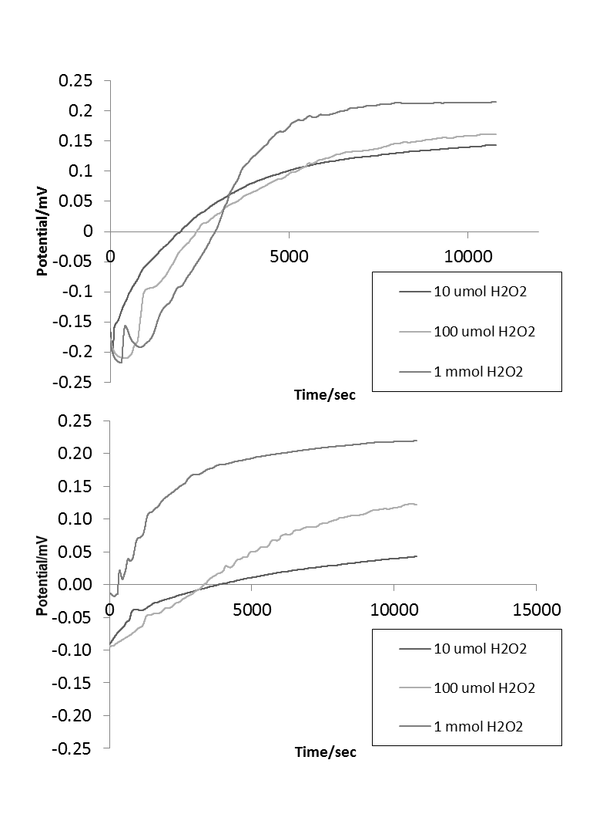

Figure 4: Open Circuit Potentials of (i) UO₂ and (ii) 43 GWd /tU SIMFUEL in anoxic modified simplified groundwater (10 mmol dm⁻³ NaCl, 2 mmol dm⁻³ NaHCO₃, pH 6.8)
The lower peroxide concentration in this range is similar to that which might be expected in an α radiation dominated near field within the fuel-cladding gap after (i) container failure and groundwater incursion; and (ii) the β−γ radiation dominated thermal pulse period of the repository has elapsed i.e. at least 1000 years after repository closure (2).
It can be seen from the lower part of Figure 4 that H₂O₂ at near field concentrations of 10 μmol dm⁻³ generates an oxidative stress of 0.05 V vs SCE on 43 GWd/tU AGR SIMFUEL in simplified modified groundwater. This corresponds to the top of the voltammetric wave for the in-grain UO₂ to UO_{2+x} oxidation process, Figure 2. This suggests in turn that even post-thermal pulse α-radiation dominated near field peroxide concentrations may be capable of inducing a substantial population of anodically active UO_{2+x} sites on AGR SNF – with consequent localised site corrosion not only at the grain boundaries but on the grains themselves.
Of course, post-containment failure, the in-repository spent fuel will not be exposed to the invading groundwater in isolation. Unique to the AGR fuel pin design is the use of 20/25/Nb steel cladding; thus, possible coupling reactions between the groundwater constituents (including radiolytically generated H₂O₂), the fuel matrix and the cladding material need to be considered. Peroxide aside, Figure 5 shows E_{OC} measurements on 43 GWd/tU simulated burn-up AGR SIMFUELs samples in intimate contact with 20/25/Nb stainless steel cladding samples in modified simplified groundwater electrolyte. These results show that the fuel/cladding assembly exhibits a mixed potential of ~-0.12 V vs SCE. To put this into context, Figure 5 also shows the open circuit potentials obtained by the steel cladding and AGR SIMFUEL when placed separately from each other into electrolytes of the same composition i.e. peroxide-free modified simplified groundwater. These were found to be -0.15 and -0.08 V vs SCE respectively.
For the steel on its own, a potential of -0.18 V vs. SCE corresponds to a region of passivity in the 20/25/Nb linear sweep voltammogram (not shown) implying that fuel-decoupled cladding is stable in peroxide free modified simplified granitic groundwater. For the AGR SIMFUEL sample on its own, a potential of -0.08 V vs. SCE corresponds to the near top of the peak for in-grain UO₂ to UO_{2+x} oxidation in the CV of Figure 2. This

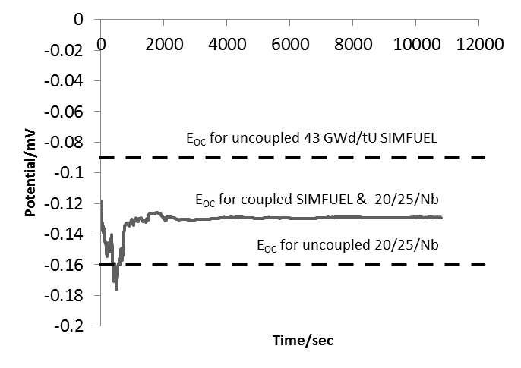

Figure 5: Open Circuit Potential of coupled 43 GWd/tU & 20/25/Nb vs time in anoxic modified simplified Groundwater
implies that cladding-decoupled AGR SIMFUEL may corrode both at the grain boundaries (E_{P} = ~-0.6 V vs. SCE in Figure 2) and on-grain (E_{P} = ~-0.1 V vs. SCE in Figure 2) in the modified simplified granitic groundwater – even in the absence of a peroxide generated oxidative stress.
When coupled to each other, both the fuel and the cladding adopt the mixed potential of -0.12 V vs. SCE. Inspection of Figure 2 indicates that this potential is now closer to the onset than the top of the UO₂ to UO_{2+x} on-grain oxidation peak. This implies that coupling the fuel with the cladding at least partially protects the UO₂ matrix against on-grain corrosion – although corrosion at UO_{2+x} sites at grain boundaries, and so release of entrained fission products, would still be expected to occur. In contrast, the coupling of the cladding to the SIMFUEL moves the constituent 20/25/Nb steel from a region of passivity at -0.18 V to a mixed potential of -0.12 V, a value 30 mV positive of a Ni-dissolution-associated pitting potential observed on 20/25/Nb in chloride containing groundwater (14). It therefore appears that, when coupled together in contact with peroxide-free granitic groundwater, the steel cladding may sacrificially protect AGR spent fuel against on-grain corrosion. Whether this protection is maintained in the presence of near field concentrations of peroxide is the focus of ongoing studies within our laboratories.

Conclusions and Further Work

AGR SIMFUELs at a range of simulated burn-ups have been prepared and the effect of the added dopants on the UO₂ crystal structure has been investigated using micro-Raman spectroscopy. The effect of deliberately added H₂O₂ on the surface of simulated AGR fuels has also been studied using Raman.
Samples prepared in the absence of dopants exhibit the cubic fluorite structure expected of UO₂. A peak associated with lattice damage (470 – 600 cm⁻¹) is observed from both 25 and 43 GWd/tU burn-up SIMFUEL, reflecting the introduction of dopant-associated lattice defects into the H₂O₂ matrix. As might be expected, the peak intensity is greater for the 43 GWd/tU sample.
Voltammetry indicates the presence of three oxidation waves in neutral media typical of UK groundwater concepts: the oxidation of UO_{2+x} sites at grain boundaries at -0.6 V vs SCE; the oxidation of UO₂ to UO_{2+x} within the grains at -0.1 V; and the oxidation of UO_{2+x} to U(VI) species at +0.3 V. The currents associated with all three waves increase with simulated burn-up indicating a similarly increasing susceptibility to anodic corrosion reactions with burn-up. The size of the feature at -0.6 V suggests a high concentration of UO_{2+x} sites at grain boundaries. As these may act as preferential and localized corrosion sites, it may be that fission products residing in grain boundaries will be instantly released on contact with groundwater.
An increase in the lattice damage peak in the Raman spectrum is observed when the SIMFUEL is exposed to H₂O₂ representative of a repository near-field, suggesting that the structure at the surface is becoming more distressed. Supported by concurrent E_{OC} measurements, this is consistent with additional point defects being established as the concentration of interstitial oxygen is increased in the lattice via H₂O₂ induced surface oxidation of the SIMFUEL – so increasing the concentration of UO_{2+x} sites both on and within the grains and thus increasing the susceptibility of the SIMFUEL to corrosion.
Open circuit potential measurements on 43 GWd/tU burn-up AGR SIMFUEL in modified simplified granitic groundwater indicate that the SIMFUEL may corrode in the modified simplified groundwater even in the absence of a peroxide generated oxidative stress. Similar studies of the same SIMFUEL held in contact with samples of the 20/25/Nb steel cladding show that this coupled system exhibits a mixed potential of ~-0.12 V vs SCE. This potential is (i) negative of that adopted by the isolated SIMFUEL and (ii) positive of that adopted by the isolated cladding in electrolytes of the same composition implying that, whilst corrosion at SIMFUEL’s grain boundaries may still obtain, the UO₂ matrix is at least in part protected against on-grain corrosion at the expense of the steel cladding, an observation that is currently the subject of further work in our laboratories.

Acknowledgements

All data created during this research are openly available from Lancaster University data archive at http://dx.doi.org/10.17635/lancaster/researchdata/5. We thank the Nuclear Decommissioning Authority (NDA), the EPSRC (Award No EP/I036400/1) and The Lloyd’s Register Foundation for financial support. Lloyd's Register Foundation supports the advancement of engineering-related education, and funds research and development that enhances safety of life at sea, on land and in the air.

References

- G. Sattonnay, C. Ardois, C. Corbel, J. F. Lucchini, M. -F. Barthe, F. Garrido, D. Gosset, J. Nuc. Mat., 1, 11 (2001)
- E. C. Buck, R. S. Wittman, F. N. Skomurski, K. J. Cantrell, B. K. McNamara, C. Z. Soderquist, Radiolysis Process Modeling Results for Scenarios, PNNL Report FCRD-UFD-2012-000199 PNNL-21554 (2012)
- B. E. Burakov, E. E. Strykanova, E. B. Anderson, Mater. Res. Soc. Symp. Proc., 465, 1309 (1997)
- R. F. Burstall, UK Atomic Energy Authority Report ND-R-328 (R) (1979)
- Z. Hiezl, D. Hambley, W.E. Lee, J. Nucl. Mat., 456, 74 (2014)
- G. T. Brett, Department of the Air Force, Air University Thesis, AFIT/GNE/ENP/05-01 (2005)
- H. He, M. Broczkowski, K. O’Neil, D. Ofori, O. Semenikhim and D. Shoesmith, Western University Report, NWMO TR-2012-09 (2012)
- H. He and D. Shoesmith, Phys. Chem. Chem. Phys. 12, 8108 (2010)
- D. W. Shoesmith, J.Nucl.Mat., 1, 282 (2000)
- W. H. Hocking, J. S. Betteridge, D. W. Shoesmith, J. Electroanal. Chem., 379, 339 (1994)
- J. S. Goldik, H. W. Nesbitt, J. J. Noël, D. W. Shoesmith, Electrochim. Acta, 49, 1699 (2004)
- R. J. Wilbraham, C. Boxall, D. T. Goddard, R. J. Taylor, S. E.Woodbury, J. Nuc. Mat., 464, 86 (2015)
- D. W. Shoesmith, Personal Communication (2013)
- C. Anwyl, C. Boxall, D.Hambley, C. Padovani, R. Wilbraham, ECS 227th Meeting, Chicago, 24th – 28th May 2015.

