Co-Designing Playful Interactions for Public Health in Green Spaces

Andy Darby, Emmanuel Tsekleves and Adrian Gradinar
Lancaster University, UK
Abstract
Public green spaces such as parks are key contributors to peoples’ health and wellbeing. Users often underutilise these green spaces in terms of undertaking casual physical activities and are recognised as having the most to gain from participating in their use and development. The Active Parks project aimed to co-design a concept for a playful and interactive ‘health trail’ in a green space to explore the effects of playful interactive experiences on the casual physical activity of park users.
In a series of co-design workshops with local residents, the Lancaster City Council and NHS Lancashire Public Health, a numbers of ideas and concepts were developed, which informed the design proposition of the health trail offering new ways of motivating and taking physical activity specific to local people in their park.
Three versions of a proof-of-concept digital prototype - large-scale musical instrument - were developed to explore how it could be used and implemented in the park. Pilot testing showed that the prototypes encouraged positive experiences of intergenerational casual physical activity among young children and teenagers, their parents and grandparents. Users described the experience as ‘fun’, ‘magical’ and ‘brilliant’ and were positive in their feedback about the prospect of the idea becoming a reality in their park.
Reflecting on the codesign process the paper recognises the successes of the project while questioning a lack of opportunity for participants to engage in the rich knowledge generation experience of prototyping in the evaluative design phase as a barrier to further innovation.
Keywords: Participatory research, codesign, playful interventions and green spaces

Introduction
“Green space is a public resource with a proven track record in improving people’s health, but too many local green spaces remain unused; people’s concerns about safety affect their use of local green space; improving the quality of spaces will encourage more active use and exercise; and local people are best placed to know what they want from green space”. (Open Space 2010)
The Friends of Ryelands Park, Lancaster City Council and a design team from Lancaster University drew on CABE’s research summary describing the benefits of green spaces in selecting a co-design approach (Sanders & Stappers 2008) to address the challenge of developing concepts and testing ideas for an interactive health trail under the project banner of Active Parks (AP). The codesign approach was adopted in appreciation of its emphasis on end-users being experts in their own experience (Visser et al. 2005) as codesign foregrounds local knowledge and values within the design process and in doing so making a successful design outcome more likely.
Where formerly the responsibility for park planning and investment sat with local authorities, it is now more common to see wide ranging partnerships led by community groups working to regenerate these green spaces and access a variety of funding to do so. The AP project brought together the Friends of Ryelands Park, local residents in the Skerton East Ward of Lancaster district, UK, Lancaster City Council, Lancashire County Council, Age UK and Lancashire NHS, with designers and researchers from Lancaster University. Such complex partnership projects hold competing tensions particularly with regard to the focus of knowledge generation, the depth of knowledge exchange and ownership of the knowledge created.
Playful Interactions and Codesign
In developing the design proposition the AP partners recognised, as others have (Knöll et al. 2014), the opportunities presented in overlapping the research interests of urban design, preventative healthcare and playful interactions.
Playful interactions centre on ‘Interactive play objects [that] can stimulate social interaction and physical play by providing motivating feedback to players’ behavior’. The interaction design of such objects is underpinned by three design values: motivating feedback, open-ended play and social interaction patterns (Bekker et al. 2010). The AP project sought to use playful interactions in support of a persuasive design intended to drive behaviour change among park users, such as increased or repeat physical activity.
The AP project adopted Sanders and Stappers definition of codesign as ‘collective creativity as it is applied across the whole span of a design process’ (2008, 4). The codesign process begins with the ‘pre-design research phase that focuses on the larger context of experience’ (Sanders & Stappers 2014, p.8) and often makes extensive use of probes. The core of the process is the use of generative tools that prioritize visual over verbal responses in an attempt to overcome the difficulties faced by some in expressing their ideas and imaginings through words (Sanders 2000, p.4). These generative tools are used early in the design development process (Sanders 2006, p.6) at the fuzzy front-end ‘not just to elicit contextual information, but also to bring it to a design team in a form that serves the generation of human-centred designs’ (Visser et al. 2005, p.6). The generative research design phase is followed by a more ‘traditional design process where the resulting ideas for product, service, interface, etc., are developed first into concepts, and then into prototypes that are refined on the basis of the feedback of future users’ (Sanders & Stappers 2008, p.5). Finally, ‘post-design research looks at how people actually experience the product, service or space’ (Sanders & Stappers 2014, p.8). The activities within the phases of the codesign process may be practiced from either and expert-driven ‘designing for’ mindset or a participatory ‘designing with’ mindset.
Active Parks
The AP case study described here was part of a larger research project based at Lancaster University, Catalyst (Catalystproject.org.uk 2015). Lancaster City Council and the Friends of Ryelands Park established a working relationship with the design team through a Lancaster University knowledge exchange event and began to develop project ideas together over several meetings. A Catalyst ideas lab provided further impetus and a platform for the pre-design stage, and allowed Lancaster City Council and the Friends of Ryelands Park to work with academics from the design team to refine the AP project aim towards developing a digital health trail in Ryelands Park in Lancaster, UK. It also allowed them the opportunity to secure project finance.
The AP project spanned the pre-design, generative and evaluative research design phases. The pre-design research design phase took place between March and April, the generative in April and May and the evaluative between June and August and also November and December of 2014. The aim of the pre-design stage was to generate a viable research mission between the Friends of Ryelands Park and the design team, to establish a working partnership and to secure funding to support the codesign process. The generative stage sought to co-design a brief from a single shared vision to a number of concept propositions around the design proposition, the subsequent evaluative stage aimed to test a selected concept in the real world.
Two Codesign Workshop Sessions and one Public Information Stand Session took place at Ryelands Park, in Lancaster UK, with the Codesign Workshop Sessions taking place inside the Children’s Centre set in the grounds of the park and the Public Information Stand Session outdoors as part of another event. The three proof-of-concept prototypes were designed, user-tested and evaluated by the design team, the first on site Ryelands Park, the second in Lancaster City Centre’s Market Square and the third at a Lancaster University conference.
The first Codesign Workshop participants (n=9) were drawn from the district and included members of the stakeholder group, the Friends of Ryelands Park. Age range: 40 to 70 years of age. The Public Information Stand participants (n=25) were drawn from across the North West with many never having visited Ryelands Park prior to the event. A small number of participants were very familiar with Ryelands Park and visited regularly and a larger number were familiar with it but did not visit often, preferring other parks in the district. The second Codesign Workshop participants (n=8) were again drawn from across the district and included members of the stakeholder group. Age range: 15 to 70 years of age.
Next, the design team developed a first prototype proof-of-concept and user testing (n=150 approx.) took place at Ryelands Park as part of a community event with the majority of people identifying as from the district and a significant number from the surrounding local area. Age range: 1 to 80 years of age. An iteration of the design was then completed based on user feedback to create a second prototype and further user testing (n=350 approx.) took place. The user testing took place in the city centre on a market day to maximise potential engagement. The majority of users were from across the district with a few indicating they were visiting the area. Age range: 2 to 70 years of age. A further iteration of the design interaction was then completed creating a third prototype for an academic poster. The user testing (n=100 approx.) took place as part of a poster session during a conference. The majority of users were from outside the district and had not visited the park. Age range: 22 to 65 years of age. No participants were paid for their involvement as either codesigners or user-testers as part of the project.
The feedback gathered fed to a set of design guidelines and recommendations included in a design report that aimed to inform further project development and implementation.

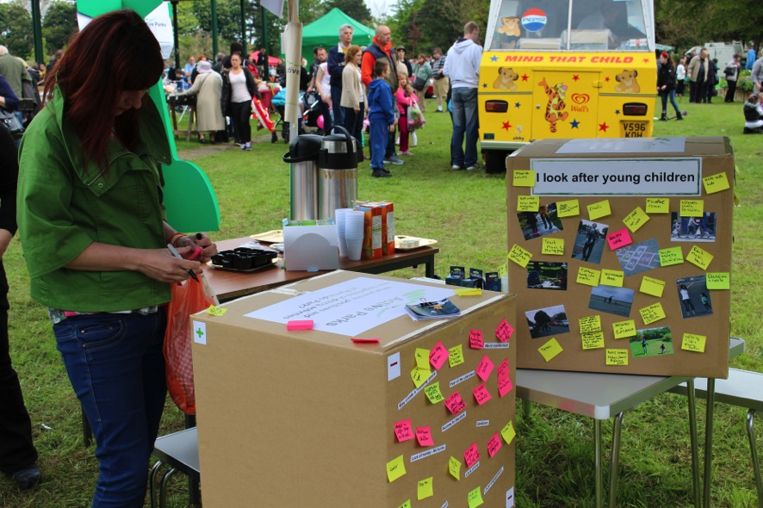
Figure 1. The Public Information Stand
Participants, prototypes and process
The design team met to review the potential concept prototypes from the generative phase of the codesign process. The team selected a concept based on ‘a wind chime’ or ‘xylophone’. The selection was made as it was felt that the idea represented a single interaction that could be part of a larger series of interactions as part of a ‘digital health trail’. The single interaction could be representative of a kind of playful or gameful activity that was inclusive, safe and communal. It was felt that the concept had the potential to refresh people’s motivation to revisit the park, increase people’s activity levels and enhance the physical environment. Each of these issues had been raised as being of importance in the generative phase.
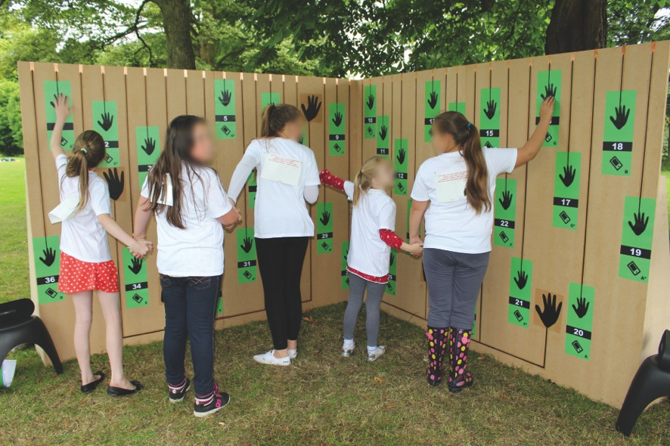
Figure 2. Prototype One User Testing
The first prototype tested both a conductive interface and an NFC based interface, the lack of responsiveness with a phone as an NFC reader made the experience cumbersome, participants preferred the immediate feedback of the conductive approach. Users who had not previously met explored the prototype together linking hands to create conductive human chains.
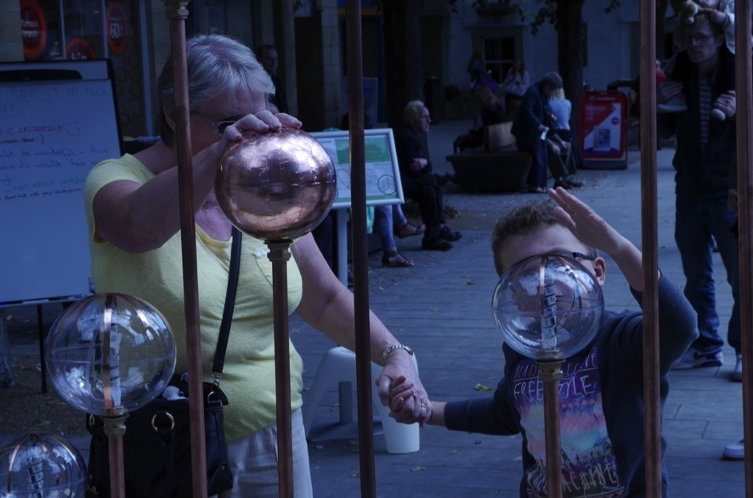
Figure 3. Prototype Two User Testing

The second prototype developed the concept to include motivating feedback from lights and a new physical design that acted as a bench, light source and activity in the park space. User concerns were that the designs would not stand up to the vandalism and several suggestions sought to make gameplay less exerting either by reducing scale or simplifying the interaction design. These suggestions were perhaps born out of a misconception of the purpose of the prototype and highlight a desire for ease of playfulness over exertion amongst users. The design was recognised as being inclusive, safe and communal by users. The playful interaction acted as a leveller with even accomplished musicians finding the musical element challenging but fun. The aesthetic was viewed as surprising and unusual.
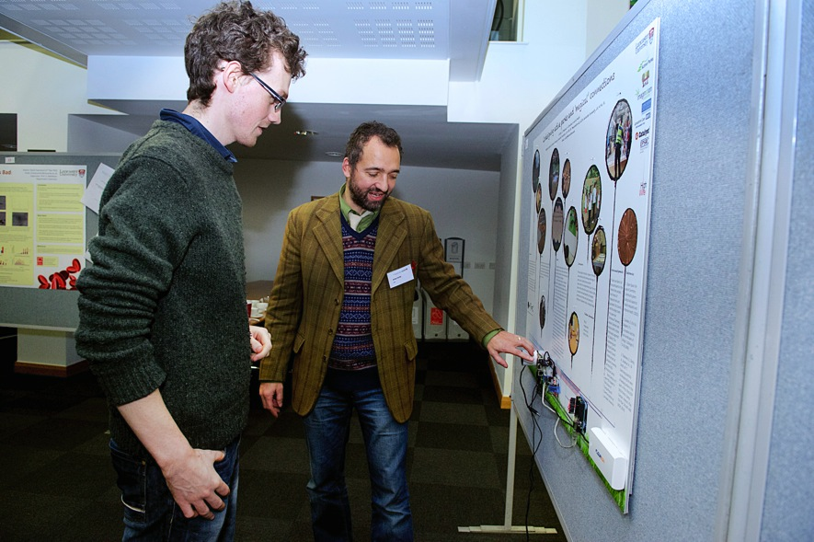
Figure 4. Prototype Three User Testing
The third prototype was intended for academic benefit as a student exercise. It happened to offer further insight into the importance of scale as users displayed all the social connectedness of previous iterations on an AO sized model whereas earlier prototypes were each two metres across.
Each of the prototypes showed that the simplest of playful interactions appear to stimulate casual physical activity among a wide range of users, and in addition observation of usage indicated that they might offer opportunities for intergenerational play.
In terms of community engagement the pre-design stage offered stakeholders an extended period to engage and to negotiate, establish and refine the design proposition and the broad shape of the AP project. Project participation was then opened to all-comers for the codesign workshops and a small group of interested people were able to contribute throughout the generative design phase. One limitation of the codesign process was that participants’ contributions were not available throughout the design development process as opportunities to engage were limited to the generative stage. Participants were able to offer a response to the designed artefacts but allowing participants access to prototyping activities was not planned in to the evaluative stage.
The generative design stage provided a number of opportunities for codesigners to engage in early stage prototyping activities and to make use of generative methods. Both projective and constructive techniques were used. Constructive techniques provide ‘design elements for users to manipulate in guiding concept development’ and projective techniques provide users tools ‘to project their thoughts, feelings and desires through ambiguous visual stimuli’ (Hanington 2007). These projective and constructive activities formed the bulk of the generative methods used, with the exception of some additional text based tools to establish vision and values. The projective techniques and the text based tools use highlighted the same concerns and values about Ryelands Park as others expressed about their local green spaces space in the CABE research summary (Open Space 2010). The constructive methods provided the inspiration for some highly creative responses from the codesigners we worked with, in particular the development of health trail concepts benefitted from participants entering the spirit of making as they added to the resource materials provided by borrowing a range of curious objects from the building and integrating them with their prototypes and stories. They engaged in acts of making, telling and enacting which are central to the codesign process.
No opportunity to engage as anything other than an end-user was offered to participants as the AP project entered the evaluative design stage. The lack of opportunities for engagement in this way denied the participants, and particularly those who came from the stakeholder group, the knowledge development created from working through the design decisions required in the traditional prototyping process.
The phrases in italics below draw attention to a series of ‘tentative designerly functions which prototypes can play in research projects’ (Stappers 2013) these functions highlight the high degree of knowledge generation in the evaluative phase which is generated through active participation in the prototyping process.
The design team went on to engage in the evaluative design stage leading a traditional prototyping process and generating significant knowledge and learning through the range of design decisions they were required to address to confront the world through the object. They engaged in constant discussion and reflection as they developed the first prototype. They explored issues such as the scale of the prototype through a variety of paper prototyping explorations. Indeed the primary concern with the first prototype was to test the theory that a large-scale musical instrument would demand and encourage movement and stretching in its use. They did this having already interrogated the concepts created in the generative design stage and developed an understanding of how the single interaction of the first prototype might sit within a larger series of interactions. They developed a metaphor that originated in the concept selection stage of ‘navigating a constellation’ recognising that there was value in approaching the single interaction as part of a broader range of engagements in the park space, as well as a standalone activity. The team explored the dimensions of gamefulness through playful activities and though exertion games and in doing so confronted theories of user interactions. Finally the development of the prototypes themselves demanded of the design team that they consider in depth the ways in which the prototypes would come into being in an imagined near future, and in doing so how they might change the world.
Conclusion
The AP project was successful in developing an engaging concept that indicated the potential of playful interactions for health outcomes. The next steps of the AP project will continue to explore this kind of interaction and the development of other elements of the interactive health trail.
However the knowledge generated by the project is held mostly by the academic partner, despite a document being shared with the other partners the tacit knowledge remains with the makers. Does the shift from a ‘designing with’ to ‘designing for’ mindset create an unnecessary barrier? Had a more participatory mindset been taken in the AP project would the Friends of Ryelands Park be better prepared to innovate for themselves?
Acknowledgements
The Catalyst Project is funded by the EPSRC, UK Research Council (RCUK Grant EP/I033017/1).
Thanks to Adrian Gradinar, Marcia Taveres Smith, Gabriela Suarez Trueba, Neko Chen, Robert Potts and Stephen Wearden. Thanks to the Friends of Ryelands Park, Lancaster City Council, Lancashire County Council, Lancashire NHS and all the participants in the Active Parks project.

References
Bekker, T., Sturm, J. & Eggen, B., 2010. Designing playful interactions for social interaction and physical play. Personal and Ubiquitous Computing, 14, pp.385–396.
Catalystproject.org.uk, 2015. Catalyst | Citizens Transforming Society : Tools For Change. Available at: http://www.catalystproject.org.uk [Accessed March 5, 2015].
Hanington, B., 2007. Generative research in design education. … : Emerging Trends in Design Research, pp.1–15.
Knöll, M. et al., 2014. Technologies of Inclusive Well-Being A. L. Brooks, ed. , 536, pp.245–259.
Open Space, 2010. Research Summary: Community green: using local spaces to tackle inequality and improve health,
Sanders, E.B., 2006. Design Research in 2006 From the Communications Secretary : , (September), pp.1–25.
Sanders, E.B., 2000. Generative Tools for Co-Designing. Collaborative Design, pp.3–12.
Sanders, E.B. –N. & Stappers, P.J., 2014. Probes, toolkits and prototypes: three approaches to making in codesigning. CoDesign : International Journal of CoCreation in Design and the Arts, 10(1), pp.5–14.
Sanders, E.B.-N. & Stappers, P.J., 2008. Co-creation and the new landscapes of design. CoDesign, 4(1), pp.5–18.
Stappers, P.J., 2013. Prototypes as a Central Vein for Knowledge Development. In L. Valentine, ed. Prototype: Design and Craft in the 21st Century. Bloomsbury Academic.
Visser, F.S. et al., 2005. Contextmapping: experiences from practice. CoDesign, 1(2), pp.119–149.

