The importance of second shell effects in the simulation of hydrated Sr²⁺ hydroxide complexes

Eszter Makkos,¹ Andrew Kerridge^{1,2} * and Nikolas Kaltsoyannis¹ *

¹ Department of Chemistry, University College London, 20 Gordon Street, London WC1H 0AJ, UK
² Department of Chemistry, Lancaster University, Bailrigg, Lancaster LA1 4YP, UK

Electronic Supplementary Information

- Sr²⁺ hydroxide complexes with a first solvation shell

  - [Sr:3/3:1/0]⁺
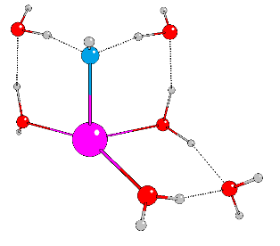
SCF Energy = -565.5202782749

Atoms X Y Z
Sr -1.0146625 0.3581517 0.9151213
O -2.2231815 2.0451591 -0.5260129
O -0.0092754 -1.2080368 -0.7874119
H 0.1129081 -2.1390636 -0.4915350
O 0.9177276 1.7201035 0.4985571
H 1.4796036 2.0483014 1.2180043
H -1.5583961 2.7463853 -0.8092389
H -2.8161167 1.8948750 -1.2787512
O -0.9217582 -1.7681158 2.2997161
H -1.5078826 -2.0527914 3.0184674
H -0.6300962 -2.5903533 1.8298809
H 0.8967938 -0.8499622 -1.0272138
O -0.1539269 3.6818091 -0.8548274
H 0.2304243 3.7205796 -1.7455344
H 0.3837510 2.9730690 -0.3440170
O 2.2784639 0.1549078 -1.0986030
H 2.3903804 0.5814906 -1.9634975
H 1.8395273 0.8541223 -0.4918838
O 0.0245642 -3.6728779 0.5752178
H -0.5768696 -4.3737283 0.2714038
H 0.8580217 -4.1240249 0.7921582

  - [Sr:2/3:2/0]

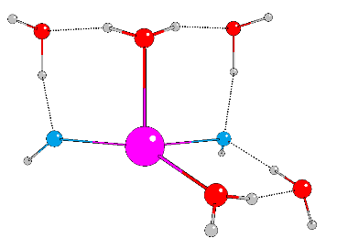
SCF Energy = -565.0525454927

Atoms X Y Z
Sr 0.9855686 0.1227192 0.6532514
O 0.7458200 -0.8569034 -1.6972183
O -2.1526233 -1.0307045 2.5815495
O 2.2892479 1.8038174 -0.3538040
H 2.6386869 2.6875374 -0.1731057
O -1.4132661 0.5001230 0.6087061
H -0.2274446 -0.7810566 -1.9041400
H -1.9688738 -0.3674865 1.8153944
H 1.2223594 -0.1965651 -2.2797107
H -2.4618886 -0.4922782 3.3279928
H -1.7846754 1.3933844 0.6795297
H -0.5061869 -1.4037286 2.7722822
O 0.4788105 -1.5018340 2.5932409
H 0.9149313 -1.5495606 3.4583896
O 2.1665332 1.1552656 -2.8360999
H 3.0399874 0.8542272 -3.1339755
H 2.2993690 1.4957740 -1.8595106
O -1.9527979 -0.4644969 -1.7657674
H -2.4646488 -1.2835985 -1.6682628
H -1.8489088 -0.0846356 -0.8187418

  - [Sr:3/2:2/0]
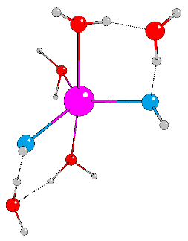
SCF Energy = -565.0482594933

Atoms X Y Z
Sr 0.0272475 -0.0213109 0.0044156
O -1.3776535 -0.3748927 -2.1373551
O -0.0409545 1.0456764 3.7447433
O -0.1731479 -2.5781278 0.5627575
O 1.6381807 0.8318682 -1.5368125
H 2.2055731 1.6092475 -1.4270337
O -1.0579501 1.5169142 1.4652516
H -2.2928515 -0.0791072 -2.2634767
H -0.4926645 1.3508640 2.8404023
H 0.1828323 -2.5728254 1.4711013
H -0.8343774 0.0476490 -2.8761581
H 0.5319676 1.7795607 4.0194838
H -0.9612637 -3.1445371 0.5917153
H -1.2912418 2.4428139 1.3039967
H 0.8673030 -0.0991177 2.9388417
O 1.2121453 -0.7520094 2.2484224
H 2.1714044 -0.8133444 2.3803561
O 0.3846471 0.7945675 -3.7467621
H 0.8166157 0.1658818 -4.3470799
H 0.9946073 0.8472649 -2.8869547

  - [Sr:4/1:2/0]
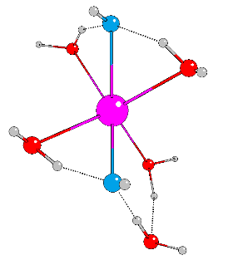
SCF Energy = -565.0474029244

Atoms X Y Z
Sr -0.0578182 -0.0390574 -0.3196584
O 2.0981258 1.2673588 -1.0417078
O -0.5658777 -1.6416636 -2.3645605
O 0.9975223 -1.7514273 1.2512163
O -2.5792132 0.3728610 0.2902036
O -0.6320022 1.1295674 1.7906997
H -0.4734953 2.0704905 1.9602644
O 0.2168911 0.7778323 -2.6982351
H 1.4947147 1.2945773 -1.8697043
H -0.3669630 -0.7332080 -2.7886906
H -2.0613084 0.8511373 1.0258002
H 0.9229311 -1.3801632 2.1857026
H 2.2795609 2.1879029 -0.7944249
H -1.4507453 -1.9037309 -2.6639834
H -3.1417429 1.0391604 -0.1358923
H 1.8658388 -2.1788337 1.1869985
H -0.3341079 1.4749485 -3.0846895
O 0.4287402 -0.4693187 3.5129596
H 1.1947862 -0.0534548 3.9399552
H 0.0068552 0.2619962 2.9110440

  - [Sr:1/3:3/0]⁻
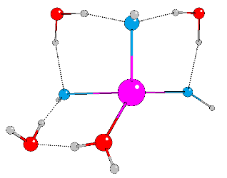
SCF Energy = -564.5743523453

Atoms X Y Z
Sr -0.5084375 0.1291068 0.1177550
O 1.1276816 -1.0017946 -1.2942859
O -1.4410567 -1.0856256 1.9272683
O 3.0836921 0.4863364 -0.0339819
O 0.0700532 0.4102964 3.6170642
O 1.0028114 1.5792821 1.3248442
H 0.9626764 2.5470080 1.2858860
O -1.4345613 1.1215345 -2.0852383
H 0.4816544 0.9419545 2.8745318
H 2.4075964 0.9814191 0.5213209
H 1.3047937 -1.9546885 -1.2843803
H -2.3637387 -1.1976756 2.1991913
H -0.5555440 -0.1928738 3.1087469
H 2.4967831 -0.1195223 -0.5673977
H -2.3468351 1.0191850 -2.3993949
H -0.8414329 0.7108071 -2.7906245
O 0.3569555 -0.1551335 -3.5845016
H 1.0370314 0.4327095 -3.9508967
H 0.7565400 -0.5471517 -2.7006586

  - [Sr:2/2:3/0]⁻
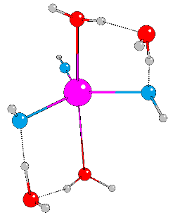
SCF Energy = -564.5704310170

Atoms X Y Z
Sr 0.4040985 0.9543843 0.0074525
O -1.2349546 1.2333923 2.0596279
O -1.4192575 0.3416765 -1.5076018
O 1.7827054 -0.0830131 -2.0045664
H 2.4994459 -0.7168478 -1.8444104
O 1.2244549 -0.8068253 1.5033449
H -1.1533640 0.3705673 2.5755166
H -2.1845640 1.4083871 1.9693901
H -2.2806612 0.0153813 -1.2069464
H 1.5982946 -1.6434888 1.1887257
O 1.2861452 3.0918496 -0.0169072
H 1.6415146 3.9903707 -0.0244003
O -0.5848737 -1.0664530 3.2347302
O -0.3347347 -1.0904461 -3.2714814
H 0.2025570 -1.0647125 2.5089581
H -1.1813972 -1.7884220 2.9797969
H -0.4714413 -2.0287131 -3.0638871
H 1.0925898 -0.5749534 -2.5521368
H -0.8865578 -0.5421339 -2.5352051

  - [Sr:3/1:3/0]⁻
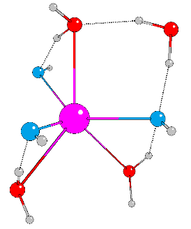
SCF Energy = -564.5680311812

Atoms X Y Z
Sr -0.3120191 0.1631074 0.3893266
O 2.4059789 -0.1382495 0.7751749
O -2.5908603 0.6539706 1.7569492
O -1.4724435 1.2861537 -1.7792222
O -0.1089115 -0.8709016 -1.8615352
H -0.5333192 -1.7155053 -2.0761963
O -1.1029909 -1.3512794 2.1293395
H 2.7725427 -0.5133406 1.5911379
H -2.1923600 -0.2719725 2.0317399
H -1.0553977 0.3907927 -2.0656756
H 2.0797481 0.8500119 0.9868369
H -3.4464722 0.4731666 1.3367150
H -2.4268571 1.2081008 -1.9355667
H -1.4585926 -2.2421157 1.9927014
O 1.1519882 1.9924004 1.1218376
H 1.4401983 2.7360433 0.5713645
O 2.5673816 -0.9628786 -1.9502567
H 2.7229438 -0.7116232 -1.0136421
H 1.5594426 -0.9758812 -2.0010285

  - [Sr:4/0:3/0]⁻
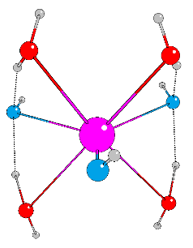
SCF Energy = -564.5642657015

Atoms X Y Z
Sr -0.0086890 -0.1880202 0.0185480
O -2.5392055 -0.2183494 -1.0654659
O -0.7704968 0.3230483 2.5822552
O 0.5898404 0.1406091 -2.6151284
O 2.4616682 0.1162893 1.1239876
O 1.7901349 1.5454131 -0.8696742
H 1.5696309 2.4822174 -0.7537343
O -1.8706440 1.5454843 0.6440866
H -2.4703465 0.6266882 -0.4854620
H -1.2761045 0.9945110 1.9876697
H 2.3764972 0.8438858 0.3985477
H 1.1244531 0.8609636 -2.1065250
H -2.6597875 0.0843632 -1.9790079
H -0.2024230 0.8472717 3.1681040
H 2.5655027 0.5813172 1.9688530
H -0.0064706 0.6125678 -3.2170459
H -1.7129231 2.4783130 0.4350322
O 0.1062153 -2.5267029 0.0860344
H -0.5029311 -3.1778647 -0.2923478

  - [Sr:0/3:4/0]²⁻
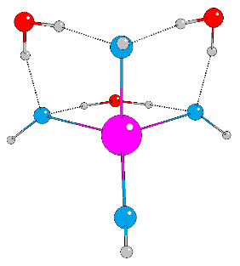
SCF Energy = -564.0962794625

Atoms X Y Z
Sr -0.7205792 0.8630581 -0.0000024
O -0.7646925 -0.7464329 -1.8475578
O -0.7646750 -0.7464501 1.8475800
O 1.8576820 -0.1927103 -2.2838448
O 1.8576817 -0.1926918 2.2838287
O 1.6946422 1.2690022 -0.0000101
H 2.1115052 2.1438574 0.0000036
O -2.1769212 2.6585191 -0.0000008
H 1.9314803 0.3851511 1.4649402
H 1.9315099 0.3851102 -1.4649311
H -1.3704718 -0.7292746 -2.6037266
H -1.3704676 -0.7292453 2.6037287
H 0.8917476 -0.4673685 2.2484917
H 0.8917302 -0.4672906 -2.2484806
H -2.7877394 3.4071792 0.0000024
O -1.1467919 -2.6967216 0.0000182
H -1.0328544 -2.0718179 0.7794294
H -1.0327862 -2.0718736 -0.7794689

  - [Sr:1/2:4/0]²⁻
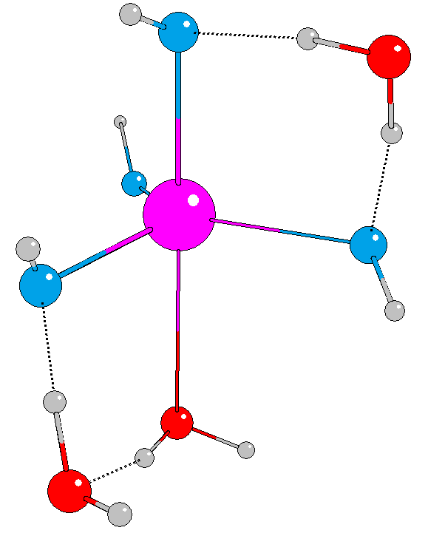
SCF Energy = -564.0898062481

Atoms X Y Z
O 0.2465132 1.5765462 0.1616909
Sr -1.1889349 1.1260517 2.6524024
O -3.1547345 0.4597531 1.5000989
O 0.1388761 3.2410453 2.1896402
O 0.3702982 -0.7304999 2.8993688
O -1.5388959 4.3496790 4.0398600
O 1.9869741 -0.4632008 0.9444904
O -2.0067106 1.8302196 4.8275378
H -2.9109376 1.7030315 5.1525069
H 0.9498000 0.9080817 0.3704143
H 0.3522325 2.3135908 0.8555807
H 1.0122824 3.3240584 2.6039309
H 0.8408056 -0.9483016 3.7181806
H -3.2467444 0.2233441 0.5649951
H 1.3795203 -0.6009994 1.7956701
H 2.8178799 -0.0868646 1.2755471
H -1.7905241 3.4519522 4.4366462
H -0.8887345 4.0709494 3.3286845

  - [Sr:2/1:4/0]²⁻
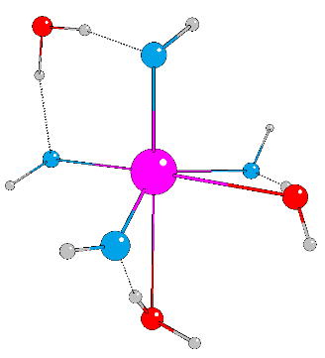
SCF Energy = -564.0857030233

Atoms X Y Z
Sr 0.0523994 0.2408549 -0.1192058
O -0.6161094 2.8686058 0.8131879
O -1.9366220 0.0385186 -1.5069950
O 1.6771265 0.3028245 2.2330066
O 1.3250632 -1.5358895 -1.1896344
O -0.6253761 -0.7288134 2.0892682
H -0.6233863 -1.6841592 2.2550330
O 1.1342728 2.3463260 -0.9347160
H 0.9302689 2.7314397 -1.8008414
H 0.1411070 2.8337570 0.0830985
H 0.7419412 -0.1645903 2.3544652
H -0.1897953 3.1734615 1.6294818
H -2.2522407 0.7843291 -2.0399997
H 1.5784691 -2.3381994 -0.7079323
H 1.6530421 1.1030866 2.7806724
O -0.7080466 -1.8947746 -2.9159708
H 0.1075608 -1.8761512 -2.3192497
H -1.2645970 -1.1670472 -2.4886131

- W24 water cluster

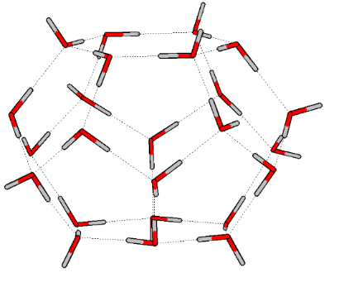
SCF Energy = -1835.6524726596

Atoms X Y Z
O -2.4837372 -2.8646387 -1.1853464
O -2.3643759 -2.9672165 1.3299779
O 0.1033073 -2.9209341 2.5550547
O 2.3451266 -2.9556846 1.2442412
O 2.2135397 -2.9562628 -1.5698848
O -0.1484579 -2.9400361 -2.7519633
O -3.7874041 -0.9050962 2.3308782
O 0.1826225 -0.7783393 4.4157371
O 3.8002316 -0.7138693 1.9245939
O 3.7850883 -0.7416149 -2.3832343
O -0.3146462 -0.6743270 -4.4597421
O -3.9461451 -0.8497001 -2.0755195
O -4.4986593 0.7632434 0.0878272
O -2.3737428 0.7701495 -3.8096293
O -2.1509698 0.8007715 3.8388637
O 1.9566167 0.7827238 -4.0264986
O 4.4027014 0.6992428 -0.1648663
O 2.2457670 0.8703942 3.7004230
O 1.2893887 2.8961599 2.3140383
O 2.6063338 2.9056726 -0.1834009
O 1.2441846 3.0322756 -2.4458192
O -1.5669859 2.9346882 -2.2988900
O -2.6994923 2.9708768 0.0392194
O -1.2267863 2.8587093 2.3525105
H 0.2317138 2.8565655 2.2899839
H 2.0930176 2.8629889 0.6580974
H 1.7374186 2.9886773 -1.5649198
H -0.5819268 2.9527924 -2.3288457
H -2.2255599 2.9393955 -0.8667044
H -1.7211034 2.8885160 1.4916713
H -2.3776831 -2.8964524 0.2749090
H -1.6398082 -2.8687455 -1.6947770
H 0.7440712 -2.9460622 -2.2765401
H 2.2187552 -2.9518639 -0.5836436
H 1.4396911 -2.9415620 1.7194040
H -0.7638617 -2.9087581 2.0700922
H -3.8830886 1.5320542 0.0899878
H -4.1930008 -0.2467580 -1.3235774
H -4.2568269 0.2348498 0.8781865
H -3.2259015 3.7846469 0.0250287
H -3.4439817 -0.2846657 -2.7063820
H -3.0408360 -2.0969597 -1.5441228
H -3.2991039 -1.7027430 1.9661851
H -2.7353820 -3.8421780 1.5231939
H -1.5650392 0.2009153 -4.0779891
H -1.8499571 2.1695602 -2.8646260
H -2.8256024 0.9927115 -4.6373130
H -0.2431775 -1.4656403 -3.8774162
H -0.1662644 -3.7513727 -3.2818973
H 0.5330926 -0.1646185 -4.3354068
H 1.7242969 1.5761405 -3.4904919
H 2.6035138 0.2843113 -3.4837359
H 2.7700441 -2.1926929 -1.8471346
H 4.0830945 -0.2081900 -1.5938849
H 4.5902497 -1.0025184 -2.8551138
H 1.5185019 3.8655418 -2.8577221
H -2.7612885 0.2037225 3.3445060
H -1.6131991 2.1079542 2.8906708
H -4.6050311 -1.2418825 2.7265409
H -1.3924532 0.2338371 4.0937092
H 0.9511205 -0.1758077 4.2190331
H 3.2293702 2.1434630 -0.1648190
H 4.1768150 0.1318016 0.6586874
H 5.3170322 0.9961715 -0.0413176
H 3.2832632 -1.5342859 1.7079451
H 2.7666762 -3.7842792 1.5193923
H 0.0762885 -2.1826400 3.2039749
H 0.2824471 -1.0562110 5.3386688
H 1.8820359 1.6774913 3.1975616
H 1.4971561 3.7758785 2.6657973
H 3.2480258 -0.1958214 2.5536890
H 2.7988798 1.2255338 4.4128943

- Sr²⁺ hydrate complexes with a first and second solvation shells

  - [Sr:6/18:0/0]²⁺ (CN=6)

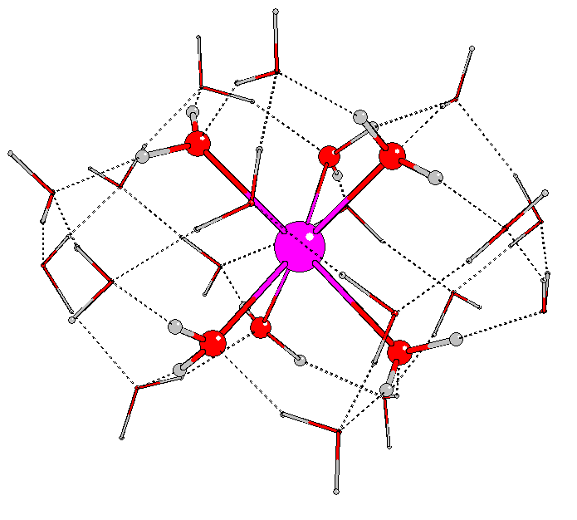
SCF Energy = -1866.2509240457

Atoms X Y Z
O -2.4968628 -2.9724378 -1.3697446
O -3.3320624 -3.9355399 0.9780746
H -2.9533087 -3.5198952 0.1450184
H -3.7495385 -3.1851039 1.4851173
H -1.8673769 -2.2321917 -1.3582566
H -3.3596172 -2.6047573 -1.7035856
O -5.6793663 -4.9714651 -1.4548375
O -5.0877927 -2.4092956 -1.9437323
H -5.3553166 -2.0344132 -2.7991437
H -5.6459805 -1.9556534 -1.2322990
H -4.7469645 -6.0219837 -2.6515669
O -4.0554712 -6.6870932 -2.8946656
H -4.2961252 -7.0326862 -3.7702569
O -1.5484648 -5.5220323 -2.2164946
H -1.8157190 -4.5945319 -2.0199187
H -2.3616028 -5.9463197 -2.5761042
O -1.3050658 -5.3516827 2.1938096
H -1.8651260 -4.6144016 1.8428570
H -0.6851761 -4.9520669 2.8264332
O -4.2550053 -7.9591723 -0.5201912
H -3.4012706 -8.4488252 -0.3017299
H -4.1761265 -7.6931305 -1.4782807
O -0.5021489 -6.8909484 -0.0633943
H -0.8709142 -6.3761259 -0.8332214
H -0.6489713 -6.3226115 0.7285740
O -1.9661214 -9.0874751 0.2305256
H -1.3308081 -8.3076237 0.1175810
H -1.6207963 -9.8150944 -0.3124040
H -2.6420642 -6.3492739 2.7649993
O -3.5203731 -6.8187616 2.7740589
H -3.3059254 -7.8169947 2.8245943
H -2.6369118 -9.5071494 1.9196895
O -3.0546949 -9.3913751 2.8054827
H -3.9716185 -9.7847743 2.7500284
O -5.6538687 -10.2217873 2.7651672
H -6.0102447 -10.0989325 1.8546317
H -6.1671780 -9.6046773 3.3409963
O -5.2424909 -6.2817132 4.8093553
H -4.4315860 -6.4997558 4.2765409
H -4.9364667 -6.0045542 5.6890185
O -7.0357764 -8.3393527 4.4077622
H -6.3909352 -7.6501059 4.7165759
H -7.3750399 -8.7612169 5.2150964
O -8.9000190 -7.0887927 2.7628352
H -8.3360695 -7.4735880 3.4811983
H -9.0048934 -6.1301800 2.9616225
H -7.1142854 -4.4642433 2.9011764
H -7.9450737 -7.1034933 1.4679356
O -6.1253225 -4.6358782 2.8424809
H -5.8732166 -5.0785640 3.6994377
O -7.3078632 -7.0723095 0.6740006
H -7.1855279 -8.0200093 0.3906584
H -5.4342301 -2.9493171 2.7360144
O -4.9725711 -2.2043113 2.2735995
H -4.7019360 -1.5749650 2.9629482
H -6.0546398 -1.6041675 0.8887552
O -6.5562835 -1.4552680 0.0515669
H -7.3847114 -1.9865159 0.1389628
H -8.9562338 -5.6653236 -1.8843105
O -8.3468057 -5.3615782 -1.1909966
H -8.1951863 -6.1319769 -0.5816406
H -8.8059027 -3.8947655 -0.3004106
O -8.8519450 -3.1266056 0.3298838
H -9.6738312 -2.6553254 0.1111264
H -8.9389444 -3.7927657 1.9384324
O -8.7692530 -4.2628070 2.8030629
H -9.1471882 -3.7026266 3.5011041
H -6.6608329 -5.0872525 -1.5829228
O -6.4133937 -9.5646058 0.1055362
H -5.5904921 -9.2026465 -0.3103566
H -6.7925407 -10.1953131 -0.5288652
H -5.4845823 -4.0235474 -1.7261619
Sr -5.0093616 -5.9149505 0.8722704

  - [Sr:7/17:0/0]²⁺ (CN=7)

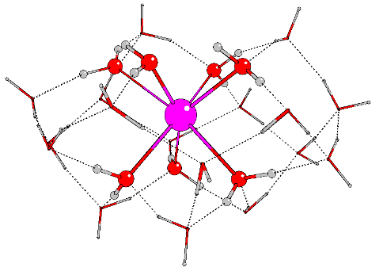
SCF Energy = -1866.2486508991

Atoms X Y Z
O -2.3204644 -3.1843387 -1.3574226
O -3.4503533 -4.2540948 0.8613335
Sr -5.2111372 -6.2587990 0.7830954
O -3.7588109 -6.8576141 2.9020221
O -7.8200883 -6.7682547 0.5178945
O -3.8830787 -7.9168981 -0.6298721
O -5.6249222 -5.1600724 -1.5688951
O -6.2526554 -4.6579912 2.6250704
O -3.1190029 -9.4161219 3.0962721
O -9.2389617 -6.7176517 2.7543999
O -1.8416705 -9.2156520 0.5752222
O -0.3715640 -6.9990011 0.2523728
O -8.8458120 -3.9145631 2.5084532
O -4.8799072 -2.6043126 -2.0987548
O -6.4111030 -1.4543315 -0.1882898
O -3.7429523 -6.6578752 -3.0398292
O -6.0290919 -8.7818297 0.9223951
O -8.3735218 -5.1272891 -1.5303642
O -5.5052786 -6.0946407 4.8117253
O -4.8725678 -2.3028183 2.0164928
O -1.5116981 -5.4326250 2.3268988
O -8.7682068 -2.8752025 -0.0444107
O -5.9463531 -10.0225197 3.3029923
O -1.2183252 -5.7035141 -2.0776042
O -7.4216875 -8.0194427 4.5367457
H -2.9885099 -3.8750791 0.0600511
H -3.8974361 -3.4589513 1.2919515
H -1.7265962 -2.4298912 -1.2086662
H -3.1509288 -2.8136531 -1.7568215
H -5.0859066 -2.2941539 -2.9963042
H -5.4397937 -2.0603571 -1.4733314
H -4.5142683 -6.1115232 -2.7506292
H -3.9708884 -7.0158285 -3.9132512
H -1.4919895 -4.7767283 -1.8884895
H -2.0145951 -6.0948434 -2.5024298
H -2.1073186 -4.8017866 1.8361163
H -0.9893707 -4.8992913 2.9485995
H -3.1116750 -8.4598520 -0.3095834
H -3.7250234 -7.6858342 -1.5777529
H -0.6894140 -6.5443259 -0.5734001
H -0.6491326 -6.4115092 0.9949106
H -1.1942467 -8.4481631 0.4782167
H -1.4339201 -9.9782503 0.1330783
H -2.8915453 -6.3680378 2.8846741
H -3.5065087 -7.8318785 3.0164518
H -2.7088404 -9.5655119 2.2109146
H -3.9921025 -9.8648475 3.1039086
H -6.3480190 -10.9011797 3.4022727
H -6.5037613 -9.3985733 3.8422714
H -4.7057677 -6.4022246 4.3006353
H -5.1860147 -5.7550263 5.6639579
H -6.7452535 -7.3382642 4.8020077
H -7.8555694 -8.2900334 5.3637886
H -8.6673878 -7.0992898 3.4649696
H -9.2678837 -5.7461962 2.9015854
H -7.2122163 -4.3746956 2.6375523
H -8.3957569 -6.7518725 1.3518041
H -6.0577613 -5.0054607 3.5358573
H -7.6237930 -7.7191448 0.3816656
H -5.4535105 -2.9943169 2.4162426
H -5.4229078 -1.8991735 1.3003653
H -6.5660617 -0.4967857 -0.2501543
H -7.3131021 -1.8793295 -0.1722756
H -8.9873519 -5.3800798 -2.2397877
H -8.3972435 -5.8568968 -0.8518609
H -8.7334839 -3.6503020 -0.6735559
H -9.5572039 -2.3653088 -0.2953892
H -8.9470462 -3.4922061 1.6123976
H -9.1159695 -3.2443401 3.1576970
H -6.5942079 -5.1995325 -1.7834598
H -5.4430400 -9.1994260 0.2665172
H -6.0440379 -9.3684374 1.7300016
H -5.3574002 -4.2237534 -1.7955732

- Sr²⁺ hydroxide complexes with first and second solvation shells

  - [Sr:5/18:1/0]⁺

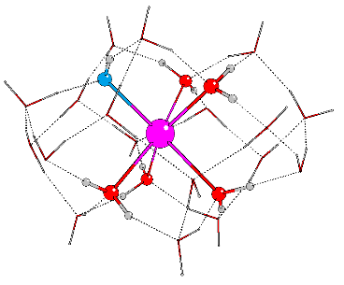
SCF Energy = -1865.7917395895

Atoms X Y Z
O -0.5709520 2.3587837 -0.9933930
O -0.9103928 3.5318123 1.4027714
O 1.7294004 3.7735637 2.1303256
O 1.3436126 3.6456420 -2.2800094
O 3.2182023 3.4545104 -0.2884041
O -2.5114052 1.4694983 -2.6356595
O -2.3482181 -0.4617935 -0.9667516
O -2.7428328 -2.6846803 -2.1801431
O -0.8756233 -2.2343454 -4.1783712
O -1.8440261 -4.0617440 0.0361705
O 0.3555921 -2.6262195 -0.0724325
O 1.4486505 -2.7515191 -2.5709307
O -0.9462958 0.4760751 -4.7041300
O 1.4226201 1.4636594 -4.0536638
O 1.7766762 -0.1408435 -1.9498382
O 3.8515149 0.6965731 -0.3788130
O 2.0357148 -0.1272642 1.4706701
O 1.7655507 -2.7041271 2.2778056
O -0.3657672 -2.4664874 3.9765017
O -0.2999791 0.2102933 4.4552815
O 2.1003369 1.4365570 3.6028675
O -1.2373651 0.9051899 2.0365217
O -3.6466134 -0.4357041 1.7520811
O -2.7328015 -2.9867710 2.4058163
H 2.0814095 -1.7783217 2.0846783
H 0.9279395 -2.8785874 0.6967843
H 1.1345765 -2.9493389 -1.6483312
H 1.8381793 -1.0794207 -2.2819227
H 3.2856168 0.3381438 -1.1129575
H 2.8428349 0.0861962 0.9290961
H -0.9110211 3.2945739 0.4326066
H -1.3478480 2.2473267 -1.6140904
H -2.5984897 0.6712265 -1.9717725
H -3.0222834 -0.4207753 -0.2617022
H -2.8990215 0.1808600 1.9563095
H -1.2614550 1.8981085 1.9697102
H 3.5538391 2.5271949 -0.2749387
H 2.0977000 3.5824274 -1.6293178
H 2.7376437 3.5766608 0.5658846
H 4.7466784 0.3459144 -0.5181974
H 1.5258316 2.9913546 -2.9950814
H 0.1284498 2.8895944 -1.5031731
H 0.7628356 3.8416596 1.9068371
H -1.5635946 4.2408554 1.5224640
H 0.5272977 1.1206011 -4.3865777
H 1.7152550 0.4355399 -2.7723258
H 2.0496060 1.3786096 -4.7904684
H -1.5839678 0.8482560 -4.0410109
H -3.3951977 1.8516480 -2.7573757
H -0.9222596 -0.5046511 -4.5216881
H -0.0401405 -2.4904799 -3.7261073
H -1.5888856 -2.4445973 -3.5177513
H -2.6538845 -1.7601882 -1.7043823
H -2.3226214 -3.6588936 -0.7361461
H -3.6633973 -2.7572882 -2.4805540
H 2.1530228 -3.3902599 -2.7693100
H 1.9158492 2.3345271 3.2268931
H 2.0944368 0.4683206 2.2894873
H 1.9557882 4.6088527 2.5727976
H 1.2860454 1.1524831 4.0783227
H -0.3175818 -0.7882408 4.4313295
H -0.4657115 -3.2288943 -0.0218498
H -2.2624404 -3.6875509 0.8603966
H -3.1092139 -2.0848071 2.2428514
H -4.4243866 -0.0679274 2.2028463
H -0.9397611 0.6991989 2.9713972
H -0.8222669 0.4786037 5.2290460
H 0.4592900 -2.6606468 3.4529215
H 2.5522544 -3.2306122 2.4963759
H -1.9396312 -2.8401843 2.9717640
H -0.3249149 -3.0393679 4.7606680
Sr -0.0949931 -0.0548649 -0.1117613

  - [Sr:5/17:1/1]

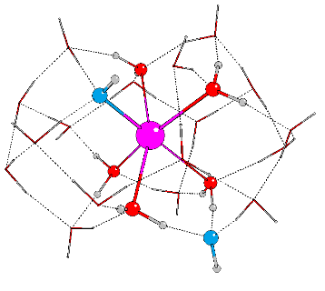
SCF Energy = -1865.3280926845

Atoms X Y Z
O -0.5600265 2.3520287 -1.0265978
Sr -0.9203225 3.4809091 1.3182027
O 1.5411528 3.3866810 1.3432326
O 1.9805798 3.2406466 -1.1623884
O 2.7449073 5.4294764 2.3097708
O -0.8767983 5.2476394 3.2128611
O -0.8398151 0.9908504 2.1309096
O -1.8899694 5.5161908 -0.0469807
O 1.3703659 5.2133859 4.7115913
O -2.0753219 3.1685079 -3.0401394
O -3.3907693 3.4069638 2.1872948
O -4.5806999 0.9418269 2.2909275
O -1.0433509 5.7616931 -2.5732304
O 1.5215595 5.8713123 -1.9075055
O -2.4779602 0.2632539 4.1258871
O -1.3104331 -0.1349936 -0.3019849
O -0.9131994 7.3971118 1.6270629
O -2.8500966 4.2851836 4.5035209
O -4.5344522 4.8305560 0.0989751
O -1.8075903 2.3061857 5.7177959
O -4.4625924 2.7272996 -1.7939032
O -4.1154572 0.3738287 -0.3718150
O 0.9909623 2.6015347 5.5184154
O 1.7019220 7.2366646 0.4894612
O 1.6674342 1.0587156 3.2752985
H -3.3268732 3.8075143 3.1536199
H -1.6813784 4.9830325 3.8224544
H -0.9432231 6.7310223 2.3777379
H -1.6526209 6.3442654 0.4563166
H -3.6557968 5.2763224 -0.0327633
H -3.9743973 3.9865573 1.6422010
H -0.9218207 0.6686853 -0.7472685
H 0.3962530 2.5407829 -1.2493490
H 1.9413860 3.2543513 -0.1166755
H 1.8679570 2.6199357 1.8508905
H 0.7993881 0.8496599 2.8430161
H -0.9686535 0.3962170 1.3427805
H -4.5979928 3.4522481 -1.1387666
H -2.9858346 3.0818268 -2.6344979
H -4.3455883 1.8956885 -1.2567366
H -5.2047305 5.5331925 0.0871509
H -1.8455382 4.1265778 -3.0309467
H -1.1055891 2.6341001 -1.8326272
H -3.1716657 0.0969826 -0.4214047
H -0.8547902 -0.9091130 -0.6712777
H -0.0468319 5.8399318 -2.4017518
H -1.6206155 5.6825242 -1.0001560
H -1.3079475 6.5571913 -3.0633874
H 1.7801567 4.9380059 -1.6882806
H 2.7631666 2.7294603 -1.4231490
H 1.5856392 6.3693927 -1.0452347
H 0.8128070 7.4136269 0.8749050
H 2.1415147 6.6353698 1.1494240
H 2.3144598 4.5682302 1.9026215
H 2.0036197 5.2575088 3.9492843
H 3.7071524 5.3073194 2.2649525
H -1.3712825 8.1953645 1.9363800
H -4.2126414 1.8677209 2.2698709
H -4.2851465 0.5095496 0.6003623
H -3.9942947 0.4950430 2.9402488
H -2.2764831 0.9663815 4.8195798
H -0.0644959 5.2714144 3.8040348
H 1.3324391 4.2592391 4.9961384
H 1.2489306 1.9982917 4.7777516
H 2.1149268 0.2052949 3.3963743
H -1.4475430 0.6444854 2.8511846
H -2.2929407 -0.5956078 4.5394205
H -2.2828473 3.1468750 5.3018739
H -3.4661168 4.8583456 4.9845252
H 0.0102816 2.4933207 5.6159441
H -2.1024111 2.2464775 6.6410816

  - [Sr:4/18:2/0]

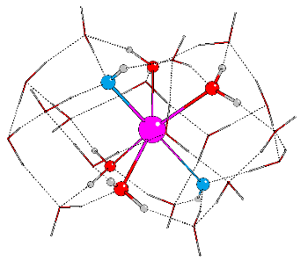
SCF Energy = -1865.3269565274

Atoms X Y Z
Sr -0.6346070 2.2865056 -1.0334767
O -1.0292426 3.4467859 1.3151426
H -0.2507289 3.7076580 1.8890594
H -1.5477985 4.2811512 1.1535978
H -2.7887919 1.6114854 3.4030318
H -1.9013554 2.2363220 2.2701771
O -2.2563674 1.3786989 2.6250259
O -2.5552626 0.8450739 -0.3294807
H -2.7249446 0.9254590 0.6283105
H 1.2255758 -0.9468731 -4.0820143
H 0.7890419 -0.4640500 -2.6404536
O -2.4177655 -1.6566105 -0.7914273
H -2.5311686 -0.6325264 -0.5780670
H -3.2211333 -2.0982208 -0.4712971
O -2.2307521 -1.4221249 -3.5429910
H -1.2773643 -1.2016780 -3.6522349
H -2.3354450 -1.5750737 -2.5648817
O -4.3953064 1.8542202 -1.7580414
H -3.7336774 1.3795256 -1.0911396
H -5.2770714 1.8528670 -1.3527873
O -2.6246400 3.8799487 -1.7180001
H -2.6063618 4.3814108 -2.5972670
H -3.4264603 3.2822854 -1.7469679
O -2.2542120 2.6009821 -5.2572825
H -2.1223181 2.4518806 -6.2077423
H -2.9027627 1.8904706 -4.9362062
O -3.8266492 0.7315661 -4.2212165
H -4.1274072 1.1013771 -3.3493062
H -3.2496650 -0.0475953 -3.9853231
O -2.4258217 5.1502793 -4.0387868
H -1.5100911 5.5431194 -3.9379246
H -2.3395525 4.3687429 -4.6324745
O 0.0170194 6.2330861 -3.5095292
H 0.0159045 6.4449436 -2.5349870
H 0.6869072 5.5150631 -3.6296485
O 1.7345222 4.0427262 -3.8365047
H 2.3013834 4.0084626 -4.6242393
H 1.1027178 3.2818027 -3.9218562
O 1.6565165 3.2577171 -0.9453434
H 1.9800838 3.4835539 -1.8379622
O 1.9433553 5.4907218 0.4117971
H 1.7470657 5.2060698 1.3282451
H 1.8562064 4.6232116 -0.1227092
O -0.0444706 6.8922953 -0.8198336
H 0.6745597 6.4036566 -0.3225855
H -0.8831460 6.5742692 -0.4155293
O 2.9355201 1.3902032 0.1093496
H 2.4962875 2.2519487 -0.3725811
H 3.8726772 1.3460938 -0.1379628
O 0.8393129 0.0908332 -0.9872696
H 1.7329501 0.3861034 -0.6542156
H 0.5490412 -0.6680105 -0.3826993
O -0.0517345 -1.8355843 0.6142838
H -0.1268552 -1.3279328 1.4687198
H -0.9672127 -1.8828101 0.2300733
O -0.0489731 -0.3024923 2.9058612
H -0.8338814 0.3018678 2.8831528
H 0.7382677 0.2906778 2.8468264
O 2.1760398 1.4742917 2.6585384
H 2.5748815 1.4150111 1.7328519
H 2.8949409 1.2628417 3.2769154
O 1.1630236 3.9933432 2.7870445
H 1.0053156 4.2877014 3.6989168
H 1.6068344 3.0999986 2.8511748
O -2.3426530 5.6119096 0.3178101
H -3.1257307 6.0367712 0.7041368
H -2.6616738 5.0614517 -0.4518065
O 0.4930294 -0.5401305 -3.5912096
O -0.1902769 2.0818356 -3.6232411
H 0.1294912 1.1553148 -3.8017342
H -0.9112475 2.2585814 -4.2982290

  - [Sr:5/16:1/2]⁻

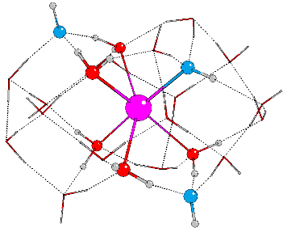
SCF Energy = -1864.8602673114

Atoms X Y Z
O -0.4680023 2.4388458 -1.0220830
Sr -0.8898481 3.2647979 1.4015730
O 1.5436736 3.5454639 1.5901776
O -0.7684224 5.5341894 0.1045374
O -1.2258188 4.5952174 -2.1745880
O -2.4907902 7.4517437 0.7161633
O 1.7255426 6.0291275 1.1673658
O 2.1438093 1.8099036 -0.2726875
O -2.2004390 4.6062375 3.2250759
O -1.1168134 3.4393370 5.2029275
O 1.1311668 4.6376576 5.3582563
O -0.7870510 1.6230113 3.4262557
O 1.5832987 -0.4304808 1.0374277
O -4.6717987 4.1891613 2.3209367
O -3.3129948 2.1988261 1.0539374
O -1.8142695 0.2045918 -1.8528128
O 2.7771172 2.8391497 4.1844290
O -4.1113779 1.8139869 -1.4912438
O -3.8397890 4.3388824 -2.1847742
O -1.6998456 7.2735324 3.4063295
O -2.6467002 -0.1405944 2.4515088
O 1.6077630 0.3550967 3.7216905
O -1.0875496 -1.2004826 0.4098823
O 1.0079071 6.9136681 3.6913209
O -4.7162195 5.8676352 0.0265861
H -0.9291216 2.2474501 4.2421690
H -1.8538336 4.1787511 4.1177104
H -3.8253138 4.4014977 2.8217992
H -3.9752399 2.7870275 1.5041851
H -3.0963105 0.5706094 1.9341601
H -1.9842251 0.3897119 2.9700260
H 1.3129500 1.9661332 -0.7855085
H -0.7268637 3.2505168 -1.6149397
H -0.8824371 5.2441208 -0.9165791
H 0.1588756 5.8480935 0.2630012
H 1.7634815 4.9823926 1.3339654
H 2.0307013 2.5001197 0.4793796
H -1.6289837 -0.8704961 1.1769596
H -1.6427779 -0.3368339 -1.0338219
H -0.1543030 -0.9483109 0.6183623
H -2.7098203 0.6026180 -1.7513734
H -0.9379973 1.6403309 -1.3909316
H 1.8485204 0.3861838 0.4947948
H -4.0516086 2.7797614 -1.8167636
H -3.6738219 2.0287664 0.1358448
H -5.0290136 1.5277139 -1.6274389
H -2.8290255 4.4802518 -2.2339748
H -0.7576068 4.9548803 -2.9432305
H -4.1441044 4.8757910 -1.4087533
H -4.7997110 5.3060156 0.8327950
H -3.9890263 6.5015080 0.2468614
H -1.7965388 6.7810262 0.4148698
H -1.9176005 7.5172888 2.4742054
H -2.3437619 8.2529142 0.1872221
H -5.3765092 4.0960788 2.9821081
H 1.7375858 0.0773575 2.7796139
H 0.0767316 1.1435449 3.5799197
H 2.2156255 -1.1283663 0.7989949
H 2.1591378 1.1637676 3.8589925
H 2.2352804 3.5065947 4.6997307
H -2.0388562 5.5914197 3.3133106
H -0.7040540 7.2255095 3.4628024
H 1.3421949 6.6232819 2.8012137
H 2.5551688 6.2864154 0.7349639
H 2.0017829 3.3207540 2.4251857
H 3.7087843 3.0512693 4.3523939
H 0.1983602 4.1583934 5.3839341
H -1.6214232 3.2747070 6.0139087
H 1.0684273 6.1129330 4.2730984
H 1.3447053 4.8750832 6.2751863

  - [Sr:4/17:2/1]⁻

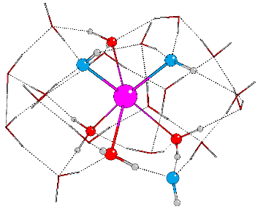
SCF Energy = -1864.8613269723

Atoms X Y Z
O -0.4887090 2.3940342 -1.0716936
Sr -0.8973291 3.3607683 1.3566103
O 1.5463312 3.5429430 1.5475620
O -0.8206066 5.5022090 0.0656184
O -2.4806506 7.3210998 0.6700544
O -1.2948277 4.6850473 -2.2834330
O 1.8532144 6.0562824 1.2209300
O 2.1510721 1.7899674 -0.2720671
O 1.5763932 -0.4450806 1.0357375
O -2.2383125 4.6147746 3.2437460
O -1.7141631 7.2814790 3.3326172
O -1.8294953 0.1811529 -1.8119370
O -0.7792298 1.6698359 3.3946627
O 1.6031080 0.3618895 3.7114500
O -1.1180907 3.4554954 5.2102127
O -4.6936825 4.1747096 2.3318554
O -3.3105720 2.2178473 1.0390143
O -4.1713589 1.7611922 -1.4865489
O -4.0254341 4.3295644 -2.1672619
O -2.6327475 -0.1008730 2.4605659
O 0.9917645 6.9094824 3.6846892
O 1.1348580 4.6339902 5.3547974
O -1.0984654 -1.2115520 0.4373285
O 2.7735053 2.8395240 4.1649878
O -4.7348103 5.8499702 0.0373691
H -0.9245720 2.2790538 4.2175781
H -1.8767590 4.1914562 4.1292070
H -3.8482150 4.3931724 2.8344413
H -3.9754483 2.7964876 1.4978958
H -3.0837138 0.5997421 1.9300581
H -1.9624451 0.4442606 2.9568075
H 1.3422070 1.9295901 -0.8163982
H -0.7083514 3.1381727 -1.6958651
H -1.0424411 5.1312182 -1.3607330
H 0.0784246 5.8581070 0.2150575
H 1.8172061 5.0143932 1.3381965
H 2.0114259 2.4957375 0.4707834
H -1.6328515 -0.8608881 1.2014809
H -1.6548885 -0.3641681 -0.9935197
H -0.1624071 -0.9589828 0.6336617
H -2.7360513 0.5542557 -1.7226890
H -0.9685623 1.5805349 -1.4123089
H 1.8434181 0.3731542 0.4953495
H -4.1651329 2.7207240 -1.8114049
H -3.6905850 2.0241365 0.1359782
H -5.0820433 1.4395076 -1.5863692
H -3.0540732 4.5093729 -2.2849240
H -0.8416774 5.1784236 -2.9852461
H -4.2899891 4.8664513 -1.3692045
H -4.8259123 5.2867370 0.8415253
H -3.9580969 6.4395668 0.2407196
H -1.7617687 6.6008895 0.3807353
H -1.9235887 7.4474395 2.3766744
H -2.3300054 8.1033271 0.1150616
H -5.3963371 4.0634569 2.9922678
H 1.7301899 0.0769049 2.7712580
H 0.0801405 1.1855035 3.5479343
H 2.2097896 -1.1422344 0.7983407
H 2.1585628 1.1686941 3.8431773
H 2.2320100 3.5084834 4.6791144
H -2.0698884 5.6002414 3.3159625
H -0.7207816 7.2168118 3.4018425
H 1.3631887 6.6171482 2.8066845
H 2.7529518 6.2740370 0.9299713
H 1.9830645 3.3036847 2.3894724
H 3.7052162 3.0639374 4.3150461
H 0.1973928 4.1588534 5.3841766
H -1.6084332 3.2711744 6.0257112
H 1.0497676 6.1136930 4.2726073
H 1.3564058 4.8656667 6.2712711

  - [Sr:3/18:3/0]⁻

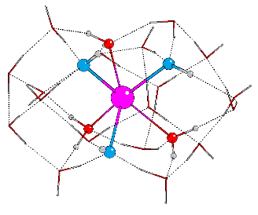
SCF Energy = -1864.8593862609

Atoms X Y Z
O 1.7301519 0.8769268 1.8606126
Sr 0.0659548 -0.0328840 -0.0311429
O 1.6271077 0.9594245 -1.6669815
O 1.6920027 -1.9388986 0.1372275
O 2.6870257 -1.5972475 2.4305702
O 0.6824593 -4.2660361 0.0403324
O 2.8440484 -1.1281487 -2.4789489
O 2.7675985 2.6476392 -0.0568290
O -1.7191033 -1.5314098 -0.9998930
O -2.7353796 -0.0149956 -2.6991196
O -0.8940136 0.0342595 -4.6282432
O -1.7181746 1.7874685 -0.9560285
O 0.8810858 4.4978152 0.1120447
O -2.8259126 -2.2859167 1.1573394
O -1.6624965 -0.0298173 2.0360938
O 0.7200506 2.2004507 3.9842545
O 0.4766579 2.3423225 -4.0533252
O -0.6483076 -0.2233629 4.5501335
O 0.6358604 -2.4969629 4.0376150
O -0.5963244 -3.8289098 -2.3983885
O -2.8140765 2.4349954 1.4827762
O -0.6905163 3.9855210 -2.1306664
O -0.7021212 3.9607576 2.4245260
O 0.8792799 -2.1639393 -4.0822360
O -0.9065962 -3.9753463 2.2862332
H -2.2411036 1.2758127 -1.6328881
H -2.3763481 -0.7453511 -1.9828089
H -2.4566660 -2.0307598 0.2033539
H -2.2373676 -0.8274395 1.8573680
H -2.5394455 1.5553831 1.8460222
H -2.5715163 2.3234978 0.5270870
H 2.6225679 2.1169239 0.7613680
H 2.2228767 0.0750396 2.1852301
H 2.3773750 -1.8110021 1.4402427
H 2.2985648 -1.8297258 -0.6220159
H 2.4073671 -0.2199438 -2.1810320
H 2.3678470 2.0165478 -0.7724552
H -1.4884482 3.4627701 2.0693704
H 0.1330927 2.8338642 3.4830976
H -0.1422049 4.1613550 1.6343807
H 0.1460174 1.4700475 4.3104368
H 1.4081724 1.3631101 2.6763620
H 1.6529872 3.8369065 0.0620340
H -0.1532427 -1.0997652 4.4354022
H -1.3573604 -0.1099571 2.9818744
H -1.2862653 -0.3564778 5.2698228
H 1.4292381 -2.2294035 3.5002003
H 3.6116349 -1.8768226 2.5203558
H 0.0662378 -3.0248675 3.4095350
H -1.6518705 -3.4320658 1.9250661
H -0.3270449 -4.1483441 1.4953021
H 1.1525494 -3.3206563 0.0735935
H -0.0624029 -4.0574269 -1.5959055
H 1.3888609 -4.9285537 0.1077315
H -3.7782482 -2.4517249 1.0751965
H -0.0421243 4.2326519 -1.4219262
H -1.3763663 2.6087352 -1.4208883
H 1.2853745 5.3801209 0.1535679
H -0.1780456 3.5359079 -2.8451828
H -0.0331196 1.5436163 -4.3605871
H -1.3756030 -2.3243189 -1.4717456
H -0.0118687 -3.2666513 -2.9717531
H 1.6242868 -1.7755352 -3.5435956
H 3.6992660 -0.9078348 -2.8811009
H 1.2826370 1.4298542 -2.4512352
H 1.0794954 2.5762396 -4.7766415
H -1.6644766 -0.0064198 -3.9785201
H -3.6717662 -0.1951040 -2.8779749
H 0.2769782 -1.4074127 -4.2751973
H -1.2879321 -0.0237052 -5.5142724

  - [Sr:3/17:2/2]²⁻

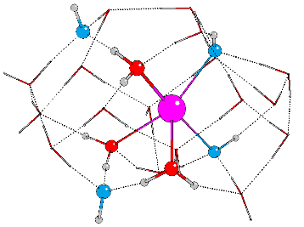
SCF Energy = -1864.3776225447

Atoms X Y Z
O -1.9447171 -2.9960714 -1.3692076
O -1.4053434 -1.6676655 1.0128454
Sr 0.2261680 -0.0938727 -0.2443895
O 0.5425264 1.8298897 -1.6874437
O 2.0024980 -1.6019211 0.8904612
O 0.7158039 1.6592461 1.6165369
O -1.6128859 2.4258186 2.2652351
O 2.6317150 -2.6179704 -1.5702948
O 3.9607665 -0.3192780 2.1340901
O 0.4015629 -2.6187223 2.5334225
O 2.4518773 3.1952575 0.2641122
O 1.9408721 1.1080391 -3.7839613
O -1.8730726 2.6387718 -2.3052240
O -3.8174195 -1.2906529 -2.1626403
O -2.1970638 0.6255425 3.9413537
O -2.5347877 0.5481222 -3.9050859
O 0.2833437 -1.8048049 -2.0356969
O -0.0720963 -0.5533890 -4.6867764
O -3.6737157 -0.9401119 2.4096919
O 0.1213502 -0.9275213 4.5585577
O 4.4231736 1.2585333 -0.1575874
O -4.7160805 0.1768330 0.0656110
O -3.1958886 2.5259088 0.1133816
O 3.9855997 -0.3247612 -2.4242301
O 2.0623152 0.8570143 3.8715047
H -1.0689948 -2.5955607 -1.7305372
H -1.8883204 -2.7165408 -0.4212740
H -3.1320660 -1.9921665 -1.8987114
H -4.5471589 -1.7740820 -2.5836681
H -4.3998820 -0.3857348 -0.6852269
H -4.4201921 -0.2777036 0.8904695
H -2.2260931 -1.4580416 1.5270896
H -2.3548964 2.6080956 -1.4340949
H -0.9123619 2.3776221 -2.0715696
H -2.3305856 1.3214035 -3.2990083
H -2.9895141 -0.1118189 -3.3283711
H -0.9220241 -0.1255292 -4.4041300
H 0.6547478 0.0692328 -4.4074417
H 0.1974640 -1.4523977 -2.9484386
H 1.0453701 2.5419852 -1.2545304
H 2.8143858 -3.5163536 -1.8874673
H 2.3126915 -2.1971008 0.1604046
H 2.7225265 3.9872235 0.7560674
H 1.7838879 2.7207789 0.8463666
H 3.7551923 1.9800315 -0.0271566
H 4.3648694 0.7165083 0.6668652
H 3.5731005 -1.1759747 -2.1293298
H 4.1142810 0.2136701 -1.5999315
H 2.6654610 0.5710353 -3.3765543
H 1.4043797 1.4290158 -2.9721694
H 3.2785510 -0.9054063 1.6761782
H 4.6603187 -0.9129125 2.4523118
H 1.4116668 0.1540954 4.1658952
H 2.7946019 0.3819044 3.4116677
H -0.2250416 2.0456631 1.9097542
H 1.1836238 1.3923111 2.4575679
H 1.4057219 -2.1533068 1.5857095
H -1.6031756 3.3072878 2.6714948
H 0.4036310 -3.5775630 2.6769441
H -0.7487774 -2.1464828 1.6740673
H -1.9639092 1.4312861 3.2804144
H -2.6211716 1.0167893 4.7220470
H -0.6923379 -0.4071156 4.3474140
H 0.2032876 -1.6213326 3.8229380
H -3.2076399 -0.3416842 3.0798019
H -4.1219237 -1.6362163 2.9161523
H 1.6430924 -2.3658688 -1.8571087
H -2.6008036 2.4824797 0.9327438
H -3.7300168 1.6915092 0.1138965

  - [Sr:2/18:3/1]²⁻

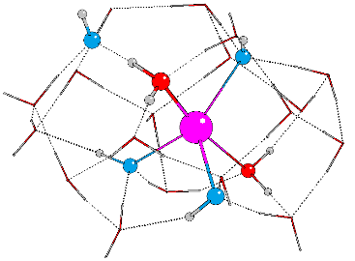
SCF Energy = -1864.3817770345

Atoms X Y Z
O -2.0987037 -2.9929811 -1.1737162
O -1.3899699 -1.6018519 0.8900547
Sr 0.3228060 -0.1800850 -0.1130726
O 0.5501259 1.7275779 -1.6518550
O 2.1656036 -1.6332091 0.6895597
O 0.7258683 1.6803352 1.6437918
O -1.5995654 2.4546246 2.2870490
O 2.9378204 -2.5355497 -1.5644984
O 3.9045525 -0.3366998 2.0074993
O 0.1223899 -2.8282407 2.5600883
O 2.4123299 3.2317674 0.2600020
O 1.8956598 1.1066405 -3.7881264
O -1.8482484 2.5729115 -2.2555169
O -3.8847571 -1.2774119 -2.1163922
O -2.1797982 0.6536296 3.9599667
O -2.4955876 0.4820139 -3.8423759
O 0.3352832 -1.9043758 -2.1467555
O -0.0571466 -0.6574221 -4.4917073
O -3.8080301 -0.8348011 2.4498231
O 0.0562218 -0.9311742 4.5501808
O 4.4470639 1.3492427 -0.1450195
O -4.7819797 0.2418979 0.0862919
O -3.2179732 2.5707157 0.1498007
O 4.0913307 -0.1492586 -2.4785787
O 2.1059929 0.7555513 3.8291404
H -1.2771252 -2.8449641 -1.6945533
H -1.8690540 -2.4893083 -0.2967721
H -3.2270734 -1.9820712 -1.7944144
H -4.6094128 -1.7623911 -2.5441585
H -4.4584732 -0.3228738 -0.6589825
H -4.4809909 -0.2059235 0.9144211
H -2.1912906 -1.3331233 1.3810509
H -2.3396564 2.5680210 -1.3895329
H -0.8944630 2.2837500 -2.0131664
H -2.2992042 1.2612853 -3.2378923
H -2.9895521 -0.1580378 -3.2739013
H -0.9220264 -0.2058143 -4.2815415
H 0.6606350 0.0214042 -4.3200440
H 0.2159348 -1.5029885 -3.0625799
H 1.0426945 2.4483537 -1.2211596
H 3.3928833 -3.3919149 -1.5371190
H 2.6886454 -2.2783521 -0.5824991
H 2.6511054 4.0472345 0.7295025
H 1.7649814 2.7454621 0.8569894
H 3.7601047 2.0527612 -0.0214360
H 4.3315143 0.7516096 0.6398344
H 3.7593269 -1.0311308 -2.1760272
H 4.1949088 0.3849114 -1.6464087
H 2.6770459 0.6301522 -3.4118837
H 1.3736488 1.3945897 -2.9461085
H 3.2180489 -0.9383469 1.4809864
H 4.6241149 -0.9210195 2.2958588
H 1.4348366 0.0737019 4.1122352
H 2.7903262 0.2792041 3.2917097
H -0.2188115 2.0632528 1.9338604
H 1.1951158 1.3980506 2.4786037
H 1.7208480 -2.2632721 1.2904427
H -1.5838849 3.3330697 2.6997426
H -0.2276195 -3.7097617 2.7657113
H -0.5506602 -2.3927997 1.8877651
H -1.9463047 1.4574710 3.2942787
H -2.5863073 1.0523877 4.7462465
H -0.7385566 -0.3728464 4.3443818
H 0.0480957 -1.6580802 3.8682525
H -3.2585744 -0.2886790 3.0916593
H -4.1582031 -1.5868938 2.9520923
H 1.2449754 -2.2995889 -2.1182528
H -2.6087880 2.5105524 0.9560980
H -3.7538469 1.7374025 0.1454934

  - [Sr:1/19:4/0]²⁻

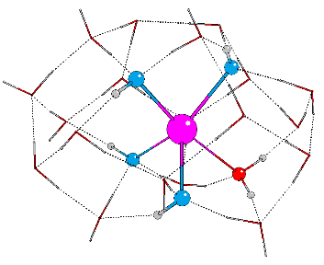
SCF Energy = -1864.3808332762

Atoms X Y Z
O -1.3024089 -2.9558172 -2.0182701
O -1.6273328 -1.6256916 0.1762240
Sr 0.3516284 -0.1749316 0.1125065
O 1.6596604 -1.7116490 1.5843862
O -0.0996111 1.6208307 1.7915741
O -2.4131276 2.4544086 1.3855806
O 1.9242216 3.1529259 1.3531933
O 3.3588827 -2.5265566 -0.1157152
O 2.5960465 -0.4158654 3.5573384
O -1.0279110 -2.9074621 2.3115122
O 1.1788988 1.7413984 -1.2172073
O 1.2869163 -1.8699812 -1.7805910
O -2.4914497 -1.2389207 -3.6415316
O -3.8005287 0.5665253 2.6237903
O 1.9829737 -0.5909272 -4.0474208
O 3.3614770 1.1723997 -2.5016733
O 4.7369301 -0.0981713 -0.3585434
O -4.5185776 -0.8809020 0.4429704
O -0.4953260 0.5302481 -4.5830924
O -0.6320319 2.6173562 -2.8663237
O -2.9884559 2.6036466 -1.3514203
O -4.2773384 0.2653693 -2.0791350
O -1.9933782 -1.0815677 4.1141460
O 3.9550452 1.3542002 1.8861247
O 0.1801272 0.6110431 4.5355005
H -0.3353708 -2.7873232 -2.1034946
H -1.5045771 -2.4762711 -1.1209594
H -2.0395794 -1.9424793 -3.0618316
H -2.9546376 -1.7259760 -4.3426036
H -3.6508713 -0.2961933 -2.6023529
H -4.3982822 -0.1979393 -1.2150214
H -2.5659856 -1.3665896 0.2518698
H -1.4723469 2.6118773 -2.3397708
H 0.0911957 2.3077391 -2.2015474
H -0.5894606 1.3077988 -3.9529878
H -1.1844098 -0.1140692 -4.2883583
H 1.1117390 -0.1497537 -4.2514020
H 2.5295570 0.0898614 -3.5536299
H 1.5865342 -1.4514239 -2.6441637
H 1.4163079 2.4376243 -0.5775379
H 3.7696274 -3.3824204 0.0837999
H 2.6901368 -2.3051450 0.6616811
H 1.8890966 3.9517777 1.9030448
H 1.0793788 2.5955096 1.5893037
H 3.2551420 2.0364446 1.6970241
H 3.5265735 0.7314283 2.5299193
H 4.3253095 -0.9924503 -0.2562112
H 4.4336293 0.4188097 0.4360388
H 3.8896322 0.6909234 -1.8171437
H 2.5040484 1.4376222 -1.9889107
H 2.2263382 -1.0154978 2.7742728
H 3.1386602 -0.9938323 4.1175381
H -0.5449057 -0.0545249 4.4021190
H 1.0227441 0.1681278 4.2633128
H -1.3847432 2.1358119 1.5866793
H -0.0484535 1.3383240 2.7317579
H 0.9888012 -2.3485267 1.8994772
H -2.5115854 3.3413747 1.7683881
H -1.4402912 -3.7859846 2.3144317
H -1.3254777 -2.4450366 1.4193632
H -3.3091700 1.3463110 2.1994443
H -4.5121894 0.9533497 3.1596820
H -2.6149595 -0.5146709 3.5985507
H -1.6836416 -1.7799963 3.4721873
H -4.3644968 -0.3628703 1.2818662
H -5.0818782 -1.6333327 0.6827333
H 2.0908395 -2.2649250 -1.3541641
H -2.7787747 2.5342371 -0.3835771
H -3.4445549 1.7530219 -1.5920229

- Transition state for the Sr²⁺ dihydroxide ([Sr:4/18:2/0]) → Sr²⁺ monohydroxide ([Sr:5/17:1/1]) reaction

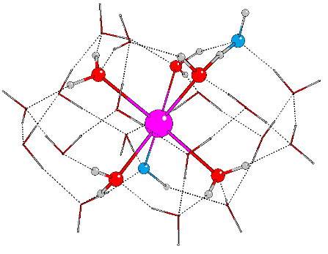
SCF Energy = -1865.3263494039

Atoms X Y Z
O -0.5790432 2.3401857 -1.0245693
Sr -0.9824667 3.4656450 1.3199584
O 1.5022349 3.3914149 1.3596560
O 1.9565439 3.2404321 -1.1381066
O 2.7264867 5.4256315 2.2994586
O -0.8591486 5.2826239 3.2181599
O -2.9299180 4.2603116 4.4925783
O -3.3359147 3.4006241 2.2489891
O -1.8033891 2.2666459 5.7592977
O -0.8215151 0.9586610 2.1346807
O -1.8955521 5.5210226 -0.0516049
O -2.0763120 3.1679697 -3.0501351
O -0.9034466 7.4266025 1.5980425
O -2.4577511 0.2056591 4.1353596
O -1.0411134 5.7599488 -2.5795132
O 1.5242610 5.8638001 -1.9132234
O -1.3123913 -0.1493928 -0.3042498
O 1.3649723 5.2137291 4.6952927
O -4.4598764 2.7431619 -1.7999765
O -4.5639289 4.8614267 0.0444103
O -4.5329116 1.0193707 2.2813653
O 1.6713380 1.0599515 3.2816784
O 1.0127076 2.6044692 5.5152856
O -4.1205934 0.4048193 -0.3546095
O 1.7182405 7.2456047 0.4733767
H -3.2443333 3.8620127 3.4145549
H -1.6478937 5.0701971 3.8119734
H -0.9268751 6.7787187 2.3600224
H -1.6551853 6.3503116 0.4461867
H -3.6670199 5.2771398 -0.0487908
H -3.9366443 3.9648482 1.7210464
H -0.9307714 0.6596881 -0.7465923
H 0.3788102 2.5374900 -1.2341001
H 1.9051567 3.2586217 -0.0899091
H 1.8323402 2.6261877 1.8672486
H 0.8055702 0.8441709 2.8457756
H -0.9522080 0.3710436 1.3418359
H -4.5899839 3.4769919 -1.1508309
H -2.9865938 3.0854158 -2.6413916
H -4.3405532 1.9168636 -1.2546969
H -5.2067980 5.5824996 -0.0543895
H -1.8410412 4.1247240 -3.0375550
H -1.1161272 2.6252528 -1.8346857
H -3.1830680 0.1115116 -0.4145438
H -0.8582317 -0.9184975 -0.6855143
H -0.0448941 5.8372445 -2.4061244
H -1.6234096 5.6823090 -1.0042378
H -1.3039200 6.5551039 -3.0711359
H 1.7709371 4.9299462 -1.6812937
H 2.7415260 2.7274881 -1.3879577
H 1.5917259 6.3701867 -1.0560606
H 0.8272261 7.4299311 0.8503403
H 2.1442123 6.6361880 1.1351939
H 2.2806304 4.5641266 1.8997902
H 1.9994271 5.2592577 3.9324049
H 3.6866974 5.2893540 2.2518444
H -1.3570537 8.2312320 1.8975003
H -4.1087262 1.9382632 2.2795625
H -4.2685663 0.5724266 0.6196929
H -3.9805657 0.5264475 2.9239602
H -2.2629411 0.8948910 4.8361758
H -0.0439873 5.2912070 3.8146825
H 1.3354984 4.2608642 4.9858187
H 1.2629521 1.9984957 4.7728803
H 2.1266690 0.2107240 3.4025862
H -1.4287233 0.6065110 2.8501983
H -2.2769623 -0.6582585 4.5401873
H -2.2982446 3.0667635 5.3613340
H -3.6660180 4.7504582 4.8905194
H 0.0384391 2.4851534 5.6330174
H -2.0908143 2.1995568 6.6847264

- The effect of infinite permittivity on the relative energies
Table (i): Dependence of the absolute and relative SCF and Gibbs free energies on the dielectric constant (ε) of the COSMO calculation.

total number of OH | Type of hydroxide | ε=80 | ε=∞ | ε=80 | ε=∞ | ε=80 | ε=∞ | ε=80 | ε=∞
 |  | SCF ENERGY (a.u.) |  | E+G ENERGY (a.u.) |  | ∆SCF (kJ/mol) |  | ∆G (KJ/MOL)
2 | mono [Sr:5/17:1/1] | -1865.326 | -1865.328 | -1864.848 | -1864.850 | 0.0 | 0.0 | 0.0 | 0.0
 | di [Sr:4/18:2/0] | -1865.325 | -1865.327 | -1864.847 | -1864.849 | 3.2 | 3.0 | 3.1 | 2.9
3 | mono [Sr:5/16:1/2]⁻ | -1864.858 | -1864.860 | -1864.392 | -1864.395 | 2.8 | 2.8 | 3.4 | 2.9
 | di [Sr:4/17:2/1]⁻ | -1864.859 | -1864.861 | -1864.394 | -1864.396 | 0.0 | 0.0 | 0.0 | 0.0
 | tri [Sr:3/18:3/0]⁻ | -1864.857 | -1864.859 | -1864.393 | -1864.396 | 5.4 | 5.1 | 2.4 | 1.8

- Single point calculations for Equation 1 with different basis sets
Table (ii): Dependence of SCF energies (kJ/mol) for Equation 1 on basis set quality. For the def2-SVP and def2-TZVP basis sets the error percentages compared with the def2-QZVP are shown in parentheses.

total number of OH | Type of hydroxide | SVP (EQZVP-SVP) |  | TZVP (EQZVP-TZVP) |  | QZVP
1 | mono [Sr:5/18:1/0]⁺ | -49.3 | (5.3%) | -36.3 | (1.0%) | -33.3
2 | mono [Sr:5/17:1/1] | -89.1 | (18.8%) | -60.9 | (3.3%) | -54.8
 | di [Sr:4/18:2/0] | -80.3 | (14.7%) | -57.9 | (3.0%) | -52.0
3 | mono [Sr:5/16:1/2]⁻ | -115.2 | (32.6%) | -74.5 | (6.1%) | -65.2
 | di [Sr:4/17:2/1]⁻ | -114.6 | (31.7%) | -77.3 | (6.3%) | -67.9
 | tri [Sr:3/18:3/0]⁻ | -104.8 | (26.3%) | -72.2 | (5.9%) | -62.9
4 | di [Sr:3/17:2/2]²⁻ | -71.4 | (12.3%) | -49.2 | (3.0%) | -42.1
 | tri [Sr:2/18:3/1]²⁻ | -79.2 | (13.9%) | -60.1 | (3.8%) | -53.0
 | tetra [Sr:1/19:4/0]²⁻ | -72.6 | (11.2%) | -57.6 | (3.6%) | -50.4

