Secondary Crystal Nucleation:
Nuclei Breeding Factory Uncovered
Jamshed Anwar*^{[a]}, Shahzeb Khan^{[b]}, and Lennart Lindfors^{[c]}
[a] Prof. Jamshed Anwar
Chemical Theory and Computation, Department of Chemistry, Lancaster University, Lancaster LA1 4YB U.K.
Email: j.anwar@lancaster.ac.uk
[b] Dr Shahzeb Khan
Department of Pharmacy
University of Malakand, KPK, Pakistan
[c] Dr Lennart Lindfors
Pharmaceutical and Analytical R & D, Experimental Formulations, AstraZeneca R&D Mölndal, SE-431 83 Sweden

Abstract: Secondary nucleation, wherein crystal seeds are utilized to induce crystallization, is widely employed in industrial crystallizations. Despite its significance, our understanding of the process, particularly at the molecular level, remains rudimentary. An outstanding question is why do a few seeds give rise to a many-fold increase in new crystals? Using molecular simulation coupled with experiments we have uncovered the molecular processes that give rise to this autocatalytic behaviour. The simulations reveal formation of molecular aggregates in solution, which on coming in contact with the surface of the seed undergo nucleation to form new crystallites. These crystallites are weakly bound to the crystal surface and can be readily sheared by fluid, making the seed surfaces available again to repeat the process. Further, the new crystallites on development can in turn serve as seeds. This mechanistic insight will enable better control in engineering crystalline products to design.
It is common practice both in research and industry to employ crystal seeds to induce crystallization, a process termed as secondary nucleation.^{[1]} This can enable the selective crystallization of a particular crystalline or chiral form, and yields a more consistent crystalline product in terms of particle size and distribution.^{[2]} Secondary nucleation is also now considered as a key mechanism for consolidating biological homochirality post symmetry-breaking in the racemic prebiotic world.^{[3]} What is remarkable about secondary nucleation is that the addition of a small quantity of seed crystals can result in a many-fold increase in the number of new crystals (i.e. one-to-many relationship), as if some kind of breeding of the emergent embryonic crystallites - the nuclei, occurs.^{[4,5]} Exactly how the crystal seeds are involved in breeding new nuclei is an outstanding fundamental question.
Supersaturated solutions exhibit a metastable region over which crystallization does not occur provided the solution is free from impurities or is not perturbed, which suggests a free energy barrier. The barrier results from the interplay between the favourable cohesive free energy of the solute-solute interactions and the (generally) unfavourable interfacial free energy characterizing the created interface between the organized molecules in the nucleus and the solvent phase. At some critical radius of the nucleus, the cohesive energy (being dependent on the number of molecules in the nucleus) overwhelms the interfacial free energy (which depends on the surface area). Thus, clusters of solute which are larger than the critical radius become stable and grow, whilst smaller ones re-dissolve. This is the basis of the classical nucleation theory (CNT) for unperturbed, homogeneous systems free from foreign particles i.e. homogenous nucleation.^{[6,7]} Nucleation is easier on foreign particles as the solute-solvent interface is now reduced, which forms the basis for the more commonplace phenomenon termed heterogeneous nucleation. A variation on CNT which is gaining traction is multistep nucleation theory (MNT), which includes the possibility of decoupling of the 2 main order parameters, density and structure.^{[8-13]} Thus, a pathway to nucleation could in principle involve first an increase in density and then the development of crystallinity.
Nucleation in the presence of crystalline solute material is termed secondary nucleation, and forms the basis for most industrial crystallization processes where crystal seeds are employed to promote bulk crystallization. It is particularly important in continuous crystallization, where a certain amount of the product crystal is always present to induce nucleation in the fresh feed.
Despite the importance of secondary nucleation, our understanding of this phenomenon remains limited. This is largely because the molecular level picture is experimentally inaccessible and the interpretation of observations and measurements requires much inference. The fundamental experimental observations go back many decades and include: (i) seeds of a pure enantiomer or of a particular polymorphic form can induce crystallization of that particular form, confirming that the origin of the secondary nuclei is the crystal seed;^{[2,14]} (ii) movement of a crystal in a moderately supersaturated solution or the movement of the solution past a stationary crystal surface produces copious nuclei;^{[15]} and (iii) contact between crystals, between a crystal and the agitator, or a crystal with the vessel surface in a moderately supersaturated solution can give rise to breeding of crystal nuclei, which is termed contact breeding (or collision breeding in the earlier literature).^{[16-18]} For example, allowing a crystal to slide along the bottom of a tilted glass vessel containing a moderately supersaturated solution yields large numbers of nuclei.^{[18]}
There are two main ideas that attempt to rationalize the above and other related observations. The first suggests that secondary nuclei originate from semi-ordered clusters of solute molecules at the crystal-solute interface.^{[4,16]} The alternative proposition is that secondary nuclei originate from micro-attrition (mechanical breakage or shearing) of the rough growing surface of the seed crystal or of the original seed surface itself. Recent work of Cui & Myerson^{[19]} indicates that nuclei can originate from both mechanisms, with mechanical attrition being promoted at higher contact/impact forces - which is intuitive.
We note that whilst micro-attrition has been shown as an important mechanism for nuclei generation at high contact force, these observations have mainly come from large single crystals. In stirred crystallizations involving crystal seeds in the micron-size range, micro-attrition is probably insignificant. In fact we assert that mechanical breakage of typical seed crystals (of the order of 10 μm) would not occur even under harsher conditions. This particle size range is close to the critical diameter d_{crit} that characterises the brittle-ductile transition for most substances.^{[20,21]} Below d_{crit} all impact energy is accommodated by lattice slip.
Whilst nuclei breeding has been linked with dislodging of formed crystalline structures from the seed surface, its catalytic nature has been given little consideration. A relatively recent computational study revealed that a curved surface (serving as a seed) can act as a catalyst.^{[22]} Pre-critical nuclei were observed to form on the curved surface, which on further growth became strained and then detached, leaving the surface available for the next event. The detached clusters underwent homogeneous nucleation in the solution.
To uncover the molecular level processes in secondary nucleation, we employed molecular dynamics (MD) simulations,^{[23,24]} wherein the trajectories of interacting molecules are simulated. The solute and solvent molecules were represented by simple, single-particle models based on the Lennard Jones (LJ) interaction. Such simple models are appropriate since the nucleation processes of interest are generic, being observed in a wide class of materials. These models have been successfully employed by us earlier to probe other crystal nucleation problems including the design rules for nucleation inhibitors.^{[25,26]}
A series of large-scale MD simulations were carried out in which a crystal slab (approximate size 43.7 x 43.7 x 91.0 nm, comprising 172800 molecules) representing a seed crystal, was immersed in a set of solutions of increasing supersaturation (see Figure 1). The solution concentration was kept fixed at approximately 17.6 % (124080 solute, 703120 solvent molecules), with supersaturation being varied via the LJ solute-solvent affinity parameter ε(solute-solvent). A solute with a low affinity for the solvent would be poorly soluble. Therefore, setting the affinity to a low value for a fixed solute concentration yields a more supersaturated solution. Five different supersaturations were considered.
The simulations revealed three distinct supersaturation regimes (Figure 1). At low supersaturation (Lennard Jones solute-solvent affinity parameter ε = 3.5 kJ mol⁻¹), the simulations reveal (rough) growth of the crystal slab on both surfaces and no primary or secondary nucleation events, which is entirely as expected (Figure 1b). At high supersaturation (Lennard Jones solute-solvent affinity parameter ε = 2.5 kJ mol⁻¹), one observes spontaneous nucleation in the solution phase, with some of these nuclei interacting with the crystal surface (Figure 1d). This too is expected as the chemical potential of the solution is sufficient to induce homogenous nucleation events in the bulk solution.
The fascinating observations come from the intermediate supersaturation regime defined by the Lennard-Jones solute-solvent affinity parameter ε = 3.0 kJ mol⁻¹, where the solute molecules form spherical clusters in solution but do not nucleate (Figure 1c). The clusters that are close to the crystal seed surface, on making contact with the surface, immediately nucleate. Any clusters that come in contact with the newly formed nuclei also nucleate. Thus we have individual crystallites and aggregates of crystallites attached to the seed surface. A particular feature of interest is that the contact area between the crystallites and the slab surface and that between any two tethered crystallites is rather minimal, reflecting the contact between a sphere and a flat surface or between two spheres, respectively. The implication is that the nuclei are bound rather weakly to the seed surface or between themselves.

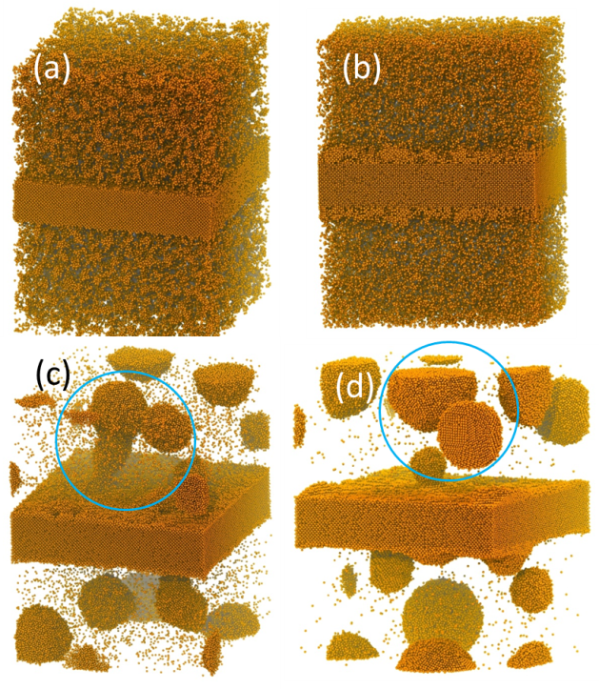

Figure 1. Snapshots from molecular dynamics simulations of a crystal slab (representing the seed crystal) immersed in a supersaturated solution of solute, illustrating the three supersaturation regimes: crystal growth, surface-induced nucleation of clusters, and spontaneous nucleation in solution. The system consists of 172800 molecules of solute within the crystal slab, 124080 of molecules of solute in solution, and 703120 molecules of solvent representing a solute concentration of about 17.6%. The simulations utilised 3-dimensional periodic boundaries to eliminate surfaces. Consequently, corresponding parts of structures that are cut by the simulation cell edges appear at the opposing cell surface. The solvent is not shown. (a) Starting configuration. (b) Low supersaturation (Lennard Jones solute-solvent affinity parameter ε = 3.5 kJ mol⁻¹): giving rise to (rough) crystal growth of the seed crystal at both the top and bottom surfaces (135 ns into the simulation). (c) Moderate supersaturation (Lennard Jones solute-solvent affinity parameter ε = 3.0 kJ mol⁻¹): solute clusters form in solution and nucleate on coming into contact with the crystal surfaces or with the previously nucleated clusters attached to the surfaces (225 ns); note the low contact area between nuclei and between nuclei and crystal surface. (d) High supersaturation (Lennard Jones solute-solvent affinity parameter ε = 2.5 kJ mol⁻¹): spontaneous nucleation occurs in the solution phase, along with some events involving nucleation of disordered clusters when they make contact with the seed surfaces (225 ns).
The picture that emerges is that, under conditions when seeding is employed, the seed surface induces nucleation of pre-existing clusters, and that these newly formed nuclei are weakly bound to the surface and can be readily mechanically sheared by the agitated fluid. Indeed the simulations reveal rocking motion of the nucleated structures as they are buffeted by the solvent, confirming the fragile nature of the nuclei-crystal surface contacts. Once the surface nuclei have been displaced, the surface is again available to serve its catalytic role in inducing further nucleation. An important observation is that clusters can nucleate on coming in contact with other nuclei (that are attached to the surface), rather than nucleating only as a result of contact with the primary seed surface (see Figure 2). Thus the detached nuclei also have the potential to serve as seeds, further propagating nucleation of the solution. Both aspects, the surface acting as a catalyst and the recursive behavior of the new nuclei developing and serving as seeds, explain the observed autocatalytic nature of secondary nucleation. These observations also completely rationalize the earlier key experimental observations i.e. copious nuclei being produced as result of movement of a moderately supersaturated solution past a stationary crystal, and on gentle contact between crystals or between a crystal and an agitator or a vessel surface.
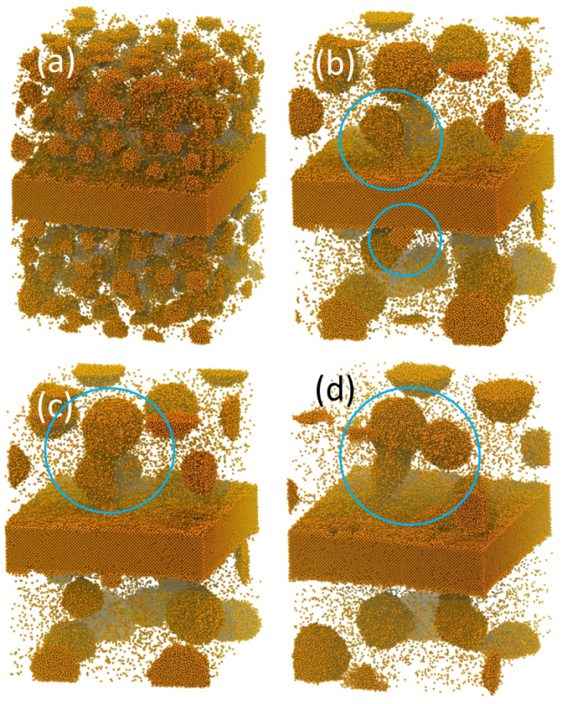

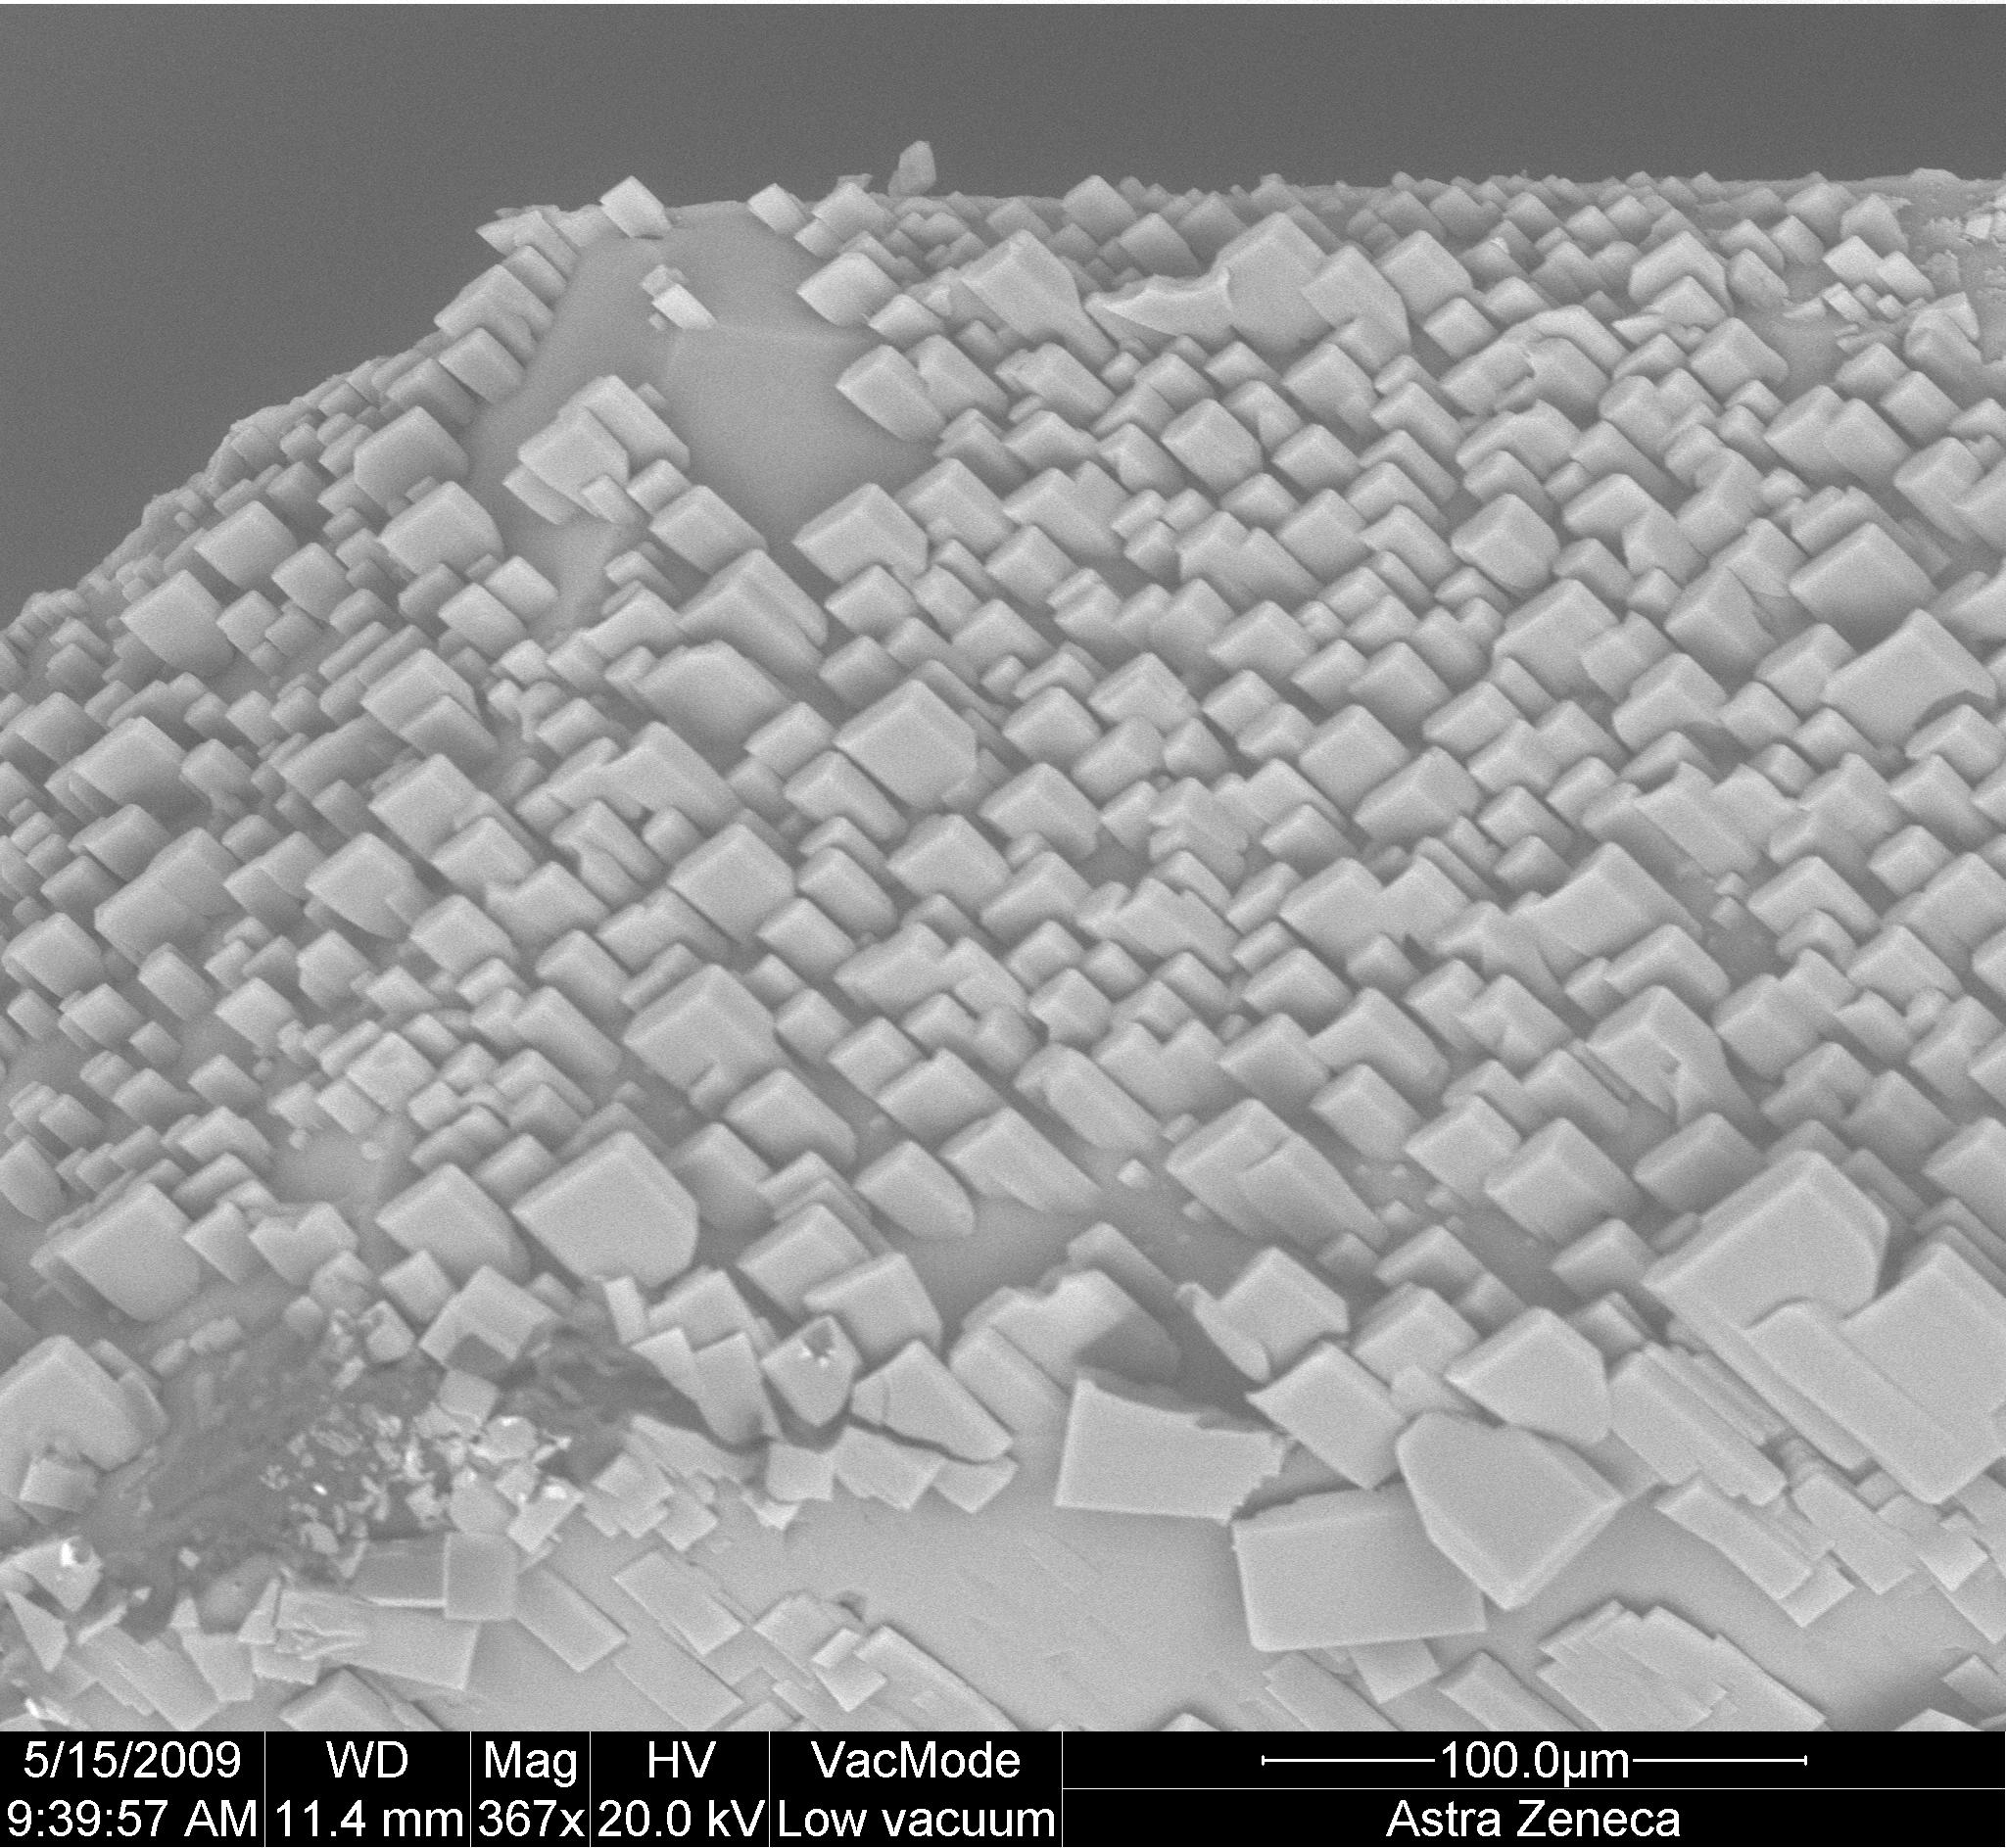

Figure 2. Snapshots from a molecular dynamics simulation trajectory showing the stepwise formation of crystalline structures on the surface of the seed crystal for the moderately supersaturated system (Lennard Jones solute-solvent affinity parameter ε = 3.0 kJ mol⁻¹). (a) Configuration showing the emergence of clusters of solute molecules in the solvent (15 ns into the simulation); the solvent is not shown. (b) Nucleation of a solute clusters on coming in contact with the crystal surface (120 ns). (c) Nucleation of a solute cluster on coming in contact with a previously nucleated structure in contact with the seed crystal surface (135 ns). (d) Yet another nucleation event as a disordered cluster nucleates on coming in contact with the aggregated crystallite structure (225 ns).
We augmented the simulations with experiments where we examined the surface of large single crystals (of the drug bicalutamide, polymorph A) after exposure to a supersaturated solution within the metastable region. The crystals were mounted on a glass fibre and gently rotated within the solution. The exposed crystals were washed quickly with water and then dried in a gentle stream of nitrogen. Scanning electron microscopy images of the dried crystal surface (Figure 3) reveal the surface being completely covered by small crystallites – a feature which is very similar to that revealed by the simulations. From surface energy considerations, such a topology cannot result from the drying of the crystal. The foundations for it must have been laid when the crystal was in solution, though we expect some relaxation of the structures on drying.
How might such a topology emerge? There are two possible options: (i) spontaneous nucleation in the solution resulting in new crystallites which subsequently attach to the crystal surface; (ii) crystal surface-induced nucleation of solute clusters pre-existing in solution. Spontaneous nucleation and subsequent attachment would result in random orientations of the crystallites, which as the image in Figure 3 shows is clearly not the case as the crystallites show almost identical alignment– thus we discount spontaneous nucleation. A homogeneous solution without clusters (transient or otherwise) would lead to conventional crystal growth.
Figure 3. Scanning electron micrograph of the surface of a large crystal of form A of bicalutamide which had been exposed to a supersaturated solution of bicalutamide. The surface reveals attached crystallites of form A with a headstone-like morphology. Note that in almost all cases the crystallite headstone orientation is upside down and the contact with the crystal surface is along a narrow edge.
The existence of persistent pre-nucleation clusters in supersaturated solutions is increasingly gaining support, both from experimental data and from simulations,^{[9,12,13,27-32]} representing an important tenet for multistep nucleation theory (MNT).^{[9-11]} Particularly notable is the study of Sleutel and Van Driessche^{[32]} which presents strong evidence for the existence of long-lived (order of tens of seconds) pre-nucleation clusters in protein solutions. These clusters were observed to form 3D crystalline islands (also referred to as ‘closed looped macrosteps’) on coming into contact with the crystal surface, akin to clusters nucleating as they come into contact with the seed crystal in the current simulations. Crystallites resulting from spontaneous nucleation in solution were also observed, but these did not fuse with the growing protein crystal surface. Earlier AFM studies of protein and virus crystal growth mechanisms also similarly revealed the attachment of 3D clusters onto the growth surface.^{[33]}
The simulations reported here reveal the formation of rigid but weakly tethered nuclei. Our expectation of real systems, however, is a broad spectrum of behavior depending on the solute (more specifically, the nature and strength of its molecular interactions), supersaturation, and the crystal-solvent interfacial energy. For a weakly-interacting solute molecule, the solute clusters could for instance integrate with the crystal surface as reported for proteins^{[32]} rather than form rigid nuclei. The strength and nature of the contact of the emerging crystallites with the crystal surface could also vary. Finally, we note that in principle, the secondary nucleation processes on a seed crystal could be accessed using a cryo–TEM (transmission electron microscope).^{[30]}
Keywords: Crystallisation • Crystal nucleation • Secondary nucleation • Crystallisation by seeding • Nuclei breeding • Contact breeding • Classical nucleation theory • Multstep nucleation theory • Molecular dynamics simulation
[1] M. J. Mullin Crystallization 4th Edition, Butterworth-Heinemann 2001.
[2] W. Beckmann, Seeding the desired polymorph: background, possibilities, limitations, and case studies, Org. Proc. Res. Dev. 2000, 4, 372-383.
[3] a) D. K. Kondepudi, R. J. Kaufman, N. Singh, Chiral symmetry breaking in sodium chlorate crystallization, Science 1990, 4983, 975-976. b) C. Viedma, Chiral symmetry breaking during crystallization: complete chiral purity induced by nonlinear autocatalysis and recycling, Phys. Rev. Lett. 2005, 6, 065504. c) J. M. McBride, J. C. Tully, Did life grind to a start? Nature 2008, 7184, 161-162
[4] M. A. Larson, Secondary nucleation: an analysis, Chem. Eng. Commun. 1981, 12, 161-169.
[5] R. J. Davey, How comes you look so good? Nature 2004, 428, 374-375.
[6] D. Kashchiev, Nucleation: Basic Theory with Applications, Butterworth-Heinemann, Oxford, 2000.
[7] K. F. Kelton, A. L. Greer, Nucleation in Condensed Matter: Applications in Materials and Biology, Elsevier Pergamon Materials Series, Amsterdam 2010.
[8] P. R. ten Wolde, D. Frenkel, Enhancement of protein crystal nucleation by critical density fluctuations, Science 1997, 277, 1975-1978.
[9] D. Gebauer, A. Volkel, H. Colfen, Stable pre-nucleation calcium clusters, Science 2008, 322, 1819-1822.
[10] P. G. Vekilov, Nucleation, Cryst. Growth Design 2010, 10, 5007–5019.
[11] A. S. Myerson, B. L. Trout, Nucleation from solution, Science 2013, 341, 855-856.
[12] Denis Gebauer, Matthias Kellermeier, Julian D. Gale, Lennart Bergstrom, Helmut Colfen, Pre-nucleation clusters as solute precursors in crystallisation. Chem. Soc. Rev., 2014, 43, 2348
[13] M. Salvalaglio, C. Perego, F. Giberti, M. Mazzotti, M. Parrinello. Molecular-dynamics simulations of urea nucleation from aqueous solution, Proc. Natl. Acad. Sci. USA 2014, 112 (1) E6-E14
[14] E. G. Denk Jr. & G. D. Botsaris, Fundamental studies in secondary nucleation from solution, J. Crystal Growth 1972, 13/14, 493-499.
[15] H. E. C. Powers, Sucrose Crystals, Nature 1960, 188, 289-291.
[16] N. A. Clontz & W. L. McCabe, Contact nucleation of magnesium sulfate heptahydrate, CEP Symposium Series No. 110, 1971, 67, 6.
[17] L. L. Bendig, M. A. Larson, AIChE Symposium Series No. 153, 1976, 72, 21.
[18] H. Garabedian, R. F. Strickland-Constable, Collision breeding of crystal nuclei: sodium chlorate, J. Crystal Growth 1972, 13/14, 506-509.
[19] Y. Cui & A. S. Myerson, Experimental evaluation of contact secondary nucleation mechanisms, Cryst. Growth Des. 2014, 5152-5157.
[20] K. Kendall, The impossibility of comminuting small particles by compression, Nature 1978, 710-711.
[21] R. J. Roberts, The elasticity, ductility and fracture toughness of pharmaceutical powders. PhD thesis, University of Bradford, U.K. 1991.
[22] A. Cacciuto, S. Auer, D. Frenkel, Onset of heterogeneous crystal nucleation in colloidal suspensions, Nature 2004, 428, 404-406.
[23] D. Frenkel, B. Smit, Understanding molecular simulation: from algorithms to applications, 2nd edition, Computational Sciences Series, Vol. 1. Academic Press 2001.
[24] J. Anwar, D. Zahn, Uncovering molecular processes in crystal nucleation and growth by using molecular simulation, Angewandte Chem. Int. Ed. 2011, 50, 1996-2013.
[25] J. Anwar & P. K. Boateng, Computer simulation of crystallization from solution, J. Amer. Chem. Soc. 1998, 120, 9600-9604.
[26] J. Anwar, P. K. Boateng, R. Tamaki, S. Odedra, Mode of action and design rule for additives that modulate crystal nucleation, Angewandte Chemie Int. Ed. 2009, 48, 1-6.
[27] J. W. Mullin, C. L. Leci, Evidence of molecular cluster formation in supersaturated solutions of citric acid, Philosophical Magazine 1969, 19, 1075-1077.
[28] R. M. Ginde, A. S. Myerson, Cluster size estimation in binary supersaturated solutions. J. Crystal Growth 1992, 116, 41-47.
[29] N. Niimura, Y. Minezaki, M. Ataka, T. Katsura, Aggregation in supersaturated lysozyme solution studied by time-resolved small angle neutron scattering, J. Crystal Growth 1995, 154, 136-144.
[30] E. M. Pouget, P. H. H. Bomans, J. A. C. M. Goos, P. M. Frederik, G. de With, N. A. J. M. Sommerdijk, The initial stages of template-controlled CaCO3 formation revealed by cryo-TEM, Science 2009, 323, 1455-1458.
[31] R. Demichelis, P. Raiteri, J. D. Gale, D. Quigley, D. Gebauer, Stable pre-nucleation mineral clusters are liquid-like ionic polymers, Nature Comm. 2011, 2, 590.
[32] M. Sleutel, A. E. S. Van Driessche, Role of clusters in nonclassical nucleation and growth of protein crystals, PNAS 2014, Jan 21, E546-E553.
[33] Y. G. Kuznetsov, A. J. Malkin, W. Glantz, A. McPherson, In situ atomic force microscopy studies of protein and virus crystal growth mechanism, J. Cryst. Growth 1996, 168, 63-73.

Entry for the Table of Contents (Please choose one layout)

Layout 1:

COMMUNICATION
Molecular dynamics simulations uncover nuclei breeding factory responsible for secondary nucleation in crystal growth. We now know why a few crystal seeds give rise to a many-fold increase in new crystals. This mechanistic insight will enable better control in engineering crystalline products to design. |  |  |  | Jamshed Anwar,* Shahzeb Khan, and Lennart Lindfors  Page No. – Page No.  Secondary Crystal Nucleation:  Nuclei Breeding Factory Uncovered

