Recovery of Platinum Group Metals from End of Life PEMFC
Anant Patel*, Alan Harding, Richard Dawson
Lancaster University, Bailrigg,Lancaster, Lancashire,UK, LA1 4YR
a.patel2@lancaster.ac.uk
Fuel cells have been poised to enter the energy market as a viable alternative to non-renewable resources for years, but due to prohibitive costs and reliability concerns they remain commercially untenable. One of the primary concerns facing PEMFCs today are the platinum group metals (PGM) catalysts which represent a significant portion of the total manufacturing cost of these devices. Recovery programs could provide an alternative source for the metals, but current processes are expensive, hazardous, and environmentally unsound. We propose an alternative methodology based on electrochemical assisted dissolution in halide solutions, with a specific focus on platinum and ruthenium recovery in strong iodide solutions.
An electrochemical quartz crystal microbalance (EQCM) was used to accurately determine the change in mass of the system during the initial stages of the project. Using an EQCM a controlled deposition of the target metals was achieved. This new electrode was then placed into varying halide solutions at room temperature in order to determine the effective dissolution rate at differing pHs and electrical potentials. Rotating ring disk electrode experiments were also conducted in order to determine if a recovery process from halide solution would be possible. Results suggest native pH solutions are likely unsuitable for Ru dissolution, but acidified solutions are more suitable, as predicted by E-pH diagrams. Surface oxide or halide complex formation complicates recovery process as these moieties must be removed before dissolution can occur. Rotating ring disk experiments show that the dissolution process is possible at ambient conditions, but may progress too slowly for a viable industrial process. Future work will investigate dissolution processes at elevated temperature.
  - Introduction
Fuel cell technology shows great promise as alternative energy resources, but they generally restricted by limited useful lifetime and high manufacturing costs. The factors contributing to device breakdown vary with the type of fuel cell, but the cost of polymer electrolyte and direct alcohol fuel cells can be largely be attributed to the platinum group metal (PGM) electrocatalysts. Though significant work is being done to either reduce or even eliminate the use of PGMs, these metals are likely to remain the most efficient catalysts for the foreseeable future. Because of high demand and limited supply the price per troy ounce will remain high, therefore, salvaging PGMs from end-of-life fuel cells could provide a viable alternative to conventional methods. The work presented here aimed to establish a method for recovering PGMs via electrochemical pathways, focusing primarily on platinum and ruthenium.
    - Background
The physical characteristics of PGMs make them highly attractive for a wide variety of applications, such as medical implants, manufacturing processes, and as automotive catalysts. Currently the majority of demand for these metals is being met through refining metallic ore, a complex and potentially hazardous process. As Jha, et al. (2013) state, PGMs present in metal ore as sulphides or tellurides are extracted using pyro/hydrometallurgical processes generally involving chemicals such as aqua regia or ammonia-based compounds. Chen and Huang (2006) proposed an alternative method using pressurized and heated cyanide in a similar process used for gold extraction. Though established methods have proven to be highly successful, concerns about the environmental and health impact of the reagents used in these processes remain.
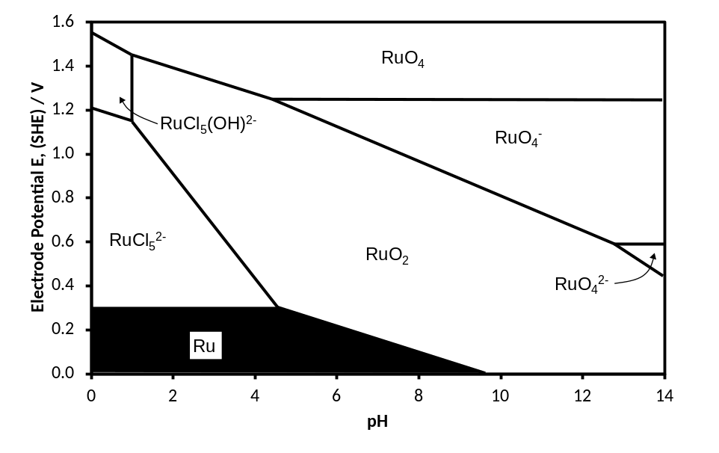
Figure 1 E-pH diagram for ruthenium chloride system at room temperature. Activity of chloride, 1 M, activity of dissolved species 1x10⁻⁵ M. Thermodynamic data from Bard et al (1985).
Figure 1 shows the E-pH diagram for the Ru chloride system drawn from thermodynamic data, similar diagrams could be drawn for the Ru-Br and Ru-I systems however, the thermodynamic data available for these systems is very limited which may suggest that soluble Ru-Br and Ru-I products are difficult to achieve. The reversible potential for the reduction of chlorine, bromine and iodine in 1 M solutions of their own halide salt are 1.25 V, 0.93 V and 0.47 V (SHE) respectively. This would suggest that the halogens will be suitable oxidants to affect dissolution even in mixed systems where, for example, chlorine is used to form the RuCl₅²⁻_{(ag)} complex.
1.2 Recovery
While refining remains the primary source for PGMs, recycling PGMs has the potential to provide an alternative source for these materials. Estimates by the US Government show that in 2004 roughly 70% of PGMs in scrapped automobiles was recovered, an amount equal to roughly 16% of the US consumption for that year. Unfortunately estimates for PGM recovery from other devices, such as fuel cells, have not been established, but this does present the opportunity to implement a recycling system before commercialization. Researchers have explored this area, with the general consensus being that pyrometallurgical methods are the most efficient. Much like the extraction processes, however, the byproducts from these reactors are predominantly hazardous and corrosive chemicals, such as hydrofluoric acid. Other groups, such as Zanjani and Baghalha (2009) have shown that iodide could be used to selectively dissolve Pt, but their experiments were conducted in 3+ M acid solutions, again raising concerns about environmental safety and sustainability. Dawson and Kelsall (2013), however, showed that native pH iodine solutions at elevated temperatures are capable of recovering >99 % of Pt content on graphite spheres by quickly facilitating the dissolution of platinum from alumina support material. The challenge then becomes extending the technology to other PGMs, such as ruthenium. Figure 2 shows a representation of the proposed process.
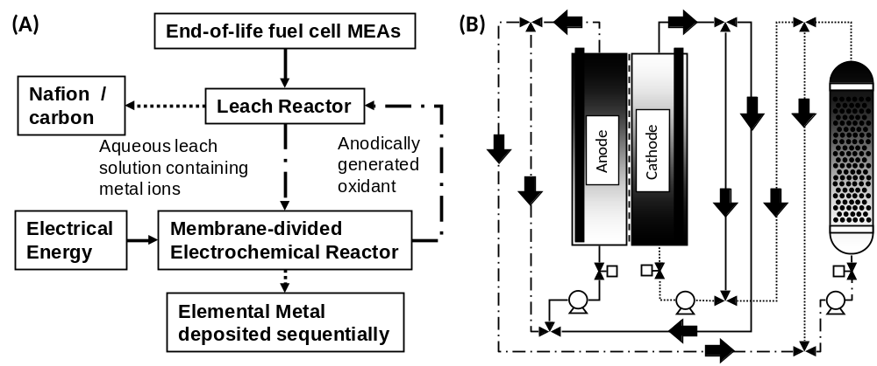
Figure 2: Simplified representations of proposed PGM leaching process with a) written description for ideal process and b) illustration of membrane divided electrochemical reactor and packed bed leach reactor. Design is adapted from process described by Dawson and Kelsall (2007).
The envisioned process is a closed loop with the leach solution circulating throughout, with the objective of selectively depositing metals in a sequential manner. In order to do so, it was necessary to determine the feasibility of varying solutions, electrical potentials, and temperatures for PGM dissolution. This article focuses on the dissolution of planar ruthenium metal in strong halide solutions and initial conclusions we have drawn from this study.
  - Experimental
All chemicals used in the experiments are reagent grade and were either purchased from Sigma Aldrich or Fischer Scientific or in the case of PGM containing materials, were provided by our collaborators at Johnson Matthey Plc. All water used in the study was double distilled using a Direct-Q UV Millipore. A Maxtek Model CHK-100 electrochemical quartz crystal microbalance (EQCM) holder, and Ti/Pt 5 MHz polished crystals suitable for ambient temperature conditions were used in this work, as was a Pine Instrument Platinum-Ring vitreous carbon disc RRDE E7R9 Series. The RRDE was polished between experiments using 0.3 µm Alumina dispersions and washed with DI water. All electrochemical measurements were made using an Ivium Compactstat potentiostat. All electrochemical experiments were conducted using a saturated calomel reference electrode produced by Scientific Laboratory Supplies, however all voltage values listed in this work have been adjusted for standard hydrogen electrode reference.
2.1 Electrochemical Quartz Crystal Microbalance Electrode Preparation
Ruthenium was deposited on to the quartz crystal from a 3 mM solution of RuNO(NO₃)₃ in 0.1 M H₂SO₄ at -0.6 V (SHE) for 2 h. The deposited electrodes had a mass of approximately 50 µg with sub-micron variations in Z-height, as measured by atomic force microscopy. The electrode assembly was then placed into a reaction vessel containing 300 mL of 4 M NaCl, NaBr, or KI. Mass losses were quantified while the electrode was subjected to cyclic voltammetric measurements.
2.2 Rotating Ring Disk Electrode Preparation
The rotating ring disk electrode experiments, 30 mM RuNO(NO₃)₃ in 0.1 M H₂SO₄ was used during the deposition process. The disk was pulsed from -0.8 V (SHE) for 20 s to -0.45 V (SHE) for 30 seconds 4 times before being held at -0.8 V (SHE) for 10 minutes. The system operated at 13.33 Hz to prevent bubbles from adhering to the electrode surface. Following the electrochemical deposition the electrode was examined under a microscope to determine if a smooth and continuous Ru layer was produced. The Ru deposited was then placed in 100 mL of nitrogen purged 4 M NaCl, NaBr, or KI for electrochemical experiments.
  - Results
Dissolution of ruthenium was largely restricted to acidified NaCl solutions. Due to its complex chemistry, the targeted ruthenium species was Ru³⁺ ion, nominally RuCl₅²⁻, RuBr₅²⁻, or RuI₅²⁻, an ion that should be recoverable from solution and not form an insoluble products. For all solutions mass gains were observed at near neutral pH probably due to the formation of ruthenium oxide layers as predicted for the chloride system by the E-pH diagram. Figure 3, below, shows EQCM results for cyclic voltammograms in 4 M NaCl, NaBr, and KI acidified to pH 1.

(A)
(B)
Figure 3: Cyclic voltammograms for acidified halide solutions (A) and the subsequent mass changes, scan rate 20 mV s⁻¹, room temperature during cycling (B).
From Figure 3 it is clear to see that the systems showed improved results in the more electronegative halides, with the strong NaCl solution showing a mass loss and NaBr showing little change. The mass loss in acidified 4 M NaCl becomes more pronounced at longer intervals, as shown in Figure 4.

Figure 4: Mass change to planar Ru electrode over 50 cycles between 0 and 0.8 V (SHE) in acidified 4 M NaCl. Though an initial mass gain was observed, after prolonged cycling, the electrode mass was observed to reduce at a steady rate. Scan rate 50 mV s⁻¹ at room temperature.
As seen in Figure 4, the electrode mass steadily decreased during the 50 cycle experiment, though it was shown to increase at lower potentials. The exact cause of the mass is gain is currently unknown, but data suggests it can be attributed to the formation of adsorbed Ru-halide complexes or surface oxides.
Since the acidified NaCl appear to be affecting measureable dissolution, rotating ring disk electrode experiments were conducted in order to verify that a solution species was being formed and could be detected at the ring. This would give some appreciation for the proportion of the disc current attributable to either solutions species or the formation of adsorbed species. The disk was rotated at 10 Hz and cycled between 0.0 and 0.9 V (SHE) at 20 mV s⁻¹ while the ring was held at 0 V (vs RHE). Figure 5, below, shows a representative voltammogram for the deposited Ru, with the ring current shown as the dotted line.
(B)
Figure 5: Cyclic voltammogram of Ru dissolution in acidified 4 M NaCl showing disk current (solid) and ring current (dotted). The ring was held at -0.15 V (SHE) for the duration of the experiment. Disk potential scan rate 20 mV s-1, electrode rotation rate 10 Hz, room temperature
Figure 5 shows the cyclic voltammograms for a thin Ru layer deposited on a rotating ring disk electrode and those obtained from a polished vitreous carbon electrode. The ring was held at -0.15 V (SHE) in order to capture the presence of species evolved from the disk. In the case of the vitreous carbon electrode, the system was essentially inert; the disk and ring currents are minimal and do not produce any species that can be reduced by the ring. The deposited ruthenium layer, however, shows two features: a shoulder on the anodic sweep at 0.6 V (SHE) and a large reduction peak at 0.25 V. From the E-pH diagram in Figure 2, we expect the formation of Ru³⁺ ions to occur at roughly 0.3 V during the anodic sweep, and the short peak at 0.35 V could be evidence of its formation, but more data is needed. The collection efficiency of the ring in this particular electrode is 37.0 %. The ring current does show a species being produced by the disk and that 27 µA can be attributed to this as this dissolution rate plateaus at a disk potential of around 0.6 V (SHE). Given the mirror finish of the electrode the surface area was essentially the same as the geometric area indicating the double layer capacity will be low and from this is can be seen that ca. 20 % of the disc current at for example 0.7 V (SHE) can be attributed to the formation of the oxide.
The potential window used in these experiments has largely been restricted to low potentials in order to avoid halogen formation which dominates the current observed in the voltammogram, but some work was done at potentials above 1 V (SHE). Figure 6 shows a portion of these results using the EQCM
(A)
(A)
(B)
Figure 6: Mass change of planar ruthenium electrode in acidified 4 M NaCl (A) and NaBr (B) during cyclic voltammetry from 0 to 1.5 V (SHE) at 10 mV s⁻¹.
As seen in Figure 6, dissolution was vastly improved for both chloride and bromide at higher potentials. At low potentials, the system saw minor growth in the acidified bromide solution, but was capable of removing upwards of 4 µg cm⁻² when subjected to higher potentials. The artifact in Figure 6 (B) at 1.5 V is caused by a hardware limitation of the potentiostat, and does not actually occur; in reality the current likely continues to grow linearly. Finally, though it is not shown, when the bromide system was subjected to more cycles, it achieved mass losses similar to those shown for the acidified chloride solution. These losses proceeded at a continuous rate and cannot be considered recoverable, however they are coupled with the formation of gaseous halogens. Because of the increased dissolution rates, it is likely that chlorine and bromine are acting as the oxidizing agents, as predicted by the E-pH diagram in Figure 2. The concentrations of these species are unknown, but are likely to be significant.
(B)
(B)
  - Conclusions
Ruthenium dissolution in strong halide solution is possible at room temperature if the solution has been acidified, but the rate of dissolution makes it unfavorable for large-scale processes. At potentials below oxygen evolution, only acidified chloride was able to assist in the dissolution of Ru; at high potentials, bromide was also shown to be dissolve ruthenium readily, but this presents potential complications due to the formation of bromine and chlorine. Iodide does not appear to be able to promote the dissolution of ruthenium; instead the system will either remain unperturbed or grow steadily as an oxide or insoluble layer develops. Dissolution processes are restricted by the formation of surface oxides or adsorbed ruthenium-halide species. These species must be removed or dissolved before further metal dissolution can occur.
  - Acknowledgements
This work was funded by a grant from the EPSRC (Project Code EP/K020099/1). Materials, equipment, and assistance were provided by Johnson Matthey. Special thanks to Drs James Dickinson and Richard Wilbraham for their assistance in acquiring experimental results. Finally we would like to thank Professor Geoff Kelsall for his general advice.
  - References

Jha, M. K., Lee, J.-C., Kim, M.-S., Jeong, J., Kim, B.-S. & Kumar, V. 2013. Hydrometallurgical
recovery/recycling of platinum by the leaching of spent catalysts: A review. Hydrometallurgy, 133,
23-32.
Chen, J. & Huang, K. 2006. A new technique for extraction of platinum group metals by pressure cyanidation. Hydrometallurgy, 82, 164-171.
Bard, A., Parsons, B. & Jordan, J. 1985. Standard Potentials in Aqueous Solution. New York, United States: CRC Press.
Zanjani, A. & Baghalha, M. 2009. Factors affecting platinum extraction from used reforming catalysts in iodine solutions at temperatures up to 95 °C. Hydrometallurgy, 97, 119-125.
Dawson, R. J. & Kelsall, G. H. 2007. Recovery of platinum group metals from secondary materials. I. Palladium dissolution in iodide solutions. Journal of Applied Electrochemistry, 37, 3-14.
Dawson, R. J. & Kesall, G. H. 2013. Pt Dissolution and Deposition in High Concentration Aqueous Tri-Iodide/Iodide Solutions. ECS Electrochemistry Letters, 2, D55-D57.

