Solar Soldier: Virtual Reality Simulations and Guidelines for the Integration of Photovoltaic Technology on the Modern Infantry Soldier
Ioannis Paraskevopoulos¹, Emmanuel Tsekleves¹
¹School of Engineering and Design, Brunel University, UK
Ioannis.paraskevopoulos@brunel.ac.uk, emmanuel.tsekleves@bruenl.ac.uk

Abstract. Following recent advances in the field of thin and flexible materials, the use of product integrated photovoltaics (PIPV) for light harvesting and electric power generation has received increased attention today. PIPV is one of the most promising portable renewable energy technologies of today, especially for the defense industry and the modern infantry soldier. Nevertheless, there is limited work on light harvesting analysis and power generation assessment for its use in various military scenarios including on how to best integrate the technology on the infantry soldier. This study aims to fill this gap by accurately analyzing the light harvesting through virtual reality simulations. Following the virtual light analysis, an assessment of the power generation potential per scenario and investigation of the optimum integration areas of flexible PV devices on the infantryman are presented. Finally, there is a discussion of the key results, providing the reader with a set of guidelines for the positioning and integration of such renewable energy technology on the modern infantry soldier.

Keywords: renewable energy, 3D simulation, virtual reality, photovoltaic, solar energy harvesting, computer simulation, daylight simulation, infantry soldier, design, human factors, usability, military environment, product integrated photovoltaics (PIPV), wearable photovoltaics
- Introduction
Despite modern advances in military technology, the infantry soldier continues to play a significant role in defense. In the age of stealth jets, nuclear munitions and guided weapons, it is still the infantry soldier that examines and secures a location to ascertain whether the target area is cleared and the enemy is defeated. The modern infantry soldier utilizes the electronic technology and resources available today, in order to penetrate into hostile and difficult terrain, where armored vehicles cannot trespass and overcome the enemy. The power requirements of such electronic technology, critically essential for the modern soldier, are much higher when compared to the power requirements of a civilian counterpart. Furthermore, the environment of operation is far more hostile and challenging than those of the civilian applications and the loss of power may endanger the infantry soldier’s life. That is the main reason behind the massive overload of batteries constituting nearly 25% [1] of the overall equipment load (including lethal, survival and communication). Owing to the aforementioned fact, there is an uncontested restriction of maneuverability and operational range, as well as a significant burden, both physical and cognitive. The recent advances in the field of sustainable energy, and particularly the innovative flexible and wearable photovoltaic (PV) technologies, could offer a potential solution to this issue, by removing, or reducing to a great extent, the use of batteries. The Solar Soldier project, which is partly funded by the Defense Science and Technology Laboratory (DSTL) of the MoD in the United Kingdom (UK) and the Engineering and Physical Sciences Research Council (EPSRC), investigates this research challenge. Part of the work conducted in the boundaries of that project is presented in this article, which focuses on how one could integrate the PV technology epitomizing the Solar Soldier concept from a human interface and design perspective. The objectives of this challenge are the following:
- To assess the incorporation of the PV technology on the uniform and equipment of the infantry soldier;
- To accurately measure and evaluate its effectiveness (amount of light captured under various scenarios) taking into account usability (human comfort, intuitiveness).
- To assess the effectiveness of each area (amount of power generated under various scenarios) as well as to investigate the areas that yield the same power values all over their extent for further research on usability (human comfort, intuitiveness).
This chapter is organized in a number of sections. Section 2 offers a background literature review on related work. This is followed by a presentation of the adopted overall methodology, including the validation study of the simulation software platform employed. Next, the outcomes of the simulations are presented and discussed and finally, the inferred conclusions on the design aspects along with guidelines on the integration of PV on the infantryman are offered.
- Related Work
The theoretical background of the study presented in this paper falls within various research areas, including Modeling and Simulation (M&S), virtual reality (VR) applications and product design aspects.
  - Virtual reality and defense applications

The advances of VR, in recent years, have led to the development of new areas of applications beyond the entertainment industry. Research and development in interactive VR has been employed in the areas of training, education, health and simulation, with one of the major areas of interest being military and defense applications [2]. VR can be utilized for military applications to perform a wide range of simulations. These range from cognitive and behavior simulations in battle to ergonomic simulations; all serving the improvement of the welfare of the modern soldier. These simulations have to be conducted in a virtual framework often consisting of assets that offer three dimensional (3D) graphical representations of terrains, human avatars and objects, as well as weather and daylight-augmented systems. All these elements create a Virtual world on a computer-based simulated environment. This is of significant interest and importance to research, as it offers a very useful alternative reality, especially for situations (as in the case of this research works), where actual experiments are not feasible or dangerous to conduct in real life [3], [4]. More precisely, Chryssolouris et al. [5] have conducted research in the area of human ergonomics in an assembly line and Reece [6] has studied the movement behavior of soldier agents on a virtual battlefield. Furthermore, the Santos [7],[8] project offers a virtual platform for human ergonomics in military environments and Shiau and Liang [9] present a real-time network VR military simulation system comprising weather, physics and network communications. Blount et al. [10] have introduced the aspect of physical fitness into simulations for infantry soldiers and others, such as Cioppa et al. [11] and Bitinas et al. [12], have worked with agent-based simulations and their military applications, focusing on human factors in military combat and non-combat situations, respectively. Apart from these aforementioned articles, there is a recently published three-volume edition containing an extensive literature on VR and applications: The PSI handbook of virtual environment training and education: developments for the military and beyond [13]. The second volume of this text contains subjects such as ‘Mixed and augmented reality for training’, ‘Evaluating virtual environment component technologies’ and ‘Enhancing virtual environments to support training’. The aforementioned literature focuses mainly on simulating human factors and ergonomics, either in the production line or in military environments. However, the applications of VR human-centered simulations are not restricted to ergonomics. The aspect of Human-centered Design (HCD) that this article examines is the integration of renewable energy devices on the human vesture, and in particular the integration of PV technology on the uniform or equipment of the modern infantry soldier in terms of light capture efficiency.
  - Simulation of solar light harvesting
Currently, the main focus of PV technology and its corresponding simulations has been on building and infrastructure applications. The very recent developments in the area of PV devices [14], [15], along with the introduction of thin films and flexible materials for light absorption [16], have attracted the focus of harvesting renewable energy to human-centered applications as well. The study of the performance of the so-called Product Integrated Photovoltaics (PIPV) [17] is twofold: firstly, to investigate the performance and electrical characteristics of the PV device itself; secondly, to study the effectiveness of light harvesting, which is also the main focus and aim of our work. The effectiveness of light harvesting depends on the interaction of the device with the environment, as well as on the type of integration of the PV technology on the product (e.g. attached on clothing, embroidered or woven onto the fabric). The environmental conditions would require the modeling of daylight and shading in a 3D authoring and simulation tool, whilst the integration guidelines would require simulated scenarios and results that would infer the most effective method of integration.

Daylight and shading modeling
With regards to daylight modeling, there have been numerous studies on methods to maximize solar system outputs [18]. Furthermore, there are studies on the shading effect of the environment, which investigate the effects of random shading on PV energy production [19], [20]. Apart from research studies, there has been major development in the corresponding software industry, with very intelligent and complex packages developed for daylight simulations, including 3D Studio Max Design (3DSMD) by Autodesk, which is the software, utilized in this project. 3DSMD was chosen mainly because it comprises a toolset for animation and because it includes the feature of light analysis of a 3D scene, which is essential for a HCD project such as this. 3DSMD also offers extension capabilities through its embedded programming language, Maxscript. It can thus be used to semi-automate the procedures as described in the work of Paraskevopoulos and Tsekleves [21]. The results of the light analysis of 3DSMD have been validated by Reinhart et al [22] and Paraskevopoulos and Tsekleves [21] and the software has been used in a number of other studies regarding light harvesting for PV technology [17], [23]. Nevertheless, all of them have focused on simulations where the PIPV device was in a static position and none of these has used simulation to analyze the effects of movement on PIPV light harvesting. Furthermore, no previous work has offered any conclusions or guidelines on the design aspects of wearable PV devices in terms of the light capturing efficiency of mobile agents.

Integration of PV technology on commercial products
Although the integration of PV technology on commercial products is not a new idea, the emergence of flexible and thin-film materials has extended the possibilities of integration into more products with a smaller scale factor, which can be portable. However, until recently and as stated by Mestre and Diehl [24], there have been no guidelines for the integration of PV technology on products in the context of either human comfort or efficiency of energy harvesting. The work of Reinders [25] examines in depth the options for PV systems and portable devices and presents their advantages and drawbacks. Among the drawbacks, one indicates the lack of PV technology penetration in our society and market. This is mainly due to limited knowledge of this technology by product designers and manufacturers, restricting in turn the extension of applications for this technology. The work presented in this article aims to fill in this gap by deploying design guidelines and a simulation platform on the integration of PV technology on military garments or equipment initially and commercial products in the future. As already mentioned in the introduction of this article, the use of VR simulations is a prerequisite for military applications, due to the hostile and extremely hazardous environment. Randall et al. [26] have integrated solar modules to use them as light sensors in order to collect physical measurements and not for the purposes of light analysis simulation. With regards to the design aspects of the integration of PV technology on clothing, Schubert and Werner [27] have presented an overview of flexible solar cell technologies applied on wearable renewable sources. This, however, focuses only on the material aspect of PV technology. In their paper, Schubert and Werner [27] reference Gemmer, who has performed experimental investigation on light harvesting under different daylight scenarios and has calculated energy yield for various user profiles. For example a ‘regular clerk’, an ‘outdoor construction worker’ and a ‘night shift nurse’. In the system we propose, these profiles can be very easily modeled (3D avatars and motion capture) and simulated (light analysis tool, 3DSMD) for all various light conditions (daylight system, 3DSMD) and encompassing environments (3D terrain models). The outcomes of such simulations would infer the design guidelines of the most efficient manner of integration of PV on clothing in terms of light harvest.
- Methodology
The overall methodology adopted for this project is outlined in this section. The problem stated in the Introduction of this paper requires the employment of a virtual framework able to conduct a number of experiments and collect measurements, which are impossible to collect due to the hazardous nature of the real environment. The methodology that fulfils the development of such a virtual framework is Modelling and Simulation (M&S) [28]. The application of M&S presented in this article is aimed at applying an existing feature of a 3D authoring commercial software, 3D Studio Max Design (3DSMD), by extending its capabilities and applying it to simulation of daylight for sustainable energy applications of military interest. The lighting analysis system of 3DSMD will be employed in a virtual military environment framework. Nevertheless, before the development of the simulation platform, the software plugin is validated against real sunlight measurements in order to facilitate the accuracy required for the purposes and conditions of the project. Only after the accuracy provided proof of our concept we moved on with the design of the light sensors. These are offered in the design assets palette of the software and are attached on specific areas of the soldier’s uniform and equipment to assess the incorporation of PV technology. The Block Diagram of Figure 1 illustrates the adopted methodology of the Solar Soldier project.
  - Validation Study
As stated above, the initial step of the methodology is to validate the accuracy of the simulated daylight values against real daylight measurements on a virtual reality model that would match the actual circumstances. This took place at Brunel University campus, since light intensity data have collected for the site on a daily basis since October 2006 by the weather station of the SunnyBoy project conducted by Chowdhury et al. [29]. The next element towards the validation is the 3D model of the campus. Accurate models of this were available prior to the start of this study, which were utilized here. A more detailed presentation of the validation methodology can be found in the work of Paraskevopoulos and Tsekleves [30].
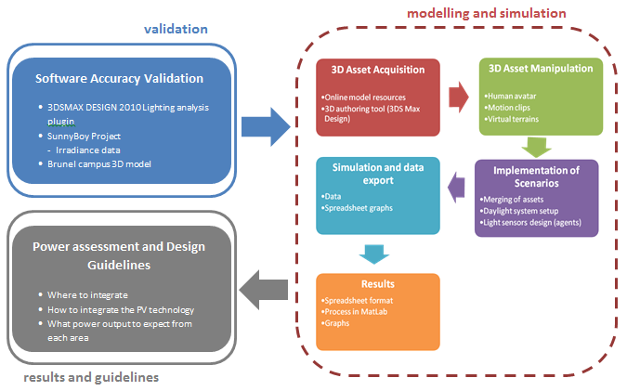
Fig. 1. Block diagram of the overall methodology
  - The light analysis platform
Moving on to the main purpose of this study, the simulation platform is assembled according to M&S methodology very similarly to the validation study that preceded; however engaging more complex set of models and daylight conditions. The software consists of a light analysis plugin, which is the tool we extended to fulfill the requirements of our study. The main purpose of the light analysis plugin of 3DSMD is for building light assessment and is mostly used by civil engineers. The aim of our study requires light analysis of non-static sensors attached on the soldier’s uniform and equipment. Therefore, by the aid of the software’s API we developed a script that would enable the light analysis of mobile sensors. Following is the assembly of the simulation platform. The platform consists of an animated human avatar, namely the UK infantry soldier, various terrain types and a virtual daylight system. Merging the assets together derive to a set of scenarios which are simulated under different daylight conditions. The daylight conditions vary in terms of times of the day, season and global location. The complete set of scenarios is illustrated in the tree of Figure 2. For the purposes of this project and as the VR simulations are performed for various global positions a database of irradiance values is required as an input for the VR daylight system. This data is available via the Photovoltaic Geographical Information System (PVGIS) [31]. PVGIS is an online system developed by the Joint Research centre for Energy and Renewable Energy Units. Another essential element of the simulation platform is the light sensors. These are designed and attached on the soldier, as demonstrated in Figure 3 in order to follow the motion directed on the soldier avatar by the animation clips. The set of areas examined is produced by trial simulations as well as suggestions and recommendations of the corresponding liaising expert of DSTL.
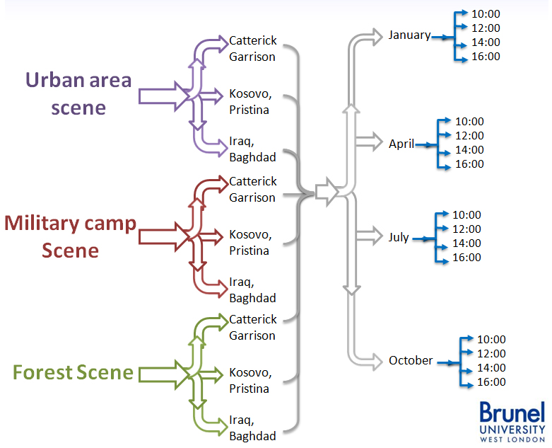
Fig. 1. Scenarios tree
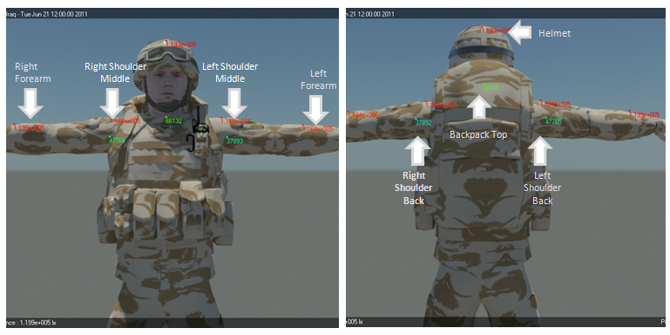
Fig. 1. Distribution of sensors. Front and Back view
The gathering of all assets facilitates the simulations from which the results are gathered in an organized fashion and automatically stored into spreadsheet format through the developed script. Those files infer the light harvest capabilities of each of the simulated scenarios and further processed into Matlab in the following steps will derive to the power assessment of each of the proposed areas of integration of PV technology. An extended version of that study is available in the work of Paraskevopoulos and Tsekleves [30].
  - Power assessment and investigation of integration areas
The previous step of this project was aimed towards the analysis of light harvested on individual points on the uniform and equipment of an infantryman. Nevertheless, the requirements of the Solar Soldier project dictate an analysis of the power generation capabilities for the proposed PIPV system. Therefore a further analysis of the data from the previous section is required, in order to assess the power generation efficiency of each of the proposed areas. The extent of each area under investigation is defined as an entity by the variance it shows with the centre of each aforementioned area, on which the light sensor was attached for reasons of computational economy. In other words, the areas extend from the light sensor up to the point they show significant deviation. From that point and beyond, the area is taken as being another entity. Figure 4 depicts each of the proposed areas and their extent in cm²:
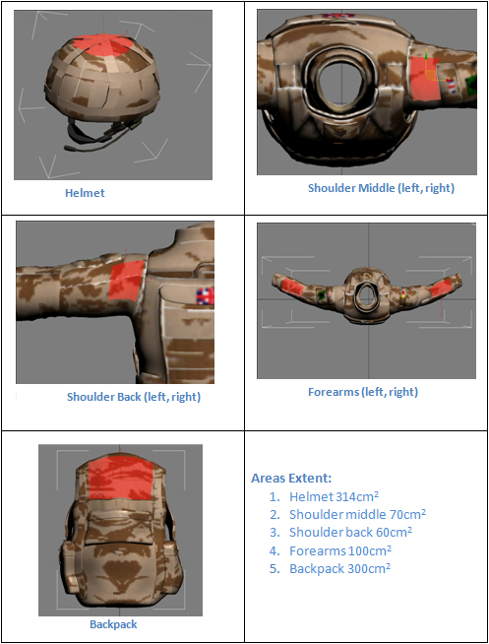
Fig. 1. Areas of integration
The light intensity data is imported into Matlab using the appropriate script. Then the units are converted appropriately and further analyzed to derive to the power generation assessment of each area. Therefore, hitherto the concept of sensor is replaced by the concept of integration area. Using the value of the area (in cm²) and the efficiency value (5%) of the prototype PV device developed for the Solar Soldier project by our corresponding project partners we are able to calculate and produce the average power graphs of each sensor (in watt) [32].
- Results
Each step of the methodology presented above produces massive sets of results and plots, with each set illustrating and inferring specific conclusions towards the final guidelines. The size of the chapter does not facilitate the presentation of each set of results in detail. Therefore only the key results that derive to the conclusions defined by the aims and objectives of the entire Solar Soldier project will be presented here. However readers who wish to find more information on the detailed results are encouraged to look at [21], [30] and [32].
  - Light intensity assessment
As the results of the validation study [21] showed very low discrepancy between the simulated and actual light intensity values for the outdoor conditions examined, we simulated the scenarios presented on Figure 4. These simulations will manifest the classification of the various areas on the uniform and equipment in the context of higher light intensity incidents on these areas. Engineers and designers can then, by using the data of this study, have a draft blueprint of how and where to incorporate the PV device on the soldier’s uniform and equipment. There are a total of 144 scenarios simulated with 8 sensors each. The stratification of areas according their light harvesting capabilities is allocated in Table 1 that follows:
Table 1. Classification of light harvesting capabilities of each candidate area of integration[30]
 | Scene
Location |  | Forest Scene | Military Base | Urban Area
Season: |  | Jan/Apr/Jul/Oct | Jan/Apr/Jul/Oct | Jan/Apr/Jul/Oct
Baghdad |  | - Helmet  - Forearms  - Backpack  - Shoulders Middle  - Shoulders Back | - Helmet  - Forearms  - Backpack  - Shoulders Back  - Shoulders Middle | - Helmet  - Shoulders Middle  - Forearms  - Backpack  - Shoulders Back
Catterick Garrison |  | - Helmet  - Forearms  - Backpack  - Shoulders Middle  - Shoulders Back | - Helmet  - Forearms  - Backpack  - Shoulders Back  - Shoulders Middle | - Helmet  - Shoulders Middle  - Forearms  - Backpack  - Shoulders Back
Pristina |  | - Helmet  - Backpack  - Forearms  - Shoulders Middle  - Shoulders Back | - Helmet  - Forearms  - Backpack  - Shoulders Back  - Shoulders Middle | - Helmet  - Shoulders Middle  - Forearms  - Backpack  - Shoulders Back

The table above indicates that the change in location or season does not affect the order in the classification immensely, although the divergence between two sensors is not constant. Hence, the classification of the sensor for each scene can be simplified to the following (Table 2):
Table 1. Classification of light harvesting capabilities of integration areas [30]
Scene | Sensor Classification
Forest Scene | - Helmet  - Forearms  - Backpack  - Shoulders Middle  - Shoulders Back
Military Base | - Helmet  - Forearms  - Backpack  - Shoulders Back  - Shoulders Middle
Urban Area | - Helmet  - Shoulders Middle  - Forearms  - Backpack  - Shoulders Back

This overall classification of the areas manifests the light harvesting capabilities of each area examined. Nevertheless, the extent of each area plays significant role in the power generation assessment. A larger area that is not very efficient might be able to provide more power due to its extent. Therefore, further analysis of the light intensity assessment is required as mentioned in the methodology. The results of the power generation assessment of each integration area that follows tackles this issue.
  - Power generation assessment
The elements that facilitate the calculations of power generation capacity for each area or integration, apart from the extent of this particular area and the light harvesting capabilities, is the efficiency of the PV device. As stated in the methodology, the efficiency of the flexible PIPV developed in the boundaries of Solar Soldier by our project partners is in the range of 5%. Therefore, the light intensity data produced by the results of the previous section appropriately process with the aforementioned setup derive to the power generation assessment of the proposed integration areas. The areas then are classified in a descending order in the context of the higher power yield. The results of this step can be used by engineers and PIPV designers as a draft blueprint of how and where to incorporate the PV devices on the infantry soldier according to each scenario. The average power values in W for each of the scenarios and for all areas are organized and presented in figures in [32]. These results were interpreted and the classification of the areas can be inferred by comparing the values of each season. Table 4 provides the overall classification in terms of power generation for the examined scenarios as well as the extent of each area in cm²:
Table 1. Classification of power generation capabilities of integration areas
Scene | Area  Classification
Forest | - Backpack  - Helmet  - Forearms  - Shoulder Mdl  - Shoulder Back | 300cm²  314cm²  100cm²  70cm²  60cm²
Military Base | - Helmet  - Backpack  - Forearms  - Shoulder Middle  - Shoulder Back
Urban Area | - Helmet  - Backpack  - Forearms  - Shoulder Middle  - Shoulder Back
- Discussion and Guidelines
As stated in the previous sections, the usability of the PV device proposed by the Solar Soldier project is examined by liaising and interacting with DSTL. This interaction derived to a preliminary set of guidelines for the integration of PV on the uniform or equipment. The feedback we received from DSTL enabled us to shortlist the potential areas where PIPV could be integrated and thus reduced the number of light sensors to use in our simulations. For instance, it was gathered that the chest and the back of the uniform areas would not constitute good candidate areas for installation of PIPVs as they are constantly occluded by the gun and hands holding it and by the backpack respectively. The second set of guidelines derived from the case studies of the three different environments presented above. The light analysis and the power generation assessment derived the results presented in Tables 2 and 3. Those results provide a draft guideline for designers and manufactures of wearable PV devices in military environments; especially for the positioning of such devices on the uniform and equipment of the infantry soldier for the examined areas. The light harvesting assessment is slightly different to the power generation assessment as the two differ in the extent of areas examined. For instance in the light harvesting assessment, the Helmet area came first in all scenarios indicating that it is the optimum area of integration. However, owing to the actual size of this area the power generation is not the optimum in all cases according to the power generation assessment but still a very efficient area. This fact was apparent but yet not validated by any study so far. Moving on, we notice that the top of the backpack as well as the forearms as a set (right and left) qualify as important area candidates for integration even if they showed, in cases, poor light harvesting capabilities. Particularly, the backpack showed low light intensity in some scenarios but was proven to perform well in terms of power generation for the same scenarios. The rest areas qualify only as supplementary areas as they show poor performance and score low in most classifications. Combining the simulation data presented in this paper along with the feedback on the HCD ascertained from DSTL we can provide the following set of guidelines and recommendations with regards to the integration of PIPVs on the modern infantry soldier:
1. The best places on the soldier’s uniform in terms of ergonomics and power generation are the helmet followed by the backpack and forearms. These three positions will provide the PV system with constant exposure to solar radiation, which can be converted to energy even when the soldier is on the move.
2. It is recommended that the entire backpack is covered with PVs as, on one hand, more PV panels can be placed and thus more energy can be harvested at all times as the soldier can easily leave the backpack in the sun whilst resting. Although the helmet yields the highest amount of light its consistent supply of power to the solar harvesting system may be stopped in certain cases. In very warm environments of operations the soldier will seek shade under natural and man-made constructions such as trees and buildings and may even take off the helmet whilst resting. This necessitates further the need to place PVs on the backpack as it can be removed and placed under the sun.
3. Integrating PV directly into the uniform is not recommended as this is washed in extremely boiling hot water. As fabric and nano-material technology evolves it may be able to interweave the solar panel nano-material onto the uniform that will withstand extremely high temperatures. Until then it is recommended that the solar panels are attached onto Velcros so that the PV can be attached and detached. This would also enable the interchange of the PV positioning on the uniform according to the environment and location of operation.
- Conclusion
Infantry soldiers today carry a lot of electronic equipment essential for the operations, which have high power consumption requirements. This forces them to carry, in dismounted operations, several heavy and bulky batteries, which increase dramatically their total equipment load and may affect their maneuverability. Renewable energy technology such as the incorporation of PVs can substitute batteries and relieve the soldier from the physical and cognitive load or carrying and replacing batteries. This study has proposed a virtual simulation framework that mimics closely the military environment for the purposes of investigating the integration of PIPV technology on the infantry soldier. By analyzing and measuring the effectiveness of light capture on various areas of the uniform and equipment of the virtual soldier. The examined case studies covered several basic military environments as well as the several potential areas of integration of the PV device after interacting with the army personnel. After performing numerous simulations, the resulting data were organized and presented in such a manner enabling the classification of the examined areas in order of power generation efficiency. The derived overall classification infers draft yet qualitative guidelines for any designer or practitioner of wearable military applications.

References
- British Army – Vehicles and Equipment: http://www.army.mod.uk/documents/general/285986_ARMY_VEHICLESEQUIPMENT_V12.PDF_web.pdf
- Zyda M, From visual simulation to virtual reality to games. Computer, 38(9), 25-32 (2005)
- Jarvenpaa S, Leidner D, Teigland R, and Wasko M, MISQ Special Issue: New Ventures in Virtual Worlds, MIS Quarterly Call for Papers. (2007)
- Chaturvedi A, Dolk DR, Drnevich PL, Design Principles for Virtual Worlds, MIS Quarterly, 35: 3, pp.673-684, (2011).
- Chryssolouris G, Mavrikios D, Fragos D, Karabatsou V, A virtual reality- based experimentation environment for the verification of human-related factors in assembly processes, Robotics and Computer Integrated Manufacturing, 16 pp.267-276, (2000)
- Reece D, Movement Behaviour for Soldier Agents on a Virtual Battlefield, Presence, Vol. 12, No. 4, pp. 387—410, August (2003)
- Yang J, Rahmatalla S, Marler T, Abdel-Malek K, Harrison C, Validation of Predicted Posture for the Virtual Human Santos™, Digital Human Modelling, HCII 2007, LNCS 4561, pp. 500–510, (2007)
- Abdel-Malek K, Yang J, Kim JH, Marler T, Beck S, Swan C, Frey-Law L, Mathai A, Murphy C, Rahmatallah S, Aror, J, Development of the Virtual-Human SantosTM, Digital Human Modelling, HCII 2007, LNCS 4561, pp. 490–499, (2007)
- Shiau YH and Liang SJ, Real-time network virtual military simulation system. In IV ’07. 11th International Conference Information Visualization, pages 807–812, 4-6 July (2007)
- Blount EM, Ringleb SI, Tolk A, Bailey M, Onate JA, Incorporation of physical fitness in a tactical infantry simulation, The Journal of Defence Modelling and Simulation: Applications, Methodology, Technology September 8, (2011)
- Cioppa TM, Lucas TW, Sanchez SM, Military applications of agent-based simulations. In: ed. R. G. Ingalls, M. D. Rossetti, J. S. Smith, and B. A. Peters, Proceedings of the 2004 Winter Simulation Conference, 171–180, (2004)
- Bitinas EJ, Henscheid ZA, Truong LV, Pythagoras: A new agent-based simulation system, Technology Review Journal, pages 45–58, (2003)
- Schmorrow D, Cohn J, Nicholson D (Editors), “The PSI Handbook of Virual Environment Training and Education: Developments for the Military and Beyond, Volume 2: VE Components and Training Technologies”, Praeger Security Internastional, Westport CT, 2009.
- Parida B, Iniyan S, Goicm R, A review of solar photovoltaic technologies, Renewable and Sustainable Energy Reviews, 15 (3): 1625-1636, (2011)
- Chaar LE, Lamont LA, Zein NE, Review of photovoltaic technologies, Renewable and Sustainable Energy Reviews, Volume 15, Issue 5, Pages 2165-2175, June (2011)
- Hashmi G, Miettunen K, Peltola T, Halme J, Asghar I, Aitola K, Toivola M, Lund P, Review of materials and manufacturing options for large area flexible dye solar cells, Renewable and Sustainable Energy Reviews, Volume 15, Issue 8, Pages 3717-3732, October (2011)
- Reich NH, van Sark WGJHM, Turkenburg WC, Sinke WC, Using CAD software to simulate PV energy yield – The case of product integrated photovoltaic operated under indoor solar irradiation, Solar Energy 84 1526–1537, (2010)
- Mousazadeh H, Keyhani A, Javadi A, Mobli H, Abrinia K, Sharifi A, A review of principle and sun-tracking methods for maximizing solar systems output, Renewable and Sustainable Energy Reviews, Volume 13, Issue 8, Pages 1800-1818, October (2009)
- Nguyen DD, Lehman B, Kamarthi S, Solar Photovoltaic Array's Shadow Evaluation Using Neural Network with On-Site Measurement, In: Electrical Power Conference, 2007. EPC 2007. IEEE Canada, vol., no., pp.44-49, 25-26 Oct. (2007)
- Cortez L, Cortez JI, Adorno A, Muñoz-Hernandez GA, Cortez E, Study of the effects of random changes of solar radiation on energy production in a photovoltaic solar module, Canadian Journal on Electrical and Electronics Engineering Vol. 1, No. 4, June (2010)
- Paraskevopoulos I, Tsekleves E., Simulation of Photovoltaics for Defence and Commercial Applications by Extending Existing 3D Authoring Software - A Validation Study. In: International Conference on Simulation and Modelling Methodologies, Technologies and Applications (SIMULTECH). Netherlands, 28-31 July (2011)
- Reinhart C, Breton PF, National Research Council Canada, Institute for Research in Construction, Ottawa, Canada (2001-2008), Harvard University, Graduate School of Design, Cambridge, MA, USA, Autodesk Canada, Media & Entertainment, Montreal, Canada, 2009, Experimental Validation of 3DS Max® Design 2009 and DAYSIM 3.0, Building Simulation. (2009)
- Reinders A, A design method to assess the accessibility of light on PV cells in an arbitrary geometry by means of ambient occlusion, In: Proceedings of 22nd EU Photovoltaic Solar Energy Conference and Exhibition, Milan, (2007)
- Mestre A, Diehl JC, Ecodesign and Renewable Energy: How to Integrate Renewable Energy Technologies into Consumer Products, In: Environmentally Conscious Design and Inverse Manufacturing, 2005. Eco Design 2005. Fourth International Symposium on , vol., no., pp.282-288, 12-14 Dec. (2005)
- Reinders AHME, Options for photovoltaic solar energy systems in portable products, In: Proceedings of TMCE, Wuhan, China, (2002)
- Randall J, Bharatula N, Perera N, Von Buren T, Ossevoort S, Troster G, Indoor Tracking using Solar Cell Powered System: Interpolation of Irradiance. In: International Conference on Ubiquitous Computing. (2004)
- Schubert MB, Werner JH, Flexible solar cells for clothing, Materials Today, Volume 9, Issue 6, June (2006)
- Bruzzone AG, Critical issues in advancing Modelling and Simulation. In: Keynote speaker: International Conference on Simulation and Modelling Methodologies, Technologies and Applications (SIMULTECH). Netherlands, 28-31 July (2011)
- Chowdhury, S., Day, P., Taylor, G.A., Chowdhury, S.P., Markvart, T., Song, Y.H., (2008) “Supervisory Data Acquisition and Performance Analysis of a PV Array Installation with Data Logger”, IEEE Power and Energy Society General Meeting: Conversion and Delivery of Electrical Energy in the 21st Century. USA, Institute of Electrical and Electronics Engineers, 1-8. (2008)
- Paraskevopoulos, I., Tsekleves, E. (2012) Simulating the integration of photovoltaic technology on the modern infantry soldier using Agent-based modelling: simulation scenarios and guidelines. Journal of Defense Modeling and Simulation. Special Issue in Simulation and Intelligent Agents to support Defense and Homeland Security. Sage. DOI: 10.1177/1548512912458194 (2012)
- Sŭri M, Solar resource data and tools for an assessment of photovoltaic systems. In: Jäger-Waldau A. (editor), Status Report 2006, Office for Official Publications of the European Communities, Luxembourg, pp. 96-102, 2007. Data source: http://re.jrc.ec.europa.eu/pvgis/index.htm
- Paraskevopoulos, I., Tsekleves, E. (2012) Simulation Of Photovoltaics For Defence: Applications Power Assessment and Investigation of the available integration areas of photovoltaic devices on a virtual infantry man. International Conference on Simulation and Modeling Methodologies, Technologies and Applications (SIMULTECH). Rome, 28-31 July (2012)

