X-Ray visions: photography, propaganda and Guantánamo Bay
Bruce Bennett, Lancaster University, U.K.
The prison at the Guantánamo Bay naval base in Cuba has become one of the most symbolically dense sites of the ‘war on terror’. Images of the prison have come to communicate not merely the technical processes by which the US military detains selected prisoners of war, but the relationship of the USA with the rest of the world, a visual rendering of power – cultural, imperial, military, legal and physical.
Despite careful control of access to the site, and of the range of images that are publishable, many images of the detention camps located at Guantánamo Bay – Camp Delta, Camp Iguana, Camp X-Ray – have circulated across various media. The prison remains an object of dramatic force, reconstructed on the stage for the 2004 documentary drama by Victoria Brittain and Gillian Slovo, Honour Bound to Defend Freedom, Jai Redman’s 2003 art installation in Manchester, This is Camp X-Ray, and in the film docudrama, The Road to Guantánamo (Whitecross, Winterbottom, 2006). It served as the squalid setting for several scenes in the Hollywood comedy, Harold and Kumar Escape from Guantanamo Bay (Hurwitz, Schlossberg, 2008) and in 2008, the human rights campaign group, Amnesty International, also staged one of a number of ‘dissent events’ in protest against the Guantánamo Bay prison by placing activists, dressed as prisoners, inside a replica ‘Guantánamo cell’ outside the U.S. embassy in London. However, the most familiar images of the prison, which have been the source for many subsequent images and imaginings of the prison, remain two photographs from a series published on January 18th 2002 in a press release by the US Department of Defense. These images show some of the first group of ‘enemy combatants’ captured in Afghanistan to be held in the newly opened Camp X-Ray ‘holding facility’.
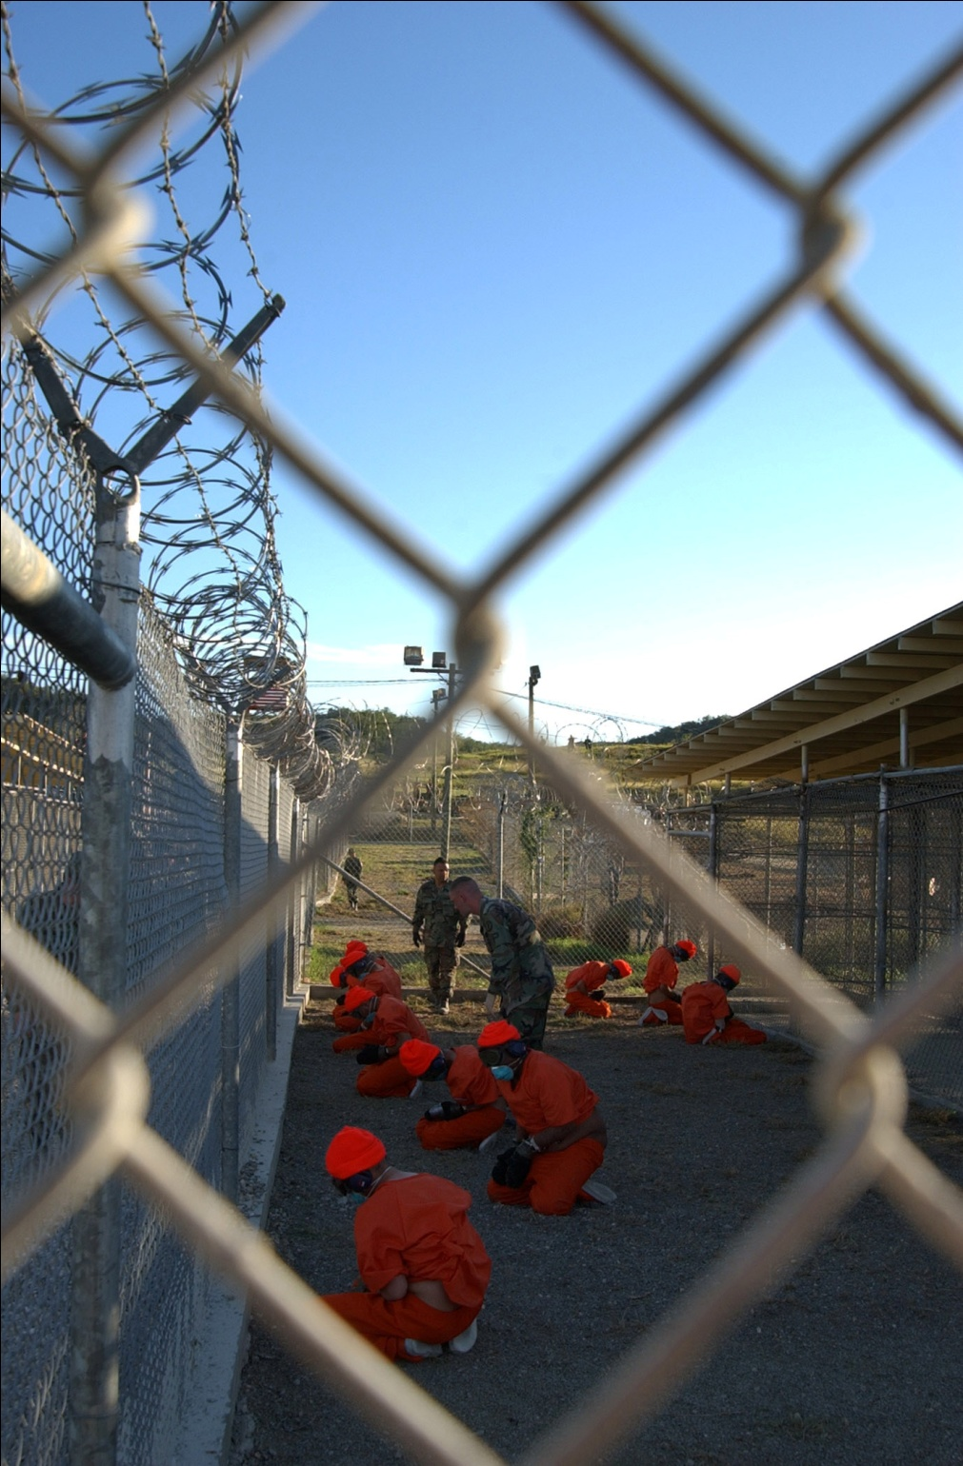
Fig. 1
Resembling shots taken illictly by a press photographer, but in fact official publicity images by US Navy photographer Shane T. McCoy on January 11th, they show prisoners with their hands bound together, wearing face masks, eye masks, ear defenders, gloves, and orange overalls, being ‘in-processed’ by military police inside a wire-fenced compound. These photographs, which were initially received with shock and outrage, have come to serve as controversial images for the wider ‘war on terror’, both for its defenders and its opponents. Subsequent images have failed to displace or over-write McCoy’s photographs which have acquired a definitive status as representations of the US government’s degradation of international justice in the operations of the war on terror. As journalist George Monbiot suggests, writing on the historical legacy of George Bush’s presidency,
one image is stamped indelibly on this presidency: the trussed automata in orange jumpsuits. It portrays a superpower prepared to dehumanise its prisoners, to wrap, blind and deafen them [...] It wanted us to know that nothing would stand in its way: its power was both sovereign and unaccountable (Monbiot, 2008).
The conscious motivation behind the distribution of these publicity images was unclear, although Judith Butler also asserts that a key reason for putting the prisoners on display was triumphal: ‘to make known that a vanquishing has taken place, the reversal of national humiliation, a sign of a successful vindication’ (Butler, 2006, 77-8). Certainly, rather than merely documenting the admission of prisoners into Camp X-Ray, these images employ the visual tropes of photojournalism to dramatize the ‘making safe’ of the captives, demonstrating their disempowerment and de-individualisation before an international audience. Moreover, far from being the sign of a commitment to transparency and accountability in the treatment of these prisoners, I would argue that these ambiguous photographs have a contradictory function. The controversial status of these images rests not so much on the ostensible content of the photographs, as on the way in which the photographs embody a political order in which power is exercised through the management of the visible. As John Pilger observes, U.S. Army commander, General David Petraeus has described the invasion of Afghanistan as a ‘war of perception...conducted continuously through the media’ (Pilger, 2010, 6), and in this respect the war in Afghanistan is one frontier in a much broader political project concerned with controlling the flow and interpretation of images and text. Accordingly, in appearing to make the camp and its occupants publicly visible in this carefully managed way, McCoy’s photographs simultaneously work to ensure the invisibility of the camp, the radical silencing and isolation of the occupants, and the concomitant suspension of Guantánamo Bay prison from the régime of international law. John Berger suggests, ‘A photograph, whilst recording what has been seen, always and by its nature refers to what is not seen. It isolates, preserves and presents a moment taken from a continuum’ (Berger, 1980, 293). The photograph represents a selective decision or action that excludes other possible moments and views. In making one moment visible, then, the photograph is a paradoxical sign of the invisibility of other moments, the sign of a simultaneous action of concealment and exposure, censorship and candour.

These photographs prompt a number of urgent questions about the politics of representation and visibility, US imperialism, indefinite detention and the heterotopic spaces of the Guantánamo prisons, the use of torture and the suspension of rights associated with this ‘war’. They also raise questions about the status of photojournalism in relation to propaganda. This chapter will address these questions through a close analysis of these controversial images, their circulation and reception, and the troubling of the boundaries between press release, propaganda, and document that they enact.

Combat Camera and illusive photojournalism
The photographer Shane McCoy was employed in a Navy ‘Combat Camera’ unit, one of several ‘visual information acquisition units’ comprising groups of photographers and videographers whose job is to document a broad range of military activities. Combat Camera photographers and video camera operators produce photographic documentation of combat operations, ‘combat support operations, humanitarian efforts, scientific research, and related peacetime activities such as exercises and war games’. The imagery they produce is passed on to the Pentagon in Washington, whence it can be distributed throughout the Department of Defense, but the visual material produced by Combat Camera has a broad range of uses from legal documentation and mission assessment through to ‘information warfare’ (propaganda or disinformation) and public affairs (community relations and media liaison). Combat Camera personnel are frequently referred to as photojournalists, and indeed the material they produce is used by the military’s official TV channels, newspapers and periodicals such as the Navy’s magazine All Hands (founded in 1922 and now published by the US ‘Naval Media Center’), Marines, or Airman. This designation of these military personnel as journalists indicates a wilful blurring of distinctions between photo-reconnaissance, historical documentation, propaganda and reportage in contemporary visual culture.
Naval officer Aaron Ansarov explains the function of Combat Camera in these dramatic terms:
The assignment... simple. The objective... illusive. The cost... immeasurable. We are the men and women who go through great risks to get the shot. We extraordinary videographers and photojournalists train with the best, operate in the worst and get noticed the least. Our mission is to be there when history happens. Ever notice that photo or video clip in the news, book, or documentary? Well, someone had to be there. Someone had to get the shot. Someone had to tell the story. We are that someone.

One of Combat Camera’s primary roles is expository, explaining military operations both to the public and the military chain of command, but it is also concerned with documenting and narrating history, and it appears that this self-description of these military personnel as documentarists or photojournalists is unironic. This naming moves some way beyond the mechanisms of managing reporting through press pools and embedding that were pioneered by the British military in the Falklands conflict. With the function of displacing and undermining the authority of independent publications and broadcasters, it comprises what might be termed ‘counter-journalism’ (as a counter-terrorist strategy) or ‘simulated journalism’, through the creation of a parallel system wherein recruits can be trained in a military journalism college, such as the Defense Information School in Maryland, before going on to provide material for the official entertainment and news agency, ‘Defense Media Activity’.
Ansarov’s comment that their objective is ‘illusive’ rather than ‘elusive’ is perhaps a mis-spelling which inadvertently identifies the interminable play of misdirection, self-delusion and fantasy in which these image-makers are engaged. In a recent critical survey of war reportage, Geoff Dyer suggests that ‘In Iraq and Afghanistan we are perhaps glimpsing the end of the era of the combat photographer as a special category of occupation, the twilight of the photographer as novelist in the way that [Robert] Capa [...] and Eugene Smith were visual novelists’ (Dyer, 2010). Dyer speculates that it is the superabundance of photographs in circulation that has dissipated the author function of photojournalism; whether or not this is the reason, the figure of the professional Comcam photojournalist can certainly be understood to mark both the displacement and parody of a certain ethics of journalism. The romantic conception of the photojournalist, epitomised by the figure of Capa, is of a heroic, commercially and institutionally independent, ethically conscientious witness whose published work constitutes a measure of truthfulness by which other, official accounts can be tested. Photojournalism challenges the narrative and moral adequacy of the various histories of particular events and provides the basis for the construction of other narratives. Of course, this conception of the photojournalist relies upon a questionable investment in the status of the photograph as proof and the understanding that, as Susan Sontag puts it, ‘Photographs furnish evidence’ (Sontag, 1973, 5) As John Taylor suggests, far from being a transparent document, the meanings of a photograph are modified by the contexts in which it is used and viewed: ‘photography as evidence [..] reveals points of view held by photographers and editors who make it available; its use helps to confirm beliefs and hopes or sometimes to fashion spheres of controversy’ (Taylor, 1998, 60). Of course, semantic instability is a quality of any photograph, but ontological questions of authenticity can take on a greater urgency in relation to documentary or journalistic photographs as questions of meaning give way to questions of the struggle for hermeneutic control. For Berger, for instance, what is at stake in the interpretation of a photograph is the validation of a certain world-view: ‘Hence the crucial role of photography in ideological struggle. Hence the necessity of our understanding a weapon which we can use and which can be used against us’ (Berger, 1980, 294). Photojournalistic practice and discourses of journalism are characterized by a particularly heightened awareness of the use-value of photography, the ways in which a photograph can be appropriated and put to work ideologically and politically. This struggle is dramatized especially well in the Camp X-Ray photographs.
The first image (fig. 1), shot through the links of a wire fence, shows ten kneeling captives in orange caps arranged along an alley running between two rows of cells. They are accompanied by two military policemen, dressed in camouflage uniforms that blend with the greys, beiges, pinks and blues of the background. One of the M.P.s seems to be haranguing a captive, or perhaps he simply has to shout because they’re wearing ear defenders. He may merely be leaning in to look or listen more closely to one of the men – it is unclear. Other figures watching this scene from behind the fence are just visible. All the figures within the alley are carefully framed within a single square of the fence.
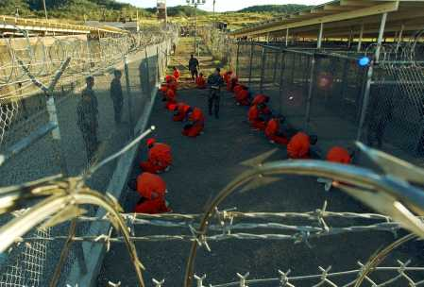
Fig. 2
In the second image (fig. 2) - although the temporal relationship of the two scenes is uncertain - shot from a high angle over the top of the wire fence, seventeen kneeling captives are visible, some of them bare-headed. A military policeman – presumably the one who was leaning over one of the men in the first image - walks between the two rows of prisoners, reading a piece of paper. The second policeman stands at the far end of the corridor watching the kneeling men, and another five uniformed figures are also watching the proceedings from outside the fence. Barbed wire and coiling razor wire run along the bottom of the frame in the foreground.
Viewed without captions it is unclear exactly what is taking place in the ritual captured in the photographs – the kneeling men, arranged so that they all face away from one another, are in an apparently uncomfortable position with their legs crossed beneath them on the gravel floor, and a number of them are doubled over as if in pain, fear, or from the cold. It might be that some of them are falling asleep or have slumped into the most comfortable position available, but the pose with heads bowed and hands clasped in front of them is also a parody of prayer, as if to reinforce the assumption that these are zealots.
The initial impression is that these photographs are unstaged. The photographer is unacknowledged by the figures within the images and the fact that they are taken from outside the fence implies that the photographer is an incidental witness with limited access, peering over or through the wire in order to steal the shots. Positioned by this perspective as an external, illegitimate observer rather than a participant in the action, we might imagine that he happened upon this scene as he was passing through the camp. He is simultaneously proximate but distant, and is also consequently positioned as a representative of us, rather than a representative of the U.S. government, the Navy, or the coalition of the willing. And, of course, the visual emphasis upon the fences asserts the extreme danger posed by these people who must be handled and photographed, like wild animals, with great caution. As Edmund Clark, whose own photographs of the Guantánamo Bay prison include very few prisoners or guards, observes, ‘We’ve seen lots of pictures of people in orange jumpsuits, and plenty of photojournalistic long lens imagery of Guantánamo, and I’m not really sure what that tells anyone. In a way it just reinforces our paranoia, our fear and our suspicion’.

Whether or not it is an effect of accident or technique, these appear to be judicious compositions; they both use sharply receding perspective to dramatic effect, as if to emphasize the fact that the captives are trapped with no way out, and they both foreground the wire fence, incorporating it into the design of the image. McCoy has explained that the second photograph was taken by placing the camera on a monopod, setting the automatic timer and hoisting it above his head, which does suggest that the composition of the image is partly a matter of luck, and the lens flare in the right hand corner of the photograph does indicate a degree of accident (Rosenberg, 2008). Nevertheless, the curving razor wire and barbed wire in the immediate foreground dominates the image, aggressively filling the bottom third of the frame, while in the other, by far the most reproduced image, the wire fencing occupies more than half of the frame, almost as if gesturing towards modernist abstraction, destabilizing the relationship between the flat picture plane and the depth of the image.
This has two significant effects – the first is that the ostensible subject of the photograph, which is the assembly of the prisoners, is relegated to the background of the image, reducing the prisoners to an undifferentiated group. A second effect is that the wire is used as a frame within the frame of the photograph, reiterating visually the enclosure of the captives through their visual capture within the square of bent wire. In several ways, then, these photographs repeat or perform the capture, confinement and exclusion of the prisoners in a visually stylish or self-reflexive manner, offering us an image of frames within frames, spaces divided and transected by screens and barriers.
These images are often tightly cropped and recomposed when they are reproduced, effectively rejecting the distancing device of the original composition and reducing the spatial complexity of the photograph in order to focus our attention on the figures in the image, perhaps in a humanitarian gesture of recognition and greater melodrama, but also to render the images in a conventional reproducible format for newspaper and magazine pages, web pages and the backdrops for TV news reports, excising the extraneous information (See Fig. 3). The first image is frequently cropped so severely that all that is visible is the group of figures within the links of the fence (See Fig. 4).
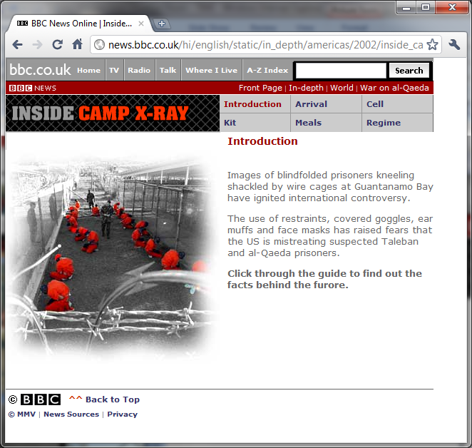
Fig. 3 BBC News webpage
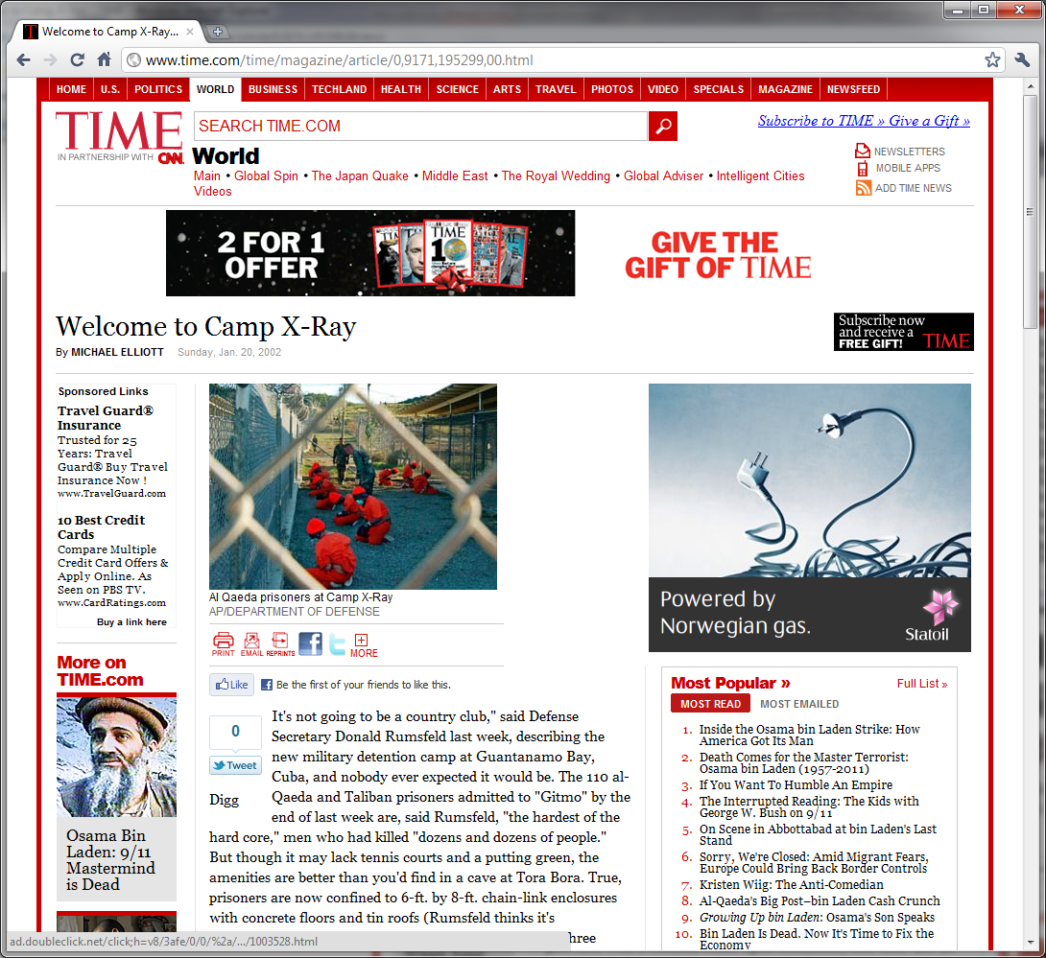
Fig. 4 Time magazine webpage
In the background of both of these images, a guard tower emblazoned with a US flag is just visible and this redundant detail, like an advertising hoarding, betrays the fact that these images are staged in a different sense in so far as the mise-en-scène of the prison camp itself is a set, a tableau vivant constructed for certain audiences. These are images of the theatre of war. Floodlights are visible overhead, the actors are in colour-coded costume, we are positioned alongside the other watching figures in the picture as audience members and, of course, in place of opaque prison walls are fences (fourth walls) that purport to hide nothing. These images echo the archetypal representation of a prison in Gustave Doré’s 1872 engraving of the exercise yard of London’s Newgate prison, which shows a group of prisoners trudging in an endless circle within the high walls, while three onlookers stand watching. The echoes of Doré’s image in McCoy’s photographs again indicates that these photographs are more than spontaneous objective documents of this event but composed in such a way that they invoke a genre of images of incarceration, although they refer to very different models of the carceral. Camp X-Ray is a prison camp that realizes the disciplinary and design principles of Jeremy Bentham’s panopticon. As Michel Foucault explains, the repressive principle of the panopticon is visibility:
By the effect of backlighting, one can observe from the tower, standing out precisely against the light, the small captive shadows in the cells of the periphery. They are like so many cages, so many small theatres, in which each actor is alone, perfectly individualized and constantly visible. The panoptic mechanism arranges spatial unities that make it possible to see constantly and to recognize immediately. In short, it reverses the principle of the dungeon; or rather of its three functions – to enclose, to deprive of light and to hide – it preserves only the first and eliminates the other two. Full lighting and the eye of a supervisor capture better than darkness, which ultimately protected. Visibility is a trap. (Foucault, D and P, 200)
McCoy’s photographs describe the panoptic theatrical mechanism of Camp X-Ray, the prisoners isolated from one another, deprived of sensory stimulation, unable to communicate, exposed not just to their captors but to other observers as well as the international audience for these images, and unable to know when, whether and by whom they are being observed.
Although supposedly coincidental, since the camps are named using numbers or the phonetic alphabet used by radio operators, ‘Camp X-Ray’ implies an inverted space, its viscera or internal structures visible as if laid open to objective, compassionate diagnostic scrutiny or exposed beneath the paranoid gaze of a border agent or security guard. This is a prison, the name tells us, in which nothing can be hidden from the lethal, penetrating electromagnetic gaze. Of course, x-rays are only visible on screens or on photographic negatives and in this respect McCoy’s photographs are integral to the apparatus of capture and exposure constituted by the prison.
Some months after they were distributed, the second of these images, (Fig. 2) was removed from the press release archive on the Department of Defense website as unrepresentative and outdated. It is now marked as ‘for Official use only’, and the Department of Defense has done its best to prevent news organizations from using both of the images (Rosenberg, 2008). The powerful impact of these images meant that they eclipsed other images of the prison and, in particular, of the permanent camps that replaced the temporary structures of Camp X-Ray such as Camp Delta and Camp Iguana (where the children are held). Indeed, McCoy’s photographs have become visual shorthand for the Guantánamo Bay prison. The posters for the films, The Road to Guantánamo and Harold and Kumar Escape from Guantanamo Bay, both reprise the orange outfits, wire fence and watchtower in a distillation of the key elements of the initial photographs, while in Steve Bell’s June 13th 2006 cartoon in The Guardian newspaper (based on fig. 1) the prisoner’s caps are replaced with Mickey mouse ears while the M.P. shouts at them ‘IS THERE ANYTHING YOU PEOPLE WON’T DO FOR PUBLICITY?’ The cartoon refers to a comment by the US deputy assistant secretary of state that three suicides by prisoners were ‘a good PR move to draw attention’, (Goldenberg, Muir, 2006). Bell’s drawing confirms what is acknowledged in this statement, which is that a central function of the Guantánamo Bay prisons is as a public stage hijacked here (whether intentionally or not) by prisoners exploiting their limited capacity for self-representation by appropriating and inverting its publicity value.
Image, text and interpretation
The captions accompanying the photographs on the original press release read as follows:
Detainees sit in a holding area in Camp X-Ray, Guantanamo Bay, Cuba, Jan. 11, 2002, to await in-processing. Camp X-Ray is the holding facility for detainees held at the U.S. Naval base during Operation Enduring Freedom. [fig. 1]

Detainees in orange jumpsuits sit in a holding area under the watchful eyes of Military Police at Camp X-Ray at Naval Base Guantanamo Bay, Cuba, during in-processing to the temporary detention facility on Jan. 11, 2002. The detainees will be given a basic physical exam by a doctor, to include a chest x-ray and blood samples drawn to assess their health. [fig. 2]
These explanations – written by the photographer - frame the moment not as a violently repressive encounter (although the threatening detail of the ‘watchful eyes’ suggests a tension), but as a routine, humane, professionally conducted process of institutional admission.
Writing about the relationship between image and text in late twentieth-century visual culture, Roland Barthes observes that images are rarely seen in the absence of accompanying written text, and that one of the key functions of text in relation to images ‘commonly found in press photographs and advertisements’ is that of anchorage, securely attaching a polysemous image to a restricted range of readings (Barthes, 1977, 41). As Barthes explains:
the text directs the reader through the signifieds of the image, causing him to avoid some and receive others; [...] With respect to the liberty of the signifieds of the image, the text thus has a repressive value and we can see that it is at this level that the morality and ideology of a society are above all invested’ (Barthes, 1977, 40).
It is usual for captions to be removed, edited or paraphrased when press photographs are reproduced in different contexts and so, therefore, the repressive function of the caption is restricted or thwarted – the author’s control over the moral and ideological inference of the photographs is inevitably weakened. However, in this particular case the contradictory disjunction between the bland caption and the content of the image ensures that the caption is already displaced by the photograph. The caption assures us that there is nothing remarkable in this purportedly anodyne image of prisoners awaiting a routine medical exam, and effectively invites us not to linger over the photograph, but to move quickly on to the next image, whatever it may be, our gaze skimming across a stream of images.
Whereas Louis Althusser argued that we are incorporated ideologically as individual subjects in the symbolic moment in which we acknowledge a policeman’s call, Nicholas Mirzoeff proposes that the exercise of state power can be understood as the injunction to keep moving. The captions to these photographs relay this power relation. ‘Jacques Rancière has argued that the police now say to us, “’Move along, there’s nothing to see’.” The police interpellate the Western subject not as an individual but as part of traffic’ (Mirzoeff, 2006, 23). The caption similarly invites us not to look closely at the images although, despite this injunction to move along, McCoy’s arresting photographs have nevertheless served to obstruct this flow. This is partly because of what they show and partly because of what they mask and what makes them controversial images is that this repressive inter-play of the visible and the invisible has been foregrounded in the reception. As Mirzoeff continues,
when the police say there is nothing to see, we do not believe them – nor are we supposed to. Rather, we know perfectly well that there is something to see, but that we are not authorized to see it. For all the mass proliferation of images, the visuality of war remains profoundly undemocratic (23).
More clearly than many other images to emerge from the ongoing war against terror, McCoy’s photographs circulate within ‘the sphere of the militarized image’ which is circumscribed by a ‘boundary between seeing and not being allowed to see’ (24). What is striking about the images is not just the visual representation of transnational militarized state power exercised through and upon these bodies, but their function as an extension or symbolic instrument of such power.

In this context, it is hard to credit official surprise at the reception of the photographs. A report from December 2006 by the American Forces Press Association (which produces reports for military news publications as well as for distribution to the international press) relates that:
Servicemembers [at Guantánamo bay prison] said they are especially frustrated by repeatedly seeing television, movie and print images of detainees being held at Camp X-Ray, a considerably more austere temporary facility that was operated for only four months and has been closed for four years. Many international news stories still are illustrated with old photos of Camp X-Ray (Greenhill, 2006).
The article goes on to correct the misperception that torture or mistreatment is taking place at Guantánamo bay, insisting that what people fail to appreciate is that ‘the guard force and the intelligence people maintain a remarkable degree of restraint and equilibrium’, despite having dealt with over 3000 instances of ‘detainee misconduct’ in the previous year ‘including 432 assaults with bodily fluids, 227 physical assaults and 99 efforts to incite a disturbance or riot’ (Ibid.). Interviewed in the article, Navy Rear Admiral Harry Harris Jr., commander of the Joint Task Force in charge of the camps, invites foreign reporters to visit the camp in order to see for themselves how the camp has been improved over the intervening years with over $100m spent on upgrading the prison facilities. ‘We’re getting better at communicating,’ he explains. ‘But our opponents can lie and we can’t, and so we have to fact check and make sure that we tell the truth’ (Ibid.).

What is stake here is, of course, not so much truthful communication as control over the ways in which images are interpreted. As Torie Clarke, the Pentagon spokesperson who authorized the circulation of the images, admitted,
Did I ever misread what was in those photos […] The problem wasn't that we released too much, it was that we explained too little ... which allowed other critics to say we were forcing the detainees into poses of subjugation (Rosenberg, 2008).
However, the blurring of boundaries that permits Shane McCoy to be characterized as a photojournalist, is the same destabilizing movement that takes the capacity to fix the meaning of images out of the hands of government and military public relations. As Liam Kennedy observes, in a discussion of the relationship between photography and US foreign policy,
the expansion of new technologies has produced a global media sphere in which images and information have become ever more difficult to control. The machinery of American public diplomacy [...] has struggled to adapt to these new conditions. The difficulty of conducting a war of images is compounded in a global information sphere that can swiftly expose and interrogate contradictions of declared values and apparent policies and actions (Kennedy, 279).
The adoption of digital photography has made the exchange and circulation of images ever more instant. Berger proposes that ‘The very principle of photography is that the resulting image is not unique, but on the contrary infinitely reproducible’(Berger, 1980, 291). This is even more the case with digital photographs, the accelerated temporality and the volume of images making the management of this circulation more challenging. As Susan Sontag observes, discussing the effects of the soldiers’ souvenir photographs of abuse in Abu Ghraib prison that were passed on to the US TV news,
In our digital hall of mirrors, the pictures aren't going to go away. Yes, it seems that one picture is worth a thousand words. And even if our leaders choose not to look at them, there will be thousands more snapshots and videos. Unstoppable. (Sontag, 2004)
However the result of this superabundant heterogeneous proliferation of images is not a contemporary global media environment in which images are substitutable and indifferent, their meanings playing freely. The persistence of certain images is testament to Sontag’s optimistic investment in the semantic power of images. As Rancière argues, the political problem with the contemporary globalized visual régime is not an anaesthetizing deluge of images:
We do not see too many suffering bodies on the screen. But we do see too many nameless bodies, too many bodies incapable of returning the gaze that we direct at them, too many bodies that are an object of speech without themselves having a chance to speak. The system of information does not operate through an excess of images, but by selecting the speaking and reasoning beings who are capable of deciphering the flow of information about anonymous multitudes. The politics specific to its images consist in teaching us that not just anyone is capable of seeing and speaking (Rancière, 2009, 96).
The controversial dimension of McCoy’s photographs is not so much that they reveal a contradiction between values and action (which rests on a problematic commitment to photographic truth) as that they reveal how ways of seeing and interpreting images are circumscribed by and incorporated into an information system that reproduces unequal power relations. As Mirzoeff proposes, the pressing critical challenge in the face of this system is:
to provide tactics and strategies for the visual subject in the era of global war [..,] a person who is both the agent of sight – regardless of his or her biological abilities to see – and an object of discourses of visuality’ (Mirzoeff, 22).
One such resistant strategy is a critically oriented contemplative gaze that refuses to ‘move along’ and pass over images such as these. It is a matter not merely of scrutinizing the images for hidden detail, nor of demanding to see more, but of ‘seeing through’ the illusive transparency of the photographs in order to recognize how transparency and visibility can function as critically diverting spectacular excess - as a trap. Ironically, the official withdrawal of the images extends this illusion, through the implication that international audiences were accidentally allowed to see too much in a brief moment of slippage or excessive openness, but this censorious gesture also paradoxically confirms that the US government and military news agencies and personnel naturally tend towards transparency if not carefully managed. It implies that censorship is an a posteriori response, rather than an intrinsic function of the system. This is not a paranoid conceptualization of a total system that can anticipate and disarm any assault upon it, since I am arguing that McCoy’s images have acquired an autonomous significance. However, what critical engagement with these images, and the system in which they circulate, must recognize is that they belong to a political order that functions not by concealment, nor by overexposure, but by a particular ordering of the perceptual field. What is controversial about these photographs is the information system that they represent, which is an intrinsic part of a system of economic, biopolitical and martial imperial power – the fact that they are taken by a Navy photographer simply highlights this. What is instructive about the reception and circulation of McCoy’s photographs is precisely the way in which these images have been repeatedly reframed, reworked and reinterpreted, rather than passed over. This ongoing process of interpretation and re-interpretation reminds us that the acts of looking (at these images) are potentially political in so far as looking at controversial images can reconfigure the prevailing perceptual frames through which we perceive – and fail to perceive – the lives of others.
References

Barthes, R. (1977), Image, Music, Text, London: Fontana, ed. and trans. Stephen

Heath

Berger, J., (1980), ‘Understanding a photograph’, in Rachtenberg, A., ed., Classic Essays on

Photography, New Haven, Conn: Leete’s Island Books, pp. 291-294

Brothers, C, (1997), War and Photography: A Cultural History, London and New York:

Routledge

Butler, J, (2006), Precarious Life: The Power of Mourning and Violence, London and

New York: Verso

Clark, E., (2010), Guantánamo: If the Light Goes Out, Stockport: Dewi Lewis

Dyer, G, (2010), ‘The Human Heart of the Matter’, The Guardian, 12 June 2010.

Available from: http://www.guardian.co.uk/books/2010/jun/12/geoff-dyer-war-reporting?INTCMP=SRCH. Accessed 24/11/10

Foucault, M., (1991), Discipline and Punish: The Birth of the Prison, trans.

Sheridan, A., London: Penguin

Goldenberg, S., Muir, H., (2006), ‘Killing themselves was unnecessary. But it certainly

was a good PR move’, The Guardian, 12 June 2006. Available from: http://www.guardian.co.uk/world/2006/jun/12/guantanamo.topstories3. Accessed 11/7/08

Greenhill, J., (2006), ‘Outdated Images of Detention Center, Mission Frustrate Guantanamo

Troopers’, December 2 2006, Available from: http://www.defense.gov/news/NewsArticle.aspx?ID=2272. Accessed 1/4/08

Kennedy, L., (2008), ‘Securing vision: photography and US foreign policy’, Media

Culture Society vol. 30, no. 3, 279-294

Mirzoeff, N., (2006), ‘Invisible Empire: Visual Culture, Embodied Spectacle, and Abu

Ghraib’, Radical History Review, Spring 2006, no. 95, pp. 21-44

Monbiot, G (2008),’Lost in the System’, The Guardian, 17 June 2008. Available from:

http://www.monbiot.com/archives/2008/06/17/lost-in-the-system/

Accessed 27/6/08
Pilger, J., (2010), ‘Why was this event reported as a bloodless victory welcomed by all
Iraqis?’, The Guardian (G2 supplement), 10 December 2010, pp. 4-7
Rancière, J., (2009), The Emancipated Spectator, trans. Elliott, G., London and New
York: Verso
Rosenberg, C., (2008), ‘Sailor’s photos became icons of Guantanamo’, 13 January
2008. Available from: http://humanrights.ucdavis.edu/projects/the-guantanamo-testimonials-project/testimonies/prisoner-testimonies/sailors-photos-became-icons-of-guantanamo. Accessed 1/4/2008
Scalmer, S, (2002), Dissent Events: Protest, the Media and the Political Gimmick in
Australia, Australia: University of New South Wales Press
Sontag, S, (1973), On Photography, New York: Farrar, Straus and Giroux
Sontag, S, (2004), ‘Regarding the Torture of Others’, New York Times, 23 May 2004.
Available from: http://www.nytimes.com/2004/05/23/magazine/regarding-the-torture-of-others.html?pagewanted=all&src=pm. Accessed 12/11/10
Taylor, J., (1998), Body Horror: photojournalism, catastrophe and war, Manchester
and New York: Manchester University Press

See Edmund Clark’s account of shooting at Guantánamo Bay (Clark, 2010).
See Scalmer, 2002, for a discussion of ‘dissent events’ by political activists.
See http://www.amnesty.org.uk/news_details.asp?NewsID=17598 (accessed 6/12/10)
http://www.defenseimagery.mil/imagery.html#a=search&s=camp%20x-ray%202002&chk=6cfe0&sel=1000&guid=468628ba07bf4c9fa58370c11b0468124e20ee4a
http://www.defenseimagery.mil/community/taskcomcam/navy.html (Accessed 12/11/10)
http://www.defendamerica.mil/specials/CombatCamera.html (Accessed 12/11/10)
See Brothers, 1997, 206-9
See http://www.dma.mil/
http://www.guardian.co.uk/artanddesign/gallery/2010/nov/03/guantanamo-photographs-edmund-clark-gallery?picture=368316599#/?picture=368316595&index=6 (Accessed 2/12/10)
http://news.bbc.co.uk/hi/english/static/in_depth/americas/2002/inside_camp_xray/default.stm. Accessed 5/5/11.
http://www.time.com/time/magazine/article/0,9171,195299,00.html. Accessed 5/5/11.
McCoy suggests that the gloves and hats are not a means of sensory deprivation but simply because the weather was cold (Rosenberg, 2008).
http://www.scoop.co.nz/stories/WO0201/S00047.htm

