A transnational approach to the implementation of eco-design methodologies in SMEs

RENNIE A.E.W.*, LAMBERT C.G.*, BAKER N.J.* & HJELM O.**
*Engineering Department, Lancaster University, Lancaster, United Kingdom
**Environmental Technology and Management, Linköpings Universitet, Linköpings, Sweden
ABSTRACT
The financial limitations of Small and Medium-sized Enterprises (SME’s) can be particularly acute during new product development. Combined with the ever growing desire to manufacture and market their products in a sustainable manner, there is a strong case for SME’s supporting each other on best practice for eco-design of new or existing products. Development of frameworks across international boundaries, such as the Anglo-Swedish SIMPLE project (Successful Implementation of Eco-Design in SMEs), can bring further advantages. This paper describes the development of a collaborative transnational network of sharing design methodology to aid the implementation of eco-design. The project, funded under the EU Interreg IIIC Programme, aims to use partnerships between small companies, local authorities, consultants and universities to educate industry in such activities. Although fairly established in the general area of sustainability, the adoption and integration of an eco-design approach combined with sustainable design methodologies and tools (Bhamra & Lofthouse, 2003; Hjelm, 2004) are found to be developmental in SME product design and manufacture in a number of sectors in the North West Region of the UK.

In the present programme, a major emphasis has been on the understanding and consideration of eco-design concepts such as material minimisation, design optimisation, value engineering, and design for environment and surroundings. Methods of incorporating such concepts within the diverse cross-sector portfolio of SMEs participating in this programme have been investigated. Comparisons between attitudes to adoption and the benefits that can be derived in both the UK and Sweden where similar programmes have yielded success (Hjelm, 2004) have allowed for a greater understanding of the impacts as well as the environmental and financial benefits.

A number of case studies are given in the paper and used to demonstrate the main learning outcomes and achievements that the SIMPLE project has had on participating SMEs.
INTRODUCTION
Climate change has never before been so high on the public and political agenda. Natural resource depletion, energy-use and rising temperatures receive widespread media and political attention. It is widely accepted that the rise in global temperatures since the inception of the industrial revolution has been the result of anthropogenic activity (IPCC, 2001). The mitigation measures of such effects are growing to become more and more embedded into our daily lives and routines. From separating household waste for recycling to offsetting carbon emissions, the daily environmental consciousness of today’s generation is widely different to previous ones. This extends well beyond the chores of household duties and into the world of manufacturing and product design, which provides the focus for this paper.

Heavy industries, up until the middle of the Twentieth Century, dominated the North West region of the UK. Over the past fifty years, and mirrored with other parts of the UK such as the North East, South Yorkshire and West Wales, heavy industries have experienced a decline. Despite such a shift, manufacturing has remained an important pillar in the economic structure of the North West, with an output of £19.5 billion between 1991 and 2001, whilst employing 423,000 people, the highest of all the English regions (NWDA, 2005). Since the turn of the century there has been growing concern over the viability of sustaining similar outputs in the following decade.

Arguably, legislative drivers have a significant influence on the development of any industry, and therefore any organisation engaged in that industry will be required to develop in much the same way. An example is the Waste Electrical and Electronic Equipment (WEEE) Directive (EU, 2003a) that was transposed into UK law on 02 January 2007, somewhat after the original EU deadline of 13 August 2004. The WEEE Directive places a level of producer responsibility on to those companies that manufacture, resell or import electronic and electrical equipment. One of the major problems that the industry has experienced is confusion over what constitutes ‘equipment’ and ‘producer’, both key terms in the Directive (Turner and Callaghan, 2007). This level of ‘greyness’ towards emerging legislation makes it difficult for manufacturers to understand how, if at all, individual firms are implicated. A further disadvantage that comes about from the implementation of new legislation is the increased burden in terms of money, time and administration.

The Restriction of Hazardous Substances (RoHS) Directive (EU, 2003b) was adopted by the UK on 1 July 2006, and aims to reduce the amount and type of hazardous substances that are used in electrical and electronic equipment. Whilst the two Directives remain autonomous from one another, there are strong links between them and therefore one should always be considered alongside the other. By attempting to divert hazardous substances from use in products, there is a clear move from the industry to harness a level of producer responsibility and make a positive contribution to cleaner design.

Legislation plays a key role in determining the activities and ultimate direction of any industry. One of the key benefits of the Directives outlined above is the move towards a manufacturing industry that is better placed to encompass eco-design and the advantages that this brings. The aim of eco-design is to reduce and balance the adverse impact of manufactured products on the environment by considering the product's whole life cycle – from raw materials acquisition, through manufacture, distribution and use, to reuse, recycling and final disposal (Roy, 2000). The concept of eco-design grew in the 1990’s and is considered by many to be a well-established mechanism of achieving many advantages by shifting the attitudes of designers and manufacturers in considering the totality of a product, from inception to disposal.

Despite these changing attitudes towards an approach that centres on the principles of eco-design, there is still further progress to be made, particularly by smaller firms. It can be argued that a current transition phase exists, where SMEs awareness and exposure to the benefits of eco-design are increasing. Whilst some companies experience benefits throughout their operations, there are many SMEs that find other priorities constraining them from moving further from manufacturing operations of the past and into the future. Reasons for this include the continued use of dated machinery, resulting in design decisions that are dictated by operational equipment. The dependency that small firms have on such equipment, often plant machinery, without which manufacturing would cease, demonstrates how potentially cleaner design decisions are not being considered as available technology provides a barrier.
SME ENGAGEMENT WITH ECO-DESIGN
The advantages gained from eco-design can be considerable, with the one generally seen as most attractive to SMEs being the reduction in cost of developing a product. This can be achieved considerably well through mechanisms such as Virtual Prototyping, allowing designs to be computer modelled and changes made very quickly, preventing the need for physical prototypes to be made, reducing costs and lead times. Another significant advantage experienced by SMEs is that they become much more appealing to customers. Clients in the manufacturing world are now often seeking that suppliers not only have environmental policies but that they are often employing eco-design principles with the aspirations of Environmental Management Systems, and even external certification of such systems through programmes like the IEMA Acorn scheme, EMAS or even ISO14001, although the former would be inappropriate for many SMEs.

The SIMPLE Project has embraced a number of eco- based approaches in its attempt to foster a better understanding of sustainable/eco-design, including but not limited to, design for environment and surroundings, material minimisation and optimisation, value engineering, and design for disassembly and end-of-life. Such expertise is wide and varied, and it is essential that a variety of players, both academic and industrial, public and private sector engage to ensure that best practice is disseminated as widely as possible. Thus, with a history of SME engagement in the areas of eco-design (Hjelm, 2004), design for environment (Lindahl, 2005), disassembly strategies (e.g. Johansson, 1997; Bröte & Björkmam, 1997) and remanufacturing (Sundin, 2004), it was felt that collaboration with the East Central region of Sweden would be of enormous benefit to the SME base of the North West of England.

SIMPLE Project - SWEDEN
SIMPLE Project - UK
Sharing Best Practice / Networking
Process and Product Development
Best Practice in Eco-design and Product Development
SMEs
Higher Education Institution
Business Support Organisations
Governmental Organisations
Sector Representative Organisations (Dissemination)
SMEs
Higher Education Institution
Business Support Organisations
International Networking Events
Web Portal
Study Visits
Posters / Presentations

Fig. 1 Model showing the approach and construction of the SIMPLE Project in East Central Sweden and North West UK

Figure 1 gives a representation on how the SIMPLE Project was operated between Sweden and the UK, highlighting differences in the approaches taken and the channels of communication, whilst maintaining a strong SME-centric focus. The Project incorporated several bodies and within Sweden has used the networking capacity between SMEs, an HEI (Linköpings Universitet), Business Support Organisations (ALMI Företagspartner AB) and Governmental Organisations (County Administrative Boards) as the major driver to sharing best practice. There is sometimes a misbelief that sharing ideas and knowledge between SMEs is disliked by industry as it can be seen to be benefiting competitors. Many SMEs, particularly within their own industry can find it difficult, even unnatural to decide to collaborate with other firms who are sometimes seen as competitors. What has been shown here is that SMEs within similar sectors have – through the SIMPLE Project – embraced the opportunity to learn from one another. By facilitating this engagement, the Swedish Partners found that SMEs were able to benefit from sharing ideas, establishing new supply chains and developing their customer base through networking with others.

The UK aspect of the Project similarly held business support, via SME engagement as the central focus, in line with the aims and objectives of the Project’s delivery. However, this engagement relied more heavily on direct knowledge transfer between SMEs and the HEI (Lancaster University) to develop specific products or processes within SMEs. Through the portfolio of industrial collaboration that already existed within Lancaster University’s Engineering Department, SMEs were targeted for the Project that had specific design problems concerning products or processes that they specialised in, but were not yet embracing the opportunities and benefits that could be derived from eco-design principles. By taking each SME in turn, and using techniques described above such as Virtual Prototyping and Finite Element Analysis (for product optimisation), products could be designed, refined and tested without the need for physical prototypes. Two case studies detailing such scenarios are given later in the paper.

The Project has allowed for the bringing together of all these organisations from both countries to undertake: (i) study visits to SME partners; (ii) presentation of individual product development activities and demonstrations; (iii) international networking in both countries, thereby facilitating best practice discussions and allowing opportunities for trans-national business collaboration; and (iv) generation of a web portal from which SMEs can access tools and techniques relating to eco-design.

Using the SIMPLE Project as a model, it can be seen how trans-national collaboration with HEIs, business support organisations and government bodies can provide significant benefits to SMEs in the manufacturing sector. These benefits come about through creating effective networks in which SMEs are able to share ideas and best practice in a supportive environment. Moreover, by reproducing similar operational practices that have been proven elsewhere, eco-design principles have been integral in saving money and time for UK-based manufacturing firms.
METHODOLOGY APPLIED
Using effective design methods from the outset has many advantages in the process of product development, from conception through to manufacture. These are well documented and include time-saving, cost reduction and more effective supply-chain management through leaner manufacturing (Cross, 1994). To help capture these advantages, a methodology was adopted based on historical SME-engagement, which could be employed in the company’s that were integral to the SIMPLE Project. This approach is detailed in Figure 2 and shows how consideration is given at each stage in the design process, from idea inception to end-of-life.

Low / medium / high volume production
Optimum product / process designed
Manufacture test prototypes / run test simulations
New product / process identified
Product / process conceptualised
Market study undertaken
Create detailed design
Viable idea?
Already in existence?
Can it be improved?
Material selection
Value engineering
Design optimisation
FEA / CFD analysis
Cost / time benefits
Environmental benefits
Manufacturing benefits
Disassembly/End of Life
Can it be improved?
Product disassembled / recycled
Product marketed, bought, used
N months / years pass

Fig 2 Design methodology employed through the SIMPLE Project and applied to SMEs
CASE STUDY 1: LEACO LTD
Leaco Ltd is a traditional manufacturing operation, producing components in both injection moulded plastic and pressed/punched metal. The product under investigation is a galvanised steel aerial mounting bracket, manufactured by pressing and punching steel sheet to produce components that are then riveted together. The quality of the bracket is considered to be superior to those of their competitors, however the competition outsource manufacture to China and as such, price Leaco Ltd out of the market. In order to reduce the costs involved in producing their own brackets and thus remain competitive (whilst maintaining a UK manufacturing base), the product had to be optimised to make it viable for continued investment. By opting for a single-piece injection moulded replacement for the most commonly used bracket in their range, and reducing the material required in the structure of these brackets, it was hoped that the principles of eco-/sustainable design could reap huge financial benefits for the company whilst safeguarding their existing business.

Some basic considerations/assumptions where made early on in the development process in order to limit the number of possible design scenarios and speed up the design process, including: (i) be of single piece construction; (ii) be capable of being produced using a two part injection mould tool; (iii) be produced using the minimum amount of material possible with no strengthening inserts used; (iv) mounting holes, both to the wall and for accepting U-bolts, must be maintained.

With consideration to the surrounding environment for product utilisation, the worst case loads applied to the mounting bracket from the aerial (which is manufactured from lightweight Aluminium) would result from pigeons and other birds choosing the aerial as a perch. The worst case loading scenario was simulated as the aerials own mass displaced as far to one side of its mast as possible, and with five very fat (370g) feral pigeons sat on the distant end. Thus, a number of options were considered in the design process that would result in components that were suitable for manufacture (Figure 3a), with consideration to part optimisation, material minimisation and structural integrity (Figure 3b) and finally, moulding capability (Figure 3c).

A major consideration was the selection of a plastic that would provide the physical strength required, and that would withstand the environmental loads applied by outdoor installation. High Density Polypropylene was selected as the most suitable material, and as such was used during the structural analysis portion of the products development, giving the bracket a nominal Factor of Safety of approximately 2.2 (ability to withstand twice the load described above before any part of the structure experiences a stress equal to its ultimate strength).

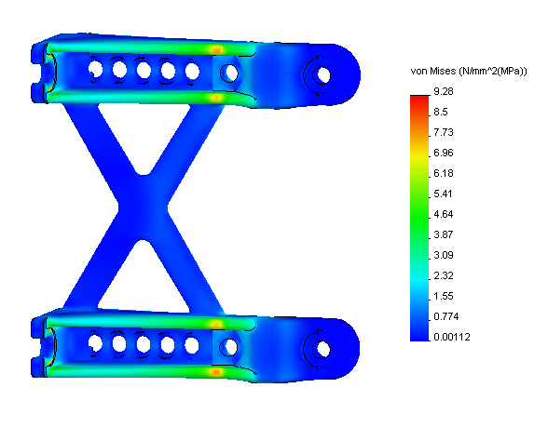
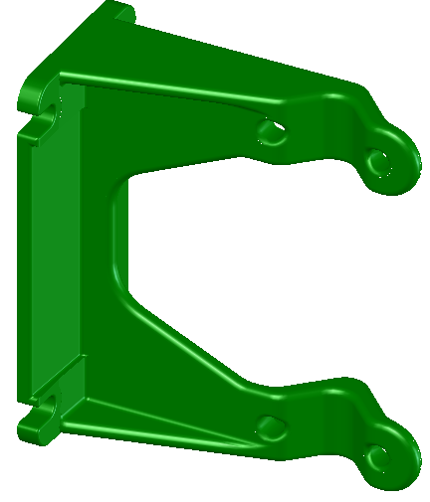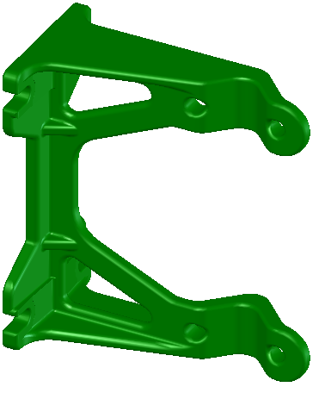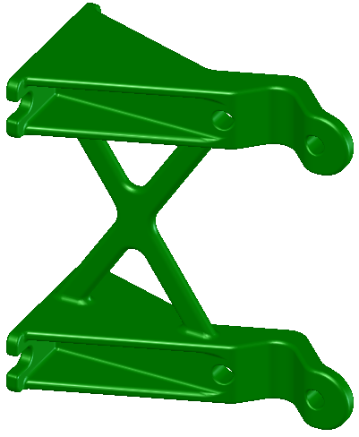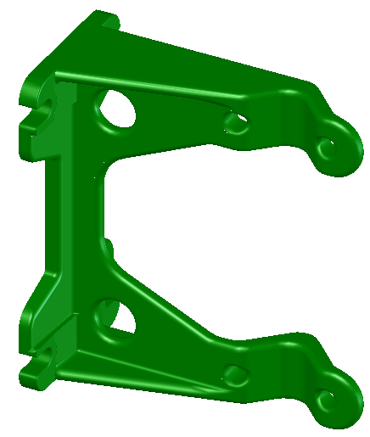

(a) (b) (c)

Fig 3 (a) Four design concepts; (b) Finite element analysis for product optimisation;
(c) Capability for injection mould generation

By considering material usage, capability for manufacture and integration of the product into its operational surroundings, Leaco Ltd are now in a position to recoup a great portion of their business and once again compete in what is now a global manufacturing marketplace. In using the design methodology from the outset, focus was given to these key aspects which it is anticipated will bring advantages for Leaco Ltd. The economic and environmental benefits for the company are evident, but the financial implications and successes of the use of eco-design techniques are yet to be reported.
CASE STUDY 2: RAW STUDIO LTD
As a freelance designer with a diverse portfolio of contemporary furniture, Raw Studio Ltd have now embarked on designs for the provision of high volume manufacture for the educational sector, an approach that has been driven by the quality of the design of their products, but also with consideration for newly introduced legislation (e.g. PR EN 1729: Chairs and Tables for Educational Institutes – Part 1: Functional Dimensions; Part 2: Safety Requirements and Test Methods). Schools traditionally estimate the lifetime of a classroom chair to be no more than 2-3 years and will invest between £7-8 per unit. But no consideration is given to the product at its end of life.

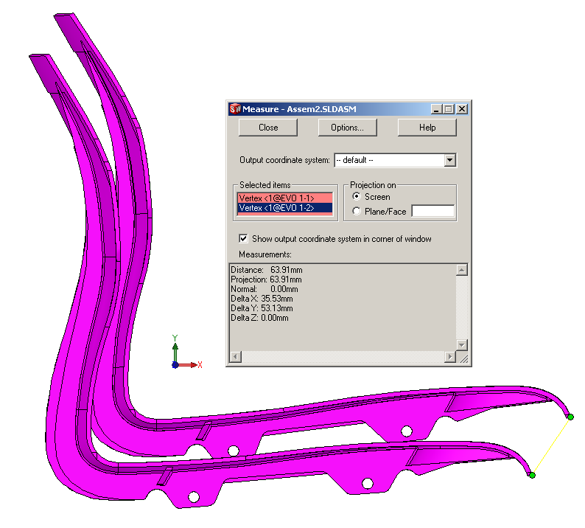
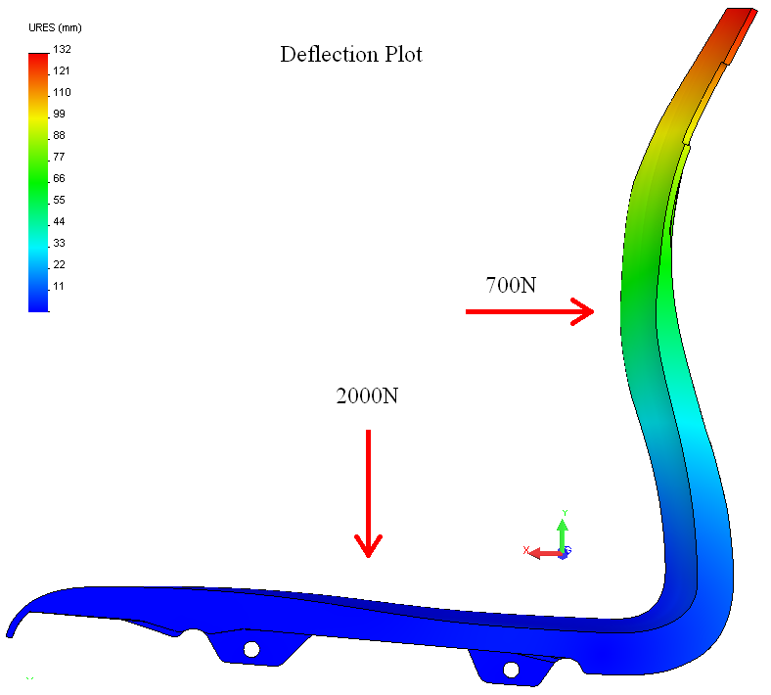
- (b)

Fig 4 (a) Finite Element Analysis of the single part chair back/seat; (b) Nesting analysis for storage and stacking optimisation

Using eco-design techniques, incorporating optimisation for material minimisation (including addition of strengthening ribs for structural analysis (Figure 4a) of a single moulded component), fixture reduction (locations points for chair back/seat to leg joints), nesting analysis for stacking and storage (Figure 4b), and coupling these with disassembly potential for remanufacture, reuse or recycling at its end-of-life, a cost-effective product has been designed suitable for the abuse that generally comes with educational furniture. The hope is that its lifetime will be prolonged beyond the perceived three years, but with the additional benefit that its constituent materials could have a use beyond that period.

The success of implementing these techniques and using the design methodology outlined earlier has allowed Raw Studio Ltd the opportunity to progress to manufacture and most recently, exhibit what is now considered a novel, simplistic, yet aesthetic and ergonomically suitable chair for use in the educational sector (Figure 5). Huge sales are anticipated and will be reported to the Project over time in order that a financial model of the benefits of eco-design for direct product development can be built up.

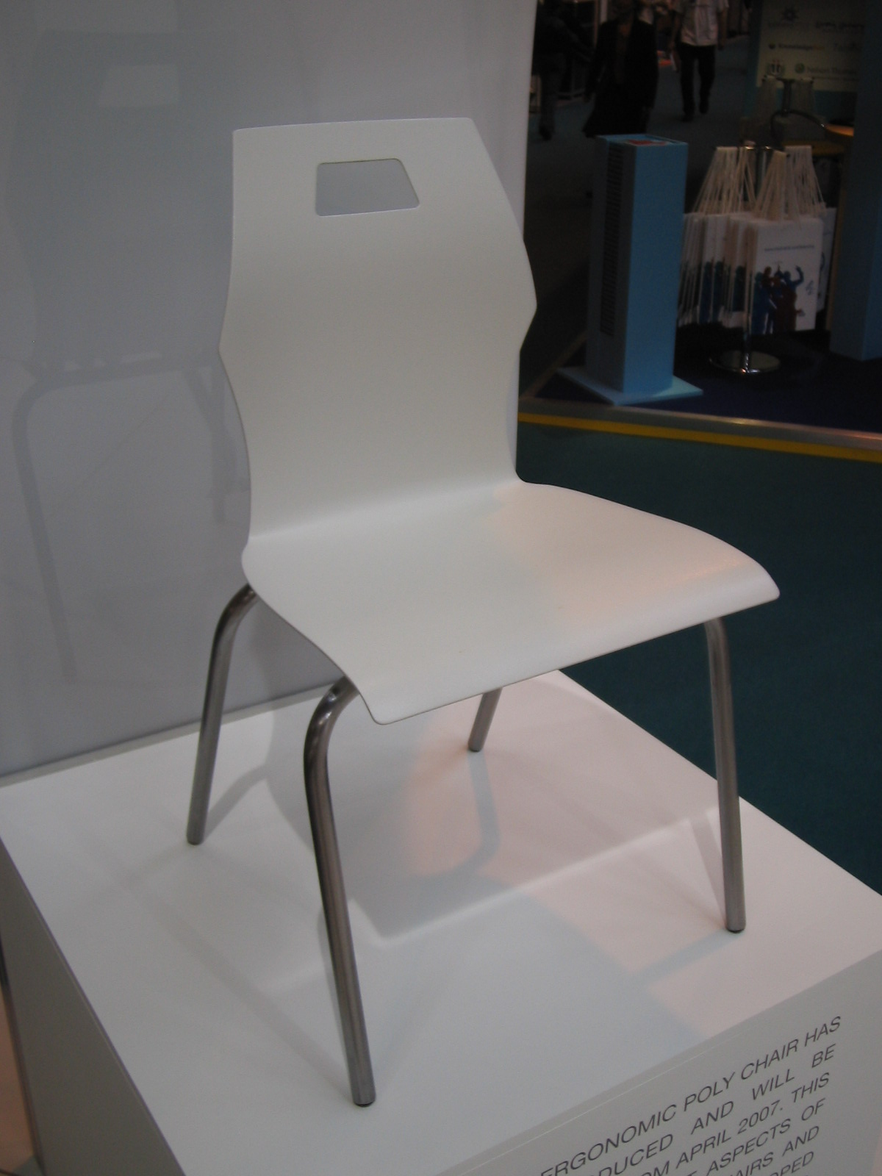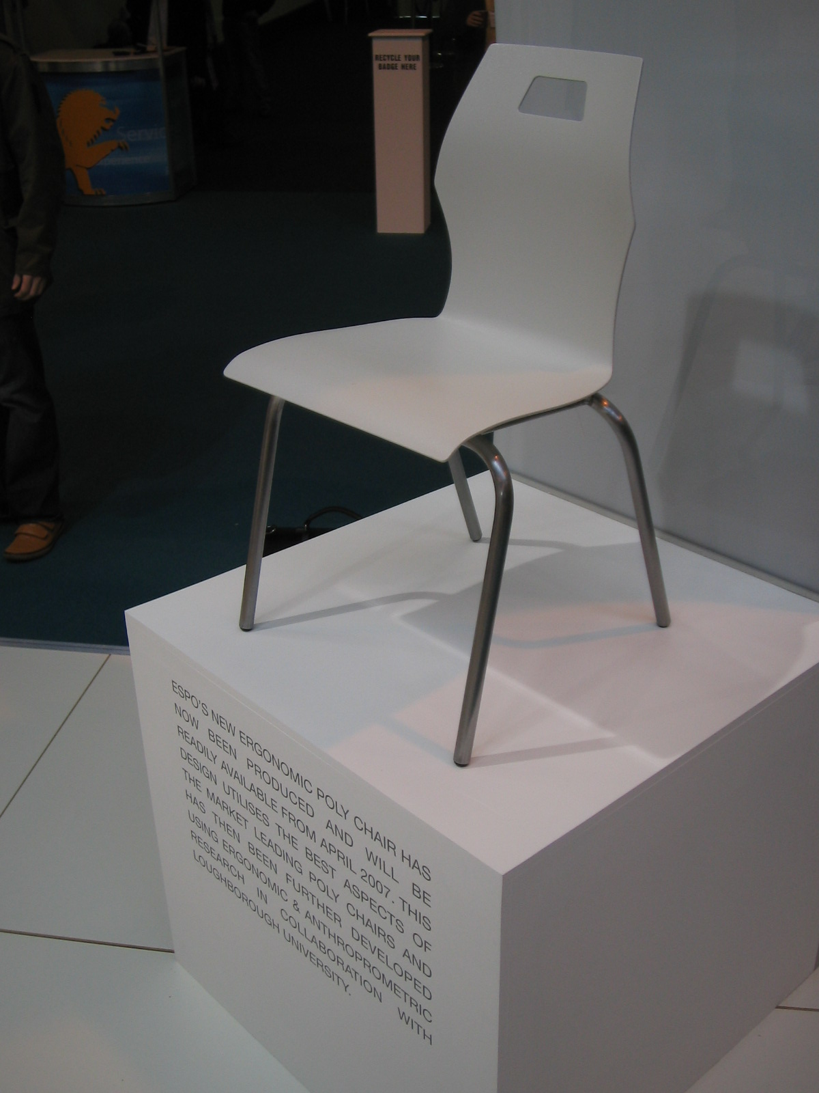

Fig 5 Final product being exhibited at an educational furniture exhibition, 2006
The use of a design methodology that can be applied to SMEs in various sectors has undoubtedly given the companies engaged in the SIMPLE Project advantages in the design process. Early results are positive and have been shown here through material reduction, optimisation of designs by structural testing and the consideration of end-of-life and design for environment issues. However, as the case studies presented here are in the early phases, it would be worthy to investigate the longevity and sustainability of using such approaches in the future by continually assessing the product performance.
CONCLUSIONS
Through the SIMPLE Project, effective SME engagement resulted in the dissemination of approaches used to benefit areas of industry, particularly manufacturing sectors in East Central Sweden and North West UK. These benefits have come about through cross-border collaboration, by taking best practice models which have proven to work, and applying them to a different geographical region. This model has been used to demonstrate how the benefits of eco-design can be reproduced and achieved elsewhere within the manufacturing sector. Confidence is growing that using these principles, and applying them to other geographical regions will reap the benefits that have been shown here.

In the past, manufacturing firms have often had a choice over their environmental agenda and the relative priority that this takes in relation to people strategies, wider social responsibility and of course economic sustainability. Legislative drivers are slowly producing different attitudes to the way in which the manufacturing sector operates: there is now a greater emphasis placed on producer responsibility, design for environment and design for disassembly. As such practices become rooted in the manufacturing industry, so too does a greater responsibility for the products and processes that are generated, from inception to disposal.
ACKNOWLEDGEMENTS
The authors would like to acknowledge the TOWER (Towards Sustainable Excellence by Innovating Regions) EU INTERREG IIIC Programme for the funding that has enabled the SIMPLE Project to go ahead. Participating SMEs are also thanked for their input to the Project to date.
REFERENCES
Bhamra, T.A., Lofthouse, V.A. (2003), Information/Inspiration: A web based Sustainable Design Tool, International Conference on Engineering Design (ICED), Stockholm, Sweden.
Bröte, S., Björkman M. (1997), Disassembly and Manufacturing Strategies – a manufacturing strategic view on disassembly, World Congress Manufacturing Technology Towards 2000 (incorporating 7th International Conference on Manufacturing Engineering AND 3rd Australasian Conference on Rapid Product Development), Cairns, Australia.
Cross, N. (1994), Engineering Design Methods: Strategies for Product Design (2nd Edition), John Wiley & Sons (Publishers), Chichester, England, ISBN 0-471-94228-6.
European Union (2003a), Directive 2002/96/EC of the European Parliament and of the Council of 27 January 2003 on waste electrical and electronic equipment (WEEE), Official Journal of the European Union.
European Union (2003b), Directive 2002/95/EC of the European Parliament and of the Council of 27 January 2003 on the restriction of the use of certain hazardous substances in electrical and electronic equipment, Official Journal of the European Union.
Hjelm, O. (2004), “Advantage Eco-design”: A partnership for promoting eco-design activities in small companies, International Conference of the Greening of Industry Network – Partnerships for Sustainable Development, Hong Kong, China.
IPCC (2001) Climate Change 2001: Synthesis Report
Johansson, G. (1997), A Tool for Facilitating Communication between Manufacturers and Disassemblers/Recyclers in order to Support Design for Disassembly – The Generic Disassembly Process Model, World Congress Manufacturing Technology Towards 2000 (incorporating 7th International Conference on Manufacturing Engineering AND 3rd Australasian Conference on Rapid Product Development), Cairns, Australia.
Lindahl, M. (2005), Engineering Designers’ Requirements on Design for Environment Methods and Tools, Doctoral Thesis, Royal Institute of Technology, Stockholm, Sweden.
North West Regional Development Agency (2005), Available online at: http://www.nwda.co.uk/SimpleContent.aspx?news=1&area=72&subarea=73&item=20054010408004572&yr=2005 (accessed 22 February 2007).
Roy, R. (2000), Sustainable product-service systems, Futures, Vol. 32, Issues 3-4.
Sundin, E. (2004), Product and Process Design for Successful Remanufacturing, Doctoral Thesis, Linköpings Universitet, Linköpings, Sweden.
Turner M, Callaghan D, (2007), UK to finally Implement the WEEE Directive, Computer Law and Security Report, Vol. 23, Issue 1.

