Influence of hydrothermal treatment on the interaction of active components and following COS+CS₂ sulfation of Ce_{0.5}Fe_{0.5}O_{x}-CP catalyst for NH₃-SCR reaction
Yafei Zhu^{1*}, Jingsong Zhou^{1*}, Yanping Du^{2*}, Zhou Liu³, Fei Zhou³, Zhenchang Sun¹, Wei Lu¹, Zhibo Xiong^{1**}
(1. School of Energy and Power Engineering, University of Shanghai for Science & Technology, Shanghai, 200093, China
2. School of Engineering, Lancaster University, Lancaster, LA1 4YW, UK
3. Jiangsu Guoxin Research Institute Co. Ltd., Nanjing, 210000, Jiangsu, China)
Abstract:
Herein, the methods of co-precipitation and hydrothermal treatment were proposed to regulate the promotional effect of COS+CS₂ sulfation on the NH₃-SCR activity of Ce_{0.5}Fe_{0.5}O_{x} catalyst. The results indicated that the co-precipitation method contributed to the formation of Ce-Fe solid solution in Ce_{0.5}Fe_{0.5}O_{x}-CP catalyst, but the further hydrothermal treatment depressed the incorporation of Fe³⁺ into cubic fluorite CeO₂, promoting the formation of Fe₂O₃ crystals while decreasing the defective sites of catalyst. Furthermore, the different interaction of active components not only influenced the NH₃-SCR activity of Ce_{0.5}Fe_{0.5}O_{x}-CP and Ce_{0.5}Fe_{0.5}O_{x}-HT catalysts, but also regulated the sulfation of COS+CS₂ on the catalysts surface. The further hydrothermal treatment decreased the concentration of iron species, but increased the concentration of cerium species on the Ce_{0.5}Fe_{0.5}O_{x}-CP catalyst surface. COS+CS₂ sulfation increased the surface Ce³⁺/(Ce³⁺+Ce⁴⁺) and Fe²⁺/(Fe³⁺+Fe²⁺) molar ratios of Ce_{0.5}Fe_{0.5}O_{x}-HT effectively, but decreased the calculated corresponding values of Ce_{0.5}Fe_{0.5}O_{x}-CP. Furthermore, Ce_{0.5}Fe_{0.5}O_{x}-HT-S exhibited larger deposited surface sulfate, stronger medium-strong acid sites and more active oxygen than Ce_{0.5}Fe_{0.5}O_{x}-CP-S due to the better surface conversion of COS+CS₂.
Keywords: NH₃-SCR, Ce_{0.5}Fe_{0.5}O_{x}, Gas-phase sulfation, Organic sulfur, Preparation method, Regulation
* Co-first authors: Yafei Zhu, Jingsong Zhou and Yanping Du
** Corresponding author: Zhibo Xiong, Tel.: +86 21 55272320, Email addresses: xzb412@usst.edu.cn(Zhibo Xiong), https://orcid.org/0000-0001-6125-0941
- Introductions
Due to the excellent oxygen storage capacity via the redox cycle of Ce⁴⁺/Ce³⁺, CeO₂ has been widely used to develop the non-toxic, non-vanadium catalyst for selective catalytic reduction of nitrogen oxides (NO_{x}) with NH₃ (NH₃-SCR), which was confirmed to be an effective technology to control the emission of NO_{x} from the stationary and mobile sources [1-4], and other metal ions have been doped to optimize the NH₃-SCR activity of cerium-based catalyst [5-7]. Among them, Fe element attracts more attention owing to the properties of environmental-friendliness, low price and good electron transfer of Fe³⁺/Fe²⁺ [8], and Fe doping helped the formation of cerium-iron solid solution, which contributed to enhancing the acid sites and redox ability of CeO₂ catalyst, and thus promoted the adsorption and activation of NH₃ on the catalyst surface [9]. Meanwhile, there still exist the disadvantages of narrow active temperature window and strong high-temperature oxidation of NH₃ for the developed cerium-iron mixed oxide catalyst [10], which needs to be further optimized.
It should be mentioned that preparation method can affect and regulate the interaction of active components in the as-fabricated catalyst, which has a significant effect on the physical and chemical properties of catalyst, including pore structure, reducibility and surface acid sites, thus influences the catalytic performance [11,12]. For example, Yao found that compared to the mechanical mixing, impregnation, co-precipitation and sol-gel methods, the as-fabricated MeCe-HTM catalyst by hydrothermal treatment had the largest concentrations of surface Ce³⁺, oxygen vacancies and active oxygen, the strongest reducibility and acid sites due to the good electronic interaction between Mn and Ce species, and thus exhibited the best NH₃-SCR activity [12]. Zhao et al. also pointed out that the environment of high temperature and high pressure during the hydrothermal process promoted the embedding of Sn⁴⁺ into the lattice of fluorite cube CeO₂, which enhanced the interaction of cerium and tin species and optimized the surface oxygen vacancies of CeO₂ catalyst [13]. Furthermore, compared to the conventional co-precipitation and impregnation methods, the Ce-Mn/TiO₂ catalyst prepared by the reverse co-precipitation presented the best low temperature activity and high anti-SO₂ performance due to high specific surface area, uniform dispersion of active sites, strong surface redox properties and acid sites [14]. Therefore, the co-precipitation and hydrothermal methods contributed to promoting the different interaction of active metal species in the as-synthesized bimetallic and tri-metallic mixed oxide catalysts, thereby regulated the physical-chemical properties and corresponding NH₃-SCR activity.
In order to overcome the poor surface acidity and depress the high temperature peroxidation of NH₃, the sulfation of SO₂ and H₂SO₄/(NH₄)₂SO₄/CS(NH₂)₂ have been used to improve the NH₃-SCR activity of cerium-based catalyst due to the introduced SO₄²⁻ species and the optimized redox properties [15,16]. For instance, Song et al. pointed out that the sulfation of 0.18% SO₂/N₂ at 300 ºC for 4 h not only retained Fe-O-Ce bonds, oxygen vacancies and active species of CP-Fe-Ce catalyst, but also increased the Brønsted acid sites and NH₃-SCR activity of catalyst [17]. Cai et al. also found that the sulfation time of 200 ppm SO₂+5.0 vol.% O₂ at 200 ºC affected the amount of sulfate deposition on the surface of PrO_{x} catalyst, and there existed the appropriate sulfation time for NH₃-SCR reaction [18]. In our previous researches, organic COS or/and CS₂ from blast furnace gas was firstly used to increase the NH₃-SCR activity of CeO₂ catalyst, and presented better promotional effect of sulfation than the traditional inorganic SO₂ [19]. Furthermore, the introduction of O₂ or/and H₂O further regulated the physical-chemical properties of the sulfated CeO₂ catalyst by COS+CS₂, thereby affected the NH₃-SCR activity of catalyst [20,21]. Actually, COS or/and CS₂ are also the toxic pollutants, which need to be converted into H₂S by the hydrolysis method due to strong stable properties [22-24]. Interestingly, previous studies indicated that the introduction of rare earth and transition metals, including Ce, Fe and so on, contributed to promoting the hydrolysis activity of COS/CS₂ and anti-oxy poisoning of the hydrolysis catalysts [25-27]. For example, the doping of Fe, Cu and Ni helped to increase the surface oxygen vacancies and active hydroxyl groups of CeO₂ catalyst due to the formation of Ce-based solid solution and the promoted surface activation of H₂O for COS/CS₂ hydrolysis [28]. In addition, preparation method also affected the hydrolysis of organic sulfur over the rare earth-doped γ-Al₂O₃ catalysts, and the as-synthesized mixed oxide catalyst by incipient wetness impregnation presented better hydrolysis activity of COS than the catalysts prepared by co-precipitation and deposition-precipitation methods [29]. Therefore, preparation method can affect the interaction of active components in cerium-based mixed catalyst, which thus influences the catalytic performance of COS/CS₂ or/and NO_{x} reduction. However, to our best knowledge, the influence of COS+CS₂ sulfation on the NH₃-SCR activity of cerium-iron mixed oxide catalyst has not been studied. Herein, the co-precipitation and hydrothermal methods were proposed to fabricate Ce_{0.5}Fe_{0.5}O_{x}-CP and Ce_{0.5}Fe_{0.5}O_{x}-HT catalysts, and we found that the preparation methods contributed to regulating the surface sulfation process of COS+CS₂ due to the induced different interaction of active cerium and iron species within this mixed oxide catalyst. And the sulfated Ce_{0.5}Fe_{0.5}O_{x}-HT-S catalyst presented better catalytic activity than Ce_{0.5}Fe_{0.5}O_{x}-CP-S. Finally, the physicochemical properties of catalysts were measured to reveal the regulation of preparation methods on the sulfation process of organic sulfur.
2 Experimental sections
2.1 Catalyst preparation
The co-precipitation and hydrothermal methods were proposed to synthesize Ce_{0.5}Fe_{0.5}O_{x}-CP and Ce_{0.5}Fe_{0.5}O_{x}-HT catalysts with Ce(NO₃)₃·6H₂O, Fe(NO₃)₃·6H₂O and NH₄HCO₃ as the precursors and precipitant, respectively. And the used chemical reagents are analytical grade without further purification herein. The preparation of Ce_{0.5}Fe_{0.5}O_{x}-HT mainly referred to our reported researches via one-pot hydrothermal method by keeping Ce/Fe molar ratio and Ce³⁺+Fe³⁺ total concentration being 1:1 and 1.67 mol/L [22,23], while the preparation of Ce_{0.5}Fe_{0.5}O_{x}-CP catalyst via co-precipitation was the same as that of Ce_{0.5}Fe_{0.5}O_{x}-HT besides the hydrothermal treatment at 200 ºC for 6 h in a Teflon-lined high-pressure reactor. Furthermore, the gas-phase sulfation of COS+CS₂ was carried out in a tube furnace, and the sulfated catalysts were recorded as Ce_{0.5}Fe_{0.5}O_{x}-HT-S and Ce_{0.5}Fe_{0.5}O_{x}-CP-S, respectively. The specific preparation process and corresponding sulfation conditions of catalysts are given in Supporting Information (SI).
2.2 Catalytic activity test and Catalyst characterizations
The NH₃-SCR activity of catalyst was tested in a fixed-bed quartz tube micro-reactor with 0.45 g sample (40~60 mesh) placed in the middle and sealed with quartz cotton. The concentrations of O₂ and NO_{x} at inlet and outlet were continuously monitored by T-350 flue gas analyzer (Testo, Germany), and the NO_{x} conversion rate (η) is calculated according to the following formula: η= (1−[NO_{x}]_{out}/[NO_{x}]_{in})×100%, where [NO_{x}]_{in} and [NO_{x}]_{out} represent the inlet and outlet concentrations of NO_{x} (NO and NO₂), respectively. Furthermore, a series of characterization techniques, including XRD, Raman, SEM, HR-TEM, N₂ adsorption-desorption, XPS, H₂-TPR, NH₃-TPD and TG were measured to study the physicochemical properties of catalysts in order to reveal the regulation of preparation methods on the sulfation process of COS+CS₂. The detailed testing process and conditions of activity or/and characterizations were given in Supporting Information (SI).
3 Results and discussion
3.1 Catalytic performance
Fig.1 Influence of preparation method and COS+CS₂ sulfation on the NH₃-SCR activity of Ce_{0.5}Fe_{0.5}O_{x} catalyst. Reaction conditions: [NH₃] = [NO]= 600 ppm, [O₂] = 5.0 vol.% and 1500 mL/min of total flow rate with the corresponding GHSV of 200,000 mL/(g·h)
Fig.1 gives the influence of preparation method on the NH₃-SCR activity of the sulfated Ce_{0.5}Fe_{0.5}O_{x} catalyst by COS+CS₂, and it can be found that Ce_{0.5}Fe_{0.5}O_{x}-CP exhibits better NH₃-SCR activity than Ce_{0.5}Fe_{0.5}O_{x}-HT at the reaction temperature range of 150 ~ 300 ºC. However, its catalytic activity decreases quickly when the reaction temperature increases from 300 ºC to 400 ºC, and the conversions of NO_{x} over it at 375 ºC and 400 ºC are even lower than zero, indicating the side reaction of NH₃ oxidization takes place at high-temperature over Ce_{0.5}Fe_{0.5}O_{x}-CP [30]. Furthermore, Ce_{0.5}Fe_{0.5}O_{x}-HT presents better NH₃-SCR activity at the high-temperature of 300 ~ 400 ºC than the former. Therefore, the preparation method plays an important role on the NH₃-SCR activity of Ce_{0.5}Fe_{0.5}O_{x} catalyst, which may affect the physical-chemical properties of catalysts. Interestingly, the sulfation of COS+CS₂ contributes to regulating the NH₃-SCR activity of Ce_{0.5}Fe_{0.5}O_{x}-CP and Ce_{0.5}Fe_{0.5}O_{x}-HT, especially promoting the high-temperature NO_{x} conversions over them. However, this sulfation presents different role on their low-temperature NH₃-SCR activity lower than 250 ºC, which decreases the low-medium temperature catalytic activity of the former, but increases the catalytic activity of the latter. Therefore, the preparation method not only affects the NH₃-SCR activity of Ce_{0.5}Fe_{0.5}O_{x} catalyst, but also may influence the interaction of COS+CS₂ and active components during the process of sulfation, thereby Ce_{0.5}Fe_{0.5}O_{x}-CP-S and Ce_{0.5}Fe_{0.5}O_{x}-HT-S exhibit different catalytic performance of NO_{x} reduction, especially the low-temperature NH₃-SCR activity. Our previous researches indicated that the sulfation of organic sulfur helped to improve the surface acidity of CeO₂ catalyst and regulated its surface oxygen defect sites, thereby increased the NH₃-SCR activity of catalyst [20,21]. Therefore, it is necessary to study the influence of preparation method on the physical-chemical properties of catalysts by a series of characterizations, which affects the hydrolysis of COS+CS₂ over Ce_{0.5}Fe_{0.5}O_{x} catalysts.
3.2 Catalyst characterization
3.2.1 XRD
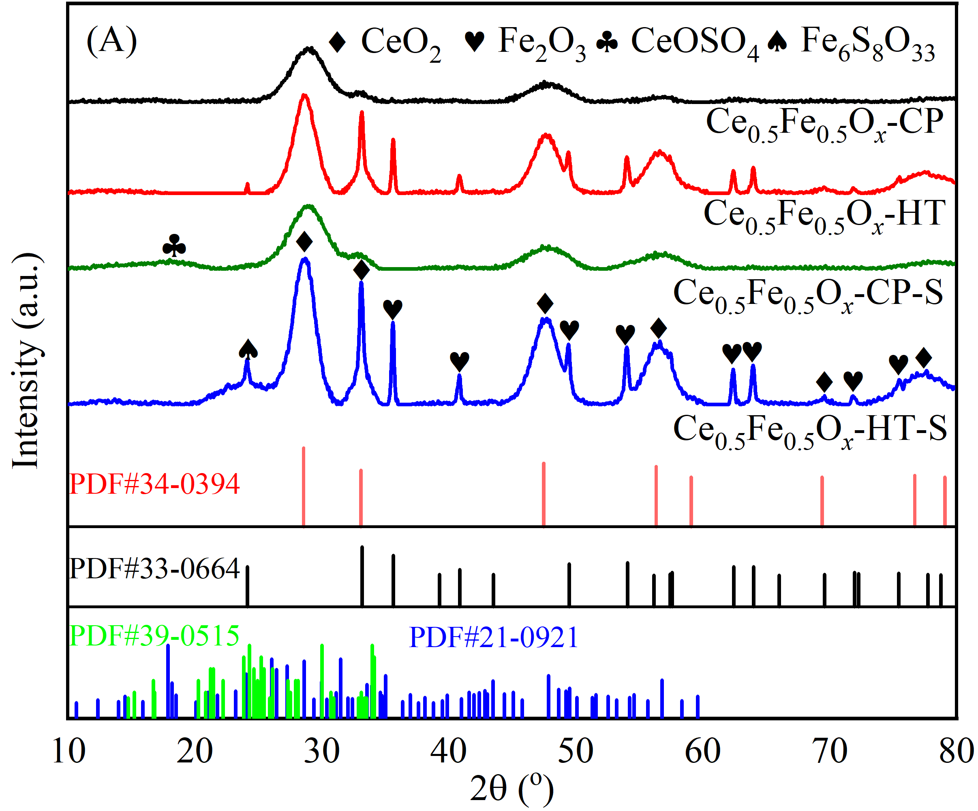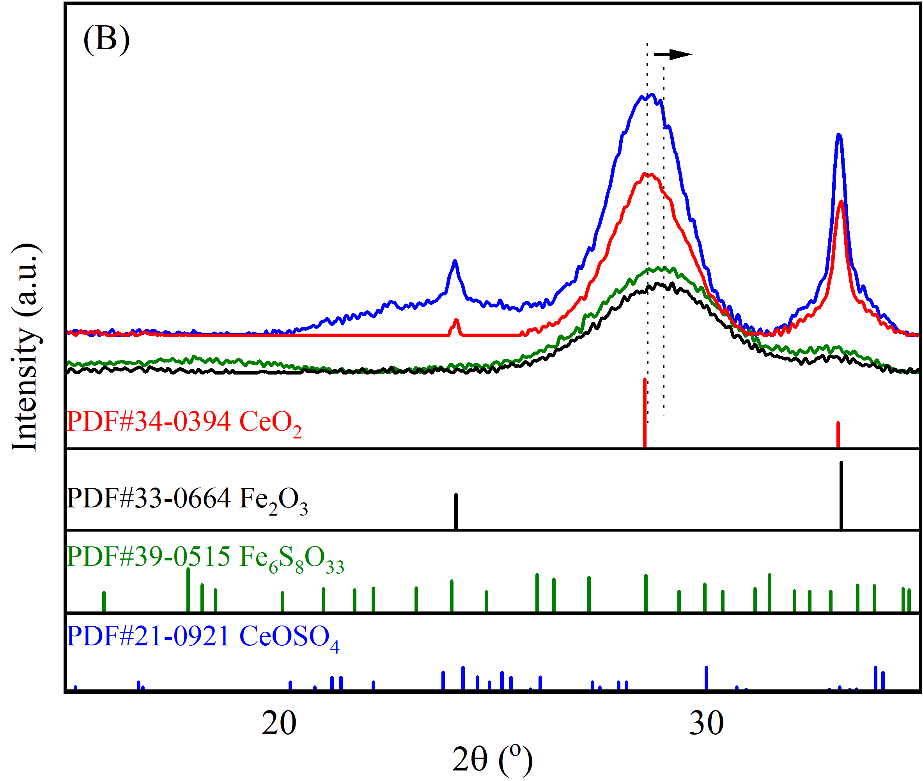
Fig.2 XRD patterns (A) and the locally enlarged XRD at 15 ~ 35 º (B) of Ce_{0.5}Fe_{0.5}O_{x}-CP, Ce_{0.5}Fe_{0.5}O_{x}-HT, Ce_{0.5}Fe_{0.5}O_{x}-CP-S and Ce_{0.5}Fe_{0.5}O_{x}-HT-S catalysts
According to the XRD patterns in Fig.2, Ce_{0.5}Fe_{0.5}O_{x}-CP presents two distinct lattice diffraction peaks respectively located at about 30 º and 50 º, which are attributed to cubic fluorite CeO₂ (PDF#34-0394) [31,32]. And no lattice diffraction peak ascribed to Fe₂O₃ crystals is detected for Ce_{0.5}Fe_{0.5}O_{x}-CP, indicating that the formed iron species present in a highly dispersed or amorphous state and the application of co-precipitation method herein is helpful to obtain the cerium-iron mixed oxide catalyst with the good interaction among the active components. Furthermore, compared to the standard card of cubic fluorite CeO₂ (PDF#34-0394), the peak positions of the detected XRD patterns of Ce_{0.5}Fe_{0.5}O_{x}-CP shift towards the right, demonstrating that iron species are incorporated into the lattice structure of cubic fluorite CeO₂ based on the smaller ionic radius of Fe³⁺(0.64 Å) than that of Ce⁴⁺ (0.92 Å) [33], which contributes to resulting in the structural defects of cubic fluorite CeO₂. However, different from Ce_{0.5}Fe_{0.5}O_{x}-CP, Ce_{0.5}Fe_{0.5}O_{x}-HT not only exhibits stronger lattice diffraction peaks attributed to cubic fluorite CeO₂, but also presents the distinct lattice diffraction peaks of α-Fe₂O₃ (PDF#33-0664). This indicates that the following hydrothermal treatment in a Teflon-lined high-pressure reactor at 200 ºC for 6 h is not conducive to the interaction of cerium and iron species in Ce_{0.5}Fe_{0.5}O_{x}-CP, and the rightwards of the XRD patterns attributed to cubic fluorite CeO₂ also disappear in Ce_{0.5}Fe_{0.5}O_{x}-HT, demonstrating that this hydrothermal treatment depresses the incorporation of Fe³⁺ into cubic fluorite CeO₂, which is unhelpful to the formation of defective sites in Ce_{0.5}Fe_{0.5}O_{x}-HT, thus it shows poorer low-temperature NH₃-SCR activity than Ce_{0.5}Fe_{0.5}O_{x}-CP (Fig.1). The results in Fig.2 also indicate that the sulfation of COS+CS₂ contributes to the formation of CeOSO₄ (PDF#39-0515) in Ce_{0.5}Fe_{0.5}O_{x}-CP-S [34], indicating the occurrence of surface sulfation of catalyst during this process, which is usually thought to improve the surface acid sites of cerium-based catalyst and corresponding catalytic de-nitrification performance [21]. Similarly, a new wide diffraction peak at 20 ~ 30° attributed to Fe₆S₈O₃₃ (PDF#21-0921) or/and CeOSO₄·H₂O (PDF#12-0089) species appears for Ce_{0.5}Fe_{0.5}O_{x}-HT-S, confirming the presence of surface sulfation again. Thus, the different surface sulfates of Ce_{0.5}Fe_{0.5}O_{x}-CP-S and Ce_{0.5}Fe_{0.5}O_{x}-HT-S demonstrates that preparation method leads to the different interaction of cerium and iron components, which also influences the conversion of COS+CS₂ on the surface of Ce_{0.5}Fe_{0.5}O_{x} catalysts. Previous studies pointed out that the presence of Fe₂O₃ crystal could play as an active site to enhance the hydrolysis of COS or/and CS₂ [35]. Furthermore, this hydrolysis process also resulted in an enhancement of surface oxygen vacancies due to the consumption of adsorbed or/and lattice oxygen during the oxidization of hydrolyzed products, which was usually accompanied by the sulfation of surface-active components of catalyst [22]. In addition, it should be mentioned that COS+CS₂ sulfation promotes the intensity of lattice diffraction peaks of the formed crystals in Ce_{0.5}Fe_{0.5}O_{x}-CP and Ce_{0.5}Fe_{0.5}O_{x}-HT, especially cubic fluorite CeO₂. Therefore, the preparation method and subsequent hydrolysis of organic sulfur can regulate the particle diameters of Ce_{0.5}Fe_{0.5}O_{x} catalyst, thus the average grain sizes of catalysts based on the (111) plane of CeO₂ cubic fluorite crystal were calculated using the Debye-Scherrer formula. As shown in Table 1, the average crystal sizes of catalysts decrease as follow: Ce_{0.5}Fe_{0.5}O_{x}-HT-S ≈ Ce_{0.5}Fe_{0.5}O_{x}-HT > Ce_{0.5}Fe_{0.5}O_{x}-CP > Ce_{0.5}Fe_{0.5}O_{x}-CP-S. Therefore, preparation method presents stronger effect on the growth up of particle diameters of Ce_{0.5}Fe_{0.5}O_{x} catalyst than COS+CS₂ sulfation.
Table 1 Structure parameters of Ce_{0.5}Fe_{0.5}O_{x} catalysts
Samples | S_{BET} ª  (m²/g) | Pore volume ^{b} (cm³/g) | Average pore size ^{c}  (nm) | Average crystallite size ^{d} (nm)
Ce_{0.5}Fe_{0.5}O_{x}-CP | 65.08 | 0.299 | 18.78 | 2.69
Ce_{0.5}Fe_{0.5}O_{x}-HT | 141.84 | 0.349 | 9.11 | 4.54
Ce_{0.5}Fe_{0.5}O_{x}-CP-S | 57.72 | 0.262 | 18.77 | 2.63
Ce_{0.5}Fe_{0.5}O_{x}-HT-S | 129.12 | 0.245 | 7.07 | 4.44
ª BET surface area
^{b} BJH desorption pore volume
^{c} BJH desorption pore diameter
^{d} Estimated by Scherrer equation according to the FWHM of the (111) peak of cubic fluorite CeO₂
3.2.2 Raman
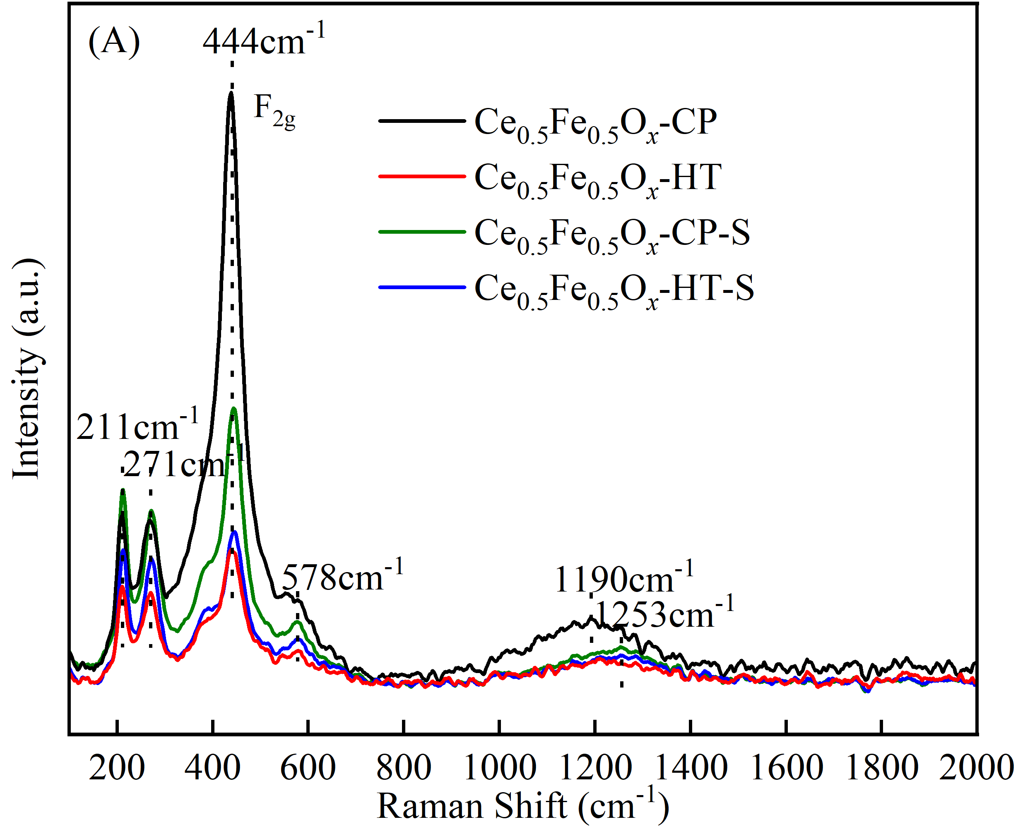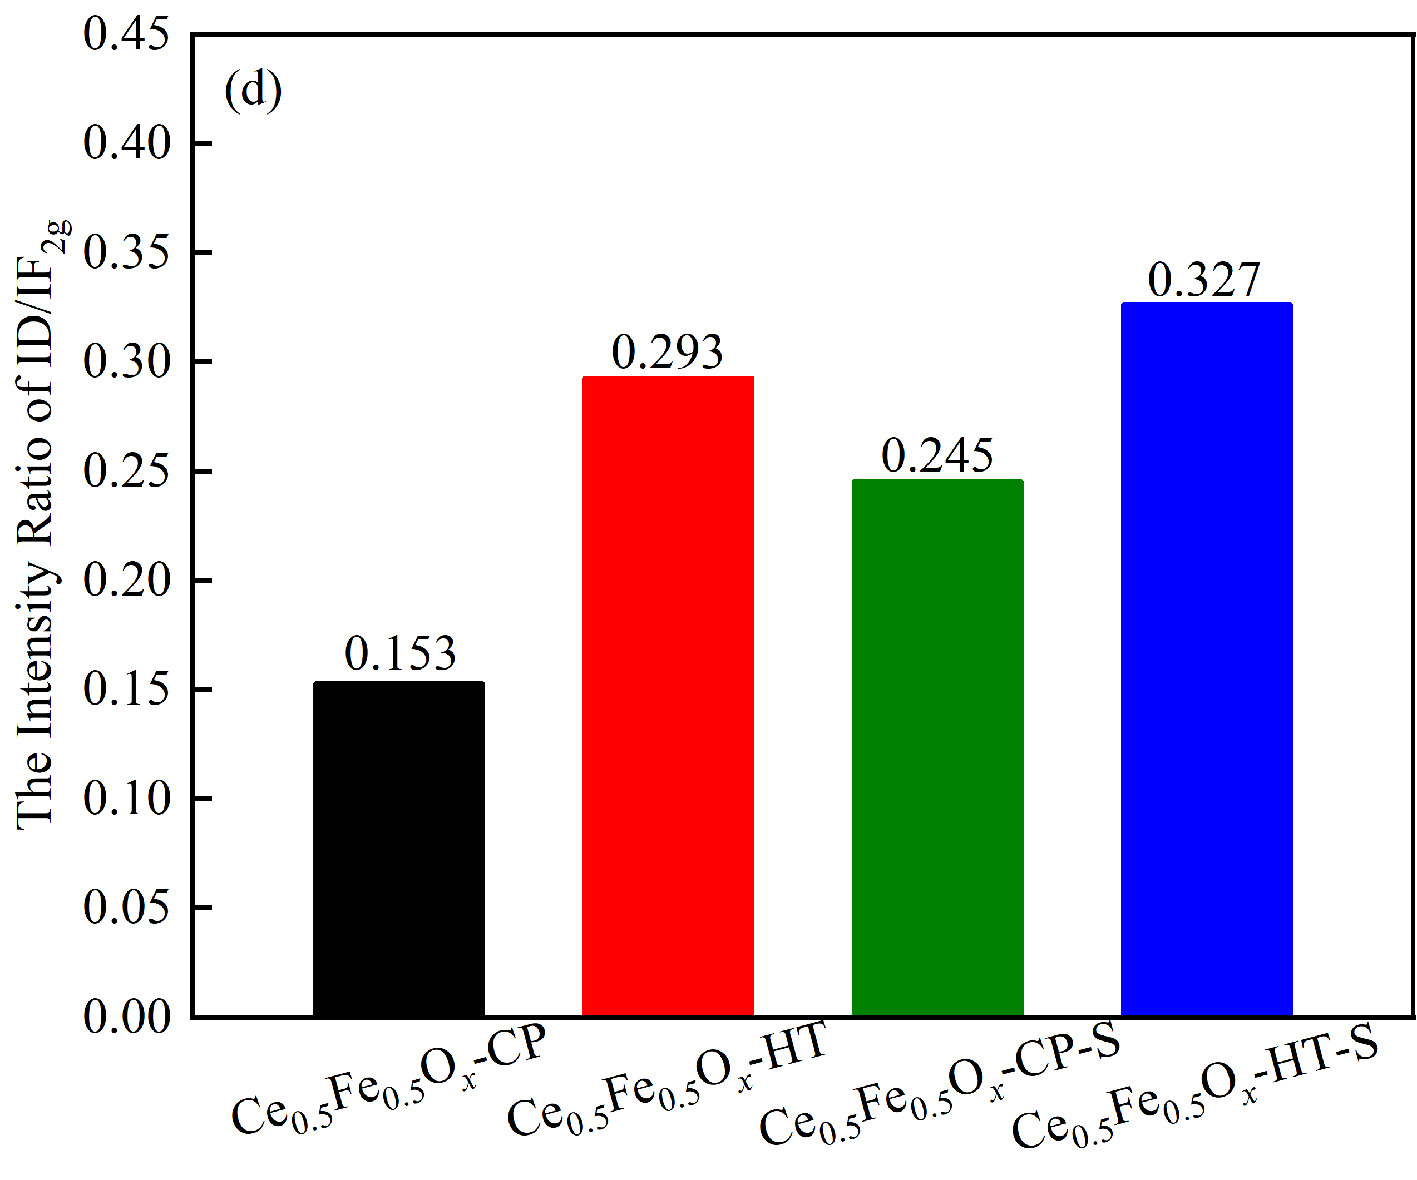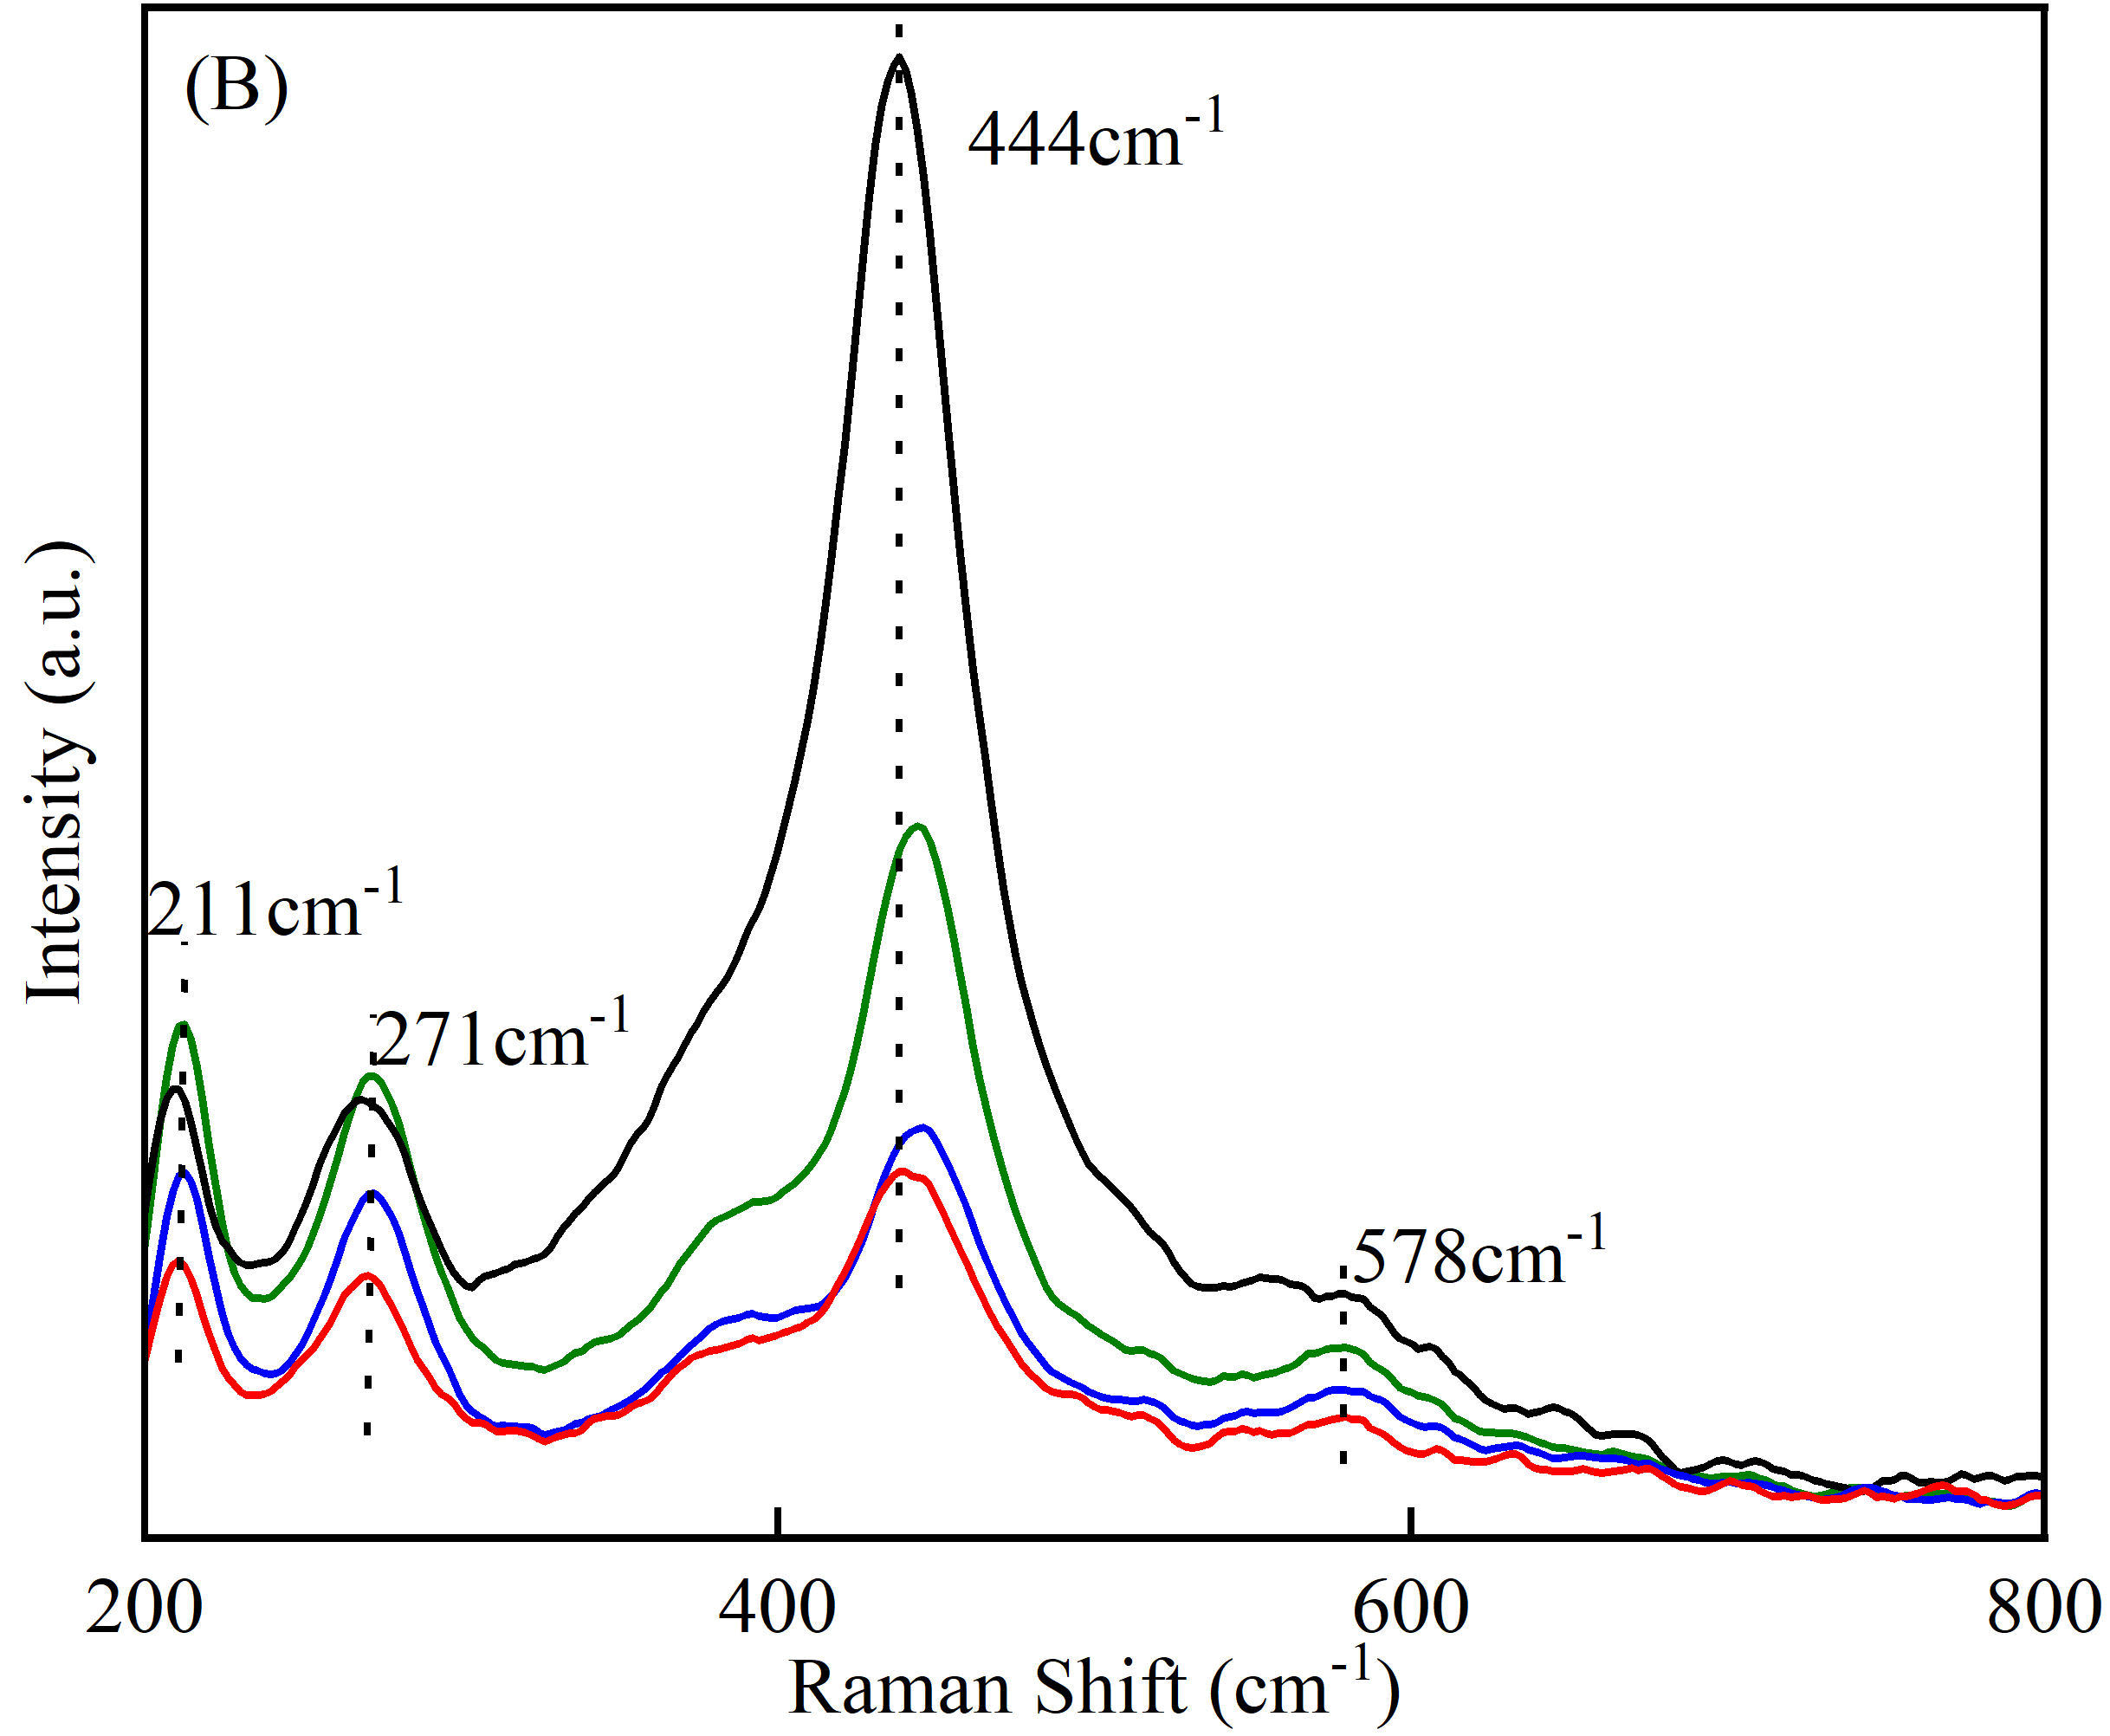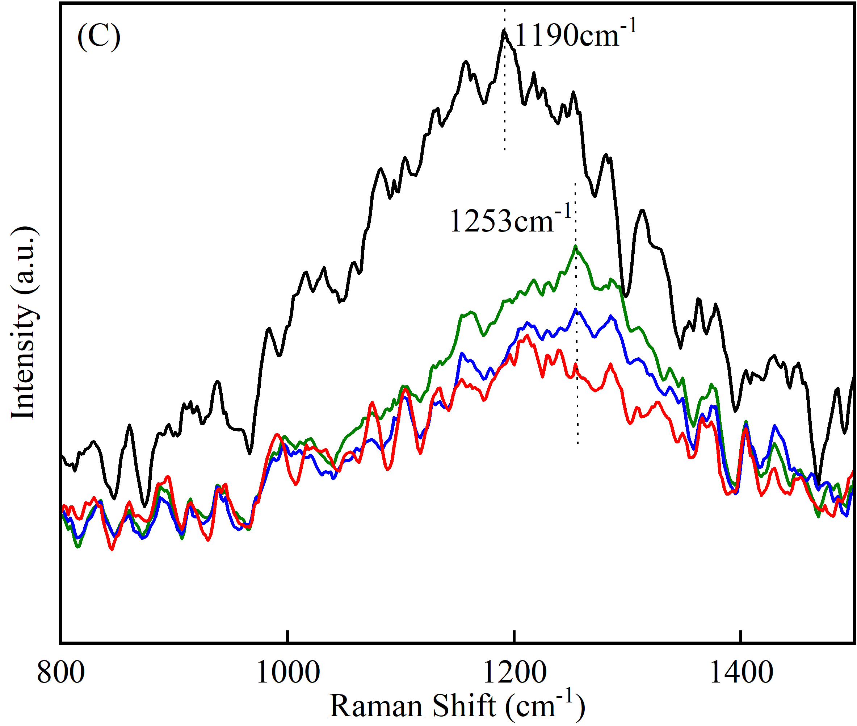
Fig.3. Raman spectra (A) overall view, (B-C) local enlarged view and the intensity ratio of ID/IF_{2g} (D) for Ce_{0.5}Fe_{0.5}O_{x} catalysts
In order to further understand the surface structure of catalysts, Raman spectra was also measured and the results are shown in Fig.3. Base the result of Fig.3 (A) and its local enlarged view Fig.3 (B) and Fig.3 (C), the Raman Bands at about 211 cm⁻¹, 271 cm⁻¹, 444 cm⁻¹, 578 cm⁻¹ and 1190 cm⁻¹ are detected for all catalysts. Among them, the bands at 211 cm⁻¹ and 271 cm⁻¹ belong to the tensile vibration peaks of Fe₂O₃ crystals, and the bands at 444 cm⁻¹, 578 cm⁻¹ and 1190 cm⁻¹ correspond to the F_{2g} symmetric vibration mode, defect-induced (D) mode and second-order longitudinal optical (2LO) mode of cubic fluorite CeO₂ crystals, respectively [36,37], demonstrating the presence of both CeO₂ and Fe₂O₃ crystals in Ce_{0.5}Fe_{0.5}O_{x} catalysts. The intensity ratio of D and F_{2g} modes (ID/IF_{2g}) is generally believed to be proportional to the surface oxygen vacancy concentration of cerium-based catalyst [4]. Therefore, the ratio of ID/IF_{2g} is calculated to represent the relative surface oxygen vacancy concentrations of Ce_{0.5}Fe_{0.5}O_{x} catalysts. According to the calculated ID/IF_{2g} in Fig.3(D), it can found that the order of ID/IF_{2g} is Ce_{0.5}Fe_{0.5}O_{x}-HT-S > Ce_{0.5}Fe_{0.5}O_{x}-CP-S > Ce_{0.5}Fe_{0.5}O_{x}-HT > Ce_{0.5}Fe_{0.5}O_{x}-CP, indicating the further hydrothermal treatment contributes to increasing the concentration of oxygen vacancies on the surface of Ce_{0.5}Fe_{0.5}O_{x}-CP. Usually, oxygen vacancies have been thought to be beneficial to the oxygen storage capacity and also help to increase the surface alkalinity of catalyst, thus improving the adsorption and conversion of COS on the catalyst surface [38,39]. Therefore, the concentration of oxygen vacancies on Ce_{0.5}Fe_{0.5}O_{x}-HT surface is higher than that of Ce_{0.5}Fe_{0.5}O_{x}-CP, and the formed Fe₂O₃ crystals on the surface of Ce_{0.5}Fe_{0.5}O_{x}-HT presents higher crystallization which both are beneficial for the adsorption and conversion of COS+CS₂. During the hydrolysis of COS and CS₂, more H₂S is generated on Ce_{0.5}Fe_{0.5}O_{x}-HT surface with more surface or lattice oxygen consumed, which promotes the formation of surface sulfate and oxygen vacancies. This further helps to increase the redox properties and acid sites of Ce_{0.5}Fe_{0.5}O_{x}-HT, which may be the reason for the better de-NO_{x} activity of Ce_{0.5}Fe_{0.5}O_{x}-HT-S than Ce_{0.5}Fe_{0.5}O_{x}-CP-S.
3.2.3 SEM and HR-TEM
Fig.4 shows the influence of preparation method and the surface morphology of the sulfated Ce_{0.5}Fe_{0.5}O_{x} catalysts by COS+CS₂, and it can be found that Ce_{0.5}Fe_{0.5}O_{x}-HT presents stronger surface agglomeration and crystallization than Ce_{0.5}Fe_{0.5}O_{x}-CP, which all are composed of nanoparticles. This is in accordance with the calculated results of XRD patterns in Table 1. Furthermore, COS+CS₂ sulfation enhances this agglomeration on the surface of Ce_{0.5}Fe_{0.5}O_{x}-CP-S and Ce_{0.5}Fe_{0.5}O_{x}-HT-S due to the reaction of organic sulfur and active components. Therefore, both preparation method and COS+CS₂ sulfation can regulate the surface morphology of Ce_{0.5}Fe_{0.5}O_{x} catalysts, and Ce_{0.5}Fe_{0.5}O_{x}-CP presents the best surface dispersion of active cerium or/and iron species, which may play an important role on its good NH₃-SCR activity of 150 ~ 400 ºC.
Fig.4. SEM images of Ce_{0.5}Fe_{0.5}O_{x}-CP (A), Ce_{0.5}Fe_{0.5}O_{x}-HT (B), Ce_{0.5}Fe_{0.5}O_{x}-CP-S (C) and Ce_{0.5}Fe_{0.5}O_{x}-HT-S (D)
Due to the stronger agglomeration and better medium/high temperature catalytic activity, the HR-TEM images of Ce_{0.5}Fe_{0.5}O_{x}-HT and Ce_{0.5}Fe_{0.5}O_{x}-HT-S were measured and the results are given in Fig.5. There exist two lattices spacing of 0.314 nm and 0.219 nm for Ce_{0.5}Fe_{0.5}O_{x}-HT, which correspond to the (111) and (113) planes of cubic fluorite CeO₂ and Fe₂O₃ crystals, respectively. Furthermore, the forming cubic fluorite CeO₂ mainly distributes to the surface of Fe₂O₃ crystal, demonstrating a poor interaction of cerium and iron species in Ce_{0.5}Fe_{0.5}O_{x}-HT, which is different from the HR-TEM image of Ce_{0.5}Fe_{0.5}O_{x}-CP with only (111) plane of cubic fluorite CeO₂ crystal exposed in Fig.S1. This finding is in accordance with the results of XRD patterns in Fig.2. Interestingly, the sulfation of COS+CS₂ leads to expose one new plane (200) of cubic fluorite CeO₂ besides the (111) plane for Ce_{0.5}Fe_{0.5}O_{x}-HT-S, but the (113) plane of Fe₂O₃ crystal disappears compared to Ce_{0.5}Fe_{0.5}O_{x}-HT, which is mainly attributed to the formation of surface sulfate due to the sulfation of Fe₂O₃ crystal by COS+CS₂. Therefore, by combining the results of XRD, Raman and SEM/HR-TEM, it can be induced that preparation method can regulate the interaction of cerium and iron species and the formation of their solid solution in Ce_{0.5}Fe_{0.5}O_{x} catalyst. Subsequently, it may affect the sulfating reaction of COS+CS₂ with the active components in the above catalysts, and the formed Fe₂O₃ crystals are more easily sulfated by COS+CS₂ compared to the doped Fe species from the solid solution of cerium and iron.
Fig. 5. HR-TEM images of Ce_{0.5}Fe_{0.5}O_{x}-HT (A, B) and Ce_{0.5}Fe_{0.5}O_{x}-HT-S (C, D) catalysts
3.2.4 N₂ adsorption-desorption
The N₂ adsorption-desorption isotherms of Ce_{0.5}Fe_{0.5}O_{x} catalysts are shown in Fig. 6. According to the IUPAC classification, the obtained isotherms are type Ⅳ with a typical H3 hysteresis loop, indicating the presence of meso-pore structure [40]. However, the closed points (P/Pº) at low relative pressure of the N₂ adsorption-desorption isotherms for Ce_{0.5}Fe_{0.5}O_{x}-HT and Ce_{0.5}Fe_{0.5}O_{x}-HT-S are lower than those of Ce_{0.5}Fe_{0.5}O_{x}-CP and Ce_{0.5}Fe_{0.5}O_{x}-CP-S, demonstrating that the following hydrothermal treatment in a Teflon-lined high-pressure reactor at 200 ºC for 6 h is conducive to enriching the meso-pore or/and micro-pore structure of Ce_{0.5}Fe_{0.5}O_{x}-CP [16]. As shown in Fig.7, Ce_{0.5}Fe_{0.5}O_{x}-HT and Ce_{0.5}Fe_{0.5}O_{x}-HT-S assuredly present wider pore size distributions, which had been thought to be an important reason for the good NH₃-SCR activity of iron-titanium catalyst [41], because the relatively wide pore size distribution contributes to improving the diffusion of reactant gas, which is beneficial to enhance NO_{x} conversion over the catalysts [34,38]. Furthermore, the sulfation of COS+CS₂ further strengthen this effect, and Ce_{0.5}Fe_{0.5}O_{x}-HT-S exhibits lower closed points (P/Pº) of N₂ adsorption-desorption isotherm than Ce_{0.5}Fe_{0.5}O_{x}-HT. The pore size distributions in Fig.7 also confirm that COS+CS₂ sulfation is unhelpful to maintain the mesopore structure located at 10-60 nm for Ce_{0.5}Fe_{0.5}O_{x}-HT, demonstrating stronger sulfation of active components by COS+CS₂ compared to Ce_{0.5}Fe_{0.5}O_{x}-CP. Therefore, preparation method can affect the interaction of cerium-iron species, and the formed active components of Ce_{0.5}Fe_{0.5}O_{x}-HT are more likely to be sulfated by COS+CS₂ than those of Ce_{0.5}Fe_{0.5}O_{x}-CP, thereby the sulfation of organic sulfur contributes to regulating the pore structure of Ce_{0.5}Fe_{0.5}O_{x}-HT.
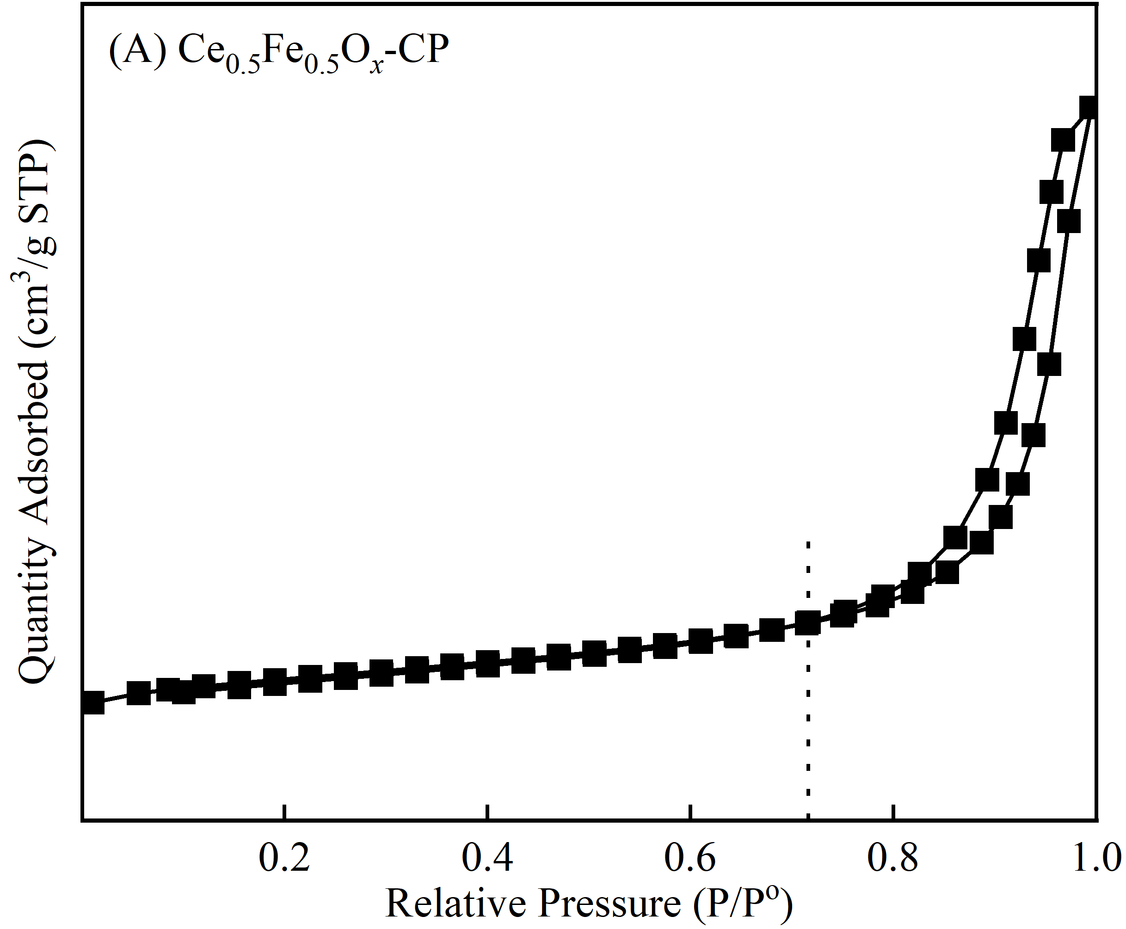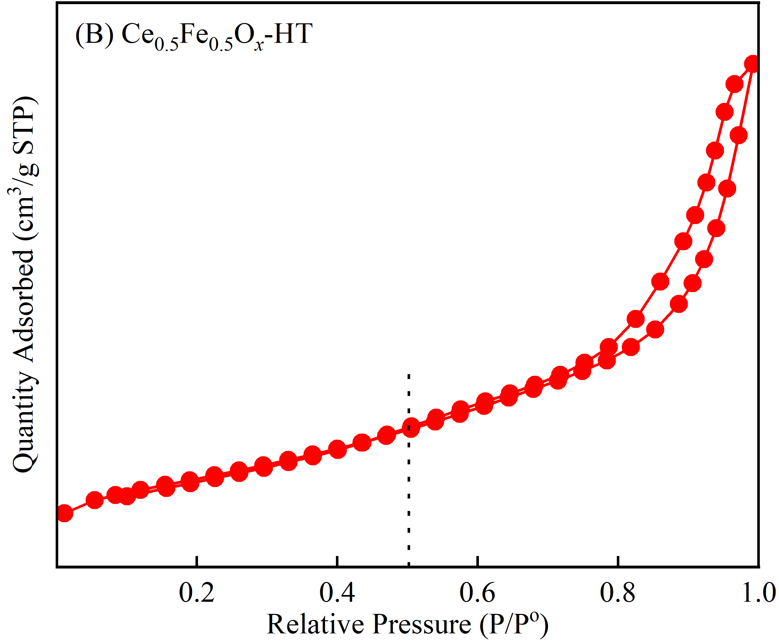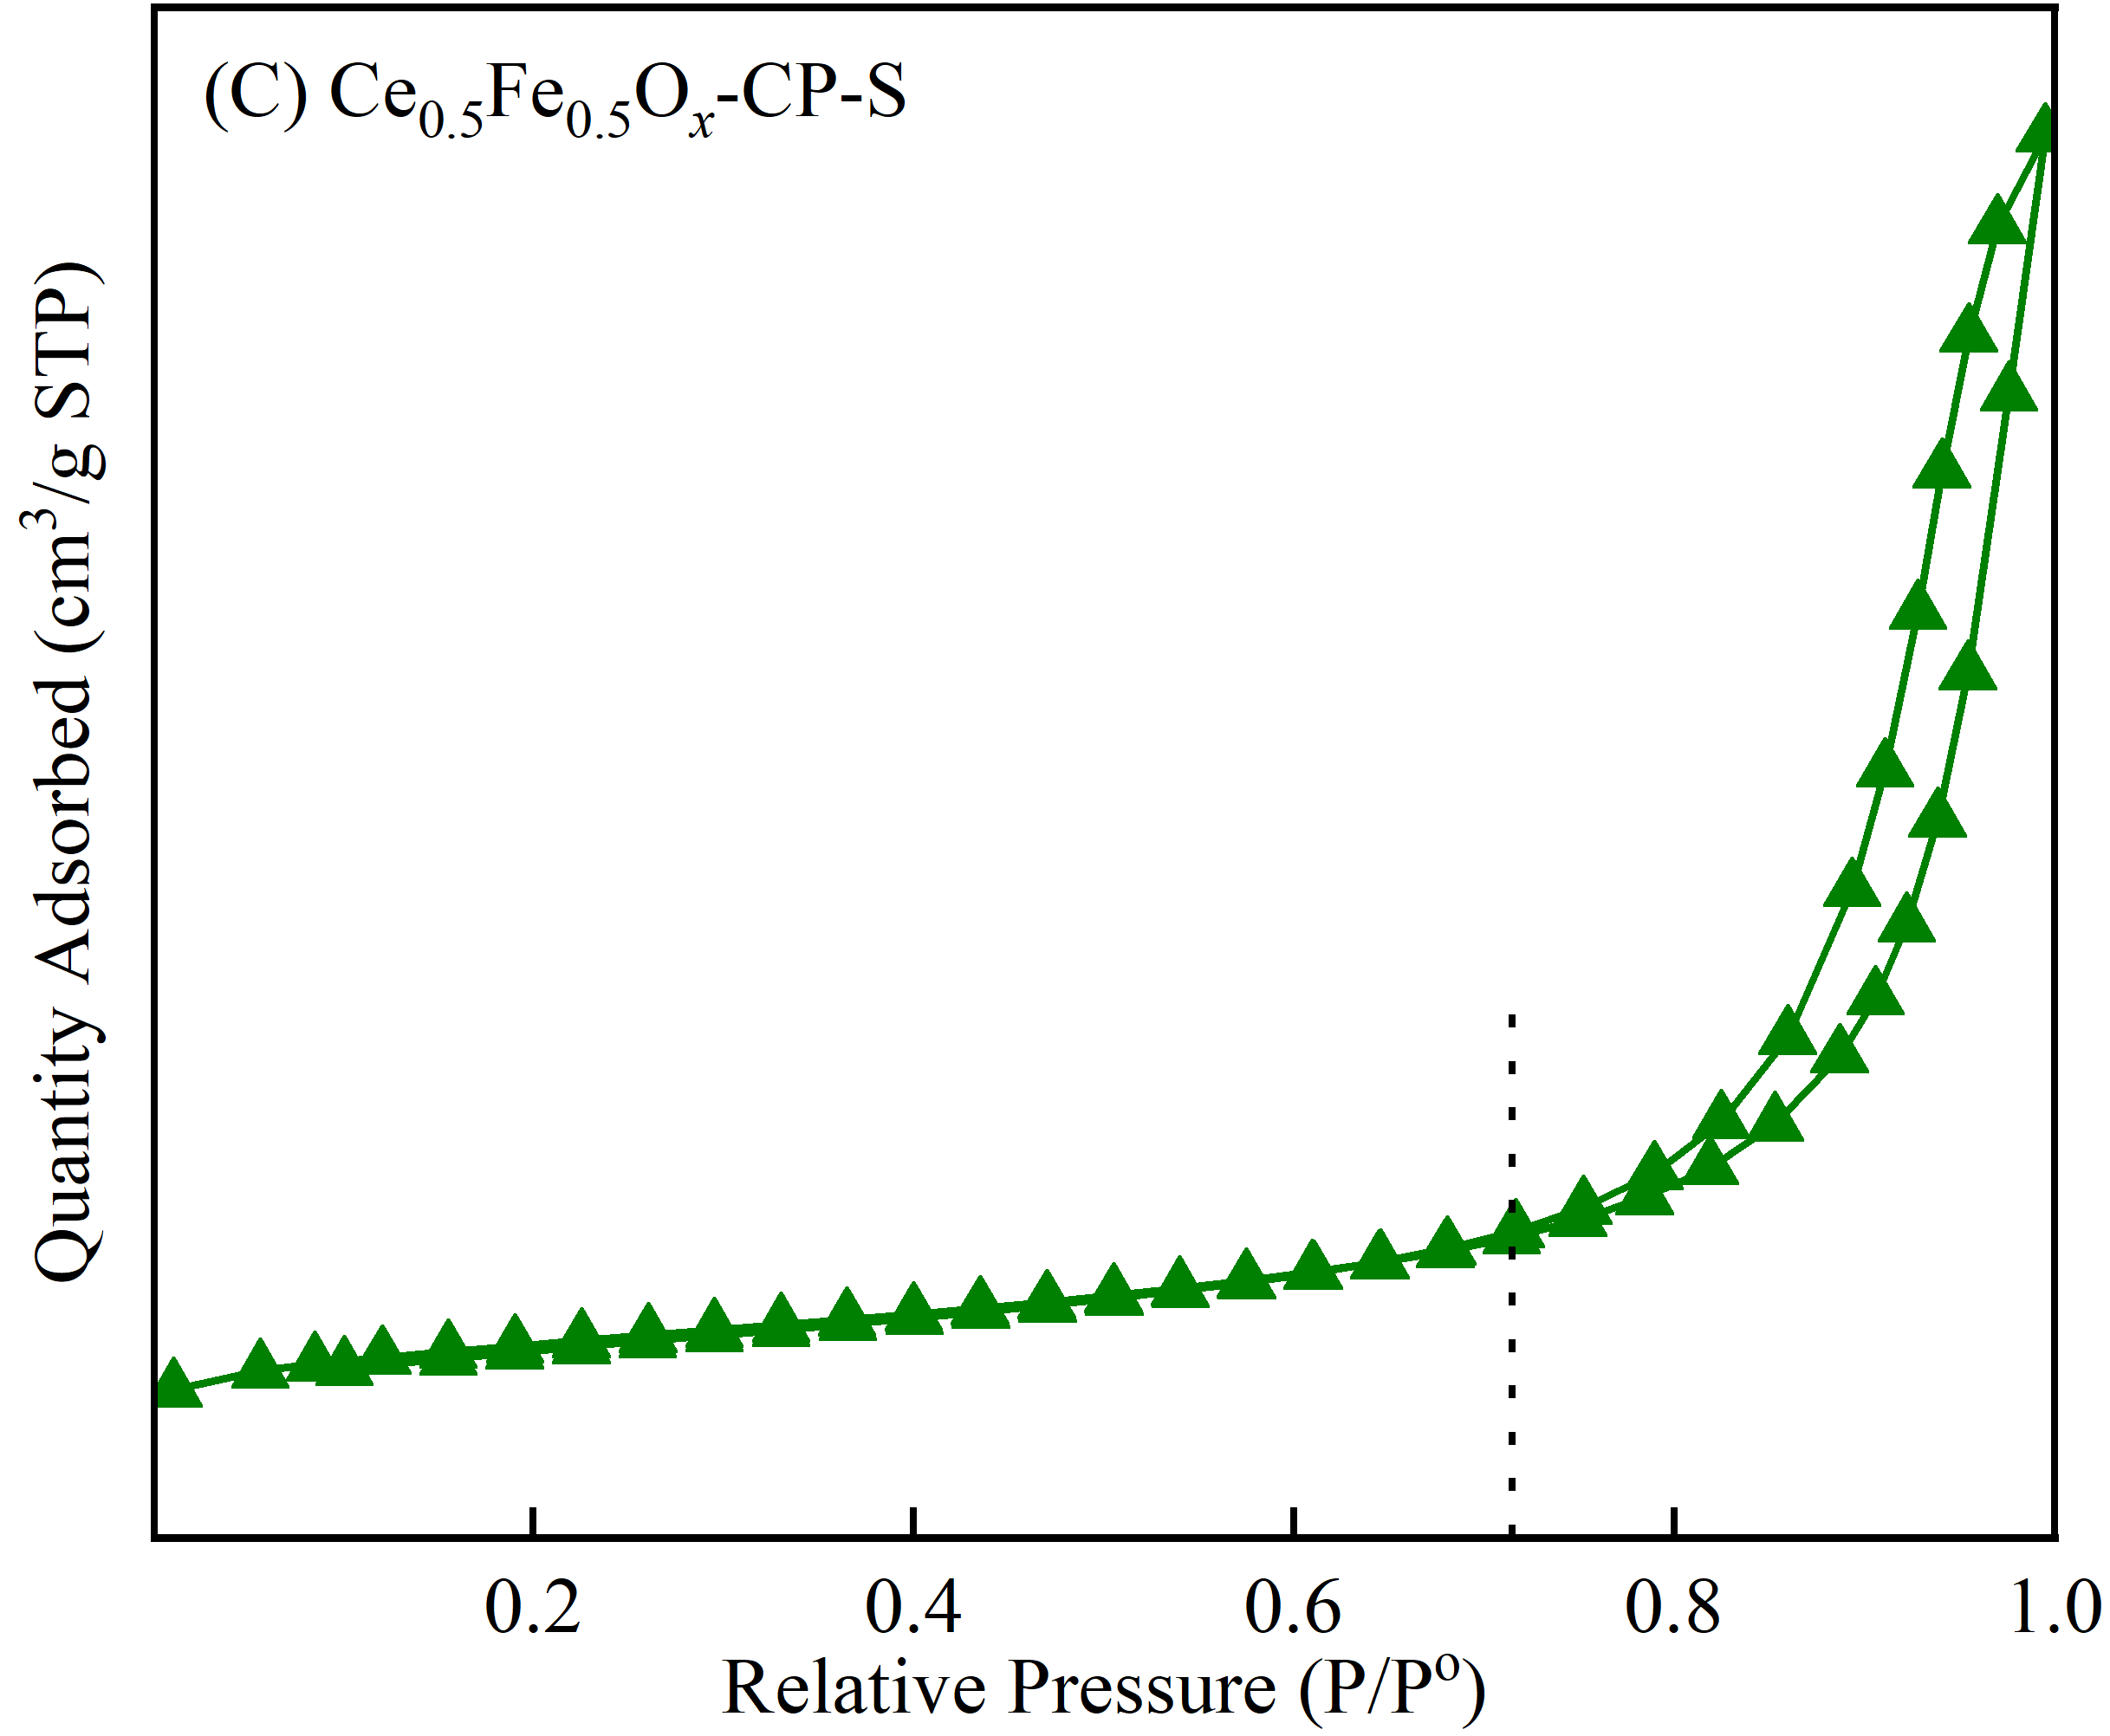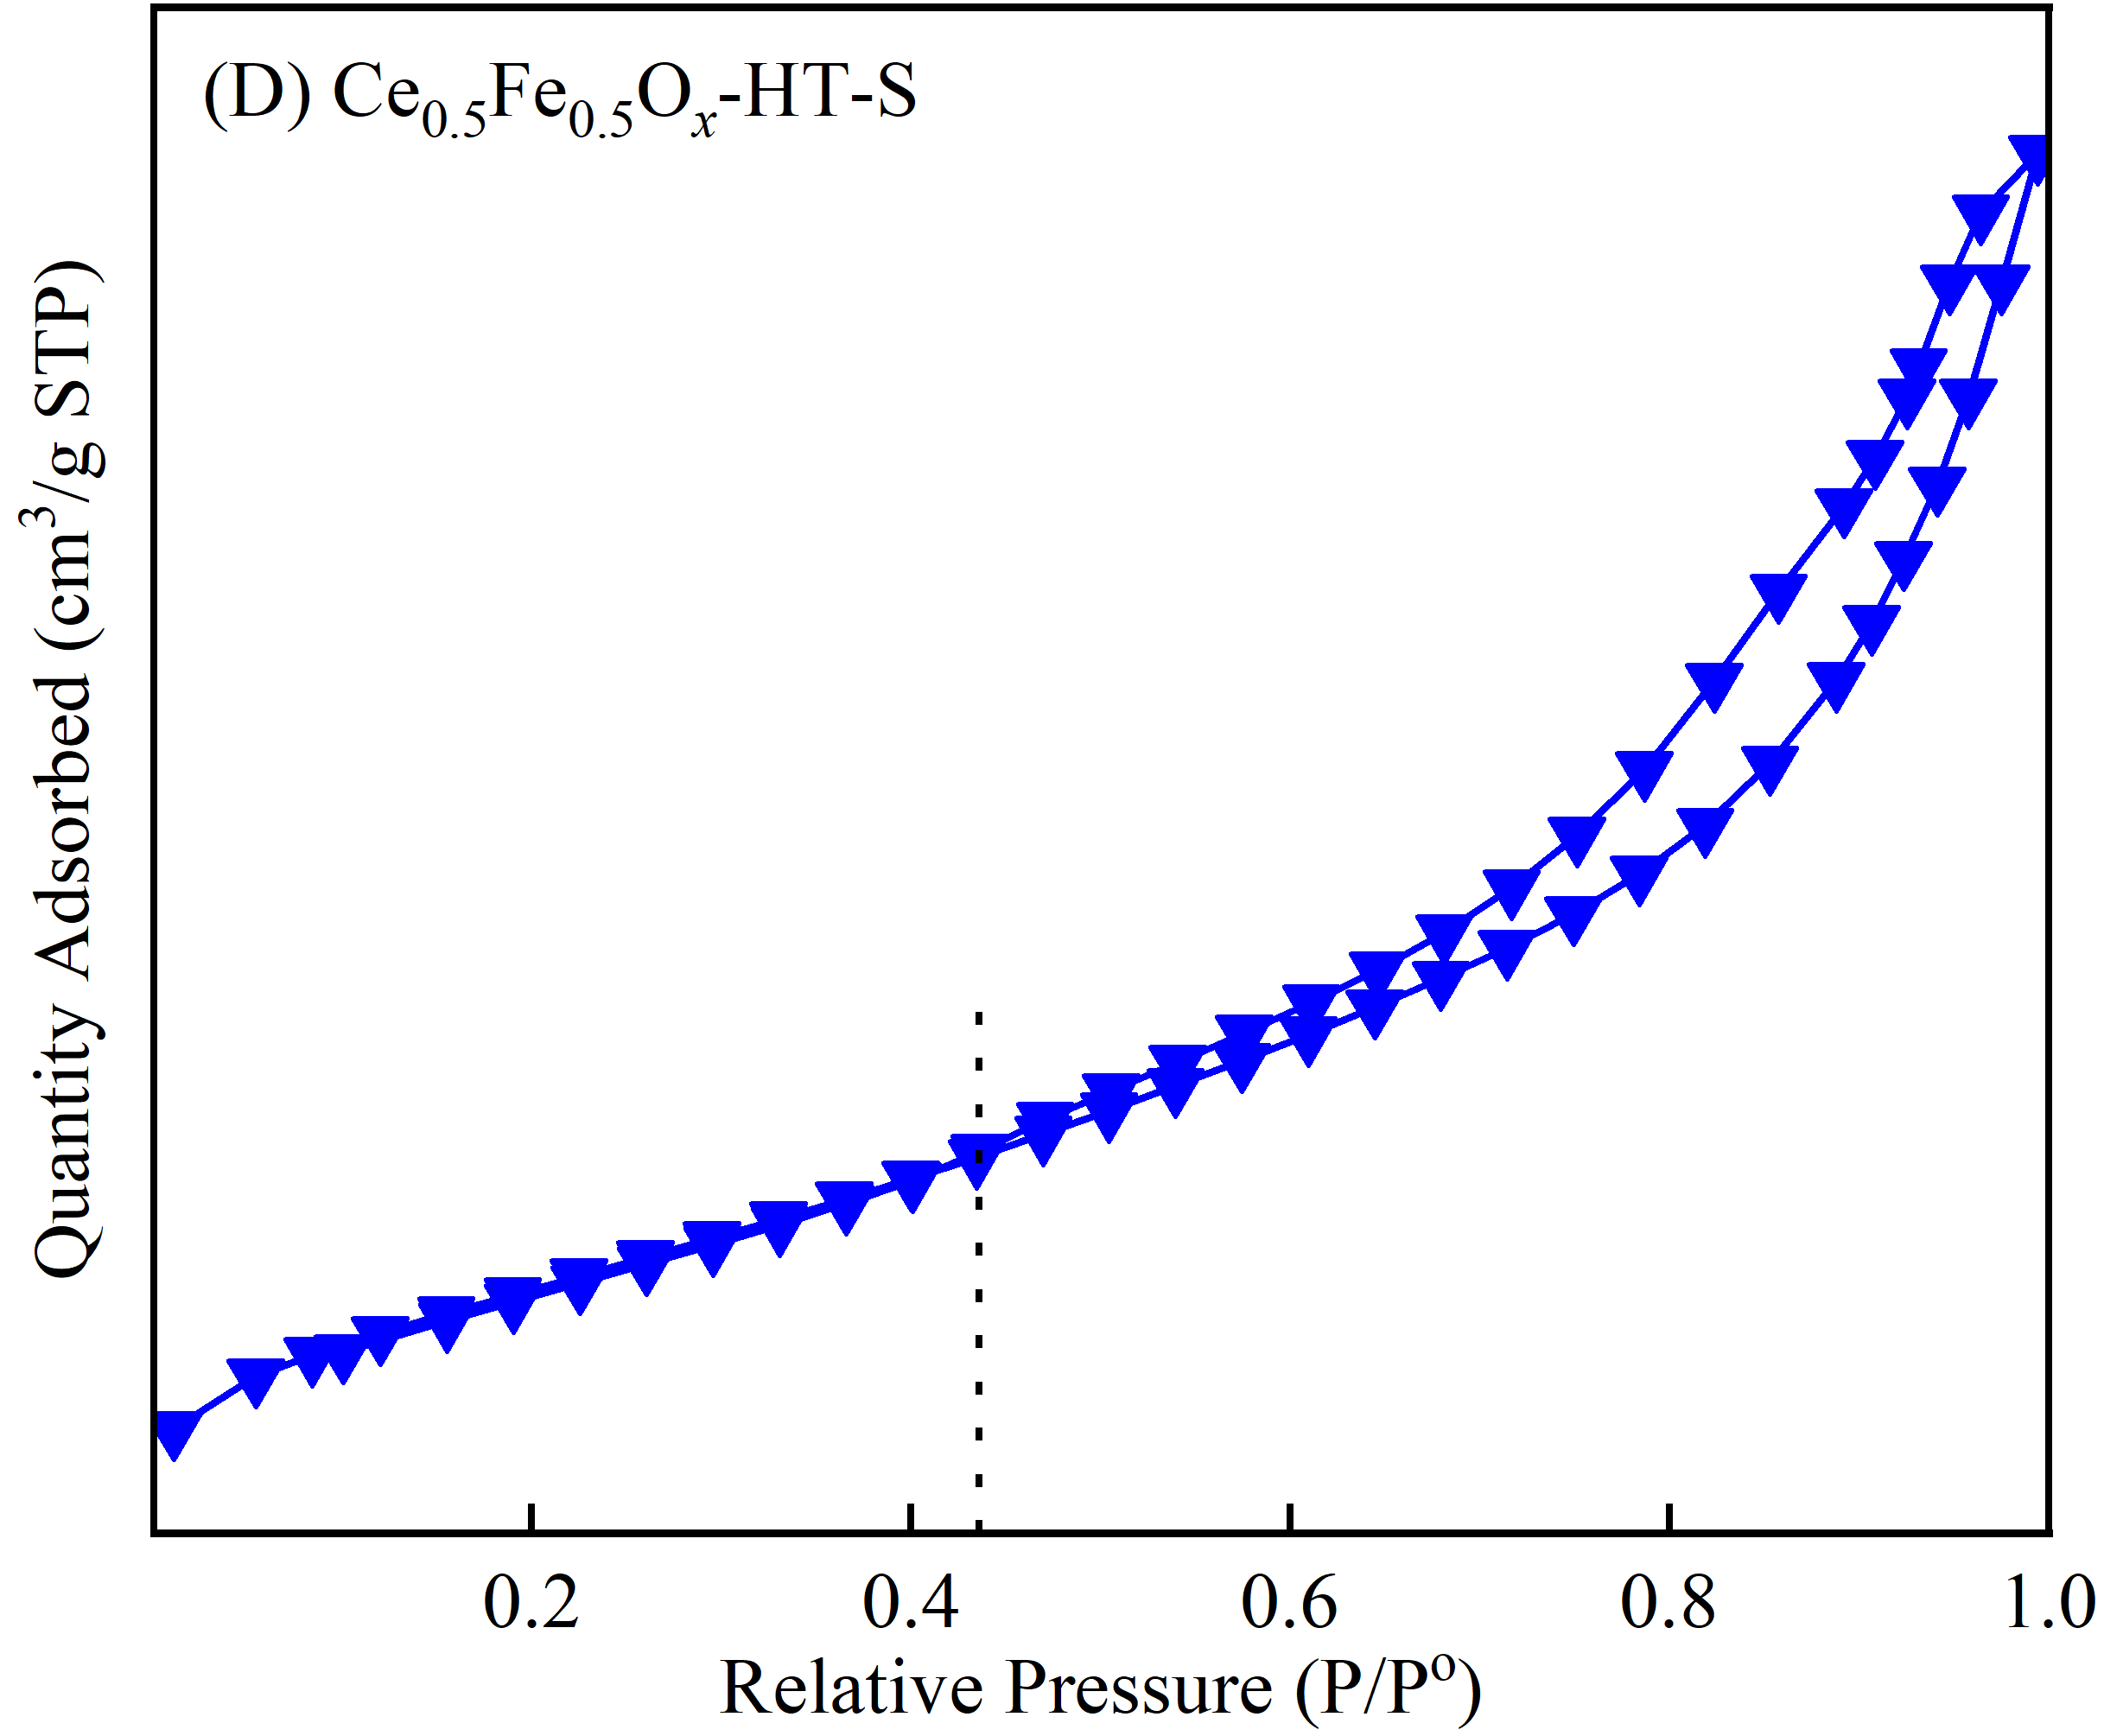
Fig.6. N₂ adsorption-desorption isotherms of Ce_{0.5}Fe_{0.5}O_{x} catalysts
The calculated specific surface areas, pore volumes and average pore sizes of catalysts in Table 1 demonstrate that Ce_{0.5}Fe_{0.5}O_{x}-HT shows larger BET surface area and pore volume than Ce_{0.5}Fe_{0.5}O_{x}-CP due to smaller average pore size, but COS+CS₂ sulfation decreases their BET surface areas and pore volumes due to the collapse of partial pore or/and the occupation of the generated sulfate [42,43], and Ce_{0.5}Fe_{0.5}O_{x}-HT-S has smaller pore volume than Ce_{0.5}Fe_{0.5}O_{x}-CP-S. Generally, larger BET specific surface area is conducive to the adsorption and hydrolysis of organic sulfur on the catalyst surface, as well as the oxidation of H₂S [22,38]. Therefore, it can be induced that COS+CS₂ sulfation decreases the BET surface areas and pore volumes of Ce_{0.5}Fe_{0.5}O_{x}-HT and Ce_{0.5}Fe_{0.5}O_{x}-CP due to the sulfation of active components, but the good pore structure may not be the determining factor on the NH₃-SCR activity of Ce_{0.5}Fe_{0.5}O_{x} catalyst.
Fig.7. Pore size distributions of Ce_{0.5}Fe_{0.5}O_{x} catalysts
3.2.5 XPS
Fig.8 and Table 2 give the detected surface dispersion, valence state and relative concentration of elements for Ce_{0.5}Fe_{0.5}O_{x} catalysts by XPS technology. The Ce3d orbital spectra of all as-prepared samples in Fig.8(A) can be divided into eight characteristic peaks, which are attributed to the v', u' peaks of Ce³⁺ ions and the v, v'', v''', u, u'' and u''' peaks of Ce⁴⁺ ions, respectively. In Fig.8(B), the Fe2p orbital spectra of all samples were divided into five characteristic peaks, which are attributed to Fe³⁺ ions, Fe²⁺ ions, and the corresponding satellite peaks, respectively [44]. From Fig.8(A) and (B), it can be found that there exist both Ce³⁺/Ce⁴⁺ and Fe³⁺/Fe²⁺ species on the catalysts surface [44-46], which is helpful to promote the creation of oxygen vacancies via boosting the charge imbalances and facilitating the redox cycles of Ce⁴⁺/Ce³⁺ or/and Fe³⁺/Fe²⁺ due to the electron transfer process among them [12,37]. Furthermore, the binding energies of surface Ce³⁺ and Ce⁴⁺ species of Ce_{0.5}Fe_{0.5}O_{x}-CP are larger than those of Ce_{0.5}Fe_{0.5}O_{x}-HT, while the changes law of the binding energies attributed to their Fe²⁺/Fe³⁺ species is different, demonstrating the different cerium-iron interaction in Ce_{0.5}Fe_{0.5}O_{x}-CP and Ce_{0.5}Fe_{0.5}O_{x}-HT, which is in accordance with the results of XRD patterns. Wang et al found that the gas-phase sulfation of 200 ppm SO₂ at 300 ºC for 2 h increased the binding energies of active components of Fe-Ce bimetal oxide catalyst due to the formation of iron sulfate [47]. In this study, the sulfation of COS+CS₂ enlarges the binding energies of both Ce³⁺/Ce⁴⁺ and Fe²⁺/Fe³⁺ species of the as-fabricated catalysts, especially the binding energies of Fe²⁺/Fe³⁺ species, and the binding energies of Fe²⁺/Fe³⁺ species of Ce_{0.5}Fe_{0.5}O_{x}-CP-S are even larger than those of Ce_{0.5}Fe_{0.5}O_{x}-HT-S. This indicates that the preparation method indeed affects the interaction of cerium and iron species in Ce_{0.5}Fe_{0.5}O_{x} catalysts, which influence the sulfation process of Ce_{0.5}Fe_{0.5}O_{x}-CP and Ce_{0.5}Fe_{0.5}O_{x}-HT by COS+CS₂. Previous researches pointed out that the presence of more Ce³⁺ species contributed to enriching oxygen vacancies of catalysts and improving the corresponding redox capacity, which was usually thought to help to enhance the catalytic performance of COS/CS₂ hydrolysis, H₂S oxidation and NO_{x} reduction [22,23,45]. And the formation of more surface Fe³⁺ species also enhanced the redox property of catalyst by activating the surface oxygen, which contributed to increasing the rapid NH₃-SCR activity via promoting the catalytic oxidation of NO to NO₂ [4,37]. As shown in Table 2, Ce_{0.5}Fe_{0.5}O_{x}-CP presents larger surface iron element and less cerium element than those of Ce_{0.5}Fe_{0.5}O_{x}-HT, and the sulfation of COS+CS₂ further enlarges the concentration of iron species on the catalysts surface. The calculated surface molar ratios of Ce³⁺/(Ce³⁺+Ce⁴⁺) and Fe²⁺/(Fe³⁺+Fe²⁺) in Table 2 also demonstrate that the as-fabricated Ce_{0.5}Fe_{0.5}O_{x}-CP catalyst exhibits larger molar ratios of both Ce³⁺/(Ce³⁺+Ce⁴⁺) and Fe²⁺/(Fe³⁺+Fe²⁺) than Ce_{0.5}Fe_{0.5}O_{x}-HT, meaning better electron transfer performance and redox capacity, which might be an important reason for its better low-medium NH₃-SCR activity than Ce_{0.5}Fe_{0.5}O_{x}-HT. Interestingly, the sulfation of COS+CS₂ increases the surface Ce³⁺/(Ce³⁺+Ce⁴⁺) and Fe²⁺/(Fe³⁺+Fe²⁺) molar ratios of Ce_{0.5}Fe_{0.5}O_{x}-HT effectively, but decreases the calculated corresponding values of Ce_{0.5}Fe_{0.5}O_{x}-CP. This confirms that preparation method plays an important role on the sulfation of Ce_{0.5}Fe_{0.5}O_{x} catalyst by COS+CS₂ due to the different interaction of active cerium and iron species. The XRD patterns in Fig.2 demonstrate that CeOSO₄ is formed in Ce_{0.5}Fe_{0.5}O_{x}-CP-S, while iron sulfate is mainly formed in Ce_{0.5}Fe_{0.5}O_{x}-HT-S, confirming the different sulfated active sites in them.
The O 1s spectrum in Fig. 8(C) indicates that there exist two kinds of oxygen on the catalysts surface: lattice oxygen (529.0 eV ~ 530.0 eV, O_{α}) and chemisorbed oxygen (531.0 eV ~ 532.0 eV, O_{β}) [48,49]. And the latter has stronger mobility and larger surface O_{β}/(O_{α}+O_{β}) molar ratio had been thought to be beneficial to enhance the catalytic performance of COS/CS₂ hydrolysis, H₂S oxidation and NO_{x} reduction [22,23,50]. The calculated O_{β}/(O_{α}+O_{β}) molar ratios in Table 2 indicate that Ce_{0.5}Fe_{0.5}O_{x}-HT-S presents the largest surface O_{β}/(O_{α}+O_{β}) molar ratio, followed by Ce_{0.5}Fe_{0.5}O_{x}-CP, Ce_{0.5}Fe_{0.5}O_{x}-HT and Ce_{0.5}Fe_{0.5}O_{x}-CP-S in sequence, which is consistent with the low-medium NH₃-SCR activity of catalysts. This confirms that the formation of cerium sulfate is disadvantageous to the active chemisorbed oxygen of Ce_{0.5}Fe_{0.5}O_{x}-CP under the sulfation of COS+CS₂, while the formed iron sulfate contributes to enlarging the surface molar ratio of O_{β}/(O_{α}+O_{β}) and enriching the relative concentration of surface chemisorbed oxygen. The results of S 2p spectra in Fig.8 (D) confirm the formation of S⁶⁺ species on the surface of Ce_{0.5}Fe_{0.5}O_{x}-CP-S and Ce_{0.5}Fe_{0.5}O_{x}-HT-S [21]. But the latter catalyst presents larger binding energies and concentration (2.73 %) of surface S⁶⁺ species, demonstrating more Fe₂O₃ crystals are sulfated by COS+CS₂ compared to Ce_{0.5}Fe_{0.5}O_{x}-CP-S.
Fig.8. XPS spectra of (A) Ce 3d, (B) Fe 2p, (C) O 1s, (D) S 2p of Ce_{0.5}Fe_{0.5}O_{x} catalysts

Table 2 Atomic concentrations and ratios on Ce_{0.5}Fe_{0.5}O_{x} catalysts surface
Samples | Atomic  concentrations (%) |  |  |  |  | Atomic ratios (%)
Samples | Ce | Fe | O | S |  | Ce³⁺/  (Ce³⁺+Ce⁴⁺) | Fe³⁺/  (Fe²⁺+Fe³⁺) | O_{β}/  (O_{α}+O_{β})
Ce_{0.5}Fe_{0.5}O_{x}-CP | 24.93 | 9.17 | 65.90 | - |  | 35.12 | 69.77 | 44.48
Ce_{0.5}Fe_{0.5}O_{x}-HT | 29.71 | 6.13 | 64.16 | - |  | 34.78 | 69.07 | 43.43
Ce_{0.5}Fe_{0.5}O_{x}-CP-S | 22.50 | 9.85 | 65.15 | 2.50 |  | 29.06 | 64.09 | 41.45
Ce_{0.5}Fe_{0.5}O_{x}-HT-S | 27.17 | 6.73 | 63.37 | 2.73 |  | 38.56 | 73.28 | 47.69
3.2.6 TG-DTG
Fig.9. TG-DTG curves of Ce_{0.5}Fe_{0.5}O_{x}-CP-S and Ce_{0.5}Fe_{0.5}O_{x}-HT-S catalysts
Thermogravimetric analysis was carried out to investigate the influence of preparation method on the sulfated intensity of Ce_{0.5}Fe_{0.5}O_{x} catalyst by COS+CS₂, and the corresponding DG-DTG curves are given in Fig.9. As shown in Fig. 9, the weight loss of Ce_{0.5}Fe_{0.5}O_{x}-CP-S and Ce_{0.5}Fe_{0.5}O_{x}-HT-S can be divided into three stages: the desorption of physically adsorbed water or hydroxyl below 200 ºC, the oxidation of weakly adsorbed sulfur species to SO₂ at the temperature range of 200～600 ºC and the decomposition of metal sulfate above 600 ºC, which had been confirmed by the TG-MS characterization of previous researches [51,52]. Specially, Ce_{0.5}Fe_{0.5}O_{x}-HT-S presents greater weightlessness in the third stage than Ce_{0.5}Fe_{0.5}O_{x}-CP-S, indicating more sulfate are formed during the sulfation of COS+CS₂, which may be attributed to higher BET surface area and more surface active Fe₂O₃ crystals. This demonstrates that the preparation method affects the interaction of cerium-iron species in Ce_{0.5}Fe_{0.5}O_{x} catalyst, and regulates the formation of active metal oxide components, thereby influences the sulfation. And the formation of Fe₂O₃ crystals is more conducive to the adsorption and hydrolysis of COS or/and CS₂ on the surface of Ce_{0.5}Fe_{0.5}O_{x} catalyst.
3.2.7 H₂-TPR
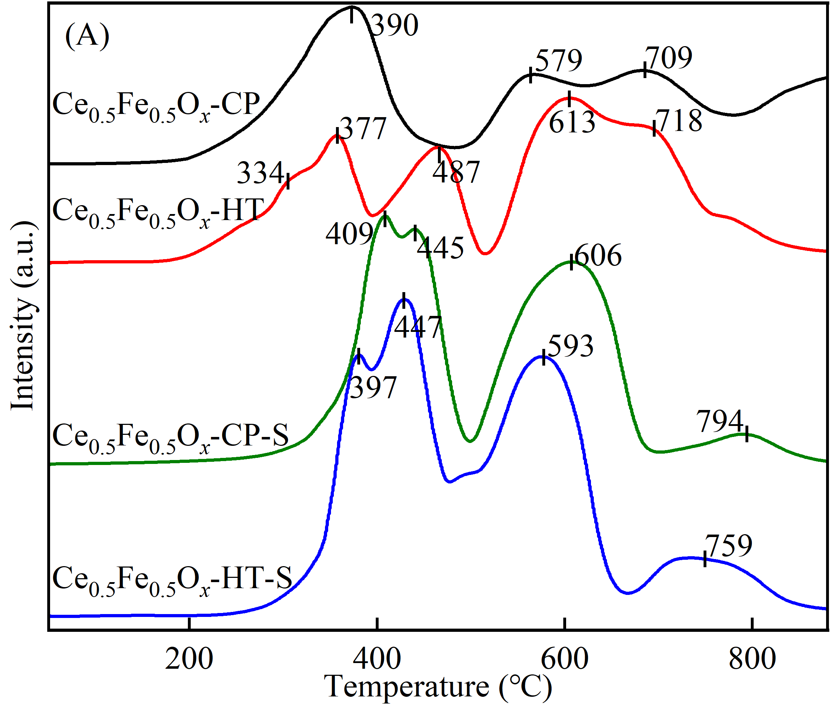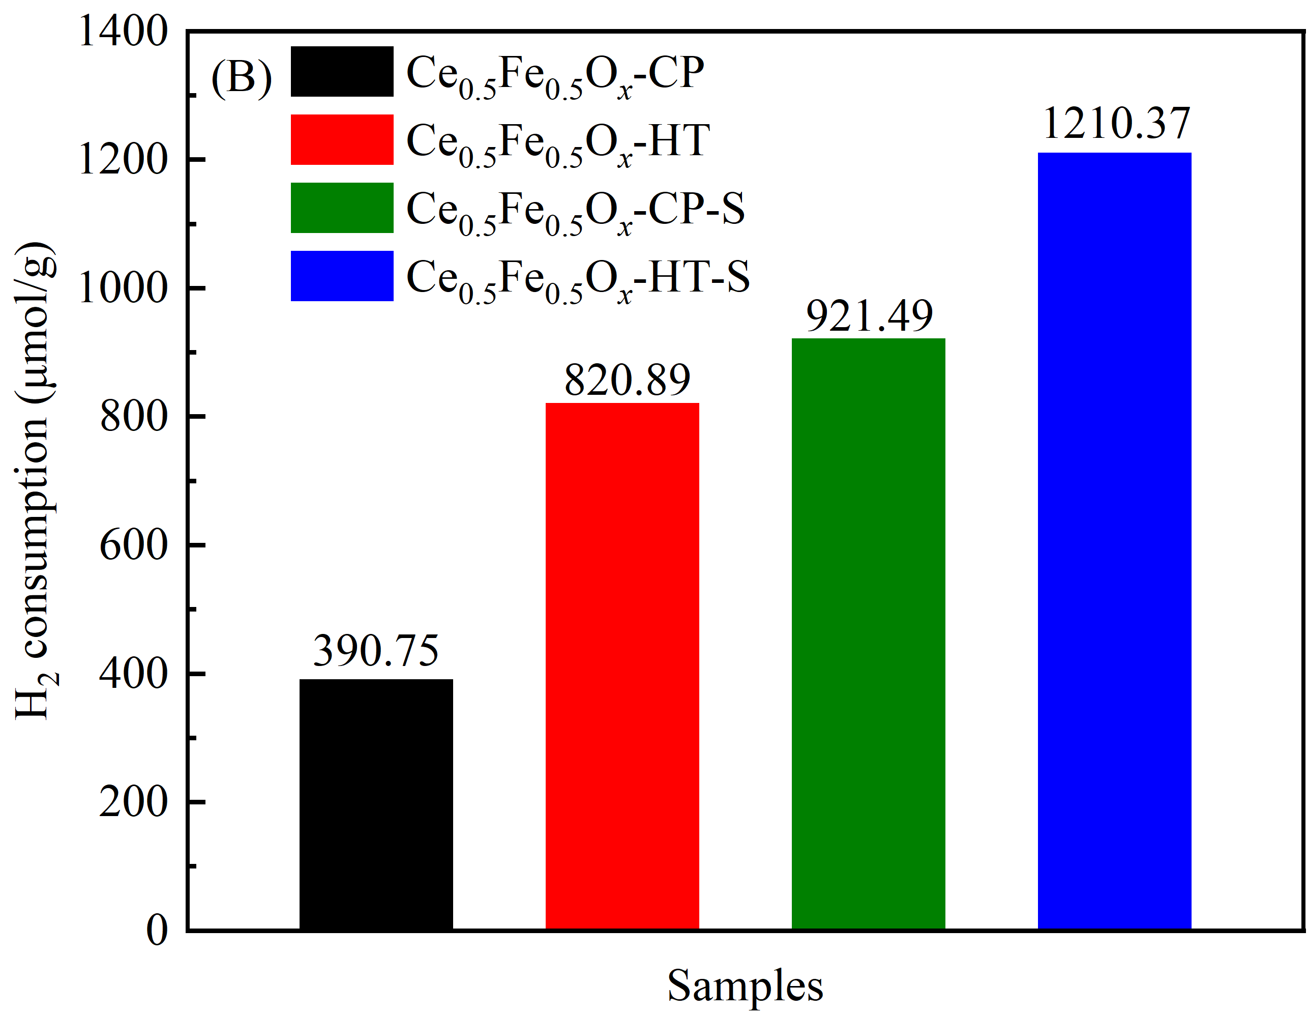
Fig.10. The H₂-TPR profiles (A) and calculated H₂ consumption (B) of Ce_{0.5}Fe_{0.5}O_{x} catalysts
H₂-TPR experiments were measured to reveal the influence of both preparation method and COS+CS₂ sulfation on the redox ability of Ce_{0.5}Fe_{0.5}O_{x} catalyst, which plays an important factor in NO_{x} reduction, and the results are given in Fig.10. There exist three obvious reduction peaks locating at 390 ºC, 579 ºC and 709 ºC for Ce_{0.5}Fe_{0.5}O_{x}-CP, which are attributed to the reduction of Fe₂O₃ to Fe₃O₄/FeO and Ce⁴⁺ to Ce³⁺, the reduction of FeO to Fe and the reduction of bulk Ce⁴⁺ to Ce³⁺, respectively. In addition, the calculated H₂ consumption of Ce_{0.5}Fe_{0.5}O_{x}-CP is about 390.75 μmol/g [41,53]. Meanwhile, Ce_{0.5}Fe_{0.5}O_{x}-HT exhibits two obvious low-temperature H₂-TPR peaks at 200-550 ºC, rather than only one peak as the same as Ce_{0.5}Fe_{0.5}O_{x}-CP, and its intensity of H₂ reduction at 550-800 ºC is stronger than those of the latter. Ma et al. pointed out that compared to solid phase mixing (SPM) and sol-gel methods (SG), the as-synthesized cerium-iron composite oxide catalyst by micro-emulsion presented stronger reducibility due to the formation of solid solution [8]. Therefore, preparation method affects the interaction of cerium and iron species, which influences the redox property of Ce_{0.5}Fe_{0.5}O_{x} catalyst, and Ce_{0.5}Fe_{0.5}O_{x}-CP presents stronger low-temperature reduction performance than Ce_{0.5}Fe_{0.5}O_{x}-HT, which may be responsible for its better low-temperature NH₃-SCR activity [34,47]. Furthermore, the sulfation of COS+CS₂ makes the low-temperature reduction peaks of both Ce_{0.5}Fe_{0.5}O_{x}-CP and Ce_{0.5}Fe_{0.5}O_{x}-HT catalysts shift to higher temperature, but increases their reduction intensity of H₂, and a wide reduction peak, including two obvious strong peaks, was detected at about 300-700 ºC for Ce_{0.5}Fe_{0.5}O_{x}-CP-S and Ce_{0.5}Fe_{0.5}O_{x}-HT-S. Interestingly, at this reduction temperature range, Ce_{0.5}Fe_{0.5}O_{x}-HT-S presents lower initial reduction temperature and final reduction temperature than Ce_{0.5}Fe_{0.5}O_{x}-CP-S with the lower temperatures for the detected three peaks. And the detected all four reduction peaks of Ce_{0.5}Fe_{0.5}O_{x}-CP-S and Ce_{0.5}Fe_{0.5}O_{x}-HT-S are attributed to the reduction of Fe₂O₃ to Fe₃O₄, the reduction of Fe₃O₄ to FeO and surface Ce⁴⁺ to Ce³⁺, the reduction of FeO to Fe or/and metal sulfate, and the reduction of bulk Ce⁴⁺ to Ce³⁺, respectively [47]. Furthermore, the total calculated H₂ consumptions of Ce_{0.5}Fe_{0.5}O_{x}-CP, Ce_{0.5}Fe_{0.5}O_{x}-HT, Ce_{0.5}Fe_{0.5}O_{x}-CP-S and Ce_{0.5}Fe_{0.5}O_{x}-HT-S under the tested temperature range are 390.75, 820.89, 921.49 and 1210.37 μmol/g, respectively, which is inconsistent with the NH₃-SCR activity, because the calculated values of total H₂ consumption only reflect the overall capacity of oxygen supply of catalyst, but the active oxygen reduced at low/medium temperature may play an important role on the catalytic performance of catalyst [30]. Therefore, it can be induced that the preparation method can affect the interaction of cerium and iron species in Ce_{0.5}Fe_{0.5}O_{x} catalyst, which thereby regulates the sulfation reaction of COS+CS₂ due to the difference in the reactivity of different components of catalysts, and Ce_{0.5}Fe_{0.5}O_{x}-HT presents better surface conversion of COS+CS₂, enriching the formation of sulfate and active oxygen on the surface of Ce_{0.5}Fe_{0.5}O_{x}-HT-S compared to Ce_{0.5}Fe_{0.5}O_{x}-CP-S.
3.2.8 NH₃-TPD
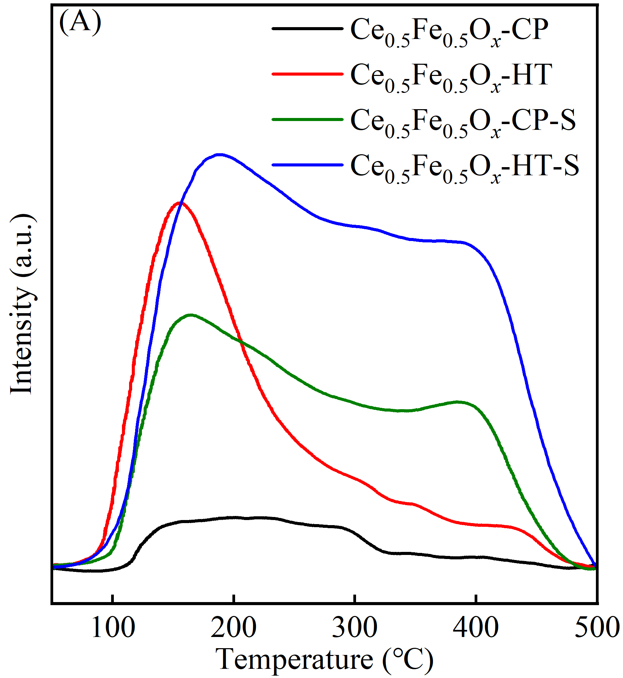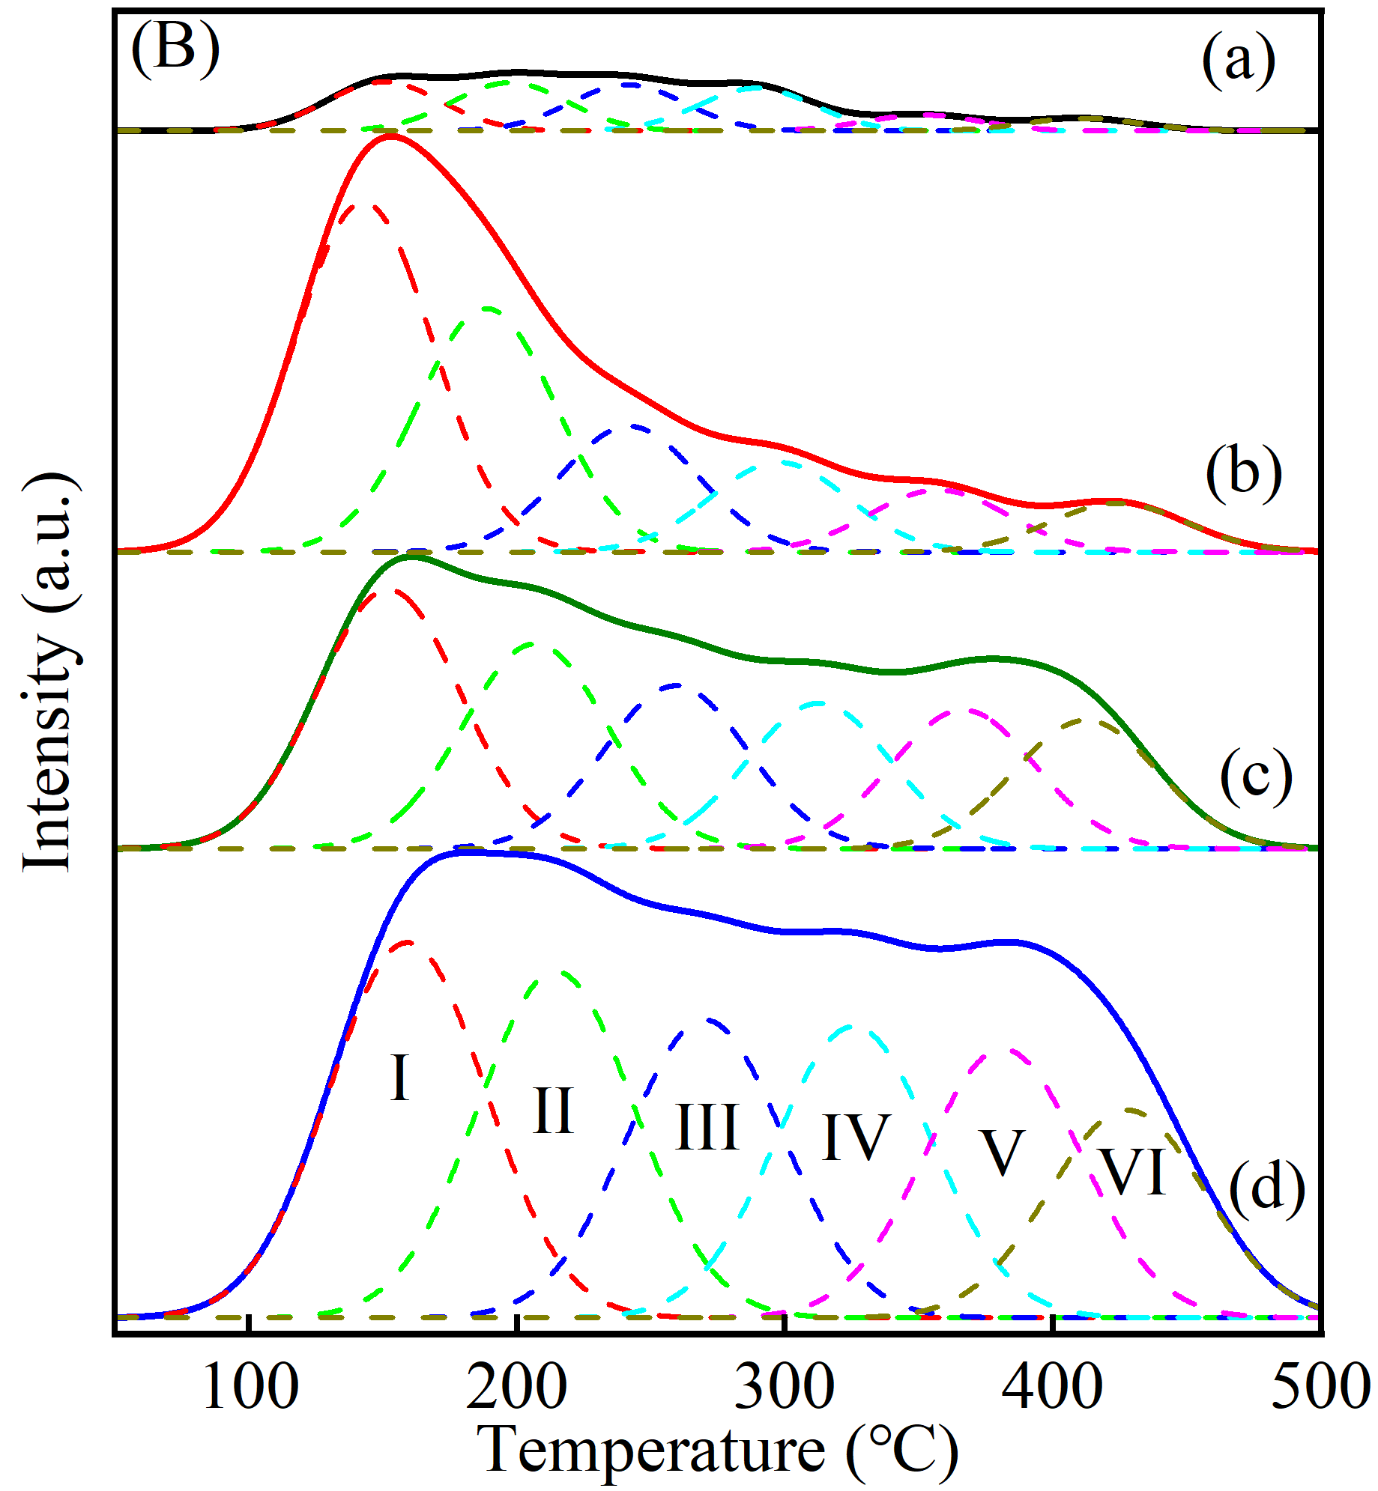
Fig.11. NH₃-TPD profiles of Ce_{0.5}Fe_{0.5}O_{x}-CP (a), Ce_{0.5}Fe_{0.5}O_{x}-HT (b), Ce_{0.5}Fe_{0.5}O_{x}-CP-S (c) and
Ce_{0.5}Fe_{0.5}O_{x}-HT-S (d) catalysts
As known, the surface acidity also plays an important role in NO_{x} reduction by affecting the adsorption and conversion of NH₃ reducing agent on the catalyst surface, and thus the NH₃-TPD measurements were tested at 50-500 ºC herein. As shown in Fig.11(A), Ce_{0.5}Fe_{0.5}O_{x}-HT exhibits stronger desorption intensity of NH₃ species than Ce_{0.5}Fe_{0.5}O_{x}-CP, especially the desorption of NH₃ species at the temperature range of 100-250 ºC, demonstrating larger surface acid sites. And the sulfation of COS+CS₂ enlarges the surface acid sites of both Ce_{0.5}Fe_{0.5}O_{x}-CP and Ce_{0.5}Fe_{0.5}O_{x}-HT catalysts, especially enhancing the desorption intensity of NH₃ species at the temperature range of 200-500 ºC. Therefore, both preparation method and COS+CS₂ sulfation can influence the formation of acid sites on the surface of Ce_{0.5}Fe_{0.5}O_{x} catalyst. As usual, the NH₃-TPD curve could be fitted into several peaks to study the kind of acid sites on the catalyst surface, and the results in Fig.11(B) indicate that six peaks (labeled as Ⅰ, Ⅱ, Ⅲ, Ⅳ, Ⅴ and Ⅵ) are fitted and obtained for the NH₃-TPD profiles of Ce_{0.5}Fe_{0.5}O_{x}-CP, Ce_{0.5}Fe_{0.5}O_{x}-HT, Ce_{0.5}Fe_{0.5}O_{x}-CP-S and Ce_{0.5}Fe_{0.5}O_{x}-HT-S. Among them, the first two peaks are attributed to weak acid sites and the others are ascribed to medium-strong acid sites [54,55]. Thus, Ce_{0.5}Fe_{0.5}O_{x}-HT has more weak acid sites than Ce_{0.5}Fe_{0.5}O_{x}-CP, although it presents worse low-temperature NH₃-SCR activity. However, as shown in Table S1, the sulfation of COS+CS₂ effectively enhances the medium-strong acid sites of Ce_{0.5}Fe_{0.5}O_{x}-CP and Ce_{0.5}Fe_{0.5}O_{x}-HT, and the calculated total medium-strong acid sites of Ce_{0.5}Fe_{0.5}O_{x}-CP-S and Ce_{0.5}Fe_{0.5}O_{x}-HT-S are up to 292.9 μmol/g and 547.9 μmol/g, which are about 1.95 and 2.02 times of Ce_{0.5}Fe_{0.5}O_{x}-CP and Ce_{0.5}Fe_{0.5}O_{x}-HT. Therefore, the introduced sulfate can enrich the surface acid sites of Ce_{0.5}Fe_{0.5}O_{x} catalysts under the condition of COS+CS₂ sulfation, but the types and quantities of formed sulfate for Ce_{0.5}Fe_{0.5}O_{x}-CP-S and Ce_{0.5}Fe_{0.5}O_{x}-HT-S are affected by the preparation method due to the different exposed active components via influencing the interaction of cerium-iron species. And the enhancement of medium-strong acid sites contributes to increasing the NH₃-SCR activity of Ce_{0.5}Fe_{0.5}O_{x} catalyst, especially the medium-high catalytic performance of NO_{x} reduction [56,57].
4 Conclusions
In this study, the co-precipitation and hydrothermal methods were proposed to fabricate Ce_{0.5}Fe_{0.5}O_{x}-CP and Ce_{0.5}Fe_{0.5}O_{x}-HT catalysts in order to regulate the influence of COS+CS₂ sulfation on the NH₃-SCR activity of catalyst by resulting in different interaction of active cerium and iron species. The results indicate that the further hydrothermal treatment at 200 ºC for 6 h decreases the NH₃-SCR activity at 150~300 ºC of Ce_{0.5}Fe_{0.5}O_{x}-CP, but increases its activity at 300~400 ºC. Furthermore, COS+CS₂ sulfation improves the NH₃-SCR activity of Ce_{0.5}Fe_{0.5}O_{x}-HT, especially the high-temperature activity, but decreases the catalytic activity of Ce_{0.5}Fe_{0.5}O_{x}-CP at the temperature lower than 250 ºC. The further hydrothermal treatment is disadvantageous to the interaction of cerium and iron species in Ce_{0.5}Fe_{0.5}O_{x}-CP, and depresses the incorporation of Fe³⁺ into cubic fluorite CeO₂, which promotes the formation of iron oxide crystals but decreases the defective sites of catalyst. Interestingly, this hydrothermal treatment promotes the sulfation of COS+CS₂ on the surface of Ce_{0.5}Fe_{0.5}O_{x}-HT due to the weaker interaction of active cerium and iron species or/and the formation of iron oxide crystals compared to Ce_{0.5}Fe_{0.5}O_{x}-CP. However, the further hydrothermal treatment contributes to enriching the pore-structure of Ce_{0.5}Fe_{0.5}O_{x}-CP and widening its pore size distribution, which effectively resists the adverse effects of COS+CS₂ sulfation on the pore-structure of Ce_{0.5}Fe_{0.5}O_{x} catalysts, and Ce_{0.5}Fe_{0.5}O_{x}-HT-S has large BET surface area. Furthermore, the regulation of preparation method on the interaction of active cerium and iron species of Ce_{0.5}Fe_{0.5}O_{x} catalyst or/and the subsequent COS+CS₂ sulfation were also confirmed by the results of Raman, SEM, TEM/HR-TEM and XPS. Interestingly, the inhibition of the hydrothermal treatment on the interaction of active components decreases the concentration of iron species but increases the concentration of cerium species on the surface of Ce_{0.5}Fe_{0.5}O_{x}-CP. And this effect can be restrained to a certain extent by the subsequent COS+CS₂ sulfation. The sulfation increases the surface Ce³⁺/(Ce³⁺+Ce⁴⁺) and Fe²⁺/(Fe³⁺+Fe²⁺) molar ratios of Ce_{0.5}Fe_{0.5}O_{x}-HT effectively, but decreases the calculated corresponding values of Ce_{0.5}Fe_{0.5}O_{x}-CP. Therefore, Ce_{0.5}Fe_{0.5}O_{x}-HT-S exhibits larger surface sulfate, acid sites and active oxygen than Ce_{0.5}Fe_{0.5}O_{x}-CP-S due to the better conversion of COS+CS₂ on the surface of Ce_{0.5}Fe_{0.5}O_{x}-HT.
CRediT authorship contribution statement
Yafei Zhu, Jingsong Zhou and Yanping Du: Writing-original draft, Methodology and Validation. Zhou Liu, Fei Zhou and Zhenchang Sun: Experiment and Methodology. Zhibo Xiong: Conceptualization, Funding acquisition, Writing-review & editing. Wei Lu: Investigation, Supervision and editing.
Declaration of Competing Interest
The authors declare that they have no known competing financial interests or personal relationships that could have appeared to influence the work reported in this paper.
Acknowledgements
This work was supported by General program of Shanghai Natural Science Foundation (No. 21ZR1461900) and the National Science Foundation of China (No. 51406118).
Data Availability Statement
The data that support the findings of this study are available from the corresponding author upon reasonable request.
Supporting Information
Additional supporting information can be found online in the Supporting Information section.
References
- J. Guo, et al., “Ni/N co-doped NH2-MIL-88(Fe) derived porous carbon as an efficient electrocatalyst for methanol and water co-electrolysis,” Renewable Energy 244 (2015):122661.
- L. Wang, et al., “Anti-K salt poisoning of MnO_{x} catalyst via X (X = Ce, Sm and Er) oxides for low-temperature NH₃-SCR of NO and oxidating CO,” Journal of Environmental Chemical Engineering 13 (2025):116933.
- S. Yang, et al., “Morphology regulation of CuO/CeO₂ catalyst for simultaneous NH₃-SCR denitration and CO oxidation,” Journal of Environmental Chemical Engineering 13 (2025):118868.
- X. Tan, G. Sastre, S. Hong, “Effect of zeolite framework composition on the fast NH₃-SCR performance of hydrothermally aged iron zeolites,” Journal of Hazardous Materials 494 (2025):138487.
- L. Li, C. Ge, J. Ji, et al., “Effects of different methods of introducing Mo on denitration performance and anti-SO₂ poisoning performance of CeO₂.” Chinese Journal of Catalysis 42 (2021):1488-1499.
- M. Shi, J. Yang, M. Zhang, S. Zhang, and Q. Zhong, “Design strategy for enhancing sulfur resistance in efficient NH₃-SCR through confined CeO₂ nanoparticles within mesoporous zeolite ZSM-5: Inhibition of SO₂ adsorption and reaction,” Chemical Engineering Journal 519 (2025):165187.
- H. Zhang, Z. Lian, C. Lin, Y. Zhu, W. Shan, and H. He, “Insight into the mechanisms of activity promotion and SO₂ resistance over Fe-doped Ce-W oxide catalyst for NO_{x} reduction,” Journal of Colloid Interface Science 652 (2023):923-935.
- Y. Ma, X. Tang, F. Gao, et al., “Selective catalytic reduction of NO_{x} with NH₃ over iron-cerium mixed oxide catalyst prepared by diﬀerent methods,” Journal Chemical Technology Biotechnology 95 (2020):232-245.
- J. Han, J. Meeprasert, P. Maitarad, S. Nammuangruk, L. Shi, and D. Zhang, “Investigation of the Facet-Dependent Catalytic Performance of Fe₂O₃/CeO₂ for the Selective Catalytic Reduction of NO with NH₃,” The Journal of Physical Chemistry C 120 (160):1523-1533.
- J. Sun, Y. Lu, L. Zhang, et al., “Comparative Study of Different Doped Metal Cations on the Reduction, Acidity, and Activity of Fe₉M₁O_{x} (M = Ti⁴⁺, Ce^{4+/3+}, Al³⁺) Catalysts for NH₃-SCR Reaction,” Industrial & Engineering Chemistry Research 56 (2017):12101-12110.
- X. Yu, et al., “Steam Stripping-Coupled Cycle for Thermodynamic Optimization and Carbon Cycle Intensification in CO/CO₂ Mixed-Gas Hydrogenation Methanol Synthesis,” ACS Omega 10 (2025):40477-40491.
- X. Yao, et al., “Influence of preparation methods on the physicochemical properties and catalytic performance of MnO_{x}-CeO₂ catalysts for NH₃-SCR at low temperature,” Chinese Journal of Catalysis 38 (2017):146-159.
- W. Zhao, J. Rong, W. Luo, L. Long, X. Yao, “Enhancing the K-poisoning resistance of CeO₂-SnO₂ catalyst by hydrothermal method for NH₃-SCR reaction,” Applied Surface Science 579 (2022):152176.
- C. Chen, et al., “Comparison of low-temperature catalytic activity and H₂O/SO₂ resistance of the Ce-Mn/TiO₂ NH₃-SCR catalysts prepared by the reverse co-precipitation and impregnation method,” Applied Surface Science 571 (2022):151285.
- X. Yuan, X. Zhao, Y. Li, X. Niu, Y. Zhu, “Boosting the H₂O resistance and NH₃-SCR activity over sulfated FeCe_{0.5}Sm_{a}Ti₄O_{x}-S catalysts by Sm modification,” Journal of Environmental Chemical Engineering 11 (2023):110010.
- X. Zhang, et al., “Noritatsu Tsubaki, Promotion of surface acidity and surface species of doped Fe and SO₄²⁻ over CeO₂ catalytic for NH₃-SCR reaction,” Molecular Catalysis 462 (2019):1-7.
- Z. Song, et al., “Mechanism of gas-phase sulfur modified Fe-Ce catalysts in the NH₃-SCR reaction,” Molecular Catalysis 569 (2024):114635.
- Y. Cai, et al., “Getting insights into gas-phase sulfation effect on catalytic performance of praseodymium oxides in NH₃-SCR of NO,” Journal of Rare Earths 41 (2023): 952-958.
- W. Wang, Z. Xiong, J Jin, W. Lu, H. Shi, “Influence of CS₂ pretreatment on the NH₃-SCR activity of CeO₂: Synergistic promotional effect of sulfation and reduction,” Journal of Environmental Chemical Engineering 9 (2021):106836.
- J. Liu et al., “Promotional effect of H₂O introduction on the NH₃-SCR activity of the gas-phase sulfated CeO₂ catalyst by organic CS₂+COS: Influence of H₂O concentration,” Journal of Environmental Chemical Engineering 11 (2023):111529.
- Z. Xiong et al., “The inﬂuence of H₂O or/and O₂ introduction during the low-temperature gas-phase sulfation of organic COS+CS₂ on the conversion and deposition of sulfur-containing species in the sulfated CeO₂-OS catalyst for NH₃-SCR,” Nanoscale 16 (2024):1223.
- Y. Xiong et al., “Constructing oxygen vacancy-enriched Fe₃O₄@MnO₂ core-shell nanoplates for highly efficient catalytic oxidation of H₂S in blast furnace gas,” Separation and Purification Technology 336 (2024):126234.
- D. Wei et al., “Research progress of carbonyl sulfide removal from blast furnace gas by porous materials,” Journal of Environmental Chemical Engineering 11 (2023):109606.
- Q. Li, et al., “Preparation and characterization of Cu/Ni/Fe hydrotalcite-derived compounds as catalysts for the hydrolysis of carbon disulfide,” Chemical Engineering Journal 284 (2016):103-111.
- Y. Wang, et al., “Carbonyl sulfur removal from blast furnace gas: Recent progress, application status and future development,” Chemosphere 307 (2022):136090.
- S. Renda, D. Barba, Vi. Palma, “Recent Solution for Efficient Carbonyl Sulfide Hydrolysis: A Review,” Industrial & Engineering Chemistry Research 61 (2022):5685-5697.
- X. Song et al., “Research on the low temperature catalytic hydrolysis of COS and CS₂ over walnut shell biochar modified by Fe-Cu mixed metal oxides and basic functional groups,” Chemical Engineering Journal 314 (2017):418-433.
- S. Zhao et al., “Spontaneous Formation of Asymmetric Oxygen Vacancies in Transition-Metal-Doped CeO₂ Nanorods with Improved Activity for Carbonyl Sulfide Hydrolysis,” ACS Catalysis 10 (2020):11739-11750.
- H. Huang, et al., “Purification of chemical feedstocks by the removal of aerial carbonyl sulfide by hydrolysis using rare earth promoted alumina catalysts,” Green Chemistry 10 (2008):571-577.
- Y. Wang, et al., “Revealing the excellent low-temperature activity of the Fe_{1-x}Ce_{x}O_{δ}-S catalyst for NH₃-SCR: improvement of the lattice oxygen mobility,” ACS Applied Materials & Interfaces 15 (2023):17384-17847.
- J. Ji, et al., “Promotion effect of bulk sulfates over CeO₂ for selective catalytic reduction of NO by NH₃ at high temperatures,” Chinese Chemical Letters 34 (2023):107769.
- Z. Zou, W. Li, Z. Liu, “Significantly Enhanced Catalytic Performance of Fe₂(SO₄)₃/CeO₂ catalyst for the Selective Catalytic Reduction of NO_{x} by NH₃,” Industrial Engineering Chemical Research 60 (2021):15472-15478.
- A. Stahl, Z. Wang, T. Schwammle, J. Ke, X. Li, “Novel Fe-W-Ce mixed oxide for the selective catalytic reduction of NO_{x} with NH₃ at low temperatures,” Catalysts 7 (2017):71.
- W. Wang, Z. Xiong, W. He, W. Lu, Hu. Shi, “Influence of thiourea modification on the NH₃-SCR activity of CeO₂: Simultaneous tuning morphology and surface acidity,” Journal of the Energy Institute 98 (2021):322-333.
- P. Gao, Y. Li, Y. Lin, L. Chang, Ti. Zhu, “Promoting effect of Fe/La loading on γ‑Al₂O₃ catalyst for hydrolysis of carbonyl sulfur,” Environmental Science and Pollution Research 29 (2022):84166-84179.
- X. Yao, et al., “Influence of preparation methods of supports on the deNO_{x} performance and alkali-metal resistance over TiO₂/CeO₂ catalysts in NH₃-SCR reaction.” Fuel 320 (2022):123920.
- Q. Zhang, et al., “Inﬂuence of preparation methods on iron-tungsten composite catalyst for NH₃-SCR of NO: The active sites and reaction mechanism,” Applied Surface Science 503 (2020):144190.
- P. Wu, et al., “Experimental and theoretical research on pore-modified and K-doped Al₂O₃ catalysts for COS hydrolysis: The role of oxygen vacancies and basicity,” Chemical Engineering Journal 450 (2022):138091.
- X. Tang, et al., “Promotional role of Mo on Ce_{0.3}FeO_{x} catalyst towards enhanced NH₃-SCR catalytic performance and SO₂ resistance,” Chemical Engineering Journal 398 (2020):125629.
- Si. Chen, R. Xie, Z. Liu, L. Ma, N. Yan, “Efficient NO_{x} Reduction against Alkali Poisoning over a Self-Protection Armor by Fabricating Surface Ce₂(SO₄)₃ Species: Comparison to Commercial Vanadia Catalysts,” Environmental Science & Technology 57 (2023):2949-2957.
- F. Liu, H. He, “Structure-activity relationship relation of iron titanate catalysts in the selective catalytic reduction of NO_{x} with NH₃,” Chemical Engineer Journal 114 (2010):16929-16936.
- H. Li, L. Schill, Q. Gao, S. Mossin, A. Riisager, “The effect of dopants (Fe, Al) on the low-temperature activity and SO₂ tolerance in solvothermally synthesized MnO_{x} NH₃-SCR catalysts,” Fuel 358 (2024):130111.
- C. Li, et al., “Promotional effect of tungsten modification on magnetic iron oxide catalyst for selective catalytic reduction of NO with NH₃,” Journal of the Energy Institute 93 (2020):1809-1818.
- J. Cao et al., “Synergistic effect of Cerium and Niobium enhances the low-temperature NH3-SCR activity of Fe-containing solid waste,” Separation and Purification Technology 354 (2025):129373.
- K. Cheng, S. Tang, J. Feng, M. An, J. Zhu, M. Xia, “Broadening active temperature window for NH₃-SCR on tungsten-promoted MnCeO_{x} nanorod catalysts,” Process Safety and Environmental Protection 182 (2024):1-10.
- Y. Zhang, Z. Xiong, Q. Yang, F. Zhou, W. Lu, H. Shi, “Influence of copper doping on the low-medium NH₃-SCR activity of magnetic W/Fe₂O₃ catalyst: Its synergetic effect of glucose dosage,” Journal of Environmental Chemical Engineering 10 (2022):108694.
- H. Wang, Z. Qu, L. Liu, S. Dong, Y. Qiao, “Promotion of NH₃-SCR activity by sulfate-modification over mesoporous Fe doped CeO₂ catalyst: Structure and mechanism,” Journal of Hazardous Materials 414 (2021):125565.
- S. Liu, H. Wang, Y. Wei, R. Zhang, “Core-shell structure effect on CeO₂ and TiO₂ supported WO₃ for the NH₃-SCR process,” Molecular Catalysis 485 (2020):110822.
- C. Gao, et al., “Modiﬁed red mud catalyst for the selective catalytic reduction of nitrogen oxides: Impact mechanism of cerium precursors on surface physicochemical properties,” Chemosphere 257 (2020):127215.
- Z. Zhou, J. Lan, L. Liu, Z. Liu, “Enhanced alkali resistance of sulfated CeO₂ catalyst for the reduction of NO_{x} from biomass fired flue gas,” Catalysis Communications 149 (2021):106230.
- Z. Xiong, et al., “Influence of organic sulfur gas-phase sulfation on the NH₃-SCR activity of CeO₂ catalyst: The competitive adsorption and conversion of CS₂ and COS at a low hydrolysis temperature,” Fuel 364 (2024):131101.
- X. Liu, et al., “A basic comprehensive study on synergetic effects among the metal oxides in CeO₂-WO₃/TiO₂ NH₃-SCR catalyst,” Chemical Engineering Journal 421 (2021):127833.
- Q. Xu, Z. Li, L. Wang, W. Zhan, Y. Guo, Y. Guo, “Understanding the role of redox properties and NO adsorption over MnFeO_{x} for NH₃-SCR. Catalysis,” Science & Technology 12 (2022):2030.
- Z. Xiong, et al., “Promotional effect of nickel doping on the W/Fe₂O₃ catalyst for selective catalytic reduction of NO_{x} with NH₃,” Molecular Catalysis 535 (2023):112902.
- L. Jia, et al., “Interface Engineering of a Bifunctional Cu-SSZ-13@CZO Core-Shell Catalyst for Boosting Potassium Ion and SO₂ Tolerance,” ACS Catalysis 12 (2022): 11281-11293.
- Z. Zhou, L. Wang, Z. Li, S. He, T. Ma, “Oxidation of SO₂ to SO₃ by Cerium Oxide Cluster Cations Ce₂O₄⁺ and Ce₃O₆⁺,” The Journal of Physical Chemistry A 120 (2016):3843-3848.

