Chlorinated Paraffins in Global Air: First Results from the GAPS and GAPS-Megacities Networks

Amandeep Saini^{1‡}*, Selene Kutarna^{1‡}, Shan Niu², Meera Mohindra¹, Jasmin Schuster¹, Jacob Mastin¹, Anita Eng¹, Tom Harner¹, Alan Yates³, Andrew Sweetman⁴, Begoña Jiménez⁵, Carlos A. Manzano⁶, Eftade O. Gaga⁷, Gavin Stevenson³, Jerzy Falandysz⁸, Ji Eun Lee⁹, Karina S. B. Miglioranza¹⁰, Maria Tominaga¹¹, Narumol Jariyasopit¹², Néstor Y Rojas¹³, Omar Amador-Muñoz¹⁴, Patricia Forbes¹⁵, Rose Alani¹⁶, R. Suresh¹⁷, Seung-bok Lee⁹, Takahiro Nishino¹⁸, Tamer Shoeib¹⁹, Urs Jans²⁰, Xinghua Qiu²¹, Zhen Cheng²¹
¹Air Quality Processes Research Section, Environment and Climate Change Canada, 4905 Dufferin Street, Toronto, Canada M3H5T4
²Advanced Interdisciplinary Institute of Environment and Ecology, Beijing Normal University, Zhuhai, Guangdong 519085, China
³ Australian Ultra-Trace Laboratory, National Measurement Institute, North Ryde, NSW 2113, Australia
⁴Lancaster Environment Centre, Lancaster University, Lancaster, United Kingdom LA1 4YQ
⁵Department of Instrumental Analysis and Environmental Chemistry, Institute of Organic Chemistry, IQOG-CSIC, 28006, Madrid, Spain
⁶Department of Chemistry, Faculty of Science, University of Chile, Las Palmeras 3425, Santiago, Chile
⁷Department of Environmental Engineering, Eskişehir Technical University, 26555 Eskişehir, Turkey
⁸University of Gdańsk, Environmental Chemistry and Ecotoxicology, 80-308 Gdańsk, Poland
⁹Center for Environment, Health and Welfare Research, Korea Institute of Science and Technology, Seoul, Korea
¹⁰Universidad Nacional Mar del Plata, IIMyC−CONICET, Mar del Plata, 7600, Argentina
¹¹ Sao Paulo State Environmental Company, Av. Prof. Frederico Hermann Jr, 345, São Paulo, Brazil
¹²Siriraj Metabolomics and Phenomics Center, Faculty of Medicine Siriraj Hospital, Mahidol University, Bangkok 10700 Thailand
¹³Department of Chemical and Environmental Engineering, Universidad Nacional de Colombia, Bogotá, Colombia
¹⁴Centro de Ciencias de la Atmósfera, Universidad Nacional Autónoma de México, 04510 Mexico City, Mexico
¹⁵Department of Chemistry University of Pretoria
¹⁶Department of Chemistry, Faculty of Science, University of Lagos, Lagos, Nigeria
¹⁷Centre for Environmental Studies, The Energy and Resources Institute, Indian Habitat Centre, New Delhi, 110003, India
¹⁸Tokyo Metropolitan Research Institute for Environmental Protection 1-7-5, Sinsuna Koto-ku Tokyo, Japan
¹⁹Department of Chemistry, The American University in Cairo, New Cairo 11835, Egypt
²⁰ Department of Chemistry & Biochemistry, Room MR-1218, City College of New York, New York, USA
²¹College of Environmental Sciences and Engineering, Center for Environment and Health, Peking University, Beijing, 100871 China

* Corresponding author: Amandeep Saini, phone: +1-416-739-5961, e-mail address: Amandeep.saini@ec.gc.ca
‡Equal contributions

Graphical abstract

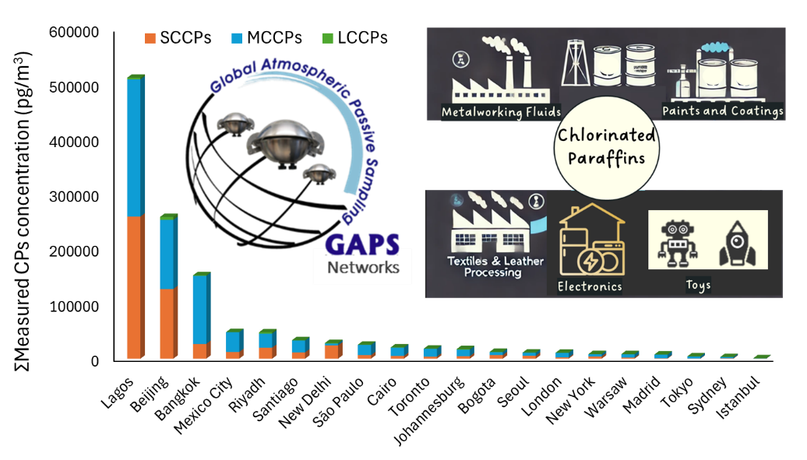
Abstract
This study presents the first global dataset of measured short-chain (SCCPs), medium-chain (MCCPs), and long-chain chlorinated paraffins (LCCPs) in ambient air derived from a single coordinated sampling network, i.e. the Global Atmospheric Passive Sampling (GAPS) network, using a passive sampling approach. Concentrations exhibited pronounced regional disparities, with two megacities—Lagos, Nigeria (512000 pg/m³) and Beijing, China (258 000 pg/m³) exceeding the combined total levels observed across the rest of the world (≈459 000 pg/m³). Evidence of long-range atmospheric transport was observed at remote sites in western Canada (Little Fox Lake and Whistler), influenced by trans-Pacific air trajectories during the sampling period. These findings underscore the substantial global heterogeneity in CPs’ spatial distribution and the heavily disproportionate contributions of a few regions. Notably, the major producers/emitters, such as China, had several years of delay in ratifying the SCCP listing under the Stockholm Convention (Annex A, elimination since 2017), with some countries yet to ratify. Without timely implications of regulatory action in such countries, global concentrations are expected to remain stagnant or even increase if emissions persist at current levels. Without timely implementation of regulatory measures in these jurisdictions, global concentrations are expected to remain stagnant—or even increase—if emissions persist at current levels. These results further suggest that substantial time lags are likely before measurable declines in SCCP concentrations—and potentially in recently listed MCCPs—are observed, even in regions where control measures are already in place. Hence, this global data set serves as a baseline for future assessments of temporal and spatial trends.

Keywords: Chlorinated Paraffins, GAPS network, GAPS-Megacities, Passive air sampling, global levels

Synopsis: Global levels of chlorinated paraffins are measured using polyurethane foam passive air samplers. The data set will serve as a global baseline for future trend assessments.

Introduction

Chlorinated paraffins (CPs) are a class of synthetic chemicals produced by the chlorination of n-alkanes with varying carbon chain lengths and degrees of chlorination. This combination of different carbon chain lengths and variable stereochemical structures makes the potential existence of over 10,000 isomers of CPs.¹ CPs have been produced in high volumes and have been widely used in lubricants, plastics, rubbers, and metal-cutting fluids ². Due to their widespread production and applications, CPs have been detected in various environmental and biota samples, including outdoor air, soil, and even cetacean samples collected from the Arctic, raising concerns about their potential impacts on ecosystems and human health.³⁻⁶ ^{inter alia}
CPs are classified into three groups based on their carbon chain lengths: short-chain CPs (SCCPs, C₁₀₋₁₃), medium-chain CPs (MCCPs, C₁₄₋₁₇), and long-chain CPs (LCCPs, C_{≥18}). They are also classified based on chlorine content, with commercial mixtures such as CP-42, CP-52, and CP-70 referring to approximately 42%, 52%, and 70% chlorine by weight, respectively.⁷⁻⁸ Due to the structural diversity and analytical complexity of CPs, Fernandes et al.⁹ recommended using the term "measured polychlorinated alkanes" when reporting their environmental concentrations. They also advocated reporting the sum of individual chain lengths, where quantifiable, rather than using the aggregated term "total CPs", to improve comparability across studies and better support toxicological evaluations and risk assessment processes.
Owing to their persistence in the environment, toxicity, bioaccumulation, and long-range transport potential, SCCPs with a chlorination extent greater than 48% by weight were listed in Annex A (elimination) of the Stockholm Convention on Persistent Organic Pollutants (POPs) since 2017.¹⁰ As a result, MCCPs and LCCPs are increasingly used as substitutes, with growing evidence of their environmental occurrence.¹¹⁻¹³ Very recently, in the Conference of the Parties to the Stockholm Convention on POPs (SC COP-12), MCCPs with chlorine contents at or exceeding 45% by weight were also listed as POPs under the Stockholm Convention with specific exemptions.¹⁴ MCCPs are listed under Annex A requiring Parties to eliminate their production and use. However, the timeline for ratification and subsequent implementation varies depending on each country’s domestic processes and legal frameworks. For instance, while SCCPs were listed in 2017, by 2018, 166 of the 186 Parties had ratified the amendment, however, a few countries such as Canada and China ratified the listing in 2022 and 2023, respectively.¹⁵ These time lags in ratification and implementation can result in the continued production, use, and export of listed chemicals during the interim, creating potential “loopholes” in global trade and undermining the effectiveness of collective elimination efforts.
Despite global production and environmental release, relatively few studies have measured CP concentrations in air, especially for MCCPs and LCCPs, primarily due to analytical challenges in detecting such complex mixtures. ¹⁶ The levels, profiles, and atmospheric transport of CPs remain poorly understood, especially on a global scale. The Global Atmospheric Passive Sampling (GAPS) core network has been established since 2005 to monitor POPs and chemicals of emerging concern in global air at over 100 sites, with 40+ sites contributing to long-term monitoring data.¹⁷ The GAPS-Megacities network, initiated in 2018, aims to assess chemical pollution in large urban centers.¹⁸⁻¹⁹ Both networks use double-dome polyurethane foam passive air samplers (PUF-PAS), which have been successfully applied to monitor SCCPs in air in global regions including Canada²⁰, China²¹⁻²³, India²⁴, Australia^{1, 25}, and Switzerland²⁶. The applicability of PUF-PAS for monitoring MCCPs and LCCPs has also been previously demonstrated in a few studies^{4, 20, 23, 27}. Analytically, multiple technologies have been employed to quantify CPs, including gas chromatography coupled with mass spectrometry (GC-MS)²⁸⁻²⁹ two-dimensional gas chromatography coupled with mass spectrometry (GC×GC-MS)³⁰⁻³¹, two-dimensional gas chromatography coupled with high-resolution mass spectrometry (GC×GC-HRMS)³², and high-performance liquid chromatography coupled with high-resolution mass spectrometry (HPLC-HRMS).³³ Each technique offers different strengths, but HPLC-HRMS has shown particular promise in resolving and detecting longer chain CPs, particularly LCCPs.^{6, 33}
This study aims to assess the global distribution and chemical profiles of the full suite of CPs (SCCPs, MCCPs, and LCCPs) in ambient air. We developed and validated a high-throughput method using HPLC-HRMS (Orbitrap 240) for application to PUF-PAS samples from the GAPS networks. While previous studies have predominantly focused on SCCPs—with limited data on MCCPs—this is, to our knowledge, the first study to report global-scale atmospheric concentrations of all three CP groups using a harmonized passive sampling approach.

Materials and Methods
Passive air sampling: Polyurethane foam (PUF) disks samples were deployed in double-dome type passive samplers as used previously under the GAPS network over decades ³⁴⁻³⁵. The samplers were deployed at 20 GAPS-Megacities sites and at the 10 Canadian sites under the core GAPS network for 3 months (Quarter 3: July-September, with some exceptions) as a part of routine annual sampling campaigns over 4 quarters of the year. Further details of locations, sampling dates and sampling rates are given in the Supporting Information (SI), Table S1.
Extraction and processing: Samples were extracted using an accelerated solvent extraction system (ASE, ASE 350, Dionex Corporation, Sunnyvale, CA, USA). A combination of Hexane: Acetone (1:1, v/v) with ASE method set at 70 °C, 1500 psi for two cycles (5 min static cycle with 100% flush and 240 s purge) was used for the extraction of target analytes. Post extraction, extracts were reduced to 1mL using Turbovap blowdown evaporator (Biotage, Sweden) under a gentle stream of nitrogen, followed by eluting on BondElute Florisil normal phase columns (5g, 20 mL) (Agilent Technologies, USA). Prior to loading the concentrated raw extract onto the column, latter were topped up with ~1 g of sodium sulphate and pre-cleaned by running 20 mL of Hexane: Acetone (1:1, v/v). The extract was then loaded onto the column followed by the elution with 30 mL of Hexane: Acetone (1:1, v/v). The eluates were blown down to 0.5 mL using Turbovap and N-evap equipment following the solvent exchange with Methanol before transferring the extracts to GC vials. XX ng of ¹³C₁₀ anti-DP standard was added as an internal standard. The extracts were push filtered using Whatman® Mini-UniPrep® syringeless 0.2 μm filters (Cytivia Life Science, USA) before instrumental analysis.
Instrumental analysis: CPs were analyzed using Ultra-High Performance Liquid Chromatograph coupled with Orbitrap Exploris 240 high resolution mass spectrometer (UHPLC-Orbitrap240 HRMS) (Thermo Fisher Scientific, USA). An instrumental method was adapted from a previously published method by Kutarna et al.³⁶ and optimized using Vanquish UHPLC system coupled with an Exploris 240 mass spectrometer (Thermo Fisher Scientific, USA). Separation of CPs was achieved with reverse phase chromatography using ZORBAX RRHD (Stable Bond CN, 1.8 µm, 2.1 x 100 mm) fitted with ZORBAX guard column (Agilent Technologies, USA). The injection volume was 5 µL with 0.1 mM ammonium chloride in ultrapure water (A) and 0.1 mM ammonium chloride in methanol (B) as mobile phases. Initially, 30% B was increased to 70% over 1.5 min, then increased to 100% at 2.5 min and held static for 2 min, followed by a decrease to initial conditions of 30% B and held for 1 min to allow for equilibration. Flow rate was 0.4 mL/min. The column and sample compartment temperatures were maintained at 40 °C and 4 °C, respectively. Data were acquired in full MS mode. Parameters for full scan (100–1100 m/z) recorded at resolution R = 90 000 (at m/z 200) with a maximum of 3 × 106 ions collected within 200 ms. Mass spectrometric settings for negative electrospray ionization mode were as follows: spray voltage, 3.4 kV; sheath gas flow rate, 35 L/h; auxiliary gas flow rate, 7 L/h; capillary temperature, 275 °C; and probe heater temperature, 350 °C. Calibration curves were generated using a concentration series of 0.5, 1.0, 2.0, 3.9, 7.8, 15.6, 31.2, 62.5, 125, 250, and 500 ng/mL, which showed strong linearity (r² > 0.99). Further details on method optimization results are given in SI, Text 1 and shown in Figure S2.
Quantification method: Automated Processing in R: Post-acquisition processing and quantification of chlorinated paraffins was conducted using a custom-built R script. The script has three major components: construction of the screening database, peak picking/compound screening, and quantification. First, a screening database of chlorinated paraffins was constructed in R based on user input of desired carbon chain lengths. Each line of the database contained a formula with the general pattern C_{X}H_{(2x+2-y)}Cl_{y} where y ranges from 1 to x, plus associated exact mass, isotopic abundance, mass-to-charge ratio for the detected [M+Cl]⁻ ion, and two additional chlorine isotope masses for verification. Compound entries were also automatically grouped into categories based on carbon chain length (SCCP, MCCP, or LCCP).
Next, raw mass spectrometry data files in mzXML format were imported into R. These were processed using functions from the ‘xcms’ package³⁷, with these major steps: centroiding profile-mode data, smoothing, peak picking, peak grouping across samples, peak filling between samples, and retention time correction. The processed mass spectrometry data was then screened against the previously constructed CP database using exact mass matching with a default mass error of 5 ppm. Chlorine isotope peaks were used to verify peak identity, and a peak height cutoff of 10,000 was applied to reduce false positives.
Lastly, the screened CP results were quantified using a modified version of the method proposed by Reth et al.³⁸ For each technical mixture, peak areas of the most abundant isotope of each congener were collected and normalized by the peak area of the mass-labelled internal standard ¹³C₁₀-anti-DP, which was added to every standard solution and spiked into every sample at the same concentration. Further details opted from Reth et al. (2005)³⁸ method is given in SI, Text S2.
Quality Assurance and Quality control (QA/QC): Laboratory blanks were extracted and processed along with field blanks and samples to monitor any contamination occurring during the laboratory processes (Table S2). Recoveries were monitored by adding surrogate standards, i.e. 50 ng each of ¹³C10H16Cl7 and ¹³C12H18Cl9 to all blanks and samples before the extractions. The extraction method was validated by conducting spiked recovery tests. Clean PUF disks were spiked with a known amount of native MCCPs and mass-labelled SCCPs, and underwent the whole procedure as explained above. The recoveries of spiked standards ranged between 80–110%, confirming the validity of the extraction and processing procedures used for this study. The recoveries of surrogate standards added to samples and blanks were 107±50%. The higher variability in recoveries of spiked surrogates to samples is attributed to larger PUF matrix interferences, which have been observed previously for other suites of compounds analyzed in PUFs in the GAPS networks.³⁹ The data was blank corrected but not recovery corrected, hence the air concentrations reported here should be considered semi-quantitative estimates of the real environmental levels of CPs.
The GAPS template was used to measure the equivalent air volume (Veq, m³) sampled by PUF at each site to convert mass sampled by PUF to corresponding air concentrations.⁴⁰ The GAPS template corrects Veq for average temperature during the sampling period. Site-specific sampling rates were used for calculations that consider the site-specific meteorological data such as wind speed (WS) based on the sampling dates and location coordinates⁴¹ (Table S1). Further details on the calculation of sampling rates are provided by Schuster et al.³⁴ This template has been used in the past for previous reports under GAPS network and other regional studies. The sampling rates used in this study were within the range as measured by He et al.²³ in a field calibration study.

Results and Discussion
Spatial profile: Chlorinated Paraffins, hereafter, refer to measured chlorinated alkanes with carbon chain length from C₁₀ to C₂₀ with variable chlorine contents, as quantified under this study. The results have been reported as the sum of measured SCCPs (ΣC₁₀₋₁₃), MCCPs (ΣC₁₄₋₁₇) and LCCPs (ΣC₁₈₋₂₀) as well as sums of individual chain lengths, as recommended by Fernandes et al.⁹ Results for descriptive statistics for GAPS-Megacities and core-GAPS networks are given in Table 1. Detailed results for each site and the sums of individual carbon chain lengths with variable chlorine content are given in Tables S3 and S4, respectively. Overall, across most of the sampling sites, CP profiles were dominated by MCCPs, followed by SCCPs, together accounting for up to 95% of total CPs. LCCPs typically contributed ≤5% of the total CP burden. Detailed results are given below and reported to 3 significant figures for ease of comparison.

Table 1. Summary of measured CP concentrations (pg/m³) measured in the passive air samples under the core-GAPS and GAPS-Megacities networks. N represents the number of sites under each network monitored for this study. Asterisk* indicates the values below the method detection limit (given in Table S3) after blank correction and were included in average and median calculations. The values are reported to 3 significant figures.
Network |  | Minimum− Maximum | Average | Median
 | SCCPs (ΣC₁₀₋₁₃)
Core-GAPS (n=10) |  | 0.653*−3520 | 539 | 16.9
GAPS-Megacities (n=20) |  | 267*−259000 | 26200 | 5180
 | MCCPs (ΣC₁₄₋₁₇)
Core-GAPS |  | 56.4*−5890 | 1800 | 1090
GAPS-Megacities |  | 428*−250000 | 34500 | 10200
 | LCCPs (ΣC₁₈₋₂₀)
Core-GAPS |  | 6.97*−890 | 114 | 14.4
GAPS-Megacities |  | 5.79*− 5450 | 824 | 333

Global/GAPS-Megacities network: Global air concentrations of total measured chlorinated paraffins (ΣCPs) ranged from 3000 to 512,000 pg/m³ (Table S3). The highest levels were observed in Lagos, Nigeria, where SCCPs, MCCPs and LCCPs were measured at 259000, 250000 and 3010 pg/m³, respectively. Lagos hosts one of the world’s largest dumpsites, which receives thousands of tons of unsorted waste, including substantial amounts of plastic and electronic waste.⁴² Inadequate waste management practices, such as open burning, are known to release chlorinated contaminants into the atmosphere, consistent with previous observations for flame retardants.¹⁸ The next-highest levels were observed at Beijing, China and Bangkok, Thailand, with total quantifiable CPs measuring at 258,000 and 152,000 pg/m³, respectively. Elevated concentrations observed in Beijing align with China's status as the world’s leading producer and consumer of CPs since the early 2000s, with a total CP production of up to 1.4 million metric tons in 2020.⁴³⁻⁴⁴ Although SCCPs were listed under the Stockholm Convention in 2017, China only ratified the listing recently in 2023, which implies that SCCPs were still being manufactured/used in the country.⁴⁵ Such delays in ratification and implementation can undermine the Convention’s effectiveness, as a global decline in atmospheric SCCP concentrations would not be expected while emissions persisted from the world’s largest producer. Guida et al.⁸ also highlighted the challenges pertaining to effective implementations of regulations under the Stockholm Convention, given there are several other substantial producer countries, e.g. India, Russia, Australia⁴⁶, that have not ratified the SCCPs listing as of August 2025. Consequently, the 2023 concentrations from GAPS Networks reported here may represent near-maximum levels in the global atmosphere and therefore provide a valuable baseline for assessing future reductions in the levels due to the implementation of control measures by Parties to the Stockholm Convention. The concentration levels in the remaining mega/major cities were orders of magnitude lower than Lagos, Beijing and Bangkok, spanning from 48,400 pg/m³ (Mexico City) to 3000 pg/m³ (Sydney). Istanbul was the only GAPS-MC site where the sum of measured SCCPs, MCCPs and LCCPs (270, 430 and 20 pg/m³, respectively) was below method detection limits after blank correction.

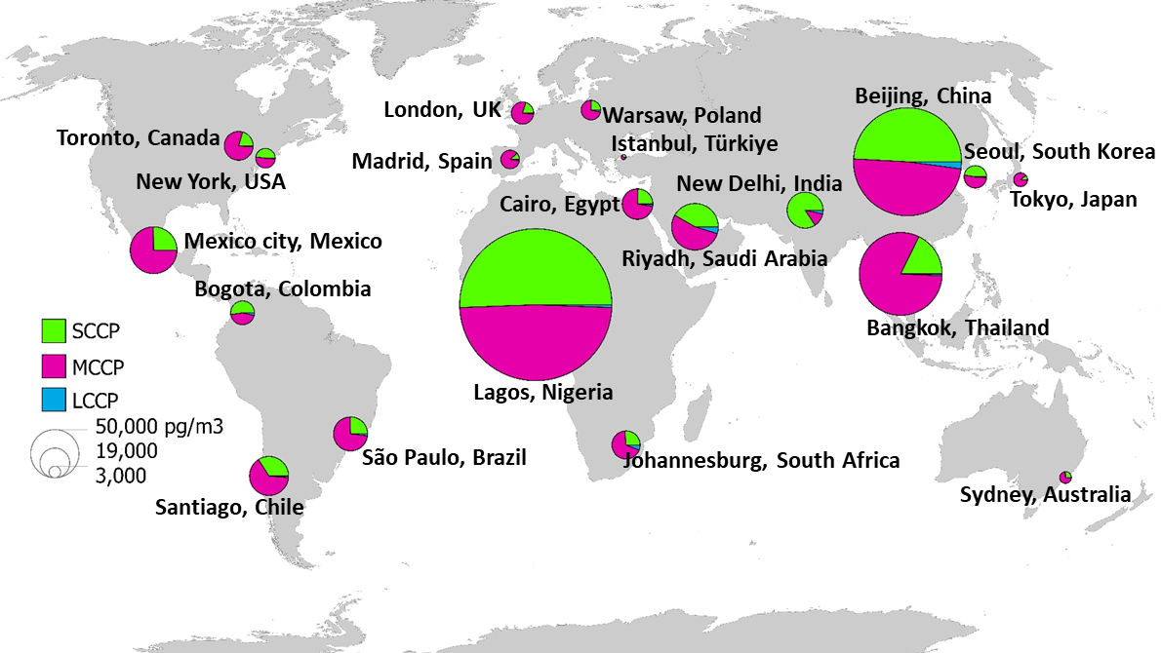

Figure 1. Pie charts representing the global air concentrations (pg/m³) and contributions of the sum of measured SCCPs (ΣC₁₀₋₁₃), MCCPs (ΣC₁₄₋₁₇) and LCCPs (ΣC₁₈₋₂₀) in samples from the year 2023. Map source: Esri, ArcGIS Online basemap.
Air concentrations were also compared based on the 5 United Nations region groupings - Western Europe and Others Group (WEOG), Latin American and Caribbean Group (GRULAC), Eastern Europe (EE), Asia-Pacific, and Africa (Figure 2a). The median concentrations were highest and similar for the Africa, Asia-Pacific and GRULAC regions, while the WEOG and EE regions were about half and an order of magnitude lower, with a range of levels between 695–18,400 pg/m³.
The ΣMCCPs/ΣSCCPs ratios (M/S) are given in Table S3. Higher MCCPs/SCCPs ratios were observed for Tokyo (8.39), Madrid (7.49), Bangkok (4.61), Toronto (3.78), as well as in Cairo, Johannesburg, Warsaw, Mexico City, São Paulo and Syndey (all with ratios between 2–3), indicating a shift to the use of commercial formulations and/or products containing more MCCPs. Contrary, MCCPs/SCCPs ratio of ≤1 was observed for Lagos, Beijing, Seoul, Bogota, New York and New Delhi, which reflects continuous emissions from production (e.g., in China and India) or release from in-use products, stockpiles and end-of-life products in the waste phase (e.g., in Lagos).

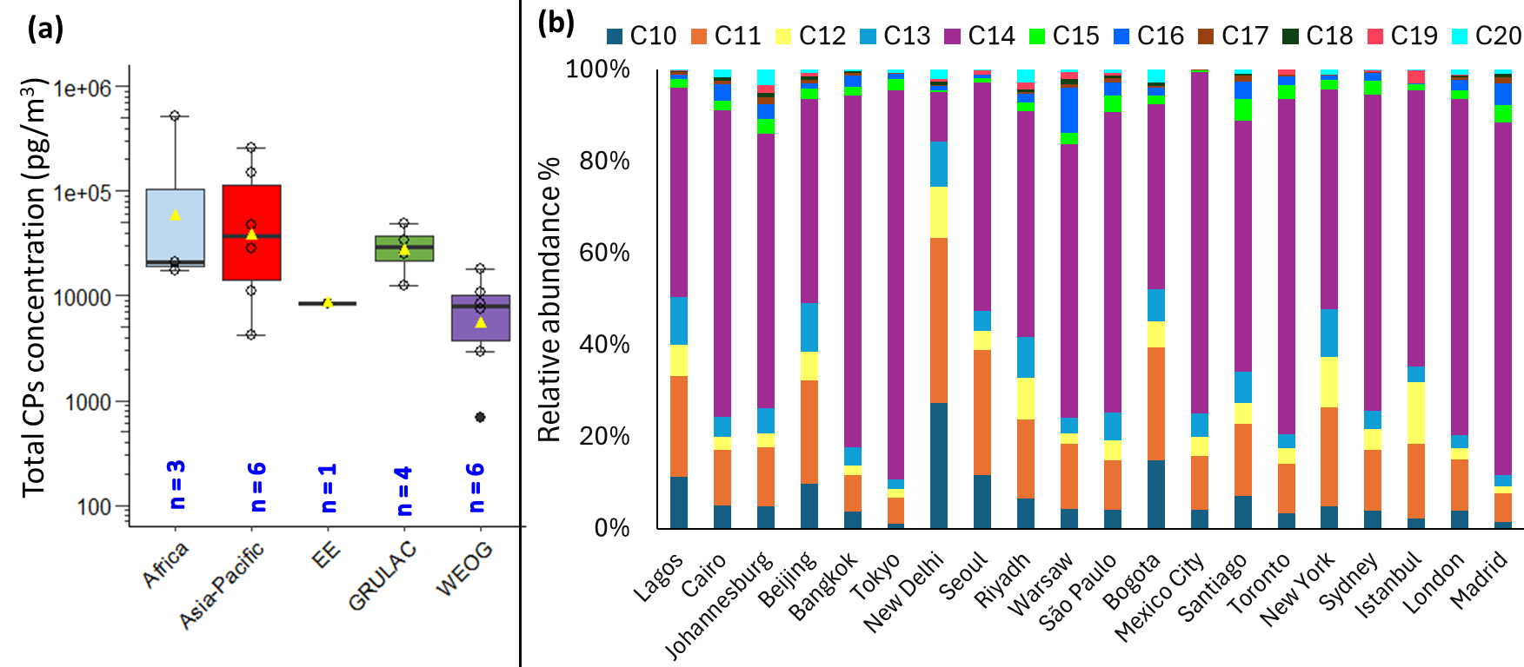

Figure 2: (a) Comparison of concentrations (during 2023) of total measured CPs as shown in box and whisker plots across the five United Nations regional groups. Yellow triangle markers indicate the average; top, middle and bottom lines of the boxes show 75th percentiles, medians and 25th percentiles, respectively, and whiskers represent the minimum and maximum total concentration. N represents the number of sites sampled in the given region. UN regions: Africa; Asia-Pacific; EE (Eastern Europe), GRULAC (Group of Latin American and the Caribbean countries); WEOG (Western Europe and Other States Group). (b) Relative abundance of measured homologues based on carbon chain length for SCCPs (C₁₀₋₁₃), MCCPs (C₁₄₋₁₇) and LCCPs (C₁₈₋₂₀) as observed at GAPS-MC study sites. Sites are arranged in order of UN regions given in the left panel.
Canada/Core-GAPS network: Total CP concentrations at ten Canadian sites under the Core-GAPS network ranged from 35 (<MDL) to 10300 pg/m³. These sites represent a range of land-use types and locations, including five background, three rural, one semi-urban, and one polar site (Table S2). The background site, Whistler in British Columbia, exhibited the highest levels of SCCPs, MCCPs and LCCPs measured at 3520, 5890 and 890 pg/m³, respectively. Although Whistler is situated at a high elevation, it may still be influenced by local emissions resulting from tourism and recreational activities such as skiing. Another background site, Little Fox Lake (LFL) in Yukon, also exhibited noticeably high levels of CPs, with SCCPs, MCCPs, and LCCPs measured at 991, 1690, and 134 pg/m³, respectively. Previous studies have identified the influence of long-range atmospheric transport (LRAT) in this region of western sub-Arctic Canada, highlighting the role of westerly winds from the Pacific and East Asia in transporting contaminants to remote sites, including LFL ⁴⁷⁻⁴⁸. Backward air parcel trajectories were assessed for Whistler and LFL sites using the US National Oceanic and Atmospheric Administration (NOAA) Hybrid Single Particle Lagrangian Integrated Trajectory (HYSPLIT) model with GDAS one-degree archive meteorological data ⁴⁹ for the sampling period. The model was run for 15-days back trajectories for every hour at a receptor height of 200 meters above ground level with a total of 4400 trajectories over the sampling period for each site. However, only one-third of trajectories were used for cluster analysis due to HYSPLIT's limitations in processing all trajectories simultaneously. Trajectory clustering was performed using the built-in clustering algorithm in HYSPLIT, which groups trajectories based on their geometric similarity using the Ward’s minimum variance method. This analysis showed the pattern of transpacific movement of air mass with more than 60% of trajectories originating from East Asia/Russia that arrived at Whistler and LFL sites (Figure 3b). Hence, apart from possible influences of local sources at Whistler, these two sites have the impacts from transpacific transport of contaminants which is also supported by elevated levels seen at East Asian sites under the GAPS-MC network.
The semi-urban site in Toronto, Ontario (Downsview)—characterized by proximity to light industry, commercial areas, and residential buildings within a 5 km radius—recorded the second-highest concentrations of SCCPs and MCCPs (725 and 4650 pg/m³, respectively) among core-GAPS sites, whereas LCCPs at this site were below MDL (15.1 pg/m³). Fraserdale and Egbert, Ontario had MCCPs measured at 1090 and 2200 pg/m³, respectively, whereas SCCPs and LCCPs were below MDL at both sites (Table S3). In contrast, concentrations of all three CP classes were below MDL at the polar site in Alert, Nunavut, as well as at several rural and background sites, including Bratt’s Lake (Saskatchewan), Ucluelet (British Columbia), Sable Island (Nova Scotia), and Longwoods (Ontario), their data is provided in Table S4 for reference.

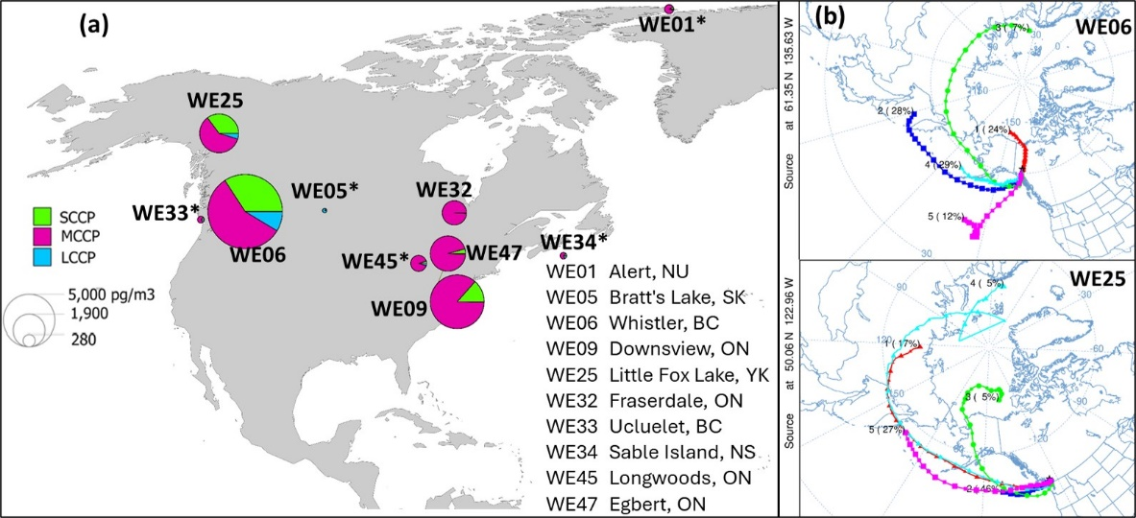

Figure 3: (a) Pie charts representing the Canadian air concentrations (pg/m³) and contributions of the sum of measured SCCPs (ΣC₁₀₋₁₃), MCCPs (ΣC₁₄₋₁₇) and LCCPs (ΣC₁₈₋₂₀) in samples from the year 2023. The sites with asterisks have data < MDLs. Map source: Esri, ArcGIS Online basemap. (b) Cluster analysis of air mass back trajectories arriving at Whistler (WE06) and Little Fox Lake (WE25) sites. Trajectories were computed using the HYSPLIT (Hybrid Single-Particle Lagrangian Integrated Trajectory) model developed by NOAA’s Air Resources Laboratory (https://www.ready.noaa.gov/hypub-bin/trajtype.pl). The model was initialized with GDAS one-degree archive meteorological data and run for 15-day back trajectories for every hour at a receptor height of 200 meters above ground level. Each color represents a distinct cluster of similar trajectories based on their spatial paths, with clustering performed using Ward’s hierarchical method.

Comparison to the literature: Details of previous studies from 2005 to 2025, reporting on CP levels in air are given in Table S5. Overall, the concentrations measured at GAPS-MC sites were generally in agreement (within an order of magnitude) with previous studies reporting atmospheric CP concentrations in similar regions. In the current study, the highest atmospheric concentrations of both SCCPs and MCCPs were observed at an urban site in Lagos, Nigeria. However, to the best of our knowledge, there is no other study that has reported CP concentrations in Nigeria to date and very limited monitoring studies have been conducted in a few other African countries. Arko et al.²⁷ reported on CPs levels in Ghana using PUF-PAS in source-sector based measurements, with SCCPs and MCCPs ranges of 50–15,200 and 1780–240,000 pg/m³, respectively. The elevated levels were observed at an e-waste site in Ghana, linking it to poor waste management, such as open burning practices. Nipen et al.⁴ also reported CPs measurements in Tanzanian air at rural, suburban, urban and dump/e-waste sites, with the waste-source transect and urban locations having the highest individual concentrations of CPs (ranges of SCCPs and MCCPs reported were: 300–63000, <400–35000 pg/m³, respectively). In comparison to the levels observed at Lagos, Nigeria in the current study, the atmospheric CP levels in Ghana, in particular MCCPs, are in close agreement, while the levels in Tanzania are more than an order of magnitude lower. Nevondo and Okonkwo⁵⁰ and Arko et al.²⁷ have highlighted the research gaps related to atmospheric studies on CPs in Africa as compared to other UN regions, which is linked to a lack of sampling resources and analytical capacity required for complex analyses of CPs.
China has the most abundance data reported so far for all three CP classes, with active air sampling being the widely used technique to collect the air samples. A wide range of CP concentrations has been reported in the Chinese atmosphere,⁵¹⁻⁵⁵ ^{inter alia} with a maximum level of ΣSCCPs–881000 pg/m³ measured in Beijing⁵⁶, which is approximately 3.5 times higher than the levels reported in the current study. Similarly, the highest reported levels so far of ΣMCCPs were 1136400 pg/m³–measured near a CP production plant (location unknown).⁵⁷ The highest reported levels of LCCPs–17,400 pg/m³ were measured in the Pearl River Delta, China⁷, ~3 times higher than the current study. Dong et al.⁵⁸ reported 22000 and 1600 pg/m³ of ΣSCCPs and ΣMCCPs, respectively, in rural environments of Beijing in 2022, which were orders of magnitude lower than the current study, likely due to fewer emission sources as compared to urbanized environments. In the remaining parts of Asia, CP levels have been reported in India, Pakistan and Vietnam with a maximum ΣCPs of 85,600, 23,700 and 18,600 pg/m³, respectively. These levels are in a similar range as observed in New Delhi, Seoul and Riyadh, but orders of magnitude higher than the levels measured in Tokyo (4200 pg/m³) in the current study.
In Europe, the maximum levels of SCCPs and MCCPs reported in Switzerland were 3300 and 26000 pg/m³, respectively, measured in Zurich in 2012. Balla et al.¹³ monitored CP levels in Athens, Greece where the concentrations of measured SCCPs and MCCPs ranged from 290 to 25500 pg/m³ and from 1100 to 19000 pg/ m³, respectively. In comparison, the levels reported at European sites under the current study, including Madrid, Warsaw and London, were towards the lower end of these ranges (Table S4).
In terms of polar locations, in the Norwegian Arctic, Borgen et al.⁵⁹ measured SCCPs at a background location of Mt. Zeppelin, Svalbard, ranging from 9.0 to 57 pg/m³ in 1999, whereas levels from 1800 to 10600 pg/m³ were measured in air at Bear Island, between Svalbard and mainland Norway.⁶⁰ In polar urban air, ranges of measured concentrations of SCCPs, MCCPs and LCCPs in three Nordic capitals of Finland, Norway and Iceland were 25–430, 63–1100 and 2–1370 pg/m³, respectively. ⁶¹ In another study conducted in the urban location of Tromsø, only SCCPs were reported at the levels of 270 ± 100 pg/m³.⁶² In the Antarctic region, SCCP and MCCPs concentrations detected at the background sites were up to 4600 and 35 pg/m³ for the years 2014-2018 ⁶³. In comparison to these studies, the levels measured in the Canadian Arctic in the current study (although <MDLs) were 12.8, 137 and 6.97 pg/m³ for SCCPs, MCCPs and LCCPs, respectively. However, the levels measured at remote locations of Whistler and Little Fox Lake in Canada (impacted by transpacific LRAT from Asian sources) were ≥2 times higher than the Nordic urban air.
Within Canada, there are very few reports on atmospheric levels of CPs. Tomy⁶⁴ reported average concentrations of SCCPs in air samples ranged from 65 to 924 pg/m³ at Egbert, Canada in 1990, whereas, concentration of SCCPs (ΣC₁₀₋₁₃) in air over Lake Ontario was 249 pg/m³.⁶⁵ In comparison, SCCPs levels measured at Egbert in the current study were 97.3 pg/m³ (<MDL) while MCCPs were present at levels of 2200 pg/m³. More recently, Niu et al.²⁰ reported ΣSCCPs levels from 500 to 78,500 pg/m³ at different source-sector based locations. In the same study, average SCCP levels at the Toronto site (same location as under the current study) were ~30,000 pg/m³, which is approximately an order of magnitude higher than the levels reported under the current study. This difference might be due to the reduced/regulated use of SCCPs in Canada due to domestic as well as international regulations and also attributed by differences in sampling durations (multiple periods in 2017/2018 versus one period in 2023) to certain extent.
Homologues composition and profile: The composition of short-, medium- and long-chain CPs was variable among the cities (Figure 3b). Lagos, Beijing, Seoul, Riyadh, Bogota and New York had about 40–50% of SCCPs, whereas the remaining cities except New Delhi, were 65–85% of MCCPs. In New Delhi sample, SCCPs were 85% of the total composition. In each sample, the carbon chain length-based homologue profile was dominated by C₁₄ followed by C₁₁ at all sites, except New Delhi, India where C₁₀ and C₁₁ dominated the profile. Note that India has not ratified the SCCP listing yet under the Stockholm Convention.¹⁵ There are several manufacturers in and around New Delhi (anecdotally via web search) that might still be using feedstocks and/or producing technical mixtures of different chain lengths, including SCCPs. Moreover, the existing consumer products containing SCCPs across these major cities also contribute to their continued emissions to the atmosphere. Guida et al.⁸ analyzed the homologue compositions of 36 technical mixtures from different global regions with their production dating back to 1970s. The study highlighted significant variability in the homologue composition and chlorine content, including those originating from the same manufacturer. The study⁸ further emphasized that, due to the lack of transparent and accurate information regarding the contents of feedstocks and mixtures, producers or importer countries may unknowingly be incorporating substantial quantities of SCCPs into their products, which could have implications on the successful implementation of restrictions under the Stockholm Convention.
Chlorine-based homologue profiles of SCCPs and MCCPs were characterized by a predominance of congeners with lower chlorine content (Figure S4), which is consistent with previous findings.^{13, 23, 27} The abundance of Cl₆ congeners was observed in C₁₀, C₁₁, and C₁₄ carbon-chain lengths whereas Cl₇ dominated C₁₂, C₁₃, C₁₅ and C₁₆ carbon-chain length congeners. In contrast, congeners with C₁₇ and above carbon chain length exhibited variable profiles, likely due to their relatively low contributions in the samples. Li et al.⁷ reported a similar dominance of lower chlorine length homologues in the composition profiles of commercial mixtures CP-42 and CP-52.
Multivariate Analysis
Principal component analysis (PCA) and hierarchical clustering analysis were conducted on the log-transformed SCCPs, MCCPs and LCCPs concentrations to show how cities relate to each other in terms of their CP concentration and profiles. PCA was reduced to two principal components explaining the majority of the variance (likely associated with total CP burden) as well as capturing secondary patterns (e.g., variation in CP type proportions). Figure 4 displays the distribution of cities based on CP profiles, with superimposed loading vectors representing the contribution of SCCPs, MCCPs, and LCCPs. The sites with the highest total concentrations, i.e., Lagos, Beijing and Bangkok, were positioned together in the top-right quadrant far along the PC1 axis, whereas Istanbul, Tokyo and Sydney, with lower CP concentrations, were placed towards the left of the plot, indicating differing sources and/or composition profiles. The sites with concentrations above 75th percentile, i.e. Bangkok and Riyadh were located around the middle of the plot, whereas the 13 sites with levels up to the 25th percentile clustered together around the origin. The remaining cities, except Mexico City, which was an outlier (perhaps due to substantially lower LCCP levels compared to SCCPs and MCCPs), were clustered in the center of the plot, indicating a similar origin, likely linked to emissions from their use in industrial processes and/or consumer products. In hierarchical clustering (Figure S5), the horizontal lines represent clusters, with shorter lines meaning more similarity among sites. This analysis also supported PCA findings, categorizing cities into three main groups: high, intermediate, and low CP burden. These multivariate analyses reveal geographical and regulatory patterns that may reflect CP manufacturing, consumption, or policy enforcement differences. No correlation was observed though among previously reported¹⁸ organophosphate esters, flame retardants and CPs in the same mega/major cities , likely due to their distinct sources and fate in the atmosphere.

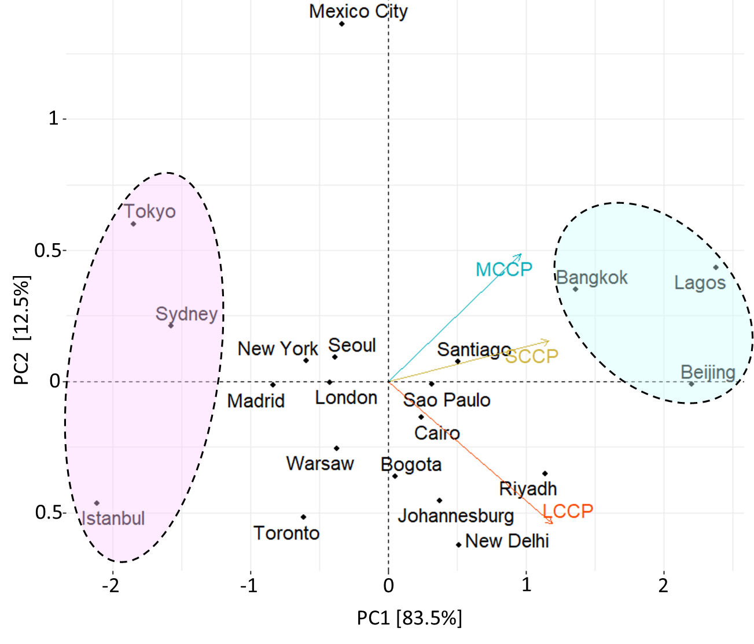
Figure 4. Principal component analysis biplot (score and loading plot) of the sum of measured concentrations in air for SCCPs (ΣC₁₀₋₁₃), MCCPs (ΣC₁₄₋₁₇) and LCCPs (ΣC₁₈₋₂₀) in 2023. Components 1 and 2 account for 96 percent variability in the dataset. The blue and pink ovals show the sites with the highest and lowest total concentrations, respectively, clustering on the opposite ends of the score plot.

Conclusion
This study reports and compares chlorinated paraffins (CP) concentrations in ambient air across 20 global cities, which provides a global baseline for future assessments of temporal and spatial trends. At the time of sampling in 2023, only SCCPs had been listed under the Stockholm Convention, with most countries only recently ratifying the listing and beginning to implement control measures. The data reveal pronounced spatial variability in the distribution of SCCPs, MCCPs, and LCCPs. The data indicate that cities such as Lagos, Beijing, and Bangkok exhibit substantially elevated levels of SCCPs and MCCPs, likely reflecting regional usage patterns, industrial activities, and regulatory differences. In contrast, cities including Tokyo, Sydney, and Istanbul show consistently low CP levels across all chain lengths. Principal component analysis and clustering approaches further demonstrated clear groupings of cities with similar CP profiles, underscoring distinct regional signatures and possibly differing sources or environmental fate and behaviour of these chemicals. The separation of LCCPs from SCCPs and MCCPs in multivariate space also highlights the necessity of chain-length-specific monitoring and reporting, especially when the industry is likely to shift towards LCCPs as a replacement after the recent listing of MCCPs under the Stockholm Convention. Overall, this global snapshot of atmospheric CPs underscores the need for harmonized international monitoring frameworks and targeted mitigation strategies, particularly in regions with high ambient concentrations and limited regulatory oversight. We recommend that, given the complexity of the analysis, GAPS Network samples be analyzed for CPs during every 6-year cycle of the Global Monitoring Plan, for the purposes of Effectiveness Evaluation – in which case the next analysis would be for samples collected in 2029. In the case of MCCPs, global baseline data from this study (2023) will be available for the period prior to listing of MCCPs in 2025. However, similar to SCCPs, the inherent time lag of about 1.5 to 2 years or more for the period between listing of a chemical/class and when most Parties ratify and begin implementing control measures, means that the 2029 data will represent the period immediately following a sharp decrease in production/use of MCCPs.

Acknowledgment
The authors thank the United Nations Environmental Programme (UNEP), the Chemicals Management Plan (CMP), and the Northern Contaminants Program (NCP) for providing financial funding and support. These data have been generated in the frame of the Global Monitoring Plan for POPs under the Stockholm Convention, with support from the Secretariat of the Stockholm Convention and the UN Environment. The implementation of the project as part of the Global Monitoring Plan for POPs has been made possible thanks to the generous contribution to the Stockholm Convention Voluntary Trust Fund by the European Commission through its Global Public Goods and Challenges (GPGC) programme.
We are grateful to our collaborators at the Canadian GAPS sampling sites for assisting with the sampling campaign.
The authors also acknowledge the NOAA Air Resources Laboratory (ARL) for the provision of the HYSPLIT transport and dispersion model, Trajectory Cluster Analysis© and/or READY website (https://www.ready.noaa.gov) used in this publication.

References

1. van Mourik, L. M.; Wang, X.; Paxman, C.; Leonards, P. E. G.; Wania, F.; de Boer, J.; Mueller, J. F., Spatial Variation of Short- and Medium-Chain Chlorinated Paraffins in Ambient Air across Australia. Environ. Pollut. 2020, 261, 114141.
2. Fridén, U. E.; McLachlan, M. S.; Berger, U., Chlorinated Paraffins in Indoor Air and Dust: Concentrations, Congener Patterns, and Human Exposure. Environ. Int. 2011, 37, 1169.
3. van Mourik, L. M.; Gaus, C.; Leonards, P. E. G.; de Boer, J., Chlorinated paraffins in the environment: A review on their production, fate, levels and trends between 2010 and 2015. Chemosphere 2016, 155, 415-428.
4. Nipen, M.; Vogt, R. D.; Bohlin-Nizzetto, P.; Borgå, K.; Mwakalapa, E. B.; Borgen, A. R.; Jørgensen, S. J.; Ntapanta, S. M.; Mmochi, A. J.; Schlabach, M.; Breivik, K., Spatial trends of chlorinated paraffins and dechloranes in air and soil in a tropical urban, suburban, and rural environment. Environmental Pollution 2022, 292, 118298.
5. Zhou, Q.; Xu, C.; Shen, C.; Li, F.; Liu, S.; Aamir, M., Congener profiles, air-soil exchange, and potential risks of short- and medium-chain chlorinated paraffins in demonstration zone of Yangtze River Delta. Atmospheric Pollution Research 2023, 14 (1), 101639.
6. Yuan, B.; McLachlan, M. S.; Roos, A. M.; Simon, M.; Strid, A.; de Wit, C. A., Long-Chain Chlorinated Paraffins Have Reached the Arctic. Environmental Science & Technology Letters 2021, 8 (9), 753-759.
7. Li, T.; Gao, S.; Ben, Y.; Zhang, H.; Kang, Q.; Wan, Y., Screening of Chlorinated Paraffins and Unsaturated Analogues in Commercial Mixtures: Confirmation of Their Occurrences in the Atmosphere. Environmental Science & Technology 2018, 52 (4), 1862-1870.
8. Guida, Y.; Matsukami, H.; Oliveira de Carvalho, G.; Weber, R.; Vetter, W.; Kajiwara, N., Homologue Composition of Technical Chlorinated Paraffins Used in Several Countries over the Last 50 Years─SCCPs Are Still Out There. Environmental Science & Technology 2023, 57 (35), 13136-13147.
9. Fernandes, A. R.; Krätschmer, K.; McGrath, T. J.; Yuan, B.; Brandsma, S.; Brits, M.; Cariou, R.; Letcher, R. J.; Mueller, J.; Muir, D.; Vetter, W.; Wang, T.; Yu, G.; Bergman, Å., Recommended terms and abbreviations for polychlorinated alkanes (PCAs) as the predominant component of chlorinated paraffins (CPs). TrAC Trends in Analytical Chemistry 2023, 169, 117363.
10. UNEP Eighth Meeting of the Conference of the Parties to the Stockholm Convention: Decision SC-8/11. https://chm.pops.int/TheConvention/ConferenceoftheParties/Meetings/COP8/tabid/5309/Default.aspx.
11. Yuan, B.; Rüdel, H.; de Wit, C. A.; Koschorreck, J., Identifying emerging environmental concerns from long-chain chlorinated paraffins towards German ecosystems. Journal of Hazardous Materials 2022, 424, 127607.
12. Gluge, J.; Schinkel, L.; Hungerbuhler, K.; Cariou, R.; Bogdal, C., Environmental Risks of Medium-Chain Chlorinated Paraffins (MCCPs): A Review. Environ Sci Technol 2018, 52 (12), 6743-6760.
13. Balla, D.; Costopoulou, D.; Perkons, I.; Saraga, D.; Zacs, D.; Voutsa, D.; Leondiadis, L.; Maggos, T., Short- and medium-chain polychlorinated alkanes in the air of Athens, Greece. Chemosphere 2025, 373, 144162.
14. UNEP Twelfth meeting of the Conference of the Parties to the Stockholm Convention. https://chm.pops.int/TheConvention/ConferenceoftheParties/Meetings/COP12/tabid/9744/Default.aspx.
15. UNEP Amendments to Annexes to the Stockholm Convention. https://chm.pops.int/Countries/StatusofRatifications/Amendmentstoannexes/tabid/3486/Default.aspx
16. South, L.; Saini, A.; Harner, T.; Niu, S.; Parnis, J. M.; Mastin, J., Medium- and long-chain chlorinated paraffins in air: A review of levels, physicochemical properties, and analytical considerations. Sci Total Environ 2022, 843, 157094.
17. Harner, T.; Saini, A.; Shahpoury, P.; Eng, A.; Schuster, J. K.; Kalisa, E.; Mastin, J., Cross-cutting research and future directions under the GAPS networks††Electronic supplementary information (ESI) available. See DOI: https://doi.org/10.1039/d4va00034j. Environmental Science Advances 2024, 3 (6), 798-807.
18. Saini, A.; Harner, T.; Chinnadhurai, S.; Schuster, J. K.; Yates, A.; Sweetman, A.; Aristizabal-Zuluaga, B. H.; Jimenez, B.; Manzano, C. A.; Gaga, E. O.; Stevenson, G.; Falandysz, J.; Ma, J.; Miglioranza, K. S. B.; Kannan, K.; Tominaga, M.; Jariyasopit, N.; Rojas, N. Y.; Amador-Munoz, O.; Sinha, R.; Alani, R.; Suresh, R.; Nishino, T.; Shoeib, T., GAPS-megacities: A new global platform for investigating persistent organic pollutants and chemicals of emerging concern in urban air. Environmental pollution (Barking, Essex : 1987) 2020, 267, 115416.
19. Mastin, J.; Saini, A.; Schuster, J. K.; Harner, T.; Dabek-Zlotorzynska, E.; Celo, V.; Gaga, E. O., Trace Metals in Global Air: First Results from the GAPS and GAPS Megacities Networks. Environmental Science & Technology 2023, 57 (39), 14661–14673.
20. Niu, S.; Harner, T.; Chen, R.; Parnis, J. M.; Saini, A.; Hageman, K., Guidance on the Application of Polyurethane Foam Disk Passive Air Samplers for Measuring Nonane and Short-Chain Chlorinated Paraffins in Air: Results from a Screening Study in Urban Air. Environmental Science & Technology 2021, 55 (17), 11693–11702.
21. Li, Q.; Li, J.; Wang, Y.; Xu, Y.; Pan, X.; Zhang, G.; Luo, C.; Kobara, Y.; Nam, J.-J.; Jones, K. C., Atmospheric Short-Chain Chlorinated Paraffins in China, Japan, and South Korea. Environmental Science & Technology 2012, 46 (21), 11948-11954.
22. Niu, S.; Chen, R.; Zou, Y.; Dong, L.; Hai, R.; Huang, Y., Spatial distribution and profile of atmospheric short-chain chlorinated paraffins in the Yangtze River Delta. Environmental pollution (Barking, Essex : 1987) 2020, 259, 113958.
23. He, C.; Thai, P. K.; Bertrand, L.; Jayarathne, A.; van Mourik, L.; Phuc, D. H.; Banks, A.; Mueller, J. F.; Wang, X. F., Calibration and Application of PUF Disk Passive Air Samplers To Assess Chlorinated Paraffins in Ambient Air in Australia, China, and Vietnam. Environmental Science & Technology 2023, 57 (50), 21061–21070.
24. Chaemfa, C.; Xu, Y.; Li, J.; Chakraborty, P.; Hussain Syed, J.; Naseem Malik, R.; Wang, Y.; Tian, C.; Zhang, G.; Jones, K. C., Screening of Atmospheric Short- and Medium-Chain Chlorinated Paraffins in India and Pakistan using Polyurethane Foam Based Passive Air Sampler. Environmental Science & Technology 2014, 48 (9), 4799-4808.
25. Gillett, R. W.; Galbally, I. E.; Keywood, M. D.; Powell, J. C.; Stevenson, G.; Yates, A.; Borgen, A. R., Atmospheric short-chain-chlorinated paraffins in Melbourne, Australia – first extensive Southern Hemisphere observations. Environmental Chemistry 2017, 14 (2), 106-114.
26. Diefenbacher, P. S.; Bogdal, C.; Gerecke, A. C.; Glüge, J.; Schmid, P.; Scheringer, M.; Hungerbühler, K., Short-Chain Chlorinated Paraffins in Zurich, Switzerland—Atmospheric Concentrations and Emissions. Environmental Science & Technology 2015, 49 (16), 9778-9786.
27. Arko, W. E.; Zhao, S.; Ma, J.; Tian, L.; Asante, K. A.; Amoah, D. K.; Qi, S.; Zhang, G., Impact of anthropogenic activities on atmospheric chlorinated paraffins in Ghana using polyurethane foam disk - passive air sampler. Science of The Total Environment 2024, 954, 176252.
28. Li, H.; Bu, D.; Fu, J.; Gao, Y.; Cong, Z.; Zhang, G.; Wang, Y.; Chen, X.; Zhang, A.; Jiang, G., Trophic Dilution of Short-Chain Chlorinated Paraffins in a Plant–Plateau Pika–Eagle Food Chain from the Tibetan Plateau. Environ. Sci. Technol. 2019, 53, 9472.
29. Pan, X.; Zhen, X.; Tian, C.; Tang, J., Distributions, transports and fates of short- and medium-chain chlorinated paraffins in a typical river-estuary system. Science of The Total Environment 2021, 751, 141769.
30. Niu, S.; Chen, R.; Hageman, K. J.; Zou, Y.; Dong, L.; Zheng, R.; Wang, X.; Hai, R., Disentangling the Contributions of Urban and Production Sources in Short- and Medium-Chain Chlorinated Paraffin Concentrations in a Complex Source Region. J. Hazard. Mater. 2021, 405, 124117.
31. Niu, S.; Chen, X.; Chen, R.; Zou, Y.; Zhang, Z.; Li, L.; Hageman, K. J.; Ng, C.; Dong, L., Understanding inter-individual variability in short-chain chlorinated paraffin concentrations in human blood. Journal of Hazardous Materials 2023, 443, 130235.
32. Xia, D.; Gao, L.; Zheng, M.; Li, J.; Zhang, L.; Wu, Y.; Tian, Q.; Huang, H.; Qiao, L., Human Exposure to Short- and Medium-Chain Chlorinated Paraffins via Mothers’ Milk in Chinese Urban Population. Environmental Science & Technology 2017, 51 (1), 608-615.
33. Li, T.; Wan, Y.; Gao, S.; Wang, B.; Hu, J., High-Throughput Determination and Characterization of Short-, Medium-, and Long-Chain Chlorinated Paraffins in Human Blood. Environmental Science & Technology 2017, 51 (6), 3346-3354.
34. Schuster, J. K.; Harner, T.; Eng, A.; Rauert, C.; Su, K.; Hornbuckle, K. C.; Johnson, C. W., Tracking POPs in Global Air from the First 10 Years of the GAPS Network (2005 to 2014). Environmental Science & Technology 2021, 55 (14), 9479–9488.
35. Rauert, C.; Schuster, J. K.; Eng, A.; Harner, T., Global Atmospheric Concentrations of Brominated and Chlorinated Flame Retardants and Organophosphate Esters. Environ Sci Technol 2018, 52 (5), 2777-2789.
36. Kutarna, S.; Du, X.; Diamond, M. L.; Blum, A.; Peng, H., Widespread presence of chlorinated paraffins in consumer products. Environmental Science: Processes & Impacts 2023, 25 (5), 893-900.
37. Smith, C. A.; Want, E. J.; O'Maille, G.; Abagyan, R.; Siuzdak, G., XCMS: Processing Mass Spectrometry Data for Metabolite Profiling Using Nonlinear Peak Alignment, Matching, and Identification. Analytical Chemistry 2006, 78 (3), 779-787.
38. Reth, M.; Zencak, Z.; Oehme, M., New quantification procedure for the analysis of chlorinated paraffins using electron capture negative ionization mass spectrometry. Journal of Chromatography A 2005, 1081 (2), 225-231.
39. Saini, A.; Chinnadurai, S.; Schuster, J. K.; Eng, A.; Harner, T., Per- and polyfluoroalkyl substances and volatile methyl siloxanes in global air: Spatial and temporal trends. Environmental Pollution 2023, 323, 121291.
40. Harner, T. 2024 v5 Template for calculating PUF and SIP disk sample air volumes Dec9. . https://www.researchgate.net/publication/387335058_2024_v5_Template_for_calculating_PUF_and_SIP_disk_sample_air_volumes_Dec9 (accessed December 12, 2024).
41. Herkert, N. J.; Spak, S. N.; Smith, A.; Schuster, J. K.; Harner, T.; Martinez, A.; Hornbuckle, K. C., Calibration and evaluation of PUF-PAS sampling rates across the Global Atmospheric Passive Sampling (GAPS) network. Environ Sci Process Impacts 2018, 20 (1), 210-219.
42. Majolagbe, A. O.; Adeyi, A. A.; Osibanjo, O., Vulnerability assessment of groundwater pollution in the vicinity of an active dumpsite (Olusosun), Lagos, Nigeria. Chem. Int 2016, 2 (4), 232-241.
43. Chen, C.; Chen, A.; Li, L.; Peng, W.; Weber, R.; Liu, J., Distribution and Emission Estimation of Short- and Medium-Chain Chlorinated Paraffins in Chinese Products through Detection-Based Mass Balancing. Environmental Science & Technology 2021, 55 (11), 7335-7343.
44. Chen, C.; Chen, A.; Zhan, F.; Wania, F.; Zhang, S.; Li, L.; Liu, J., Global Historical Production, Use, In-Use Stocks, and Emissions of Short-, Medium-, and Long-Chain Chlorinated Paraffins. Environmental Science & Technology 2022.
45. MEE-China Ministry of Ecology and Environment of the People’s Republic of China. Announcement on Environmental Risk Management Requirements for Five Types of Persistent Organic Pollutants, Including Polychlorinated Naphthalenes. . https://www.mee.gov.cn/xxgk2018/xxgk/xxgk01/202306/t20230606_1032939.html (accessed June 9th, 2025).
46. Guida, Y.; Capella, R.; Weber, R., Chlorinated paraffins in the technosphere: A review of available information and data gaps demonstrating the need to support the Stockholm Convention implementation. Emerging Contaminants 2020, 6, 143-154.
47. Bailey, R.; Barrie, L. A.; Halsall, C. J.; Fellin, P.; Muir, D. C. G., Atmospheric organochlorine pesticides in the western Canadian Arctic: Evidence of transpacific transport. Journal of Geophysical Research: Atmospheres 2000, 105 (D9), 11805-11811.
48. Yu, Y.; Hung, H.; Alexandrou, N.; Roach, P.; Nordin, K., Multiyear Measurements of Flame Retardants and Organochlorine Pesticides in Air in Canada’s Western Sub-Arctic. Environmental Science & Technology 2015, 49 (14), 8623-8630.
49. Stein, A. F.; Draxler, R. R.; Rolph, G. D.; Stunder, B. J. B.; Cohen, M. D.; Ngan, F., NOAA’s HYSPLIT Atmospheric Transport and Dispersion Modeling System. Bulletin of the American Meteorological Society 2015, 96 (12), 2059-2077.
50. Nevondo, V.; Okonkwo, O. J., Status of short-chain chlorinated paraffins in matrices and research gap priorities in Africa: a review. Environmental Science and Pollution Research 2021, 28 (38), 52844-52861.
51. Zhuo, M.; Ma, S.; Li, G.; Yu, Y.; An, T., Chlorinated paraffins in the indoor and outdoor atmospheric particles from the Pearl River Delta: Characteristics, sources, and human exposure risks. Sci Total Environ 2019, 650 (Pt 1), 1041-1049.
52. Ai, Q.; Zhang, P.; Gao, L.; Zhou, X.; Liu, Y.; Huang, D.; Qiao, L.; Weng, J.; Zheng, M., Air–soil exchange of and risks posed by short- and medium-chain chlorinated paraffins: Case study in a contaminated area in China. Chemosphere 2022, 297, 134230.
53. Huang, J.; Zhao, L.; Shi, Y.; Zeng, X.; Sun, W.; Zhao, X.; Liu, R.; Wu, Q.; Dong, G.; Chen, D.; Liu, X., Characterization of short-, medium- and long-chain chlorinated paraffins in ambient PM2.5 from the Pearl River Delta, China. Environment International 2023, 175, 107932.
54. Liang, N.; Cao, R.; Jiang, N.; Shi, C.; Guo, Z.; Gao, Y.; Zhang, R.; Zhang, H.; Chen, J.; Geng, N., Occurrence and fate of atmospheric short/medium chain chlorinated paraffins: Size distribution and inhalation exposure. Science of The Total Environment 2024, 954, 176507.
55. Zhang, Z.; Geng, N.; Ning, C.; Zhu, X.; Zhang, H.; Chen, J.; Cao, R., Physicochemical properties dominating the behaviors of short/medium chain chlorinated paraffins in the atmosphere. Journal of Hazardous Materials 2024, 477, 135335.
56. Zhou, T.; Yang, Q.; Weng, J.; Gao, L.; Liu, Y.; Xu, M.; Zhao, B.; Zheng, M., Characterization and health risks of short- and medium-chain chlorinated paraffins in the gas and size-fractionated particulate phases in ambient air. Chemosphere 2024, 358, 142225.
57. Yu, S.; Gao, Y.; Zhu, X.; Yu, H.; Zhang, Y.; Chen, J., Gas/particle partitioning of short and medium chain chlorinated paraffins from a CP production plant using passive air sampler and occupational exposure assessment. Science of The Total Environment 2023, 858, 159875.
58. Dong, S.; Qi, S.; Zhao, Y.; Zhang, S.; Wu, X.; Cao, J.; Zou, Y.; Wang, Y.; Xia, S.; Wang, P.; Wu, L., Bee colonies map the short- and medium-chain chlorinated paraffin contamination from the apiary environment. Science of The Total Environment 2024, 926, 171846.
59. Borgen, A. R.; M. Schlabach, M.; Gundersen, H., Polychlorinated alkanes in arctic air. Organohalogen Compounds 2000, 47, 272-274.
60. Borgen, A. R.; Schlabach, M.; Kallenborn, R.; Christensen, G.; Skotvold, T., Polychlorinated alkanes in ambient air from Bear Island. Organohalogen Compounds 2002, 59, 303-306.
61. Bohlin-Nizzetto, P.; Borgen, A. R.; Nipen, M. Chlorinated paraffins in urban air in Nordic Countries. https://pub.norden.org/temanord2023-515/index.html.
62. Al Saify, I.; Cioni, L.; van Mourik, L. M.; Brandsma, S. H.; Warner, N. A., Optimization of a low flow sampler for improved assessment of gas and particle bound exposure to chlorinated paraffins. Chemosphere 2021, 275, 130066.
63. Jiang, L.; Gao, W.; Ma, X.; Wang, Y.; Wang, C.; Li, Y.; Yang, R.; Fu, J.; Shi, J.; Zhang, Q.; Wang, Y.; Jiang, G., Long-Term Investigation of the Temporal Trends and Gas/Particle Partitioning of Short- and Medium-Chain Chlorinated Paraffins in Ambient Air of King George Island, Antarctica. Environ. Sci. Technol. 2021, 55, 230.
64. Tomy, G. T. The Mass Spectrometric Characterization of Polychlorinated n-Alkanes and the Methodology for their Analysis in the Environment. University of Manitoba, Canada, 1997.
65. Muir, D.; Bennie, D.; Teixeira, C.; Fisk, A.; Tomy, G.; Stern, G.; Whittle, M., Short Chain Chlorinated Paraffins: Are They Persistent and Bioaccumulative? In Persistent, Bioaccumulative, and Toxic Chemicals II, American Chemical Society: 2000; Vol. 773, pp 184-202.

