The Impact of Video-based Intervention for Improving Attitudes towards Autism in Chinese Higher Education: A Pre-Post Study

Abstract

This study assessed whether a brief video-based intervention could improve attitudes toward autism among Chinese university students and staff. A total of 1,158 participants—including undergraduates, graduate students, and staff—completed the 17-item Autism and Neurodiversity Attitudes Scale (ANAS) before and after watching a 6-minute autism-awareness video. Paired-sample t-tests assessed pre-post differences. Exploratory factor analysis (EFA) examined whether the intervention altered the underlying attitudinal structure. To predict individual responsiveness, four machine learning models were trained using pre-intervention responses and demographics; TabPFN achieved the highest accuracy (73.4%). The study revealed significant positive changes in attitudes towards autism following the educational video intervention (t = -13.30, p < 0.001, Cohen's d = 0.86). We identified three stable dimensions of autism perception: support for normalization, acceptance as natural variation, and empathy. SHapley Additive exPlanations analysis identified that pre-intervention responses to deficit-based items and pity-based attitudes are the strongest predictors of attitudinal change, while demographic variables had negligible influence. Higher baseline endorsement of normalization and pathologizing attitudes were associated with reduced responsiveness to the intervention, highlighting the role of entrenched beliefs in moderating intervention effectiveness. While a brief video intervention can enhance attitudes toward autism, its ability to transform deep-seated beliefs remains limited.

Keywords: Autism in adulthood; Higher education; Neurodiversity; Attitude change; Video-based intervention; Machine Learning

Introduction
Autism encompasses a range of neurodevelopmental variations characterized by challenges in social communication and restricted or repetitive behaviours (Diagnostic and Statistical Manual of Mental Disorders, 2013). Recent data indicates that 1 in 36 children in the United States are diagnosed with autism as of 2020 (Maenner, 2023), reflecting a significant increase from the 1-in-150 prevalence reported in 2000 (Fombonne, 2009). This 312% rise is attributed not solely to an epidemiological surge but also to improved diagnostic practices (Hayes et al., 2018), heightened societal awareness (Turnock et al., 2022), and greater acceptance of autism characteristics (Nevill & White, 2011). These factors have encouraged individuals with subthreshold autistic traits to seek formal evaluations. However, this progress is not universal. In many cultural contexts, including China, societal awareness and acceptance of autism remain limited (Li et al., 2024), creating significant barriers for autistic individuals.

In Chinese higher education, these challenges are particularly pronounced due to entrenched cultural stigmas surrounding neurodevelopmental conditions and underdeveloped institutional support systems for autistic students (Zhang & Spencer, 2015). For example, traditional collectivist values that emphasize social conformity and place strong emphasis on adhering to social norms and thus make presenting neurodivergence a risk. Autistic individuals, who may exhibit behaviors such as repetitive movements, difficulty with eye contact, or atypical communication styles are often perceived as disruptive to group harmony and social face (*mianzi*), further marginalizing autistic individuals (Wang et al., 2023). Evidence suggests that these stigmatising cultural norms can in fact exacerbate atypical behaviours and difficulties (Kim & Markus, 1999). Finally, in academic environments, cultural pressures intersect with the social motivation theory of autism, wherein autistic students’ intrinsic patterns of social engagement may be misinterpreted as disinterest or disengagement, compounding their exclusion (Chevallier et al., 2012).

Globally, efforts to promote autism awareness have historically focused disproportionately on modifying autistic behaviours to align with neurotypical norms and standards (Pruneti et al., 2024; Restoy et al., 2024). This approach has inadvertently reinforced systemic barriers, including bullying (Junttila et al., 2024), social marginalization, and inadequate prioritization of autistic needs across age groups (Davies, Islaam, et al., 2024). Families often lack the resources or capacity to effectively advocate for their autistic young people, leaving many without meaningful support or representation (Godfrey et al., 2024). These systemic barriers are particularly evident in higher education, where autistic students face unique stressors during the transition to post-secondary environments (Farmer, 2024). For example, daily challenges such as navigating complex interpersonal interactions often intersect with academic demands thus requiring advanced social understanding and executive functioning skills (Kofler et al., 2024)—domains where many autistic learners experience difficulties. While some institutions provide accommodations like counselling services (Noble et al., 2024), structured teaching methods (Nowell & Hume, 2023) including extended or alternative deadlines (Chen & Yakubova, 2024), and social skills workshops (Estival et al., 2024), these supports are inconsistently available across regions (Ames et al, 2022). Moreover, they often lack applicability beyond structured settings where once students leave the classroom environment, coping strategies taught in training sessions may lose efficacy, leaving them ill-equipped to manage unstructured academic or social situations (Carruthers et al, 2020).

A more sustainable solution may lie in addressing the root causes of systemic barriers: societal perceptions of neurodiversity. Improving public awareness and acceptance of autism can foster inclusive environments that benefit both autistic individuals and society at large (Hariharan et al., 2024). Awareness campaigns could educate neurotypical peers and faculty about cognitive differences associated with autism, encouraging teaching practices that incorporate diverse representation formats (e.g., combining visual aids with verbal explanations). At an institutional level, increased acceptance might incentivize universities to integrate metacognitive strategy training into standard curricula, equipping autistic students with tools to navigate both academic abstraction and social complexities more effectively (Ma et al., 2024).

On a societal scale, reducing stigma could normalize neurodivergent interaction patterns in academic and residential spaces alike, decreasing reliance on high-cost personalized interventions (Hensel et al., 2024). As environmental demand diminishes for autistic individuals, their demonstrated competencies may challenge stereotypes and accelerate cycles of acceptance. Ultimately, fostering a cultural shift toward more inclusive higher education creates self-reinforcing benefits that enhance both individual outcomes for autistic students and broader societal understanding of neurodiversity. Someki et al. (2018) found that college students in both Japan and the United States held stigmatizing attitudes towards autism, with misconceptions about autistic individuals being socially isolated or lacking empathy. However, after participating in an online training program that provided accurate information about autism and emphasized the strengths and challenges of autistic individuals, students in both countries showed significant improvements in their attitudes. While the content covered in the 71 powerpoint slides was comprehensive , the lack of interactive elements (e.g., real-life scenarios or visual materials) may have limited participants' ability to actively engage with the material and apply it to real-world situations.

While the discussion above situates attitudes at a societal and institutional scale, our study adopts a psychological lens to make change measurable. We distinguish explicit attitudes—deliberate, reportable evaluations—from implicit attitudes—automatic associations inferred from speeded tasks (Dickter et al., 2020). We focus on explicit attitudes because they are closest to the behaviors and decisions that govern campus life (e.g., accommodation support, inclusive teaching, peer norms, Levine & Strube, 2012), are more responsive to brief, information-dense interventions, and can be assessed reliably at scale in heterogeneous university populations (Wüthrich et al., 2024). Accordingly, we measure change with the 17-item Autism and Neurodiversity Attitudes Scale (ANAS, VanDaalen et al., 2025), which indexes endorsement of autism as natural variation, resistance to pathologizing/‘normalization,’ and empathy for autistic experiences. We analyze pre–post change in the total score and explore the scale’s dimensional structure to determine whether the intervention shifts both level and configuration of beliefs.

To address the systemic challenges faced by autistic individuals in Chinese higher education, and considering the psychological scope, this study employs a short video-based intervention designed to improve autism awareness and neurodiversity acceptance among undergraduates, graduate students, and university staff. Video-based interventions (VBIs) are particularly well-suited for this purpose due to their accessibility, cost-effectiveness, and evidence-based efficacy in enhancing knowledge, attitudes, and skills (Xiao et al., 2024). VBIs leverage the visual learning strengths of many individuals, including autistic people, by breaking down complex concepts into digestible components through repeated exposure to clear, standardized models of behaviour or information (McConnell et al., 2024). This approach not only facilitates learning but also enables generalization across diverse contexts.

The decision to use a video format stems from its unique advantages over traditional in-person or textual interventions. Videos allow for consistent delivery of content, ensuring that all participants receive the same information without variability introduced by live presenters (Saeed et al., 2024). Moreover, videos are highly engaging and can be tailored to meet the needs of diverse audiences. For instance, they can incorporate culturally relevant scenarios and visual storytelling techniques to resonate with viewers in specific sociocultural contexts like China. Additionally, VBIs have been shown to reduce cognitive load by focusing attention on relevant stimuli while minimizing distractions, making them particularly effective for promoting understanding of abstract or stigmatized topics such as autism (Šola et al., 2024).

Research supports the use of VBIs for fostering positive social behaviours and attitudes toward individuals with autism (Le Cunff et al., 2024). Studies have demonstrated that VBIs can increase awareness and reduce biases by presenting relatable narratives or modelling inclusive behaviours in a non-threatening manner (Lopez Naranjo et al., 2024). For example, video modelling has been successfully used to teach social skills and enhance empathy among neurotypical peers. In educational settings, VBIs have also been employed to train staff and students on how to interact effectively with autistic individuals, improving both interpersonal dynamics and institutional inclusivity (McConnell et al., 2024).

Method

Procedure

The study employed a pre-post quasi-experimental design to evaluate the impact of an autism awareness video intervention on neurodiversity acceptance. Recruitment occurred between October and December 2024 via a multi-channel strategy: (1) collaboration with instructors at 15 Chinese universities and research institutes, (2) social media outreach on WeChat, Bilibili and Red Note, and (3) campus bulletin postings. Eligible participants (aged ≥18 years) accessed the study through the Wenjuanxing survey distribution platform and Bilibili media platform, where they completed four steps:

1. Informed Consent: Digitally reviewed ethical protocols approved by [Anonymised] University Research Ethics Committee (reference ID: EdRes-2024-4559-EdAp-2).
2. Pre-Intervention Assessment: Completed the 17-item Autism Neurodiversity Attitudes Scale (ANAS) (VanDaalen et al., 2025).
3. Video Intervention: Viewed a 6-minute educational module (minimum 6-minute viewing time enforced) covering autism characteristics, neurodiversity principles, and academic inclusion strategies.
4. Post-Intervention Assessment: Repeated ANAS administration.

Specifically, Steps 1 (Informed Consent) and 2 (Pre-Intervention ANAS) were completed sequentially in a single session. Steps 3 (Video Intervention) and 4 (Post-Intervention ANAS) were administered separately, with participants completing the post-assessment after viewing the video. The mean time interval between pre-assessment and intervention was 3 days (SD = 1.2 days), while the interval between intervention and post-assessment averaged 4 days (SD = 1.4 days). Data anonymization included IP masking and SSL encryption, with responses stored on password-protected university servers.

Participants

The final cohort comprised 1,158 adults (63% female, 37% male; M_{age} = 21.0 years, SD = 1.4) recruited from 15 institutions across 10 Chinese provinces, ensuring geographic diversity. Participants represented three groups across science and social science disciplines: undergraduates (58%, n = 672) from 12 universities, graduate students (32%, n = 371) across nine universities, university staff (7%, n = 81) from three universities. Exclusion criteria included age <18 years (automatically filtered by platform) and incomplete pre/post surveys.

Materials

Autism and Neurodiversity Attitudes Scale (ANAS)
Our study employs the ANAS (VanDaalen et al., 2025)—a rigorously validated instrument consisting of 17 Likert-scale items—to measure key dimensions of autism awareness and neurodiversity acceptance. This scale assesses participants’ knowledge of autism symptoms (for instance, variations in social communication), evaluates attitudes toward neurodiversity (including acceptance of diverse sensory needs), and gauges the willingness to support autistic peers within academic settings. VanDaalen et al. (2025) demonstrated the instrument’s strong internal consistency (Cronbach’s α = 0.83), underscoring its reliability for both research and applied settings.

Video Intervention
The video intervention is a central component of our study and was designed with input from autistic self-advocates from China, Malaysia, the Netherlands, and New Zealand to ensure authenticity and relevance. In total, it was 6.21 minutes in length and was hosted on the bilibili platform (see supplemental materials for link). The video made use of stock visuals to represent the target audience and presented using a neutral voice-over. For accessibility, all spoken information was provided in both Chinese and English subtitles. The video’s content was organized into three distinct modules. The first module introduces viewers to core autism traits, including challenges in social reciprocity and differences in sensory processing and was derived from current research evidence and the DSM-5 and ICD-11. The second module employs simulated learning scenarios that illustrate practical examples—like strategies to support peers experiencing sensory overload—thus contextualizing the challenges within everyday academic environments. The third module features personal testimonials from autistic university students, providing first-hand narratives derived from contributions by the advisory group of autistic students. These accounts illuminate the real-world impact of these challenges and the strengths inherent within the neurodiversity paradigm.
Figure 1. Sample Screenshots from the Autism Awareness Video Intervention.

Platform and Security

To administer the survey and intervention, we utilized Wenjuanxing’s secure online platform. This platform is configured to enforce a sequential progression through the study—from obtaining informed consent, to the pre-test and post-test assessments—ensuring that participants receive the content in the intended order. Moreover, the platform complies with Chinese data protection laws that are equivalent to the GDPR, utilizing SSL encryption and anonymized identifiers to safeguard participant confidentiality and ensure robust data security throughout the study.

Data Analysis
To assess the effectiveness of the video intervention, a comprehensive statistical approach was employed. Primary analyses involved paired-sample t-tests comparing pre- and post-intervention scores on each of the 17 items of ANAS. This tested whether the intervention produced significant shifts in attitudes toward autism. Effect sizes were calculated using Cohen’s d, with thresholds of 0.2, 0.5, and 0.8 denoting small, medium, and large effects, respectively, to contextualize the practical significance of observed changes (Cohen, 2013). Directionality was examined to determine whether shifts reflected increased acceptance and understanding of autism.
To investigate whether the intervention influenced deeper conceptual structures underlying participants' attitudes, Exploratory Factor Analysis (EFA) was conducted separately on pre- and post-intervention datasets. Using principal axis factoring with promax rotation (Costello & Osborne, 2005), factors with eigenvalues >1 were retained to capture latent attitudinal dimensions. Comparisons of factor loadings and total variance explained assessed whether the intervention restructured attitudinal frameworks or merely shifted surface-level responses, providing insights into conceptual coherence and stability post-intervention.
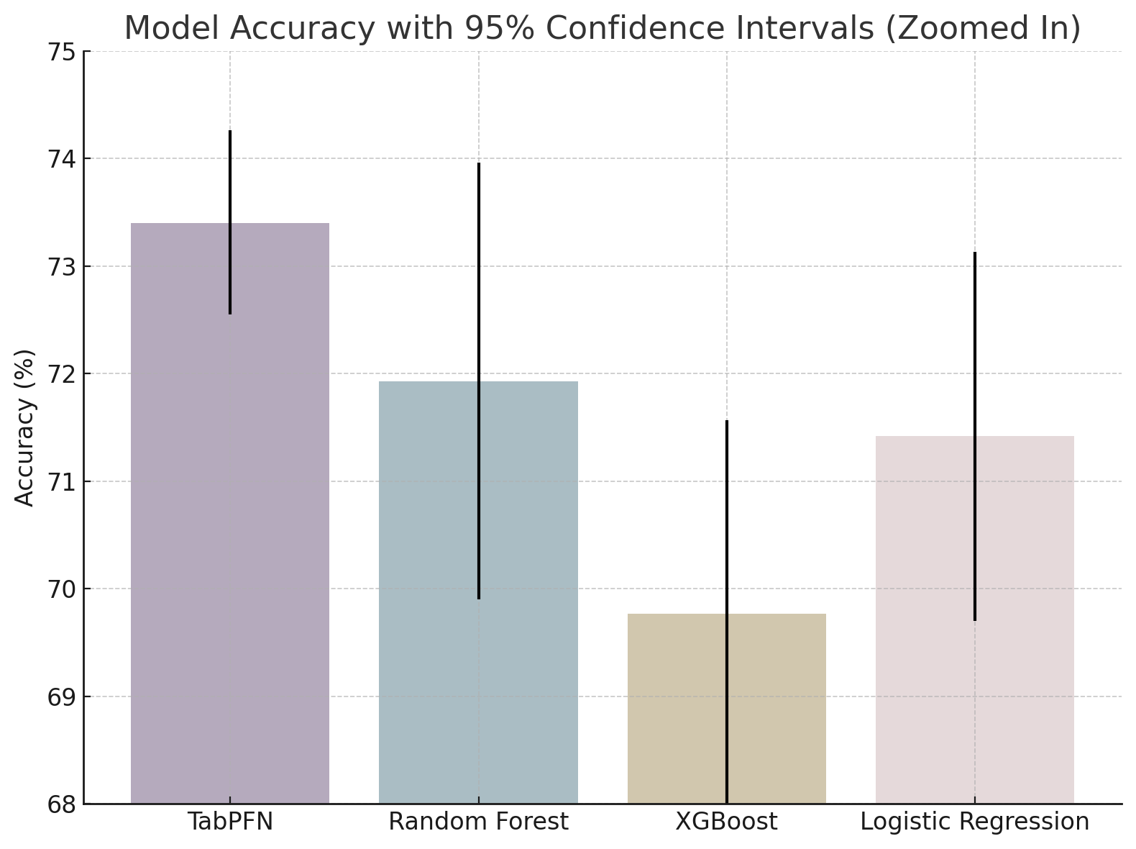
Figure 2 Comparison of Machine Learning Model Accuracy with 95% Confidence Intervals. Classification accuracy of four machine learning algorithms—TabPFN, Random Forest, XGBoost, and Logistic Regression—in predicting positive attitudinal change following the video intervention. Accuracy values are displayed as percentages with 95% confidence intervals based on stratified k-fold cross-validation. TabPFN achieved the highest accuracy (73.4%) with narrower confidence bounds compared to other models, indicating superior predictive performance and stability. Random Forest and Logistic Regression showed moderate accuracy, while XGBoost performed the lowest among the tested models. These results support the selection of TabPFN for final analysis due to its robust and consistent classification capability.
Beyond group-level changes, individual variability in response to the intervention was analyzed through predictive modeling. A binary classification task was defined to distinguish participants exhibiting positive attitudinal change (i.e., a net increase in ANAS scores) from those showing no change or negative shifts. Four machine learning algorithms—TabPFN (Tabular Prior-data Fitted Networks, Hollmann et al., 2025), Random Forest (Breiman, 2001), Logistic Regression, and XGBoost (Chen & Guestrin, 2016)—were trained and evaluated using stratified k-fold cross-validation to ensure robustness across diverse subsets (Kohavi, 1995). Model performance was assessed primarily via classification accuracy, as shown in Figure 2, supplemented by confidence intervals to gauge consistency. TabPFN outperformed other models, achieving an accuracy of 73.4%, and was selected for final analysis due to its superior predictive stability.
To enhance interpretability, SHAP (SHapley Additive exPlanations) values were computed for the TabPFN model, allowing for granular analysis of feature importance (Lundberg & Lee, 2017). This approach quantified the contribution of each pre-intervention ANAS item and demongraphic features to the likelihood of positive attitudinal change, identifying key predictors and clarifying whether specific baseline beliefs and demographic features facilitated or hindered responsiveness to the intervention. The SHAP analysis highlighted that items addressing core misconceptions about autism—particularly those reflecting deficit-based views—were the most influential in predicting shifts toward greater acceptance.
To benchmark this setup and clarify how it aligns with common practice, we used KernelSHAP with a background/reference set of 100 k-means prototypes drawn from the training data and coalition sampling constrained to nsamples = 100 × p (p = number of features) with a maximum coalition size of 10; stability was assessed across five random seeds, yielding high rank agreement (mean Spearman ρ ≈ 0.84 ± 0.02), consistent top-10 overlap (Jaccard ≈ 0.72 ± 0.02), strong sign agreement for local attributions (≈96% of test instances), a small additivity deviation (|f(x) − 𝔼[f(x)] − Σφⱼ(x)| ≈ 0.011), and median runtime ≈ 14 s per 100 test instances (see Supplementary Figure S1). This configuration parallels established KernelSHAP use in unsupervised anomaly explanation—e.g., attributing autoencoder reconstruction error in Antwarg et al. (2021)—but differs in that we explain a supervised TabPFN output with background and sampling tuned for tabular prediction. Relative to LIME, SHAP is slower yet axiomatically consistent, and in our setting showed stronger rank stability and finer feature-level granularity (Rundel et al., 2024).
Descriptive statistics, including means, standard deviations, and 95% confidence intervals, were reported for all key outcomes to provide precise estimates of effect magnitudes (Altman & Bland, 1995). Finally, residual analyses identified areas where medical-model biases or neutral attitudes persisted, informing recommendations for future intervention refinement.

Result

General Intervention Effect

The video intervention yielded statistically significant improvements in participants’ attitudes toward autism, shown in Table 1. A paired-sample t-test revealed a mean increase of 2.03 points in overall ANAS scores (95% CI [1.73, 2.33]), indicating a robust shift toward more accepting views (t(1157) = -13.30, p < .001, Cohen’s d = 0.39), representing a small-to-medium effect size. This overall shift suggests that, on average, participants moved from mild endorsement of deficit-based views toward greater neutrality or from neutrality toward affirming neurodiversity perspectives.

Table 1 Item-Level Attitudinal Shifts Pre- and Post-Intervention.
Paired-sample t-test results for each ANAS item, showing t-values, significance levels, Cohen’s d, and direction of change. Significant shifts were observed for 14 items, mainly reflecting reduced stigma and increased neurodiversity acceptance. Some items showed no significant change, indicating areas of resistance.
Note: † p < .10, p < .05*, p < .01**, p < .001***.
Item Statement | t | p | Cohen's d | Direction
1. We should help people with autism change to fit into society better | -11.37*** | <0.001 | 0.33 | Disagreement
2. People with autism should try really hard to be ‘‘normal’’ | -7.09*** | <0.001 | 0.21 | Disagreement
3. It is important that autistic people learn to act the same way that most people do | -0.72 | 0.471 | 0.02 | Neutral
4. People with autism need to be cured | -14.05*** | <0.001 | 0.41 | Disagreement
5. I feel sorry for families of autistic people | -17.45*** | <0.001 | 0.51 | Disagreement
6. I would not trust an autistic person to give me reliable information about autism | -0.99 | 0.323 | 0.03 | Neutral
7. Being diagnosed with autism is a tragedy | -5.57*** | <0.001 | 0.16 | Disagreement
8. Most of the problems experienced by autistic individuals are caused by autism itself | -2.90** | 0.004 | 0.09 | Disagreement
9. It is good for our world to have autistic people in it | -7.26*** | <0.001 | 0.21 | Disagreement
10. I understand why someone would be proud to be autistic | -6.44*** | <0.001 | 0.19 | Disagreement
11. People with autism are most often born with it | -5.29*** | <0.001 | 0.16 | Disagreement
12. Autism is hard-wired into the way someone’s brain works | 0.07 | 0.943 | -0.002 | Neutral
13. If someone has autism, it cannot be cured | -6.84*** | <0.001 | 0.20 | Disagreement
14. Autism is a form of natural human variation, not a disorder or deficit | 4.23*** | <0.001 | -0.12 | Agreement
15. Autism is a difference, not an illness or disease | 2.79** | 0.005 | -0.08 | Agreement
16. There is nothing wrong with being autistic | 1.69† | 0.092 | -0.05 | Neutral
17. Autism is more than just a difference; it is a disorder | 2.48* | 0.013 | -0.07 | Agreement

Out of the 17 ANAS items, 14 showed statistically significant improvement, primarily reflecting reductions in stigma and pathologizing beliefs. The largest changes were observed in statements framing autism as a "tragedy" (Item 5, d = 0.51), a condition requiring "cure" (Item 4, d = 0.41), and the need for autistic individuals to "fit into society" (Item 1, d = 0.33). Conversely, items affirming autism as a natural variation (Item 14, d = -0.12) and a difference rather than a disease (Item 15, d = -0.08) demonstrated smaller but significant positive shifts toward neurodiversity acceptance.
However, four items—those addressing social conformity (Item 3), trust in autistic voices (Item 6), the “hard-wired brain” view (Item 12), and moral neutrality (Item 16)—remained statistically unchanged, indicating areas where attitudes were resistant to short-term intervention. Additionally, while biomedical understanding (e.g., "born with autism") improved modestly, 17% of participants continued to endorse autism as a disorder (Item 17), highlighting incomplete conceptual shifts.

Structural Examination of Autism Awarenss and Acceptance

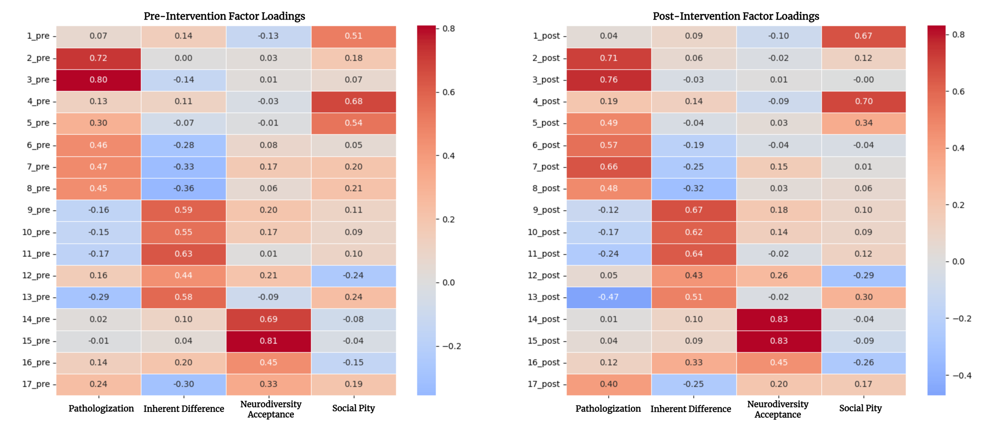
Figure 3. Pre- and Post-Intervention Factor Loadings from Exploratory Factor Analysis (EFA).

The EFA revealed a combination of structural stability and targeted conceptual shifts following the intervention. Pre-intervention responses grouped into four factors—Pathologization, Inherent Difference, Neurodiversity Acceptance and Social Pity—accounting for 42.5% of total variance. Post-intervention, the same four-factor structure was largely retained (84.9% similarity), but with an increase in total explained variance to 47.8%, indicating enhanced conceptual clarity in participants' attitudes. The detailed loadings for each item are presented in Figure 3.

Notable changes were observed within specific factors. The Neurodiversity Acceptance factor strengthened considerably, with key items such as "Autism is a form of natural human variation" (Item 14) and "Autism is a difference, not a disease" (Item 15) showing increased loadings from 0.69 to 0.83 and 0.81 to 0.83, respectively. This suggests that the intervention effectively reinforced neurodiversity-affirming beliefs, leading to a more coherent understanding of autism as a natural variation rather than a deficit.

Conversely, items associated with pathologizing views also became more tightly clustered. For example, "Being diagnosed with autism is a tragedy" (Item 7) increased its loading from 0.47 to 0.66 within the Pathologization factor. This indicates that while explicit stigma was reduced overall, for some participants, deficit-based perceptions remained internally consistent, reflecting a consolidation of residual medical-model thinking. Additionally, pity-based attitudes showed moderate decline. The item "I feel sorry for families of autistic people" (Item 5) decreased in factor loading from 0.54 to 0.34, suggesting partial weakening of social pity constructs post-intervention.
Individual Variability and Predictors of Change

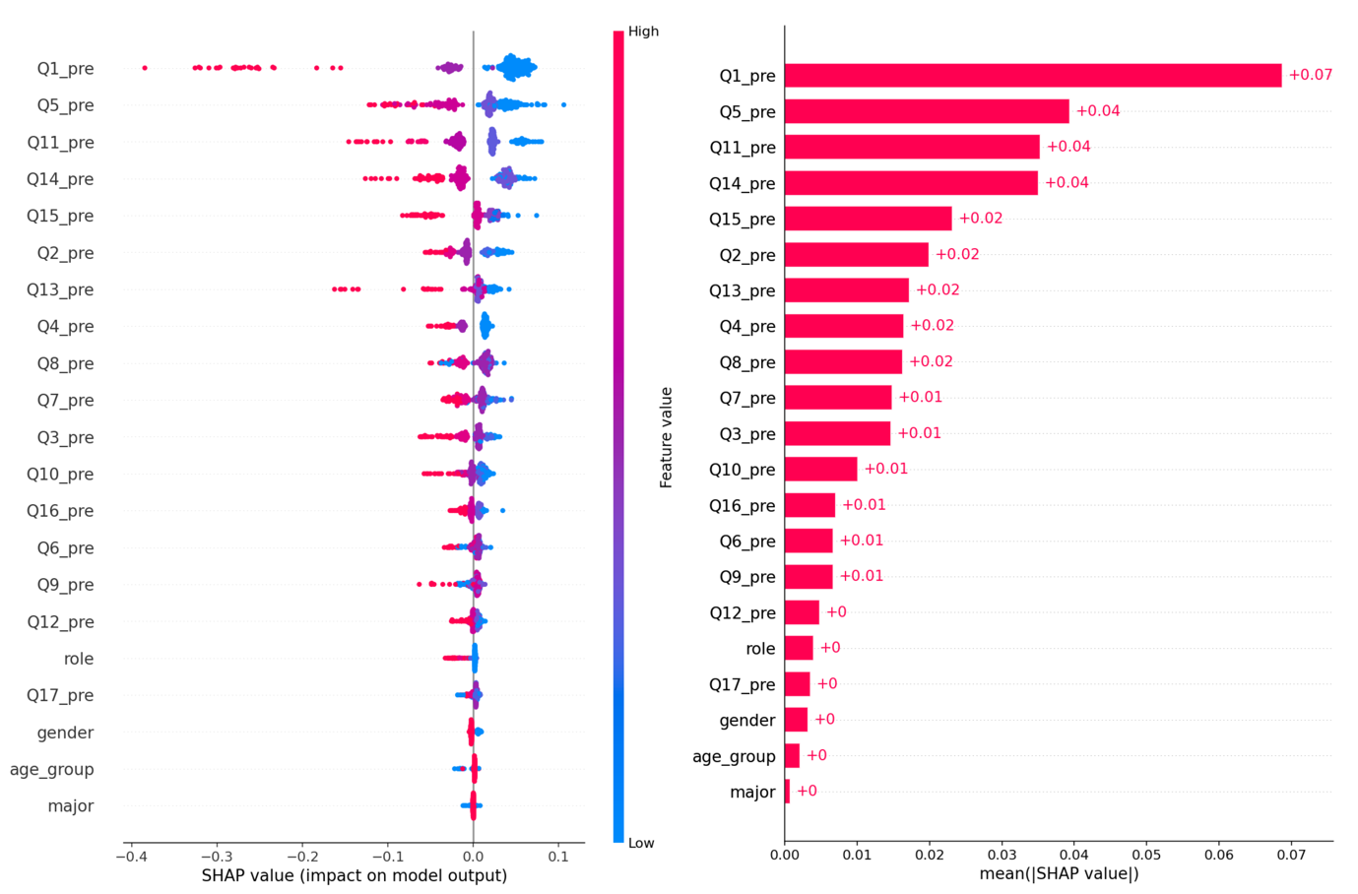
Figure 4. SHAP Analysis of Predictors for Positive Attitudinal Change Following Video Intervention. The left panel displays the SHAP summary plot, illustrating the impact of each pre-intervention ANAS item and demographic feature on the likelihood of positive attitudinal change. Features are ranked by importance, with color indicating the feature value (red = high, blue = low). The right panel shows the mean absolute SHAP values for each feature, quantifying their overall contribution to the model’s predictions.

To explore why some participants responded more positively than others, a classification model was developed to predict positive attitudinal change based on pre-intervention responses. Among the machine learning algorithms tested, TabPFN demonstrated superior performance, achieving a classification accuracy of 73.4%, indicating good discriminatory power.

Model interpretability was enhanced using SHAP analysis, as shown in Figure 4, which quantified the contribution of each feature to the prediction of attitudinal improvement. As shown in Figure 4, the top predictors were overwhelmingly pre-intervention responses to specific ANAS items, with demographic variables exerting negligible influence.The item Q1_pre (“We should help people with autism change to fit into society better”) exhibited the highest mean absolute SHAP value (+0.07), marking it as the most critical determinant of change likelihood. Higher baseline agreement with this deficit-oriented statement significantly decreased the probability of positive attitudinal shift, suggesting that entrenched beliefs about enforcing social conformity present substantial resistance to brief interventions.

Following Q1_pre, three items—Q5_pre (“I feel sorry for families of autistic people”), Q11_pre (“People with autism are most often born with it”), and Q14_pre (“Autism is a form of natural human variation, not a disorder or deficit”)—each demonstrated mean absolute SHAP values of +0.04. For Q5_pre, similar to Q1_pre, higher agreement reflected stronger pity-based attitudes, which negatively impacted responsiveness to the intervention. In contrast, lower baseline agreement with Q11_pre and Q14_pre—indicating limited biomedical understanding or weaker alignment with neurodiversity principles—was associated with greater potential for attitudinal improvement, as the intervention effectively introduced these concepts. Secondary predictors, including Q15_pre, Q2_pre, and Q13_pre (all at +0.02), had moderate influence, while remaining items contributed minimally (≤+0.01). Demographic features—role, gender, age, and major—all displayed near-zero SHAP values, underscoring that attitudinal baselines, rather than personal characteristics, determined intervention effectiveness.

Discussion

A brief video intervention yielded practically meaningful attitude gains across a large campus sample. Change hinged on baseline belief profiles—especially deficit and pity frames—while demographics added little. The discussion examines why video-based instruction is a low-friction, scalable intervention for shifting beliefs and where its limits may lie.

Overview of Key Findings and Attitudinal Shifts
This study demonstrated that a brief VBI can produce measurable improvements in university students’ attitudes toward autism. Participants showed significant positive shifts on attitude measures after the intervention, indicating that even a short, targeted educational video can enhance understanding and reduce prejudice. This finding is consistent with prior research showing that concise media interventions improve autism knowledge and attitudes (Janoušková et al., 2017; Stern, 2024). Notably, our participants exhibited increased openness and empathy towards autistic individuals post-intervention. This outcome aligns with the broader literature suggesting that exposure to autism-related content (especially when delivered in engaging formats) can correct misconceptions and foster more accepting views (Jones et al., 2021). By framing autism in humanizing terms and providing factual information, the VBI helped move some students away from seeing autism solely through a deficit lens. This attitude improvement is encouraging, as positive shifts in perceptions of autism may translate into more inclusive behaviours in academic and social settings.
Despite these gains, the intervention’s impact was uneven across different attitude dimensions. While certain aspects of attitudes (e.g., medical model thoughts) and affective components (e.g. reduced pity or negative emotion) improved markedly – a result mirrored by other multi-component stigma-reduction programs (Restoy et al., 2024) – changes in the major cognitive dimension of attitudes were less pronounced. In other words, students became more comfortable with and sympathetic toward autistic peers, but certain underlying beliefs about autism remained largely unchanged. This nuanced pattern suggests that the VBI succeeded in softening emotional reactions and increasing willingness to engage with autistic individuals but it did not fully dismantle all preconceived notions or deep-seated stereotypes in the short term. Such an outcome is not unexpected; research indicates that implicit beliefs and cognitive schemas about autism can be resistant to brief interventions (Someki et al., 2018b). Scholars have noted, for example, that traditional autism trainings often frame autistic people as “less than” an ideal of normalcy, reflecting a medicalized narrative that one video may not completely overturn (Pruneti et al., 2024). Our findings align with this, as some participants continued to endorse elements of the medical model of autism, even after the intervention. These persistent beliefs point to the need for more sustained or comprehensive approaches to truly reshape the cognitive frameworks through which people understand autism.

Persistent Medical-Model Beliefs vs. Emerging Neurodiversity Perspectives
One of the most significant challenges observed was the persistence of medical-model beliefs among participants. Before the intervention, many students viewed autism primarily as a biomedical disorder – a tragic condition requiring cure or correction. The VBI introduced concepts from the neurodiversity paradigm, emphasizing autism as a natural variation of human diversity and focusing on acceptance and support rather than “fixing” the individual (Author 1 et al., 2024). Some shift in perspective was evident: in post-intervention responses, students more frequently acknowledged social barriers faced by autistic people and the importance of inclusion, suggesting an incipient move toward a social-model (Wood, 2017) or neurodiversity-informed understanding (Le Cunff et al., 2024). This indicates that a brief video can seed conceptual change, helping learners reconceptualize autism in terms of person-environment fit and civil rights (e.g. the need for accommodations and acceptance) rather than solely as a biomedical issue. Such conceptual framework changes are notable because they reflect movement toward contemporary views of autism as an identity and a form of neurodiversity.
Nonetheless, the tension between the biomedical and social models was clearly reflected in our data (Davies, et al., 2024). Many participants, even after the video, still held beliefs consistent with the medical model – for instance, viewing autism through deficits in need of treatment or maintaining that autistic people are inherently limited. These residual attitudes echo the broader cultural context in China (Lao et al., 2024), where the neurodiversity movement is a relatively new concept. Autism has historically been highly stigmatized in Chinese society, with evidence of many prejudices and misunderstandings about autistic individuals (Yu et al., 2020). Public discourse (e.g. on social media) shows improving sentiment over time but indicates that knowledge (the cognitive component of attitudes) remains underdeveloped (Li et al., 2024). In our study, this manifested as participants showing empathy and willingness to help (affective and behavioral changes), while still lacking a fully accurate understanding of autism’s nature (cognitive beliefs). In fact, our findings mirror recent analyses of Chinese social media (Meizhen et al., 2025), where affective and behavioral attitudes towards autism have become more positive, but cognitive attitudes lag behind. Deep-rooted cultural factors may contribute to these persistent beliefs. For example, the prevalent Chinese terminology for autism (自闭症, literally “self-closed syndrome”) and past framing of autism in medical terms may reinforce viewing autism as a pathology (Shabana, 2012). It takes time and repeated exposure to counteract years of socialization under the medical model.
Importantly, this persistence of medical-model thinking is not unique to Chinese students (Waltz, 2008); it is observed globally that brief educational interventions often do not fully erase entrenched beliefs. Even when knowledge increases, people may cling to familiar frameworks to make sense of that knowledge (Zedelius et al., 2022). Our results emphasize that true paradigm shift (from a deficits-focused view to a neurodiversity-affirming view) likely requires more than a single exposure (Krzeminska et al., 2019). It calls for ongoing education and contact with autistic perspectives. The fact that some movement occurred at all is heartening and shows that young adults are potentially receptive to new ways of thinking when presented with compelling information (Costera Meijer, 2007). With reinforcement, today’s Chinese university students could become the next generation to broadly embrace neurodiversity. The study, therefore, highlights both the potential and the limits of one-time interventions: they might initiate the process of changing minds but may not complete it. Recognizing this, we argue that Chinese universities should treat our VBI as one component in a multi-pronged strategy to shift campus culture (combining policy changes, curriculum integration, and continued dialogue, as discussed below).
Pre-existing Belief as Predictors of Intervention Effects
Our results revealed that pre-intervention attitudes toward autism played a crucial role in predicting intervention effectiveness. The questions reflecting normalization perspectives (Q1: "We should help people with autism change to fit into society better" and Q5: "I feel sorry for families of autistic people") were among the strongest predictors, with higher agreement generally associated with reduced intervention effectiveness. Notably, questions representing seemingly opposing conceptual frameworks—the medical/innate perspective (Q11: "People with autism are most often born with it") and neurodiversity viewpoints (Q14: "Autism is a form of natural human variation, not a disorder or deficit" and Q15: "Autism is a difference, not an illness or disease")—showed similar patterns where strong pre-intervention agreement predicted lower intervention impact. This counterintuitive finding suggests that the strength of pre-existing beliefs, rather than their specific content, may be the determining factor in participants' receptiveness to intervention. Participants with firmly established views about autism's nature, regardless of theoretical orientation, appeared less likely to demonstrate measurable attitude change. In contrast, demographic variables (gender, age group, major, role in university) exhibited minimal predictive influence, emphasizing that preconceived attitudes rather than background characteristics primarily determined intervention outcomes. These findings highlight the importance of considering belief entrenchment when designing educational interventions aimed at modifying autism attitudes, as strongly held initial perspectives in any direction may create resistance to change that transcends the specific content of those beliefs (Lieberman et al., 2023).
Implications for Higher Education and Societal Integration of Autistic Adults
The partial success of this intervention,marked by reduced stigma but persistent medical-model residues,highlights both the promise and complexity of attitude change within Chinese higher education. Universities, as gateways to adulthood and professional life, are uniquely positioned to address systemic barriers faced by autistic adults (Hillier et al., 2018). By integrating brief, scalable VBIs into orientation programs, faculty training, and student-led initiatives, institutions can cultivate environments where neurodiversity is normalized. For instance, pairing brief educational videos with structured peer mentorship programs could bridge the gap between awareness and action, fostering empathy while providing autistic students with practical social support. Such initiatives not only improve campus inclusivity but also prepare neurotypical students to advocate for workplace accommodations and equitable policies as future employers or policymakers (Khalifa et al., 2020).
The intervention’s stronger impact on affective attitudes (e.g., reduced pity) compared to cognitive restructuring (e.g., lingering beliefs in “curing” autism) underscores the need for complementary strategies. For example, integrating lived experiences of autistic adults into curricula—such as case studies in business courses about neurodiverse workplaces or public health discussions on disability rights—could deepen conceptual shifts (DePape & Lindsay, 2016). These efforts align with global movements toward autism acceptance, where educational institutions serve as incubators for societal change. In China, leveraging collectivist values to frame inclusion as a communal responsibility (e.g., “harmonious collaboration”) may enhance buy-in, addressing cultural nuances while advancing neurodiversity principles (Qi et al., 2016).

Regional neurodiversity discourse and design implications

Across East and Southeast Asia, the neurodiversity paradigm is taking shape through different institutional and advocacy channels (Hirota et al., 2024; Sun et al., 2013). In China, university-facing practice is often routed through formal diagnostic and student-service pathways in major cities, with growing—but uneven—links to autistic self-advocates alongside long-standing parent organisations (Cheng et al., 2023). In Japan, debates increasingly foreground identity and authenticity at school and work, where expectations of behavioral conformity make masking a salient concern in everyday inclusion (Atherton et al., 2023). In Indonesia, advocacy is newer and highly community-embedded, and access to assessment and educational support varies substantially by province; community groups frequently act as first points of contact and translation between families, schools, and services (Margaretha et al., 2025). Read together, these trajectories suggest that our approach generalises as a format (short, story-driven, rights-framed video) but requires local institutional adaptation.

For design, this means building localisation into the video asset rather than treating it as an afterthought: (i) use locally accepted terms and plain-language glosses; (ii) offer subtitle/voice options (standard Mandarin, Bahasa Indonesia; JP captions with furigana where relevant); (iii) swap examples to mirror local institutions (e.g., university disability offices and campus counselling in China; seminar/lab, club, and part-time work contexts in Japan; school–community–NGO interfaces in Indonesia); and (iv) co-produce scripts and on-screen guidance with regional autistic and community groups. These adaptations preserve the intervention’s core while clarifying where generalisation is warranted and where context-specific negotiation is essential (Cheng et al., 2023).

Limitations and Future Directions
This study has several limitations. First, the pre-post design measured short-term attitude shifts; longitudinal research is needed to assess whether changes endure or translate into behavioral outcomes (e.g., inclusive hiring practices post-graduation). Second, self-reported attitudes may reflect social desirability rather than genuine change, and estimates can be shaped by researcher expectancy and tool/measurement bias. Specifically, social desirability/demand characteristics may be asymmetric across waves (stronger at post-test), our estimates should be viewed as upper-bound effects. Analyst degrees of freedom (variable selection, model specification, missing-data handling) and instrument choices (item wording, scale anchors, scoring rules) can inflate effects and so any automated scoring or NLP tools should also be audited for bias. Future work should preregister analyses, blind coders where feasible, test measurement invariance/DIF, and run sensitivity checks across estimators and feature sets, while adding implicit or behavioral outcomes (e.g., IAT; unobtrusive observations) to triangulate results (Kurdi et al., 2019). Third, whilst the sample was robust in size, it overrepresented students (91%) compared to staff (7%), limiting insights into institutional decision-makers’ attitudes. Finally, while the video included autistic perspectives, their involvement in study design was advisory rather than co-creative—a critical gap given evidence that autistic-led interventions yield deeper engagement (Gourdon-Kanhukamwe et al., 2023).
Future research should:
- Examine Real-World Impact: Track whether attitude improvements correlate with autistic students’ academic retention, mental health outcomes, or post-graduation employment rates.
- Develop Tiered Interventions: Tailor VBIs to participants’ baseline attitudes (e.g., intensive modules for those with entrenched medical-model views vs. advanced content for neurodiversity advocates).
- Scale Cross-Culturally: Compare the intervention’s efficacy across regions with varying autism stigma levels (e.g., urban vs. rural China) and adapt content for non-student populations (e.g., corporate trainings).
- Assess Durability: Check rates of sustained change among neurotypical participants at 1–3 months post-intervention (and beyond, if possible), linking persistence to baseline belief profiles.
- Probe Dose-Response: Conduct a small experimental probe manipulating video elements (e.g., narrator identity, degree of autistic voice, myth-debunking segment, pacing/length, captions/subtitles) to identify active ingredients and optimal “dose.”

Conclusion: Toward Lifelong Inclusion
This study demonstrates that brief, accessible interventions can initiate meaningful attitude shifts within Chinese higher education—a critical step toward improving outcomes for autistic adults. While one-time VBIs alone cannot dismantle systemic stigma, they lay the groundwork for sustained cultural change. Universities must now expand these efforts by embedding neurodiversity into institutional policies (e.g., mandatory staff training, inclusive hiring practices for autistic graduates) and fostering partnerships with employers and advocacy groups. By doing so, higher education can be transformed from a site of medicalized accommodation to a catalyst for societal inclusion, ensuring autistic adults are not merely included but valued as integral contributors to China’s future. The journey from awareness to acceptance is gradual, but as this study shows, it is both possible and imperative to begin.

Acknowledgment

This work is dedicated to all individuals who face challenges in accessing education due to autism. Your resilience continues to inspire efforts toward greater inclusion and understanding.

Authorship Confirmation Statement
Y.X: Conceptualization, methodology, formal analysis, data curation, investigation, writing—original draft, and writing—review and editing; J.V.: project administration, methodology, supervision, and writing—review and editing. M.Z.: Data Curation. P.W.: Formal Analysis, and writing—review and editing. The article has been submitted solely to Research in Autism.

Author Disclosure Statement
The authors declare that they conducted the research with-out any commercial or ﬁnancial relationships that could beconstrued as a potential conﬂict of interest.

Funding Statement
This research does not receive any funding.

Reference

Altman, D. G., & Bland, J. M. (1995). Statistics notes: Absence of evidence is not evidence of absence. Bmj, 311(7003), 485.
Antwarg, L., Miller, R. M., Shapira, B., & Rokach, L. (2021). Explaining anomalies detected by autoencoders using Shapley Additive Explanations. Expert Systems with Applications, 186, 115736. https://doi.org/10.1016/j.eswa.2021.115736
Atherton, G., Morimoto, Y., Nakashima, S., & Cross, L. (2023). Does the study of culture enrich our understanding of autism? A cross-cultural exploration of life on the spectrum in Japan and the West. Journal of Cross-Cultural Psychology, 54(5), 610–634.
Breiman, L. (2001). Random forests. Machine Learning, 45, 5–32.
Chen, T., & Guestrin, C. (2016). Xgboost: A scalable tree boosting system. Proceedings of the 22nd Acm Sigkdd International Conference on Knowledge Discovery and Data Mining, 785–794.
Cheng, Y., Tekola, B., Balasubramanian, A., Crane, L., & Leadbitter, K. (2023). Neurodiversity and community-led rights-based movements: Barriers and opportunities for global research partnerships. Autism, 27(3), 573–577. https://doi.org/10.1177/13623613231159165
Chevallier, C., Kohls, G., Troiani, V., Brodkin, E. S., & Schultz, R. T. (2012). The social motivation theory of autism. Trends in Cognitive Sciences, 16(4), 231–239. https://doi.org/10.1016/j.tics.2012.02.007
Cohen, J. (2013). Statistical Power Analysis for the Behavioral Sciences (2nd ed.). Routledge. https://doi.org/10.4324/9780203771587
Costello, A. B., & Osborne, J. (2005). Best practices in exploratory factor analysis: Four recommendations for getting the most from your analysis. Practical Assessment, Research, and Evaluation, 10(1).
Costera Meijer, I. (2007). The paradox of popularity: How young people experience the news. Journalism Studies, 8(1), 96–116.
Davies, J., Cooper, K., Killick, E., Sam, E., Healy, M., Thompson, G., Mandy, W., Redmayne, B., & Crane, L. (2024). Autistic identity: A systematic review of quantitative research. Autism Research, 17(5), 874–897.
Davies, J., Islaam, L., Carter, S., Redmayne, B., Cooper, K., Mandy, W., & Crane, L. (2024). Examining the Support Experiences of Autistic Young People with Multiple Marginalized Identities in the United Kingdom. Autism in Adulthood. https://doi.org/10.1089/aut.2024.0059
DePape, A.-M., & Lindsay, S. (2016). Lived experiences from the perspective of individuals with autism spectrum disorder: A qualitative meta-synthesis. Focus on Autism and Other Developmental Disabilities, 31(1), 60–71.
DESQUENNE GODFREY, G., DOWNES, N., & CAPPE, E. (2024). A Systematic Review of Family Functioning in Families of Children on the Autism Spectrum. Journal of Autism and Developmental Disorders, 54(3), 1036–1057. https://doi.org/10.1007/s10803-022-05830-6
Dickter, C. L., Burk, J. A., Zeman, J. L., & Taylor, S. C. (2020). Implicit and explicit attitudes toward autistic adults. Autism in Adulthood, 2(2), 144–151.
Estival, S., Demulier, V., Renaud, J., & Martin, J.-C. (2024). Training work-related social skills in adults with Autism Spectrum Disorder using a tablet-based intervention. Human–Computer Interaction, 39(1–2), 96–108. https://doi.org/10.1080/07370024.2023.2242344
Farmer, G. (2024). Experiences of autism in higher education. In Social Justice in Practice in Education. Routledge.
Fombonne, E. (2009). Epidemiology of Pervasive Developmental Disorders. Pediatric Research, 65(6), 591–598. https://doi.org/10.1203/PDR.0b013e31819e7203
Gourdon-Kanhukamwe, A., Kalandadze, T., Yeung, S. K., Azevedo, F., Iley, B., Phan, J. M., Ramji, A. V., Shaw, J. J., Zaneva, M., Dokovova, M., Hartmann, H., Kapp, S. K., Warrington, K. L., Training (FORRT), F. of O. R. R., & Elsherif, M. M. (2023). Opening up understanding of neurodiversity: A call for applying participatory and open scholarship practices. The Cognitive Psychology Bulletin, 1(8), 23–27. https://doi.org/10.53841/bpscog.2023.1.8.23
Hariharan, D., Banerjee, S. K., Jinnah, A. M. A., Banu, D. S. B., & Ranju, P. (2024). Awareness with Accuracy: A Study Representing the Acceptance of Autistic People in the Society. 2024 10th International Conference on Communication and Signal Processing (ICCSP), 464–468. https://doi.org/10.1109/ICCSP60870.2024.10543574
Hayes, J., Ford, T., Rafeeque, H., & Russell, G. (2018). Clinical practice guidelines for diagnosis of autism spectrum disorder in adults and children in the UK: A narrative review. BMC Psychiatry, 18(1), 222. https://doi.org/10.1186/s12888-018-1800-1
Hensel, L., Lüdtke, J., Brouzou, K. O., Eickhoff, S. B., Kamp, D., & Schilbach, L. (2024). Noninvasive brain stimulation in autism: Review and outlook for personalized interventions in adult patients. Cerebral Cortex, 34(13), 8–18. https://doi.org/10.1093/cercor/bhae096
Hillier, A., Goldstein, J., Murphy, D., Trietsch, R., Keeves, J., Mendes, E., & Queenan, A. (2018). Supporting university students with autism spectrum disorder. Autism, 22(1), 20–28.
Hirota, T., Cheon, K.-A., & Lai, M.-C. (2024). Neurodiversity paradigms and their development across cultures: Some reflections in East Asian contexts. Autism, 28(11), 2685–2689.
Hollmann, N., Müller, S., Purucker, L., Krishnakumar, A., Körfer, M., Hoo, S. B., Schirrmeister, R. T., & Hutter, F. (2025). Accurate predictions on small data with a tabular foundation model. Nature, 637(8045), 319–326.
Janoušková, M., Tušková, E., Weissova, A., Trančík, P., Pasz, J., Evans-Lacko, S., & Winkler, P. (2017). Can video interventions be used to effectively destigmatize mental illness among young people? A systematic review. European Psychiatry, 41(1), 1–9.
Jones, D. R., DeBrabander, K. M., & Sasson, N. J. (2021). Effects of autism acceptance training on explicit and implicit biases toward autism. Autism, 25(5), 1246–1261.
Junttila, M., Kielinen, M., Jussila, K., Joskitt, L., Mäntymaa, M., Ebeling, H., & Mattila, M.-L. (2024). The traits of Autism Spectrum Disorder and bullying victimization in an epidemiological population. European Child & Adolescent Psychiatry, 33(4), 1067–1080. https://doi.org/10.1007/s00787-023-02228-2
Khalifa, G., Sharif, Z., Sultan, M., & Di Rezze, B. (2020). Workplace accommodations for adults with autism spectrum disorder: A scoping review. Disability and Rehabilitation, 42(9), 1316–1331.
Kim, H., & Markus, H. R. (1999). Deviance or uniqueness, harmony or conformity? A cultural analysis. Journal of Personality and Social Psychology, 77(4), 785–800. https://doi.org/10.1037/0022-3514.77.4.785
Kofler, M. J., Soto, E. F., Singh, L. J., Harmon, S. L., Jaisle, E. M., Smith, J. N., Feeney, K. E., & Musser, E. D. (2024). Executive function deficits in attention-deficit/hyperactivity disorder and autism spectrum disorder. Nature Reviews Psychology, 3(10), 701–719. https://doi.org/10.1038/s44159-024-00350-9
Kohavi, R. (1995). A study of cross-validation and bootstrap for accuracy estimation and model selection. Ijcai, 14(2), 1137–1145.
Krzeminska, A., Austin, R. D., Bruyère, S. M., & Hedley, D. (2019). The advantages and challenges of neurodiversity employment in organizations. Journal of Management & Organization, 25(4), 453–463. https://doi.org/10.1017/jmo.2019.58
Kurdi, B., Seitchik, A. E., Axt, J. R., Carroll, T. J., Karapetyan, A., Kaushik, N., Tomezsko, D., Greenwald, A. G., & Banaji, M. R. (2019). Relationship between the Implicit Association Test and intergroup behavior: A meta-analysis. American Psychologist, 74(5), 569.
Lao, U., Dai, J., Liang, F., Chen, Q., Cao, W., Pan, Y., Zou, X., & Zhu, H. (2024). Unveiling the perceptions of autism-related Chinese language among the autism community and the general public. Autism in Adulthood.
Le Cunff, A.-L., Giampietro, V., & Dommett, E. (2024). Neurodiversity and cognitive load in online learning: A systematic review with narrative synthesis. Educational Research Review, 43, 100604. https://doi.org/10.1016/j.edurev.2024.100604
Levine, D. S., & Strube, M. J. (2012). Environmental attitudes, knowledge, intentions and behaviors among college students. The Journal of Social Psychology, 152(3), 308–326.
Li, X., Xu, H., & Zhang, J. (2024). Attitudes of Chinese public towards the autism community: Evidence from a decade of Weibo data. Heliyon, 10(16), e35113. https://doi.org/10.1016/j.heliyon.2024.e35113
Lieberman, A., Amir, O., & Carmon, Z. (2023). The entrenchment effect: Why people persist with less-preferred behaviors. Organizational Behavior and Human Decision Processes, 178, 104277.
Lopez Naranjo, F., Maldonado, M. A., Cuadrado, E., & Moyano, M. (2024). Video Games Interventions to Reduce Radicalization and Violent Extremism in Young People: A Systematic Review. Games and Culture, 15554120231223067. https://doi.org/10.1177/15554120231223067
Lundberg, S. M., & Lee, S.-I. (2017). A unified approach to interpreting model predictions. Advances in Neural Information Processing Systems, 30.
Ma, Y., Lee, L. Y., Wang, Y., & Zhang, X. (2024). The relationships of autistic child characteristics, metacognitive beliefs, and autistic traits with affiliate stigma among parents of children with autism spectrum conditions: A moderated mediation study. Research in Autism Spectrum Disorders, 111, 102315. https://doi.org/10.1016/j.rasd.2023.102315
Maenner, M. J. (2023). Prevalence and Characteristics of Autism Spectrum Disorder Among Children Aged 8 Years—Autism and Developmental Disabilities Monitoring Network, 11 Sites, United States, 2020. MMWR. Surveillance Summaries, 72. https://doi.org/10.15585/mmwr.ss7202a1
Margaretha, M., Mosen, J., Page, A., Naylor, A., & Kerr, J. M. (2025). Autism management and inclusion in East Java, Indonesia: A reflection on opportunities and challenges. International Journal of Developmental Disabilities, 71(6), 929–938.
McConnell, K., Keenan, C., Storey, C., & Thurston, A. (2024). Video-based interventions promoting social behavioural skills for autistic children and young people: An evidence and gap map. Campbell Systematic Reviews, 20(2), e1405. https://doi.org/10.1002/cl2.1405
Meizhen, L., Ma, B., & Zhang, Y. (2025). Analysis of Theme Characteristics and Emotional Tendency in Weibo Discourse of People with Autism Spectrum Disorder. The Journal of Medicine, Humanity and Media, 3(2), 109–123.
Nevill, R. E. A., & White, S. W. (2011). College Students’ Openness Toward Autism Spectrum Disorders: Improving Peer Acceptance. Journal of Autism and Developmental Disorders, 41(12), 1619–1628. https://doi.org/10.1007/s10803-011-1189-x
Noble, N., Bueno, N., Zatopek, A., & Hernandez, J. (2024). Helping college students with autism spectrum disorder: Exploring factors affecting use of counselling. Counselling and Psychotherapy Research, 24(4), 1310–1321. https://doi.org/10.1002/capr.12751
Nowell, S., & Hume, K. (2023). Structured Teaching and Environmental Supports. In Learners on the Autism Spectrum (3rd ed.). Routledge.
Pruneti, C., Coscioni, G., & Guidotti, S. (2024). Evaluation of the effectiveness of behavioral interventions for autism spectrum disorders: A systematic review of randomized controlled trials and quasi-experimental studies. Clinical Child Psychology and Psychiatry, 29(1), 213–231. https://doi.org/10.1177/13591045231205614
Qi, X., Zaroff, C. M., & Bernardo, A. B. (2016). Autism spectrum disorder etiology: Lay beliefs and the role of cultural values and social axioms. Autism, 20(6), 673–686.
Restoy, D., Oriol-Escudé, M., Alonzo-Castillo, T., Magán-Maganto, M., Canal-Bedia, R., Díez-Villoria, E., Gisbert-Gustemps, L., Setién-Ramos, I., Martínez-Ramírez, M., Ramos-Quiroga, J. A., & Lugo-Marín, J. (2024). Emotion regulation and emotion dysregulation in children and adolescents with Autism Spectrum Disorder: A meta-analysis of evaluation and intervention studies. Clinical Psychology Review, 109, 102410. https://doi.org/10.1016/j.cpr.2024.102410
Rundel, D., Kobialka, J., von Crailsheim, C., Feurer, M., Nagler, T., & Rügamer, D. (2024). Interpretable machine learning for TabPFN. 465–476.
Saeed, R., Ahmed, F., Danish, S. H., Talha, M., Usmani, M., Durrani, N., & Ali, N. (2024). Video based educational intervention in waiting area to improve awareness about health screening among patients visiting family medicine clinics. BMC Health Services Research, 24(1), 818. https://doi.org/10.1186/s12913-024-11143-4
Shabana, S. (2012). A Phenomenological Study of a Culture-specific Theory of Self and Other among Individuals with Autism in the United States and India. Pacifica Graduate Institute.
Šola, H. M., Qureshi, F. H., & Khawaja, S. (2024). AI Eye-Tracking Technology: A New Era in Managing Cognitive Loads for Online Learners. Education Sciences, 14(9), Article 9. https://doi.org/10.3390/educsci14090933
Someki, F., Torii, M., Brooks, P. J., Koeda, T., & Gillespie-Lynch, K. (2018a). Stigma associated with autism among college students in Japan and the United States: An online training study. Research in Developmental Disabilities, 76, 88–98. https://doi.org/10.1016/j.ridd.2018.02.016
Someki, F., Torii, M., Brooks, P. J., Koeda, T., & Gillespie-Lynch, K. (2018b). Stigma associated with autism among college students in Japan and the United States: An online training study. Research in Developmental Disabilities, 76, 88–98.
Stern, S. C. (2024). Using popular media to change attitudes and bolster knowledge about autism spectrum disorder. Journal of Autism and Developmental Disorders, 54(11), 3975–3991.
Sun, X., Allison, C., Matthews, F. E., Sharp, S. J., Auyeung, B., Baron-Cohen, S., & Brayne, C. (2013). Prevalence of autism in mainland China, Hong Kong and Taiwan: A systematic review and meta-analysis. Molecular Autism, 4(1), 7.
Turnock, A., Langley, K., & Jones, C. R. G. (2022). Understanding Stigma in Autism: A Narrative Review and Theoretical Model. Autism in Adulthood, 4(1), 76–91. https://doi.org/10.1089/aut.2021.0005
VanDaalen, R. A., Dillon, F. R., Santos, C. E., & Capielo Rosario, C. (2025). Development and Initial Validation of the Autism and Neurodiversity Attitudes Scale. Autism in Adulthood, 7(1), 39–51. https://doi.org/10.1089/aut.2023.0090
Waltz, M. (2008). Autism= death: The social and medical impact of a catastrophic medical model of autistic spectrum disorders. Popular Narrative Media, 1(1), 13–24.
Wang, X., Zhai, F., & Wang, Y. (2023). Interplay between Tradition and Modernity: Stress and Coping Experiences among Parents of Children with Autism in Beijing, China. Behavioral Sciences, 13(10), Article 10. https://doi.org/10.3390/bs13100814
Woods, R. (2017). Exploring how the social model of disability can be re-invigorated for autism: In response to Jonathan Levitt. Disability & Society, 32(7), 1090–1095.
Wüthrich, S., Lozano, C. S., Lüthi, M., & Wicki, M. (2024). Changing students’ explicit and implicit attitudes toward peers with disabilities: Effects of a curriculum-based intervention programme. Social Psychology of Education, 27(3), 935–953.
Xia, Y., Wang, P., & Vincent, J. (2024). Why we need neurodiversity in brain and behavioral sciences. Brain-X, 2(2), e70. https://doi.org/10.1002/brx2.70
Xiao, X., Wong, R. M., & Yang, W. (2024). Effectiveness of video-based health promotion: A systematic review and meta-analysis. Patient Education and Counseling, 119, 108095. https://doi.org/10.1016/j.pec.2023.108095
Yu, L., Stronach, S., & Harrison, A. J. (2020). Public knowledge and stigma of autism spectrum disorder: Comparing China with the United States. Autism, 24(6), 1531–1545.
Zedelius, C. M., Gross, M. E., & Schooler, J. W. (2022). Inquisitive but not discerning: Deprivation curiosity is associated with excessive openness to inaccurate information. Journal of Research in Personality, 98, 104227. https://doi.org/10.1016/j.jrp.2022.104227
Zhang, D., & Spencer, V. G. (2015). Addressing the Needs of Students with Autism and Other Disabilities in China: Perspectives from the Field. International Journal of Disability, Development and Education, 62(2), 168–181. https://doi.org/10.1080/1034912X.2014.998175

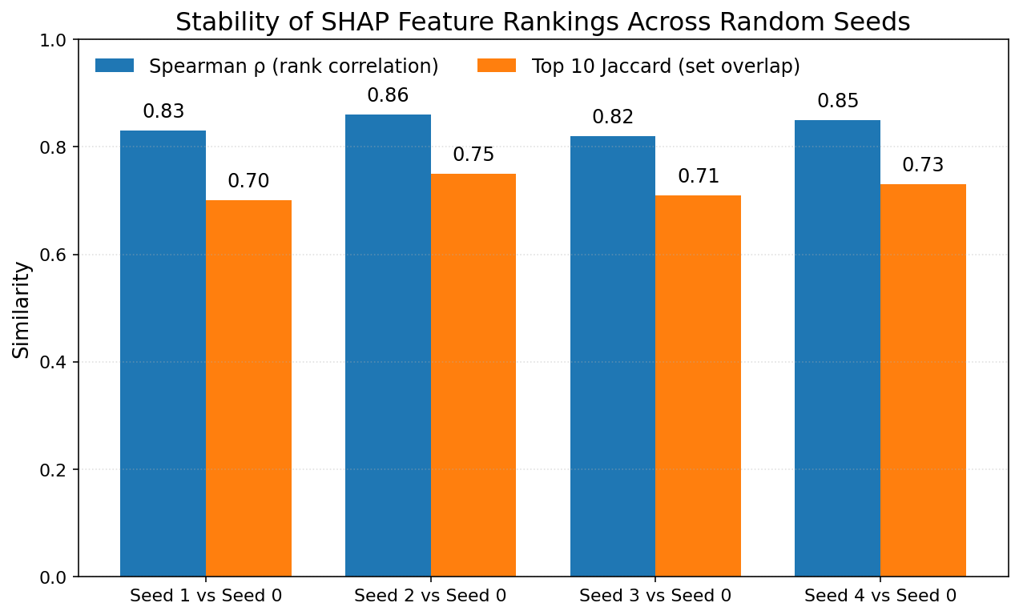
Figure S1. Stability of SHAP feature rankings across random seeds.
Each bar pair compares SHAP explanations obtained with a different random seed to the baseline (seed 0). Blue bars show Spearman ρ (rank-order correlation of global SHAP importance), and orange bars show top-10 feature overlap (Jaccard index). Values above 0.8 indicate highly consistent feature rankings across seeds, confirming the robustness of SHAP interpretations

