Transnational Perspectives on Anime: A Symposium – Conference Proceedings Introduction
Looking at Anime from Every Angle
Since the 1990s, English-language research into Japanese animation has flourished, and as the Journal of Anime and Manga Studies has demonstrated over the course of its six-year tenure, it’s an exciting time to be entering the field. We’ve seen an exponential increase in the amount of research being published on anime, manga, and other components of Japanese popular culture, and anecdotally I’ve found as an educator that more and more students want to pursue this research as a part of their own studies. In fact, on a team-taught MA Film Studies module that I contributed a Howl’s Moving Castle lecture to last year, a significant proportion of the students chose to write their assigned essay on Studio Ghibli amongst nine other critically acclaimed and fascinating options.
As an early career researcher in the area myself who has recently completed my PhD in Ghibli’s adaptations of Western literature (with a book on the topic incoming), I wanted to create another opportunity for this community of new scholars in the field to mingle and share ideas. Fantastic events like the annual Mechademia conference and conventions with academic strands like the JAMS@AX symposium have long served the community, and I’ve been involved with several myself over the years. However, I considered that another more ad-hoc event with an international research focus could help bring together those just entering academia to get to know both each other and established scholars in a more intimate setting. Anime is an increasingly global form with a densely layered identity. Engaging with each of these layers from a fresh perspective felt like an endeavour suited to emerging voices in the field – fortunately, others agreed (including those who could fund it), and the symposium upon which these proceedings are based was born.
Transnational Perspectives on Anime: A Symposium took place at Lancaster University on July 4th 2025 (a somewhat less significant date in the UK) and was kindly funded by Japan Foundation London and Lancaster’s Research Culture Fund. Given the increasingly global qualities of anime as a medium, both in terms of the texts themselves and their distribution and reception, I thought that a focus on transnationalism – one of my home institution’s specialties – would be a perfect fit, as the breadth of ideas in these proceedings shows. Japan Foundation London also hosted a talk afterwards by myself and the pre-eminent Ghibli scholar Professor Rayna Denison on the impact of AI on Studio Ghibli’s image and anime more broadly. It will be made available on YouTube in the coming weeks – if you are interested, it serves as an excellent companion piece to these proceedings.
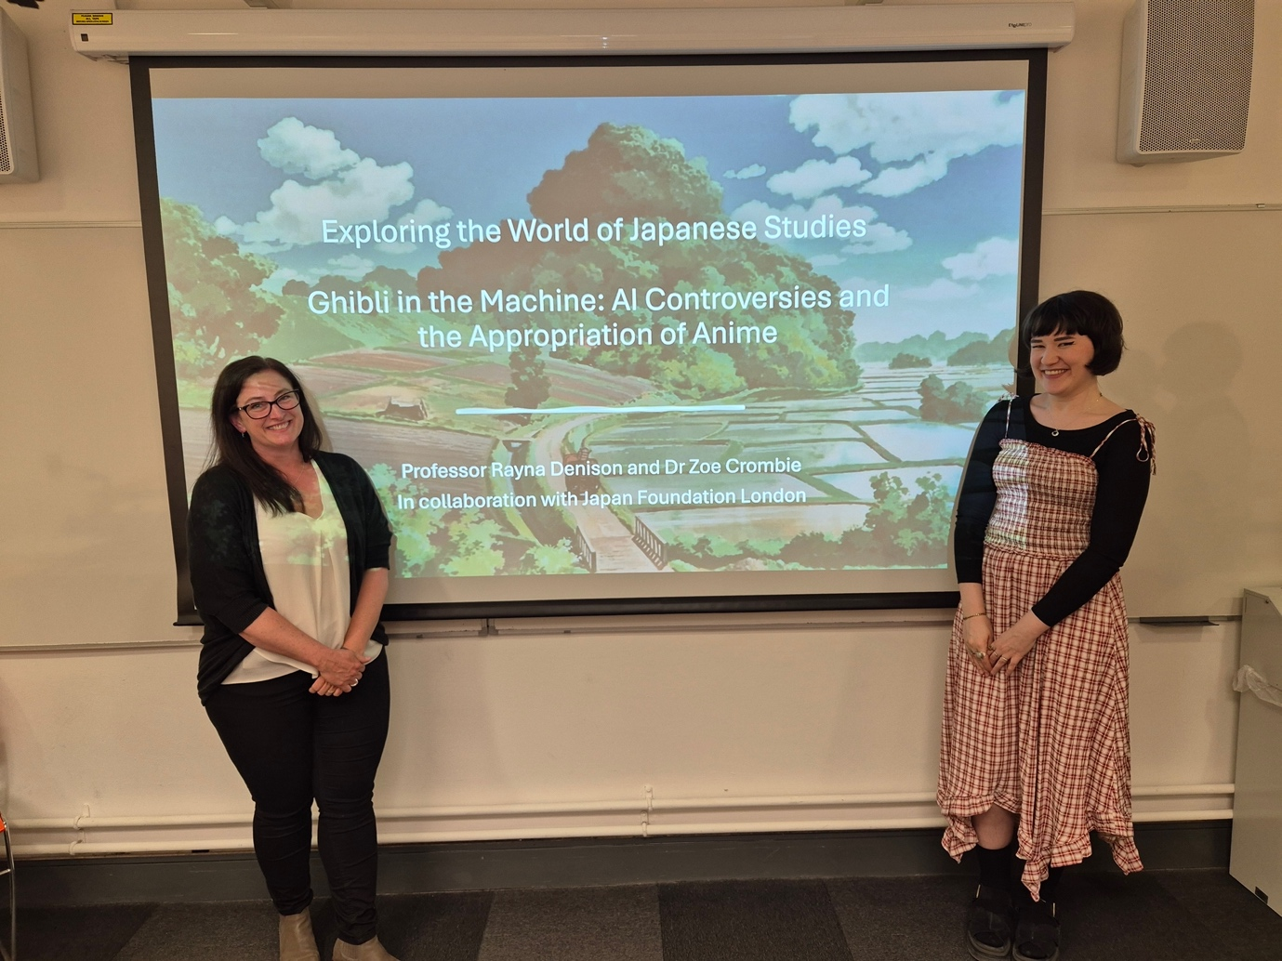
Professor Rayna Denison and Dr Zoe Crombie
The symposium welcomed talks from 15 scholars across a range of disciplines, with representatives from film, media studies, literature, and creative industries amongst other fields. It was also truly transnational in the makeup of speakers, with participants coming from (or presenting remotely from) eight nations across three continents, and many of the papers drawing upon the nuances of the speaker’s specific cultural background. For instance, Antonio Rivera Arnaldos was able to draw out the complexity of ‘Spanish anime’ and soft power, while Khushboo Bansal looked to the distribution of globally known anime like Doraemon within India. A majority of these talks can now be found in paper form in these proceedings; orbiting the theme of transnationalism, these scholars demonstrate the immense diversity emerging from the field, providing invaluable analyses of texts and trends that I’m sure will be cited for years to come.
Among the papers were three keynote talks, each punctuating a section of the day, from the previously mentioned Professor Rayna Denison, JAMS’ own wonderful Billy Tringali, and the prolific Dr Jonathan Clements, author of Anime: A History whose own paper can be found in these pages. Their presence, along with the kind participation of Helen McCarthy, an anime legend who we all have to thank for the existence of our field and whose paper is first in these proceedings, allowed emerging scholars to make connections with those who have achieved the dream and made anime research their career.
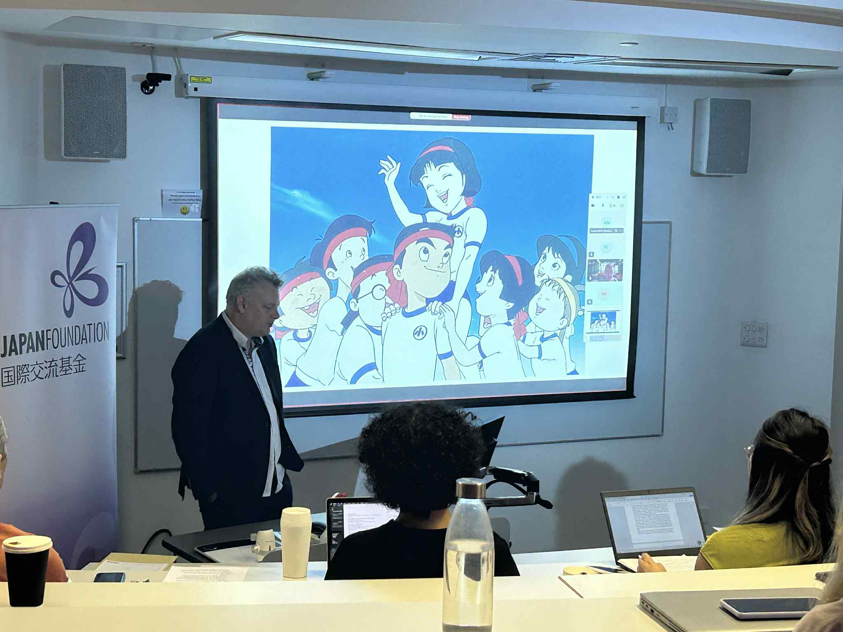
Dr Jonathan Clements discussing the history of anime in China
Organising this event and the subsequent proceedings was no easy task, and so I’d like to thank (along with our fantastic speakers) Dr. Maryam Ghorbankarimi, Professor Richard Rushton, Jamie Hodge, Andrew Lacey, and my wonderful husband Adam Ross for their invaluable support. Of course, I also need to thank the lovely people at Japan Foundation London who, in addition to funding the event, travelled to attend the talks and share their enthusiasm. Director Miyamoto Kaoru, assistant director Abe Natsumi, and assistant programme officer Iona Vos – ありがとうございました！
Finally, I have to thank JAMS itself and with it, the foundational support of Billy Tringali; you gave my first ever article, ‘The spectacular mundane in the films of Studio Ghibli’, the kind of home I dreamed of, and kickstarted many of my academic successes in the process. Working with you on this, and editing for JAMS, has been an honor.
On behalf of the contributors, I hope you enjoy this labor of love and celebration of our field.
Thank you for reading,
Dr. Zoe Crombie
Lancaster University

The programme containing this module (Transnational Cinemas, convened by Dr Maryam Ghorbankarimi) can be found at this link

