A Decade of Design for Additive Manufacturing Research: A Bibliometric Analysis (2014–2024)

^{1,}* H. Kursat CELIK, PhD, Prof. hkcelik@akdeniz.edu.tr ORCID: 0000-0001-8154-6993
² Ali ELHAM, PhD. Prof. a.elham@soton.ac.uk ORCID: 0000-0001-6942-7529
² M. Ali ERBIL, PhD ma.erbil@soton.ac.uk ORCID: 0000-0002-3751-3884
³ Allan E.W. RENNIE, PhD, Prof. a.rennie@lancaster.ac.uk ORCID: 0000-0003-4568-316X
¹ Ibrahim AKINCI, PhD, Prof. iakinci@akdeniz.edu.tr ORCID: 0000-0002-0057-0930

¹ Dept. of Agr. Machinery and Technology Engineering, Akdeniz University, Antalya, Turkey
² School of Engineering, The University of Southampton, Southampton, United Kingdom
³ School of Engineering, Lancaster University, Lancaster, United Kingdom

ABSTRACT
Background and Aim: Design for Additive Manufacturing (DfAM) has gained significant traction over the past decade, fundamentally reshaping engineering design by leveraging the unique capabilities of Additive Manufacturing (AM). Despite its rapid evolution, gaps persist in consolidating the vast body of knowledge that has emerged. This bibliometric study aims to provide a comprehensive analysis of DfAM research from 2014 to 2024, mapping key contributions, identifying thematic trends, and evaluating interdisciplinary developments using a data-driven approach.
Methodology: The study adopts a PRISMA-ScR (Preferred Reporting Items for Systematic Reviews and Meta-Analyses for Scoping Reviews) protocol to ensure systematic data selection and analysis. A combined dataset from Web of Science (WoS) and Scopus was utilised, resulting in 949 documents across 350 sources. The data were processed using RStudio and Bibliometrix, enabling co-authorship mapping, co-citation analysis, and thematic evolution tracking. Key bibliometric indicators such as publication growth rate, citation trends, and institutional collaborations were evaluated to provide a structured understanding of DfAM's development.
Results and Discussion: The analysis reveals a steady annual growth rate of 20.65%, with a sharp rise in research activity between 2018 and 2023. The highest number of publications was recorded in 2023 (138 articles), reflecting growing academic and industrial engagement. The citation impact varies, with early publications (2014–2016) receiving 55.75 to 68.68 citations per document, while recent works (2020–2024) show a declining trend, averaging 1.42 citations in 2024, likely due to citation accumulation time. The findings also highlight key research clusters, including topology optimization, generative design, and sustainability-driven DfAM strategies.
Conclusion: The study underscores the dynamic and interdisciplinary nature of DfAM research. While early studies focused on fundamental principles and design constraints, recent trends highlight automation, AI-driven design methodologies, and multi-material integration. Future research should focus on standardisation, real-time design feedback, and sustainability-oriented frameworks, ensuring DfAM's seamless transition from academia to large-scale industrial applications.
Originality/Value: Unlike previous bibliometric analyses that relied on a single database (either Scopus or WoS), this study integrates/merges both sources, offering a more comprehensive and accurate citation network. It also introduces up to date novel analytical dimensions, including thematic evolution tracking and institutional collaboration mapping, providing a strategic roadmap for future DfAM research.

KEYWORDS: Design for Additive Manufacturing, DfAM, Additive Manufacturing, Bibliometrics, Research Trends

Word Counts : Approx. -7692- (Except abstract page, acknowledgement and references)
Number of Figures : 11
Number of Tables : 3
Number of Supplementary File : 0

- INTRODUCTION
Additive manufacturing (AM), commonly also referred to as 3D printing, has undergone substantial advancements in recent decades. Originally regarded as a specialised technology primarily employed for rapid prototyping, AM has progressively evolved into a widely adopted production method across various industries (Vaneker et al., 2020). This transformation is largely driven by its unique capabilities, including the fabrication of complex geometries, product customisation, and the reduction of material waste, thereby expanding design possibilities and fostering innovation (Félix et al., 2017; Yang et al., 2018). The integration of AM technologies holds significant potential for the development of highly tailored machinery that meets intricate design requirements while optimizing manufacturing processes (Bikas et al., 2019; Yang and Zhao, 2015). As a consequence of' these advancements, the concept of Design for Additive Manufacturing (DfAM) has emerged as a critical framework for aligning design strategies with the distinctive characteristics and constraints of AM processes. DfAM facilitates the development of innovative solutions that maximise the advantages of AM, such as weight reduction, enhanced mechanical performance, and improved manufacturability (Bikas et al., 2019; Chekurov et al., 2019). At its core, DfAM seeks to optimize the design of geometries, dimensions, mesostructures, and material compositions at the microstructural scale. More specifically, it provides a structured set of principles and guidelines that designers and engineers can implement to enhance the functionality, performance, and overall quality of components manufactured via AM. By fully leveraging the inherent capabilities of AM processes, DfAM aims to achieve superior performance outcomes while addressing broader lifecycle considerations (Chu et al., 2008).
Over the past decade, DfAM has emerged as a transformative paradigm in engineering and product design, fundamentally reshaping traditional manufacturing methodologies. In contrast to conventional subtractive manufacturing techniques, which inherently impose constraints on material usage and geometric complexity, AM enables unprecedented design freedom, enhanced material efficiency, and intricate geometric realisations (Kim et al., 2019; Rosen, 2007; Thompson et al., 2016). DfAM comprises a set of principles, strategies, and computational tools that facilitate the effective utilisation of AM technologies to optimize structural performance, minimise material wastage, and enhance overall product functionality (Gibson et al., 2010). A key factor underpinning the increasing significance of DfAM in product innovation is its ability to enable the development of lightweight structures. Traditional manufacturing processes, such as milling and casting, impose significant design constraints due to their reliance on material removal, often resulting in excessive waste and limitations in geometric complexity. By contrast, DfAM leverages AM's layer-by-layer fabrication approach to optimize material usage through the design of intricate lattice structures and topology-optimized components, which significantly reduce weight while maintaining structural integrity (Concli and Molinaro, 2023; Wiberg et al., 2021; Yi et al., 2023). This capability is particularly critical in industries where weight reduction is a primary concern, such as aerospace engineering, where even marginal reductions in mass can yield substantial improvements in fuel efficiency and overall performance (Stelziner Fischer, 2024; Yang et al., 2018).
The concept of DfAM has emerged as a critical framework for addressing the challenges associated with AM, enabling the optimization of product designs to exploit the unique capabilities of AM while mitigating its inherent limitations (Mäntyjärvi et al., 2018; Valjak and Bojčetić, 2019). The increasing research activity and widespread industrial adoption of DfAM are reshaping contemporary engineering design and manufacturing practices. DfAM equips designers with specialised methodologies, computational tools, and structured guidelines tailored to AM processes, facilitating the creation of intricate geometries and lightweight structures that would be unattainable through conventional manufacturing techniques (Alfaify et al., 2020; Valjak and Bojčetić, 2019). As AM technologies continue to evolve, they afford greater design flexibility, fostering the development of novel product architectures that integrate advanced functionalities and material complexities (Mäntyjärvi et al., 2018). This paradigm shift necessitates a systematic approach to DfAM, particularly for novice designers, who require accessible yet comprehensive design knowledge to fully leverage the technological potential of AM (Yang et al., 2018). Furthermore, the incorporation of DfAM principles into product development workflows is instrumental in overcoming the constraints associated with traditional manufacturing, thereby facilitating a holistic design methodology that enhances both product performance and sustainability (Sossou et al., 2022; Zaman et al., 2018). Consequently, the adoption of DfAM is not only transforming the landscape of product design but also catalysing advancements across multiple engineering disciplines, driving the development of more efficient, sustainable, and innovative manufacturing strategies (Booth et al., 2016; Sossou et al., 2017).
The existing regulatory framework governing DfAM is primarily encapsulated within the ISO/ASTM 52900 series, which delineates the fundamental aspects of AM processes. Notably, the ISO/ASTM 52900:2015 standard establishes the core principles and standardised terminology associated with AM, providing a systematic classification of the technology into seven principal process categories. These include vat photopolymerisation (VP), binder jetting (BJ), material extrusion (ME), material jetting (MJ), sheet lamination (SL), powder bed fusion (PBF), and directed energy deposition (DED) (ASTM, 2025; Udroiu, 2023). This standard serves as a foundational reference for subsequent DfAM guidelines aimed at optimizing the design process for AM technologies.
Beyond ISO/ASTM standards, contemporary academic research underscores the necessity of DfAM methodologies that are specifically tailored to the distinctive capabilities and constraints of AM. Nieto and Sánchez (2021) highlight the emergence of novel design strategies that address technological limitations while enhancing the functional performance of AM-produced components (Nieto and Sánchez, 2021). Similarly, Taborda et al. (2021) provide a comprehensive review of prevailing methodologies and trends in DfAM, reflecting a growing consensus on the importance of customised design approaches that capitalise on the unique advantages of AM (Taborda et al., 2021). Moreover, the significance of DfAM is further reinforced by the imperative to comply with established ISO standards governing quality and safety in manufacturing. For instance, ISO 9001:2015 plays a pivotal role in ensuring robust quality management systems within manufacturing environments, including those integrating AM techniques (Khan et al., 2021). The interplay between DfAM principles and ISO regulations underscores a broader industry-wide shift towards embedding quality assurance within the design and manufacturing processes, thereby fostering the standardisation and reliability of AM applications.
The field of AM and more specifically, that of DfAM, has garnered considerable scholarly interest in recent years, prompting a range of literature reviews that examine its methodologies, applications, and broader implications. Among the most recent contributions, Murugan and Vinodh (2024) provide a comprehensive review of the state of DfAM, underscoring its critical role in enhancing the efficiency and efficacy of AM processes. Their study systematically categorises various design methodologies, tools, and principles associated with DfAM, outlining their industrial applications and the challenges encountered in their implementation. By synthesising existing research and identifying knowledge gaps, the review advocates for a more integrated approach to DfAM that incorporates both technical and design considerations, ultimately fostering innovation and improving product outcomes in AM (Murugan and Vinodh, 2024). Similarly, Khan and Riccio (2024) focus on advancements in the design of lattice structures for aerospace applications, specifically within the context of AM. Their review highlights the pivotal role of DfAM in optimizing lattice structures to achieve significant weight reduction without compromising mechanical integrity—an essential requirement in aerospace engineering. The study identifies key trends and ongoing challenges within DfAM, such as the necessity for standardised design methodologies and further research to enhance the integration of lattice structures in aerospace applications. The authors conclude that addressing these challenges is crucial to maximising the potential of DfAM in enhancing aerospace performance and efficiency (Khan and Riccio, 2024). One of the most widely cited review articles in this domain by Thompson et al. (2016), provides a foundational analysis of the opportunities and constraints associated with DfAM, with a focus on key industrial applications and future research directions. In a similar vein, Wiberg et al. (2019) review available design methodologies and software tools for DfAM, emphasising the necessity of structured knowledge to facilitate its broader adoption in industry. A bibliometric perspective on DfAM research is offered by Obi et al. (2022), who analyse publications from January 2010 to December 2020 to map the evolution of DfAM-related knowledge and its significance in both academic and industrial contexts. Their study reveals that the majority of research has focused on DfAM methods, principles, and design guidelines. Furthermore, the bibliometric analysis identifies trends in publication venues, prominent authors, geographical distribution, and collaborative networks, offering insights into the scholarly landscape of DfAM. The authors ultimately conclude that while substantial progress has been made in developing DfAM knowledge, further exploration of its practical applications and interdisciplinary collaborations is necessary to amplify its impact in both research and industry (Obi et al., 2022). Despite these valuable contributions, existing literature often presents fragmented insights, which can hinder researchers and practitioners in synthesising a holistic understanding of DfAM. Additionally, a notable limitation of previous bibliometric studies is their reliance on a single database, restricting the comprehensiveness of their analyses. The literature review further indicates that studies integrating multiple databases in systematic reviews or bibliometric analyses remain scarce, highlighting an opportunity for future research to address this gap.
Bibliometrics encompass the statistical analysis of published materials—including books, journal articles, datasets, and blogs—alongside their associated metadata, such as abstracts, keywords, and citations, to elucidate patterns and relationships within the body of literature (Broadus, 1987). A bibliometric approach is particularly valuable for addressing this research gap, as it enables a systematic examination of the scholarly landscape pertaining to DfAM. Through bibliometric techniques, researchers can quantitatively evaluate publication trends, citation networks, and patterns of academic collaboration, thereby identifying influential authors, pivotal research themes, and emerging developments within the field (Sordan et al., 2020). Beyond providing a comprehensive overview of the current state of research, bibliometric analysis plays a crucial role in pinpointing areas that warrant further investigation, thereby shaping future research directions and industrial applications of DfAM (Pradel et al., 2018). Moreover, this analytical approach facilitates the identification of research gaps and contributes to the development of a coherent framework for DfAM, fostering a more structured and systematic integration of its principles into design methodologies (Yi et al., 2023). Consequently, bibliometric analysis constitutes an indispensable tool for advancing both the theoretical understanding and practical implementation of DfAM within engineering and manufacturing domains.
Despite the considerable expansion of research on DfAM, the majority of prior studies have predominantly concentrated on its technical dimensions, encompassing design methodologies, material selection, and the mechanical aspects of AM processes (Laverne et al., 2015; Murugan and Vinodh, 2024; Pradel et al., 2018). While these technical reviews have been instrumental in highlighting the complexities of DfAM applications, they frequently neglect broader, quantifiable trends within the field, such as the evolution of research themes, citation patterns, and the dynamics of international collaboration. Consequently, there is an increasing necessity for a comprehensive bibliometric analysis to systematically examine the trajectory of DfAM research, identify key contributors, and highlight emerging thematic developments over time. Furthermore, many existing bibliometric studies in related domains have relied exclusively on a single bibliographic database, typically either Web of Science or Scopus (Salisbury, 2009; Zhu and Liu, 2020). While such approaches provide valuable insights, they inherently restrict the breadth and completeness of analysis due to database-specific limitations in coverage and citation tracking. Notably, no prior study has undertaken a combined bibliometric assessment incorporating both Web of Science and Scopus, which would enable a more comprehensive representation of the field by mitigating the inherent constraints of individual databases and ensuring broader data inclusivity (Caputo and Kargina, 2022).
In response to these gaps in the literature, this study aims to conduct an extensive bibliometric analysis of DfAM research spanning the last decade (31 December 2014–31 December 2024). By integrating data from Web of Science and Scopus, it delivers a more precise and comprehensive depiction of research trajectories, key contributors, and thematic developments. The dual-merged-database approach enhances analytical depth, offering critical insights into the field’s scholarly evolution (Echchakoui, 2020). Key parameters examined include publication trends, authorship, institutional impact, and collaboration networks, alongside an assessment of thematic shifts and future research directions. The findings will yield valuable insights into the developmental trajectory of DfAM, equipping researchers, industry practitioners, and policymakers with a deeper understanding of past advancements while identifying avenues for future innovation and technological progress.

- METHODOLOGY
Numerous online bibliographic databases serve as repositories for metadata on scientific works, providing valuable sources of bibliographic information. The Web of Science and Scopus databases are leading resources renowned for their comprehensive citation indexing, facilitating bibliometric analysis and the tracking of scientific trends. Their broad coverage of high-impact publications renders them indispensable across multiple disciplines (Birkle et al., 2020; Caputo and Kargina, 2022; Chadegani et al., 2013; Li et al., 2017; Mongeon and Paul‐Hus, 2015; Zhu and Liu, 2020). This bibliometric analysis was conducted in alignment with the PRISMA-ScR guidelines (Preferred Reporting Items for Systematic Reviews and Meta-Analyses for Scoping Reviews), while the relevant literature informed the development of the research protocol (Jemghili et al., 2021, 2023; Obi et al., 2022; Page et al., 2021). Aria and Cuccurullo (2017) outline a science mapping workflow that can be integrated into bibliometric analyses, comprising the following stages: (1) study design, (2) data collection, (3) data analysis, (4) data visualisation, and (5) interpretation. This study adopted this workflow to review publications on DfAM research across multiple disciplines. Specifically, it aimed to address the following review question: "What are the key research trends, influential contributions, collaboration networks, and thematic evolutions in Design for Additive Manufacturing (DfAM) from 2014 to 2024, as identified through a bibliometric analysis of combined Web of Science and Scopus databases?”. The electronic database search utilised relevant keywords appearing in the titles or keywords of documents, including “design for additive manufacturing,” “design for AM,” “DfAM,” “design for 3D printing,” “design for rapid prototyping,” “design for RP,” “design for rapid tooling,” “design for rapid manufacturing,” and “design for layered manufacturing.” The search was restricted to English-language publications within both databases. To ensure relevance to DfAM, only documents with the specified keywords in the title or author's keywords were considered, excluding abstracts. Boolean operators (“AND”, “OR” and “NOT”) were applied to refine the search, which covered a ten-year period from 31 December 2014 to 31 December 2024. The objective of this study was to assess the decade of research on DfAM in full-text articles. To achieve this, studies written in languages other than English, those without direct relevance to the DfAM approach in the title or author’s keywords, and non-research/review/proceedings papers such as book chapters, letters, case studies, questionnaire studies, editorials, and opinion articles were excluded. Conversely, related DfAM research, including both research and review articles, as well as full-text conference/proceedings papers indexed in the WoS and Scopus databases, were included.
The search results were obtained from database search engines and exported in designated file formats: plain text (*.txt) for Web of Science (WoS) and comma-separated values (*.csv) for Scopus. These datasets were subsequently merged, with duplicate entries removed, and the core data exported in Excel format (*.xlsx) using the RStudio coding environment. RStudio serves as an integrated development environment (IDE) for R, a programming language widely employed for statistical computing and data analysis (https://posit.co). The initial search yielded 754 documents from WoS and 1080 from Scopus. Following the application of the predefined search criteria, the number of eligible documents for merging was reduced to 642 from WoS and 922 from Scopus. After merging and eliminating duplicate records, a total of 956 documents remained. Of these, 608 were identified as duplicates, while an additional seven records were excluded during the timespan verification and data refinement process. Consequently, 949 documents met the eligibility criteria for subsequent analysis. The dataset was analysed and visualised using Bibliometrix (www.bibliometrix.org), a comprehensive suite of tools designed for bibliometric analysis and literature visualisation (Aria and Cuccurullo, 2017). The research adopted a structured science mapping workflow, integrating the PRISMA-ScR approach for systematic scoping reviews. The detailed data collection protocol and methodological framework are illustrated in Figure 1.

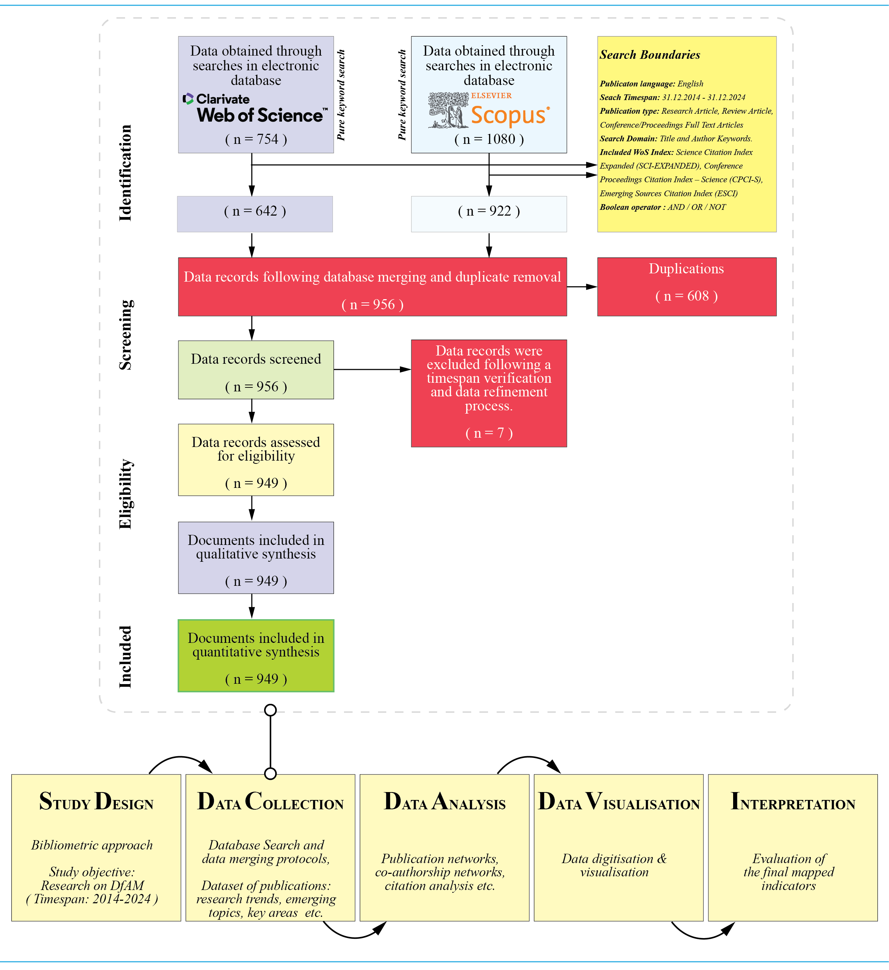

Figure 1. The mapping workflow and data collection protocol (adapted from Page et al., 2021 and Aria and Cuccurullo (2017))

- RESULTS & DISCUSSION
  - Analysis Outputs and Interpretations
    - The key details of the analysed dataset
The bibliometric analysis of research on DfAM from 2014 to 2024 indicates substantial growth, with an annual increase of 20.65%, reflecting the increasing academic and industrial interest in the domain. The merged dataset encompasses 949 publications sourced from 350 distinct sources, with an average document age of 4.41 years, underscoring the field's rapid evolution. Citation metrics further demonstrate a strong academic impact, with an average of 18.74 citations per document and a cumulative reference count of 28799 in the timespan. Authorship patterns reveal a highly collaborative research landscape, as evidenced by the contribution of 2279 authors and a mean of 4.06 co-authors per publication. In contrast, single-authored works remain scarce (28 documents), reinforcing the inherently cooperative nature of the field. Furthermore, an international co-authorship rate of 13.59% indicates moderate but growing global research collaboration, reinforcing the necessity of cross-border knowledge exchange to advance the field. An analysis of publication types indicates that journal articles (492) and conference proceedings (414) constitute the majority of contributions, whereas review articles (43) are comparatively limited. This distribution suggests a predominant focus on empirical and methodological advancements rather than synthesising existing knowledge. Overall, these findings highlight the dynamic and interdisciplinary nature of DfAM research, where increasing collaboration and international engagement continue to shape its trajectory. A detailed summary of the dataset is provided in Table 1.

Table 1. The key details of the analysed dataset (table by authors)

Description | Results
Main Information about Data
Timespan | 31.12.2014 - 31.12.2024
Sources (Journals, Proceedings, etc.) | 350
Documents | 949
Annual Growth Rate % | 20.65
Document Average Age | 4.41
Average citations per doc | 18.74
References | 28799
Document Contents
Keywords Plus (ID) (WoS) | 2740
Author's Keywords (DE) | 1941
Authors
Authors | 2279
Authors of single-authored docs (number of unique authors) | 23
Authors Collaborations
Single-authored docs (total number of single-authored docs) | 28
Co-Authors per Doc | 4.06
International co-authorships % | 13.59
Documents Type
Journal article | 492
Conference / Proceedings article | 414
Review article | 43
Total Document | 949

    - The annual volume and citation performance of the publications
The first analytical chart (Figure 2a) illustrates the annual scientific output within the field from 2014 to 2024. The data indicates a general upward trajectory in research activity, with the highest number of publications recorded in 2023 (138), followed closely by 131 in 2021 and 130 in 2024. The overall trend suggests sustained growth, particularly between 2018 and 2023, reflecting an increasing academic engagement with the subject. The annual growth rate was calculated to be 20.65%. Although a slight decline is observed in 2024, with 130 publications recorded, this reduction is likely due to incomplete data, as the publication year has not yet been fully processed by the source (not included into the dataset data). An alternative perspective on this decline (within the dataset considered in this study) suggests that the terminology and keywords within DfAM research are becoming increasingly specialised in recent years. For instance, research themes now focus on specific aspects such as topology optimization, generative design, sustainable design for AM, lightweight design for AM, and lattice structures, among others. This growing specificity may contribute to a perceived reduction in broader DfAM-related studies, as research efforts become more narrowly focused on distinct subfields within the domain (Asapu and Ravi Kumar, 2025). In the earlier years of the analysed period, publication output remained relatively modest, with 24 articles in 2014 and 41 in 2016, indicating that the research area was still in its developmental phase. These findings underscore the steady expansion of the field and its potential for continued scholarly advancement in the coming years. The citation analysis presented in Figure 2b reveals that earlier publications in this domain have accrued significantly higher citation counts than more recent works. The highest citation rates were observed for studies published in 2014 (55.75 citations per paper) and 2016 (68.68 citations per paper). However, citation counts exhibit a downward trend over time, with the average number of citations declining to 17.89 by 2020 and further decreasing to just 1.42 citations for papers published in 2024. This downward trajectory is reinforced by the negative slope of the trend line. Several factors may account for this decline. One possible explanation is the increasing volume of research output, which disperses citations across a broader range of publications. Additionally, this trend aligns with the conventional citation lifecycle of academic literature, wherein older studies have had more time to accumulate citations, while newer publications have yet to gain substantial scholarly recognition.

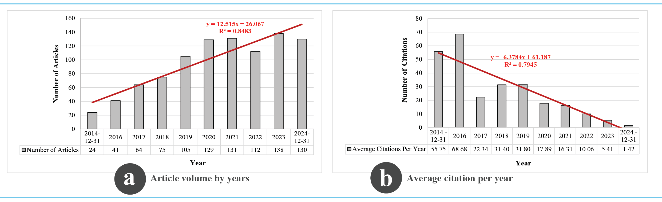

Figure 2. Annual publication volume (a) and citation impact (b) in DfAM research (figure by authors)

    - Three field plot (author, keyword and country)
The three field plot (Sankey) diagram given in Figure 3 delineates the global research landscape in DfAM, illustrating key contributors, geographical distribution, and thematic focal points. The United States, China, Germany, Italy, and the United Kingdom emerge as dominant research hubs, with leading scholars including the research groups of Timothy W. Simpson (Simpson T.) and Nicholas A. Meisel (Meisel N.) driving significant contributions. The prevailing research themes—"design for additive manufacturing," "DfAM," "3D printing," and "topology optimization" - underscore the field’s emphasis on enhancing the structural and functional performance of AM-fabricated components. Notably, the increasing focus on "lattice structures" and "generative design" signals a paradigm shift towards computationally driven, performance-oriented methodologies. Despite the described international collaboration evident in the diagram (i.e. authors in many countries), the field remains largely concentrated on established DfAM principles, necessitating a broader exploration of novel optimization techniques, sustainability considerations, and interdisciplinary integrations. It can be said that future research must move beyond conventional design frameworks, leveraging artificial intelligence (including machine learning), biomimicry, and hybrid manufacturing approaches to unlock new frontiers in AM. Additionally, the integration of DfAM into industrial-scale production remains an area of critical importance, requiring further investigation into process reliability, material performance, and regulatory standardisation. Addressing these challenges would be essential for advancing DfAM from a research-driven discipline to a transformative force in modern manufacturing.

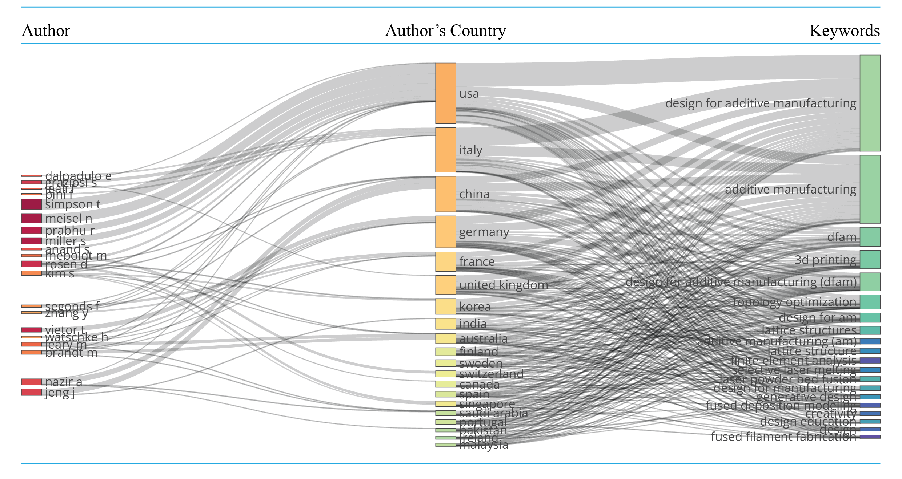

Figure 3. The three field plot (Sankey) diagram (figure by authors)

    - The core sources (journals / proceedings)
Bradford’s Law is a widely utilised bibliometric method for identifying the most influential journals within a given research field, thereby enabling scholars to optimize their literature search by focusing on the "core" sources (journals/proceedings) in the first zone (Desai et al., 2018). The distribution of publications in DfAM research, as illustrated in Figure 4 (a), applies Bradford’s Law to delineate these core sources, revealing a pronounced concentration of scholarly output within a select group of journals and proceedings. Furthermore, the H-index serves as an effective measure of research impact, as it considers both the number of publications authored by a researcher and the corresponding citation counts these publications receive (Hirsch, 2005). The outputs demonstrate a distinct concentration of publications within a limited number of journals and proceedings. The core zone consists of 11 within 350 sources, with Additive Manufacturing (40 articles), Proceedings of the Design Society (40 articles), and Rapid Prototyping Journal (39 articles) emerging as the most prolific publication venues (Figure 4b). However, when considering total citation counts, Materials & Design (2071 citations) surpasses Additive Manufacturing (1865 citations), despite the latter having a higher publication frequency (Figure 4c). This suggests that whilst Materials & Design has contributed fewer articles (15), its publications exhibit higher citation impact, potentially due to broader interdisciplinary engagement and greater relevance to the wider scientific community. The H-index rankings further reinforce this distinction, with Additive Manufacturing leading (H-index = 24), followed by Journal of Mechanical Design (H-index = 16), indicating that certain sources, despite publishing fewer articles, maintain strong influence and scholarly visibility (Figure 4d). This variation across publication volume, citation impact, and H-index rankings highlights that mere publication frequency does not necessarily equate to research influence; rather, citation patterns and scholarly engagement play a critical role in determining a source’s overall impact. The presence of engineering design and mechanical engineering journals, such as Journal of Mechanical Design and International Journal of Advanced Manufacturing Technology, within the highly cited and high-H-index sources, underscores the interdisciplinary nature of DfAM research. Furthermore, the rapid decline in publication frequency beyond the core sources indicates a fragmented research landscape, reinforcing the need for strategic dissemination to maximise visibility and cross-disciplinary knowledge transfer. These findings emphasise the importance of considering both quantitative (publication count) and qualitative (citation impact and H-index) metrics when assessing the significance and influence of research sources in DfAM.

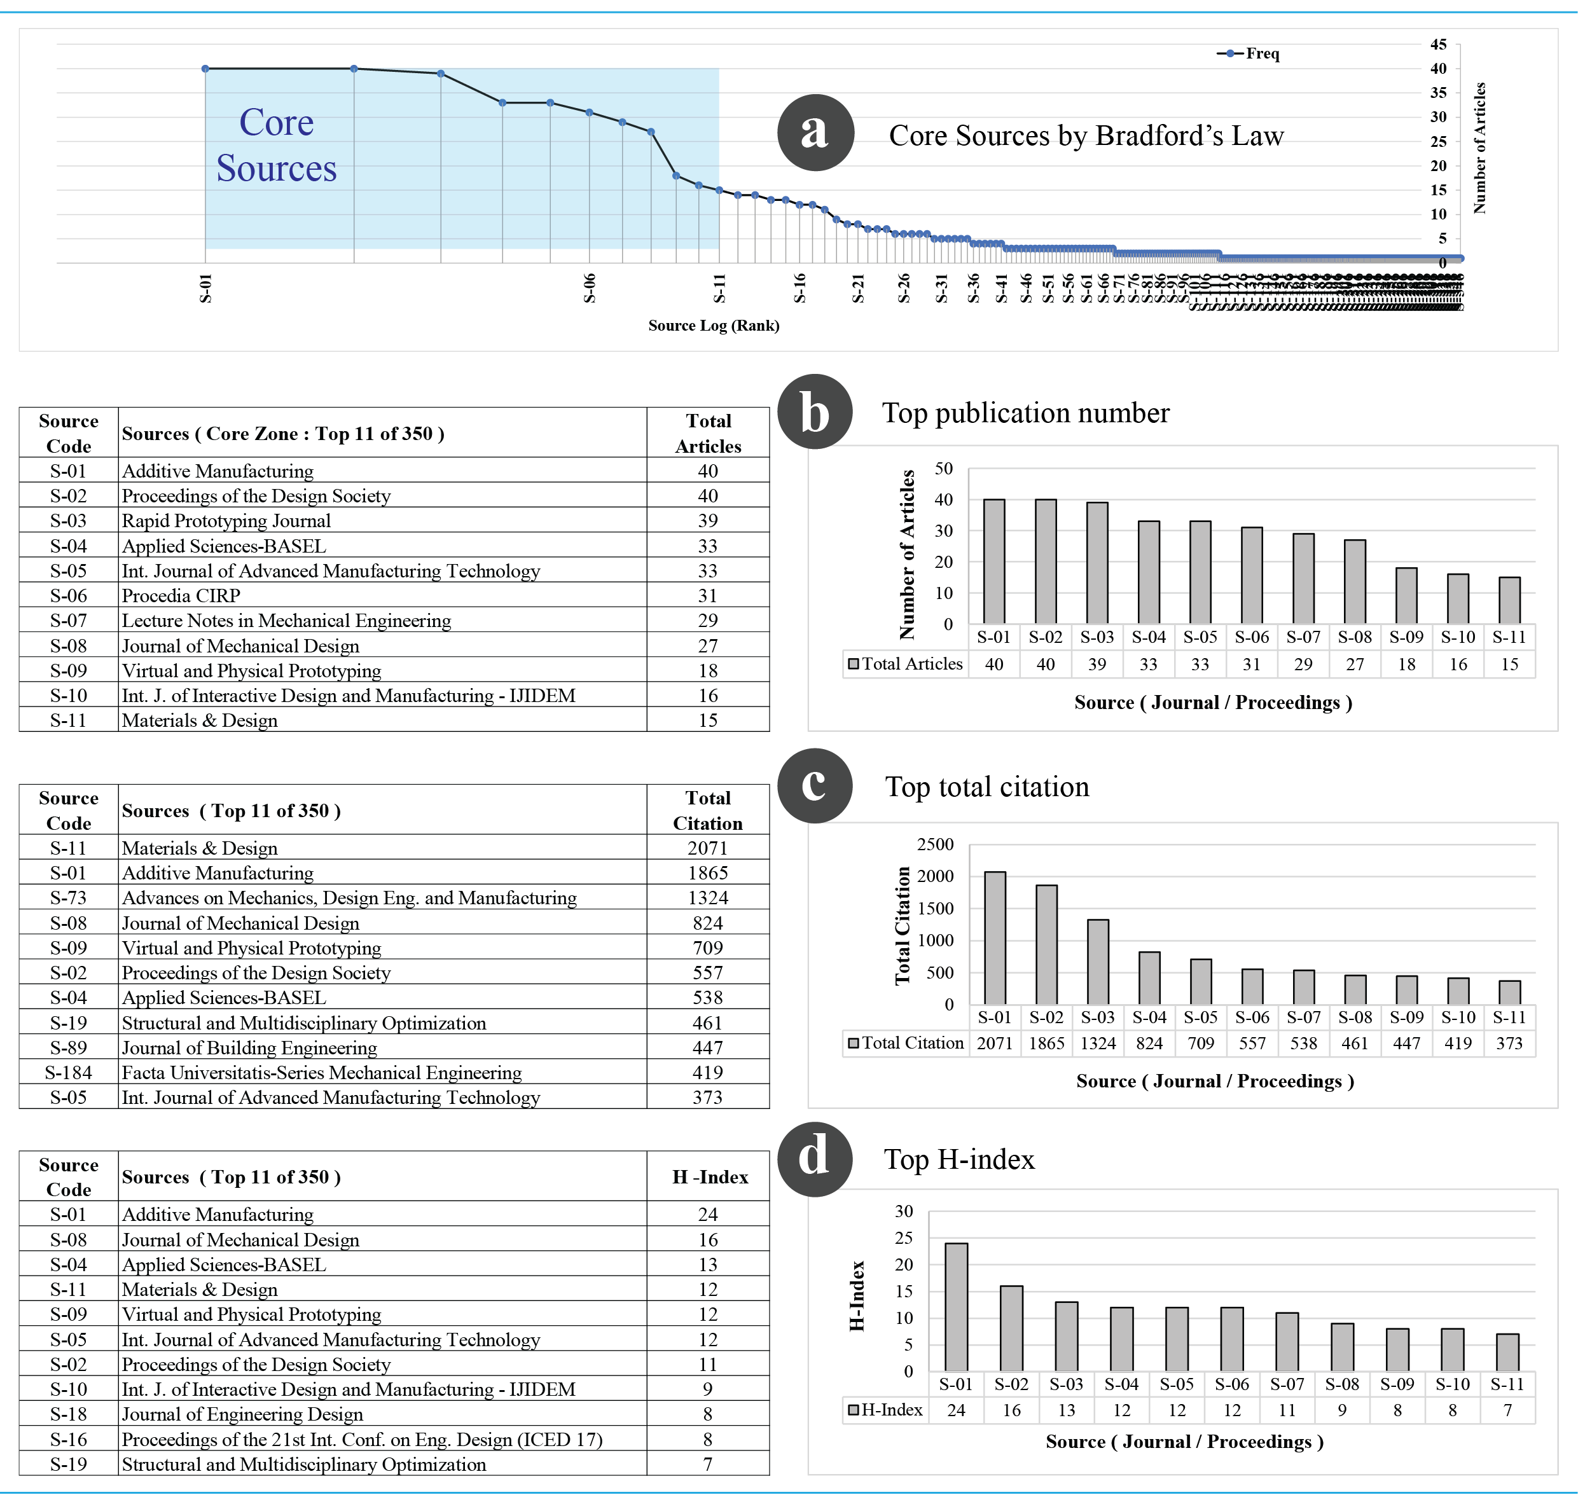

Figure 4. Core sources (journals / proceedings) defined by Bradford’s Law (a), top publication (b), total citation (c) and H-index rank (d) (figure by authors)

    - The most relevant authors
The outputs in Figure 5 (a-c) evaluates author productivity and scholarly influence within the field of DfAM through three distinct visual representations. Firstly, the ranking of the most prolific authors (Figure 5a) identifies Simpson T. (38 publications), Meisel N. (37 publications), and Miller S. (27 publications) as the leading contributors, underscoring their pivotal role in advancing DfAM research. Secondly, the application of Lotka’s Law (Figure 5b) to author productivity reveals a characteristic inverse distribution, whereby a small cohort of highly productive authors is responsible for the majority of publications, while the vast majority contribute only a limited number of papers. This pattern highlights the presence of a concentrated group of domain experts shaping the field’s scholarly discourse. Lastly, the temporal analysis of author productivity (Figure 5c) traces the research output of key contributors over time, demonstrating sustained engagement from leading scholars such as Simpson T. and Meisel N., with notable publication peaks in recent years. The varying bubble sizes further depict the total citation (TC) impact per year, illustrating that while prolific authors maintain a steady output, their citation influence fluctuates. This observation suggests that a high volume of publications does not necessarily translate to immediate scholarly impact, reinforcing the importance of balancing publication quantity with high-impact contributions. Collectively, these findings provide valuable insights into the structure of academic contributions in DfAM, identifying influential researchers, validating established bibliometric principles, and mapping the intellectual evolution of the field.
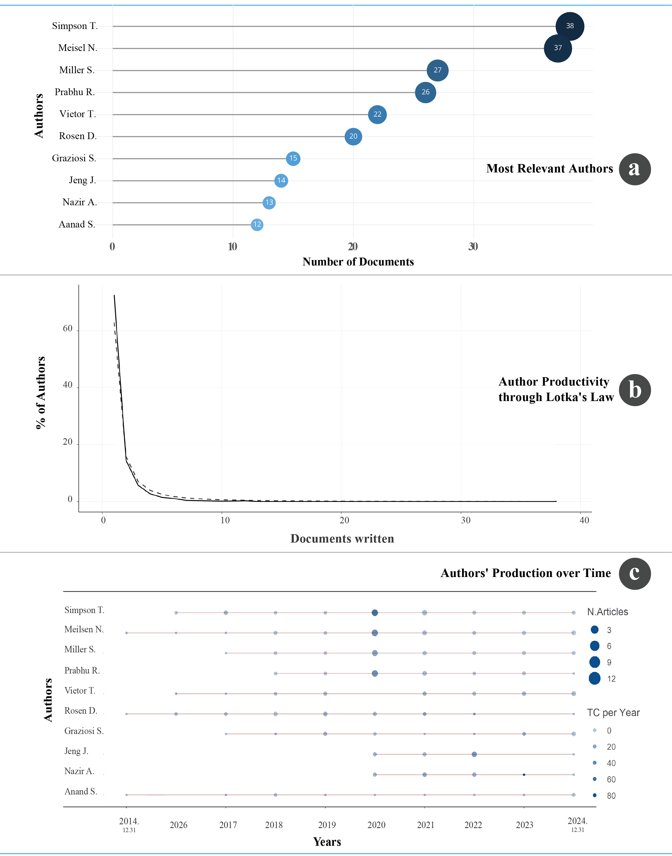

Figure 5. Author productivity and scholarly influence (figure by authors)

    - The most relevant affiliations
Figure 6 presents an analysis of institutional contributions to DfAM research through two distinct visual representations: the cumulative publication trends of leading affiliations (Figure 6a) and their scholarly output over time (Figure 6b). The cumulative analysis highlights the Pennsylvania Commonwealth System of Higher Education (PCSHE), as the dominant institution, with 253 publications—a figure significantly higher than any other contributor. The institution’s growth, particularly from 2018 onwards, indicates a concerted strategic effort to advance DfAM research, likely facilitated by specialised AM research facilities, industry partnerships, and dedicated funding programmes. Other significant contributors include the Polytechnic University of Milan (51 publications), National Taiwan University of Science and Technology (36 publications), and Braunschweig University of Technology (23 publications), reflecting the increasing globalisation of DfAM research. The evolution of institutional research output over time (Figure 6b) further reinforces PCSHE’s role as a key player, demonstrating a sustained and exponential rise in publications, growing from 12 in 2016 to 253 in 2024. European and Asian institutions, such as ETH Zurich, Singapore University of Technology and Design, and the University of Bologna, exhibit steady yet impactful contributions, highlighting the expanding role of computational design, topology optimization, and advanced material modelling in DfAM methodologies. The presence of Carnegie Mellon University and Georgia Institute of Technology in the dataset further underscores the interdisciplinary nature of DfAM research, bridging engineering, materials science, and digital manufacturing technologies.
These findings suggest that while a few institutions remain at the forefront of DfAM research, global engagement is increasing, particularly from European and Asian universities. The field’s expansion necessitates greater interdisciplinary collaboration, standardisation of design frameworks, and knowledge-sharing initiatives to facilitate the transition of DfAM from academic research to large-scale industrial implementation. As institutional involvement continues to diversify, DfAM is positioned as a pivotal discipline in modern engineering, with profound implications for manufacturing efficiency, sustainability, and design innovation. (Pennsylvania owns and operates 10 universities under the Pennsylvania State System of Higher Education (PASSHE). Notably, this classification was not explicitly delineated within the dataset - https://commonwealthfoundation.org/research/higher-education-pennsylvania/).

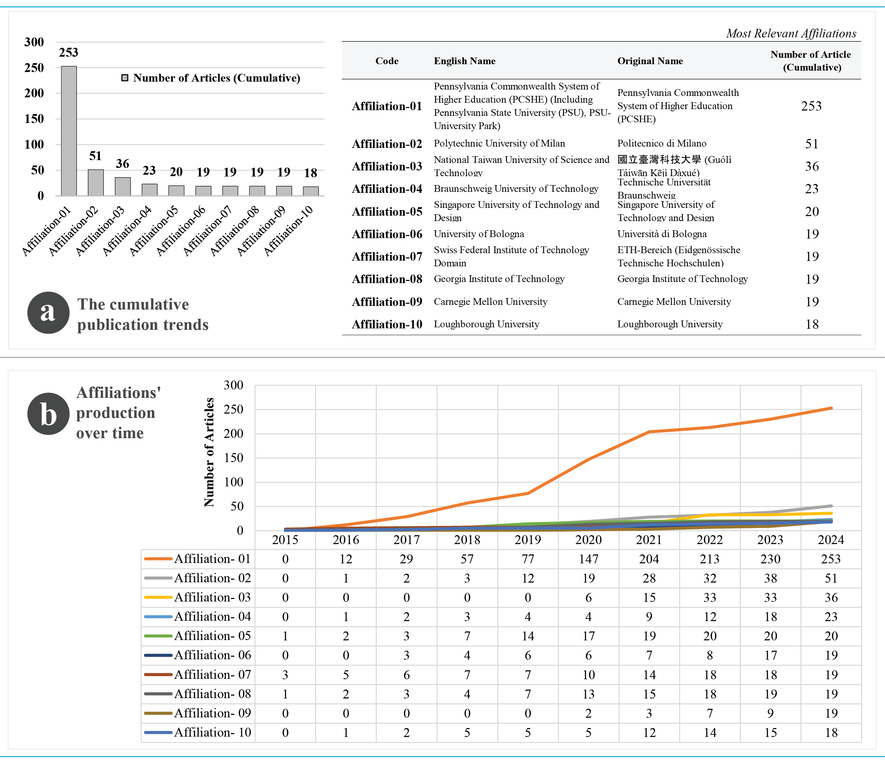

Figure 6. Evaluation of the most relevant affiliations (figure by authors)

    - The most relevant countries
Figure 7 presents a comprehensive assessment of national contributions to DfAM research through three distinct visual representations: the distribution of corresponding authors by country (Figure 7a), the temporal evolution of national research output (Figure 7b) and the citation impact of different countries (Figure 7c). The analysis of corresponding authorship (Figure 7a) reveals that the United States, Italy, and Germany are among the most prolific contributors, with a substantial proportion of their publications arising from single-country collaborations (SCP). In contrast, nations such as the United Kingdom and China exhibit a higher share of multi-country collaborations (MCP), indicating a greater emphasis on international research partnerships to enhance academic impact. The examination of research output trends (Figure 7b) highlights that the United States and China have experienced the most pronounced growth in DfAM research over the past decade, with particular observation from 2020. Meanwhile, the United Kingdom, Germany, and Italy demonstrate a steady increase in output, reinforcing their established influence within the field. The citation impact analysis (Figure 7c) identifies the United States as the most highly cited nation (4019 citations), followed by the United Kingdom (1843) and Australia (1624), reflecting the considerable influence of their research contributions. Notably, although China and Italy rank among the most productive countries in terms of publication volume, their citation impact is relatively lower, suggesting that research quantity does not necessarily equate to academic influence. Furthermore, the presence of countries such as Denmark, Singapore, and Saudi Arabia among the most highly cited nations, despite their comparatively lower research output, underscores the significance of research quality and international collaboration in achieving greater citation visibility.
Taken together, these findings illustrate the global landscape of DfAM research, the evolving role of international collaboration, and the varying impact of national contributions. They further underscore the necessity of strategic cross-border research partnerships to enhance scientific influence and visibility in the field.
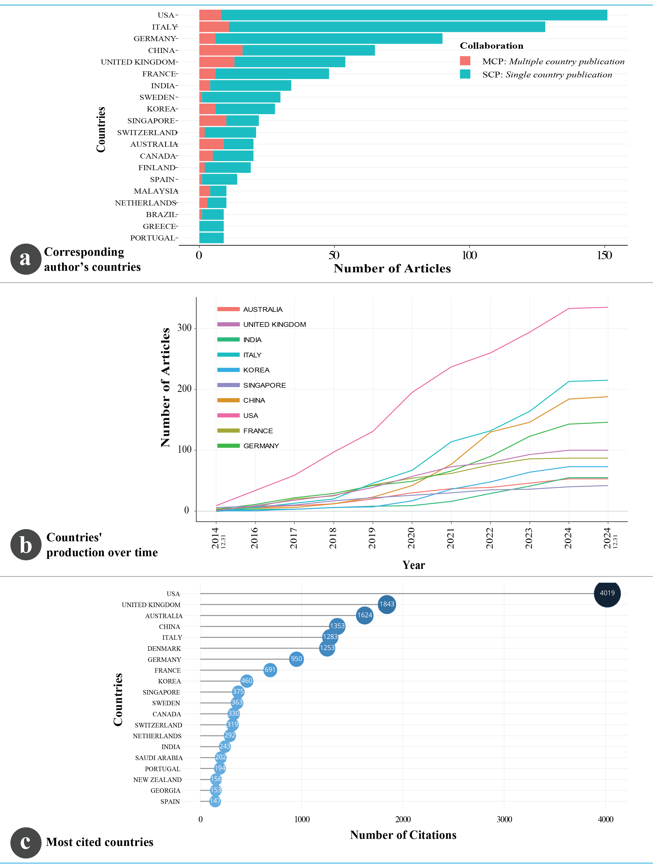

Figure 7. The most relevant countries (figure by authors)

    - The most relevant citation
The analysis presented in Table 2 and Table 3 offers a comparative assessment of the most globally cited and the most locally cited research outputs in DfAM research (In bibliometrix software, "Most Local Cited Documents" are the documents within a specified dataset that are most frequently cited by other documents in the same dataset). The globally cited outputs highlight seminal contributions that have shaped the field. Thompson et al. (2016, CIRP Annals - Manufacturing Technology) emerges as the most cited publication, accumulating 1192 citations with a remarkable annual citation rate of 119.20, affirming its foundational role in establishing DfAM principles. Similarly, Maconachie et al. (2019, Materials & Design) exhibits a high annual citation rate (122.71 per year), signifying its recent and growing influence. Notably, research on topology optimization, lattice structures, and multi-material AM—such as Leary et al. (2018, Materials & Design) and Nazir et al. (2023, Materials & Design)—demonstrates the field’s evolving focus towards optimizing structural performance and material integration. In contrast, the locally cited documents prioritise influential studies within a specific bibliometric dataset, with Thompson et al. (2016) again leading with 151 citations. Papers such as Kumke et al. (2016, Virtual and Physical Prototyping) and Gao et al. (2015, Computer-Aided Design), while featuring fewer global citations, hold strong relevance within this database, indicating their concentrated impact on DfAM methodologies and computational design approaches. Additionally, the presence of earlier works, such as Rosen (2007, Computer-Aided Design and Applications) and Adam & Zimmer (2014, CIRP Journal of Manufacturing Science and Technology), suggests that foundational research on computational modelling and structural optimization continues to be widely referenced in domain-specific literature.
The discrepancy between global and local citation metrics highlights how certain studies gain broader interdisciplinary recognition, while others remain core references within a specialised research community. This divergence underscores the importance of both high-impact foundational research and field-specific advancements, reinforcing the structured dissemination of DfAM knowledge across both broad academic networks and specialised domains.
Table 2. Most global cited documents (Top 10) (table by authors)
Rank | Paper Reference ( Most global cited documents (Top 10) ) | DOI | Total Citations | Times Cited per Year
1 | Thompson, M.K., Moroni, G., Vaneker, T.H.T., Fadel, G., Campbell, R.I., Gibson, I., Bernard, A., et al. (2016), “Design for Additive Manufacturing: Trends, opportunities, considerations, and constraints”, CIRP Annals, Vol. 65 No. 2, pp. 737–760. | 10.1016/j.cirp.2016.05.004 | 1192 | 119.20
2 | Maconachie, T., Leary, M., Lozanovski, B., Zhang, X., Qian, M., Faruque, O. and Brandt, M. (2019), “SLM lattice structures: Properties, performance, applications and challenges”, Materials & Design, Vol. 183, p. 108137. | 10.1016/j.matdes.2019.108137 | 859 | 122.71
3 | Plocher, J. and Panesar, A. (2019), “Review on design and structural optimization in additive manufacturing: Towards next-generation lightweight structures”, Materials & Design, Vol. 183, p. 108164. | 10.1016/j.matdes.2019.108164 | 419 | 59.86
4 | Yang, L., Harrysson, O., West, H. and Cormier, D. (2015), “Mechanical properties of 3D re-entrant honeycomb auxetic structures realized via additive manufacturing”, International Journal of Solids and Structures, Vol. 69–70, pp. 475–490. | 10.1016/j.ijsolstr.2015.05.005 | 419 | 38.09
5 | Panesar, A., Abdi, M., Hickman, D. and Ashcroft, I. (2018), “Strategies for functionally graded lattice structures derived using topology optimization for Additive Manufacturing”, Additive Manufacturing, Vol. 19, pp. 81–94. | 10.1016/j.addma.2017.11.008 | 371 | 46.38
6 | Gaynor, A.T. and Guest, J.K. (2016), “Topology optimization considering overhang constraints: Eliminating sacrificial support material in additive manufacturing through design”, Structural and Multidisciplinary Optimization, Vol. 54 No. 5, pp. 1157–1172. | 10.1007/s00158-016-1551-x | 327 | 32.70
7 | Leary, M., Mazur, M., Williams, H., Yang, E., Alghamdi, A., Lozanovski, B., Zhang, X., et al. (2018), “Inconel 625 lattice structures manufactured by selective laser melting (SLM): Mechanical properties, deformation and failure modes”, Materials & Design, Vol. 157, pp. 179–199. | 10.1016/j.matdes.2018.06.010 | 316 | 39.50
8 | Nazir, A., Gokcekaya, O., Md Masum Billah, K., Ertugrul, O., Jiang, J., Sun, J. and Hussain, S. (2023), “Multi-material additive manufacturing: A systematic review of design, properties, applications, challenges, and 3D printing of materials and cellular metamaterials”, Materials & Design, Vol. 226, p. 111661. | 10.1016/j.matdes.2023.111661 | 252 | 84.00
9 | Herzberger, J., Sirrine, J.M., Williams, C.B. and Long, T.E. (2019), “Polymer Design for 3D Printing Elastomers: Recent Advances in Structure, Properties, and Printing”, Progress in Polymer Science, Vol. 97, p. 101144. | 10.1016/j.progpolymsci.2019.101144 | 205 | 29.29
10 | Yuan, S., Li, S., Zhu, J. and Tang, Y. (2021), “Additive manufacturing of polymeric composites from material processing to structural design”, Composites Part B: Engineering, Vol. 219, p. 108903. | 10.1016/j.compositesb.2021.108903 | 146 | 29.20

Table 3. Most local cited documents (Top 10) (figure by authors)
Rank | Paper Reference  (Most local cited documents (Top 10) within selected database - 949 Docs) | DOI | Citations
1 | Thompson, M.K., Moroni, G., Vaneker, T.H.T., Fadel, G., Campbell, R.I., Gibson, I., Bernard, A., et al. (2016), “Design for Additive Manufacturing: Trends, opportunities, considerations, and constraints”, CIRP Annals, Vol. 65 No. 2, pp. 737–760. | 10.1016/j.cirp.2016.05.004 | 151
2 | Kumke, M., Watschke, H. and Vietor, T. (2016), “A new methodological framework for design for additive manufacturing”, Virtual and Physical Prototyping, Vol. 11 No. 1, pp. 3–19. | 10.1080/17452759.2016.1139377 | 70
3 | Jemghili, R., Ait Taleb, A. and Khalifa, M. (2021), “A bibliometric indicators analysis of additive manufacturing research trends from 2010 to 2020”, Rapid Prototyping Journal, Vol. 27 No. 7, pp. 1432–1454. | 10.1016/j.cad.2015.04.001 | 66
4 | Laverne, F., Segonds, F., Anwer, N. and Le Coq, M. (2015), “Assembly Based Methods to Support Product Innovation in Design for Additive Manufacturing: An Exploratory Case Study”, Journal of Mechanical Design, Vol. 137 No. 12. | 10.1115/1.4031589 | 64
5 | Rosen, D.W. (2007), “Computer-Aided Design for Additive Manufacturing of Cellular Structures”, Computer-Aided Design and Applications, Vol. 4 No. 5, pp. 585–594. | 10.1080/16864360.2007.10738493 | 60
6 | Yang, S. and Zhao, Y.F. (2015), “Additive manufacturing-enabled design theory and methodology: a critical review”, The International Journal of Advanced Manufacturing Technology, Vol. 80 No. 1–4, pp. 327–342. | 10.1007/s00170-015-6994-5 | 60
7 | Adama, G.A.O. and Zimmer, D. (2014), “Design for Additive Manufacturing-Element transitions and aggregated structures”, CIRP Journal of Manufacturing Science and Technology, Vol. 7 No. 1, pp. 20–28. | 10.1016/j.cirpj.2013.10.001 | 58
8 | Kranz, J., Herzog, D. and Emmelmann, C. (2015), “Design guidelines for laser additive manufacturing of lightweight structures in TiAl6V4”, Journal of Laser Applications, Vol. 27 No. S1. | 10.2351/1.4885235 | 56
9 | Vayre, B., Vignat, F. and Villeneuve, F. (2012), “Designing for Additive Manufacturing”, Procedia CIRP, Vol. 3, pp. 632–637. | 10.1016/j.procir.2012.07.108 | 54
10 | Ponche, R., Kerbrat, O., Mognol, P. and Hascoet, J.-Y. (2014), “A novel methodology of design for Additive Manufacturing applied to Additive Laser Manufacturing process”, Robotics and Computer-Integrated Manufacturing, Vol. 30 No. 4, pp. 389–398. | 10.1016/J.RCIM.2013.12.001 | 47

    - The most frequent words
The analysis of word occurrences and trend topics in DfAM research provides valuable insights into the thematic evolution of the field (Figure 8 (a-d)). The author's keywords analysis (Figure 8a) indicates that ‘Design for Additive Manufacturing’ (464 occurrences) and ‘Additive Manufacturing’ (369 occurrences) are the most frequently used terms, highlighting the research community's strong focus on integrating design principles with AM technologies. Other recurrent terms, such as ‘Topology Optimization’ (78 occurrences), ‘Lattice Structures’ (28 occurrences), and ‘Laser Powder Bed Fusion’ (28 occurrences), suggest a methodological emphasis on structural efficiency, lightweight design, and advanced manufacturing techniques. The research title analysis (Figure 8b) further reinforces these observations, with high-frequency unigrams such as ‘Design’ (677 occurrences), ‘Manufacturing’ (644 occurrences), and ‘Additive’ (642 occurrences) signifying the dominant research themes. Bigram and trigram analyses highlight key technical areas such as ‘Topology Optimization’ (40 occurrences) and ‘Powder Bed Fusion’ (22 occurrences), indicating a continued interest in optimizing geometries and material properties to enhance AM performance. The subject category analysis (Figure 8c) classifies the disciplinary distribution of DfAM research, with ‘Engineering Manufacturing’ (266 occurrences) and ‘Materials Science Multidisciplinary’ (225 occurrences) emerging as the most prominent categories. The presence of ‘Computer Science Interdisciplinary Applications’ (41 occurrences) and ‘Physics Applied’ (58 occurrences) suggests that computational modelling and physics-based simulations are increasingly contributing to AM research. The trend analysis of author keywords (Figure 8d) provides a temporal perspective on DfAM research developments. The dataset shows that the dominant terms ‘Design for Additive Manufacturing’ and ‘Additive Manufacturing’ have remained consistent from 2019 to 2023. However, emerging terms such as ‘Generative Design’ and ‘Selective Laser Melting’, with median years of 2023, suggest a growing focus on advanced computational design strategies and laser-based AM processes. The increasing research activity in design automation, education, and multi-material fabrication techniques indicates an expanding scope of DfAM applications.
Overall, the analysis underscores the evolution of DfAM as a multidisciplinary field, integrating computational optimization, materials science, and advanced manufacturing methodologies. The observed trends suggest that while foundational research areas such as topology optimization and lattice structures remain central, emerging technologies and computational design methodologies are shaping the future direction of DfAM.
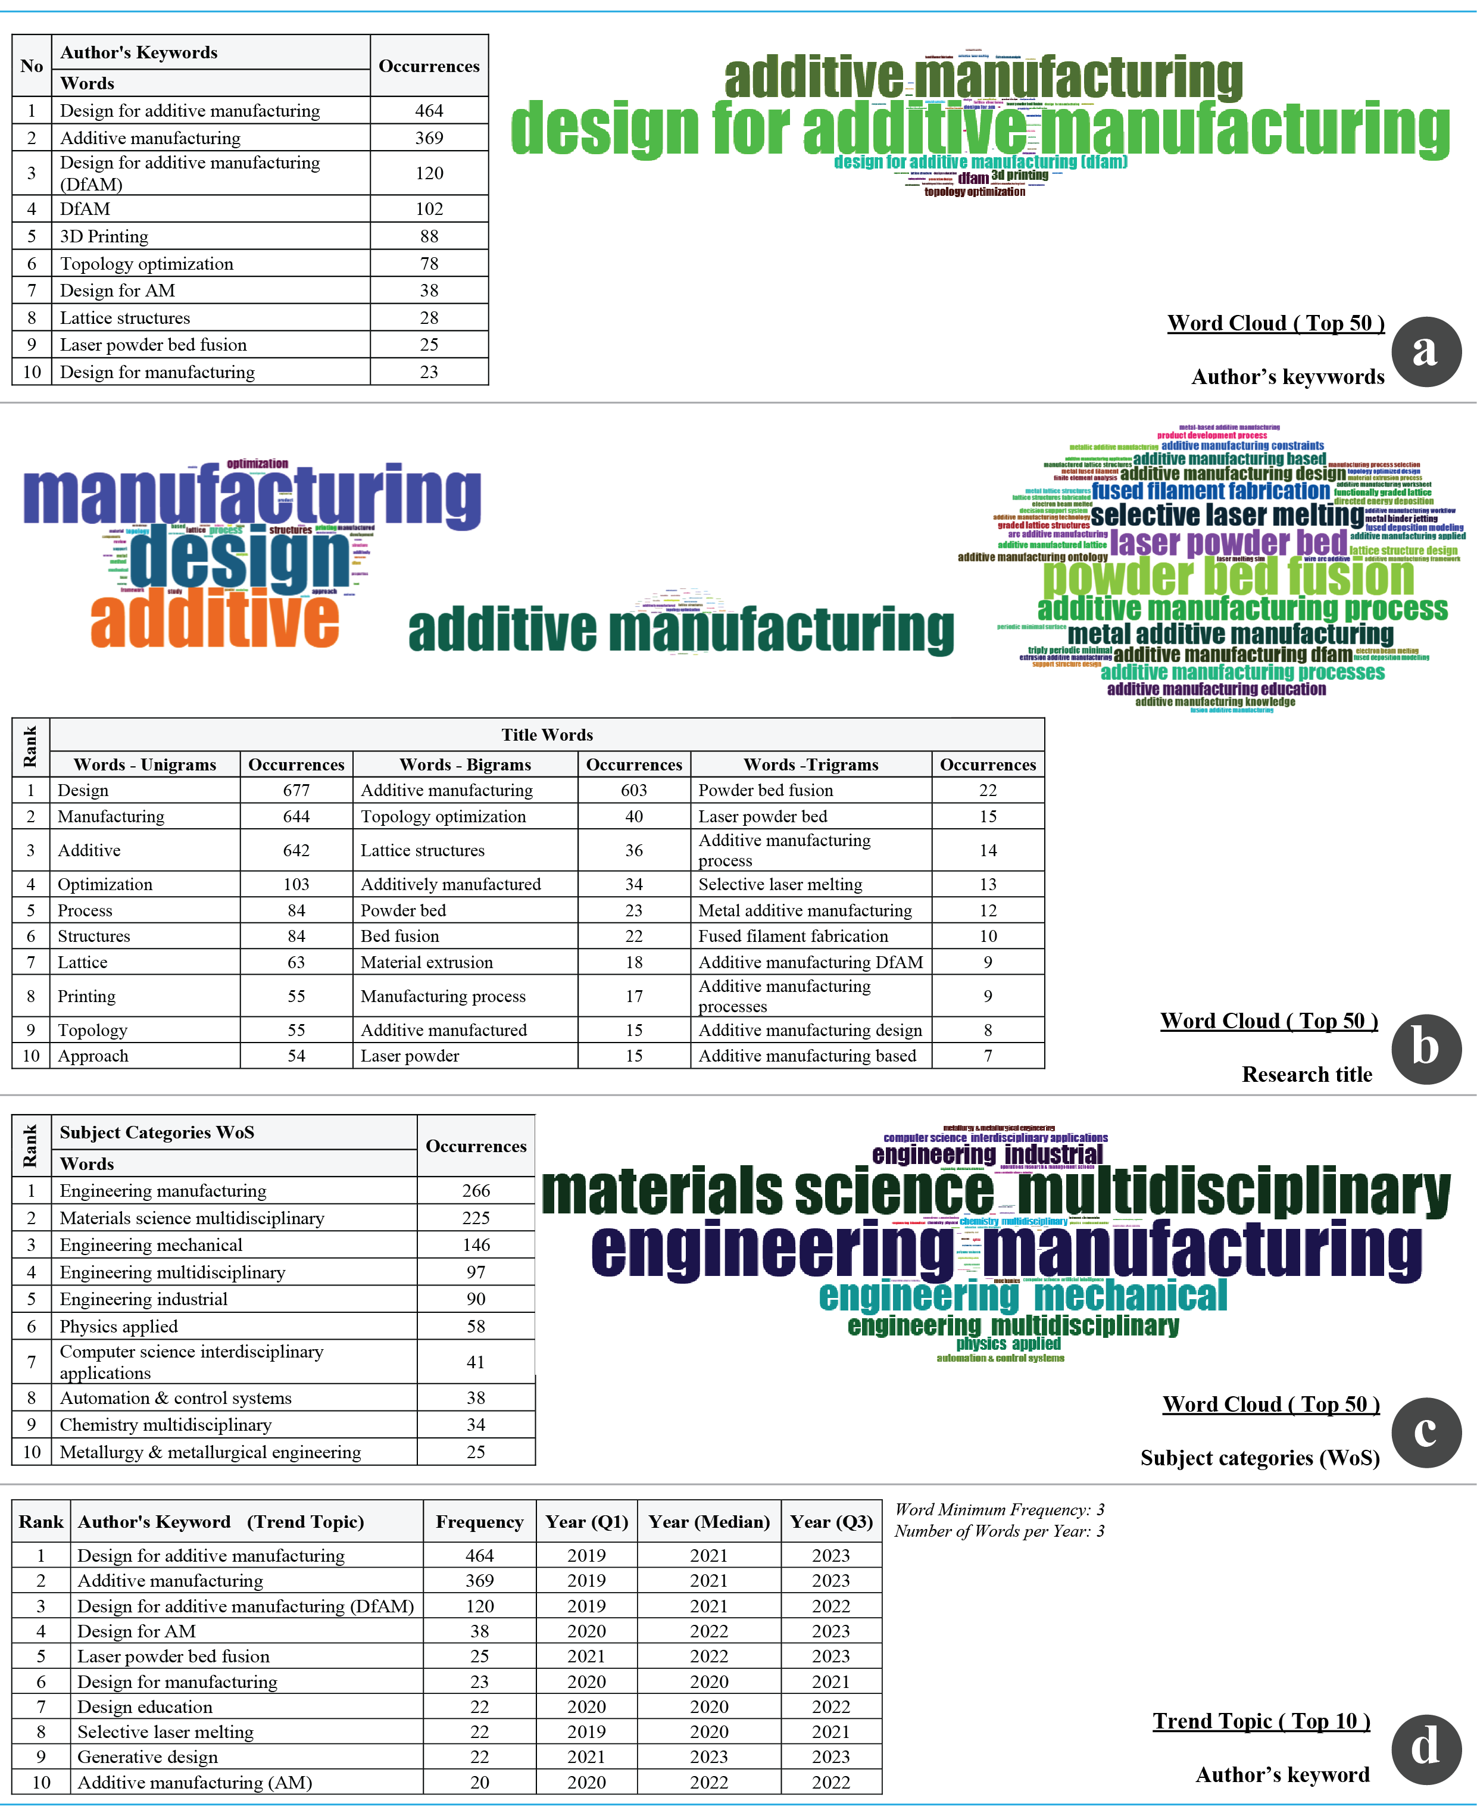

Figure 8. The most frequent words (figure by authors)

    - Co-occurrence network
The co-occurrence network of author keywords, based on 949 documents spanning 23 clusters, highlights the centrality and interconnectedness of key terms (Figure 9a). "Design for Additive Manufacturing" and "Additive Manufacturing" exhibit the highest betweenness centrality, indicating their pivotal role in shaping the research discourse. The presence of related keywords such as “3D Printing,” “Topology Optimization,” and “Lattice Structures” suggests a strong emphasis on geometrical optimization, computational design approaches, and function-driven material usage in AM. The cumulative degree distribution further confirms that DfAM is the most influential keyword, followed by Additive Manufacturing. The degree of interconnectedness suggests that DfAM research is expanding beyond theoretical explorations towards practical, application-oriented approaches, particularly in structural and performance-driven designs. The inclusion of “Computational Fluid Dynamics” (CFD) and “Creativity” indicates an increasing interest in fluid-structure interactions and generative design methodologies in AM. The ranking table also underscores the dominance of DfAM-related topics, with high PageRank values for “3D Printing,” “Topology Optimization,” and “Lattice Structures.” This suggests that these subfields serve as critical enablers of DfAM implementation, with lattice structures playing a key role in lightweight and high-strength design applications.
The co-occurrence network of subject categories (Web of Science), based on 949 documents across seven clusters, provides a macroscopic view of the disciplinary spread of DfAM research (Figure 9b). Engineering, Manufacturing emerges as the dominant research domain, followed by Materials Science, Multidisciplinary and Engineering, Mechanical. These findings reinforce the strong link between DfAM and engineering applications, particularly in aerospace, automotive, and biomedical industries, where optimized geometries and material efficiencies are paramount. The cumulative degree distribution reveals a high correlation between Engineering, Manufacturing and Materials Science, Multidisciplinary, demonstrating the interdisciplinary nature of DfAM. The inclusion of Green & Sustainable Science & Technology in the ranking suggests that DfAM is increasingly being explored from an environmental sustainability perspective, likely driven by its potential to reduce material waste and energy consumption in production processes. Notably, the presence of Computer Science, Interdisciplinary Applications and Computer Science, Theory & Methods within the top-ranked categories indicates a growing interest in algorithm-driven design, artificial intelligence (AI)-assisted DfAM, and computational modelling approaches. These findings align with the recent surge in machine learning and generative design frameworks being integrated into AM workflows.
These outputs indicate that DfAM has evolved into a multidisciplinary field, drawing from engineering, materials science, and computational methodologies. The dominance of “Topology Optimization” and “Lattice Structures” highlights a strong focus on optimized structural efficiency, while the emergence of sustainability and AI-driven design frameworks suggests that future research will likely shift towards automation, eco-conscious manufacturing, and smart design methodologies. Moreover, the high degree of connectivity between engineering, manufacturing, and materials science disciplines indicates that DfAM is at the intersection of multiple research domains, necessitating further collaboration between material scientists, engineers, and computational designers. Future research should aim to bridge the gap between theoretical design methodologies and real-world industrial applications, particularly in mass customisation, lightweighting strategies, and AI-driven generative design techniques.

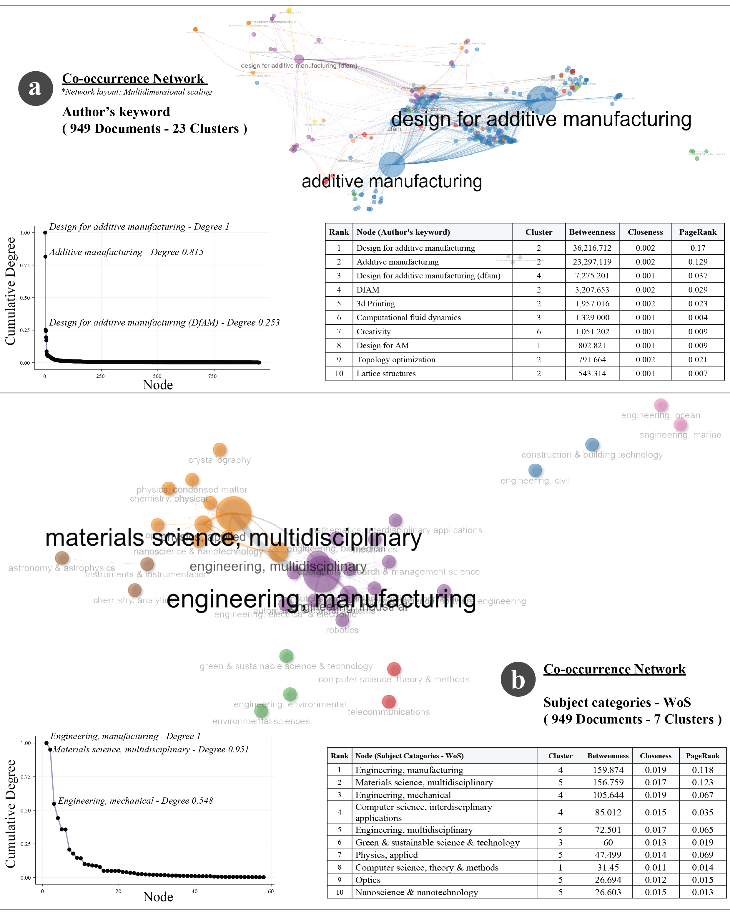

Figure 9. Co-occurrence network (figure by authors)

    - Co-citation network
The analysis reveals key influential publications and their interconnections, providing insight into the intellectual structure of the field. The heatmap-based co-citation network (Figure 10) highlights Thompson et al. (2016) as the most central and frequently co-cited work, exhibiting the highest degree of connectivity (degree: 1.0), indicating its foundational role in DfAM. Other highly co-cited works include Gao et al. (2015) (degree: 0.524) and Leary et al. (2014) (degree: 0.516), both of which focus on computational design strategies and performance optimization in AM. The presence of Chu et al. (2008) and Rosen (2007) in the co-citation map underscores the long-standing influence of early research on topology optimization and computational design methodologies in AM. The tabular ranking of co-cited papers further reinforces these findings, with Thompson et al. (2016) leading in betweenness centrality (65,607.460), demonstrating its pivotal role in connecting diverse research strands within DfAM. Notably, Blösch-Paidosh et al. (2019) and Ahn et al. (2002) exhibit high betweenness values, suggesting their impact on specific subdomains, such as design automation and functional material integration. The inclusion of Schmelzle et al. (2015) and Kumke et al. (2016) highlights the growing focus on methodological frameworks for design optimization in AM.
The overall structural composition of the co-citation network suggests that DfAM research is deeply rooted in computational modelling, topology optimization, and advanced material processing techniques, with an increasing shift towards multi-disciplinary and application-driven innovations. The clustering of highly cited papers into distinct yet interconnected research streams indicate a well-established but evolving field, where foundational studies continue to shape emerging advancements in design methodologies, material sciences, and industrial applications of AM.
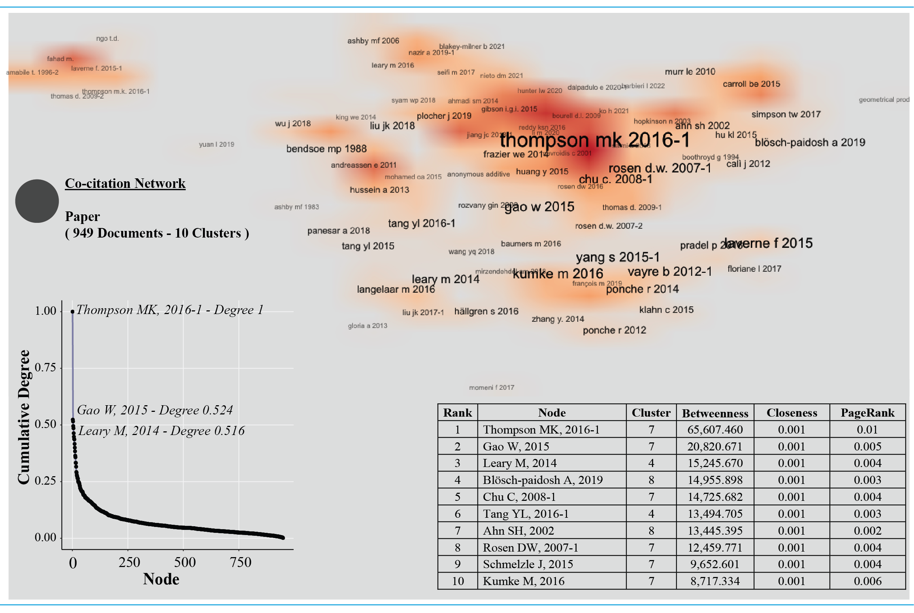

Figure 10. Co-citation network (figure by authors)

    - Collaboration network
Figure 11 gives valuable insights into author and institutional research partnerships. The author collaboration network (Figure 11a) identifies Simpson T. as the most central and highly connected researcher (degree: 1.0, betweenness: 150.267), signifying his pivotal role in linking different research groups. Meisel N. and Miller S. also exhibit high connectivity, reinforcing their influence in shaping collaborative efforts in the field. The presence of Prabhu R., Mathur J., and Williams C. within the network suggests that DfAM research benefits from cross-institutional and interdisciplinary collaborations, particularly in the integration of computational design, materials science, and advanced manufacturing processes. The country collaboration network (Figure 11b) highlights Italy as the most influential node (betweenness: 215.181), closely followed by the USA (172.626) and the United Kingdom (148.24). The dominance of these countries indicates that DfAM research is primarily driven by leading industrial and academic institutions in Europe and North America. The strong presence of China, France, and Germany in the network further underscores the global reach of collaborative efforts, particularly in areas related to topology optimization, process development, and industrial applications of AM. The global collaboration map (Figure 11c) visualises the geographic distribution of international partnerships, highlighting frequent collaborations between the USA and Singapore (13 instances), Korea and Singapore (7), and China and the UK (6). The USA’s extensive research partnerships, particularly with China, Korea, and the UK, suggest that knowledge exchange in DfAM is facilitated through well-established international research networks. Similarly, Italy’s high betweenness centrality reflects its strong engagement in European collaborative projects.
Overall, the findings indicate that DfAM research is highly collaborative and interdisciplinary, with strong institutional and geographic research networks. The structured global partnerships observed in the analysis suggest that international cooperation is essential in driving innovation, advancing computational design methodologies, and expanding industrial applications in AM.

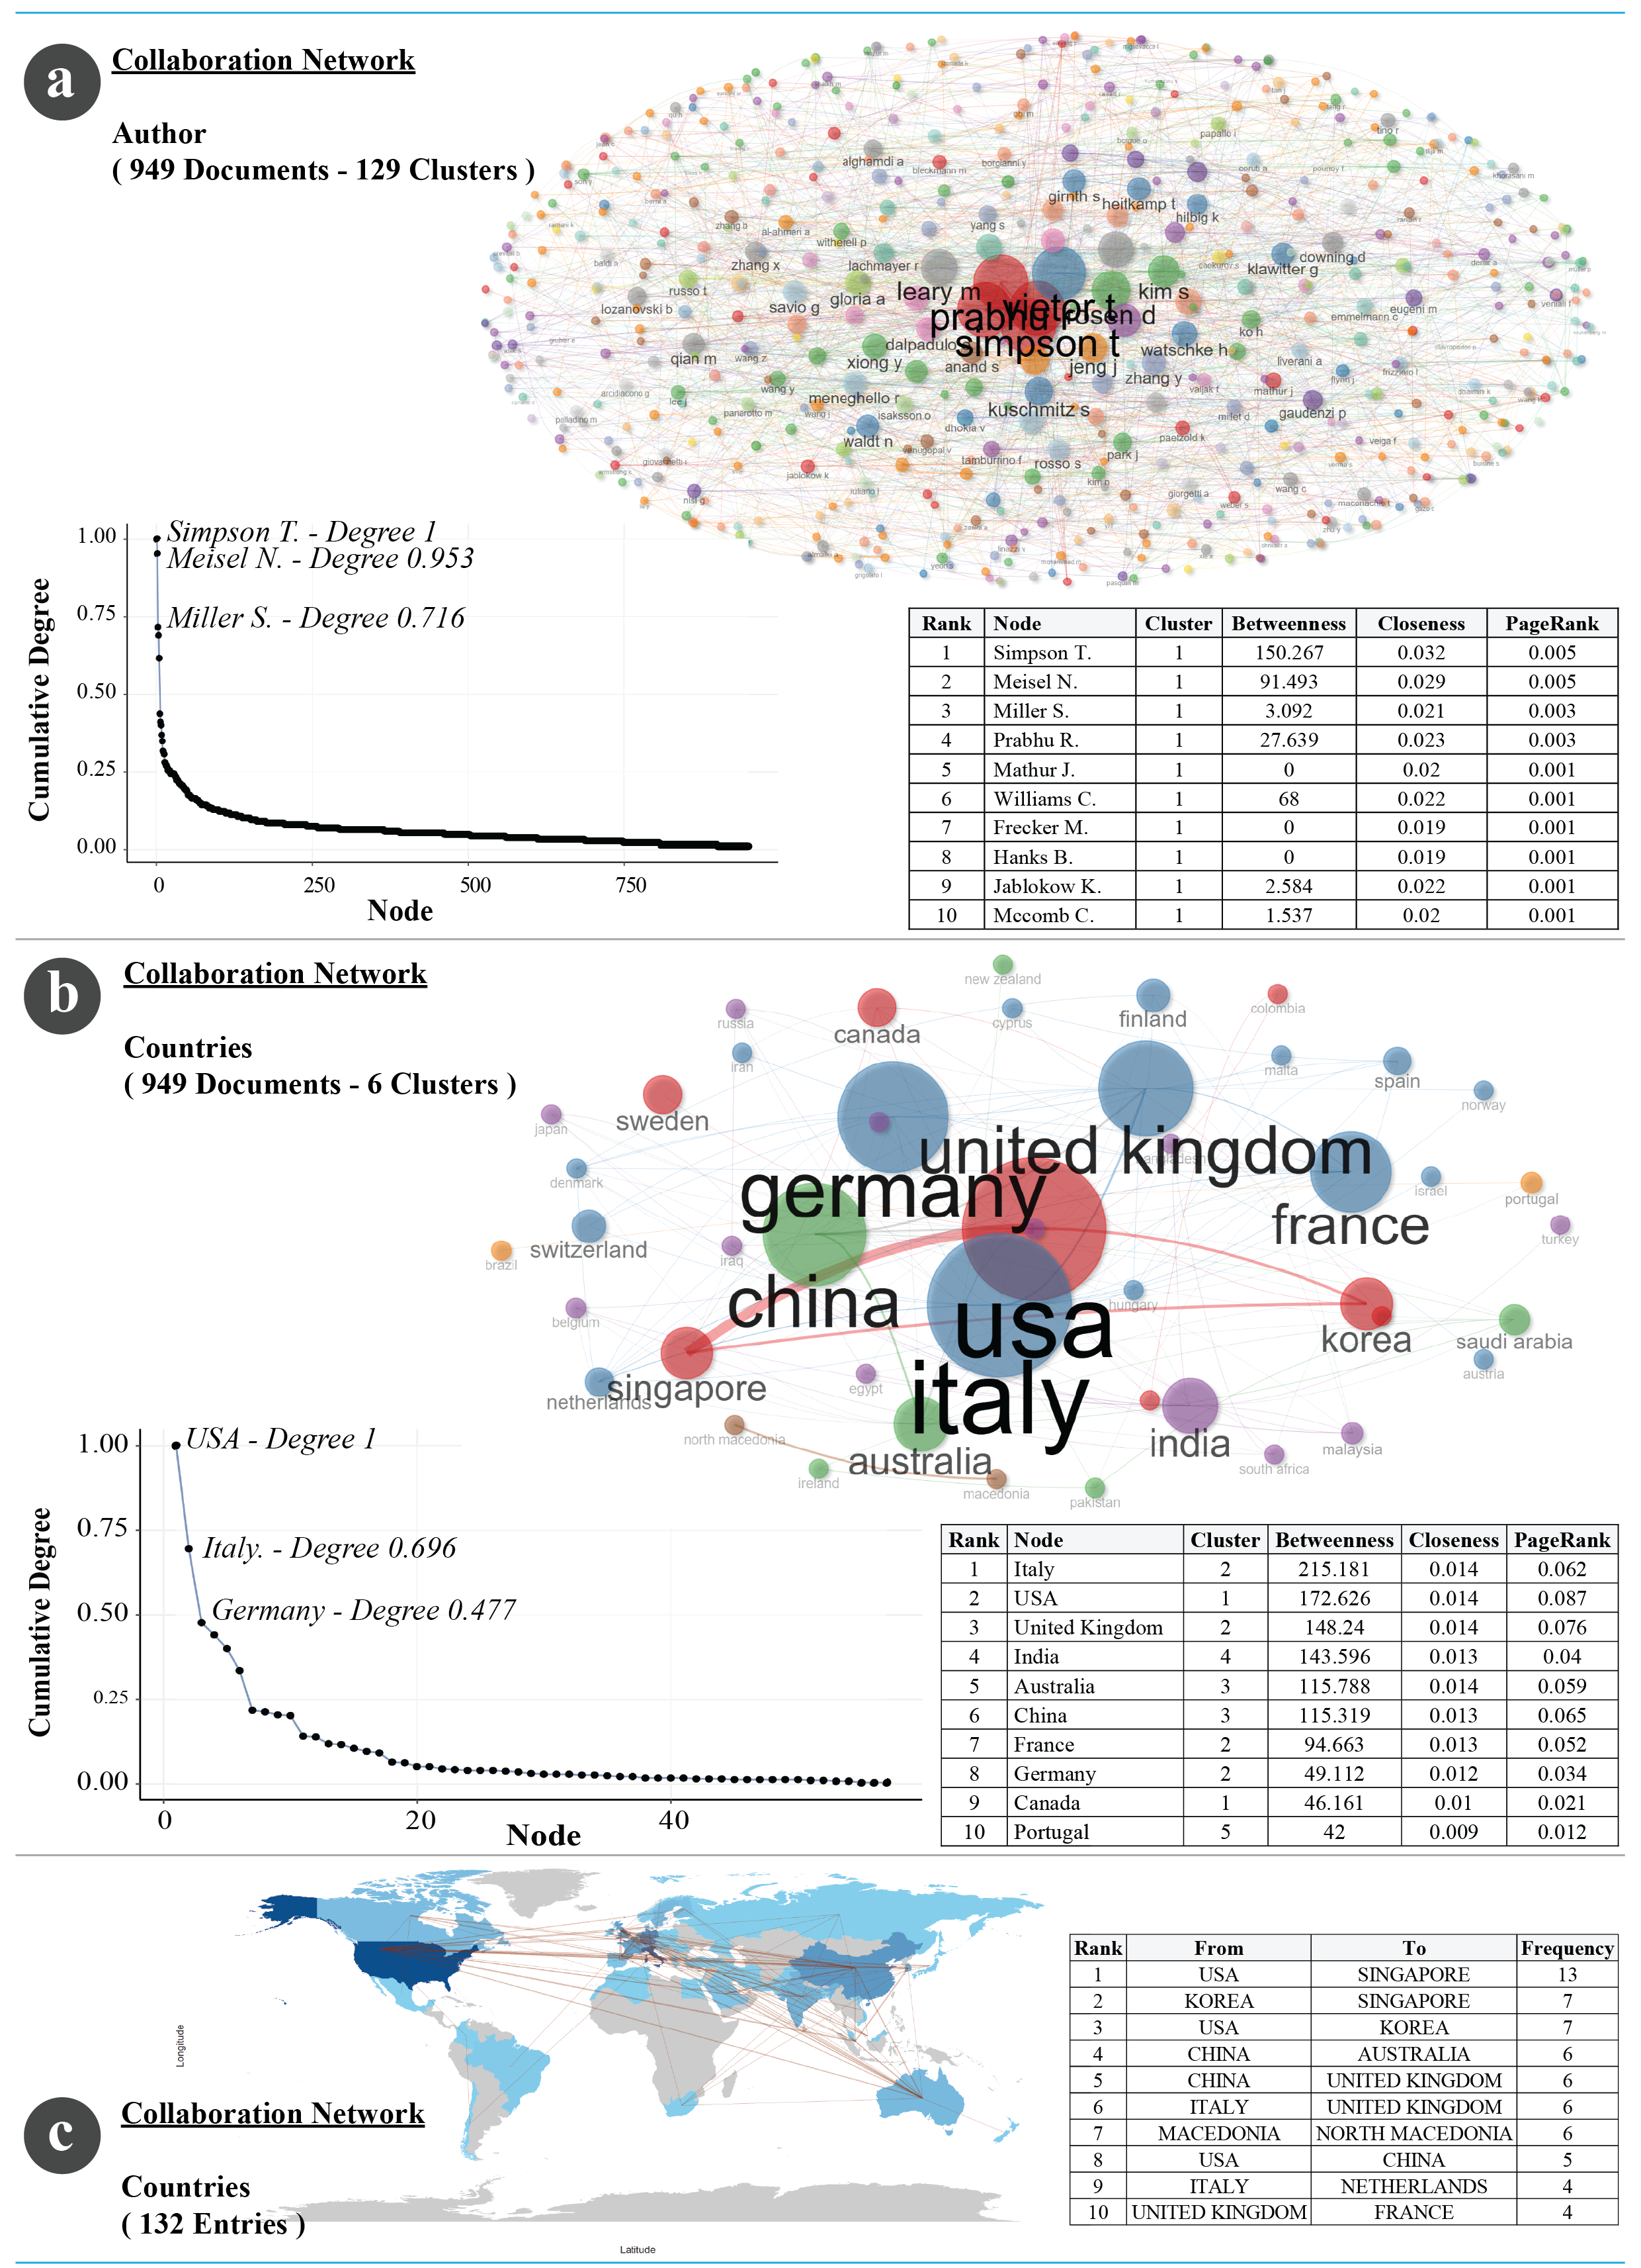

Figure 11. Collaboration Network (figure by authors)

  - Comparative Discussion
The results of this bibliometric analysis offer an extensive perspective on the evolution and impact of DfAM research from 2014 to 2024. Compared to earlier bibliometric studies such as Obi et al (2022) and Wiberg et al. (2019) which primarily examined research outputs up to 2020, this study provides an updated, multi-database synthesis that integrates/merges data from both Web of Science and Scopus, a methodological improvement over previous single-database approaches (Obi et al., 2022; Wiberg et al., 2019).
    - Comparison with previous bibliometric analyses
Prior studies such as Thompson et al. (2016) identified the foundational principles and key research themes in DfAM, primarily focusing on constraints and industrial applications. More recent reviews, such as Murugan & Vinodh (2024), expanded on these principles by classifying various DfAM methodologies and discussing the need for an integrated approach that balances design freedom with manufacturing constraints (Murugan and Vinodh, 2024; Thompson et al., 2016).
    - The present study highlights several important trends
This study observed a significant increase in publication volume, with an annual growth rate of 20.65%, peaking in 2023. This surpasses the 15.2% growth rate observed in previous analyses (Murugan and Vinodh, 2024). While earlier studies emphasised topology optimization and process selection, our findings indicate a growing focus on generative design, artificial intelligence-driven DfAM, and sustainability considerations in addition to topology optimization (Alfaify et al., 2020; Mehrpouya et al., 2021; Plocher and Panesar, 2019; Wang et al., 2023; Wiberg et al., 2021). Unlike previous analyses that identified North America and Western Europe as dominant contributors (Guertler et al., 2022). This study highlights a growing research presence, most especially in countries such as China and India, suggesting an increasing globalisation of DfAM research.
    - Emerging trends and methodological differences
Recent systematic reviews, such as Khan & Riccio (2024), have focused on specialised applications, particularly in aerospace, where lattice structures are being optimized to reduce weight while maintaining mechanical integrity. This study corroborates those findings but further extends them by identifying a rising interest in cross-disciplinary applications, such as the integration of DfAM into biomedical and construction engineering. A key distinction in our methodology compared to past studies is the combined database approach. Whilst Obi et al. (2022) relied on Scopus data alone, the analysis in this paper integrates Web of Science, ensuring broader coverage and a more comprehensive citation network, which helps mitigate database-specific biases (Khan and Riccio, 2024; Obi et al., 2022).
    - Thematic shifts in DfAM research
One of the most significant findings of this study is the thematic evolution of DfAM research. In the scope of Traditional Focus (2014–2019); The field was primarily concerned with material properties, manufacturability constraints, and optimization of single-component designs (Taborda et al., 2021). Recent Developments (2020–2024) indicates that there has been a surge in research on multi-material printing, biologically inspired DfAM, and machine learning-driven design strategies, with a notable emphasis on process reliability and standardisation (Obi et al., 2022; Obilanade, 2023; Rosen, 2014). These shifts indicate that while foundational DfAM research remains relevant, the field is moving towards more complex, multi-functional designs that leverage computational tools for real-time optimization (Egan, 2023)
    - Future directions
This study underscores the interdisciplinary expansion of DfAM, where computational modelling, materials science, and advanced manufacturing methodologies are converging. Whilst earlier research focused on topology optimization and process integration, current and future directions suggest a stronger emphasis on: Design automation using artificial intelligence; Sustainability-driven innovations, particularly in material reuse and waste reduction; and standardisation efforts for industrial-scale implementation. The findings reinforce the need for continued exploration of real-world applications, with greater emphasis on process repeatability, automation, and lifecycle assessment, ensuring that DfAM transitions from an academic-driven discipline to a fully integrated industrial practice.

- CONCLUSION
This bibliometric study examines the evolution of 'Design for Additive Manufacturing' (DfAM) research between 31.12.2014 and 31.12.2024, offering critical insights into its developmental trajectory, collaborative networks, and emerging thematic foci. The findings substantiate DfAM as an increasingly expansive and interdisciplinary domain, integrating computational design methodologies, materials science, and advanced manufacturing technologies. The analysis indicates a significant surge in research output, with an annual growth rate of 20.65%, peaking in 2023. While fundamental topics such as topology optimization and lattice structures remain central to the field, there is a discernible shift towards novel computational design paradigms, notably artificial intelligence-driven DfAM, generative design approaches, and sustainability-oriented strategies. The study further underscores the global expansion of DfAM research, with China and India emerging as major contributors alongside established research hubs in North America and Western Europe. Another observation is the degree of international collaboration, the 13.59% international co-authorship rate reflects moderate yet expanding global research collaboration, highlighting the growing need for cross-border knowledge exchange to advance the field. The United States, Italy, and Germany are identified as key contributors, with institutions such as Pennsylvania Commonwealth System of Higher Education (PCSHE), Polytechnic University of Milan and the National Taiwan University of Science and Technology exhibiting sustained research engagement in advancing DfAM methodologies. Despite these advancements, several critical research gaps persist. There remains an urgent need for the standardisation of methodologies for lattice structures, particularly in aerospace applications, as well as the development of more sophisticated geometric modelling tools and integrated frameworks encompassing all stages of the engineering design process. Furthermore, although computational design techniques are becoming increasingly prevalent, their practical implementation in industrial settings continues to present challenges, necessitating further investigation into real-world applications. In conclusion, DfAM research is progressing towards a more integrated and collaborative framework, leveraging emerging technologies to enhance the efficiency and effectiveness of additive manufacturing. The sustained expansion of interdisciplinary engagement, coupled with methodological innovations, will be pivotal in unlocking the full industrial and engineering potential of DfAM. Overall, the bibliometric findings confirm that DfAM is not merely an extension of conventional design practices but represents a paradigm shift that synthesises computational intelligence, advanced materials, and sustainable design principles. The growing interdisciplinarity of the field indicates a promising trajectory towards the development of next-generation AM technologies, with far-reaching implications for both industry and academia.

ACKNOWLEDGEMENT
This publication was partially supported by the Scientific Research Projects Coordination Unit of Akdeniz University (Turkiye) and the Scientific and Technological Research Council of Turkiye (TUBITAK) through the 2219 International Postdoctoral Research Fellowship Programme (Prof. H. Kursat CELIK, PhD; Application ID: 1059B192402306). The funding bodies had no involvement in the study’s design, data collection, analysis, or interpretation, nor in the preparation of the manuscript or the decision to publish the findings. The authors declare that there is no conflict of interest to disclose and they have no known competing financial interests or personal relationships that could have appeared to influence the work reported in this paper.

REFERENCES
Alfaify, A., Saleh, M., Abdullah, F.M. and Al-Ahmari, A.M. (2020), “Design for Additive Manufacturing: A Systematic Review”, Sustainability, Vol. 12 No. 19, p. 7936, doi: 10.3390/su12197936.
Aria, M. and Cuccurullo, C. (2017), “bibliometrix : An R-tool for comprehensive science mapping analysis”, Journal of Informetrics, Elsevier Ltd, Vol. 11 No. 4, pp. 959–975, doi: 10.1016/j.joi.2017.08.007.
Asapu, S. and Ravi Kumar, Y. (2025), “Design for Additive Manufacturing (DfAM): A Comprehensive Review with Case Study Insights”, JOM, Springer US, doi: 10.1007/s11837-025-07164-x.
ASTM. (2025), “ASTM Additive Manufacturing Technology Related Standards”, American Society for Testing and Materials (ASTM) International, 1 February, available at: https://www.astm.org/sub-addmfgcmp-plus.html (accessed 4 February 2025).
Bikas, H., Lianos, A.K. and Stavropoulos, P. (2019), “A Design Framework for Additive Manufacturing”, The International Journal of Advanced Manufacturing Technology, Vol. 103 No. 9–12, pp. 3769–3783, doi: 10.1007/s00170-019-03627-z.
Birkle, C., Pendlebury, D., Schnell, J.D. and Adams, J. (2020), “Web of Science as a Data Source for Research on Scientific and Scholarly Activity”, Quantitative Science Studies, Vol. 1 No. 1, pp. 363–376, doi: 10.1162/qss_a_00018.
Booth, J.W., Alperovich, J., Reid, T.N. and Ramani, K. (2016), “The design for additive manufacturing worksheet”, Proceedings of the ASME Design Engineering Technical Conference, Vol. 7, American Society of Mechanical Engineers (ASME), School of Mechanical Engineering, Purdue University, West Lafayette, 47907, IN, United States, doi: 10.1115/DETC201660407.
Broadus, R.N. (1987), “Toward a definition of ‘bibliometrics’”, Scientometrics, Kluwer Academic Publishers, Vol. 12 No. 5–6, pp. 373–379, doi: 10.1007/BF02016680/METRICS.
Caputo, A. and Kargina, M. (2022), “A user-friendly method to merge Scopus and Web of Science data during bibliometric analysis”, Journal of Marketing Analytics, Vol. 10 No. 1, pp. 82–88, doi: 10.1057/s41270-021-00142-7.
Chadegani, A.A., Salehi, H., Yunus, M.M., Farhadi, H., Fooladi, M., Farhadi, M. and Ebrahim, N.A. (2013), “A Comparison Between Two Main Academic Literature Collections: Web of Science and Scopus Databases”, Asian Social Science, Vol. 9 No. 5, doi: 10.5539/ass.v9n5p18.
Chekurov, S., Kretzschmar, N., Rossoni, M., Redaelli, D.F. and Colombo, G. (2019), “Axiomatic Design to Foster Additive Manufacturing-Specific Design Knowledge”, doi: 10.1115/imece2019-11480.
Chu, C., Graf, G. and Rosen, D.W. (2008), “Design for Additive Manufacturing of Cellular Structures”, Computer-Aided Design and Applications, Vol. 5 No. 5, pp. 686–696, doi: 10.3722/cadaps.2008.686-696.
Concli, F. and Molinaro, M. (2023), “Design for Additive Manufacturing: Cost Evaluations”, International Journal of Computational Methods and Experimental Measurements, Wit Press, Faculty of Science and Technology, Free University of Bolzano/Bozen, Bozen, Bolzano, 39100, Italy, Vol. 11 No. 1, doi: 10.18280/ijcmem.110101.
Desai, N., Veras, L. and Gosain, A. (2018), “Using Bradford’s law of scattering to identify the core journals of pediatric surgery”, Journal of Surgical Research, Vol. 229, pp. 90–95, doi: 10.1016/j.jss.2018.03.062.
Echchakoui, S. (2020), “Why and how to merge Scopus and Web of Science during bibliometric analysis: the case of sales force literature from 1912 to 2019”, Journal of Marketing Analytics, Palgrave Macmillan UK, Vol. 8 No. 3, pp. 165–184, doi: 10.1057/s41270-020-00081-9.
Egan, P.F. (2023), “Design for Additive Manufacturing: Recent Innovations and Future Directions”, Designs, Multidisciplinary Digital Publishing Institute (MDPI), Department of Mechanical Engineering, Texas Tech University, Lubbock, 79409, TX, United States, Vol. 7 No. 4, p. 83, doi: 10.3390/designs7040083.
Félix, S., Dias, N. and Clemente, V. (2017), “Designing for Additive Manufacturing Technologies: A Design Research Methodology”, The Design Journal, Vol. 20 No. sup1, pp. S4754–S4757, doi: 10.1080/14606925.2017.1352981.
Gibson, I., Rosen, D.W. and Stucker, B. (2010), Additive Manufacturing Technologies: Rapid Prototyping to Direct Digital Manufacturing, Additive Manufacturing Technologies: Rapid Prototyping to Direct Digital Manufacturing, Springer US, Boston, MA, doi: 10.1007/978-1-4419-1120-9.
Guertler, M.R., Clemon, L.M., Bennett, N.S. and Deuse, J. (2022), “Design for Additive Manufacturing (DfAM): Analysing and Mapping Research Trends and Industry Needs”, in D.F., K., T.R., A., D.C., K., K., N. and H.-J., S. (Eds.), PICMET 2022 - Portland International Conference on Management of Engineering and Technology: Technology Management and Leadership in Digital Transformation - Looking Ahead to Post-COVID Era, Proceedings, Institute of Electrical and Electronics Engineers Inc., University of Technology Sydney, Centre for Advanced Manufacturing, Faculty of Engineering and It, Sydney, Australia, doi: 10.23919/PICMET53225.2022.9882894.
Hirsch, J.E. (2005), “An index to quantify an individual’s scientific research output”, Proceedings of the National Academy of Sciences, Vol. 102 No. 46, pp. 16569–16572, doi: 10.1073/pnas.0507655102.
Jemghili, R., Ait Taleb, A. and Khalifa, M. (2021), “A bibliometric indicators analysis of additive manufacturing research trends from 2010 to 2020”, Rapid Prototyping Journal, Emerald Group Holdings Ltd., Vol. 27 No. 7, pp. 1432–1454, doi: 10.1108/RPJ-11-2020-0274.
Jemghili, R., Ait Taleb, A. and Mansouri, K. (2023), “A collaborative multidisciplinary design methodology for additive manufacturing with a left-handed mouse as a case study”, International Journal of Advanced Manufacturing Technology, Springer Science and Business Media Deutschland GmbH, M2S2I Laboratory, ENSET of Mohammedia, UH2C, Casablanca, Morocco, Vol. 125 No. 11–12, pp. 4925–4951, doi: 10.1007/s00170-023-11051-7.
Khan, N. and Riccio, A. (2024), “A systematic review of design for additive manufacturing of aerospace lattice structures: Current trends and future directions”, Progress in Aerospace Sciences, Elsevier Ltd, Department of Engineering, University of Campania “Luigi Vanvitelli”, Via Roma, 29, CE, Aversa, 81031, Italy, Vol. 149 No. June, doi: 10.1016/j.paerosci.2024.101021.
Khan, Z.A., Yusof, Y., B. Abass, N.H., Ahmed, M. and Jamali, Q.B. (2021), “Recommendations for the Implementation of ISO 9001:2015 in the Manufacturing Industry of Pakistan”, Engineering Technology \& Applied Science Research, doi: 10.48084/etasr.4075.
Kim, S., Tang, Y. and Rosen, D.W. (2019), “Design for additive manufacturing: Simplification of product architecture by part consolidation for the lifecycle”, Solid Freeform Fabrication 2019: Proceedings of the 30th Annual International Solid Freeform Fabrication Symposium - An Additive Manufacturing Conference, SFF 2019, The University of Texas at Austin, Digital Manufacturing and Design Centre, Singapore University of Technology and Design, 8 Somapah Road, Singapore, 487372, Singapore, pp. 3–12.
Laverne, F., Segonds, F., Anwer, N. and Le Coq, M. (2015), “Assembly Based Methods to Support Product Innovation in Design for Additive Manufacturing: An Exploratory Case Study”, Journal of Mechanical Design, American Society of Mechanical Engineers (ASME), LCPI-Laboratoire de Conception de Produits et Innovation, Ecole Nationale Supérieure DArts et Métiers, 151 Bd de LHôpital, Paris, 75013, France, Vol. 137 No. 12, doi: 10.1115/1.4031589.
Li, K., Rollins, J. and Yan, E. (2017), “Web of Science Use in Published Research and Review Papers 1997–2017: A Selective, Dynamic, Cross-Domain, Content-Based Analysis”, Scientometrics, Vol. 115 No. 1, pp. 1–20, doi: 10.1007/s11192-017-2622-5.
Mäntyjärvi, K., Iso-Junno, T., Niemi, H. and Mäkikangas, J. (2018), “Design for Additive Manufacturing in Extended DFMA Process”, Key Engineering Materials, Vol. 786, pp. 342–347, doi: 10.4028/www.scientific.net/KEM.786.342.
Mehrpouya, M., Vosooghnia, A., Dehghanghadikolaei, A. and Fotovvati, B. (2021), “The benefits of additive manufacturing for sustainable design and production”, Sustainable Manufacturing, Elsevier, pp. 29–59, doi: 10.1016/B978-0-12-818115-7.00009-2.
Mongeon, P. and Paul‐Hus, A. (2015), “The Journal Coverage of Web of Science and Scopus: A Comparative Analysis”, Scientometrics, Vol. 106 No. 1, pp. 213–228, doi: 10.1007/s11192-015-1765-5.
Murugan, R.S. and Vinodh, S. (2024), “Holistic review on design for additive manufacturing”, Progress in Additive Manufacturing, Springer Science and Business Media Deutschland GmbH, Department of Production Engineering, National Institute of Technology, Tamil Nadu, Tiruchirappalli, 620015, India, doi: 10.1007/s40964-024-00887-4.
Nieto, D.M. and Sánchez, D.M. (2021), “Design for additive manufacturing: Tool review and a case study”, Applied Sciences (Switzerland), MDPI AG, Departamento de Ingeniería Mecánica y Diseño Industrial, Escuela Superior de Ingeniería, Universidad de Cádiz, Puerto Real, Cádiz, 11510, Spain, Vol. 11 No. 4, pp. 1–13, doi: 10.3390/app11041571.
Obi, M.U., Pradel, P., Sinclair, M. and Bibb, R. (2022), “A bibliometric analysis of research in design for additive manufacturing”, Rapid Prototyping Journal, Emerald Group Holdings Ltd., School of Design and Creative Arts, Loughborough University, Loughborough, United Kingdom, Vol. 28 No. 5, pp. 967–987, doi: 10.1108/RPJ-11-2020-0291.
Obilanade, D. (2023), “Design and Standardisation of Additive Manufacturing for Spacecraft Structures”, Proceedings of the International Astronautical Congress, IAC, Vol. 2023-Octob, International Astronautical Federation, IAF, Luleå University of Technology, Luleå, Sweden.
Page, M.J., McKenzie, J.E., Bossuyt, P.M., Boutron, I., Hoffmann, T.C., Mulrow, C.D., Shamseer, L., et al. (2021), “The PRISMA 2020 statement: an updated guideline for reporting systematic reviews”, Systematic Reviews, Vol. 10 No. 1, pp. 1–11.
Plocher, J. and Panesar, A. (2019), “Review on design and structural optimisation in additive manufacturing: Towards next-generation lightweight structures”, Materials & Design, Elsevier Ltd, Department of Aeronautics, Imperial College London, SW7 2AZ, United Kingdom, Vol. 183, p. 108164, doi: 10.1016/j.matdes.2019.108164.
Pradel, P., Zhu, Z., Bibb, R. and Moultrie, J. (2018), “A framework for mapping design for additive manufacturing knowledge for industrial and product design”, Journal of Engineering Design, Taylor and Francis Ltd., Loughborough Design School, Loughborough University, Loughborough, United Kingdom, Vol. 29 No. 6, pp. 291–326, doi: 10.1080/09544828.2018.1483011.
Rosen, D.W. (2007), “Computer-Aided Design for Additive Manufacturing of Cellular Structures”, Computer-Aided Design and Applications, Vol. 4 No. 5, pp. 585–594, doi: 10.1080/16864360.2007.10738493.
Rosen, D.W. (2014), “Research supporting principles for design for additive manufacturing This paper provides a comprehensive review on current design principles and strategies for AM”, VIRTUAL AND PHYSICAL PROTOTYPING, Georgia Inst Technol, Sch Mech Engn, 813 Ferst Dr, Atlanta, GA 30332 USA, Vol. 9 No. 4, pp. 225–232, doi: 10.1080/17452759.2014.951530 WE - Emerging Sources Citation Index (ESCI).
Salisbury, L. (2009), “Web of Science and Scopus: A Comparative Review of Content and Searching Capabilities”, The Charleston Advisor, Vol. 11 No. 1, pp. 5–18.
Sordan, J.E., Oprime, P.C., Pimenta, M.L., Chiabert, P. and Lombardi, F. (2020), “Lean Six Sigma in manufacturing process: a bibliometric study and research agenda”, The TQM Journal, Vol. 32 No. 3, pp. 381–399, doi: 10.1108/TQM-08-2019-0207.
Sossou, G., Demoly, F., Gomes, S. and Montavon, G. (2022), “An Assembly-Oriented Design Framework for Additive Manufacturing”, Designs, MDPI, ICB UMR 6303, CNRS, University Bourgogne Franche-Comté, UTBM, Belfort, 90010, France, Vol. 6 No. 1, doi: 10.3390/designs6010020.
Sossou, G., Demoly, F., Montavon, G. and Gomes, S. (2017), “An Additive Manufacturing Oriented Design Approach to Mechanical Assemblies”, Journal of Computational Design and Engineering, Vol. 5 No. 1, pp. 3–18, doi: 10.1016/j.jcde.2017.11.005.
Stelziner Fischer, L.A. (2024), “Design for Additive Manufacturing (DFAM) Applied in the Manufacture of Master Sample for the Automotive Industry”, Proceedings of the Institution of Mechanical Engineers Part B Journal of Engineering Manufacture, doi: 10.1177/09544054241230571.
Taborda, L.L.L., Maury, H., Pacheco, J., Lopez Taborda, L.L., Maury, H. and Pacheco, J. (2021), “Design for additive manufacturing: a comprehensive review of the tendencies and limitations of methodologies”, Rapid Prototyping Journal, Emerald Group Holdings Ltd., Univ Atlantico, Dept Mech Engn, Barranquilla, Colombia, Vol. 27 No. 5, pp. 918–966, doi: 10.1108/RPJ-11-2019-0296.
Thompson, M.K., Moroni, G., Vaneker, T.H.T., Fadel, G., Campbell, R.I., Gibson, I., Bernard, A., et al. (2016), “Design for Additive Manufacturing: Trends, opportunities, considerations, and constraints”, CIRP Annals, Vol. 65 No. 2, pp. 737–760, doi: 10.1016/j.cirp.2016.05.004.
Udroiu, R. (2023), “Quality Analysis of Micro-Holes Made by Polymer Jetting Additive Manufacturing”, Polymers, doi: 10.3390/polym16010032.
Valjak, F. and Bojčetić, N. (2019), “Conception of Design Principles for Additive Manufacturing”, Proceedings of the Design Society: International Conference on Engineering Design, Cambridge University Press, Vol. 1 No. 1, pp. 689–698, doi: 10.1017/dsi.2019.73.
Vaneker, T., Bernard, A., Moroni, G., Gibson, I. and Zhang, Y. (2020), “Design for additive manufacturing: Framework and methodology”, CIRP Annals, Elsevier Ltd, Vol. 69 No. 2, pp. 578–599, doi: 10.1016/j.cirp.2020.05.006.
Wang, Z., Zhang, Y., Orquera, M., Millet, D. and Bernard, A. (2023), “A New Hybrid Generative Design Method for Functional & Lightweight Structure Generation in Additive Manufacturing”, in A., L. and S., K. (Eds.), Procedia CIRP, Vol. 119, Elsevier B.V., Université de Toulon, SeaTech Ecole d’Ingénieurs, Laboratoire COSMER, La Garde, 83130, France, pp. 66–71, doi: 10.1016/j.procir.2023.02.127.
Wiberg, A., Persson, J. and Ölvander, J. (2019), “Design for additive manufacturing – a review of available design methods and software”, Rapid Prototyping Journal, Vol. 25 No. 6, pp. 1080–1094, doi: 10.1108/RPJ-10-2018-0262.
Wiberg, A., Persson, J. and Ölvander, J. (2021), “An optimisation framework for designs for additive manufacturing combining design, manufacturing and post-processing”, Rapid Prototyping Journal, Emerald Group Holdings Ltd., Linköping University, Linköping, Sweden, Vol. 27 No. 11, pp. 90–105, doi: 10.1108/RPJ-02-2021-0041.
Yang, S., Page, T. and Zhao, Y.F. (2018), “Understanding the Role of Additive Manufacturing Knowledge in Stimulating Design Innovation for Novice Designers”, Journal of Mechanical Design, American Society of Mechanical Engineers (ASME), Department of Mechanical Engineering, McGill University, Montreal, H3A 0C3, QC, Canada, Vol. 141 No. 2, doi: 10.1115/1.4041928.
Yang, S. and Zhao, Y.F. (2015), “Additive manufacturing-enabled design theory and methodology: a critical review”, The International Journal of Advanced Manufacturing Technology, Vol. 80 No. 1–4, pp. 327–342, doi: 10.1007/s00170-015-6994-5.
Yi, L.L., Wu, X., Glatt, M., Ravani, B. and Aurich, J.C. (2023), “Framework to Improve the Energy Performance During Design for Additive Manufacturing”, Proceedings of the 3rd Conference on Physical Modeling for Virtual Manufacturing Systems and Processes, Springer International Publishing, Cham, pp. 213–232, doi: 10.1007/978-3-031-35779-4_12.
Zaman, U.K.U., Rivette, M., Siadat, A. and Mousavi, S.M. (2018), “Integrated product-process design: Material and manufacturing process selection for additive manufacturing using multi-criteria decision making”, Robotics and Computer-Integrated Manufacturing, Elsevier Ltd, Laboratoire de Conception Fabrication Commande (LCFC), Ecole Nationale Supérieure d’Arts et Métiers (ENSAM), 4, Rue Augustin Fresnel, Metz Cedex 3, 57078, France, Vol. 51, pp. 169–180, doi: 10.1016/j.rcim.2017.12.005.
Zhu, J. and Liu, W. (2020), “A tale of two databases: the use of Web of Science and Scopus in academic papers”, Scientometrics, Vol. 123 No. 1, pp. 321–335, doi: 10.1007/s11192-020-03387-8.

