Article
Whey protein isolate hydrogels containing Cannabidiol support the proliferation of pre-osteoblasts
Daniel K. Baines^{1,2}, Varvara Platania³, Nikoleta N. Tavernaraki³, Karen Wright², Maria Chatzinikolaidou^{3,5}, Timothy E. L. Douglas¹*
Citation: To be added by editorial staff during production.
Academic Editor: Firstname Lastname
Received: date
Revised: date
Accepted: date
Published: date

Copyright: © 2023 by the authors. Submitted for possible open access publication under the terms and conditions of the Creative Commons Attribution (CC BY) license (https://creativecommons.org/licenses/by/4.0/).
¹ School of Engineering Lancaster University, Gillow Avenue, Lancaster LA1 4YW, UK; d.baines3@lancaster.ac.uk
² Biomedical and Life Sciences Lancaster University, Gillow Avenue, Lancaster LA1 4YW, UK; d.baines3@lancaster.ac.uk; karen.wright@lancaster.ac.uk
³ Department of Materials Science and Technology, University of Crete, Heraklion, Greece;
mchatzin@materials.uoc.gr; plataniavarvara@yahoo.com; ntav@materials.uoc.gr
⁴ Institute of Electronic Structure and Laser, Foundation for Research and Technology Hellas, Heraklion, Greece
* Correspondence: t.douglas@lancaster.ac.uk
Abstract: Bone associated pathologies are major contributors to chronic pathology statistics. Current gold standard treatments present limitations such as the ability to act as scaffolds whilst effectively delivering medications to promote cellular proliferation. Recent advancements in biomaterials have suggested whey protein isolate (WPI) hydrogel as a potential candidate to act as a scaffold with the capacity for drug delivery for bone regeneration. In this study, we investigate whey protein isolate hydrogels enhanced with the phytocannabinoid Cannabidiol (CBD). The use of CBD in WPI hydrogels for bone regeneration is original. The results suggest that CBD was successfully incorporated into the hydrogels bound potentially through hydrophobic interactions formed between hydrophobic patches of the protein and the hydrophobic cannabinoid. The incorporation of CBD into the WPI hydrogels improved the mechanical strength of the hydrogels. Improving the Young’s modulus from 2700 kPa ± 117 kPa to 7100 kPa ± 97 kPa, when comparing to the WPI control, without plant-derived cannabinoids to the WPI with the maximum CBD concentration. Furthermore, statistically significant differences for both Young’s modulus and compressive strength were observable between the WPI control and CBD hydrogel variables. The release of CBD from the WPI hydrogels was confirmed with the results suggesting a maximum release of 20 μM over the 5-day period. Furthermore, the hydrogels supported the proliferation, synthesis of collagen and calcium, as well as the alkaline phosphatase activity of MC3T3-E1 pre-osteoblasts, which demonstrates the potential of WPI/CBD hydrogels as a biomaterial for osseous tissue regeneration.
Keywords: Whey protein; hydrogel; cannabinoids; hydrophobic; swelling; drug delivery; biocompatibility; bone tissue engineering.

1. Introduction
Osteoporosis and the resulting breaks and fractures are the consequence of structural deterioration of the bone and low bone mass density [1]. Although bone has regenerative qualities, with age the regenerative properties diminish, and fractures and breaks fail to heal correctly. Currently, the number of individuals aged over 60 is approximately 1 billion. This number is expected to rise to 1.4 billion by 2030 and 2.1 billion by 2050 [2]. This increase in aging will impose further strain to the global healthcare services due incidents stemming from age related chronic pathologies such as osteoporosis. In the United Kingdom alone the annual cost to the National Health Service is expected to reach £2.2 billion by 2025 [3].
Currently, the gold standard treatments for osteo related pathologies are autogenous tissue grafts or, in more extreme cases, sectional implants such as hip replacements [4]. However, these procedures present their own limitations with non-union of the graft to osteo site the dominating limiting factor [5]. To address this problem several synthetic and natural materials, alone or in combination, have been developed as scaffolds for tissue engineering (TE), a viable alternative to traditional grafting methods. However, current scaffolds have limitations. [6]. Some materials fail structurally and present poor mechanical integrity or fail to distribute weight correctly, whilst some materials prove to be cytotoxic, non-osteoconductive, non-osteoinductive or unable to promote osseointegration [7]. A further limiting factor is the inability of scaffolds to deliver hydrophobic molecules to the graft site. The inability to delivery hydrophobic drugs creates a barrier to potential treatments that could potentially reduce the chance of implant rejection by inhibiting infection and inflammation, whilst promoting cellular proliferation and differentiation, allowing for the formation of new bone [8]. Therefore, there remains a requirement for bone scaffolds with the potential to deliver hydrophobic molecules.
Recently, dairy-derived, whey protein isolate (WPI) has demonstrated the potential to be loaded with hydrophobic molecules. Derived as a waste product from the dairy industry, WPI consists of the purified proteins of Whey with β-lactoglobulin as the main constituent (75%), Figure 1 [9]. The recent evaluation of WPI hydrogels suggests that WPI is a suitable scaffold for tissue engineering. The potential of WPI stems from its ability to form hydrogels through a mechanism of heat or pressure induced protein dissociation and denaturation. [10, 11]. The formed hydrogels are easily sterilisable and non-toxic during degradation [12]. Advantageously, WPI hydrogels has demonstrated the ability to load hydrophobic molecules. For instance, a previous report [13] described on the synthesis of WPI hydrogels enriched with the hydrophobic drug phloroglucinol. The subsequent WPI-phloroglucinol hydrogels promoted the growth of human dental pulp stem cells and the production of collagen. Furthermore, inorganic phases or polymeric materials such as bioactive glass, aragonite and poly-γ-gamma glutamic acid have been incorporated into WPI hydrogels; the results have demonstrated the potential of WPI hydrogels in a bone scaffolding role by supporting the proliferation of MG-63 cells [14, 15, 16].
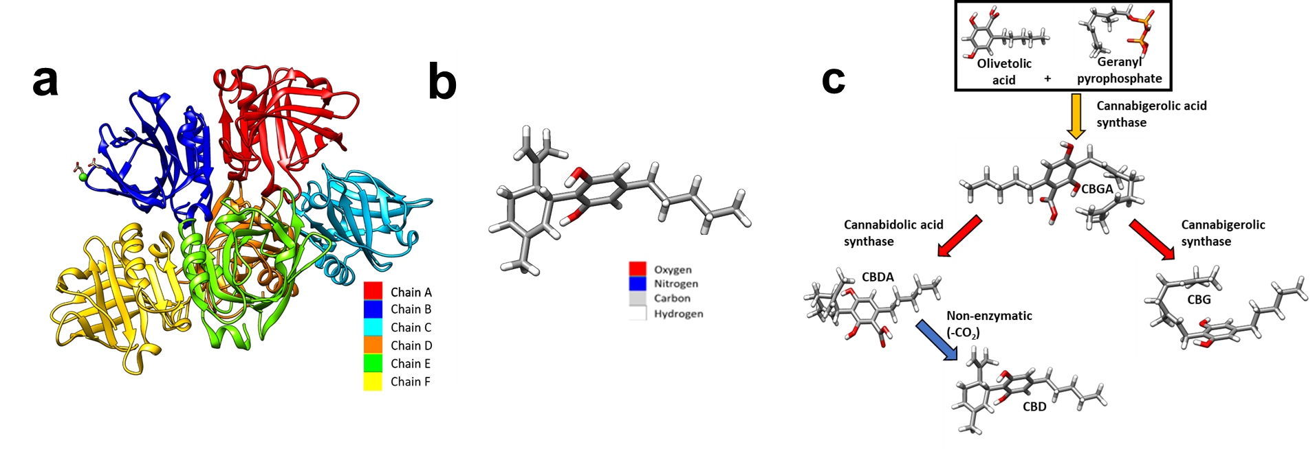
Figure 1. a) Coloured depiction of the chains of beta-lactoglobulin. Beta lactoglobulin consists of 6 chains, A-F. A – red, B – blue, C – cyan, D – orange, E – green and F – yellow. b) A schematic of a CBD molecule. c) A schematic demonstrating the biosynthesis of both CBD. Cannabigerolic acid (CBGA) is produced by interacting olivetolic acid and geranyl pyrophosphate. CBGA is degraded into CBDA. CBDA is further degraded into CBD. Molecular graphics and analyses were performed with University of California, San Fransico (UCSF) Chimera [17]. The beta-lactoglobulin molecular structure was sourced from PubMed and the glutamic acid molecule was sourced from PubChem.
CBD Figure 1b is a phytocannabinoids, synthesised from Cannabigerolic acid (CBGA), Figure 1C. CBD affects biological processes by acting as ligands acting on cellular transmembrane receptors. CBD is a non-competitive cannabinoid receptor 1 (CB1R) and cannabinoid receptor 2 (CB2R) receptor antagonist with further notable ligand-receptor interactions with G protein coupled receptor 55 (GRP55), transient receptor potential cation channel subfamily V (TRPV’s) and peroxisome proliferator-activated receptors (PPARS) [18]. CB1 and CB2 receptors are ubiquitous in osteocytes with the CB2 receptor being the most abundant, with the presence of GRP’s and TRPV receptors also being recognised [19]. Furthermore, the presence of CB1 and CB2 receptors have been evidenced to have a positive effect on bone metabolism [20]. The role of CB2R has been suggested to be as an inducer of matrix formation [21]. In vitro analysis has also suggested a positive role in bone regeneration. For instance, Idris et al [22] demonstrated an increase in osteoblasts in-vivo and inhibition of osteoclasts, in vitro with CBD, achieved through CB1R and CB2R the antagonism. Similarly, Apostu et al [23] demonstrated an increased osteoblast functioning whilst inhibiting osteoclasts. However, the mechanism suggested was through GPR55 antagonism. Similarly, and additionally, CBD promoted the osteogenic differentiation of bone marrow mesenchymal stem cells by p38 MAPK signalling pathway activation [24].
Microbial infection is often recorded as a causative agent in implant failure. CBD has demonstrated the inhibition of pathogenic microbial species, limiting the potential chance of microbial infections, increasing the chance of implant success [25, 26]. Further mitigation to implant rejection is presented through the potential for CBD to reduce excess inflammation, limiting the chance of implant rejection. The anti-inflammatory properties of CBD have been established with [27] suggesting nuclear factor-κβ transcription inhibition (NF-κβ) as the main mechanism. Additionally, [28] demonstrated the anti-inflammatory of CBD suggesting a 50-65% decrease in neutrophils recruitment.
Therefore, we took the novel approach of combining the potential of WPI as a delivery vehicle for hydrophobic substances with the bone regenerative potential of hydrophobic CBD, synthesizing WPI/CBD hydrogels. The investigation sought to evaluate any potential for WPI/CBD in bone regenerative medicine and to add to the understanding of WPI to deliver hydrophobic, small molecule to treat chronic pathologies. The analysis and potential of the WPI/CBD hydrogel was analysed by immersion in a pH 7 solution, a pH consistent with an osteogenic environment, and evaluation of the hydrogel swelling characteristics. Secondary, mechanical compression testing was conducted to ascertain any potential influence on the Young’s modulus of the WPI hydrogels by the addition of CBD. Release profiling was conducted to analyse the WPI potential of CBD release in a pH7 environment from the hydrogels. Finally, MC3T3-E1 pre-osteoblasts were utilised to analyse the potential of WPI/CBD hydrogels to promote cellular differentiation and cellular functioning.

2. Results and Discussion

2.1. Swelling
A swelling assay was performed to ascertain the swelling potential of the hydrogels in an osteogenic environment, with an optimal pH of 7.4, the results of which can be observed int Figure 2. Although, some linear concentration dependence can be observed between WPI/CBD hydrogels and the WPI control samples, the effects fail to produce statistical significance. Although, given the closeness to statistical significance it would be expected that only a minor further increase in concentration of either cannabinoid would yield statistical significance.
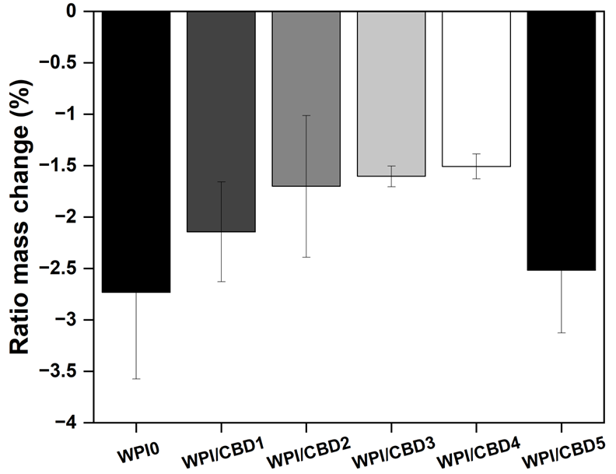
Figure 2. The results of a polymer swelling assay in pH7 conditions presented as ratio mass change (%) of the WPI/CBD hydrogels (n=10). No statistical significance was observed between the WPI/CBD hydrogel variables and the WPI hydrogel control with no CBD.
All hydrogel variable failed to swell during the assay. In fact, the hydrogels lost mass, resulting in a negative ratio mass change (%). The mass loss observed was likely the result of degradation of the hydrogels in pH7. However, an observable was the effect that the addition of CBD exhibited on the hydrogels. The effect was that an increase in CBD concentration had a positive effect on the degradation of the WPI hydrogels, when compared to the WPI control. The positive effect was demonstrated by a reduction in the mass loss. For instance, CBD improved mass loss lineally from a swelling mass ratio of -2.73 to swelling mass ratios of -2.14, -1.70, -1.60 and -1.51 for WPI/CBD1, WPI/CBD2, WPI/CBD3 and WPI/CBD4 respectively. However, the result for WPI/CBD5 did not follow the trend and lost more mass. The reasons for this remain unclear, but it is may be due to imperfections in the hydrogels resulting from the manufacturing process. For instance, bubbles can form in the hydrogel due to residual dissolved air or formation of steam; these can form pockets that weaken its structural integrity. Additionally, hydrogels have the potential to develop cracks and fractures.
WPI hydrogels incorporate hydrophobic molecules through hydrophobic interactions caused because of the exposure of hydrophobic regions, of hydrophobic amino acids during the denaturing process [29]. Therefore, any change in ratio mass change (%) could potentially be attributed to the structural changes due to hydrophobic interactions between hydrophobic CBD and the WPI proteins. Therefore, it is potentially possible that even with the low concentration the observables are the result of the underlying hydrophobic interactions. However, due to the low concentrations utilised further analysis would have to be undertaken to determine if the previous statement is factual. Additionally, the results of the WPI control align with WPI controls taken from previous investigations such as the aforementioned Baines et al, [16].

2.2. Mechanical testing
Osteogenic scaffolding requires the potential to withstand loading. A limitation to WPI hydrogels as bone scaffolding is lack of load bearing potential. Therefore, mechanical assays were conducted to ascertain whether the addition of cannabinoids had any effect on the load bearing potential of WPI hydrogels. The results of the assay can be observed in Figure 3 A-C. The WPI/CBD hydrogels presented some effect on the relative strength of the WPI samples as demonstrated by the results for Young’s modulus, compressive strength and strain at break. There are some anomalies are observable in the data, likely the result of imperfections in the hydrogels. However, an increase in cannabinoid concentration generally increased both the Young’s modulus and compressive strength of the samples containing cannabinoids. For example, the WPI0 control demonstrated a Young’s modulus of 2736 kPa compared to a recorded for the WPI/CBD5 hydrogel of 7146 kPa. Additionally, the data suggested statistically significant differences for all WPI/CBD variables apart from WPI/CBD1 when compared to the WPI control variable. Furthermore, the results gained from the WPI control variable are consistent with previous works, aligning with the aforementioned [13] and [14] respectively.
The reasons for the increases in Young’s Modulus and compressive strength due to addition of CBD remain unclear. It is conceivable that hydrophobic interactions between CBD and β-lactoglobulin may occur. During the gelation process, it is believed that β-lactoglobulin molecules unfold and expose hydrophobic regions to which hydrophobic molecules can bind, as shown previously [13]. Possibly, hydrophobic CBD may act as a crosslinker by forming hydrophobic bridges between hydrophobic regions of β-lactoglobulin molecules, acting as a crosslinker. This would explain the trend whereby increasing the CBD concentration leads to improved mechanical properties. However, in the absence of further evidence, such discussion must remain speculative.
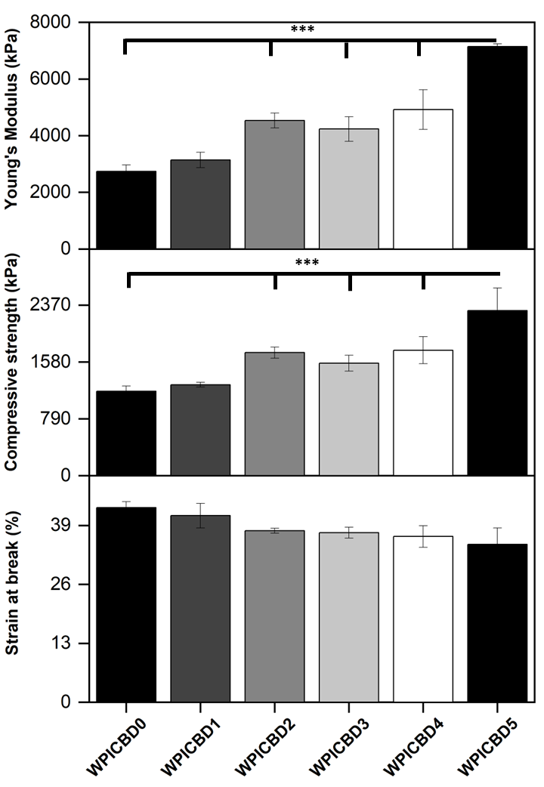
Figure 3. A-B. The results for the compression analysis of the WPI/CBD hydrogels. The results for Young’s modulus (kPa), compressive strength (kPa) and strain at break (%) are depicted. Each bar represents the mean ± SD of n = 10 (*** p < 0.001; compared to the WPI control)

2.3. Release profiling

2.3.1. Standardisation process
Amino acids found in β-lactoglobulin and α-lactalbumin demonstrate absorbance at 280 nm, resultant mainly of the aromatic portion associated with amino acids tryptophan and tyrosine. CBD has been demonstrated to present absorbance in the same region with a maximum absorbance peak at 273 nm. Therefore, a standardisation assay determined if small scale differences could be observed in the aromatic associated region. The results, observable in Figure 4, demonstrated a linear increase in concentration related absorbance as would be expected. Moreover, the results demonstrated an expected difference in absorbance at each concentration between the β-lactoglobulin and α-lactalbumin variables, with β-lactoglobulin presenting less absorbance at each concentration variable. No further statistical analysis was performed, other than standard error due to the minor percentile differences between the proteins, meaning the samples were unlikely to yield any statistically significant differences (n=15).

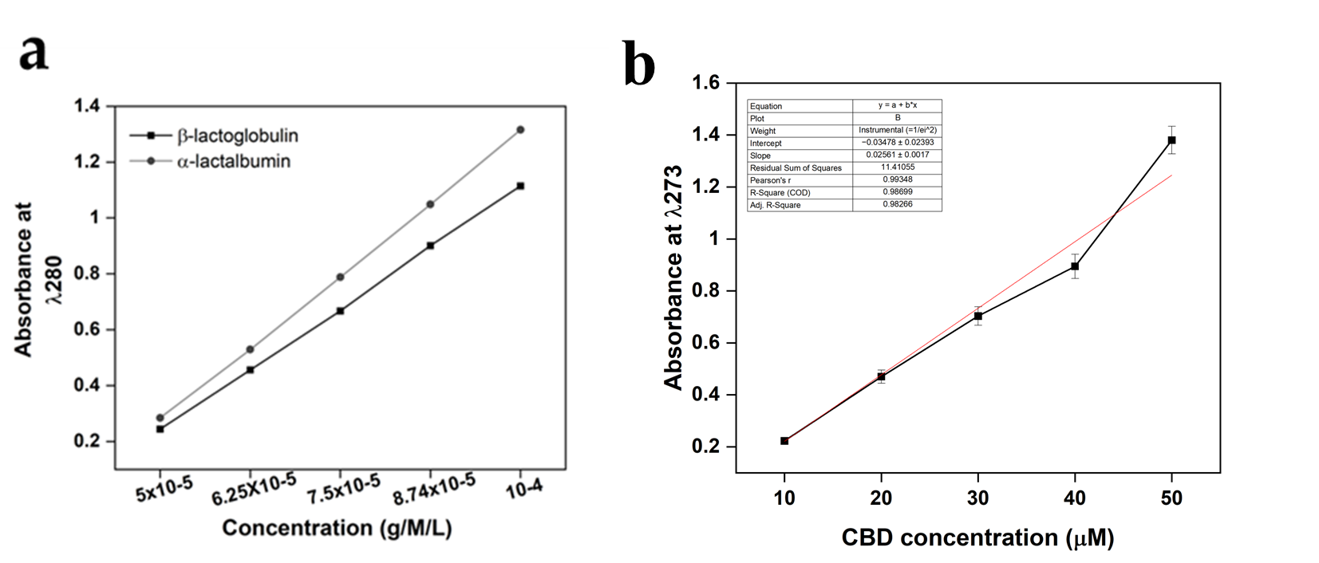
Figure 4. UV-Vis method standardisation calibration curves for both a) β-lactoglobulin and α-lactalbumin at 280 nm, and b) CBD calibration curves. For β-lactoglobulin and α-lactalbumin the region of interest was 280 nm, whereas the region of interest for CBD was 273 nm. The concentration unites were g/M/L for both β-lactoglobulin and α-lactalbumin and μΜ for CBD. Each bar represents the mean ± SD of n = 15.

2.3.2. CBD calibration
The results of the CBD calibration curve performed with UV-Vis can be observed in both Figure 5 and Table 3. The results provided a basis for the analysis of understanding the release of both CBD for the WPI/CBD hydrogels. The results demonstrated a concentration dependent linearity with each increasing CBD concentration. However, the 50 μM deviated from the linear trend, resulting in higher-than-expected absorbance, potentially the result of background interference.
Table 1. represents the numerical data gained from the UV-Vis calibration curve of CBD.
CBD concentration (μM) | Absorbance at 273 nm | SD  +/-
10  20  30  40  50 | 0.22  0.47  0.70  0.90  1.38 | 0.01  0.03  0.04  0.05  0.05

2.3.3. CBD release at pH 7.4
The release of CBD was monitored at a pH consistent with an osteogenic environment, the results of which can be observed in Figure 5a. The results demonstrated an increase in absorbance for the CBD concentrations WPI/CBD1, WPI/CBD2, WPI/CBD3, WPI/CBD4 and WPI/CBD5 with statistical significance acquired for the WPI/CBD1, WPI/CBD2 and WPI/CBD5 when compared to the WPI control sample (P < 0.05). Both WPI/CBD2 and WPI/CBD4 present anomalous results likely due in part to sample imperfections. The results at 120 h for the WPI0 control was subtracted from the maximum WPI/CBD variable and can be cross referenced with Table 1. The result suggests a 0.49 cm⁻¹ increase in absorbance between the WPI0 control and the WPI/CBD resulting in circa 20 μM. The absorbance data suggested 120 h as the maximum release was at 120 h. However, when the percentage of relative release was calculated, Figure 5b the maximum release of CBD was at 96 h.When compared with the literature, the amount of CBD released in this study could potentially promote the osteogenic differentiation of mesenchymal stem cells, as previously mentioned in [24]. Additionally, CBD concentrations between 10 μM and 30 μM have been shown to inhibit osteoclast differentiation, demonstrating the effect of low concentrations of CBD on bone tissue remodelling [30]. Furthermore, CBD has exhibited antimicrobial activity at concentrations as low as 10 μM, suggesting the potential of the WPI/CBD hydrogel to prevent infection.
Previously, CBD release has been analysed by [31]. The data from [31] suggested that the maximum release for CBD from a transdermal patch was between 39-70 h. However, the WPI hydrogel system analysed here increased maximum potential release to 96 h, which in part agrees with [32] who suggested that CBD release was sustained in-vivo when released from a nanochannel delivery system. However, due to the protein nature of the WPI hydrogels - the hydrophobic binding mechanism underlying the formation of the WPI/CBD - the full release of CBD would be relevant to the degradation of the hydrogels and would only be complete upon the full degradation of the hydrogels.

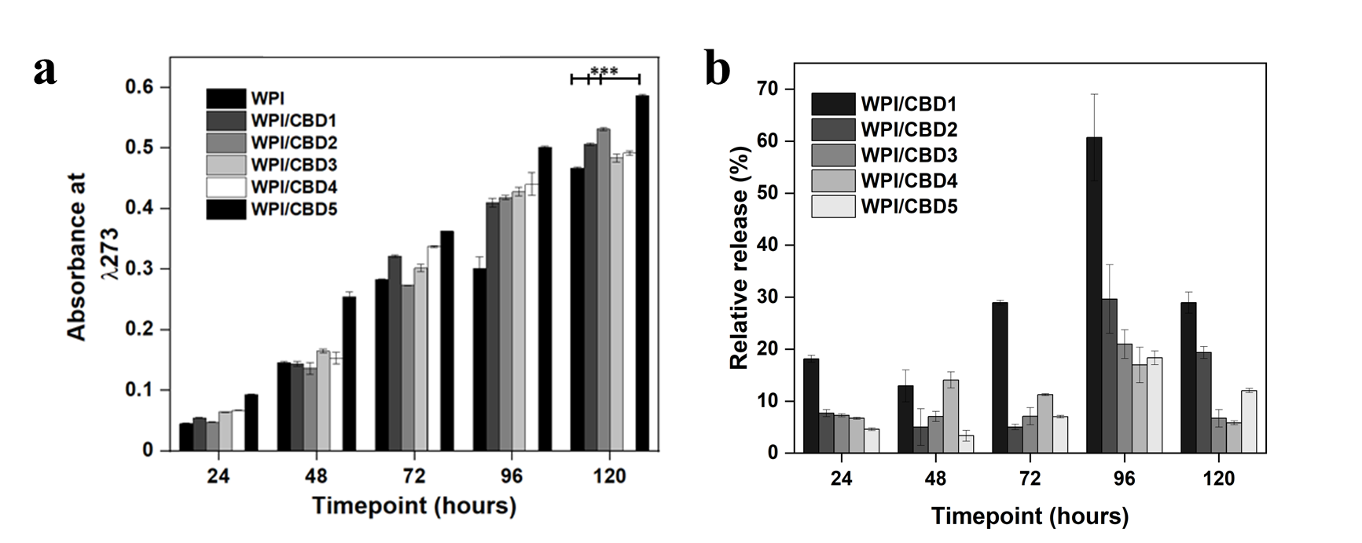
Figure 5. a, representative CBD release data at each timepoint. The chart maps the release of CBD over 120 h. WPI has no CBD. The WPI/CBD1 samples contain 10 μΜ CBD. The WPI/CBD2 samples have 20 μM CBD. The WPI/CBD3 samples contain 30 μM CBD. The WPI/CBD4 samples have 40 μΜ CBD. The WPI/CBD5 samples have 50 μΜ CBD. The absorbance was analysed at 273 nm. Each bar represents the mean ± SD of n = 15 (*** p < 0.001; compared to the WPI control). b, percentage relative release of CBD.

2.4. Biocompatibility and Osteogenic capacity of the scaffolds
In vitro analysis was conducted to determine the biocompatibility of the WPI/CBD hydrogel samples with MC3T3-E1 pre-osteoblasts. A PrestoBlueTM cell viability assay was utilised and cytocompatibility was established from 3-14 days for WPI/CBD hydrogels. At the 7 day timepoint the WPI/CBD4 and WPI/CBD5 presented significant difference in cellular proliferation when compared to the WPI0 control variable (P < 0.05). At day 14, all WPI/CBD hydrogel variables had demonstrated the potential for cellular proliferation, as demonstrated in Figure 6. Additionally, MC3T3-E1 proliferation is observable in SEM images in Figure 7. The hydrogel variables WPI/CBD1, WPI/CBD2, WPI/CBD4 and WPI/CBD5 presented higher absorbance readings than the WPI0 control but failed to produce statistically significant data. Additionally, the results support the release of CBD from the hydrogels, demonstrated through biological activity.
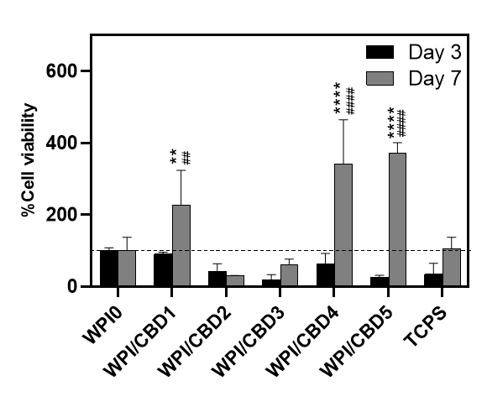
Figure 6. The results of % cell viability and proliferation of MC3T3-E1 pre-osteoblasts seeded on WPI/CBD hydrogels relative to the WPI0 (set as 100%). TCPS is tissue culture treated polystyrene and serves as control. Absorbance readings at 570/600 nm were taken at days 3 and 7. Each bar represents the mean ± SD of n=6 (**p < 0.01, ****p < 0.0001; compared to the WPI control) (##p < 0.01, ####p < 0.0001; compared to the TCPS control.
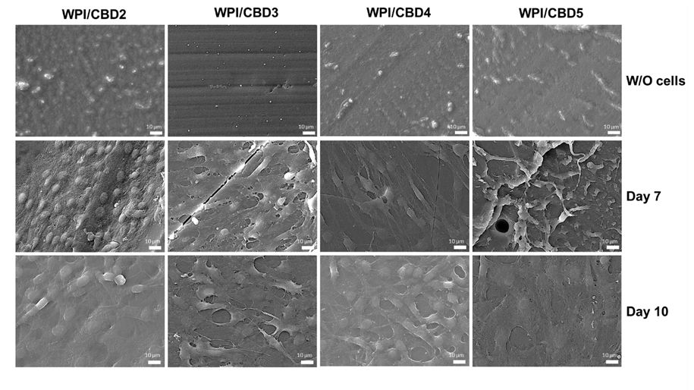
Figure 7. SEM images demonstrating the cellular morphology of MC3T3-E1 pre-osteoblasts on WPI/CBD hydrogels. Images were taken at 7 and 10 days of culture (middle and lower panel). The upper panel shows unseeded hydrogels (without cells) to facilitate comparison. Scale bars represent 10 μm.
Further analysis was conducted on the WPI/CBD variables. The analysis sought to establish the metabolic functioning of the MC3T3-E1 pre-osteoblasts. The results of this are observable in Figure 8. The analysis investigated the concentrations of three markers synonymous with osteogenic differentiation; two protein-based, namely ALP activity and collagen secretion, and one mineral-based, namely calcium production. ALP has been demonstrated to catalyse calcium mineralisation synthesising new bone and negatively regulating an inhibitor of mineralisation, extracellular pyrophosphate, while collagen is one of the main constituent protein of the extracellular matrix, and calcium mineralisation is indicative of new bone formation making all three markers for bone regeneration [33, 34, 35]. The results for each marker are displayed in Figure 8. Their activity was observable in the cells seeded on the WPI/CBD hydrogels. Additionally, EDS analysis in Figure 9 suggests the deposits of both calcium and phosphorus, markers of cellular mineralisation. Future work could involve measurement of Ca and P amounts to further characterize the mineral phase.
It is important to note that all groups, including TCPS and WPI/CBD hydrogels, were cultured under identical osteogenic conditions; the higher calcium production observed in the TCPS control may be attributed to its stiff nature, which may promote late-stage osteogenic differentiation and mineralization, as previously reported on the effect of the substrate stiffness on cell responses [1]. In contrast, the softer, three-dimensional WPI/CBD hydrogels support early osteogenic activity, while potentially modulating or delaying terminal calcium deposition [2].

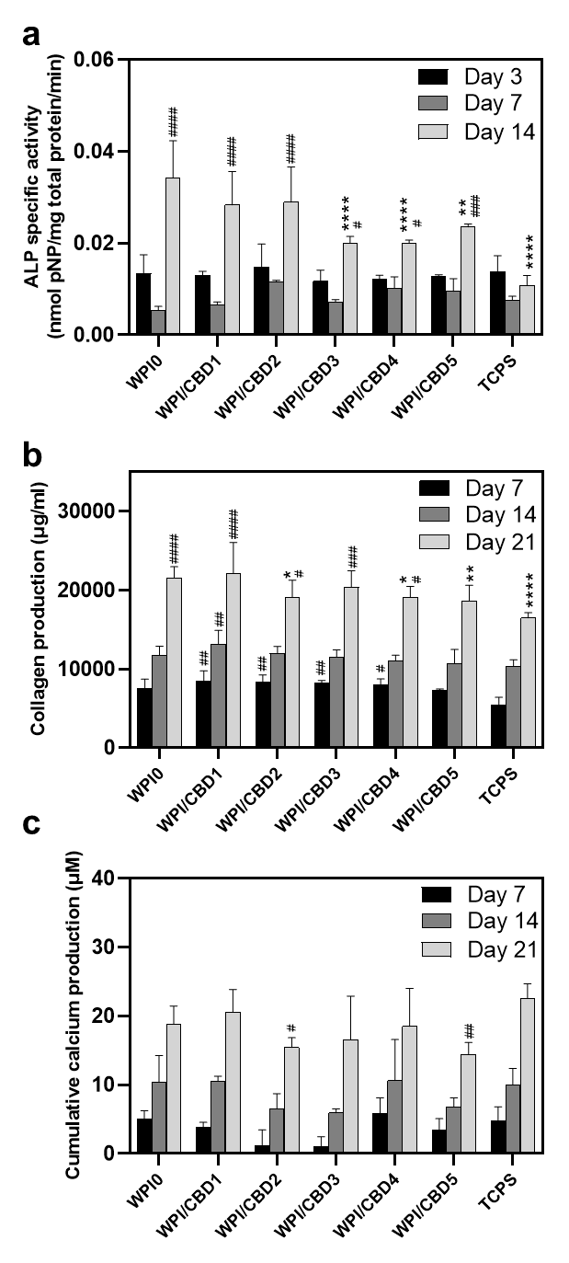
Figure 8. Assessment of the osteogenic potential of MC3T3-E1 pre-osteoblastic cells cultured on WPI/CBD hydrogels; a, the expression of normalised ALP specific activity on days 3, 7 and 14, b, collagen production, and c, calcium production by pre-osteoblasts on days 7, 14 and 21. Each bar represents the mean ± SD of n=6 (*p < 0.05, **p < 0.01, ****p < 0.0001; compared to the WPI0 control) (#p < 0.05, ##p < 0.01, (###p < 0.001, ####p < 0.0001; compared to the TCPS control), while the absence of asterisks in the graph of calcium production (c) signifies statistically non-significant differences when compared to the WPI0 control.
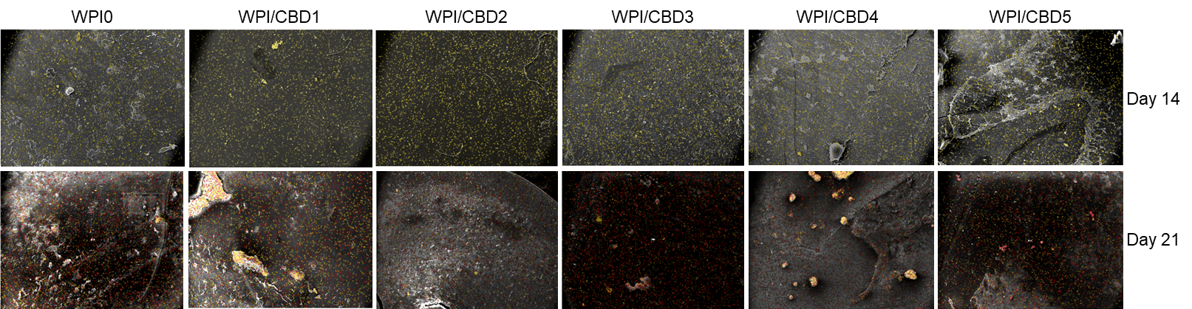
Figure 9. A visual representation of the determination of the mineralization through atomic-resolution mapping of calcium and phosphorus via EDS analysis. The top row depicts day 14 and the bottom row depicts day 21. Calcium is highlighted in yellow, while phosphorus is highlighted in red.
These results suggest that CBD retains its biological activity to a certain extent after autoclaving. The fact that CBD is detected (Figure 5) indicates that CBD is not destroyed by autoclaving. Previous work has demonstrated that phloroglucinol, the phenolic subunit of phlorotannins, polyphenols occurring in brown seaweed, retains biological activity after incorporation in WPI hydrogels and sterilization by autoclaving [13]. Further work is necessary to elucidate the exact effect of autoclaving on biological activity.
The positive effect on cellular functioning established in this study support previous investigations which suggest that CBD has a potential role in osseous regeneration. As suggested in the introduction CBD enable biological responses by acting on cellular receptors, most notably CB1R and CB2R. The role of CB1R and CB2R in osseous functioning has been well established. The presence of CB1 And CB2 receptors in osteoblasts has been evidenced to be abundant, as previously mentioned in [19]. Notably, it was suggested by [36] that once acted on, the receptors have a positive metabolic effect. Similarly, [37] suggested the CBD treatment enhanced bone healing. Furthermore, CBD acting as an GPR55 antagonist increased the functioning of osteoblasts as demonstrated by [38]. CBR1 and CBR2 knock out mice models produce contrasting results with a decrease in bone mass being observed when CB1R and CB2R is deleted. However, background age and sex present variability into the results. For instance, CBR1 deletion in a female C57Bl/6 mouse presented a decrease in bone density. Similarly, when CBR1 was inhibited in a mouse model with the same background the results supported the previous investigation. However, CD1 male and female mice with a CD1 background demonstrated an increase in bone density at three months [39]. Our findings support that the CBD can promote osseous regeneration. However, the pathway is yet to be determined.

3. Conclusion and Outlook
This preliminary investigation sought to manufacture WPI hydrogels with CBD incorporated and evaluate their potential use as biomaterials or scaffolds for bone regeneration. Numerous conclusions can be taken from the study; the successful incorporation of CBD into the WPI hydrogel; a difference in both the swelling and mechanical behaviour of the WPI hydrogels with the addition of CBD influencing their physical properties is observed, as demonstrated by the significant differences in the mechanical analysis.
Release investigations demonstrated the release of CBD from the hydrogel. Significant differences were observed between the WPI/CBD0 and the WPI/CBD variables. The variables WPI/CBD1, WPI/CBD2, WPI/CBD5, demonstrated significant differences when compared with the WPI0 control. Evidence for the release of CBD was further supported by the cellular viability analysis. Specifically, CBD retained its biological activity post-autoclaving, as indicated by its ability to promote pre-osteoblastic cell proliferation (Figure 6). However, CBD did not consistently enhance osteogenic differentiation markers, suggesting that its primary effect may lie in the early-stage cell activation rather than the later-stage differentiation. Additionally, The WPI/CBD hydrogels supported the cellular functioning of pre-osteoblasts. Therefore, demonstrating the potential of WPI to encapsulate and deliver hydrophobic molecules and the potential of WPI/CBD hydrogel in bone regeneration.
Further work should focus on several questions emerging from this study, including a study of the effect of the sterilization technique on the biological activity of CBD; an elucidation of the mechanism by which CBD reinforces WPI hydrogels mechanically, as well as a more detailed examination of the mineral formed, perhaps by use of Raman spectroscopy. Optimization of the WPI/CBD hydrogels may include expanding the range of CBD concentrations or WPI concentrations, or the use of different sterilization methods (e.g. gamma sterilization or electron-beam crosslinking and simultaneous sterilization), use of primary osteoblasts or mesenchymal stem cells, and elucidation of the pathway by which CBD exerts is biological effect.

4. Materials and Methods

4.1. Materials
WPI (>97% protein, of which >75% β-lactoglobulin) was obtained from Davisco, USA. CBD was obtained from Tocris, Bristol, United Kingdom. Unless stated otherwise, cell culture reagents and consumables were obtained from PAN-Biotech, Aidenbach, Germany.

4.2. WPI CBD hydrogel formation
WPI – cannabinoid hydrogels were formed under heat induced disassociation. The hydrogels were formed to a concentration of 40% WPI (W/V) with ultrapure H₂O. The addition of cannabinoid CBD created a WPI-cannabinoid hydrogel to concentrations of 10 µM, 20 µM, 30 µM, 40 µM and 50 µM. Homogenisation was achieved firstly by vortexing the solution before full homogenisation was achieve utilising an IKA Loopster for 24 h. The induction of gelation was achieved by introducing 1 g samples, to a 70°C water bath, for 5 min. Sterilisation was achieved with an autoclave at 126°C and 1.5 bar of pressure for 15 min.
Table 2. Experimental concentrations of WPI/CBD hydrogels.
Sample name | WPI % | Cannabinoid concentration (µM)
WPI0 | 40 | 0
WPI/CBD1 | 40 | 10
WPI/CBD2 | 40 | 20
WPI/CBD3 | 40 | 30
WPI/CBD4 | 40 | 40
WPI/CBD5 | 40 | 50

4.3. Swelling
To determine the both the effect of the structural behaviour of the hydrogels with the incorporation of the cannabinoids and the effect of the neutral pH of the osteogenic environment on the hydrogels, swelling assays were performed. The method was as follows; WPI-cannabinoid hydrogel samples with a height of 10 mm, a diameter of 8 mm and a mass of 1 g were introduced to a 5 mL pH 7.4 solution, namely phosphate buffered saline (PBS). The initial mass of the hydrogels was measured before the samples were incubated for 1 week. Post incubation the final mass was measured, and the swelling mass ratio was calculated using the formula below where the swelling percentage S% is calculated from the wet mass Mw and the dry mass Md.
S%=(Mw-Md)/Md x100%

4.4. Mechanical analysis
Any potential scaffold requires sufficient compressive strength. Therefore, it was important to analyse any potential changes the addition of cannabinoids have on the compressive potential of WPI hydrogels. Previously, WPI hydrogels have presented less than desirable compressive potential. Therefore, compression analysis was conducted to ascertain if the addition of cannabinoids had any influence on WPI hydrogel compressive abilities. Compression testing was achieved using an Instron 3345 (United States of America). WPI hydrogel samples with additional CBD concentrations of 10 µM, 20 µM, 30 µM, 40 µM and 50 µM were developed to a height of 10mm with a radius of 4 mm. The rate of compression was 2 mm per min.

Youngs modulus (Ε) was calculated as,
Ε=σ/∈
where σ denotes stress and ε denotes strain.

Compressive strength was calculated as,
F=P/(πr2)
where P is the load at failure and A is the cross-sectional area.

Strain at break was calculated as,
∈ =∆L/L x100
where ΔL is the difference between the initial length and the final length and L is the initial length.

4.5. Release profiling

4.5.1. Standardisation assay
4.5.1.1. β-lactoglobulin and α-lactalbumin standardisation.
The standardisation assay was conducted to provide preliminary validation in the methodology. β-lactoglobulin and α-lactalbumin were chosen as the molecules for standardisation for two key reasons. Firstly, β-lactoglobulin and α-lactalbumin are to 2 main protein components of WPI. Secondly, β-lactoglobulin and α-lactalbumin present differing amounts of tryptophan (Trp) and tyrosine (Tyr) residues with a percentage of 1.1% and 2.8% for Trp and 2.2 and 2.8 for Tyr respectively. Due to the aromatic portion of the respective molecules both Try and Trp exhibit absorbance at 280 nm. CBD possess an aromatic portion and display maximum absorbance at 273 nm.
Both β-lactoglobulin and α-lactalbumin solutions were formed to the max concentrations of 10⁻⁴ g/M/L. the solutions were serial diluted and analysed on UV-Vis nano drop (ThermoFisher). The method utilised in the investigation was adapted from a previously described method by [40].
4.5.1.2. CBD calibration
CBD solutions was formed to 50 μM in 95% ethanol. The solution was serial diluted and analysed as per the β-lactoglobulin and α-lactalbumin standardisation obtaining data for absorbance at 273 nm.
4.5.2 CBD release profiling
To enable both CBD to act with their known biological activity, the release from the WPI hydrogels is advantageous. Here, 1 g WPI/CBD samples were introduced to 5 mL PBS. The samples were incubated at 37°C. At 24-hour timepoints, 100 µL was removed from each sample and replaced with 100 µL of fresh PBS, for 5 days. The samples were analysed utilising UV-Vis spectroscopy with an emphasis on 273 nm, the known region of both CBD (n=15).
Percentage of relative release was calculated as,
Relative Release (%) = (CBD concentration at time (t )/ Max CBD concetration ×100

4.6. Cell culture and viability
Cellular viability and behaviour assays were conducted utilising the mouse calvaria osteoblast precursor cell line (MC3T3-E1, DSMZ Braunschweig, Germany, ACC-210). The cells were cultured in alpha-MEM medium supplemented with 10% fetal bovine serum (FBS), 2 mM L-glutamine, 100 μg/mL penicillin/streptomycin, and 2.5 μg/mL amphotericin (Thermo Fisher Scientific, Waltham, MA, USA) and incubated in a 5% CO₂ incubator at 37°C (Heal Force, Shanghai, China). When the cells had reached confluence, they were detached with trypsin-0.25% ethylenediaminetetraacetic acid (EDTA) (Gibco, Thermo Fisher Scientific, Waltham, MA, USA) and were seeded on to WPI/CBD hydrogels previously sterilised through UV radiation, for 10 min. Each concentration hydrogel was treated with 25 × 10³ cells for the proliferation assay and 40 × 10³ cells per scaffold for the differentiation assays, suspended in 10 μL complete media. Additionally, 400 μL culture medium was seeded onto each hydrogel. L-ascorbic acid (50 μg/mL), β-glycerophosphate (10 mM), and dexamethasone (10 nM) (all provided by Sigma, Darmstadt, Germany) was added to the primary culture medium, for differentiation assay purposes.
A PrestoBlue™ (Invitrogen Life Technologies, Waltham, MA, USA) viability assay was conducted to assess the cellular viability of the WPI/CBD hydrogels. The hydrogels were treated with MC3T3-E1 pre-osteoblastic cells (n=6). The assay utilised a resazurin-based indicator, a methodology previously described by [41]. The resazurin-based indicator stains cells, resulting in a red product that can be analysed photometrically. At timepoints (days) 3 and 14, 40 μL of PrestoBlue™ reagent, diluted in alpha-MEM at a 1:10 ratio, were added to each well and incubated at 37°C for 60 min. Post incubation, 100 μL of the supernatants were transferred to a 96-well plate, and their absorbance analysed at 570 and 600 nm. The assay employed a Synergy HTX Multi-Mode Microplate Reader. (BioTek, Bad Friedrichshall, Germany). After this, the cell-seeded scaffolds were rinsed twice with PBS, and their culture media were renewed.

4.7. Cell adhesion and morphology evaluation via scanning electron microscopy
Scanning electron microscopy (SEM) was used to examine cell attachment and morphology on the WPI/CBD hydrogels. The assay was conducted with a JEOL JSM-6390 LV scanning electron microscope, with an accelerating voltage of 20 kV. MC3T3-E1 pre-osteoblastic cells (25 × 10³ cells per sample) were seeded onto the hydrogels and incubated in a CO₂ incubator at 37°C for 7 days. The hydrogels were rinsed with PBS, fixed using a 4% v/v paraformaldehyde solution, for 15 min. Post fixing the hydrogels were dehydrated with ethanol with concentrations ranging from 30% to 100% v/v. The hydrogels were dried in a critical point dryer (Baltec CPD 030) and gold coated with a 20 nm thick layer of gold using a sputter coater (Baltec SCD 050).

4.8. Alkaline phosphatase (ALP) activity
ALP as a vital role in bone mineralisation and therefore is a model biomarker to determine cellular functioning of pre-osteoblasts. ALP activity on was assessed over a 7-day period with timepoints on days 3 and 7. The hydrogels (n=6) were prepared by being washed in PBS and introduced to 350 μL lysis buffer. The lysis buffer was prepared according to the following formula: 0.1% Triton X-100 and 50 mM Tris-HCl and buffered to pH 10.5. Three freezing/thawing cycles were conducted with temperatures ranging from ambient to a maximum low of -20°C. Upon completion of the third cycle, a 100 μL suspension was homogenised with 100 μL of 2 mg/mL p-nitrophenyl phosphate (pNPP, Sigma, Darmstadt, Germany). The solution was diluted further in a buffer containing 50 mM Tris-HCl and 2 mM MgCl₂, before incubation at 37°C for 1 h. Colour change was measured at 405 nm with a spectrophotometer. The enzymatic activity was calculated using the formula [units = nmol p-nitrophenol/min]. Bradford (AppliChem GmbH, Darmstadt, Germany) protein concentration assay was utilised to determine to cellular protein concentrations from the lysates.

4.9. Determination of the Produced Extracellular Collagen
Sirius Red Dye assay (Direct red 80, Sigma-Aldrich, St. Louis, MO, USA) was conducted to determine concentration of collagen secreted by MC3T3-E1 pre-osteoblastic cells (n=6). The analysis was conducted over a 21-day period with the supernatants being collected every 3 days. The supernatants were diluted 1:4 with deionised water producing a total volume of 100 µL. The solution was homogenised with 1 mL of 0.1% Sirius Red Dye in Acetic acid and incubated for 30 min in ambient conditions. Post incubation the samples were centrifuged at 15,000 g for 15 min. The resulting pellets were washed with 0.1 N Acetic acid removing any excess dye. The samples were dissolved in 500 µL of 0.5 N NaOH. The absorbance was measured at 530 nm using a Synergy HTX plate reader. The acquired data was cross-referenced with a collagen type 1 calibration curve.

4.10. Calcium concentration determination
A method using O-cresol phthalein complexone (CPC) (Biolabo, Maizy, France) was employed to quantitatively analyse calcium in supernatants (n=6) according to a methodology previously described by [42]. Calcium deposition is an indicator of osteogenesis, having a significant role in the development of the bone extracellular matrix. The investigation was conducted over a 21-day period with the supernatants being collected every 3 days. 10 μL of culture medium from each sample was diluted in 100 μL of calcium buffer with an additional 100 μL of CPC calcium dye. The solutions were analysed with absorbance calculated at 550 nm.

4.11. Statistical analysis
Statistical analysis was carried out using an ANOVA t-test in GraphPad Prism version 8 software to assess the significance of differences among various scaffold compositions and the control at different experimental time periods. A p-value (*) less than 0.05 was considered significant (*p < 0.05), **p < 0.01, ***p < 0.001, ****p < 0.0001, and "ns" denoted a statistically non-significant difference compared to the WPI control scaffold at the corresponding time point.
Supplementary Materials: Not applicable.
Author Contributions: Conceptualization, T.E.L.D., D.K.B., and M.C.; methodology, D.K.B., V.P., M.C. and T.E.L.D.; validation, D.K.B., V.P., N.N.T., M.C. and T.E.L.D.; formal analysis, D.K.B., V.P., N.N.T., M.C. and T.E.L.D.; software, D.K.B. and V.P.; investigation, D.K.B., V.P., N.N.T. and M.P.; resources, M.C., K.W. and T.E.L.D.; data curation, D.K.B., V.P., N.N.T. and M.P.; writing—original draft preparation, D.K.B. writing—review and editing, all authors; visualization, D.K.B., V.P., N.N.T..; supervision, M.C., K.W. and T.E.L.D.; project administration, M.C., and T.E.L.D.; funding acquisition, M.C., K.W. and T.E.L.D. All authors have read and agreed to the published version of the manuscript.
Funding: Please add: This research was funded by the Faculty of Science and Technology, Lancaster University, United Kingdom. They are thanked for their financial support to D.K.B. The research work was supported by the Hellenic Foundation for Research and Innovation (H.F.R.I.) under the “First Call for H.F.R.I. Research Projects to support Faculty members and Researchers and the procurement of high-cost research equipment grant” with project number: HFRI-FM17-1999 for M.C., V.P. and N.N.T
Institutional Review Board Statement: Not applicable.
Informed Consent Statement: Not applicable.
Data Availability Statement: Data are contained within the article.
Acknowledgments: Molecular graphics and analyses were performed with UCSF Chimera, developed by the Resource for Biocomputing, Visualization, and Informatics at the University of California, San Francisco, with support from NIH P41-GM103311.
Conflicts of Interest: The authors declare no conflict of interest.

References
- NICE (2017) ‘Osteoporosis: assessing the risk of fragility fracture.’ National Institute for Health and Care Excellence.
- World Health Organisation. international (2022) ‘Aging and Health’ Available at: https://www.who.int/news-room/fact-sheets/detail/ageing-and-health.
- Office of the Surgeon General (US) (2004). ‘Bone Health and Osteoporosis: A Report of the Surgeon General.’ Diseases of Bone Vol 3 Available from: https://www.ncbi.nlm.nih.gov/books/NBK45506/
- Schmidt, A.H. 2021. ‘Autologous bone graft: Is it still the gold standard?’ Injury vol. 52(2) pages S18-S22
- Munakata, M., Kataoka, Y., Yamaguchi, K., and Sanda, M. 2024. ‘Risk Factors for Early Implant Failure and Selection of Bone Grafting Materials for Various Bone Augmentation Procedures: A Narrative Review.’ Bioengineering, Vol 11(2), pages192.
- Amini, A.R., Laurencin, C.T. and Nukavarapu, S.P. 2012 ‘Bone tissue engineering: recent advances and challenges.’ Crit Rev Biomed Eng. Vol 40(5), pages 363-408.
- Ghassemi, T., Shahroodi. A., Ebrahimzadeh, M.H., Mousavian, A., Movaffagh, J. and Moradi, A. 2018 ‘Current Concepts in Scaffolding for Bone Tissue Engineering.’ Arch Bone Jt Surg. Vol 6(2) pages 90-99.
- Dorati, R., DeTrizio, A., Modena, T., Conti, B., Benazzo, F., Gastaldi, G. and Genta, I. 2017 ‘Biodegradable Scaffolds for Bone Regeneration Combined with Drug-Delivery Systems in Osteomyelitis Therapy.’ Pharmaceuticals (Basel). Vol. 10(4) pages 96.
- Rabe, R., Hempel, U., Martocq, L., Keppler, J.K., Aveyard, J. and Douglas, T.E.L. 2020. ‘Dairy-Inspired Coatings for Bone Implants from Whey Protein Isolate-Derived Self-Assembled Fibrils.’ Int J Mol Sci. Vol. 21(15), page 5544.
- Sager, V.F., Munk, M.B., Hansen, M.S., Bredie, W.L.P. and Ahrné, L. 2021. ‘Formulation of Heat-Induced Whey Protein Gels for Extrusion-Based 3D Printing.’ Foods Vol. 10(1) page 8.
- Su, J., Wang, L., Dong, W., Wei, J., Liu, X. and Yan, J. 2022. ‘Fabrication and Characterization of Ultra-High-Pressure (UHP)-Induced Whey Protein Isolate/κ-Carrageenan Composite Emulsion Gels for the Delivery of Curcumin.’ Frontiers in Nutrition Vol. 9.
- Dvora, M., Warwick, P. and Henry, J. 2022. ‘WPI hydrogels as a potential substrate for tissue scaffolds: mechanical properties.’ Mechanics of Soft Materials Vol. 4.
- Platania, V., Douglas, T.E.L., Zubko, M.K., Ward, D., Pietryga, K. and Chatzinikolaidou, M. 2021. ‘Phloroglucinol-enhanced whey protein isolate hydrogels with antimicrobial activity for tissue engineering.’ Materials science & engineering. C, Materials for biological applications. Vol. 129, page 112412.
- Gupta, D., Kocot, M., Tryba, A.M., Serafim, A., Stancu, I.C., Jaegermann, Z., Pamula, E., Reilly, G.C and Douglas, T.E.L., 2020. ‘Novel naturally derived whey protein isolate and aragonite biocomposite hydrogels have potential for bone regeneration.’ Materials & Design Vol. 188, pages 108408.
- Dziadek, M., Charuza, K., Kudlackova, R., Aveyard, J., D'Sa, R., Serafim, A., Stancu, I.C., Iova, H., Kerns, J., Allinson, S., Dziadek, K., Szatkowski, P., Cholewa-Kowalska, K., Bacakova, L., Pamula, E. and Douglas, T.E.L. 2021. ‘Modification of heat-induced whey protein isolate hydrogel with highly bioactive glass particles results in promising biomaterial for bone tissue engineering.’ Materials & Design. Vol. 205, page 109749.
- Baines, D.K., Platania, V., Tavernaraki, N.N., Parati, M., Wright, K., Radecka, I., Chatzinikolaidou, M. and Douglas, T.EL. 2023. ‘The Enrichment of Whey Protein Isolate Hydrogels with Poly-γ-Glutamic Acid Promotes the Proliferation and Osteogenic Differentiation of Preosteoblasts.’ Gels. Vol. 10(1) pages 18.
- Pettersen E.F., Goddard T.D., Huang C.C., Couch G.S., Greenblatt D.M., Meng E.C., Ferrin T.E.2004. UCSF Chimera? A visualization system for exploratory research and analysis. J. Comput. Chem. Vol. 25, pages 1605–1612.
- Zou, S. and Kumar, U. 2018. ‘Cannabinoid Receptors and the Endocannabinoid System: Signalling and Function in the Central Nervous System.’ Int J Mol Sci. Vol.19(3), page 833.
- Bab, I. and Zimmer, A. 2008. ‘Cannabinoid receptors and the regulation of bone mass.’ Br J Pharmacol. Vol 153(2), pages 182-188
- Idris, A.I., Sophocleous, A., Landao-Bassonga, E., Canals, M., Milligan, G. Baker, D., Van’t Hof, R.J. and Ralston, S.H. 2009. ‘Cannabinoid Receptor Type 1 Protects against Age- Related Osteoporosis by Regulating Osteoblast and Adipocyte Differentiation in Marrow Stromal Cells.’ Vol 10 (2), pages, 139-147.
- Rossi, F., Tortora, C., Punzo, F., Bellini, G., Argenziano, M., Di Paola, A., Torella, M. and Perrotta, S. 2019. ‘The Endocannabinoid/Endovanilloid System in Bone: From Osteoporosis to Osteosarcoma.’ Int J Mol Sci. Vol. 20(8) pages 1919.
- Idris, A., van 't Hof, R., Greig, I. et al. 2005 ‘Regulation of bone mass, bone loss and osteoclast activity by cannabinoid receptors.’ Nat Med Vol 11, pages 774–779.
- Apostu, D., Lucaciu, O., Mester, A., Benea, H., Oltean-Dan, D., Onisor, F., Baciut, M., Bran, S. 2019. ‘Cannabinoids and bone regeneration.’ Drug Metab Rev. Vol51(1), Pages 65-75.
- Li, L., Feng, J., Sun, L., Xuan, Y.W., Wen, L., Li, Y.X., Yang, S., Zhu, B., Tian, X.Y., Li, S., Zhao, L.S., Dang, R.J., Jiao, T., Zhang, H.S., Wen, N. 2022. ‘Cannabidiol Promotes Osteogenic Differentiation of Bone Marrow Mesenchymal Stem Cells in the Inflammatory Microenvironment via the CB2-dependent p38 MAPK Signalling Pathway.’ Int J Stem Cells, Vol. 15(4), pages 405-414.
- Martinenghi, L.D., Jønsson, R., Lund, T., Jenssen, H. 2020. ‘Isolation, Purification, and Antimicrobial Characterization of Cannabidiolic Acid and Cannabidiol from Cannabis sativa L.’ Biomolecules. Vol 10(6) page 900.
- Luz-Veiga, M., Amorim, M., Pinto-Ribeiro, I., Oliveira, A.L.S., Silva, S., Pimentel, L.L., Rodríguez-Alcalá, L.M., Madureira, R., Pintado, M., Azevedo-Silva, J., Fernandes, J. 2023. ‘Cannabidiol and Cannabigerol Exert Antimicrobial Activity without Compromising Skin Microbiota.’ Int J Mol Sci. Vol. 24(3), page 2389.
- Sangiovanni, E., Fumagalli, M., Pacchetti, B., Piazza, S., Magnavacca, A., Khalilpour, S., Melzi, G., Martinelli, G. and Dell’Agli, M. 2019. ‘Cannabis sativa L. extract and cannabidiol inhibit in vitro mediators of skin inflammation and wound injury.’ Phytother Res, Vol. 33, pages 2083-2093.
- Robaina Cabrera, C. L., Keir-Rudman, S., Horniman, N., Clarkson, N. and Page, C. 2021. ‘The anti-inflammatory effects of cannabidiol and cannabigerol alone, and in combination.’ Pulm Pharmacol Ther. Vol. 69, pages 102047.
- Shao, F., Zhang, Y., Wan, X., Duan, Y., Cai, M., and Zhang, H. 2024. ‘Improving the properties of whey protein isolate-zein nano-gels with novel acidifiers: Re-dispersity, stability and quercetin bioavailability.‘ International Journal of Biological Macromolecules. Vol. 266(2), page 13128.
- Nielsen, S. S. R., Pedersen, J. A. Z., Sharma, N., Wasehuus, P. K., Hansen, M. S., Møller, A. M. J., Xenia G. Borggaard, X. G., Rauch, A., Frost, M., Teis E. Sondergaard, T. E. and Søe, K. 2024. ‚Human osteoclasts in vitro are dose dependently both inhibited and stimulated by cannabidiol (CBD) and Δ9-tetrahydrocannabinol (THC).‘ Bone Vol 181, pages 117035
- Yu L, Madsen FB, Eriksen SH, Andersen AJC, Skov AL. 2022. ‚A reliable quantitative method for determining CBD content and release from transdermal patches in Franz cells.’ Phytochem Anal, Vol. 33(8), pages 1257-1265.
- Kaplan B. L.F., Swanson, E.A., Ross, M.K., Olivier, A.K., Guo-Ross, S., Burroughs, K.J., Ross, A.K., Matula, M., Tarbox, T., Greenberg, M., Carr. R.L. 2022. ‘Nanochannel delivery system for CBD: Sustained low level plasma levels without liver toxicity.’ Journal of Drug Delivery Science and Technology, Vol. 79, pages 104029,
- Vimalraj, S. 2020. ‘Alkaline phosphatase: Structure, expression and its function in bone mineralization.’ Gene. Vol 5. Pages 754.
- Selvaraj, V., Sekaran, S., Dhanasekaran, A. and Warrier, S. 2024 ‘Type 1 collagen: Synthesis, structure and key functions in bone mineralization.’ Differentiation. Vol. 136, pages 100757.
- Vannucci, L., Fossi, C., Quattrini, S., Guasti, L., Pampaloni, B., Gronchi, G., Giusti, F., Romagnoli, C., Cianferotti, L., Marcucci, G. and Brandi, M.L. 2018 ‘Calcium in-take in Bone Health: A Focus on Calcium-Rich Mineral Waters.’ Nutrients. Vol. 5(10), page 12.
- Saponaro, F., Ferrisi, R., Gado, F., Polini, B., Saba, A., Manera, C. and Chiellini, G. 2021. ‘The Role of Cannabinoids in Bone Metabolism: A New Perspective for Bone Disorders.’ Int J Mol Sci. Vol. 22(22), pages 12374.
- Raphael-Mizrahi, B. and Gabet, Y. ‘The Cannabinoids Effect on Bone Formation and Bone Healing.’ Curr Osteoporos Rep. Vol. 18(5) pages 433-438
- Whyte, L.S., Ryberg, E., Sims, N.A., Ridge, S.A., Mackie, K., Greasley, P.J, Ross, R.A., and Rogers, M.J. 2009 ‘The putative cannabinoid receptor GPR55 affects osteoclast function in vitro and bone mass in vivo.’ Proc Natl Acad Sci U S A. Vol. 106(38), pages 16511-6.
- Ehrenkranz, J. and Levine, M.A. 2019. ‘Bones and Joints: The Effects of Cannabinoids on the Skeleton.’ J Clin Endocrinol Metab. Vol. 104(10), pages 4683-4694.
- Fleming, I., and Williams, D.H. 2020 ‘Spectroscopic methods in organic chemistry.’ Cham, Switzerland: Springer.
- Hadjicharalambous, C., Mygdali, E., Prymak, O., Buyakov, A., Kulkov, S. and Chatzinikolaidou M. 2015. ‘Proliferation and osteogenic response of MC3T3-E1 pre-osteoblastic cells on porous zirconia ceramics stabilized with magnesia or yttria.’ Journal of Biomedical Materials Research Part A. Vol. 103 (11) pages 3612-3624.
- K. Loukelis, K., Papadogianni, D. and M. Chatzinikolaidou. 2022. ‘Kappa-carrageenan/chitosan/gelatin scaffolds enriched with potassium chloride for bone tissue engineering’. International Journal of Biological Macromolecules. Vol. 209, pages 1720-1730.
Disclaimer/Publisher’s Note: The statements, opinions and data contained in all publications are solely those of the individual author(s) and contributor(s) and not of MDPI and/or the editor(s). MDPI and/or the editor(s) disclaim responsibility for any injury to people or property resulting from any ideas, methods, instructions, or products referred to in the content.

[1] B. Trappmann, J.E. Gautrot, J.T. Connelly, D.G.T. Strange, Y. Li, M.L. Oyen, M.A. Cohen Stuart, H. Boehm, B. Li, V. Vogel, J.P. Spatz, F.M. Watt, W.T.S. Huck, Extracellular-matrix tethering regulates stem-cell fate, Nature Materials 11(7) (2012) 642-649.
[2] N. Huebsch, P.R. Arany, A.S. Mao, D. Shvartsman, O.A. Ali, S.A. Bencherif, J. Rivera-Feliciano, D.J. Mooney, Harnessing traction-mediated manipulation of the cell/matrix interface to control stem-cell fate, Nature Materials 9(6) (2010) 518-526.

