# Title: Fast-tracking Trust: Exploring the Relative Importance of Competence, Integrity, and Benevolence in Informant-Handler Interactions

**Short title**: Relative Importance of Trustworthiness Factors

**Authors**: Lina Hillner*1, Lorraine Hope1, Feni Kontogianni2, Stacey Conchie3, and Jordan Nunan4

**Affiliations**: University of Portsmouth1, University of Winchester2, Lancaster University3, University of Northampton4

**\*Corresponding author**: Correspondence concerning this article should be addressed to Lina Hillner, Department of Psychology, University of Portsmouth, King Henry I Street, PO1 2DY, United Kingdom. Email: [lina.hillner@port.ac.uk](mailto:lina.hillner@port.ac.uk)

**Ethics statement**: The rationale and procedure developed for this experiment were subjected to a rigorous evaluation in which two separate ethics committees considered confidentiality and ethical concerns. Ethical approval for this project was received from the Science and Health Faculty Ethics Committee (SHFEC 2024-014) and the CREST Security Research Ethics Committee (SREC). Participants' consent was obtained at the beginning of the study.

**Funding statement**: This research was funded by the University of Portsmouth and the Centre for Research and Evidence on Security Threats (ESRC Award: ES/N009614/1) as a postgraduate bursary for the doctoral work of the first author.

**Data availability statement**:The materials, anonymised data, and R syntax can be found on <https://doi.org/10.17605/OSF.IO/T85YB>

**Conflict of interest statement**: The authors declare that they have no conflicts of interest.

**Abstract**

**Introduction:** Demonstrating trustworthiness has been shown to increase trust and, in turn, information sharing in investigative interviews. However, the most effective ways to build trust in security contexts and the role of trust demonstrations in informant-handler relationships remain underexplored. This study tests the relative importance of competence, integrity, and benevolence demonstrations on initial trust development and willingness to cooperate in remote informant-handler encounters. **Methods:** Using a within-subject design, participants received background information on an organized crime scenario and listened to three simulated phone call recordings, where handlers demonstrated each of the three factors of trustworthiness during attempts to recruit an informant. After each recording, participants rated the handler's trustworthiness and their own willingness to trust and cooperate and provided written feedback on each call. Participants also expressed their preferred trust-building strategy used by handlers and rated their trust propensity. **Results:** A repeated measures ANCOVA revealed no significant differences in willingness to trust based on the type of trustworthiness demonstration. However, trust propensity significantly impacted trust levels, so that more trusting individuals were more likely to trust the handler. Thematic analyses highlighted substantial individual differences in what participants liked and disliked about each approach. **Conclusions:** Findings suggest that no specific demonstration of trustworthiness is more effective in fostering initial trust, indicating that handlers should tailor trust-building strategies to individuals instead of adhering to general guidelines. Future research should employ idiographic approaches to further understand how individuals perceive and react to trust-building strategies.

**Keywords:** trustworthiness, informant, information elicitation, investigative interviewing, HUMINT, CHIS, competence, integrity, benevolence

## Introduction

Although trust has been shown to reduce uncertainty about another person’s future behaviour and increase cooperative behaviours such as information sharing in investigative (Oleszkiewicz et al., 2023) and vetting interviews (Hillner et al., 2024), the role of trust in Human Intelligence (HUMINT) contexts remains understudied. Informants must rely on the officer assigned as their handler to treat their information confidentially and to ensure their welfare and safety on a daily basis (Stanier & Nunan, 2018). Building (and maintaining) trust is therefore crucial at the outset of these relationships. Recent research revealed that demonstrating trustworthiness increases trust and willingness to cooperate, leading to more admissions in interviews with mock suspects (Oleszkiewicz et al., 2023). Although the three factors of trustworthiness—competence, integrity, and benevolence—are believed to vary in importance throughout (Mayer et al., 1995) and across relationships (Moore et al., 2023), few studies have explored their relative impact on dyadic trust development (Alarcon et al., 2022). The current research aimed to address this gap by investigating the effects of a handler’s demonstration of trustworthiness, through competence, integrity, or benevolence, on mock informants' willingness to trust and cooperate.

**Assessing Trustworthiness: Competence, Integrity, and Benevolence**

Trustors assess the reliability of a trustee and develop beliefs about their trustworthiness based on evaluations of the trustee’s competence, integrity, and benevolence (Mayer et al., 1995). Competence refers to the necessary expertise, skills, and abilities to effectively and consistently perform tasks or fulfil roles; it is specific to particular domains. For instance, competence in one area, such as precise and thorough record-keeping, does not necessarily imply competence in another, such as handling and storing data in compliance with data protection laws. In contrast, integrity and benevolence are concerned with the assessment of the trustee’s motivation and intentions (Greene et al., 2001). Integrity reflects a trustee’s inclination to behave consistently across diverse circumstances and is often equated with reliability. It is also about adhering to ethical principles and moral values, such as honesty, even in situations where one's actions are not being observed or monitored (Mayer et al., 1995). Benevolence entails demonstrating genuine care and goodwill towards others, often by prioritizing others’ well-being and acting in their best interests. According to Mayer et al. (1995), a trustee is likely to be regarded as trustworthy if they score high on all three factors of trustworthiness.

Perceptions of trustworthiness form quickly (van’t Wout & Sanfey, 2008) and significantly influence the willingness to trust another person, alongside the trustor’s inherent tendency to trust others (Mayer et al., 1995). This level of trust subsequently determines whether individuals are willing to rely on the person and engage in risk-taking behaviours. Generally, individuals are less inclined to rely on and take risks with someone they perceive as untrustworthy compared to someone they see as trustworthy (Colquitt et al., 2007). In security contexts, such as informant-handler relationships, risk-taking often involves sharing sensitive information. Therefore, it seems crucial for handlers to rapidly develop trust with their informants to ensure the elicitation of security-relevant information that aids in protecting national security.

Oleszkiewicz et al. (2023) investigated the effectiveness of two distinct strategies in developing trust and eliciting admissions from mock-suspects. Using a 2x2 between-subjects design, interviewers attempted to build trust by either i) demonstrating trustworthiness through making and fulfilling a promise (present vs. absent), or ii) showing a willingness to trust by granting participants access to a restricted area restroom (present vs. absent). The results indicated that demonstrating trustworthiness, but not willingness to trust, increased participants' trust in the interviewer, which in turn enhanced cooperation and led to more admissions. While this study suggests that trustworthiness can successfully induce feelings of trust and positively influence face-to-face interview outcomes, the specific method used to demonstrate trustworthiness cannot be implemented when communicating remotely and hence it remains unclear whether these findings apply to remote communication. Yet informant-handler interactions often occur via telephone (Nunan et al., 2020), particularly in the early stages of the relationship. More importantly, Oleszkiewicz et al. (2023) demonstrated trustworthiness solely through integrity, without considering competence or benevolence (Mayer et al., 1995). However, it is reasonable to assume that demonstrating competence and benevolence can positively affect interactions in security contexts. For example, a handler who shows they have the skills and expertise to protect an informant (competence) or one who demonstrates they have the informants’ best interests at heart (benevolence) may effectively establish their trustworthiness and, in turn, inspire trust. To test this assumption, the current experiment manipulated all factors of trustworthiness and assessed their relative impact on trust development in initial informant-handler interactions.

**The relative importance of competence, integrity, and benevolence**

Although competence, integrity, and benevolence are all proposed to influence trustworthiness perceptions, research suggests each factor is of differential importance throughout different relationship stages (Mayer et al., 1995; Schoorman et al., 2007). Therefore, it is crucial to consider whether one factor might be more effective than the others in fostering trust within unfamiliar dyads in security settings. Scholars have distinguished between the cognitive and affective dimensions of trust (McAllister, 1995), arguing that cognitive trust, which is established more quickly, plays a more crucial role in the early stages of relationships (Mayer et al., 1995). Cognitive trust is informed by perceptions of the trustee’s competence and integrity, while affective trust is based on the trustee’s benevolent intentions. Mayer et al. (1995) argue that integrity perceptions are the strongest predictor of trust in new relationships and that competence perceptions will influence trust whenever the trustee’s abilities for a specific domain are known. Conversely, some researchers argue that assessing integrity—rooted in personal values like honesty and reflecting alignment between words and actions—requires repeated interactions, making it challenging to evaluate early in a relationship (Colquitt & Salam, 2012; Moore et al., 2019).

Supporting cognitive trust theories, Alarcon et al. (2022) provided evidence highlighting the importance of competence in risk-taking behaviours within unfamiliar dyads interacting online. In their trust violation paradigm, participants played an investment game where the trustee violated trust through breaches in competence, integrity, or benevolence. The results indicated that violations of competence had a more significant impact on reducing financial risk-taking behaviour compared to violations of integrity or benevolence, suggesting competence may be the most prominent factor in the early stages of relationships. In line with these findings and cognitive trust theories, it could be argued that competence and integrity perceptions might be the most important determinants of trust in informant-handler relationships.

However, researchers have also long recognized that the relative importance of trustworthiness components might partially depend on the relationship between the trustor and trustee (Colquitt et al., 2007; Mayer et al., 1995). According to the size-closeness-hierarchy (SCH) model, in small groups, such as dyads, with equally distributed power people prefer benevolent partners over those with high integrity (Moore et al., 2023). In HUMINT contexts, this might suggest that although benevolence is harder to establish, it could become more relevant than integrity or competence if successfully demonstrated in early dyadic interactions. However, an informant-handler relationship might not have equal power distribution and might be more comparable to a supervisor-supervisee relationship. Previous research indicates that when trusting a supervisor, integrity and benevolence are significantly more important than competence (Knoll & Gill, 2011). This research, in conjunction with the SCH model, indicates a pattern opposite to that suggested by cognitive trust theories.

Given our aim to test the differential relevance of trustworthiness in a novel social context—handler-informant interactions—that has not been previously examined, and considering the mixed findings and perspectives in the literature, we decided against proposing any directional hypotheses and instead opted for an exploratory research approach.

**The current research**

The current research adopted a mixed-method approach and a repeated measure within-subject design. Each participant was exposed to three different audio-recorded interactions between a mock informant and a handler. Each audio constituted a separate cold call, in which a mock handler tried to recruit an informant and demonstrated their trustworthiness by highlighting either their competence, integrity, or benevolence (i.e., trustworthiness manipulation). After listening to each audio, participants were asked to imagine how they would feel if they were the informant and rated the handler’s competence, integrity, and benevolence, as well as their own willingness to trust the handler. They were also asked to rate their willingness to cooperate and engage in online and offline future interactions. The study examined the relative effectiveness of the three trustworthiness manipulations (demonstrating competence, integrity, and benevolence) in increasing participants’ willingness to trust the mock handler. Since trust intentions can translate into risk-taking behaviours (Colquitt et al., 2007; Mayer et al., 1995), participants’ willingness to trust the mock handler constituted the main dependent variable.

Participants were also asked to provide feedback on what they liked and disliked about each handler's approach after listening to the audio recordings. At the end of the study, they were asked to indicate their preferred approach and explain their choice. These responses were analysed using thematic analysis to gain a deeper understanding of which factor of trustworthiness were most effective and why.

## Method

## Participants

Given that powering for a small effect size of 0.1 would have exceeded our available resources, we decided to power for the smallest effect size that our resources could support. To detect an effect size of .15, with a power of 0.80 and an alpha level of .05, an a-priori G*Power analysis recommended a minimum sample size of 73 participants. Participants were screened for English proficiency using Prolific’s pre-screening tool for demographic factors. We collected data from 73 participants via Prolific during May and June 2024. After reviewing attention and audio checks, no data had to be excluded. Out of 73 participants, 44 described themselves as male, 27 as female, and 2 preferred not to say. Participants’ age ranged from 20 to 73 years (*M* = 35 years, *SD* = 12 years). From all participants, 54 self-identified as White, 10 as Black, 3 as Asian, 1 as Mixed White and Black, 1 as Filipino, 1 as Latino, and 3 preferred not to say. Participants received an honorarium of £5.63 for approximately 45 minutes of their time (7.50£/hour). Participants were told that the research was concerned with investigating people’s perceptions of phone calls. Ethical approval for the project was secured from the Science and Health Faculty Ethics Committee (SHFEC 2024-014), with participants providing consent at the beginning of the study.

### Materials

All materials are openly available on OSF (<https://doi.org/10.17605/OSF.IO/T85YB>).

**Piloting**

Phone call scripts, accompanying manipulation check items, and instructions were developed and refined through four rounds of piloting (*N* = 57). The first round (*N* = 11) involved colleagues from the university staff of the first author, providing valuable qualitative feedback that led to a thorough review of the phone scripts. After revising the wording to clearly distinguish the individual trustworthiness factors, the second round (*N* = 16) was conducted via Prolific to ensure full remote functionality. The third (*N* = 16) and fourth (*N* = 14) rounds of piloting focused on fine-tuning the manipulation check items and addressing technical issues.

**Phase 1: Scenario**

Participants were instructed to begin by reading background information about a fictional police case. The background described the operations of an organized crime group known as the "Omega Cartel" in Lewisham, London, UK. Participants learned that this cartel was involved in extreme violence, lucrative drug deals, and selling firearms to known terrorist groups resulting in increased crime rates, affecting community safety and prosperity. Participants were informed that the intelligence unit in Lewisham had recently identified three potential informants, and that the unit director had assigned three handlers to approach these individuals to evaluate their willingness to act as undercover informants.

After reading the background, participants were instructed to imagine themselves in the position of these potential informants while listening to three audio recorded phone calls. They were to picture themselves as long-time residents of Lewisham, familiar with the neighbourhood and its surroundings.

Before proceeding to the next phase, participants listened to an audio clip of bird sounds. They were then asked, "Which sound did you hear at the end of this audio?” and instructed to select the correct option from: i) pigs, ii) birds, iii) horses. This task served as an audio check to confirm that their sound was functioning properly.

**Phase 2: Phone calls**

Participants listened to three different audio recordings, each performed by a different voice actor. To minimize the influence of the actor’s gender, accent, or tone of voice on participants' perceptions, we had three male British actors read each of the scripts. The order in which participants heard the three calls, as well as the assignment of each script to the three voice actors, was counterbalanced across participants. To avoid any bias introduced by variations in call length, we standardised the duration of each audio recording to approximately 2 minutes.

Each phone call script followed the same structure: an introduction, a middle part, and an ending. Each phone call began with the handler introducing themselves, including their name, affiliation, and reason for calling. The middle part of the call consisted of an explanation of the approach (described below), which varied according to the specific condition. At the end of the call, the handler asked the potential informant if they were willing to schedule another phone call or meet in person, at which point the audio cut off. Each phone call included the same five questions from the informant, with the audios differing only in how each handler answered these questions. The questions posed were as follows: i) Who are you exactly?, ii) What is this about?, iii) Can you give me more details? Why are you calling me?, iv) Who else knows about this?, and v) What do you want information about?. To ensure that participants based their ratings on the handler’s dialogue rather than the informant’s responses, the informants responded by posing the next question or minimal affirmative replies such as “hmm.”

***Competence***

In the competence script, Handler Antony demonstrates his expertise by referencing his extensive experience, in-depth knowledge of the job and procedures, and his history of success (Colquitt & Salam, 2012; Mayer et al., 1995). For instance, he begins by highlighting his 25 years of experience in enhancing community well-being and addressing significant issues effectively. He mentions that engaging with community members has been successful in similar past situations and stresses that everyone under his supervision has consistently remained safe. This demonstrates his understanding of the role and his success in similar cases.

***Integrity***

Consistent with previous research, Handler Ben underscores his integrity by embodying a sense of justice (Kohlberg, 1964) and adhering to principles such as honesty (Larzelere & Huston, 1980), transparency, and fairness (Greenberg, 1990). Unlike other scripts, Handler Ben is notably transparent, providing additional details such as the reasons behind the increase in violence in Lewisham and disclosing who is aware of the call. He openly communicates the risks for potential informants and emphasizes that participation in the call and process is entirely voluntary, thereby demonstrating transparency and openness. He further exhibits strong principles and a commitment to justice by expressing his intent to hold perpetrators accountable and affirming his belief that justice is a fundamental right for everyone.

***Benevolence***

Throughout the call, Handler Charlie seeks to demonstrate his benevolence by prioritizing the informant's well-being and safety over the objective of recruiting them as an informant (Mayer et al., 1995). He is considerate of the informant’s needs, asking if it is a convenient time to talk and offering to meet at a location that suits the informant, while also respecting their time to make a decision. Additionally, he shows empathy and connects the purpose of the call to improving the community's well-being, illustrating that he has the best interests of both the informant and the community members in mind.

**Post-call questionnaire**

***Trustworthiness manipulation check***

To check if participants noticed the accentuation of the three trustworthiness components, they were asked to rank the following items reflecting competence ("The officer is well qualified and has successfully handled similar situations in the past."), integrity ("The officer tries hard to be fair and honest in dealing with others and made it clear that the process is voluntary"), and benevolence ("My needs and well-being are the officer’s top priorities and he really looks out for what is important to me and my community") in order of how well they described the handler from the audio conversation they just listened to. They were asked to indicate the order from the most fitting description (position 1, top; most accurate description) to the least fitting description (position 3, bottom; least accurate description).

***Perceived Trustworthiness*** (Cronbach’s α = 0.96)

Participants were asked to answer 16 adapted items from Mayer and Davis (1999) trustworthiness scale on a 5-point Likert scale ranging from strongly disagree (1) to strongly agree (5). These items specifically address the individual factors of trustworthiness, namely competence (5 items, Cronbach’s α = 0.89), integrity (6 items, Cronbach’s α = 0.87), and benevolence (5 items, Cronbach’s α = 0.91).

***Trust Intentions*** (Behavioral Trust Inventory;Cronbach’s α = 0.95)

Participants had to indicate how willing, ranging from not at all willing (i.e., 1) to completely willing (i.e., 7) they were to engage in five reliance-based (e.g., rely on the officer’s skills and abilities) and five disclosure-based behaviours (e.g., share my personal feelings with the officer; Gillespie, 2003).

***Willingness to Cooperate*** (Cronbach’s α = 0.90)

Participants were asked to indicate how willing, ranging from not at all willing (i.e., 1) to completely willing (i.e., 7) they were to (i) agree to another phone call, (ii) agree to meet in person, and (iii) cooperate with the handler in the future.

***Filler task***

Between audio segments, participants were given the task of spotting three differences between two pictures. They could not proceed to the next audio until a two-minute song finished playing in the background. Participants were instructed to continue with the study even if they had not identified all three differences after the two-minute time period. This filler task was included to minimize spill-over effects and cognitive overload.

**Phase 3: Final questionnaire**

***Handler preference***

After answering the post-call questionnaire items for the third call, participants were asked to indicate which handler's conversation they preferred. They were provided with audio segments of each handler's voice to refresh their memory before being asked to rank the handlers in order of preference, from most preferred (position 1, top) to least preferred (position 3, bottom). To follow up, participants were asked to explain why they preferred the selected conversation.

***Trustworthiness rating and preference***

Participants were asked to write down the characteristics that would make them trust an officer enough to share sensitive information if approached to be an undercover informant (open-ended question). Subsequently, they were provided with brief definitions of the trustworthiness factors and asked to rate the importance of competence, integrity, and benevolence on a scale from 1 (not important at all) to 7 (extremely important). Lastly, they were asked to choose the trustworthiness component most important to them from the three available options.

***Trust propensity* (**Cronbach’s α = 0.87)

To test trust propensity, participants were asked to answer the items of the ‘trust propensity’ subscale (n = 4) developed by Gefen (2000). The subscale uses a 7-point Likert scale ranging from strongly agree (= 1) to strongly disagree (= 7).

***Perceived police legitimacy*** (Cronbach’s α = 0.96)

To evaluate participants' attitudes toward police legitimacy, we drew on a validated scale consisting of 16 items as reported by (Tankebe et al., 2016). Participants provided their responses on a scale from 1 (strongly disagree) to 4 (strongly agree), addressing aspects such as lawfulness (3 items), procedural fairness (9 items), distributive fairness (3 items), and effectiveness (3 items) of the police.

***Motivation*** (Cronbach’s α = 0.83)

Three items were developed to assess participants’ motivation. On a 5-point Likert scale participants were asked: i) I was motivated to perform well during this experiment, ii) I wanted to do a good job answering the questions, and iii) I was motivated to put myself in the shoes of the informant being approached when answering the questions.

***Reason for exclusion***

Finally, participants were presented with a multiple-choice question asking whether there were any potential reasons for excluding their data (Yes/No). If participants answered "Yes," they were then prompted to provide details explaining why their data should be excluded. To encourage honest responses, participants were informed that their answer to this question would not affect their reimbursement.

***Attention checks***

As per Prolific guidelines, we included seven instructed manipulation checks (e.g., "Please select ‘disagree’") to assess participants' attention while completing the post-interview and final questionnaires. If participants failed more than one of these attention checks they were excluded from data analysis and were not compensated for their participation.

### Procedure

After starting the study via Prolific, participants were redirected to the Gorilla platform. Initially, they were asked to read the information sheet and sign the consent form. Then participants were presented with background information on the fictional police case. Afterwards, they underwent an audio check, and those who failed were automatically redirected back to Prolific and instructed to return their submission. Those who passed the audio check were randomly assigned to one of the 16 counter-balanced options, reflecting the unique combination of the order in which they would listen to the phone calls and the voice actors delivering the audio. After listening to each phone call, participants completed a post-call questionnaire and the subsequent filler task. After the final filler task, participants were given the final questionnaire, debriefed, thanked, and redirected back to Prolific.

### Analytic Strategy

We preregistered our statistical analysis here <https://doi.org/10.17605/OSF.IO/X825P>. To address the primary aim of this experiment, repeated measures ANCOVA was conducted to assess whether the willingness to trust the mock handler varied according to the levels of the mock-handler’s demonstrations of trustworthiness (competence vs. integrity vs. benevolence). Given that previous research has shown that propensity to trust influences willingness to trust early in interactions (Colquitt et al., 2007), participant score on the trust propensity scale was included as a covariate.

## Results

**Data quality check**

***Trustworthiness manipulation check***

To determine if the trustworthiness manipulations affected participants' ranking of the most suitable handler descriptions after listening to each audio, we performed chi-square tests of independence. Assuming the null hypothesis of equal distribution, each handler description (competence vs. integrity vs. benevolence) would receive about 24.33 selections, based on 73 participants and the three available handler descriptions. This means that if a handler description was selected significantly more often than the others, it would suggest an unequal distribution of choices. This would support the alternative hypothesis, suggesting that the trustworthiness manipulation significantly influenced participants' decisions.

**Competence.** Analysis showed that 51 participants selected the competence description, 10 opted for the integrity description, and 12 chose the benevolence description. The chi-square test of independence indicated a significant relationship between the choice of handler description and the competence manipulation, χ²(2) = 43.92, *p* < .001.

**Integrity.** The results indicated that 9 participants chose the competence description, 56 selected the integrity description, and 8 chose the benevolence description. The chi-square test of independence revealed a significant link between the participants' choice of handler description and the integrity manipulation, χ²(2) = 61.84, *p* < .001.

**Benevolence.** The data showed that 4 participants selected the competence description, 15 chose the integrity description, and 54 opted for the benevolence description. The chi-square test of independence revealed a significant association between the choice of handler description and the benevolence manipulation, χ²(2) = 56.74, *p* < .001.

These results indicate that the distribution of choices significantly differs from what would be expected by chance, suggesting that the manipulation of each trustworthiness factor affected participants’ preferences. In other words, the three individual trustworthiness factors were operationalized successfully and could be distinguished by participants.

**Primary analysis: Quantitative responses*[1]***

***Trust Intentions***

To assess whether or not one of the three trustworthiness manipulations induced greater feelings of trust while controlling for participants’ trust propensity, we ran a repeated measures ANCOVA. While willingness to trust was normally distributed for the competence and integrity condition, there were deviations from normality for the benevolence condition. However, as ANOVA is generally considered robust against normality violations (Blanca et al., 2017), and the non-parametric alternative Friedman test cannot account for covariates, we decided to conduct the repeated measures ANCOVA analysis. The Greenhouse-Geisser sphericity correction was applied for all factors violating the sphericity assumption. The descriptive statistics are depicted in Table 1. The results indicate that willingness to trust was not significantly different across trustworthiness manipulations, *F*(2, 215) = 0.05, *p* = .95, *η²* = 0.00. However, participants’ trust propensity significantly influenced participants’ willingness to trust the handlers across all conditions, *F*(1, 215) = 11.32, *p* < .001, *η²* = 0.05.

***Willingness to cooperate***

To further examine whether one of the three trustworthiness demonstrations increased participants’ willingness to cooperate with the handler, we performed a non-parametric Friedman test due to the non-normal distribution of the data. The analysis showed no significant difference in participants’ willingness to cooperate across the different trustworthiness demonstrations, χ²(2) = 0.03, *p* = .983, *W* = 0.00. This suggests that the variations in the handlers' trustworthiness demonstrations did not lead to different levels of willingness to cooperate among participants.

***Handler preference***

Assuming the null hypothesis of equal distribution, each handler would be anticipated to receive about 24.33 selections, based on 73 participants and the three available handlers. The data demonstrated that 25 participants chose Handler Antony (competence), 22 participants chose Handler Ben (integrity), and 26 participants chose Handler Charlie (benevolence) as their preferred conversation. The chi-square test of independence revealed there was no significant association between the participants’ preferred handler and the trustworthiness manipulations, χ²(2) = 0.36, *p* = .837. This result indicates that the distribution of choices is not significantly different from chance level, suggesting participants have no specific preference for how handlers demonstrated their trustworthiness.

**Table 1**

*Descriptive Statistics and Correlations for Study variables.*

|  |  |  |  |  |  |  |  |  |  |  |  |
| --- | --- | --- | --- | --- | --- | --- | --- | --- | --- | --- | --- |
| Variable | | *M* | *SD* | 1 | 2 | 3 | 4 | 5 | 6 | 7 | 8 |
| Trust Intentions following | |  |  |  |  |  |  |  |  |  |  |
| 1. | Competence demonstration | 5.10 | 0.96 | - |  |  |  |  |  |  |  |
| 2. | Integrity demonstration | 5.06 | 1.05 | 0.55** | - |  |  |  |  |  |  |
| 3. | Benevolence demonstration | 5.11 | 1.11 | 0.48** | 0.48** | - |  |  |  |  |  |
| Willingness to cooperate following | |  |  |  |  |  |  |  |  |  |  |
| 4. | Competence demonstration | 5.47 | 1.29 | 0.71** | 0.44** | 0.30** | - |  |  |  |  |
| 5. | Integrity demonstration | 5.48 | 1.32 | 0.46** | 0.76** | 0.33** | 0.52** | - |  |  |  |
| 6. | Benevolence demonstration | 5.62 | 1.20 | 0.45** | 0.47** | 0.83** | 0.47** | 0.52** | - |  |  |
| 7. | Trust propensity | 4.41 | 1.39 | 0.25* | 0.24* | 0.19 | 0.23* | 0.11 | 0.22 | - |  |
| 8. | Police legitimacy | 2.69 | 0.67 | 0.20 | 0.31* | 0.18 | 0.26* | 0.27* | 0.27* | 0.49** | - |

*Note.* Trust intentions and willingness to cooperate were measured on 7-point Likert scales (1 = not at all willing, 7 = completely willing). Trust propensity scores were reverse-coded, with higher scores indicating greater trust propensity (1 = strongly disagree, 7 = strongly agree). Perceived police legitimacy was measured on a 4-point Likert scale (1 = strongly disagree, 4 = strongly agree).

* *p* <.05, *\*\* p* <.001

***Trustworthiness rating and preference***

On a scale from 1 (not important at all) to 7 (extremely important), participants rated how important they thought competence, integrity, and benevolence would be for them to trust a handler. As data was highly skewed, a Friedman test was used to examine differences in participants’ ratings. There was a significant effect, *χ²*(2) = 14.1, *p* < .001, *W* = 0.096, indicating that participants rated the importance of the three components differently. Pairwise comparisons using Wilcoxon signed-rank tests with a Bonferroni correction indicated that the competence (*M* = 6.53, *z* = 192, *p* = .001) and integrity (*M* = 6.45, *z* = 146, *p* = .02) conditions were rated significantly more important than the benevolence condition (*M* = 6.03). However, the competence and integrity conditions did not significantly differ from one another (*z* = 438, *p* = .466).

When requested to make a decision on which factor of trustworthiness would be most important for them, 31 participants chose competence, 24 participants chose integrity, and 18 participants chose benevolence. A chi-square test of independence revealed there was no significant association between the participants’ preference and the three trustworthiness factors, χ²(2) = 0.36, *p* = .837. This is in line with the chi-square results for handler preference and suggests that participants have no specific preference for one over the other trustworthiness factor when asked directly.

**Exploratory analysis: Qualitative responses**

To further understand what participants liked and disliked about each of the approaches taken by the three handlers, we analysed their responses to the following questions “What did you like/dislike about the approach taken by Handler [Antony/Ben/Charlie]?” and “Why did you prefer this conversation?”. The qualitative responses were thematically analysed following the guidelines put forward by Braun and Clarke (2006). The analysis of responses was conducted inductively, with themes identified from the data following these steps: (i) collating and organizing participants' responses by question; (ii) the first author thoroughly familiarising themselves with the transcriptions through repeated reading; (iii) generating numerous first-order codes to capture every relevant discussion point; (iv) searching for and reviewing themes, consolidating first-order codes into fewer second-order codes; and (v) further refining and naming the second-order codes to capture the essence of the identified themes.

***Reflexive statement by the first author***

As the first author, my background in trust research and prior experience with interviewing in security contexts have inevitably shaped my approach to analysing the qualitative data and constructing themes. My role in developing the telephone scripts and my familiarity with their operational aspects likely influenced how I interpreted participants’ responses, potentially making me more attentive to themes distinguishing the individual trustworthiness factors. To mitigate potential biases like confirmation bias, I used methodological triangulation. This approach combined both quantitative and qualitative data and involved analysing various open-ended questions on the same topic (e.g., preferences for each individual script and reasons for the most favoured script). This allowed for a well-rounded understanding of the underlying concepts from multiple perspectives and aimed to ensure a more balanced interpretation. However, it is important to recognize that my personal perspectives and experiences may still have subtly affected how themes were created and interpreted.

***Handler Antony: Competence***

**Aspects Liked.** We developed three overarching themes based on 96 quotes: (1) Professional conduct, (2) Communication style, and (3) Demeanour, depicted in 5.1. The theme of professional conduct was identified as the most prominent, with approximately half of the participants (35 out of 70) highlighting their appreciation for Handler Antony’s explicit declaration of his experience and expertise during the call. For example, Participant 18 remarked, “He made it very clear that he has a lot of experience in the job and made me feel confident in his abilities.” Additionally, 13 participants noted the handler’s professionalism, 9 highlighted his confidence, and 7 appreciated his focus on safety and confidentiality. The second theme, communication, includes three sub themes: direct and straightforward communication (noted by 11 participants), clear explanation of procedures (mentioned by 6 participants), and a non-intrusive communication style (mentioned by 5 participants). Lastly, 8 participants felt that Handler Antony demonstrated genuine care, with comments such as “his dedication” (Participant 23) and “the fact that he is trying to help the Lewisham and further community” (Participant 19).

**Aspects Disliked.** We categorised 79 quotes into four major themes: (1) Dislikeable approach, (2) Vagueness or insufficient information, (3) Script delivery, and (4) No specific dislikes (see Figure 1). For the first theme, participants noted that Handler Antony’s approach was perceived as impersonal, mentioned by 12 participants, and intrusive, noted by 6 participants. For example, Participant 24 commented, “he didn't approach me very personally,” while Participant 25 observed, “He sounded a bit pushy at times.” Additionally, 11 participants identified behaviours that they interpreted as narcissistic, such as self-centeredness (Participants 53 and 66), arrogance (Participant 69), or a sense of superiority (Participant 23). This led to concerns about the handler’s consideration for their personal well-being, with Participant 1 expressing, “I'd wonder if he takes my personal well-being into consideration or will do anything to crack his case, even if that means 'sacrificing' me.” The second theme, vagueness or insufficient information, encompassed frustrations related to unclear details about who else was aware of the call (Participants 14 and 36), the nature of previous work (Participant 10), the next steps if the informant cooperated (Participant 26), or how the informant’s safety would be ensured (Participant 52). This theme was noted by 19 participants. The third theme focused on script delivery, with 7 participants commenting on the handler’s delivery as “abrupt” (Participant 72), “robotic” (Participant 1), or lacking “empathy and care” (Participant 19). Finally, 20 participants reported that there was nothing specific they disliked about the handler’s approach.

Figure 1

*Thematic map of participants’ responses to Handler Antony’s approach (Competence manipulation).*

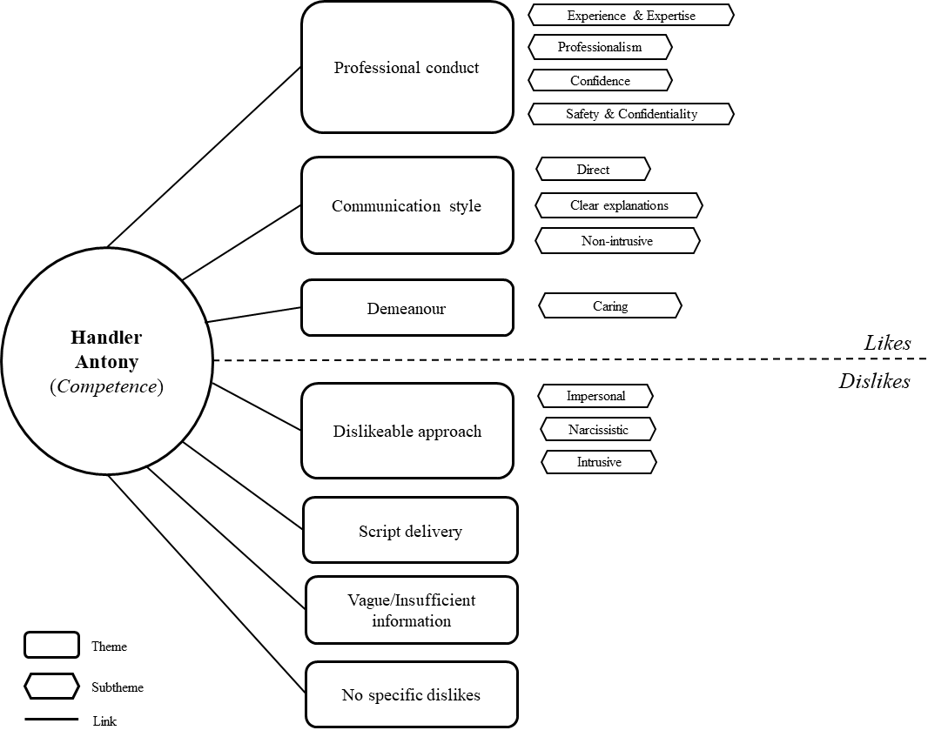

***Handler Ben: Integrity***

**Aspects Liked.** The 124 quotes were organised into four main themes: (1) Communication style, (2) Demeanour, (3) Respect for autonomy, and (4) Professional conduct, which are visually displayed in Figure 2. In the theme of communication, 21 participants described Handler Ben’s style as transparent, 18 as straightforward, and 15 as honest. Participants particularly valued the handler's openness about potential drawbacks, with one noting that he “didn’t sugarcoat the risks” (Participant 15). The second theme focused on perceptions of the handler’s character. A total of 16 participants found him caring, while 5 appreciated his friendly demeanour. Additionally, 6 participants noted his value-driven nature, with comments such as, “Officer Ben has an aura of authority and seems like someone who does his job by the book” (Participant 67) and that he “wants to be fair” (Participant 64). For the third theme, 12 participants appreciated the handler’s non-intrusive approach, and 13 liked the emphasis on the voluntariness of the process. Participant 18 remarked that the handler “did not push the informant to do anything they were not comfortable with.” Lastly, 10 participants noted that Handler Ben appeared very professional, competent, and reliable.

**Aspects Disliked.** We analysed 57 quotes and created four general themes: (1) Dislikeable approach, (2) Distrusting the handler’s experience, (3) Vagueness or insufficient information, and (4) No specific dislikes (see Figure 2). In the theme of dislikeable approach, 10 participants felt that the handler’s manner was too open, casual, or direct, with comments such as, “It was too casual, like you were meeting for coffee” (Participant 5) and that the handler “seemed a little bit too laid back at times” (Participant 25). Additionally, 8 participants expressed dissatisfaction with the handler’s emphasis on negatives, such as risks, without discussing any benefits. Participant 17 noted, “He offered me only negatives, so there was no reason for me to want to engage further.” The second theme, lack of experience, was highlighted by 9 participants who were concerned about the handler’s failure to discuss his experience, which made him appear inexperienced and “not qualified for a dangerous task” (Participant 1). In the third theme, vagueness or insufficient information, 8 participants criticized the handler’s communication as lacking clarity. Specific issues included the absence of details about protection measures (Participant 28), information about the involved supervisor (Participant 57), and the type of information the handler was seeking (Participant 18). Lastly, 22 participants indicated that there was nothing specific they disliked about the handler’s approach.

Figure 2

*Thematic map of participants’ responses to Handler Ben’s approach (Integrity manipulation).*

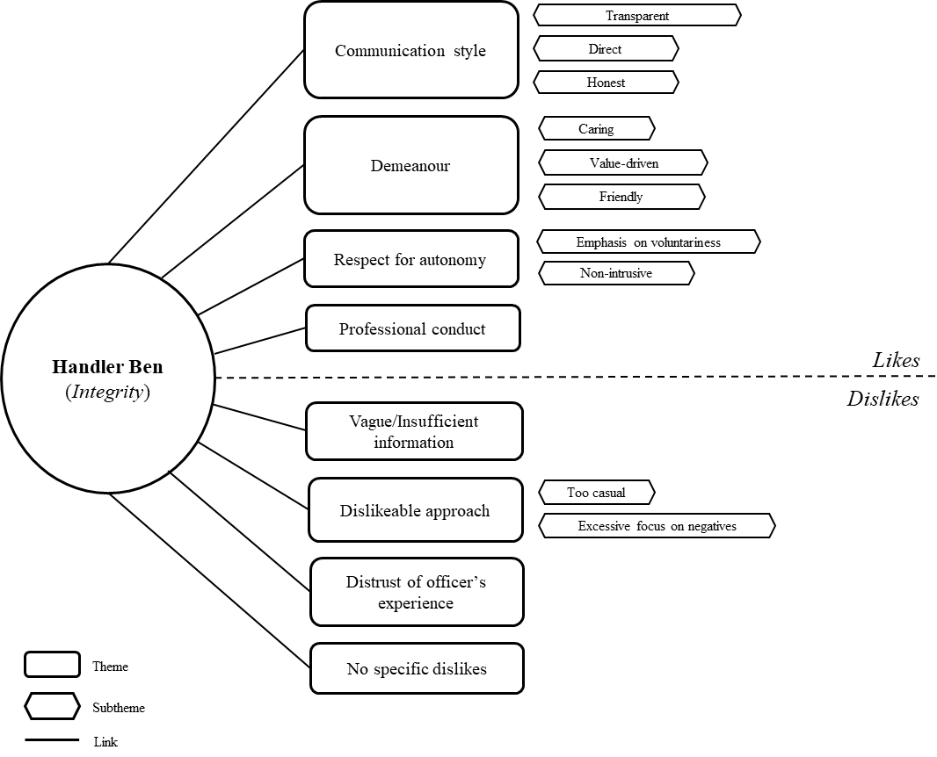

***Handler Charlie: Benevolence***

**Aspects Liked.** As depicted in Figure 3, a total of 142 quotes were categorised into four overarching themes: (1) Demeanour, (2) Communication, (3) Respect for autonomy, and (4) Professional conduct. In the theme of demeanour, 23 participants described the handler as caring, 10 described him as calm and gentle, 8 mentioned his friendly attitude, and 5 noted his kindness. Additionally, 21 participants felt that the handler’s emphasis on their safety and welfare conveyed genuine care. For example, Participant 18 remarked, “He made it clear that my safety was his number one priority which made me feel more at ease with releasing information.” The second theme of communication was highlighted by 12 participants who noted the handler’s clear explanations. 7 participants described his communication as straightforward, and 9 as honest and transparent. The third theme focused on the handler’s non-intrusive approach and respect for autonomy. 11 participants appreciated that the handler allowed them to retain control and make choices without pressure, with 8 noting his non-intrusive approach. For instance, participants valued that the handler “made it clear that it was my choice” (Participant 56) and appreciated that “this was not an order and simply a request for assistance in the issue at hand” (Participant 10). Additionally, 5 participants described the handler as patient, noting his lack of frustration when questions were repeated, as mentioned by Participant 21. Lastly, the fourth theme, professional conduct, was noted by 14 participants who recognized the handler’s professionalism and competence, with 6 participants specifically mentioning his respectfulness.

**Aspects Disliked.** Out of 71 quotes, four themes were developed: (1) Vague or insufficient information, (2) Distrusting the handler’s experience, (3) Script delivery and tone of voice, and (4) No specific dislikes (see Figure 3). For the first theme, 22 participants noted that there was insufficient information regarding the situation, who else was aware of the call, or the purpose of the meeting. For example, Participant 10 mentioned, “It might have helped to have a bit more information about what it was that they specifically needed my help with.” The second theme involved 13 participants who expressed distrust in the handler or his experience. Comments included, “By his voice, I think he was still pretty young and inexperienced in dealing with such situations” (Participant 35). In the third theme, 12 participants criticized the delivery of the script. Six participants felt that it sounded too robotic and scripted, while another 6 took issue with the tone of voice, noting that the handler sounded “a bit too happy” (Participant 56) or that “there was no emotional weight to his words” (Participant 60). Finally, 21 participants indicated that they had no specific criticisms about Handler Charlie’s approach.

Figure 3

*Thematic map of participants’ responses to Handler Charlie’s approach (Integrity manipulation).*

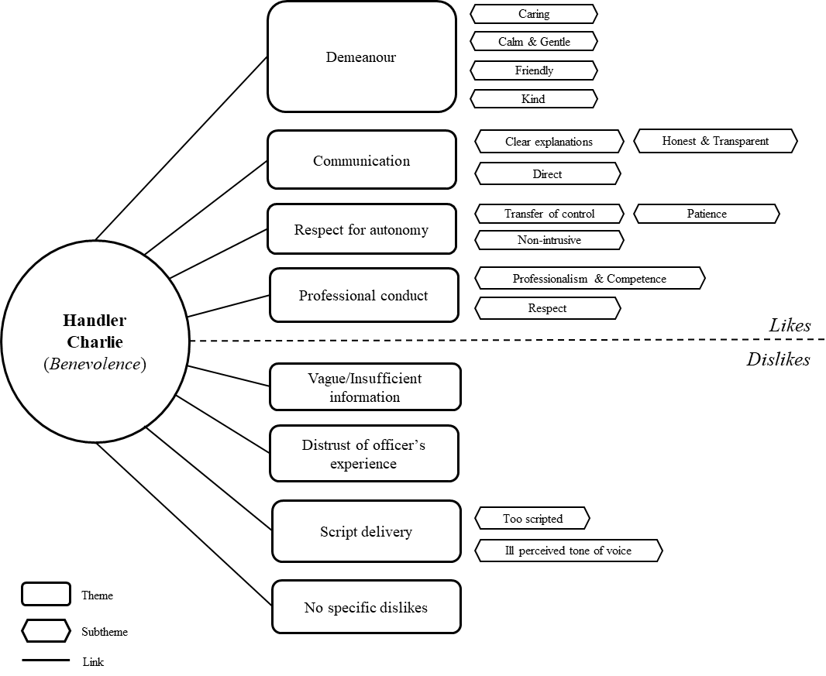

***Personal preference***

Participants were asked to justify their preference for a particular handler. For Handler Antony (Competence approach), 20 participants preferred him due to his perceived qualifications, experience, and confidence compared to the other handlers. For example, Participant 47 noted, “I have great admiration for Handler Antony, who, with over 20 years of experience on the force, shared his extensive background in handling dangerous cases. His detailed explanation of past incidents and the strategies employed to ensure safety provided me with a deep sense of assurance that no harm would come to me as a witness.” Those who preferred Handler Ben (Integrity approach) highlighted three main themes: (1) his caring attitude, (2) his transparency and honesty, and (3) his approachable and non-intrusive demeanour. Firstly, 10 participants appreciated Handler Ben’s caring nature, noting he was “concerned about the well-being of the informant” (Participant 49). Secondly, 9 participants valued his honest and transparent communication. Lastly, 9 participants described Handler Ben as approachable (Participants 13 and 19), laid-back (Participant 4), or non-pressuring (Participant 57). Participants who chose Handler Charlie (Benevolence approach) favoured his personable, caring, and supportive approach, as noted by 20 participants. For instance, Participant 27 mentioned, “Officer Charlie tried his hardest to make me feel comfortable during the call,” while Participant 61 remarked that “he was distinguished by empathy and was not a typical serviceman.”

## Discussion

The current experiment examined the relative perceived importance of competence, integrity, and benevolence in facilitating trust during remote informant-handler encounters, thus contributing to limited body of research on trust development in time-critical security contexts. Our findings demonstrate that we effectively operationalized all three factors of trustworthiness in a brief verbal interaction, without reliance on non-verbal cues. However, the different trustworthiness manipulations did not lead to significantly different levels of trust; all three approaches yielded comparable results. Instead, participants’ general propensity to trust others significantly influenced their willingness to trust the handler. This suggests that while the manner of demonstrating trustworthiness may be less critical, individuals who generally have a higher tendency to trust are more likely to trust a handler. This finding aligns with previous research and theoretical frameworks, which indicate that when limited information is available, factors such as prior experiences and general trust tendencies play a crucial role in decision-making (Colquitt et al., 2007; Mayer et al., 1995). Prior studies also suggest that individuals with a higher propensity to trust others are more sensitive to trustworthiness cues and therefore more inclined to trust those who demonstrate their trustworthiness (Heyns & Rothmann, 2015). This implies that trustworthiness may mediate the relationship between trust propensity and trust. However, due to our sample size, we could not conduct a reliable mediation analysis to explore this relationship directly.

Consistent with these findings, participants did not show a distinct preference for any of the handlers or specific trustworthiness factors when asked directly which handler they preferred, or which factor they considered most important. However, when rating the importance of each trustworthiness factor, they demonstrated a slight preference for competence and integrity over benevolence. This aligns with cognitive trust theories (McAllister, 1995), which suggest that competence and integrity are likely more critical early in relationships due to their ease of observation and objective assessment (Mayer et al., 1995). Additionally, given the risks associated with reporting on an organized crime group, competence and integrity might be viewed as particularly crucial in this context. Nonetheless, it is important to note that this difference in expressed preference is small, and all three trustworthiness factors were rated highly, with benevolence also considered very important on average. Taken together, it appears that participants view all these factors as important in determining whether to trust someone and do not exhibit a strong preference for any particular one.

Although our findings might initially seem to differ from those of Alarcon et al. (2022), who observed that competence violations had a more pronounced effect on reducing risk-taking behaviour compared to integrity or benevolence violations in an online two-player game, they provide complementary insights. Their study, which used a between-subjects design to manipulate trustworthiness negatively, highlighted how breaches in trust influence ongoing risk-taking. In contrast, our study employed a within-subjects design to investigate the relative effectiveness of competence, integrity, and benevolence in establishing trust. This approach reveals that all three factors are valuable for demonstrating trustworthiness. In a security-relevant context, this insight has practical implications; handlers can demonstrate their trustworthiness by leveraging their particular strengths, thus maintaining authenticity, a factor often considered crucial for credibility (Wang & Weng, 2024). Previous research (Oleszkiewicz et al., 2023) supports that such demonstrations increase participants’ trust, ultimately leading to more relevant information.

Since there was no distinct preference for one handler over the other among participants, our qualitative research offers valuable insights into individual preferences and the perceived strengths and weaknesses of each approach. First, Handler Antony (i.e., competence manipulation) showcased his competence effectively, and his demonstration of experience and expertise were key reasons why some participants favoured this approach. However, some participants felt that his focus on his experience appeared narcissistic. Consequently, it might be preferable to emphasize competence through confidence and professionalism instead of self-promotion. When discussing experience, it seems crucial to do so with humility to avoid coming across as condescending.

Second, Handler Ben, who demonstrated integrity, was commended for his transparent, direct, and honest approach, as well as for appearing caring and value driven. However, some participants found that excessive transparency and a focus on risks, without highlighting potential benefits, were off-putting. This suggests that a balance between transparency and careful communication of risks is crucial to maximize the benefits of open communication while avoiding unnecessary alarm.

Third, Handler Charlie, who exemplified benevolence, was valued for his caring and non-intrusive manner, which made participants feel both in control and genuinely cared for. However, some participants also observed a perceived lack of experience. This suggests that while demonstrating concern for the mock-informants' safety and well-being is well-received, it is also important to convey the necessary expertise to ensure their welfare effectively.

Overall, it appears that positive perceptions of each trustworthiness demonstration are accompanied by corresponding negative perceptions. In the competence demonstrations, participants valued the handler's professionalism and skill but found the approach to be impersonal. Conversely, in the benevolence demonstration, participants appreciated the handler's personal approach but noted a lack of emphasis on competence. This ambivalence aligns with the universal dimensions of social cognition, namely warmth and competence (Fiske et al., 2007). Fiske and colleagues (2007) suggest that people evaluate one another based on warmth (likability) and competence (respect) across different cultures, stimuli, and time periods. Individuals who score high on both dimensions consistently evoke positive emotional and behavioural responses, whereas those who score low on both dimensions consistently trigger negative emotional and behavioural responses. Furthermore, this binary distinction is consistent with our factor analysis (see supplementary materials in Appendix B), which demonstrates that trustworthiness was assessed along the dimensions of competence and benevolence (warmth), with integrity items influencing both factors. Taken together, trustworthiness is assessed through both cognitive and affective cues. These cues complement each other, and maintaining a balance between them seems essential for fostering trust in initial informant-handler interactions.

It is important to recognize that some criticisms likely stem from the direct comparison of handlers' approaches; for instance, participants may have noticed a lack of expressed expertise from Handler Ben and Handler Charlie more acutely because of the evident expertise demonstrated by Handler Antony. However, this design also made it easier for participants to identify each approach and draw relative comparisons. As a result, the absence of an expressed preference arguably lends even greater significance to these findings. Regardless, the findings offer valuable insights for designing future trustworthiness manipulations and guiding practitioners. In real-world settings, demonstrations of trustworthiness can encompass multiple categories rather than adhering strictly to one (Oleszkiewicz et al., 2023). The findings can help guide how to balance the display of competence, integrity, and benevolence positively while avoiding potential negative perceptions. Future research should examine these themes in various informant-handler scenarios and investigate their progression beyond the initial interactions to develop a comprehensive understanding of how different facets of trustworthiness collectively contribute to building trust in handler-informant relationships. The integration of qualitative and quantitative data added considerable depth to our findings, highlighting the importance of employing mixed-methods approaches in future research projects.

**Limitations and Directions for Future Research**

The current research has several important limitations. First, participants listened to audio recordings of phone calls and were asked to imagine themselves as potential informants rather than actively participating in the conversations. This might have influenced participants’ level of engagement and influenced their responses, which, in turn, might reduce the ecological validity of our findings. However, this method was crucial for maintaining control and ensuring script adherence, which minimized variability among participants and was essential for developing a novel comparative paradigm. While role-playing was essential for the employed paradigm and an important first step, future research should explore the relative importance of trustworthiness demonstrations in more ecologically valid contexts, such as personally relevant paradigms or ideally real-life interview scripts.. In real-life situations, informants often have various and sometimes conflicting motivations for providing information (Stanier & Nunan, 2023), likely including reluctance due to the risks associated with reporting criminal activities (De La Fuente Vilar et al., 2020). It is important to recognize that these complexities cannot be fully replicated in a role-playing scenario and field research is necessary to understand when and why trustworthiness demonstrations resonate in real-world informant-handler interactions. To address this limitation, future research could retro-actively code real-life interactions between handlers and informants for indicators of competence, integrity, and benevolence demonstrations and investigate how these demonstrations correlate with adaptive interpersonal behaviours from informants and subsequent information disclosure (Alison et al., 2013; Nunan et al., 2020).

Second, scripting the telephone conversations minimized natural variability in speech and differences between scripts. A small number of participants remarked that the conversations sounded scripted or robotic, which likely had a negative impact on their perceptions. However, scripting was necessary to ensure that any observed differences were due to the varying trustworthiness conditions rather than the content of the conversations. To achieve this, we standardized the questions asked by all three informants, while varying the responses of each handler. This approach maintained consistency in the content covered while allowing for differences in how each handler handled the questions. Nonetheless, this methodological approach likely reduced ecological validity and future research should aim to move beyond the laboratory and conduct field research on the efficacy of trustworthiness demonstrations.

Third, the order in which participants listened to the phone calls or the voice of the handler could have influenced their ratings. To minimize any potential bias from order or tone of voice, we counterbalanced the sequence in which participants heard the three phone calls and the voice of the handler delivering the script.

Lastly, the current experiment did not include a control group in which the approaching handler refrained from demonstrating trustworthiness or untrustworthiness, nor did it feature a condition with all trustworthiness demonstrations combined. We acknowledge this limitation in assessing the overall effectiveness of our trustworthiness demonstrations. However, prior research by Oleszkiewicz et al. (2023) has demonstrated that trust-building strategies significantly enhance trust and subsequent disclosure compared to the absence of such strategies in investigative interviews. Furthermore, the relationship between trust and risk-taking (e.g., information disclosure) has been widely explored and consistently supported in organisational psychology research (Colquitt et al., 2007; van’t Wout & Sanfey, 2008). Additionally, the aim of our study was not to assess whether trust-building, in general, enhances trust, but rather to investigate the *relative* importance of competence, integrity, and benevolence in fostering trust in security-related contexts. Future research should examine what trust-building strategies are most effective to demonstrate competence, integrity, and benevolence and compare these strategies to a non-trust-building approach in informant-handler interactions. This line of research would offer further clarity on the effectiveness of trust-building strategies and enable the development of practitioner-specific guidelines.

**Implications for Policy and Practice**

Overall, our findings suggest that the three factors of trustworthiness – competence, integrity, and benevolence – do not differently impact trust levels in initial interactions between handlers and informants conducted via the telephone. The current data provided no evidence that one factor is more effective than the others in fostering trust at initial contact. This highlights significant individual differences in how mock informants respond to various trustworthiness demonstrations and personal trust tendencies, indicating that a universal approach might not be suitable. This aligns with research on individual differences in witness interviewing by Hudson et al. (2018), who found that participants’ unique interview experiences had a greater impact on their interview performance than either their memory or the interviewer’s questioning tactics. Practically, this implies that trust-building strategies should be customized to fit individual preferences rather than being standardized. This may require handlers to demonstrate high adaptability, which constitutes cognitive, behavioural, and emotional adjustments that help to effectively respond to new or unforeseen situational demands when changing goals is not feasible (Martin et al., 2013). Adaptability is a crucial trait for managing dyadic interpersonal interactions successfully and positively correlates with higher ratings of rapport and trust given by observers (Oleszkiewicz et al., 2022). Future research should explore how adaptability influences trust-building, specifically investigating whether handlers with higher adaptability can establish trust more quickly with mock informants or interviewees compared to those with lower adaptability.

**Conclusions**

In conclusion, the current experiment highlights the relative perceived importance of competence, integrity, and benevolence in facilitating trust during remote informant-handler encounters. Our findings demonstrate that all three factors can be effectively operationalized in brief verbal interactions without reliance on non-verbal cues. Interestingly, none of the trustworthiness factors resulted in significantly different levels of trust; instead, different participants preferred different demonstrations, with their general propensity to trust playing a more influential role. This suggests that individual trust tendencies may be more crucial than the specific manner of demonstrating trustworthiness. The relevance of these findings lies in their contribution to the limited body of research on trust development in time-critical and remote security contexts. By showing that all three trustworthiness factors similarly effective, this research challenges the assumption that one factor may dominate in developing trust. Additionally, it highlights the significant role of individual differences, suggesting that trust-building strategies should be tailored to the informant’s personal tendencies rather than relying on a one-size-fits-all approach.

**References**

Alarcon, G. M., Capiola, A., Lee, M. A., & Jessup, S. A. (2022). The Effects of Trustworthiness Manipulations on Trustworthiness Perceptions and Risk-Taking Behaviors. *Decision*, *9*(4), 388–406. https://doi.org/10.1037/dec0000189

Alison, L., Alison, E., Noone, G., Elntib, S., & Christiansen, P. (2013). Why tough tactics fail and rapport gets results: Observing rapport-based interpersonal techniques (ORBIT) to generate useful information from terrorists. *Psychology, Public Policy, and Law*, *19*(4), 411–431. https://doi.org/10.1037/a0034564

Blanca, M. J., Alarcón, R., Arnau, J., Bono, R., & Bendayan, R. (2017). Datos no normales: ¿es el ANOVA una opción válida? *Psicothema*, *29*(4), 552–557. https://doi.org/10.7334/psicothema2016.383

Braun, V., & Clarke, V. (2006). Using thematic analysis in psychology. *Qualitative Research in Psychology*, *3*(2), 77–101. https://doi.org/https://doi.org/10.1191/1478088706qp063oa

Colquitt, J. A., & Salam, S. C. (2012). Foster trust through ability, benevolence, and integrity. In Locke, E. (Eds.), *Handbook of Principles of Organizational Behavior: Indispensable Knowledge for Evidence‐based Management*, (pp. 389–404). Wiley Online Library. https://doi.org/10.1002/9781119206422.ch21

Colquitt, J. A., Scott, B. A., & LePine, J. A. (2007). Trust, Trustworthiness, and Trust Propensity: A Meta-Analytic Test of Their Unique Relationships With Risk Taking and Job Performance. *Journal of Applied Psychology*, *92*(4), 909–927. https://doi.org/10.1037/0021-9010.92.4.909

De La Fuente Vilar, A., Horselenberg, R., Strömwall, L. A., Landström, S., Hope, L., & van Koppen, P. J. (2020). Effects of cooperation on information disclosure in mock-witness interviews. *Legal and Criminological Psychology*, *25*(2), 133–149. https://doi.org/10.1111/lcrp.12167

Fiske, S. T., Cuddy, A. J. C., & Glick, P. (2007). Universal dimensions of social cognition: warmth and competence. *Trends in Cognitive Sciences*, *11*(2), 77–83. https://doi.org/10.1016/j.tics.2006.11.005

Gefen, D. (2000). E-commerce: The role of familiarity and trust. *Omega*, *28*(6), 725–737. https://doi.org/10.1016/S0305-0483(00)00021-9

Gillespie, N. (2003). (2003). *Measuring trust in work relationships: The Behavioural Trust Inventory.* *18*(1), 22–27.

Greenberg, J. (1990). Organizational justice: Yesterday, today, and tomorrow. *Journal of Management*, *16*(2), 399–432. https://doi.org/10.1177/014920639001600208

Greene, J. D., Sommerville, R. B., Nystrom, L. E., Darley, J. M., & Cohen, J. D. (2001). An fMRI investigation of emotional engagement in moral judgment. *Science*, *293*(5537), 2105–2108. https://doi.org/10.1126/science.1062872

Heyns, M., & Rothmann, S. (2015). Dimensionality of trust: An analysis of the relations between propensity, trustworthiness and trust. *SA Journal of Industrial Psychology*, *41*(1), 1–12. https://doi.org/10.4102/sajip.v41i1.1263

Hillner, L., Hope, L., Kontogianni, F., & Conchie, S. (2024, July 9-12). *Facilitating disclosure: The impact of perceived trustworthiness and rapport on information sharing in remote interviews* [Conference presentation]. EAPL 2024 Annual Conference, Caparica, Portugal.

Hudson, C. A., Satchell, L. P., & Adams-Quackenbush, N. (2018). It takes two: The round-robin methodology for investigative interviewing research. *Frontiers in Psychology*, *9*, 1–11. https://doi.org/10.3389/fpsyg.2018.02181

Knoll, D. L., & Gill, H. (2011). Antecedents of trust in supervisors, subordinates, and peers. *Journal of Managerial Psychology*, *26*(4), 313–330. https://doi.org/10.1108/02683941111124845

Kohlberg, L. (1964). *Development of moral character and moral ideology* (Vol. 1). University of Chicago.

Larzelere, R. E., & Huston, T. L. (1980). The dyadic trust scale: Toward understanding interpersonal trust in close relationships. *Journal of Marriage and the Family*, 42(3) 595–604. https://doi.org/https://doi.org/10.2307/351903

Martin, A. J., Nejad, H. G., Colmar, S., & Liem, G. A. D. (2013). Adaptability: How students’ responses to uncertainty and novelty predict their academic and non-academic outcomes. *Journal of Educational Psychology*, *105*(3), 728–746. https://doi.org/10.1037/a0032794

Mayer, R. C., & Davis, J. H. (1999). The effect of the performance appraisal system on trust for management: A field quasi-experiment. *Journal of Applied Psychology*, *84*(1), 123–136. https://doi.org/10.1037/0021-9010.84.1.123

Mayer, R. C., Davis, J. H., & Schoorman, F. D. (1995). An Integrative Model Of Organizational Trust. *Academy of Management Review*, *20*(3), 709–734. https://doi.org/10.5465/amr.1995.9508080335

McAllister, D. J. (1995). Affect- and Cognition-Based Trust as Foundations for Interpersonal Cooperation in Organizations. *Academy of Management Journal*, *38*(1), 24–59. https://doi.org/https://doi.org/10.5465/256727

Moore, A. K., Lewis, J., Levine, E. E., & Schweitzer, M. E. (2023). Benevolent friends and high integrity leaders: How preferences for benevolence and integrity change across relationships. *Organizational Behavior and Human Decision Processes*, *177*, 104252. https://doi.org/10.1016/j.obhdp.2023.104252

Moore, A. K., Munguia Gomez, D. M., & Levine, E. E. (2019). Everyday dilemmas: New directions on the judgment and resolution of benevolence–integrity dilemmas. *Social and Personality Psychology Compass*, *13*(7), 1–12. https://doi.org/10.1111/spc3.12472

Nunan, J., Stanier, I., Milne, R., Shawyer, A., Walsh, D., & May, B. (2020). The impact of rapport on intelligence yield: police source handler telephone interactions with covert human intelligence sources. *Psychiatry, Psychology and Law*, *29*(1), 1–19. https://doi.org/10.1080/13218719.2020.1784807

Oleszkiewicz, S., Atkinson, D. J., Kleinman, S., & Meissner, C. A. (2023). Building Trust to Enhance Elicitation. *International Journal of Intelligence and CounterIntelligence*, *0*(0), 1–22. https://doi.org/10.1080/08850607.2023.2255507

Oleszkiewicz, S., Weiher, L., & Mac Giolla, E. (2022). The adaptable law enforcement officer: Exploring adaptability in a covert police context. *Legal and Criminological Psychology*, 1–18. https://doi.org/10.1111/lcrp.12209

Schoorman, F. D., Mayer, R. C., Davis, J. H., Mayer, R. C., & Davis, J. H. (2007). An Integrative Model of Organizational Trust: Past, Present, and Future. *Academy of Management Review*, *32*(2), 344–354. https://doi.org/https://doi.org/10.5465/amr.2007.24348410

Stanier, I., & Nunan, J. (2018). Reframing intelligence interviews: The applicability of psychological research to HUMINT elicitation. In Griffiths, A., & Milne, R. (Eds.), *The Psychology of Criminal Investigation: From Theory to Practice*, (1st ed., pp. 226–248). Routledge.

Stanier, I., & Nunan, J. (2023). Exploring the Motivation of the United Kingdom’s Domestic Extremist Informants. *Studies in Conflict and Terrorism*, 1–18. https://doi.org/10.1080/1057610X.2023.2195064

Tankebe, J., Reisig, M. D., & Wang, X. (2016). A multidimensional model of police legitimacy: A cross-cultural assessment. *Law and Human Behavior*, *40*(1), 11–22. https://doi.org/10.1037/lhb0000153

van’t Wout, M., & Sanfey, A. G. (2008). Friend or foe: The effect of implicit trustworthiness judgments in social decision-making. *Cognition*, *108*(3), 796–803. https://doi.org/10.1016/j.cognition.2008.07.002

Wang, E. S.-T., & Weng, Y.-J. (2024). Influence of social media influencer authenticity on their followers’ perceptions of credibility and their positive word-of-mouth. *Asia Pacific Journal of Marketing and Logistics*, *36*(2), 356–373. https://doi.org/10.1108/APJML-02-2023-0115

**Supplementary materials**

***Factor analysis: Trustworthiness***

To explore if the three trustworthiness factors were perceived as separate constructs by participants, an exploratory factor analysis was performed using Ordinary Least Squares with an Oblimin rotation. The sampling adequacy was acceptable (KMO = 0.90) and Barlett’s test of sphericity indicated that correlations between items were large enough for factor analysis, *χ²*(105) = 627.84, *p* > .001. Upon examination of the screeplot and eigenvalues, two factors were extracted. The first factor accounted for 28% of the variance and was interpreted as “Benevolence and Support” based on high loadings of items related to benevolence and integrity. The second factor explained an additional 27% of the variance and reflected “Ability and Expertise” as items reflected competence and integrity. Please consult Table 1 for detailed output.

**Table 1**

*Results from the Factor Analysis of the Trustworthiness questionnaire items by Mayer and Davis (1999)*

|  |  |  |
| --- | --- | --- |
| Items | Factor loading | |
|  | 1 | 2 |
| Factor 1: Benevolence and Support |  |  |
| B1. The officer is very concerned about my welfare. | **0.79** | 0.02 |
| B2. My needs and desires are very important to the officer. | **0.93** | -0.14 |
| B3. The officer would not knowingly do anything to hurt me. | **0.45** | 0.17 |
| B4. The officer really looks out for what is important to me. | **0.77** | 0.04 |
| B5. The officer will go out of his way to help me. | **0.67** | 0.17 |
| I2. I never have to wonder whether the officer will stick to his word. | **0.52** | 0.07 |
| I5. I like the officer’s values. | **0.69** | 0.18 |
| Factor 2: Ability and Expertise |  |  |
| A1. The officer is very capable of performing his job. | 0.13 | **0.67** |
| A2. The officer is known to be successful at things he tries to do. | 0.00 | **0.82** |
| A3. The officer has much knowledge about the work that needs to be done. | -0.16 | **0.96** |
| A4. I feel very confident about the officer’s skills. | 0.20 | **0.73** |
| A5. The officer is well qualified. | 0.07 | **0.68** |
| Items | | Factor loading | |
|  | | 1 | 2 |
| I1. The officer has a strong sense of justice. | 0.30 | **0.55** |
| I3. The officer tries hard to be fair in dealing with others. | 0.34 | **0.39** |
| I4. The officer’s actions and behaviours are not very consistent. | 0.12 | **-0.31** |

*Note.* The letter represents the trustworthiness factor that the item measured, while the number corresponds to the item's position in the scale. "A" denotes Ability items, "B" represents Benevolence items, and "I" indicates Integrity items.

**Telephone scripts**

***Ability (Handler Antony)***

**Handler Antony:** Hello, this is Officer Antony. Before we proceed, can I confirm that you're alone and in a secure location to talk?

*Informant: Yes, I'm good. Who are you exactly?*

**Handler Antony:** I'm from your local policing team in Lewisham, London. I have 25 years of experience working on community well-being. My role is to reach out to members of the local community, and I have a lot of knowledge about key issues in the area. I’ve successfully addressed some of these issues, including those related to violence and drugs.

*Informant: What is this about?*

**Handler Antony:** I’m calling you about increasing rates of violence in your area, I’ve been making a lot of progress tackling this, but more needs to be done. To continue and further improve my efforts, I am reaching out to individuals like you who might be willing to help further reduce harm. This has worked well in similar situations in the past.

*Informant: Can you give me more details? Why are you calling me?*

**Handler Antony:** Certainly. I'm reaching out because our records indicate that you've been living in the neighbourhood for some time. We know from previous experience that having someone like you, who knows key areas well, can greatly benefit our team and the work we do. I am afraid I am not allowed to share any other specifics over the phone, but your involvement would be centred around sharing your knowledge of the area. I understand you may have some concerns about potential risks, and I want to assure you that I possess the resources and expertise needed to keep you safe. I have been doing this job for a long time, and everyone I’ve worked with has always stayed safe under my supervision.

*Informant: Who else knows about this?*

**Handler Antony:** At this stage, only me and another person from my unit are aware that I’m reaching out to you. Confidentiality is at the centre of my approach, and I will make sure only people in my team know about your assistance to ensure the safety of you and everyone else.

*Informant: What do you want information about?*

**Handler Antony:** It would be reckless and unprofessional of me to disclose this kind of information over the phone. However, during a face-to-face meeting, I will provide more information about our objectives and how you and your insights will help in achieving our goals.

*Informant: Mh.*

**Handler Antony:** I understand that this is a big decision to make. If you're open to the face-to-face meeting, then we can arrange that today. This is the same process we follow with everyone, and I have done this for years. We have careful procedures in place to ensure your anonymity. However, if you prefer, we can arrange a call back instead. What do you think?

***Integrity (Handler Ben)***

**Handler Ben:** Hello, this is Officer Ben. Before we begin, can I confirm you’re alone and free to talk?

*Informant: Yes, I'm alone. Who are you exactly?*

**Handler Ben:** I'm from your local policing team in Lewisham, London. I work as part of a team that focuses on preventing violence in local communities in southeast London. Before we talk any further, I just want to make sure that you understand what we will talk about is voluntary.

I know this call may seem out of the blue and that you don’t know me, but it is important that we are honest with each other throughout the call.

*Informant: What is this about?*

**Handler Ben:** Alright, I’m going to be direct with you. As you might have seen in the news, there's been a noticeable increase in violence in Lewisham, largely due to a surge in the availability of weapons. Within the bounds of ethical practices and the law, my team and I are working hard to bring crime rates down and hold the perpetrators accountable because we believe that justice is a fundamental right for all. Now I am reaching out to community members such as yourself to see if anyone is willing and able to help us with this task.

*Informant: Can you give me more details? Why are you calling me?*

**Handler Ben:** Absolutely. We're working out plans to tackle these safety issues together with people who know the area. I’m calling you because you’ve lived in the area for many years and have knowledge that could help us address some of the underlying violence issues very effectively. Now, I want to be honest and transparent – there are some risks for you, so I want you to think carefully about this and remember that your help is completely voluntary.

Also, if you decide to do this, you can be confident that I will fulfil all aspects of my legal obligation to look after you.

*Informant: Who else knows about this?*

**Handler Ben:** Only my supervisor is aware I’m getting in touch with you. She has worked with me on countless other cases, and I trust her completely. So, I want you to know that whatever information you share is safe with us.

*Informant: What do you want information about?*

**Handler Ben:** It would be careless and unethical for me to tell you about these details over the phone. If I were to reveal too much, this may put our operation, and the people involved at risk. But, during a face-to-face meeting, I can fill you in on our objectives and why your knowledge about the area could play a crucial role in achieving our goals.

*Informant: Mh.*

**Handler Ben:** I understand that there are a lot of things to think about and it’s a big decision to make. Remember, that this is completely voluntary. If you're up for it, I'd like to set up a face-to-face meeting as this is the required process. I will be honest with you and do my best to answer all your questions in person. Alternatively, we can arrange a call-back instead.

You do not have to answer now, and if you are unsure, you can call me back on this number. What do you think?

***Benevolence (Handler Charlie)***

**Handler Charlie:** Hello, this is Officer Charlie. Is this a convenient time for you to talk?

*Informant: Yes, I got time. Who are you exactly?*

**Handler Charlie:** I'm from your local policing team in Lewisham, London. My team is all about looking out for the well-being of the community, checking in on any needs, and tackling the issues that negatively impact residents in our neighbourhoods. In other words, we do everything we can to assist members of the local community. Throughout this call, your well-being is my priority and if there is anything that isn’t clear or you’re not sure about please do ask.

*Informant: What is this about?*

**Handler Charlie:** I've noticed an increase in violence in your community, and this concerns me as it directly impacts the safety and welfare of residents like yourself. My team and I are actively addressing these concerns to enhance overall community safety. In this regard, we're reaching out to individuals such as yourself who may be willing to contribute to our efforts in supporting their local community.

*Informant: Can you give me more details? Why are you calling me?*

**Handler Charlie:** Of course! I am calling you because you seem to be an active community member who knows and cares about their neighbourhood. So, your role would be all about sharing insights that have a direct positive impact on your community. To avoid jeopardising your safety, I can’t tell you many more details over the phone, but I can tell you that your help could make a meaningful difference. We both want what's best for your neighbourhood and by working together we can reduce crime rates in your area.

*Informant: Who else knows about this?*

**Handler Charlie:** I understand your concern but please be assured that we strictly monitor and restrict the number of individuals who are aware of this outreach. Your welfare is important to me, and I will do everything in my power to ensure your well-being at all times.

*Informant: What do you want information about?*

**Handler Charlie:** As I said previously, I can't go into any more details over the phone. However, to prioritize your well-being and minimize any potential risks, I'd be happy to share more information about our goals and how you might be able to help your community in a face-to-face meeting.

*Informant: Mh.*

**Handler Charlie:** I completely understand that this is a big decision to make. I will respect whatever amount of time you need to reach a decision, and I'm here to accommodate any needs you may have. If there is any preferred date and times for a face-to-face meeting, please let me know. I will then update you on a convenient location. Our procedures would ensure your welfare every step of the way. However, if you prefer, we can also set up a callback instead. What do you think?

1. We also conducted an exploratory factor analysis on the trustworthiness scale. Results are reported in the supplementary materials section.