Adaptive Materials and The Role of Design[ers] (Research[ers]) in Shaping Transformative Futures

Mariana Fonseca Braga, Imagination, Lancaster University

Adam Blaney, Imagination, Lancaster University

Dilan Ozkan, Hub for Biotechnology in the Built Environment, Newcastle University

Emel Pelit, Department of Chemistry, Kırklareli Üniversitesi

John Hardy, Material Science Institute, Lancaster University

Abstract

Imagine if our structures (buildings, cities) or objects (medical prosthetics, clothes) could be grown, self-healed and have multiple properties (shape, textures, composition etc) tuned or adapted to meet fluctuating demands. This could significantly enhance how designs can be made increasingly bespoke, reduce associated waste (financial, pollution, resources) and could begin to enable materials to be shared or flexibly utilised. The research presented in this paper aims to develop multi-adaptive materials/structures and discusses the considerable role design research can play in this developing area of research. We present our pilot project, which aims to develop adaptive material samples for medical prosthetics applications. The project involved two main research activities, material prototyping and collaborative industry workshops. We focus on the workshop findings and present a framework for determining interrelationships between material properties, responses, user demands and implications as this is key to understanding how to develop transformative material systems and how to determine what constitutes as desirable material responses/associations. From this we then reflect on our research to date to open up key questions on the role design[ers] and design research[ers] play in maximising the potential of adaptive materials and aspirations within this field.
Design Research; Processes and Innovation; Adaptive Materials; Sustainability; Collaborative Prototype Development

Biological design and fabrication processes create structures capable of self-healing when damaged as well as adapting to consistently imposed design demands. As a result, material performance is improved, and structures become increasingly bespoke or time. Importantly, these adaptive abilities are made possible because material processes maintain a discourse with fluctuating design demands, resulting in interrelationships. Meaning, the design and fabrication processes are highly iterative and flexible because of how these processes can interact with a structure’s material makeup. Conversely, artificial modes of design and manufacturing, which are typically linear in nature, do not leverage these highly desirable abilities because they treat materials as inert, no discourse is maintained post-fabrication between design parameters, and material properties and there is no framework or mechanism to enable interrelationships for a material-system to be developed. As a result, significant pollution and waste (material, resources, financial) are generated because the material makeup/properties of a structure cannot be iteratively interacted with.
Imagine if we could instil these highly desirable abilities present within biology into the material make-up of our artificial structures by enabling iterative interactions with multiple material properties. In doing so, issues of waste and pollution could be addressed but also new design potentials to improve bespoke qualities. We have developed a novel design and fabrication approach, which can produce self-healing and multi-adaptive materials. Meaning, material systems can be developed that can have multiple material properties (texture, colour, composition, shape etc) iteratively updated on demand at high resolutions (e.g., molecular/granular). However, embedding multi-adaptive abilities within the material makeup of structures (prosthetics, objects, architecture etc.) highlights two fundamental challenges relevant to design research; 1) how can desirable material properties be determined for a given application? 2) How to determine what constitutes desirable material responses for a given application? We argue that these questions are particularly important in the developing area of adaptive materials and requires a framework for determining complex interrelationships, which is especially important when conceiving bolder visions for applications, such as, growing buildings or cities capable of responding and acting as ‘living’ material ecosystems.
To open up this discussion, we present our ongoing research to date from a pilot project, which aimed to create multi-adaptive material samples for medical prosthetics. This involved two key research activities; 1) interdisciplinary prototyping between design and chemistry and, 2) online workshops with industry collaborators. This paper focuses on the latter activity and discusses; how interdisciplinary collaboration, collaborative workshops and the role design[ers] can play in developing novel material processes to develop transformative futures, applications and platforms, which are inclusive and desirable.
Background: Framing Design Research and Adaptive Materials
Design researchers contribute to understanding real world issues and forecasting innovation through making and experimenting. In doing so, they combine creative methods and knowledge from other fields, producing ‘sharable’ outputs such as prototypes that enable effective communication and collaboration in transdisciplinary teams by early experimentation to advance solutions to contemporary complex problems that cannot be solved anymore through linear (non-iterative) processes that utilise pre-set answers, demanding iterative test cycles typical of design approaches, crafting solutions first on a small scale to gradually increase the impact of those.
These flexible experimental design approaches and methods enable effective communication and collaboration between people with varied backgrounds and lived experiences from different stakeholder groups (e.g., experts from businesses, public sector and academy as well as citizens, ‘users’ or ‘beneficiaries’). Making and experimenting practices throughout projects allow earlier feedback from the different stakeholders involved. These iterative tests anticipate the varied inputs, integrating knowledge beyond the designers’ perspectives and experience earlier in the development process. As a result, these design approaches have been spilled over into different areas of knowledge and practices, from policy and service in the public and private spheres to science advancement involving transdisciplinary, interdisciplinary and multidisciplinary teams and projects.
Therefore, design[ers] and design research[ers] can meaningfully address communication challenges in transdisciplinary projects that often fail due to poor communication (Project Management Institute, 2012), and because of this, can play a meaningful role in the developing research area of adaptive materials. Furthermore, the design phase is critical, defining most of the financial and environmental impacts of a solution although less investment is dedicated to this phase (Boothroyd, Dewhurst, & Knight 2002; Jeswiet & Hauschild, 2005; Tischner, 2000).
The challenges of defining the material specifications for a given application affect design processes as these are transformative materials which will require different inputs from the varied stakeholders impacted by the solution throughout the material’s lifecycle. For example, each changeable property should be addressing a failure at satisfying not only the users’ positive experience but also other desirable characteristics such as the ones related to health and sustainability that require also expert input. Hence, differences in these tuneable materials’ lifecycle require different involvement from stakeholders in the development and maintenance of the ‘final’ transformative product when compared to standard product design that generates ‘static’ outputs.
Regarding material flexibility in relation to sustainability, sustainability challenges require a multistakeholder and transdisciplinary approach. In the 2000s, the interest in valuing waste grew and underpinned the ideas of industrial ecology and circular economy (Dogan & Walker 2003; Dijkema, Reuter, & Verhoef 2000). However, making circular systems work effectively presents several challenges including but not limited to the creation and maintenance of infrastructure and services encompassing a wide range of stakeholders and their interests in different industries, the public and non-for-profit sectors as well as in communities.
Adaptive materials offer potential solutions to circular systems that could be significantly independent from existing infrastructures and services that currently enable circular economy, such as recycling ones. Nonetheless, implications of adaptive material applications for design processes need to be considered beforehand to ensure they are appropriate and sensitive besides the need for further development of digital environments.
This paper sheds light into these implications through the analysis of a pilot project that explored the development of adaptive materials through prototyping, which was developed in collaboration between Design and Chemistry. Additionally, online workshops were carried out with industry collaborators to scope these implications further for medical prosthetic applications. This application was targeted because typical prosthetics do not physically adapt to any physiological changes of a patient's stump caused by multiple factors (atrophy/hypertrophy, seasonal changes, travel) (Ghoseiri & Safari, 2014), which can result in significant issues (discomfort, sores/infections) (Turner, et al., 2022). Additionally, there are specific functional demands for prosthetic (structural etc) with others being unique to a single stakeholder (shape/fit). This makes it less complex compared to a multi-stakeholder application (e.g., adaptive cities), which could have highly subjective and interconnected design demands. Making prosthetics a sound starting point to inform the development of multi-adaptive materials.
Design, fabrication, and sustainability
Typical design and fabrication processes reduce or even eliminate the ability of materials to have their properties updated. Hence, these typical linear design and fabrication processes generate significant waste, pollution, and resource depletion when design outputs become outdated (e.g., aesthetics, capacity, environmental, etc.) or start failing.
However, materials demonstrate the ability to update multiple properties (shape, composition, texture) in response to stimuli induced upon them (e.g., gravity, magnetism, tension, sound). These physical material abilities are evident in Otto’s and Rasch’s (Otto & Rasch, 1995) form-finding experiments. They demonstrate how flexible material systems for scale architectural schemes can be created by employing various material platforms (soap films, woollen threads, polystyrene chips) and subjecting them to stimuli. The ‘agency’ of the materials when subject to stimuli creates material systems, which enable material flexibility and discourse between design parameters and material properties. As a result, the architectural forms created can be updated and collectively tuned by varying stimuli. Furthermore, the role of stimuli to interact with, guide and ‘upload’ design information in active materials/biological materials is becoming increasingly evident as a strategy for new modes of manufacturing that can leverage material agency and new possibilities for design and sustainability (Ozkan, et al., 2022; Alima, 2022). This raises the question; how can we develop flexible/multi-adaptive materials at high resolutions?
We have developed our own approach that engages with a material’s capacity to compute form and enable discourse between multiple properties and design parameters. We term this approach ‘tuneable environments’ (Blaney, et al., 2019), which begins to open up the idea of circular material abilities that can be infinitely updated (Blaney, et al., 2021). The ability to create tuneable/updatable materials can contribute to tackling the challenges of extraction and addition of materials to ‘new’ lifecycles with linear materials that cannot change properties overtime. However, to maximise their potential for a given application there is a need to establish hierarchies and interrelationships between material properties, responses, design demands and tangible performance indicators (e.g., comfort, improved circulation, healing rates etc).
Design innovation
Design innovation can play a meaningful role in the developing field of adaptive materials within two mainstreams in which design contributes to innovation: (1) the use of design to make R&D or technological innovations marketable and suited to users (i.e., Thenint, 2008), and (2) the value of design as a ‘learning by doing’ process, as well as an experimental approach or a ‘trial and error’ practice to tackling challenges and identifying opportunities in a faster and uncertain world (i.e., Brown, 2009; Ito & Howe, 2016; Julier, 2017).
There are several design approaches to innovation. Below we illustrate design innovation approaches’ flows (Figure 1).
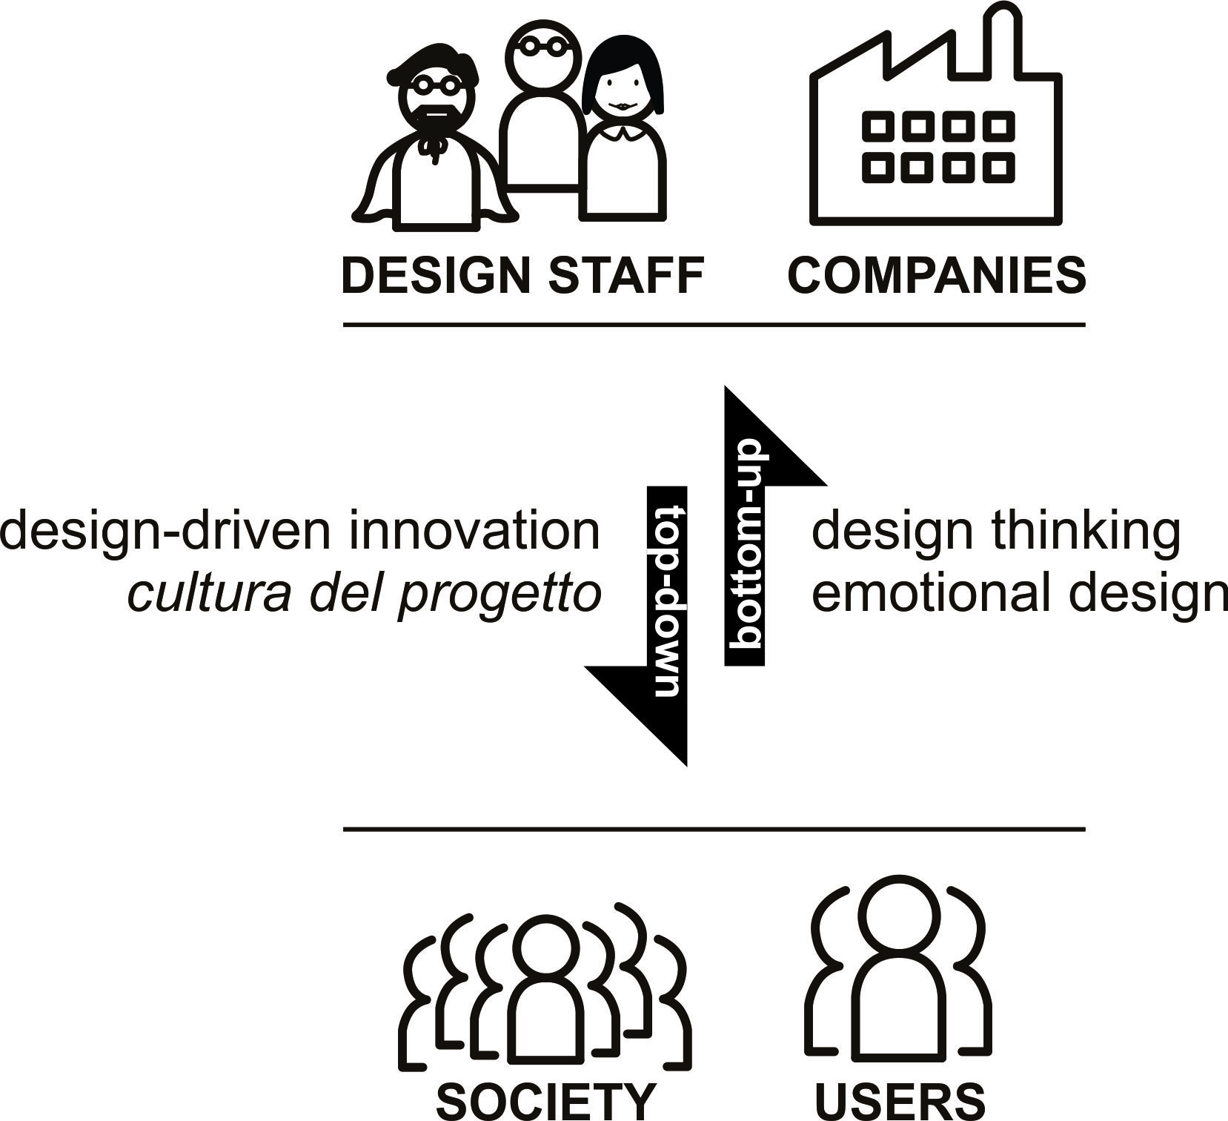
Figure 1: Design Innovation Approaches and Flows. Adapted from Fonseca Braga (2016).
Bottom-up design innovation is mostly based on and inspired by insights from users of a product, service, or system. Top-down design innovation approaches count on the expert capacity of designers to forecast trends and innovation. Both present advantages and disadvantages. For instance, disruptive innovations that are unfamiliar to users or citizens require a more top-down design innovation approach as users tend to refer mostly to prior experiences with a product, tending to generate ideas related to these prior experiences and knowledge of a product. This often leads to less innovative ideas or improvements in current solutions. Conversely, less innovative solutions, that are familiar to people, may benefit more from bottom-up design innovation approaches (e.g., design thinking, participatory design, co-design) that enable major inputs from users of a product, service, or system.
Pilot project
Our pilot project aimed to understand and develop further updatable/circular materials through interdisciplinary prototyping. The prototype set-up, our approach to interacting with materials and multi-adaptive material samples will now be briefly discussed to provide context and highlight key challenges of developing these material systems that can leverage desirable material abilities but need to be further explored through collaborative workshops.
Prototype set-up
In our current prototype set-up (Figure 2), we have developed a multi-stimuli system where heat and magnetism are modulated using a simple digital design tool (see Figure 3). This enables us to iteratively update multiple properties (shape, patterns, volume, opacity, texture etc) of magnetised plastic-like material samples at high resolutions (particle size) (see Figure 4). The plastic-like samples are melted via a heating mat, which enables self-healing when in a liquid state and can have multiple properties updated. The material updates are achieved by varying the strength of magnetism induced upon the sample by altering the height/proximity of an individual magnet as they are attached to linear actuators in a 4x4 grid.
Importantly, the ability to change the state of the material (i.e., from solid to liquid and vice versa) combined with the ability to update multiple properties opens up iterative interactions as the samples can be taken out of their fabrication environment, interacted with/hand-held and then updated or healed based on these interactions. This raised the possibility of creating structures that can become increasingly bespoke to a given user as well as their material make-up demonstrating material circularity/flexibility if the structure can be radically transformed and used for other applications. Where we see material circularity as a material that affords high degrees of flexibility and does not need to be totally recycled to radically update its properties.
The focus of this paper is to discuss how to determine desirable material response and the interrelationships between material properties and user demands for a given application. This is because the materials samples and prototyping has been documented as videos and discussed in a previous paper by the authors (Blaney, et al., 2022). To be able to determine what constitutes a desirable material response when materials are capable of multiple responses across their area/volumes and in doing so, form complex interrelationships for a given applications a framework for further prototyping research is required. For this reason, we carried out two online workshops. First with a physiotherapist from Great Britain (GB) Paratriathlon and a second with prosthetists and consultants from Preston hospital’s Specialist Mobility and Rehabilitation Centre. 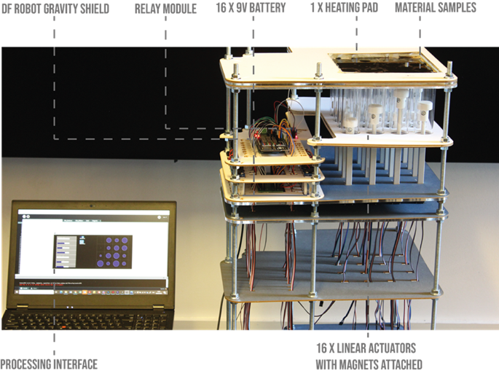
Figure 2. The prototype set-up with a material sample being interacted with.


Figure 3. The parametric interface used to control material patterns.
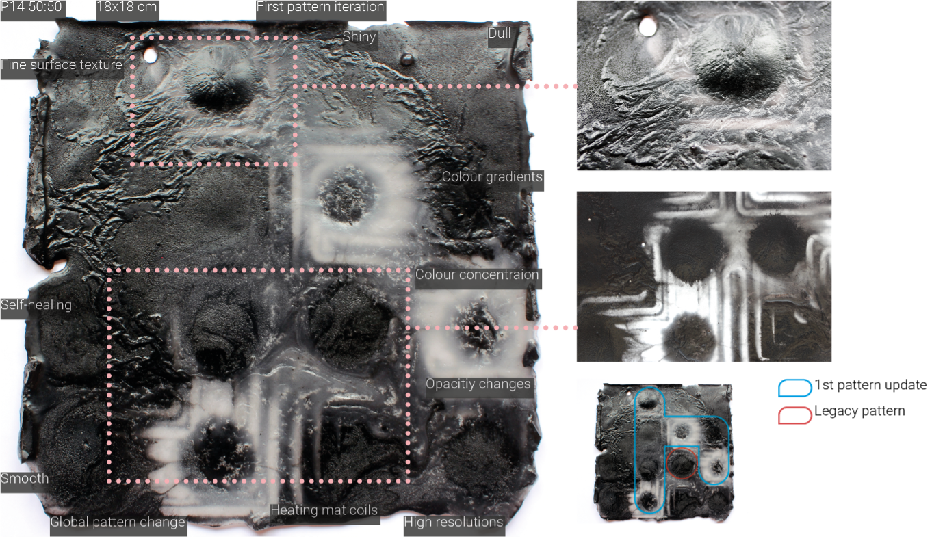
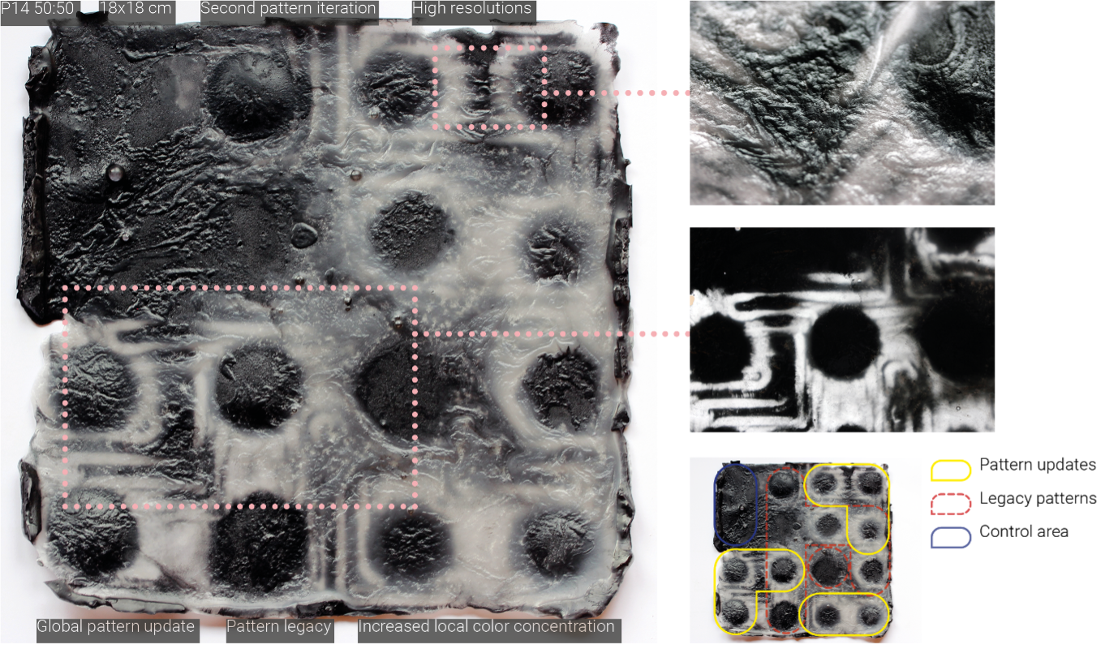
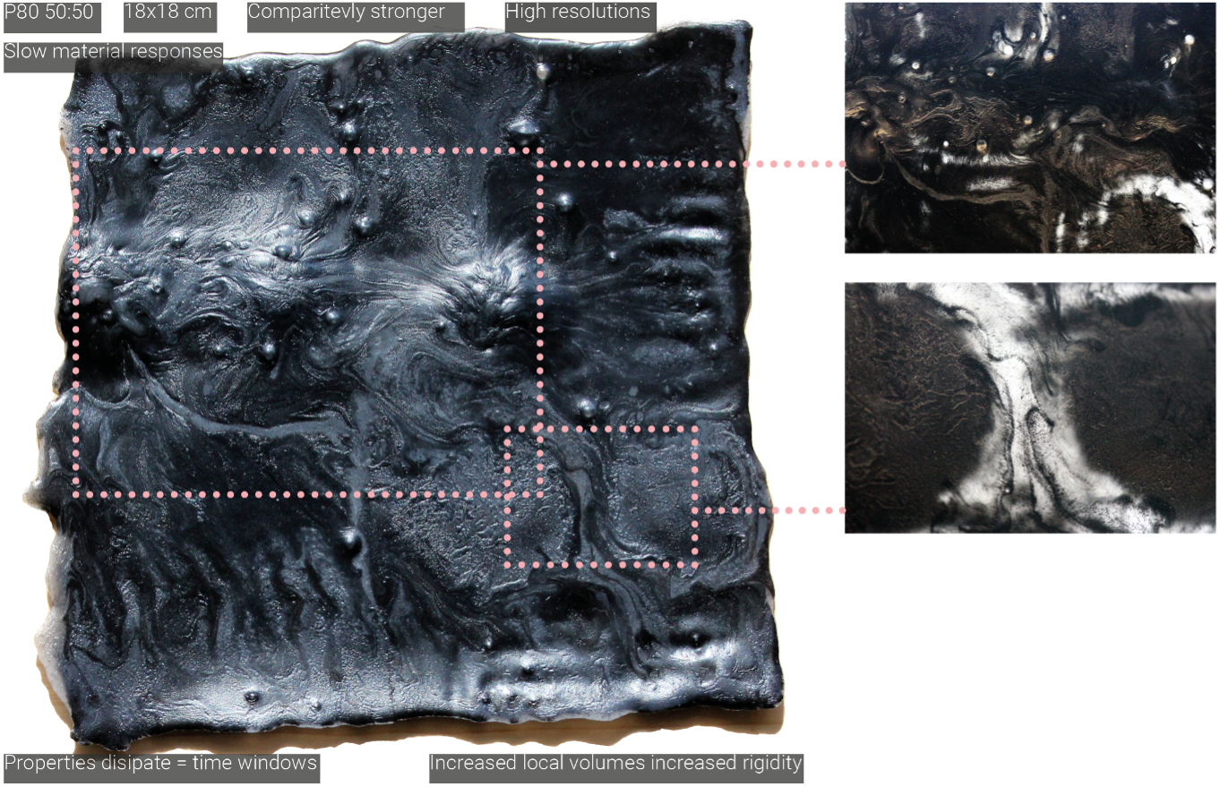
Figure 4. Material results for two material samples. The magnetised plastics enable multiple material properties to be iteratively updated at high material resolutions. The two samples have different strengths and as a result, demonstrate different qualities when interacting with them via stimuli. The annotations aim to highlight these implications and the properties generated.
Online workshops with experts
Two online workshops were conducted with experienced experts. One with prosthetists and healthcare consultants from Preston hospital’s Specialist Mobility and Rehabilitation Centre who perform surgery as well as fabricate prosthetics. A second one was with a GB paratriathlon physiotherapist who supports para-athletes during competitions and training.
Each workshop lasted around 90 minutes. They aimed to capture the challenges, desirable properties, trade-offs and associations from a medical and high-performing athletes’ perspectives and experiences with prosthetics.
Online templates were utilised to structure the workshop activities and capture the professionals’ insights into the above-mentioned aspects.
Firstly, the pilot project and its developments were introduced to experts in both workshops to frame and make tangible the potentials of adaptive material in their field. The other topics approached varied according to the area and experience of the professionals. We described these below.
Healthcare professionals (prosthetist and consultant surgeons) play an active role in the design and fabrication processes of prosthetics. They help to define the product specifications for each patient besides following and monitoring the patient’s progress during the adaptation to the prosthetics. The workshop with healthcare professionals enabled the team to understand and capture:
- Aspects of design and fabrication processes of prosthetics as well as how users’ data are considered and applied to those, defining the product specifications.
- Problems and challenges of prosthetics and their effects on patients’ bodies, their health-related risk, and patients’ feelings.
- Failures of prosthetics/current materials in tackling the issues generated and areas of opportunities to improve prosthetics.
- Perspectives of the healthcare professionals on promising materials’ response to alleviating or improving different types of prosthetics.
- Implications of materials that could be updated on demand for design and fabrication processes.
- Speculative ideas on tuneable materials applications to prosthetics (e.g., what if we had prosthetics made from materials that could be updated?) and implications for users.
- Desirable material responses and the types of data that need to be considered to improve patients' wellbeing.
- Types of amputation (bone/no bone) and implications on material systems and properties.
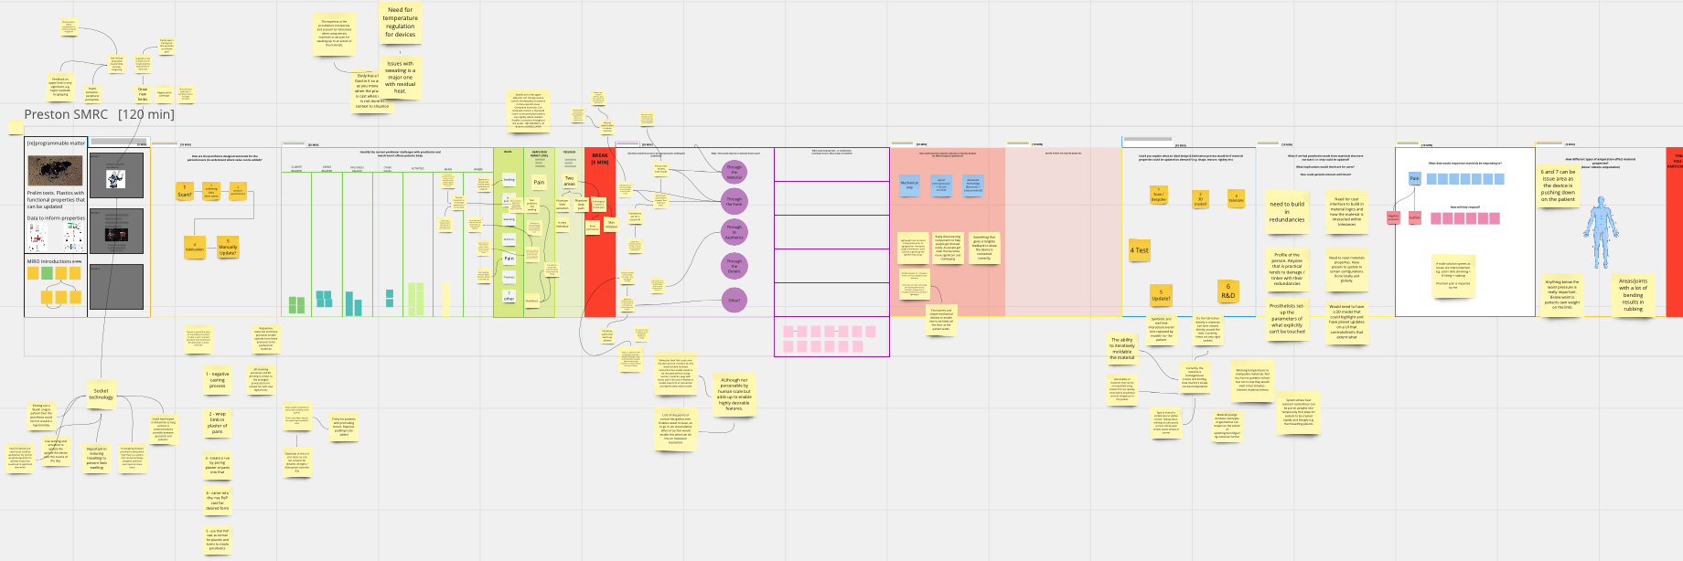
Figure 5. Online template utilised with healthcare professionals.
The workshop in the context of paratriathlon explored 8 key topics as follows:
- Para-athletes' data: Types of prosthetics and their impacts on the para-athletes’ body parts.
- Effects of running, swimming and cycling with the use of prosthetics on para-athletes' health.
- Current management of problems and strategies to mitigate those during training and races.
- Types of prosthetics according to each activity (i.e., running, swimming, cycling); adaptations during transitions between activities and desirable properties whilst switching activities; expert insight into ways of ‘measuring’/perceiving desirable properties associated with para-athletes performance metrics (e.g., running speed, heart rate, displacement etc).
- Current material properties of braces, prosthetics and tri-suits utilised during training and races.
- Types of data and potential associations to inform material responses.
- Desirable expert and para-athletes interaction with data (e.g., to inform materials’ updates).
- Future visions on adaptable abilities/properties for para-athletes' prothesis.
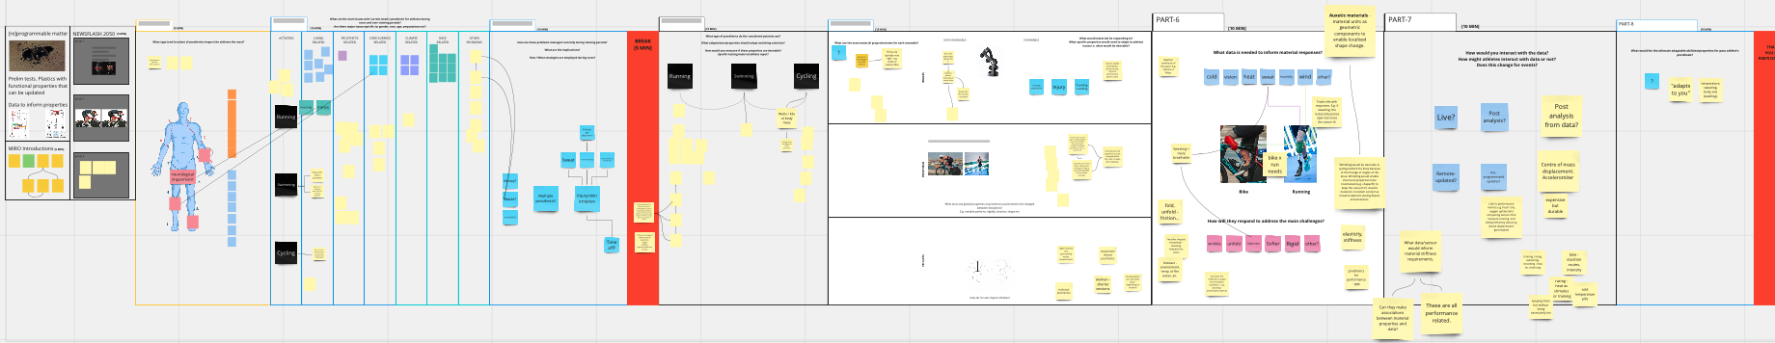
Figure 6. Online template utilised with the paratriathlon physiotherapist.
The analysis of the data collected was conducted in two stages. In the first one, the researchers identified the relations and associations between the different points made by experts and established cross-references (Figures 5, 6). In the second, they mapped the problems and explored solutions to tackling them defining also potential applications (e.g., what data/sensor would inform material requirements) (Figure 7). We present the synthesis of the data collected and of the analysis in the following sections.
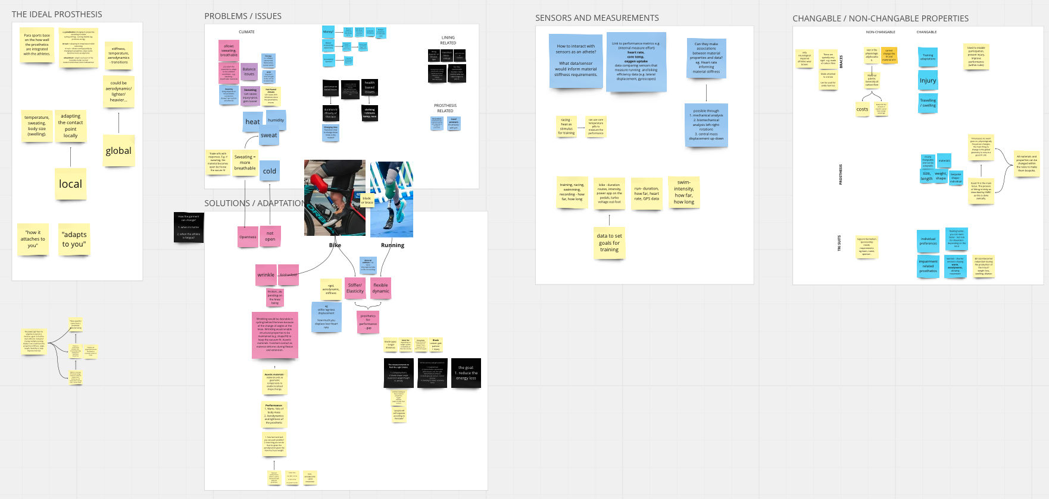
Figure 7. Example of analysis from the workshop with the paratriathlon physiotherapist.

Workshops’ results
Workshop with healthcare professionals
Existing prosthesis’ development process
Prostheses are designed by collecting patient’s data in a single-still position, using a negative casting or 3D scanning process. The data then informs the product specifications, and fabrication process begins with casting using plastic, laminated fiberglass, and plaster. All the adjustments are made manually via the prosthetist expert knowledge. The sockets created are very rigid in form, which prevents global shape-change after the final production. Also, patients need to wear silicone liners with their prosthesis (socket=glass fibre or carbon fibre, thermoplastic, cylindrical, liner=silicone). Parts of the socket and liner are made of a single material that present a single behaviour. Both lining and the prosthesis causes issues that effects patients’ daily life and are influenced by the prosthetics’ design and materials.
Current challenges of prosthetics
The materials currently applied to prosthetics do not respond to changes in the body and environment. This leads to several problems that impact people’s health and wellbeing from short to long term. We identified these challenges and their related prosthetics’ feature as follows.
While heat causes sweating and skin problems, cold leads to discomfort. The lining of the prosthetics does not adapt to the environment and body temperature changes to prevent sweating and people’s sensitiveness to cold. As a result, people can sweat, have their limb’s volume changed and suffer from skin problems such as infections and folliculitis due to rubbing of ill-fitting devices.
The volume of the body fluctuates throughout the day and with temperature changes or due to other factors such as monthly cycles for female patients. Current prosthetics’ inability to transform accordingly can lead to increase of pressure around the limb that is rubbed by the lining, affecting the body temperature in this area. Consequently, numbness can happen, fluids can build up and bursas can emerge.
Different activities cause different changes in the body’s shape and volume. The prosthetics’ connection does not respond to these changes. For example, when bending articulations, the volume and shape of the body area changes (e.g., knee gets wider and narrower during different activities). Hence, skin irritations, circulation issues, protrusions of muscle, nerves and bones can happen.
Furthermore, older adults need lightweight and structurally strong components that can be easily disconnected. Additionally, tangible feedback is necessary to confirm if the device is correctly connected to the prosthetics, which requires the deployment of advanced technology and could be useful for all user demographics.

Paratriathlon workshop
Para-athletes use different types of prosthesis during the race for cycling and running. Blade and brace type prostheses used during the race can have pin or suction attachment. Blade type is generally used for running, and its flexibility can be arranged according to the weight, speed of the athlete and complexity of the racecourse. Brace type is ideal for cycling and helps to push the peddles harder. The aerodynamics and lightness of the brace can be arranged according to the athlete's weight and comfort.
Athletes need to change their prosthesis while switching activities. Reducing the transition/changing time during the race is critical for them. Therefore, it would be ideal if their prosthetics could adapt not only to different climate conditions but also to the different activities.
The comfort of the prosthetics is a subjective matter, depends on the athlete and the condition of their tissue. Therefore, it is not possible to make ultimate claims on the best adjustments valid for everyone. However, there are also common problems that athletes face during the race and training period. These issues can be categorised according to the activities and type of prosthetics they use. Other than that, they can be related to accessibility/money, environmental, performance and health issues.
Health-based issues include sweating, balance problems, local pressure, friction/rubbing and skin irritations. They generally come from the lining, ill-fitting prosthesis, and environmental factors (climate). The performance-based issues depend on the duration and the difficulty of the race (hilly/flat). Both problems can occur when the environment is not ideal and when the athlete is suffering from fatigue.
During a race keeping the liner clean and dry is important and having a stock of liners can help the athlete. However, they are expensive, and sponsors often only help successful athletes and accessibility/affordability becomes an issue. The shortness of the material life expectancy causes environmental issues. For instance, carbon fibre degrades, loses its components and stiffness accordingly.
How can responsive materials contribute to tackling prosthetics’ challenges?
Responsive materials can play a meaningful role in tackling the current challenges of prosthetics. They can change and adapt their properties to prevent the problems generated by the inability of current prosthetics’ materials and fabrication processes to respond to changes in the environment and body temperature, pressure, and shape. However, to develop and define appropriate adaptive material’s responses, we need a system that enables real-time data to be integrated, informing the necessary changes in those material properties. Therefore, considering the prosthetics’ challenges, we envisioned the following system (Figure 8) capable of capturing real-time data from the environment and body through sensors in order to adapt and respond to changing environment and body conditions. Moreover, features of the lining’s architecture can work also as structures that further facilitate these changes to timely happen.
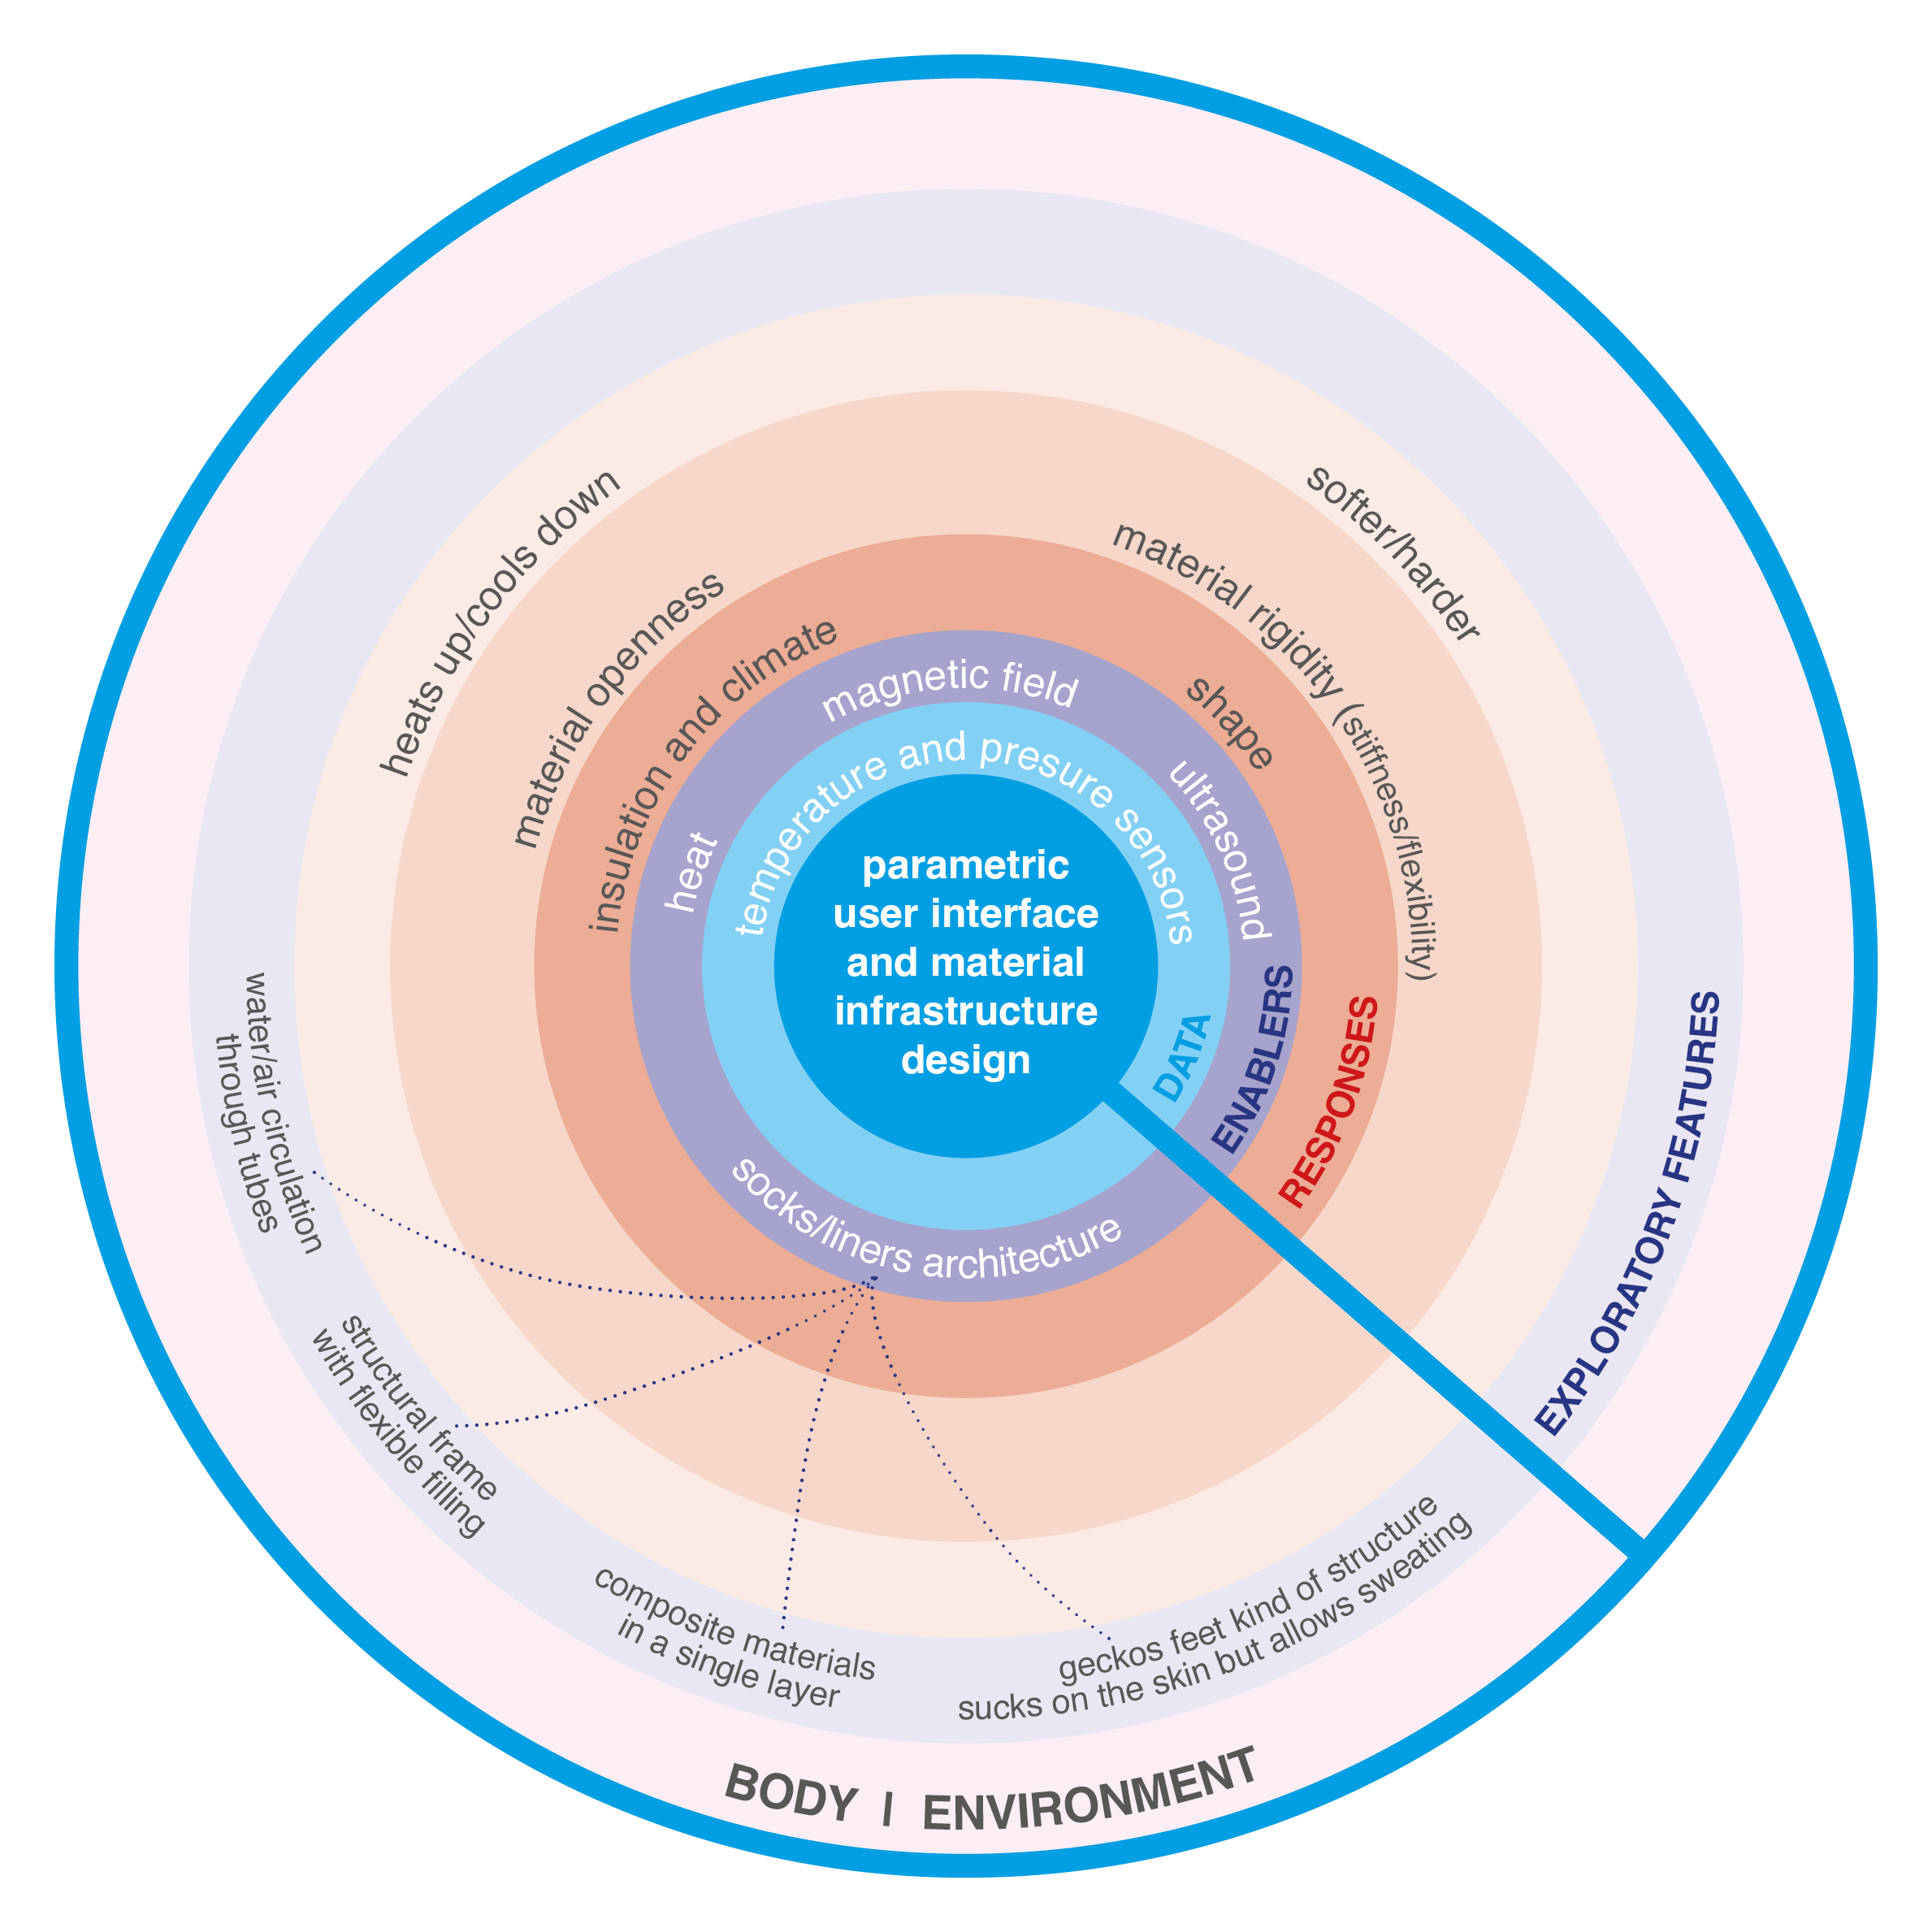
Figure 8: A parametric user interface for adaptive materials applied to prosthetics.
Additionally, the fabrication processes of prosthetics are limited in how they can accommodate varying body positions as the person moves, the diversity of activities that people will carry out as well as their intensity. Furthermore, para-athletes' prosthetics may need to be more robust due to the frequency and intensity of physical activities but still enable flexibility so they can be adapted to different activities in cases such as paratriathlon competitions and training which involve running, cycling, and swimming.
The ideal prosthetic for the para-athletes would be the one that can self-heal, respond to the race rules to become bespoke and change its material properties, size, weight, and shape according to the needs of the athlete in different activities. Moreover, responding to sweat, wind, and temperature can help the athlete to overcome their challenges.
Sweating through localised overheating is an issue for both athlete and non-athlete prosthetic users as it can cause injuries and balance issues since the prosthesis become slippery with sweat. To address this, current linings have ‘pores’/small holes to allow seat to flow to the outside of the linear and in between the socket. However, a desirable response would be to make the overall structure more breathable/porous but with current material results in a trade-off. This is because the current approaches achieve a vacuum-like fit, which provides; comfort, enables the prosthetic to be worn quickly and limits movement/rubbing between layers until it becomes wet with sweat. But it results in this overheating and the resultant issues associated with sweating. Meaning, there is a hierarchy of what is a priority with this current approach. Additionally, cycling and running needs are different, thus the rigidity of the prothesis could change according to the different activities being carried out.
Therefore, in this case, making the contacting points adaptive is even more critical. So, we suggest further sensors and an additional lining’s architecture features as follows:
- An oxygen uptake sensor and a heart rate sensor to inform tuneable materials’ openness and stiffness/flexibility.
- Potentially locating auxetic materials at locations that bend to achieve localised geometric shape-change. This kind of product architecture feature could improve comfort when move at an amputated limb’s joint. It would be desirable to position this feature behind the knee because of the change of angles at the knee when cycling. Wrinkling would make possible to maintain structural properties (e.g., shape/fit) meanwhile it would keep the vacuum fit.
- Develop a ‘geckos’ foot like material that combines soft liner layers within the structural outer layers of the prosthetic. This would enable void areas/lattice-like prosthetics and where it is in contact with the skin it can stick to it to maintain a vacuum-like fit. In doing so, it could address the trade-off issue of overheating and irritation caused by sweating because it can naturally evaporate.
All in all, a system embedding a new socket technology with adaptive materials that can also give feedback would help to speed and inform fabrication, reduce waste, be more tolerable, and open up the potential for prosthetist to remotely update a patient’s prosthetics in remote areas by reviewing data captured and sending updates directly into the prosthetic, which could improve quality of life and access to health care specialities.
Implications for design[ers] research[ers]
Design researchers and designers do not often play a meaningful role in the development of prosthetics. However, they can be key to advancing prosthetics’ innovation. Working on solutions throughout prototyping processes with adaptive materials requires designers and design researchers to anticipate not only the users’ experience and needs in order to define the changeable properties of the product/materials but the future demands for the maintenance of the prosthetics that ideally should be ‘user friendly’ or ease the users’ jobs as well as adapt to potential future needs and desires in people’s lives. The interdisciplinary collaboration between design and chemistry in this research has enabled multi-adaptive materials. In doing so, it highlighted new implications for designing with these new types of materials, most importantly; how to interact with materials across a structure’s scales (molecules to global shape), the role transdisciplinary workshops play in determining what constitutes desirable responses for a given application, and the implications of how to monitor and co-ordinated the multiple material responses generated via a range of induced stimuli over time. This ability to iteratively interact with materials enables enhanced decision-making processes by facilitating collaboration and discourse between multiple stakeholders (in the case of prosthetics; patients, prosthetists, designers, material scientists/chemists, consultants). This is because increased material flexibility is afforded along with a system that would enable faster and infinite iterations that reduce material waste and costs associated with that. Meaning, a patient can have a single prosthetic over their whole life because it can be radically altered but also finely tuned to enhance bespoke qualities.
These design innovation processes require a continuous collaboration between designers/design researchers, people who use prosthetics, heath care professionals, and other knowledge areas that contribute to advancements of adaptive materials and technologies. Therefore, the development of creating adaptive prosthetics is transdisciplinary in nature.
In this context, design[ers] research[ers] can enable better and effective communication between different stakeholder groups and can create embedded systems that make feedback loops possible utilising real-time data to inform changeable features. These exploratory, experimental and flexible design approaches are led and crafted to capture, share and harness meaningful dialogues among these groups and enable them to be further translated into the adaptive materials and technology’s development.
Hence, this flexible design innovation approach utilises elements of top-down and bottom-up design innovation as both are essential to inform and advance the development of prosthetics involving responsive materials and technology. People utilising prosthetics in different conditions, contexts and circumstances are key to understanding positive and negative experiences with and features of current prosthetics. Health professionals are critical to identifying current challenges which impact the life of prosthetics’ users and to facilitating associations with specific products and material features that are currently employed in the fabrication of prosthetics. Chemistry and other disciplines besides design, advancing the field of tuneable materials and technologies, are also crucial as they provide fundamental insights into materials’ possibilities on the molecular level bringing implications for materials’ design and helping to make the informed and imagined transformative features feasible to be experimented.
As a result of that, designers need to be capable of capturing the ‘thoughts’, experiences and knowledge of these different groups as well as communicating effectively with them, utilising accessible vocabulary (lay or jargon-free), being able to deeply listen and discuss possibilities of advancements in collaboration with health care professionals and these other knowledge areas (learning their vocabularies), in a continuous learning process enabled through design research that allows these exploratory and experimental learning cycles.
Furthermore, designers and design researchers provide the enabling structures and platforms for the experimentation to happen. They creatively combine technologies making structures and developing unique methods for testing these ideas. These creative processes and structures leverage future advancements with inputs from these varied stakeholder groups.
Another aspect to be considered is the openness of these different stakeholders to these design flexible and experimental approaches, understanding the value and advantages of those as well as their limitations when compared to conventional scientific approaches and methods.
Future Work
This paper outlined an initial framework and highlighted associations between fluctuating user demands, challenges with current prosthetics’ materials as well as design and fabrication processes and the trade-offs and hierarchies of these. Future work will aim to expand and refine these associations/interrelationships and generate an ‘interface’ that enables intuitive interactions and understanding. To do this, we would develop prototypes with users to incorporate their own perspectives so nuances can be captured within the materials. Additionally, we will continue to carry out transdisciplinary research and collaborations to develop transformative material platforms/systems that can address these trade-offs through novel material properties.
References
Alima, N. (2022). Interspecies Formations: The Hybridisation of Architectural, Computational and Mycelia Agencies. PhD, RMIT.
Blaney, A., Dunn, N., Alexander, J., Richards, D., Doursat, R., Rennie, A. E. W. & Anwar, J. (2016). Coupling Self-Assembling Materials with Digital Designs to Grow Adaptive Structures. in: Doursat, R. & Sayama, H., eds. Artificial Life: 6th Morphogenetic Engineering Workshop, July 2016 Cancun, Mexico. MIT Press, pp.7-10.
Blaney, A., Dunn, N., Alexander, J., Richards, D., Rennie, A. E. W. & Anwar, J. (2017). Directing Self-Assembly to Grow Adaptive Physical Structures. International Journal of Rapid Manufacturing, 6, pp.114-133.
Blaney, A., Alexander, J., Dunn, N. & Richards, D. (2019). Designing Parametric Matter. IASDR 2019: Design Revolutions. International Association of Societies of Design Research Conference 2019. Manchester, United Kingdom.
Blaney, A., Richards, D., Gradinar, A. & Stead, M. (2021). Prototyping Circular Materials Based on Reprogrammable Matter. IASDR 2021: [ _ ] With Design: Reinventing Design Modes. Poly U Design, School of Design, Hong Kong Polytechnic University.
Blaney, A., Ozkan, D., Pelit, E., Fonseca Braga, M., Hardy, J., & Ashton, M. (2022). 'Parametric Matter': Pushing’ Updates into Materials and the Implications of Legacy and Lag. ACADIA 2022: Hybrids and Haecceities.
Boothroyd, G., Dewhurst, P., & Knight, W. A. (2002). Product Design for Manufacture and Assembly. New York: Marcel Dekker.
Brown, T. (2009). Change by design: how design thinking transforms organizations and inspires innovation. New York, NY: HarperCollins Publishers.
Dogan, C., & Walker, S. (December 2003). The best of both: A study of the feasibility of integrating scales of design and production for sustainable products. The Journal of Sustainable Product Design, 3 (3-4), 135-147.
Fonseca Braga, M. (2016). The value of design: an issue of vision, creativity and interpretation. In P. Lloyd & E. Bohemia (Eds.), DRS 2016 Conference Proceedings, pp. 1865-1881. London, UK: Design Research Society. https://doi.org/10.21606/drs.2016.12
Ghoseiri, K., & Safari, M. R. (2014). Prevalence of heat and perspiration discomfort inside prostheses: Literature review. Journal of rehabilitation research and development, 51(6), 855-868.
Ito, J., & Howe, J. (2016). Whiplash. How to Survive Our Faster Future. New York, NY: Grand Central Publishing.
Jeswiet, J., & Hauschild Michael. (2005). EcoDesign and future environmental impacts. Materials & Design, 26, 629-634.
Julier, G. (2017). Economies of design. London, UK: Sage Publications Ltd.
Otto, F. & Rasch, B. (1995). Finding Form: towards an architecture of the minimal. Stuttgard, Axel Menges.
Ozkan, D., Morrow, R., Zhang, M. and Dade-Robertson, M. (2022). Are Mushrooms Parametric?. Biomimetics, 7(2), p.60.
Petrina, S. (2000). The Political Ecology of Design and Technology Education: An Inquiry into Methods. International Journal of Technology and Design Education, 10, 207-237.
Project Management Institute. (2012). Um guia do conhecimento em gerenciamento de projetos [PMBOK guide]. São Paulo, Brasil: Saraiva.
Thenint, H. (2008). Design as a tool for innovation. Pro-Inno Europe. Retrieved from http://grips-public.mediactive.fr/workshops/view/2/design-as-a-tool-for-innovation/
Tischner, U. (2000). Ecodesign in practice. In: German Federal Environmental Agency Berlin, editor. How to do ecodesign. A guide for environmentally and economically sound design. Frankfurt: Verlag form GmbH.
Turner, S., Belsi, A., & McGregor, A. H. (2022). Issues faced by people with amputation (s) during lower limb prosthetic rehabilitation: a thematic analysis. Prosthetics and Orthotics International, 46(1). Pp.61-67.

Dr Mariana Fonseca Braga

is a hybrid designer with industry and academic experience in developing and implementing projects utilising diverse design approaches to unlock innovation and tackle societal challenges with interdisciplinary teams. She is currently a Post-Doctoral Research Associate International in Imagination Lancaster at Lancaster University with an MSc in Industrial Engineering and a PhD in Design awarded with honours from Politecnico di Milano. Braga leads research in community-led capabilities focusing on how these can feed into effective policy and technology design. Her recent publications encompass the value of design and challenges in organisations, and in tackling the UN SDGs.

https://www.linkedin.com/in/mariana-fonseca-braga/?locale=en_US

Dr Adam Blaney

is a lecturer at Lancaster School of Architecture. His research interests mainly focus on developing digital design and fabrication processes that aim to create physically responsive, adaptive and self-healing objects, devices and architectural structures. Additionally, based on principles from these prototypes, he is also interested in developing speculative visions of materially adaptive architectures and cities.

Dilan Ozkan

is an architect and researcher who focuses on working with living systems. She aims to push the limits of traditional architectural production and bring different approaches by discovering new material making processes. Dilan completed an architectural design masters at Pratt Institute in New York, where she was first inspired by the strange aesthetics of living organisms. Currently, she is a PhD student at Newcastle University. Within her research, she is investigating non-linear materials and working fungi as a biomaterial probe. She formed a study group called Mycology for Architecture to collaborate with other disciplines and share knowledge about fungi.

Dr Emel Pelit

is a researcher working in the field of organic chemistry. Her research interests are on the synthesis of heterocyclic compounds and the study of their biological activities, and on conjugated polymers. In addition, she is interested in performing organic reactions in accordance with the principles of green chemistry, using methods such as aqueous media and sonochemistry. Organic Chemistry, sonochemistry, conjugated polymers.

Dr John G Hardy

is a senior lecturer at Lancaster Universities’ Material Science Institute. He is an interdisciplinary researcher with experience in chemistry, materials science, pharmacy and biomedical engineering. Hardy is interested in developing materials that interact with electricity, light and magnetism for a variety of technical applications (e.g. transient electronics) and medical applications (drug delivery, tissue engineering and regenerative medicine). He is particularly interested in bioelectronics (e.g. biodegradable conducting polymers, 3D printable conducting polymers) and biophotonics for drug delivery, tissue engineering and neuromodulation.

Diverse knowledge areas that intersect and combine their expertise in response to a shared research interest.
Collaborations beyond the academy, such as other industries, businesses, the public sector, practitioners, citizens etc.
Different knowledge areas studying a phenomenon and bringing implications for their specific fields.

