**The Cumbrian – The Trials of a Never Before Attempted Ultra-Endurance Challenge**

On the 22nd July 2022 Kirk Wadsworth and Tim Jenner set off on a never before attempted ultra-endurance challenge. The Cumbrian, a 352km race across the Lake District fells, lakes, and mountain passes. The Cumbrian combines three well known endurance challenges into one intense, gruelling feat of physiological and psychological resilience to be completed in under 60 hours.

Figure ? The Cumbrian stages: three ultra-endurance challenges completed back to back in a mammoth 60-hour race

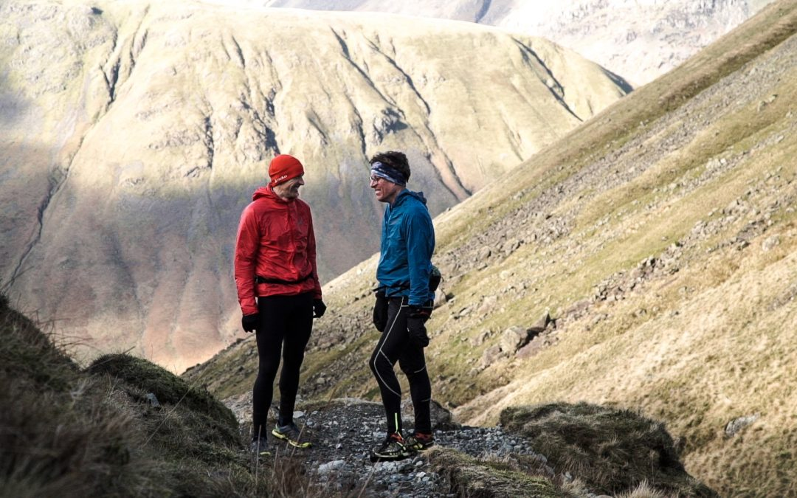

Figure ? Kirk Wadsworth and Tim Jenner – the first to attempt the Cumbrian extreme challenge. (Image taken from [22-24 JULY 2022 | The Cumbrian (cumbrian22.co.uk)](https://cumbrian22.co.uk/uncategorized/hello-world/))

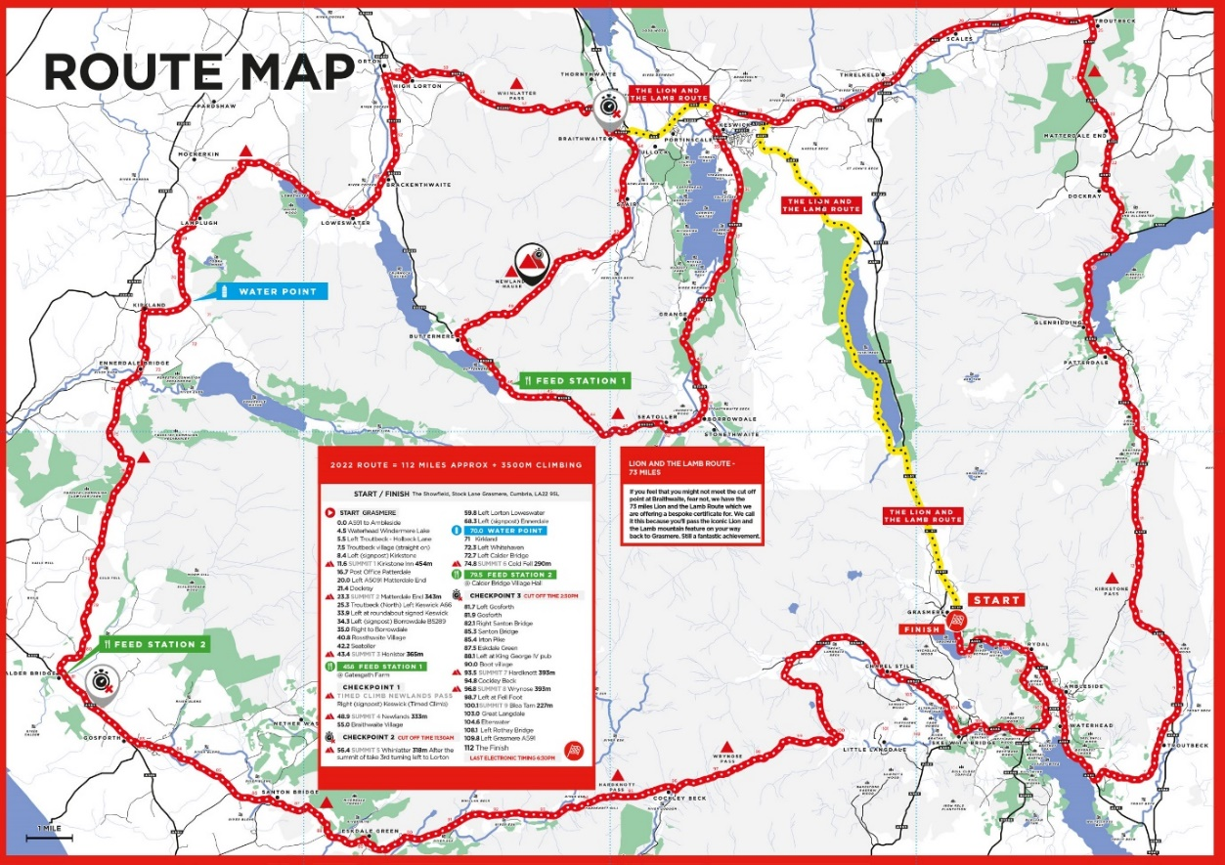

Figure ?: The final 182km Fred Whitton Challenge route – the toughest cycling route in Britain with a 30% gradient hitting at 157km. (image taken from [Route | Fred Whitton Challenge](https://www.fredwhittonchallenge.co.uk/route/))

Ultra-endurance events and adventure racing have never been more popular but they are challenges requiring significant preparation. The longer the challenge, the more important preparation becomes to be in good health at the finish line. The key areas to consider are training volume and load, nutritional strategy, and the prevention of overtraining and injury.

**Training volume and load**

The principles of training apply to ultra-endurance training. **Overload** is essential to ensure physiological adaptations to the aerobic system are exploited, for example maximum capillary density and haemoglobin content to transport oxygen to the muscle cell and maximum mitochondrial density for aerobic energy production. However, the principles of **progression** and **moderation** are important due to the scale of the challenge, i.e. training to move 352km without inducing burnout, repetitive strain or chronic injuries along the way. Consider the fact both Kirk and Tim have full-time jobs and family commitments, creating a training:work:life balance is a hard task.

* **Frequency**: 5+ days per week
* **Intensity**: Low-moderate intensity, e.g. long-distances through rolling countryside interspersed (and increasing towards the event) with higher intensity, e.g. elevation hill-training
* **Time**: Gradual progression from 40-120 miles per week
* **Type**: Fell running, endurance cycling, and open water swimming

**SP:** When did you start training for this challenge?

**KW:** Targeted training started around November 2021 but the reality is that the culmination of several years of long distance running and cycling has primed the body for the rigours of the last few months. So really, we’ve been training for years without really knowing it.

To maximise our chances of success, we entered the winter knowing that we needed a massive base. We planned to run as many miles as we could and increase this steadily as we progressed. Although the crux of the challenge itself lay in dealing with huge volumes of vertical gain, we eased into this slowly for two reasons. Firstly, if we started serious hill training too early, we knew there was a chance we’d pick injuries or we’d burn out. Secondly, we live roughly 45 minutes from the big hills. What we have on our doorstep is endless rolling countryside, littered with beautiful trails. So, we planned to maximise training time by staying local, cutting down on travel time and waiting patiently until we were ready to start serious hill training. Also, the weather is far worse in the hills during the winter and although we needed a good amount of resilience training, it’s hard enough getting up at 04:00 to run in the dark and rain. Staying local paid off both in terms of efficiency and reducing the chances of injury.

**SP:** Roughly how many miles did you put in per week?

**KW:** We started with 40-50 miles for the first few weeks and built it up to around 120 miles towards the end.  We planned to increase the mileage steadily but it fluctuated due to family and work commitments.  We knew that the key to success was being able to absorb the demands placed on us by the elevation, rather than simply increasing the number of miles. Vertical is everything for the Cumbrian since you climb over 17,000m in less than 60 hours. In the last 2 months, we dropped the overall mileage and focused on vertical gain, sometimes running up to 6000m of vertical a week.

**Did you know?**

**Training volume** = product of frequency and duration of training

**Training load** = product of frequency, duration and intensity of training

Training volume and load changes throughout a periodised plan are essential to ensure adaptation and avoid overtraining

Monitoring the frequency and duration of training is easy, especially with GPS trackers. Monitoring the intensity of training over long distances on variable terrain is more difficult and often relies on one of two options: **HR rate training zones** or the **rating of perceived exertion** (RPE).

Months before the Cumbrian Kirk and Tim visited the human performance laboratory at Lancaster University to undergo physiological testing to see whether they were capable of attempting and finishing this mammoth challenge. A **VO2max** test revealed the size of their cardio-respiratory engines were big enough, but lactate tolerance tests gave more specific detail about the highest intensity they could perform at for a sustained period of time. The test pinpointed specific heart rates they could push themselves to without accumulating fatigue.

The lactate tolerance test is similar to the VO2max test – a progressive intensity test performed on a treadmill or bicycle ergometer. The difference lies in the measures taken during the test. A fingertip blood sample is taken at each exercise intensity to track blood lactate accumulation. As exercise intensity increases, so does blood lactate. Monitoring the heart rate (HR) and exercise intensity (e.g. speed) this occurs at can reveal key information which can be used to plan and monitor training. Two key factors for consideration:

* **Lactate can be a friend** – knowing the heart rate a performer can work at whilst producing enough lactate to process as a fuel but not too much to cause fatigue can push the intensity of exercise whilst maintaining steady state energy production
* **The lactate turn-point** (also known as the onset of blood lactate accumulation, OBLA) – the associated HR or intensity to avoid, where blood lactate rapidly rises leading to swift fatigue

**SP:** What did you gain from the laboratory fitness testing?

**KW:** The support gained from the Sport and Exercise Science Department allowed us to test, with real accuracy, the rate at which we could work at over prolonged periods of time. The test measured our blood lactate levels at various intensities in a controlled environment, which allowed us to determine work rate zones using standard heart rate monitors and in particular the zone in which we could operate for the longest periods of time.  We took this data and transferred it to our real time training in the hills. We simply ran at the required heart rate intensity over as much of the route as possible and plotted this against speed and distance. Knowing that we needed to complete each leg in a specific time to complete the challenge, we were then able to determine the split times. I’m pleased to say that the testing proved that we would be able to run at the desired intensity and speed to achieve our goal. It gave us the confidence to run at the required speed, knowing that we could sustain that indefinitely if we refuelled as planned.

**Nutritional Strategies**

Achieving an energy balance is important to all athletes during training, but due to the extreme duration it is equally important during the event to an ultra-endurance performer. Energy intake should equal energy expenditure (not just activity energy expenditure but also basal metabolic rate (BMR) and thermic effect of food). This is an enormous task for ultra-endurance athletes who often finish events with an energy intake less than half that expended. A research study on 25 trail runners in the Scottish Highlands (similar conditions to the Cumbrian) showed an average energy deficit of -8359kcal over a 24-hour period. These huge energy deficits are associated with delayed recovery and poor performance which considering the 3-day timespan of the Cumbrian serve up a huge challenge.

During the high-intensity race pace Kirk and Tim will work at around 80%+ of their VO2max needing carbohydrate (CHO) as the primary fuel. During lower intensities there can be more of a reliance on fat. The extreme nature of the Cumbrian leads to a reliance on CHO for energy production during the event, despite the fact fat sources weigh less in the rucksack! Glycogen will provide reserve stores and should be loaded prior to and in-between stages, e.g. an ambitious 10-12g per kg body weight, per day in the 48hrs prior event. To save these glycogen stores maintaining circulating levels of blood glucose is key to sustained performance. New technologies are available to provide continuous glucose monitoring for exceptional knowledge access during performance.

**SP:** Did you find the continuous glucose monitoring useful?

**KW:** The bio sensor and the App developed by Supersapiens has been invaluable during training and during the challenge itself. When most people take on endurance events, they have a good sense of how their body reacts over long periods of continuous exercise. However, the longer this period extends, the less ‘in tune’ we become with our bodies because tiredness and general fatigue play havoc with our built-in sensors. This has certainly been the case for me over the years. Having a bio sensor that projected real time glucose monitoring to my watch helped me look at data when I was feeling strong and conversely, when I started to feel fatigued or had stomach issues. The data either reassured me that there was enough fuel in the tank, or that I needed to take on fuel. Sometimes this aligned with my build in systems and sometimes it didn’t. This is where the technology is most powerful and can avert issues with dire consequences.

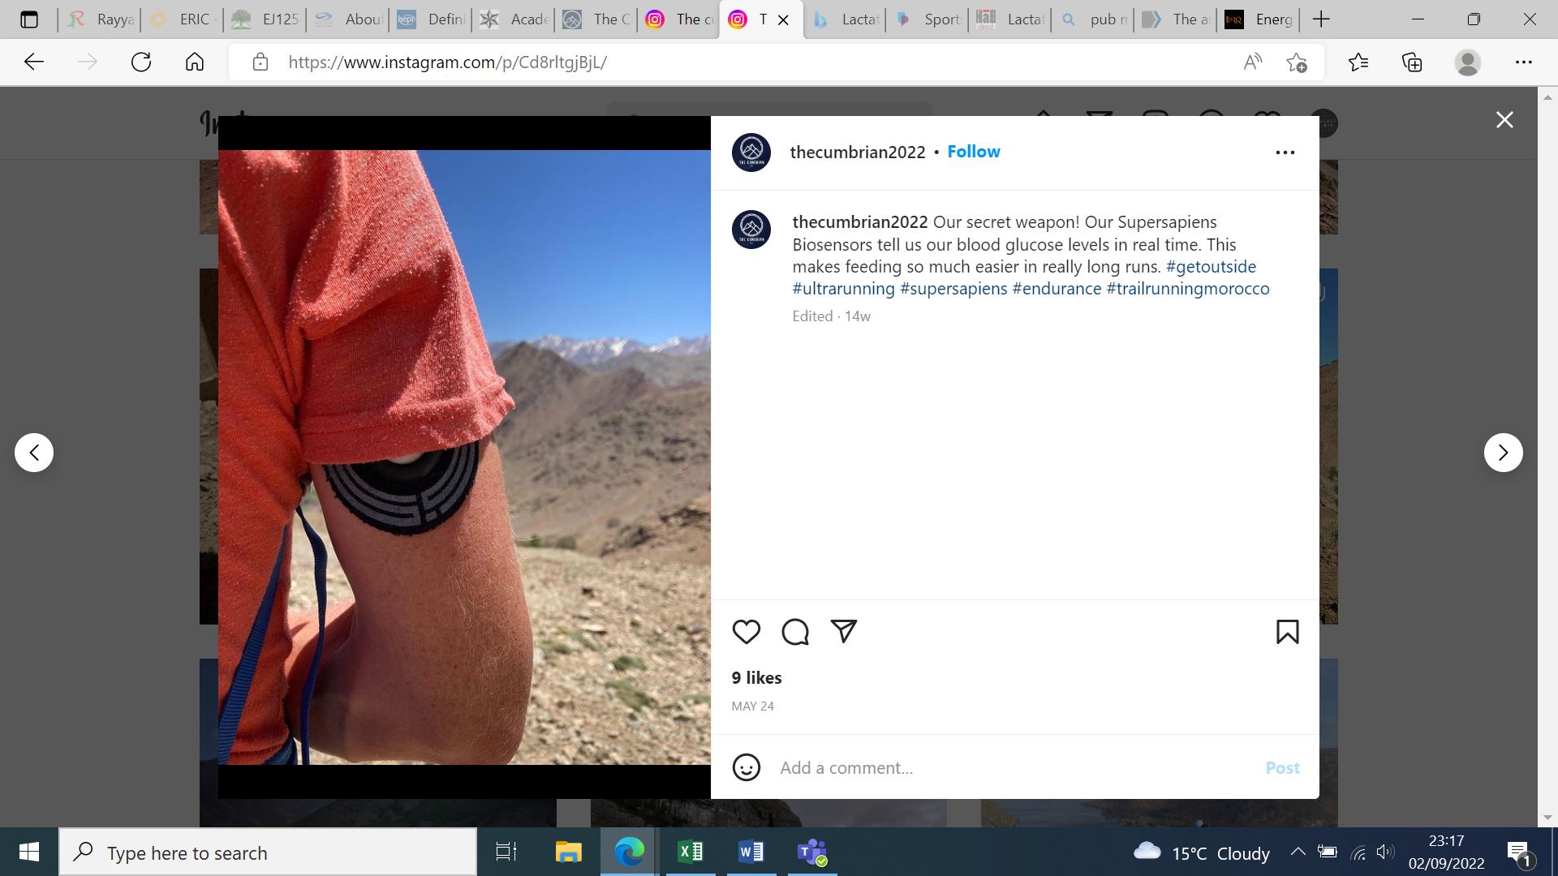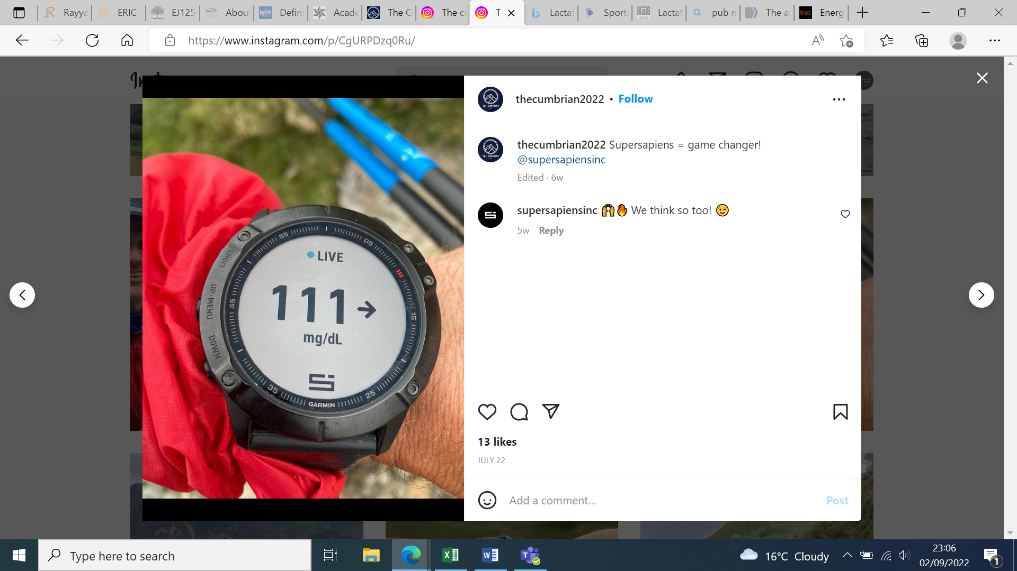 Figure ? Minute by minute glucose monitoring from an upper arm biosensor gave Kirk and Tim the knowledge of when to refuel (image taken from: [The cumbrian (@thecumbrian2022) • Instagram photos and videos](https://www.instagram.com/p/CgURPDzq0Ru/))

There are additional challenges for ultra-endurance athletes. As intensity and duration increase so do symptoms of reduced appetite, nausea, stomach pain, bloating, and diarrhoea. Gels are often preferred to gain high doses of glucose and fructose (CHOs) without the associated chewing, swallowing, and gastro-intestinal distress, but individual testing to find out what the athletes prefer and can tolerate is essential.

**SP:** What was the hardest part of the challenge?

**KW:** Finishing the Bob was tough. The weather was predicted to worsen on leg 5 but remain dry until then. That didn’t happen. The rain started during leg 3 and intensified until the end. I was extremely fatigued as the weather deteriorated. The wet rock made it difficult to move quickly and I was against the clock as I came into Keswick. I was struggling to eat knowing that I had to find a way to get CHO inside so I could replenish my glycogen stores. It didn’t happen. I returned to my van knowing I had to change, eat and sleep. I simply couldn’t eat so I grabbed what sleep I could in the hope that my body would reset and I’d feel hungry when I woke. It didn’t. I forced down 2 weetabix with banana and climbed onto the bike knowing that 2 weetabix doesn’t get you very far around the Fred! The weather was still awful. I’d slept roughly 3 hours in the last 2 days and I had to cycle up Honister Pass. That was the hardest part.

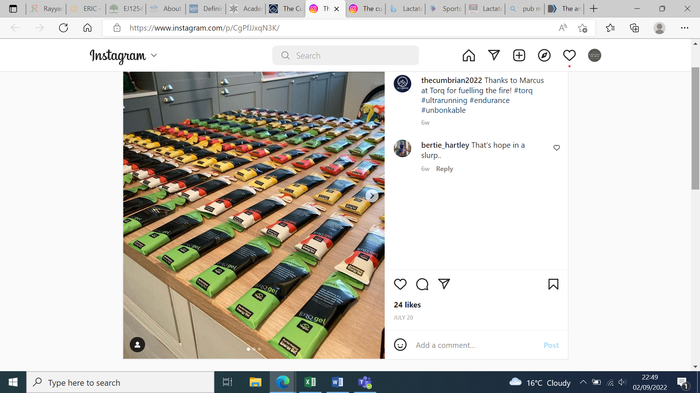 Figure ? The glucose and fructose carbohydrate energy gels used to fuel performance with added electrolytes and caffeine (image taken from: [The cumbrian on Instagram: “Thanks to Marcus at Torq for fuelling the fire! #torq #ultrarunning #endurance #unbonkable”](https://www.instagram.com/p/CgPfJJxqN3K/))

**Overtraining and the prevention of acute injuries**

Research has shown over 80% of triathlete injuries happen in training compared to during the event itself. In reality a triathlete will spend so many more hours training than actually competing - events carry a 6x greater risk for injuries. Musculo-skeletal injuries in ultra-endurance events typically stem from repetitive physical stresses and occur largely to the knee, ankle and foot. They typically include;

* Ankle tendonitis (‘ultramarathon runner’s ankle’)
* Medial tibial stress syndrome (MTSS)
* Chronic exercise-induced compartment syndrome (CECS)

The years of fitness training Kirk and Tim have undergone have led to a level of ‘structural tolerance’ - the ability to endure months of high-volume training without an injury, illness, or such fatigue that overtraining leads to burnout. Adequate recovery is key, ensuring the body has time to heal and adapt before further overload is applied. There are many considerations, but all recovery planning should be individualised to the athlete’s needs and include;

* Periodised training with regular monitoring and progress reviews
* Correct nutrition before, during and after training
* Hydration and rehydration protocols
* Ice and cooling aids (to reduce inflammation)
* Adequate sleep (where hormones are released to stimulate muscle repair)

If the athlete can balance the training and nutrition demands, can they cope with all the additional stressors placed upon them? The changing environmental conditions; wet windy days in the mountains, cold temperatures, dark evenings after a full day at work, family commitments, work commitments, emotional highs and lows – the list goes on. The training required for an ultra-endurance challenge goes beyond the psychological resilience of the athlete themselves but requires huge support from family and friends.

**SP:** How does it feel to have successfully completed the challenge for the first time?

**KW:** I’m still trying to process it all and I’m still very emotional as I recount the last few days.  I’m so relieved to have made it to the finish line after what felt like months on the hill. So much has gone into making this challenge a reality and so many people have given their support to both Tim and I to help us to the start line. I’ve been blown away by the support and generosity of our special community and beyond. It’s been really tough but worth every moment of hardship and toil.

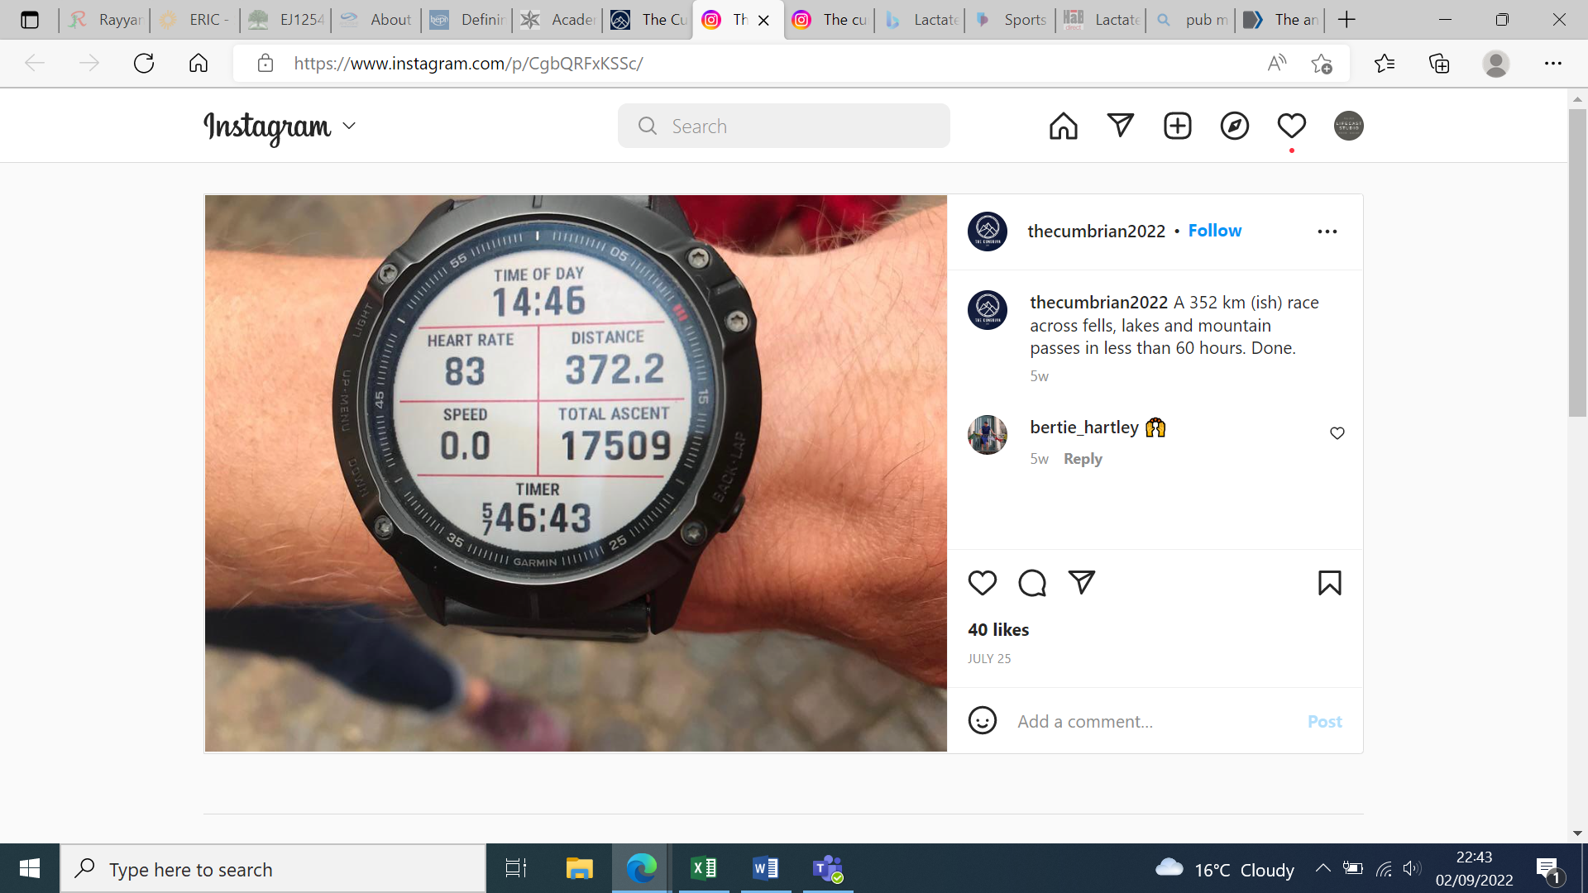 Figure ? Kirk completed the Cumbrian in 57 hours and 46 minutes - well under the 60-hour target, unfortunately alone after Tim suffered an injury (image taken from: [The cumbrian (@thecumbrian2022) • Instagram photos and videos](https://www.instagram.com/p/CgbQRFxKSSc/))

**SP:** Did you feel ready when the time came?

**KW:** Yes. There is always a fear of failure because there are so many variables that play out in an event like the Cumbrian. Only injury or something out of our control would prevent us from finishing. We were both physically conditioned and mentally conditioned in equal measure because we had planned everything to the smallest detail we could. When we drove to Keswick the night before the challenge, we knew we were in best shape possible.

|  |
| --- |
| **Did you know?**  The importance of sleep is an exciting research area in sports and exercise science. Check out the review and 2021 expert consensus recommendations on ‘sleep and the athlete’ from the British Journal of Sports Medicine ([Sleep and the athlete: narrative review and 2021 expert consensus recommendations | British Journal of Sports Medicine (bmj.com)](https://bjsm.bmj.com/content/55/7/356))  (image taken from: [The cumbrian (@thecumbrian2022) • Instagram photos and videos](https://www.instagram.com/p/CgbQcZ-K_8G/)) |
|  |
| **Key Article**: To read about the **psychological** influences when running ultramarathons see the PE Review in April 2022, volume 17, number 3 by Jake Barnard. |

|  |
| --- |
| **Further research:**  **View** training plans and fuelling guides for the Fred Whitton challenge at [www.fredwhittonchallenge.co.uk](http://www.fredwhittonchallenge.co.uk) which since starting in 1999 has raised over 2 million pounds for charity.  **Read** training principles and issues for ultra-endurance athletes, a short report published in current Sports Medicine Reports ([Training Principles and Issues for Ultra-endurance Athletes : Current Sports Medicine Reports (lww.com)](https://journals.lww.com/acsm-csmr/Fulltext/2005/06000/Training_Principles_and_Issues_for_Ultra_endurance.10.aspx)) |
|  |
| **Key Words**  **Overload** Training load set above a performer’s comfort zone to place a stress on the body to force and adaptation  **Progression** Training demand should gradually increase over time to ensure adaptation  **Moderation** Training load is appropriate for the performer to adapt whilst maintaining a health, balanced lifestyle and avoiding overuse injuries and burnout  **HR training zone** A specific HR range used to monitor training intensity  **Rating of perceived exertion (RPE)** A scale used to measure how hard an athletes feels they are working  **VO2max** The maximum volume of oxygen inspired, transported and utilised per minute during exhaustive exercise (measured in mls/kg/min) |
|  |
| **Exam Board Links**  **OCR**: 1.2.b. Preparation and training methods and 1.2.a Diet and nutrition  **AQA**: 3.2.1.2 Preparation and training methods and 3.2.1.1 Diet and nutrition  **Edexcel**: 2.2 Preparation and training methods and 2.1 Diet and nutrition |
|  |
| Dr Sarah Powell is a teaching fellow at Lancaster University Medical School, specifically for the BSc in Sports and Exercise Science, and author of a range of A-level PE textbooks and resources. |