

A FOUR-DIMENSIONAL LIBRARY: EXPERIMENTS IN TIME, FORM AND THE BOOK

by

Brian Baker S19001560

A Dissertation
Submitted for MA ART PRACTICE, Faculty of Art, Science and Technology
Wrexham Glyndwr University
In Partial Fulfilment of the Requirements
for the Degree of Master of Arts
August 2021

ABSTRACT

The Fourth Dimension is an idea which came to prominence in the late 19th century, notably in the work of C. Howard Hinton and H.G. Wells. In the works of artists such as Marcel Duchamp and Kazemir Malevich, the Fourth Dimension came to be used as a way to investigate space and time, or ‘higher dimensions’ of mathematics, thought or spirituality. This project investigates the concept of the Fourth Dimension through an analysis of Wells’ The Time Machine (1895), and Duchamp’s Nude Descending a Staircase, No.2 (1912) and The Bride Stripped Bare By Her Bachelors, Even (1915-23). In thinking about the representation of the Fourth Dimension in three or two dimensions, the dissertation considers motifs of projection, reduction (or ‘flattening’) or extension in how these literary and art works present time and space. It extends the verbal and visual modes of these presentations by considering dimensionality is sound reproduction, something that was not considered by either Wells or Duchamp. The dissertation consists of two, related parts: a short story or autofiction, patterned on the short stories of J.G. Ballard in The Atrocity Exhibition (1969), in which my own practice is fictionalised as the work of ‘Dr James Baker’; and a short essay with deals with time, space, sound, and projection. The connection between the two parts is implicit and asks the reader to work to decode, in terms of allusion, citation, and biography. The two-part dissertation is one component of a ‘multi-dimensional’ assemblage of objects, texts, bookworks and soundworks. The dissertation and exhibition is not a map of a higher-dimensional object (the project), but rather an echo of the multi-dimensionality of my practice throughout the MA.

CONTENTS

GHOSTING 4

Notes Towards the Fourth Dimension 10

Bibliography 18

Appendices 20
GHOSTING

‘You say these constitute a Time Machine?’ The black box consisted of 16 objects and ephemera: (a) a prism; (b) a burned page from Freud and Breuer’s Studies in Hysteria; (c) a moebius loop inscribed with the phrase ‘Once Upon a Time there was a story that began’; (d) a Star Atlas; (e) a small black wooden maquette, in the shape of a box; (f) a reproduction of Alfred Jarry’s ‘How to Construct a Time Machine’; (g) a coverless copy of HG Wells’ The Time Machine that had been exposed to the elements for a long period; (h) a 1932 Austin Sixteen wiring diagram; (i) a kaleidoscope; (j) a series of 21 collages titled ‘Argo-0’; (k) an edition of Typographica magazine, dated December 1967: (l) a paperback copy of Peter Halliday’s How Grey Was My Valley; (m) a pamphlet titled ‘The Nelson Mandala’; (n) a facsimile of JG Ballard’s ‘The Atrocity Exhibition’ from New Worlds 166, September 1966; (o) a CD-R of music titled Numbers; (p) a hardback copy of Richard Hamilton’s The Bride Stripped Bare By Her Bachelors, Even. The Director turned to Dr Baker and said, ‘You say these constitute a Time Machine?’

Signal to Noise Ratio. He rubbed his eyes. Too much screen time. Dr James Baker, former lecturer and now associate at the Institute, closed the laptop and leaned back in his chair. How much time had passed? How innocent he’d been. A world that had been much less full of screens, where cellphone masts were only then beginning to sprout like metallic weeds along country lanes. He’d trusted in the power of the printed page, then, a holy fool of the codex. Now, a stricken world lay etherised on a table of retina screens, plugged in and tuned out. He carried on amassing his library against the tides of digital information, walls of books enclosing himself and his family.

Ghosting. ‘Give me your definition of EVP’, said Rawley as he began recording on the DV camera. Even that object, sat atop its tripod, seemed vaguely obsolescent. Rawley, the maverick experimenter and magician, was collating a documentary, he said, on Electronic Voice Phenomena, the recording of voices imprinted on magnetic tape or digital media in seemingly empty space. With his mutton-chop whiskers and flared corduroys, Rawley presented himself like some media don from the early 1970s, commissioned from the ranks of OU lecturers to make a late-night tv feature on the occult. They sat in a featureless modern seminar room, wired for network connection, with the dry hum of the terminals and cooling fans dampening the ambient sound into a dry, flat, echoless space. There seemed little enough chance for ghost voices to be imprinted upon this recording, with the building just some five years old, but James waited a few moments, composing his thoughts before replying. ‘EVP is the conjunction between a tape recorder, an operator and an empty room’, he said.

Numerical Experiment. ‘Neurologically or psychologically, do you mean?’ Margaret Head smiled wryly at the near-lucid imaginings of her colleague who, once again, rolled out the blueprint of the wiring diagram and pointed out the nodes and relays of the circuit. ‘Do you see, Margaret’, Dr Baker said, his shock of white hair nodding over the blueprint, ‘how the transmission lines both anticipate the network of transmissions and etheric broadcasts we live in, and provide a map of the human brain?’ She nodded sympathetically. The poor man had become obsessed with schizophrenic art and ideas of influencing machines, and she wondered about his own mental health. Did he fear that he was being operated or taken over? Not a difficult thing to imagine these days, especially considering the state of the Institute.

Boundary Value Problem. ‘Tell me about it’, said Rawley as he pulled the car to a stop at a red light. ‘It started with dreams,’ said James. ‘A dream about a telephone call from my grandmother. She knew I was in trouble and called me. Of course, she’s been dead for fifteen years.’ Rawley gunned the accelerator as the light switched to green, and the old Mercedes growled as it jumped across the intersection. ‘In this dream, she gave me a code word. A word I could use when I was in danger or feeling unwell. I remembered the word when I woke up, unusually.’ Rawley smiled, visibly clicking through magical permutations, keys to James’s interior Rosetta Stone. ‘What was it?’ he asked. James grimaced, the light of the sodium streetlamps flickering across a rictus of remembrance. ‘I didn’t write it down,’ said James. ‘And now it’s lost.’

Iterative Image Restoration. The echo chamber of the heart is a delicate thing, thought Margaret Head as she walked along the echoing corridor of the Annex. Like the school she had attended as a girl, the Annex had been converted into an educational establishment from its first use as a hospital. This building had treated soldiers returning from the Western Front in 1915, and sometimes she thought she could hear echoes of the clatter of trolleys laden with surgical equipment, or the cries of men in the wards. Turning towards her office, she mused that many of the young men who studied at the Institute were of the same age as those who attempted to recuperate from their wounds, physical or emotional, in 1915. Back then she might have been Matron rather than a doctor, let alone the Director of the Institute. She smiled wryly to herself. Some echoes had to be dampened for hearts to heal.

Degradation Model. ‘That’s right’, said Benedict the artist-cyclist as he demonstrated to the audience his latest rackety device, a Tinguely-like object spliced with a bicycle, in the darkened lecture theatre. ‘If Dr Baker could come and help for a moment…’ Dr Baker left his seat and wandered into the light, the flickering projection of the early cycling films refracting from his strake of white hair. Benedict grinned mischievously as he took Dr Baker by the hand, led him to the device, and placed the Doctor’s finger on a metal lever to one side of the cube-like, two-wheeled frame. There was a breath of wind, and the projection stopped. The machine became indistinct, was seen as a ghost for a second, and was gone. ‘We all saw the lever turn. There was no trickery,’ said Benedict to the audience. ‘So where is the machine?’

How To Construct a Time Machine. As he sat in the garden, chickens at his feet and wife and daughter reading in the sun a few yards away, James wondered about the scene at the lecture theatre. Benedict, who he’d known for some years, had been unwilling to share an explanation for the disappearance of the machine, and had, in fact, processed from the stage in something like triumph. The whole thing was inexplicable, from the disappearance of the strange wheeled framework to Benedict’s elation, a man he’d known previously for his amused and enigmatic manner. Sitting in the sun, surrounded by birdsong and family, the scene was almost like a dream, or a memory over-illuminated by imagination. Had the machine ever been real?

Reverberation. James wrote: ‘Moorcock’s conception of the space and time of the city is represented in the form of Mother London itself. Just before the bomb lands for Josef Kiss to defuse, Beth and Chloe Scaramanga, whose canal-side cottage it descends upon, feel time standing still in the summer heat.

They heard nothing from the gasworks, nothing from the canal, no traffic in Ladbroke Grove, no trains from the other side of the gasholders. […] Time itself might have stopped, save that Chloe, experimenting, saw her fingers move and knew that if she wished she could easily get up, while the lapping of the water from the canal meant that too was unaffected. Or was Time moving backward?

This is the still centre of the novel, around which its structure revolves. Though the structure of the novel is concentric, it does not narrate time flowing linearly towards and from 1940. Rather, the events of the Blitz are like a stone dropped into the canal, and the ripples of its significance move forwards to the present and back again. Chloe, like ourselves, cannot be sure whether time is linear, is fragmented, has stopped, or is running in several directions at once.’

Impulse Response. The Director of the Institute, Margaret Head, sat at the back of the lecture theatre while Dr Baker paced compulsively in front of the console desk below, gesticulating while outlining his latest theories about transmissions and time travel. The radio microphone hissed and sputtered as he moved, his arms brushing the mic, but either he didn’t hear or took no notice. She was worried about him. Perhaps all he needed was a period of rest, a chance for the disturbed surface of his mind to become placid and calm once more. The tides of Dr Baker’s enthusiasms were galvanising but wearisome, and there was a curious tension in the lecture theatre that she couldn’t quite identify. The students’ attention was fixed on the pacing figure, but whether they were listening to him or wondering at him, she couldn’t be certain. Stray phrases came to the surface of her own attention as he pointed towards the screen, seemingly at random. But there was method here. After she clicked off the Dictaphone, recording evidence for or against him in some putative future hearing, she looked up and saw the final words projected onto the screen: ‘everybody can become an artist. But only if you tune into the right station.’

The Imaging Equation. JG Ballard’s book of ‘condensed novels’, The Atrocity Exhibition, rested broken-backed and well-thumbed in his hands as he waited in the cafeteria for Rawley to arrive. The tepid cup of green tea sat untouched on the Formica tabletop. James scanned the sparsely arrayed customers, everyone keeping their distance since the Event. Rawley slid through the open glass doorway and bopped, there was no other word for it, between the tables. ‘Ah, Ballard’, said Rawley, pointing to the novel. ‘You do know that you’re meant to take that book as a cautionary tale rather than an instruction manual?’ James smiled painfully. He’d noticed his strange proximity to the ever-shifting ‘T’ character, though his obsessions were of a somewhat different character. ‘I have been thinking about billboards…’, he confessed. Rawley nodded and grinned as he sat down, and James watched the ripples in the surface of the tea expand, interfere, and still. Curious, Rawley asked, ‘Is there something in your tea, Doctor?’

Anechoic Chamber. Benedict took up the acoustic guitar and plucked a string percussively. The oddly metallic noise reverberated around the empty church, and as Benedict added harmonics, the space filled with frequencies resounding from its hard surfaces. The village church and its graveyard stood by the river, but the heavy oak door closed off the exterior sound-world. ‘Concert pitch?’ he asked. James stretched his legs in the end pew and stopped recording. ‘Only for a junkyard orchestra,’ he said.

Fourier Transform. The reported last words of Sir Isaac Newton, as pinned to the door of Dr Baker’s office: ‘I don’t know what I may seem to the world. But as to myself, I seem to have been only like a boy playing on the seashore and diverting myself now and then in finding a smoother pebble or a prettier shell than the ordinary, whilst the great ocean of truth lay all undiscovered before me.’

Frame-Tale. There were a number of secret transmissions to which Dr Baker listened: (1) the voice recording of the female Soviet cosmonaut, made on 24 November 1963 by Achille and Gian Battista Judica-Cordiglia, cursing her superiors as she re-entered the Earth’s atmosphere in a malfunctioning Soyuz capsule; (2) the ‘Russian Man’ numbers station broadcast in the 30m band, recorded on 27 September 2006; (3) the telephone call received by Alexander Graham Bell from his deceased brother Melville, on 10 December 1919.

Ripples in the Dirac Sea. Rawley wound himself into a riff. ‘I mean the novel White Noise, not the film. The Delillo novel. No, they’re not related. The film is an EVP story, yes, you’re right, but it’s not very interesting. The EVP investigator’s house was all red and brown, cluttered, old rugs on the floor, talk about a cliché! Tapes and video recorders all over the place, a computer, a DAT player, modern tech, but even they seem out of place. It’s like he’s heard voices through a crystal radio set in his front room. But anyway, the novel. Have you read it? There’s this catastrophe called the Airborne Toxic Event. Reading it now sends shivers up your spine. Anyway, it’s all about media, tv. Postmodernism. Before the internet and all that, way before, mid-1980s. The title, it’s a metaphor, signal to noise, how information gets swamped. Cybernetics. The Image. The main guy is an academic, professor of Hitler Studies. Yes, I know. He’s obsessed with death and meaning. Death is white noise. Oh. Actually, there is a relation to the film. Death and voices coming out of the white noise. If they’re there at all, if you know what I mean.’ He gripped his earlobe and tugged it, twice.

Additive Noise. ﻿A disquieting feature of the Time Machine exhibition was the marked preoccupation of the work with the theme of being lost in time, as if the artist and curator had sensed some seismic upheaval in the cultural landscape. As Margaret Head walked around the converted lock-up these bizarre objects, with their fusion of Duchamp, Wells and Konstantin Raudive, reminded her of the fossil Hunsrück slates she had studied in the Rhineland in her youth. They stood in the space like the codes of insoluble dreams, the keys to a nightmare in which she had begun to play an unwilling and mystifying role.

Deconvolution. ‘Thank you, Margaret, for all you’ve done. I mean that,’ said James, sitting at his desk in the narrow, cell-like office in the Annex. The Time Machine box was packed in Styrofoam and wrapped generously in insulation tape. ‘It’s just a period of leave, James,’ she said, standing at the open door. ‘Come back after the summer, you’ll feel completely different about things.’ He smiled ruefully. Perhaps he had gone too far. Margaret had, he knew, protected him from the whispers of colleagues and management after the incident with the billboards, but the failure of his most recent experiment, either as an art project or as a temporal intervention, had made this moment inevitable. The echoes of the Event passed through his memory, the isolation and paranoia, the black hole at the centre of his being, the pulsing radio stars and the drive towards terminal silence.

Notes Towards the Fourth Dimension

In my report for ART714, I wrote that
The word ‘project’ is derived from two Latin roots: ‘pro’ (meaning forth or forward) and ‘Jacere’ (meaning to throw). To ‘project’ is therefore to ‘throw forward’. In English, however, it can be pronounced with two different stresses, which mean two slightly different things. One is a noun, one a verb; one refers to time, the other to space. (Baker 2020: 5)

My subsequent investigations into dimensionality have foregrounded the idea of projection. In the camera obscura, the 3-dimensional object, landscape or building is projected on to a 2-dimensional surface in order for the correct perspective to be ascertained. Similarly, in the cinema, the 3-dimensional world/ illusion of narrative cinema is projected onto the screen. Most importantly here, in terms of maps, the curved, 3-dimensional surface of the Earth is projected onto the 2-dimensional sheet of the map. Anyone looking at a Mercator next to a Peters projection of the global map will see how certain decisions about how the flat map is scaled has a significant impact upon how we comprehend the continents and their relation.
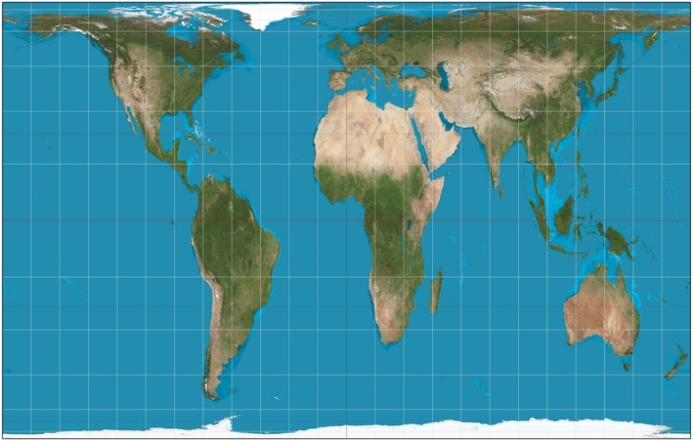
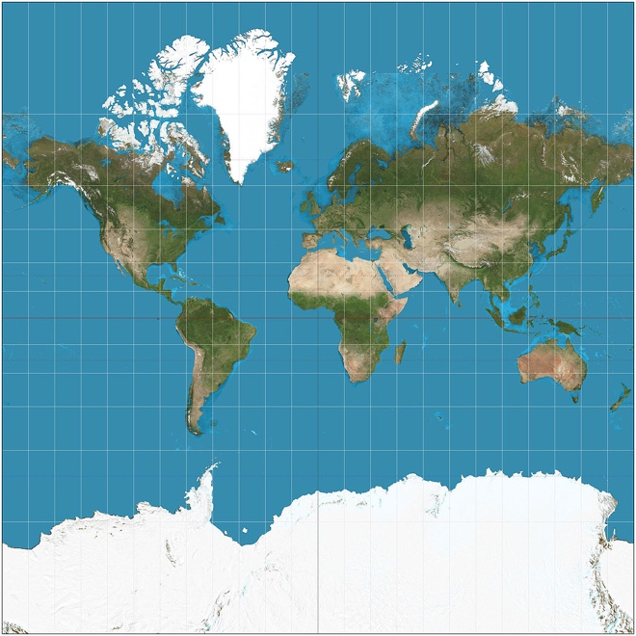
Left: Mercator; above: Peters

The same is true of the relationship between the third and fourth dimensions. In The Time Machine, H.G. Wells’ Time Traveller articulates how projection is crucial to the ways in which dimensionality has been understood. He says:
‘Space, as our mathematicians have it, is spoken of as having three dimensions, which one may call Length, Breadth, and Thickness, and is always definable by reference to three planes, each at right angles to the others. But some philosophical people have been asking why three dimensions particularly—why not another direction at right angles to the other three?—and have even tried to construct a Four-Dimensional geometry. […] You know how on a flat surface, which has only two dimensions, we can represent a figure of a three-dimensional solid, and similarly they think that by models of three dimensions they could represent one of four—if they could master the perspective of the thing. See?’ (Wells 1895: 4).

‘Some philosophical people’ is the clue to his rather dismissive attitude to what is now called n-dimensional geometry. ‘The perspective of the thing’ identifies precisely the issue of projection, and how our capacity to visualise and understand a higher dimension is limited by our own three-dimensional condition. It is a revealing word to use; it connects the novel directly to the art history of representations of space.

In the work of Wells and C. Howard Hinton, the Fourth Dimension is conceived of and articulated in very different ways. In the works of Hinton, especially in the pamphlets published between 1884 and 1886 collected as the Scientific Romances in 1886, of which ‘What is the Fourth Dimension?’ is one; and in The Fourth Dimension (1904), he conceives of the Fourth Dimension as a kind of higher space. In The Fourth Dimension, Hinton uses Plato’s allegory to suggest that we exist, as it were, watching four-dimensional shadows on the wall of our three-dimensional cave. Just as a two-dimensional being (existing in a ‘plane-world’ or ‘Flatland’) cannot conceive of three-dimensional existence, so we cannot really conceive of four-dimensional forms. In which case,
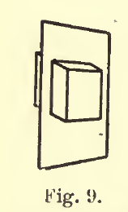
‘a being in four dimensions would have to us exactly the appearance of a being in space. A being in a plane would only know solid objects as two-dimensional figures—the shapes namely in which they intersected his plane. So if there were four-dimensional objects, we should only know them as solids—the solids, namely, in which they intersect our space.’ (Hinton 1896: 34. Image from Hinton 1904: 12)

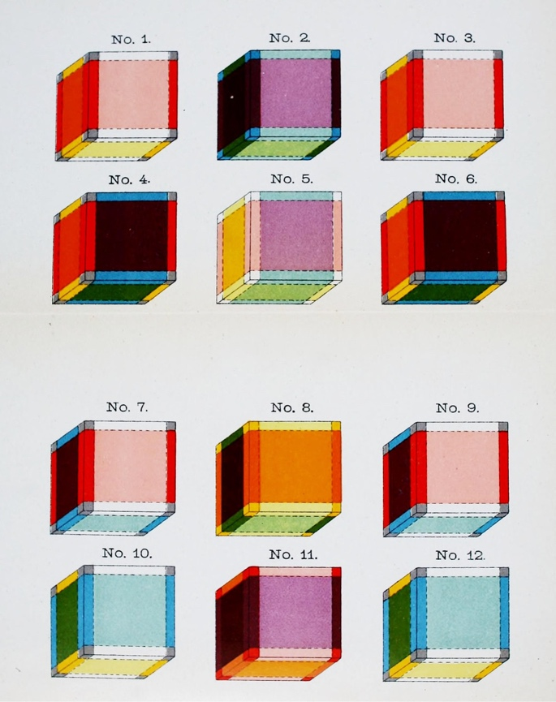
The difficulty of this is demonstrated by the odd diagrams of the four-dimensional cube, the ‘tesseract’, that were contained in Hinton’s The Fourth Dimension (image to left). In The Time Machine (1895), the Time Traveller rejects this theory of higher or n-dimensions altogether. The Traveller explains to his invited audience of professional men that ‘“There are really four dimensions, three which we call the three planes of Space, and a fourth, Time. […] There is no difference between Time and any of the three dimensions of Space except that our consciousness moves along it”’ Wells 1895: 3). In fact, the Traveller rejects Hintonian projections of four-dimensional space and instead argues that it is a matter of human perception and ‘perspective’. A four-dimensional object, for Wells’ Traveller, is actually a three-dimensional one articulated through time.

The idea of projection, in relation to ‘throwing forward’ or to the reduction of three-dimensional space to a two-dimensional plane in the creation of maps, is central to what Marcel Duchamp was investigating in the Large Glass, and directly relates to the quotation from Hinton above.
D: Simply, I thought of the idea of a projection, of an invisible fourth dimension, something you couldn’t see with your eyes. […]
The fourth dimension could project an object of three dimensions, […] Any three-dimensional object, which we see dispassionately, is a projection of something four-dimensional, something we’re not familiar with. […]
“The Bride” in the “Large Glass” was based on this, as if it were the projection of a four-dimensional object. (Cabanne 1979: 40)

As Mark Blacklock notes about the theorists of the Fourth Dimension in ‘The Higher Spaces of the Late Nineteenth-century Novel’ (2013), ‘All aimed to think through the experience of limited dimensionality in order to explicate the speculated experience of raised dimensionality’ (Blacklock 2013: 1). Hinton, E.A. Abbott in Flatland (1884) and many others, including Duchamp, used reduction in dimensionality (from three to two) to stand in metaphorically for an extension from three to four (and beyond). The Bride is both projected on and through the two-dimensional plane of glass, but is also manifested within the accompanying Green Box. The Large Glass and Green Box form a complex assemblage, a four-dimensional object.

One might think of Duchamp’s Nude Descending a Staircase (1912) as similarly presenting, in two dimensions, a higher-dimensional being. Wells anticipates this in The Time Machine:
‘I have been at work upon this geometry of Four Dimensions for some time. Some of my results are curious. For instance, here is a portrait of a man at eight years old, another at fifteen, another at seventeen, another at twenty-three, and so on. All these are evidently sections, as it were, Three-Dimensional representations of his Four-Dimensioned being, which is a fixed and unalterable thing.’ (Wells 1895: 4-5)

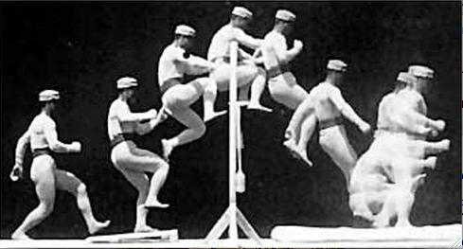
Both Duchamp’s and Wells’ figures suggest both flow and spatiality in paradoxical unity. Wells’ four-dimensional being is a single entity that flows from birth to death, segmented only by our incapacity to perceive it that way, as ‘our consciousness moves along’ time. There are very strong pre-echoes here of Bergson’s understanding of time as durée, and of Deleuze’s conception of cinema as the ‘cut’ (or in Wells’ word, ‘section’) which reveals to us time’s flow. In The Time Machine, however, time is space. A spatialization of time is precisely the method by which Wells imagines the way by which the Traveller moves in his machine from the world of late Victorian England to the year 801, 702. In a sense, writing in 1895, Wells’s ‘Four Dimensioned Being’ anticipates the developments in temporal representation that will come with the advent of Cubism and Duchamp’s interest in turning to painting the ‘four-dimensional’ figures of Etienne Marey’s chronograms. The chronograms, or Eadweard Muybridge’s series photographs, or the cartoon figures of proto-cinematic toys such as the zoëtrope or phenakistoscope, indicate the point at which the still representation becomes moving representation, where photography becomes cinema, where the static moment flows into time. The Time Machine was published at precisely the same moment as the Lumière brothers first projected their films at the Café Royale in Paris: 1895. As the celluloid strip passed through the projector, and the ‘persistence of vision’ made the succession of still images into seamless movement, the relation between time and space was redefined, not least in art. Duchamp, in his conversations with Pierre Cabanne, when asked whether film influenced Nude Descending a Staircase (1912), replied ‘Yes, of course. That thing from Marey…’ (Cabanne 1979: 34). In fact, the first conception of The Bride Stripped Bare By Her Bachelors, Even (1915-23) was much closer to Nude Descending than its later form:
Duchamp: The idea of the “Bride” preoccupied me. So I made a first drawing in pencil, “Virgin No.1”, then a second, “Virgin No.2”, touched up with wash and a little water-colour. Then a canvas, then I went on to the idea of the “Bride and the Bachelors”. The drawings I made were still the same type as the “Nude Descending a Staircase”, and not at all like the one that followed after, with the measured things. […] What we were interested in at the time was the fourth dimension. In the “Green Box” there are heaps of notes on the fourth dimension. (Cabanne 1979: 36-7; 39)

As Linda Dalrymple Henderson, in The Fourth Dimension and Non-Euclidean Geometry in Modern Art (2018) investigates, ideas of the Fourth Dimension were absolutely central to experiments in Modern art in the first decades of the Twentieth Century. The legacies of these experiments resound in contemporary art.

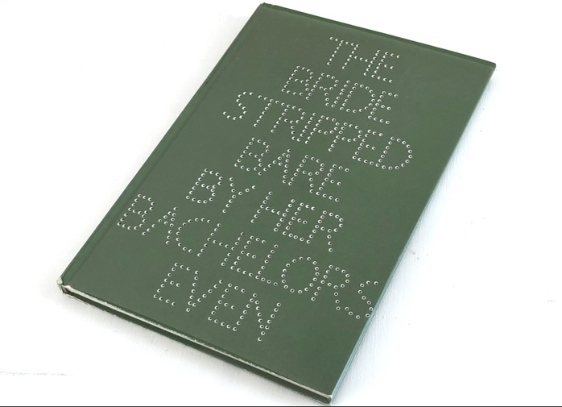
In 1966, Richard Hamilton embarked upon a project to re-make The Bride Stripped Bare By Her Bachelors, Even, which included a book-shaped version of the Green Box. So uncanny was this ‘re-made’ that it was installed in the Tate Gallery in London with Duchamp’s name attached to it; although Hamilton felt it would be inappropriate to replicate the accidental cracking of the ‘original’ Large Glass when he supervised the making of his own version at Newcastle, much later, after installation at the Tate, this glass itself fractured, although with a different pattern to the one in New York. It was decided not to restore the Hamilton ‘edition’ (which was certified by Duchamp), but to leave this second accidental fracturing in place. The replication, duplication or projection of the Large Glass through time, as an uncanny object, connects the practices of Duchamp, and in particular his objects and readymades, to the Independent Group and Pop’s re-articulation of consumer culture through collage and screen-print reproduction. Duchamp, in the Rrose Selavy boîte-en-valise objects, himself authorised a series of reduced or projected objects whose scale (rather than dimensionality) was altered in reproduction. It is little wonder that Hamilton felt himself so much inspired by, or even inhabited by, Duchamp, that he repeated the construction of the Large Glass and translated the Green Box as a book. I own a recent, authorised version of the boîte-en-valise and a 1966 copy of Hamilton’s Bride Stripped Bare By Her Bachelors, Even, but I am also inspired/ inhabited by two other British artists whose work of the late 1960s has had a defining influence on my own practice: Tom Phillips’ A Humument, which he began in 1966; and Eduardo Paolozzi’s Moonstrips Empire News (1967), a box of 100 loose-leaf screen-prints, some of which derived from Paolozzi’s own collage practice of the previous decades.

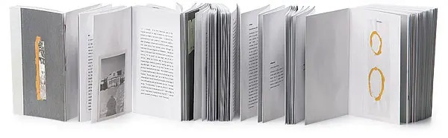
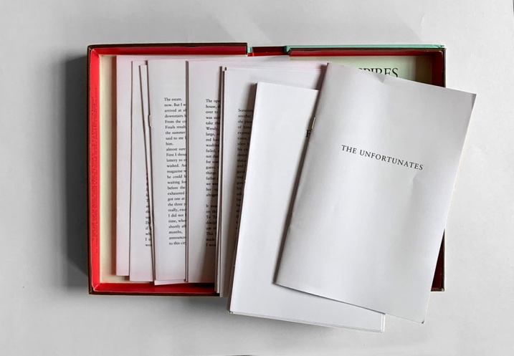
Hamilton’s version (reproduction) of the Green Box is a codex-form book, with Duchamp’s French translated into English, his loose-leaf notes re-arranged into bound form. Tom Phillips’ first set of altered pages from A Human Document was presented loose-leaf, in a box. Elsewhere, B.S. Johnson’s novel The Unfortunates (1969, left) published 2 years after Moonstrips Empire News in 1969, was itself a ‘book-in-a-box’, with stapled signatures provided to the reader, with only the first and last sections signified to be read in that order, and the rest to be freely randomized. Where Hamilton’s Bride Stripped Bare By Her Bachelors, Even fixes the order of the fragments in the Green Box, the other experimental forms offer something more random, what Deleuze and Guattari would call ‘rhizomatic’ in structure: differently ordered, non-hierarchical, multi-cursal, non-linear. If there is a flattening here, it is the flattening of surfaces arrayed in a constellation rather than the codex-model of sequence, or the hermeneutic model of depth. The book-in-a-box, seen again more recently in Ann Carson’s Nox (2010; see image above) or Chris Ware’s Building Stories (2012), is both formal experimentation and a replacement of temporal sequence with spatiality. My own book-in-a-box, a version of this dissertation, will accompany both an object and a (black) box of texts.

Unlike other Dada artists (most notably Hugo Ball), or the Futurist Luigi Russolo, Duchamp did not appear to be particularly interested in sound: his multi-dimensional work exists as object and texts, and his investigation of dimensionality in the Large Glass is only accidentally set against the acoustic dimensions of the gallery space in which it is exhibited. In my own exhibition, I intend to add the element of acoustic dimensionality to the three-dimensional object, again to suggest a supplemental (if not exactly ‘fourth’) dimension. In Background Noise (2015), Brandon LaBelle suggests that
Sound and space are inextricably connected, interlocked in a dynamic through which each performs the other, bringing aurality into spatiality and space into aural definition. This plays out in acoustical occurrence whereby sound sets into relief the properties of a given space, its materiality and characteristics, through reverberation and reflection, and, in turn, these characteristics affect the given sound and how it is heard. There is a complexity to this that overrides simple acoustics and filters into a psychology of the imagination (LaBelle 2015: 123).

LaBelle identifies the implication between space and the hearer, between psychology and materiality, as the means by which space is produced. In fact, the acoustic space of a room is no more ‘empty’ than the fixed and immutable time-space that Wells’s Time Traveller proposes, through which he will travel, or be projected perhaps, without consequence. Just as the Traveller changes the world of the future by his presence, acoustic space is produced and in part projected by the observer/ listener. As Mike Kelley notes in ‘An Academic Cut-Up’, ‘this projective relationship of listener to artworks […] is common today. […] The listener is invited to project his or her own subjective readings upon such a work, or to simply give up trying to ascribe meaning to it at all in favour of a more “disembodied” relationship’ (Kelley 2003: 36). Works of sound art, such as Alvin Lucier’s ‘I Am Sitting In A Room’ (1969), often involve themselves in what LaBelle identifies as ‘sound and its source diffus[ing] into a larger conversational interaction’ (LaBelle 2015: 126). My installation experiments with the number and positioning of sound sources, playing a sequence of 8 ‘broadcasts’. If two sound sources are to be used, they will be played out of sync with each other. The sound remains ambient, and any voice will be identifiable only in close proximity to the source. My intention is to supplement the presentation of visual and material dimensionality (the viewers are invited to handle the boxes and slates) with sound. The visual and apperceptive qualities of the room in which the installation sits will be rendered uncanny by the supplement of an altered ambient/ acoustic dimension. If set up in an exterior space, of course, there will be a far greater, louder and wider range of environmental sounds with which those ‘broadcasts’ would intersect/ interfere. In future, developing an historical and site-specific relation to the acoustic and temporal echoes of a particular space, thinking through dimensionality through historical time, will be something that this project will open out onto.

If, as I have suggested above, the Large Glass and Green Box together form a complex assemblage, a four-dimensional book/ object, which itself travels through time, then my own exhibition also aspires to the condition of multi-dimensionality. The relation between the boxes, the Black Box, the book-in-a-box and the sound broadcasts will be one for the visitor/ viewer to establish; the games with numbers and Magic Squares that the slates will suggest also provide clues to its geometrical and spatial concerns. Through working with objects, texts, different spaces and sound broadcasts, the exhibition will attempt to establish a series of relays, echoes and loops through which the different components interact. This dissertation, with its several parts, also asks the reader to conceive of the relation between practice, autobiography, critical reflection and fiction not as separate, but as inter-related and dialogic. The dissertation is not a map of a higher-dimensional object (the project), but rather an echo of the multi-dimensionality of my practice throughout the MA.

Bibliography

Abbott, E.A. (1884). Flatland, A Romance of Many Dimensions. New York: Dover, 1992.

Baker, B. (2017). ‘The Audio File’, LUNE: The Journal of Literary Misrule issue 00. http://lunejournal.org

Baker, B. (2020). ART714 report.

Banks, J. (2012). Rorschach Audio: Art and Illusion for Sound. London: Disinformation/Strange Attractor.

Bergson, H. (1910). Time and Free Will. London: George Allen and Unwin.

Blacklock, M. (2013). ‘The Higher Spaces of the Late Nineteenth-century Novel’, 19: Interdisciplinary Studies in the Long Nineteenth Century, 17. <http://19.bbk.ac.uk>

Cabanne, P. (1979). Dialogues with Marcel Duchamp. London: Da Capo.

Carson, A. (2010). Nox. New York: New Directions.

Deleuze, G. and F. Guattari, (1980). A Thousand Plateaus: Capitalism and Schizophrenia. London: Continuum, 2004.

Deleuze, G. (1983). Cinema 1. London: Continuum, 2005.

Deleuze, G. (1985). Cinema 2. London: Continuum, 2005.

Duchamp, M. (1968) De ou par Marcel Duchamp ou Rrose Selavy. Koln: Verlag der Buchhandlung. Serie G.

Hamilton, R. (1966) The Bride Stripped Bare By Her Bachelors, Even. Newcastle.

Henderson, L.D. (2018) The Fourth Dimension and Non-Euclidean Geometry in Modern Art. 2nd edn. Cambridge MA and London: MIT Press.

Hinton, C.H. (1886). ‘What is the Fourth Dimension?’, Scientific Romances: Series One. London: Swan Sonnenschein.

Hinton, C.H. (1904). The Fourth Dimension. London: George Allen.

Johnson, B.S. (1969), The Unfortunates. London: Picador, 1999.

Kelley, M. (2003) ‘An Academic Cut-Up in Easily Digestible Paragraph-Size Chunks; Or, The New King of Pop: Dr. Konstantin Raudive’, Grey Room 11, Spring, 22–43.

LaBelle, B. (2015) Background Noise: Perspectives on Sound Art, London: Bloomsbury, 2015.

Paolozzi, E. (1967) Moonstrips Empire News. London: Editions Alecto.

Phillips, T. (1966-present). A Humument. London: Thames and Hudson, multiple edns.

Ware, C. (2012). Building Stories. London: Jonathan Cape.

Wells, H.G. (1895). The Time Machine. London: Heinemann, 1911.

Appendices

Eight Broadcasts: soundscapes
https://soundcloud.com/brianbaker-2/sets/exhibition

Eight Broadcasts: voice phenomena
https://soundcloud.com/brianbaker-2/sets/exibition-vocal-tracks

Eight Broadcasts: Scripts
https://issuu.com/brianbaker0/docs/scripts

GHOSTING booklet:
https://issuu.com/brianbaker0/docs/ghosting

DIMENSION booklet: https://issuu.com/brianbaker0/docs/notes_on_the_fourth_dimension_v2

Argo-0 collages:
https://issuu.com/brianbaker0/docs/argonaught

Numbers album:
https://soundcloud.com/brianbaker-2/sets/numbers

The same can be said of the empty room of EVP experiments, the psychological aspect of which was investigated by Joe Banks in his Rorschach Audio artworks and book.
I re-worked Lucier’s method as part of a fiction supplemented by sound files, called ‘The Audio File’, published in LUNE: The Journal of Literary Misrule issue 00, 2017. http://lunejournal.org

