Beatriz Sanchez-Cano, Emma Woodfield, Sam Rennie and Diego Moral Pombo report on a big meeting reflecting a thriving community

Specialist Discussion Meeting Report
A bigger broader Autumn MIST
T
he Magnetosphere, Ionosphere and Solar- Terrestrial (MIST) community met in person at their annual Autumn MIST meeting at the
Geological Society building on Tuesday 28 November 2023. It was the largest in-person attendance at a MIST meeting in London, with 122 attendees in the room and 10 online. The meeting was split into three sessions of talks, focusing on planetary, solar and Earth-based science, respectively, plus two poster sessions to accommodate the very large number
of abstract submissions, together producing a packed meeting to reflect a thriving community.

Planetary patterns
The opening session for this Autumn MIST meeting encompassed talks on planetary science,
showcasing some of the varied research carried out by groups across the UK on the magnetospheres
of different planets of our solar system.
The meeting kicked off with a statistical analysis of Mercury’s magnetotail lobe by Charles Bowers (Dublin Institute for Advanced Studies), who used data from the MErcury Surface, Space ENvironment, GEochemistry and Ranging (MESSENGER) plasma spectrometer and magnetometer to constrain the crossings of the spacecraft with the magnetotail lobes.
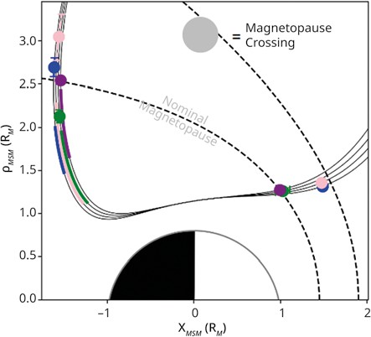
He developed a new expression to describe the fall-off of the lobe field strength with radial distance from the planet and, based on four years
- Mercury’s Lobe field strength and magnetopause boundary both vary from orbit-to-orbit compared to their nominal state. Diminished lobe in blue and pink, enhanced lobe in green, and nominal state in purple.
(Modified from Bowers et al. Journal of Geophysical Research, 2024 CC BY 4.0 DEED)
of data, showed evidence that the solar wind pressure directly influences the response of the lobe magnetic flux, presenting enhanced lobes when the magnetosphere is compressed by the upstream dynamic pressure (figure 1, Bowers et al. 2024).
Staying focused on Mercury, Sophia
Downloaded from https://academic.oup.com/astrogeo/article/65/3/3.38/7683040 by Serials Dept user on 23 July 2024
Zomerdijk‑Russell (Imperial College London), presented newly published results on the location of magnetic reconnection
in Mercury’s magnetosphere, using both modelling and MESSENGER data.
The results, besides the expected high-magnetic shear regions, show that in some cases the reconnection occurs at low shear angles (<70°). This supports the idea that symmetric reconnection dominates at Mercury’s dayside magnetopause and could imply a smaller influence of the diamagnetic drift in the reconnection processes than, for example, Earth, where reconnection
is restricted to sites of maximum shear.
Moving outward in the solar system to Mars, Dikshita Meggi (University of Leicester), presented work comparing ionospheric variability to the presence of crustal magnetic fields in the Southern hemisphere of Mars.
Through 12 years of data from Mars Express, the ionosphere response is correlated to the crustal magnetic fields; strong crustal magnetic fields
and near-vertical magnetic field inclinations on the dayside result in extra ionospheric layers, while
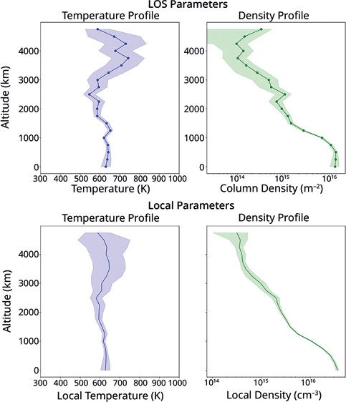
- Comparisons between JWST line-of-sight profiles (top panels) and local profiles (bottom panels) from from JWST Programme #3665. (From talk by P.I.Tiranti)

near-horizontal fields contribute to significant and long-lasting reductions of the topside density.
Moving away from the rocky planets to Jupiter, Gabrielle Provan (University of Leicester), presented model fits to proton and heavy ion densities from the Jovian Auroral Distributions Experiment (JADE) on the Juno mission.
The model shows that changes in magnetospheric conditions impact the magnetosphere-ionosphere coupling parameters; for example, the hot plasma index K_{h} increases with total magnetodisc current.
These results suggest that the plasma pressure carried by the hot plasma population is the cause of the increasing total magnetodisc current.
The final talk in the planetary session was again about Jupiter, exploring the upper atmosphere
of this gas giant. By combining novel data from the JWST Near Infrared Spectrograph (NIRSpec) with Juno Jovian Infrared Auroral Mapper (JIRAM) vertical profiles, Paola Ines Tiranti (University
of Leicester) used new model (H3PPY) to fit H3+
ion spectra, allowing the analysis of vertical density and temperature profiles up to 1000km for JIRAM data and 5000km for JWST data.
She derived local parameters from line-of-sight profiles and extended the analysis to different local times, allowing the evolution of the profiles across all dayside regions to be explored (figure 2).

Solar and solar wind science
The second session began with a presentation from Nawin Ngampoopun (Mullard Space Science Laboratory, University College London) on the evolution of coronal hole boundaries.
Using Solar Dynamics Observatory (SDO) data and the Differential Emission Measure analysis technique to track the dynamics of coronal hole edges, he showed that the leading edge of a coronal hole can have a higher temperature and magnetic flux than the trailing edge. These measurements will contribute to the debate over where exactly the solar wind comes from.
From the source of the solar wind the session moved on to plasma measurement. Georgios Nicolaou (MSSL, UCL) presented work on how plasma is measured by the Solar Wind Analyser’s Electron Analyser System (SWA-EAS) on Solar Orbiter.
A simplified formula is often used to construct the 3D electron velocity distribution function, but Nicolaou presented a new, more accurate method to calculate it, and the resulting velocity moments (i.e., temperature, density, etc.). This new method helps particularly with relatively cold and fast electron distributions in which errors in the temperature can be overestimated
by 60% as well as density in some cases by 40%.
Pauline Simon (Queen Mary University of London) continued the solar wind theme with a presentation on turbulence in a magnetised, collisionless plasma.
Using a model based on the generalisation of Kolmogorov’s 4/5 law for an incompressible fluid applied to the case of a bi-adiabatic magnetised fluid with Hall effect, Simon investigated the compressible gyrotropic-pressure exact law in Hall-model simulations, finding that the anisotropic pressure makes a significant contribution to the total turbulent cascade rate. This
is important to understand how heat is distributed
in the plasma through turbulent processes.
Next, James Plank (University of Southampton) discussed the downstream influence of shock-driven turbulence.

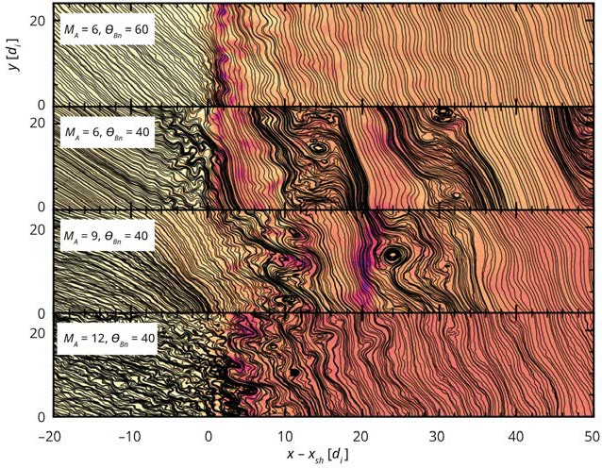
- Simulation for quasi-parallel, quasi-
perpendicular and high-low Mach of shock-driven turbulence. (From talk by J. Plank)

- This figure illustrates the result of particle-in-cell simulations of an electron core-beam distribution in a magnetic bottle structure. The white lines represent the magnetic field lines.
The top panel displays the core number density, the bottom panel displays the beam number density.
The inhomogeneous background leads to a spatially inhomogeneous triggering of beam-driven kinetic instabilities. The unstable waves share properties with electrostatic waves observed by Solar Orbiter near magnetic holes in the solar wind.
(From talk by J. Liu).

Using a variety of hybrid and full particle-in-cell simulations, Plank investigated the behaviour of the magnetic spectrum, kurtosis and correlation length with distance from the shock for a wide variety of shock conditions. His work showed that shock-driven turbulence is effective at cascading
away small-scale structures, but the larger structures seem to persist a long way downstream (figure 3).
Downloaded from https://academic.oup.com/astrogeo/article/65/3/3.38/7683040 by Serials Dept user on 23 July 2024
Laura Vuorinen (University of Turku, Finland), presented new work on the effect of solar wind conditions and solar cycle phase on enhancements of dynamic pressure in Earth’s magnetosheath, known as magnetosheath jets.
Vuorinen used data from the Time History of Events and Macroscale Interactions during Substorms (THEMIS) mission to show that jets downstream
of quasi-perpendicular shocks are much more sensitive to solar wind parameters. After careful removal of orbital bias in the THEMIS observations of these jets, the dependence of jet occurrence
on solar cycle phase was shown to be weak.
Wrapping up the solar wind session, Jingting Liu (MSSL,UCL) spoke about Langmuir waves associated with magnetic holes in the solar wind.
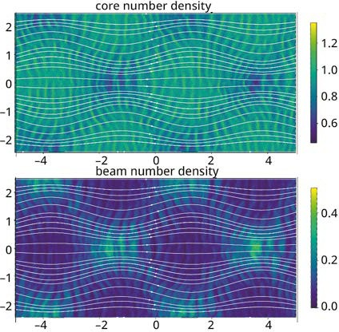
These magnetic holes are small-scale, short- duration reductions in the amplitude of the interplanetary magnetic field. She showed simulations of magnetic bottle particle-in-cell simulations with an electron beam, that show that

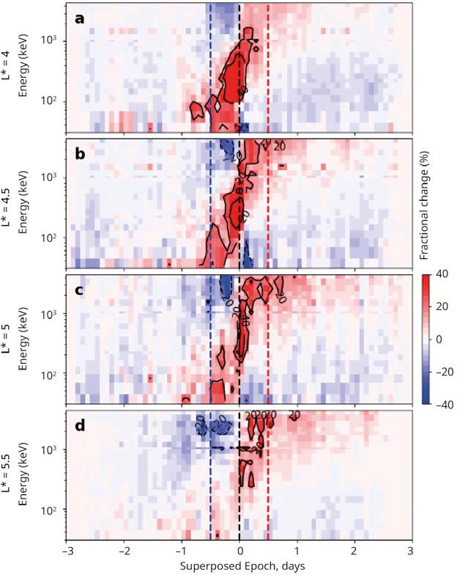
- This figure shows the relative changes in electron flux at different energies in a superposed epoch study of 70 isolated storms observed by the Van Allen Probes. The storm recovery phase starts at 0 days, the main phase starts at the blue dashed line and chorus wave power is enhanced between the blue and red dashed lines. (Chakraborty et al. submitted to Geophysics Research Letters)

Langmuir waves in different parts of the magnetic hole have different wavenumbers (figure 4).

Down to Earth
The third and final session of talks explored work on Earth’s environment. Samuel Greess (QMUL) presented research undertaken using Terrestrial Reconnection EXperiment (TREX)
laboratory observations of magnetic reconnection processes in plasmas along with specialised kinetic, particle-in-cell simulations to study asymmetric reconnection in low-density space environments such as Earth’s magnetopause.
He reported observation-simulation agreements, finding that reconnection rates increase for decreased system sizes, suggesting a shift to an electron-dominated regime, and a spreading of layer widths that can be attributed to a toroidal instability developing in the current layer.
Looking to data closer to the planet’s surface, Rosie Hodnett (University of Leicester), presented work on the ionospheric Alfvén resonator: the structure in which magnetohydrodynamic waves are partially reflected at ionospheric boundaries and drive ionospheric Alfvén resonances (IAR).
To complement IAR harmonic frequencies extracted from observations from the Eskdalemuir induction
coil magnetometer dataset, Hodnett modelled IAR harmonics in an ionosphere with a non-uniform Alfvén velocity profile. Good agreement between
observed and modelled harmonics was observed, and she concluded that the non-uniformity of the
ionosphere is significant in controlling harmonic phase.
Suman Chakraborty (Northumbria University) then took the meeting off the surface and into the heart of Earth’s outer radiation belt.
Chakraborty used measurements from the
Van Allen Probes to correlate chorus wave power with the fractional change of relativistic electron fluxes during 70 isolated geomagnetic storms. The results showed that intense chorus waves are responsible for reducing net losses of relativistic electrons during the main phase of geomagnetic storms, which is important for capturing the complex chorus wave activity for accurate radiation belt modelling (figure 5).
Radiation belt modelling relies on realistical capture of the interactions between high- energy particles and magnetospheric waves. But the physical processes are highly variable, introducing uncertainties. Sarah Bentley (Northumbria University), explained ways in which ensembles – collections of model results obtained using varied input parameters – are ideal for addressing such uncertainties.
Downloaded from https://academic.oup.com/astrogeo/article/65/3/3.38/7683040 by Serials Dept user on 23 July 2024
Bentley explored the impact that initial particle distributions and outer-boundary conditions have on modelled radial diffusion in the radiation belts; she used the time it takes to reach monotonicity, akin to the time for radial diffusion effects to be interesting, and an energy-like density distribution to investigate changes in mass and energy. This analysis revealed multiple key considerations, including the importance
of the outer-boundary properties in modelled diffusion.
Staying in the Earth’s radiation belts, Dovile Rasinskaite (Northumbria University), presented a method using number density and temperature description of the outer belt to understand how plasma populations evolve through heating and transport.
Using Van Allen Probe measurements from the Energetic particle, Composition, and Thermal plasma (ECT) Suite, Rasinskaite investigated
the response of outer-belt particle populations during substorms (previously only done at geosynchronous orbit using lower-resolution data). This work indicated that both number density and temperature are highly variable, with temperature and density enhancements occurring mostly on the nightside at lower energies, a result postulated to be due to particle injection.
Next, Martin Cafolla (University of Warwick) presented work on space-time correlated enhancements in the ionosphere with respect to seasonal variations and Geomagnetic Activity.
The work is based on 18 years of Total Electron Content (TEC) observations from Global Position Satellites and 100–200 ground stations, from which global TEC maps are retrieved every 15 minutes.
By analysing the most extreme TEC values in these maps, Cafolla showed the evolution in time and space of these enhancements, as well as their trajectories over the surface of Earth.
The last part of the session focused on electrodynamics of the Earth’s system. Cara Waters (Imperial College London) applied machine learning techniques together with a 2.5D
particle-in-cell simulation to show how energy is distributed during magnetic reconnection, combining the results with data from the Magnetospheric Multiscale (MMS) Mission.

Waters showed that regions are distinct in their energy partition signatures, meaning that different energy transfer mechanisms may be playing a role. Moreover, she demonstrated
a new way of identifying different regions of reconnection, by determining the spacecraft location relative to the reconnection site and attributing energy flux densities to different regions.
Following on this topic, Michaela Mooney (University of Leicester) described how a northward interplanetary magnetic field (IMF) can undergo magnetic reconnection at higher latitudes tailward of the cusps and simultaneously in both hemispheres.
The process can result in an almost entirely closed magnetosphere and has been linked to cusp-aligned arcs (an auroral signature). By using cusp-aligned arc observations from the electrostatic analyser on-board ARTEMIS, together with Cluster-II observations of plasma densities, Mooney et al. (2024) found that precipitation of trapped plasma into the polar region may produce the cusp-aligned arc signatures (figure 6).
The final talk of the session – and of the day – was by Patrik Krcelic (University of Southampton),
who presented work on the variability in the electrodynamics of the small-scale auroral arcs.
He used three distinct wavelengths from the narrow- field Auroral Structure and Kinetics (ASK) camera to cross-correlate electric field measurements, separating its normal and tangential components; he compared these data with a modelled auroral source for
23 auroral arcs in order to understand the mechanism
and connections in auroral electrodynamics, as well as to comprehend the source of high auroral variability.
MIST council would like to thank the Geological Society for hosting Autumn MIST 2023 and for the continued support for MIST from the Royal Astronomical Society. Furthermore, we thank
all attendees and presenters for contributing to an engaging and enjoyable meeting. The next MIST community meeting will take place at the upcoming NAM 2024 meeting and we
look forward to another vibrant meeting! •
Downloaded from https://academic.oup.com/astrogeo/article/65/3/3.38/7683040 by Serials Dept user on 23 July 2024
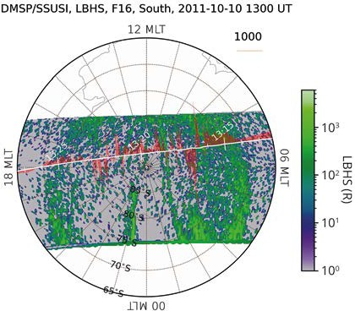
- DMSP/SSUSI observation of cusp-aligned arcs observed in the southern hemisphere during a prolonged period of Northward IMF
(Figure produced by Michaela Mooney using the Python geospacelab module)

The posters
In addition to the excellent oral presentations we had 41 posters split across two sessions, which led to a vibrant atmosphere of discussions that once again demonstrates the power of an enthusiastic group that gathers together year after year to informally discuss and engage with the latest cutting-edge MIST science being developed in the UK.
Author | Institution | Title
Martin Archer | Imperial College London | Magnetosonic ULF waves with anomalous plasma – magnetic field correlations
Ravindra Desai | University of Warwick | ROARS: Revealing Orbital and Atmospheric Responses to Solar activity – A multi-spacecraft mission to Low Earth orbit
Gareth Dorrian | University of Birmingham | Tracking asymmetric quasi-periodic oscillations within a travelling ionospheric disturbance from Poland to the North Sea with LOFAR
George Greenyer | Lancaster University | Implementing the Boris Method in a jovian middle-magnetosphere plasma simulation
Charalambos Ioannou University College Polytropic analysis of ion-acoustic waves in the
London solar wind observed by Solar Orbiter
Nawapat Kaweeyanun University of In-situ observations of interaction between the closed magnetic
Southampton field of Earth’s transpolar auroral arcs and the magnetopause
Adrian LaMoury | Imperial College London | Operational modelling of space weather ground effects with the GorgonOps simulation suite
Zoe Lewis | Imperial College London | Constraining ion transport in the diamagnetic cavity of comet 67P
Sophie Maguire | University of Birmingham | Large-scale plasma structures and scintillation in the high-latitude ionosphere
Jack McIntyre | Queen Mary University of London | Observations of the turbulence transition range as evidence for the helicity barrier
Sam Rennie | University of Leicester | Modelling of ULF waves in SuperDARN backscatter
Joshua Ruck | University of Birmingham | On the use of SuperDARN ground backscatter measurements for ionospheric propagation model validation

Beatriz Sanchez-Cano University of Leicester
From the Sun to Mars’s surface: How solar energetic particles affect Mars’s atmosphere and ionosphere
Jasmine Sandhu Northumbria University How do plasmaspheric plumes impact ULF waves?
Audrey Schillings
University of Leicester
Space weather on Earth: how could we better preserve our technologies from space weather events?
Julia Stawarz Northumbria University Distributed Receivers for Electron Astrophysics

Konrad Steinvall
University of Southampton
The influence of rotational discontinuities on magnetic reconnection in the shock transition region

Katerina Stergiopoulou
Measurements (DREAM): A CubeSat
University of Leicester Ionopause detections in the martian ionosphere

Maria-Theresia Walach Lancaster University
Introducing TiVIE: a new model of the Time- Varying Ionospheric Electric field

Xueyi Wang
University of Warwick, University of Tromsø, International Space Science Institute
Wavelet determination of magnetohydrodynamic- range power spectral exponents in solar wind turbulence seen by Parker Solar Probe

Nicholas Brindley
University of Southampton
Intermittent turbulence in fine-scale auroral structure
Gemma Bower University of Leicester Identification of geomagnetic disturbances
John Coxon Northumbria University A geomagnetic storm case study of Birkeland current timescales
Tom Daggitt British Antarctic Survey
Chorus wave power at the strong diffusion limit overcomes electron losses due to strong diffusion
Rowan Dayton-Oxland University of
Southampton
Pc1 measurements of EMIC waves are not significantly linked to the acceleration of auroral protons in the cusp




Kendra Gilmore Northumbria University How important is magnetospheric time
AUTHORS
Beatriz Sanchez- Cano is an STFC Ernest Rutherford Fellow and lecturer
at the University of Leicester and member of MIST council, working on planetary space physics mainly Mars and Mercury space weather.
Emma Woodfield is a member of MIST council working
as a Radiation Belt
Modeller at the British Antarctic Survey investigating these extremely energetic regions on Earth and the outer planets.
Sam Rennie is a PhD student at the University of Leicester studying
the occurrence and spatio- temporal characteristics of ultra-low frequency waves in Earth’s magnetosphere.
Diego Moral- Pombo is a PhD student at
Lancaster University
studying magnetospheric and auroral dynamics at Jupiter. mist.council@gmail.com

REFERENCES
Bowers et al. 2024, Statistical Analysis of Mercury’s Magnetotail Lobe Field using MESSENGER Observations, under review, submitted to the Journal of Geophysical Research-Space Physics.
Chakraborty et al., submitted to
J. Geophysical Res.
Mooney M K et al. 2024 J. Geophys. Res.Space Phys. 129 e2023JA031999.
history for predicting auroras?

Shannon Killey
Northumbria University
Mapping the evolution of relativistic electrons during geomagnetic storms

Patrik Krcelic University of
Southampton
Local Joule heating profile near small scale auroral features estimated from high resolution electric fields

Adrian LaMoury
Imperial College London
Magnetic reconnection in Earth’s turbulent magnetosheath: Exhaust structure and heating

Andrea Larosa Queen Mary University
of London
On the relation between switchbacks and turbulence in the inner heliosphere for different types of solar wind

Christian Lao
UCL Mullard Space Science Laboratory
On the robustness of a new global index of solar wind-magnetospheric coupling

UCL Mullard Space Science Laboratory
Georgios Nicolaou
Determining electron plasma properties from solar orbiter observations

Jonathan Nichols
University of Leicester
Jovian magnetospheric injections observed by the Hubble Space Telescope and Juno
Utsav Panchal Northumbria University An investigation of the helicity barrier
effect using Parker Solar Probe

Abid Razavi
University College London
Investigating electron energisation across interplanetary shocks in the solar wind

Natalie Reeves University of
Birmingham
Understanding the sensitivity of TIE-GCM’s forcing parameters

Andrey Samsonov
UCL Mullard Space Science Laboratory
Magnetospheric response to a southward IMF turning in the dayside and nightside magnetosphere
Jasmine Sandhu Northumbria University Results from the survey of bullying and
Downloaded from https://academic.oup.com/astrogeo/article/65/3/3.38/7683040 by Serials Dept user on 23 July 2024
harassment in the MIST community
Hannah Trigg
University of Birmingham
Highly detailed observations of symmetrical quasi-periodic oscillations with LOFAR
Observations and modelling of accelerated particles at interplanetary shocks in the inner heliosphere

James Waters
Aix Marseille Univ, CNRS, CNES, LAM,
Marseille, France
Domenico Trotta Imperial College London
Evaluating remote auroral kilometric radiation observations as a classification and predictive tool for substorms

