The role of boundary object in undertaking legitimacy-seeking behaviours for a circular transition

Quynh Do (q.do1@lancaster.ac.uk)
Management Science, Lancaster University

Abstract
This paper aims to explore how circular innovations can gain stakeholders’ support to be seen as legitimate. This paper positions circular economy as a boundary object and aims to explore the process through which it facilitates the legitimacy-seeking actions for circular innovation. Drawing on three UK circular-born start-ups, this paper underpins the need of gaining cognitive, moral and pragmatic legitimacy for circular innovation to reap sizable impacts and expounds the process through which a circular economy undertakes mechanisms to gain three forms of legitimacy. This paper argues for more nuanced understanding of abstract object such as boundary object in legitimacy-seeking processes.

Keywords: boundary object, circular economy, legitimacy theory

Introduction
The prevalence of the circular economy as a viable pathway for sustainable development in political, academic and practical arenas has led to a growing interest in seeking innovative solutions to design out waste and increase resource efficiency (de Jesus et al., 2018; de Jesus & Mendonça, 2018; Donner & de Vries, 2021). Innovations are deemed to be the key to unlocking the circular transition and a large body of research has been devoted to exploring the potential of different types of innovations for circular transition, ranging from new product, technology, and process to business models (Kuhlmann et al., 2022). Despite tangible benefits, the radicality of circular innovations makes it difficult to demonstrate immediate impacts and returns compared to linear innovations, causing hesitance and low uptake in practice (Kuhlmann et al., 2022; Linder & Williander, 2017). Hence, it is interesting to explore how circular innovations can gain stakeholders’ support to be seen as legitimate in the environment.
This paper positions the concept of the circular economy as a boundary object and aims to explore the process through which such an object facilitates the legitimacy-seeking actions for circular innovation. This paper aims to unpack the mechanism through which a boundary object facilitates legitimacy-seeking strategies for circular supply chains involving actors from food and non-food sectors. This is also a response to the call in Sehnem et al. (2019) for more empirical studies of circular business cases with the use of management theories. Accordingly, this seeks to answer the following research question (RQ):
How does the concept of circular economy operate as a boundary object to facilitate legitimacy-seeking strategies?
To answer the RQ, this paper employed a multiple case study with circular-born startups in the garment sector. These startups convert food waste into plant-based fibres that replace virgin and synthesised materials, thereby contributing to a circular transition.

Literature review
This review is organised into three sections. First, a radical innovation for a circular fashion is provided, followed by key dimensions of legitimacy and legitimacy-seeking strategies as well as their relevance to the innovation literature. The final section defines the boundary object and outlines its role in facilitating legitimacy-seeking strategies.

Circular innovation
Circular innovation refers to the process in which firms “develop new technologies, products, or ways of doing business to transform their current practices from linear to circular” (Kuhlmann et al., 2022). It aims to reconcile value creation with a resource efficiency strategy (Donner & de Vries, 2021). Circular innovation is the core to accelerate transition (de Jesus et al., 2018) and becomes a pressing need for firms to gain a competitive advantage (Pieroni et al., 2019). Circular innovations can take many forms, including new product development, new technology, new process, and new business model (Hafsa et al., 2022; Prieto-Sandoval et al., 2018). However, the literature mostly agrees that for a genuine circular transition, these innovations should be radical and systemic. First, radical innovation – a high degree of novelty – disrupts the existing linear thinking, business-as-usual model, and unsustainable practices. It contrasts to incremental innovation, which only improve the business impacts rather than eradicate its externalities (Souto, 2015; Donner & de Vries, 2021). Second, systemic aspect refers to a joint thinking and joint action of multiple actors, including those from different industries and sectors (Konietzko et al., 2020). As quoted in Antikainen and Valkokari (2016, p. 7), these innovation “are by nature networked: they require collaboration, communication, and coordination within complex networks of interdependent but independent actors/stakeholders”.
Garments and textiles are positioned as short shelf-life products and advocated to follow the regenerative principles where materials can be safely returned to the biosphere. This leads to growing interests of startups to look for “regenerative materials” that convert plant-based materials to textiles. As these materials remain novel, it is unclear how their innovations gain supports and win legitimacy in the environment. This paper will unpack the mechanism through which circular innovation can gain cross-sectoral legitimacy using legitimacy theory and a boundary object.

Legitimacy and legitimacy-seeking strategies
Legitimacy was originally introduced by Suchman (1995), which refers to the judgments of the extent to which an entity or its actions are “desirable, proper, or appropriate within some socially constructed system of norms, values, beliefs, and definitions” (p.574). Legitimacy is the key explanatory factor for the success and demises of innovations, particularly radical ones like innovations for the circular economy as analysed above (Meyer & Rowan, 1977; Zimmerman & Zeitz, 2002). Previous literature has explored the three dimensions to evaluate legitimacy, so-called legitimacy evaluation dimensions, and different strategies that were undertaken to align these dimensions in extant literature. Three dimensions of legitimacy include: pragmatic, moral, and cognitive legitimacy. Four strategies to win legitimacy include: conformance, selection, manipulation and creation.
Apart from these actions and strategies, legitimacy can also be sought and sustained through the creation of more abstract objects such as the creation of a dominant design (Aldrich & Fiol, 1994). However, much less attention is paid to exploring mechanisms through which these objects enable the legitimacy-seeking process. Hence, this study advances the understanding in this under-explored stream of research by exploring the role of a boundary object in undertaking legitimacy work for radical innovations across multiple organisational fields.

Boundary objects and legitimacy-seeking works
The concept of a boundary object was originally proposed by Star and Griesemer (1989) to examine the nature of collaborations without (initial) consensus. A boundary object that resides in the shared space across multiple communities of practices (domains) fosters collaborations thanks to two dominant traits: interpretation flexibility and work arrangements (Star, 2010). A circular economy concept is a boundary object because its meaning is ill-defined for common use (interpretation flexibility) but its introduction fosters and accelerates joint actions to standardise it for local use (work arrangement). Indeed, it takes the “ideal type” form (Kirst & Schroth, 2022) – one of four forms of boundary objects proposed in Star and Griesemer (1989). Since its introduction in the EU Action Plan, the circular economy has quickly gained traction among policymakers, scholars and practitioners in a majority of key sectors. It calls for collaborative work among a diverse set of stakeholders. Its meaning remains ambiguous, signified by a high number of conceptual papers. To operationalise the concept, stakeholders need to work together and adapt the key principles to fit their purpose. The concept opens up a plethora of interdisciplinary projects that seek tailored solutions across scientific and non-scientific worlds (Abson et al., 2014)

Methodology
The scarcity of research in this novel field of circular innovations calls for an exploratory investigation. A case study research design is deemed to be appropriate to derive a holistic and in-depth understanding of complex, unique and emergent phenomena such as the resource mobilisation strategies of start-ups (Eisenhardt, 1989; Voss et al., 2002; Baxter & Jack, 2008). Further, this study employed a multiple-case design, made up of three EU-based circular start-ups, for its ability to reinforce the generalities of the results and enable a cross-case analysis of the significant variables to assure external validity and avoid bias (Eisenhardt, 1989; Yin, 2018).

Case selection
This paper selected the case following theoretically motivated purposive sampling and literal replication logic (Eisenhardt, 1989) where each case is chosen for its fit in illuminating similar and complementary behaviours of resource mobilisation (Voss et al., 2002). This paper specified two criteria for case selection (1) being an exemplary circular startup involving in radical innovation that focuses on regenerative materials; (3) generating impacts by successfully launching the products to the market and/or in the growth trajectory. Based on these criteria, three cases constituted our sample.

Data collection
A series of semi-structured interviews were conducted with informants from circular enterprises. Interview questions were developed on relevant questions through abductive reasoning (Morgan, 2007). As the unit of analysis is legitimacy-seeking processes, I formulated the questions accordingly. For theoretical elaboration purposes, I did not seek to develop tightly formulated interview questions around theoretical constructs, instead preferring relatively open-ended questions that allowed interviewees to openly talk about the themes. The loose structure of questions enables other factors to emerge during the interviews and allows the researcher to develop additional themes. All interviews were either conducted by telephone.

Data analysis
Data is analysed using an abductive approach, which moves back and forth between a deductive approach, where constructs are derived from the data, and an inductive approach, where emergent constructs are provided from empirical data (Dubois & Gadde, 2014; Ketokivi & Choi, 2014). The constructs guided the design of data collection and the development of higher-order codes. For example, the codes, work arrangement or moral legitimacy are respectively guided by the literature. Meanwhile, new themes inductively identified from the empirical data gave us additional theoretical insights, which allows theoretical elaboration. For example, codes such as scalable arrangements inductively emerge from the data. Such an abductive approach allows us to gain sufficient depth and breadth of explorative study to achieve the object of theoretical elaboration and development (Ketokivi & Choi, 2014). The coding process was supported by NVIVO software with the structure presented in Figure 1.

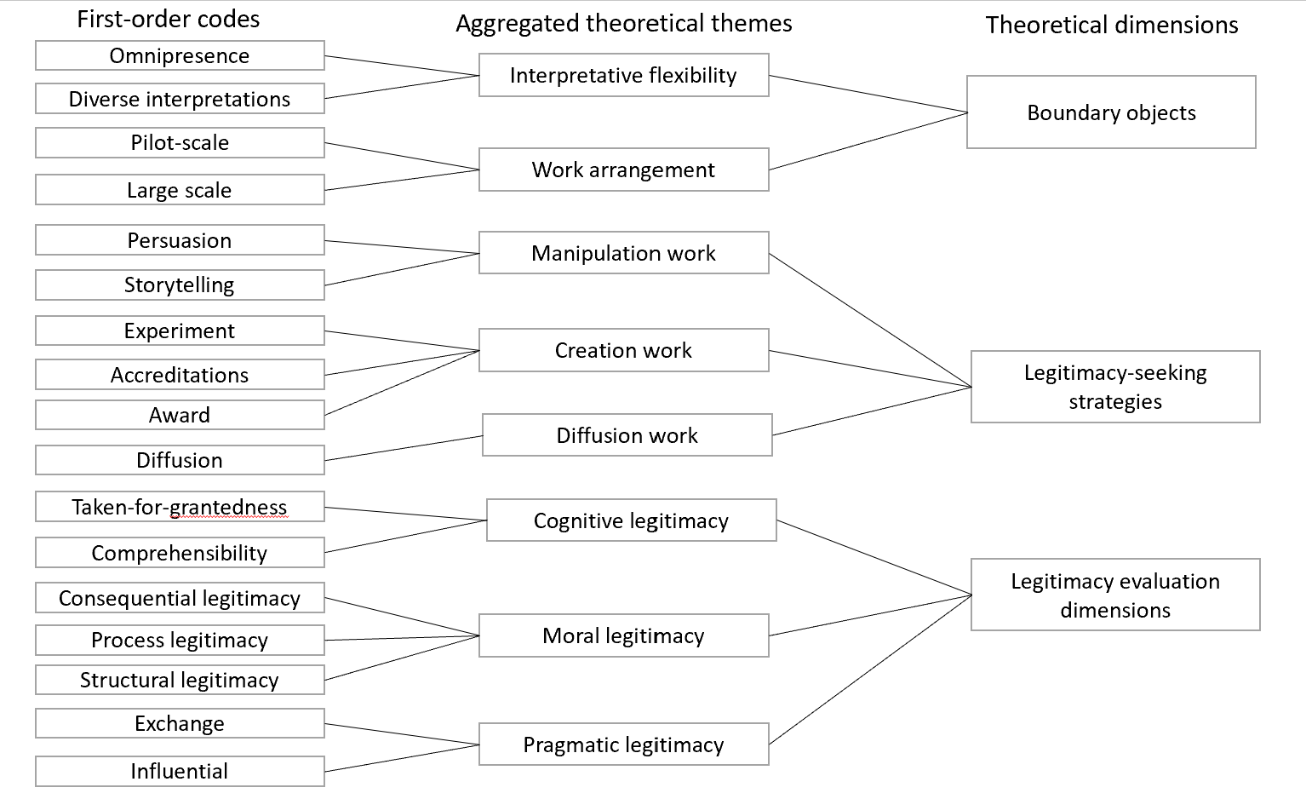Figure 1 - Coding structure

Research quality assurance
Following Yin (2018), different measures were taken to assure the research quality of this paper in four dimensions - construct validity, external validity, internal validity and reliability. Construct validity was strengthened by data triangulation from multiple sources (interviews, websites, internal documents). External validity was assured by multiple cases using replication logic as specified above. Internal validity was strengthened by the pattern matching technique. Finally, reliability was assured by the same rigorous data collection process and consistent interview protocol. Data collection process involved multiple informants and multiple interviewers. Interviews were recorded transcribed verbatim and then sent to informants for validation and authenticity checking.

Findings
This section provides a summary of how the boundary object facilitates legitimacy-seeking strategies for the emerging circular supply chain. This section will be structured to firstly present a summary of key aspects of the boundary object, secondly outline perceived the way in which startups seek legitimacy, and finally discuss the legitimacy judgment outcomes for three firms.

Circular economy as a boundary object
In general, although different preferences were expressed on how circular economy should be applied in food waste innovations, actors in the three cases shared similar viewpoints on the way in which the concept of circular economy exhibits the traits of the boundary object, including interpretative flexibility, and work arrangement.
In terms of interpretative flexibility, the concept of the circular economy has been omnipresent across all interviewees involved in the innovation process, but subject to different interpretations from different stakeholders.
Second, interviewees confirmed the role of the coordinated work arrangement to operationalise the diverse interpretation of the circular economy concept in the innovations’ ecosystems. All three innovations under this study were initiated in collaborative work projects launched after the wide advocation of the concept in the EU Action Plan and several conversations to explore the possibilities of operationalising the concept.

Legitimacy seeking strategies
As the three cases include radical innovations to upcycle food waste, these innovations are not automatically given a socially accepted status but entail actors enacting different strategies to gain ‘legitimate’ status for their innovations. The following provides different strategies and actions undertaken in three cases prior to, during and after the collaboration projects.
Prior to the collaborations, all three startups were found to rely on a manipulation strategy that includes storytelling and persuasion to gain support from their stakeholders.
When pilot projects were launched, all three cases counted on the creation strategy using an experimental approach, accreditations, and awards. In terms of the experiment, the fact that innovation is radically new in terms of both market and product aspects makes the experiment approach boldly underlined.
After the pilot collaboration, only case 3 was able to engage in larger work arrangements to ramp up the production and diffuse its impact. The diffusion strategy was used by startup 3 to gain external validation for the innovations from its market. Unlike this case, case 1 moves from small arrangements to the next ones and continues to explore the possibility of expanding. Similarly, case 2 remains in the pilot phase with only several aspects.

Legitimacy evaluation outcomes
Legitimacies of the innovations are continuously evaluated and re-evaluated to establish the norms for their innovations. The evaluation works are mostly conducted by existing firms and experts in the startup ecosystem. Three cases represent different levels of legitimacies that have been gained by three innovation cases. Only case 3 is able to demonstrate its innovation value and bring economic benefits for engaged partners as well as scalable environmental and economic outcomes.

Conclusion
The paper provides a framework to operationalise the concept of the circular economy as a boundary object to legitimise radical innovation in the circular transition process. This sheds light on the role of a non-human object such as a circular economy concept in the legitimacy-seeking process that has widely focused on the role of heroic actors in the institutional change period. The research also underlines the alignment of three forms of legitimacy for innovations to reap an impact on the circular transition journey. Finally, the research adds to prior research on legitimacy-seeking behaviours by providing empirical evidence for manipulation, creation and diffusion works.

References
Abson, D. J., Von Wehrden, H., Baumgärtner, S., Fischer, J., Hanspach, J., Härdtle, W., Heinrichs, H., Klein, A., Lang, D., & Martens, P. (2014). Ecosystem services as a boundary object for sustainability. Ecological Economics, 103, 29-37.
Antikainen, M., & Valkokari, K. (2016). A framework for sustainable circular business model innovation. Technology Innovation Management Review, 6(7).
Baxter, P., & Jack, S. (2008). Qualitative case study methodology: Study design and implementation for novice researchers. The qualitative report, 13(4), 544-559.
de Jesus, A., Antunes, P., Santos, R., & Mendonça, S. (2018, 2018/01/20/). Eco-innovation in the transition to a circular economy: An analytical literature review. Journal of Cleaner Production, 172, 2999-3018. https://doi.org/https://doi.org/10.1016/j.jclepro.2017.11.111
de Jesus, A., & Mendonça, S. (2018, 2018/03/01/). Lost in Transition? Drivers and Barriers in the Eco-innovation Road to the Circular Economy. Ecological Economics, 145, 75-89. https://doi.org/https://doi.org/10.1016/j.ecolecon.2017.08.001
Donner, M., & de Vries, H. (2021). How to innovate business models for a circular bio-economy? Business Strategy and the Environment, 30(4), 1932-1947. https://doi.org/https://doi.org/10.1002/bse.2725
Dubois, A., & Gadde, L.-E. (2014). “Systematic combining”—A decade later. Journal of Business Research, 67(6), 1277-1284.
Eisenhardt, K. M. (1989). Building theories from case study research. Academy of management review, 14(4), 532-550.
Hafsa, F., Dooley, K. J., Basile, G., & Buch, R. (2022, 2022/10/01/). A typology and assessment of innovations for circular plastic packaging. Journal of Cleaner Production, 369, 133313. https://doi.org/https://doi.org/10.1016/j.jclepro.2022.133313
Ketokivi, M., & Choi, T. (2014, 2014/07/01/). Renaissance of case research as a scientific method. Journal of Operations Management, 32(5), 232-240. https://doi.org/https://doi.org/10.1016/j.jom.2014.03.004
Kirst, E., & Schroth, T. (2022, 2022/12/15/). A framework to enable sustainability-oriented transition activities in HEIs: Learnings from two case studies in Germany and Switzerland. Journal of Cleaner Production, 379, 134605. https://doi.org/https://doi.org/10.1016/j.jclepro.2022.134605
Konietzko, J., Bocken, N., & Hultink, E. J. (2020). Circular ecosystem innovation: An initial set of principles. Journal of Cleaner Production, 253, 119942.
Kuhlmann, M., Bening, C. R., & Hoffmann, V. H. (2022). How incumbents realize disruptive circular innovation - Overcoming the innovator's dilemma for a circular economy. Business Strategy and the Environment, n/a(n/a). https://doi.org/https://doi.org/10.1002/bse.3109
Linder, M., & Williander, M. (2017). Circular business model innovation: inherent uncertainties. Business strategy and the environment, 26(2), 182-196.
Meyer, J. W., & Rowan, B. (1977). Institutionalized organizations: Formal structure as myth and ceremony. American journal of sociology, 83(2), 340-363.
Morgan, D. L. (2007). Paradigms lost and pragmatism regained: Methodological implications of combining qualitative and quantitative methods. Journal of mixed methods research, 1(1), 48-76.
Pieroni, M. P., McAloone, T. C., & Pigosso, D. C. (2019). Business model innovation for circular economy and sustainability: A review of approaches. Journal of cleaner production, 215, 198-216.
Prieto-Sandoval, V., Jaca, C., & Ormazabal, M. (2018, 2018/04/01/). Towards a consensus on the circular economy. Journal of Cleaner Production, 179, 605-615. https://doi.org/https://doi.org/10.1016/j.jclepro.2017.12.224
Sehnem, S., Vazquez-Brust, D., Pereira, S. C. F., & Campos, L. M. S. (2019). Circular economy: benefits, impacts and overlapping. Supply Chain Management: An International Journal, 24(6), 784-804. https://doi.org/10.1108/SCM-06-2018-0213
Star, S. L. (2010). This is not a boundary object: Reflections on the origin of a concept. Science, Technology, & Human Values, 35(5), 601-617.
Star, S. L., & Griesemer, J. R. (1989). Institutional ecology,translations' and boundary objects: Amateurs and professionals in Berkeley's Museum of Vertebrate Zoology, 1907-39. Social studies of science, 19(3), 387-420.
Suchman, M. C. (1995). Managing legitimacy: Strategic and institutional approaches. Academy of management review, 20(3), 571-610.
Voss, C., Tsikriktsis, N., & Frohlich, M. (2002). Case research in operations management. International journal of operations & production management, 22(2), 195-219. https://doi.org/https://doi.org/10.1108/01443570210414329
Yin, R. K. (2018). Case Study Research: Design and Methods (6 ed.). SAGE Publications. https://books.google.co.uk/books?id=OgyqBAAAQBAJ
Zimmerman, M. A., & Zeitz, G. J. (2002). Beyond Survival: Achieving New Venture Growth by Building Legitimacy. Academy of Management Review, 27(3), 414-431. https://doi.org/10.5465/amr.2002.7389921

