Running Head: IMPURITY DOMAIN

Minimal Criteria for an Impurity Domain of Morality

Jared Piazza¹
and
Paulo Sousa²
Jared Piazza  https://orcid.org/0000-0001-7261-3939
Paulo Sousa https://orcid.org/0000-0002-7681-855X

¹ Lancaster University, Department of Psychology, Bailrigg, Lancaster, UK
² Queen’s University Belfast, Institute of Cognition and Culture, Belfast, Northern Ireland, UK
Current draft, 23 March 2023 (Author copy)

Correspondence to be addressed to Dr. Jared Piazza, Department of Psychology, Lancaster University, Lancaster, United Kingdom LA1 4YF (Email: j.piazza@lancaster.ac.uk).

Abstract
There is much disagreement about the claim that impurity constitutes a moral domain. We propose a set of minimal criteria that could help re-orient the field to a direction of consensus in the assessment of this claim. We illustrate how the criteria apply to aspects of the current literature.

Keywords: impurity, morality, moral domains, disgust, emotion

Minimal Criteria for an Impurity Domain of Morality
No issue in moral psychology has generated more disagreement than the claim that there is a distinct domain of morality tied to the concept of impurity. Impurity sceptics point out that impurity has been characterised and operationalised in vastly heterogenous ways [1-2]. Further, this domain is presumed to encompass a wide variety of actions: from licking shoes, eating human flesh, desecrating Bibles, to rape and suicide [3-8] (see Table 1 for more examples). This abundance of characterisations and varied action-content makes the search for an impurity domain seem ill-fated. We take a useful step back and propose a minimal set of criteria that researchers could agree upon to test whether such a domain exists (see Figure 1). The criteria draw upon Social Domain Theory, Social Intuitionism, and our own theorising [9], and they should be tested cross-culturally to confirm that they reflect a universal learning disposition [7-8].
[Insert Table 1 about here]
Researchers have made the general claim that there is a group of actions conceptualised as impure that are judged as moral wrongdoing [7-8]. They have also made specific claims about how impure actions might contrast with other types of actions, particularly harmful actions (with the meaning of “harmful” often underspecified). For example, compared to harmful actions, impure actions are posited to be more self-directed [3], less sensitive to intentionality [3], and less sensitive to dosage (i.e., action severity) [4]. Our criteria speak to both general and specific claims.
[Insert Figure 1 about here]
Criterion 1 – Wrongdoing
This criterion concerns the distinction between what is wrong (or, equivalently, impermissible) and what is discretionary [9]. For impure actions to be considered moral wrongdoing (a subclass of wrongdoing—see Criterion 5), they first must be construed as wrongdoing instead of a matter of personal choice. Although this criterion seems obvious, it is not always carefully implemented in practice. For example, actions like “pouring urine on one’s own lap” and “smearing cat poop on one’s arm” [2] have been used to exemplify impurity without fully assessing whether they are deemed wrong or a matter of personal choice. It is possible that such actions are considered gross, weird, and/or imprudent but still a matter of personal choice.
Criterion 2 – Impurity
It should also go without saying that impure actions ought to be conceptualised as impure. Here, one must characterize the concept of impurity (and the psychological mechanism whose function it is to process impure actions). Furthermore, one must show that this concept is not reducible to other well-established psychological constructs [5,10]. The concept of impurity has been characterised in various ways. Notably, Haidt [6-8] proposed that the concept of impurity is part of a psychological mechanism that evaluates actions by positioning them on a vertical dimension from High/Divine/Pure/Natural to Low/Animal/Impure/Unnatural. On this view, operationalisations of impurity might include “one’s actions are degrading/make one low like an animal/make one impure/violate the natural order.” These operationalisations are not without problems, since expressions like “degrading” and “impure” have meanings related to other constructs.
Take the action “A person enslaves a child for the sex trade” [8]. One may say that this action is “degrading” and mean that the action is extremely unjust. Other presumed “impure” actions may be conceptualised simply as imprudent (a threat to the person acting; e.g., “ordering stir-fried rat” [3]), or as a threat to others (e.g., “urinating on stage” [7]), or as something that disrespects God (e.g., “graffitiing churches” [4]). The issue here is not that an action can be conceptualised in multiple ways, but that one must show that there is a conceptualisation of impurity that goes beyond conceptualisations related to injustice, imprudence, threat to others, disrespect to God/religion, even if there may be some conceptual overlap.
This problem has direct implications for some specific claims made about impure actions. Take the claim that impure actions are more self-directed than harmful actions [3]. It is possible that self-directed actions like “smear cat poop on one’s arm” [3] fail to discriminate impurity from imprudence. It may be that a fundamental property of imprudent actions (i.e., their self-direction) is being misattributed to impure actions. Another claim is that impure actions are insensitive to dosage [4]. Alternatively, it may be that items like “eating/touching corpses” [4] relate to a threat of pathogen contagion. Even a single pathogen can be a “complete threat” to others, since pathogens replicate and spread through contact, whereas other injuries (e.g., tissue damage from “punching” and “throwing rocks” [4]) are isolated and do not spread. Hence, it is unclear whether sufficient discrimination has been achieved between impurity and concepts like imprudence, threat to others, etc.
Criterion 3 – Causality
Criterion 3 specifies that the judgment of wrongdoing should be caused by the conceptualisation of impurity. In other words, the psychological mechanism related to impurity needs to play a causal role in the judgment of wrongdoing, though it need not be the sole contributor [9]. Much of the literature falls short on this criterion, including some of our own work [10], because it provides only correlational evidence for the role of impurity. A methodological step in the right direction would be to directly ask participants whether impurity (properly operationalised) is a reason for their judgment or to ask participants to justify their judgment and code for impurity-related content. This of course leaves open the possibility that responses are mere post-hoc rationalisations [8]. Therefore, more sophisticated methods probing causation [e.g., 11] should be part of the methodological picture to address this issue.
Criterion 4 – Disgust
Most researchers accept that moral judgments are functionally and prototypically associated with emotions [8]. In the case of impurity, the commonly accepted associate is disgust [3,6,8]. However, since the vocabulary of disgust is often used metaphorically to express other emotions (e.g., anger), it is important, when probing disgust reactions, to utilise validated measures that minimise this issue [12]. Moreover, one cannot assume that, simply because an action elicits disgust, the action is part of the impurity domain. Disgust need not relate to morality, and disgust (and other emotions) can be incidentally associated with moral judgments. One must show that when disgust is elicited by a presumed impure action, it is at least partly caused by the action being appraised as wrongfully impure, that is, the disgust should follow from criteria 1-3.
Criterion 5 – Strong convictions
This criterion concerns how to specify judgments of moral wrongdoing, as opposed to other types of wrongdoing (e.g., violations of etiquette) [9]. Researchers often use “wrongdoing” (or “impermissibility”) to probe moral wrongdoing—as if criterion 1 was sufficient to test for moral wrongdoing. Also problematic is the use of “morally wrong” or “immoral” to probe moral wrongdoing [3-5]. This practice is questionable because words like “morally” or “moral” are polysemous and do not have precise translations in many languages. An alternative approach is to probe whether judgments of wrongdoing involve strong normative convictions, namely, convictions that the action is objectively and/or universally wrong [13]. There were some early attempts to apply this approach to disgust-eliciting acts [6], but it has since been largely neglected. We believe this approach should be revitalised, though we leave some finer points open to discussion, such as whether both objectivity and universality are necessary to establish the strong normative conviction that characterises morality. Some impure actions may be judged objectively but not universally wrong. For example, Jews may judge that it is impure and objectively wrong for Jews to eat pork, without having the same conviction about non-Jews eating pork. The field may need to decide whether objectivity is sufficient to indicate that a judgment of moral wrongdoing is at stake in such cases.
Conclusion
Like many, we are intrigued about the prospect of an impurity domain of morality. We are not impurity defenders or deniers. We are cautiously sympathetic, since, at present, there are just too many unaddressed issues to allow a firm conclusion. Of the presumed impure actions envisaged by researchers, there may indeed be a subset that indicates the existence of an impurity domain of morality. There is nothing radical about the criteria we have outlined, and so we are hopeful they can help steer the field towards a more unified answer.

Table 1. Examples of “impurity” actions from the literature by category.
Category and Examples | Source
Food taboos and oral ingestion
A person intentionally ordered stir-fried rat for himself at a small restaurant. | [3]
A person cooks and eats their dog, after it dies of natural causes. | [6]
Pathogen contact  A person inappropriately touches a corpse. | [4]
A person intentionally smears cat poop on their own arm. | [3]
Sex taboos and deleterious reproduction
A person has sex with a goat.  A brother and sister kiss each other passionately on the mouth. | [4]  [6]
Animal reminder
A person enacts a performance art piece where the person acts like an animal for 30 minutes, including crawling around naked and urinating on stage.  A person gets plastic surgery that adds a 2-inch tail onto the end of their spine. | [7]  [7]
Disrespect to God/religion
A business person builds a casino on ground that is considered sacred. | [4]
A person draws graffiti on two churches.  Degradation | [4]
A person enslaves a child for the sex trade.  A person forces another person to have sexual intercourse with them, without that person’s consent. | [8]  [5]

Figure 1. Criteria for an impurity domain of morality. To confirm the existence of an impurity domain of morality, one should show that there is a group of actions that (1) are judged as wrong (something one must not do) rather than discretionary, (2) are conceptualised as having a distinct property denoted by the concept of impurity (the content of which requires specification), (3) are judged as wrong because impurity plays a constitutive causal role in this judgment, (4) prototypically elicit reactions of disgust due to (1-3), and (5) are judged as objectively and/or universally wrong. The criteria are not designed to provide a definition of “impure immoral actions”. Rather they represent aspects of the psychological mechanism that would constitute an impurity domain of morality. Moreover, we depict the criteria as a decision tree simply to facilitate understanding. The decision tree should not be understood as indicating a causal sequence for testing the criteria—each criterion need not be tested separately or in a specific order.
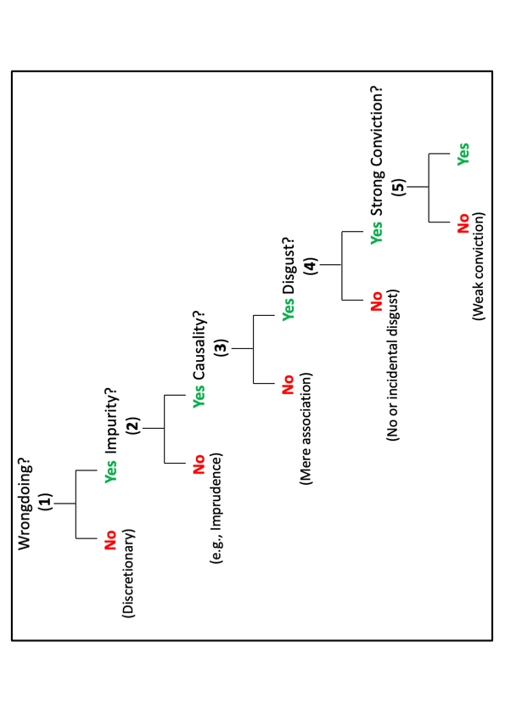

References
1. Gray, K., DiMaggio, N., Schein, & Kachanoff, F. (2023). The problem of purity in moral psychology. Personality and Social Psychology Review, 1-37. DOI:10.1177/10888683221124741
2. Kollareth, D., Brownell, H., Durán, J. I., & Russell, J. A. (2022). Is purity a distinct and homogenous domain in moral psychology? Journal of Experimental Psychology: General, 152(1), 211-235.
3. Chakroff, A., Dungan, J., Young, L. (2013). Harming ourselves and defiling others: What determines a moral domain? PLoS One, 8(9), e74434.
4. Rottman, J., & Young, L. (2019). Specks of dirt and tons of pain: Dosage distinguishes
impurity from harm. Psychological Science, 30(8), 1151-1160.
https://doi. org/10.1177/0956797619855382
5. Gray, K., & Keeney, J. E. (2015). Impure, or just weird? Scenario sampling bias raises questions about the foundation of moral cognition. Social Psychological and Personality Science, 6(8), 859–868.
6. Haidt, J., Helena Koller, S., & Dias, M. G. (1993). Affect, culture, and morality, or is it wrong to eat your dog? Journal of Personality and Social Psychology, 65(4), 613-628.
7. Graham, J., Haidt, J., & Nosek, B. A. (2009). Liberals and conservatives rely on different
sets of moral foundations. Journal of Personality and Social Psychology, 96, 1029–
1046.
8. Haidt, J. (2012). The righteous mind: Why good people are divided by politics and religion. New York, NY: Pantheon Books.
9. Sousa, P., & Piazza, J. (2014). Harmful transgressions qua moral transgressions: A deflationary view. Thinking & Reasoning, 14(1), 99-128.
http://dx.doi.org/10.1080/13546783.2013.834845
10. Piazza, J., Sousa, P., Rottman, J., & Syropoulos, S. (2019). Which appraisals are
foundational to moral judgment? Harm, injustice, and beyond. Social Psychological and Personality Science, 10(7), 903-913.
11. Hannikainen, I. R., & Rosas, A. (2019). Rationalisation and reflection differentially modulate prior attitudes toward the purity domain. Cognitive Science, 43, e12747. DOI:10.1111/cogs.12747
12. Piazza, J., & Landy, J. F. (2020). Folk beliefs about the relationships anger and disgust have with moral disapproval. Cognition and Emotion, 34(2), 229-241.
13. Sousa, P., Allard, A., Piazza, J., & Goodwin, G. (2021). Folk moral objectivism: The case of harmful actions. Frontiers in Psychology, 12, 1-18.

