A Tale of Two (Stuffed) Fish: Coastal Encounters in the Scientific Writings of Sir John Richardson

Christopher Donaldson
Lancaster University

James Maclaine
Natural History Museum, London

Abstract
This essay delves into the history of two stuffed fish in London’s Natural History Museum. These fish came from opposite ends of the earth: one from southern Australia, the other from northern Canada. But they were both documented and named by a Scotsman, Sir John Richardson (1787–1865). Richardson’s encounters with these fish shed light on different aspects of his career as a naval surgeon, polar explorer, and natural historian. More importantly, though, these encounters also reveal how European knowledge of the world’s coastal environments was created during the Romantic era. In considering the context and consequences of these encounters, this essay reflects on how the subject of this special issue, though nationally defined, connects with broader histories of nineteenth-century exploration and empire. The places where these fish were caught lay well beyond Scotland. Nonetheless, these fish are relevant to the study of Scotland’s coastal Romanticisms, and tracing their history invites us to rethink the geographical assumptions that often govern the study of national pasts.

Biographical Note
Christopher Donaldson is Senior Lecturer in Cultural History at Lancaster University, where he is also co-director of the Regional Heritage Centre. His recent publications include Henry Hobhouse’s Tour of Cumbria in 1774 (2018).

James Maclaine is Senior Curator, Fish, in the Vertebrates Division, Life Sciences Department of the Natural History Museum. His research has appeared in journals including Zoology, Zootaxa, and Journal of Natural History.

- If animals are “good to think” with, then that goes for dead animals too (Lévi-Strauss 89). That is a central premise of this essay. In what follows, we discuss the histories of two stuffed fish specimens in London’s Natural History Museum. These specimens are valuable primary sources. Neither of them is Scottish. One is Australian, the other Canadian. Yet they still pertain to the subject of this special issue. Both were documented and named by the eminent Scottish naval surgeon, naturalist, and polar explorer Sir John Richardson (1787–1865). Both, moreover, reveal a good deal about how European knowledge of the world’s coastal environments was created during the Romantic era. In doing so, these stuffed fish can help us think about the history and geography of Scotland’s coastal Romanticisms in entirely new ways. Rather than tethering our focus to the space of Scotland’s national territory, they enable us to trace the cultural legacies of Scotland’s coastal Romanticisms within the broader entangled histories of nineteenth-century exploration and empire.

- Such an approach to the subject of this special issue redirects lessons learned from the subfield of coastal history to broaden the geographical scope of Scottish Romantic studies. Coastal historians have generally emphasized the dynamic and hybrid nature of coastal landscapes. Equally, they have emphasized the need to reconsider the geographical frameworks that govern humanities research (Wigen). At the coast, binary distinctions between the terrestrial and the maritime break down, prompting us to think and speak differently. Inevitably, this has resulted in the introduction of new labels and terminology, but it has also helped usher in new concepts and perspectives. What is more, it has provoked critical reflection, and that reflection has proved especially meaningful in fields that have often been defined by either terrestrial or maritime concerns. David Gange’s remarks about how different British history looks when inland cities are seen from Atlantic shorelines come to mind (x). So, too, do John Gillis’s comments about the role coastal studies can play in “reformulating and revitalizing” the “remarkably landlocked” field of environmental history (“Filling the Blue Hole” 16–18; see also Gillis and Torma). Coasts, in so many words, seem to be good to think with as well.

- The sort of fluid perspective that Gange and Gillis promote suits the approach of this essay. We want to push beyond the national confines that often constrict studies of Scottish Romanticism by adopting a different interpretive angle. That angle may seem somewhat skewed, even erratic, as it inclines us to consider things and places that might be dismissed as rather far removed from the focus of this special issue. Obliquity, however, is the measure of our intent. Coastal history often involves bricolage and boundary crossings. As a subfield, it invites us to combine different kinds of sources. These might include drawings, paintings, private manuscripts, published works of literature, or other printed documents, but they might just as easily include scientific specimens, such as our two stuffed fish, or other sorts of material remains. Equally, in critiquing our tendency to think solely in terms of land and sea, coastal history invites us to rethink the geographical assumptions that underpin our perception of the past. We want to take up that invitation, and in doing so we want to reflect on how studying Scottish encounters with coastal landscapes during the Romantic era can carry us to opposite ends of the earth.

- In this latter respect, our essay aims to give fuller expression to an intuition evident, but only partially developed, in some of the other articles in this special issue. Gerard McKeever’s and Claire Connolly’s contributions stand out especially. Their articles affirm that the geographical scope of Scotland’s coastal Romanticisms extends beyond Scotland. Connolly’s analysis of John Keats’s tour, for its part, confirms the necessity of viewing Romantic writing about the coasts of southwestern Scotland within the fluid, transnational space of the Irish Sea. McKeever goes even farther. Though mainly focused on the Firth of Clyde, his consideration of John Galt’s diverse literary and commercial concerns (spanning as they did from Greenock to Guelph and from Ayrshire to the Aegean) gestures at how Scottish experiences of coastal environments were shaped by the colonial and imperial contexts of the Hanoverian era.

- Our essay extends this line of reflection in a more focused and deliberate manner. Here, though, the discussion is less overtly concerned with Romantic literature and art than with early nineteenth-century science. Consequently, our interest is not solely in literary and pictorial representations of coastal regions but also in the ways the material reality of those regions was experienced and preserved. In turning to this topic, we also wish to reveal the relevance of the study of coastal Romanticisms to the broader historiographies of Hanoverian exploration and natural history. The publications of several specialists in Romantic literary studies stand out in this context, including contributors to this issue. So, too, does the work of historians such as Fredrik Albritton Jonsson and John MacKenzie, who have drawn attention to the imperial frameworks that shaped Scottish contributions to Hanoverian natural history. For our part, though, we shall build particularly on the work of Alan Bewell (Natures) and Adriana Craciun. Bewell’s consideration of the contributions that natural history made to Romantic-era discourses of nature provides, as we shall show, a useful framework for explaining how biological specimens collected from different parts of the globe were translated into objects of colonial knowledge. Similarly, Craciun’s documentation of the mutually influential entanglement of literary Romanticism and Arctic expeditions helps illuminate how the scientific pursuits of explorers contributed to the larger colonial project of representing and recording a seemingly alien polar world.

- In responding to the work of these and other scholars, we aim to stress the importance of recognizing the wider contexts that shaped Scottish encounters with coastal environments during the first half of the nineteenth century. Many of those encounters took place within the colonial landscapes of Scotland. Many others, however, took place in colonial landscapes elsewhere on earth. In some cases, they occurred in the “centres of calculation” (Latour 239) where knowledge about exotic environments was classified, constructed, and shared. Below, we stake our approach to these contexts through a set of case studies, each of which concerns the history of a stuffed fish.

Ruskin, Richardson and a Prowfish

- The first stuffed fish we want to consider is an example of the species Pataecus fronto, or the Australian prowfish. This specimen came to our attention during the first COVID-19 lockdown, in the spring of 2020, when we were corresponding about connections between the collections of London’s Natural History Museum and The Ruskin – Museum and Research Centre at Lancaster University. Our correspondence was occasioned by one of John Ruskin’s drawings (fig. 1). The drawing is not one of Ruskin’s finer works. It is simply a detailed sketch of a fish that had seized his interest. Frustratingly, the drawing does not give any indication of the fish’s species, size, or origin. Ruskin did not even bother to date the drawing. The only annotation he made on the page were the words “British Museum,” which appears in brackets next to his signature. This annotation makes sense. Ruskin spent many happy hours at the British Museum in his later life, poring over books and sketching objects. Most of the objects he sketched, though, were antiquities, not natural curiosities, and in the absence of further clues, we are left to wonder what it was about this fish that reeled Ruskin in.

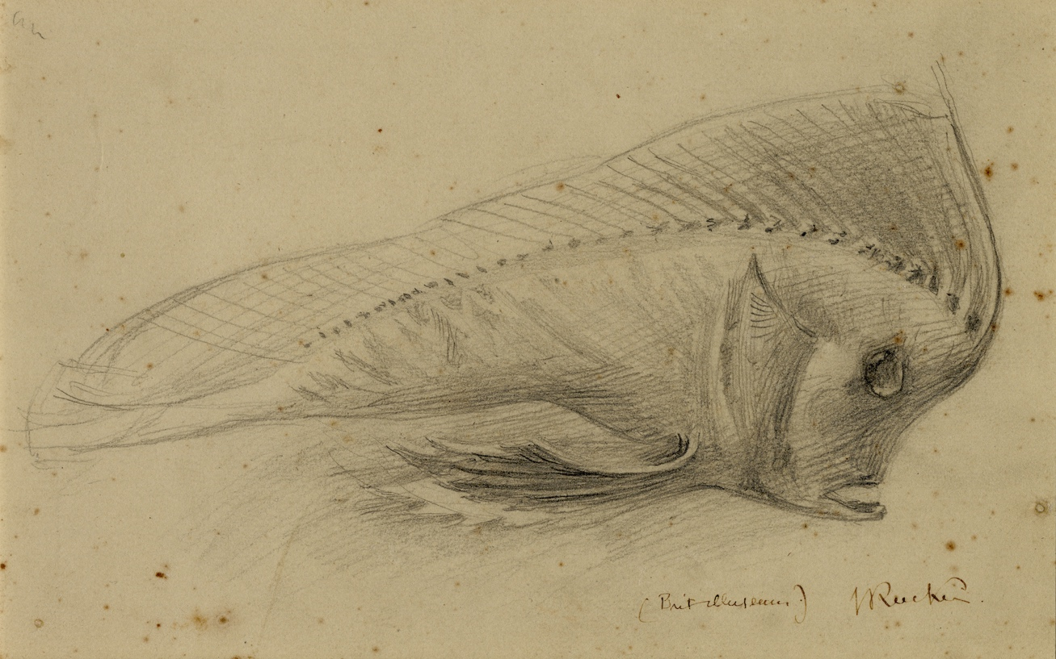
Fig. 1. John Ruskin, “Study of a Stuffed Fish, British Museum,” 1870, pencil on toned paper, 5.9 x 25.4 cm. Invent no. 1996P1253, © The Ruskin – Museum and Research Centre, Lancaster University.

- Thankfully, trawling through Ruskin’s papers turns up a few clues. Flip to the entry in his diary for 16 December 1870, and you will see that he had spent the previous day “in [the] British museum,” where he “drew [a] beetle-browed fish” (Ruskin 58). Evidently, the fish’s bulging forehead was part of what caught Ruskin’s eye. This clue, along with the fish’s distinctive features, aided us in identifying its species and tracking down the original specimen. Like the rest of Britain’s national natural history collection, the Australian prowfish specimen had been transferred to South Kensington during the 1880s and is now housed among the Natural History Museum’s collections. Once it was again possible to access those collections, we were able to find the very fish Ruskin drew (fig. 2).

Fig. 2. Australian prowfish (Pataecus fronto), 1844, Natural History Museum, BMNH 1844.9.3.11. Photograph by Kevin Webb, © The Trustees of the Natural History Museum, London.

- This fish has a tale of its own. The Natural History Museum’s records indicate that it was plucked from the coastal waters of southwestern Australia some 180 years ago. Dried and stuffed, it was sent as a specimen to the British Museum in the early 1840s. The fish was personally gifted by Sir George Grey (1812–1898), then Governor of South Australia, and was possibly brought to Britain with the bounty of colonial flora and fauna carried by the HMS Terror and HMS Erebus at the end of Sir James Clark Ross’s Antarctic expedition in 1843. A drawing and description of the fish later appeared in the official study of the expedition’s zoological cargo (Richardson, Ichthyology 20–22; fig. 3). Comparing that drawing with the one Ruskin made is instructive. Though both works show the specimen from the same profile, Ruskin’s drawing neglects several important features, not least the fish’s anal fin and details of the caudal fin. Such omissions depart from the conventions of scientific illustration and render Ruskin’s drawing little more than an idle sketch.

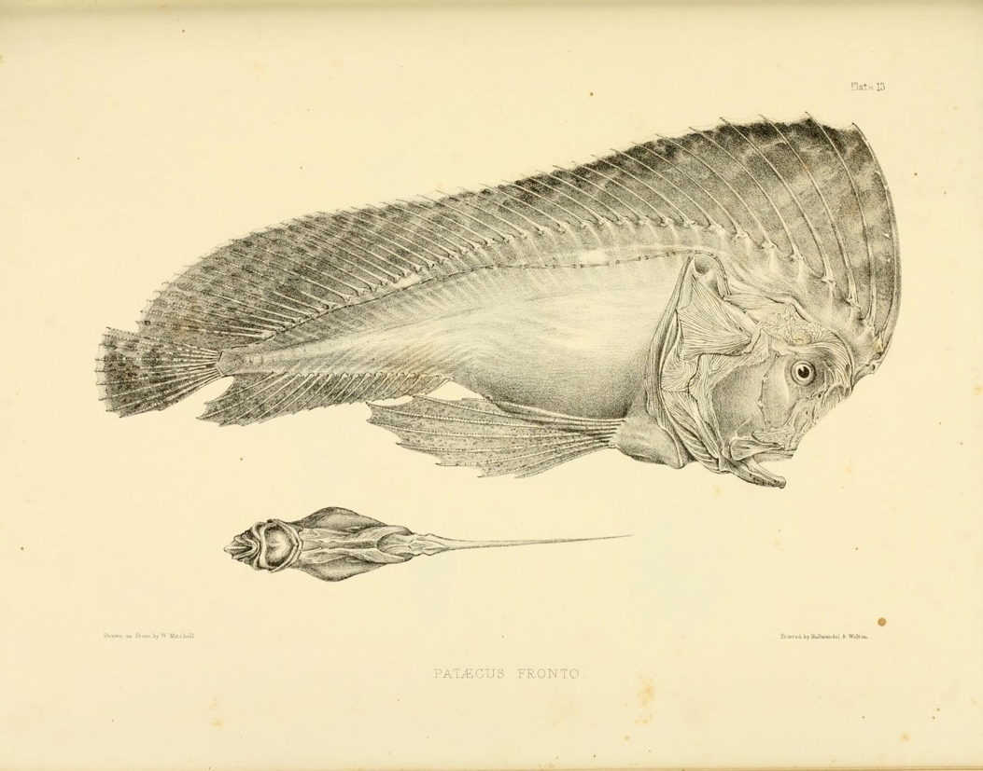
Fig. 3. Pataecus fronto, by W. Mitchell, printed by Hullmandel and Walton, in Richardson Ichthyology of the Voyage, plate 13.

- But why does this matter? And how, moreover, does this specimen relate to the subject of this special issue? Pataecus fronto, as we have hinted, is a species commonly found in the coastal waters of western and southern Australia. The fish tends to frequent rocky reefs and sponge beds. But what has this specimen’s history to do with Scotland or, for that matter, Romanticism? The answer to that question lies in the specimen’s history. This was the first Australian prowfish formally described by Europeans (even today it serves as the type specimen of the species), and the story of its classification exemplifies processes of knowledge creation that defined many Romantic-era encounters with colonial environments. Notably, the specimen was classified by none other than Sir John Richardson, who, by the time he encountered this stuffed fish at the British Museum in 1844, was one of Europe’s more renowned authorities on colonial natural history.

- Richardson is a fascinating figure. His career as a naval surgeon, natural historian, and polar explorer spanned the last twenty years of the Hanoverian era and the first three decades of the Victorian age. As Craciun has pointed out, his “intellectual curiosity and practical versatility” exemplify the “predisciplinary” character of the sciences during his lifetime (93). His career, she continues, “encompasse[d] the full range of early nineteenth-century intellectual and social pursuits” (93). To put the point more plainly, we might say that Richardson was a gifted generalist, who managed to be a master of more than one trade. He was not entirely unlike Ruskin in this respect. Richardson was certainly highly regarded among his peers. His many accolades included his election as a fellow of the Royal Society in 1825 and of the Royal Society of Edinburgh in 1855. When Ross returned to Britain in 1843, he entrusted Richardson with the task of managing the documentation and publication of the Antarctic expedition’s zoological collections (Ross).

- Richardson’s connections with Scottish Romanticism and the Scottish Enlightenment run deep. As a boy, he was bounced on Robert Burns’s knee. Richardson’s father, the brewer Gabriel Richardson (1759–1820), was a friend of the poet during his final years in Dumfries. Some readers may recall the affectionate mock-epitaph that Burns wrote for Gabriel in 1795. Burns’s poetry and personality deeply impressed Gabriel’s eldest son, John, who memorized a good many of the poet’s songs. Richardson’s first biographer put this point across melodramatically when he wrote how Burns’s works “were stored up” in Richardson’s “memory,” and “cheered him with thoughts of home, while pacing the deck, during his life at sea, and afterwards amid the solitude of the North American forests” (McIlraith 4). Even at the end of his days, when he retired to Grasmere, in the English Lake District, Richardson is said to have charmed his neighbours with recitations of “The Auld Farmer’s New-Year-Morning Salutation to his Auld Mare, Maggie” and “The Cotter’s Saturday Night” (McIlraith 263).

- Richardson made three noteworthy voyages to the Arctic over the course of his naval career. In 1819 and 1825, he accompanied Sir John Franklin’s overland expeditions to the coast of Nunavut, then known to the British as the North-Western Territory. In 1848, moreover, Richardson set sail in search of Franklin’s lost polar expedition, which coincidentally involved the very ships that might have brought the Pataecus fronto specimen to Britain. (The interlinkages of imperial history rarely cease to astound.) To contextualize Richardson’s encounter with the specimen, though, we need to recognize that Burns was not the only noteworthy influence on his early years. After studying at Dumfries Grammar School, and undertaking an apprenticeship as a surgeon, Richardson completed his studies in medicine at Edinburgh University, where he was a student of Robert Jameson (1774–1854) and Thomas Hope (1766–1844), as well as the philologist Andrew Dalzell (1742–1806). Jameson and Hope both fanned the flames of Richardson’s passion for natural history. Dalzell, for his part, provided him with a firm grasp of Ancient Greek. Both these aspects of Richardson’s education are apparent in his classification of Pataecus fronto.

- The name recalls Herodotus’s description of the dwarfish figures (or pittuchim) with which the Phoenicians decorated their warships. In Book 3 of The Histories, Herodotus explained that these figures looked rather like the Egyptian god, Ptah, whom the Greeks associated with Hephaestus and whom, Herodotus tells us, was often represented as a dwarf (Herodotus 278, 3.37; see also Dasen 84–85). The Greek rendering of pittuchim is pataikoi, which becomes pataeci in Latin. Fronto, for its part, just means “beetle-browed.” Richardson did not mention Herodotus in the entry included in the account of Pataecus fronto published in his study of the fish collected by Terror and Erebus, but he did allude to the passage from The Histories in the initial classification of the specimen printed in The Annals and Magazine of Natural History. There, he provided the following gloss: “[P]ataikoi are the likenesses of Phoenician gods on the sterns of ships” [παταικοὶ simulacra deorum Phoenicum in puppibus] (Richardson, “Generic Characters” 280). In a certain sense, this association is apt. Pataecus fronto is a relatively small fish. (The specimen Richardson classified is about 8 inches long.) What is more, it has a protruding forehead, which is accented by a long dorsal fin. The shape of that fin is also the source of the species other, more problematic common name: the “Red Indian fish.” That name would be proposed by the Australian marine biologist David Stead in 1906 (Stead 212). Stead’s idea was that the fish’s dorsal fin resembled a Native American headdress.

- Like Richardson’s description, the name “Red Indian fish” is a product of the European imagination. Both names reflect a Western view of the fish’s appearance. Both associate its appearance with artefacts from remote cultural contexts: ancient Phoenicia, on the one hand, and, on the other, the Indigenous peoples of North America’s Great Plains. Both names, in sum, reveal how the wonders of the natural world were translated into units of colonial knowledge. Both treat the fish as an exotic object, not an organism. Neither name accounts for how the fish was perceived by Australia’s Indigenous peoples, nor, for that matter, for its coastal habitat. Stead does admittedly touch on the latter subject. He tells us that the prowfish “lives in weedy, rocky localities, along parts of the coast” (213). Richardson’s description, however, is entirely anatomical. He never visited the coasts of southern Australia, and he evidently could not confer with anyone who had seen a prowfish in the wild. He was, consequently, ignorant of the fish’s ecology. “The habits of the fish are unknown to us,” he confessed, “we have seen but a single example . . . which was dried without any preparation whatever” (Ichthyology 20–21).

- All this is remarkable as an illustration of how knowledge about global coastal environments was created and accrued in early nineteenth-century Britain. Richardson’s classification and characterization of the Pataecus fronto specimen, conducted as it was some ten thousand miles from the place where the prowfish was caught, exemplifies how colonial organisms were converted into museum objects. The knowledge lost in such a process is incalculable. Barry Lopez’s remarks about how “the imposed view . . . always obscures” spring to mind (176). So, too, do Bewell’s assertions about how the ideals of Enlightenment science led to the destruction of Indigenous understandings of the natural world. “Every inscription,” he writes, “is also a form of erasure, every possession an act of dispossession, every settlement a form of unsettlement, as one name or one material nature supplants and displaces another” (Natures 15–16; see also Bewell, “Cartogrpahy”). The naming of Pataecus fronto illustrates this process, and it reminds us of the role natural historians like Richardson played in forming the vocabularies that were used to describe and categorize the world’s coastal environments. Equally, this act of naming calls attention to the grammar that shaped those vocabularies and their deployment.

- By grammar, we mean taxonomy, which was one of several systems of totalizing classification employed in the documentation of colonial environments. Benedict Anderson has emphasized the importance of maps and censuses in this context as well (167–90). But taxonomy is an especially interesting focus for our purposes, because its application in colonial natural history did not only entail the creation of knowledge about decontextualized specimens studied in museums thousands of miles from their place of origin. It also entailed the compilation and translation of knowledge in situ. Bewell puts this point well in his book Natures in Translation, wherein he observes how the conventions of Linnaean taxonomy “can be understood as inherently [part of] a project of translation” (41). Linnaeus’s system, Bewell concludes, “allowed local natures, rooted in different cultures, to be remade so that they could cross the physical and cultural boundaries that had previously separated them.” Colonial natural history, viewed in this way, can be understood as “a cross-cultural activity,” and Bewell cites the frontispiece of Pierre Sonnerat’s Voyage à la Nouvelle Guinée as an emblematic expression of this ideal (fig. 4).

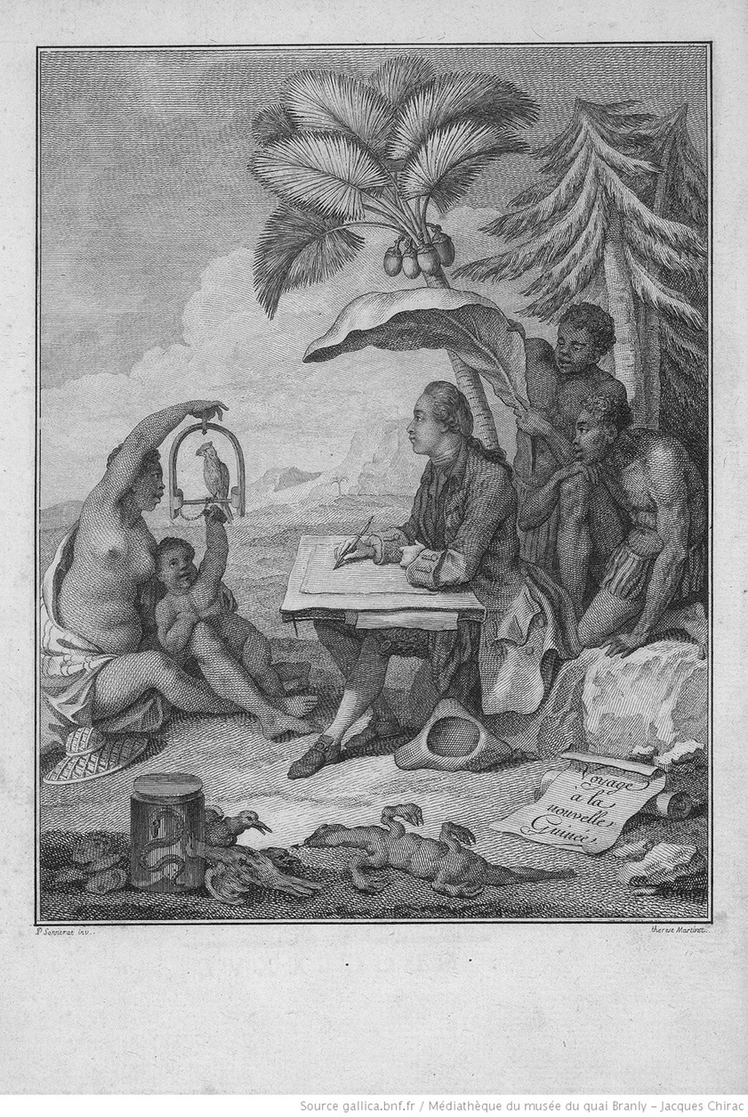
Fig. 4. Pierre Sonnerat, Voyage à la Nouvelle Guinée, Ruault, 1776. Source: gallica.bnf.fr. Bibliothèque nationale de France, Réserve A 200 259.

- This etching presents a fanciful view of early modern colonial coastal encounters. We see a young Sonnerat, as Madeleine Ly-Tio-Fane once remarked, “portrayed as a thoughtful student of Nature in a landscape enlivened by the ‘cocotier de mer’ palm and the abaca” and flanked by human figures who seem intended to represent “various stages of social evolution” (72). This composition, Bewell comments, is thoroughly “structured by colonial power relations” (Natures in Translation 44). The picture “depicts a hierarchical division of labor that sharply differentiates European scientific culture from the indigenous localities that it translates. Nevertheless, it still presents Sonnerat and the Papuans as being engaged in a shared activity.” It presents them, in other words, in a kind of cross-cultural collaboration.

- This sort of reading can be taken too far. Fanciful images such as this frontispiece mask much darker histories of violence and subjugation. The motives of naturalists such as Sonnerat, and Richardson for that matter, were hardly egalitarian. The taxonomies they produced often failed to credit their Indigenous “collaborators.” What is more, we are not aware of any evidence that demonstrates that naturalists such as Sonnerat and Richardson ever attempted to share their scientific interpretations and discoveries with the Indigenous communities on whom they relied. With these caveats in mind, though, there is merit in Bewell’s claims insofar as they help us to recognize that the works of colonial natural historians, like Richardson, do in some cases provide more than just a record of the decontextualization of colonial natures and the imposition of Eurocentric ideas on the rest of the world. Such works sometimes also record processes of knowledge exchange that reflect the complex history of colonization. There are other fish connected with Richardson in the Natural History Museum’s collection that illustrate this point. It is to one of those fish, a specimen Richardson classified as Salmo tullibee (fig. 5), that we now want to turn.

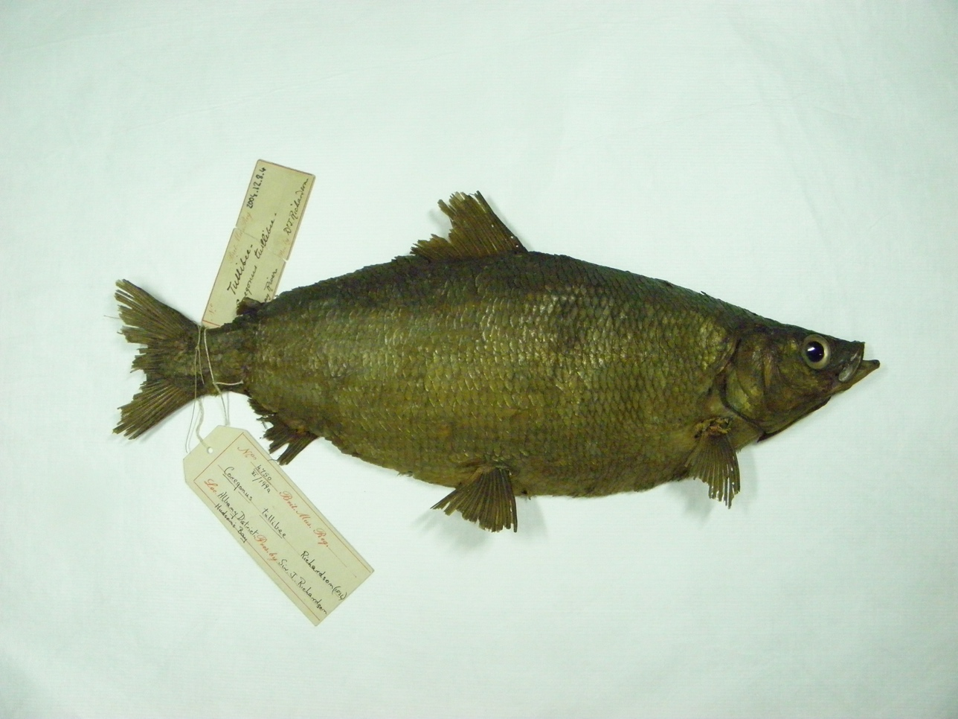
Fig. 5. Tullibee (Salmo (Coregonus) tullibee). Natural History Museum, BMNH 2004.12.8.4, © The Trustees of the Natural History Museum, London.

Richardson, the Cree, Fur Trappers, and a Tullibee

- Richardson received this stuffed fish from the Hudson’s Bay Company’s Albany District, in what is now Northern Ontario, in 1836. He formally described the specimen in the third volume of his Fauna Boreali-Americana, which appeared that same year. This was not, however, his first encounter with the species. In his description, he explained that he had examined tullibees at Cumberland House, in what is now Saskatchewan, some sixteen years earlier. “This fish,” he observed, “is very generally diffused through the waters of the fur countries,” and “the fishermen know it at once, but as I was [then] a novice in ichthyological pursuits. . . . I failed in detecting [its] discriminating external characters” (201). Richardson was referring here to his travels in North America between 1819 and 1822, when he was serving as the naturalist and surgeon to Franklin’s first polar expedition. That expedition, the so-called Coppermine expedition, holds a notorious place in the history of British attempts to chart the Northwest Passage. Taken at face value, Franklin’s orders were straightforward. He and his crew were principally tasked with charting “the Northern Coast of North America” from “the Mouth of the Coppermine River,” in northwestern Nunavut, “to the eastern extremity of th[e] Continent” (Franklin xi). In effect, their main objective was to survey the northern coastline of mainland Canada, extending the trail to the Arctic Ocean blazed some fifty years earlier by Samuel Hearne (1745–1792). Maps from the period illustrate by absence the terra incognita (or more properly, the litus incognitum) Franklin and his men were meant to chart (figs. 6 and 7). Completing their mission, however, proved impossible.

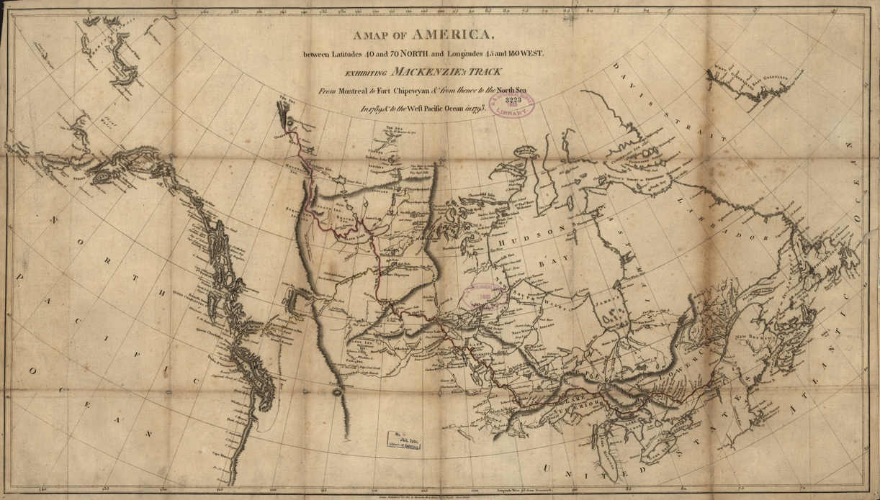
Fig. 6. Alexander Mackenzie, A Map of America, Between the Latitudes 40 and 70, and Longitudes 45 and 180 West, Exhibiting Mackenzie’s Track from Montreal to Fort Chipewyan and from thence to the North Sea in 1789, & to the West Pacific Ocean in 1793, 1801, 43 x 78 cm. Library of Congress Geography and Map Division Washington, DC, G3401.S12 1801.M2.

Fig. 7. Detail of Mackenzie’s Map of America, 1801, showing the mouth of the Coppermine River.

- It would require a greater philosopher and historian than the two of us to explain all the causes of this infamous expedition’s failure. Suffice it to say that a range of factors – including inexperience, ambition, improper provisioning, and poor luck – conspired to prevent Franklin and his crew from completing their survey. In the end, they only managed to reach Kiillinnguyaq (which Franklin dubbed Point Turnagain), some 675 miles east of the mouth of the Coppermine River. There, they were compelled to turn south over Nunavut’s Barren Grounds. Their retreat over the tundra proved treacherous. It was plagued by privation and eventually starvation. The party were forced to subside on famine foods, including rock tripe (lichen), rotten moose, and burnt leather. Some of the men resorted to murder and cannibalism. Richardson himself ended up shooting one of the expedition’s hired porters, a Mohawk voyageur named Michel Terohaute (d. 1821), whom Richardson accused of having murdered one of the expedition’s midshipmen, Robert Hood (1797–1821). In all, eleven of the twenty men who made up the expedition’s main party perished. Franklin, Richardson, and the other survivors were within hours of starving to death when they were rescued by members of the Yellowknives Nation on 7 November 1821.

- What we know of these events mostly depends on the official account of the expedition Franklin and Richardson prepared after returning to Britain. That book, A Narrative of a Journey to the Shores of the Polar Sea, was published by John Murray in 1823. It proved a commercial success, and it is generally credited with having rescued Franklin’s and Richardson’s reputations and established them as respected explorers and national heroes. In short, the book was a truly breathtaking act of imperial spin-doctoring. As Craciun observes, it transformed a terrible “Arctic debacle into a triumph in print” (82). It would be a mistake, however, to neglect the contributions the book made to the contemporary knowledge of North American natural history. Although they were by no means as extensive as his Fauna Boreali-Americana, the scientific papers Richardson appended to A Narrative of a Journey included detailed descriptions of two dozen species of fish and several hundred botanical specimens. Alongside these papers, Richardson also provided his own narrative of the trek over the Barren Grounds, including an account of the murders of Hood and Terohaute. That account went some way toward clearing Richardson’s name. Still, suspicion about the circumstances of the murders clung to him throughout his life, as did curiosity about whether he had knowingly resorted to cannibalism.

- Previous assessments of A Narrative of a Journey have revealed how Franklin’s and his fellow officers’ experience of the Arctic informed and was informed by the literature of the Romantic era. Annaliese Jacobs, for one, has provided a compelling assessment of the influence the Coppermine expedition had on the writings of Eleanor Porden, who married Franklin in 1823. Craciun, moreover, has convincingly documented the bibliographical and intertextual connections between A Narrative of a Journey and, among other works, Walter Scott’s Guy Mannering and, more especially, Mary Shelley’s Frankenstein. In a particularly shrewd piece of archival sleuth work, Craciun has brought to light a previously expurgated passage from one of Richardson’s letters. That passage, Craciun argues, suggests how Shelley’s and Scott’s fiction influenced his perception of the polar North. The passage in question appears in a letter Richardson wrote to George Back (1796–1878), the expedition’s other midshipman, on 9 June 1821. Therein, Richardson described an unnamed Indigenous woman making her way through the deep snow with a group of the expedition’s Yellowknives guides:

She came striding along supported by a stick which towered over the heads of all the others; a pair of red stockings and various other articles of her garb heightened the peculiarities of her figure; and as to her gait, it was similar to nothing I had ever before seen. Sometimes I was tempted to compare her to Hecate, sometimes to Meg Merrilies. Not that she had mind enough to be a sorceress, or majesty sufficient for a commanding presence, but because she appeared to be rather a creature of the imagination than a reality—I think however that she might have been more aptly considered a powerful fit companion for Frankenstein’s [monster] chef d’oeuvre, as she had this in common with that vision of Byshe Shelly [sic], that every member of her body seemed to have belonged to different individuals and to have been formed by a random association into a sort of semblance of the human form[.] (qtd. in Craciun 94)

- This passage offers a striking illustration of how Romantic-era literature influenced contemporary encounters with the Arctic. Such literature, in short, was part of the repertoire of cultural associations on which British explorers drew in their efforts to make sense of a seemingly alien environment. Richardson’s admission that the woman seemed more “a creature of the imagination than a reality” is telling in this latter respect. His description is jocular, even whimsical, and it reflects his and Back’s shared knowledge of contemporary fiction. The playful substitution of chef d’oeuvre for monster illustrates as much. The ostensible lightheartedness of Richardson’s account is, however, belied by the darker import of the implications of such allusions. As Craciun comments, this “projection of European fears and desires onto indigenous people is typical” of the “Eurocentric rhetorical violence” that enabled “the actual violence . . . such expeditions set into motion” (96).

- In developing this point, Craciun extends a line of interpretation that Ian MacLaren developed back in 1984. In a paper published that year, MacLaren contended that Richardson, Franklin, and their fellow officers were cognitively unprepared to deal with the landscapes they encountered in the Arctic: “If the British navy had prepared the explorers to survive physically,” he argued, “British ideas of nature had not prepared them to survive perceptually” (88). Their “dependence on the [aesthetics of the] sublime and the picturesque,” he concluded, “reflect[ed] a dangerous, if unconscious, blindness to nature which could only end in accidents.” As evidence for this assertion, MacLaren adduced passages from A Narrative of a Journey as well as the watercolours that the expedition’s two midshipmen made. His discussion of Back’s Preparing an Encampment on the Barren Grounds, Gathering Tripe de Roche, &c. (fig. 8) is indicative. Back began working on this picture on 16 September 1821, the day the party completed their journey over the Willingham Hills. As a composition, the painting adheres to the conventions of the picturesque and the sublime. The shading of the boulders and ravines provides a frame that helps to highlight both the figures at work in the foreground and their minuteness amid the enormity of the Arctic landscape. But this orderly composition contrasts the gritty reality of the experience Back’s picture portrays. The hills down which we see a scattered line of figures descending were, as MacLaren points out, ones “over which the men had hauled themselves on cut and bleeding feet that day” (87).

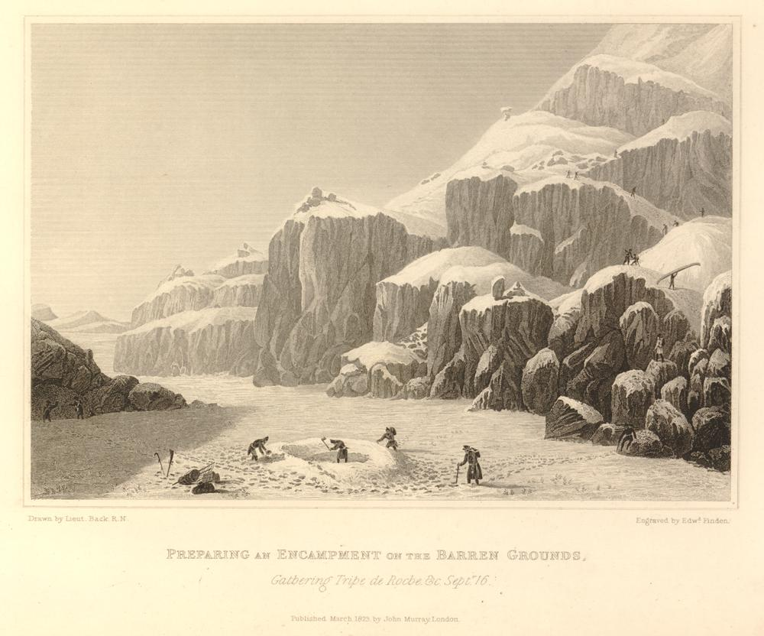
Fig. 8. George Back, Preparing an Encampment on the Barren Grounds, Gathering Tripe de Roche, &c., Septr. 16, engraved by Edward Finden, 1823. 412. British Library, G.7397. Public Domain Mark 1.0.

- Jacobs, Craciun, and MacLaren are not alone, of course. Other scholars have commented on how fictional and nonfictional accounts of polar journeys, both verbal and pictorial, influenced one another during the early nineteenth century. Penny Fielding’s consideration of Allan Cunningham’s tribute to Richardson in The Songs of Scotland (1825) stands out in this context, not least because of the parallel she draws with the main character of James Hogg’s novella The Surpassing Adventures of Allan Gordon (1837). As Fielding explains, Cunningham honoured Richardson not only as a fellow Dumfriesian, but also as an explorer who had boldly trodden around one of the last places of wonder left within an otherwise scientifically demystified world: “The Muse,” Cunningham claimed, “has [now] no nearer resting place where she may indulge her inventions than on some few acres of untrodden snow, near the North Pole, around which she may yet see the marks of the feet of my townsman, Richardson” (Cunningham, 1: 131). Such an appreciation of Richardson’s achievements, as Fielding contends, complements the adventures of “Hogg’s Aberdonian sea captain” insofar as both Scots are portrayed as voyagers into “an alien Arctic space” that resists the scientific epistemologies of the Enlightenment (Fielding 175, 184). This linking of Richardson and Hogg via Cunningham, connecting as it does the literary histories of the Arctic and the Scottish Borders, is noteworthy, as it accords with the content of another neglected passage from a letter Richardson wrote in 1821. That letter, which Richardson sent to his wife, mentions his brother’s recent meeting with Hogg and then proceeds to recall an amusing story about the latter’s visit to the Solway:

A letter from my brother Peter has informed me that the Ettrick Shepherd has become a connection of ours, but I have suspected something of the kind before—Blackwoods Magazine let me into the secret—The Poet’s exclamations from the top of Lauther heights [sic] of “the Lassie, the Lassie,” as he cast a lovers glance across the vale of Solway spoke volumes in this remote corner of the world. (Richardson, Letter)

- The article Richardson references here was written by Thomas Gillespie (1778–1844), and it appeared in Blackwood’s Edinburgh Magazine in February 1820, about eight months after Franklin’s expedition set sail. The issue reached Richardson at Fort Enterprise a year later. Fort Enterprise sits near Lac de Gras (or E’kati, “the fat lake,” in the Tlicho language), where the Coppermine River rises in what is now the Northwest Territories. Richardson was stationed there in the spring of 1821, and his casual recollection of Hogg’s exclamation on the Lowther Hills (a dually romantic and bathetic rendition of the cry of Xenophon’s Ten Thousand) makes for a curious episode in the history of Romantic-era periodical print. It is astounding to realize that copies of the Maga were making their way to the Arctic more than two hundred years ago. What matters here, though, is that this passage, in linking the hills overlooking the Solway with the outer reaches of the Arctic coastal plain, provides concrete evidence of a point Fielding and other scholars have made on more figurative grounds: namely, that what we might regard as “Romanticism” was an integral part of an infrastructure that spread outward from Britain’s coasts, connecting and constituting a global empire.

- For our part, though, we want to take advantage of the subject of this special issue to consider an equally important, though less widely acknowledged, influence on Richardson’s encounters with the coastal landscapes of the Arctic: the communities he encountered there. Our discussion of Richardson’s description of the unnamed Indigenous woman might suggest that his impressions of the First Nations peoples of Northern Canada were merely superficial. A consideration of his scientific writings, however, reveals a deeper interest in Indigenous ecologies. More so than some naturalists of his era, Richardson’s documentation of the flora and fauna of North America reflects a commitment to recording the names First Nations peoples used to describe the species that inhabited their environments. What is more, his classifications often include information about the importance of those species both for those peoples and for European colonial communities, including the fur trappers, who were present there. This returns us to Richardson’s tullibee.

- We mentioned that Richardson recalled having first seen this species during the Coppermine expedition. In the third volume of Fauna Boreali-Americana, he wrote that he had examined male specimens of the species at Cumberland House during the winter of 1819–1820. In the notes he had originally made that winter, he had recorded that the species bore a strong resemblance to the whitefish known to the Cree as the attihawmeg (or “caribou fish,” more conventionally spelled atikameg) and to the fur traders as the tittameg (tittymeg) or poisson blanc, which “abound[ed] in every river and lake in the country,” and was consequently a fixture of the regional diet. “At many posts,” he observed, “it is the sole article of diet for years together, without producing satiety” (Richardson, “Notices” 711). Unlike the atikameg, though, the fish he had examined at Cumberland House were smaller, leaner, and had a thinner stomach coating. Consequently, Richardson speculated that they might be conspecific with the Coregonus artedi (or “herring salmon”) that Charles Alexandre Lesueur (1778–1846) had classified in 1818. Lesueur’s classification paid homage to the Swedish naturalist Peter Artedi (1705–1735), and it included a detailed description of the species’s size and colour. He also noted its presence in the waters of Upper Canada and mentioned that it was considered a “very delicate food” (231). For all that, though, Lesueur did not make any reference to the names used locally to describe the species. Richardson’s description made up for this omission: “The Cree name of this fish,” he observed, is “ottonneebees,” and “has been corrupted by the traders into tullibee” (“Notices” 711). “It is,” he continued, “inferior to the attihhawmegh [sic] as an article of food; but in its habits and food it appears to correspond with that fish, notwithstanding the different structure of their stomachs.”

- It was only when Richardson obtained the specimen in figure 5 that further study convinced him that the tullibee was sufficiently different from Lesueur’s herring salmon to merit a separate classification, and in naming the species, he cited the Cree Nation and the European fur traders as his sources:

Salmo (Coregonus) Tullibee. (Richardson) The Tullibee.
Ottonneebees, Cree Indians. Tullibee. Fur Traders.
This fish is very generally diffused through the waters of the fur countries, but nowhere is it taken in such numbers as the Attihawmeg. The fishermen know it at once, but as I was a novice in ichthyological pursuits when the recent fish were before me, I failed in detecting discriminating external characters, and my prepared specimens having gone to decay, the deficiency cannot now be supplied. In the appendix to the narrative of Sir John Franklin’s First Journey, I referred the Tullibee doubtfully to the Coregonus Artedi of Le Sueur; but on reconsidering the description of that fish, it appears to be decidedly unlike the former in its pointed snout and round scales. The Tullibee differs from the Attihawmeg in having a much thinner stomach and a smaller number of cæca, yet its food and general habits are the same with those of that fish. It is much inferior as an article of food, being generally lean and watery, though it is wholesome and destitute of any disagreeable flavour. (Richardson, Fauna Boreali-Americana 201–02)

This entry preserves a record of the adaptation of Indigenous vocabularies by European colonists, and it is worth emphasizing just how different this entry is from Richardson’s rather more conceited description of the Pataecus fronto. Rather than decontextualizing the fish from its place of origin and assigning it a fanciful name, the name “tullibee” conveys a sense of why the fish was valued by the peoples of what is now northwestern Canada. Tullibee, as Richardson notes, is a European corruption of the Cree word otōnapiy, which just means “white,” and, like poisson blanc, reminds us that the fish was largely prized for its flesh (Okimasis 172, 186; Wolvengrey 360).

- This interest in recording native and European vocabularies for colonial species was by no means unprecedented. As Bewell has pointed out, eighteenth-century naturalists, such as Thomas Pennant, had also emphasized the importance of documenting “the indigenous languages and local knowledges by which local natures had previously been understood” (Natures 44). Interest in zoology and ethnography, in such cases, intersected, and this had the effect of making works such as Pennant’s Arctic Zoology (1784) repositories of more than just data about exotic fauna. Such works also consequently contained “a substantial amount of information about First Nations peoples’ attitudes toward and relationships with the natural world” (Bewell, Natures 46). In general, however, such information was lost with the passage of time, and Bewell has commented on this process too. As works such as Arctic Zoology “were incorporated into newer natural histories . . . the acknowledgement of the indigenous knowledge and the understanding of nature on which these studies were initially built disappeared.” This sort of erasure is certainly evident in the reception and integration of Richardson’s research. Although the entry for the tullibee in David Storer’s Synopsis of Fish in North America (1846) included Richardson’s notes about the origins of the species’s name, they were omitted in Albert Günther’s Catalogue of the Fishes in the British Museum (1866) and many of its successors.

- This process of knowledge loss illustrates a notable tension in the scientific pursuits of naturalists such as Richardson, especially when they were working in the field. On the one hand, their research was guided by totalizing systems of classification that aspired to establish a universal language for interpreting the natural world. On the other hand, their published work reflects a desire to reveal and document native and vernacular knowledge about colonial species and their environments. Possessing such knowledge often proved essential to the task of compiling authoritative accounts of the characteristics of those species. In many cases, however, that knowledge was deemed dispensable once those accounts had been produced, and the awareness of Indigenous and vernacular perceptions of colonial environments was consequently displaced. In commenting on this process in the context of colonial Canada, Bewell has drawn an apt comparison with the effects of cartography: “Just as indigenous place names on maps began to disappear, so did the indigenous names of most of Canada’s animals” (“Cartography” 46). Yet, in the case of Salmo tullibee, the erasure has left a faint trace of the Indigenous perception of the species. The fish is still known by the name tullibee, thanks in part to Richardson’s classification. Interestingly, it is also commonly known by another Indigenous name: cisco, from siscowet or siskawette, a corruption of the Ojibwe pemitewiskawet, meaning “fish with oily flesh” (“siscowet, n.”). These corruptions of Indigenous names may reflect the kind of cross-cultural collaboration Bewell has described. They are, after all, the results of acts of translation, but they are also part of the enduring legacy of the knowledge destruction that was caused by colonial cultural contact.

- Now that we have considered our second fish, it is time to turn toward a conclusion. We want to do so by making an admission. Richardson was mistaken. His Salmo tullibee specimen has since been reidentified as an example of Lesueur’s herring salmon (Coregonus artedi). Richardson was right in his original surmise that the two were conspecific. As we have just mentioned, though, Richardson’s proposed name has not disappeared. Salmo tullibee is now regarded as a junior synonym of Coregonus artedi, and that fact affirms the importance of Richardson’s classification in preserving awareness of a First Nations name that Lesueur had ignored. Today, the name tullibee calls our attention to the ways information about the world’s coastal environments was derived through the cooptation of Indigenous knowledge, which was then put into conversation with knowledge produced by settlers and colonial natural historians. In preserving a record of the contact between Indigenous and European peoples, the name reconfigures our sense of the nature of Scottish coastal encounters during the Romantic era. Like Pataecus fronto, the name Salmo tullibee reminds us that those encounters took place not just in Scotland, but within the wider world as well.

- This point returns us to where we began. The tale our two fish have helped us tell has been wide ranging. It has spanned the northern and southern hemispheres. It has revealed connections between the histories of the arts and sciences. It has emphasized how these connections were informed by the colonial and imperial contexts of the Hanoverian era. Our purpose in all this has been to enlarge the geographical and historical scope of this special issue. In keeping with principles introduced in previous studies of coastal history, we have sought to move the consideration of Scotland’s coastal Romanticisms beyond the space of Scotland’s national territory. In doing so, we have stressed the need to acknowledge the links between Scottish responses to coastal environments and the histories of exploration and empire, which framed and shaped the culture of the Romantic era. The tale we have told has been essayistic, both in its structure and style. Like any essay, it has been an attempt to trace a few patterns within a much wider constellation of relationships. There are other (stuffed) fish, including many that Richardson catalogued, whose stories remained to be explored. Their as-yet-untold tales are ones to which future studies might turn. Poems and paintings remain evergreen sources for such explorations, of course. But dead fish, as we have endeavoured to show, can be well worth thinking with too.

Acknowledgement of Support
We would like to thank The Ruskin – Museum and Research Centre and the Natural History Museum, London, for permission to reproduce images of items from their collections. We would, moreover, like to extend special thanks to Naomi Boneham, at the Scott Polar Research Institute, for her assistance with providing access to materials and assisting us with securing permission to reproduce transcriptions of Richardson’s letters. We are grateful to the owner of Richardson’s letters for granting this permission. Finally, we would like to thank the editors of this special issue and the participants in the Scotland’s Coastal Romanticisms workshop at the University of Edinburgh for feedback on earlier versions of this essay.

Works Cited
Albritton Jonsson, Fredrik. “Natural History.” Old Ways New Roads – Travels in Scotland 1720–1832, edited by John Bonehill, Anne Dulau Beveridge, and Nigel Leask, Birlinn, 2021, pp. 72–90.
Allen, Nicholas, et al., editors. Coastal Works: Cultures of the Atlantic Edge. Oxford UP, 2017.
Anderson, Benedict. Imagined Communities: Reflections on the Origin and Spread of Nationalism. Rev. ed., Verso, 2006.
Baker, Samuel. Written on the Water: British Romanticism and the Maritime Empire of Culture. U of Virginia P, 2010.
Bewell, Alan. “Cartography and Natural History in Late-Eighteenth-Century Canada.” Romantic Cartographies: Mapping, Literature, Culture, 1789–1832, edited by Sally Bushell et al., Cambridge UP, 2020, pp. 27–49.
———. Natures in Translation: Romanticism and Colonial Natural History. Johns Hopkins UP, 2017.
Cavell, Janice. Tracing the Connected Narrative: Arctic Exploration in British Print Culture, 1818–1860. U of Toronto P, 2008.
Cook, E. T., and Alexander Wedderburn. “Introduction.” The Library Edition of the Works of John Ruskin, edited by E. T. Cook and Alexander Wedderburn, vol. 22, George Allen, 1906, pp. xvii–xliv.
Craciun, Adriana. Writing Arctic Disaster: Authorship and Exploration. Cambridge UP, 2016.
Cunningham, Allan, The Songs of Scotland, Ancient and Modern. John Taylor, 1825. 4 Vols.
Dasen, Veronique. Dwarfs in Ancient Egypt and Greece. Oxford UP, 2013.
Fielding, Penny. Scotland and the Fictions of Geography: North Britain 1760–1830. Cambridge UP, 2008.
Franklin, John. Narrative of a Journey to the Shores of the Polar Sea, in the Years 1819, 20, 21, and 22. John Murray, 1823.
Gange, David. The Frayed Atlantic Edge: A Historian’s Journey from Shetland to the Channel. William Collins, 2019.
Gillis, John R. “Filling the Blue Hole in Environmental History.” The Future of Environmental History: Needs and Opportunities, special issue of Rachel Carlson Center Perspectives, edited by Kimberly Coulter and Christof Mauch, no. 3, 2011, pp. 16–18.
———. The Human Shore: Seacoasts in History. Chicago UP, 2012.
Gillis, John R., and Franziska Torma, “Introduction.” Fluid Frontiers: New Currents in Marine Environmental History, edited by John R. Gillis and Franziska Torma, White Horse Press, 2015, pp. 1–12.
Herodotus. Historiae, I: Libros I–IV Continens. Edited by Haiim B. Rosén, Teubner, 1987.
Houston, C. Stuart. Arctic Ordeal the Journal of John Richardson, Surgeon-Naturalist with Franklin, 1820–1822. McGill-Queen’s UP, 1984.
Jacobs, Annaliese. Arctic Circles: The Franklin Family, Networks of Knowledge, and Early Nineteenth-Century Arctic Exploration, 1818–1859. 2015. U of Illinois, PhD dissertation.
Land, Isaac. “Tidal Waves: The New Coastal History.” Journal of Social History, vol. 40, no. 3, 2007, pp. 231–43.
Latour, Bruno. Science in Action: How to Follow Scientists and Engineers Through Society. Harvard UP, 1987.
Lesueur, Charles Alexandre. “Descriptions of Several New Species of North American Fishes.” Journal of the Academy of Natural Sciences of Philadelphia, vol. 1, no. 2, 1818, pp. 222–35.
Lévi-Strauss, Claude. Totemism. Translated by Rodney Needham, Beacon Press, 1963.
Lopez, Barry. Arctic Dreams: Imagination and Desire in a Northern Landscape. Charles Scribner and Sons, 1986.
Ly-Tio-Fane, Madeleine. Pierre Sonnerat, 1748–1814: An Account of His Life and Work. Imprimerie & Papeterie Commerciale, 1976.
MacKenzie, John M. “Scots and the Environment of Empire.” Scotland and the British Empire, edited by John M. MacKenzie and T. M. Devine, Oxford UP, 2017, pp. 147–75.
McCorristine, Shane. The Spectral Arctic: A History of Dreams and Ghosts in Polar Exploration. UCL Press, 2018.
McIlraith, John. The Life of Sir John Richardson. Longmans, Green, & Co., 1868.
MacLaren, Ian. “Retaining Captaincy of the Soul: Response to Nature in the First Franklin Expedition.” Essays on Canadian Writing, no. 28, 1984, pp. 57–92.
Okimasis, Jean L. Cree, Language of the Plains. U of Regina P, 2004.
Regard, Frédéric, editor. Arctic Exploration in the Nineteenth Century: Discovering the Northwest Passage. Pickering & Chatto, 2013.
Richard, Jessica. “‘A Paradise of My Own Creation’: Frankenstein and the Improbable Romance of Polar Exploration.” Nineteenth-Century Contexts, vol. 25, no. 4, 2003, pp. 295–314.
Richardson, John. Fauna Boreali-Americana, or, The Zoology of the Northern Parts of British America. vol. 3, 1836.
———. “Generic Characters of an Undescribed Australian Fish.” The Annals and Magazine of Natural History, vol. 14, no. 91, 1844, p. 280.
———. Ichthyology of the Voyage of the H.M.S. Erebus & Terror. Edward Newman, 1844–1848.
———. Letter to Mary Richardson, 29 March 1821. Richardson–Voss Collection, Scott Polar Research Institute, MS 1503/4/1.
———. “Notices of the Fishes.” Narrative of a Journey to the Shores of the Polar Sea, in the Years 1819, 20, 21, and 22, John Murray, 1823, pp. 705–28.
Ross, James Clark. Letter to John Richardson, 8 March 1844. Richardson–Voss Collection, Scott Polar Research Institute, MS 1503/27/2.
Ruskin, John. MS 16. The Ruskin – Museum and Research Centre, Lancaster University.
“siscowet, n.” Oxford English Dictionary, www.oed.com. Accessed 24 July 2022.
Stead, David. Fishes of Australia: A Popular and Systematic Guide to the Study of the Wealth within our Waters. William Brooks, 1906.
Watson, Robert M. F. Closeburn (Dumfriesshire): Reminiscent, Historic and Traditional. Inglis Ker, 1901.
Wigen, Kären. “Introduction.” Seascapes: Maritime Histories, Littoral Cultures, and Transoceanic Exchanges, edited by Jerry Bentley et al., Hawaiʻi UP, 2007, pp. 1–18.
Wildman, Stephen. Life Distilled: Ruskin and Still Life. Lancaster UP, 2016.
Wolvengrey, Arok. nēhiýawēwin: itwēwina/Cree: Words. U of Regina P, 2001.
Worthington, David, editor. The New Coastal History: Cultural and Environmental Perspectives from Scotland and Beyond. Palgrave Macmillan, 2017.

Notes This point was underscored by Land Gillis (Human Shore). It has since been echoed and developed by various writers and academics across the arts, humanities, and social sciences. See Worthington and Allen et al.
Stephen Wildman has suggested that the fish might have reminded Ruskin of “the peculiar large-headed fish” in the foreground of J. M. W. Turner’s The Slave Ship. Ruskin had owned Turner’s painting and studied it extensively (21). So, this conjecture may be on the mark. In any case, ichthyology was clearly on Ruskin’s mind in 1870. The following year he proposed delivering a series of lectures on fish at Oxford University (Cook and Wedderburn xxv–xxvi).
This link with the Lake District is interesting, not least because it stems from another of Richardson’s connections with British Romanticism. His third wife, Mary (née Fletcher; 1802–1880), was the daughter of the Wordsworths’ friend Elizabeth Fletcher (1770–1858). Elizabeth purchased Lancrigg, near Grasmere, in 1840, and that is where Richardson and Mary lived out their days. In the context of this special issue, moreover, it seems worth noting that the Lake District is partly coastal itself. For a consideration of how the influence of this aspect of the Lake District’s geography on Romantic literature, see Baker.
For recent perspectives on the expedition, see McCorristine, Regard, and Cavell. See also Houston.
As Craciun notes of the erroneous reference to “Bysshe Shelley”: “When Richardson departed for the Arctic in 1819, the anonymously published Frankenstein was still assumed to be the work of the atheist Percy Shelley” (94). The connections between polar narratives and Shelley’s novel have also been considered by Richard
Hogg and Peter Richardson (1789–1831) likely met through their mutual friend James Gray (1770–1830), who served as Rector of Dumfries Grammar School during the 1790s. Gray’s wife, Mary (née Phillips) (1773–1806), was the elder sister of Hogg’s wife, Margaret (1789–1870), who is generally assumed to be “the Lassie” Hogg had in mind. See Watson (233). Like the Richardsons, the Phillips family hailed from Dumfriesshire.
I am indebted to Gerard McKeever for identifying Gillespie as the author of this article.

