Step Into My Mind Palace: Exploration of a Collaborative Paragogy Tool in VR

Abstract—Virtual Reality (VR) can mediate remote collaborative learning and can support pedagogical processes like paragogy. Within education, methods such as spaced repetition and memory palaces exist to support the cognitive process of remembering. We identify an opportunity to enhance learner-led collaborative paragogy involving these methods through immersive VR experiences. We present CloVR, a VR-mediated collaboration-based system that supports the memory palace and spaced repetition techniques. As an exploratory study, we aim to identify the applicability, viability and user perception for such a system combining these two techniques in VR. CloVR is a novel implementation which provides a location-driven metaphor to populate and present multiple resources related to a topic for peer-led exploration. We discuss the design and provide a prototype implementation of CloVR. We conducted two studies, a targeted expert user review and a broader proof of concept survey. The results of the studies show interesting outcomes, with the system described as 'engaging', 'useful' and 'fun'. Our findings provide insights to the potential of using Virtual Reality Learning Environments (VRLE) geared towards collaborative learner-led activities.
Index terms—Virtual Reality, Education, Method of Loci, Memory Palace, Spaced Repetition

Introduction
Technology-mediated pedagogy is an actively growing area. The COVID-19 pandemic has put the role of technology at the forefront of education and policy-makers have realized the need for seamlessly integrating technological systems to organically transform education [1]. Efficient communication and access to information at a pace determined by the learner are two roles of technology that facilitates a learner-centric pedagogical model [2]. The pandemic has disrupted education and fast-tracked the adoption of remote learning. Learning management systems deployed by schools and universities facilitate asynchronous learning, allowing learners to access information at their convenience. However, the increased reliance on these systems during remote teaching has unexpected implications, like reduced peer interaction. From a pedagogical perspective, this face-to-face interaction is central to learning [3] and needs to be facilitated beyond chats and forums as they have a low uptake [4]. For equitable access, educators need to provide the students with a system designed specifically for the purpose of peer-learning.
Virtual reality (VR) devices can play a pivotal role in transforming teaching and learning through immersion, telepresence and novelty [5]. VR has been explored for collaborative [6] and online pedagogy [7]. However, designers of VR-based solutions need to design solutions that are equal in opportunity of access. They should not aggravate the widening gap in skills between lower-income students and their higher-income counterparts.
In this paper, we present CloVR – a collaborative learning environment in Virtual Reality. The aim of CloVR is to facilitate collaborative paragogy mediated through VR. CloVR provides an adaptive set of tools for students to customize their learning experience to suit their educational needs. CloVR focuses on self-directed student learning experiences and collaboration between peers, alleviating concerns of reduced face-to-face interaction. We discuss the design of CloVR which implements two learning techniques (mind-palace and spaced repetition) which are augmented with VR-based peer-learning features. We analyse the usage of the system through two studies to understand the perception of the end-users towards the application.

Related Work and Background

Collaborative Learning and Paragogy
Paragogy describes peer-to-peer learning where students provide a supportive structure for each other to learn and grow [8]. It is a heutagogical method of learning that builds on the idea that the learner is the initiator and main agent of acquiring knowledge [9]. This places paragogy in an ideal position when considering remote and independent learning activities. Researchers have explored paragogy through tutor-led activities, Learning Management Systems (LMS) [10] and mediated through VR [6]. In such systems, the tutor establishes the thematic organization of learning content and identifies the activities which require students to engage in paragogy. Collaboration has been studied extensively for its benefits of improving cognitive abilities, skill attainment and the transfer of knowledge to peers in education [11]. Plass et al. [12] demonstrated that collaborative learning games promote situational interest and a desire to repeat learning exercises. Collaboration in peer learning enables peer feedback in absence of teacher participation [13] and enhances students’ exposure to unexplored strategies, solutions and points of view [14]. There is evidence to suggest that technology which mediates connections between peers [15], through collaborative virtual learning environments, allows students to connect and share information in ways that are not possible in real life [16].
Experience with LMS suggests that the structuring of learning content and activities is driven by the tutor or institution, with student-focused elements such as interaction and discussion being under utilsed [17]. Unlike students, they are well equipped to create scaffolding based on pedagogical principles. However, paragogy can manifest beyond peers simply contributing to an overall product (e.g., a presentation or other educational artifact). Paragogical activities, which occur outside of the planned learning, occur during periods of self-study. While the learners may be highly motivated, they lack the tools and understanding to suitably scaffold their learning activity within a self-study (or group-based study) session. The positioning of CloVR is within this gap where paragogy occurs outside of activities planned by the tutor, and instead is a student-initiated activity which builds towards another activity (e.g., study preparations for exams). Such a tool can scaffold the learning activity through well-understood pedagogical approaches leaving the learner unencumbered to focus on the actual learning.

Learning Activities
Blooms taxonomy [18] describes six key elements of learning: remembering, understanding, applying, analysing, evaluating and creating. Each scaffolds the next and enables deeper learning within the cognitive domain. A student must attain proficiency in the lower order before advancing to the next. Memory palaces and spaced repetition are two well-studied examples of learning activities that students use for remembering. These two activities complement one another and can be included in the review and reflect element crucial to contemporary active learning [19].

Mind Palaces
The concept of a mind palace is a technique for memory recall [20]. Literature uses the terms “mind palace” and “memory palace” interchangeably. In this paper, we use another common term, “method of loci”, to include both ‘mind-palace’ and ‘memory palace’. It is a spatial mnemonic technique where information is associated with various aspects of an imagined environment. The environment can be hosted by immersive technologies as a 3D environment [21]. Memory palaces in VR enhance productivity through superior memory recall [22]. Pedagogical efficacy differs based on the visual implementation and immersion. Memory palaces in VR show performance is increased versus traditional desktop alternatives [21]. Reggente et al. [23] showed spatially mediated spaces are effective in supporting memory palace techniques. This motivates our choice of selecting the memory palace technique for integration into CloVR’s active learning space to assist the cognitive processes of students. The mind-palace technique follows a set of steps. The first places the user in a familiar environment, e.g., the user’s home. Next the user recollects and visualizes a piece of information that needs to be remembered. The user then “places” the visualized form of the information within their environment. This is repeated for each piece of information to be stored and each is positioned at a different location. To retrieve the information, the user retraces their path, observing and interacting with the pieces of information in their locations.
This conceptualization of the mind-palace experience is grounded in enactive thinking [24] and provides the basis for our interpretation that a memory palace consists of a location, visualizations, and a journey. The location sets the context of the virtual journey and the visualizations are pieces of information the participant wants to remember or recall. The journey is a way of serializing this information, aiding its mnemonic recall. The journey is created and controlled by the user while technology mediates the location and visualization aspects. Studies suggest the memory palace approach should utilize familiar environments [25], [26], but evidence to the contrary [27] suggests it is recognizability instead of familiarity that matters. CloVR grounds the use of virtual mind-palaces as a learning tool and furthers the exploration in creating shared experiences. Such experiences set in a common mind-palace, involving shared conversations around visualizations are underexplored in a paragogical context.

Spaced Repetition
Spaced repetition is a repetitive technique used to train the brain to retain knowledge for long term memory [28]. Using spaced repetition, e.g. flashcards, in active learning strategies strengthens the “review and reflect” elements of active learning. This heuristic technique strengthens long term memory and reduces memory decay [29]. It also increases efficacy of learning compared to mass learning [30] and boosts learner confidence [31]. The focus of research in spaced repetition is the identification of timing protocols and algorithms to identify the optimal times [32] when repetition is to be carried out.
Technology is ideally placed to mediate the use of spaced repetition without manual actions from a teacher/lecturer. Spaced repetition is beneficial under collaborative conditions [33]. Spaced repetition follows a set of steps. The first is the identification of the content in need of repetition. In its simplest form, the content can take the form of single words or word-pairs. This can be expanded to cover relevant details associated with the initial content. The expansion of details can continue until the whole topic is covered. The second is to aggregate the content into groups with common elements, like complexity or relevance. At each repetition iteration, the cards can be reorganized based on difficulty or errors in recalled content using an algorithm [34]. As a system, the key components are widgets representing the information to be repeated, a storage or organization system and the interactive actions to reorganize the widgets as required.

Virtual Reality in Education
Technology-enhanced education focuses on scaffolding student’s engagement in the subject through attention and immersion [35], [36]. VR enhances attention [37], increases motivation [38] and inspires self-directed discovery [39] through different interactive applications like virtual proxies of learning locations [40] and learning tools [41]. For a practical approach to pedagogy in VR, media and resources play an important part in the learning process of the users. Considerations need to be made when designing interactive elements catered for the practice of teaching. This includes deploying reusable elements in teaching and passing on material for other didactic purposes [42].
A key strength of VR assisted learning experiences is the detailed visualization of objects [5], [43]. Visualization creates variety of stimulation which in turn increases memorability of experiences [44]. Systems like iScape [45] visualize the semantic relationship within learning content. In VR, text can be replaced or augmented by videos or 3D objects that learners can watch, hear and interact with. Visualization, audio and interactivity lends itself well to the different learning styles described within the VARK learning styles model [46]. Suitable design ensures learners have a multi-modal approach to learning styles. CloVR derives further guidance on presentation style of learning artefacts from the associated learning paradigm defined by Kolb [47] which classifies learning styles within a two-dimensional learning space, delineated by ‘Abstract Conceptualization - Concrete Experience’ and ‘Active Experimentation - Reflective Observation’.

Design
The design of CloVR is grounded in concepts that are well-understood from a pedagogical perspective. It is also informed by personal learning experiences such as participation in self-directed group study activities. The pandemic-driven change to learning processes, especially isolation and social distancing of learners motivated us to design a system which could bring users together in the same environment in which they can learn by sharing resources and interacting as if they did not have the limitations of an online learning platform.

Choice of VR over AR
During design discussions, the alternative of augmented reality (AR) was also considered. AR and VR are considered closely related technologies on Milgram’s continuum [48] and the pedagogical advantages of either technologies are comparable. Initially, the idea of an AR mind-palace was extremely attractive where the learner could transform their own room into a mind-palace. However, from an equality of access perspective, we want CloVR to be accessible from a wide range of devices including laptops, desktop PCs and mobile devices and not constrained to specialized or expensive hardware. AR could also lead to information clutter, privacy concerns and overt technological focus on registering and mapping the room’s easily mutable arrangement to learning content. However, Legge et al. [27] suggest that the mind-palace doesn’t need to be a familiar place. In a collaborative context, the mind-palace can be anything which is common to the learner group and established in a neutral setting. This further strengthened our decision to choose VR as our enabling technology which could be deployed as both desktop and immersive VR.

Learning Resources vs Interactive Objects
The main objective of CloVR is to present learning resources in a collaborative environment. These learning objects (eLRs) are derived from existing material which can be text-based resources (cards, text snippets, annotations, notes), image-based (diagrams, sketches, scans), audio/video resources and finally interactive 3D models. These eLRs are commonly curated within an LMS which typically contains a multitude of individual tools, which could include CloVR. For CloVR, the upload and curation of the eLRs is managed by the learner instead of the tutor. The learner is free to organize the eLRs in a manner that suits them best for future access and consumption within the CloVR environment. The CloVR environment is also populated with artefacts unrelated (in a pedagogical context) to the content but helps facilitate the creation and interaction with the mind-palace. Artefacts tagged with eLRs are intentionally animated to distinguish them from non-interactive artefacts of the mind-palace. CloVR allows users to use predefined artefacts or populate their own objects which are either more familiar with the user or stand out in the environment. Customization of the artefact tagged with eLRs is desirable to increase memorability but not central to the experience.

Virtual Mind Palace
VR to create a virtualized representation of a mind palace has been explored before. For single-user virtual mind palaces Yang et al [49] studied retrieving knowledge from scholarly articles using a virtual mind palace. Vindenes et al.’s [50] showed that desktop VR has comparable (if not slightly better) performance than immersive VR, in contrast to findings of Krokos et al. [22]. A key difference between CloVR and these prior examples is the use of the virtual memory palace in a paragogical context. The learner can invite a peer and CloVR mediates the conversation and interaction with the peer.

Virtual mind palace workflow
A virtual memory palace needs to support a location, a visualization, and a journey. The location can be a popular real-world site or based on a visually memorable rendering of a locale. The learner can select a spot or artefact within the environment for depositing one or more related eLRs. The learner is reminded of the tagged artefacts through animation which sets the artefact apart from other untagged artefacts. When the learner wishes to access the eLR, the system populates the eLR content into the environment. For example, annotations, text, images or videos can appear as floating planes, while 3D models appear within the environment. The journey is defined as a series of navigation steps within the environment, retracing a path undertaken by the learner to step through different pieces of information in a serialized order. When engaging in peer-based collaborative recall, the learners can decide to take alternative paths based on the retrieval and recall of the subject as a group.

Interactivity and Communication
The learner or their peer(s) interact with tagged artefacts located across the virtual environment. Navigation and its control should not compete for the attention of the users and should only facilitate movement between artefacts. This can be achieved through teleportation and guided rails that minimize the cognitive load of providing precision input to perform locomotion within the mind palace. Additional interactions are needed to trigger tagged artefacts and control the play-through of the visualized eLRs. Similar inputs are required to ‘store’ or deactivate a visualized eLR once the learner is done with the resource. Since the system expects one or more concurrent users, there needs to be two-way audio communication between the learners. Any modification or results of interaction within the environment is visible to all learners within the viewing area..

Spaced Repetition within 3D space and time
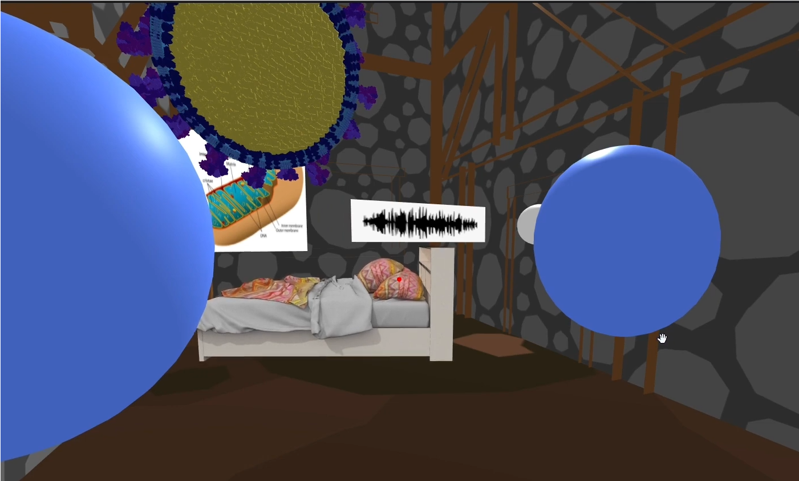
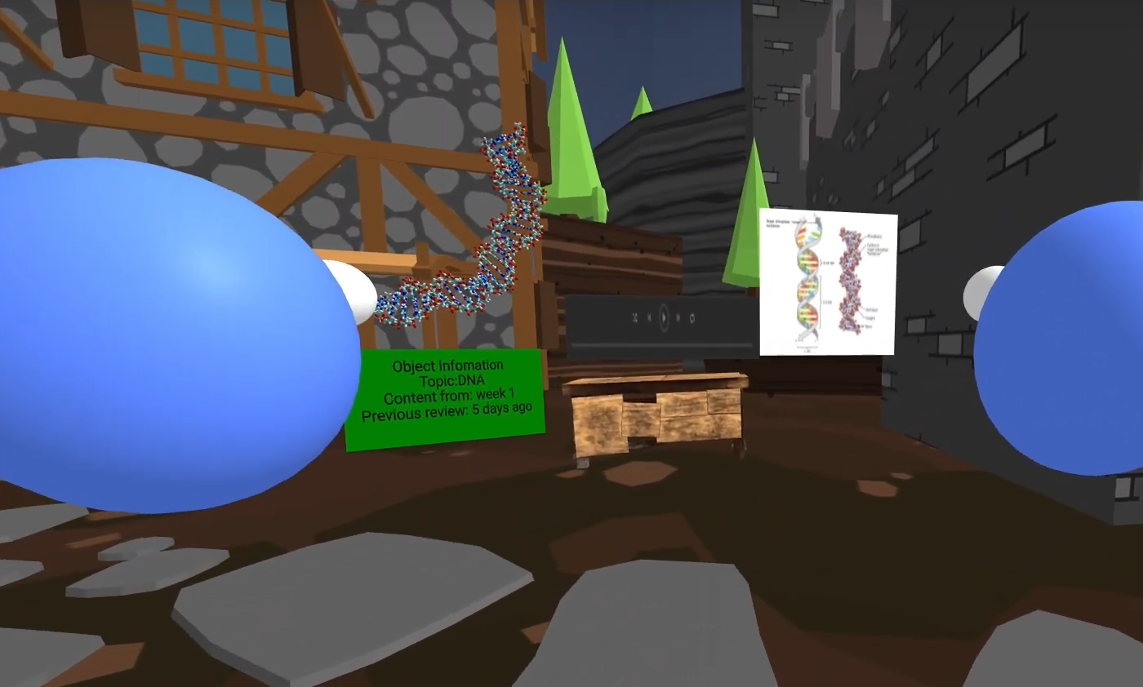
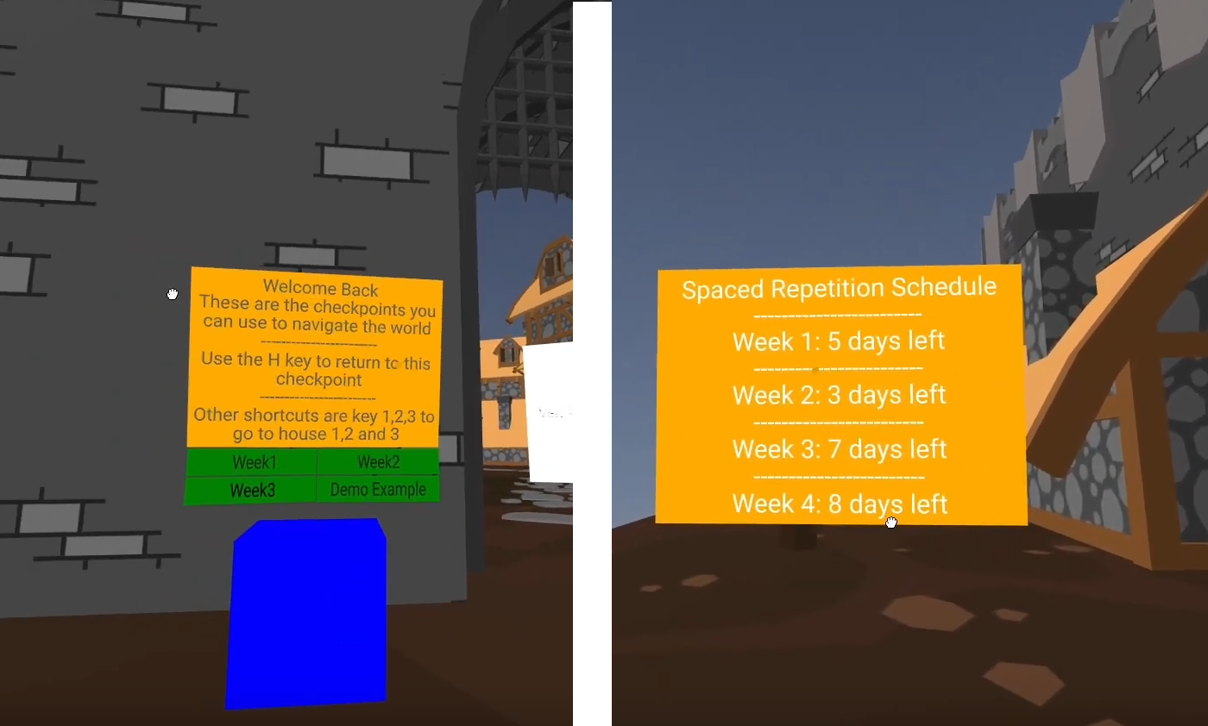
The mind palace offers an interesting approach to the implementation of spaced repetition. First the learner can organize eLRs with each representing a point in time. This concept emerged from the discussion that a single lecture usually covers aspects of single topic. To revise such a topic, all related content is hosted within the same “room” within a mind-palace. CloVR then keeps track of the actual content which has been repeated and provides cues to access more difficult or less repeated content. As the learner completes spaced repetition sessions, more frequently accessed content floats towards the ceiling while more difficult content stays firmly positioned over the floor. Two predefined rooms are provided – a bedroom and a sparse warehouse in which the eLRs are grouped into appropriate cubes or boxes. The metaphor of the cubes is associated with the lecture event during which the stored eLRs were covered. The ‘age since last access’ or associated difficulty in recall of the eLRs is conveyed through color-based cues displayed on the cube walls. To improve the individual outcomes for learners, the system needs to customize the indications differently for group-learning sessions than for individual sessions. In either implementation, an algorithm like Leitner’s [34] can help keep track of the repetition schedule.

Implementation
We developed a prototype to showcase the capabilities of CloVR. As we were also concerned with the equality in opportunity of access, we needed a platform-independent solution capable of running on a wide range of devices and without high-end requirements. We chose WebXR and A-Frame to develop our prototype.

Interactivity and Workflow
A-Frame provides off-the-shelf implementations for various common input modalities (e.g., touch, mouse and gaze). It supports specialized inputs through plugin components (e.g., Quest controllers). To support low-end cardboard-style VR headsets, we enabled dwell-based gaze-interaction techniques. The gaze-input allowed learners to trigger open/close and start/stop functions of associated eLRs. Since CloVR is expected to host content of entire modules (i.e., courses), we enabled navigation waypoints (Fig. 1 bottom-right) as a metaphor for menu-based selection of topics and particular day/week. Tagged artefacts were presented as interactive objects with animation cues (Fig. 1 top left, top right) This allows the user to differentiate between interactive and non-interactive objects.

Single Learner Experience
As a mind-palace, CloVR can be used by a single learner any time. A learner can customize or select the environment (location) and tag eLRs to artefacts (visualization). A learner populates the eLRs at their own pace, creating their own personal journey through the mind-palace. The learner decides their own journey through the location, depositing the eLRs in a way that suits them best. This contrasts with existing LMS which follow a standardized structure of displaying the eLRs for all learners and even across entire degree programs. CloVR does not host the actual eLRs, rather only providing linked placeholders. The eLRs are provided online [51], integrated within an existing LMS. For the sake of prototyping, the integration with an existing LMS was replaced with static hosted links. The spaced repetition schedule helps users keep track of how often the users need to come back to the topics for them to register this knowledge into their long-term memory. In its single-learner form, CloVR is comparable to previous mind-palace implementations.

Peer Learning Experience
CloVR facilitates peer-learning activities as its key feature. The experience begins with a pre-populated virtual mind-palace curated and organized by one of the learners. The learner invites a peer (i.e., ‘step into my mind-palace’) into CloVR’s specific instance of that learner’s mind-palace. The environment becomes a synchronized shared environment accessed through the web. The learners are represented as low-fidelity anthropomorphic avatars (Fig. 1 top left, top right). The avatar fidelity is prototyping pragmatism and future versions can trivially support high-fidelity avatars. The “host” learner can interact with one or more peers. We assume a maximum of five peers, i.e., the nominal size of a private study group. The “host” learner takes the peers through the host’s own journey within the mind-palace, interacting with the artefacts associated with the topic of discussion. The collocation within the virtual mind-palace enables the learners to discuss shared topics with a better sense of context and utilizing the full range of eLRs including 3D models, voice recordings and images. As a future feature, we envision that the invited peers can either duplicate the host journey or record their own to carry back to their own instances of CloVR’s mind-palace. With the current prototype, the invited peers would have to manually create their own journey once they return to their own virtual mind-palace.

Evaluation
The motivating factor behind the creation of CloVR is also the reason why controlled in-lab studies could not be carried out. Due to COVID-19 lock-down restrictions, we opted for a mixed model of analysis. We conducted an expert user review [52] and an online survey adapted from a standard UES (User Experience Survey) [53] to obtain feedback on the user experience and perception of using CloVR. The studies were conducted following the standard ethics approval process from Lancaster University FST Research Ethics Committee. Both studies started with a consent form and all responses were anonymized.

Expert User Review
We see CloVR as a system utilized in conjunction with LMS of higher education institutions (HEs). The end-users are HE students, engaging in learning activities, and as such have extensive experience with group study activities. We use these ‘domain experts’ as subjects for our study similar to previous studies [52].

Participants
The purpose of the expert user review was to assess the suitability of CloVR for our target audience of higher education students. The expert ‘reviewer’, and therefore the target population for the survey, were individuals over the age of 18, currently engaged in higher education. Participants were asked to confirm their age and self-certify their educational status. We recruited seven participants for this part of the study. Six participants were aged 18 − 24 (the seventh participant being 25 − 34). Participants were recruited online.

Procedure
Participants were accompanied virtually by an experimenter within CloVR. This allowed us to replicate the experience of collaboration. To reduce experimenter bias, the experimenter followed the same pre-set structure of interactions for each iteration. Participants were asked to complete CloVR’s tutorial to familiarize themselves with the system. After, participants were asked to interact in the CloVR world. Finally, the participant was asked reflective questions about the system. If the participant was using headset/binocular VR for exploring the CloVR environment at any point during the survey then they were required to fill in a motion sickness questionnaire [54]. Due to the variable time taken for the participant to interact with CloVR, each review took a minimum of 25 minutes.

Results and Analysis
The expert user review contained demographic questions to determine age, their experience with VR, memory palaces and spaced repetition. All participants responded that ‘Most’ or ‘All’ of their current studies are carried out online and five out of seven stating they were ‘Somewhat satisfied’ with their current online learning experience. One participant answered ‘All’ to ‘Before the pandemic, how much of your studies were carried out remotely/online’. Four out of seven the participants had used VR before. When the participants were asked to provide feedback on the experience, the overall sense was that the program was user-friendly. ‘I was able to navigate my way through easily’ and ‘the instructions were clear so I was able to move around even though I had never done anything like this before’.
Six out of the seven participants responded they would be interested (to different extents) in the final product. Some of the ideas on how they would use CloVR were: ‘Customizable and interactive revision materials’, ‘Having all revision materials in one place (including other’s resources)’ This suggests that for most participants, CloVR could be a program that they could use in future revision. One participant mentioned that they were ‘not sure what type of a problem [they] could solve with it’.
Finally, we asked the participants to rank the system features in order of importance/relevance to their studies (1 being most important, 7 being least important). The features in question were virtual memory palace, spaced repetition revision prompts, customizability of the virtual space, replaying time spent in the space, synced viewing, hosting other users in your environment and full immersion. Virtual Memory Palace ranked the highest and no feature ranked 5 or below. The results are tabulated in Table 1.

Proof of Concept Survey
Due to lockdown restrictions and difficulty in scheduling participants who had to be paired with an experimenter, the second study was planned as an online-only survey. The interactive demo and exploration of CloVR was replaced with a video that demonstrated the proof of concept and visualized all the elements mentioned in the survey.

Participants
The target population for the survey was individuals over the age of 18 currently engaged in higher education. Our distribution methods followed a convenience sampling method in which a link to a Qualtrics survey was shared on social media. Although convenience sampling does not allow for our results to be generalized to a wider population, we were able to utilize snowball sample distribution to recruit those further detached from the initial convenience sample.
Of the 33 individuals that begun our survey 26 were in our target population and these 26 participants completed the survey in full. The age-distribution of the participants was: 18 – 24: 68%, 25 – 34: 9%. One participant was between the ages of 45 and 54. All but one of the participants were students in a higher education setting, with one participant identifying as a teacher.
When asked about their current studies, all the participants identified that ‘some’ ‘most’ or ‘all’ of their studies were currently online with one participant having more than ‘some’ face to face learning. Sixty five percent of our sample were satisfied to some extent with their current online learning. Prior to the pandemic, two participants in this survey carried out their learning entirely online with no face-to-face element, suggesting that they may be participating in an education designed for the purpose of remote/distance learning. This provides another perspective to the remaining participants who have been more displaced by the pandemic, with fifty percent of the sample revealing that ‘none’ of their previous learning took place online.

Procedure and Questionnaire
The questionnaire followed a similar structure to that of the expert review but with the removal of the interaction sections and the motion sickness questionnaire. The participants saw a short video that demonstrated interaction within CloVR and included a voiceover description of what was happening at each point in the video. To prevent click-through participation, the starting survey questions required the participants to enter a code which was only displayed in the video.

Results
Although all participants responded that they engage in collaboration for studying/revision, ‘Hosting others in the environment’ was ranked, on average, only the 5th most important feature of the revision space. This could be caused by two main factors: the demonstration video serving as an ineffective placeholder to physical interaction with a product and therefore misrepresenting collaboration in the space. Alternatively, CloVR’s collaboration features need more refinement to allow users to collaborate in a way that is important to them.
When asked ‘does this end product sound like something you would be interested in using’, sixty nine percent responded positively, nineteen percent were undecided and twelve percent chose ‘probably not’. No participants chose the option ‘definitely not’.

Discussion

Implications
For the users’ opinion about the system, the open-ended responses included positive comments. These were centred on CloVR being ‘engaging’, ‘useful’ and ‘fun’. Users could visualize the potential in having all their revision materials in the same place. One participant, who identified themselves as a trainee teacher, described potential future applications in the software, ‘This could also be quite a valuable interactive learning tool for school children […] For instance, you could recreate the Titanic as a Virtual Memory Palace and assign information bubbles to specific objects, e.g. lifeboats, boilers, hull/stern/bow, etc.’ Even users who were unsure of how it would personally fit into their studies, offered positive responses. One user responded that ‘if there was a way to use it for essay writing or structuring then definitely!’. This provides insights that variation in learning styles can affect uptake of specific solutions. Another interpretation is that given enough fidelity and flexibility, a system like CloVR could be repurposed for other pedagogical activities.
Three users from the online survey referenced motion sickness/VR induced headaches. Although none of the users had used a VR headset to view the video (let alone used CloVR), it was apparent that users associate discomfort with the use of VR. These responses, alongside ’Immersion’ ranking as the least important feature, indicate certain pre-conceived notions about VR. This bolsters our decision to make CloVR usable with or without a VR headset.
Closer examination of the participants responses for those who responded that they ‘probably (did) not’ see themselves using the system (twelve percent) revealed differing reasons. This included lack of interest in the featured techniques or concerns over the distraction potential of the software and that they struggled to ‘think visually’. Other users praised the software for helping with the users’ learning style.
We looked at the answers to the question ‘list top three learning/revision methods that they find most useful’ through the pedagogical lens of VARK. 80 percent of respondents answered ‘watching videos/lecture recordings’, with the remaining twenty percent all including ‘watching demonstrations/tutorials’ in their top three. According to VARK, this would indicate that visual learning is a preference to these respondents. CloVR facilitates all components of VARK, allowing students to watch videos, demonstrations (Visual), listen to recordings (Aural), read and write, revision resources (Read/write) and moving around the space, interacting with models (Kinesthetic). The effectiveness of learning style is not considered which is in line with Fleming et al.'s [46] observation that preference of style doesn't imply effectiveness.

Limitations
Both studies involved a non-probabilistic convenience sample with a simple distribution method of self-selected recruitment and no cost. Convenience sampling means they may all be a similar type of student and it would be interesting to do further research into differing perceptions of the system depending on degree area. We further lacked the opportunity to ask follow-up questions. We also collected all of this data from each questionnaire undertaken with no researcher present and so our responses may suffer from recall bias [55]. Although we recognize the limitations of this research, we emphasize that it acts as a pilot study, to inform future evaluation methods. Unfortunately, due to the physical restrictions in place due to COVID-19 we were unable to run tests on participants using headset VR and future research would no doubt investigate the consequences of using this hardware.
From a system perspective, the prototype requires further refinement. For e.g., due to open issues with the component system, especially Networked AFrame, voice chat was not reliable. The prototype has limited configurability for users when tagging additional eLRs to virtual artefacts. For the study, the prototype used pre-tagged virtual artefacts and are already allocated a specific timeline during development.

Paragogy and Remote Collaboration
Compared to existing VRLEs which are designed as tutor-led LMS or designed with a single application or single user implementation, CloVR occupies a sparsely populated gap of VRLEs designed for learner-led paragogy. CloVR provides a flexible approach to the curation of eLRs as desired by the learner. It also implements two learning techniques, virtual memory palace and spaced repetition. Unlike previous implementations of virtual memory palaces, CloVR also takes into consideration, group-recall and reflection activities, thus enabling paragogy. CloVR also takes advantage of the fourth dimension to learning – time. It provides the users to scan back and forward in time, taking advantage of spaced repetition activities scaffolded in a virtual mind-palace and carried out in groups. Using WebXR, CloVR can be deployed on virtually any modern-day user device and operated without using expensive and specialized hardware. It ensures equitable ease of access for remote learners to come together and provides the scaffolding required for collaborative learning to occur.

Conclusion
In this paper we present CloVR, a VR-based learning environment which supports two distinct learning techniques, mind-palace, and spaced-repetition, applied in the context of learner-led paragogy. We demonstrate CloVR as a WebXR based prototype built using A-Frame aimed at showcasing the feasibility of low-cost equitable access implementations for VR-based applications. We conducted two studies which showed that CloVR is liked as an application and it is likely to find use if made available to learners. Overall, our results show that a VR mediated environment combining the memory palace and spaced repetition methods would be a viable, useful and desirable learning tool.

References
- UK Department for Education, “Realising the potential of technology in education,” p. 48, 2019, [Online]. Available: https://www.gov.uk/government/publications/realising-the-potential-of-technology-in-education.
- K. McKnight, K. O’Malley, R. Ruzic, M. K. Horsley, J. J. Franey, and K. Bassett, “Teaching in a Digital Age: How Educators Use Technology to Improve Student Learning,” J. Res. Technol. Educ., vol. 48, no. 3, pp. 194–211, Jul. 2016, doi: 10.1080/15391523.2016.1175856.
- H. R. Tenenbaum, N. E. Winstone, P. J. Leman, and R. E. Avery, “How effective is peer interaction in facilitating learning? A meta-analysis.,” J. Educ. Psychol., vol. 112, no. 7, pp. 1303–1319, 2020, doi: 10.1037/edu0000436.
- M. Hölbl and T. Welzer, “Students’ Feedback and Communication Habits using Moodle,” Elektron. ir Elektrotechnika, vol. 102, no. 6 SE-, pp. 63–66, May 2010, [Online]. Available: https://eejournal.ktu.lt/index.php/elt/article/view/9354.
- Y. Slavova and M. Mu, “A Comparative Study of the Learning Outcomes and Experience of VR in Education,” in 2018 IEEE Conference on Virtual Reality and 3D User Interfaces (VR), 2018, pp. 685–686, doi: 10.1109/VR.2018.8446486.
- J. Abdullah, W. N. Mohd-Isa, and M. A. Samsudin, “Virtual reality to improve group work skill and self-directed learning in problem-based learning narratives,” Virtual Real., no. 0123456789, 2019, doi: 10.1007/s10055-019-00381-1.
- G. Thorsteinsson and L. V Shavinina, “Developing an understanding of the pedagogy of using a virtual reality learning environment (VRLE) to support innovation education,” Routledge Int. Handb. Innov. Educ. Ed. by LV Shavinina. Oxford Routledge. ISBN-10, vol. 415682215, pp. 456–470, 2013.
- J. Corneli and C. J. Danoff, “Paragogy: Synergizing individual and organizational learning,” 2011.
- S. Hase and C. Kenyon, “Heutagogy: A Child of Complexity Theory,” Complicity An Int. J. Complex. Educ., vol. 4, no. 1, Jul. 2007, doi: 10.29173/cmplct8766.
- D. Weaver, C. Spratt, and C. S. Nair, “Academic and student use of a learning management system: Implications for quality,” Australas. J. Educ. Technol., vol. 24, no. 1, Jan. 2008, doi: 10.14742/ajet.1228.
- J. D. Wilson, N. Hoskin, and J. T. Nosek, “The benefits of collaboration for student programmers,” ACM SIGCSE Bull., vol. 25, no. 1, pp. 160–164, 1993.
- J. L. Plass et al., “The impact of individual, competitive, and collaborative mathematics game play on learning, performance, and motivation,” J. Educ. Psychol., vol. 105, no. 4, pp. 1050–1066, 2013, doi: 10.1037/a0032688.
- J. Elizondo-Garcia and K. Gallardo, “Peer Feedback in Learner‑Learner Interaction Practices. Mixed Methods Study on an xMOOC,” Electron. J. e-Learning, vol. 18, no. 2, Feb. 2020, doi: 10.34190/EJEL.20.18.2.002.
- S. E. M. Meek, L. Blakemore, and L. Marks, “Is peer review an appropriate form of assessment in a MOOC? Student participation and performance in formative peer review,” Assess. Eval. High. Educ., vol. 42, no. 6, pp. 1000–1013, Aug. 2017, doi: 10.1080/02602938.2016.1221052.
- D. Herlo and A. Vlaicu, “Paragogy. A New Theory in Educational Sciences.,” J. Plus Educ., vol. X, no. 1, pp. 35–41, 2014.
- J. Laister, S. Kober, and T. Joanneum, “Social Aspects of Collaborative Learning in Virtual Learning Environments,” 2002.
- J. Sinclair and A. M. Aho, “Experts on super innovators: understanding staff adoption of learning management systems,” Higher Education Research and Development, vol. 37, no. 1. pp. 158–172, 2018, doi: 10.1080/07294360.2017.1342609.
- M. Forehand, “Bloom ’ s Taxonomy : Original and revised,” Emerg. Perspect. Learn. teaching, Technol., p. 12, 2010, doi: 1475074379.
- M. T. H. Chi and R. Wylie, “The ICAP Framework: Linking Cognitive Engagement to Active Learning Outcomes,” Educ. Psychol., vol. 49, no. 4, pp. 219–243, Oct. 2014, doi: 10.1080/00461520.2014.965823.
- J. Harman, “Creating a memory palace using a computer,” in CHI ’01 extended abstracts on Human factors in computing systems - CHI ’01, 2001, p. 407, doi: 10.1145/634067.634306.
- J.-P. Huttner and S. Robra-Bissantz, “An Immersive Memory Palace: Supporg the Method of Loci with Virtual Reality,” 2017.
- E. Krokos, C. Plaisant, and A. Varshney, “Virtual memory palaces: immersion aids recall,” Virtual Real., vol. 23, no. 1, pp. 1–15, Mar. 2019, doi: 10.1007/s10055-018-0346-3.
- N. Reggente, J. K. Y. Essoe, H. Y. Baek, and J. Rissman, “The Method of Loci in Virtual Reality: Explicit Binding of Objects to Spatial Contexts Enhances Subsequent Memory Recall,” J. Cogn. Enhanc., vol. 4, no. 1, pp. 12–30, Mar. 2020, doi: 10.1007/s41465-019-00141-8.
- A. Peeters and M. Segundo-Ortin, “Misplacing memories? An enactive approach to the virtual memory palace,” Conscious. Cogn., vol. 76, p. 102834, Nov. 2019, doi: 10.1016/j.concog.2019.102834.
- C. R. Madan and A. Singhal, “Motor imagery and higher-level cognition: four hurdles before research can sprint forward,” Cogn. Process., vol. 13, no. 3, pp. 211–229, Aug. 2012, doi: 10.1007/s10339-012-0438-z.
- F. A. Yates, The Art of memory. London: Routledge and Kegan Paul, 1966.
- E. L. G. Legge, C. R. Madan, E. T. Ng, and J. B. Caplan, “Building a memory palace in minutes: Equivalent memory performance using virtual versus conventional environments with the Method of Loci,” Acta Psychol. (Amst)., vol. 141, no. 3, pp. 380–390, Nov. 2012, doi: 10.1016/j.actpsy.2012.09.002.
- D. P. Ausubel and M. Youssef, “The Effect of Spaced Repetition on Meaningful Retention,” J. Gen. Psychol., vol. 73, no. 1, pp. 147–150, Oct. 1965, doi: 10.1080/00221309.1965.9711263.
- P. Smolen, Y. Zhang, and J. H. Byrne, “The right time to learn: mechanisms and optimization of spaced learning,” Nat. Rev. Neurosci., vol. 17, no. 2, pp. 77–88, Feb. 2016, doi: 10.1038/nrn.2015.18.
- S. H. K. Kang, “Spaced Repetition Promotes Efficient and Effective Learning,” Policy Insights from Behav. Brain Sci., vol. 3, no. 1, pp. 12–19, Mar. 2016, doi: 10.1177/2372732215624708.
- D. Edge, S. Fitchett, M. Whitney, and J. Landay, “MemReflex: adaptive flashcards for mobile microlearning,” Proceedings of the 14th international conference on Human-computer interaction with mobile devices and services. Association for Computing Machinery, San Francisco, California, USA, pp. 431–440, 2012, doi: 10.1145/2371574.2371641.
- B. Tabibian, U. Upadhyay, A. De, A. Zarezade, B. Schölkopf, and M. Gomez-Rodriguez, “Enhancing human learning via spaced repetition optimization,” Proc. Natl. Acad. Sci., vol. 116, no. 10, pp. 3988–3993, Mar. 2019, doi: 10.1073/pnas.1815156116.
- A. R. Congleton and S. Rajaram, “The influence of learning methods on collaboration: Prior repeated retrieval enhances retrieval organization, abolishes collaborative inhibition, and promotes post-collaborative memory.,” J. Exp. Psychol. Gen., vol. 140, no. 4, pp. 535–551, 2011, doi: 10.1037/a0024308.
- S. Leitner, So lernt man lernen: Der Weg zum Erfolg. Nikol, 2011.
- D. R. Serrano, M. A. Dea-Ayuela, E. Gonzalez-Burgos, A. Serrano-Gil, and A. Lalatsa, “Technology-enhanced learning in higher education: How to enhance student engagement through blended learning,” Eur. J. Educ., vol. 54, no. 2, pp. 273–286, 2019, doi: 10.1111/ejed.12330.
- C. I. Muntean, “Raising engagement in e-learning through gamification,” in Proc. 6th international conference on virtual learning ICVL, 2011, vol. 1, pp. 323–329.
- E. A. O’Connor and J. Domingo, “A Practical Guide, With Theoretical Underpinnings, for Creating Effective Virtual Reality Learning Environments,” J. Educ. Technol. Syst., vol. 45, no. 3, pp. 343–364, 2017, doi: 10.1177/0047239516673361.
- Y. Georgiou and E. A. Kyza, “Relations between student motivation, immersion and learning outcomes in location-based augmented reality settings,” Comput. Human Behav., vol. 89, pp. 173–181, Dec. 2018, doi: 10.1016/j.chb.2018.08.011.
- H.-M. Huang, U. Rauch, and S.-S. Liaw, “Investigating learners’ attitudes toward virtual reality learning environments: Based on a constructivist approach,” Comput. Educ., vol. 55, no. 3, pp. 1171–1182, Nov. 2010, doi: 10.1016/j.compedu.2010.05.014.
- A. A. Rizzo et al., “The Virtual Classroom: A Virtual Reality Environment for the Assessment and Rehabilitation of Attention Deficits,” CyberPsychology Behav., vol. 3, no. 3, pp. 483–499, 2002, doi: 10.1089/10949310050078940.
- M. Bower, “Virtual classroom pedagogy,” in Proceedings of the 37th SIGCSE technical symposium on Computer science education - SIGCSE ’06, 2006, p. 148, doi: 10.1145/1121341.1121390.
- J. Saunier, M. Barange, B. Blandin, R. Querrec, and J. Taoum, “Designing adaptable virtual reality learning environments,” in Proceedings of the 2016 Virtual Reality International Conference, Mar. 2016, pp. 1–4, doi: 10.1145/2927929.2927937.
- Y. Yang, B. Jenny, T. Dwyer, K. Marriott, H. Chen, and M. Cordeil, “Maps and Globes in Virtual Reality,” Comput. Graph. Forum, vol. 37, no. 3, pp. 427–438, 2018, doi: 10.1111/cgf.13431.
- R. R. Nandagopal R, “A Study on the Influence of Senses and the Effectiveness of Sensory Branding,” J. Psychiatry, vol. 18, no. 2, 2015, doi: 10.4172/Psychiatry.1000236.
- K. Börner, “iScape: A collaborative memory palace for digital library search results,” Proc. 2001 Int. Conf. Human-Computer Interact., vol. 1, no. 1998, pp. 1160--1164, 2001, [Online]. Available: https://citeseerx.ist.psu.edu/viewdoc/summary?doi=10.1.1.94.5497.
- N. Fleming, E. Developer, and D. Baume, “Learning Styles Again: VARKing up the right tree!,” Educ Dev, vol. 7, 2006.
- A. Y. Kolb and D. A. Kolb, “The Kolb Learning Style Inventory — Version 3 . 1 2005 Technical Specif cations,” no. January 2005, pp. 1–72, 2005.
- P. Milgram and F. Kishino, “A taxonomy of mixed reality visual displays,” IEICE Trans. Inf. Syst., vol. 77, no. 12, pp. 1321–1329, 1994.
- F. Yang, J. Qian, J. Novotny, D. Badre, C. Jackson, and D. Laidlaw, “A Virtual Reality Memory Palace Variant Aids Knowledge Retrieval from Scholarly Articles,” IEEE Trans. Vis. Comput. Graph., p. 1, 2020, doi: 10.1109/TVCG.2020.3009003.
- J. Vindenes, A. O. de Gortari, and B. Wasson, “Mnemosyne: Adapting the Method of Loci to Immersive Virtual Reality,” in Augmented Reality, Virtual Reality, and Computer Graphics, 2018, pp. 205–213.
- M. Tesar, “Towards a Post-Covid-19 ‘New Normality?’: Physical and Social Distancing, the Move to Online and Higher Education,” Policy Futur. Educ., vol. 18, no. 5, pp. 556–559, Jun. 2020, doi: 10.1177/1478210320935671.
- K. Lyons, “Everyday Wearable Computer Use: A Case Study of an Expert User,” 2003, pp. 61–75.
- H. L. O’Brien, P. Cairns, and M. Hall, “A practical approach to measuring user engagement with the refined user engagement scale (UES) and new UES short form,” Int. J. Hum. Comput. Stud., vol. 112, pp. 28–39, Apr. 2018, doi: 10.1016/j.ijhcs.2018.01.004.
- R. S. Kennedy, N. E. Lane, K. S. Berbaum, and M. G. Lilienthal, “Simulator Sickness Questionnaire: An Enhanced Method for Quantifying Simulator Sickness,” Int. J. Aviat. Psychol., vol. 3, no. 3, pp. 203–220, 1993, doi: 10.1207/s15327108ijap0303_3.
- J. Lazar, J. H. Feng, and H. Hochheiser, Research Methods in Human-Computer Interaction. 2017.

