A NOVEL HETEROGENEOUS CATALYTIC PROCESS FOR STYRENE CARBONATE SYNTHESIS VIA CO₂ UTILISATION
Bisi Olaniyan, Joshua Kanmodi and Basudeb Saha*
ªSchool of Engineering, London South Bank University, 103 Borough Road, London SE1 0AA, UK
^{b}School of Engineering, Lancaster University, Lancaster, LA1 4YW, UK
*b.saha@lancaster.ac.uk (B. Saha)
1. INTRODUCTION
In recent years, the growing emissions of anthropogenic carbon dioxide (CO₂) into the atmosphere has reached an unsustainable level. One of the most promising reaction schemes for effective utilisation of CO₂ is the synthesis of cyclic carbonates via a coupling reaction of CO₂ and epoxides. Organic carbonates such as styrene carbonate (SC) are widely used as polar aprotic solvents, fuel additive, and electrolytes for lithium-ion batteries. This research is focused on the design of an efficient and stable Zr/ZIF-8 catalyst for the synthesis of organic carbonate by incorporating zirconium (with high thermal stability) into zeolitic imidazolate framework-8 (ZIF-8). This research is aimed to improve the thermal stability as well as the catalytic performance of the catalyst.

2. EXPERIMENTAL
2.1. Materials
Zirconium (IV) oxynitrate hydrate (purity: 99%), zinc nitrate hexahydrate (purity: 99%), 2-methylimidazole (purity: 99%), DMF, styrene oxide (purity: 99%) and methanol (purity: 99%). ZIF-8 catalyst was purchased from Sigma-Aldrich Co. LLC under the trademark of Basolite Z1200. All chemicals are used without further purification or pre-treatment.
2.2. Preparation and characterisation of Zr/ZIF-8 catalyst
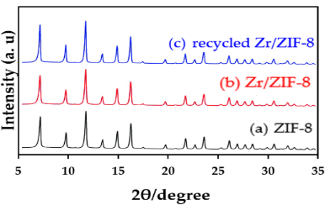
Zr/ZIF-8 catalyst was prepared by a simple low-cost traditional solvothermal method. 10 g of zirconium (IV) oxynitrate hydrate and zinc nitrate hexahydrate in a molar percentage (mol%) of Zr to Zn = 10 mol% were dissolved in 54.7 g of methanol. In a separate solution, 6.1 g of 2-methylimidazole was dissolved in 54.7 g methanol. The two solutions were then mixed vigorously by dropwise addition in a four-neck flask under nitrogen flow at ambient temperature for 6 h. The Zr-doped ZIF-8 crystals were collected and separated by centrifugation at 400 rpm for 30 min and washed. The solution was washed thoroughly with methanol and DMF and then dried at ambient temperature. The greyish-white powder of Zr/ZIF-8 sample was collected and heated at a temperature of 373 k in order to activate the catalyst. The X-ray diffraction (XRD) patterns of both ZIF-8 and Zr/ZIF-8 are shown in Fig. 1. The XRD pattern of Zr/ZIF-8 exhibited a characteristic peak of ZIF-8 with no diffraction peak of zirconium (IV) nitrate. The XRD patterns of both (a) and (b) are identical, indicating high phase purity and good crystalline stability of Zr/ZIF-8.
Fig. 1. PXRD of ZIF-8, Zr/ZIF-8, and recycled Zr/ZIF-8
2.3. Synthesis of styrene carbonate (SC) using Zr/ZIF-8 catalyst
A 25 mL reactor was charged with Zr/ZIF-8 catalyst and styrene oxide (SO). The reactor was heated up and stirred continuously. At the desired temperature, a specific amount of CO₂ was discharged through a supercritical (fluid) SCF pump into the reactor. The reaction was continued for the desired period. After the reaction was completed, the reactor was cooled down to room temperature and the mixture was collected and filtered. A known amount of toluene (used as an internal standard) was added to the product and analysed using a gas chromatograph (GC).
3. RESULTS
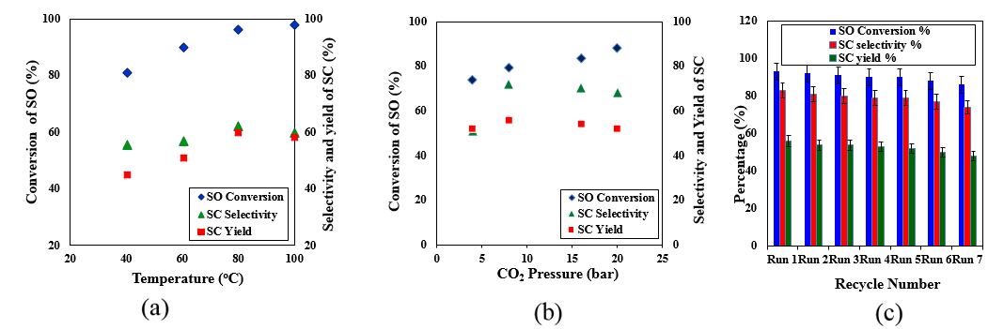
Fig. 2. Showing the effect of (a) temperature and (b) CO₂ pressure on the conversion of styrene oxide (SO), yield and selectivity of styrene carbonate (SC), respectively and (c) Zr/ZIF-8 catalyst reusability studies.
4. DISCUSSION
According to Fig. 2 (a) and (2b), when the reaction temperature was increased from 313 to 333 K, the conversion of SO also increased from 81% to 90%, yield and selectivity of SC also increased linearly from 55% to 57% and 45% to 51%, respectively demonstrating that 333 K temperature was high enough for this catalytic system. Conversely, selectivity and SC yield experienced a marginal decrease when the temperature was increased beyond 353 K. Similarly, when the CO₂ pressure was increased from 4 to 8 bar at a fixed reaction time and temperature, SO conversion, also increased from 74% to 79%, yield and selectivity of SC also increased from 51% to 72% and 52% to 56% respectively. In terms of reusability performance, the catalyst was recycled up to seven times (Fig. 2c) with no significant loss in catalytic activity.
Based on our experimental results and theoretical study, we proposed a plausible reaction mechanism for the reaction of SO and CO₂. The reaction was initiated by the synergetic effect between the Lewis acidic zinc site species and SO to form the adduct of the zinc-epoxide complex, followed by nucleophilic interaction on the carbon of CO₂. The acidic sites of Zr/ZIF-8 interact with the oxygen atom of SO. The activated CO₂ attacks the less sterically hindered carbon atom of SO, which results in the epoxide ring opening. Finally, the ring-closure step takes place between the O−anion and carbon atom to produce styrene carbonate.

5. CONCLUSIONS
The catalyst has shown a good substrate tolerance towards SO in solvent-free conditions. Its heterogeneity has been proven by recovering and reusing up seven times without any significant loss in catalytic activity. PXRD analysis of the recycled catalyst shows that its framework is quite stable after reusability performance. The high efficiency of the catalyst may also be ascribed to the ion-exchange effect between the strong Lewis acidic Zn²⁺ sites and the basic nitrogen atoms from the imidazolate ligands, which promotes the epoxy ring-opening. The high selectivity towards styrene carbonate, simple separation by centrifugation, and excellent reusability demonstrated that the catalyst is viable for large-scale industrial applications.

