Lithium ion uptake and diffusion in a family of organically synthesised porous carbon
Patrick Heasman¹, Ellie Varley¹, and Abbie Trewin^{1*}
¹Department of Chemistry, Lancaster University, Bailrigg, Lancaster, UK, LA1 4YB
*corresponding author email: a.trewin@lancaster.ac.uk

Abstract
Organically synthesized porous carbon (OSPC-1) is a newly discovered carbon allotrope. OSPC-1 is synthesized via the Eglinton homo-coupling of ethynyl methane. It has a large surface area (766 m² g⁻¹) and a high lithium uptake of 748 mA h g⁻¹, demonstrating its great potential as an anode material for lithium-ion batteries (LIBs). Here we explore the extension of the family of OSPC materials, giving three new potential carbon allotropes: OSPC-0, OSPC-2, and OSPC-3. These materials differ in node-to-node distance by an increase or decrease in the number of connecting ethynyl units in the struts. We propose synthetic strategies, construct structural models, discuss the structural properties, and assess the potential application of the proposed OSPC family members as LIBs anode materials. We suggest the optimal materials for capacity (OSPC-0) or for charging time (OSPC-3). Overall, we suggest that OSPC-3 is the optimal material from the proposed OSPC family members for an LIB anode. This could lead to LIBs that have much greater charging and discharging rates that could lead to reduced charging times and greater power output.

Introduction
Graphite is the most widely used commercially available carbon-based anode for lithium-ion batteries (LIBs)^{1, 2} but has a tendency to swell upon lithium ion uptake,³ resulting in fractures and destruction of the crystal structure. Lithium dendrites are known to form at the graphite-electrolyte interface, potentially resulting in a dangerous short circuit within the battery.^{4, 5} Graphite has a capacity of 350 mAh g⁻¹, which combined with the poor safety record means that it is necessary to evaluate alternative materials that can provide a greater uptake of lithium ions with reduced risk of explosion.⁶⁻¹³
Organically synthesized porous carbon (OSPC-1)¹⁴ is a newly discovered allotrope of carbon synthesized via the Eglinton homo-coupling of ethynyl methane (shown in Figure S1),¹⁵ it has a high lithium capacity of 748 mA h g⁻¹, and the ability to be charged at a high rate without any signs of detrimental lithium plating or dendrite formation, demonstrating its great potential as an anode material for LIBs.
The synthesis of OSPC-1 results in an amorphous material with a BET surface area (SA_{BET}) of 766 m² g⁻¹,and showed a conductivity of 1.2 x 10⁻⁴ S cm⁻¹, making OSPC-1 a semiconductor. OSPC-1 showed an uptake of ~ 2000 mAh g⁻¹ upon initial charging, dropping to ~ 1000 mAh g⁻¹ upon the second charging cycle, then a reversible lithium ion uptake of 748 mAh g⁻¹ is obtained at a current density of 200 mA g⁻¹ over 100 cycles, which exceeds many alternative carbon-based materials including C₆₀ (2.5 mA h g⁻¹), carbon nanotubes (324 mA h g⁻¹), and graphite (324 mA h g⁻¹). It is believed that a stable solid electrolyte interphase (SEI) is formed accounting for the irreversible lithium ion uptake observed within the first few cycles. The electrochemical behaviour of OSPC-1 indicates that the SEI formed is different in nature to those that form on other carbon materials, including graphite.
OSPC is constructed from sp³ carbon nodes linked by an alkyne strut. For OSPC-1 there are two alkyne groups in the alkyne strut and is the first member of a new family of synthetic carbon allotropes alongside fullerenes and nanotubes.¹⁶
There is great potential to increase the members of this family by simple shortening or lengthening of the alkyne struts by increasing or decreasing the number of sp carbon atoms. Changing the node-strut structure may greatly influence the charging behaviour and SEI formation with the possibility to decrease the SEI and therefore increase the reversible uptake. Extension of the struts between nodes potentially gives rise to larger pore sizes, greater pore volumes, and higher surface areas. However, with longer struts and larger pore channels comes the potential for interpenetration within the network, reducing the overall pore volume, pore channel size, and surface area. This means that there is great potential to optimise the lithium ion uptake behaviour of the OSPC material for specific properties including faster charging or greater reversible uptake.
Here, we explore the structure of three further members of the OSPC family and their potential for use in a lithium-ion battery.

Extension of OSPC family
We propose an extension of the OSPC family to include three further materials; OSPC-0, OSPC-2, and OSPC-3, with the idealised structure of each shown in Figure 1 and compared to the synthesised OSPC-1 structure. OSPC-0 reduces the sp³-sp³ distance by reducing the number of alkyne groups in the strut from two to one. OSPC-2 and OSPC-3 increase the sp³-sp³ distance by increasing the number of alkyne groups in the struts from two to three and four respectively.
While these are hypothetical materials, we still need to ensure that they are synthetically viable. Hence here we discuss potential synthetic pathways for OSPC-0, OSPC-2, and OSPC-3. The idealized repeat structure for OSPC-0 contains a single alkyne group between the sp³ nodes. A potential synthetic route is via a Sonogashira cross-coupling of halogenated methane and tetraethynylmethane,¹⁷ shown in Figure S2. However, this method can give rise to two potential strut motifs; a diethynyl group, resulting from the homocoupling of tetra ethynyl methane, and the target singular ethynyl group that is a result of cross-coupling, shown in Table 1.
The suggested synthetic routes for OSPC-2 and OSPC-3 derives from the synthetic route to OSPC-1. Here, we take tetra ethynyl methane and undertake GaCl₃ promoted ethynylation (Figure S3) to give tetra diethynyl methane. The ideal structure of OSPC-2 arises from direct cross-coupling of tetra ethynyl methane and tetra diethynyl methane, to give three alkyne groups between the sp³ carbon nodes (Figure S4). However, several potential structural outcomes could arise (much like OSPC-0). The random combination of monomers through homocoupling and cross-coupling could result in a variation of two, three, and four alkyne groups linking each sp³ carbon in the framework (shown in Table 1). The synthetic route to OSPC-3 can be undertaken by homo-coupling of tetra diethynyl methane via the synthetic procedure utilised for OSPC-1. Figure S5 displays this formation process, along with the resulting OSPC-3 structure.

Methodology
Binding Energy
For each OSPC structure a model was generated based on the repeating unit of the respective OSPC family member, shown in Figure 1, but including four surrounding nodes capped with hydrogen atoms, shown in Figure S6 (a). GAUSSIAN (Version 16, B3LYP/6-311g+) was used to optimise the structure of each model with no charge and to then determine the binding energy of the addition of a lithium ion in the charging phase (where the OSPC structure is charged negatively in line with the number of lithium ions) and in the discharging phase (where the OSPC structure is neutral). The resulting structure was then used to determine the binding energy of an additional lithium ion and so on up to the addition of a total of four lithium ions.
OSPC extended structure generation
The OSPC structures were generated using AmBuild, an in-house developed code designed specifically for amorphous hyper cross-linked polymer generation, following the procedure previously described.¹⁸⁻²⁰ Within the AmBuild generation process we assign end groups and cap atoms with two end groups from joining building blocks forming the new bond and a cap atom that provides the bond vector and is a leaving group. For OSPC-0 we model the idealised cross-coupling scenario and therefore the building block is constructed from a tetrahedral carbon with four bonded carbon atoms, that act as the end groups and each end group is bonded to a hydrogen leaving group. The force field atom types are defined by what they will be in the final structure, rather than the atom types and bonding present with in the monomers. Therefore, the central carbon atom is defined as sp³-hybridised and the carbon end groups are defined as sp-hybridised. In the resulting newly formed bond between the end group carbon atoms the force field allocation will therefore result in the formation of the “alkyne” strut. The building block for OSPC-0 and a resulting small cluster generated by the AmBuild process is shown in Figure S6. The same approach is used for the building block of OSPC-3 but there are four carbon atoms in the strut of the building block resulting in a final strut of 8 carbon atoms each typed with as a sp carbon resulting in four linking ethynyl groups. For OSPC-2, we use a combination of the OSPC-1 and OSPC-3 building blocks, shown in Figure S6. The network generation steps for OSPC-1 were run until the density of the model matched that of the experimentally determined density. For OSPC-0, -2 and -3 we halt the network generation process at the same step number so that a fair comparison can be made.
Two different model types were generated; a periodic system, that is used to assess the structural and porosity characteristics and self-diffusion, and a slab model, discussed below, used for active-diffusion determination and pathway assessment. The periodic models have a x=y=z cell length of 50 Å³ and the slab models have x=y cell length of 25 Å and z= 75 Å.
The periodic models were used to assess the system surface area, and porosity using PoreBlazer²¹ as previously described for OSPC-1.²⁰ The lithium ion uptakes were calculated using Materials Studio,²² using the Sorption module and the polymer consistent force field (PCFF).^{23, 24} For OSPC-1,-2, and -3, four different 25 x 25 x 25 Å sections of the respective model-a were used. For OSPC-0, a 12.5 x 12.5 x 12.5 Å section of model-a was used. In the charging phase, the OSPC structure is charged negatively in line with the number of lithium ions to be inserted so that the resulting system is neutral. In the discharging phase, the OSPC structure is neutral and is charged using the Gasteiger approach.²⁵ In both phases the resulting capacity is calculated using Faraday’s law (Figure S7). The resulting models and surfaces are shown in Figure S8 and the structural data is for each system is shown in Table S1-4. The pore size distributions are shown in Figure S9-12.
Diffusion coefficients
To determine the self-diffusion coefficients, a molecular dynamics simulation was undertaken with the respective OSPC periodic model loaded with thirty lithium ions randomly located within the simulation cell. Active diffusion of lithium ions, which we define as diffusion of a guest under an external influence – here this is the lithium ion diffusing within a neutral OSPC slab between two oppositely charged graphene sheets, was determined from the slab models of each OSPC material with the fifteen lithium ions located near to the positively charged graphene sheet. At the start of the simulation the graphene sheets are not charged. At step 2000, one graphene sheet is charged positively and the other graphene sheet is charged negatively. The charge is intended to instigate the active diffusion rather than mimic any influences of the cathode or anode. Further details are given in SI 5.1 and 5.2.

Discussion

OSPC Binding Energy Analysis
Using the Faraday equation, (Figure S7 (a) and (b)) and assessing the cycling performance of OSPC-1, we establish that for every repeat unit of OSPC-1 an uptake of eight Li⁺ ions is found for the initial uptake capacity of ~2000 mAh g⁻¹. This is far larger than for graphite, which takes up one Li⁺ for every six-membered ring (Figure S7 (c)). The initial discharge value is at ~1000 mAh g⁻¹ with this difference in capacity probably due to the formation of a solid electrolyte interphase (SEI). This equates to four Li⁺ ions for each OSPC-1 repeat unit. Eventually the reversible capacity settles to ~800 mA h g⁻¹ which equates to approximately three Li⁺ ions per OSPC-1 repeat unit. This can be summarised as there being five Li⁺ ions being non reversibly taken up, either in an SEI or potentially kinetically trapped, and three Li⁺ ions being reversibly taken up as the active capacity, shown in Figure S7 (d).
The binding energy of sequentially added lithium ions can be determined for both the charging state (where the OSPC structure is charged an opposing negative charge so that all model systems are neutral) and the discharging state (where the OSPC structure is not charged and so the model system is charged positively through the lithium ions). Comparing the cycling performance analysis to the binding energy data for OSPC-1, shown in Figure 2 (a), we can see that in the charging state, binding of lithium is favourable for all ten of the sequentially added lithium ions. Whereas in the discharging state, only the first lithium is favourably bound with the subsequent three lithium ions being unfavourable but staying bound to the OSPC-1. The fifth lithium ion was ejected from the OSPC-1 node, shown in Figure S7 (f), showing that binding to the node is highly unfavourable and that there is a large driving force to eject the lithium ion from the OSPC-1-lithium ion system. This is consistent with the analysis of the OSPC-1 cycling performance leading to the following inferences: 1. The initial uptake of lithium during the charging phase is limited by the presence of the extended polymeric packed OSPC-1 structure to eight lithium ions, 2. That four lithium ions constitute part of the SEI within the microporous structure due to the low driving force to eject them during the discharging phase, 3. That the reversible lithium-ion uptake is due to the large driving force to eject them from the microporous structure of the OSPC-1-lithium ion system due to the unfavourable interactions, and 4. That some lithium ions are not reversibly taken up due to becoming trapped within the system, possibly due to the tortuosity of the pore system or slow diffusion, or through forming part of an SEI in other regions of the system e.g. at the macro scale polymer-solvent interface.
Figure 2(b) shows the binding energy with increasing the number of lithium ions sequentially in the charging phase of each OSPC family member model. For all OSPC models the binding energy is favourable for the sequential addition of lithium ions up to the total of four that is calculated here. OSPC-0 shows the largest binding energy for one lithium ion, but OSPC-1 has the largest binding energy for the addition of the second lithium ion. OSPC-3 has the smallest binding energy for the addition of one and two lithium ions. A large decrease in the binding energy of the third lithium ion is observed for OSPC-0, -1, and -2. However, OSPC-3 continues to an increase in the binding energy and has the largest binding energy for the addition of the fourth lithium. Similarly, as for OSPC-1, we postulate that the uptake in the charging phase is limited by the volume available to the lithium ions.

In the discharging phase shown in Figure 2 (c), the binding energy starts with a favourable binding energy for all model systems with one lithium ion but decreases with each sequential addition of a lithium ion, becoming unfavourable at the second lithium ion addition for OSPC-0 and OSPC-1. The binding energy of the lithium ions is less unfavourable with larger node-to-node strut size with OSPC-2 and OSPC-3 both showing negative binding energies for two lithium ions. For three lithium ions the binding energy is unfavourable for all model systems. Assessing these structures, for OSPC-0 the 4th lithium ion is ejected suggesting a stable SEI of three lithium ions per OSPC-0 repeat unit. Both OSPC-2 and 3 ejected the 6th lithium ion suggesting a stable SEI of 5 lithium ions per OSPC repeat unit.
The difference in binding energy between the charging and discharging phases, shown in Figure 2 (d), combined with considering the absolute binding energy values is a good indication to the cyclability of the lithium ion uptake. A large favourable charging phase binding energy combined with a very unfavourable binding energy in the discharging phase means that there is a large driving force to take the lithium ion up when charging but that it is easily removed when discharging – which is the optimal situation for a lithium-ion battery anode material. Therefore, for a single lithium ion, OSPC-0 is the most optimal material but on increasing the lithium ion count to two, OSPC-1 becomes more optimal, and for three and four lithium ions OSPC-3 becomes optimal.

OSPC Structure Analysis
OSPC-0: Table S1 shows the density, surface area, and pore volume for each model of OSPC-0 generated. An average surface area of 307 m² g⁻¹, an average density of 1.022 g cm⁻³ and an average pore volume of 0.453 cm³ g⁻¹ were obtained. An average node-to-node distance of 4.127 Å and an average node-to-node angle of 173º were obtained, these are defined in Figure S13.
OSPC-1: Table S2 shows the density, surface area, and pore volume for each model generated. An average surface area of 749 m² g⁻¹ was obtained in good agreement with the experimentally determined SA_{BET} of 766 m² g⁻¹. An average density of 0.779 g cm⁻³ and an average pore volume of 0.739 cm³ g⁻¹ were obtained. An average node-to-node distance of 6.766 Å and an average node-to-node angle of 171º were obtained.
OSPC-2: The models of OSPC-2 were constructed with a 1:1 ratio of the building blocks. The stoichiometric synthetic approach resulted in a random combination and therefore a random distribution of the available struts described in Table 1. Table S3 shows the density, surface area, and pore volume for each model of OSPC-2 generated. An average surface area of 646 m² g⁻¹, an average density of 0.780 g cm⁻³ and an average pore volume of 0.740 cm³ g⁻¹ were obtained. An average node-to-node distance of 9.624 Å and an average node-to-node angle of 171º were obtained.
OSPC-3: Table S4 shows the density, surface area, and pore volume for each model of OSPC-3 generated. An average surface area of 1018 m² g⁻¹, an average density of 0.774 g cm⁻³ and an average pore volume of 0.764 cm³ g⁻¹ were obtained. An average node-to-node distance of 12.236 Å and an average node-to-node angle of 168º were obtained.
Table 2 shows a comparison of the structural properties of the periodic models of the OSPC family of materials and Figure SI 8 shows an example periodic model of each system with a solvent accessible surface area. The density of the family decreases with the increase in average node-to-node distance with a large decrease from OSPC-0 to OSPC-1 and then smaller incremental decreases in the density. The surface area increases from OSPC-0 to OSPC-1, we then see a decrease from OSPC-1 to OSPC-2, and then a large increase from OSPC-2 to OSPC-3. A large increase in the pore volume is observed for OSPC-0 to OSPC-1 but we then see a gradual increase in the pore volume. We believe that these observations can be rationalised by the respective flexibility of the struts for each system. Figure S14 shows the average node-to-node angle plotted against the node-to-node distance. For OSPC-0, the struts are short and the node-to-node angle is close to the idealised 180°, which leave very little ability for the network to interpenetrate. For OSPC-1 and OSPC-2, the struts are longer, potentially leading to a more open framework, but as they are more flexible, shown in the node-to-node angle being further away from the idealised 180°, they show increased network interpenetration. For OSPC-3, we do not see a large increase in the degree of network interpenetration, but as the average node-to-node is longer a more open structure is formed.
The differential and cumulative pore size distributions of each OSPC periodic model are shown in Figure S9-12, calculated using Pore Blazer. Table 2 summarizes the key features of the pore size distributions. The pore size distributions for the OSPC models are quite similar, with no clear trend between the diffusion rate and the pore structure. However, the cumulative pore size distributions, shown in Figure 3, shows a clear increase in pore size distributions going from OSPC-0 to -3.
Periodic Model Lithium Ion Capacity
The lithium ion capacity in the charging and discharging phase were calculated for 4 samples of each OSPC structure, shown in Table S6-10. The model of OSPC-1 displays an average lithium ion capacity in the charging phase of 2863 mAh g⁻¹, which overestimates the experimental uptake in the first step of approximately 2000 mAh g⁻¹. However, the simulated uptake is only able to model uptake in the microporous region and does not into account microporous regions as is included in the experimental value. It is common to overestimate simulated values in porosity measurements, including uptake, surface area, and micropore volume, as the models are idealistic representations and do not include features such as retained solvent or pore blocking by unreacted starting materials. In the discharging phase a value of 1817 mAh g⁻¹ is obtained, lower than that obtained for the charging phase as expected due to the higher interaction between the negatively charged OSPC structure and the positive lithium ions. The uptake obtained in the discharging phase represents the stable interaction between OSPC-1 and Lithium ions and is equivalent to the microporous SEI that was described previously. The difference between the uptake in the charging and discharging phase is equivalent to the reversible uptake within the microporous region without considering any kinetic trapping that may occur or SEI formation at the macro scale. A reversible uptake of 1046 mAh g⁻¹is obtained in good agreement with the equivalent experimental value of approximately 1000 mAh g⁻¹. ¹⁴ We interpret this good agreement as being a result of fortuitous cancellation of overestimation of the charging and discharging phase values.
OSPC-3 has the highest charging phase uptake obtained at 3298 mAh g⁻¹ but it also has the highest uptake in the discharging phase at 2232 1000 mAh g⁻¹. For OSPC-1, -2, and -3, as the uptake in the charging phase increases so does the uptake in the discharging phase leading to a similar reversible uptake value being obtained for these structures of 1046 mAh g⁻¹, 1018 mAh g⁻¹, and 1066 mAh g⁻¹ being obtained for OSPC-1, -2, and -3 respectively. Although OSPC-0 has a comparibly small uptake in the charging phase of 2964 mAh g⁻¹, it has a relatively smaller uptake in the discharging phase of 1765 mAh g⁻¹, leading to the largest reversible microporous lithium ion uptake of 1200 mAh g⁻¹.
Self-Diffusion of Lithium Ions Analysis
Table 3 shows the determined average self-diffusion coefficients of the lithium ions for each system and Figure 4 shows the diffusion pathways and a zoomed in example for each system. The self-diffusion coefficient increases by almost 400% going from OSPC-0 to OSPC-1 but then decreases more gradually for OSPC-2 and OSPC-3, shown clearly in a plot of the average self-diffusion rate against the average node-to-node distance, Figure 4. The increase in self-diffusion coefficient going from OSPC-0 to OSPC-1 can be explained by the larger pore diameter of OSPC-1 allowing more space for diffusion. It is less clear why the lithium ion self-diffusion coefficients decrease for OSPC-2 and OSPC-3. Assessing the trajectories of each lithium ion in the respective OSPC systems we can see that for OSPC-2 and OSPC-3, the lithium ions reside mainly around the tetrahedral node whereas for OSPC-1 the lithium ions seem to move from node to neighouring nodes. A possible rationalisation is that the area between the linkers adjacent to the node is particularly energetically favourable due to the ability to interact with two ethynyl groups. In OSPC-1, as the struts are shorter and therefore the nodes are closer, it is easy for the lithium ions to hop between the tetrahedral nodes with only a small energy penalty. Whereas for OSPC-2 and OSPC-3 the increased distance between the nodes leads to a larger energy penalty upon moving from one tetrahedral node to another.

Active diffusion of Lithium Ions Analysis
OSPC-0: Upon charging of the graphene sheets, the lithium ions can be seen moving along the z-axis from their initial starting point adjacent to the positively charged graphene sheet towards the negatively charged graphene sheet. However, due to tight packing and narrow channels within the OSPC-0 structure generated, not all the lithium ions are able to fully diffuse to the negatively charged graphene sheet with some of the lithium ion only diffusing less than half the distance. The ion diffusion pathways are shown in Figure S15. We can see in the diffusion pathways that there are many points in which the lithium ion progress in the z direction is halted as the lithium ions were required to find new pathways within the structure as the current trajectory pathways were too narrow to pass through. For example, Li5 showed several periods of slow movement and fast movement. The diffusion rates for each lithium ion are plotted in Figure S16 and an average diffusion rate of 1.80 x 10⁴ cm s⁻¹ is determined. To test if this limited diffusion is due to the small pore structure resulting in narrow constricted pathways we assessed the distance between the lithium ion and the closest carbon atom for the fastest lithium ion (Li2) and the slowest lithium ion (Li11). Shown in Figure S17. We can see for Li11 the distance stays consistent at approximately 2.4 Å indicating that it is stuck in a dead-end pore with no ability to exit from the pore. Whereas the distance between Li2 and the closest carbon changes constantly during its diffusion pathway until it reaches the negatively charged graphene sheet at approximately step 3200 and shows a large increase at approximately step 2750.
For OSPC-0, we see very little movement of the carbon atoms from their initial starting positions showing the rigidity and density of the OSPC-0 structure. This resulted in nine of the lithium ions becoming trapped within the pore structure.
OSPC-1: For OSPC-1, we have previously described the lithium ion diffusion through the network structure.²⁰ Here we include a brief summary of our findings to enable a direct comparison to be made. All lithium ions are able to diffuse fully through the OSPC-1 structure, Figure S18 shows the diffusion pathways and Figure S19 shows the diffusion rates with an average diffusion rate of 4.78 x 10⁴ cm s⁻¹ being determined. The diffusion rates for each ion are in a small range reflecting the similarity in the pathways available for each ion. Assessment of the distance between the lithium ion and the closest carbon, shown in Figure S20, for the slowest (Li4) and the fastest (Li12) shows little difference between the ions up until approximately step 3000, where Li12 shows a large increase in the distance indicating that it has moved into a larger pore corresponding to a region of fast movement in its diffusion pathway.
For OSPC-1, eight active lithium ion diffusion pathways were found where the bounding carbon atoms were required to be laterally displaced to allow the lithium ion to pass through, an example is shown in Figure S21. We plot the displacement of these carbon atoms from their original starting point as a function of step, shown in Figure S22. We can see that as the lithium ion diffuses through the bounding carbon atoms the distance increases. In some cases we can see that the carbon-carbon distance decreases as the lithium ion approaches, it then opens for the lithium ion to pass through and then snaps back quickly to its original position, for example pathway 3 shown in Figure S22 (c). For most systems the carbon atoms return to their original positions whereas in some cases the carbon atoms remain in new positions.
OSPC-2: Similarly, all lithium ions are able to migrate through the OSPC-2 network fully. The diffusion profiles are shown in Figure S23. The diffusion rates for each lithium ion are plotted in Figure S24 and an average diffusion rate of 6.36 x10⁴ cm s⁻¹ is determined.
Assessment of the distance between the lithium ion and the closest carbon, shown in Figure S25, for the slowest (Li10) and the fastest (Li6) shows a distinct difference. For Li10, the distance between Li and the closest carbon atom starts large at ~5 Å but then quickly drops to ~ 2.5 Å at approximately step 2200. Whereas for Li6 the distance starts off small at ~ 2.5 Å but then increases at approximately step 2750 to ~ 5 Å.
Similarly to OSPC-1, eight structures were found where lithium ion diffusion bounding carbon atoms are found, an example is shown in Figure SI 26 and the plots are shown in Figure SI 22. The same characteristic responses are observed however the average displacement is half that that is observed in OSPC-1, shown in Table 3.
OSPC-3: All lithium ions are able to diffuse through the OSPC-3 network fully. The diffusion profiles are shown in Figure S28. The diffusion rates for each lithium ion are plotted in Figure S29 and an average diffusion rate of 7.63 x10⁴ cm s⁻¹is determined.
Assessment of the distance between the lithium ion and the closest carbon, shown in Figure S30, for the slowest (Li1) and the fastest (Li6) shows a distinct difference. For Li1, the distance between Li and the closest carbon atom stays at between ~2.5 Å and 3 Å throughout the migration process showing a consistently sized pathway. Whereas for Li6 the distance starts off at ~ 3 Å, then oscillates between ~ 4 Å and ~ 2.5 Å before a large increase in size is seen at approximately step 2600.
For OSPC-3, only six structures were found where lithium ion diffusion bounding carbon atoms are found, shown in Figure SI 31. Similarly to OSPC-2, the lithium ion pathway bounding carbon atoms are displaced by a small amount to allow the lithium ion to pass through.
Figure 5 shows the active-diffusion pathway for lithium ion 1 as an example for each respective OSPC system. We can see that for OSPC-0, the lithium ion has a very tortuous pathway that is unable to diffuse fully having found a dead end within a pore, whereas the lithium ions in the other OSPC systems are able to fully diffuse fully through to the opposite graphene sheet. Table 3 shows the average active-diffusion rate of lithium ions in each of the OSPC family members. It is clear that as we increase the node-to-node distance the active-diffusion rate increases, shown in Figure 4. The average rate of lithium ion active-diffusion within the OSPC-3 system is over four times as fast in comparison to those within the OSPC-0 system (OSPC-3, 7.63 x10⁴ cm s⁻¹; OSPC-0, 1.80 x10⁴ cm s⁻¹).
A comparison of the average angle of the struts within each structure and the range of values seen is shown in Table 3 and plotted in Figure 6. These values demonstrate the flexibility of each OSPC structure. A more flexible strut will allow the structures to bend and move to open up pathways for the ions to traverse. This flexibility is subjective of the length of alkyne strut. OSPC-0 possessed the shortest strut, making it the most rigid structure of the series, whereas OSPC-3 possessed the longest strut, which in principle should result in the most flexible strut. The relative flexibility of the OSPC structures determines their ability to respond to the presence of the diffusing lithium ion. OSPC-0 has a rigid, dense structure that does not allow lithium ions to easily diffuse through the system. Whereas the structures of OSPC-1, OSPC-2, and OSPC-3 possessed more flexibility and open structures and we see the bounding carbon atoms are able to move to allow the lithium ions to pass. OSPC-1 shows the greatest displacement value of 2.0 Å, while OSPC-2 showed the smallest displacement value of 1.0 Å. However, OSPC-1 and -2 showed eight occasions of a structural response whereas OSPC-3 showed only six occasions of a structural response. OSPC-3 allows facile diffusion through an open pore structure that is easily able to respond to allow diffusion to occur if the pore becomes too small.
Application to Lithium-ion Battery
All proposed OSPC materials discussed here show potential for application as anode materials in LIBs. The simulated lithium ion uptake behaviour from the binding and periodic models shows a reversible uptake is expected. The binding energy calculations suggest that for one lithium ion the most optimal material is OSPC-0, but for multiple lithium ions then the optimal material is OSPC-3. For the periodic uptake simulations OSPC-1 showed the largest reversible uptake but there is only a small difference between the model systems. This suggests that OSPC-0 and OSPC-3 may be similar in terms of the lithium ion capacity overall.
Whereas the calculated self-diffusion constant, which gives an indication of the degree of diffusivity of the ion, showed that the OSPC-1 had the highest diffusivity. This means that under normal diffusion conditions lithium ions are most freely able to diffuse in OSPC-1. However, the diffusion under a charge bias, known as the activated diffusion which mimics diffusion conditions within the charging phase, showed that the greatest diffusivity was found in OSPC-3 due to the ability of the OSPC-3 linkers to be flexible allowing the lithium ion to pass through easily. This suggests that the rate at which charging could be achieved in OSPC-3 would be greatest. Inversely, the lowest diffusion coefficient and activated diffusion coefficient were found for OSPC-0.
This suggests that a high capacity can be achieved with OSPC-0 but with slow kinetics and therefore long charging times. Whereas a slightly lower capacity is achieved for OSPC-3 but with faster kinetics and therefore quicker charging times.

Conclusion
Here we have proposed a new set of carbon allotropes, extending the family of organically synthesized porous carbon materials. We have explored the potential of these new family members as LIB anode properties and have suggested the optimal materials for capacity (OSPC-0) or for charging time (OSPC-3). Overall, we suggest that OSPC-3 is the optimal material from the proposed OSPC family members for an LIB anode. This could lead to LIBs that have much greater charging and discharging rates that could lead to reduced charging times and greater power output.

Supporting Information

Supporting Information is available and contains the full details of synthetic strategies for preparation of OSPC-0, OSPC-2, and OSPC-1, computational details, structure characterisation of porosity and lithium ion uptake behaviour.

References
1. Li, L.; Zhang, D.; Deng, J.; Gou, Y.; Fang, J.; Cui, H.; Zhao, Y.; Cao, M., Carbon-based materials for fast charging lithium-ion batteries. Carbon 2021, 183, 721-734.
2. Li, W.; Fang, R.; Xia, Y.; Zhang, W.; Wang, X.; Xia, X.; Tu, J., Multiscale Porous Carbon Nanomaterials for Applications in Advanced Rechargeable Batteries. Batteries & Supercaps 2019, 2 (1), 9-36.
3. Li, X.; Yan, P.; Xiao, X.; Woo, J. H.; Wang, C.; Liu, J.; Zhang, J.-G., Design of porous Si/C–graphite electrodes with long cycle stability and controlled swelling. Energy & Environmental Science 2017, 10 (6), 1427-1434.
4. Fu, A.; Wang, C.; Pei, F.; Cui, J.; Fang, X.; Zheng, N., Recent Advances in Hollow Porous Carbon Materials for Lithium–Sulfur Batteries. Small 2019, 15 (10), 1804786.
5. Harry, K. J.; Hallinan, D. T.; Parkinson, D. Y.; MacDowell, A. A.; Balsara, N. P., Detection of subsurface structures underneath dendrites formed on cycled lithium metal electrodes. Nat Mater 2014, 13 (1), 69-73.
6. Tarascon, J. M.; Armand, M., Issues and challenges facing rechargeable lithium batteries. In Materials for Sustainable Energy, Co-Published with Macmillan Publishers Ltd, UK: 2010; pp 171-179.
7. Bazilevsky, A. V.; Yarin, A. L.; Megaridis, C. M., Co-electrospinning of Core−Shell Fibers Using a Single-Nozzle Technique. Langmuir 2007, 23 (5), 2311-2314.
8. Bruce, P. G.; Scrosati, B.; Tarascon, J.-M., Nanomaterials for Rechargeable Lithium Batteries. Angewandte Chemie International Edition 2008, 47 (16), 2930-2946.
9. Lin, Y.-M.; Abel, P. R.; Heller, A.; Mullins, C. B., α-Fe2O3 Nanorods as Anode Material for Lithium Ion Batteries. The Journal of Physical Chemistry Letters 2011, 2 (22), 2885-2891.
10. Bai, Z.; Fan, N.; Sun, C.; Ju, Z.; Guo, C.; Yang, J.; Qian, Y., Facile synthesis of loaf-like ZnMn2O4 nanorods and their excellent performance in Li-ion batteries. Nanoscale 2013, 5 (6), 2442-2447.
11. Yang, T.; Liu, Y.; Huang, Z.; Yang, Q.; Guan, M.; Fang, M.; Wu, X., A facile strategy for fabricating hierarchically mesoporous Co3O4 urchins and bundles and their application in Li-ion batteries with high electrochemical performance. RSC Advances 2015, 5 (31), 24486-24493.
12. Park, K.; Cho, J. H.; Jang, J.-H.; Yu, B.-C.; De La Hoz, A. T.; Miller, K. M.; Ellison, C. J.; Goodenough, J. B., Trapping lithium polysulfides of a Li–S battery by forming lithium bonds in a polymer matrix. Energy & Environmental Science 2015, 8 (8), 2389-2395.
13. Feng, Y.; Yu, X.-Y.; Paik, U., Formation of Co3O4 microframes from MOFs with enhanced electrochemical performance for lithium storage and water oxidation. Chemical Communications 2016, 52 (37), 6269-6272.
14. Zhao, Z.; Das, S.; Xing, G.; Fayon, P.; Heasman, P.; Jay, M.; Bailey, S.; Lambert, C.; Yamada, H.; Wakihara, T.; Trewin, A.; Ben, T.; Qiu, S.; Valtchev, V., A 3D Organically Synthesized Porous Carbon Material for Lithium-Ion Batteries. Angewandte Chemie International Edition 2018, 57 (37), 11952-11956.
15. Eglinton, G., Chem. lnd.(London) 1956, 737; G. Eglinton and AR Galbraith. J. Chem. Soc 1959, 889.
16. Kroto, H. W.; Heath, J. R.; O'Brien, S. C.; Curl, R. F.; Smalley, R. E., C 60: buckminsterfullerene. Nature 1985, 318 (6042), 162-163.
17. Li, S.; Qiu, J.; Lai, C.; Ling, M.; Zhao, H.; Zhang, S., Surface capacitive contributions: Towards high rate anode materials for sodium ion batteries. Nano Energy 2015, 12, 224-230.
18. Thomas, J. M. H.; Trewin, A., Amorphous PAF-1: Guiding the Rational Design of Ultraporous Materials. The Journal of Physical Chemistry C 2014, 118 (34), 19712-19722.
19. HOOMD-blue web page: http://codeblue.umich.edu/hoomd-blue.
20. Heasman, P.; Trewin, A., Uptake and Diffusion of Ions in Organically Synthesized Porous Carbon for Battery Anode Applications. The Journal of Physical Chemistry C 2019, 123 (42), 25603-25610.
21. Sarkisov, L.; Harrison, A., Computational structure characterisation tools in application to ordered and disordered porous materials. Molecular Simulation 2011, 37 (15), 1248-1257.
22. Accelrys Materials Studio 5.0, San Diego, CA, 2009.
23. Sun, H., Ab initio calculations and force field development for computer simulation of polysilanes. Macromolecules 1995, 28 (3), 701-712.
24. Sun, H., J.Phys. Chem. B 1998, 102, 7338-7364.
25. Gasteiger, J.; Marsili, M., Iterative partial equalization of orbital electronegativity--a rapid access to atomic charges. Tetrahedron 1980, 36 (22), 3219-3228.

- OSPC-0 (b) OSPC-1 (c) OSPC-2 (d) OSPC-3

Figure 1: The proposed family of OSPCs, showing the sp³ nodes and the incorporated linkers for (a) OSPC-0 (proposed), (b) OSPC-1 (synthesised), (c) OSPC-2 (proposed), and (d) OSPC-3 (proposed).

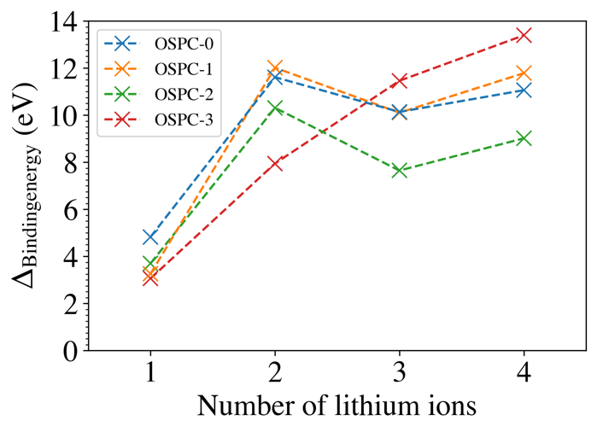
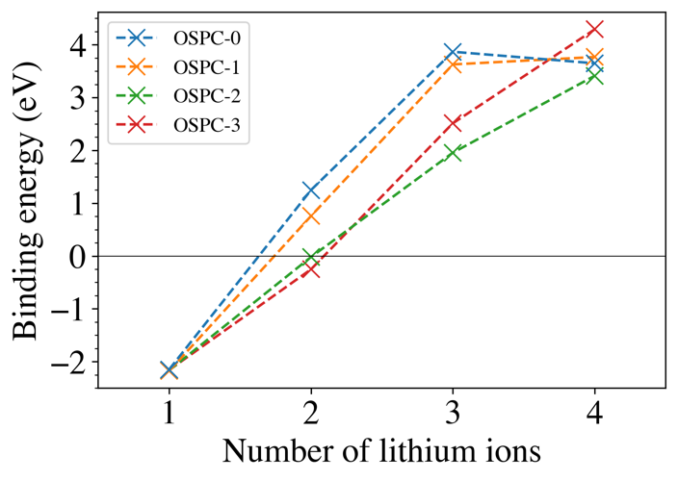
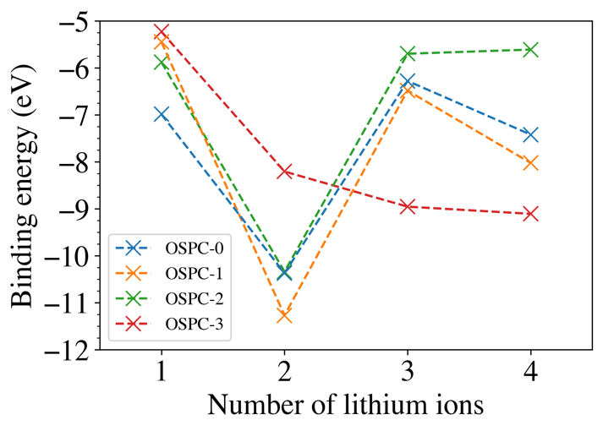
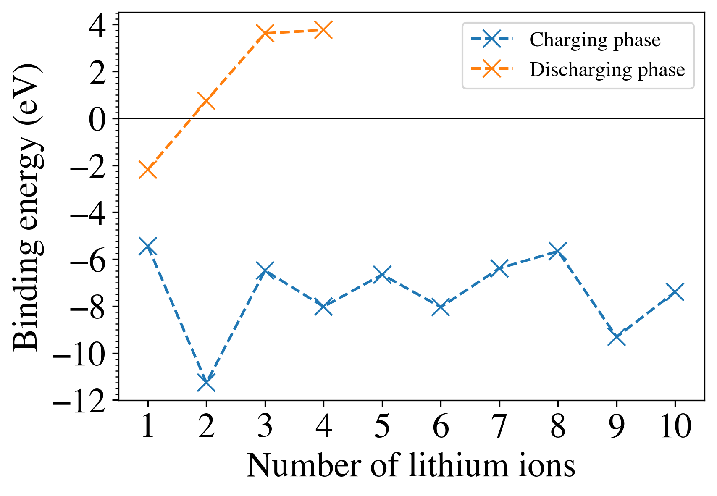
Charging Phase
Discharging Phase
(a)
(b)
(c)
(d)

Figure 2: (a) Calculated binding energy for OSPC-1 and sequential addition of lithium ions in the charging state (where the OSPC structure is charged an opposing negative charge so that the system is neutral) and discharging state (where the OSPC structure is not charged and so the model system is charged positively through the lithium ions). (b) Calculated binding energy for OSPC family members and sequential addition of lithium ions in the charging state. (c) Calculated binding energy for OSPC family members and sequential addition of lithium ions in the discharging state. (d) The difference in binding energy between the charging and discharging phases for OSPC family members.

OSPC structure | Potential bonding formation
OSPC-0
OSPC-1
OSPC-2
OSPC-3

Table 1: Potential bonding arrangements within each OSPC structure.

 | Density  (g cm⁻³) | Average  surface area  (m² g⁻¹) | Average pore  Volume  (cm³ g⁻¹) | Average  node-to-node  angle (°) | Average node-to-node distance (Å) | Minimum pore size  (Å) | Maxima  pore size  (Å) | Average reversible microporous capacity  (mA h g⁻¹)
OSPC-0 | 1.023 | 307 | 0.453 | 173.24 | 4.127 | 3.27 | 3.62 | 1200
OSPC-1 | 0.780 | 749 | 0.739 | 171.00 | 6.766 | 4.32 | 4.38 | 1046
OSPC-2 | 0.782 | 646 | 0.740 | 171.20 | 9.624 | 4.26 | 3.70 | 1018
OSPC-3 | 0.7695 | 1018 | 0.764 | 168.34 | 12.236 | 4.05 | 4.86 | 1000

Table 2: Comparison of the density, surface areas and pore volumes (calculated using PoreBlazer ¹⁷), reversible microporous lithium ion uptake capacity (determined using Materials Studio Sorption module), and node-to-node distances and angles (defined in Figure SI 27) of the modelled OSPC family using the periodic models generated.

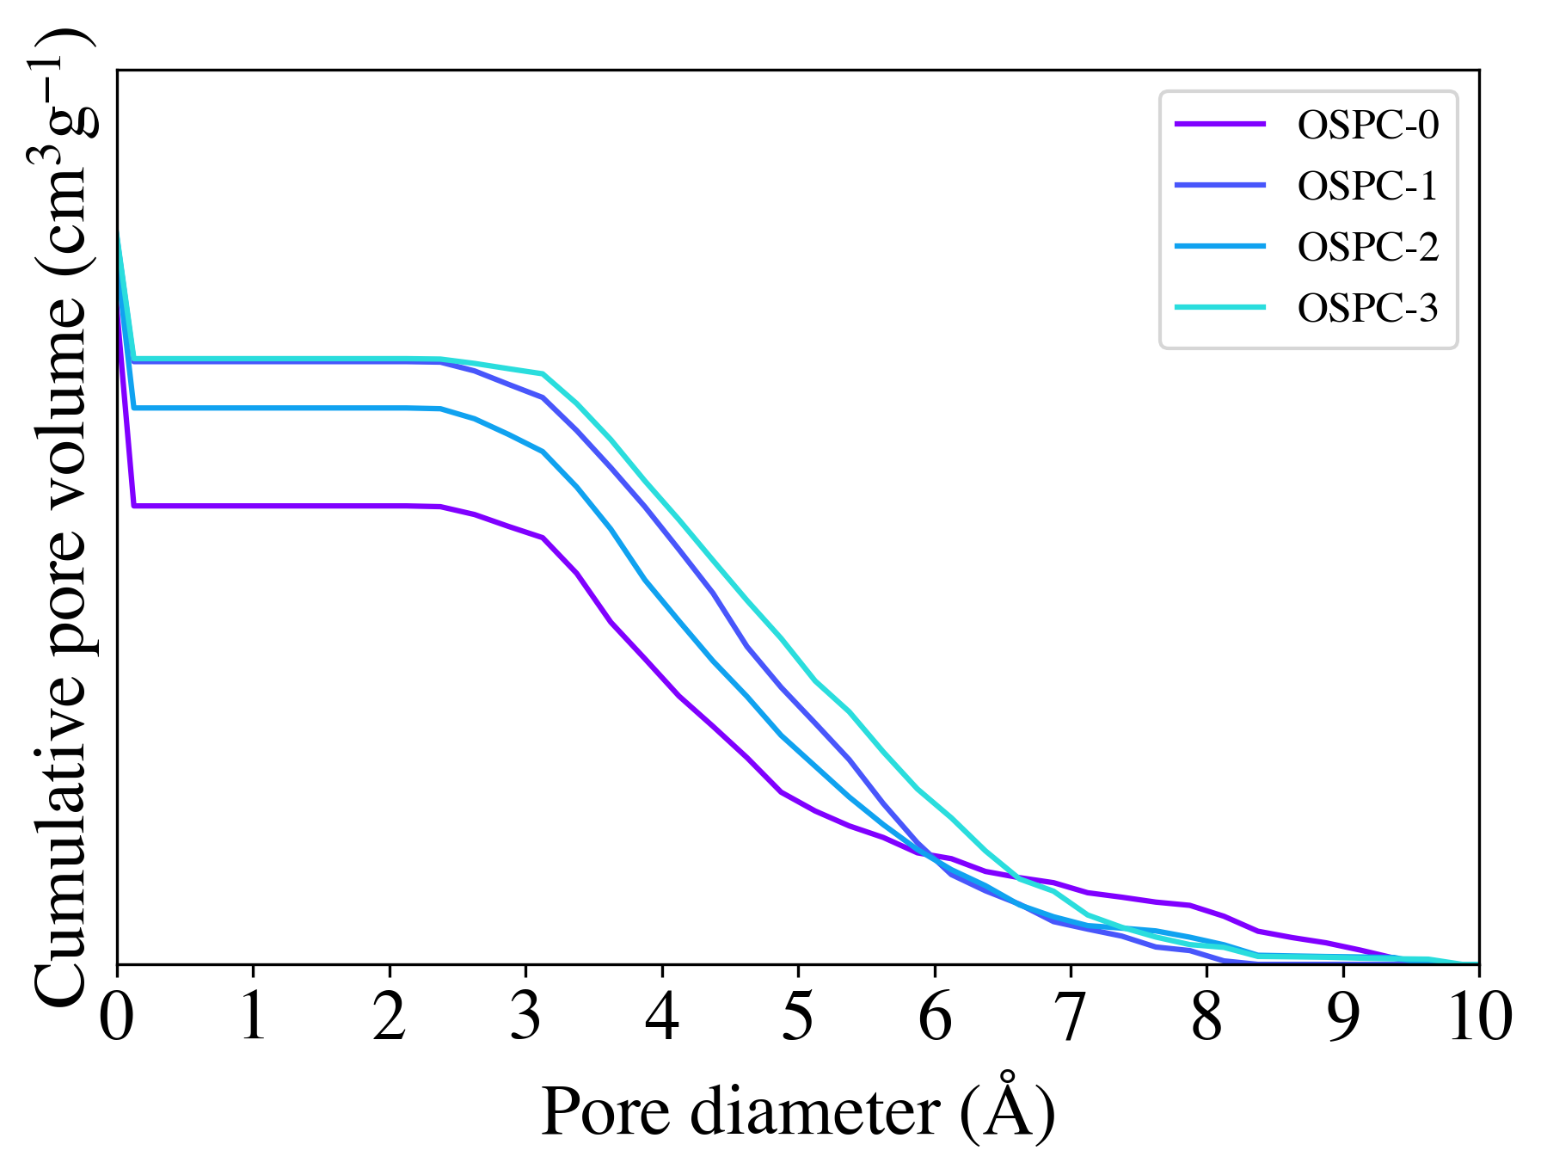

Figure 3: Cumulative pore size distribution for the modelled OSPC family using the periodic models generated.

OSPC structure | Average self diffusion rate  (x10⁻⁷ cm s⁻¹) | Average activated diffusion rate  (x10⁴ cm s⁻¹) | Maximum bounding carbon displacement (Å) | Average bounding carbon displacement (Å)
OSPC-0 | 1.45 | 1.80 | 0 | 0
OSPC-1 | 550 | 4.78 | 2.0 | 1.2
OSPC-2 | 126 | 6.36 | 1.0 | 0.6
OSPC-3 | 55.2 | 7.63 | 1.4 | 0.68

Table 3: Average lithium ion self diffusion (determined for the periodic models generated) and the activated diffusion rate (determined for the slab models generated) of OSPC-0, OSPC-1, OSPC-2, and OSPC-3. The bounding carbon displacement is determined from the activated lithium ion diffusion pathways.

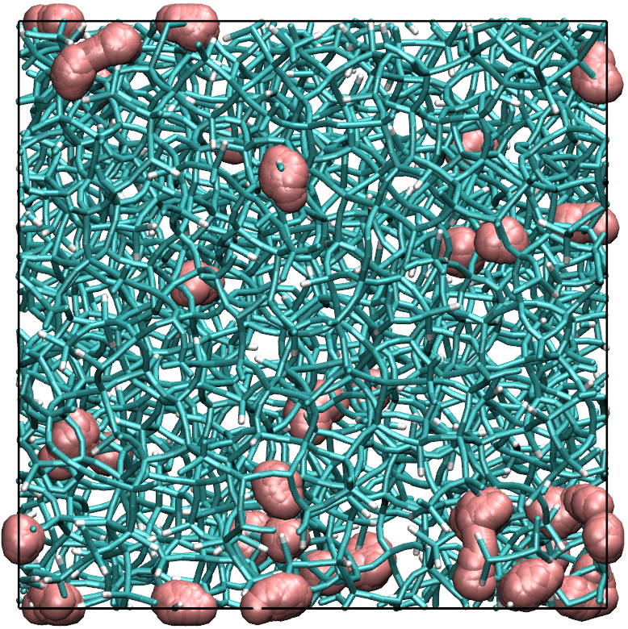
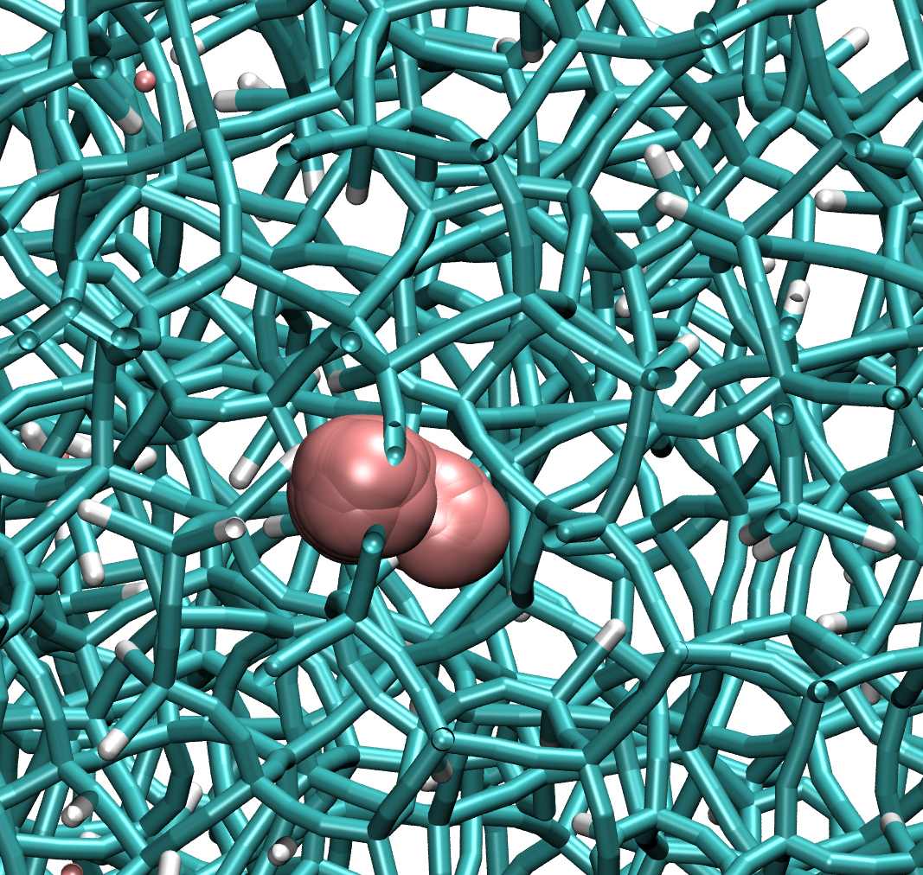
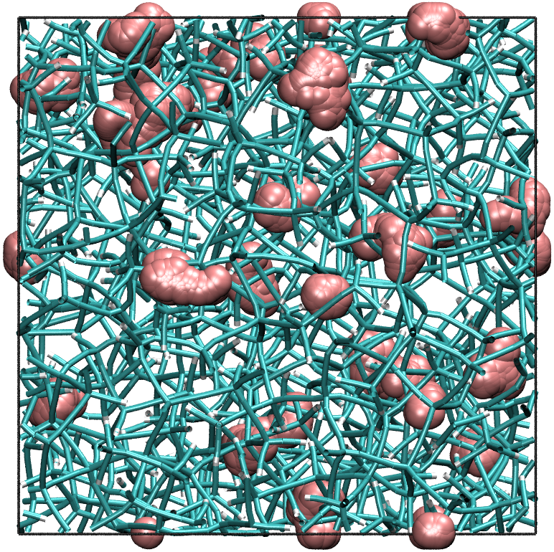
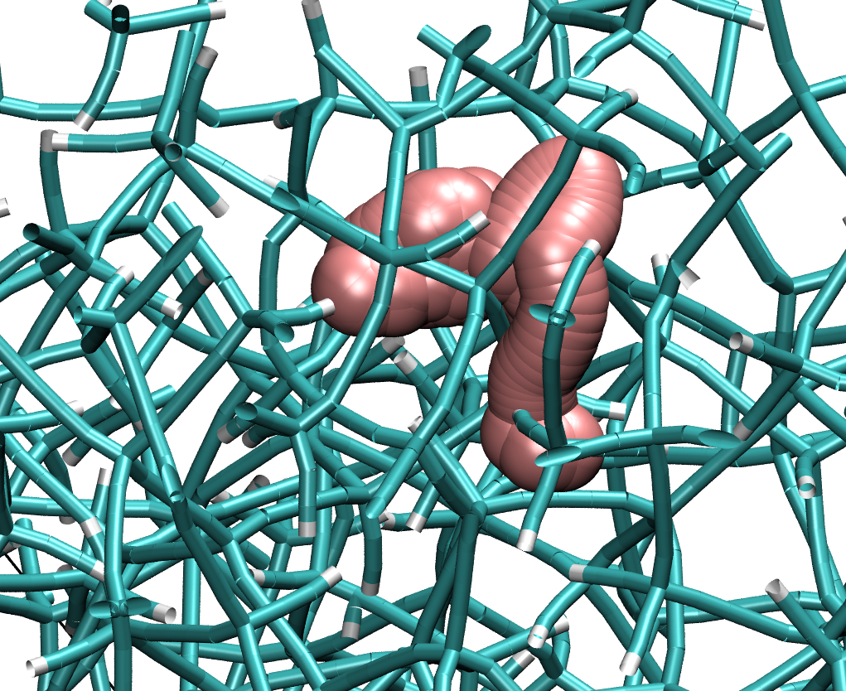
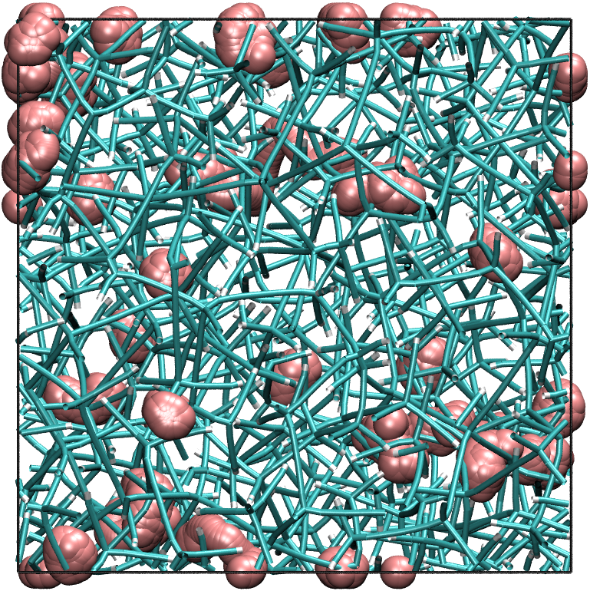
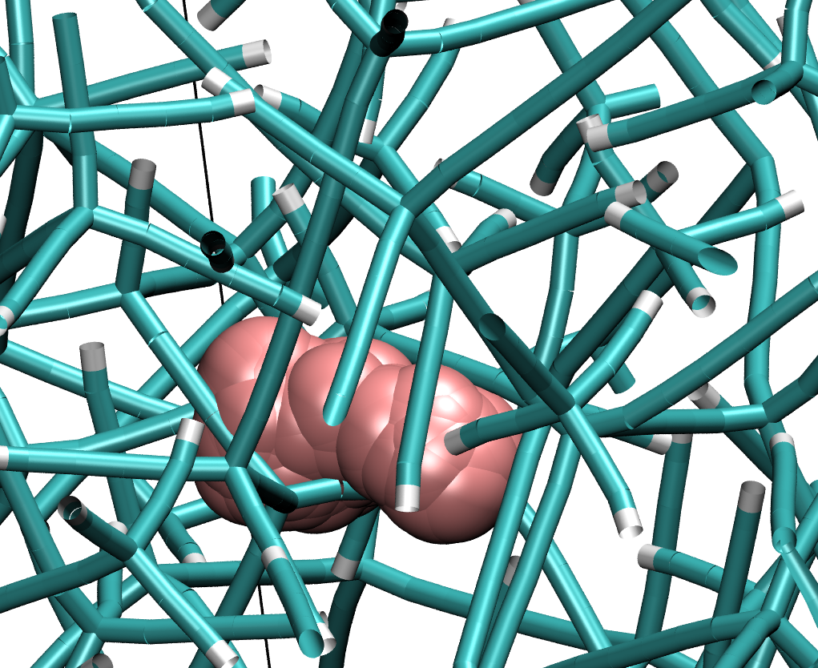
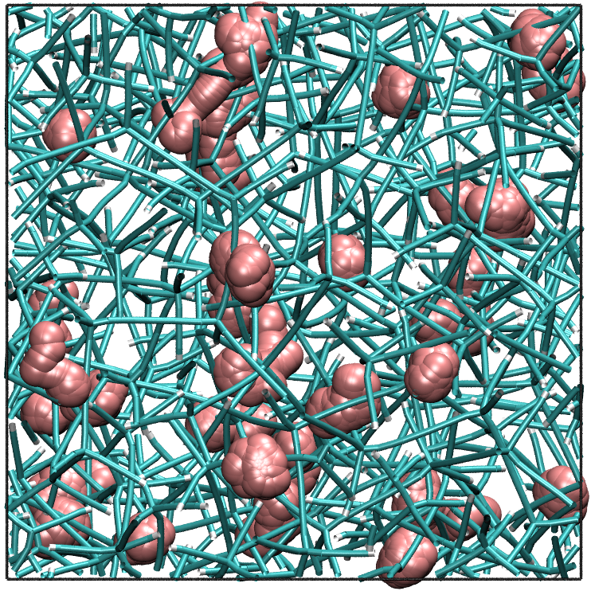
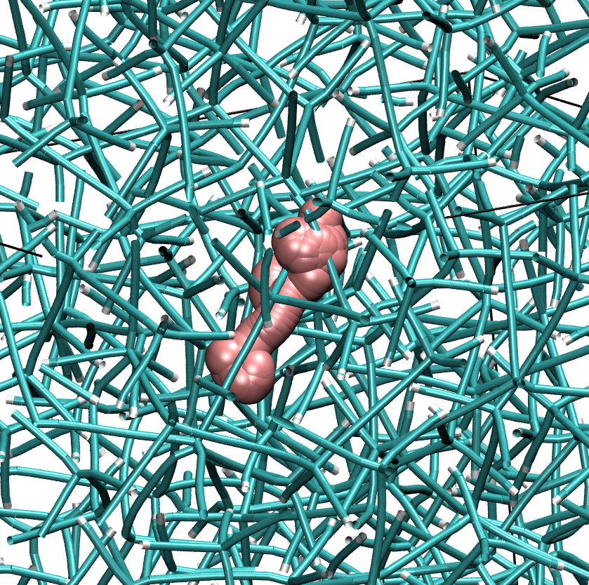
(a) OSPC-0
(b) OSPC-1
(c) OSPC-2
(d) OSPC-3
Figure 4: The self-diffusion pathways of lithium ions (pink) through a periodic model of the respective OSPC. Top showing the overlaid trajectories of all lithium ions modelled with different starting positions. Bottom zoomed in an example trajectory of a single lithium ion.

(a) OSPC-0 (b) OSPC-1

(c) OSPC-2 (d) OSPC-3

Figure 5: An example of the active diffusion pathway of a lithium ion (pink) through a slab of the respective OSPC between two oppositely charged graphene sheets (a) OSPC-0, (b) OSPC-1, (c) OSPC-2, and (d) OSPC-3.

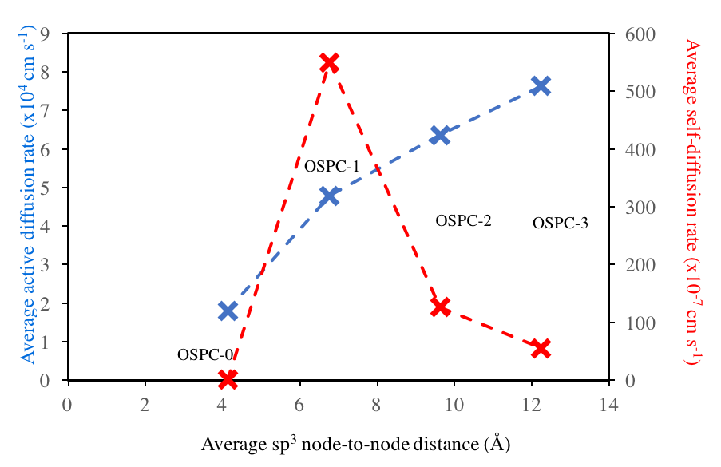

Figure 6: A comparison of lithium ion diffusion rates for OSCP-0, OSPC-1, OSPC-2, and OSPC-3, as a function of sp³ node-to-node distance (Å) (defined in Figure SI 27). The red line represents a linear trend with respect to the increasing node-to-node distance, and the blue dashed line represents a trend that follows the changes in ion mobility with the increasing node-to-node distance.

TOC GRAPHIC
