Long title: A systematic literature search, review and dissemination methodology for the COVID-19 pandemic.

Short title: Filtering the Firehose of COVID-19

Dr Charles Reynard^{1,2}, Dr Daniel Darbyshire^{3,4}, Dr Gabrielle Prager⁵, Dr Anisa Jafar^{1,2,6}, Dr Mina Naguib^{6,7}, Dr Govind Oliver⁸, Dr Patricia van den Berg², Professor Richard Body^{1,2}, Harriet Ambroziak⁹, Professor Simon Carley^{1,10}

Affiliations
1- Emergency Department, Manchester University NHS Foundation Trust, Manchester
2- Division of Cardiovascular Sciences, University of Manchester
3- Emergency Department, Salford Royal NHS Foundation Trust
4- Lancaster Medical School, Lancaster University
5- Emergency Department, Royal Bolton Hospital, Bolton NHS Foundation Trust
6- Humanitarian and Conflict Response Institute, University of Manchester
7- Emergency Department, Stepping Hill Hospital, Stockport NHS Foundation Trust
8- Emergency Department, Royal Preston Hospital, Lancashire Teaching Hospitals NHS Foundation Trust
9- Royal College of Emergency Medicine
10- Department of Postgraduate Medicine, Manchester Metropolitan University

Corresponding author: Dr Charles Reynard
Email: charlie.reynard@manchester.ac.uk

Acknowledgements:

The authors would like to thank the weekly writing teams for their contribution to the RCEM top 5. They included:

Centre for Urgent and Emergency Care Research – University of Sheffield
Jamie Miles, Dr. Susan Croft, Colin O’Keeffe, Jo Coster, Maxine Kucsawski, Dr Carl Marincowitz, Dr. Mike Tonkins, Professor Suzanne Mason

Emergency Medicine Academic Group – University of Leicester
Professor Tim Coats, Dr James Van Oppen, Dr Mohammed Elwan, Dr Ffion Davies, Dr Mohamed Morsy

King's College Hospital London
Dr Andrew Brookes, Dr Ruth Sneep, Dr Raeesa Jina, Dr Carole Reid, Mr Aidan Beaumont, Miss Inbar Aberman, Miss Nicole Minta, Miss Emma Backhurst, Dr Fleur Cantle

Academic Emergency Department in Plymouth, & Academic Department of Military Emergency Medicine
Dr Laura Cottey, Dr Ffion Barham, Dr Felix Wood, Dr Stacey Webster, Dr Robert James, and Professor Jason Smith

Cambridge Emergency Medicine Research Group
Dr Virginia Newcombe, Dr Sophie Richter, Dr Sam Love, Dr Daniel Whitehouse, Dr Edward Barnard, Dr Adrian Boyle

University Hospital Coventry Emergency Department
Dr Caroline Leech, Dr Ed Hartley, Dr Karen Jones

Emergency Medicine Research Group Edinburgh
Rajesh Chatha, Matt Reed, Rachel McLatchie, Maddie Colmar, Salma Alawiye, Joseph McIntyre, Craig Davidson, Krishma Kataria, Benjamin Earle-Wright, Jesymin Choong, Sarah Jane Zammit

Emergency Innovation Research Network - Cork University Hospital Emergency Department, Ireland
Professor Conor Deasy, Dr Ronan Callanan, Dr Rory O’ Brien, Dr Adrian Murphy, Dr Eoin Fogarty, Dr Darren McLoughlin, Dr Stephen Gilmartin, Dr Joe Slowey, Dr Michael Dunphy, Dr Andrew Patton

Royal College of Emergency Medicine
Laura Sweeney

Exclusive Licence
The Corresponding Author has the right to grant on behalf of all authors and does grant on behalf of all authors, a worldwide licence (http://www.bmj.com/sites/default/files/BMJ%20Author%20Licence%20March%202013.doc) to the Publishers and its licensees in perpetuity, in all forms, formats and media (whether known now or created in the future), to i) publish, reproduce, distribute, display and store the Contribution, ii) translate the Contribution into other languages, create adaptations, reprints, include within collections and create summaries, extracts and/or, abstracts of the Contribution and convert or allow conversion into any format including without limitation audio, iii) create any other derivative work(s) based in whole or part on the on the Contribution, iv) to exploit all subsidiary rights to exploit all subsidiary rights that currently exist or as may exist in the future in the Contribution, v) the inclusion of electronic links from the Contribution to third party material where-ever it may be located; and, vi) licence any third party to do any or all of the above. All research articles will be made available on an open access basis (with authors being asked to pay an open access fee—see http://www.bmj.com/about-bmj/resources-authors/forms-policies-and-checklists/copyright-open-access-and-permission-reuse). The terms of such open access shall be governed by a Creative Commons licence—details as to which Creative Commons licence will apply to the research article are set out in our worldwide licence referred to above.

Author contribution
CR, DD, GP, AJ, MN, GO, PB, RB, HA, SC – Conception and design
CR, DD, GP, AJ, MN, GO, PB, - SC Analysis and interpretation
CR, DD, GP, AJ, MN, GO, PB, RB, HA, SC - Drafting and approving the final version

Patient and Public involvement
Patient and public involvement was not sought for this project that was designed primarily for a clinical audience. It was not possible due to the speed of the pandemic.

Transparency declaration
The lead author affirms that this manuscript is an honest, accurate, and transparent account of the study being reported; that no important aspects of the study have been omitted; and that any discrepancies from the study as planned (and, if relevant, registered) have been explained.

Dissemination declaration
We plan to disseminate these findings by a short video which will be made available on the website.

Abstract

Purpose of Study
Severe acute respiratory syndrome coronavirus 2 (SARS-CoV-2) has caused healthcare systems globally to re-organise. A pandemic paradox emerged; while clinicians were desperate for information on a new disease, they had less time to find and evaluate the vast volume of publications at times of significant strain on healthcare systems.

A multidisciplinary team undertook a weekly literature search capturing all COVID-19 publications. We also monitored free open access medical education (FOAMed) sources for emerging themes. Title and abstract screening pooled the most relevant papers for emergency medicine. Three summary types were created, a ‘Top 5 Flash Update’, a journal club, and a rapid response to emerging FOAMed themes. From these summaries three modes of dissemination were used: short written summaries, blogs, and podcasts. These were amplified through social media.

Study Design
A retrospective review was conducted assessing the impact of this knowledge dissemination strategy for the period of March to September 2020.

Results
In total 64,687 papers were identified and screened. Of the papers included in the ‘Top 5’ 28.3% were on epidemiology, 23.6% treatment, 16.7% diagnostics, 12 % prognosis, 8.7% pathophysiology with the remaining 10.7% consisting of PPE, public health, wellbeing and ‘other’. We published 37 blogs, 17 podcasts and 18 ‘Top 5 Flash updates’. The blogs were read 138,343 times, the top 5 flash updates 68,610 times and the podcasts had 72,501 listens.

Conclusion
A combination of traditional academic and novel social media approaches can address the pandemic paradox clinicians are facing.

What is already known on this subject?
- Since December 2019 the world has faced a new virus, SARS-CoV-2, and a new disease, COVID-19.

- In 2020 103,892 articles were published on the topic and translating the knowledge generated through scientific study to busy frontline clinicians is challenging.

- A pandemic paradox has emerged where clinicians are desperate for information on a new disease, with less time than ever to absorb vital knowledge, that is hidden in a vast volume of publications.
What this study adds
- A multimedia approach that utilises the power of different formats amplified through social media, enabled an audience of 279,454 to be reached in an 18-week period.

- FOAMed highlighted emerging themes which were popular compared to our journal club and top 5 flash update summary types.

- The pandemic paradox can be countered by a multimedia strategy encompassing blogs, flash updates and podcasts.

Long title: A systematic literature search, review and dissemination methodology for the COVID-19 pandemic.

Short title: Filtering the Firehose of COVID-19

Background

Severe acute respiratory syndrome coronavirus 2 (SARS-CoV-2), the cause of coronavirus disease 2019 (COVID-19), emerged in China in late 2019 from a zoonotic source (1). As of January 2021 it has become a global pandemic infecting nearly 100 million people of which 2 million died (2).

There has been a need to find answers to this new disease at a pace and scale that matches the spread of the virus itself, which in turn led to a rapid increase in the number of publications on the topic. This haste has, at times, led to publications in high impact journals that were a lower level of evidence than usual and of lower quality than concurrently published non-COVID literature (3). This unprecedented scenario has resulted in some very high-profile retractions, which in turn has led many to question the very ethics of scientific publication (4,5).

The increase in new research about COVID-19 parallels the day-to-day clinical challenge for healthcare professionals tasked with managing an acute severe illness which is not only a threat to patients but also to our colleagues and indeed ourselves. Keeping up with the unprecedented pace and scale of new publications presents a major challenge. Combining this with working in a difficult clinical environment, creates the pandemic paradox. Such difficulty in managing large numbers of publications has been described as trying to ‘drink from a firehose’ (6,7).

Non-traditional knowledge dissemination methods have developed online in forms such as blogs and the Free Open Access Medical Education community (FOAMed). The St Emlyn’s blog and podcast is a free and open access platform that published on topics related to emergency and critical care (8). It was started in 2012 and is rated as one of the most influential international blogs/podcasts in emergency care (9). In 2020 it was accessed over 860,000 times worldwide.

This paper describes a systematic and collaborative approach to filtering the flow of information from original sources through peer review and critical appraisal and then through to dissemination using both traditional and non-traditional methods.

Methods

In March 2020, we convened a multi-disciplinary team (MDT) of emergency physicians, medical virologists and public health specialists. We aimed to help bridge the evolving science and clinical practice in relation to COVID-19 with those practicing emergency medicine as the intended audience. We initiated a surveillance programme to continually identify new published evidence, which was maintained at the same pace until the end of September 2020. To survey the emerging literature, we undertook a weekly, automated search of PubMed using prospectively agreed search terms to perform a structured systematic literature search (see box 1).
Box 1: Search terms
("COVID-19"[All Fields] OR "COVID-2019"[All Fields] OR "severe acute respiratory syndrome coronavirus 2"[Supplementary Concept] OR "severe acute respiratory syndrome coronavirus 2"[All Fields] OR "2019-nCoV"[All Fields] OR "SARS-CoV-2"[All Fields] OR "2019nCoV"[All Fields] OR (("Wuhan"[All Fields] AND ("coronavirus"[MeSH Terms] OR "coronavirus"[All Fields])) AND (2019/12[PDAT] OR 2020[PDAT]))) OR sars-cov-19[All Fields] OR ("coronavirus"[MeSH Terms] OR "coronavirus"[All Fields])

Following a title screen and abstract review, papers considered the most relevant and informative to emergency medicine were pooled. We also undertook a specific review of high impact and relevant journal sites including: the Lancet, the New England Journal of Medicine, the British Medical Journal, Medical Virology and the Journal of the American Medical Association. Similarly, given the speed of publication, pre-prints were identified on the medRxiv website and reviewed in full when deemed relevant. Further, we distributed a call for submissions of relevant literature via a Google Form portal, which was publicised by the Royal College of Emergency Medicine (RCEM) and disseminated through social media, webinars and word of mouth. The weekly writing team initially consisted of the MDT, however this was quickly expanded to include research teams from around the United Kingdom (each team is listed and thanked in the acknowledgements). This democratised the process and decreased the risk of bias that would be unavoidable with a single team. They screened identified papers based on: (1) relevance to emergency medicine practice (2) level of evidence and (3) methodological quality. Any conflicts were resolved by consensus, if this was not possible then SC cast the deciding vote (figure 1). Of those papers selected, they were given a categorical impact rating which was agreed by consensus: worth a peek, head turner, and game changer. 'Game changer' was a paper that could potentially warrant a change in clinical practice. 'Head turner' papers were directly relevant but lacking in specific areas that preclude them from directly changing practice. 'Worth a peek' papers were indirectly relevant to an aspect of EM practice but contained potentially useful insights. The MDT retained editorial oversight and peer-reviewed the weekly writing team’s submission.

The MDT also responded rapidly to developing topics within the pandemic. These were identified by monitoring for themes within the FOAMed community, including social media and other FOAMed websites. We/they provided an in-depth analysis of large trials, for example RECOVERY (10), and emerging clinical phenomena such as the association of venous thrombosis and COVID-19 (11). This also provided experiential information from those involved in the early phase of the pandemic. This experiential information was used as a way of sharing ideas and good practice and was aimed at those yet to experience an influx of patients.

To present the most relevant literature, we generated three weekly outputs the RCEM Top 5, Journal Club and Rapid Responses (see figure 1). These were disseminated through written summaries, podcasts and blogs. The ‘Top 5 Flash Update’ was created with the aim of giving succinct written summaries and an informal review of the papers. This was disseminated by RCEM to all members and shared widely on social media. We conducted a journal club and disseminated it as a podcast and blog. This was an in-depth review of papers with expert discussion and an audience Q&A (question and answer). It was a joint venture between the University of Manchester, RCEM and the St. Emlyn’s blog and podcast. Rapid responses were curated into blogs and podcasts.

We used non-traditional means of dissemination. This was initially through synchronous and asynchronous Twitter and Facebook posts linked to the St. Emlyn’s blog and podcast. This reach was further amplified through retweets and likes from members of the FOAMed community. We collated data on the reach and impact of the process using the following methods :

- Email conversion rate (click-throughs) from the Top 5 Flash Update was obtained from RCEM records.
- Page views of COVID-19 specific articles from the St. Emlyn’s blog were obtained from the WordPress platform.
- Audience for the St. Emlyn’s podcast were obtained from the Podbean platform.

Results

Results are based on the period from 1st March 2020 and 1st September 2020. During this period, 64,687 papers were identified using the search terms above (figure 2). These were screened by title, abstract and, if appropriate, reviewed in depth.

There were a total of 279,454 views and listeners across all mediums, by medium this was 138,343 for blogs, 72,501 for podcast, and 68,610 for written summaries (exclusively the Top 5 flash update). By Source there were 180,867 for rapid responses and 18,314 for journal club (table 1).

Mode of Dissemination | Total Views | Summary Type | Total Views
Emailed summaries | 68,610 | Top 5 Flash update | 68,610
Blog | 138,343 | Journal Club | 18,314
Podcast | 72,501 | Rapid Responses | 180,867

Table 1: Engagement stratified by the different modes and summary type. The top 5 flash update was the only type to use written summaries and therefore the numbers are equal. Journal club and rapid responses were both disseminated in blog and podcast form.

In this period the ‘Top 5 Flash update’ ran for 18 weeks and included 90 papers. The full list of Top 5 bulletins can be downloaded from the RCEM website here. Of the included studies 28.3% were on the topic of epidemiology, 23.6% treatment, 16.7% diagnostics, 12 % prognosis, 8.7% pathophysiology and the remaining 10.7% consisting of PPE, Public Health, wellbeing and other. This dissemination was read 68,610 times by clinicians over the 18 weeks, averaging 4036 readers a week, which would represent 41.0% of the RCEM’s membership.

37 blog posts were published on St. Emlyn’s during the study period. 23 were rapid responses to new emerging themes, 14 of the blogs were related to the journal club. One of the themes was the early experience of EM clinicians in the outbreak in northern Italy and an interview with EM physician, Dr Robert Cosentini from Papa Giovanni XXIII hospital in Bergamo, Italy, was conducted and received 30,098 listens. Table 2 shows the geographical distribution and unique users from the top 10 countries accessing the St. Emlyn’s blog during the study period.

Rank | Country | Users
1 | UK | 63,472
2 | US | 50,124
3 | Australia | 17,420
4 | India | 7,497
5 | Canada | 6,325
6 | South Africa | 3,773
7 | Germany | 2,351
8 | Ireland | 2,628
9 | Italy | 2,100
10 | New Zealand | 1,885
- | Other | 39,312
Total |  | 196,887
Table 2: Unique users accessing the St. Emlyn’s website by country (blog and podcast)

17 podcasts were published on the St. Emlyn’s site during the study period. These were downloaded 72,501 times, with 7 covering the journal club and 10 covering rapidly emerging topics. Of these rapid response topics the interview with an Italian emergency medicine clinician was an outlier accounting for 41.5% of all downloads.

Discussion

This paper describes the broad international reach of a multimodal and multimedia approach to evidence collation, appraisal and dissemination that straddles traditional academic and novel social media platforms. The data demonstrates users across a wide geographical distribution who engaged with the evidence-based summaries.

It is commonly stated that the time taken for evidence to translate from publication through to clinical practice is measured in years (12). This delay may not apply during a novel pandemic when there is little established practice and all knowledge is, to a degree ‘new’. Paradoxically, the absence of prior knowledge about COVID-19 led to an explosion in the number of papers published, many of which were of questionable scientific merit (13). It is clearly ineffective for every individual, especially those tied up in clinical work, to seek, sort, critique and summarise this body of emerging evidence. There is a logical argument for this task to be centralised and organised into a systematic approach to knowledge translation with outputs presented in an easily accessible format. Our data presented demonstrates that this can be achieved using a combination of techniques that span traditional information dissemination methods such as email, combined with social media platforms, blogs and podcasts.

We have also demonstrated the appetite for variety in the type of media from the audio only podcast to the short ‘bite size’ top 5 flash update. Interestingly, one of the most popular resources deployed was the rapid response experiential narrative of an Italian emergency medicine physician. Whilst expert opinion does represent a lower level of evidence it adds value when there is a paucity of evidence. This insight appears to have been sought by physicians, perhaps in part because the Italians were hit early in the global pandemic (14).

Throughout the pandemic other traditional publishing groups (such as BMJ, Lancet, NEJM) and #FOAMed sites have collated and curated COVID-19 information, but few have adopted a formalised multimodal collaborative approach that targets specific clinical groups (in this case emergency care clinicians) as described in this paper. This multimodal approach to knowledge dissemination reflects how we now live our lives through technology, and we believe this is a significant factor in the success of the project.

Limitations
In this paper, we have focused on data obtained from blogs and podcasts on the St. Emlyn’s and RCEM platforms which is where the information was accessible to clinicians. However, a significant degree of sharing/dissemination took place through other social media platforms such as Facebook and Twitter. As we did not create a specific hashtag for these evidence-based updates at the beginning of this project, we have been unable to track the dissemination through these and other online platforms.

Whilst the search terms used were broad and consistent, the study selection was not according to the rigorous systematic review methodology. This was deliberate, as its purpose was to filter large volumes of evolving literature for research likely to have the most impact and relevance for those working in emergency medicine trying to remain up to date with the COVID-19 pandemic.

We were unable to determine how much cross-over existed between platforms. The St. Emlyn’s and RCEM sites undoubtedly have a cross-over of users, but the degree to which this occurs is unknown. However, the broad geographical reach of the St. Emlyn’s site does not match the geographical distribution of members and fellows of RCEM.

Conclusion

A clinician-led approach incorporating both traditional and social media-based platforms allowed the rapid dissemination of research to clinicians in emergency medicine. During a period of rapidly changing research information this became an important, and widely received, source of information translation.

Figures to Legends
Figure 1 - A flow chart of the search, selection, and dissemination strategy from the core activities. FOAMed – free open access medical education.

Figure 2 - Publication count by week from 01/01/2020 the beginning of the outbreak, according to our search criteria from PubMed.

Conflict of interest
Dr Charles Reynard and the authors are all members of the RCEM COVID-19 CPD team who produce the top 5 flash update.

Professor Simon Carley is the co-founder of the blog and podcast and Director of Manchester Meducation plc (which is responsible for publishing St. Emlyn’s).

References

1. World Health Organization, World Health Organization. Report of the WHO-China joint mission on coronavirus disease 2019 (COVID-19). 2020;
2. Dong E, Du H, Gardner L. An interactive web-based dashboard to track COVID-19 in real time. The Lancet infectious diseases. 2020;20(5):533–4.
3. Zdravkovic M, Berger-Estilita J, Zdravkovic B, Berger D. Scientific quality of COVID-19 and SARS CoV-2 publications in the highest impact medical journals during the early phase of the pandemic: A case control study. PLoS One. 2020 Nov 5;15(11):e0241826–e0241826.
4. Mehra MR, Desai SS, Ruschitzka F, Patel AN. Hydroxychloroquine or chloroquine with or without a macrolide for treatment of COVID-19: a multinational registry analysis. The Lancet. 2020;
5. Mehra MR, Desai SS, Kuy S, Henry TD, Patel AN. Cardiovascular disease, drug therapy, and mortality in COVID-19. New England Journal of Medicine. 2020;
6. Waldrop MM. Learning to drink from a fire hose. Science. 1990;248(4956):674–6.
7. Patil C, Siegel V. Drinking from the firehose of scientific publishing. Dis Model Mech. 2009 Apr;2(3–4):100–2.
8. Carley S, Beardsell I, May N, Crowe L, Baombe J, Grayson A, et al. Social-media-enabled learning in emergency medicine: a case study of the growth, engagement and impact of a free open access medical education blog. Postgrad Med J. 2018 Feb 1;94(1108):92.
9. Thoma B, Ma M. Social Media Index (SMi) [Internet]. ALiEM. [cited 2021 Jan 25]. Available from: https://www.aliem.com/social-media-index/
10. Dexamethasone in Hospitalized Patients with Covid-19 — Preliminary Report | NEJM [Internet]. [cited 2020 Sep 17]. Available from: https://www.nejm.org/doi/full/10.1056/NEJMoa2021436
11. Klok FA, Kruip MJHA, van der Meer NJM, Arbous MS, Gommers DAMPJ, Kant KM, et al. Incidence of thrombotic complications in critically ill ICU patients with COVID-19. Thrombosis Research. 2020 Jul;191:145–7.
12. Morris ZS, Wooding S, Grant J. The answer is 17 years, what is the question: understanding time lags in translational research. Journal of the Royal Society of Medicine. 2011;104(12):510–20.
13. Yeo-Teh NSL, Tang BL. An alarming retraction rate for scientific publications on coronavirus disease 2019 (covid-19). Accountability in research. 2020;1–7.
14. Tuite AR, Ng V, Rees E, Fisman D. Estimation of COVID-19 outbreak size in Italy. The Lancet Infectious Diseases. 2020;20(5):537.

Figures

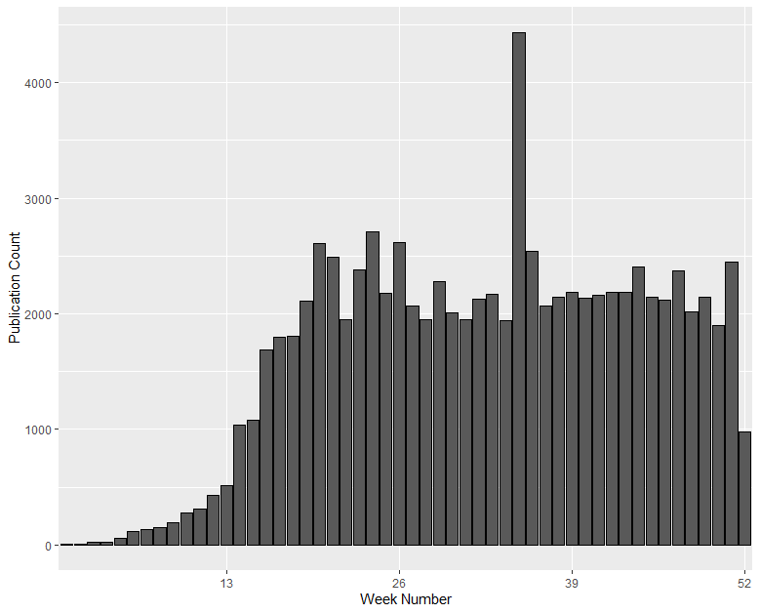
Figure 1.

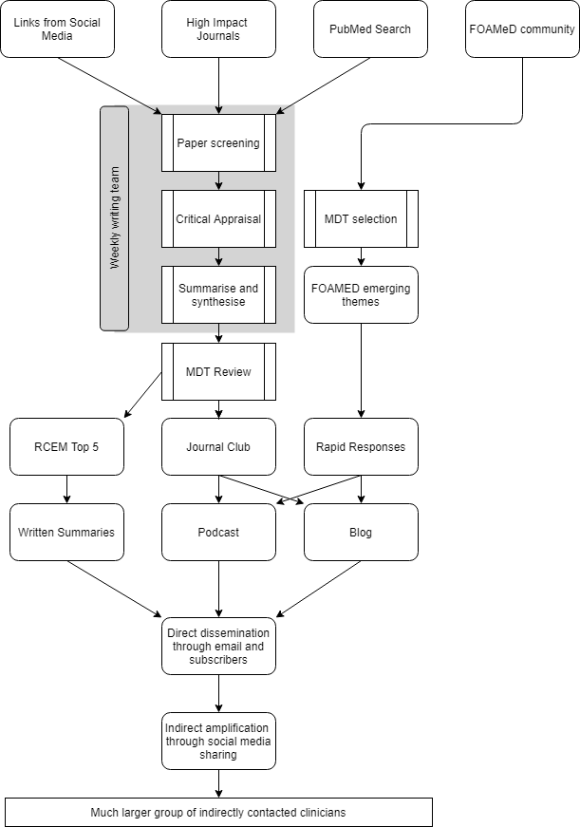
Figure 2.

