Footprints in Spatial Narratives: Reading at the Limits of Digital Literary Mapping
Joanna E. Taylor and Christopher Donaldson
– and not simply by the fact that this shading of
forest cannot show the fragrance of balsam,
the gloom of cypresses
is what I wish to prove. (Boland 2012)
Eavan Boland’s poem ‘That the Science of Cartography is Limited’ (1994) proves a truth about map reading: however detailed its visualisation, a map can never communicate the way it feels to stand in a place. A map might demonstrate what a place looks like, and express a location’s key features, but it ‘cannot show’ what it’s like to be there: to smell the foliage; to feel the ground underfoot; or to understand the associations that make certain features expressive of gloom, like Boland’s cypresses, or, like Wordsworthian daffodils, joy. Places become more meaningful when we acknowledge the numberless interactions at macro and micro scales, and in geographical and phenomenological ways, that make it so. Cartography, as Boland’s poem indicates, is good at representing where things are, but limited when it comes to showing why things matter. Poetry is the opposite: it often ekes out, foot by foot, the feeling of being somewhere – but where precisely can be difficult to pin down. There are three elements at play in the relationship Boland describes: location, body, and perception. The map’s province is location; the poem’s is perception. But what of the body, the entity that mediates between place and perception? How might we communicate the embodied experience of being somewhere in a spatial narrative?
The limitations of analogue maps in capturing a sense of place are exaggerated by their digital counterparts. Notwithstanding attempts to represent digitally the experience of standing in a location (Google’s Street View being an obvious example), digital maps cannot comprehend an embodied sense of place. Indeed, on its own, no visual media can capture the complex and multisensory feeling of being at a particular place, and in a particular body. And that matters, because our unique bodies influence the way we experience the world. Re-inserting the body into geographical discussion has long been a focus for feminist geographers; as Doreen Massey demonstrates, assuming a ‘standard’ body of either sex risks eliding the impact of difference – including in gender, health, or mobility – on every spatial experience (Massey 1994). Donna Haraway goes as far as to indicate that a feminist mapping practice would register the ‘view from a body’ as opposed to a ‘view from above’ (Haraway 2013). If conventional maps (at least, in Western cartographic traditions) flatten and elide the differences that define how people perceive and experience a place, then one important job for spatial narratives is to highlight such differences and to illuminate how multifarious human perceptions of places are. Previous work in digital literary studies has amply shown that combining maps with texts can enrich the science of cartography by aligning place with perception. But, in this chapter, we want to go a step further by demonstrating how new technologies afford a means of re-introducing the body as a crucial link between map and text.
Twenty-first century mobile cartographic technologies have re-centred quotidian mapping practices on person rather than place. Wearable technologies and fitness apps have become almost ubiquitous in the last few years; in the US in 2013, 21% of adults reported using digital technology to track some aspect of their body (e.g. weight, heart rate, blood pressure). By 2018, that figure had risen to 70%. The data captured by these technologies threaten to disrupt understandings of subjectivity as being ‘unified, rational, and static’ (Mitchell 2013). Instead, they break down both body and place into a multifaceted series of cartographic marks, including GPS tracks, step-counts, heart rate, calories burned, or distance covered. We might consider these technologies as examples of mapmaking which emphasise movement over stasis, line over point, and connection over individuation. The result, as Peta Mitchell has concluded, is ‘a reassertion of local agency’ (Mitchell 2013). Mitchell means the map reader. But wearables also make it possible for the map writer to reflect multivalent and individuated spatial subjectivities. In quantifying the individual’s relationship to their location, recent research involving wearables has emphasised the extension of cartographic interest from geographic sciences towards the arts and humanities (Berglund, Duvall, and Dunne 2016; Broadhurst and Price 2017; Guler, Gannon, and Sicchio 2016; Horvath, Hoge, and Cameron 2016; Pedersen, Everrett, and Caldwell 2020; Pedersen and Iliadis 2020). Justin Tonra’s project Eververse has introduced wearables into discussions of poetry; his interdisciplinary team investigated how data from the quantified self can be used alongside poetic theory and Natural Language Generation to produce automatically a form of literally embodied poetry (Tonra et al. n.d.). Yet, outside of the performing arts, rhetoric, and fashion studies, wearable technologies are not yet widely used in humanities research. This chapter seeks to encourage more creative-critical experimentation with wearables by showing how they can contribute to the study of literary spatial narratives. Specifically, the chapter demonstrates how incorporating embodied data – including heart-rate monitoring and GPS tracks – alongside a literary text in a mapping environment can transform not only how we read, but also how we understand the role of embodiment in historical and contemporary place-making.
To do so, the chapter takes as a case study one particular text: Dorothy Wordsworth’s epistolary account of her pioneering ascent of England’s highest mountain, Scafell Pike, on October 7, 1818. The letter in which Wordsworth described this feat is one of the earliest known records of a recreational ascent of England’s highest mountain (the earliest occurred three years before) (Taylor and Gregory 2021), and it is the first known account written by a woman. The original manuscript of Wordsworth’s letter does not survive, but her account was first published in her brother William’s Description of the Scenery of the Lakes in 1822. This book later became William’s bestselling Guide through the District of the Lakes, and the inclusion of Dorothy’s letter in it inspired several generations of walkers to follow in her footsteps – even if, since the letter was published without attribution, these walkers thought they were following William. We read this letter alongside data gathered from a recreation of this walk by a party of researchers, artists and mountaineers who retraced Wordsworth’s footsteps on October 7, 2020. In part, this was a reimagining of an important moment in the history of British Romanticism and the history of mountaineering. But, as this chapter contends, the recreation was also an opportunity to reflect on the relationship between reading and digital technologies, wherein the maps created by walking this route might transform the ways we read and respond to the texts the initial ascent inspired. The chapter’s ultimate claim is therefore that bringing these two types of data – those generated by author and by reader – together can foreground a phenomenology of place that induces new ways of reading both text and map, and that positions embodiment as a central element in scholarship on digital mapping.
This approach is well suited to Wordsworth. She was born in Cockermouth, Cumberland (now Cumbria), at the edge of the modern Lake District National Park and World Heritage Site (Figure 1) in 1771. She was 9 years old when the earliest wearable fitness technology – a pedometer made by a Swiss watchmaker – was manufactured (‘Perrelet’ n.d.). By the 1790s, as her career as a prodigious walker was beginning (Andrews 2020), these devices were available in London. Wordsworth did not use a pedometer herself, but her letters prove that she kept track of the distances she walked and the pace at which she did so. Her decision to include such data in epistolary descriptions of her journeys reflects the role that counting and measuring played in her poetics of walking. Throughout her life, Wordsworth remained sensitive to the interplays between place and person, text and map. Her journals and letters in particular reveal her efforts in recreating something of the lived experience of place in text. Most of these works were not published during her lifetime, and in them we often find personal impressions and detailed accounts that connect place and perception through the body.
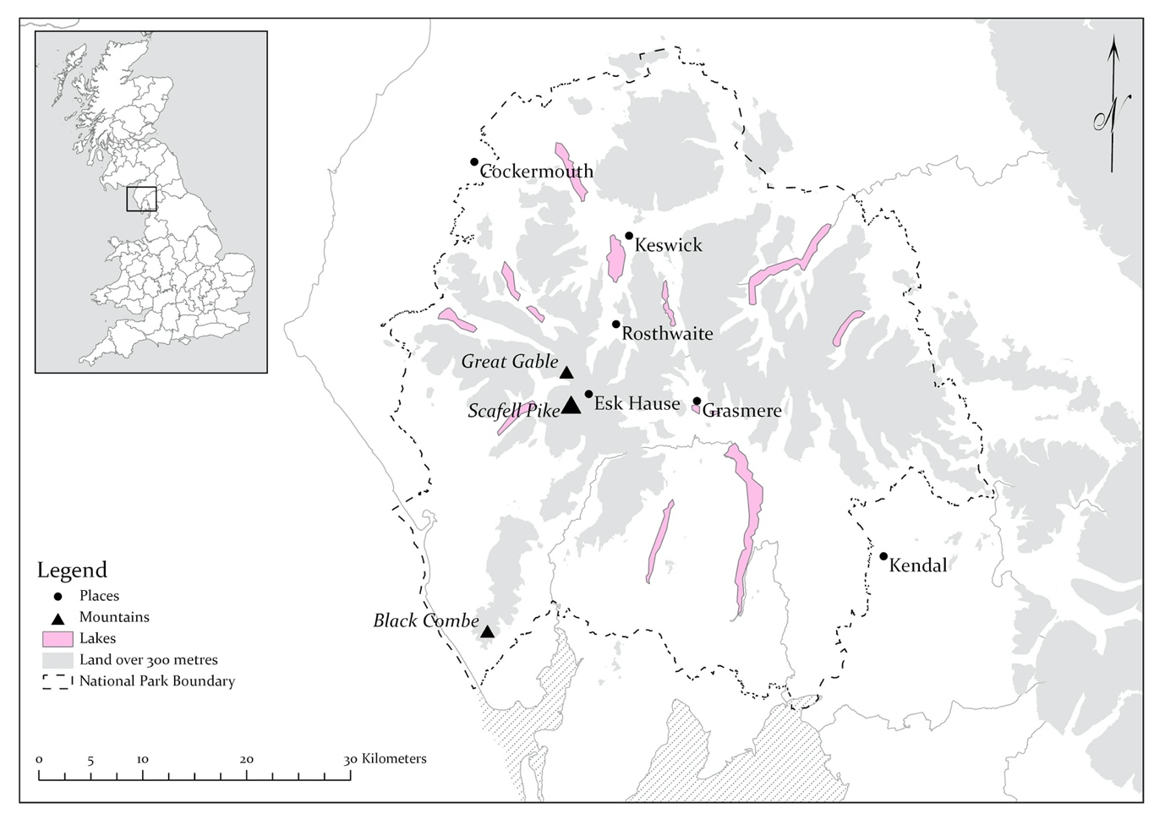
[Figure 1: England’s Lake District.]
The new approaches to reading we present herein share much in common with historical reading practices, including the sort of participatory reading in which Wordsworth herself engaged. When William Wordsworth went on a walking tour of the Alps in 1790, he sent Dorothy letters that described his journey. While William ‘march[ed]’ at ‘military speed’ (Prelude VI.428) (Wordsworth 1926) through the Swiss mountains, Dorothy used his letters to trace his route on a map, an action which allowed her to partake vicariously in the excursion. Following William’s journey on the map evidently helped her feel a connection with her absent brother and to share in the bodily experiences of the walking tour; she wrote to her friend Jane Pollard that when she ‘trace[d] his paths upon the maps’, she wondered ‘that his strength and courage have not sunk under the fatigues he must have undergone’ (De Selincourt 1935). William, for his part, was imagining that the landscape was a ‘book’, in which he ‘could not chuse but read | A frequent lesson of sound tenderness’ (Prelude VI.473–75) (Wordsworth 1926). Collectively, then, as brother and sister they developed a cyclical, reciprocal relationship between text and place. What both Wordsworths enacted in different ways in this example is what we call active reading. In her reading of William’s letters, Dorothy not only dynamically participated in the creation of meaning, but also translated his descriptions into activity. By following the map’s contour lines, she sensed the bodily ‘fatigue’ her brother must surely have felt. Her fingers replaced his feet; the map stood in for the landscape, and this enabled the siblings to share the journey through the medium of the letters. The data from wearable technologies, we suggest, can offer similar insights into the active reader’s bodily engagement with both text and landscape, and contribute to a spatial narrative which blends cartography and phenomenology.
Yet, the emergent analytical practices wearables might facilitate in studies of written works is underexplored. The connection between body, location, and text that our practice develops begins to move us towards the pinnacle of the spatial narrative as the highly curated peak of the deep map pyramid (Ridge, Lafreniere, and Sarma 2013): a mode of analysis based both on a particular text and/or location, and its interactions with a specific body. Birringer and Danjoux discovered in 2009 that ‘the mobilisation of smart technology concerns sensorial experience and expression’ that can encourage ‘a more experimental and playful adaptation of the digital medium as a wearable medium’ (Birringer and Danjoux 2009). Here, we adapt this performance-focused approach to suggest that the mobilisation of this technology, which uniquely captures elements of the physical processes that inform perception, can lead to experimental and playful textual analyses that translate digital data into interpretative tools. Just like secondary reading can enhance our understandings of a literary work, so too can using digital data in this way augment our personal and critical relationships with the text.

Mapping the body: wearable technologies and spatial narratives
Before we proceed to explain how wearables can contribute to the study of spatial narratives, a brief overview of wearable technology is in order. Such technology, as Catherine Gouge and John Jones have suggested, comprises an array of devices ‘whose primary functionality requires that they be connected to bodies’ (Gouge and Jones 2016). The design, manufacture, and use of these devices has grown rapidly over the past 20 years. Even taking into account a decline in the market thanks to the COVID pandemic (Hamblen 2020), the wearables market is on track to increase from a worth of $27 billion in 2019 to $64 billion by 2024 (‘Wearable Tech Market Set to Grow’ 2020). What the ongoing expansion of this industry indicates is that embodied experience matters – and that, as Steve Benford puts it, ‘our interaction with computers is not only a matter of abstract cognition, but also reaches out into the physical and material’ (Benford 2017). The result is a concurrent machinisation of humans with the humanisation of machines (Zheng 2017), making ‘digital humanity’ less of an oxymoron than some might wish to believe.
Wearable devices tap into our fascination with observing ourselves (Chalfen 2014): they facilitate ways of recording our actions, and of monitoring our habits towards the improvement of personal, even global, health by tracking information such as our calorie intake, exercise habits, or carbon footprint (Forrester 2014). As well as personal tracking, wearables have been experimented with to address global challenges; they have proved highly valuable throughout the COVID-19 pandemic, for instance (‘Wearable Wonderland: How Tech Is Tackling Covid-19’ 2020). Since around 2014, the most popular items on the market have been wristbands or watches (Berglund, Duvall, and Dunne 2016) that track elements like heart rate, oxygen saturation, stress levels, activity levels, footsteps, and – via GPS chips – location. At the same time as promising something like ‘mastery of the organized complexity of bodily systems’ (Gouge and Jones 2016), the physical data tracked by these devices can offer something more: a means of communicating and interpreting the user’s emotional state (Zheng 2017) The result is something approaching a comprehensive account of what the physician Eric Topol calls the ‘high definition human’ (Topol 2015) – although it is worth noting that, in most cases, being ‘human’ in the development of sports and wearable technologies usually means being a man (Criado Perez 2019).
The vocabulary applied to wearables indicates their centrality to the contemporary lives of affluent societies; in Johannes Birringer’s words, ‘you wore clothes, but now you wear a smart device’ – rhetoric that indicates how ubiquitous such devices are in day-to-day apparel. The dark side to this ubiquity is that it expands significantly the ability of those in power to understand and utilise our most intimate data; as Birringer continues, if you wear these devices, ‘you wear sensors and wireless transmitters, and you can be tracked’ (Baker 2017). Users’ data is harvested – and, in fact, owned – by the device manufacturer, who may sell it to insurance or healthcare companies (Baker 2017). Data security has been consistently secondary – both for producers and consumers – to novelty, functionality, and fashion (Dwivedi et al. 2019). This laxity has consequences that reach beyond data protection: revelations that Huawei included in patents that its systems could help to track Uighur Muslims indicate how such technologies can aid and abet the violation of human rights (BBC News 2021).
Nevertheless, wearables significantly impact the way we experience and respond to space. Users reporting changing their habits in response to their device – for example, consciously walking more to hit the ‘10,000-step’ mark (Lemos and Bitencourt 2017) – is perhaps the most obvious example, but the effects of marrying wearables with the body to navigate our place in the world are far-reaching. By moving away from perceiving wearables from what N. Katherine Hayles describes as a posthuman view (Hayles 1999) that privileges the so-called quantified self, and towards acknowledging wearables as what Jordynn Jack – promoting a feminist framework for assessing wearables in rhetoric studies – calls ‘embodied rhetorics’ (Jack 2016), we can incorporate wearables and the data they generate into a cohesive framework for producing literary spatial narratives. In fact, doing so can help us participate in the spatial narratives we investigate: wearable technologies, as Jason Kalin and Jordan Frith note, ‘foreground the specificity of location and embodiment, the user’s body in space and time’ (Kalin and Frith 2016).
Incorporating data taken from a wearable device into literary analysis presents an intriguing opportunity to investigate a physiology of active reading in ways that are both deeply intimate – focused on one body, and one text – and which have the potential to engage with big data. That might be physiological (data taken from other users of wearable technology tracked at the same location), textual (other written accounts of the place), or cartographic. In the latter case, wearables present a unique opportunity: by appearing to foreground individual interactions with, and bodily responses to, the environment, wearables can destabilise standardised cartographic hegemonies. They might be the best instance we have developed so far of what Guattari might recognise as chaosmotic maps (Guattari 1995): cartographies that reflect the multifaceted nature of subjective experience, challenge Cartesian dichotomies between mind and body, or body and world, and facilitate new forms of exploration into the inherent plurality of spatial narratives.
If the human body is a ‘key frontier for creating powerful and deeply engaging ways of interacting with computers’ (Benford 2017), then wearable technologies offer a way of mediating between environment (including, as we demonstrate here, reading material), body, and machine. Positioning the data tracked – including location, pulse, elevation climbed, or pace – alongside an account of being in the same place at a different time (in our example, two centuries apart) might, we suggest, allow us to develop an approach to spatial narratives that acknowledges active reading as a physiological activity, at the same time as recognising the experience of space as a textual – or, at least, interpretative – one. Like Merleau-Ponty, we are suspicious of any suggestion that there is a straightforward ‘point-by-point correspondence’ between being and feeling – but like him, too, we want to explore physiology’s role in the connection between the body and the ‘idea of an external world’ (Merleau-Ponty 2012).
The sort of active reading we outline below can provide an approach to a range of different spatial narratives, but it is especially suited to narratives, such as Wordsworth’s, which dwell on the author’s embodied experience. This is a point Simon Bainbridge has stressed in his recent study of Romanticism and mountaineering. Wordsworth’s Scafell letter, as Bainbridge affirms, repeatedly draws attention to her ‘awareness of her embodied state’ (Bainbridge 2020). Our investigation of active reading aims to extend this line of enquiry into spatial narratives, in general, and Wordsworth’s letter, in particular. Accordingly, in what follows we demonstrate how interpreting the data wearables track can inform a new mode of spatially conscientious narrative analysis that acknowledges both the bodily and the intellectual experience of reading.

‘Active’ reading: following Dorothy Wordsworth up Scafell Pike
Walking was central to Wordsworth’s life and writing. She completed her first long-distance walk in 1794 with her brother, trekking from Kendal at the southern edge of the Lake District to Keswick at the northern end. In 1803, she, William, and (for a while at least) Samuel Taylor Coleridge undertook a tour of Scotland. Wordsworth recorded their impressions in her Recollections of a Tour made in Scotland, a text that, after its publication in 1874, became the most widely read account of pedestrian tours to Scotland (Leask 2020). Later, in 1820, she – with William, his wife Mary, and some family friends – completed a pedestrian tour of the Alps. This trip also inspired a travel journal, which Wordsworth circulated among friends. But Wordsworth’s ascent of Scafell Pike is particularly notable for the daring it displayed. Wordsworth’s description of this excursion captures her approach to mountaineering: it goes beyond tales of sporting prowess, preferring instead to examine the details of the mountainside and to reflect on the experience of the journey.
In 1818, Scafell Pike was an uncommon choice for a recreational climb. Wordsworth’s letter, as we have mentioned, is the first known record of a recreational ascent by a woman. It is actually pre-dated only by a party led by the geologist, surveyor, and mechanic Jonathan Otley in 1815. The massif was even, in some cases, left off popular maps of the region; the profile map published by William Hutchinson in 1794 is not alone in dismissing the west of the Lake District as being uninterestingly ‘desolate and mountainous’ (Hutchinson 1794). It was not until Otley’s publication of A New Map of the District of the Lakes in 1818 – mere weeks before Wordsworth’s excursion – that the massif was properly mapped. After Wordsworth’s account of the climb was published in her brother’s Guide, it became a canonical text for the region’s mountaineers; writer-walkers including Thomas Wilkinson, Harriet Martineau, and Eliza Lynn Linton all followed in her footsteps. Indeed, modern routes up the mountain still reflect the re-inscription of Wordsworth’s route by readers on the mountainside. Figure 4 shows her route, modelled on the letter and with data taken from the Lake District National Park’s Digital Public Rights of Way dataset (Lake District National Park Authority 2019).
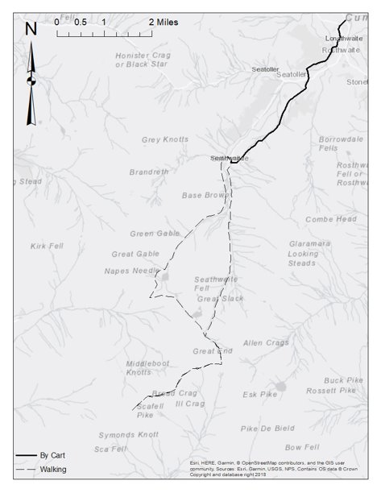
[Figure 4: Dorothy Wordsworth’s route up Scafell Pike, October 7, 1818, combining data from her letter with the Lake District National Park’s Digital Public Rights of Way dataset]
Wordsworth’s ascent of Scafell Pike, then, is even more remarkable in this context. She undertook the ascent with her friend Mary Barker, ‘an unmarried Lady’ who lived in Borrowdale. Also accompanying them were Barker’s maid, Agnes, a porter, and a shepherd who served as their guide. Wordsworth reported that Barker had been ‘bewitched with the charms of the rocks, & streams, & Mountains, belonging to that secluded spot’, and had ‘there built herself a house’. Barker occupied herself with painting, music, reading and, Wordsworth records, in becoming an ‘active Climber of the hills’ (Wordsworth 1967). This appellation recognised Barker’s commitment to exploring the uplands; not only had she moved – like Wordsworth herself – to the region better to access the uplands, she deliberately sought out mountainous adventures. No passive consumers of the scenery, Barker and Wordsworth shared an ‘active’ appreciation of the landscape that situated embodiment at the heart of their spatial narratives. Moreover, both aimed to share the experiences that, in Bainbridge’s words, they had ‘found to be so rewarding’ (Bainbridge 2020), whether by organising excursions with friends, or by sharing written accounts of them.
It is this foregrounding of ‘active’ pursuit that inspired a recreation of Wordsworth and Barker’s pioneering ascent, 200 years to the hour after the original. Part of the collaborative project This Girl Did: Dorothy Wordsworth and Women’s Mountaineering (led by the Wordsworth Trust with an international group of academics and artists), the recreation had three aims: first, to promote Wordsworth’s role in the development of women’s mountaineering; second, to conduct an embodied exploration of what the ascent might have felt like for Wordsworth and her party; and third to investigate how a recreation of this walk might guide new modes of reading Wordsworth’s account. There were five principal actors at this event: Alex Jakob-Whitworth, a Cumbria-based artist, took on the role of Wordsworth; Harriet Fraser, poet and one half of the SomewhereNowhere collective, was Barker; Joanna Taylor (Manchester University) was Agnes; Paul Westover (Brigham Young University) was the porter; and Paul Davies, a local GP and member of the Ambleside amateur dramatics group, was the shepherd guide. We were accompanied by a support team (including Jeff Cowton, Curator at Wordsworth Grasmere), and two filmmakers (who were also Mountain Rescuers), Jago Miller and Richard Berry, documented the event (Miller 2018).
October 7, 1818 was a glorious day, and Barker and Wordsworth set off by cart from Barker’s home in Rosthwaite at around 9.30 in the morning, anticipating an invigorating climb up Esk Hawes, from which Barker had promised ‘a magnificent prospect’. They acquired their guide from Seathwaite, at the foot of the mountain, and set off up the fell feeling refreshed by the autumn air and ‘the sweet warmth of the unclouded sun’. Once they had lunched at Esk Hawes, though, they decided there was enough time – and that they had enough energy – left to keep going. Notwithstanding the miles they had already walked that day, they agreed to head over to Wasdale and up Scafell. They had climbed so high in any case that they seemed already to be ‘three parts up that Mountain’. Although the distance turned out to be ‘greater than it had appeared’, still their ‘courage did not fail’. As they reached the top of Scafell Pike, Wordsworth and Barker realised that they had climbed out of the reach of the Lake District’s familiar sounds: they ‘paused & kept silence to listen, & not a sound of any kind was to be heard’. Not even an insect ‘hum[med] in the air’. They completed the descent, past Sprinkling Tarn, by the light of a full moon. Other than a brief rainstorm near Illgill Head, they had enjoyed the best of Britain’s October weather.
October 7, 2018 was cold, wet, and exceptionally windy; the first edges of what would become Storm Callum were beginning to blow into the western Lakes. Having gathered at Barker’s former home, now the Scafell Hotel, our party set off by car at around 9.30 to Seathwaite, following a near-identical route to Barker and Wordsworth’s cart. We were wearing clothes similar to what Wordsworth’s party would have worn (with the exception that we wore modern walking boots and carried waterproofs with us, and Taylor was wearing a smart watch), and the Scafell Hotel had generously provided a lunch of period-relevant eatables for the maid to carry up in her wicker basket, and the porter to take in his satchel. Up to Esk Hause, we enjoyed weather not dissimilar to the sort Wordsworth and Barker experienced in 1818, and we paused at points to enjoy the views, to talk, and to read excerpts of Wordsworth’s letter. Like Wordsworth and Barker, we enjoyed the ‘magnificent prospect’ as we ate. But, as we ascended the ridge up to Illgill Head, from whence to proceed across boulders to Scafell Pike, the storm blew in. Given the kite-like nature of long skirts, and the worryingly decreasing visibility, we were forced to descend early. Sprinkling Tarn lived up to its name, spraying vertical jets of water up into the gales as we passed. A new moon made the last part of the journey rather more treacherous than it had been 200 years before.
Wordsworth’s letter provided the information we needed to plan the route and, more than that, it offered a guide towards how we should experience the ascent. The letter emphasises how it feels to be moving on the mountain, and becoming part of it – for a time at least. Wordsworth’s peculiarly forthright interest in the relationships between place, text – whether cartographic or written – and body emphasises the limitations of conventional cartographic visualisation. The recreation had also highlighted the limits of standard literary analysis; following in Wordsworth’s footsteps had required an extraordinarily close reading of the text, and, in the chilly afterglow of the experience, a more usual analysis did not seem enough to capture adequately the experience, and the meaning, of being on the mountain. We had discovered what Dorothy had elsewhere described: that no written or visual representation can, alone, capture what it feels like to be at a place (Taylor 2019). Comparing the physiological data mapped through a wearable device with Wordsworth’s account offered an opportunity to address the limitations of both cartography and literary analysis to generate a spatial narrative that combined digital and literary material with criticism mediated through an embodied experience of place.

Beyond description: incorporating wearables into literary analysis
During the recreation, Taylor had been wearing a Garmin Vivosmart 2, a smart watch brand that has been praised, among other things, for offering accurate measurements and being waterproof (a feature that proved essential on our rain-sodden excursion) (Guler, Gannon, and Sicchio 2016). Tracking the route on the watch served two purposes: first, it allowed us to compare our actual route with the original; but second, and more significantly, it offered a way of experimenting with how to create a form of mapping that combined reading, embodiment, and digital data. The aim was to embed an ecosystem – to adapt a phrase from Adam Hammond, Julian Brooke, and Graeme Hirst – of embodied close reading (Hammond, Brooke, and Hirst 2016) into the construction of a spatial narrative that linked 1818 with 2018 via footprints over the same mountain. In documenting the performance of this excursion, the watch recorded the creation of what Schwartz and Halegoua call the ‘spatial self’, a character created by ‘intentional socio-cultural practices of self-presentation that result in dynamic, curated, sometimes idealized performances of who a user is, based on where they go’ (Schwartz and Halegoua 2015). In this case, the ‘spatial self’ was a hybrid identity: a mixture of the modern walker and the historical figure in whose footsteps we, quite literally, followed. The watch data documented the process of inserting an individual into a transhistorical group: this was not simply a case of sharing social data among our contemporaries, as such devices are designed to do (Kalin and Frith 2016). More, it recorded a physical experience shared, however vicariously, across centuries.
The watch data – route, elevation, pace, and heartrate – articulated an intimate connection between body, text, and landscape. For instance, overlaying the pace data onto the elevation indicated the places where we – mimicking the 1818 party – paused to talk, admire the views, or eat (Figure 6). In doing so, the pace data begins to reflect the letter’s structure: the places where the pace data indicates we slowed down or paused recalls the longer sentences and paragraphs that, in the letter, reveal a moment where Wordsworth had also slowed down to more carefully document her impressions. The top of Esk Hawes – Wordsworth and Barker’s original destination – offered such a moment. Two long sentences record a physical pause as Wordsworth, exhilarated, looked out across the region:
The green Vale of Esk deep & green, with its glittering serpent stream was below us; and on we looked to the Mountains near the sea – Black Coombe and others and still beyond to the sea itself in dazzling brightness. Turning round we saw the Mountains of Wasdale in tumult; and Great Gavel [sic], though the middle of the Mountain, was to us as its base, looked very grand. (Wordsworth 1967)
The embodied connection between herself and the mountains that Wordsworth recounts seems to have physically invigorated her. Maria Jane Jewsbury described Dorothy as being ‘an embodied spell’, and passages like this one give some indication of where that magic came from: she seemed almost to draw up energy from the ground. Each main clause here – distinguished by the semi-colons, dashes, and full stops – follow Wordsworth’s ‘turning round’ so that the experience of standing at a particular location is encoded into the text. The commas, meanwhile, mimic the effect of place on perception; they distinguish the groups of objects or impressions that came together in one view, from the ‘serpent stream’ winding its way through the lush valley, to the mountains along the Furness peninsula seeming to join with the sea; to Great Gable’s deceptive base, appearing from her viewpoint as though it rose up from the centre of Scafell. The letter here records the realisation of a monumental connection between body, perception, and place – and the watch records a similar effect. The peaks and troughs of the pace data are a counterpart to Wordsworth’s broken-up sentences, and reflect both the challenges of negotiating a difficult landscape, and the moments of pause and reflection that these negotiations facilitate. As we reach Esk Hause, our pace data slackens and lengthens out to match the plateau at the summit. Like Wordsworth’s long sentences, this pause records a moment of tranquillity to take in the multifaceted view.
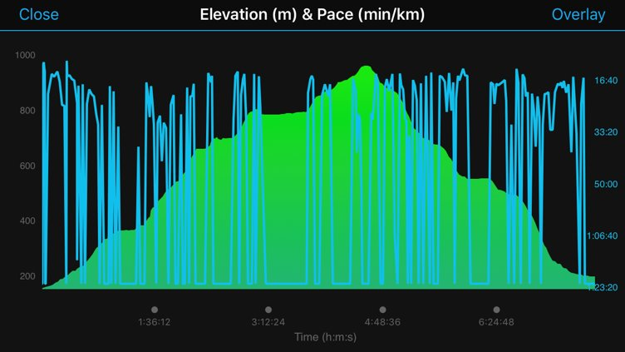
[Figure 6: pace and elevation data from Taylor’s Garmin Vivoactive2, 7 October 2018.]
The heartrate data makes this reciprocity between body, place, perception, and text even clearer. Wordsworth had recorded that the climb up to Esk Hause was ‘invigorating’, and the quickening of the heartrate data from the watch corroborates a shared experience. The climb is so ‘invigorating’ in part because it documents – in text for Wordsworth, and data for the recreation – a mutual connection between geology and physiology (Figure 7): that degree of physical exertion rises and falls with that of the terrain. At the top of Esk Hause, though, the heartrate data goes further: it allows us to develop Wordsworth’s account beyond words. She wrote of this moment that:
We found ourselves at the top of Ash Course without a weary limb, having had the fresh air of autumn to help us up, & the sweet warmth of the unclouded sun to tempt us to sit and rest by the way. From the top of Ash Course we beheld a prospect which would indeed have amply repaid me for a toilsome journey, if such it had been; and a sense of thankfulness for the continuance of that vigour of body, which enabled me to climb the high mountain, as in the days of my youth, inspiring me with fresh chearfulness, added a delight, a charm to the contemplation of the magnificent scenes before me which I cannot describe[.] (Wordsworth 1967)
She cannot describe the ‘delight, [the] charm’ of the moment because it is deeply embodied – but that is precisely where the data from the wearable steps in: it visualises the indescribable. The heart rate captures something similar to what Wordsworth recalls: a sense of repose, but not rest. What Wordsworth articulates here is an active appreciation of the view that self-consciously unites perception and place with a deeply embodied experience where the text and the landscape are united in the same breath. The data represents a profound experience of a deep and embodied close reading that transforms Wordsworth’s writing from a generic description of a location into something micro-mappable that that registers, evidently, in each heartbeat. This embodied data closes the gap between the body and the digital, the person and the place, and between the reader and the writer. It becomes the text through which we can read a personal ecology as part of three wider ecosystems: the natural, the historical, and the computational.
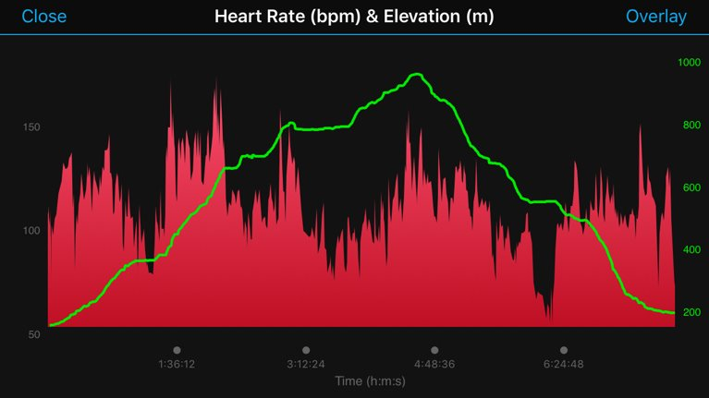
[Figure 7: heartrate and elevation data from Taylor’s Garmin Vivoactive2, 7 October 2018.]
The approach we have outlined here offers new possibilities for the study of each of these ecosystems. Recognising the uniqueness of the body being tracked – including both the vital statistics captured by the wearable and the body’s historical, social, and political situation – is crucial for challenging the homogenisation of the body-as-big-data that wearables risk promoting (Happe 2013; Gouge and Jones 2018). More than this, though, it encourages the recognition of this data as narratives in themselves, and therefore as texts to be analysed carefully. At a larger scale, using data from a wearable offers the possibility of comparing individual results with those of other users, potentially on a massive scale (the limitation being the availability of that data from private companies). Exploring the relationships we’ve outlined here – between pace, heartrate, and landscape – would allow us to ask how or to what extent other users engage, knowingly or not, with the cultural landscape generated through Wordsworth and others’ writing. Moreover, understanding the intersection between person, perception, and place may be one of the ‘previously unidentified relations’ that Gouge and Jones suggest would allow wearers better to engage with ‘an expanded range of potential relations with bodily processes’ (Gouge and Jones 2018). What, for instance, would a device that tracked the kind of physiological poetics that we have addressed here – moments of pause, of attention, registered in the slowing down of the body’s actions – look like? How might that data allow us to develop our understandings of people’s interactions with, and feelings towards, particular locations or environments? And how might that data feed in to both the development of affective computing (Picard 2000), and to the ways we understand perceptions of the non-human world at a large scale? How, in other words, might such questions help to close the gap between person, perception, and place?
These are important questions: if treating wearables as no more than representations of the body elides the embodiment that characterises individual experience (Gouge and Jones 2018), then it also risks perpetuating a divorce between the body and its environment (Kalin and Frith 2016). Might understanding wearable data as a new form of spatial narrative move us towards situating wearables as an everyday, everywhere reminder to connect differently with the places through which we move? Might they initiate new opportunities not only for aligning historical texts with present spatial experiences, but for cohering anew the active body with the long histories and projected futures of a particular place? In short, might interpreting the data from wearables as and alongside text allow for more widespread acknowledgement that, in Bruno Latour’s words, ‘there are not organisms on one side and an environment on the other, but a coproduction by both’ (Latour 2018)? A spatial narrative that blurs the boundaries between where the landscape ends and the body begins might offer a unique opportunity for a new kind of ecocritical storytelling.

Acknowledgements
We would like to thank attendees of the 2018 RSAA conference in Canberra for their considered reflections about the ideas embedded in this chapter. Thanks are due to the This Girl Did team – Alex Jakob-Whitworth, Harriet Fraser, Paul Westover, and Melissa Mitchell and Jeff Cowton at the Wordsworth Trust – for their collective enthusiasm and generosity in collaborating on the reimagining of the Scafell excursion. Kerri Andrews and Jonny Huck both offered thoughtful feedback on a draft of this piece. We are also grateful to support received from the Faculty of Arts and Social Sciences at Lancaster University.

Works Cited
Andrews, Kerri. 2020. Wanderers: A History of Women Walking. London: Reaktion Books.
Bainbridge, Simon. 2020. Mountaineering and British Romanticism: The Literary Cultures of Climbing, 1770-1836. Oxford: Oxford University Press.
Baker, Camille. 2017. ‘Critical Interventions in Wearable Tech, Smart Fashion and Textiles in Art and Performance’. In Digital Bodies: Creativity and Technology in the Arts and Humanities, edited by Susan Broadhurst and Sara Price, 175–90. Basingstoke: Palgrave Macmillan.
BBC News. 2021. ‘Huawei Patent Mentions Use of Uighur-Spotting Tech’, 13 January 2021, sec. Technology. https://www.bbc.com/news/technology-55634388.
Benford, Steve. 2017. ‘Foreward’. In Digital Bodies: Creativity and Technology in the Arts and Humanities, edited by Susan Broadhurst and Sara Price, v–ix. Basingstoke: Palgrave Macmillan.
Berglund, Mary Ellen, Julia Duvall, and Lucy E Dunne. 2016. ‘A Survey of the Historical Scope and Current Trends of Wearable Technology Applications’. In Proceedings of the 2016 ACM International Symposium on Wearable Computers, 40–43. ISWC ’16. New York, NY, USA: Association for Computing Machinery. https://doi.org/10.1145/2971763.2971796.
Birringer, Johannes, and Michèle Danjoux. 2009. ‘Wearable Performance’. Digital Creativity 20 (1–2): 95–113. https://doi.org/10.1080/14626260902868095.
Boland, Eavan. 2012. New Collected Poems. Carcanet.
Broadhurst, Susan, and Sara Price, eds. 2017. Digital Bodies: Creativity and Technology in the Arts and Humanities. Basingstoke: Palgrave Macmillan UK. https://doi.org/10.1057/978-1-349-95241-0.
Chalfen, Richard. 2014. ‘“Your Panopticon or Mine?” Incorporating Wearable Technology’s Glass and GoPro into Visual Social Science’. Visual Studies 29 (3): 299–310. https://doi.org/10.1080/1472586X.2014.941547.
Criado Perez, Caroline. 2019. Invisible Women: Exposing Data Bias in a World Designed for Men. London: Chatto & Windus.
De Selincourt, Ernest, ed. 1935. The Letters of William and Dorothy Wordsworth: The Early Years 1787-1805. Oxford: Clarendon Press.
Dwivedi, Yogesh, Emmanuel Ayaburi, Richard Boateng, and John Effah, eds. 2019. ICT Unbounded, Social Impact of Bright ICT Adoption: IFIP WG 8.6 International Conference on Transfer and Diffusion of IT, TDIT 2019, Accra, Ghana, June 21–22, 2019, Proceedings. Vol. 558. IFIP Advances in Information and Communication Technology. Cham: Springer International Publishing. https://doi.org/10.1007/978-3-030-20671-0.
Forrester, Ian. 2014. ‘Quantified Self and the Ethics of Personal Data’. BBC R&D. 2014. https://www.bbc.co.uk/rd/blog/2014-06-qs-ethics-of-data.
Gouge, Catherine, and John Jones. 2016. ‘Wearables, Wearing, and the Rhetorics That Attend to Them’. Rhetoric Society Quarterly 46 (3): 199–206. https://doi.org/10.1080/02773945.2016.1171689.
———. 2018. ‘Wearable Technologies and Invention’. Rhetoric Review 37 (4): 421–33. https://doi.org/10.1080/07350198.2018.1497887.
Guattari, Félix. 1995. Chaosmosis: An Ethico-Aesthetic Paradigm. Indiana University Press.
Guler, Sibel Deren, Madeline Gannon, and Kate Sicchio. 2016. Crafting Wearables. Berkeley, CA: Apress. https://doi.org/10.1007/978-1-4842-1808-2.
Hamblen, Matt. 2020. ‘Wearables, Wearable Sensors Gain Popularity with Pandemic, despite 2020 Revenue Lull’. FierceElectronics. 23 November 2020. https://www.fierceelectronics.com/electronics/wearables-wearable-sensors-gain-popularity-pandemic-despite-2020-revenue-lull.
Hammond, Adam, Julian Brooke, and Graeme Hirst. 2016. ‘Modeling Modernist Dialogism: Close Reading with Big Data’. In Reading Modernism With Machines: Digital Humanities and Modernist Literature, edited by Shawna Ross and James O’Sullivan, 49–78. Basingstoke: Palgrave Macmillan.
Happe, Kelly E. 2013. The Material Gene: Gender, Race, and Heredity after the Human Genome Project. New York: New York University Press.
Haraway, Donna. 2013. Simians, Cyborgs, and Women: The Reinvention of Nature. Routledge.
Hayles, N. Katherine. 1999. How We Became Posthuman: Virtual Bodies in Cybernetics, Literature, and Informatics. Chicago: University of Chicago Press.
Horvath, Joan, Lyn Hoge, and Rich Cameron. 2016. Practical Fashion Tech. Berkeley, CA: Apress. https://doi.org/10.1007/978-1-4842-1662-0.
Hutchinson, William. 1794. The History of the County of Cumberland: And Some Places Adjacent, from the Earliest Accounts to the Present Time: Comprehending the Local History of the County; Its Antiquities, the Origin, Genealogy, and Present State of the Principal Families, with Biographical Notes; Its Mines, Minerals, and Plants, with Other Curiosities, Either of Nature Or of Art ... F. Jollie.
Jack, Jordynn. 2016. ‘Leviathan and the Breast Pump: Toward an Embodied Rhetoric of Wearable Technology’. Rhetoric Society Quarterly 46 (3): 207–21. https://doi.org/10.1080/02773945.2016.1171691.
Kalin, Jason, and Jordan Frith. 2016. ‘Wearing the City: Memory P(a)Laces, Smartphones, and the Rhetorical Invention of Embodied Space’. Rhetoric Society Quarterly 46 (3): 222–35. https://doi.org/10.1080/02773945.2016.1171692.
Lake District National Park Authority. 2019. ‘LDNPA Public Rights Of Way’. 5 July 2019. https://data.gov.uk/dataset/767931ee-c98a-4030-bb87-eb6b6512fb1f/ldnpa-public-rights-of-way.
Latour, Bruno. 2018. Down to Earth : Politics in the New Climatic Regime. Cambridge: Polity Press. http://web.a.ebscohost.com.manchester.idm.oclc.org/ehost/ebookviewer/ebook/bmxlYmtfXzE5ODUzMDZfX0FO0?sid=388adc0f-76dc-43f7-9480-ec178f1f9597@sessionmgr4006&vid=0&format=EK&lpid=navPoint-19&rid=0.
Leask, Nigel. 2020. Stepping Westward: Writing the Highland Tour c.1720-1830. Oxford: Oxford University Press.
Lemos, André Luiz Martins, and Elias Bitencourt. 2017. ‘Smartbody and Performative Sensibility in Fitbit Devices’. Galaxia 36: 5–17.
Massey, Doreen B. 1994. Space, Place, and Gender. Minneapolis: University of Minnesota Press.
Merleau-Ponty, Maurice. 2012. Phenomenology of Perception. London: Taylor & Francis Group.
Miller, Jago. 2018. Journeywoman - Walking in the Footsteps of Dorothy Wordsworth. https://vimeo.com/301608226.
Mitchell, Peta. 2013. Cartographic Strategies of Postmodernity: The Figure of the Map in Contemporary Theory and Fiction. Routledge.
Pedersen, Isabel, Tom Everrett, and Sharon Caldwell. 2020. ‘The Wearable Past: Integrating a Physical Museum Collection of Wearables into a Database of Born-Digital Artifacts’. Digital Studies/Le Champ Numérique 10 (1). https://doi.org/10.16995/dscn.366.
Pedersen, Isabel, and Andrew Iliadis. 2020. Embodied Computing: Wearables, Implantables, Embeddables, Ingestibles. MIT Press.
‘Perrelet’. n.d. Accessed 19 January 2021. https://perrelet.com/en/content/14-history.
Picard, Rosalind W. 2000. Affective Computing. MIT Press.
Ridge, Mia, Donald Lafreniere, and Sisira Sarma. 2013. ‘Creating Deep Maps and Spatial Narratives through Design’. International Journal of Arts and Humanities Computing 7 (1–2): 176–89.
Schwartz, Raz, and Germaine R Halegoua. 2015. ‘The Spatial Self: Location-Based Identity Performance on Social Media’. New Media & Society 17 (10): 1643–60. https://doi.org/10.1177/1461444814531364.
Taylor, Joanna E. 2019. ‘Mountain Matter(s): Anticipatory Cartography in Nineteenth-Century Mountain Literature’. In Anticipatory Materialisms in Literature and Philosophy, 1790-1930. Basingstoke: Palgrave Macmillan.
Taylor, Joanna E., and Ian N. Gregory. 2021. Deep Mapping the Literary Lake District. Lewisburg, PA: Bucknell University Press.
Tonra, Justin, Brian Davis, David Kelly, and Waqas Khawaja. n.d. ‘Eververse’. Text. NUI Galway. Moore Institute @ NUI Galway. Global. Accessed 13 January 2021. https://eververse.nuigalway.ie.
Topol, Eric. 2015. The Patient Will See You Now: The Future of Medicine Is in Your Hands. New York: Basic Books.
‘Wearable Tech Market Set to Grow’. 2020. GlobalData (blog). 13 August 2020. https://www.globaldata.com/wearable-tech-market-set-to-grow-137-by-2024-but-smartwatches-to-see-a-10-decline-in-revenue-this-year-due-to-shipment-delays-and-tighter-consumer-wallets-says-globaldata/.
‘Wearable Wonderland: How Tech Is Tackling Covid-19’. 2020. Medical Technology. October 2020. https://medical-technology.nridigital.com/medical_technology_oct20/wearable_tech_covid-19.
Wordsworth, William. 1926. The Prelude, or Growth of a Poet’s Mind (1850). Edited by Ernest De Selincourt. Oxford: Oxford University Press.
———. 1967. The Letters of William and Dorothy Wordsworth: The Middle Years: Pt. 2, 1812-1820. Clarendon P.
Zheng, Caroline Yan. 2017. ‘Machinising Humans and Humanising Machines: Emotional Relationships Mediated by Technology and Material Experience’. In Digital Bodies: Creativity and Technology in the Arts and Humanities, edited by Susan Broadhurst and Sara Price, 111–27. Basingstoke: Palgrave Macmillan.

A fair copy of a version sent to William Johnson is in the collections of the Wordsworth Trust (WLL / Wordsworth, W and D / 4 / 326).

