The Principle of (Im)politeness Reciprocity

Jonathan Culpeper and Vittorio Tantucci, Lancaster University

Abstract
Despite featuring prominently in religions and legal frameworks, and being discussed by anthropologists and sociologists in relation to rights and obligations in society, reciprocity has not received the attention it deserves in the (im)politeness literature. This article proposes and defines the Principle of (Im)politeness Reciprocity, which concerns the (mis)matching of (im)politeness across participants in interaction – something which can be construed in terms of a debit-credit balance sheet. We claim that this principle, driven by morality, is a fundamental mechanism in shaping (im)politeness in interaction and triggering the search for (im)politeness implicatures. We show how it impacts on various kinds of (im)politeness and interacts with context, especially power. The latter part of the article, focusing on requestive exchanges, is more quantitative in orientation, involving studies based on informant testing and corpus analysis. These reveal, for example, that (im)politeness matching is by far the most common interaction, that mismatches are perceived as clear deviations, and that certain kinds of (mis)matching are associated with specific contexts (e.g. school classroom interaction is associated with downward shifts from polite to less polite). Finally, we briefly discuss possible future research avenues.

Keywords
impoliteness, politeness, power, reciprocity, requestive exchanges

1. Introduction
One of the most famous comedy sketches produced by the British Monty Python group is “The Man who is Alternately Rude and Polite” (part of “Live from the Grill-O-Mat”, episode 18 of Monty Python’s Flying Circus) (widely available on the Internet). It concerns a service encounter between a butcher (played by Eric Idle) and a customer (played by Michael Palin). The setting is a butcher’s shop, with the participants on either side of the counter. The participants’ clothes suggest the time period is somewhere in the first half of the twentieth century. Our transcription of the first part is as follows:

[1] Customer: Good morning, I'd care to purchase a chicken, please.
Butcher: Don't come here with that posh talk, you nasty stuck-up twit. [Laughter]
Customer: I beg your pardon?
Butcher: A chicken, sir. Certainly. Here we are.
Customer: Thank you. And how much does that work out to per pound, my good fellow?
Butcher: Per pound, you slimy trollop, what kind of a ponce are you? [Laughter]
Customer: I'm sorry?
Butcher: Four and sixpence a pound, sir, nice and ready for roasting. [Laughter]
Customer: I see, and I'd care to purchase some stuffing in addition, please.
Butcher: Use your own, you great poovy poolagger! [Laughter]

Clearly, the utterances of this interaction perform the alternation of “polite” and “rude” flagged by the title. Linguistic material that is potentially polite includes good morning, I’d care to (x2), please (x2), I beg your pardon, thank you, my good fellow and I’m sorry; linguistic material that is potentially impolite includes you nasty stuck-up twit, you slimy trollop, what kind of a ponce are you, and you great poovy poolagger. Langlotz and Locher (2017) analyze the same comedy sketch in their work on (im)politeness and emotion, noting that the butcher’s impoliteness breaks frame expectations for seller-buyer talk. However, for us, the central aspect of this interaction is that reciprocity is violated with respect to both politeness and impoliteness (i.e. a polite approach to someone sets up expectations of a polite response and vice versa).
Ohashi (2008) called for reciprocity to be brought more fully into politeness studies, and showed its relevance to thanking in Japanese culture. Author1 (A) showed the importance of reciprocity not just to politeness but also impoliteness. In this article, we offer the first full treatment of (im)politeness reciprocity. Section 2 introduces the notion of (im)politeness and takes first steps toward reciprocity, whilst Section 3 focusses on reciprocity and morality. Section 4 proposes the Principle of (Im)politeness Reciprocity (hereafter PIR), and elaborates on some of its key aspects, the nature of the patterns it involves, issues of pragmatic inferencing, and, importantly, the role of social context. Section 5 reports two studies, one an informant-based study and the other corpus-based, exploring perceptions of (im)politeness reciprocity in requestive exchanges and their contexts.

2. (Im)politeness and reciprocity

2.1 (Im)politeness
We adopt the broad definition of impoliteness given in Author1a, with adjustments:

(Im)politeness is an evaluative attitude, ranging on a positive-negative continuum, towards specific in-context-behaviours. Such behaviours are viewed positively − considered "polite" − when they are in accord with how one wants them to be, how one expects them to be and/or how one thinks they ought to be. The converse is the case for behaviours considered “impolite”.

The words “polite” and “impolite” here are in scare quotes to indicate that they are second-order cover terms for the many labels (e.g. courteous, friendly, rude, aloof) that participants use for specific aspects of politeness or impoliteness.
In this definition, the idea that people have particular behavioural “wants” echoes Brown and Levinson’s (1987) claims about negative face wants (the want to be unimpeded by others) and positive face wants (the want to be approved of). However, wants are not restricted to face wants defined in that way, or in fact face (or even identity). For example, Spencer-Oatey (2005: 107-108) makes a case for interactional wants or goals, goals which can be transactional (e.g. achieving a certain task) or relational (e.g. making a friend), and notes how orientations to these can result in positive or negative judgements (e.g. facilitating someone in a task can result in a positive evaluation). Of particular relevance to this paper is the centrality of norms in this definition. Haugh (2014: 159) states that “[e]valuations in interpersonal settings […] involve the casting of persons and relationships into particular valenced (i.e., positive-neutral-negative) categories according to some kind of perceived normative scale or frame”. Two different kinds of norm are alluded to in our definition: expected behaviours (resulting from behavioural regularities or habits) and social “oughts” (authoritative injunctions to perform social actions) (see also Haugh 2003: 399-400). Reciprocity is realized in contextually specific ways in both: it is expected and should happen. Consistency with norms, is a way of characterising unmarked and appropriate behaviour, something which has been said to be key to politeness (e.g. Meier 1995; Schneider 2012), and lack of consistency is a way of characterising marked and inappropriate behaviour, whether that be a matter of excessive politeness (i.e. beyond what is appropriate) or of impoliteness (e.g. Locher and Watts 2005; Terkourafi 2001).
With the advent of post-structuralist forms of linguistics and more particularly the so-called “discursive turn” in politeness research, the idea that politeness or impoliteness is not inherent in linguistic forms but a contextual judgement is frequently stated (e.g. Fraser and Nolan 1981: 96; Locher and Watts 2008: 78). However, there is a risk of throwing the baby out with the bath-water: the idea that there is a simple dichotomy, language as inherent or not, does not stack up (see the argument in Author1: 117-126). Specifically, and pertinently with regard to the first part of our study reported in Section 5.1, words out of context are not devoid of context. Roman Jakobson, for example, at alludes various points (1971: e.g. 246-7) to the context carrying potential of words. But it is Terkourafi's (e.g. 2001: Chapter 6; see also 2005) frame-based approach that factors this idea into politeness theory. She argues that expressions and their stereotypical contexts are stored together as frames in one’s mind. Consequently, there are no context-free politeness evaluations: contexts can call up expressions and expressions can call up contexts, and either can serve as an entry point to the other. Thus, seemingly context-independent politeness judgments are in fact made against the background of contexts “called up” by expressions associated with them. (Im)politeness expressions have contextual (im)politeness values, even in the abstract (see also Holtgraves 2005).

2.2 (Im)politeness and reciprocity
In general, reciprocity is little mentioned in (im)politeness studies. It plays a limited role in the classic and oft cited politeness theory, Brown and Levinson (1987). Most explicitly, it forms a strategy of positive politeness (Brown and Levinson 1987:129), but the focus here is solely on the act of claiming reciprocity. More implicitly, reciprocity is in the background of their discussion of cooperation and mutual self-interest: “[i]n general, people cooperate (and assume each other's cooperation) in maintaining face, such cooperation being based on the mutual vulnerability of face” (1987: 61). We will briefly discuss the connection between reciprocity and cooperation in Section 3.2. Reciprocity is explicitly mentioned in Spencer-Oatey’s (e.g. 2008) rapport management framework. One “sociality right” concerns “equity” and includes reciprocity, “the belief that costs and benefits should be ‘fair’ and kept roughly in balance through the principle of reciprocity” (Spencer-Oatey 2002: 540). However, it is not discussed further.
In Japanese politeness studies, reciprocity fairs somewhat better. Particular mention should be made of Ohashi (2008). Ohashi (2008; see also 2010) calls for a “norm of reciprocity” to be integrated into theories of language use, especially politeness, and discusses its operation in relation to thanking. Importantly, Ohashi (2008: 2163) talks of participants observing a “debit-credit equilibrium”, with a beneficiary investing “linguistic devices such as thanking speech formula, speech formulae for apology and benefactive verbs in compensating the imbalance symbolically”. Note that this key idea of a debit-credit equilibrium treats politeness metaphorically as money, as a kind of social payment (see e.g. Werkhofer [1992] 2005: 170-2, 182-7; Watts 2003: 115). We prefer, so that we also connect with the balance metaphor discussed in Section 3.2, to refer to this as a debit-credit balance. Reciprocity, or at least implicit reciprocity in the guise of non-matching politeness interactions, appears in Usami’s (e.g. 2002) work on discourse-level politeness. We refer briefly to this in Sections 4.3 and 4.4.
That reciprocity might be involved in both politeness and impoliteness is articulated in Author1 (A). Author1 (A) argues that people can attempt to create certain (im)politeness thresholds – a particular degree of politeness or impoliteness – through their behaviours, which can be continuously updated as the interaction progresses, and that those thresholds can be matched or mismatched by other participants. Author1 (A) proposes that:

Setting the (im)politeness threshold at a particular point constrains the interlocutor to match it. Reciprocal polite 'thank yous', sometimes repeating themselves over several exchanges, are not uncommon in British culture. Conversely, reciprocal impolite exchanges are also not uncommon. People tend not to 'turn the other cheek', but to retaliate in kind in British and North American cultures.

3. Morality and reciprocity

3.1 Reciprocity in the moral order
From our definition given in section 2.1, the link between impoliteness and morality would have been apparent, especially insofar as social oughts are concerned. Rules of conduct, Goffman (1967: 49) asserts, establish how a person is morally constrained to act and how others are constrained to act in relation to that person. Thus, if you are polite to someone because you think that that is the right thing to do, they will, if reciprocity applies, feel morally constrained to be polite to you in return. Morality is an increasingly popular topic in (im)politeness studies (see Kádár 2017, for a recent substantial work). The concept of “moral order” – the “rule governed activities of everyday life” which members of society experience as “perceivedly normal courses of action” (Garfinkel 1964: 225) – is often referred to (e.g. Parvaresh and Tayebi 2018; Xie 2020). Domenici and Littlejohn (2006: 7; original emphasis) define it thus:

The moral order is a socially constructed set of understandings we carry with us from situation to situation. It is moral because it guides our sense of right and wrong, good and bad. It is an order because it is reflected in a patterned set of personal actions … [It] provides notions of how groups and individuals should act or respond to the conditions of life (Pearce and Littlejohn 1997).

A moral order is a culture-specific ideology about what counts as right or wrong. As ideologies, they are “taken-for-granted interpretations of activities and events” (Verschueren 2004: 65), and they refer to "ideas, meaning and practices which, while they purport to be universal truths, are maps of meaning which support the power of particular social groups" (Barker 2000: 59). The role of power in influencing reciprocity will be noted in various places in this article.
In many societies, perhaps the most salient instantiation of a moral order is in religious and legal systems, and here reciprocity is prominent. The importance of reciprocity in religions is acknowledged in the fact that in several cultures it is referred to as the “golden rule” (Gensler 2013) or by the popular dictum “an eye for an eye”. In the Hebrew bible (the Tanakh), which as the Old Testament forms the first part of the Christian Biblical canon, Hashem (God) articulates reciprocity in exacting penalty for injury: a “fracture for a fracture, eye for eye, tooth for tooth. The injury he inflicted on another shall be inflicted on him” (Leviticus 24: 20). In Islam, it is articulated in the Quran: “We prescribed for them a life for a life, an eye for an eye, a nose for a nose, an ear for an ear, a tooth for a tooth, an equal wound for a wound: if anyone forgoes this out of charity, it will serve as atonement for his bad deeds” (4: 45). Even "atonement" here involves reciprocity: if you forego a reciprocal debt owed to you, you re-balance what you owe on account of your bad deeds. In Confucianism, Confucius seems to articulate it in Annalects 15:24: “What you don’t like done to yourself, don’t do to others” (http://www.acmuller.net/con-dao/analects.html#div-16). Such statements are, of course, taken out of context; they are often qualified or even contradicted elsewhere. For example, in the Christian New Testament, the idea of not engaging in spiteful revenge – the idea of “turning the other cheek” – is articulated in Mathew (5: 38-42).
Reciprocity is also represented in many civic legal systems, specifically in relation to laws of retribution – the “lex talionis”, the law of retaliation. Such laws appear in the Code of Hammurabi (c. 1754 BC; Ancient Babylon/Mesopotamia), possibly the oldest surviving legal framework. Laws 196 and 197 state:

196. If a man [sic] put out the eye of another man, his eye shall be put out.
197. If he break another man's bone, his bone shall be broken.
(https://avalon.law.yale.edu/ancient/hamframe.asp)

Interestingly, it is clear from other laws that the implementation of the golden rule is dependent on other factors, notably social status:

200. If a man knock out the teeth of his equal, his teeth shall be knocked out.
201. If he knock out the teeth of a freed man, he shall pay one-third of a gold mina.
(https://avalon.law.yale.edu/ancient/hamframe.asp)

Reciprocity in terms of (im)politeness is also sensitive to social context, especially power.
Moral orders, of course, are not always crystalized in written religious or legal frameworks. They are articulated in the rights and obligations which are part of the “social machinery” (Malinowski 1932: 55) that enables societies to function. Here, rights and obligations are “realised in the equivalent arrangement of reciprocal services” (Malinowski 1932: 55); or, in other words, in accord with reciprocity. Malinowski’s thinking had been shaped by his study of Melanesian society. MacCormack (1976: 92) notes that Malinowski’s fundamental claim here is that “within a Melanesian society groups are able to survive and to co-exist with other groups because the individuals who compose them perform services for, and make presents to, others, receiving in return services and presents from those whom they have benefitted”. Gouldner (1960: 168), in an important early statement, similarly argues that “social system stability […] depends in part on the mutually contingent exchange of gratifications, that is, on reciprocity as exchange”.
Clearly, reciprocity is a key part of moral orders, and applies to both negative and positive behaviours. In legal systems the focus is on a negative behaviour as a reciprocal response to a negative behaviour and the institutional legitimisation of that response. In contrast, in rights and obligations, as discussed by anthropologists and sociologists, the focus is on positive behaviours (“services”, “gratifications”, “presents”), and the interaction amongst them. It is a sort step to see the relevance of this to (im)politeness, especially when conceived of as a kind of social payment.

3.2 Reciprocity in proto-morality
Whilst reciprocity is clearly instantiated as part of moral orders, that is not where reciprocity is rooted. Gouldner (1960: 170) argues that the key to reciprocity is “a generalized moral norm [...] which defines certain actions and obligations as repayments for benefits received”. Reciprocity is motivated by the fact that “the partners share the higher-level moral norm: ‘You should give benefits to those who give you benefits’” (Gouldner 1960: 170, original emphasis). Consistent with this idea of reciprocity as a “generalized” and “higher-level” moral norm, we argue that it is part of what Bergmann (1998: 283-4) calls “proto-morality”: “the basic stuff out of which morality is built; it is the substructure underneath the cultural specific forms and manifestations of morality”. Whether reciprocity is a feature of all moral orders is an empirical question, but there is evidence that it is fundamental, “basic stuff”.
From a cognitive perspective, a key concept underlying reciprocity is the balance image schema (Johnson 1987). Whilst embodied in the physical act of balancing, it has been metaphorically extended to various domains – economics (e.g. “balance of payments”), politics (e.g. “balance of power”), law (e.g. “balance of justice”), psychology (e.g. “balanced personality”), and so on. Lakoff and Johnson (1999: 325) point out that virtually all moral concepts are defined by metaphors, and that achieving “moral balance” “may universally be regarded as a good thing”. This points to reciprocity being a part of proto-morality. However, they add that “what gets balanced and precisely what it means to achieve balance may vary across cultures” (1999: 325). This points to mediation by a particular moral order.
From an evolutionary perspective, Flack and de Waal (2000: 3) argue that reciprocity is one of the “very building blocks of moral systems”, blocks which “facilitate co-operative social interaction because they require individuals to make ‘commitments’ to behave in ways that later may prove contrary to independent individual interests”. Indeed, Fehr et al.'s (2002) study shows that the moral obligation to reciprocate can trump self-interest. The important point here is the connection with “co-operative social action”. Reciprocity is amongst the moral obligations which developed to sustain social cooperation (Darwall 2006). At first, cooperativeness and the suppression of immediate self-interest was motivated by its occurrence in contexts where exclusion from collaboration with fellow group members might mean death (Tomasello 2020; see also Trivers 1971 on “reciprocal altruism”). The “I” and the “you” were involved in co-actional, exclusively goal-oriented reciprocal cooperation, aiming at pure survival. From this, “a moral system emerged out of the interaction of the two sets of interests, thus providing a way to express both” (Flack and de Waal 2000: 19). Later moral developments (involving how individuals relate to collective intentionality, the development of a social agent “we” and of a norm-based morality in the social group), resulted in complex moral obligations which fuel the distinctively human “ultra-cooperative nature” (Tomasello 2020:3). Moral obligations provide a means of address, of sanctioning those who are not cooperative, such as “free riders”, people who “take the benefits of social cooperation but do not pay the costs” (Barrett et al. 2002: 253).

4. The Principle of (Im)politeness Reciprocity (PIR)

4.1 The principle
Spencer-Oatey and Jiang’s (2003) postulate “sociopragmatic interactional principles” (SIPs), which

guide or influence people’s productive and interpretative use of language. The principles are typically value-linked, so that in a given culture and/or situational context, there are norms or preferences regarding the implementation of the principles, and any failure to implement the principles as expected may result in mild to strong evaluative judgements. (p.1635)

Such principles are context sensitive. In their study, Spencer-Oatey and Jiang’s (2003: 1643) found that “the relative importance of the SIPs varies from situation to situation”. They also suggest that some SIPs will be fundamental or even universal (Spencer-Oatey and Jiang’s 2003: 1645). Although they briefly suggest that one of these could be a “rights and obligations SIP”, there is no explicit mention of reciprocity. The principle we propose here is one such SIP and we believe it to be fundamental.
We define the Principle of (Im)politeness Reciprocity (PIR) as:

a constraint on human interaction such that there is pressure to match the perceived or anticipated (im)politeness of other participants, thereby maintaining a balance of payments.

(Im)politeness reciprocity is about maintaining a balance of payments, as when, for example, a politely formulated request makes a politeness credit that can be balanced by politely formulated compliance, or an impolitely formulated insult makes a debit that can be balanced by an impolitely formulated counter insult. How do interactants know what the state of the (im)politeness “balance of payments” is? They make assumptions about it on the basis of their memory of the perceived (im)politeness of the interlocutor’s past relevant actions. As Gouldner (1960: 171) points out, “[w]e owe others certain things because of what they have previously done for us, because of the history of previous interaction we have had with them”. Of course, “past” need not necessarily mean far in the past; it could be actions within the same interaction or even just the immediately prior action. Also, participants may not view the balance of payments in the same way. A mismatch amongst interactants’s perceptions could, for example, result in an attribution of impoliteness on the basis that you are “owed” more than you are given.
The “pressure” to maintain the balance, to match (im)politeness, is primarily the pressure afforded by obligations flowing from the relevant moral order, though it can include other aspects (e.g. self-interest). Readers will note that the definition specifies “perceived or anticipated (im)politeness”. Perceived (im)politeness refers to (im)politeness associated with past actions, but what of “anticipated” (im)politeness? Any social action presumes a response, otherwise it would not be social action. That being so, any interactant presumes reciprocity in the target’s understanding and response. (Im)politeness in interaction is not unidirectional. Bryson (1998: 123), discussing the meanings of the word “oblige” in the context of commentaries on good manners in seventeenth century England, notes that it was bidirectional: one fulfils an obligation by performing “pleasing” behaviour, but in performing that behaviour one imposed an obligation on the target. One may note here that some forms of passive aggression rely on the pressure to reciprocate following on from ostensibly polite behaviours. So, (im)politeness can be anticipated on the basis of what usually happens and/or what should happen. Regarding the processes of interpreting past actions and anticipating upcoming ones, Arundale (e.g. 2020) work on politeness-related phenomena is of particular note. For example, he posits the following key process of “recipient design”:

As speaker anticipate recipient interpreting, ascribing, assessing, and invoking as you deliver your utterance, creating your provisional interpreting of your utterance, and invoking expectations for your interpreting of subsequent utterances. (Arundale 2020: 149)

The following sections further elaborate and illustrate aspects of the PIR.

4.2 Matching
Politeness matching often involves routine exchanges – reciprocal greetings, partings, favours and thanks, requests and compliances, assertions and acknowledgements, and so on. This list of exchanges may give the impression that what we are dealing with is covered by “preference organisation” in Conversation Analysis (e.g. Pomerantz 1984). Whilst fulfilling a structural preference in conversation contributes to reciprocity and the perception of (im)politeness, it is not the sole factor. (Im)politeness perceptions are triggered by specific linguistic and/or non-linguistic material (e.g. prosody, gestures), some of which may be conventionalised for (im)politeness, and the inferences derived from this material (or its absence) in its context. For example, one of the findings of our study outlined in section 5 is that the particular politeness formula used to perform the first part of a requestive exchange feeds the perception of a certain degree of politeness, which in turn calls for a certain kind of response, if politeness reciprocity is to be maintained. Thus, a response of “ok” matches a requestive utterance formulated with the stem “Can you …?”, but would not work for a requestive utterance formulated with the stem “I would be grateful (if) …”, for which something like “ok sure” would be required. Furthermore, context here is not just the interactional context but also personal, situational, sociocultural and so on. Findings reported in section 5 show that the context, most notably relative power, has an important influence on reciprocity. The PIR involves perceptions and, as noted in the previous section, assumptions drawn from one’s knowledge of an interactant’s prior (im)politeness actions. Cognitive notions (e.g. perceptions, assumptions, knowledge) and social notions (e.g. power) are anathema to Conversation Analysis, at least in its more traditional guise.
Turning to impoliteness, impoliteness matching is typical of tit-for-tat impoliteness, such as insults met with insults (e.g. A: You shit; B: No, you shit). Research on aggression has repeatedly shown that verbal insults and taunts are reciprocated (see the references given in Barron and Richardson 1994: 142). Author1 (A) suggests a number of reasons why impoliteness reciprocation may occur, including (a) the fact that countering coercive impoliteness with impoliteness may not only restore the loss of face one might have experienced (see Harris et al. 1986), but could also block the coercive strategy of forcing you to do something you do not want to do, and (b) the fact that impoliteness may cause emotional arousal in the target increases the likelihood that that target will retaliate in kind (see Jay 2000: 60). As mentioned earlier, a further possible trigger for a cycle of impoliteness reciprocity is mismatching perceptions of the balance of (im)politeness payments. Impoliteness reciprocity has regularly been demonstrated in many contexts where impoliteness abounds. For example, in parliamentary discourse, Murphy (2014), examining prime minister’s questions in the British House of Commons, found evidence that rude questions tend to prompt rude answers, possibly driven by a desire to avoid the appearance of seeming weak if one did not respond in kind. Waddle et al. (2019), also examining Prime Minister’s questions, found additional possible evidence of impoliteness reciprocation. However, what is particularly interesting is their follow-up paper, Bull and Waddle (2019). Amongst other things, this paper notes the effects of the new Leader of the Opposition’s (Jeremy Corbyn) attempts to introduce a more respectful style of questions. This seems to have been matched for a period of time by the Prime Minister’s responses which were less adversarial than usual (Bull and Waddle 2019: 73) – a possible case of politeness reciprocity.

4.3 Mismatching
Of course, interlocutors do not always act in tune with the PIR. This fact is articulated in Usami’s (e.g. 2002) work on discourse-level politeness. Reciprocity is not explicitly mentioned, but some relevant phenomena are there. She examines expected unmarked politeness and speech level shifts across Japanese discourse, and observes that not matching the unmarked speech level creates pragmatic effects (namely, plus-politeness, neutral-politeness and minus-politeness). However, how these pragmatic effects come about is not spelt out. Deviations from the PIR are of particular interest because they can trigger further inferencing. The power of the PIR to account for inferences is a reason why we refer to it as a “principle”. Pragmatic inferencing here is “based not on direct computations about speaker-intentions, but rather on general expectations about how language is normally used” (Levinson 1995: 93; original emphasis). Non-reciprocity is an abnormal situation – as indeed our study reported in Section 4 evidences – and involves linguistic markedness: more prolix or periphrastic forms, more infrequent or non-neutral forms, or, as is often the case, an absence of expected linguistic material (e.g. silence in response to someone saying hello). One way of explaining the inferencing is through reference to Levinson's (2000) M-heuristic, “What’s said in an abnormal way isn’t normal”. The use of a marked (non-reciprocal) linguistic expression implicates that the stereotypical interpretation associated with the use of an alternative unmarked (reciprocal) expression does not apply. Discussing politeness implicatures, Terkourafi (2003) explains how first the M-heuristic may be triggered, and then, based on that, the listener searches for a particularized implicature, which may or may not be polite – a search which is “wholly dependent on the particulars of the situation” (2003: 154). This is also the case for inferences triggered by deviations from the PIR, not least because such deviations alone work for both politeness and impoliteness (and positions in between) – they do not pinpoint where one is in terms of (im)politeness. Furthermore, the PIR is sensitive to contextual factors which influence what counts as “normal” reciprocity in a particular context. We discuss this issue further in Section 4.4 and 5.
Let us consider Figure 1, a cartoon which illustrates a mismatching downshift.

Figure 1. ANARCHY IN THE UK (reproduced with the kind permission of Hugleikur Dagsson; https://dagsson.com/)

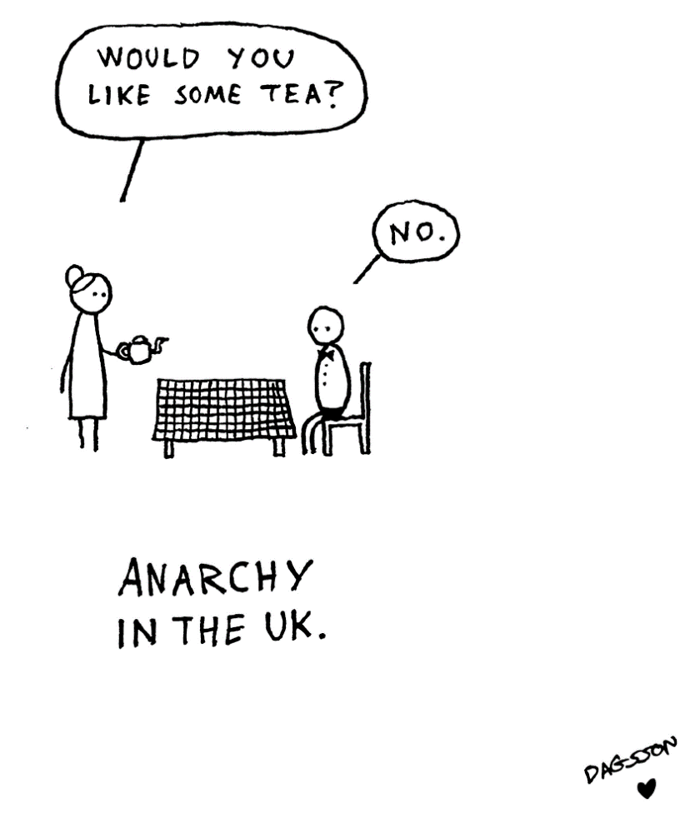

“Anarchy in the UK” is an inter-textual reference to the song by the English punk band Sex Pistols. The joke here is that refusal of a cup of tea is tantamount to anarchy in British culture. But what is important is the manner of the refusal of the politely expressed offer. Internet comments on the refusal include: “It’s not even a ‘no thank you’. I shudder to think where this is headed” and “Especially not saying ‘thanks’ afterwards”. It is also worth noting that the interaction seems to be taking place in the context of an asymmetrical power relationship between an adult and child. However, as we will comment in section 4.4, reciprocating to somebody of less relative power reduces the value of the credit required to rebalance the debit-credit sheet. But here it is the converse. The expected and accepted response of “No thanks / thank you” is lacking, (im)politeness debit-credit is out of balance (other things having been previously equal), reciprocity is violated and additional impoliteness implicatures are triggered. Such downshifts violating reciprocity are likely to be thought unfair, thus increasing the strength of the impoliteness (see Afifi and Burgoon 2000, for empirical evidence).
Let us examine Figure 2, a tweet from Chelsea Clinton (hereafter CC) which illustrates a possible mismatching upshift.

Figure 2. Chelsea Clinton tweet

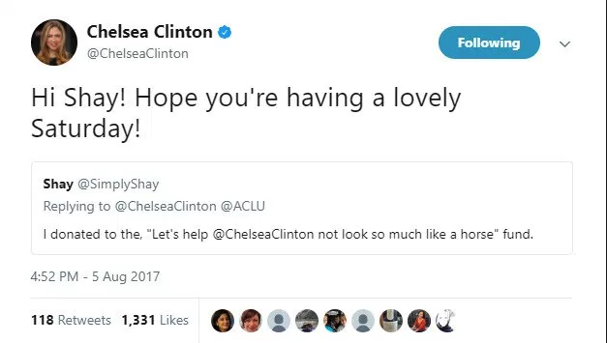

Focussing on Shay’s original tweet, despite the existential presupposition triggered by the definite article the, it seems highly unlikely that this “fund” exists. In other words, Shay flouts the maxim of quality, implicating an impolite belief that CC looks so much like a horse that surgery is required. An impoliteness debit on the balance sheet is created. But CC’s response does not seem to reciprocate (i.e. perform tit-for-tat impoliteness). Hi Shay! is an effusive, friendly greeting, and hope you’re having a lovely Saturday! a strong expression of good wishes. So, a politeness credit seems to be created, we have a clear mismatch, potentially triggering, via the M-heuristic, implicatures. Is that implicature polite or impolite? Part of CC’s skill here is that an array of possible (im)politeness implicatures are generated. One interpretation is that CC is expressing politeness despite Shay’s impoliteness; in other words, she is being notably magnanimous, and taking the moral high ground (see Robles and Castor 2019). Indeed, CC is well known for taking the moral high ground in dealing with large quantities of hate, and she is widely admired for this, as Figure 3 illustrates. In other words, her responses to such impoliteness are regarded as genuine politeness, at least by some.

Figure 3. Comment on Chelsea Clinton’s responses to impolite tweets

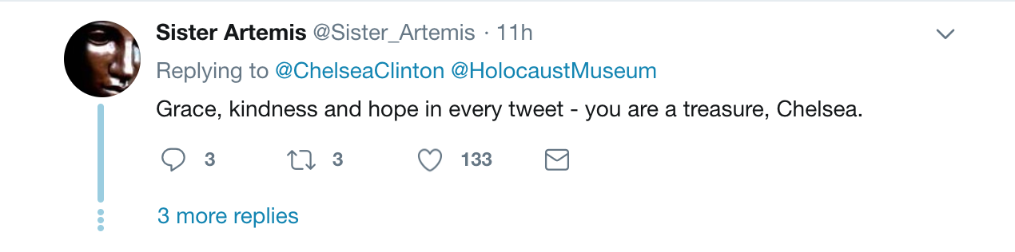

However, one might argue that CC’s expressed politeness is actually, in this context, mock politeness, that is, sarcasm (Leech 1983; Author1 (B)) (i.e. she is wishing him a horrible Saturday). In this interpretation, we do in fact have impoliteness reciprocity, a match at a deeper level. Additionally, note that rather than replying to the tweet, CC chooses to retweet with a comment – she makes an example of Shay’s tweet. This public shaming is perhaps a another way of reciprocating impoliteness without sacrificing her personal image.

4.4 Reciprocity in context
The PIR is context-sensitive. In Section 2.1, we noted that the “golden rule” is flexed in some legal frameworks according to social status. In the realms of politeness research, Usami (e.g. 2002), studying discourse-level politeness in Japanese, investigated downshifts and upshifts in politeness across participant exchanges. She noted that “all of these behaviors reflect the power relationships between the speaker and the addressee” (2002: 204).
Example [2] is taken from Lunan’s (2019) study of interactions between patients and nurses in doctors’ surgeries.

[2] [Male, under 45, patient (P) is called by a female nurse (N) into the consultation room for a booked appointment]
N: Mr Smith please (.) good morning (.) Hi Mr Smith
P: While I’m here
N: Yeah
P: I could really do to see Dr Jones (.) I’ve started bleeding again (.)

The polite summons (please), greeting (good morning), and friendly salutation (hi) are ignored, a politeness credit is not reciprocated. Lunan (2019: Chapter 6) observes that the patients seem to want to get down to business, and construct more of a task-centred approach to the consultation. More than this, we would argue that power dynamics are also at play here. Whilst theoretically nurses have the power of the medical expert, something which patients lack, they tend not to be seen as the real expert, who is assumed to be the doctor. In the British medical system, nurses have the power to refer patients, whose conditions need a higher level of expertise, directly to doctors. Nurses are sometimes unfairly seen as an annoying obstruction to accessing the real expert, the doctor. Importantly, Lunan’s (2019) study did not find that nurses generally took offence at the lack of politeness reciprocation, suggesting it is considered appropriate and acceptable in this context, and did not appear to trigger implicatures of impoliteness. Formal (mis)matching, which pertains to the (mis)matching of (im)politeness associated with surface forms, is not what matters with the operation of the PIR. Instead, it is relative (mis)matching or context-appropriate (mis)matching, which pertains to the (mis)matching of (im)politeness associated with surface forms relative to the norms of the specific context, which matters.
Regarding impoliteness reciprocity, power is also at play here. Author1 (B) points out that a powerful participant can “(a) reduce the ability of the less powerful participant to retaliate with impoliteness (e.g. through the denial of speaking rights), and (b) threaten more severe retaliation should the less powerful participant be impolite”. Army recruits, for example, are at the bottom of the power hierarchy, and have very restricted response options (Bousfield 2008). An interesting context concerns traffic wardens (specifically traffic officials who clamp and sometimes tow away illegally parked cars) and car owners. Author1 et al. (C) observe that in their data, in response to car owner impoliteness, traffic wardens used “no clear examples of counter strategies that are clearly primarily offensive”. They explain that “whilst a clamper has the power to ticket, clamp or even tow away an owner’s illegally parked vehicle, they do not in their particular socio-discoursal role have the legitimate power to respond to the impoliteness of car owners with clear, unambiguous impoliteness” (C). Instead they use ambiguous impoliteness, notably sarcasm, which avoids going on record. Let us briefly extend the analysis of one of their examples (Author1 et al. C), which concerns a van driver, who at the conclusion of the interaction and angry at having just been clamped, says have a good day to the clamper. Superficially, this makes a politeness credit, but the good wish clearly flouts the maxim of quality and implicates the opposite – have a bad day (the sarcastic interpretation is aided by the prosody) – thereby creating an impoliteness debit. The clamper responds I will do. This matches both the politeness of the literal good wish, achieving a politeness match, and the implied impoliteness, as it implicates, via the maxim of relation, that he will have a good day despite what the van driver says and in fact to spite him, an impoliteness match.

5. Reciprocity in requestive exchanges
In this section we report two studies designed to explore (im)politeness reciprocity in requestive exchanges. Our understanding of “requestive” is broad, akin to Searle’s (1969) “directive” speech act category. The aim of the first study, which is focussed on formal (mis)matching, is to investigate (a) the typical perceptions of the politeness of the first parts of requestive exchanges, and then, more particularly, (b) the perceived (im)politeness consequences of a second part of the exchange matching or mismatching that first part. Our second study, which also widens the focus to relative (mis)matching, takes the key findings of the first study and tracks them over corpus data. The particular aims here are to investigate (a) the frequencies of different kinds of (im)politeness (mis)matching, and (b) how (im)politeness (mis)matching are influenced by particular kinds of context.

5.1 Study 1
Study 1 involved two tasks, A and B. Task A addresses the research question: What is the degree of politeness associated with particular requestive forms in isolation? “In isolation” means not situated. But recollect the arguments in Section 2.1 that (im)politeness expressions are not context-free – they are associated with stereotypical (im)politeness judgements in context. Note that this task investigates degrees of politeness, and not impoliteness. This restriction was motivated by the fact that (a) genuinely impolite requestive stems are quite rare in the British National Corpus, and (b) it would help constrain, for practical reasons, the number of (mis)matching combinations we would deal with in Task B. Task B addresses the research question: What is the degree of (im)politeness associated with particular responses to particular requestive forms? Both Tasks involve 60 British undergraduate informants. Full ethics clearance was granted by the Faculty of Arts and Social Sciences and Management School Research Ethics Committee at Lancaster University, UK.

Task A
Method: The test items consisted of 12 different requestive stems selected from Aijmer (1996). Aijmer’s (1996) work on requestive patterns has the particular merit that it is based on the naturally-occurring spoken data collected for the London-Lund Corpus. The requestive stems are:

could I, will you, why don’t you, could you, let me, can you, I would be grateful, would you mind, perhaps you would, may I, you would, I would like to suggest

The selection does not simply represent the most frequent stems, as that would most likely not result in a set of expressions associated with varying degrees of politeness. Instead, the selection encompassed a range of frequencies, from the highly frequent could you to the relatively infrequent why don’t you. Testing these stems as just stems would be completely unnatural, and, in some cases, might lead to ambiguities. Three different requestive utterances for each stem were sourced from the spoken section of the (original) British National Corpus (e.g. Chris, could you pass me the Hula Hoops?; I would be grateful if you could confirm your acceptance of this proposal). The downside of this move towards ‘naturalness’ is the difficulty of controlling for the influence of other features in any specific utterance (e.g. a vocative such as Chris). However, this is mitigated by the fact that we selected three different utterances for each stem, thereby helping neutralize the possible interference of specific features in one utterance. This resulted in a manageable number of test items – 36 in total.
Informants accessed the questionnaire via the online system Qualtrics. They were asked to rate test items on a four-point scale. That the scale had an even number of points and no mid-point, is mainly a consequence of our aim to sort the requestive stems into two overall groups (see below). How to label rating scales for informants is not straightforward. Given the fact that the test items were not situated, informants were given a speaker-focussed instruction to rate the "extent to which the speaker makes an effort to be polite". What we are seeking here is the mental knowledge that informants have about the typical politeness contexts in which these items would be used (see Section 2.1). To reduce informant fatigue, test items were split between two questionnaires, and informants were randomly assigned to one. Completed questionnaires were combined into one dataset.

Results: Figure 4 displays the degrees of politeness associated with requestive stems. The vertical axis represents the overall number of 90 responses for each form (each of the 12 stems occurring in three different utterances, each rated by 30 informants). The proportions of the stacked bars that include ratings from 1 to 2 (i.e. judged as involving less effort to be polite) appear in dark grey, while proportions comprising ratings from 3 to 4 (i.e. judged as involving more effort to be polite) appear in light grey.

Figure 4. Degrees of politeness associated with requestive stems (dark grey = less politeness; light grey = more politeness)

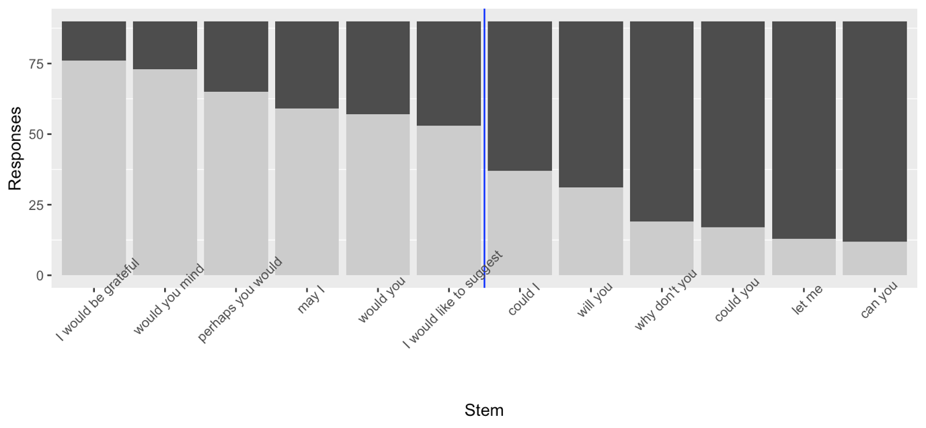

Contrary to Watts (2003) and in line with comments made by Leech (2007: 203), there is no hard border between polite “politic behaviour” and greater politeness, but instead a steady cline running from less polite to more polite. Nevertheless, for the purposes of operationalising our remaining studies, we grouped requestive stems into two: normal politeness and extra politeness. We thus split the expressions into two groups at the mid-point, i.e. between I would like to suggest and could I (see the blue line in Figure 4). Although there is no statistically significant difference between I would like to suggest and could I, the statistical trends place I would like to suggest in the extra politeness group and could I in the normal politeness group.

Task B
Method: This second task is centred on the informants’ perception of the dialogic exchange as a whole. In other words, what now is at stake is their perception of the degree of (im)politeness of B’s response in relation to A’s request.
As a preliminary, we examined requestive stems and their interactional contexts in the British National Corpus, and developed a categorisation of the main ways in which the second parts following requestive utterances varied (category codes are given in square brackets).

- Acceptance [A] vs. refusal [R] (e.g. yes vs. no);
- Comment [C] vs. absence of comment [NoC] (e.g. Yes, sure vs. Yes Ø);
- Positive comment [Cp] vs. negative comment [Cn] (e.g. Unfortunately, I can’t do this vs. No, no way)

The codes capture (1) whether the request was accepted by the requestee, (2) whether the acceptance included a comment, and (3) whether this comment was positive or negative. Socially positive comments included: (1) boosting acceptance (e.g. Yes, sure) and/or face enhancement (e.g. (Yes, my pleasure), and (2) mitigating refusal (e.g. No, not just now) and/or remedial facework (e.g. No, sorry). Socially negative comments included: (1) mitigating acceptance (e.g. Yes, I might) and/or face aggravation (e.g. Yes, I might, but can’t you see I’m busy?), and (2) boosting refusal (e.g. No, no way) and/or face aggravation (e.g. No, do it yourself).
We randomly retrieved 20 requestive exchanges for task B from the British National Corpus, taken from a pool of exchanges that were not overtly marked for context. Our aim was to capture informants’ perceptions of the formal (mis)matching of requestive exchanges, bearing in mind that, as discussed in Section 2.1, expressions and their stereotypical contexts are stored together as frames in one’s mind (see Terkourafi 2003) (Study 2 will focus on overt contextual information). Each informant was presented with two variations of each of the 10 dialogic patterns (e.g. two instances of a normal politeness requestive utterance, followed by acceptance and a positive comment), amounting to 20 utterances in total. Possible dialogic combinations involved four dimensions: the normal/extra politeness dimension, plus the three response dimensions in the paragraph above. Informants were asked to examine each exchange combination and rate whether “B’s response is impolite or polite” on a 5-point scale. Table 1 displays all 10 dialogic exchange types that the informants were presented with in random order throughout the questionnaire, and also supply one random example for each pattern. In the column to the right the codes that we used for our analysis are listed (‘→’ stands for ‘followed by’, ‘+’ stands for ‘as well as’).

Table 1. Coding of the requestive exchanges

Requestive exchange | Codes
A: Normal Politeness request; B: Acceptance & additional positive comment.  A: Could I just come in?  B: Sure, make yourself comfortable. | NormalP→A+Cp
A: Extra Politeness request; B: Acceptance & additional positive comment.  A: I would be grateful if you could confirm your acceptance of this proposal.  B: Yes, I will let you know as soon as possible. | ExtraP→A+Cp
A: Extra Politeness request; B: Refusal & additional positive comment.  A: I would be grateful if you would sign the attached copy of this letter and  return it to me.  B: Unfortunately I can’t do this at the moment. | ExtraP→R+Cp
A: Normal Politeness request; B: Refusal & additional positive comment.  A: Why don't you sit on the pouffe and let grandma sit there.  B: I'm sorry, but I have a bad back myself and cannot really sit on the pouffe. | NormalP→R+Cp
A: Normal Politeness request; B: Acceptance & no additional comment.  A: Could you just turn, thanks.  B: Ok. | NormalP→A+NoC
A: Extra Politeness request; B: Acceptance & no additional comment.  A: I would be grateful if you could confirm your acceptance of this proposal  B: Yeah. | ExtraP→A+NoC
A: Extra Politeness request; B: Refusal & additional negative comment.  A: I would be grateful if you could confirm your acceptance of this proposal.  B: No, I don't have the time for this. | ExtraP→R+Cn
A: Normal Politeness request; B: Refusal & additional negative comment.  A: Could I just come in?  B: No, you can't really. | NormalP→R+Cn
A: Normal Politeness request; B: Refusal & no additional comment.  A: Chris could you pass me the Hula Hoops?  B: No. | NormalP→R+NoC
A: Extra Politeness request; B: Refusal & no additional comment.  A: I would be grateful if you would sign the attached copy of this letter and  return it to me.  B: No. | ExtraP→R+NoC

Results: The plot in Figure 5 below is known as an “assocplot” (R package: vcd; see Hornik et al. 2006). It allows the analyst to visualise significant mismatches between observed and predicted frequencies derived from a X² test. These mismatches are commonly called Pearson residuals. If the observed frequency is greater than expected, the residual is positive; if the observed frequency is smaller than expected, it is negative (Levshina 2015: 218). The plot displays the perceived (im)politeness of second parts of requestive exchanges following first parts that are either normal politeness or extra politeness. On the horizontal axis, the 10 different types of requestive exchanges are represented. Their labels indicate whether they had normal politeness or extra politeness first part, and then the kind of response (see Table 1 above for the full display of relevant codes). The vertical axis represents the five-point scale, varying from polite to impolite. The Pearson residuals of each bar indicate the degrees of attraction (in blue) or repulsion (in red) amongst the categories of the politeness scale when informants were judging the (im)politeness of a particular response in the light of a normal politeness or extra politeness first part. The key insights from this plot are also presented in a more accessible form in Table 2.

Figure 5. Perceived (im)politeness of responses to extra politeness [ExtraP] or normal politeness [NormalP] requestive utterances ([A] acceptance; [R] refusal; [Cp] positive comment; [Cn] negative comment; [NoC] absence of comment)

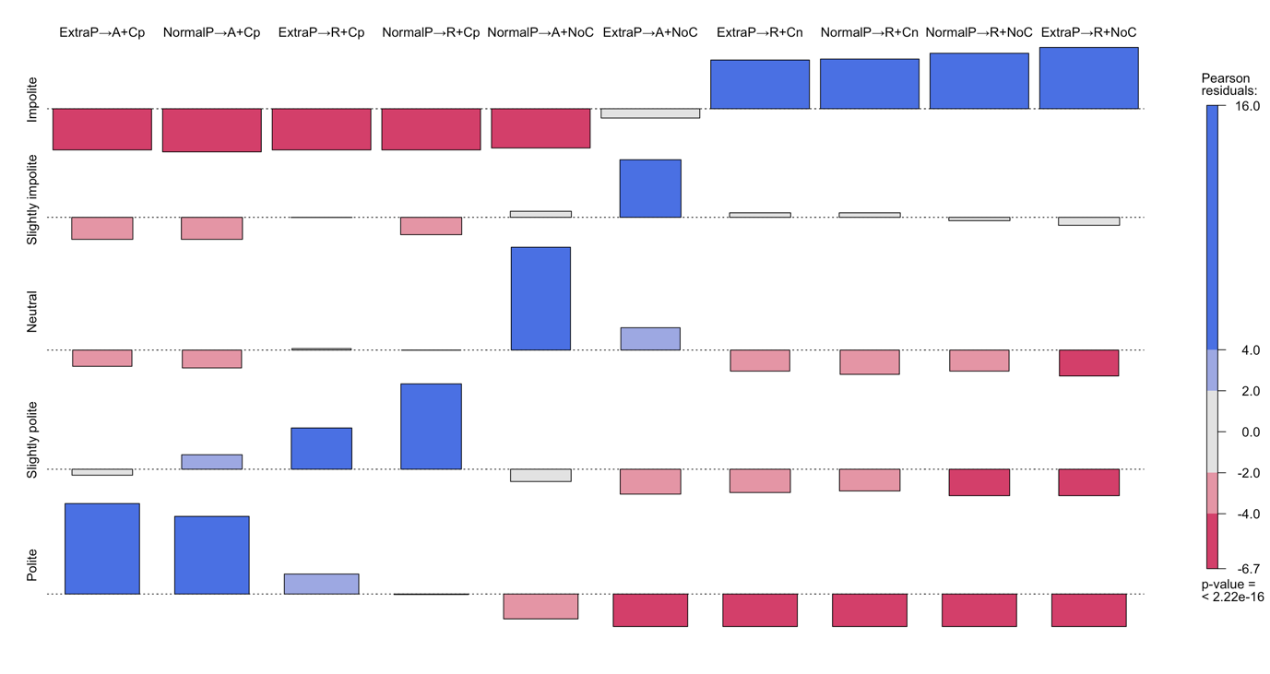

From Figure 5, we can see a gradient picture of requestive exchanges that informants perceived as comparatively more or less polite (X² = 1721.1, df = 36, p < 0.0005). This visualisation shows a data-driven perception of (im)polite behaviour as a multidimensional continuum, rather than a bare dichotomistic decision.
Perhaps the easiest way to read the plot in Figure 5 is to proceed from right to left. In the last four columns on the right there is a clearly a significant tendency for refusals not including an additional comment (ExtraP→R+NoC, NormalP→R+NoC) or refusals with a negatively reinforcing additional comment (NormalP→R+Cn, ExtraP→R+Cn) to be perceived as distinctly impolite (as shown by the blue bars at the top right corner and the corresponding red ones at the bottom right corner of the plot). In the next two columns, absence of additional comments after the acceptance of extra politeness and normal politeness requests (ExtraP→A+NoC, NormalP→A+NoC) was perceived respectively as slightly impolite and neutral. There was then, in the following two columns, a clear tendency towards slight politeness in cases where normal politeness and extra politeness requests were first refused, yet some counter-balancing positive comment was then added (NormalP→R+Cp, ExtraP→R+Cp). In the final two columns to the left, when requests of normal and extra politeness were accepted and followed by some additional positive comment (NormalP→A+Cp, ExtraP→A+Cp), informants significantly considered the response as distinctly polite.

Results and discussion of Study 1 (both Tasks A and B)
Table 2 brings together results for both Tasks A and B, displaying reciprocal matching or the lack of it across the parts of the exchange; or, put another way, the degree to which the politeness debit-credit sheet is balanced, other things being equal. The first column contains row numbers, purely for ease of reference. The second column displays results from Task A identifying the degree of politeness associated with particular requestive first part forms, in terms of whether they were generally considered normal politeness or extra politeness. The third column displays a summary of results from Task B, identifying the degree of (im)politeness associated with particular responses to requestive forms of normal or extra politeness (as in Figure 5). The politeness perception was tested in terms of a five-point scale: polite, slightly polite, neutral, slightly impolite, impolite (the vertical axis in Figure 4). The final column is the one that deals with reciprocity, as it displays the extent and direction of the (mis)match between the two parts of the exchange. Extra politeness is matched by what was perceived to be a distinctively polite response. This means that any response that was not perceived as markedly polite at the top of the scale would lead to a downwards degrees of mismatch (Weak Down, Strong Down, or Very Strong Down). Normal politeness is matched by what was perceived to be a neutral response. In this case, responses could involve degrees of upwards mismatch (Weak Up or Up) or degrees of downwards mismatch (Strong Down).

Table 2. Reciprocity in requestive exchanges

Row number | Politeness perception of first part | Politeness perception of type of second part | (Mis)match
1 | Normal politeness (e.g. Can you) | Polite: Acceptance + Positive comment (e.g. Ok, sure) | Mismatch: Up
2 | Normal politeness (e.g. Can you) | Slightly polite: Refusal + Positive comment (e.g. No, not just now) | Mismatch: Weak up
3 | Normal politeness (e.g. Can you) | Neutral: Acceptance (e.g. Ok) | Match
4 | Extra politeness (e.g. I would be grateful) | Polite: Acceptance + Positive Comment (e.g. Ok, sure) | Match
5 | Extra politeness (e.g. I would be grateful) | Slightly polite: Refusal + Positive comment (e.g. No, not just now) | Mismatch: Weak down
6 | Normal politeness (e.g. Can you) | Impolite: Refusal (e.g. No) | Mismatch: Strong down
7 | Normal politeness (e.g. Can you) | Impolite: Refusal + Negative comment (e.g. No, no way) | Mismatch: Strong down
8 | Extra politeness (e.g. I would be grateful) | Slightly impolite: Acceptance (e.g. Ok) | Mismatch: Strong down
9 | Extra politeness (e.g. I would be grateful) | Impolite: Refusal (e.g. No) | Mismatch: Very strong down
10 | Extra politeness (e.g. I would be grateful) | Impolite: Refusal + Negative comment (e.g. No, no way) | Mismatch: Very strong down

Table 2 does not, of course, contain the full range of (mis)matching (im)politeness possibilities. The key reason for this is that we only have two starting points, normal politeness or extra politeness, and not impoliteness. This explains why in Table 2 there is more mismatching downwards than upwards. We did not include impolite starting points (requestive first parts) because they are relatively rare in the British National Corpus, meaning that we could not have operationalized them. The two matching exchanges, rows 3 and 4, clearly illustrate reciprocity at work: the second parts are calibrated to match the differing first parts, the addition of a positive comment being required to match the extra politeness first part. On either side of the matches, we have weak upwards and weak downwards. Both involve refusals and positive comments, but have different starting points, normal politeness or extra politeness. At the top of the table is the widest upwards mismatch from a normal politeness first part to a polite acceptance and positive comment. All of the downwards mismatches involve refusals, except the exchange in row 8. Clearly, this is consistent with preference organisation, where a dispreferred response may be taken as negative in some way (e.g. Pomerantz 1984). In row 8, however, an extra politeness first part followed by simple acceptance is judged slightly impolite. Simple acceptance does not suffice to match an extra politeness first part. Of the remaining downwards mismatches (rows 6, 7, 8 and 9), the second parts, involving various refusals with no positive comment, all involve impolite judgements, none of which were significantly different from the others. This is perhaps a little surprising, as one might expect a simple refusal such as no to be significantly less impolite than a negatively reinforced one, such as no, no way (in fact, there is a tendency, though insignificant, the other way round; see Figure 5). This could be evidence that the presence of a dispreferred response represents a hard edge for judgements. Equally, however, this could partly be a reflection of our method: our judgement scale only accommodated two different degrees of impoliteness. Further investigation would be needed here. Also, it is intriguing to ponder whether it might be because perceptions of impoliteness are less amenable to fine gradations. Author1 (A; see also Greenberg 1976) argues that at higher levels of impoliteness finer distinctions get lost in the “white noise” of offensiveness.

5.2 Study 2
The particular aims of this study are to establish (a) the frequencies of different kinds of (im)politeness matching, and (b) how (mis)matching (im)politeness is influenced by particular kinds of context.

Method
We computationally extracted instances of the 12 requestive stems from the spoken section of the (original) British National Corpus, manually identifying which occurred as a request of some kind. Expectedly, some stems were much more frequent as requestive forms than others (e.g. normal politeness formulas, including let me, are much more frequent than extra politeness ones like I would be grateful). For stems used as requests that were more frequent than 200, a randomised sample of 200 occurrences was retrieved. This was the case for let me, would you like and will you. In total, our dataset amounted to 1141 exchanges.
Our coding scheme for mismatching responses of the requestees was that outlined in Section 5.1. Regarding inter-rater reliability, 88% agreement was reached among three different coders. Anything uninterpretable was excluded. The dependent variable of our study was reciprocity, which was based on the taxonomy that resulted from our previous questionnaire studies, given in the (mis)matching column of Table 3.

Results and discussion
Figure 6 below illustrates the distribution of matches and mismatches between request and response across our annotated dataset. (An example of each kind of mismatch is given in Appendix 1).

Figure 6. Distribution of matching and mismatching reciprocity among requestive exchanges in the spoken section of the BNC

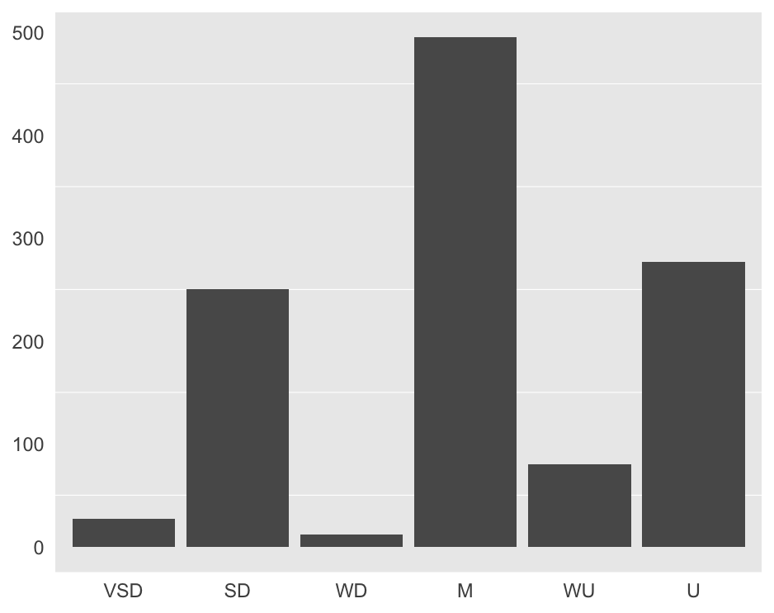

From Figure 6, we can see that Matching is by far the most common mechanism at play in requestive exchanges in the BNC, with an overall frequency of 495 dialogic pairs. Importantly, this supports the underlying assumption that reciprocity tends to be “the norm” for requestive exchanges in British English; reciprocity is the “golden rule of (im)politeness payments” between requestor and requestee (X² = 749.73, df = 5, p-value < 2.2e-16). As for the other reciprocity categories, note that the frequencies of the categories do not construct an evenly gradated continuum. The most frequent requestive exchanges concern Matches, followed by Upwards and Strong Downwards mismatches respectively. The key point is that when reciprocity is not maintained, the outcome of the conversation tends to shift significantly to either prototypically polite (Upwards) or to prototypically impolite (Strong Downwards). Conversely, extreme cases of Very Strong Downwards, or mild adjustments hinging on Weak Downwards and Weak Upwards are all pursued far less frequently. This is an important finding because it underpins the implicational power of mismatching reciprocity, as discussed in Section 4.3. Deviation from reciprocity is distinctly abnormal and has the power to trigger inferencing. In the remaining paragraphs of this section, we bring in the social context and its influence on the PIR, especially its role in relative matching (see Section 4.4).
Concerning context, the dialogic demographic spoken section of the BNC includes 16 different “genres” arising from diverse contextual environments. In order to provide results that can give insights into broadly different context types and reciprocity, we grouped all the genres into 7 main categories: Broadcast (Bro), Consultation (Con), Courtroom (Cou), Formal Meeting (FoM), Generic Conversation (GeC), Institutional Inquiry (InI) and School Class (ScC). We then plotted a multiple correspondence analysis (see Nenadic and Greenacre 2007) of the mutual attraction between Context and Reciprocity on a two-dimensional plane. In correspondence analysis models, associations among variables are based on the X² distance between different categories of the variables and observations. These associations can be visualised in the form of a map as powerful tool to assist the interpretation of the structures in the data. The closer the distance between variables, the stronger the statistical attraction; conversely, the further two variables are apart, the stronger the repulsion. The two dimensions of the map in Figure 7, Dim 1 and Dim 2, therefore do not stand for variables, they are simple coordinates of statistical distances.

Figure 7. Multiple correspondence analysis of the attraction/repulsion between context and reciprocity (D=down, U=up, M=match; GeC=general conversation, ScC=school class, InI=institutional inquiry, Con=consultation, FoM=formal meeting, Bro=broadcast talk, Cou=courtroom interaction)

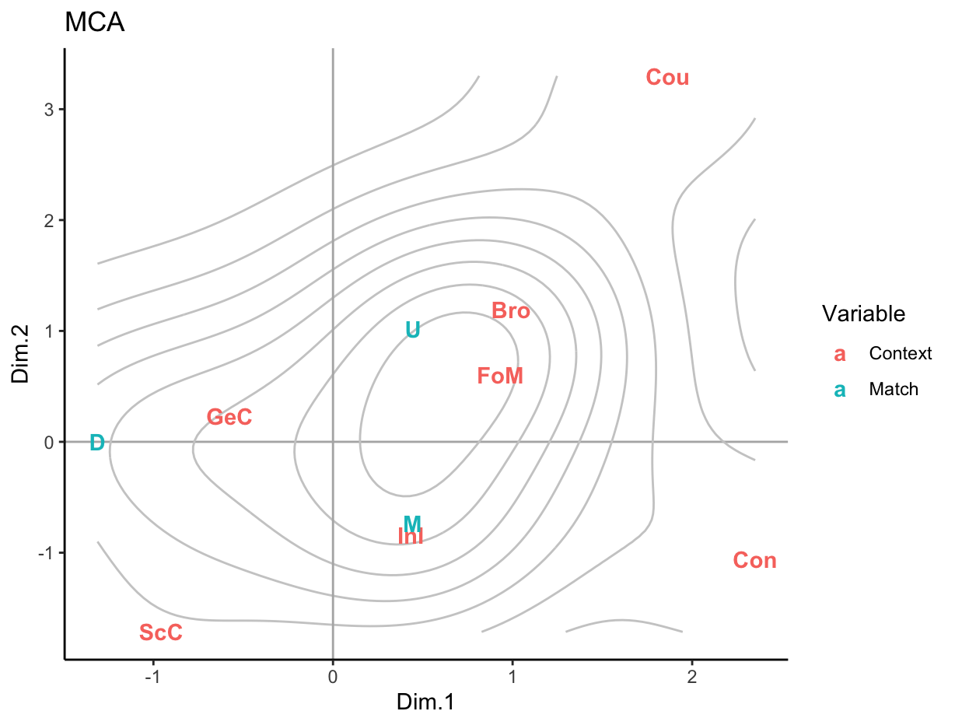

Figure 7 is organised into four quadrants. In the bottom right quadrant, we see Matching reciprocity (M) closest to Institutional Inquiry (InI), as in the case of example [3]:

[3]
S1: Would you like to, to give us an update on that please?
S2: Thank you very much. Erm, I've written it out here if I may read it.
BNC HYG 265

The exchange in [3] occurs in a Town council meeting: an extra politeness requestive first part is reciprocated with acceptance and a positive comment, resulting in a match. Here, the institutionalization of discourse in democratic bodies underpins social appropriateness. There are, of course, some power asymmetries in such contexts, but they are complex, and interaction is highly regulated to help ensure no one party automatically suppresses the discourse of another. Note that British parliamentary discourse, as discussed in Section 4.2 on matching discourses, is an archetype of institutionalized discourse in a democratic body. Consultations (Con) are also in this quadrant, but work in a different way. They are very distant from downward mismatching (D) on the left; on the other hand, their relative attraction is comparatively stronger to Matching. These doctor medical consultations, usually between doctor and patient, are unlike the nurse-patient interactions discussed in Section 4.4, where formal mismatching was quite normal. Doctors are more powerful than nurses and are the desired interlocutor for patients, and perhaps these reasons motivate the reciprocation of politeness by patients.
To the left of Figure 7, we can see that Downward shifts (D) are more closely associated with the context types of General Conversation (GeC) and School Class (ScC). General Conversation is markedly more informal and less institutionalized than contexts to the right of the Figure; people have more scope to shift downwards. Whilst institutionalization does pertain to School Class (ScC), it is the power asymmetries that are solidified in this interactional schema between teachers and pupils. Consider example [4] below:

[4]
S1: Please may I borrow a rubber sir.
S2: Already? Why don't you ask for a rubber when you make a mistake.
BNC JAA 701

This dialogue takes place during a science demonstration lesson and is a case of a strong downward shift. The student (S1) makes use of a requestive formula conventionalised for extra politeness in a school classroom context. The teacher (S2) refuses and adds a negative comment about the timing of the requestive act. As noted in this paper on a number of occasions, social power licences mismatching. As evidenced in Section 3.4 in relation to Lunan (2019), such downward shifts are not usually seen as impolite – they count as a relative match.
In the top-right quadrant, the contexts of Broadcast interaction (Bro) and Formal Meetings (FoM) seem to be characterised by upwards politeness shifts (U). An example of upwards shift (U) in Broadcast talk (Bro) is given in [5]:

[5]
S1: Er can you hang on a minute?
S2: Yes certainly.
BNC HV0 506

[5] occurs during a radio broadcast. (S1)’s normal politeness requestive first part is accepted by (S2) with the addition of a further positive comment, certainly, suggesting strong politeness, an upwards shift. Compared with example [4], an important difference, and one that is general across these contexts, concerns the first part: [4] has an extra politeness first part; [5] has a normal politeness first part. A normal politeness first part allows the requestee more scope to shift upwards. Requestive acts made in Courtroom discourse (Cou) are also part of the same quadrant of upward mismatch (U). They are farthest from downward mismatching (D), where we found School class (ScA). One might suggest that the reasons for the extreme upwards shift in the courtroom are similar but opposite to schools: the power asymmetries are institutionalized in the interaction. Of course, it is not only the status differences in these contexts that are important, but also the directionality of the requestive acts (i.e. who is doing the first part and who the second, and consequently who is accountable for the shift).

6. Conclusion
Reciprocity is fundamental to the way (im)politeness works in interaction yet has not been accorded the attention it deserves. This paper, having defined (im)politeness, laid out the background to reciprocity in terms of a social debit-credit balance, and pointed to its importance in the moral order (as crystallised in religions and legal frameworks), as well as in the rights and obligations of societies. Moreover, it argued that its basis is in proto-morality, the basic substructure underlying cultural forms of morality.
Framing the PIR as a sociopragmatic interactional principle, we defined it as: a constraint on human interaction such that there is pressure to match the perceived or anticipated (im)politeness of other participants, thereby maintaining a balance of payments. Maintaining reciprocity through politeness matching is what people normally do, as evidenced by our study in Section 5. It is the stuff of everyday, routine politeness. We argue that reciprocal impoliteness matching is the stuff of tit-or-tat impoliteness, and gave evidence for this in Section 4.2. However, for practical reasons (the lack of data in the British National Corpus (BNC)), this was not thoroughly explored; it could benefit from further research. Conversely, deviating from reciprocity through mismatching (im)politeness is abnormal and triggers further inferencing. Section 4.3 elaborated on this inferencing with reference to Levinson's (2001) M-heuristic. Mismatching with a downwards shift can trigger, context permitting, strong impoliteness implicatures (e.g. rejecting someone or something); conversely, mismatching with an upwards shift can trigger, context permitting, strong politeness implicatures (e.g. being magnanimous by turning the other cheek). Of course, as noted with reference to Terkourafi (2003), the precisely implicatures are dependent on the specifics of the situation.
In Study 1 reported in Section 5, we focused on requestive exchanges, bringing quantitative methods to bear. Through informant testing, we established the degree of politeness associated with 12 different requestive stems, extracted from the BNC. The results show that there was no clear distinction between examples that count as normal politeness behaviour and those as extra politeness, but instead there is a cline between the two. We then tested the perceptions of various types of second parts of requestive exchanges in response to first parts that were either normal politeness or extra politeness, the focus being on formal (mis)matching. We revealed, for example, that – other things being equal – simple acceptance is not enough to match the extra politeness of a first part, and that the second parts that were deemed impolite were not perceived to differ much (perhaps they get lost in the “white noise” of impoliteness). The first part of Study 2, which analysed well over a thousand requestive exchanges from the BNC across different contexts, computed the frequency of different types of (mis)matching exchange. Matching is by far the most common, with distinct shifts towards upwards or downwards as clear runners-up. This was expected: if the PIR involves in some sense a normal situation, then matching had to be the most frequent. Deviations from this matching are generally not perceived as slight deviations but clear deviations upwards or downwards – deviations that seem likely to have the capacity to invite further inferencing.
The PIR is mediated by context. Formal (mis)matching, the focus of the first study reported in Section 5, is ultimately not what matters with the operation of the PIR. It is relative (mis)matching (i.e. context-appropriate matching), the focus of the second study reported in Section 5, which matters. Power in particular seems to be a key factor in making a mismatch in terms of form a match relative to the norms of the context. Thus, a school pupil in the school classroom must normally respond to a schoolteacher with more politeness than they received in order to effect a "normal" relative match in that context. In contrast, Institutional inquiries was the context most closely associated with relative matching, possibly as a consequence of an institutionalised democratising force, keeping personal desires and agendas in check. Section 4.4 also noted specific ways in which power constrains the PIR, as when a less powerful person may fear retaliation if they reciprocate impolitely.
We have left many questions unanswered, questions which can be pursued in future research. We have already briefly mentioned two areas: impoliteness and inferencing. Other possible research avenues include:

- The final example of Section 4 concerns mock impoliteness, where the gap between formal and relative matching is exploited. Mock reciprocity could usefully be further studied.
- We focused on English and largely British cultures. It is important to examine the workings of the PIR in other languages and cultures.
- We discussed L1 interactions. How the PIR works in L2 interactions could be usefully examined.
- The workings of the Principle could be examined diachronically too. Some steps in this direction have been taken in Author2 et al. (A).
- In section 5, we focused on requestive exchanges. Other speech act sets (e.g. compliments and compliment responses) could usefully be examined.
- Our focus has been on dyadic talk. One only needs to think of digitally mediated interactions for something very different (our Chelsea Clinton example alludes to some of the complexities). Multiple participants can contribute, and it can become difficult to keep track of who is responding to what. How do interactions like this work?
- Our examples, even in the Section 4 containing some qualitative analyses, were relatively short. Over extended interactions one can begin to lose sight of what one is actually responding to; the debit-credit balance sheet is less visible. Is this a factor in triggering conflict?
- Another relevant area of investigation underpins the cognitive relationship between reciprocity and Theory of Mind (and increasingly complex capacities of collective intentionality) throughout ontogeny and in Autism Spectrum Disorder.

Finally, it is worth pointing out that our work has implications for teaching and learning pragmatics. Knowing the likely politeness value of a requestive utterance is useful, but it is also useful to know what might count as a polite response, other things being equal.

Acknowledgements
The research presented in this article was supported by the UK's Economic and Social Research Council (ESRC) Centre for Corpus Approaches to Social Science, ESRC grant reference ES/R008906/1. This publication is based on datasets which for ethical and legal reasons cannot be publicly shared. We are grateful to Isolde van Dorst for her assiduous work in helping us process the data for the studies reported in section 5. We owe particular thanks to the paper’s two reviewers and the co-editor Michael Haugh, whose comments helped us immeasurably (the usual disclaimers apply). Finally, we thank the wider scholarly community who have provided us with invaluable feedback at conference presentations.

References
Afifi, Walid. A., Burgoon, Judee, K., 2000. Behavioral violations in interactions: The combined consequences of valence and change in uncertainty on interaction outcomes. Human Communication Research 26, 203-233.
Aijmer, Karin, 1996. Conversational Routines in English. Longman, London.
Arundale, Robert B., 2020. Communicating and Relating: Constituting Face in Everyday Interacting. New York: Oxford University Press.
Author1 et al., C.
Author1, A.
Author1, B.
Author1, C.
Author2 et al., A.
Author2, B.
Baron, Robert A., Richardson, Deborah R., 1994. Human Aggression. Plenum: Plenum.
Barrett, Louise, Robin Dunbar, Lycett, John, 2002. Human evolutionary psychology. Princeton, NJ: Princeton University Press.
Bergmann, Jörg R. 1998. Introduction: Morality in Discourse. Research in Language and Social Interaction 31(3/4): 279-294.
Biber, Douglas, Johansson, Stig, Leech, Geoffrey N., Conrad, Susan, Finegan, Edward, 1999. Longman Grammar of Spoken and Written English. Pearson Education, Harlow.
Bousfield, Derek, 2008. Impoliteness in Interaction. John Benjamins, Philadelphia and Amsterdam.
Brown, Penelope, Levinson, Stephen C., 1987. Politeness: Some Universals in Language Usage. Cambridge University Press, Cambridge.
Bryson, Anna, 1998. From Courtesy to Civility: Changing Codes of Conduct in Early Modern England. Clarendon Press: Oxford.
Bull, Peter, Waddle, Maurice, 2019. Let me now answer, very directly, Marie’s question”: The impact of quoting members of the public in Prime Minister’s Questions. Journal of Language Aggression and Conflict 7(1), 56-78.
Darwall, Stephen, 2009. The second-person standpoint: Morality, respect, and accountability. Cambridge, MA: Harvard University Press.
Disler, Edith A., 2008. Language and Gender in the Military: Honorifics, Narrative, and Ideology in Air Force Talk. Amherst, N.Y., Cambria Press.
Fehr, Ernst, Urs Fischbacher, Gachter, Simon, 2002. Strong reciprocity, human cooperation and the enforcement of social norms. Human Nature 13, 1-25.
Flack, Jessica C., Frans B., De Waal, 2000. ‘Any animal whatever'. Darwinian building blocks of morality in monkeys and apes. Journal of Consciousness Studies 7(1-2), 1-29.
Fraser, Bruce, William Nolan, 1981. The association of deference with linguistic form. International Journal of the Sociology of Language 27, 93-109.
Garfinkel, Harold, 1964. Studies of the routine grounds of everyday activities. Social Problems 11(3), 225-250.
Gensler, Harry J., 2013. Ethics and the Golden Rule. Routledge, New York.
Goffman, Erving, 1967. Interactional Ritual: Essays on Face-to-face Behavior. Anchor Books, Garden City, New York.
Gouldner, Alvin W., 1960. The norm of reciprocity: A preliminary statement. American Sociological Review, 25(2), 161–178.
Greenberg, Bradley S., 1976. The effects of language intensity modification on perceived verbal aggressiveness. Communication Monographs 43, 130-139.
Harris, Linda, Gergen, Kenneth, Lannaman, John, 1986. Aggression rituals. Communication Monographs 53, 252-265.
Haugh, Michael, 2003. Anticipated versus inferred politeness. Multilingua, 22(4), 397-413.
Holtgraves, Thomas, 2005. Social psychology, cognitive psychology, and linguistic politeness. Journal of Politeness Research: Language, Behaviour, Culture 1, 73-93.
Jacobs, Cassandra L., Griffin, Zenzi M., 2010. When Do Mothers Address Their Children By Name? A Corpus Analysis. Talk presented at the Vocative! Workshop, Bamberg, Germany.
Jakobson, Roman (1971) Word and Language. Mouton: Hague and Paris.
Jay, Timothy, 2000. Why We Curse: A Neuro-psycho-social Theory of Speech. John Benjamins, Philadelphia and Amsterdam.
Johnson, Mark, 1987. The Body in the Mind: The Bodily Basis of Reason and Imagination. Chicago, IL: University of Chicago Press.
Kasper, Gabriele, 1990. Linguistic politeness: current research issues. Journal of Pragmatics 14(2), 193-218.
Komter, Aafke Elisabeth, 1996. Reciprocity as a principle of exclusion: gift giving in the Netherlands. Sociology 30, 299-316.
Labov, William, 1972. Sociolinguistic Patterns. University of Pennsylvania Press: Pennsylvania.
Lagerspetz, Eerik, Ikaheimo Heikko, Kotkavirta, Jussi (eds.) (2001) On the Nature of Social and Institutional Reality. Finland: SoPhi.
Lakoff, George, Johnson, Mark, 1999. Philosophy in the Flesh: The Embodied Mind and its Challenge to Western Thought. Basic Books: New York.
Langlotz, Andreas, Locher, Miriam, 2017. (Im)politeness and emotion. In: Culpeper, J., Haugh, M., Kádár, D. (Eds.) Palgrave Handbook of (Im)politeness. Palgrave, Basingstoke, pp. 287-322.
Leech, Geoffrey N., 1983. Principles of Pragmatics. Longman: London.
Leech, Geoffrey N., 2007. Politeness: Is there an East-West divide? Journal of Politeness Research: Language, Behaviour, Culture 3(2), 167-206.
Leech, Geoffrey N., 2014. The Pragmatics of Politeness. Oxford University Press, Oxford.
Levinson, Stephen C., 1995. Interactional biases in human thinking. In: Goody, E.N. (Ed.) Social Intelligence and Interaction: Expressions and Implications of the Social Bias in Human Intelligence. Cambridge University Press, Cambridge, pp. 221-260.
Levinson, Stephen C., 2000. Presumptive Meanings: The Theory of Generalised Conversational Implicature. M.I.T. Press: Cambridge, Massachusetts.
Levshina, N., 2015. How to do linguistics with R: Data exploration and statistical analysis. Amsterdam: John Benjamins Publishing Company.
Locher, Miriam A., Richard J. Watts, 2008. Relational work and impoliteness: Negotiating norms of linguistic behaviour. In: Derek Bousfield and Miriam A. Locher (eds) Impoliteness in Language: Studies on its Interplay with Power in Theory and Practice. Berlin and New York: Mouton de Gruyter, pp. 77-99.
Lunan, Michela, 2019. The Dynamics of Nurse Interaction: A Comparison of speech with older and younger patients. Lancaster University, unpublished PhD thesis.
MacCormack, Geoffrey, 1976. Reciprocity. Man (New Series) 11(1), 89-103.
Malinowski, Bronislaw, [1926] 1932. Crime and Custom in Savage Society. Paul, Trench, Trubner, London.
Murphy, James, 2014. (Im)politeness during Prime Minister’s Questions in the UK Parliament. Pragmatics and Society 5(1), 76-104.
Nenadic, O., & Greenacre, M. 2007. Correspondence analysis in R, with two-and three-dimensional graphics: the ca package. Journal of statistical software, 20(3).
Ohashi, Jun, 2008. Linguistic rituals for thanking in Japanese: Balancing obligations. Journal of pragmatics, 40(12), pp.2150-2174.
Ohashi, Jun, 2010. Balancing obligations: Bowing and linguistic features in thanking in Japanese. Journal of Politeness Research, 6(2), 183-214.
Parvaresh, Vahid, Tahmineh, Tayebi, 2018. Impoliteness, aggression and the moral order. Journal of Pragmatics, 132, 91-107.
Pomerantz, Anita, 1984. Agreeing and disagreeing with assessments: some features of preferred/dispreferred turn shapes. In: Atkinson, J. Max, Heritage, John (eds.), Structures of Social Action: Studies in Conversation Analysis. Cambridge University Press: Cambridge, pp. 57-101.
Robles, Jessica S., Theresa Castor, 2019. Taking the moral high ground: Practices for being uncompromisingly principled. Journal of Pragmatics 141, 116-129.
Searle, John R., 1969. Speech Acts: An Essay in the Philosophy of Language. Cambridge University Press, Cambridge.
Searle, John R., 1990. Collective intentions and actions. In: Cohen, P.R., Morgan, J.L., Pollack, M.E. (Eds.) Intentions in Communication. Bradford Books: Cambridge, Massachusetts, pp. 401-415.
Spencer-Oatey, Helen D. M., 2002. Managing rapport in talk: Using rapport sensitive incidents to explore the motivational concerns underlying the management of relations. Journal of Pragmatics 34(5), 529-545.
Spencer-Oatey, Helen D. M., 2005. (Im)Politeness, face and perceptions of rapport: Unpackaging their bases and interrelationships. Journal of Politeness Research: Language, Behaviour, Culture 1(1), 95-119.
Spencer-Oatey, Helen D. M., 2008. Culturally Speaking: Managing Rapport through Talk across Cultures (2nd edn). Continuum, London and New York.
Spencer-Oatey, Helen, Jiang, Wenying, 2003. Explaining cross-cultural pragmatic findings: Moving from politeness maxims to sociopragmatic interactional principles (SIPs). Journal of Pragmatics 35: 1633-1650.
Terkourafi, Marina, 2003. Generalised and particularised implicatures of politeness. In: Kühnlein, P., Rieser, H., Zeevat, H. (Eds) Perspectives on Dialogue in the New Millennium. John Benjamins, Amsterdam, pp. 151-166.
Terkourafi, Marina, 2005. Pragmatic correlates of frequency of use: the case for a notion of ‘minimal context’. In: Nikiforidou et al. (eds.) Reviewing Linguistic Thought: Converging Trends for the 21st Century. Berlin: de Gruyter, pp. 209-233.
Tomasello, M., 2019. Becoming human: A theory of ontogeny. Cambridge: Belknap Press.
Tomasello, Michael, 2020. The moral psychology of obligation. Behavioral and Brain Sciences, 43.
Trivers, Robert L., 1971. The evolution of reciprocal altruism. The Quarterly review of biology 46(1), 35-57.
Usami, Mayumi, 2002. Discourse Politeness in Japanese Conversation. Hituzi Syobo, Tokyo.
Veale, Tony, Feyaerts, Kurt, Brône, Geert, 2006. The cognitive mechanisms of adversarial humor. Humor 19(3), 305-339.
Waddle, Maurice, Bull, Peter, Böhnke, Jan R., 2019. “He is just the nowhere man of British politics”: Personal attacks in Prime Minister’s Questions. Journal of Language and Social Psychology 38(1), 61-85.
Watts, Richard J., 1989. Relevance and relational work: linguistic politeness as politic behaviour. Multilingua 8, 131-166.
Watts, Richard J., 2003. Politeness. Cambridge University Press, Cambridge.
Werkhofer, Konrad T., [1992] 2005. Traditional and modern views: The social constitution and the power of politeness. In: Watts, R.J., Ide, S., Ehlich, K. (Eds.) Politeness in Language: Studies in its History, Theory and Practice (2nd edn). Mouton de Gruyter, Berlin and New York, pp. 155-99.
Xie, Chaoqun, ed., 2020. (Im) politeness and Moral Order in Online Interactions. Vol. 107. John Benjamins Publishing Company.

APPENDIX 1

[VSD]
E.g. [ExtraP→R+NoC]
S1: Would you like to finish off this cereal first?
S2: No.
BNC KDE 131

[SD]
E.g. [ExtraP→A+NoC]
S1: May I <pause> make a, a separate point.
S2: Yeah.
BNC FLS 1141

[M]
E.g. [NormalP→A+NoC]
S1: Can you take it away and do it?
S2: Yeah.
BNC KDM 231

[WU]
E.g. [NormalP→R+Cp]
S1: Oh well let me get to this.
S2: I’ve just cancelled it. I didn’t mean to do that.
BNC KP6 1410

[U]
E.g. [NormalP→A+Cp]
S1: But you will let me have my tablets before I go?
S1: Yes, definitely.
BNC KP1 5156

Scripts on the Internet are not entirely in tune with what is actually said in the production. Very brief indications of the meanings of possibly problematic words, mostly British slang, follow: stuck-up aloof, condescending; twit silly, stupid person; trollop slightly old-fashioned word for a promiscuous woman; ponce someone who has an air of fake poshness and/or has characteristics associated with women; poovy like a gay man; and poolagger meaning unclear (sometimes transcribed as “poonagger”).
The general connection between norms and evaluations is, of course, well-established in linguistics (see, for example, Labov 1972: 121).
Relatedly, some politeness models (e.g. Fraser and Nolan 1981; Leech 1983) adopt notions from economics or commerce (e.g. costs and benefits). It should be noted that we do not know whether conceptualising (im)politeness as money works equally well for all cultures. In England, it is applicable at least as far back as the sixteenth century (Bryson 1998: 124).
The notion of the moral order has a long history. In the ancient world, it has some similarities with Aristotle’s concept of phronesis; in the eighteenth-century, it is discussed in Kant’s moral philosophy,
Although work on “exotic” societies by anthropologists like Malinowski is well-known, one should not assume that reciprocity does not apply to “Western” cultures. Komter (1996), for example, shows the importance of reciprocity in a study of gift giving in Dutch communities.
Arundale’s work is not an account of either politeness of impoliteness; in fact, it was designed to side-step problems associated with (im)politeness theories (e.g. 2020: 310). However, it is undeniable that it focuses on many interactional phenomena and interpretative processes that are – or should be – encompassed by (im)politeness theories. More generally, our discussion here relates to wider discussions concerning inferred and anticipated politeness (see, in particular, Haugh 2003).
https://www.reddit.com/r/firstworldanarchists/comments/1uyf1v/anarchy_in_the_uk/
This assumes that CC has not previously created a debit on the balance sheet for Shay, which he is now rebalancing. Shay is replying to something CC tweeted previously, but Shay’s account has been suspended, and so is not possible to discover what this was.
Strictly speaking, all language is situated. Obviously, this means situated beyond the experimental context.
These labels overlap with what Watts (2003) refers to as “politic behaviour” and “politeness”.
While all of A’s requests are naturally-occurring uses, the majority of B’s responses were manipulated so as to obtain all possible combinations among the dimensions of request type, acceptance and comment listed previously.
To clarify, the degrees of mismatch are not an even scale imposed by us as researchers but reflect the tendencies in perceptions as displayed in Figure 5. This is why there are two degrees of upwards mismatch, but only one downwards.
137 items out of 1141 items were not deemed requestive by all the annotators. We therefore eliminated them from our enquiry and randomly retrieved an equal number of occurrences from our annotated dataset. The retrieval was based on the same distribution of stem-types as in the set that we discarded. We finally added the remaining annotated lines to our dataset (see Author2 B for more details about post-annotating normalization).
Footnote 12 also applies here as the explanation of why not all categories appear on the horizontal axis.
Significantly negative Pearson residuals were present for Very Strong Down (-10.8), Weak Down (-11.9) and Weak Up (-7.1), while Strong Down (3.6) Match (17) and Up (5.2) returned significantly positive residuals.
More specifically, Broadcast (Bro) includes Broadcast discussions, documentaries and news. Consultation (Con) includes medical, doctor-patient consultations. Courtroom (Cou) includes interaction occurring in legal Courtrooms. Formal Meeting (FoM) includes Business meetings, Public Speeches and Lectures. Institutional Inquiry (InI) includes interaction types where one participant asks a set of questions, and the other provides answers. They broadly comprise Job Interviews or other forms of set of questions that are performed in the presence of an extended generic audience or a group of experts in a specific field (Academic research, Journalism, Parliament and City council). School Class (ScC) includes interaction occurring at schools among teachers and students.
This two-dimensional solution is assessed with mjca() function in the R ca package. The summary suggests that two first dimensions capture 89.2 % of inertia (i.e. variance) which is a reliable result for the visualisation of the data on a two-dimensional plane (see Levshina 2015: 382)
For this part of the study, we just used these three broad categories with no distinctions (e.g. weak, strong).

