Composition-structure-property effects of antimony in soda-lime-silica glasses
T.-Y. Chen¹, P. Rautiyal¹, S. Vaishnav¹, G. Gupta^{1,2}, H. Schlegl³, R. J. Dawson³, A. W. Evans⁴, S. Kamali⁴, J. A. Johnson⁴, C. E. Johnson⁴ and P. A. Bingham^{1,*}
¹ Materials and Engineering Research Institute, College of Business, Technology and Engineering, Sheffield Hallam University, City Campus, Howard Street, Sheffield, S1 1WB, UK.
² Glass Division, Central Glass and Ceramic Research Institute, Raja S. C. Mullick Road, Kolkata, India
³ Department of Engineering, Lancaster University, Lancaster, LA1 4YW, UK
⁴ Department of Mechanical, Aerospace and Biomedical Engineering, University of Tennessee Space Institute, Tullahoma, TN 37388, USA.

* Corresponding author, contact details: Email p.a.bingham@shu.ac.uk; Phone +44 1142256449
Abstract
Float glass-type SiO₂-Na₂O-CaO glasses with 0 – 10 mol% Sb₂O₃ were melted and their compositional, structural, thermal and optical properties characterised. All glasses were X-ray amorphous and increasing Sb₂O₃ content progressively decreased glass transition temperature (T_{g}) and dilatometric softening point (T_{d}), despite increases in Al₂O₃ content from greater crucible corrosion. ¹²¹Sb Mössbauer spectroscopy confirmed that Sb was predominantly incorporated as Sb³⁺ (Sb³⁺/ΣSb ~ 0.9) and Raman spectroscopy showed that Sb substantially decreased average (Si, Al)-O Q^{n} speciation. Both techniques confirmed that Sb³⁺ ions were incorporated in trigonal pyramidal [:SbO₃] polyhedra. XRF and Raman spectroscopies confirmed that SO₃ content decreased with increasing Sb₂O₃ content. TGA analysis showed, as a linear function of Sb₂O₃ content, mass gain commencing at 700°C, reaching a maximum at 1175°C, then mass loss above 1175°C, consistent with oxidation (Sb³⁺ → Sb⁵⁺) then reduction (Sb⁵⁺ → Sb³⁺). The TGA samples were shown to have attained or approached Sb redox equilibrium during measurement. Optical absorption spectroscopy (UV-Vis-nIR) showed red-shifts of the UV absorption edge with increasing Sb₂O₃ content, consistent with increasing intensity of far-UV absorption bands from Sb³⁺ and Sb⁵⁺ s→p transitions. UV-Vis-nIR fluorescence spectroscopy evidenced a broad luminescence band centred at ~25,000 cm⁻¹, attributed to the ³P₁→¹S₀ transition of Sb³⁺, which is Stokes shifted by ~15,000 cm⁻¹ from the ¹S₀→³P₁ absorption at ~40,000 cm⁻¹. The most intense emission occurred at 0.5 mol% Sb₂O₃, with concentration quenching reducing luminescence intensities at higher Sb₂O₃ contents. Additions of Sb₂O₃ to float-type soda-lime-silica glasses could thus enable lower melting energies and/or new solar energy applications.
- Introduction
Antimony and arsenic oxides are historically among the most efficient and widely-used fining agents for aiding the removal of bubbles during melting of commercial soda-lime-silica glasses and other types of glass [1-7]. More recently, both Sb- and As-based refining agents have been replaced (largely on the basis of their toxicity [1, 2]) by sulphur-containing refining agents such as Na₂SO₄ and blast-furnace slag [1-4]. The combination of Sb and As oxides with nitrates in the raw materials mixture (batch) in 0.1-1 wt% quantities lead to particularly effective two-stage refining [2-4], whereby decomposition of alkali nitrates at intermediate temperatures (i.e. at an earlier stage of glass melting) releases large quantities of NO and O₂ gas, creating large bubbles which rapidly rise to the glass melt surface sweeping smaller bubbles with them; whilst also oxidising the Sb or As components as in (1), where R = alkali cation:
4RNO₃ + 2Sb₂O₃ → 2R₂O + 2Sb₂O₅ + 4NO↑ + O₂↑ (1)
The reaction described by (1) is followed at higher temperatures (i.e. at later stages of glass melting) by reduction of the Sb₂O₅ or As₂O₅ according to (2), which releases further O₂ bubbles and thus provides further refining action:
Sb₂O₅ → Sb₂O₃ + O₂ (2)
A criterion for a metal oxide, such as Sb or As, with two different oxidation states that are available under conditions accessible in glass making, to be active and effective as a fining agent, is the ability to release oxygen at a temperature that is not too high and not too low, so as to occur in the appropriate stages of glass melting. Arsenic, antimony and sulphur oxides are among the few known oxides which fulfil this criterion without colouring the glass [1-5]. Indeed, in addition to its efficacy as a refining agent, Sb has also been used as a decolourising and oxidising agent in glasses, from Roman times to the modern day [5, 8-15]. Soda-lime-silica glasses are often coloured by impurities (< ~0.1 wt%) of Fe and other transition metals such as Ti and Mn, which chiefly arise from the raw materials used in glass production. Iron, which is the most problematic from the viewpoint of unwanted colour, occurs in both Fe²⁺ and Fe³⁺ oxidation states in soda-lime-silica glasses and such glasses melted in air and under mildly oxidising conditions exhibit typical Fe²⁺/ΣFe ratios of 0.1 – 0.4 [16, 17]. These Fe²⁺ and Fe³⁺ impurities can substantially affect optical absorption behaviour of the glass, with well-known oxygen-metal charge-transfer bands affecting UV absorption; and d-d absorption bands arising at visible and near-infrared wavelengths [5, 8, 17-19]. Antimony decolourises such glasses by oxidising Fe²⁺ to Fe³⁺ through mutual redox interactions during glass melting and cooling [5, 8-10, 15, 20, 21], whereby:
Sb⁵⁺ + 2Fe²⁺ → Sb³⁺ + 2Fe³⁺ (3)
In addition to the study of antimony as a refining and decolourising agent, other effects of antimony in oxide glass have also received attention. Antimony oxide is a conditional glass former and simple binary SiO₂-Sb₂O₃ [22, 23], B₂O₃-Sb₂O₃ [24, 25] and P₂O₅-Sb₂O₃ [26] glasses, and more complex glasses [11, 13, 27-31], have all been studied to gain new and fundamental composition-structure-property understanding. Oxide glasses containing Sb₂O₃ as a major constituent exhibit novel optical properties [31-35], with high refractive indices [32, 34] and transparency to infrared radiation [32] making them potential candidate glasses for non-linear optical devices. There is also evidence that Sb₂O₃ can render oxide glasses more resistant to formation of high-energy radiation-induced defects [25, 29, 35] and thus Sb₂O₃ additions can provide enhanced shielding against γ-radiation [25].
Both Sb and As typically occur in multiple valence states in oxide glasses (Sb³⁺/Sb⁵⁺ and As³⁺/As⁵⁺), but unlike many other well-known multivalent cations (e.g. most transition metals and several lanthanides) they do not generate absorption bands centred at visible or near-infrared energies. Even antimonate and arsenate glasses, wherein the major constituent is Sb_{x}O_{y} or As_{x}O_{y}, are yellow-gold in colour but remain transparent [25, 31- 34]. This yellow-gold colouration is caused by far-UV absorption bands which produce tails that reach visible energies [36-42]. Following photon absorption, vibrational losses in the oxide glass host lead to Stokes Shifts and re-emission of a portion of the absorbed energy as photons with lower energies, some at visible wavenumbers. Enhanced UV absorption, coupled with re-emission of a proportion of the absorbed energy as lower-energy (visible) photons, is a combination that could have particular advantages in certain solar energy applications [43, 44].
The research presented here is part of a wider study with the joint aims of: (i) improving understanding of the composition-structure-property effects of antimony additions to soda-lime-silica glasses representative of current commercial glass compositions; and (ii) establishing whether additions of antimony to soda-lime-silica glasses can provide new functionalities and applications; and greater stability in extreme environments. The first part of this study, presented here, focuses on composition-structure-property effects. The second part will be presented in a forthcoming publication.

- Experimental Procedures
Batches to provide 200 g of glass were produced using raw materials of ≥99·9% purity sand (SiO2), aluminium hydroxide (Al(OH)3), magnesium carbonate (MgCO3), calcium carbonate (CaCO3), sodium carbonate (Na2CO3), sodium sulphate (Na2SO4) and antimony oxide (Sb₂O₃). Raw materials were dried at 110°C for at least 24 h prior to weighing and mixing. Batches were weighed into sealed polymer bags using a calibrated 3 decimal place balance. Once weighing was complete, the bags were sealed and batches were thoroughly mixed in a figure-of-eight motion for at least 3 minutes to ensure good mixing of all raw materials. The antimony-free glass had a nominal composition representative of commercial float-type soda-lime-silica glass [1, 2]. Antimony was supplied to the batches as Sb₂O₃, which was added on a pro-rata molar basis at levels of 0.5, 1, 5 and 10 mol% Sb₂O₃. Consequently the glass samples with 0, 0.5, 1, 5, and 10 mol% Sb₂O₃ were labelled Sb0, Sb0.5, Sb1, Sb5 and Sb10 respectively. The mixed batches were placed in recrystallized Al₂O₃ crucibles, which were then placed in an electric furnace and heated at a rate of 5°C min⁻¹ to 1450°C, then held at this temperature for 5 h. The crucibles were then removed from the furnace and the melts were poured into steel moulds on a steel plate and allowed to cool until sufficiently stiff to remove the moulds without flow of the cooling melt. The glasses were then immediately placed in an electric furnace at 530°C and held at this temperature for 1 h to relieve thermal stresses, then cooled slowly within the furnace to room temperature. The nominal compositions of all glasses (mol%) are given in Table 1.
For measurements by X-ray diffraction and X-ray fluorescence and ¹²¹Sb Mössbauer spectroscopies, powdered samples were prepared in a vibratory disc mill. X-ray diffraction (XRD) was carried out using an Empyrean PANalytical diffractometer in Bragg–Brentano geometry with Co K_{a1} (1.78897 Å) radiation, operating at 40 kV and 40 mA on a spinner stage, with a step size of 0.001° 2θ. All obtained diffraction patterns are shown in Figure 1.
Chemical compositions of all glasses were analysed using a Philips Magix Pro X-ray fluorescence spectrometer. Fused beads were made by mixing the powdered sample and lithium tetraborate flux in a 1:10 ratio. Beads were melted in a Pt/5%Au crucible at 1065°C for 15 min before being air cooled. An in-house quantitative XRF Wide-Range Oxide analysis program, OXI, was used to analyse XRF data [45]. The analysed compositions of all glasses (mol%) are given in Table 1. The estimated uncertainties associated with the XRF OXI program-analysed compositions are ± 0.05 % for minor oxides (< 1 mol% abundance); ± 0.10 % for middle oxides (1 - 10 mol% abundance); and ± 0.20 % for major oxides (>10 mol% abundance).
Densities were measured on samples of ~10 g bulk glass using the Archimedes method in deionised water at 22.5 ± 1°C, assuming a density of water 0.9976 g cm⁻³. Density values were calculated using the expression ρ = (m_{d}/ m_{d-}m_{w}) × ρ_{water}, where m_{d} = weight of the dry sample and m_{w} = weight of the immersed sample. Averages of three measurements were taken for each sample. All measured densities are given in Table 1. Uncertainties were conservatively estimated to be ±0.005 g cm⁻³ to incorporate any human, instrumental and sample errors / uncertainties. Molar volumes for each glass, also given in Table 1, were calculated using the analysed compositions and measured densities, according to (4):
V_{m} = m_{m} / ρ (4)
where V_{m} = molar volume / cm³ mol⁻¹; m_{m} = molar mass / g mol⁻¹; and ρ = density / g cm⁻³. The estimated uncertainties incorporate density and XRF uncertainties, and consequently they increase with increasing Sb₂O₃ content of the glass.
¹²¹Sb Mössbauer spectroscopy was performed on powdered samples Sb5 and Sb10 using an MS4 spectrometer operating in constant acceleration mode in transmission geometry at room temperature (293K, 20°C) using a Ca¹²¹Sn source. All centre shifts, δ, were measured with respect to metallic α-Fe at room temperature. The velocity scale was determined by iron calibration, hence the absolute source velocity must be slightly adjusted because an Rh⁵⁷Co source has an isomer shift relative to α-Fe. This correction requires subtraction of 0.1 mm s⁻¹. Next, the centre shift values were converted to give values relative to InSb by adding 8.6 mm s⁻¹, to enable direct comparisons with the literature. Hence the conversion was -0.1+8.6 = +8.5 mm s⁻¹. Spectra were least-square fitted to extract the hyperfine parameters centre shift (δ), quadrupole interaction (e²Qq), Lorentzian linewidth (Γ), and intensities (I). Both spectra, which are best fitted with two sub-spectra, are illustrated in Figure 2. The velocity scale shown in Figure 2 is the as-measured velocity scale and does not incorporate the aforementioned velocity-scale conversions. The asymmetry in the larger component is due to the presence of eight lines in the 7/2⁺ to 5/2⁺ transition in ¹²¹Sb. The extracted Mössbauer parameters for both spectra, which include the converted centre shift (δ) values, are given in Table 2.
All Raman and UV-Vis-nIR optical absorption and fluorescence spectroscopy measurements were carried out on polished samples. Samples were cut, ground and polished to 3 - 4 mm thickness (also typical of commercial float glass) with SiC grinding papers in decreasing particle sizes from 125 μm to 15 μm, and then polished with a suspension of CeO₂ polishing media to give a mirror-polished surface (< 1 μm).
UV-Vis-nIR absorption spectra were collected using a Varian Cary 50 Scan UV-visible spectrophotometer over the range 10,000 – 50,000 cm⁻¹ (1000 – 200 nm) at a scan rate of 60 nm min⁻¹, and with a data interval of 0.5 nm. Baseline and background scans were performed prior to sample runs to provide accurate data correction. Measured absorption data was corrected to a path length of 1 mm and all spectra are shown in Figure 3.
UV-Vis-nIR fluorescence spectroscopy was performed using a Varian Cary Eclipse fluorescence spectrophotometer. All samples of bulk glass were placed in the spectrometer at 30° to the excitation source and were excited at 40,000 cm⁻¹ based on the known energy of the ¹S₀ → ³P₁ transition of Sb³⁺ in similar oxide glasses [36-42]. Excitation and emission slits were both set at 5 nm and the detector voltage was 615 V. Excitation interference was minimised by an excitation bandpass filter (40,000 – 25,316 cm⁻¹) and an emission bandpass filter (33,898 – 9,090 cm⁻¹). All samples were measured in emission mode from 33,333 – 9,090 cm⁻¹ with a scan rate of 120 nm min⁻¹, a data interval of 1 nm and an averaging time of 0.5 s. All luminescence spectra are shown in Figure 4.
Raman spectroscopy was performed using a Thermo Scientific DXRTM2 spectrometer with a depolarised 10 mW 532 nm laser, on flat and polished bulk samples of all glasses, over a spectral range of 200 – 2000 cm⁻¹. Calibrations and laser alignment with the proprietary Thermo auto-alignment tool using a polystyrene film were carried out prior to sample data collection. Background subtractions and baseline corrections were carried out using the Thermo software smart background removal tool, and a 5th polynomial baseline correction method, respectively. Data were then corrected for temperature and excitation line effects, following the widely-used methodology (see, for example, [47-49]) which is based on the approach developed by Long [50]. The corrected Raman spectra for all samples are presented in Figure 5, in which all corrected spectra were normalised to an intensity of 1 for the peak at ~1100 cm⁻¹. Figure 6 shows difference spectra obtained by subtracting the corrected, normalised Raman spectrum for the Sb0 antimony-free glass from the other corrected, normalised sample spectra.
Dilatometric measurements were performed using a Netzsch Expedis Select DIL 402 dilatometer in air at a heating rate of 5°C min⁻¹. Regular glass cuboids of dimensions 5 mm × 5 mm × 25 mm were prepared for dilatometry. The glass transition temperature (T_{g}), dilatometric softening temperature (T_{d}) and coefficient of thermal expansion between 150°C and 400°C (α_{150-400°C}) were determined for all glasses. Uncertainties associated with measured T_{g} and T_{d} (±5°C each) were estimated from repeated measurements of the same sample and from temperature calibration of the instrument using an Al₂O₃ standard material. All corrected dilatometry traces are shown in Figure 7 and the extracted T_{g}, T_{d} and α_{150-400°C} are given in Table 3.
Simultaneous TGA and DSC analyses were carried out using a Netzsch STA 449 F3 Jupiter simultaneous thermal analyser. Powdered samples were loaded into Al₂O₃ sample pans and heated in air at 10°C min⁻¹ from 20°C to 1250°C. DSC traces became progressively less detailed with increasing sample Sb₂O₃ content, and samples Sb5 and Sb10 did not provide measurable values of T_{g}. The obtained DSC T_{g} values and estimated uncertainties are given in Table 3. Note that the heating rate used for these measurements was different to that used for the dilatometric measurements. As discussed by Fluegel [46], it is well known that measured values of T_{g} depend on heating rate, however, Fluegel [46] also noted that the difference in heating rates that we have used here (dilatometry 5°C min⁻¹ and DSC/TGA 10°C min⁻¹) is appropriate, and enables direct comparison between T_{g} values extracted from dilatometry and DSC data. The T_{g} values from the two different techniques, given in Table 3, can thus be considered comparable. TGA data is shown in Figure 8, and mass gain between 700°C and 1175°C as a function of analysed Sb₂O₃ content of the glass is illustrated in Figure 9, which also shows molar volumes (V_{m}) as a function of analysed Sb₂O₃ content.

- Results
3.1. Phase, Composition, Density and Molar Volume Analyses
Figure 1 shows the diffraction patterns for all glass samples. Only amorphous humps were obtained with no sharp peaks, confirming that all samples were X-ray amorphous. The angle (°2θ) corresponding to the maximum intensity of the amorphous hump shifted to larger angles (°2θ) with increasing Sb₂O₃ content of the glass, from 29.0±1°2θ (Sb0) to 29.5±1°2θ (Sb0.5), 30.0±1°2θ (Sb1), 30.5±1°2θ (Sb5) and 32.0±1°2θ (Sb10).
The nominal composition, XRF analysed composition, measured density and molar volume of each sample are shown in Table 1. As expected on the basis of the high atomic mass of Sb, glass densities increase from ~2.5 to g cm⁻³ ~3.0 g cm⁻³ with increasing Sb₂O₃ concentration from 0 to 10 mol%. Analysed glass compositions are, in general, in close agreement with nominal compositions. However, increasing contents of Al₂O₃ (arising from increasing levels of crucible corrosion with increasing Sb₂O₃ contents) were detected, reaching high levels (~7 to ~12 mol%) in the Sb5 and Sb10 samples. Incorporation of this additional Al₂O₃ in the glass led to corresponding decreases in the analysed contents of the other constituents, with particular impact on the compositions of the Sb5 and Sb10 samples. Molar volume (V_{m}) remained approximately constant for Sb₂O₃ contents of up to 1 mol%, then V_{m} increased linearly from 1 to 10 mol% Sb₂O₃ content, suggesting possible changes in the structure of the glass and / or the local environment of Sb³⁺/Sb⁵⁺ at a point between 1 and 5 mol% Sb₂O₃. The shift, with increasing Sb₂O₃ content, in the diffraction angle (°2θ) at which the amorphous hump has its maximum (see above) is also qualitatively consistent with corresponding changes in the composition and / or structure of the glass. Impurity levels (≤0.01 mol%) of Fe₂O₃ were also detected in the glasses by XRF (Table 1). These impurities are believed to have originated from the raw materials, principally the silica sand, used to prepare the glasses.

Figure 1. X-ray diffraction (XRD) patterns for all glasses. Note shift in amorphous hump.
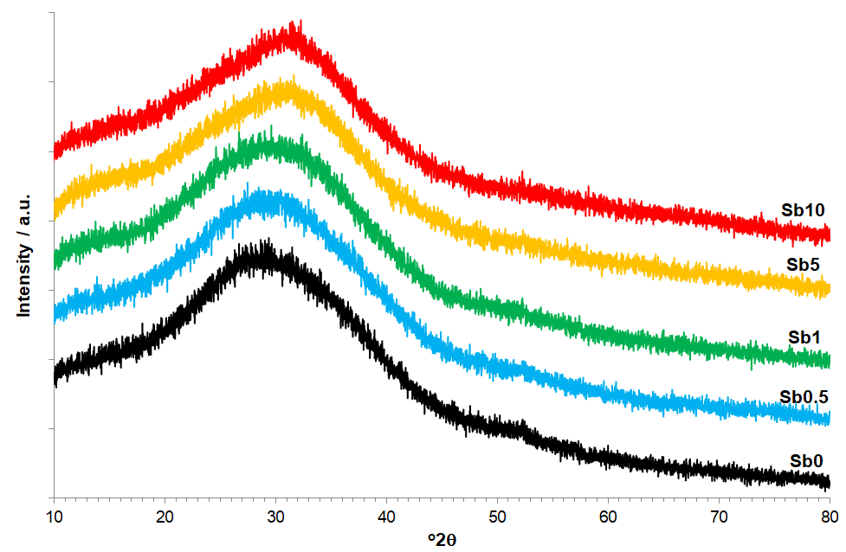

Table 1. Nominal and analysed compositions (mol%) and measured densities and molar volumes of all glasses (Nom. nominal; An. Analysed).
Glass | Sb0 |  | Sb0.5 |  | Sb1 |  | Sb5 |  | Sb10
Mol% | Nom. | An. | Nom. | An. | Nom. | An. | Nom. | An. | Nom. | An.
Na₂O | 13.76 | 13.41 | 13.69 | 13.38 | 13.62 | 13.19 | 13.07 | 12.07 | 12.38 | 10.86
MgO | 5.49 | 3.94 | 5.46 | 3.85 | 5.44 | 3.85 | 5.22 | 3.37 | 4.94 | 2.94
Al₂O₃ | 0.59 | 0.76 | 0.59 | 0.97 | 0.58 | 1.18 | 0.56 | 6.94 | 0.53 | 11.62
Fe₂O₃ | 0.00 | 0.01 | 0.00 | 0.01 | 0.00 | 0.00 | 0.00 | 0.00 | 0.00 | 0.01
SiO₂ | 70.67 | 71.73 | 70.32 | 71.34 | 69.96 | 70.92 | 67.13 | 63.50 | 63.60 | 56.43
SO₃ | 0.22 | 0.18 | 0.22 | 0.13 | 0.22 | 0.11 | 0.21 | 0.03 | 0.20 | 0.00
CaO | 9.27 | 9.96 | 9.22 | 9.84 | 9.18 | 9.75 | 8.81 | 8.84 | 8.35 | 7.60
Sb₂O₃ | 0.00 | 0.00 | 0.50 | 0.49 | 1.00 | 1.00 | 5.00 | 5.26 | 10.00 | 10.54
Total | 100.00 | 100.00 | 100.00 | 100.00 | 100.00 | 100.00 | 100.00 | 100.00 | 100.00 | 100.00
ρ /  g cm⁻³ | 2.499 ± 0.005 |  | 2.537 ± 0.005 |  | 2.603 ± 0.005 |  | 2.839 ± 0.005 |  | 3.002 ± 0.005
V_{M} /  cm³ mol⁻¹ | 23.8 ± 0.10 |  | 23.98 ± 0.10 |  | 23.85 ± 0.15 |  | 26.22 ± 0.25 |  | 29.49 ± 0.50

3.2. ¹²¹Sb Mössbauer Spectroscopy
Figure 2 shows the fitted ¹²¹Sb Mössbauer spectra obtained from the Sb5 and Sb10 glasses, and Table 2 shows all fitted parameters. The two fitted spectra are closely similar in profile, component areas and fitted parameters. Spectra exhibit two major components, characteristic of Sb³⁺ (broad asymmetric component) and Sb⁵⁺ (narrow symmetric component) [23, 24, 26, 30, 51, 52]. The Sb⁵⁺ has a Kr electron configuration with a filled d-shell (d¹⁰), i.e. it is spherical and therefore has no electric field gradient at the nucleus, so any quadrupole interaction observed for Sb⁵⁺ will be small compared to that for Sb³⁺; or it will be zero. In some of the previous ¹²¹Sb Mössbauer studies of oxide glasses the quadrupole interaction for Sb⁵⁺, e²Qq(Sb⁵⁺), was either constrained to a value of zero [51, 52], or no quadrupole interaction for Sb⁵⁺ was observed [26], with those authors noting that this component can be fitted with a singlet-line quadrupole model. Other researchers have fitted this component with a small quadrupole interaction of e²Qq(Sb⁵⁺) ≈ 3 to 6 mm s⁻¹ [23, 24]. However, it was noted that “no reliable value could be obtained” [24] and that “this is difficult to separate from the linewidth contribution and is of doubtful accuracy” [23]. Similarly-mixed results were obtained by Stewart et al. [53] who studied several different antimony oxides and found that whilst α-Sb₂O₄ and Sb₂O₅.3.61H₂O produced fitted spectra with e²Qq(Sb⁵⁺) = -6.1 mm s⁻¹ and -4.3 mm s⁻¹, respectively, β-Sb₂O_{4,} Sb₂O₅.3.56H₂O and Sb₆O₁₃ all produced no visible asymmetry so those spectra were fitted with single lineshapes. In the present study we were able to successfully fit spectra with a single-line quadrupole model for Sb⁵⁺, however, given the signal-to-noise ratios for the measured spectra (Figure 2) a quadrupolar component with a small value of e²Qq(Sb⁵⁺) could also have been fitted whilst achieving equivalent values of χ² for the fits.
This study has not directly established the recoil-free fractions, f, for Sb³⁺ and Sb⁵⁺ in the glasses studied, and consequently it cannot be stated with certainty that the ratio of recoil-free fractions, f(Sb³⁺) / f(Sb⁵⁺) = 1. However, there is some evidence to suggest that the value is close to 1. In their ¹²¹Sb Mössbauer study of several different oxides of antimony, Stewart et al. [53] noted that “while in general this assumption can by no means be taken for granted, there are grounds for believing that for the compounds investigated here it cannot be far wrong and leads to reasonably realistic independent estimates of the Sb^{III}:Sb^{V} ratios”. Holland et al. [24] confirmed, through variable-temperature measurements of a 60 Sb₂O₃ – 40 B₂O₃ (mol %) glass, that the relative intensities of Sb³⁺ and Sb⁵⁺ remained approximately constant, i.e. f(Sb³⁺) / f(Sb⁵⁺) ≈ 1, between 10K and 77K. Mee et al. [23] reached a similar conclusion from measurements at 77K of cervantite (Sb₂O₄ ≡ Sb³⁺Sb⁵⁺O₄). However, they also described unpublished research which indicated that Sb₂O₃-B₂O₃ glasses exhibited a ~20% increase in Sb³⁺ relative intensity on cooling from 77K to 10K. This appears to contradict the results of Holland et al. [24] and the two findings are not easy to reconcile. It is possible that there may have been significant differences in: (1) the compositions (i.e. Sb₂O₃/B₂O₃ ratio) of the glasses; and / or (2) the Sb³⁺ / Sb⁵⁺ redox ratios in the glasses; and / or other differences. However, our measurements were made at 293K, and this must be considered against the lower-temperature measurements from the literature. De Laune et al. [54] studied FeSb₂O₄ and noted a difference in relative Sb³⁺ and Sb⁵⁺ absorption areas at 90K and 293K, such that the apparent Sb⁵⁺ fraction increased from 18% to 22%. They stated that at 90K the recoil-free fractions, f, for Sb³⁺ and Sb⁵⁺ were similar but the difference in apparent Sb⁵⁺ fraction at ambient temperature was expected because of the significantly higher Debye-Waller factor for Sb³⁺ compared with Sb⁵⁺, and the resulting lower recoil-free fraction at ambient temperatures for Sb³⁺ compared with Sb⁵⁺. Hence, we can surmise that the published research for oxide glasses and Sb₂O₄ [23, 24, 53] support the view that the recoilless fraction ratio f(Sb³⁺) / f(Sb⁵⁺) ≈ 1 for those materials, measured between 10K and 77K. However, for the samples measured at 293K in this study, according to the literature f(Sb³⁺) / f(Sb⁵⁺) at 293K may vary slightly from a value of 1 (see, for example, [54]) and consequently the Sb³⁺/ΣSb ratios derived here from the Sb³⁺ and Sb⁵⁺ spectral component areas have greater uncertainties than the corresponding fitted spectral peak areas.

Figure 2. Fitted ¹²¹Sb Mössbauer spectra (293K) for samples Sb5 and Sb10, each showing two fitted components representing Sb³⁺ (blue line) and Sb⁵⁺ (red line).
Sb10
Sb5

Table 2. Refined ¹²¹Sb Mössbauer parameters (293K): centre shift relative to InSb (δ), quadrupole interaction (e²Qq), Lorentzian linewidth (Γ), intensity (I). Bracketed numbers are uncertainties in the first decimal place.
Glass | Sb5 | Sb10
δ₁ / mm s⁻¹  e²Qq₁ / mm s⁻¹  Γ₁ / mm s⁻¹  I₁ / % | -3.6(2)  19.5(9)  4.0(4)  90(3) | -3.2(3)  18.9(9)  3.5(4)  88(3)
δ₂ / mm s⁻¹  Γ₂ / mm s⁻¹  I₂ / % | 9.7(4)  2.6(7)  10(3) | 9.1(8)  3.5(6)  12(3)
Peak absorption / % | 1.5 | 2.0

3.3. Optical Absorption and Fluorescence Spectroscopies
All glass samples were optically transparent, with colours ranging from colourless (Sb0) to light yellow (Sb10), with increasing depth of the colour accompanying increasing Sb₂O₃ content. Figure 3 displays the UV-Vis-nIR absorption spectra of the five studied glasses. The most notable feature is a red-shift of the absorption edge, of the order of 4500 cm⁻¹, which corresponds with increasing Sb₂O₃ content from sample Sb0 to Sb10. Also of note, and shown in the inset in Figure 3, very weak and narrow absorption bands (labelled Fe³⁺) are observed in the spectra for samples Sb0, Sb0.5 and Sb1 at ~ 26,500 cm⁻¹, ~ 24,000 cm⁻¹, ~ 23,000 cm⁻¹ and a very weak, broad band (labelled Fe²⁺) is centred at ~ 10,500 cm⁻¹ in the spectrum for sample Sb0. The band at ~ 10,500 cm⁻¹ is only observed for sample Sb0 and disappears upon addition of Sb₂O₃ to the glass; whilst the bands at ~ 26,500 cm⁻¹, ~ 24,000 cm⁻¹ and ~ 23,000 cm⁻¹ can be observed for samples Sb0, Sb0.5 and Sb1, i.e. up to Sb₂O₃ contents of 1 mol%. These bands have been attributed to the Fe₂O₃ impurities (≤ 0.01 mol%) detected in the glasses (Table 1).

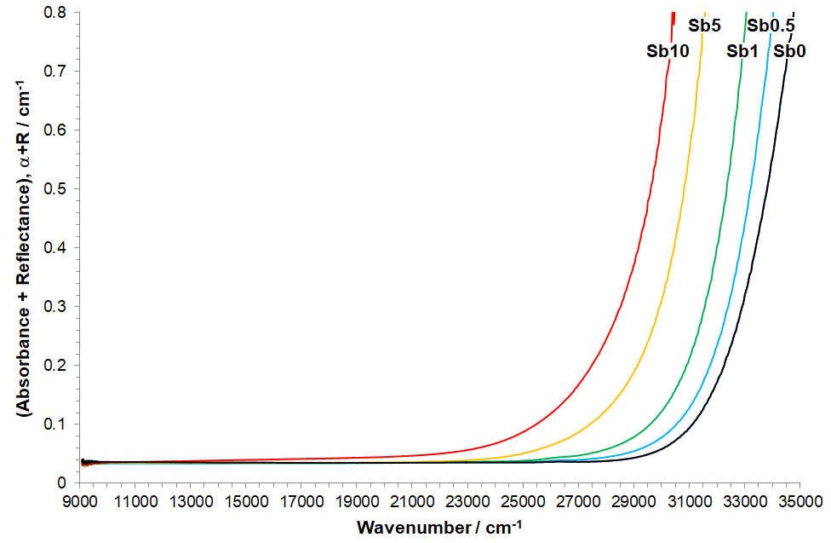
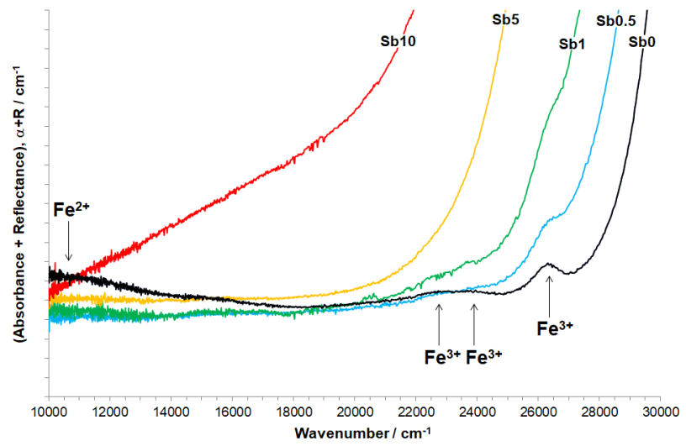
Figure 3. UV-Vis-nIR absorption spectra corrected to 1 mm path length (inset: weak Fe³⁺ and Fe²⁺ absorption bands highlighted)
The UV-Vis-nIR luminescence spectra are shown in Figure 4. A broad luminescence band, centred at 25,200 – 25,600 cm⁻¹, is present in spectra for all Sb-containing glasses, suggesting that all bands are due to the same transition. Intensity of this luminescence band decreases in the order Sb0.5 > (Sb1 ≈ Sb5) > Sb10.

Figure 4. UV-Vis-nIR luminescence spectra (excitation at 40,000 cm⁻¹)
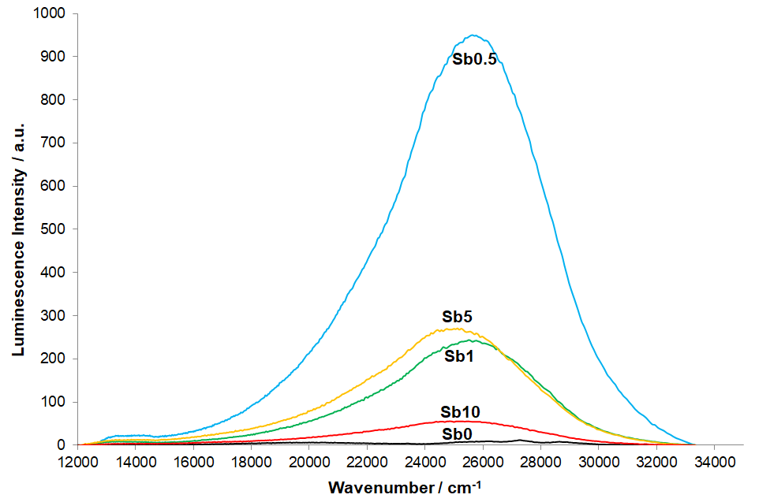

3.4. Raman Spectroscopy
A stacked plot of the corrected Raman spectra for all samples is given in Figure 5. A plot showing the difference in Raman intensity between corrected, normalised (to the peak near 1100 cm⁻¹) spectra for each Sb-containing glass from the spectrum for the Sb0 antimony-free glass is given in Figure 6. The Raman spectra for all samples can be split into two major regions: the lower-frequency region (200 – 750 cm⁻¹) and the higher-frequency region (750 – 1400 cm⁻¹). The addition of Sb₂O₃ to the batches not only affected Sb₂O₃ contents of the glasses, it also affected Al₂O₃ and SO₃ contents (Table 1) and these changes must also be taken into account when considering the effects of Sb₂O₃ additions on the Raman spectra. As shown in both Figures 5 and 6, increasing (Sb₂O₃ + Al₂O₃) content led to small spectral changes up to 1 mol% Sb₂O₃. These changes become more pronounced at 5 and 10 mol % Sb₂O₃. However, changes to the Raman spectra occur at all Sb₂O₃ contents and these changes show consistent trends for all Sb₂O₃ contents studied. The difference spectra in Figure 6 qualitatively illustrate these changes, which are summarised as follows:
- 1075 – 1250 cm⁻¹, decrease in intensity centred at ~1100 cm⁻¹
- 850 – 1075 cm⁻¹, increase in intensity centred at ~1020 cm⁻¹; dip at 990 cm⁻¹ and shoulder at ~920 cm⁻¹
- 200 – 850 cm⁻¹, two new bands arise at ~700 cm⁻¹ and ~510 cm⁻¹

Figure 5. Corrected Raman spectra, intensity-normalised to peak ~ 1100 cm⁻¹
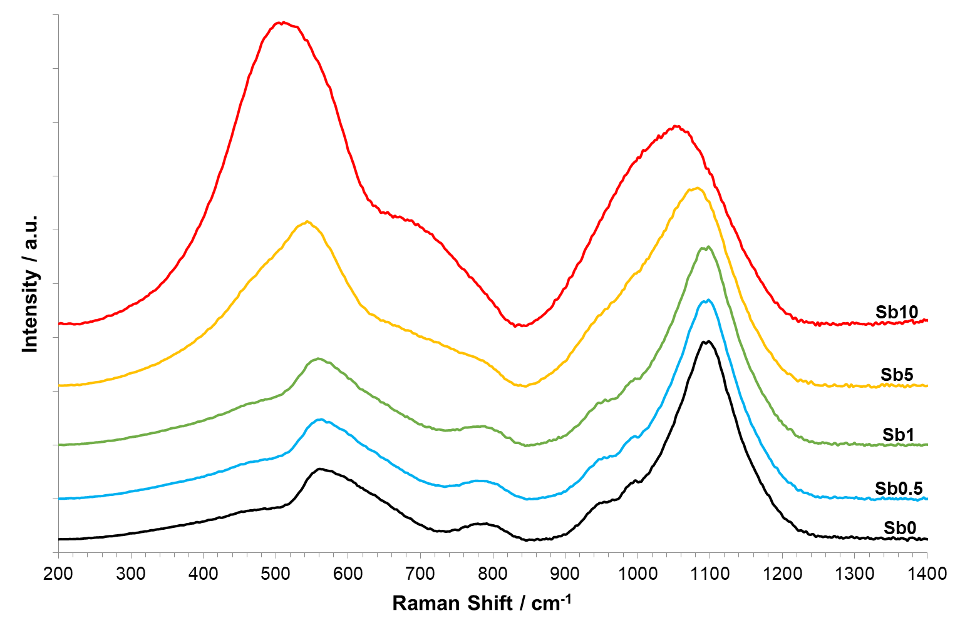

Figure 6. Difference Raman spectra of corrected data, intensity-normalised to peak at ~1100 cm⁻¹
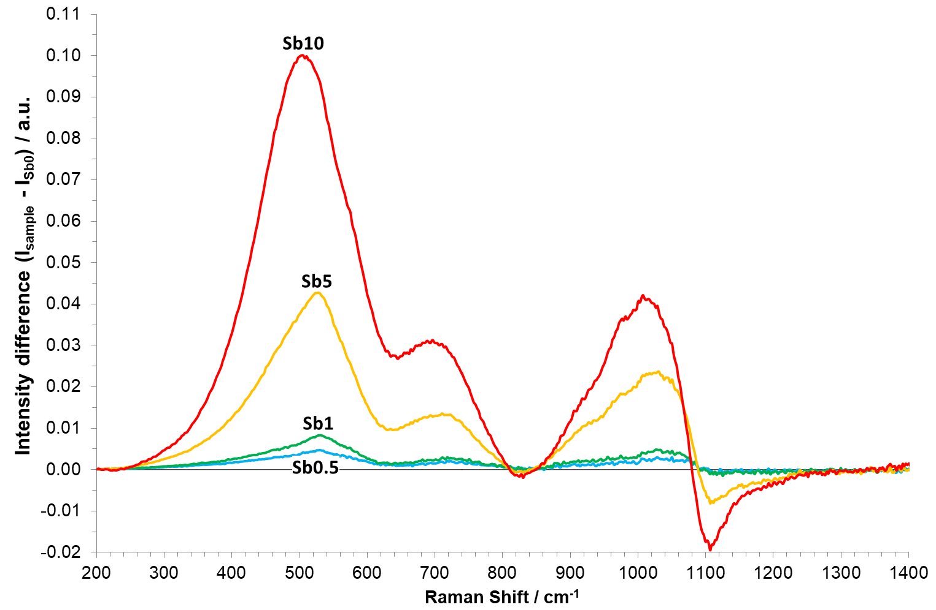

3.6. Thermal Analysis
Dilatometry data for all samples are shown in Figure 7. The extracted coefficient of thermal expansion between 150°C and 400°C (α₁₅₀₋₄₀₀º_{C}), onset glass transition temperatures obtained from both dilatometry and DSC (T_{g}), and the dilatometric softening temperature (T_{d}) are shown in Table 3. Addition of (Sb₂O₃ + Al₂O₃) to the glass had no net effect on the coefficient of thermal expansion, which remained essentially constant for all samples studied. The additional Al₂O₃ presumably arose from enhanced crucible corrosion during glass melting, as confirmed by XRF analysis (Table 1). The onset glass transition temperature, T_{g}, decreased with increasing (Sb₂O₃ + Al₂O₃) content, from ~560°C for sample Sb0 to ~500°C for sample Sb10. Similarly, the dilatometric softening temperature (T_{d}) decreased with increasing (Sb₂O₃ + Al₂O₃) content, from ~615°C for sample Sb0 to ~555°C for sample Sb10.

Figure 7. Dilatometry data for all glasses. Onset T_{g} and T_{d} are marked.
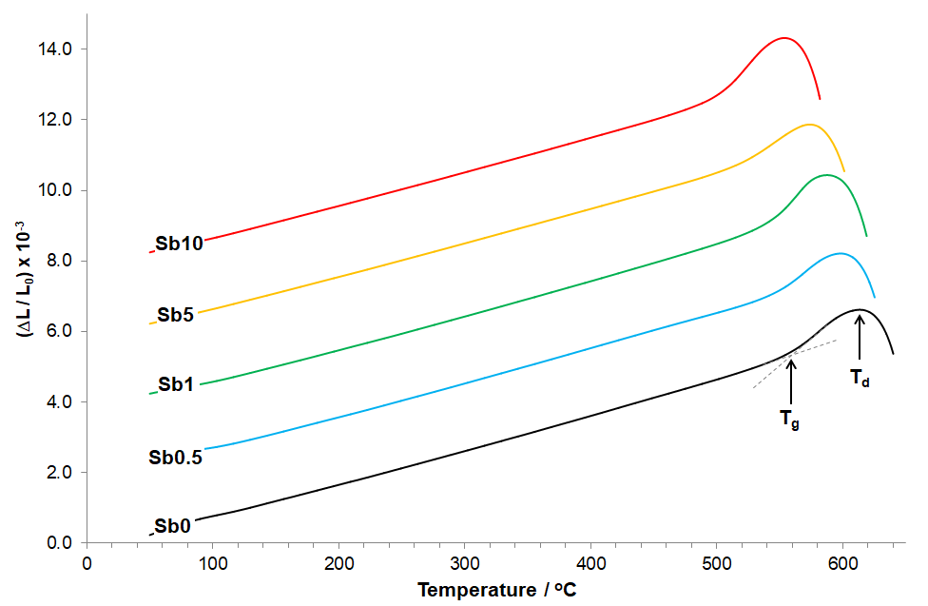
Table 3. Measured glass thermal properties: onset glass transition temperatures (T_{g}) obtained from dilatometry and DSC; dilatometric softening temperature (T_{d}) and coefficient of thermal expansion (CTE, α_{150-400 °C}).
Glass | T_{g (Dil.)} ± 5 / °C | T_{g (DSC)} ± 10 / °C | T_{d} ± 5 / °C | (α x 10⁻⁷) ± 2.0 / °C⁻¹
Sb0 | 560 | 563 | 614 | 96.6
Sb0.5 | 549 | 558 | 598 | 96.8
Sb1 | 544 | 543 | 588 | 96.7
Sb5 | 522 | - | 574 | 95.7
Sb10 | 503 | - | 554 | 96.0

TGA data for all samples, measured between 50°C and 1250°C, are shown in Figure 8. Weight gain occurs at temperatures above ~700°C for Sb₂O₃-containing samples, reaching a maximum weight at ~1175°C, followed by weight loss at temperatures above ~1175°C. As shown in Figure 9, the maximum weight gain demonstrates a linear relationship with the analysed Sb₂O₃ content of the glass, indicating a direct relationship.
Figure 8. TGA weight change of glasses as a function of temperature
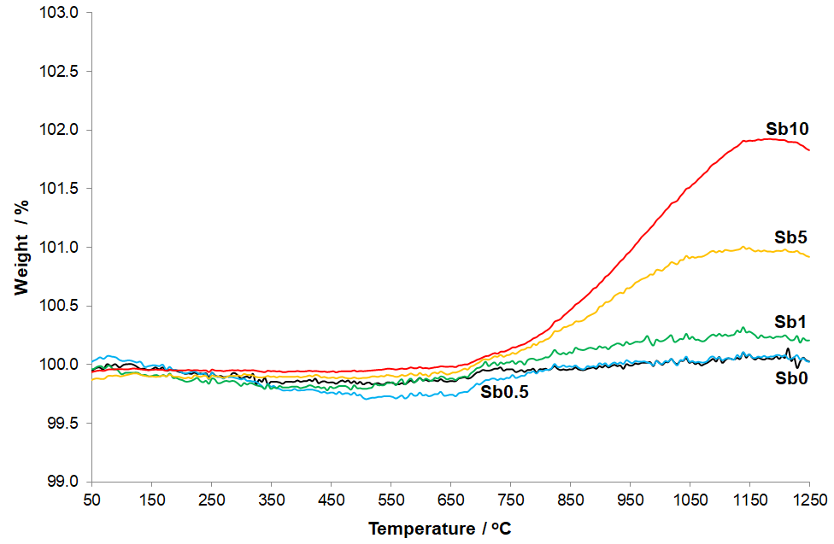
Figure 9. Molar volume (V_{m}) and TGA weight gain (700°C – 1175°C) as functions of analysed Sb₂O₃ content. Linear fit (solid line, R² shown) and guide (dotted line) shown.
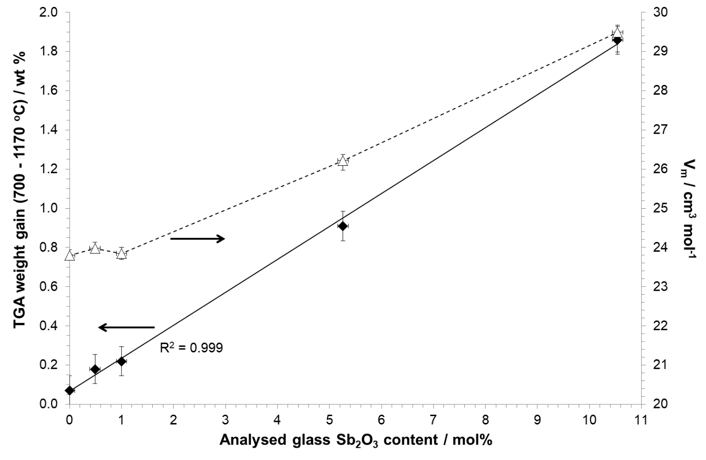
4. Discussion
4.1. Composition-Viscosity Relations
The addition of Sb₂O₃ to soda-lime-silica glasses representative of float glass compositions produces a myriad of changes to their chemical, structural, optical and thermal properties. Some of these changes are combined with the effects of increased Al₂O₃ content. As shown in Table 1, increasing Sb₂O₃ content of the glass was accompanied by increased Al₂O₃ content, particularly for the Sb5 and Sb10 samples, which had roughly comparable molar contents of Sb₂O₃ and Al₂O₃. This additional Al₂O₃ can only have arisen from increased corrosion of the recrystallized Al₂O₃ crucibles used to melt the glasses, and is consistent with Sb₂O₃ substantially decreasing the glass melt viscosity and / or surface tension during melting. Both of these can cause enhanced refractory corrosion [55]. For surface tension, Rubenstein [56] estimated that Sb₂O₃ modestly increases surface tension of soda-lime-silica type glass melts at 1200°C. This would suggest that surface tension effects are less likely to have caused the elevated Al₂O₃ contents in the glasses studied here.
Oxide glasses rich in Sb₂O₃ are known to exhibit low melting temperatures and low melt viscosities [57], consistent with the low melting temperature of pure Sb₂O₃ (656°C). The effects of Sb₂O₃ on the high-temperature viscosity of silicate glasses was studied by Fluegel et al. [58], who showed that Sb₂O₃ has a strong effect on decreasing television (TV) glass viscosity in the softening range (log (η / dPa s) = 7-10). This behaviour may reasonably be extrapolated to higher temperatures and other silicate glasses. It is also qualitatively consistent with the thermal analysis results for our glasses, which show substantial decreases in T_{g} and T_{d} with increasing (Sb₂O₃ + Al₂O₃) contents (Figure 7 and Table 3). This effect of Sb₂O₃ is all the more remarkable because it is in opposition to the effects of the elevated Al₂O₃ contents accompanying the Sb₂O₃ additions. The effects of Al₂O₃ on the viscosity of soda-lime-silica glasses are well-known and can be accurately modelled [1, 46, 58-60]. We have used Fluegel’s model [46, 60] to predict the viscosity-temperature profiles for the analysed compositions of glasses Sb0 and Sb5, in order to understand the independent effect of Al₂O₃ and thus, indirectly, the effect of Sb₂O₃. For glass Sb5, the Sb₂O₃ content was neglected and other constituents increased on a pro-rata basis to total 100% for the purpose of modelling. Glass Sb10 could not be accurately modelled as the Al₂O₃ content for this glass lay outside the boundaries of model validity [46, 60]. The modelled results for our glasses show that addition of Al₂O₃ strongly increases melt viscosity, as expected. The melting temperature (at which log (η / dPa s) = 2) of glass Sb0 is 1450°C and by comparison (and neglecting Sb₂O₃), for glass Sb5 it is 1555°C, an increase of over 100°C. Correspondingly, the Littleton Softening Point (at which log (η / dPa s) = 7.6) is 727°C (glass Sb0) and 777°C (glass Sb5), a difference of 50ºC; and differences remain considerable, even at higher viscosities. For example, (log (η / dPa s) = 10) is 630°C for glass Sb0 and 673°C for glass Sb5; (log (η / dPa s) = 11) is 600°C for glass Sb0 and 641°C for glass Sb5; and (log (η / dPa s) = 13) is 553°C for glass Sb0 and 591°C for glass Sb5. The modelled viscosities given above for glass Sb0 are closely consistent with the measured T_{d} (614°C, corresponding to log (η / dPa s) ≈ 10 to 11) and measured onset T_{g} (560°C, corresponding to log (η / dPa s) = 13). However, the measured and modelled values for the Sb-containing glasses diverge greatly, owing to the model neglecting Sb₂O₃. Whilst the model indicates that for glass Sb5, T_{d} and T_{g} should increase to ~660°C and ~590°C, respectively, on account of its higher Al₂O₃ content, the measured T_{d} and T_{g} of 574°C and 522°C, respectively, are considerably lower than those for the Sb0 glass. This demonstrates the strong fluxing effects of Sb₂O₃ in these glasses, such that for a nominal 5 mol% addition, it effects net reductions in T_{d} of (660 – 574 ≈ 85°C) and in T_{g} of (590 – 522 ≈ 70°C). This fluxing effect is evidenced by the measured and modelled thermal properties. It also helps to explain the significant enhancement of Al₂O₃ crucible corrosion during glass melting due to a substantially lowered melt viscosity (see [55]), leading to elevated Al₂O₃ contents in the resulting glasses. The T_{g} of pure Sb₂O₃ glass is 250°C [22] and even for a binary 80 SiO₂ – 20 Sb₂O₃ (mol %) glass T_{g} remains very low, at ~335°C [22, 23]. The observed effect of Sb₂O₃ in strongly decreasing T_{g} (Table 3) is also consistent with a large body of literature for low-T_{g} glasses in a range of silicate [22, 23], borate [22, 24, 57], phosphate [26, 27], and antimonate [32, 34] glasses, all of which show consistently low T_{g}’s.

4.2. Glass Structure
The incorporation of Sb₂O₃ in silicate glasses, commensurately with its effects on thermal properties, has substantial effects on glass structure. This is illustrated by the changes observed in the X-ray diffraction amorphous hump position with increasing (Sb₂O₃ + Al₂O₃) content shown in Figure 1. Whilst it is not possible to separate the effects of Sb₂O₃ and Al₂O₃ on the amorphous hump position without further research, the shift of the hump position to higher angles (º2θ) is consistent with some combination of shorter average interatomic bond distances and changes in X-ray scattering intensities. Other composition-structural indicators are density and molar volume (Table 1, Figure 9). Both increase with increasing Sb₂O₃ content. However, these changes are not linear and, as above, the effects of elevated Al₂O₃ contents must also be taken into consideration. As shown in Figure 9, the molar volume of the glasses is largely unaffected by Sb₂O₃ additions up to Sb₂O₃ contents between 1 and 5 mol%. At levels above this, the molar volume increases approximately linearly with Sb₂O₃ addition (further research is required to establish the exact Sb₂O₃ content at which this change in behaviour occurs and its structural origins). Such changes in behaviour may be indicative of changes in coordination, local environment, local clustering of Sb cations in the glass, or other effects. In order to confirm that these changes in V_{m} arose from Sb₂O₃ additions, and not to the elevated Al₂O₃ contents that accompany them in our glasses, we have used a similar approach to that used for thermal properties in Section 4.1 above. We calculated molar volumes (V_{m}) for the glasses whilst neglecting their Sb₂O₃ contents, using analysed compositions (Table 1) and Fluegel’s robust and widely-used glass density model [46, 61]. This model shows that V_{m} would slightly decrease from its measured value of 23.8 cm³ mol⁻¹ (note: the modelled value for glass Sb0 was 23.9 cm³ mol⁻¹, validating the accuracy of the model), to a modelled V_{m} of 23.0 cm³ mol⁻¹ for glass Sb10 (neglecting its Sb₂O₃ content). This modelled value takes account of the high Al₂O₃ content of this glass but ignores Sb₂O₃, and shows that Al₂O₃ incorporation in the glass has little effect on the molar volume of these glasses – the effect of Al₂O₃ is thus at least an order of magnitude smaller than that of Sb₂O₃ on a mole-for-mole basis. Given the large increases in V_{m} arising upon incorporation of (Sb₂O₃ + Al₂O₃), shown in Table 1 and Figure 9, the observed trends in V_{m} can thus be attributed predominantly to the incorporation of Sb₂O₃.
The Raman spectral region for oxide glasses between ~850 cm⁻¹ and ~1200 cm⁻¹ has been widely associated with T–O stretching modes (where T = Si, Al, Fe and others) of tetrahedrally-coordinated species [43, 47-49, 62-69]. The Q^{n} notation is also widely used to indicate network connectivity, where n = number of bridging oxygens per tetrahedron. Hence if more than one type of tetrahedral species, for example both SiO₄ and AlO₄⁻, are present they will all contribute in this spectral region. Consequently the Q^{n} notation and Raman peaks in this spectral region apply to both SiO₄ and AlO₄⁻ units in the glasses studied here. Raman spectroscopy does not distinguish between Si- or Al- based tetrahedra in this regard [48]. Spectral contributions arising from different T-O (Q^{n}) units have been widely associated with peaks at certain Raman shifts, from Q⁴ (~1150 cm⁻¹) to Q³ (~1100 cm⁻¹), Q² (~950 cm⁻¹), Q¹ (~850 cm⁻¹) and Q⁰ (~800 cm⁻¹) [43, 47-49, 62-69]. Spectral deconvolutions have also been carried out in this region (see, for example, [47-49, 64, 65, 67-69]) with variations in the nature, number and characteristics of the peaks fitted. For example, additional peaks have been assigned at ~1050 cm⁻¹ and 800 cm⁻¹ in different interpretations and deconvolutions of silicate glass Raman spectra [48, 64, 65, 67-69]. Some have attributed them to the stretching T_{2s} vibrational mode of TO₂ units [48] and some to Si–O stretching vibrations of bridging oxygens (BO) in SiO₄ tetrahedral units with at least one non-bridging oxygen (NBO) [65], respectively. Others have fitted two Q³ components: one each for NBO’s stabilised by alkali and alkaline earth cations [67]; and yet others have introduced a parameter Q_{ab}, where ‘a’ denotes a central tetrahedron type and ‘b’ denotes the nearest tetrahedron type, indicative of mid-range order [68]. Hence, whilst there is generally a degree of consensus in the literature regarding the deconvolution of Raman spectra in terms of Q⁰⁻⁴ units, there remain more subtle differences in the extracted information relating to spectral deconvolution in the Q^{n} region. It is known from ²⁹Si MAS-NMR studies of SiO₂-Na₂O-CaO glasses compositionally similar to our Sb0 glass that the only Si Q^{n} species present in this glass should be Q³ and Q⁴ [65, 66, 70, 71]. Raman bands associated with Sb-O units in glass have been reported by a number of authors [22, 23, 30, 72-74], but there is no evidence of Sb-O bands overlapping with the T-O Q^{n} region, making interpretation of the effects of Sb₂O₃ on glass structure slightly less challenging. The incorporation of Sb₂O₃ and the associated increase in Al₂O₃ content of our glasses, from Sb0 to Sb10, lead to several changes in their structure, illustrated in the Raman spectra (Figures 5 and 6). With increasing (Sb₂O₃ + Al₂O₃) content the Raman intensity centred at ~1100 cm⁻¹ decreases, and the intensity at ~1020 cm⁻¹ and ~920 cm⁻¹ increases. This indicates decreases in the average Q^{n} of T-O species (SiO₄ and AlO₄⁻) with increasing (Sb₂O₃ + Al₂O₃) content. Whilst the addition of Al₂O₃ to the glass on a pro rata basis (which approximates what occurred to the glasses studied here during melting) would be expected to result in a more polymerised network, i.e. an increase in average T-O Q^{n}, the substantial decrease in Raman intensity (Figure 6) at 1100-1150 cm⁻¹ indicates decreases in the abundance of both (Si + Al) Q⁴ and Q³ species. These changes are accompanied by substantial increases in Raman intensity (Figure 6) between 850 cm⁻¹ and 1050 cm⁻¹, with growth of peaks at ~920 cm⁻¹ and ~1020 cm⁻¹ which are consistent with increases in the abundance of (Si + Al) Q² species; and increased intensity (abundance) of the stretching T_{2s} vibrational mode of TO₂ units [48]. These changes, upon additions of Al₂O₃, are qualitatively different from the results of Le Losq et al. [48], who studied the effects of increasing Al₂O₃ content in SiO₂-Al₂O₃-Na₂O glasses and concluded that increasing the Al / (Al + Na) ratio produces a decrease in the proportion of Q³ units but an overall increase in the proportion of Q⁴ units. However, our glasses also contain Sb₂O₃ which therefore clearly has a profound effect. Our results, which suggest decreases in both Q³ and Q⁴ intensity and an increase in Q² intensity, therefore support the view that Sb₂O₃ plays a major role in (alumino)silicate network (de)polymerisation. It can thus be suggested that increasing (Sb₂O₃ + Al₂O₃) in our glasses led to substantial net (Si, Al) network depolymerisation. This is particularly illustrative of the strong depolymerising effect of Sb₂O₃ in silicate glasses, in light of the substantially increased Al₂O₃ content for samples Sb5 and Sb10 which would normally be expected to cause a re-polymerising effect on the network, with a resulting increase in the average Q^{n} as illustrated by Le Losq et al. [48]. However, the opposite appears to occur here, with a substantial decrease in the average Q^{n}. This result is consistent with the effects on thermal properties discussed in Section 4.1, which also confirm the effects of Sb₂O₃ in readily negating and overcoming the (re)polymerising effects of increased Al₂O₃. In order to further elucidate this behaviour, solid-state NMR experiments would prove beneficial.
The Raman band at 990 cm⁻¹ can be unequivocally ascribed to the ν₁ symmetric S-O stretching modes in SO₄²⁻ units, as widely reported for silicate, aluminosilicate and borosilicate glasses [75-79]. This band gradually disappeared with increasing Sb₂O₃ additions, as shown in Figures 5 and 6. XRF analysis of the glasses (Table 1) confirmed increasing loss of SO₃, presumably as SO₂ gas, with increasing (Sb₂O₃ + Al₂O₃) content. This loss of sulphate is consistent with the disappearance of the SO₄²⁻ Raman band at 990 cm⁻¹ with increasing (Sb₂O₃ + Al₂O₃) content. The mechanism by which the (Sb₂O₃ + Al₂O₃) accelerates or enhances sulphate loss is not yet clear but may involve viscosity, solubility, mutual redox reaction and / or surface tension effects, which are also discussed in Section 4.3.
The lower-frequency Raman region (200-800 cm⁻¹) contains many overlapping contributions associated with bending modes of SiO₄ tetrahedra [65, 66]. This spectral region for the Sb0, Sb0.5 and Sb1 glasses comprise a relatively narrow band centred at ~800 cm⁻¹, a broad asymmetric band with a peak at ~560 cm⁻¹, and a weak shoulder at ~460 cm⁻¹. This is consistent with Raman spectra obtained for other SiO₂-Na₂O-CaO glasses with closely similar compositions to those studied here [65, 66]. Limbach et al. [65] deconvoluted the full Raman spectrum for one such SiO₂-Na₂O-CaO glass, into several overlapping bands centred at 340, 460, 490, 540, 600, 630, 800, 950, 1080 and 1100 cm⁻¹. The bands at 490 cm⁻¹ and 600 cm⁻¹ were assigned [65] to the defect bands, D₁ and D₂ [48, 65] which correspond to oxygen breathing vibrations in 4- and 3- membered silica rings, respectively. The band at 540 cm⁻¹ was assigned to delocalized Si–O–Si bridging oxygen vibrations [65] and the broad band at 460 cm⁻¹ to symmetric Si–O–Si bridging oxygen vibrations [65]. The bands at 460, 540 and 800 cm⁻¹ are clearly observed in our spectra for glasses Sb0 to Sb5 (Figure 5) and similar glasses in literature [65, 66].
The Raman band at 800 cm⁻¹ is fundamental to spectra for pure SiO₂ glass and, as discussed earlier, and as summarised by Le Losq et al. [48], this band has been attributed to a number of origins. These include Si–O stretching involving oxygen motions in the Si–O–Si plane; the motion of the Si atom in its oxygen cage; and the threefold – degenerate “rigid cage” vibrational mode of TO₂ units. In the Raman spectrum for pure glassy SiO₂ this band can be fitted by two narrow, overlapping bands with energies corresponding to Si–O stretching vibrations [80, 81]. For the glasses studied here, the lack of spectral change at 800 cm⁻¹ upon addition of (Sb₂O₃ + Al₂O₃), as shown in Figure 6, is perhaps more consistent with Si-O stretching modes / motion of the Si atom in its oxygen cage since (as discussed above) the (Si, Al)-O Q^{n} distribution appears to change in these glasses. However, other possible explanations for the origin of the 800 cm⁻¹ band in the glasses studied here cannot be discounted.
The Raman spectra of the glasses undergo substantial changes in the lower-frequency region (200 – 800 cm⁻¹) upon incorporation of (Sb₂O₃ + Al₂O₃). As shown in Figures 5 and 6, these changes manifest as new bands at ~700 cm⁻¹ and ~500 cm⁻¹, which (i) increase roughly proportionately in intensity to one another, and (ii) move to slightly lower Raman shifts, with increasing (Sb₂O₃ + Al₂O₃) contents. To first consider whether Al-bearing units may contribute to these bands, previous Raman studies of aluminosilicate [48, 63, 69] and aluminate [82] glasses deserve attention. Raman bands at ~500 - 600 cm⁻¹ (aluminosilicate glasses [63, 69]) and at ~550 cm⁻¹ and ~800 cm⁻¹ (aluminate glasses [82]) have previously been observed, but with positions and linewidths that do not match those observed. However, progressive increase of the Al/Si ratio in SiO₂-Al₂O₃-Na₂O glasses [48] showed no evidence of a new band at ~700 cm⁻¹ although changes near 500 cm⁻¹ were observed. On balance, this suggests that Al-bearing units are less likely to be the primary source of the two new observed bands at ~700 cm⁻¹ and ~500 cm⁻¹ although contributions from Al-bearing units cannot be ruled out.
Raman bands related to Sb-O vibrational modes have very high intensities, as discussed by Miller et al. [73], who attributed this to a combination of (i) the glass-forming tendency of Sb₂O₃; (ii) the highly nonlinear geometry of the Sb-O-T (and Sb-O-Sb) bonding structures, and (iii) the high polarizability of the Sb-O bonds. Raman studies of Sb in antimonate [22, 23, 30, 32, 72, 73], borate [22, 31, 72], silicate [23, 74], aluminosilicate [74], germanate [73] and phosphate [26, 83] glasses have previously been published. An intense, broad Raman band centred at ~400-500 cm⁻¹ has been widely observed and is attributed by a number of researchers [22, 23, 26, 72] to bending of trigonal pyramidal or pseudo-tetrahedral [:SbO₃] units. Terashima et al. [72] described this as an intense band near 450 cm⁻¹ which can be divided into two peaks at 500 cm⁻¹ and 440 cm⁻¹, which they assigned to the ν₂ (symmetrical bending) and ν₄ (asymmetrical bending) vibrational modes of SbO₃ units, respectively. Only a weak band near 700 cm⁻¹ has been observed for pure v-Sb₂O₃ [73] as well as several other glasses [22, 24, 73, 74, 83]. This band has been attributed [26, 72] to symmetric stretching of [:SbO₃] units, although Mee et al. [23] assigned it to non-bridging oxygens (NBO’s). Since here the intensity of these two bands increase roughly proportionately to each other (Figures 5 and 6), bending and stretching modes of [:SbO₃] units provide a more consistent explanation.
The local structure of Sb in these glasses was also studied for samples Sb5 and Sb10 by ¹²¹Sb Mössbauer spectroscopy. The fitted parameters (Table 2) show that the large majority, approximately 90%, of the antimony is present in both glasses as Sb³⁺ [23, 24, 26, 30, 51-54] with the remainder as Sb⁵⁺ [23, 24, 51-54] As discussed in Section 3.2, there may be slight inaccuracy in the estimation of the relative proportions of Sb³⁺ and Sb⁵⁺ due to small differences between their recoil-free fractions, f. The large value of e²Qq for Sb³⁺ confirms the highly asymmetric electric field distribution around the [:SbO₃] trigonal pyramids. Conversely, the second component, Sb⁵⁺ (present in SbO₆ units) has an isotropic electron distribution around the nucleus and hence the absence of quadrupole interaction for Sb⁵⁺ in the fits (see Section 3.2). Fitted centre shifts, δ, here given relative to the InSb standard to enable comparison with literature values (Table 2) are comparable to values obtained for Sb³⁺ and Sb⁵⁺ in SiO₂-Sb₂O₃ [23, 51], B₂O₃-Sb₂O₃ [24, 51], P₂O₅-Sb₂O₃ [26, 51] and Sb₂O₃-ZnCl₂ [30] glasses. The fitted δ and e²Qq components for Sb³⁺, and δ for Sb⁵⁺, (Table 2) are consistent with the values for valentinite (Sb₂O₃) and crystalline Sb₂O₅ [23, 24, 52, 53]. As also noted previously [23, 24] this similarity in fitted parameters confirms the similarity in local environments of Sb³⁺ and Sb⁵⁺ in the glasses to their respective local environments in the corresponding crystalline materials. This conclusion is further supported by neutron diffraction of SiO₂-Sb₂O₃ glasses [22] and X-ray absorption spectroscopy of a wide range of Sb₂O₃ - (SiO₂,B₂O₃,GeO₂,As₂O₃) glasses [84-86], which confirmed consistent Sb–O coordination numbers of ~3, with Sb–O bond distances of 1.94–1.97 Å that are largely independent of glass composition; with Sb³⁺ in trigonal pyramidal coordination and Sb⁵⁺ in octahedral coordination.
The strong fluxing effect of Sb₂O₃ during melting of the glasses studied (see Section 4.1), and the evidence from Raman spectroscopy discussed earlier in this Section, are internally consistent and indicate a strong depolymerising effect of Sb₂O₃ on the (alumino)silicate network. This, in turn, suggests the presence of (Si, Al)-O-Sb bonds, with Sb providing NBO’s. A number of workers have investigated structural effects of Sb on silicate and borate glass networks using ²⁹Si MAS-NMR [23, 28], ¹¹B MAS-NMR [24, 28, 72, 84], ²⁷Al MAS-NMR [28] and X-ray absorption spectroscopy (XAS) [83, 84]. On the basis of XAS, Ellison and Sen [83] concluded that the geometry of the SbO₃ coordination polyhedra is extremely well-constrained from one glass family to another, and Sb³⁺ behaves as a classic network former (NWF) cation in binary oxide glasses, creating a continuous random network of Sb-O-M bonds where M = Sb, As, Ge, Si, or B depending on the glass system. For silicate glasses, Mee et al. [23] showed a strong depolymerising effect of Sb₂O₃ on binary SiO₂-Sb₂O₃ glasses using ²⁹Si MAS-NMR, assuming that 2 NBO are formed for each Sb₂O₃ molecule, where NBO are Si–O–Sb oxygen links with significant covalence in the bonding. Terashima et al. [72], Holland et al. [24] and Youngman et al. [84] all found evidence for B-O-Sb linkages in binary B₂O₃-Sb₂O₃ glasses using ¹¹B MAS-NMR. However, Wood et al. [28], who studied SiO₂-B₂O₃-Al₂O₃-CaO-Sb₂O₃ glasses containing 0 to 5.5 mol% Sb₂O₃ (thereby more similar to those glasses studied here) using multiple MAS-NMR isotopes, found a more complex situation where, regardless of the deconvolution method they used, addition of Sb₂O₃ appeared to increase Si Q^{n} for Sb₂O₃ contents of 0 to 1.5 mol%, above which the Q³/Q⁴ ratio remained approximately constant. From ²⁷Al MAS-NMR, the Al remained consistently 4-coordinated for all glasses, and from ¹¹B MAS-NMR the ^{[4]}B³⁺/^{[3]}B³⁺ ratio increased from 0.45 in the Sb-free glass to 0.65 at 3 mol% Sb₂O₃, above which it remained approximately constant [28]. However, Wood et al. noted that from 0 to 1.5 mol% Sb₂O₃, the glasses exhibited visible opalization and, from a TEM study, attributed this to iron nanoparticles. They concluded that Sb³⁺ was most likely present in their glasses as a combination of trigonal pyramids forming Si-O-Sb bonds and tetrahedral (SbO₄)⁻ units requiring charge balance from the Ca²⁺ cations. In light of our evidence from thermal properties, and from Raman and ¹²¹Sb Mössbauer spectroscopies, results for the glasses studied here are more consistent with the majority view that Sb³⁺ exists as trigonal pyramid (:SbO₃) units, introducing multiple NBO’s and forming Si-O-Sb linkages, thereby decreasing the average Si Q^{n}.

4.3. Redox
The redox behaviour of Sb in oxide glasses has been widely studied, partly due to its efficacy and employment over many years as a refining agent in glass manufacturing (see Section 1). Here, the areas of the fitted components for Sb³⁺ and Sb⁵⁺ in glasses Sb5 and Sb10 have been confirmed by ¹²¹Sb Mössbauer spectroscopy to be approximately 90% Sb³⁺, with the balance Sb⁵⁺ (Table 2). However, as discussed in Section 3.2, it is possible that f(Sb³⁺) / f(Sb⁵⁺) deviates slightly from a value of 1 and hence the extracted Sb³⁺/ΣSb ratios may be slightly different than ~0.9. Within uncertainties, the area ratios and hence the Sb³⁺/ΣSb ratios are the same for both glasses. These measured redox ratios are remarkably consistent with measured redox ratios for Sb in other silicate glasses melted at similar temperatures, including TV glasses [10, 11], SiO₂-Sb₂O₃ glasses [23], borosilicate glasses [87] and SiO₂-Na₂O-CaO glasses [6, 14]. Redox data for multiple silicate and borosilicate glasses melted in air at temperatures broadly similar to the melting temperature used here thus shows that Sb³⁺/ΣSb is consistently ~0.80 - 0.95, from low Sb₂O₃ contents of less than 1 mol% [6, 10, 11, 14] to high (>10 mol%) contents [23, 87], and this behaviour is consistent with measured Sb redox potentials in oxide glasses [20, 21]. It is established that glass composition can also play a significant role in determining redox ratios such as Sb³⁺/ΣSb [13, 14, 86, 88], and this behaviour can be described by accepted glass redox models for composition - structure – basicity relations [13, 14, 20, 21, 42, 86, 88-91].
The oxidising effects of the Sb₂O₃ batch additions are also manifested in UV-Vis-nIR optical absorption spectra (Figure 3). The Sb0 antimony-free glass manifested very weak absorption peaks (Figure 3, inset) attributed to Fe²⁺ and Fe³⁺. XRF (Table 1) confirmed the presence of impurity levels of Fe₂O₃ in these glasses, probably arising from impurities in the raw materials used. However, this provides a useful fingerprint for glass redox and for any mutual redox interactions involving Fe and Sb. The observed absorption bands for glass Sb0, marked in the Figure 3 inset, include a broad band centred at ~10,500 cm⁻¹ which is widely attributed to octahedrally-coordinated Fe²⁺ [5, 8, 16-19] and narrower bands centred at 22,600 cm⁻¹, 23,800 cm⁻¹ and 26,500 cm⁻¹, all attributed to tetrahedrally- and octahedrally- coordinated Fe³⁺ [5, 8, 17-19]. Addition of Sb₂O₃ to the glass, at all levels studied, oxidised the Fe²⁺ to Fe³⁺, according to equation (3), consistent with literature [5, 7-10, 15, 20, 21] and demonstrated by the disappearance of the Fe²⁺ absorption band centred at ~10,500 cm⁻¹. Similar results were recently published for Sb₂O₃-doped borosilicate glasses with trace levels of impurity Fe₂O₃ by Singkiburin et al. [7], who showed the disappearance of the Fe²⁺ band and near-complete oxidation of Fe²⁺ to Fe³⁺ at Sb₂O₃ doping levels between 0.10 and 0.50 mol%.
The final redox-active element present in the glasses studied here is sulphur. As discussed in Section 4.2, the Raman band at ~990 cm⁻¹ is due to ν₁ symmetric S-O stretching modes in SO₄²⁻ units. No other Raman bands were observed, including the weak O-S-O bending and stretching modes in SO₄²⁻ units [78, 79] but given the low sulphate contents of all glasses this is not unexpected. No Raman bands that would indicate the presence of lower oxidation states of sulphur [75, 76] were observed, and redox potentials [20, 21] confirmed that the only expected oxidation state of sulphur in glasses prepared under oxidising melting conditions, such as those used here, is S(VI). The disappearance of SO₃ from the glass with increasing (Sb₂O₃ + Al₂O₃) content (Table 1) may be related to accelerated transport properties due to the lower melt viscosities that the Sb₂O₃ additions enable, however, this does not explain the complete disappearance of sulphate with higher (Sb₂O₃ + Al₂O₃) additions and suggests (an)other mechanism(s). Sulphate is evolved as SO₂ gas during glass melting, thereby decreasing the amount of dissolved SO₄²⁻ species with increasing melting time [45, 78] yet such changes are slow and rarely lead to the complete loss of sulphate. Recent XRF analysis of sulphate content of fused beads of soda-lime-silica glass and feldspar Certified Reference Materials (CRM’s) using the same XRF equipment and program used here [45] confirms that the observed sulphate loss is real and quantified, and is not related to errors or uncertainties of measurement. Changes in sulphate solubility of the glass melt as a result of compositional change [76-79] may be one possible explanation, and such effects have been widely reported [76-79, 90]. As illustrated by Backnaes and Deubener [90] in their consideration of a wide body of literature, the solubility of sulphate in high-Al₂O₃ silicate glasses can be up to an order of magnitude lower than in SiO₂-Na₂O-CaO glasses. This may suggest that the increased Al₂O₃ that accompanies increasing Sb₂O₃ in our glasses may also contribute to the observed decreases in analysed SO₃ content. Sulphate evolution from oxide glass melts can be accurately described by a simple diffusion-based model [4, 45]. However, from XRF data (Table 1) it is clear that even at 1 mol% Sb₂O₃ addition the SO₃ content of glass Sb1 is barely over half that of the Sb0 antimony-free glass, with only a small increase in Al₂O₃ content from 0.76 to 1.18 mol%, suggesting rapid diffusion, perhaps facilitated by lower melt viscosities. Hence the increased Al₂O₃ content is unlikely to be solely responsible for the loss of SO₃. The effects of Sb₂O₃ on SO₃ retention are less clear, but evidence from archaeological studies [8, 92, 93] shows that many ancient soda-lime-silica type glasses exhibit SO₃ and Sb₂O₃ contents of up to a few weight %. Moreover, a loose linear correlation between SO₃ and Sb₂O₃ contents has been observed [92, 93] for up to ~1 weight % (approximately 0.75 mol%) SO₃ and up to ~8 weight % (approximately 2 mol%) Sb₂O₃. Clearly, therefore, the behaviour of the glasses studied here differed from the behaviour observed in the ancient glasses [8, 92, 93] and this suggests that the Sb₂O₃ additions are not solely responsible for the loss of SO₃. Other potential factors for consideration include mutual redox interactions between sulphur and antimony species. These are unlikely because any reduction of S⁶⁺ species to a lower oxidation state through a mutual redox reaction with Sb³⁺ is precluded by redox potentials [20, 21] wherein if any reaction between Sb and S did take place, it would be to reduce Sb⁵⁺ to Sb³⁺ and oxidise S²⁻ to S⁶⁺. However, since we have established that the sulphur is present in all glasses solely in its fully-oxidised S⁶⁺ form (see above and Section 4.2) and little Sb⁵⁺ exists in these glasses, this reaction would not be possible. The observed oxidation of Fe²⁺ to Fe³⁺ (Figure 3 inset), consistent with equation (3), and the absence of any Raman bands characteristic of lower oxidation states of sulphur (Figures 5 and 6), as discussed above, support this conclusion. Finally, the previously discussed studies of ancient soda-lime-silica type glasses [8, 92, 93] show that Sb and S species can coexist in such glasses. The specific effects of (Sb₂O₃ + Al₂O₃) on SO₃ solubility and retention, and their mutual interactions in silicate glasses have not, to our knowledge, been studied previously and further research is thus required to more fully understand the observed behaviour.
Thermogravimetric analysis (TGA), shown in Figure 8, illustrates a clear trend in weight gain from 700°C to 1175°C, with weight loss occurring at temperatures above 1175°C. This weight gain displays a linear relationship with analysed Sb₂O₃ content (Figure 9), enabling it to be attributed to oxidation of Sb³⁺ (Sb₂O₃) to Sb⁵⁺ (Sb₂O₅) through reaction with atmospheric oxygen (5).
Sb₂O₃ + O₂ → Sb₂O₅ (5)
At temperatures above 1175°C this reaction reverses and Sb⁵⁺ begins to reduce to Sb³⁺, releasing O₂ (2) as evidenced by the corresponding weight loss. This temperature is consistent with de Best [89] and Kim et al. [94], who showed that 1150-1200°C corresponds with the onset temperature for an increase in oxygen equilibrium pressure for TV glasses, which are alkali-alkaline earth silicate glasses and are thus broadly similar to the soda-lime-silica glasses studied here.
Krol and Rommers [10] studied the Sb³⁺/ΣSb redox ratio in TV glasses and compared glasses prepared from batch materials with those prepared from remelted cullet. For their remelted cullet samples (thus more comparable to our TGA samples), their Sb³⁺/ΣSb ratios remained > 0.9 for glasses melted at all temperatures studied (900°C to 1500°C). However, within this narrow redox range, the Sb³⁺/ΣSb redox ratio did slightly vary with melting temperature, decreasing from 900°C to 1200°C and then increasing again from 1200°C to 1500°C, with the minimum value of Sb³⁺/ΣSb occurring at 1200°C. This is again qualitatively consistent with our TGA results, i.e. maximum Sb oxidation occurring at ~ 1200°C. Krol and Rommers [10] concluded that Sb³⁺/Sb⁵⁺ equilibration is governed by two processes – one relatively fast, where equilibrium is attained with oxygen in the melt; and one relatively slow, where the melt reaches equilibrium with the surrounding atmosphere. They obtained a diffusion length of 0.04 cm after 200 hours’ melting at 1200°C, calculating the diffusion coefficient D = 2.7 x 10⁻⁹ cm² s⁻¹. Closely similar diffusion coefficients were also obtained by Kim and Lee [11]. Considering that Krol and Rommers [10] studied glass melts of 1 cm³ (~2.5 to 3 g glass) whilst our TGA samples were ~30 mg (thus having far greater surface area / volume ratios with a far smaller sample) the two sets of results are not inconsistent. Research by Lee et al. [12] using a Raman microprobe to study O₂ dissolution from bubbles in doped SiO₂-Na₂O-CaO glasses when reheated to 1000°C, indicated that for the glasses doped with Sb₂O₃ the reaction shown here in equation (5) proceeded particularly rapidly, with most of the O₂ within the bubbles dissolving within the glass after only 10 minutes. Those timescales are of the same order of magnitude as those observed here from TGA, and the origins of the apparent differences in oxidation rate with Krol and Rommers [10] are likely to derive from the large differences in sample surface area / volume ratios of the respective glass melts.
Our TGA experiments were conducted at a heating rate of 10°C min⁻¹, hence the time to reach 1175°C from 700°C, when the weight gain began, was 47.5 minutes. This indicates rapid melt / atmospheric O₂ reaction. Similarly rapid reactions, with even greater levels of O₂ uptake, were reported by de Laune et al. [54] for FeSb₂O₄. From Figure 9 it was established that the observed behaviour is consistent with equation (5) above, and hence we can estimate the equilibrium Sb³⁺/ΣSb ratio for our glasses at any temperature between 700°C and 1200°C, if volatilisation and other interactions are neglected. Taking glass Sb10 as an example, and assuming that Sb³⁺/ΣSb in the TGA sample at 700°C is the same as at 20°C (293 K), we have established by ¹²¹Sb Mössbauer spectroscopy that Sb³⁺/ΣSb ~0.9. This corresponds to 33.35 weight % Sb₂O₃ and 3.71 weight % Sb₂O₅ equivalent in glass Sb10 at 700°C. Heating from 700°C to 1175°C produces a weight gain of 1.86 weight % (Figure 8). If all Sb³⁺ in the glass were fully oxidised to Sb⁵⁺, this would produce a weight gain of 3.66 weight %. Hence 1.86 / 3.66 ≈ 50 %, thus half of all Sb³⁺ has been oxidised to Sb⁵⁺ when 1175°C is reached in the TGA experiments, i.e. Sb³⁺/ΣSb ≈ (0.5 x 0.9) ≈ 0.45 at 1175°C. Since the established relationship applies to all studied Sb₂O₃ contents, is linear, and passes close to the origin (Figure 9), this estimation applies to all Sb₂O₃ contents studied. This behaviour is consistent with the results of voltammetric studies by Yoshida et al. [14] and Yamashita et al. [95], who showed, for SiO₂-Na₂O-CaO glasses that the equilibrium Sb³⁺/ΣSb ratio at 1200°C was ~0.5. In addition, Yamashita et al. [95] also showed that the rate of evolved and removed O₂ gas quantities (i.e. when [Sb³⁺] = [Sb⁵⁺]) was at its maximum at 1200°C, again consistent with our TGA results which show this maximum at 1175°C. The glass melts of Yoshida et al. [14] and Yamashita et al. [95] were equilibrated in air for 11 hours at 1400°C and 95 hours at 1200°C, respectively, before they carried out their measurements in order to ensure that redox equilibrium had been achieved. They did not state the mass of glass melted, but given the experimental setups described [14, 95], it can be reasonably estimated that at least 10-100 g and possibly more glass (and thus high volumes with much lower surface area / volume ratios than our TGA samples) was melted, thus explaining the need for longer redox equilibration times. By comparison, 200 g of each of our glasses were melted in air for 5 hours at 1450°C then very small (~30 mg) samples of each glass were powdered and then heated at 10°C min⁻¹ during the TGA experiments. In light of the results of Yoshida et al. [14] and Yamashita et al. [95], our TGA results are thus consistent with achieving, or at least approaching, Sb redox equilibrium dynamically during the TGA experiments. This is because the Sb³⁺/ΣSb redox ratio of ~0.9, achieved here during glass melting at 1450°C, was essentially frozen-in to the TGA samples prior to the TGA experiments and consequently the Sb³⁺/ΣSb redox ratio in the TGA samples that was not at equilibrium for temperatures lower than 1450°C. Thus, as the TGA samples were heated from 20°C upwards, the Sb³⁺/ΣSb ratio would have decreased at temperatures above T_{g} (capturing oxygen and thereby increasing sample weight), with the Sb³⁺/ΣSb ratio decreasing towards the equilibrium value for that temperature. However, the TGA experiments were dynamic processes, thus the Sb³⁺/ΣSb ratio continued to decrease until the sample reached a temperature (1175°C) where it had achieved the equilibrium Sb³⁺/ΣSb ratio for that temperature (~0.5, as discussed above), and as temperature increased further above 1175°C, the Sb³⁺/ΣSb ratio thus began to increase accordingly. This behaviour provides evidence that antimony redox equilibration during the TGA experiments was particularly rapid, and it illustrates that using TGA-sized crucibles and small (mg) sample sizes can provide a practical route for rapid access to redox equilibrium in glass melts containing Sb and, potentially, other multivalent cations.

4.4. Optical Properties
UV-Vis-nIR absorption spectra (Figure 3) show changes in the oxidation state of the Fe impurities according to equation (3), as discussed in Section 4.3. However, the UV-Vis-nIR spectra also show a characteristic red-shift of the UV absorption edge as a function of Sb₂O₃ content, of the order of 4500 cm⁻¹ between sample Sb0 and Sb10. This is consistent with increasing yellow colouration of the glasses due to absorption of a proportion of violet and blue light by the tail of the UV edge. Comparable levels of visible colouration were also obtained by Singkiburin et al. [7], who added up to 2 mol% Sb₂O₃ to borosilicate glasses. Red-shift of the UV edge energy due to Sb incorporation has also been observed by many other researchers [7, 25, 31, 35, 37, 39, 41, 74, 96, 97]. This red-shift and the resulting yellow-gold colouration of the glass is caused by the presence of intense absorption bands centred in the far-UV which produce tails that absorb at visible energies. These absorption bands arise from the spin-forbidden ¹S₀ → ³P₁ transition of Sb³⁺ (centred at 40,000 - 46,000 cm⁻¹) [36-42, 97] and the Laporte-allowed electron-transfer band [42] of Sb⁵⁺ (centred at > 50,000 cm⁻¹) [38, 39, 42]. Strong UV absorption bands causing visible yellow-gold colouration are typical of oxide glasses containing substantial levels of 5p- or 6p- ns² outer electron configuration ions which exhibit s→p transitions (e.g. Pb²⁺, Bi³⁺, Sb³⁺) [25, 31-34, 36-42, 96, 97]. The red-shift of the UV edge here (Figure 3) between samples Sb0 and Sb10 is ~4,500 cm⁻¹, with smaller shifts for lower Sb additions. This effect is accompanied by reduced visible colouration due to the oxidation of Fe²⁺ impurities to Fe³⁺, as discussion in Section 4.3. The iron impurities also contribute broad oxygen-metal charge transfer (OMCT) absorption bands centred in the far-UV [17, 19, 36, 38]. For soda-lime-silica and borosilicate glasses these broad bands are centred at ~39,500 cm⁻¹ (Fe³⁺) and ~46,500 cm⁻¹ (Fe²⁺) [19, 38] but given the low (≤ 0.01 mol%) measured Fe₂O₃ contents of our glasses (Table 1), the spectral contribution here, in the energy range of interest, from the tails of these OMCT bands is very small compared with the effects of the tails from the far-UV Sb³⁺ and Sb⁵⁺ bands.
Consideration of the electronic bandgaps for the corresponding antimony oxides, as obtained by Allen et al. [97], shows energies of ~22,000 to ~28,550 cm⁻¹ for α-, β- and γ- forms of Sb₂O₃, and ~6,130 cm⁻¹ for Sb₂O₅. This is consistent with the observed shifts in UV-edge position observed in this study with increasing Sb₂O₃ content, assuming no changes in the Sb³⁺/ΣSb ratio which is supported by our ¹²¹Sb Mössbauer spectroscopy measurements of the Sb5 and Sb10 glasses. These bandgap energies, particularly of Sb₂O₅, are also consistent with the nonlinear visible and near-IR absorption observed for the higher-Sb glasses studied here (Figure 3), and particularly glass Sb10. It would be interesting to study the effects on UV edge position in oxide glasses with considerably different Sb³⁺/ΣSb redox ratios, in the context of bandgap energies of the corresponding oxides, and further research on this topic is planned.
A single broadband luminescence band, centred at the edge of the visible-range energies (25,200 – 25,600 cm⁻¹), was obtained at all Sb₂O₃ contents (Figure 4) when excited by 40,000 cm⁻¹ UV radiation. The strongest luminescence was obtained at the lowest Sb₂O₃ content studied, 0.5 mol%, with lower intensities at 1 and 5 mol% Sb₂O₃, then yet lower intensity at 10 mol% Sb₂O₃. This behaviour indicates luminescence quenching, with the maximum achievable intensity in this glass system shown to be < 1 mol% Sb₂O₃. Further research is required to establish the optimal Sb₂O₃ content, and also to assess luminescence lifetimes. These have previously been measured in borate and phosphate glasses [40, 41]. Reisfeld et al. [40] observed two distinct lifetimes, of 67 ns and 2.0 μs (P₂O₅-Na₂O glass) and 93 ns and 2.3 μs (B₂O₃-Na₂O glass) and provided a detailed rationale that explained their observed deviation from an exponential function of the luminescence decay curve at room temperature. Masai et al. [41] studied B₂O₃-ZnO glasses and also observed two distinct lifetimes, with one in the nanosecond range and one of 3.6 μs. The single broad emission band is attributed to the spin-forbidden ³P₁ → ¹S₀ transition of Sb³⁺ [40, 41, 98] and its width leads to emission across a range of visible energies, only reaching 10% of its peak intensity at 18,000 cm⁻¹ (Figure 4).
As noted in Section 1, the combination of enhanced UV absorption and re-emission of absorbed energy as lower-energy (visible) photons could have particular advantages in some solar energy applications [43, 44, 99]. For example, such glass could simultaneously: (i) provide enhanced UV protection for polymeric and photovoltaic components of solar energy modules without doping the cover glass with transition metals, lanthanides or other constituents that would produce visible and / or near-IR absorption bands which would reduce the number of photons reaching the solar cell and thereby decreasing its efficiency [43, 44, 99]; and (ii) increase the efficiency of commercial solar cell materials by converting UV photons to visible photons, thereby providing additional photons with energies capable of being efficiently absorbed by the solar cell and converted to electrical current [43, 44, 99]. This performance-enhancing behaviour has recently been studied for several d⁰-configuration d-block cations [43] and for the ns² cation, Bi³⁺ [44]; and for TiO₂ and ZnO coated soda-lime-silica float glasses [99]. On a related theme, Xu et al. [98] noted that the main absorption of chlorophyll matches the blue Sb³⁺ emission, suggesting that glasses doped with Sb³⁺ ions could potentially be used to convert UV light into blue light to promote plant photosynthesis. Additions of Sb₂O₃ to low-cost commercial float-type soda-lime-silica glasses could thus enable new lower melting energy glasses, solar energy glasses, or novel glasses utilising the beneficial thermal or optical properties of Sb₂O₃ additions.

5. Conclusions
Float glass-type SiO₂-Na₂O-CaO glasses with Sb₂O₃ contents of 0 to 10 mol% were X-ray amorphous; and increasing additions of Sb₂O₃ resulted in progressive decreases in glass transition temperature (T_{g}) and dilatometric softening point (T_{d}), despite increases in Al₂O₃ content from higher crucible corrosion during melting. These data, combined with viscosity modelling and Raman spectroscopy, confirmed the very strong fluxing action of Sb₂O₃ in silicate glasses, assisted by the decrease in average (Si, Al)-O Q^{n} speciation that it enables, indicating that Sb₂O₃ additions could be a method of melting energy reduction in glasses where the toxicity of Sb is acceptable. Antimony was shown by ¹²¹Sb Mössbauer spectroscopy to be incorporated as Sb³⁺ (Sb³⁺/ΣSb ≈ 0.9) with Sb present as trigonal pyramidal [:SbO₃] polyhedral and Sb⁵⁺ in octahedral coordination. Sulphate content decreased with increasing Sb₂O₃ content, reaching zero at 10 mol% Sb₂O₃, with the exact mechanism unclear, but which may be related to the strong decreases in melt viscosity enabled by Sb₂O₃ incorporation. TGA experiments showed oxidation then reduction of antimony, with oxidation (Sb³⁺ → Sb⁵⁺) at 700°C – 1175°C and reduction (Sb⁵⁺ → Sb³⁺) > 1175°C, with rapid redox equilibration enabled by the small TGA sample size. Optical absorption spectroscopy showed the UV absorption edge shifting to lower wavenumbers with increasing Sb₂O₃ content, consistent with increasing intensity of far-UV absorption bands arising from Sb³⁺ and Sb⁵⁺ s→p transitions. UV-Vis-nIR fluorescence spectroscopy evidenced a broad luminescence band due to the spin-forbidden ³P₁ → ¹S₀ transition of Sb³⁺, centred at ~25,000 cm⁻¹ and Stokes shifted from the ¹S₀ → ³P₁ absorption transition of Sb³⁺ at ~40,000 cm⁻¹. The strongest emission occurred for 0.5 mol% Sb₂O₃, with concentration quenching reducing intensities at higher Sb₂O₃ contents. Additions of Sb₂O₃ to low-cost commercial float-type soda-lime-silica glasses could thus prove beneficial in enabling lower melting energy glasses, new solar energy glasses or new glasses for other, related applications.

Acknowledgements
T-YC, GG, HS, RJD and PAB acknowledge with thanks funding support from the UK Engineering and Physical Science Research Council (EPSRC) under Grant EP/R020957/1, New Industrial Systems: Manufacturing Immortality. The authors also thank Frank J. Berry for useful discussions.

References
[1] F. T. Wallenberger and P. A. Bingham, Fiberglass and glass technology: energy-friendly compositions and applications, Springer, New York, 2010, 474 pp.
[2] J. E. Shelby, Introduction to glass science and technology, 2nd Ed., Royal Society of Chemistry, London, 2005.
[3] M. Hujová and M. Vernerová, Influence of fining agents on glass melting: a review, part 1. Ceramics –Silikaty 61 (2017) 119–126.
[4] M. Hujová and M. Vernerová, Influence of fining agents on glass melting: a review, part 2. Ceramics –Silikaty 61 (2017) 202-208.
[5] W. A. Weyl, Coloured glasses, Society of Glass Technology, Sheffield, 1951.
[6] M. Cable and A. A. Naqvi, The refining of a soda-lime-silica glass with antimony, Glass Technology 16 (1975) 2-11.
[7] N. Singkiburin, N. Srisittipokakun and J. Keawkhao, Effect of antimony (III) oxide on reduction of bubbles from glass melting process, Journal of Physics: Conference Series 1428 (2020) 012030.
[8] P. A. Bingham and C. M. Jackson, Roman blue-green bottle glass: chemical-optical analysis and high temperature viscosity modelling, Journal of Archaeological Sciences 35 (2008) 302-309.
[9] A. B. Atkarskaya and V. N. Bykov, Clarification of glass using arsenic and antimony oxides, Glass and Ceramics 60 (2003) 389-391.
[10] D. M. Krol and P. J. Rommers, Oxidation-reduction behaviour of antimony in silicate glasses prepared from raw materials and cullet, Glass Technology 25 (1984) 115-118.
[11] K.-D. Kim and S.-H. Lee, Redox behaviour and diffusivity of antimony and cerium ions in alkali alkaline earth silicate glass melts, Ceramics – Silikáty 54 (2010) 14-18.
[12] S. W. Lee, K. S. Hong and R. A. Condrate Sr., Raman microprobe investigation of oxygen and carbon dioxide dissolution from bubbles in silicate glasses containing antimony oxide, Journal of Materials Science 26 (1991) 4250-4254.
[13] M. Yokozeki, T. Moriyasu, H. Yamashita and T. Maekawa, Electrochemical studies of the redox behavior of antimony ions in sodium borate and silicate melts, Journal of Non-Crystalline Solids 202 (1996) 241-247.
[14] S. Yoshida, T. Sudo, M. Kato, T. Sugawara, J. Matsuoka, Y. Miura and Y. Kii, Effects of composition on redox behaviors of antimony or arsenic ion in silicate melts by differential pulse voltammetry, Journal of Non-Crystalline Solids 356 (2010) 2842-2849.
[15] A.-I. Bidegaray, A. Ceglia, M. R. Cicconi, V.-T. Pham, A. Crabbé, E. A. Mernissi Cherigui, K. Nys, H. Terryn, D. R. Neuville and S. Godet, An in-situ XANES investigation of the interactions between iron, manganese and antimony in silicate melts, Journal of Non-Crystalline Solids 502 (2018) 227-235.
[16] M. Hubert, A. J. Faber, H. Sesigur, F. Akmaz, S. R. Kahl, E. Alejandro and T. Maehara, Impact of redox in industrial glass melting and importance of redox control, 77th Conference on Glass Problems: Ceramic Engineering and Science Proceedings, Editor: S.K. Sundaram, Wiley, New York, pp. 115-129.
[17] R. G. Burns, Mineralogical applications of crystal field theory, Cambridge University Press, Cambridge, 1993.
[18] P. A. Bingham, J. M. Parker, T. Searle, J. M. Williams, K. Fyles, Redox and clustering of iron in silicate glasses, Journal of Non-Crystalline Solids 253 (1999) 203-209.
[19] T. T. Volotinen, J. M. Parker and P. A. Bingham, Concentrations and site partitioning of Fe²⁺ and Fe³⁺ ions in a soda-lime-silica glass obtained by optical absorbance spectroscopy, Physics and Chemistry of Glasses: European Journal of Glass Science and Technology B 49 (2008) 258-270.
[20] H. D. Schreiber, Redox processes in glass-forming melts, Journal of Non-Crystalline Solids 84 (1986) 129-141.
[21] H. D. Schreiber, N. R. Wilk Jr. and C. W. Schreiber, A comprehensive electromotive force series of redox couples in soda-lime-silicate glass, Journal of Non-Crystalline Solids 253 (1999) 68-75.
[22] R. G. Orman, Characterisation of novel antimony (III) oxide-containing glasses, PhD thesis, University of Warwick, UK, 2010.
[23] M. Mee, B. C. Davies, R. G. Orman, M. F. Thomas and D. Holland, Antimony and silicon environments in antimony silicate glasses, Journal of Solid State Chemistry 183 (2010) 1925-1934.
[24] D. Holland, A. C. Hannon, M. E. Smith, C. E. Johnson, M. F. Thomas and A. M. Beesley, The role of Sb⁵⁺ in the structure of Sb₂O₃–B₂O₃ binary glasses—an NMR and Mössbauer spectroscopy study, Solid State Nuclear Magnetic Resonance 26 (2004) 172-179.
[25] S. Y. Marzouk and F. H. El-Batal, Infrared and UV–visible spectroscopic studies of gamma-irradiated Sb₂O₃–B₂O₃ glasses, Journal of Molecular Structure 1063 (2014) 328-335.
[26] M. Nalin, Y. Messaddeq, S. J. L. Ribeiro, M. Poulain, V. Briois, G. Brunklaus, C. Rosenhahn, B. D. Mosel and H. Eckert, Structural organization and thermal properties of the Sb₂O₃–SbPO₄ glass system, Journal of Materials Chemistry 14 (2004) 3398-3405.
[27] M. Nalin, M. Poulain, M. Poulain, S. J. L. Ribeiro and Y. Messaddeq, Antimony oxide based glasses, Journal of Non-Crystalline Solids 284 (2001) 110–116.
[28] J. G. Wood, S. Prabakar, K. T. Mueller and C. G. Pantano, The effects of antimony oxide on the structure of alkaline-earth alumino borosilicate glasses, Journal of Non-Crystalline Solids 349 (2004) 276–284.
[29] D. F. Franco, E. E. Carvajal, J. P. Donoso, M. A.P. Silva, A. C. Sant’Ana, H. Fares, C. J. Magon and M. Nalin, Structural and EPR studies of Cu²⁺ ions in NaPO₃ – Sb₂O₃ – CuO glasses Journal of Non-Crystalline Solids 503 (2019) 169–175.
[30] J. A. Johnson, D. Holland, J. Bland, C. E. Johnson and M. F. Thomas, Cation coordination in oxychloride glass, Journal of Physics: Condensed Matter 15 (2003) 755–764.
[31] G. Jagannath, B. Eraiah, A. Gaddam, H. Fernandes, D. Brazete, K. Jayanthi, K. N. Krishnakanth, S. V. Rao, J. M. F. Ferreira, K. Annapurna and A. R. Allu, Structural and femtosecond third-order nonlinear optical properties of sodium borate oxide glasses: effect of antimony, Journal of Physical Chemistry C 123 (2019) 5591-5602.
[32] K. Ouannes, K. Lebbou, B. M. Walsh, M. Poulain, G. Alombert-Goget and Y. Guyot, New Er³⁺ doped antimony oxide based glasses: thermal analysis, structural and spectral properties, Journal of Alloys and Compounds 649 (2015) 564-572.
[33] T. Som and B. Karmakar, Green and red fluorescence upconversion in neodymium-doped low phonon antimony glasses, Journal of Alloys and Compounds 476 (2009) 383–389.
[34] K. Ouannes, K. Lebbou, B. M. Walsh, M. Poulain, G. Alombert-Goget and Y. Guyot, Antimony oxide based glasses, novel laser materials. Optical Materials 65 (2017) 8-14.
[35] X. Heng, Q. Qian, X. Chen, L. Liu, X. Zhao, D. Chen and Z. Yang, Reduced radiation damage in a multicomponent phosphate glass by Nb⁵⁺ or Sb³⁺ doping, Optical Materials Express 5 (2015) 2272-2280.
[36] D. Möncke and D. Ehrt, Photoionization of polyvalent ions, in: Materials Science Research Horizons, Editor: H. P. Glick, Nova Science Publishers, New York (2007) pp. 1-56.
[37] D. Möncke and D. Ehrt, Photoionization of As, Sb, Sn, and Pb in metaphosphate glasses. Journal of Non-Crystalline Solids 345-346 (2004) 319–322.
[38] D. Ehrt and P. Eberling, Radiation defects in borosilicate glasses, Glass Technology 44 (2003) 46-49.
[39] A. M. Efimov, A. I. Ignatiev, N. V. Nikonorov, and E. S. Postnikov, Photo-thermo-refractive glasses: effects of dopants on their ultraviolet absorption spectra, International Journal of Applied Glass Science 6 (2015) 109-127.
[40] R. Reisfeld, L. Boehm and B. Barnett, Luminescence and Nonradiative Relaxation of Pb²⁺, Sn²⁺, Sb³⁺, and Bi³⁺ in Oxide Glasses, Journal of Luminescence 15 (1975) 140-150.
[41] H. Masai and T. Yanagida, Photoluminescence of ns²-type center-containing zinc borate glasses, Journal of Non-Crystalline Solids 431 (2016) 83–87.
[42] J. A. Duffy, Prediction of ultraviolet absorption spectra of p-block ions in oxide media possible application to redox equilibria in glasses and molten salts, Journal of the Chemical Society, Faraday Transactions 2: Molecular and Chemical Physics 74 (1978) 1504-1514.
[43] B. L. Allsopp, G. Christopoulou, A. Brookfield, S. D. Forder and P. A. Bingham, Optical and structural properties of d⁰ ion-doped silicate glasses for photovoltaic applications, Physics and Chemistry of Glasses: European Journal of Glass Science and Technology Part B 59 (2018) 193-202.
[44] B. L. Allsopp, R. Orman, S. R. Johnson, I. Baistow, G. Sanderson, P. Sundberg, C. Stålhandske, L. Grund, A. Andersson, J. Booth, P. A. Bingham and S. Karlsson, Towards thinner cover glasses for photovoltaic devices with enhanced service lifetimes and lifetime efficiencies, Progress in Photovoltaics: Research and Applications (under review, February 2020).
[45] A. M. T. Bell, D. J. Backhouse, W. Deng, J. D. Eales, E. Kilinc, K. Love, P. Rautiyal, J. C. Rigby, A. H. Stone, S. Vaishnav, G. Wie-Addo and P. A. Bingham, X-ray fluorescence analysis of feldspars and silicate glass: effects of melting time on fused bead consistency and volatilization, Minerals 10 (2020) 442.
[46] A. Fluegel, http://glassproperties.com/, accessed 20/05/2020.
[47] D. R. Neuville and B. O. Mysen, Role of aluminium in the silicate network: in situ, high-temperature study of glasses and melts on the join SiO₂-NaAlO₂, Geochimica et Cosmochimica Acta 60 (1996) 1727-1737.
[48] C. Le Losq, D. R. Neuville, P. Florian, G. S. Henderson and D. Massiot, The role of Al³⁺ on rheology and structural changes in sodium silicate and aluminosilicate glasses and melts, Geochimica et Cosmochimica Acta 126 (2014) 495–517.
[49] B. O. Mysen, L. W. Finger, D. Virgo and F. A. Seifert, Curve-fitting of Raman spectra of silicate glasses, American Mineralogist 67 (1982) 686-695.
[50] D. A. Long, Raman Spectroscopy (1977) McGraw-Hill, New York.
[51] A. Paul, J. D. Donaldson and M. J. K. Thomas, The ¹²¹Sb Mössbauer spectra of antimony-containing glasses, Journal of Materials Science 12 (1977) 219-222.
[52] P. Charton and P. Armand, Glasses in the TeO₂–Sb₂O₄ binary system, Journal of Non-Crystalline Solids 316 (2003) 189–197.
[53] D. J. Stewart, O. Knop, C. Ayasse and F. W. D. Woodhams, Pyrochlores. VII. the oxides of antimony: an X-ray and Mössbauer study, Canadian Journal of Chemistry 50 (1972) 690-700.
[54] B. P. de Laune, G. J. Rees, M. J. Whitaker, H.-Y. Hah, C. E. Johnson, J. A. Johnson, D. E. Brown, M. G. Tucker, T. C. Hansen, F. J. Berry, J. V. Hanna and C. Greaves, Oxygen insertion reactions within the one-dimensional channels of phases related to FeSb₂O₄, Inorganic Chemistry 56 (2017) 594−607.
[55] P. A. Bingham, A. J. Connelly, N. C. Hyatt and R J. Hand, Corrosion of glass contact refractories for the vitrification of radioactive wastes: a review, International Materials Reviews 56 (2011) 226-242.
[56] C. Rubenstein, Factors for the calculation of the surface tension of glasses at 1200ºC, Glass Technology 5 (1964) 36-40.
[57] M. Imaoka, H. Hasegawa and S. Shindo, Properties and structure of glasses of B₂O₃-Sb₂O₃ system, Yogyo-Kyokai-Shi 77 (1969) 263-271.
[58] A. Fluegel, A. K. Varshneya, T. P. Seward and D. A. Earl, Viscosity of commercial glasses in the softening range, Ceramic Transactions 141 (2003) 379-386.
[59] T. Lakatos, Viscosity-temperature relations in glasses composed of SiO₂-Al₂O₃-Na₂O-K₂O-Li₂O-CaO-MgO-BaO-ZnO-PbO-B₂O₃, Glasteknisk Tidskrift 31 (1976) 51-54.
[60] A. Fluegel, Glass viscosity calculation based on a global statistical modelling approach, Glass Technol.: Eur. J. Glass Sci. Technol. A 48 (2007) 13-30.
[61] A. Fluegel, Global model for calculating room-temperature glass density from the composition, Journal of the American Ceramic Society 90 (2008) 2622-2625.
[62] S. A. Brawer and W. B. White, Raman spectroscopic investigation of the structure of silicate glasses. I. The binary alkali silicates, Journal of Chemical Physics 63 (1975) 2421-2432.
[63] S. A. Brawer and W. B. White, Raman spectroscopic investigation of the structure of silicate glasses. II. Soda-alkaline earth-alumina ternary and quaternary glasses, Journal of Non-Crystalline Solids 23 (1977) 261-278.
[64] D. R. Neuville, Viscosity, structure and mixing in (Ca, Na) silicate melts, Chemical Geology 229 (2006) 28-41.
[65] R. Limbach, S. Karlsson, G. Scannell, R. Mathew, M. Edén and L. Wondraczek, The effect of TiO₂ on the structure of Na₂O-CaO-SiO₂ glasses and its implications for thermal and mechanical properties, Journal of Non-Crystalline Solids 471 (2017) 6–18.
[66] E. Kilinc and R. J. Hand, Mechanical properties of soda–lime–silica glasses with varying alkaline earth contents, Journal of Non-Crystalline Solids 429 (2015) 190–197.
[67] N. Trcera, S. Rossano and M. Tarrida, Structural study of Mg-bearing sodosilicate glasses by Raman spectroscopy, Journal of Raman Spectroscopy 42 (2011) 765-772.
[68] O. N. Koroleva, V. N. Anfilogov, A. Shatskiy and K. D. Litasov, Structure of Na₂O–SiO₂ melt as a function of composition: in situ Raman spectroscopic study, Journal of Non-Crystalline Solids 375 (2013) 62–68.
[69] P. McMillan, Structural studies of silicate glasses and melts-applications and limitations of Raman spectroscopy, American Mineralogist 69 (1984) 622-644.
[70] H. Bradford, A. Ryder, J. Henderson and J. J. Titman, Structure of ancient glass by ²⁹Si magic angle spinning NMR spectroscopy, Chemistry a European Journal 24 (2018) 7474 – 7479.
[71] A. R. Jones, R. Winter, G. N. Greaves and I. H. Smith, MAS-NMR study of soda-lime-silicate glasses with variable degree of polymerisation, Journal of Non-Crystalline Solids 293-295 (2001) 87-92.
[72] K. Terashima, T. Hashimoto, T. Uchino, S.-H. Kim and T. Yoko, Structure and nonlinear optical properties of Sb₂O₃-B₂O₃ binary glasses, Journal of the Ceramic Society of Japan 104 (1996) 1008-1014.
[73] A. E. Miller, K. Nassau, K. B. Lyons and M. E. Lines, The intensity of Raman scattering in glasses containing heavy metal oxides, Journal of Non-Crystalline Solids 99 (1988) 289-307.
[74] D. Dorosz, J. Zmojda, M. Kochanowicz, P. Miluski, P. Jelen and M. Sitarz, Structural and optical study on antimony-silicate glasses doped with thulium ions, Spectrochimica Acta Part A: Molecular and Biomolecular Spectroscopy 134 (2015) 608–613.
[75] W. L. Konijnendijk and J. H. J. M. Buster, Raman-scattering measurements of silicate glasses containing sulphate, Journal of Non-Crystalline Solids 23 (1977) 401-418.
[76] T. Tsujimura, X. Xue, M. Kanzaki, M.J. Walter, Sulfur speciation and network structural changes in sodium silicate glasses: constraints from NMR and Raman spectroscopy, Geochimica et Cosmochimica Acta 68 (2004) 5081e5101.
[77] P. A. Bingham, S. Vaishnav, S. D. Forder, A. Scrimshire, B. Jaganathan, J. Rohini, J. C. Marra, K. M. Fox, E. M. Pierce, P. Workman and J. D. Vienna, Modelling the sulfate capacity of simulated radioactive waste borosilicate glasses, Journal of Alloys and Compounds 695 (2017) 656-667.
[78] M. Lenoir, A. Grandjean, S. Poissonnet and D. R. Neuville, Quantitation of sulfate solubility in borosilicate glasses using Raman spectroscopy, Journal of Non-Crystalline Solids 355 (2009) 1468–1473.
[79] S. Vaishnav, A. C. Hannon, E. R. Barney and P. A. Bingham, Neutron diffraction and Raman studies of the incorporation of sulfate in silicate glasses, Journal of Physical Chemistry C 124 (2020) 5409-5424.
[80] A. G. Kalampounias, S. N. Yannopoulos and G. N. Papatheodorou, Temperature induced structural changes in glassy, supercooled, and molten silica from 77 to 2150 K, Journal of Chemical Physics 124 (2006) 014504.
[81] A. G. Kalampounias, S. N. Yannopoulos and G. N. Papathedorou, A high-temperature Raman spectroscopic investigation of the potassium tetrasilicate in glassy, supercooled, and liquid states, Journal of Chemical Physics 125 (2006) 164502.
[82] P. McMillan and B. Piriou, Raman spectroscopy of calcium aluminate glasses and crystals, Journal of Non-Crystalline Solids 55 (1983) 221-242.
[83] L. Koudelka, J. Šubčík a, P. Mošner, L. Montagne and L. Delevoye, Structure and properties of Sb₂O₃-containing zinc borophosphate glasses, Journal of Non-Crystalline Solids 353 (2007) 1828–1833.
[84] R. E. Youngman, S. Sen, L. K. Cornelius and A. J. G. Ellison, Novel structural aspects of Sb₂O₃-B₂O₃ glasses, Physics and Chemistry of Glasses 44 (2003) 69-74.
[85] A. J. G. Ellison and S. Sen, Role of Sb³⁺ as a network-forming cation in oxide glasses, Physical Review B 67 (2003) 052203.
[86] L. A. Miller, H. St.C. O'Neill, A. J. Berry and C. J. Glover, The oxidation state and coordination environment of antimony in silicate glasses, Chemical Geology 524 (2019) 283-294.
[87] A. Schütz, D. Ehrt, M. Dubiel, X. Yang, B. Mosel and H. Eckert, A multi-method characterization of borosilicate glasses doped with 1 up to 10 mol% of Fe, Ti and Sb, Glastechnische Berichte: Glass Science and Technology 77 (2004) 295-305.
[88] W. D. Johnston, Oxidation-reduction equilibria in molten Na₂O.2SiO₂ glass, Journal of the American Ceramic Society 48 (1965) 184-190.
[89] A. W. M. de Best, Redox behaviour and fining of molten glass, PhD thesis, Technische Universiteit Eindhoven, Netherlands (1994). https://doi.org/10.6100/IR426291
[90] L. Backnaes and J. Deubener, Experimental studies on sulfur solubility in silicate melts at near-atmospheric pressure, Reviews in Mineralogy and Geochemistry 73 (2011) 143-165.
[91] L. Grund, B. Jonson and K. Lundstedt, The influence of basicity on oxygen activity and antimony oxide fining efficiency in alkali alkaline earth aluminosilicate glasses, Glass Technology: European Journal of Glass Science and Technology A 50 (2009) 241–246.
[92] P. Fredrickx, I. De Ryck, K. Janssens, D. Schryvers, J.-P. Petit and H. Döcking, EPMA and m-SRXRF analysis and TEM-based microstructure characterization of a set of Roman glass fragments, X-Ray Spectrometry 33 (2004) 326–333.
[93] I. C. Freestone and C. P. Stapleton, Composition, technology and production of coloured glasses from Roman mosaic vessels, Chapter 6 in: Glass of the Roman world, Ed. J. Bayley, I. Freestone and C. Jackson, Oxbow Books, Oxford (2015) 61-77.
[94] K. D. Kim, H. K. Kim and J. H. Kim, Behavior of oxygen equilibrium pressure in CRT glass melts doped with Sb and Ce ions from the viewpoint of fining, Journal of the Korean Ceramic Society 44 (2007) 419-423.
[95] H. Yamashita, S. Yamaguchi, R. Nishimura and T. Maekawa, Voltammetric studies of antimony ions in soda-lime-silica glass melts up to 1873K, Analytical Sciences 17 (2001) 45-50.
[96] S. Rada, L. Rus, M. Rada, M. Zagrai, E. Culea and T. Rusu, Compositional dependence of structure, optical and electrochemical properties of antimony (III) oxide doped lead glasses and vitroceramics, Ceramics International 40 (2014) 15711-15716.
[97] J. P. Allen, J. J. Carey, A. Walsh, D. O. Scanlon and G. W. Watson, Electronic structures of antimony oxides, Journal of Physical Chemistry C 117 (2013) 14759−14769.
[98] D. Xu, R. Wei, J. Cao and H. Guo, Luminescence and energy transfer of Sb³⁺/Dy³⁺ co-doped magnesium sodium-phosphate glasses, Optical Materials Express 7 (2017) 2899-2904.
[99] W. Johansson, A. Peralta, B. Jonson, S. Anand, L. Österlund and S. Karlsson, Transparent TiO₂ and ZnO thin films on glass for UV protection of PV modules, Frontiers in Materials 6 (2019) 259.

