Submitted in partial fulfilment of the Lancaster University Doctorate in Clinical Psychology
March 2020

Doctoral Thesis:

Assessing the relationships people have with their voices

Rohan M. Morris
Trainee Clinical Psychologist
Doctorate in Clinical Psychology
Division of Health Research, Lancaster University

Word Count Statement

Section | Text | Tables, figures, references, abstract, appendices, quotes and footnotes | Total
Abstract | 296 |  | 295
Literature review | 7992 | 9237 | 17229
Research paper | 7987 | 10747 | 18734
Critical Appraisal | 3590 | 999 | 4589
Ethics Section | 17798 | 8279 | 26036
Total | 37663 |  | 66883

Abstract
This body of work comprises a Systematic Literature Review (SLR), research paper and a critical appraisal.
SLR
Background: There has been an increasing trend to develop self-report assessments of voices. Assessments are crucial for research and clinical practice. However, no SLR of measures has been conducted since 2009.
Methods: Databases were systematically searched (MEDLINE, PsychINFO and Scopus) from 2009 to 2019. Measures were assessed for the quality of methods used and measurement properties.
Results: Twenty-one measures were identified, none of which were rated at ‘adequate’ or better in more than 3 of 10 areas in their methods used in measure development. No measures had involved voice hearers in the development of item pools.
Conclusion: Further research is necessary to develop measures. This should involve people with lived experience.
Research paper
Background: Relational therapeutic approaches may be beneficial for voice hearers. However, there is currently no English language measure of the Voice Hearer Relationship (VHR) which assesses both positive and negative aspects of the relationship. This study sought to gain an in-depth understanding of VHR with a view to developing an item pool for such a measure.
Methods: Qualitative interviews were conducted with voice hearers (n=7) and clinicians (n=8).
Results: Thematic analysis revealed four themes. Based on this analysis 93 items were generated regarding the VHR. This item pool will form the basis of a new measure of the VHR..
Conclusion: This study highlights that it is feasible to conduct qualitative research with voice hearers and clinicians for the purposes of developing an item pool regarding the VHR and this may contribute to the comprehensiveness of the measure.
Critical Appraisal
This chapter discusses: my epistemological position, the choice of analysis, biases in this research (and steps taken to address these), and future directions of this research.

Declaration
I declare that the work included herein was undertaken for the Doctorate in Clinical Psychology at Lancaster University’s Division of Health Research. The work presented here is the author’s own work, except where due reference is made. The work included herein has not been submitted for the award of a higher degree elsewhere.

Acknowledgments
I am very grateful for the kindness, support, guidance and inspiration that I have received from each of my supervisors. I feel like I have really gained a lot from talking and listening to each of you. If friends are the family that you choose, then I see you as my supervisory family because I would choose to have you all as my supervisors again.
I am very grateful to the love and support I have had from all my friends and family. I am looking forward to emerging from my self-imposed work related seclusion and having the opportunity to create lots more happy memories with you.
I am most grateful to my partner (soon to be wife) Sarah. Thank you for your tolerance and understanding. Thank you for engaging me in endless conversations about my work, when we both know that there are other things that you would rather talk about. Thank you for putting up with my complete dereliction of household duties. Thank you for being the amazing person that you are. I am also very grateful to my daughter Ella. Thank you for helping me to keep in perspective what is important in life. Thank you for giving me those brilliant moments where my concerns, worries, plans for the future, can just all melt away and I feel like I have no choice but to be fully present in the fun, laughter and joy you bring to my world.

Table of Contents
Table of Contents
Thesis Abstract 1-3
Declaration 1-5
Acknowledgments 1-6
Chapter 1 Systematic Literature Review
Abstract 1-3
Method 1-7
Inclusion Criteria 1-8
Exclusion criteria 1-8
Rationale for inclusion and exclusion criteria 1-8
Definition of momentary and ambulant assessments 1-9
Search Overview 1-10
Evaluation of methodological quality 1-11
Evaluation of Measurement Properties (EMP) checklist 1-12
Results 1-12
Description of extracted studies 1-12
Non-ambulant assessments 1-13
Ambulant assessments 1-23
Summary of results and comparison between ambulant and non-ambulant assessments 1-28
Discussion 1-29
Conclusion 1-32
Conflict of interests 1-33
References 1-34
Tables and Figures 1-47
Appendices 60
Appendix 1A Instructions for authors 61
Appendix 1B Search strategy and terms 73
Chapter 2 Research paper
Abstract 2-1
Introduction 2-2
Methods 2-6
Study design 2-6
Participants 2-6
Recruitment 2-6
Inclusion & Exclusion criteria 2-7
Data Collection 2-7
Analysis 2-8
Validity and credibility 2-8
Ethical considerations 2-9
Reflexivity and epistemology 2-10
Results 2-11
Participant characteristics 2-11
Themes 2-11
Theme 1: Power, powerlessness and patterns of relating: “I don’t think relationships happen in a vacuum” 2-12
Theme 1 Item pool generation 2-16
Theme 2: The interaction between relationships: “We interact as a community” 2-17
Theme 2 Item pool generation 2-19
Theme 3: Factors which influence the application of relating skills 2-20
Theme 3 Item pool generation 2-24
Theme 4: Skills that help develop the relationship 2-25
Theme 4 Item pool generation 2-27
Interaction between themes 2-28
Development of an item pool 2-28
Discussion 2-28
Implications for clinical practice 2-34
Future Research 2-35
Conclusion 2-35
Acknowledgements 2-36
Conflict of interests 2-36
References 2-37
Tables & Figures 2-47
Appendices 2-2
Appendix 2A 2-3
Appendix 2 B 2-20
Appendix 2 C 2-20
Chapter 3 Critical appraisal
Overview 3-- 2 -
Summary of findings 3-- 2 -
My epistemological position and journey with this research 3-- 2 -
The double reflective model applied to my research 3-- 2 -
Choice of analysis 3-- 6 -
Deductive versus inductive methods: Publication and researcher bias 3-- 6 -
A note on terminology and language 3-- 9 -
Barriers encountered to conducting this research 3-- 10 -
Contributions of this research to knowledge and future directions of the research 3-- 11 -
Developing the Voice-Hearing Experiences And Relationships Scale 3-- 11 -
Contributions of this research to understanding of the voice and hearer relationship 3-- 11 -
References 3-- 14 -
Figures 3-- 19 -
Chapter 4 Ethics section
Protocol 4-2
Background 4-3
Research Aim and Objectives 4-11
Phase 1 Methodology 4-12
Phase 2 Methodology 4-18
Phase 3 Methodology 4-20
Phase 4 Methodology 4-23
References 4-30
IRAS Form 4-41
Appendix 5A- Participant Information Sheet- Voice Hearers 4-2
Appendix 5B- Participant Information Sheet- clinicians 4-7
Appendix 5C- Consent Form- voice hearers 4-11
Appendix 5D Consent Form- clinicians 4-13
Appendix 5E-Topic Guide- voice hearers 4-15
Appendix 5F- Topic guide- Clinicians 4-23
Appendix 5G- Debrief researcher sheet 4-30
Appendix 5H- Debrief sheet- participant handout 4-32
Appendix 5I-Favourable opinion letters REC & HRA 4-34
Appendix 5J- Ethics committee correspondence 4-43

Literature Review
Self-report measures of auditory hallucinations: A systematic literature review
Short title: Self-report measures of hallucinations

Rohan Morris*
Doctorate in Clinical Psychology
Division of Health Research, Lancaster University

*Corresponding author information: Dr Rohan Morris, r.morris1@lancaster.ac.uk, Lancaster University, Furness College, Department of Clinical Psychology, Division of Health Research, LA1 4YW, UK +44 (0)1524 592691

Prepared for submission to the British Journal of Clinical Psychology

Data availability statement:
Data sharing is not applicable to this article as no new data were created or analysed in this study.

Abstract
Objectives:1) To systematically search the literature for publications since the most recent review (2009) describing the development of self-report measures of auditory hallucinations (AH). 2) To assess the quality of the development of these measures and their psychometric properties.
Method: Three databases were systematically searched (MEDLINE, PsychINFO and Scopus). Extracted articles were assessed against two well established checklists one examining the methods used in the development of the assessment tools and another examining the psychometric measurement properties.
Results: A total of 21 measures reported in 26 articles were identified. Nine measures were designed to be completed whilst ambulant (e.g. via mobile phone) and twelve were non-ambulant. None of the assessments were rated at ‘adequate’ (the second highest of a four point rating scale) or better in more than 3 of 10 areas in the methods used in measure development. None of the scales were evaluated to have ‘sufficient’ measurement properties in more than 2 of the 8 areas assessed. Ten measures involved people with lived experience in their development, however, no measures involved people with lived experience in the development of item pools.
Conclusions: This review highlights a lack of methodological rigour in scale development and a dearth of information about measurement properties in the tools identified. Consequently, there is a clear need to further develop and assess the psychometric properties of self-report measures of AH.

Keywords:
Auditory hallucinations, assessments, measures, self-report, psychosis, voices

Practitioner Points:
- Caution should be used when interpreting the results of assessments identified by this review as there is little information about their psychometric properties and robust methods have not typically been applied in measure development.
- Ambulant assessments are becoming more commonplace and may serve to enhance clinical work particularly therapeutic modalities which draw upon Cognitive Behaviour Therapy.
- None of the measures identified have been cross-culturally validated and thus the results of these assessments may not be valid if applied in cultures other than those in which the measures were developed.
- This investigation restricted searches to those in the English language and did not search the grey literature consequently this review may be subject to location, culture and publication biases. This investigation only utilised one rater to assess both methodological quality and measurement properties, which may also introduce bias into the study.

Auditory Hallucinations (AH) are common in the general population with estimates suggesting an incidence of 10% (van Os et al., 2009). The persistence of AH may result in a clinical need, with many people finding the experience distressing (Kumari, Chaudhury & Kumar, 2013). Although, hallucinations can occur in any sensory modality (e.g. visual, olfactory, gustatory), it is AH which are most common in people experiencing functional psychosis (Woodward et al., 2014). In people with psychosis, AH have been shown to be associated with lower levels of self-esteem, higher levels of depression and suicidal intent (Smith et al., 2006; Singh, Chandra & Reddi, 2016).
Assessments of AH are often used to: determine eligibility for inclusion in studies, as outcome measures in clinical trials, determine eligibility for services, assess effectiveness of intervention, and inform diagnosis. Thus, assessments of AH often play a key role in research, intervention and service delivery. Given the importance of these assessments, selection of the most appropriate measure for the intended purpose is crucial. However, it has been 10 years since searches were conducted about the available assessments of AH associated with functional psychotic disorder (Ratcliff, Farhall & Shawyer, 2011). There have been two previous reviews (Frederick & Killeen, 1998; Ratcliff et al., 2011).
Frederick and Killeen (1998) summarised nine published assessments of AH. Six were clinician administered and three were self-report assessments. Of the nine scales identified six were developed specifically for the purposes of assessing AH, whilst three were more ‘global’ assessments of psychosis. The authors concluded that “further use and testing of existing instruments for assessment of auditory hallucinations is needed” (p.263) and highlight the need to develop new assessment tools which will, the authors suggest, lead to improvements in treatment.
Ratcliff et al., (2011) identified ten assessment tools that had been developed since Frederick and Killeen’s (1998) review. Ratcliff et al., (2011) identified four assessments of severity, one assessment about coping with AHs (Mann & Pakenham, 2006), three assessments regarding beliefs about voices (e.g. Beliefs About Voices Questionnaire-Revised [BAVQ-R], Chadwick et al., 2000).), one about acceptance of voices (Shawyer et al., 2007) and one regarding mindful responses to voices (Chadwick et al., 2007). In accord with Frederick and Killeen (1998), Ratcliff et al., (2011) highlighted the necessity to refine assessment tools and develop new assessments. Ratcliff et al., (2011) also highlighted that none of the scales involved service users in their development. Ratcliff et al., (2011) consider that “hallucinated voices are strikingly internal and fundamentally difficult to understand from the outside” and suggested that “the first-hand knowledge of voice hearers could be used to inform more complete assessment” (p.532). Ratcliff et al., (2011) also noted that since the review conducted by Frederick and Killeen (1998) that there had been a “trend towards self-rated measures” (p.531), with eight of the ten scales reviewed being self-report.
There are clinical signs and symptoms of psychosis which were thought to reduce the accuracy of self-report assessments (e.g. delusional beliefs). However, recent research has challenged this perspective and there are several self-report assessments of delusions which have been developed (Martins et al., 2016).
In comparison to interview-based assessment, self-report: is typically quicker to complete, requires fewer resources, and may be administered remotely and ambulatory. This may be particularly advantageous when conducting internet-mediated research or research that requires participants to complete assessments in the course of their daily life (e.g. Palmier-Claus et al., 2012).
Given the importance of assessing AH and the advantages of self-report assessments, it is necessary to identify and appraise the assessment tools which are available. Consequently, the current review aims to identify self-report assessments of AH for people experiencing psychosis which have been published since the previous review.
Since the initial review conducted by Frederick and Kileen (1998), there have been developments in technology and research methods. Research requesting participants to complete ambulant assessments of experiences often via mobile technology (e.g. smartphones) is now more common place. Such technology has been used to both conduct assessments of experience and administer interventions (e.g. Bucci, Barrowclough et al., 2018). Palmier-Claus et al., (2012) draw a clear and useful distinction between Experience Sampling Methodology (ESM) assessments and ambulant assessments, with the former enquiring about concurrent experience and the latter collecting retrospective accounts. Previous measures identified by the reviews conducted by Ratcliff et al., (2011) and Frederick and Killeen (1998) indicate that non-ambulant assessments of AH typically request that participants complete retrospective accounts of their experience.
To draw comparison (and increase homogeneity) between ambulant and non-ambulant assessments of AH, the current study will systematically review ambulant or non-ambulant assessments of either retrospective accounts of AH or assessments of AH which are measuring relatively stable constructs (e.g. insight, acceptance). Therefore, ESM assessments (assessments of concurrent experience i.e. respondents reported experience at the time of data collection) fall outside the scope of this review and were not included.

Method
Ratcliff et al., (2011) searched for articles published since the review conducted by Frederick and Killeen (1998), consequently the search dates used were from 1998 (month not given) until 2009. The current review sought to update the literature review conducted by Ratcliff et al., (2011) and therefore excluded any articles published prior to 2009.

Inclusion Criteria
The inclusion criteria were:
- Research published in the English language in a peer reviewed journal after 2008.
- Measures described must have been developed for the assessment of AH in people given a diagnosis of non-affective psychosis (schizophrenia spectrum diagnosis; ICD 10 equivalent of F20-29), affective psychosis (i.e. mania [ICD F30], bipolar mood disorder, [ICD F31], or depression with psychotic features [ICD F32.3, F33.3).
- The measure must include at least one self-report item pertaining to AH.

Exclusion criteria
Studies would not be eligible for inclusion if they were developed with the sole intention of assessing:
- Sub-clinical experiences (e.g. schizotypy, psychosis-like experience).
- AH as a consequence of organic disorders or temporary states induced by exogenous factors (unless a diagnosis of drug-induced psychosis is given).
Furthermore, the current review will exclude ESM assessments(See section Definition of momentary and ambulant assessments).

Rationale for inclusion and exclusion criteria
Auditory hallucinations as a consequence of non-functional disorder can have a distinct aetiology and phenomenology (e.g. Lewy Bodies; Eversfield & Orton, 2018), hence, this review will only focus on auditory hallucinations as a consequence of functional mental health problems. Recent reviews have been conducted of measures of sub-clinical psychosis-like experience including auditory hallucinations (Addington et al., 2015; Lee et al., 2016). These reviews include assessments excluded by the previous reviews conducted by Frederick and Killeen (1998) and Ratcliff et al., (2011). The review conducted by Addington et al., (2015) is concerned with the prognostic validity of assessments for risk of psychosis and primarily considers “attenuated psychotic symptoms” (p.345). The review conducted by Lee (2016) only included data from participants without a mental health diagnosis. These previous reviews clearly differentiate between people with a diagnosed psychotic disorder and those experiencing sub-clinical symptoms. Various models have been developed to explain the relationship between sub-clinical experience and psychosis symptoms, some of which suggest a continuum (Mason, 2014). If a true continuum exists between the two, this may in some circumstances (e.g. if ceiling or floor effects do not limit the range of data) negate the necessity for differentiating between clinical and sub-clinical assessments. However, given that no review of assessments of auditory hallucinations for people with a diagnosed psychotic disorder has been conducted since 2009 this is clearly a gap in the literature that this review addresses.

Definition of momentary and ambulant assessments
The current investigation drew on the definitions provided by Palmier-Claus et al., (2012) which suggests that ESM assessments enquire about events and phenomena which are happening during (concurrent to) data completion, whereas non-ESM assessments (e.g. ambulant assessments) enquire about things that have happened before data collection (retrospectively). “ESM is designed to capture individuals’ representations of experience as it occurs, within the context of everyday life” (Hektner, Schmidt & Ciskszentmihalyi, 2007, p.32).As ESM items capture data as it occurs they are framed within the current-tense (e.g. at the time of response “I am hearing voices”; Kuepper et al., 2013, p.451), whereas none ESM items are framed within the past-tense or refer to concepts which are relatively stable. Non-ESM ambulant assessments are typically administered in the participant’s natural context. These assessments are sometimes delivered with a short time gap between them and may be designed to display variability (e.g. Mulligan et al., 2016). However, variability in response is likely to be more pronounced the shorter the time window that the item is in reference to. For example, an item enquiring about AH over a day is likely to have less variability than an ESM item enquiring about AH at the exact moment of data collection. Consequently, ambulant assessments are included in this review, whereas ESM items referring to concurrent experience which can reasonably be expected to fluctuate over time are excluded.

Search Overview
Searches of MEDLINE, PsychINFO and Scopus databases were conducted. Articles were retrieved if they were published between 2009 and when searches were conducted in January 2019. The search terms used are reported in Appendix 1B. The reference lists of articles which were found to meet inclusion were also searched. This strategy was used to identify; further information about scale development and measurement properties of the studies already identified to meet criteria and any measures which had not been identified in the initial search. This search strategy identified 27 articles which met study criteria (Figure 1).
In order to assess the recall rate of the search strategy; searches were run without any date limit. Ten out of the eleven self-report studies identified by Ratcliff et al., (2011) and Frederick and Killeen (1998) were identified using the search strategies adopted by this study, indicating a recall rate of 91%.

Evaluation of methodological quality
The current review utilised the COnsensus-based Standards for the selection of health Measurement INstruments Risk of Bias checklist (COSMIN checklist: Mokkink et al., 2018) to assess the quality of the methods used in measure development and the methods used to establish the psychometric properties, which were rated by one author (RM). The COSMIN checklist has been developed specifically for use in systematic reviews of self-report assessment tools (Patient Reported Outcome Measures; PROM). The COSMIN checklist consists of ten areas of evaluation with each area (‘box’) consisting of multiple items:
TABLE 1 HERE
The methods used to develop measures are evaluated against each of the (applicable) items to provide a rating of quality. Items in the checklist are rated as either: Very Good, Adequate, Doubtful, Inadequate or Not Applicable. The lowest rating for any item is used as the rating for the box.
Quality of PROM development (Box 1) and assessment of content validity (Box 2) are both concerned with how the scale was constructed and refined. PROM development is concerned with PROM design (e.g. methods used to develop item pool) and pilot testing or the use of cognitive interviews. Items related to content validity are concerned with asking service users and professionals about comprehensibility, comprehensiveness and relevance. Boxes 1 and 2 provide a framework for the evaluation of the adoption of the recommendation outlined by Ratcliff et al., (2011): service user involvement in measure development.
Boxes 3-10 are concerned with evaluating the methods used to assess the psychometric properties of a measurement scale. It should be noted that it would not be typical for all of these concepts to be considered within one journal article (Mokkink et al., 2018). Typically, several studies provide information about a single scale, which is the approach used within the current review (when multiple studies regarding one measure have been identified e.g. by hand searching reference lists).

Evaluation of Measurement Properties (EMP) checklist
Evaluation of measurement properties is distinct from evaluation of the methods used in PROM development. Prinsen et al., (2018) set out a checklist to evaluate whether there is sufficient evidence for psychometric properties across eight domains: structural validity, internal consistency, reliability, measurement error, construct validity, cross-cultural validity/measurement invariance, criterion validity, and responsiveness. Each of these are rated as sufficient (+), insufficient (-) or indeterminate (?) according to the strength of evidence which suggests that the measure possesses that property. These were rated by one author (RM).

Results

Description of extracted studies
The 27 articles identified described 21 measures (Figure 1). There were twelve measures described in thirteen articles which are not designed to be completed in an ambulant manner (Table 2), the COSMIN checklist and the EMP checklist are summarised in Tables 3 and 4 respectively. Nine measures in fourteen articles described assessments which are designed to be completed whilst the respondent is ambulant (typically via a mobile phone or PDA) (Table 5), the COSMIN checklist and the EMP checklist are summarised in Appendices 1C and 1D. Study IDs are displayed in Table 2 and Table 5.
FIGURE 1 HERE

Non-ambulant assessments
The largest number of assessments were developed in Australia (four assessments Studies 1, 2, 3, 9 & 10),. Research emanating from the USA accounted for the development of three assessment tools (Studies 4, 7, 12). Two assessment tools were developed in Canada (Studies 6 & 8) and one assessment tool was developed in the UK, Sweden and Spain (Studies 5, 11 & 13 respectively).
None of the measures identified used qualitative methods with people with lived experience of AH to develop the initial item pool. Only five of the twelve measures involved people with lived experience at any time in the measures’ development (Studies 1, 3, 5, 12 & 13). Five of the scales developed were entirely focused on AH (Studies 3, 4, 6, 7, 13). These measures assess: acceptance of AH (Study 3); intensity and impact of AH (Studies 4 & 7); duration, loudness, clarity, distress and control (Study 6); and the dialogical relationships with AH (Study 13). The other assessments identified included items related to AH within assessments of symptoms of psychosis (Studies 1, 2, 9, 10, 11 & 12), trauma as a consequence of AH (Study 5), insight ( Study 8) and ‘spiritual emergency’ (Studies 9 & 10).

TABLE 2 HERE

Patient Reported Outcome Measurement Information System (PROMIS; Study 1 & 2)
PROMIS is a bank of items which has a 20 item scale which purports to “cover a range of psychotic disorders”, 4 items are related to AH (Study 2, p.454). Examination of the factor structure using Item Response Theory suggests that the 20 item assessment of psychosis assess one underlying construct.
The measure did not perform favourably on Boxes 1 and 2 of the COSMIN due to;no clear description of the construct being assessed and theoretical framework for definition of the construct;the development of the item pool was only based on literature searches; only small numbers of people with lived experience of psychosis (N=6) or experts in the field (N=2) were involved in developing the measure; andno pilot testing or cognitive interviews were reported. Neither Study 1 nor Study 2 report on test re-test reliability, criterion validity, construct validity, internal consistency or responsiveness. However, Study 1 and Study 2 sought to assess measurement non-invariance (where demographic variables rather than the latent construct influence response), which resulted in the exclusion of several items.

Voice Acceptance and Action Scale-9 item version (VAAS-9; Study 3)
Study 3 describes the development of a nine-item version of the Voice Acceptance and Action Scale (VAAS-9). The VAAS is a 31-item measure and the VAAS-12 is a 12 item version both developed by Shawyer et al., (2007). Study 3found that the VAAS-9 has stronger correlations with convergent measures than VAAS-12.
Although the items from the VAAS-9 originate from two separate subscales of the original VAAS (the acceptance subscale and the action subscale), Study 3 argued that the VAAS-9 is assessing a unitary construct. However, there is little evidence presented to support this assertion.
Both Shawyer et al., (2007) and Study 3 were used to inform the completion of the COSMIN checklist. The checklist highlights the lack of qualitative methods used to develop the initial item pool and the lack of pilot-testing or cognitive interviews performed with final versions of measures after the wording of items were changed which contribute to the COSMIN ratings (Table 3). Shawyer et al., (2007) report discussing the measure with people from the target population, but provide no information about: topic guides, coding of data, recording of interviews, or analytical approach. Shawyer et al., (2007) describe that five professionals provided comments on the measure however it is unclear whether this was an interview or survey. As the VAAS-9 has fewer items than VAAS-12 further assessment of the comprehensiveness of the measure is necessary, which Study 3 does not report on.
The VAAS-9 was rated as ‘Very good’ for their methods used to assess internal consistency and construct validity on the COSMIN checklist. According to the EMP there was ‘sufficient’ evidence of construct validity due to significant correlations in the expected directions between the VAAS-9 and the: BAVQ-R. The VAAS-9 internal consistency (Cronbach’s α= 0.80) exceeded the threshold for ‘sufficient’ evidence on the EMP checklist (Table 4). However, as there is insufficient evidence of the scales structural validity the measure is scored as ‘indeterminate’ in evaluation of internal consistency.

Unpleasant Voices Scale (UVS; Study 4) and Unpleasant Voices Scale- Inpatient Version (UVS-IP: Study 7)
The authors of the UVS describe the measure as an assessment of “intensity of patients hallucinations” (Study 4, p.30), but fail to define intensity. The authors assert that the scale has been administered to “hundreds of patients” (Study 4, p.30), without providing a specific N. The UVS-IP is an adapted version of the UVS scale which has been designed to be administered to an inpatient population. The authors report that this scale was adapted by removing one item which requested that the participants rate their voices over the last week. There is no published information available about the development of either the UVS or UVS-IP or data pertaining to the scale’s validity, reliability or internal consistency. The authors do not describe how the measures are scored. Other than the items pertaining to description of the construct under assessment and context of use (which are rated as ‘inadequate’), it was not possible to complete the COSMIN or EMP checklist (Tables 3 & 4) for either measure as there is insufficient information.

Trauma And Life Events Checklist (TALE; Study 5)
TALE is a 21-item checklist of traumatic and adverse life events designed specifically for people with psychosis. Participants indicate whether each item has occurred, if it happened more than once and the age they were when it happened. There is one item pertaining to feeling in danger or distressed by AH. The TALE has a clearly defined construct, target population and context of use (to inform care planning). Literature searches were performed to develop the initial item pool, before items were reviewed by professionals and service user researchers. The measure was piloted in clinical practice. There is little information presented about the consultation with staff, service user researchers and piloting procedures which results in Box 1 and Box 2 of the COSMIN checklist being rated as ‘doubtful’ (Table 3).
EMP is described in Table 4. As the measure was a checklist of experience it would not be appropriate to assess the factorial structure or internal consistency (as each item is independent of each other). Study 5 provide evidence of the measures test retest reliability (r=0.90 for total number of endorsed items). However, as there is no indication of whether participants were stable in between assessments the evaluation of methodological quality for reliability and measurement error are rated as ‘doubtful’ on the COSMIN. Furthermore, as Intraclass Correlation Coefficient (ICC) are not reported there is ‘indeterminate’ evidence of the measurement properties related to test re-test reliability. The item related to AH had an absolute agreement of 90%, (Kappa = 0.62). The TALE total score demonstrated construct (convergent) validity as demonstrated with positive correlations with well-established assessments of trauma (Trauma History Questionnaire [Green, 1996] ; r=.69). However, the item related to AH did not demonstrate similar validity with a non-significant relationship with a convergent measure (Kappa=.17), consequently the AH item has ‘insufficient’ evidence of construct validity.

Hallucination State Rating (HSR; Study 6)
The HSR was developed to assess the ‘state’ AH during a physiological scan (EEG). It is unclear exactly how state is differentiated from trait as one of their assessments of trait (Psychotic Symptom Rating Scale [PSYRATS]; Haddock et al., 1999), assesses similar constructs to the HSR, just over a longer time frame of reference.
The five-item HSR rates duration, loudness, clarity, distress and control associated with AH. Study 6 does not report any information on the scales development other than it is informed by Margo, Hemsley and Slade (1981). Study 6 considers the HSRs items represent a unitary concept as demonstrated by them using the sum of items in their analysis. No data are presented regarding factorial structure, internal consistency, test retest reliability or validity. Consequently, it was not feasible to complete the COSMIN checklist (other than Box 1 & 2; Table 3) and the EMP checklist is rated as indeterminate (Table 4).

VAGUS-Self Report version (VAGUS-SR; Study 8)
The VAGUS-SR is a 10-item assessment of insight which has 2 items pertaining to AH. In regards to COSMIN boxes 1 and 2: the authors clearly outline what the construct assesses and a theoretical framework, literature was reviewed to inform development, but no consultation with professionals or people with lived experience is reported on, nor do they report piloting the measure (Table 3).
The authors performed an exploratory factor analysis and found three latent factors, withthe two items in regarding AH related to two independent factors. Despite identifying three underlying factors in the VAGUS-SR the study’s authors report only internal consistency for the scale total (Cronbach’s alpha = 0.77). An ICC of 0.91 (EMP criteria ICC ≥.70) provides ‘sufficient’ evidence for the measures test retest reliability on the EMP. Construct validity was assessed with assessments of insight with correlations in the expected direction (Table 4).

Experience of Psychotic Symptoms Scale (EPSS) and Spiritual Emergency Scale (SES) (Study 9 & 10)
Studies 9 and 10 both report on the development of the EPSS and SES. In regards to the COSMIN boxes 1 and 2;little information is written about the development of items ;no information is presented regarding piloting of items, or any revisions after the generation of the initial item pool prior to administering the measure (Table 3).; the construct and theoretical model underpinning the EPSS is not well defined.
Examination of the scale suggests that it is a checklist used to determine previous experience of primarily the positive and cognitive symptoms of psychosis. The three items related to AH appear to be related to ‘ever’ experiencing AH, distress associated with AH, and location of the voices.
No assessment was made of the factorial structure of the EPSS. Assessments of internal consistency indicate a Cronbach’s α of .82. Test retest reliability is cited as ‘0.84’ but, it is unclear how this figure was calculated. Limited evidence of convergent validity for both the EPSS and SES was provided in the form of a relationship between the two scales, and each scale and self-reported experience of psychosis and treatment for psychosis (Table 4).
Study 9 provides a theoretical framework and an explanation of the constructs assessed by the SES: “a critical and experientially difficult stage of profound psychological transformation” (p.81). However, they fail to state the population in which the scale is designed to be used. This is a particularly important factor as conceptualisations of spirituality are linked to nationality, ethnicity and culture (Mattis, Ahluwalia, Cowie & Kirkland-Harris, 2006). Although Study 10 performs an exploratory factor analysis, they did not enter individual items into the analysis, instead they utilised sum scores from 10 subscales; which suggested a single underlying factor. This approach does not allow for identification of individual items which may not load on to the latent factor identified. The authors use an atypical method to reduce the number of items from 84 by selecting the 30 items with the strongest correlation to this factor. Although this factor analysis technique and item selection process may have reduced the comprehensiveness of the scale it probably increased internal consistency (Cronbach’s α =.94). However, Cronbach’s alpha of >0.94 may actually suggest redundancy of items (Terwee et al., 2007). Nonetheless, the SES was rated as ‘Very Good’ on the COSMIN for the methods used to assess internal consistency and there was ‘sufficient’ evidence of internal consistency according to the EMP. Similarly, to the EPSS a figure reflecting test retest reliability is reported however, it is unclear how this has been calculated (Study 9).

Symptom Self-rating Scale for Schizophrenia (4S; Study 11).
In regards to boxes 1 and 2 of the COSMIN: the authors provide limited information on the development process (Table 2) other than to refer to a conference presentation; the authors do not describe the theoretical framework on which the constructs are based and appear to deviate from developing just a “symptom self-rating scale for schizophrenia” (Study 11, p.369) by including subscales about medication side-effects and depression. The authors assert that the scale is based on Positive and Negative Syndrome Scale (PANSS; Kay, Fiszbein & Opler, 1987) items which were selected and modified by people with a diagnosis of schizophrenia. It is unclear how many items are in the scale. The authors state that the hallucinations subscale consists of six items, however, in the measure included in the appendices there are nine items.
The authors report on internal consistency for a 6-item hallucination scale (Cronbach’s alpha .85). However, the factor structure used to assess internal consistency differs from that identified in the factor analysis, which found that the hallucination items loaded into the same factor as items related to delusional beliefs. In the paper they summarise the factor structure but do not indicate which items load on to which factor. Although, the methods used to assess internal consistency are rated as Very Good on the COSMIN the fact that no assessment of the factorial structure has been conducted the EMP for internal consistency is rated as indeterminate. The scale’s authors do not present any data regarding test retest reliability. Subscales containing the hallucination items of the 4S correlated with assessments of function suggesting convergent validity. Criterion validity was assessed by comparing scores on the 4S with the PANSS. The hallucinations subscale of the 4S positively correlated with the positive subscale of the PANSS (r=.47). It should be noted that the recommended EMP criteria to provide evidence of criterion validity is r=.70. On this basis there is ‘insufficient’ evidence of criterion validity for the 4S on the EMP (Table 4), but evaluation of the methods used to assess criterion validity is rated as Very Good on the COSMIN.

Patient Assessment Questionnaire (PAQ; Study 12)
The PAQ is a 40 item assessment of symptoms, medication side-effects and wellbeing which is administered via a computer. Information was retrieved from Study 12 which contributed to the COSMIN ratings for Boxes 1 and 2: the authors clearly state that the PAQ aims to take a broad assessment of medication effectiveness and provide a clear theoretical framework; ;the initial item pool was developed by experts from relevant professions;content analysis was conducted by convening focus groups with service users and panels of experts; and the authors described an iterative development process using distinct samples for item development and validation. Exploratory factor analysis indicated a five-factor solution, with the single item pertaining to AH loading into a factor (‘Psychotic Symptoms’) with 6 other positive symptoms of psychosis. This subscale demonstrated evidence of internal consistency (Cronbach’s α=.87 which results in a ‘sufficient’ rating on the EMP). Study 12 explored between group differences and found that scores on the PAQ were not associated with age or gender, but did differ according to ethnicity and education levels. It should be noted that this is consistent with previous research which has demonstrated ethnic group differences in symptom profiles (Denzel, Harte, van den Bergh & Scherder, 2018) and a relationship between symptom severity and educational attainment (MacCabe et al., 2008). Study 12 did not evaluate the PAQ’s test retest reliability. Sufficient evidence of convergent validity as indicated by the EMP is provided by the significant positive relationship between the Psychotic Symptoms subscale and the Schizophrenia Outcomes Module [SCHIZOM2; Collaborative Working Group on Clinical Trial Evaluations, 1998; r=0.64). EMP is summarised in Table 4.

DAIMON (Study 13)
The 28 item DAIMON scale is based on the theoretical framework of dialogical properties of AH which is described by Leudar et al., (1997) and further developed by the scale’s authors (Perona-Garcelán, Pérez-Álvarez, et al., 2015), information which contributes to Box 1 of the COSMIN checklist. Further information regarding Boxes 1 and 2 of the COSMIN checklist can be derived from the description of the development process which involved; developing an item pool within the author’s research group and selecting items based on consensus; distributing the scale to six experts independent of the authors, who provided feedback and modified items, highlighted redundant items and suggested additional items for inclusion; further reviewingand adaptation by the authors group; prior to being reviewed by the same independent experts; five people who experience AH then provided additional feedback. The evaluation of the methods used to develop the DAIMON (COSMIN checklist) is summarised in Table 3.
Study 13 did not assess the factorial structure of the measure, but consider subscales related to the subject of dialogue and the impact of dialogue. To this end, subscales were developed relating to: when the person addresses the voices (Dp-v), when the voice addresses the person (Dv-p), relationships among voices, (Dv-v) and responses of the person to the dialogue (Dem). In regards to the EMP, Cronbach’s α and test retest reliability was calculated for these scales (respectively Cronbach’s α 0.75, 0.76, 0.83, 0.73 and r = 0.59, 0.71, 0.53, 0.78) each subscale has acceptable internal consistency according to the criteria outline by Terwee et al., (2007). However, for scales that have a r value <.70 there is insufficient evidence of test retest reliability (i.e. Dp-v & Dv-v). Furthermore, as no assessment of factorial structure is reported there is indeterminate evidence for the scales internal consistency according to the EMP criteria. Study 13 demonstrated convergent validity according to the EMP through significant correlations between the DAIMON subscales and several assessments of AH and AH relationships.

TABLE 3 HERE
TABLE 4 HERE

Ambulant assessments
Nine assessment tools met inclusion criteria. Four were developed in the UK (Studies 14, 15, 21, 22, 25 & 27). Three were developed in the USA (Studies 18, 19, 20, 23, & 24), one was developed in Australia (Studies 16 & 17) and one was developed in South Korea (Study 5). All but one assessment used fewer than 5 items (Studies 16 & 17 use a 33 item assessment), with three studies using a single item assessment (Studies 20, 26 & 27). The majority of the assessment tools were designed for use in clinical practice. Six of the assessments formed part of an ambulant (mobile phone based) CBT-informed intervention (Studies 16, 17,18,19,21,22,23,24 &26). Two of the assessment tools identified were developed for the purposes of routine monitoring of symptoms to detect signs of relapse or symptom exacerbation (Studies 14, 15 & 20).
None of the authors report involving service users in the development of an item pool. Five of the nine assessments identified reported service user involvement in their development (Studies 16, 17, 18, 19, 21, 22, 23, 24 & 25). Although the extent of service user involvement in some of the studies was minimal (e.g. one service user asked for feedback; Study 25) or not described in enough detail to give a clear indication of their role in item development (e.g. Studies 23 & 24). The COSMIN checklist and EMP checklist for these studies are displayed in Tables 6 and 7 respectively.

TABLE 5 HERE

ClinTouch (Study 14 & 15)
ClinTouch is a self-monitoring mobile phone application (app). The assessment utilises a branching design where certain responses yield more questions, with between 26 and 61 distinct items administered at 2 different time points. If participants respond affirmatively to one item pertaining to AH (“I have heard voices” Study 15, Supplementary material) they are presented with three additional items about their experience.
The authors do not report on the process used to develop the ClinTouch items. There is no reference to consulting with service users or professionals or piloting the items, however, there is reference to “piloting of this technology” with people with lived experience (Study 14, p.2). Consequently, boxes 1 and 2 of the COSMIN checklist are rated as inadequate. Unlike the other assessments described in this section the authors report on the scale’s internal consistency, with the items relating to AH having a Cronbach’s alpha of 0.96. However, no assessment is made of the scale’s factorial structure resulting in an indeterminate rating for internal consistency on the EMP. The ClinTouch items were assessed for their relationship against the gold standard PANSS assessment. However, the correlation of 0.68 for the hallucination item does not provide sufficient evidence for criterion validity according to the EMP criteria.

Smartphone Assisted coping focused interVention for Voices (SAVVy; Study 16 & 17)
The SAVVy system utilised a period of data collection via an app prior to an intervention for persistent and distressing voices. The data collection period is used to provide participants with feedback about their voice hearing experiences. Items selected for inclusion in the SAVVy assessment were selected from items identified in a literature review of other ambulant assessments of psychosis symptoms (Bell et al., 2017), which provides information for Box 1 of the COSMin checklist. Four people with lived experience of AH were asked to provide feedback on the selected items providing information for Box 2 of the COSMIN. The authors do not report any data pertaining to the factorial structure, validity or reliability of their assessment scale therefore it was not feasible to rate the associated items for the COSMIN or EMP.

FOCUS (Study 18 & 19)
FOCUS delivers an ambulant intervention after participants respond to two items related to AH. Studies 18 and 19 provide information related to Boxes 1 and 2 of the COSMIN they discuss: consulting with clinicians and service users throughout measure development;collecting feedback from a group of twelve people who had schizophrenia spectrum diagnoses. In addition to transcribing a ‘think aloud’ assessment to record participant cognitions about using FOCUS, such an approach is employed in cognitive interviews (Ryan et al., 2012). Participants also completed a questionnaire about FOCUS resulting in adaptations to the system.
The authors do not provide sufficient information about the construct assessed, , however, they do provide a clear theoretical framework on which the FOCUS system is based; both of which contribute to ratings on Box 1 of the COSMIN. The authors do not present any information pertaining to the items factorial structure, internal consistency, reliability or construct/criterion validity, consequently no EMP items are rated.

CrossCheck (Study 20)
The CrossCheck system aims to provide symptom monitoring similar to the ClinTouch system. However, unlike the ClinTouch system CrossCheck employs the use of mobile phone sensors to measure activity levels. There is no information presented about the development of the items within the CrossCheck system. Neither are data presented about the items internal consistency, reliability, factorial structure or validity. Consequently, there is insufficient data to score the EMP or COSMIN scale other than Boxes 1 and 2.

ACTISSIST (Study 21 & 22)
Actissist provides a CBT-informed intervention to people experiencing early psychosis. Study 21 and 22 provide information regarding Boxes 1 and 2 of the COSMIN. The authors clearly identify a population in which the system is designed to be used and set out a clear theoretical framework. The authors report on establishing an Expert Reference Group consisting of clinicians, service users and researchers to inform the development of Actissist; Furthermore, the authors report beta-testing (piloting) and receiving “qualitative feedback regarding multiple aspects of the system and the user interface” from service users and clinicians (Study 21, p.6). Qualitative interviews and focus groups were performed to “inform the content of the Actissist app” (Study 21, p.3). The procedures used in these qualitative interviews and focus groups have been described in Bucci et al., (2019) and Bucci, Morris et al., (2018). However, these papers do not describe how these qualitative studies affected the development of the items pertaining to AH. The scale authors do not report any information about the scale’s internal consistency, reliability, or criterion/construct validity, consequently there is indeterminate evidence in the EMP.

Mobile Assessment and Treatment for Schizophrenia (MATS; Study 23 & 24 )
Information is reported relevant to Boxes 1 and 2 of the COSMIN. The authors report that “stakeholders are involved in development of…question content and wording” (Study 24, p.7). The authors report that two focus groups were held with professionals as a consequence of which the study procedures were amended. The authors do not report specifically enquiring with professionals about the items. The scale’s authors indicate that the items are developed based on a CBT framework and theoretical perspective. The scale authors do not report any information about the scale’s internal consistency, reliability, or criterion/construct validity, consequently the EMP is rated as indeterminate and the other boxes of the COSMIN could not be completed.

Study 25
Information relevant to Boxes 1 and 2 of the COSMIN was extracted, to summarise: Items were initially developed based on the literature piloted in two distinct phases and then revised based on feedback: from someone with lived experience and a carer. The authors do not state if the final items were piloted or a cognitive interview was performed prior to their administration in the study. The final scale consisted of two items assessing the severity of AH and the distress they evoke. The authors do not report on the scale’s reliability, or criterion/construct validity, consequently the EMP is rated as indeterminate and the other boxes of the COSMIN could not be completed.

Heal Your Mind (HYM; Study 26)
The authors provide information relevant to Boxes 1 and 2 of COSMIN: they set out a clear purpose for the measure and population(symptom monitoring for people with early psychosis) , and provide a theoretical framework. However, the authors do not describe the development of their single item assessment; nor discuss consultation with service users or a clear indication if they consulted with professionals outside of the research team. The authors do not report any information about the scales internal consistency, reliability, or criterion/construct validity, consequently the EMP is rated as indeterminate and the other boxes of the COSMIN could not be completed..

Study 27
The authors report that items were developed by consulting the research of Study 25. No further details are available about the development of this item. The authors do not report on the scales reliability, or criterion/construct validity, consequently it was not possible to rate the EMP.
Table 6 here
Table 7 here

Summary of results and comparison between ambulant and non-ambulant assessments
Only three non-ambulant assessments demonstrated sufficient measurement properties in more than one (of eight) domains, all of which achieved a ‘sufficient’ rating in only two domains. No ambulant assessment had sufficient measurement properties in any domain. No studies attempted to cross-culturally validate the measure and only two studies attempted to look at group differences/measurement invariance. Reliability was only assessed using an ‘adequate’ methodology by one study and was only attempted to be assessed by three others. Only one study sought to assess measurement error and no studies assessed responsiveness.
Only two of the non-ambulant scales and one of the ambulant scales achieved a rating of higher than ‘inadequate’ for the methods used to develop the scale (COSMIN Box 1; Table 2 & Appendix 1C respectively). As COSMIN uses the lowest score counts method any study which did not use cognitive interviews/pilot testing in the measures development automatically received a grading of ‘inadequate’. If the development of three ambulant assessments (Studies 14,15,16,17,23 & 24) and three non-ambulant assessments (Studies 3, 11 & 12) had employed cognitive interviews/pilot testing this would have resulted in an improvement in their grading for box one.
Five of the twelve non-ambulant assessments refer to a theoretical framework on which the assessments are based. In contrast eight of nine ambulant assessments drew on a cognitive/Cognitive Behaviour Therapy (CBT) model. Ten out of twelve non-ambulant assessments received the lowest rating of ‘inadequate’ for the methods used in developing the measure and assessing content validity. Eight out of nine ambulant assessments received a rating of ‘inadequate’ for the methods used to develop the measure. However, proportionally fewer ambulant assessments received an inadequate rating for the methods used to assess content validity (5 out of 9). This suggests that when developing ambulant assessments of AH, researchers typically utilise a more robust methodological approach to assessing content validity than developers of none ambulant assessments. This could feasibly be due to the fact that the measures need to be completed in a shorter time, so greater emphasis is placed on their comprehensiveness and comprehensibility. Comparatively, the ambulant assessments utilised fewer items to assess AH than the non-ambulant assessments (See Table 2 & 5).
Examination of the ambulant and non-ambulant assessment tools highlights clear differences in the approaches taken to develop the evidence base for their validity and reliability. For example, only one of the nine ambulant assessments (11.1%) has data reported about the construct or criterion validity (Studies 14 & 15), whereas 72.3% of the non-ambulant measures have data published regarding construct or criterion validity. Only one of the six ambulant assessment tools which contain more than one item has data reported about internal consistency, but seven of the eleven non-ambulant assessments report data regarding internal consistency.

Discussion
This investigation systematically searched the literature between 2009 and 2019 and identified 21 distinct self-report assessments with items pertaining to AH. We identified twelve assessments which are designed to be administered in a non-ambulant fashion and nine assessments which are meant to be administered whilst respondents are ambulant.
The previous review conducted by Ratcliff et al., (2011) highlighted that no assessments of AH had involved people with lived experience in their development. The current review found that 10 of the 21 assessments identified involved people with lived experience in the measures’ development, indicating that this is now becoming more common place. Although, there is increased involvement of people with lived experience in the development of scales, no measures identified reported involving people who have experienced AH in the development of the initial item pools. The scales identified all describe using deductive methods to develop item pools using approaches such as literature searches. The use of inductive methods such as conducting qualitative research with professionals prior to inform the development of the item pool is only described by Studies 13 and 14. However, “it is considered best practice to combine both deductive and inductive methods to both define the domain and identify the questions to assess it” (Boateng et al., 2018, p.5).
The initial stages of scale development are important to ensure the comprehensiveness of the scale, face validity, content validity etc. (Holmbeck & Devine, 2009). However, no assessment tool scored better than ‘doubtful’ (the second lowest rating) for the risk of bias due to the methods used in the scales’ development or the methods used to establish content validity. Furthermore, despite there being higher incidence of psychosis in ethnic minority groups (Tortelli et al., 2015) no studies attempted to cross-culturally validate or culturally adapt any assessments. This may limit their utility when applied to different cultural groups.
CBT requires clients to complete regular self-report assessments, some of which may be in vivo (Westerbrook et al., 2011). Consequently, ambulant assessments are likely to be particularly advantageous within this therapeutic model. This is evinced by all but one of the ambulant assessments drawing on a cognitive/CBT model. In contrast, only one non-ambulant assessment (Study 3) is related to a theoretical framework which can find its origins in CBT (Flaxman, Blackledge & Bond, 2011).
There appears to be less emphasis placed on establishing the psychometric properties of ambulant assessments in comparison to non-ambulant assessments. There are clear reasons why it is not suitable to examine some of the psychometric properties of ambulant assessments that would typically be examined in non-ambulant assessments. For example, many (if not all) of the ambulant assessments are designed to pick up subtle changes in AH over short periods of time. Consequently, sensitivity to change as opposed to stability (i.e. test re-test reliability) is considered a more favourable characteristic for these measures (Hektner, Schmidt & Csikszentmihalyi, 2007). It is feasible that non-ambulant assessments utilise more items to assess a more general understanding of the AH, whereas ambulant assessments examine something more akin to the impact or nature of specific hallucinatory experiences.
The structure of ambulant data may also pose a barrier to establishing psychometric properties. For example, ambulant data typically has a nested structure (where multiple observations are nested within a participant). Although it is possible to perform a factor analysis on nested data (Reise, Ventura, Neuchterlein & Kim, 2005) and to assess test re-test reliability (Morris, 2014), these techniques and study designs are less frequently applied in the social sciences. Despite there being clear barriers (e.g. unfamiliarity with nested factor analysis) and reasons (e.g. assessment of momentary fluctuations) not to assess certain psychometric properties, there still appears to be a dearth in research establishing psychometric properties for ambulant assessments.
The current review has several significant limitations. It was not feasible to include articles that were not written in the English language. Furthermore, this review did not employ searches of the grey literature. Thus, the current review has both location, cultural and publication biases. Consequently, some assessment tools will have been omitted from this review. Furthermore, the current review only utilised one rater to assess both methodological quality and measurement properties. The use of one rater may increase the likelihood of errors in the evaluation of the measures. Furthermore, the use of one rater may make it more likely that unconscious bias may influence the evaluation of the measures, a notion which is more likely given that there is a potential conflict of interest.
An additional limitation of this study is that comparison is drawn between entire scales dedicated to the assessment of AH (e.g. Study 13) with scales that assess broader concepts which AH forms part of (e.g. Study 5). Furthermore, comparison is drawn between non-ambulant measures containing comparatively more items than ambulant measures. Scales which assess broader concepts may perform less favourably in comparison to measures specifically designed to assess AH; and measures with a larger number of items related to AH may perform more favourably than assessments with fewer items. Consequently, caution should be applied when drawing direct comparison between these measures on their performance on assessments of the COSMIN and EMP. The evaluation on the COSMIN and EMP checklist should be considered within the context of the other potential advantages and disadvantages of a measure (e.g. brevity of completion, breadth of assessment).

Conclusion
There is an increasing trend to involve people with lived experience in the development of self-report assessments of AH. However, in the measures identified no people with lived experience have been involved in the development of the item pools. It would likely be advantageous for any self-report measure developed in the future to involve people with lived experience in the development of item pools. This review highlights a lack of methodological rigour in scale development and a dearth of information about measurement properties. Consequently, there is a clear need to further develop and assess the psychometric properties of self-report assessments of AH.

Conflict of interests
[Author 1] was involved in the development of one of the measures included in this review and is a co-author of Bucci et al., (2019), Bucci, Morris et al.,(2018), Study 21 and Study 22.

References
Addington, J., Stowkowy, J., & Weiser, M. (2015). Screening tools for clinical high risk for psychosis. Early Intervention in Psychiatry, 9(5), 345–356. https://doi.org/10.1111/eip.12193
Ainsworth, J., Palmier-Claus, J. E., Machin, M., Barrowclough, C., Dunn, G., Rogers, A., . . . Lewis, S. (2013). A comparison of two delivery modalities of a mobile phone-based assessment for serious mental illness: native smartphone application vs text-messaging only implementations. Journal Of Medical Internet Research, 15(4), e60-e60. doi:10.2196/jmir.2328
Batterham, P. J., Brewer, J. L., Tjhin, A., Sunderland, M., Carragher, N., & Calear, A. L. (2015). Systematic item selection process applied to developing item pools for assessing multiple mental health problems. Journal Of Clinical Epidemiology, 68(8), 913-919. doi:10.1016/j.jclinepi.2015.03.022
Batterham, P. J., Sunderland, M., Carragher, N., & Calear, A. L. (2016). Development and community-based validation of eight item banks to assess mental health. Psychiatry Research, 243, 453-462. doi:10.1016/j.psychres.2016.07.011
Bell, I. H., Fielding-Smith, S. F., Hayward, M., Rossell, S. L., Lim, M. H., Farhall, J., & Thomas, N. (2018). Smartphone-based ecological momentary assessment and intervention in a blended coping-focused therapy for distressing voices: Development and case illustration. Internet Interventions, 14, 18-25. doi:10.1016/j.invent.2018.11.001
Bell, I. H., Fielding-Smith, S. F., Hayward, M., Rossell, S. L., Lim, M. H., Farhall, J., & Thomas, N. (2018). Smartphone-based ecological momentary assessment and intervention in a coping-focused intervention for hearing voices (SAVVy): Study protocol for a pilot randomised controlled trial. Trials, 19(1). doi:10.1186/s13063-018-2607-6
Bell, I. H., Lim, M. H., Rossell, S. L., & Thomas, N. (2017). Ecological Momentary Assessment and Intervention in the Treatment of Psychotic Disorders: A Systematic Review. Psychiatric Services (Washington, D.C.), 68(11), 1172–1181. https://doi.org/10.1176/appi.ps.201600523
Ben-Zeev, D., Brenner, C. J., Begale, M., Duffecy, J., Mohr, D. C., & Mueser, K. T. (2014). Feasibility, acceptability, and preliminary efficacy of a smartphone intervention for schizophrenia. Schizophrenia Bulletin, 40(6), 1244–1253. https://doi.org/10.1093/schbul/sbu033
Ben-Zeev, D., Brian, R., Wang, R., Wang, W., Campbell, A. T., Aung, M. S. H., . . . Scherer, E. A. (2017). CrossCheck: Integrating self-report, behavioral sensing, and smartphone use to identify digital indicators of psychotic relapse. Psychiatric Rehabilitation Journal, 40(3), 266-275. doi:10.1037/prj0000243
Ben-Zeev, D., Kaiser, S. M., Brenner, C. J., Begale, M., Duffecy, J., & Mohr, D. C. (2013). Development and usability testing of FOCUS: a smartphone system for self-management of schizophrenia. Psychiatric Rehabilitation Journal, 36(4), 289–296. https://doi.org/10.1037/prj0000019
Boateng, G. O., Neilands, T. B., Frongillo, E. A., Melgar-Quiñonez, H. R., & Young, S. L. (2018). Best Practices for Developing and Validating Scales for Health, Social, and Behavioral Research: A Primer. Frontiers in Public Health, 6, 149. https://doi.org/10.3389/fpubh.2018.00149
Brockman, R., Kiernan, M., & Murrell, E. (2015). Psychometric Properties of Two Brief Versions of the Voices Acceptance and Action Scale (VAAS): Implications for the Second-wave and Third-wave Behavioural and Cognitive Approaches to Auditory Hallucinations. Clinical Psychology & Psychotherapy, 22(5), 450-459. doi:10.1002/cpp.1916
Buccheri, R. K., Trygstad, L. N., Buffum, M. D., Lyttle, K., & Dowling, G. (2010). Comprehensive evidence-based program teaching self-management of auditory hallucinations on inpatient psychiatric units. Issues In Mental Health Nursing, 31(3), 223-231. doi:10.3109/01612840903288568
Bucci, S., Barrowclough, C., Ainsworth, J., Machin, M., Morris, R., Berry, K., … Haddock, G. (2018). Actissist: Proof-of-Concept Trial of a Theory-Driven Digital Intervention for Psychosis. Schizophrenia Bulletin, 44(5), 1070–1080. Retrieved from http://dx.doi.org/10.1093/schbul/sby032
Bucci, S., Barrowclough, C., Ainsworth, J., Morris, R., Berry, K., Machin, M., … Haddock, G. (2015). Using mobile technology to deliver a cognitive behaviour therapy-informed intervention in early psychosis (Actissist): study protocol for a randomised controlled trial. Trials, 16(1), 404. https://doi.org/10.1186/s13063-015-0943-3
Bucci, S., Berry, N., Morris, R., Berry, K., Haddock, G., Lewis, S., & Edge, D. (2019). “They Are Not Hard-to-Reach Clients. We Have Just Got Hard-to-Reach Services.” Staff Views of Digital Health Tools in Specialist Mental Health Services. Frontiers in Psychiatry, 10, 344. https://doi.org/10.3389/fpsyt.2019.00344
Bucci, S., Morris, R., Berry, K., Berry, N., Haddock, G., Barrowclough, C., … Edge, D. (2018). Early Psychosis Service User Views on Digital Technology: Qualitative Analysis. JMIR Ment Health, 5(4), e10091. https://doi.org/10.2196/10091
Carr, S., Hardy, A., & Fornells-Ambrojo, M. (2018). The Trauma and Life Events (TALE) checklist: Development of a tool for improving routine screening in people with psychosis. European Journal Of Psychotraumatology, 9(1). doi:10.1080/20008198.2018.1512265
Chadwick, P., Barnbrook, E., & Newman-Taylor, K. (2007). Responding mindfully to distressing voices: Links with meaning, affect and relationship with voice. Tidsskrift for Norsk Psykologforening. Chadwick, Paul: Department of Clinical Psychology, Royal South Hants Hospital, Southampton, United Kingdom, SO14 OYG, paul.chadwick@hantspt-sw.nhs.uk: Norsk Psykologforening.
Chadwick, P., Lees, S., & Birchwood, M. (2000). The revised Beliefs About Voices Questionnaire (BAVQ–R). British Journal of Psychiatry, 177(3), 229–232. https://doi.org/DOI: 10.1192/bjp.177.3.229
Collaborative Working Group on Clinical Trial Evaluations. (1998). Measuring outcome in schizophrenia: differences among the atypical antipsychotics. The Journal of Clinical Psychiatry, 59 Suppl 1, 3–9
Denzel, A. D., Harte, J. M., van den Bergh, M., & Scherder, E. J. A. (2018). Ethnic variations regarding clinical profiles and symptom representation in prisoners with psychotic disorders. BJPsych Open, 4(1), 18–28. https://doi.org/10.1192/bjo.2017.3
Depp, C. A., Mausbach, B., Granholm, E., Cardenas, V., Ben-Zeev, D., Patterson, T. L., … Jeste, D. V. (2010). Mobile interventions for severe mental illness: design and preliminary data from three approaches. The Journal of Nervous and Mental Disease, 198(10), 715–721. https://doi.org/10.1097/NMD.0b013e3181f49ea3
.
Eversfield, C. L., & Orton, L. D. (2018). Auditory and visual hallucination prevalence in Parkinson’s disease and dementia with Lewy bodies: a systematic review and meta-analysis. Psychological Medicine, 1–12. doi:10.1017/S0033291718003161
Fisher, D. J., Grant, B., Smith, D. M., Borracci, G., Labelle, A., & Knott, V. J. (2011). Effects of auditory hallucinations on the mismatch negativity (MMN) in schizophrenia as measured by a modified 'optimal' multi-feature paradigm. International Journal Of Psychophysiology: Official Journal Of The International Organization Of Psychophysiology, 81(3), 245-251. doi:10.1016/j.ijpsycho.2011.06.018
Flaxman, P. E., Blackledge, J. T., & Bond, F. W. (2011). Acceptance and commitment therapy: Distinctive features. Acceptance and Commitment Therapy: Distinctive Features. New York, NY, US: Routledge/Taylor & Francis Group.
Frederick, J. A., & Killeen, M. R. (1998). Instruments for assessment of auditory hallucinations. Archives of Psychiatric Nursing, 12(5), 255–263.
Gerlock, A. A., Buccheri, R., Buffum, M. D., Trygstad, L., & Dowling, G. A. (2010). Responding to command hallucinations to harm: The unpleasant voices scale and harm command safety protocol. Journal Of Psychosocial Nursing And Mental Health Services, 48(5), 26-33. doi:10.3928/02793695-20100304-03
Gerretsen, P., Remington, G., Borlido, C., Quilty, L., Hassan, S., Polsinelli, G., . . . Graff-Guerrero, A. (2014). The VAGUS insight into psychosis scale--self-report and clinician-rated versions. Psychiatry Research, 220(3), 1084-1089. doi:10.1016/j.psychres.2014.08.005
Goretzki, M., Thalbourne, M. A., & Storm, L. (2009). The questionnaire measurement of spiritual emergency. Journal of Transpersonal Psychology. Goretzki, Monika: transpsy@gmail.com: Association for Transpersonal Psychology.
Goretzki, M., Thalbourne, M. A., & Storm, L. (2013). Development of a spiritual emergency scale. Journal of Transpersonal Psychology, 45(2), 105-117.
Granholm, E., Ben-Zeev, D., Link, P. C., Bradshaw, K. R., & Holden, J. L. (2012). Mobile Assessment and Treatment for Schizophrenia (MATS): a pilot trial of an interactive text-messaging intervention for medication adherence, socialization, and auditory hallucinations. Schizophrenia Bulletin, 38(3), 414-425. doi:10.1093/schbul/sbr155
Green, B. L. (1996). Trauma history questionnaire. In B. H. Stamm (Ed.), Measurement of stress, trauma, and adaptation (pp. 366–369). Lutherville,MD, USA: Sidran Press.
Haddock, G., McCarron, J., Tarrier, N., & Faragher, E. B. (1999). Scales to measure dimensions of hallucinations and delusions: the psychotic symptom rating scales (PSYRATS). Psychological Medicine, 29(4), 879–889. https://doi.org/DOI: undefined
Hartley, S., Haddock, G., Vasconcelos E Sa, D., Emsley, R., & Barrowclough, C. (2014). An experience sampling study of worry and rumination in psychosis. Psychological Medicine, 44(8), 1605–1614. https://doi.org/10.1017/S0033291713002080
Hektner, J. M., Schmidt, J. A., & Csikszentmihalyi, M. (2007). Experience sampling method: Measuring the quality of everyday life. Experience Sampling Method: Measuring the Quality of Everyday Life. Thousand Oaks, CA, US: Sage Publications, Inc.
Holmbeck, G. N., & Devine, K. A. (2009). Editorial: An author’s checklist for measure development and validation manuscripts. Journal of Pediatric Psychology. Holmbeck, Grayson N.: Loyola University Chicago, Department of Psychology, 6525 N. Sheridan Road, Chicago, IL, US, 60626, gholmbe@luc.edu: Oxford University Press. https://doi.org/10.1093/jpepsy/jsp046
Kim, S. W., Lee, G. Y., Yu, H. Y., Jung, E. I., Lee, J. Y., Kim, S. Y., . . . Yoon, J. S. (2018). Development and feasibility of smartphone application for cognitive-behavioural case management of individuals with early psychosis. Early Intervention In Psychiatry, 12(6), 1087-1093. doi:10.1111/eip.12418
Kuepper, R., Oorschot, M., Myin-Germeys, I., Smits, M., van Os, J., & Henquet, C. (2013). Is psychotic disorder associated with increased levels of craving for cannabis? An Experience Sampling study. Acta Psychiatrica Scandinavica, 128(6), 448-456. doi:10.1111/acps.12078
Kumari, R., Chaudhury, S., & Kumar, S. (2013). Dimensions of hallucinations and delusions in affective and nonaffective illnesses. ISRN Psychiatry, 2013, 616304. https://doi.org/10.1155/2013/616304
Lee, K.-W., Chan, K.-W., Chang, W.-C., Lee, E. H.-M., Hui, C. L.-M., & Chen, E. Y.-H. (2016). A systematic review on definitions and assessments of psychotic-like experiences. Early Intervention in Psychiatry, 10(1), 3–16. https://doi.org/10.1111/eip.12228
Leudar, I., Thomas, P., McNally, D., & Glinski, A. (1997). What voices can do with words: pragmatics of verbal hallucinations. Psychological Medicine, 27(4), 885–898.
Lindstörm, E., Jedenius, E., & Levander, S. (2009). A symptom self-rating scale for schizophrenia (4S): Psychometric properties, reliability and validity. Nordic Journal Of Psychiatry, 63(5), 368-374. doi:10.1080/08039480902807298
MacCabe, J. H., Lambe, M. P., Cnattingius, S., Torrång, A., Björk, C., Sham, P. C., … Hultman, C. M. (2008). Scholastic achievement at age 16 and risk of schizophrenia and other psychoses: a national cohort study. Psychological Medicine, 38(8), 1133–1140.
Mann, B., & Pakenham, K. I. (2006). Development of a measure to assess coping for auditory hallucinations. Australian Journal of Psychology, 58(2), 93–100. https://doi.org/10.1080/00049530600730450
Margo, A., Hemsley, D. R., & Slade, P. D. (1981). The effects of varying auditory input on schizophrenic hallucinations. The British Journal of Psychiatry : The Journal of Mental Science, 139, 122–127. https://doi.org/10.1192/bjp.139.2.122
Martins, M. J., Castilho, P., Barreto-Carvalho, C., Pereira, A. T., Tróia, F., Matos, O., … Macedo, A. (2016). Assessing delusional ideation: A narrative review of self-report instruments. Psychologica. Portugal: Universidade De Coimbra. https://doi.org/10.14195/1647-8606_59_2_4
Mason O. J. (2014). The Duality of Schizotypy: Is it Both Dimensional and Categorical?. Frontiers in psychiatry, 5, 134. https://doi.org/10.3389/fpsyt.2014.00134
Mattis, J., Ahluwalia, M. Cowie, S & Kirkland-Harris, A. (2006). Ethnicity, Culture and Spiritual development. In E.C. Roehlkepartain, P.E. King, L. Wagener, & P.L. Benson (Eds) The Handbook of spiritual development in childhood and adolescence (pp.283-296) Sage publications: London, UK
Mojtabai, R., Corey-Lisle, P. K., Ip, E. H. S., Kopeykina, I., Haeri, S., Cohen, L. J., & Shumaker, S. (2012). The Patient Assessment Questionnaire: Initial validation of a measure of treatment effectiveness for patients with schizophrenia and schizoaffective disorder. Psychiatry Research, 200(2-3), 857-866. doi:10.1016/j.psychres.2012.06.006
Mokkink, L. B., de Vet, H. C. W., Prinsen, C. A. C., Patrick, D. L., Alonso, J., Bouter, L. M., & Terwee, C. B. (2018). COSMIN Risk of Bias checklist for systematic reviews of Patient-Reported Outcome Measures. Quality of Life Research : An International Journal of Quality of Life Aspects of Treatment, Care and Rehabilitation, 27(5), 1171–1179. https://doi.org/10.1007/s11136-017-1765-4
Morris, R. (2014). Assessing vulnerability to psychotic illness amongst cannabis users: correlates, discriminating factors and scale development. (Unpublished Doctoral Thesis). Manchester Metropolitan University, UK.
Mulligan, L. D., Haddock, G., Emsley, R., Neil, S. T., & Kyle, S. D. (2016). High resolution examination of the role of sleep disturbance in predicting functioning and psychotic symptoms in schizophrenia: A novel experience sampling study. Journal Of Abnormal Psychology, 125(6), 788-797. doi:10.1037/abn0000180
Palmier-Claus, J. E., Ainsworth, J., Machin, M., Barrowclough, C., Dunn, G., Barkus, E., . . . Lewis, S. W. (2012). The feasibility and validity of ambulatory self-report of psychotic symptoms using a smartphone software application. BMC Psychiatry, 12, 172-172. doi:10.1186/1471-244X-12-172
Perona-Garcelán, S., Escudero-Pérez, S., Barros-Albarrán, M. D., León-Palacios, M. G., Úbeda-Gómez, J., García-Montes, J. M., . . . Pérez-Álvarez, M. (2015). Reliability and validity of a new scale for measuring relationships with voices: The DAIMON Scale. Psychosis: Psychological, Social and Integrative Approaches, 7(4), 312-323. doi:10.1080/17522439.2015.1028429
Perona-Garcelán, S., Pérez-Álvarez, M., García-Montes, J. M., & Cangas, A. J. (2015). Auditory Verbal Hallucinations as Dialogical Experiences. Journal of Constructivist Psychology, 28(3), 264–280. https://doi.org/10.1080/10720537.2014.938847
Prinsen, C. A. C., Mokkink, L. B., Bouter, L. M., Alonso, J., Patrick, D. L., de Vet, H. C. W., & Terwee, C. B. (2018). COSMIN guideline for systematic reviews of patient-reported outcome measures. Quality of Life Research, 27(5), 1147–1157. https://doi.org/10.1007/s11136-018-1798-3
Ratcliff, K., Farhall, J., & Shawyer, F. (2011). Auditory hallucinations: a review of assessment tools. Clinical Psychology & Psychotherapy, 18(6), 524–534. https://doi.org/10.1002/cpp.729
Reise, S. P., Ventura, J., Nuechterlein, K. H., & Kim, K. H. (2005). An Illustration of Multilevel Factor Analysis. Journal of Personality Assessment. Reise, Steven P.: Department of Psychology, University of California, Franz Hall, Los Angeles, CA, US, 90095, reise@psych.ucla.edu: Lawrence Erlbaum. https://doi.org/10.1207/s15327752jpa8402_02
Ryan, K., Gannon-Slater, N., & Culbertson, M. J. (2012). Improving Survey Methods With Cognitive Interviews in Small- and Medium-Scale Evaluations. American Journal of Evaluation, 33(3), 414–430. https://doi.org/10.1177/1098214012441499
Shawyer, F., Ratcliff, K., Mackinnon, A., Farhall, J., Hayes, S. C., & Copolov, D. (2007). The voices acceptance and action scale (VAAS): Pilot data. Journal of Clinical Psychology, 63(6), 593–606. https://doi.org/10.1002/jclp.20366
Singh, H., Chandra, P., & Reddi, V. (2016). Clinical correlates of suicide in suicidal patients with schizophrenia spectrum disorders and affective disorders. Indian Journal of Psychological Medicine, 38(6), 517–523. https://doi.org/10.4103/0253-7176.194910
Smith, B., Fowler, D. G., Freeman, D., Bebbington, P., Bashforth, H., Garety, P., … Kuipers, E. (2006). Emotion and psychosis: links between depression, self-esteem, negative schematic beliefs and delusions and hallucinations. Schizophrenia Research, 86(1–3), 181–188. https://doi.org/10.1016/j.schres.2006.06.018
Terwee, C. B., Bot, S. D. M., de Boer, M. R., van der Windt, D. A. W. M., Knol, D. L., Dekker, J., … de Vet, H. C. W. (2007). Quality criteria were proposed for measurement properties of health status questionnaires. Journal of Clinical Epidemiology, 60(1), 34–42. https://doi.org/10.1016/j.jclinepi.2006.03.012
Tortelli, A., Errazuriz, A., Croudace, T., Morgan, C., Murray, R. M., Jones, P. B., … Kirkbride, J. B. (2015). Schizophrenia and other psychotic disorders in Caribbean-born migrants and their descendants in England: systematic review and meta-analysis of incidence rates, 1950-2013. Social Psychiatry and Psychiatric Epidemiology, 50(7), 1039–1055. https://doi.org/10.1007/s00127-015-1021-6
van Os, J., Linscott, R. J., Myin-Germeys, I., Delespaul, P., & Krabbendam, L. (2009). A systematic review and meta-analysis of the psychosis continuum: evidence for a psychosis proneness-persistence-impairment model of psychotic disorder. Psychological Medicine, 39(2), 179–195. https://doi.org/10.1017/S0033291708003814

Westbrook, D., Kennerley, H. & Kirk, J., (2011). An introduction to cognitive behaviour therapy: Skills and applications (2nd ed.). London: Sage.
Woodward, T. S., Jung, K., Hwang, H., Yin, J., Taylor, L., Menon, M., … Erickson, D. (2014). Symptom Dimensions of the Psychotic Symptom Rating Scales in Psychosis: A Multisite Study. Schizophrenia Bulletin, 40(Suppl_4), S265–S274. Retrieved from http://dx.doi.org/10.1093/schbul/sbu014

Tables and Figures
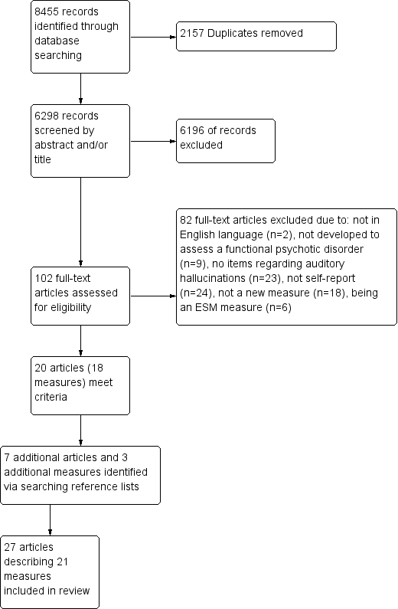
Figure 1 Flow diagram of studies (PRISMA)
Table 1
COSMIN Risk of Bias checklist
Box 1 | Patient Reported Outcome Measure (PROM) development | 35 items
Box 2 | Content validity | 31 items
Box 3 | Structural Validity | 4 items
Box 4 | Internal consistency | 5 items
Box 5 | Cross‐cultural validity\Measurement invariance | 4 items
Box 6 | Reliability | 8 items
Box 7 | Measurement error | 6 items
Box 8 | Criterion validity | 3 items
Box 9 | Hypotheses testing for construct validity | 7 items
Box 10 | Responsiveness | 13 items

Table 2
Characteristics of studies describing the development of non-ambulant assessments of auditory hallucinations
Reference  (study identifying number) | Country | Scale | Scale info | No. of items about AH | Constructs Assessed related to AH (number of items per construct) | Theoretical model construct is based on | Time frame | Internal Consistency (Cronbach’s α) | Test re-test Reliability | Sample
Batterham et al., 2015 (1), 2016 (2) | Australia | PROMIS | Item bank. Psychosis bank= 20 itmes | 4 | construct not defined (4) | Not defined | 30-days | Not reported | Not reported | 6 ‘consumers’  2 ‘experts’
 |  |  |  |  |  |  |  |  |  | 3175 general population
Brockman et al., 2015 (3) | Australia | VAAS-9* | Adapted from a 31 item version of measure | 9 | Acceptance of voices (9) | Acceptance and Commitment Therapy |  | 0.803 | Not reported | 40=SSD
Buccheri et al., 2010 (4) | USA | UVS-IP | Adapted from the UVS. No published information on scale development. | 5 | Intensity of unpleasant hallucinations (5) | Not defined | 24-hours | Not reported | Not reported | Inpatients. Sample size is not discernible.
Carr et al., 2018 (5) | UK | TALE | 21 item assessment of Trauma and Life Events | 3 | Distress or fear associated with AH (1); Single or repeated exposure (1); Age at time of experience (1) | Traumagenic affects of symptoms | Lifetime | n/a | Absolute agreement 90%; Kappa 0.62 | 39= with ‘psychosis’
Fisher 2011 (6) | Canada | HSR | Based on scale developed by Margo et al (1981) | 5 | Duration, loudness, clarity, distress and control (5) | Not defined | Experiences during EEG recording | Not reported | Not reported | SSD=12
Gerlock et al 2010 (7) | USA | UVS | Developed as part of an intervention to reduce harm due to command hallucinations | 7 | Intensity of unpleasant hallucinations,, intent to act on command hallucinations (7) | Not defined | 24 hours / 7 days | Not reported | Not reported | unclear
Gerretsen et al., 2014 (8) | Canada | VAGUS-SR | 10 item assessment of insight | 2 | Symptom misattribution (1); Illness Awareness,  Symptom  Attribution &  Awareness of Need  for Treatment (1) | Clinical insight (e.g. awareness of symptoms) | Current beliefs | 0.77 (for whole scale) | Total scale ICC=0.70 | SSD=215
Goretzki et al., 2009 (9); Goretzki et al., 2013 (10) | Australia | EPSS  SES | EPSS is a 15 item scale.  SES consists of 30 items | 3  1 | EPSS= Experience of Psychotic Symptoms (3); SES= Spiritual Emergency (1) | EPSS= not defined; SES= Spiritual Emergency based on the definition proposed by Grof and Grof (1990) | EPSS and SES lifetime rating | EPSS=0.82  SES=0.94 | EPSS total scale =0.84 | Self-reported psychosis=20, No self-reported psychosis n=80
Lindstrom et al., 2009 (11) | Sweden | 4S | 82 item measure with 6 subscales assessing symptoms and 1 assessing side-effects. 1 additional item per subscale assessing impact | 8 (including assessment of impact) | ‘Symptoms’ (7); Symptoms impact (1) | Not defined | 1 week | For only 6 symptom items**= 0.85 | Not assessed | Psychosis =151
Mojtabai et al., 2016 (12) | USA | PAQ | 40 item assessment of distress, side effects, psychotic symptoms, cognitive effects and sleep | 1 | ‘Symptoms’ (1) | Not defined | 4 weeks | Psychotic symptoms subscale (7 items)=0.87 | Not assessed | SSD=300
Perona-Garcelán, Escudero-Pérez, et al., 2015 (13) | Spain | DAIMON | 28 item assessment of relationships with voices | 28 | Dialogical relationship when the person addresses the voice (Dp-v;8); Relationship when voice addresses the person (Dv-p; 6); Relationship amongst voices (Dv-v; 7); Emotional response to the dialogue (Dem; 7) | Dialogical relationship between “I” positions. | 1 week | Dp-v = 0.75; Dv-p = 0.82; Dv-v = 0.83; Dem = 0.84 | Dp-v, r = 0.59; Dv-p, r = 0.71; Dv-v, r = 0.53; Dem, r = 0.78. | SSD=51
4S= Symptom Self-rating Scale for Schizophrenia; AH= Auditory Hallucinations; EPSS=Experience of Psychotic Symptoms Scale; HSR= Hallucination State Rating; PAQ= Patient Assessment Questionnaire; PROMIS=Patient Reported Outcomes Measurement Information System; SES= Spiritual Emergency Scale; SSD= Schizophrenia Spectrum Diagnosis; TALE=Trauma and Life Events Checklist; UVS= Unpleasant Voices Scale; UVS-IP Unpleasant Voices Scale Inpatient Version; VAGUS-SR=VAGUS Self-report version
*Note this measure was first reported in an unpublished doctoral thesis (Ratcliff, 2010) this is the first peer-reviewed journal article reporting on the development of this measure. Further information about the development of the development of items for this measure was extracted from an article included in the review conducted by Raticliffe et al., (2011); Shawyer et al., 2007.
**It is unclear from the text which of the 9 hallucination items (including one on non-auditory hallucinations) this figure is referring to.

Table 3
Risk of Bias associated with methods used to develop and assess the psychometric properties of non-ambulant self-report measures of auditory hallucinations
 | COnsensus-based Standards for the selection of health Measurement INstruments Risk of Bias Box-
Scale name | 1 | 2 | 3 | 4 | 5 | 6 | 7 | 8 | 9 | 10
PROMIS | I | I | V | NA | D | NA | NA | NA | NA | NA
VAAS-9 | I | I | NA | V | NA | NA | NA | NA | V | NA
UVS & UVS-IP | I | I | NA | NA | NA | NA | NA | NA | NA | NA
TALE | D | D | NA | NA | NA | D | D | NA | V | NA
HSR | I | I | NA | NA | NA | NA | NA | NA | NA | NA
VAGUS-SR | I | I | A | I | NA | A | NA | NA | V | NA
EPSS | I | I | NA | V | NA | I | NA | NA | I | NA
SES | I | I | I | V | NA | NA | NA | NA | I | NA
4S | I | I | I | I | NA | NA | NA | V | V | NA
PAQ | I | D | A | V | D | NA | NA | NA | V | NA
DAIMON | D | I | NA | V | NA | D | NA | NA | V | NA
4S= Symptom Self-rating Scale for Schizophrenia; EPSS=Experience of Psychotic Symptoms Scale; HSR= Hallucination State Rating; PAQ= Patient Assessment Questionnaire; PROMIS=Patient Reported Outcomes Measurement Information System; SES= Spiritual Emergency Scale; SSD= Schizophrenia Spectrum Diagnosis; TALE=Trauma and Life Events Checklist; UVS= Unpleasant Voices Scale; UVS-IP Unpleasant Voices Scale Inpatient Version; VAGUS-SR=VAGUS Self-report version

Box 1. Patient Reported Outcome Measure (PROM) development
Box 2. Content validity
Box. 3 Structural Validity
Box 4. Internal consistency
Box 5. Cross‐cultural validity\Measurement invariance
Box 6. Reliability
Box 7. Measurement error
Box 8. Criterion validity
Box 9. Hypotheses testing for construct validity
Box 10. Responsiveness

V=Very Good, A=Adequate, D=Doubtful, I=Inadequate, NA=Not Applicable or Not reported/assessed

Table 4
Evaluation of Measurement Properties of non-ambulant self report assessments of auditory hallucinations
Scale name | Structural validity | Internal consistency | Reliability | Measurement error | Construct validity | Measurement invariance | Criterion validity | Responsiveness
PROMIS | ? | ? | ? | ? | ? | + | ? | ?
VAAS-9 | ? | ? | ? | ? | + | ? | ? | ?
UVS & UVS-IP | ? | ? | ? | ? | ? | ? | ? | ?
TALE* | NA | NA | ? | ? | - | ? | ? | ?
HSR | ? | ? | ? | ? | ? | ? | ? | ?
VAGUS-SR | ? | ? | + | ? | ? | ? | + | ?
EPSS | ? | ? | ? | ? | + | ? | ? | ?
SES | ? | + | ? | ? | + | ? | ? | ?
4S | ? | ? | ? | ? | + | ? | - | ?
PAQ | ? | + | ? | ? | + | ? | ? | ?
DAIMON | ? | ? | ? | ? | + | ? | ? | ?
4S= Symptom Self-rating Scale for Schizophrenia; EPSS=Experience of Psychotic Symptoms Scale; HSR= Hallucination State Rating; PAQ= Patient Assessment Questionnaire; PROMIS=Patient Reported Outcomes Measurement Information System; SES= Spiritual Emergency Scale; SSD= Schizophrenia Spectrum Diagnosis; TALE=Trauma and Life Events Checklist; UVS= Unpleasant Voices Scale; UVS-IP Unpleasant Voices Scale Inpatient Version; VAGUS-SR=VAGUS Self-report version

+ = sufficient,- = insufficient, ? = indeterminate
NA- This criteria is not applicable to this scale.
* Criteria completed for item related to AH

Table 5
Characteristics of studies describing the development of ambulant assessments of auditory hallucinations
Reference (Study ID) | Country | Scale | Scale info | No. of items about AH | Constructs Assessed related to AH (number of items per construct) | Theoretical Framework | Time frame | Internal Consistency (Cronbach’s α) |  | Instability | Sample
Ainsworth et al., 2013 (14) | UK | CLINTOUCH | 61 item assessment (delivered in two sets) modelled on the PANSS and CDS. 8 item assessment of hallucinations | 4 | Symptoms | Not defined | Since the last data entry | 0.96 (for all hallucination items) |  | For all hallucination items MSSD (SD)= 1.2 (0.6) | SSD=24, UHR=12
Palmier-Claus et al., 2012 (15)
Bell et al., 2018 (16) & 2018b (17) | Australia | SAVVy | 56 item assessment. 46 items delivered 10 times per day and 10 items delivered once per day | 33 | Voice intensity and impact immediately before data entry (5); Responses to voices before data entry and since last data entry (18); Helpfulness of the app, coping strategies, distress (10) | CBT- Coping Strategy Enhancement | immediately before data entry/since last data entry/ 24 hours | Not reported |  | Not reported | SSD=1
Ben-Zeev et al., 2013 (18) | USA | FOCUS | CBT informed mobile app intervention. Assessments of current “status” of experience | 2 | “Status” of experience (1); “more in-depth” assessment (1) | Cognitive model / Stress-vulnerability model | unclear | Not reported |  | Not reported | SSD=33
Ben-Zeev et al., 2014 (19) |  |  |  |  |  |  |  |  |  |  | SSD=12
Ben-Zeev et al., 2017 (20) | USA | CrossCheck | 10 item assessment administered 3 times a week. App also passively monitors participants. | 1 | Symptoms (1) | Cognitive model / Stress-vulnerability model | No time frame indicated | n/a |  | Not reported | SSD=4, Psychosis NOS = 1.
Bucci et al., 2015 (21), Bucci, Barrowclough et al., 2018 (22) | UK | ACTISSIST | CBT informed app. Participants complete a 4 item assessment related to 5 domains linked to relapse. | 5 | Severity (1), Appraisal (1), Conviction (1), Feeling or behaviour (1) | CBT | Since last app usage. | n/a |  | Not reported | Psychosis =24
Granholm et al., 2012 (23); Depp et al., 2010 (24) | USA | MATS | 2 (of 3) assessment items and CBT informed interventions sent for three domains per day: medication adherence, socialisation, voices | 3 | “outcome assessment” (1); “current cognitions” (2) | CBT | No time frame indicate | n/a |  | Not reported | SSD=55
Hartley et al., 2014 (25) | UK |  | Seven items ten times per day assessing worry, rumination, persecutory delusions, and auditory hallucinations. | 2 | Report of experience (1), Distress associated with experience (1) | Metacognitive model | Immediately prior to data entry point |  |  | Not reported | Psychosis=27
Kim et al., 2018 (26) | South Korea | HYM | CBT-informed mobile app including a symptom record rating delusions, voices, anxiety, depression. | 1 | Severity (1); Description of symptom (1) | CBT | No time frame indicate | n/a |  | Not reported | SSD=19, Affective psychosis=3, “attenuated psychosis”=2
Mulligan et al., 2016 (27) | UK |  | Assessments of mood, psychotic symptoms and function 5 times per day. Symptom items derived from Hartley et al., 2014. | 1 | Report of experience (1) | Cognitive model | Immediately prior to data entry point | 0.50 (2 hallucination items) |  | Not reported | SSD=22
CBT=Cognitive Behaviour Therapy; HYM= Heal Your Mind; MATS= Mobile Assessment and Treatment for Schizophrenia; SAVVY=Smartphone Assisted coping-focused interVention for Voices; SSD= Schizophrenia Spectrum Diagnosis, UHR= People considered to be at an Ultra High Risk for psychosis

Table 6
Risk of Bias associated with methods used to develop and assess the psychometric properites of ambulant self report measures of auditory hallucinations
 | COnsensus-based Standards for the selection of health Measurement INstruments Risk of Bias Box
Scale name | 1 | 2 | 3 | 4 | 5 | 6 | 7 | 8 | 9 | 10
ClinTouch | I | I | NA | V | NA | NA | NA | V | NA | NA
SAVVy | I | I | NA | NA | NA | NA | NA | NA | NA | NA
FOCUS | I | D | NA | NA | NA | NA | NA | NA | NA | NA
CrossCheck | I | I | NA | NA | NA | NA | NA | NA | NA | NA
Actissist | D | D | NA | NA | NA | NA | NA | NA | NA | NA
MATS | I | D | NA | NA | NA | NA | NA | NA | NA | NA
HYM | I | I | NA | NA | NA | NA | NA | NA | NA | NA
Mulligan | I | I | NA | NA | NA | NA | NA | NA | NA | NA
Hartley | I | D | NA | NA | NA | NA | NA | NA | NA | NA
HYM= Heal Your Mind; MATS= Mobile Assessment and Treatment for Schizophrenia; SAVVY=Smartphone Assisted coping-focused interVention for Voices

Box 1. Patient Reported Outcome Measure (PROM) development
Box 2. Content validity
Box. 3 Structural Validity
Box 4. Internal consistency
Box 5. Cross‐cultural validity\Measurement invariance
Box 6. Reliability
Box 7. Measurement error
Box 8. Criterion validity
Box 9. Hypotheses testing for construct validity
Box 10. Responsiveness

V=Very Good, A=Adequate, D=Doubtful, I=Inadequate, NA=Not Applicable or Not reported/assessed

Table 7
Evaluation of Measurement Properties of -ambulant self report assessments of auditory hallucinations
Scale name | Structural validity | Internal consistency | Reliability | Measurement error | Construct validity | Measurement invariance | Criterion validity | Responsiveness
ClinTouch | ? | ? | ? | ? | ? | ? | - | ?
SAVVy | ? | ? | ? | ? | ? | ? | ? | ?
FOCUS | ? | ? | ? | ? | ? | ? | ? | ?
CrossCheck | NA | NA | ? | ? | ? | ? | ? | ?
Actissist | ? | ? | ? | ? | ? | ? | ? | ?
MATS | ? | ? | ? | ? | ? | ? | ? | ?
Hartley | ? | ? | ? | ? | ? | ? | ? | ?
HYM | NA | NA | ? | ? | ? | ? | ? | ?
Mulligan | NA | NA | ? | ? | ? | ? | ? | ?
HYM= Heal Your Mind; MATS= Mobile Assessment and Treatment for Schizophrenia; SAVVY=Smartphone Assisted coping-focused interVention for Voices

+ = sufficient,- = insufficient, ? = indeterminate
NA- Criteria is not applicable to this scale.

Appendices
Appendix 1A- Instructions for authors
Appendix 1B- Search strategies and search terms

Appendix 1A Instructions for authors
Beneath you can find the instructions for authors copied from the British Journal of Clinical Psychology website on 23/02/2020. Please note that as used in the current paper previous reviews published by this journal have utilised a study ID (e.g. Flinn, Braham & Das Nair, 2015).

AUTHOR GUIDELINES

Sections
Submission
Aims and Scope
Manuscript Categories and Requirements
Preparing the Submission
Editorial Policies and Ethical Considerations
Author Licensing
Publication Process After Acceptance
Post Publication
Editorial Office Contact Details

1. SUBMISSION
Authors should kindly note that submission implies that the content has not been published or submitted for publication elsewhere except as a brief abstract in the proceedings of a scientific meeting or symposium.
Once the submission materials have been prepared in accordance with the Author Guidelines, manuscripts should be submitted online at http://www.editorialmanager.com/bjcp
Click here for more details on how to use Editorial Manager.
All papers published in the British Journal of Clinical Psychology are eligible for Panel A: Psychology, Psychiatry and Neuroscience in the Research Excellence Framework (REF).
Data protection:
By submitting a manuscript to or reviewing for this publication, your name, email address, and affiliation, and other contact details the publication might require, will be used for the regular operations of the publication, including, when necessary, sharing with the publisher (Wiley) and partners for production and publication. The publication and the publisher recognize the importance of protecting the personal information collected from users in the operation of these services, and have practices in place to ensure that steps are taken to maintain the security, integrity, and privacy of the personal data collected and processed. You can learn more at https://authorservices.wiley.com/statements/data-protection-policy.html.
Preprint policy:
This journal will consider for review articles previously available as preprints. Authors may also post the submitted version of a manuscript to a preprint server at any time. Authors are requested to update any pre-publication versions with a link to the final published article.

2. AIMS AND SCOPE
The British Journal of Clinical Psychology publishes original research, both empirical and theoretical, on all aspects of clinical psychology:
clinical and abnormal psychology featuring descriptive or experimental studies
aetiology, assessment and treatment of the whole range of psychological disorders irrespective of age group and setting
biological influences on individual behaviour
studies of psychological interventions and treatment on individuals, dyads, families and groups
For specific submission requirements, please view the Author Guidelines.
The Journal is catholic with respect to the range of theories and methods used to answer substantive scientific problems. Studies of samples with no current psychological disorder will only be considered if they have a direct bearing on clinical theory or practice.
The following types of paper are invited:
papers reporting original empirical investigations;
theoretical papers, provided that these are sufficiently related to empirical data;
review articles, which need not be exhaustive, but which should give an interpretation of the state of research in a given field and, where appropriate, identify its clinical implications;
Brief Reports and Comments.

3. MANUSCRIPT CATEGORIES AND REQUIREMENTS
Articles should be no more than 5000 words (excluding the abstract, reference list, tables and figures). Brief reports should not exceed 2000 words and should have no more than one table or figure. Any papers that are over this word limit will be returned to the authors. Appendices are included in the word limit; however online appendices are not included.
In exceptional cases the Editor retains discretion to publish papers beyond this length where the clear and concise expression of the scientific content requires greater length (e.g., explanation of a new theory or a substantially new method). Authors must contact the Editor prior to submission in such a case.
Please refer to the separate guidelines for Registered Reports.
All systematic reviews must be pre-registered.

4. PREPARING THE SUBMISSION
Free Format Submission
British Journal of Clinical Psychology now offers free format submission for a simplified and streamlined submission process.
Before you submit, you will need:
Your manuscript: this can be a single file including text, figures, and tables, or separate files – whichever you prefer. All required sections should be contained in your manuscript, including abstract, introduction, methods, results, and conclusions. Figures and tables should have legends. References may be submitted in any style or format, as long as it is consistent throughout the manuscript. If the manuscript, figures or tables are difficult for you to read, they will also be difficult for the editors and reviewers. If your manuscript is difficult to read, the editorial office may send it back to you for revision.
The title page of the manuscript, including a data availability statement and your co-author details with affiliations. (Why is this important? We need to keep all co-authors informed of the outcome of the peer review process.) You may like to use this template for your title page.
Important: the journal operates a double-blind peer review policy. Please anonymise your manuscript and prepare a separate title page containing author details. (Why is this important? We need to uphold rigorous ethical standards for the research we consider for publication.)
An ORCID ID, freely available at https://orcid.org. (Why is this important? Your article, if accepted and published, will be attached to your ORCID profile. Institutions and funders are increasingly requiring authors to have ORCID IDs.)
To submit, login at https://www.editorialmanager.com/bjcp/default.aspx and create a new submission. Follow the submission steps as required and submit the manuscript.
If you are invited to revise your manuscript after peer review, the journal will also request the revised manuscript to be formatted according to journal requirements as described below.
Revised Manuscript Submission
Contributions must be typed in double spacing. All sheets must be numbered.
Cover letters are not mandatory; however, they may be supplied at the author’s discretion. They should be pasted into the ‘Comments’ box in Editorial Manager.
Parts of the Manuscript
The manuscript should be submitted in separate files: title page; main text file; figures/tables; supporting information.
Title Page
You may like to use this template for your title page. The title page should contain:
A short informative title containing the major key words. The title should not contain abbreviations (see Wiley's best practice SEO tips);
A short running title of less than 40 characters;
The full names of the authors;
The author's institutional affiliations where the work was conducted, with a footnote for the author’s present address if different from where the work was conducted;
Abstract;
Keywords
Acknowledgments.
Authorship
Please refer to the journal’s Authorship policy in the Editorial Policies and Ethical Considerations section for details on author listing eligibility. When entering the author names into Editorial Manager, the corresponding author will be asked to provide a CRediT contributor role to classify the role that each author played in creating the manuscript. Please see the Project CRediT website for a list of roles.
Abstract
Please provide a structured abstract under the headings: Objectives, Methods, Results, Conclusions. For Articles, the abstract should not exceed 250 words. For Brief Reports, abstracts should not exceed 120 words.
Articles which report original scientific research should also include a heading 'Design' before 'Methods'. The 'Methods' section for systematic reviews and theoretical papers should include, as a minimum, a description of the methods the author(s) used to access the literature they drew upon. That is, the abstract should summarize the databases that were consulted and the search terms that were used.
Keywords
Please provide appropriate keywords.
Acknowledgments
Contributions from anyone who does not meet the criteria for authorship should be listed, with permission from the contributor, in an Acknowledgments section. Financial and material support should also be mentioned. Thanks to anonymous reviewers are not appropriate.
Practitioner Points
All articles must include Practitioner Points – these are 2-4 bullet points, following the abstract, with the heading ‘Practitioner Points’. These should briefly and clearly outline the relevance of your research to professional practice. (The Practitioner Points should be submitted in a separate file.)
Main Text File
As papers are double-blind peer reviewed, the main text file should not include any information that might identify the authors.
The main text file should be presented in the following order:
Title
Main text
References
Tables and figures (each complete with title and footnotes)
Appendices (if relevant)
Supporting information should be supplied as separate files. Tables and figures can be included at the end of the main document or attached as separate files but they must be mentioned in the text.
As papers are double-blind peer reviewed, the main text file should not include any information that might identify the authors. Please do not mention the authors’ names or affiliations and always refer to any previous work in the third person.
The journal uses British/US spelling; however, authors may submit using either option, as spelling of accepted papers is converted during the production process.
References
References should be prepared according to the Publication Manual of the American Psychological Association (6th edition). This means in text citations should follow the author-date method whereby the author's last name and the year of publication for the source should appear in the text, for example, (Jones, 1998). The complete reference list should appear alphabetically by name at the end of the paper. Please note that for journal articles, issue numbers are not included unless each issue in the volume begins with page 1, and a DOI should be provided for all references where available.
For more information about APA referencing style, please refer to the APA FAQ.
Reference examples follow:
Journal article
Beers, S. R. , & De Bellis, M. D. (2002). Neuropsychological function in children with maltreatment-related posttraumatic stress disorder. The American Journal of Psychiatry, 159, 483–486. doi:10.1176/appi.ajp.159.3.483
Book
Bradley-Johnson, S. (1994). Psychoeducational assessment of students who are visually impaired or blind: Infancy through high school (2nd ed.). Austin, TX: Pro-ed.
Internet Document
Norton, R. (2006, November 4). How to train a cat to operate a light switch [Video file]. Retrieved from http://www.youtube.com/watch?v=Vja83KLQXZs
Tables
Tables should be self-contained and complement, not duplicate, information contained in the text. They should be supplied as editable files, not pasted as images. Legends should be concise but comprehensive – the table, legend, and footnotes must be understandable without reference to the text. All abbreviations must be defined in footnotes. Footnote symbols: †, ‡, §, ¶, should be used (in that order) and *, **, *** should be reserved for P-values. Statistical measures such as SD or SEM should be identified in the headings.
Figures
Although authors are encouraged to send the highest-quality figures possible, for peer-review purposes, a wide variety of formats, sizes, and resolutions are accepted.
Click here for the basic figure requirements for figures submitted with manuscripts for initial peer review, as well as the more detailed post-acceptance figure requirements.
Legends should be concise but comprehensive – the figure and its legend must be understandable without reference to the text. Include definitions of any symbols used and define/explain all abbreviations and units of measurement.
Colour figures. Figures submitted in colour may be reproduced in colour online free of charge. Please note, however, that it is preferable that line figures (e.g. graphs and charts) are supplied in black and white so that they are legible if printed by a reader in black and white. If an author would prefer to have figures printed in colour in hard copies of the journal, a fee will be charged by the Publisher.
Supporting Information
Supporting information is information that is not essential to the article, but provides greater depth and background. It is hosted online and appears without editing or typesetting. It may include tables, figures, videos, datasets, etc.
Click here for Wiley’s FAQs on supporting information.
Note: if data, scripts, or other artefacts used to generate the analyses presented in the paper are available via a publicly available data repository, authors should include a reference to the location of the material within their paper.
General Style Points
For guidelines on editorial style, please consult the APA Publication Manual published by the American Psychological Association. The following points provide general advice on formatting and style.
Language: Authors must avoid the use of sexist or any other discriminatory language.
Abbreviations: In general, terms should not be abbreviated unless they are used repeatedly and the abbreviation is helpful to the reader. Initially, use the word in full, followed by the abbreviation in parentheses. Thereafter use the abbreviation only.
Units of measurement: Measurements should be given in SI or SI-derived units. Visit the Bureau International des Poids et Mesures (BIPM) website for more information about SI units.
Effect size: In normal circumstances, effect size should be incorporated.
Numbers: numbers under 10 are spelt out, except for: measurements with a unit (8mmol/l); age (6 weeks old), or lists with other numbers (11 dogs, 9 cats, 4 gerbils).
Wiley Author Resources
Manuscript Preparation Tips: Wiley has a range of resources for authors preparing manuscripts for submission available here. In particular, we encourage authors to consult Wiley’s best practice tips on Writing for Search Engine Optimization.
Article Preparation Support: Wiley Editing Services offers expert help with English Language Editing, as well as translation, manuscript formatting, figure illustration, figure formatting, and graphical abstract design – so you can submit your manuscript with confidence.
Also, check out our resources for Preparing Your Article for general guidance and the BPS Publish with Impact infographic for advice on optimizing your article for search engines.
5. EDITORIAL POLICIES AND ETHICAL CONSIDERATIONS
Peer Review and Acceptance
Except where otherwise stated, the journal operates a policy of anonymous (double blind) peer review. Please ensure that any information which may reveal author identity is blinded in your submission, such as institutional affiliations, geographical location or references to unpublished research. We also operate a triage process in which submissions that are out of scope or otherwise inappropriate will be rejected by the editors without external peer review. Before submitting, please read the terms and conditions of submission and the declaration of competing interests.
We aim to provide authors with a first decision within 90 days of submission.
Further information about the process of peer review and production can be found in ‘What happens to my paper?’ Appeals are handled according to the procedure recommended by COPE. Wiley's policy on the confidentiality of the review process is available here.
Clinical Trial Registration
The journal requires that clinical trials are prospectively registered in a publicly accessible database and clinical trial registration numbers should be included in all papers that report their results. Authors are asked to include the name of the trial register and the clinical trial registration number at the end of the abstract. If the trial is not registered, or was registered retrospectively, the reasons for this should be explained.
Research Reporting Guidelines
Accurate and complete reporting enables readers to fully appraise research, replicate it, and use it. Authors are encouraged to adhere to recognised research reporting standards.
We also encourage authors to refer to and follow guidelines from:
Future of Research Communications and e-Scholarship (FORCE11)
The Gold Standard Publication Checklist from Hooijmans and colleagues
FAIRsharing website
Conflict of Interest
The journal requires that all authors disclose any potential sources of conflict of interest. Any interest or relationship, financial or otherwise that might be perceived as influencing an author's objectivity is considered a potential source of conflict of interest. These must be disclosed when directly relevant or directly related to the work that the authors describe in their manuscript. Potential sources of conflict of interest include, but are not limited to: patent or stock ownership, membership of a company board of directors, membership of an advisory board or committee for a company, and consultancy for or receipt of speaker's fees from a company. The existence of a conflict of interest does not preclude publication. If the authors have no conflict of interest to declare, they must also state this at submission. It is the responsibility of the corresponding author to review this policy with all authors and collectively to disclose with the submission ALL pertinent commercial and other relationships.
Funding
Authors should list all funding sources in the Acknowledgments section. Authors are responsible for the accuracy of their funder designation. If in doubt, please check the Open Funder Registry for the correct nomenclature: https://www.crossref.org/services/funder-registry/
Authorship
All listed authors should have contributed to the manuscript substantially and have agreed to the final submitted version. Authorship is defined by the criteria set out in the APA Publication Manual:

“Individuals should only take authorship credit for work they have actually performed or to which they have substantially contributed (APA Ethics Code Standard 8.12a, Publication Credit). Authorship encompasses, therefore, not only those who do the actual writing but also those who have made substantial scientific contributions to a study. Substantial professional contributions may include formulating the problem or hypothesis, structuring the experimental design, organizing and conducting the statistical analysis, interpreting the results, or writing a major portion of the paper. Those who so contribute are listed in the byline.” (p.18)

Data Sharing and Data Accessibility
The British Journal of Clinical Psychology recognizes the many benefits of archiving data for scientific progress. Archived data provides an indispensable resource for the scientific community, making possible future replications and secondary analyses, in addition to the importance of verifying the dependability of published research findings.
The journal expects that where possible all data supporting the results in papers published are archived in an appropriate public archive offering open access and guaranteed preservation. The archived data must allow each result in the published paper to be recreated and the analyses reported in the paper to be replicated in full to support the conclusions made. Authors are welcome to archive more than this, but not less.
All papers need to be supported by a data archiving statement and the data set must be cited in the Methods section. The paper must include a link to the repository in order that the statement can be published.
It is not necessary to make data publicly available at the point of submission, but an active link must be included in the final accepted manuscript. For authors who have pre-registered studies, please use the Registered Report link in the Author Guidelines.
In some cases, despite the authors’ best efforts, some or all data or materials cannot be shared for legal or ethical reasons, including issues of author consent, third party rights, institutional or national regulations or laws, or the nature of data gathered. In such cases, authors must inform the editors at the time of submission. It is understood that in some cases access will be provided under restrictions to protect confidential or proprietary information. Editors may grant exceptions to data access requirements provided authors explain the restrictions on the data set and how they preclude public access, and, if possible, describe the steps others should follow to gain access to the data.
If the authors cannot or do not intend to make the data publicly available, a statement to this effect, along with the reasons that the data is not shared, must be included in the manuscript.
Finally, if submitting authors have any questions about the data sharing policy, please access the FAQsfor additional detail.
Publication Ethics
Authors are reminded that the British Journal of Clinical Psychology adheres to the ethics of scientific publication as detailed in the Ethical principles of psychologists and code of conduct (American Psychological Association, 2010). The Journal generally conforms to the Uniform Requirements for Manuscripts of the International Committee of Medical Journal Editors (ICJME) and is also a member and subscribes to the principles of the Committee on Publication Ethics (COPE). Authors must ensure that all research meets these ethical guidelines and affirm that the research has received permission from a stated Research Ethics Committee (REC) or Institutional Review Board (IRB), including adherence to the legal requirements of the study county.
Note this journal uses iThenticate’s CrossCheck software to detect instances of overlapping and similar text in submitted manuscripts. Read Wiley’s Top 10 Publishing Ethics Tips for Authors here. Wiley’s Publication Ethics Guidelines can be found here.

ORCID
As part of the journal’s commitment to supporting authors at every step of the publishing process, the journal requires the submitting author (only) to provide an ORCID iD when submitting a manuscript. This takes around 2 minutes to complete. Find more information here.

6. AUTHOR LICENSING
If a paper is accepted for publication, the author identified as the formal corresponding author will receive an email prompting them to log in to Author Services, where via the Wiley Author Licensing Service (WALS) they will be required to complete a copyright license agreement on behalf of all authors of the paper.
Authors may choose to publish under the terms of the journal’s standard copyright agreement, or OnlineOpen under the terms of a Creative Commons License.
General information regarding licensing and copyright is available here. To review the Creative Commons License options offered under OnlineOpen, please click here. (Note that certain funders mandate a particular type of CC license be used; to check this please click here.)
BPS members:
Self-Archiving Definitions and Policies: Note that the journal’s standard copyright agreement allows for self-archiving of different versions of the article under specific conditions. Please click here for more detailed information about self-archiving definitions and policies.
Open Access fees: Authors who choose to publish using OnlineOpen will be charged a fee. A list of Article Publication Charges for Wiley journals is available here.
Funder Open Access: Please click here for more information on Wiley’s compliance with specific Funder Open Access Policies.

7. PUBLICATION PROCESS AFTER ACCEPTANCE
Accepted Article Received in Production
When an accepted article is received by Wiley’s production team, the corresponding author will receive an email asking them to login or register with Wiley Author Services. The author will be asked to sign a publication license at this point.
Proofs
Once the paper is typeset, the author will receive an email notification with full instructions on how to provide proof corrections.
Please note that the author is responsible for all statements made in their work, including changes made during the editorial process – authors should check proofs carefully. Note that proofs should be returned within 48 hours from receipt of first proof.
Publication Charges
Colour figures. Colour figures may be published online free of charge; however, the journal charges for publishing figures in colour in print. If the author supplies colour figures, they will be sent a Colour Work Agreement once the accepted paper moves to the production process. If the Colour Work Agreement is not returned by the specified date, figures will be converted to black and white for print publication.
Early View
The journal offers rapid publication via Wiley’s Early View service. Early View (Online Version of Record) articles are published on Wiley Online Library before inclusion in an issue. Before we can publish an article, we require a signed license (authors should login or register with Wiley Author Services). Once the article is published on Early View, no further changes to the article are possible. The Early View article is fully citable and carries an online publication date and DOI for citations.

8. POST PUBLICATION
Access and Sharing
When the article is published online:
The author receives an email alert (if requested).
The link to the published article can be shared through social media.
The author will have free access to the paper (after accepting the Terms & Conditions of use, they can view the article).
For non-open access articles, the corresponding author and co-authors can nominate up to ten colleagues to receive a publication alert and free online access to the article.
Promoting the Article
To find out how to best promote an article, click here.
Wiley Editing Services offers professional video, design, and writing services to create shareable video abstracts, infographics, conference posters, lay summaries, and research news stories for your research – so you can help your research get the attention it deserves.
Measuring the Impact of an Article
Wiley also helps authors measure the impact of their research through specialist partnerships with Kudos and Altmetric.

9. EDITORIAL OFFICE CONTACT DETAILS
For help with submissions, please contact: Hannah Wakley, Associate Managing Editor (bjc@wiley.com) or phone +44 (0) 116 252 9504.
Author Guidelines updated 14th October 2019

Appendix 1B Search strategy and terms
PSYCHInfo, Medline and SCOPUS databases were searched. Table 1A shows the search strategy employed for the Medline database. The search strategy employed searches of titles (TI), Abstracts (AB), and subject headings (SU). Within Medline SU encompasses both MeSH terms and keywords. Similar search strategies were employed for the other databases. In PSYCHInfo the equivalent search operator SU is KW, this encompasses searches of keywords and subject headings. Thus within this database KW was used as a search operator for steps 3and 5, instead of SU. Similarly the equivalent search operator KEY was employed for the SCOPUS database this encompasses author key words, index terms, trade names and chemical names.
Table 1A
Search terms used for Medline database
1 |  | TI( "psychometric*" OR "development") )
2 |  | AB("reliability" OR "reliable" OR "validity" OR "internal consistency")
3 |  | SU ( "ambulatory assessment*" OR "Measure*" OR "scale*" OR "questionnaire*" OR "assessment*" OR "instrument*" OR "tool*" OR "rating*" OR "test" OR "inventory*" OR "development")
4 |  | 1 OR 2 OR 3
5 |  | SU ("psychosis" OR "hallucination*" OR "hearing voice*" OR "positive symptom*" OR "voice hearing" OR "psychotic experience*" OR "psychotic symptom*" OR "psychotic illness" OR "voices" OR "psychotic disorder*" OR "verbal hallucination*")
6 |  | AB("hearing voice*" OR "auditory hallucination*" OR "verbal hallucination*" OR "voice hearing")
7 |  | 5 OR 6
8 |  | Limiters - English Language; article, editorial, article in press
9 |  | Publication year => 2009
 |  | 4 AND 7 AND 8 AND 9

Research chapter
What are the most important parts of the Voice and Hearer’s Relationship?:A qualitative investigation to develop an item pool

Short title: The most important parts of the voice and hearer’s relationship

Rohan Morris*
Doctorate in Clinical Psychology
Division of Health Research, Lancaster University

*Corresponding author information: Dr Rohan Morris, r.morris1@lancaster.ac.uk, Lancaster University, Furness College, Department of Clinical Psychology, Division of Health Research, LA1 4YW, UK +44 (0)1524 592691
Formatted for submission to Psychosis

Abstract
Background: Emerging data suggest that therapeutic approaches which focus on the Voice and Hearer Relationship (VHR) may have a beneficial effect. However, there is currently no English language measure which assesses both positive and negative aspects of the VHR and, no assessment has involved people with lived experience to develop an item pool. This study sought to co-develop an item pool for such a measure with clinicians and voice-hearers.
Methods: In-depth qualitative interviews were conducted with voice-hearers (n=7) and clinicians (n=8). Data were analysed using Thematic Analysis.
Results: Four themes were identified: Power, Powerlessness and Patterns of relating, The interaction between relationships, Factors that influence the application of relating skills; Skills that facilitate development of the VHR. Individual nodes were used to developan item pool for an assessment of the VHR Based on the quotes, nodes and themes a pool of 93 items were developed. .
Conclusion: It is feasible to develop an item pool for assessing the VHR by accessing the experiences of voice-hearers and clinicians. The item pool generated reflects a broad range of experiences that occur within the VHR and factors external to the VHR which influence the VHR.

Keywords: Voice Dialogue, voice and hearer relationship, auditory hallucinations, psychosis, measure development

Introduction
Approximately two-thirds of people with schizophrenia spectrum diagnoses experience auditory hallucinations (AH; Waters et al., 2014). These can be distressing (Kumari et al., 2013) and this in turn is associated with higher levels of depression and lower levels of self-esteem (Smith et al., 2006). However, for some people, AHs are not distressing and do not require clinical treatment (van Os et al., 2009). Although AHs can take the form of any type of perceived auditory input they frequently take the form of voices (Woodward et al., 2014).
AH’s have been conceptualised in two broad ways; either as perceptual phenomena, or as states of consciousness (Perona-Garcelán, Pérez-Álvarez et al., 2015). Models conceptualising AHs as perceptual phenomena typically suggest that AHs result from cognitive biases (e.g. Bentall, 1990), with some elaborating on this model to suggest specific neuropsychological dysfunction (e.g. Frith et al., 2000). It has been noted that there is an inconsistency between the theoretical predicted characteristics of AHs as perceptual phenomena and the phenomenological experience (Jones, 2010). These inconsistencies have led Perona-Garcelán, Pérez-Álvarez et al., (2015) to conceptualise AHs as a state of consciousness.
Perona-Garcelán, Pérez-Álvarez, et al., (2015) hypothesise that if AHs are states of consciousness then the voice-hearer would have a relationship with their voice or different relationships with multiple voices. Research indicates that people develop relationships with their voices which possess similar qualities to other interpersonal and social relationships (Benjamin, 1989; Hayward, 2003; Holt & Tickle, 2014). Theories considering voices as states of cosciousness (e.g. Lysaker & Lysaker, 2011;Perona-Garcelán, Pérez-Álvarez, et al., 2015) (), hypothesise that improving a person’s relationship with their voices through dialogue may improve their experience of the voices.
Relational therapeutic approaches typically consider voices within a more social conceptualisation i.e. a distinct entity that people have a relationship with (Hayward, 2003). Leading on from this a relational approach (Relating Therapy) to working therapeutically with voices has been developed.
Relating Therapy seeks to: draw parallels between the Voice and Hearer’s Relationship (VHR) and other social relationships, enhance awareness of reciprocity within the VHR, and to change a person’s way of relating to their voices using assertiveness training (Hayward et al., 2009; Hayward et al., 2014). Case studies and qualitative interviews indicate that Relating Therapy increases feelings of control, reduces distress and has a positive effect on the VHR (Hayward et al., 2009; Hayward & Fuller, 2010). In a randomised controlled trial, Relating Therapy demonstrated clinically significant reductions in the distress associated with voices compared to treatment as usual (Hayward et al., 2017).
An alternative relational approach is based on Voice Dialoguing; an approach developed to explore different parts of the self (Stone & Stone, 2011). There are case-studies describing a beneficial effect of Voice Dialoguing on the relationship a person has with their voices (Corstens et al., 2012). By engaging voice and hearer, Voice Dialoguing seeks to: increase insight into the function and aetiology of the voice; facilitate autonomy and assertiveness in dialogue with the voice; and increase acceptance of the voice (Corstens et al., 2012). Compassion Focused Therapy (CFT) has adopted similar approaches in the form of ‘Chair work’ (Gilbert, 2010). These approaches are differentiated from the Voice Dialogue approach by the fact that the compassionate self (a self-identity “trained to be able to compassionately engage with distress”) plays a central role in engaging with the other parts of the self (Heriot-Maitland et al., 2019, p.6).
AVATAR therapy uses virtual-reality technology to facilitate dialogue and assertive communication between the hearer and virtual reality representations of the voices. These approaches have been found to have a beneficial effect on distress associated with voices, the frequency of the voices and the voice’s omnipotence (Craig et al., 2018; Leff et al., 2013).
Numerous assessments of AHs have been developed (Frederick & Killeen, 1998; Ratcliff et al., 2011; Chapter 1). Most focus on severity, looking at concepts such as distress, frequency, content and impact on functioning (e.g Psychotic Symptoms Rating Scales; [PSYRATS], Haddock et al., 1999; Positive and Negative Syndromes Scale [PANSS] Kay et al., 1987). However, very few measures have focused on the relationship a person has with their voices.
The Voice Power Differential scale (VPDS; Birchwood et al., 2000) is a measure devoted to the assessment of relationships, as are the Voice’s relationship To the Hearer (VTH) and the Hearer’s relationship To the Voice (HTV) (Vaughan & Fowler, 2004) and The Voices and You Scale (VAYS; Hayward et al., 2008). The VTH, HTV and VAYS draw on relating theory (Birtchnell, 2002; 2014) and the VPDS is based on a model of depression: social rank theory (Gilbert & Allan, 1998). The VPDS, VTH, HTV and VAYS draw on conceptualisations of pathological (e.g. social rank theory of depression) or dysfunctional ways of relating (e.g. relating theory only considers concepts that have a “negative tone” Britchnell, 2014, p.92). Consequently, they do not assess a breadth of factors which may influence perceptions of the quality of a relationship.
Similar criticisms could be made of another assessment of the VHR: the Beliefs About Voices Questionnaire-revised (BAVQ-r; Chadwick et al., 2000). This measure draws on a cognitive approach (as opposed to relational approach) to voices (Chadwick & Birchwood, 1994). Like the VPDS, this measure assesses power but places a greater focus on the respondents’ perception of the voices’ intent (i.e. malevolent, benevolent) in addition to the respondents’ emotional and behavioural responses to the voice rather than the relationship per se.
These measures assess limited (typically negative) aspects of the VHR; to address this limitation the DAIMON measure was constructed, which considers some positive aspects of the relationship e.g. humour (Perona-Garcelán, Escudero-Pérez, et al., 2015). However, the DAIMON did not involve voice hearers in the development of the item pool, which may mean that important aspects of the VHR are not assessed. Furthermore, the DAIMON measure has only been developed in Spanish, reducing its utility to speakers of other languages.

Study rationale and research questions
Relational approaches to voice hearing have been shown to have beneficial effects (Corstens et al., 2012; Craig et al., 2018; Hayward et al., 2017). However, there are currently no relational assessments in English which do not solely focus on pathological/dysfunctional ways of relating. A broader assessment of the VHR may be useful as it could predict who is most likely to respond to the treatment effects of relational approaches, or provide a more sensitive outcome measure for trials of relational interventions.
There is a paucity of self-report assessments of voices which involve voice-hearers throughout the development process (Frederick & Killeen, 1998; Ratcliff et al., 2011; Chapter 1). This may mean that key ideas or concepts have been omitted. The first recommended step in measure development is to develop an initial item pool through conducting qualitative interviews (Boateng et al., 2018).

This study aims to develop an item pool regarding the VHR by addressing the following research questions:
- What are the most important aspects of the VHR?
- What factors influence the VHR?

Methods

Study design
This study utilised semi-structured qualitative interviews with Experts By Professional Experience (EBPE) and Experts By Lived Experience (EBLE). Using an inductive approach (Boateng, et al., 2018), codes were identified, developed into themes and used to develop an initial item pool. Initial interview topic guides were based on previous measures for assessment of auditory hallucinations and relationship quality, in addition to consultation with an expert in the use of relational approaches to voices (Dr Rufus May).

Participants
Seven EBLE and eight EBPE participated in the study. Demographic data collected included age, gender and ethnicity. Additionally, EBLE provided information about the length of time they had heard voices and the time since they last heard voices. The EBPE provided information about the amount of time they had worked with voice-hearers since qualifying as clinicians.

Recruitment
EBPE were recruited by contacting eminent professionals working in the field of relational approaches to voices and utilising opportunity sampling of clinicians known to the research team. Eleven EBPE were approached, eight consented to participate.
EBLE were recruited via group facilitators of third sector organisations who support people who hear voices. Once contact was established, participants were screened for eligibility. Eight EBLE consented for their contact details to be passed on to the research team, seven consented to participate.
EBPE were approached initially by email or via contact from a third party (a member of the supervisory team). EBLE were approached by a group facilitator and provided with the researcher’s contact details. The principal investigator (RM) was also invited to attend hearing voices support groups where he provided attendees with information about the research.

Inclusion & Exclusion criteria
EBPE had worked in a professional capacity as either a clinical psychologist or psychiatrist in a service supporting people who hear voices for a minimum of one year post qualification. The study purposively aimed to recruit a minimum of two professionals who had previously used relational approaches with voice hearers.
EBLE were included if they; responded affirmatively to the question “Have you had the experience of hearing things (e.g. voices) that other people could not?”; had experienced verbal auditory hallucinations (i.e. voices) lasting in total for a minimum of four weeks, occurring on at least 50% of the days. Participants were excluded if they were under the age of 16.

Data Collection
The initial topic guide (Appendix 5E & 5F) was modified and updated iteratively according to emergent themes identified throughout the concurrent analysis process. Interviews lasted for between 35 and 78 minutes. The mean length of time for interviews was 63 minutes for EBPE and 61 minutes for EBLE. Interviews were audio recorded and transcribed verbatim by RM.

Analysis
Data were analysed in NVivo 11 (QSR International) using the thematic analysis approach outlined by Braun and Clark (2006): (1) data familiarisation, (2) generating initial codes, (3) searching for themes, (4) reviewing themes, (5) defining and naming themes, (6) report writing. Thematic Analysis is recommended for analysing data which will be used for the development of item pools (Howitt, 2010). RM familiarised himself with the data by listening and re-listening to the audio recordings prior to transcribing and reading and re-reading transcripts. Additionally, RM conducted all interviews which contributed to data familiarisation. Data were coded line-by-line to develop initial conceptual codes. Data residing within each code was inspected and subsequently some data was re-coded, some codes were relabelled and some codes were merged. The EBPE and EBLE data were initially coded independently of each other. However a substantial degree of overlap between conceptual codes from the EBPE and EBLE data was noted and these datasets were merged. Consequently, data residing within each code was once again inspected and adjustments were made (e.g. relabelling codes). Codes were categorised into meaningful groups to develop initial themes. These themes were developed into a conceptual framework which was revised iteratively throughout the analysis. Themes were reviewed and examined alongside the data. Themes were modified (subdivided) and new themes were generated. These themes were then checked alongside the data. Themes were defined and labelled.

Validity and credibility
Yardley (2017) suggests that a criterion for validity is sensitivity to context. This criterion was considered throughout data collection, analysis and write-up. Sensitivity to context was achieved by RM being actively involved in reading literature, psychosis research (e.g. Morris, 2014), measure development (Berry et al., 2018), and developing therapeutic approaches to voice hearing (e.g. Bucci et al., 2018) prior to conducting this research. Furthermore, RM has experience of delivering one-to-one therapy, structured groups and unstructured groups for people who hear voices. RM also undertook his DClinPsy specialist third year placement under the supervision of Dr Rufus May an expert in the field of Voice Dialogue (Corstens et al., 2012). RM also attended the hearing voices groups which participants were recruited from as a group member (with attendees consent and knowledge of who RM was), prior to conducting any interviews.
Absolute convergence would not be expected between the EBLE and EBPE as there will likely be a difference in the understanding of the VHR between those with personal experience and those with vicarious experience. Nonetheless, it is anticipated that if there is a large degree of convergence this would indicate credibility. Assessments of the credibility of the analysis can be made by comparing whether or not the themes discussed herein are endorsed by members of the two different groups, which is a form of triangulation (Shenton, 2004). A substantial amount of overlap was noted in the coding of EBLE and EBPE data was noted which resulted in the two groups being merged. Merging of the datasets facilitated identification of congruence and difference between the two groups. In order to aid transparency and provide an indication of credibility participant IDs are used throughout to indicate which participants endorsed the concepts and reported the experiences described herein.

Ethical considerations
Ethical approval was provided by the NHS North West-Liverpool East Research Ethics Committee (19/NW/0545). Please see Chapter 4 for more details about ethical considerations. All participants were provided with a Participant Information Sheet (PIS; Appendix 5A & 5B) at least 24 hours before providing fully informed consent. Interviews were conducted at a location convenient to the participant or via telephone/video call.
All participants were assigned a Personal Identifying Number (PIN). At no time was identifying information stored with study data. Audio recordings were transcribed and all identifiable information was removed from transcriptions.
Prior to interviews participants were informed about the limits of confidentiality. A standard operating procedure was devised in case any disclosures of risk were made (Chapter 4-IRAS form). No disclosures were made during any interviews. Participants were debriefed after the interview (Appendix 5G & 5H).
In line with best practice, capacity was assumed (Mental Capacity Act, 2005). At no point was any information presented which would indicate that the participants were lacking capacity to decide whether or not to participate in this research. All participants retained information about the purposes of the study in between receiving the PIS and providing informed consent.

Reflexivity and epistemology
This research aligns with Pragmatism specifically the epistemological position highlighted by Dewey (1933/1986). Pragmatism suggests that “even though there is a reality that exists apart from human experience, it can only be encountered through human experience” (Morgan, 2014, p.39). This position suggests that knowledge is based on experience, however, experience and knowledge are often socially shared. Pragmatism as a method of inquiry was adopted throughout this research process (Chapter 3). Reflexivity was achieved by considering and reflecting with supervisors about how previous experiences shaped the analysis and write-up (see Chapter 3). Personal and publication biases are discussed in Chapter 3. Supervisors read interview transcripts and provided feedback, and regular supervisory meetings were held throughout the analysis.

Results

Participant characteristics
Seven of the EBPE participants had previous experience of using relational approaches with voice hearers; Relating Therapy (n=1), Voice Dialogue (n=2), AVATAR therapy (n=1), Cognitive Analytical Therapy (CAT; n=1) and empty chair work as part of Compassion Focused Therapy (n=2). One EBPE described an “interest” in voice dialogue, but reported that they typically used a Narrative approach with voice-hearers.
All voice-hearers interviewed described experience of one of these relational approaches and reported hearing voices at least within the 24 hours prior to interview. Table 1 displays participant characteristics for EBPE and Table 2 displays participant characteristics for EBLE.
[Tables 1 & 2 near here]

Themes
Analysis produced four overarching themes. These themes are highlighted with illustrative quotes. Participant IDs are utilised to maintain anonymity. Clinician IDs are denoted by a ‘C’ followed by a participant number. Voice Hearer IDs are denoted by a ‘VH’ followed by a participant number. The themes identified were:
- Power, Powerlessness and Patterns of relating: “I don’t think relationships happen in a vacuum”
- The interaction between relationships: “We interact as a community”
- Factors which influence the application of relational skills
- Skills that help develop the relationship
At the end of each theme is a discussion of how the content of the theme translates into items for the item pool, with examples illustrating the items generated from this theme. Within text items are referred to via their item number, the corresponding item can be found in Table 3.

Theme 1: Power, powerlessness and patterns of relating: “I don’t think relationships happen in a vacuum”
This theme considers the effect of societal power on the voice-hearer and power within the VHR. All participants except C03 expressed that societal perceptions often resulted in stigmatisation and deterioration in the VHR. Six EBPEs and three EBLEs commented that the VHR often mirrors other relationships. All participants except VH07 described that voice-hearers often feel powerless in the VHR. Three EBPE and three EBLE described that voice-hearers often experienced difficulties with self-esteem. Two EBLEs believed that criticism from the voice maintains difficulties with self-esteem. Power was seen to have a wide-ranging impact on the voice and hearers relationship, affecting the hearer’s ability to apply interpersonal relating skills (see Section Theme 4) with the voice. This theme has three sub-themes; The influence of society and others on perceptions of the voice; Patterns of relating; Power differentials and responses to power differentials within the VHR. Concepts considered in each of these sub-themes are used to construct items for the development of an item pool.

Subtheme 1.1 The Influence of society and others on perceptions of the voice
Most EBPEs (C01, C02, C05, C06, C08, C10 & C11) discussed the impact of societal factors such as oppression, racism and stigma on the VHR. C02 described a “fear of talking about [the voice and hearer] relationship because of stigma, discrimination and almost state based limitations on freedom that come from expressing this relationship”. C10 stated that “the voice hearing experience is an aspect of a wider issue, a wider experience of being bullied dominated not taken seriously, criticised” (C10).
All EBLEs described that at some point the negative perceptions of others had a detrimental impact on their relationship with their voices. VH01, VH02 and VH07 reported that mental health professionals being “anti-them” (VH07) about the voices led to a detrimental impact on their VHR as illustrated by this quote:
I feel very comfortable with hearing voices and I always have done… I sought help for my suicidality… not for the voices... nobody was really taking me seriously about this suicidality. So eventually I told them I heard voices... I was given anti-psychotics because the whole story became that the voices were the problem and if we could stop the voices then I would be fine. I was so confused at that point... what happened very quickly that this idea that the voices were the problem and the fear that people approached me with started to seep in. I started thinking maybe I have got it wrong after all these years and actually the voices are a problem and they are dangerous and they are making me a dangerous person. So, I was slowly getting a bit like brain washed by this. (VH01).
This viewpoint was echoed by C02, and C08 who reported an “iatrogenic” (C02) effect, with services detrimentally impacting on the VHR. C08 warned that mental health professionals “can perpetuate social injustice, power, psychological tyranny by dominating and controlling people by putting ideological frameworks on” their experiences. Voices were “often interpreted as a… sign of illness” (C06), “a bad thing” (C05), a “disease” (C08 & C11) and being “mad” (C02) which reduces acceptance of the voices and increase negative judgements: “other people’s negative responses to your voices can lead to you disowning them as well or wanting to get rid of them” (C011) rather than “giving the voice a voice to be heard” (C08).

Subtheme 1.2 Patterns of relating
C02, C06, C10, VH01, VH05, and VH06 expressed that the relationships with voices often reflected the relationships hearers had with themselves, or the things the voices say reflect the hearers thoughts about themselves: “what the voices say is something they think about themselves” (C10); “how I relate to the voices can in many ways mirror how I relate to myself” (VH01). The issue of difficulties with self-esteem or self-attacking were discussed by C02, C06, C10, VH01, VH05 and VH06. Two EBLE’s described that the critical comments from the voice “just reinforces” (VH06) self-criticism, which “feed into another cycle… [ of] self-deprecat[ing]” and the voices getting “really angry” (VH01). In addition to similarities in self-relating C01, C02, C03, C05, C08, C10, VH01, VH03, VH02, and VH06, identified that relationships with voices were often similar to other previous relationships: “voices reflect other significant relationships” (C08); “relationships people had with their voice… echoed abusive experiences” (C10); “I had a lot of relationships of being subordinate; basically, powerless to my voices and somewhat the same to authorities” (VH02).

Subtheme 1.3 Power differentials and responses to power differentials within the voice and hearer’s relationship
Every participant discussed the effect power differentials have on the VHRwith EBPEs describing it in terms such as an “absolutely key thing” (C11); “a central tenet of therapeutic approaches”; “the crux” of an equitable VHR (C08). Typically, the voice-hearer is “subordinate” to their voices (C11); “the power ratio is more in the voices favour” (VH03). EBLEs described the impact of the power differential: “powerlessness is also hopelessness” (VH02); “[the voice has] power over me…makes me angry” (VH04); “they had agency over my life” (VH05); “I feel like I can’t make my own decisions” (VH06). One EBPE stated:
A ‘one down’ relationship [in terms of social rank] doesn’t even do justice to the positions that people find themselves in, in relation to the voice. It’s kind of that embodiment of… all the inequality and the bad end of power that people have come from (C08).
All participants described in response to the power differential either being “passive …or… fight[ing] against it” (C05). Passivity was considered by some to “maintain this power relationship” (C02). All EBLEs and C05 and C06 discussed taking an “adversarial” (C06) approach and all of them reported a negative consequence of this: “The harder I fought the more I lost” (VH02); “butting heads… just made it worse” (VH05); “it was really damaging we were hurting ourselves and each other…fighting about who was in control” (VH07).
Eight participants (C02, C03, C05, C06, VH01, VH04, VH06 & VH07) discussed the VHR in terms of “an entrapped relationship” (C02) likened to; “being stuck in a jail cell with someone that hates you” (VH06). VH04 and VH06 described that this entrapped relationship exacerbates the impact of the power differential: “if you are talking to someone and they start… trying to have power over you then you can get away from them but you are stuck with these voices it makes you feel really ill” (VH04). Six EBLEs (VH02, VH03, VH04, VH05, VH06 & VH07) described at times either feeling controlled or “fighting about who was in control” (VH07). The power imbalance along with feelings of being controlled resulted in VH03, VH05 and VH06 self-harming or acting against their values at the request of the voices: “it’s usually as a quid pro quo we will do this unless you… pretty severe self-harm…if I felt any positive emotion it would punish me or someone else rather” (VH05); “A lot of things that I did were maybe immoral. Not something that myself I would openly do, but I think you just go along with [the voices]” (VH03).
This theme highlights that power operates at both the societal and interpersonal level which frequently leaves voice-hearer’s feeling passive. Power can impact on the voice-hearer’s self-esteem further perpetuating power differentials with voices.
Participants reported wide ranging impacts of the voice and hearer power differential on factors considered within Theme 3 and skills considered within Theme 4. See Figure 2 for a conceptual model of how the theme relating to power interacts with the other themes described herein. In regard to the hearer applying skills relating to negotiation and compromise one EBPE said:
In the literature [difficulties negotiating] is often seen as a skills deficit: People can’t negotiate. It often obscures the fact that people haven’t got the power or the confidence to do that and they haven’t because of many things in their lives which have completely decimated their self-worth and confidence. (C08)

Theme 1 Item pool generation
This theme highlights that the items generated should consider the impact of power on the VHR. This theme clearly highlights that people external to the VHR can exert power to impact on the VHR. Consequently, items were generated (see Table 3) to represent the impact of power including society (e.g. Item 55) and the iatrogenic effect of professionals on the VHR (e.g.Item 58a & 58b). Items were also generated to explore if the impact of “being on the bad end of power” (C08) has impacted on patterns of relating to self and the voice (e.g. Item 59, 60). Items were also generated to explore if the relationship that the person has with their voice resembles other relationships that they have or have had (e.g. Item 61). Furthermore items were generated regarding another facet of the VHR; the impact of power differentials within the VHR (e.g. Item 63) adversarial responses to power differentials within the VHR (e.g. Item 65) and passive responses to power differentials within the VHR (e.g.Item 66).

Theme 2: The interaction between relationships: “We interact as a community”
This theme highlights a complex social system that exists between the voice and/or hearer and external person or persons. This theme considers the fluid and dynamic impacts of others perceptions on the VHR; and the interaction between the VHR and relationships with others.
In addition to the detrimental impacts of others on the VHR (see Theme 1), VH01, VH02, VH03, reported that others could have a positive effect on the relationship.
The relationships [a group of voice hearers] had with each other enabled us in relationships with our voices… It’s all connected (VH02).

One EBLE described “the damage that voices do to you and your other relationships” (VH03), through creating difficulties in engaging and maintaining social relationships. However, conversely VH03, VH05, and VH07 reported that they have improved their relationship with others as a consequence of their relationship with their voices.
Me showing empathy towards [the voice] and other people that hear voices seems to connect with [the voice] (VH03).
As discussed in this theme and Theme 1; others’ perceptions of the voice can affect the VHR; the voice’s perceptions of others can affect the hearer’s relationship with others; the hearer’s relationships with others can affect how the voice responds to the hearer; the hearer’s relationship with themselves can affect their relationship with the voice etc. (see Figure 1). These systems can interact with each other which is highlighted by VH01 who describes utilising their intra and interpersonal relationships to bring about change in the whole system.
Changing how I related to the voices would change how I related to myself, but then I could also work the other way round. I could change how I relate to myself and that would change how I relate to the voices, you see?... So actually you can work to it externally as well…. changing how I related to my mum, changed how I related to myself and then fed in to how I related to this voice. (VH01)
[FIGURE 1]
One important distinction between the EBPEs and EBLEs is that the EBLEs discussed the notion that improving the VHR may in turn improve relationships with others through the development of relational skills (Theme 4). VH01, VH03, and VH04. VH01 described hearing voices as “a masterclass in relational skills” and described that they “feel better equipped if I came across a person who was like that”. VH03 and VH04 described developing specific skills due to the VHR. For example, VH04 described being more tolerant and understanding of others:
Since [Name of voice] and [Name of voice] have been hanging around... I can get on with people with different personalities and understand people that don’t come across as sensitive [to other] people. (VH04).
C01, C03, VH01 and VH02 reported that developing relational skills with other people facilitated the application of these skills with voices: “just thinking about on a continuum with all relationships including the voice who’s the safer person to practice assertiveness with” (C01); “The more I experience being with something that challenges me with another person, that’s a muscle that I use for listening for something that I’m hearing from a voice that’s challenging” (VH02).
This theme highlights relationships (including the VHR) involve complex social interactions which are embedded in a social context, where changes within inter- or intra-personal relationships can impact on other relationships within the system. These complex social interactions can be summarised as “We [voices, hearers and others] interact as a community” (C05).

Theme 2 Item pool generation
The complex interaction between relationships highlights that any assessment measure of the VHR should acknowledge the impact of the VHR on other relationships and other relationships on the VHR. To this end, items were generated to explore both the positive and negative impact of the voice on other relationships (e.g. Item 88; Item 90). Items were also generated to explore the impact of other relationships on the VHR (Item89; Item 91). Additionally an item was developed to explore whether the VHR supports the development of skills which enhance other relationships (Item 92) and an item was developed to explore whether other relationships support the development of skills which enhance the VHR (Item 93). As highlighted within this theme, it is feasible that relationships with others and relationships within the VHR may interact. Rather than generate individual items trying to capture this, feasible interaction will be assessed through statistical means in subsequent stages of measure development.

Theme 3: Factors which influence the application of relating skills
Interpersonal relating skills affect the VHR (see Theme 4). This theme describes factors which participants perceive to influence voice hearers’ ability to apply relating skills with their voices. Concepts considered within this theme were generally viewed as factors which might facilitate a more positive or negative relationship. This theme is divided into two sub-themes; factors that typically hinder the relationship; and factors that typically facilitate the relationship.

Subtheme 3.1 Factors that typically hinder the relationship
This subtheme highlights factors which participants (typically) indicated had a detrimental effect on the VHR.
Emotional impact and mentalisation
C02, C03, VH01, VH06, and VH07, discussed the emotional impact of voices on reducing the hearer’s ability to “mentalize and remain in the moment” (C02). Participants highlighted that voices can be emotionally overwhelming, which limits ability to mentalize: “If we are put in a threat state by what a voice is saying... We are more likely to grab for a rigid understanding” (VH01). VH06 related their experience to “if someone is personally attacking you, you wouldn’t stop half way through and be like oh this person is doing this because this happened to them or they have had this experience or they want you to feel like this” (VH06). Sense of self, Autonomy and Agency.
C02, C03, C05, C06, C11, VH05, VH06, and VH07 reported that voices could impact on the hearer’s sense of self, autonomy and agency. This idea was described by C03 as “the sense in which the hearer becomes enmeshed with the voice… and they can’t see themselves anymore and who they are and what they are becomes very tied up with the voice”. This was generally described in very negative terms, for example: “the louder the harder and the more relentless they are, the harder it is to separate what they are saying out from what you are thinking” (VH05).

Voice Content, Paralingustic features, and interpretation.
The voice content and paralinguistic features were seen as important by all the participants. Both tone and volume of voice were discussed as features that can affect the relationship as was the hearer’s interpretation of these paralinguistic features. For example, one EBLE previously found that “because I didn’t give a meaning to what they were saying [the screaming] just was incredibly scary” (VH07). However, because they now attribute meaning to it they now interpret “screaming” as an indication that the voices care and perceive it to be a “good thing”.

Subtheme 3.2 Factors that typically enhance the relationship
This subtheme highlights factors that (typically) serve to facilitate a positive relationship between the voice and hearer.

Commonality and Appreciation of Difference.
Commonality and appreciation of difference in interests, humour and values were discussed as factors which may enhance the VHR. One EBLE said that in relationships “we need common ground” and described “looking for any grain of something you can agree on so that things could be a bit different” with the voices (VH01). In contrast C05 thought that the voice and hearer “don’t necessarily have to have the same interests to connect with each other”.
VH01, VH03, and VH07 described humour as having a beneficial impact on their relationship: “the humorous moments are like little nuggets of connection that reassures me that things are alright with [the voice]” (VH01). However, for others the notion that the voice would find something funny was “quite alien” to them and thought they “would be quite scared if [the voices] started laughing about something” (VH06).
Both EBLE and EBPE perceived that relationships could be built with voices over shared interests in food, TV programmes and music. The potential for tension over differing interests was also discussed by participants, with one EBPE suggesting that differing interests could potentially be “something else to battle” (C01).
Acceptance.
Participants had mixed views about the impact of acceptance on the hearer. C02, C03, C06 and C08 described acceptance as something that they would work towards in therapy and VH01, VH02, VH03, VH04, and VH07 described a positive impact on their relationship with their voices as a consequence of developing acceptance:“[The voices are] less stressed, angry and everything once I accepted them. I’m less scared so it has helped the relationship on both sides” (VH07). Although it was broadly acknowledged that acceptance could improve the relationship this was not universal. For example, C01 described wanting a client to be “more rejecting” of the voice because the voice was telling them that staff were stealing from them, thus causing difficulties with staff.

Motivation to change.
Willingness or motivation to work with the voices was identified by C02, C05, VH02, VH03 and VH05 as something that was necessary to bring about change in the VHR: “there needs to be a willingness to work with the voice” (C05); "it is important that a person wants to dialogue… recognising they can change the way they relate” (C02). C05, VH02 and VH06 discussed fear of change within the relationship as a barrier to both having a willingness to change and hope that a relationship can change. This is highlighted by C05 who said “Maybe there is something about fear, ‘if I engage with my voice then what’s going to happen. Am I going to get tortured even more?’... I’m wondering if there expectation is that the voice just needs to go.”

Trust.
VH02, VH03, VH04, VH07, C05 and C06 indicated that trust enhanced the VHR. VH07 described trust as an “important” aspect of the relationship because it enabled the voices to fulfil their function of helping them to stay safe. However, trust (conviction) in unusual beliefs was seen by C01, C02, C06, and C08 as a potential draw back. For example, C01 described working with a client to reduce trust in the voices because the voice was telling him he was going to be assaulted.

Understanding the function of the voice.
All EBPE and EBLE believed that the voices could serve a function for the voice-hearer, these included: advice giving, prompting with self-care, companionship and facilitating the development of relational skills. VH03 and VH04 described difficulties with assertiveness until the voices assisted with this, which improved their relationships with the voices and others. Conversely, it was acknowledged that without any understanding of function the VHR may be hindered: “It’s hard to make a relationship with something you don’t fully understand” (VH06).
All EBLE expressed that dialoguing (see Theme 4) with the voice improves understanding of the voice’s function which had a wide-ranging impact on their relationship including; increasing compassion, empathy, acceptance, collaboration, understanding of self; and reducing power differentials, unhelpful beliefs and adversarial communication with the voice. Whereas not trying to understand the voices function had the converse affect:
The voice has often got a function… trying to get away from [the voice] is not making peace with the function of that part of themselves and what it wants. I guess trying not to have [the voice] is not accepting it, addressing it, understanding it, making peace with it (C02).

Compassion.
. EBPEs discussed the idea of developing compassion for the voices, compassionate relationships with the voices and compassion from the voice-hearer to themselves. Compassion towards the self was seen by C02 as a way of reducing self-criticism. C02 described working with a client who was “critical and attacking towards himself” so consequently they “developed compassion towards the part of him that was afraid of things”.
VH02 perceived that they developed compassion for the voices and self. VH04 perceived that they received compassion from the voices. VH04 described that in the mornings one voice tells them “come round in your own time” whereas a different voice tells them “come on its time to get up and do stuff now” (VH04). They perceived both voices as compassionate, which appears to be influenced by (developing) their interpretation of intent. They believed the voices were “rooting for [them] but in different ways”. However, previously such comments would “frighten” them.

Theme 3 Item pool generation
Theme 3 highlights a collection of factors which appear to typically enhance or hinder the relationship. Items were generated regarding each concept discussed within the subthemes. To this end, items were generated regarding the emotional impact of the voice (e.g. Item 11) and the voice impacting on sense of self (e.g. Item 17), autonomy and agency (e.g. Item 21). Items have also been generated considering the impact of voice content (e.g. Item 6), paralinguistic features (e.g. Item 10), and interpretation (Item 7).
Items were also generated regarding factors which typically enhance the relationship including commonality (e.g. Item 33) and motivation to change (e.g. Item 40). Several items were developed regarding trust within the VHR: exploring the persons trust in the voice (e.g.Item 42), the impact of this trust (e.g. Item 44) and perceptions of the voices trust in the person (e.g. Item 43). Items were also generated regarding the function of the voice (e.g. Item 49) and experiences of compassion within the VHR (e.g. Item 36).

Theme 4: Skills that help develop the relationship
This theme describes the skills that participants believed were involved in building a relationship with the voice. The majority of the skills discussed in this theme centred around the verbal communication that the hearer has with the voice.

Subtheme 4.1 Negotiation & compromise
The ability to negotiate and compromise was seen as key skills by all EBPE except C03 and all EBLE except VH01. However, distinction was drawn between appeasement and compromise. For example, C06 said “sometimes people will feel that they have to do things like appeasement. You have to like appease the voices in some way. ‘I better not do this in case this happens’.” Compromise was typically viewed by participants in a more positive light with one participant describing it as “both of you working towards your goals and coming up with a way of doing that, that meets both of your essential needs” (C02). The ability to negotiate and compromise was viewed by participants as being interlinked with power. Some participants thought that compromise could be used as a means of “taking back power” (C10) to further empower the hearer. However, other participants perceived that compromise could be used as a means of reducing the influence of power in the VHR by ensuring that “no one person hold[s] the power” (C11).

Subtheme 4.2 Rupture and repair, and accepting responsibility
VH01, VH02 and VH07 discussed the skill of handling rupture and repair within the VHR, which is linked to the idea of taking personal responsibility within the relationship. VH01 described a deterioration in their relationship with a voice. They reconciled their relationship, which they attributed to their “willingness to look at the relationship and look at [their] responsibility in [the rupture]” (VH01). Another EBLE described language as a means of repairing the relationship, by changing their perception of the voices, which also facilitated them to take responsibility.
“The voices were very cruel I mean I experienced them as very cruel… To define the voice as cruel is contradictory to the idea that this is a relational experience and you kind of develop the meaning in relationship” (VH02).

Subtheme 4.3 Dialogue
Dialogue with the voice was not seen to be related to appeasement, passivity or taking an adversarial approach. As one EBPE stated “dialogue doesn’t mean everyone has to agree it just means that we are respectful and listening” (C11). Curiosity was seen by C06, C011, VH02 and VH04 as one factor underpinning dialogue between the voice and the hearer: “if there is enough trust to… get curious and explore… it is possible to change your relationship” (VH02).
Participants discussed some features of dialogue which were thought to be beneficial to the relationship. These were in regards to using “Respectful communication” (C03) and an assertive communication style. For brevity these sub-sub-themes are included in Appendix 2B.

Subtheme 4.4 Building collaboration, alliance and developing shared goals
There was a general perception that identifying the function of the voice could facilitate acknowledgement of shared goals: “because you both want the same thing… then it’s a difference of tactics not strategy” (C02). C02 described that developing an awareness of function may limit the effects of factors such as power differentials and control (“tactics”) and allow the hearer and voice to work towards their shared wants and needs (“strategy”). This allows the hearer to “connect with the motivation not the actual form of what [the voice is] doing” (C02).
There was a strong opinion amongst C02 and C11 that the “key thing” of applying relating skills was to achieve collaboration (C11), but this view was not shared by all participants. One EBPE did not believe that having a shared goal or collaboration was “necessary” (C06). VH04 expressed that alliance building was a skill that they had sought to develop in their relationship by working to “keep [the voices] feeling that I’m looking out for them as much as they are looking out for me”. VH07 expressed a similar idea initially describing that “when [the voice and I] weren’t working together towards a shared goal [the relationship] was really bad”. However, they described an improvement in the VHR due working to understand the function of the voice to enhance their ability to collaborate on a shared goal: “I think we [now] have the same goal which is me to live the best life I can, feel as happy as I can, have the best opportunity to be happy” (VH07).

Theme 4 Item pool generation
As highlighted by this theme, participants report on a set of skills which may serve to enhance the VHR. Items were generated regarding each of the skills discussed by participants: negotiation and compromise (e.g. Item 73) whilst also exploring appeasement (e.g. Item 74); rupture and repair (e.g. When things have been difficult with the voice we have been able to resolve it) and taking responsibility (Item 86); dialogue (e.g. Item 76); building collaboration, alliance and developing shared goals (e.g. Item 71). Furthermore, items were generated regarding the skills discussed in Appendix 2B. To this end items were generated regarding communication style (e.g. Item 68) and respectful communication (e.g. Item 69)

Interaction between themes
The themes describe numerous factors that influence the VHR. A conceptual model of the VHR was developed throughout the analysis. Figure 2 displays how these themes interact to form a model of factors that influence the VHR. This model places power as a central factor influencing the VHR as indicated in Theme 1. The model includes the ideas from Theme 2 (and Theme 1) by indicating that the social and cultural context bi-directionally influences the voice, hearer, and experiences of power. Each of these concepts influences the ‘factors which impact the hearer’s ability to apply relating skills’ and relating skills directly impact the hearer’s ability to influence the VHR.

Development of an item pool
As described in each of the themes an initial item pool was developed based on the key concepts identified throughout the analytical process. The items within this pool are provided along with illustrative quotes in Table 3 which contains 93 items. When feasible one quotation has been used to illustrate multiple items and/or the shortest quotation (typically not most descriptive) quotation has been selected.

Table 3 here
[Figure 2]

Discussion
This study explored clinician and voice-hearer perspectives about the most important parts of the VHR and how these factors influence the relationship. Four themes were identified: (1) Power, Powerlessness and Patterns of relating; (2) The interaction between relationships; (3) Factors which influence the application of relating skills; (4) Skills that help develop the relationship. An item pool was developed from the nodes. The analysis identified key factors which influence the VHR, which facilitated the generation of a pool of 93-items about the VHR based on quotations and data analysis.
Previous reviews of assessments of auditory hallucinations have highlighted that no previous assessment measure have utilised qualitative interviews with voice-hearers in order to generate an initial item pool (Chapter 3). As highlighted by Ratcliffe et al., (2011) the experience of hearing voices is fundamentally internal, the clinical ‘signs’ of voice hearing are typically limited as, beyond actively responding to the voices, there is often no observable indication of what the voice hearers internal experience is. An over reliance on people who have not had the experience of the phenomena of interest to develop an item pool means that it is feasible that assessments of voices may lack comprehensiveness.
Participants described complex social relationships between voice hearers, the voices, people in the social environment, and culture. They held that each of these things may influence the individual within the system and relationships between individuals. The perceptions of others appear to be a key component of the perception of self (the internalised ‘I’). As Mead (1934) states:
“The individual experiences himself as such, not directly, but only indirectly, from the particular standpoints of other individual members of the same social group, or from the generalized standpoint of the social group as a whole” (p.138).
There is a link between stigma and discrimination and assessments of symptom severity (PANSS) and stigma from mental health professionals has been recognised previously (Kinson, Hon, Lee, Abdin & Verma, 2018). Although, the current study did not identify that mental health professionals were directly stigmatising, it was noted that professionals trying to ablate voices could cause feelings of stigma. The current research supports the assertion of Mead (1934) and highlights that it is necessary for assessments of the VHR to explore other people’s opinions of the VHR, including mental health professionals which have been internalised by the voice hearer. This finding fits with the notion of a complex interaction between the voice hearing experience and other social relationships demonstrated in the current study.
Voice-hearers often experienced a sense of powerlessness in relation to others and voices, which resulted in the generation of several items related to power. Voice power differentials are thought to play an important role in compliance with harmful commands (Birchwood et al., 2018), distress associated with voices (Peters, Williams, Cooke & Kuipers, 2012) and feelings of entrapment (Gilbert et al., 2001). This supports the finding of the current study that differences in power between the voice and the hearer can have a wide-ranging effect on the VHR and power differentials are linked to feelings of being in an entrapped relationship. Furthermore, Gilbert, et al., (2001) found that voice-hearers tended to respond to powerful and controlling voices with either a fight or flight response which is consistent with the findings of the current study. This supports the approach taken by the current study to generate items regarding both passive and adversarial responses to voices.
A seminal theory posited by Frith (1992) suggested that schizophrenia was a consequence of impairment in Theory of Mind. Although this theory is no longer widely accepted to provide a complete explanation for the range of experiences associated with psychosis (see Brune, 2005), it is clear that reduced mentalization is worse in an active phase (Bora, Yucel, & Pantelis, 2009). This supports the findings from the current study which suggests that the transient emotional impact of voice hearing has a temporary influence on the voice hearer’s ability to mentalize and that items about theVHR should consider the emotional impact of voices in the context of mentalization.
Some assessments of symptom severity have focused on the voices content and paralinguistic features. Research using the PSYRATS has demonstrated a significant positive relationship between negative content of voices and assessments of depression, however, no relationship was demonstrated with paralinguistic features and assessments of depression (Steel et al., 2007). Nonetheless, items were generated regarding paralinguistic features as this was a concept highlighted by participants as impacting on the VHR.
Clinical interventions designed to increase acceptance have not provided conclusive evidence of their benefit to voice-hearers (e.g. Shawyer et al., 2012). The inconsistency in research findings is similar to the views expressed by participants in this study with some suggesting a beneficial effect of acceptance and some disagreeing with this notion. Nonetheless, items were included regarding acceptance. It is important to note that it is anticipated that items pools are typically twice the length of the final scale (Kline, 1993). Based on results of subsequent phases of measure development items will be removed. Consequently, although there are differing opinions about the role of acceptance within the VHR, by including it in the item pool it will help to ensure comprehensiveness, whilst still allowing for this concept to be excluded from the scale if the data subsequently supports such an approach.
Relational approaches may be beneficial to the voice hearing experience. At their core these approaches typically rely on dialogue between the voice (or representations of the voice) and the hearer. All except one EBPE in this study had used relational approaches, similarly the EBLE in this study had all experienced relational approaches. Consequently, it is unremarkable that dialogue should feature as one of the relational skills identified as an important factor in improving the VHR. Participants did however note potential mechanisms by which dialogue brings about a benefit to the hearer. Namely, through increasing understanding about the function of the voice and decreasing the likelihood that the hearer adopts a position and communication style (passive/adversarial) which serves to perpetuate the power differential.
Some conceptualisations of the voice hearing experience do not place a large amount of emphasis on the content of voices or value taking a relational approach to voices. For example, DSM V refers to the form of hallucinations, but not the content (APA, 2013). Verbally responding to hallucinations increase ratings of severity on the ‘gold standard’ assessment for schizophrenia (PANSS). Thus, the implication is that voice-hearers should not talk to their voices, which is the antithesis of this studies analysis which suggested that any assessment of the VHR should include items related to dialogue. The sample was relatively, homogenous in the fact that all participants (except one) had either experienced delivering or receiving a relational therapeutic approach to voice hearing. If the current study had interviewed people who were not familiar with relational approaches, or viewed talking with voices as an indicator of severity it is likely that markedly different themes would have emerged.
It is important to note that a relational perspective is a minority view. In the UK, national guidelines recommend a therapeutic approach based on a cognitive model and antipsychotic medication (NICE, 2014), thus cognitive and bio-psychosocial/medical models dominate clinical practice. The recommendations in terms of factors which are likely to improve the VHR emanating from this study fit with a relational perspective on the voice hearing experience. A relational perspective on the voice hearing experience currently has limited evidence, whereas there is substantial data supporting other perspectives. This study sought to develop an item pool for a relational measure, consequently, it is unlikely that the items developed for this measure will be effective as an assessment for paradigms which conceptualise ‘severity’ according to concepts such as frequency. This is a limitation of this study in terms of generalising the findings to other conceptual frameworks, however, it is also a strength of the study as it addresses a gap within the literature.
Given the small sample size these findings are unlikely to be generalisable to a larger cohort. EBLE were recruited via one group facilitator from a third sector organisation. It is feasible that the sampling and recruitment strategies used introduced bias into the study, reducing the generalisability of findings to other EBLEs. Problems with generalisability are likely to be further exacerbated for both the EBPE and EBLE groups by the lack of ethnic diversity within the sample and the fact that they were selected for their interest and experience in relational approaches. Clinicians discussed the impact of racism on their clients. However, there was little ethnic diversity amongst the participants. This likely means that there are important views on the impact of being from an ethnic minority group (Rathod et al., 2010), othering (Kamens, 2019), and double-stigma (stigma due to mental health problems and ethnicity; Gary, 2005) which are absent from this research.
The analytical map demonstrates complex systems of interaction between the voice, hearer, and others. Participants discussed numerous factors which may affect the VHR, for brevity some of these have been omitted. The decision as to whether or not to include these factors was based on the frequency in which participants discussed them and the extent of the impact that these factors appeared to have on the relationship. However, it is feasible that a salient aspect of the relationship may have been omitted in this process. This limitation is addressed by including items within the item pool about these concepts. The complexity of the factors underpinning the relationship between the voice and hearer mean that it is possible to conceptualise some of the factors discussed in different ways. For example, power could be conceptualised as having two components an external component that resides within society and an internal component that is one of the ‘Factors that typically hinder the relationship’. The decision to consider power as a theme separately was based on the wide-ranging impact it appears to have on multiple aspects of the VHR, but it is feasible that other conceptualisations are just as valid.
An additional limitation of this study is that the topic guides refer to both ‘voice’ and ‘voices’. It is likely that people will develop different relationships with different voices. Consequently, asking a person to generalise their experiences across these relationships may result in key elements of relationships being omitted. Furthermore, topic guides are based on assessments of voices (e.g. VPDS) and assessments of relationships (e.g. modified interpersonal relationship scale; Garthoeffner, Henry & Robinson, 1993). As demonstrated by reviews of assessments of auditory hallucinations (Frederick & Killeen, 1998; Ratcliff et al., 2011; Chapter 1) voice hearers have not previously been involved in the development of item pools. Consequently, it is feasible that the topic guide may have omitted key areas of the VHR.

Implications for clinical practice
As the current study has shown that others’ perceptions of voices can impact on the VHR clinician’s may wish to explore the messages that people have received about their voices and offer alternative perspectives which do not portray voices in an overly negative light. The current study has supported findings from previous research which has suggested that thoughts about the self or patterns of relating to self can be replicated within the VHR. Consequently, clinicians may wish to consider therapeutically working towards aspects related to self (e.g. self-esteem) as a means of improving the VHR. The current study highlighted a complex interaction between other relationships and the VHR additionally the current study highlighted that developing skills within other relationships may enhance the VHR. Consequently, it is feasible that intervention designed to improve other relationships or relating skills could influence the VHR. Understanding the function of the voice can have a wide-ranging impact on the VHR, which may make this an appropriate goal for psychological intervention.
The current investigation highlights that the VHR can have a wide ranging impact on the voice hearer. Consequently, within clinical practice it may be useful to explore perceptions of the VHR with the client. The themes considered within this study and items included in Table 3 may provide clinicians with an indication of aspects of the VHR to explore within therapy to identify targets for intervention and changes within the VHR.

Future Research
This research represents phase one of four phases outlined for the development of a new scale (see Chapter 4). In order to further explore the impact of society, discrimination and stigma on the VHR future research may wish to purposively sample a more ethnically diverse group of participants.

Conclusion
This study highlights that people have complex relationships with their voices. These relationships do not exist in isolation, but are influenced by others. There appears to be a collection of factors which may enhance or hinder the relationship and there appears to be a collection of relating skills which can be applied by the hearer to improve their relationship with the voice. Contrary to approaches taken by previous investigations this study highlights that qualitative research with voice hearers is likely an integral part of developing a comprehensive measure of the VHR.

Acknowledgements
We would like to thank all the EBLEs and EBPEs for giving up their time to share their experiences, knowledge and stories with us.

Conflict of interests
The authors report no conflict of interest.

References
American Psychiatric Association (2013). Diagnostic and statistical manual of mental disorders: DSM-5 (5th ed.). American Psychiatric Publishing, Inc.
Bateman, A., & Fonagy, P. (2010). Mentalization based treatment for borderline personality disorder. World Psychiatry : Official Journal of the World Psychiatric Association (WPA), 9(1), 11–15. https://doi.org/10.1002/j.2051-5545.2010.tb00255.x
Benjamin, L. S. (1989). Is chronicity a function of the relationship between the person and the auditory hallucination? Schizophrenia Bulletin, 15(2), 291–310. https://doi.org/10.1093/schbul/15.2.291
Bentall, R. P. (1990). The illusion of reality: a review and integration of psychological research on hallucinations. Psychological Bulletin, 107(1), 82–95. https://doi.org/10.1037/0033-2909.107.1.82
Berry, K., Salter, A., Morris, R., James, S., & Bucci, S. (2018). Assessing Therapeutic Alliance in the Context of mHealth Interventions for Mental Health Problems: Development of the Mobile Agnew Relationship Measure (mARM) Questionnaire. J Med Internet Res, 20(4), e90. https://doi.org/10.2196/jmir.8252
Birchwood, M., Meaden, A., Trower, P., Gilbert, P., & Plaistow, J. (2000). The power and omnipotence of voices: subordination and entrapment by voices and significant others. Psychological Medicine, 30(2), 337–344. https://doi.org/ 10.1017/s0033291799001828
Birchwood, M., Dunn, G., Meaden, A., Tarrier, N., Lewis, S., Wykes, T., Davies, L., Michail, M., & Peters, E. (2018). The COMMAND trial of cognitive therapy to prevent harmful compliance with command hallucinations: predictors of outcome and mediators of change. Psychological Medicine, 48(12), 1966–1974. https://doi.org/10.1017/S0033291717003488
Birtchnell, J. (2014). Relating Therapy. British Journal of Psychotherapy, 30(1), 87–100. https://doi.org/10.1111/bjp.12070
Birtchnell, J. (2002). Psychotherapy and the interpersonal octagon. Psychology and Psychotherapy: Theory, Research and Practice, 75(3), 349–363. https://doi.org/10.1348/147608302320365235
Boateng, G. O., Neilands, T. B., Frongillo, E. A., Melgar-Quiñonez, H. R., & Young, S. L. (2018). Best Practices for Developing and Validating Scales for Health, Social, and Behavioral Research: A Primer. Frontiers in Public Health, 6, 149. https://doi.org/10.3389/fpubh.2018.00149
Bora, E., Yucel, M., & Pantelis, C. (2009). Theory of mind impairment in schizophrenia: Meta-analysis. Schizophrenia Research, 109(1), 1–9. https://doi.org/https://doi.org/10.1016/j.schres.2008.12.020
Braun, V., & Clarke, V. (2006). Using thematic analysis in psychology. Qualitative Research in Psychology, 3(2), 77–101. https://doi.org/10.1191/1478088706qp063oa
Brüne, M. (2005). “Theory of Mind” in Schizophrenia: A Review of the Literature. Schizophrenia Bulletin, 31(1), 21–42. https://doi.org/10.1093/schbul/sbi002
Bucci, S., Barrowclough, C., Ainsworth, J., Machin, M., Morris, R., Berry, K., Emsley, R., Lewis, S., Edge, D., Buchan, I., & Haddock, G. (2018). Actissist: Proof-of-Concept Trial of a Theory-Driven Digital Intervention for Psychosis. Schizophrenia Bulletin, 44(5), 1070–1080. http://dx.doi.org/10.1093/schbul/sby032
Chadwick, P., & Birchwood, M. (1994). The omnipotence of voices. A cognitive approach to auditory hallucinations. The British Journal of Psychiatry : The Journal of Mental Science, 164(2), 190–201. https://doi.org/10.1192/bjp.164.2.190
Chadwick, P., Lees, S., & Birchwood, M. (2000). The revised Beliefs About Voices Questionnaire (BAVQ–R). British Journal of Psychiatry, 177(3), 229–232. https://doi.org/DOI: 10.1192/bjp.177.3.229
Corstens, D., Longden, E., & May, R. (2012). Talking with voices: Exploring what is expressed by the voices people hear. Psychosis, 4(2), 95–104. https://doi.org/10.1080/17522439.2011.571705
Craig, T. K. J., Rus-Calafell, M., Ward, T., Leff, J. P., Huckvale, M., Howarth, E., Emsley, R., & Garety, P. A. (2018). AVATAR therapy for auditory verbal hallucinations in people with psychosis: a single-blind, randomised controlled trial. The Lancet Psychiatry, 5(1), 31–40. https://doi.org/10.1016/S2215-0366(17)30427-3
Department of Health. (2005). Mental Capacity Act. London: HMSO.
Gary, F. A. (2005). Stigma: Barrier to mental health care among ethnic minorities. Issues in Mental Health Nursing, 26(10), 979–999. https://doi.org/10.1080/01612840500280638
Frederick, J. A., & Killeen, M. R. (1998). Instruments for assessment of auditory hallucinations. Archives of Psychiatric Nursing, 12(5), 255–263. https://doi.org 10.1016/s0883-9417(98)80035-6
Frith, C. D., Blakemore, S., & Wolpert, D. M. (2000). Explaining the symptoms of schizophrenia: abnormalities in the awareness of action. Brain Research. Brain Research Reviews, 31(2–3), 357–363. https://doi.org/10.1016/S0165-0173(99)00052-1
Frith, C. D. (1992). The cognitive neuropsychology of schizophrenia. Lawrence Erlbaum Associates, Inc.
Gilbert, P., & Allan, S. (1998). The role of defeat and entrapment (arrested flight) in depression: an exploration of an evolutionary view. Psychological Medicine, 28(3), 585–598. https://doi.org/10.1017/s0033291798006710
Gilbert, P., Birchwood, M., Gilbert, J., Trower, P., Hay, J., Murray, B., Meaden, A., Olsen, K., & Miles, J. N. V. (2001). An exploration of evolved mental mechanisms for dominant and subordinate behaviour in relation to auditory hallucinations in schizophrenia and critical thoughts in depression. Psychological Medicine, 31(6), 1117–1127. https://doi.org/10.1017/S0033291701004093
Gilbert, P. (2010). Compassion focused therapy: Distinctive features. Routledge.
Garthoeffner, J. L., Henry, C. S., & Robinson, L. C. (1993). The modified Interpersonal Relationship Scale: Reliability and validity. Psychological Reports, 73(3, Pt 1), 995–1004. https://doi.org/10.2466/pr0.1993.73.3.995
Haddock, G., McCarron, J., Tarrier, N., & Faragher, E. B. (1999). Scales to measure dimensions of hallucinations and delusions: the psychotic symptom rating scales (PSYRATS). Psychological Medicine, 29(4), 879–889.
Hayward, M. (2003). Interpersonal relating and voice hearing: to what extent does relating to the voice reflect social relating? Psychology and Psychotherapy, 76(Pt 4), 369–383. https://doi.org/10.1348/147608303770584737
Hayward, M., Berry, K., McCarthy-Jones, S., Strauss, C., & Thomas, N. (2014). Beyond the omnipotence of voices: further developing a relational approach to auditory hallucinations. Psychosis, 6(3), 242–252. https://doi.org/10.1080/17522439.2013.839735
Hayward, M., Denney, J., Vaughan, S., & Fowler, D. (2008). The voice and you: development and psychometric evaluation of a measure of relationships with voices. Clinical Psychology & Psychotherapy, 15(1), 45–52. https://doi.org/10.1002/cpp.561
Hayward, M., & Fuller, E. (2010). Relating therapy for people who hear voices: perspectives from clients, family members, referrers and therapists. Clinical Psychology & Psychotherapy, 17(5), 363–373. https://doi.org/10.1002/cpp.672
Hayward, M., Jones, A.-M., Bogen-Johnston, L., Thomas, N., & Strauss, C. (2017). Relating Therapy for distressing auditory hallucinations: A pilot randomized controlled trial. Schizophrenia Research, 183, 137–142. https://doi.org/https://doi.org/10.1016/j.schres.2016.11.019
Hayward, M., Overton, J., Dorey, T., & Denney, J. (2009). Relating therapy for people who hear voices: a case series. Clinical Psychology & Psychotherapy, 16(3), 216–227. https://doi.org/10.1002/cpp.615
Heriot-Maitland, C., McCarthy-Jones, S., Longden, E., & Gilbert, P. (2019). Compassion Focused Approaches to Working With Distressing Voices . In Frontiers in Psychology (Vol. 10, p. 152). https://doi.org/10.3389/fpsyg.2019.00152
Holt, L., & Tickle, A. (2014). Exploring the experience of hearing voices from a first person perspective: a meta-ethnographic synthesis. Psychology and Psychotherapy, 87(3), 278–297. https://doi.org/10.1111/papt.12017
Howitt, D. (2010). Introduction to qualitative methods in psychology. Pearson Education Limited.
Kay, S. R., Fiszbein, A., & Opler, L. A. (1987). The positive and negative syndrome scale (PANSS) for schizophrenia. Schizophrenia Bulletin, 13(2), 261–276. https://doi.org/10.1093/schbul/13.2.261
Kamens, S. (2019). De-othering “schizophrenia.” Theory & Psychology, 29(2), 200–218. https://doi.org/10.1177/0959354319828531
Kinson, R. M., Hon, C., Lee, H., Abdin, E. Bin, & Verma, S. (2018). Stigma and discrimination in individuals with first episode psychosis; one year after first contact with psychiatric services. Psychiatry Research, 270, 298–305. https://doi.org/https://doi.org/10.1016/j.psychres.2018.09.044
Kline, P. (1993). The handbook of psychological testing.. The Handbook of Psychological Testing, (2nd Ed). Kentucky, USA: Taylor & Frances/Routledge.

Kumari, R., Chaudhury, S., & Kumar, S. (2013). Dimensions of hallucinations and delusions in affective and nonaffective illnesses. ISRN Psychiatry, 2013, 616304. https://doi.org/10.1155/2013/616304
Leff, J., Williams, G., Huckvale, M. A., Arbuthnot, M., & Leff, A. P. (2013). Computer-assisted therapy for medication-resistant auditory hallucinations: proof-of-concept study. British Journal of Psychiatry, 202(6), 428–433. https://doi.org/DOI: 10.1192/bjp.bp.112.124883
Lysaker, P. H., & Lysaker, J. T. (2010). Schizophrenia and alterations in self-experience: a comparison of 6 perspectives. Schizophrenia Bulletin, 36(2), 331–340. https://doi.org/10.1093/schbul/sbn077
Lysaker, P. H., & Lysaker, J. T. (2011). Psychotherapy and Recovery from Schizophrenia: A Model of Treatment as Informed by a Dialogical Model of the Self Experience in Psychosis. Journal of Contemporary Psychotherapy, 41(3), 125–133. https://doi.org/10.1007/s10879-010-9157-x
Mead, G. H. (1934). Mind, self and society (Vol. 111). Chicago University of Chicago Press.
Morris, R. M. (2014). Assessing vulnerability to psychotic illness amongst cannabis users: correlates, discriminating factors and scale development. [Doctoral dissertation, Manchester Metropolitan University]. https://e-space.mmu.ac.uk/id/eprint/332119
National Institute for Health and Care Excellence (2014). Psychosis and schizophrenia in adults: The NICE guideline on treatment and management (CG178). London, England: NICE
Perona-Garcelán, S., Escudero-Pérez, S., Barros-Albarrán, M. D., León-Palacios, M. G., Úbeda-Gómez, J., García-Montes, J. M., López-Jiménez, A. M., Vallina-Fernández, O., Jiménez-García-Bóveda, R., Diez-Alegría, C., Rodríguez-Testal, J. F., Ruiz-Veguilla, M., & Pérez-Álvarez, M. (2015). Reliability and validity of a new scale for measuring relationships with voices: The DAIMON Scale. Psychosis, 7(4), 312–323. https://doi.org/10.1080/17522439.2015.1028429
Perona-Garcelán, S., Pérez-Álvarez, M., García-Montes, J. M., & Cangas, A. J. (2015). Auditory Verbal Hallucinations as Dialogical Experiences. Journal of Constructivist Psychology, 28(3), 264–280. https://doi.org/10.1080/10720537.2014.938847
Peters, E. R., Williams, S. L., Cooke, M. A., & Kuipers, E. (2012). It’s not what you hear, it’s the way you think about it: appraisals as determinants of affect and behaviour in voice hearers. Psychological Medicine, 42(7), 1507–1514. https://doi.org/10.1017/S0033291711002650.
Ratcliff, K., Farhall, J., & Shawyer, F. (2011). Auditory hallucinations: a review of assessment tools. Clinical Psychology & Psychotherapy, 18(6), 524–534. https://doi.org/10.1002/cpp.729
Rathod, S., Kingdon, D., Phiri, P., & Gobbi, M. (2010). Developing culturally sensitive cognitive behaviour therapy for psychosis for ethnic minority patients by exploration and incorporation of service users' and health professionals' views and opinions. Behavioural And Cognitive Psychotherapy, 38(5), 511-533. https://doi.org/10.1017/S1352465810000378
Shawyer, F., Farhall, J., Mackinnon, A., Trauer, T., Sims, E., Ratcliff, K., Larner, C., Thomas, N., Castle, D., Mullen, P., & Copolov, D. (2012). A randomised controlled trial of acceptance-based cognitive behavioural therapy for command hallucinations in psychotic disorders. Behaviour Research and Therapy, 50(2), 110–121. https://doi.org/https://doi.org/10.1016/j.brat.2011.11.007
Shenton, A. K. (2004). Strategies for ensuring trustworthiness in qualitative research projects. Education for information, 22(2), 63-75.
Smith, B., Fowler, D. G., Freeman, D., Bebbington, P., Bashforth, H., Garety, P., Dunn, G., & Kuipers, E. (2006). Emotion and psychosis: links between depression, self-esteem, negative schematic beliefs and delusions and hallucinations. Schizophrenia Research, 86(1–3), 181–188. https://doi.org/10.1016/j.schres.2006.06.018
Steel, C., Garety, P. A., Freeman, D., Craig, E., Kuipers, E., Bebbington, P., Fowler, D., & Dunn, G. (2007). The multidimensional measurement of the positive symptoms of psychosis. International Journal of Methods in Psychiatric Research, 16(2), 88–96. https://doi.org/10.1002/mpr.203
Stone, H., & Stone, S. (2011). Embracing ourselves: The voice dialogue manual. New World Library.
Van Os, J., Linscott, R. J., Myin-Germeys, I., Delespaul, P., & Krabbendam, L. (2009). A systematic review and meta-analysis of the psychosis continuum: evidence for a psychosis proneness-persistence-impairment model of psychotic disorder. Psychological Medicine, 39(2), 179–195. https://doi.org/10.1017/S0033291708003814
Vaughan, S., & Fowler, D. (2004). The distress experienced by voice hearers is associated with the perceived relationship between the voice hearer and the voice. The British Journal of Clinical Psychology, 43(Pt 2), 143–153. https://doi.org/10.1348/014466504323088024
Waters, F., Collerton, D., Ffytche, D. H., Jardri, R., Pins, D., Dudley, R., Blom, J. D., Mosimann, U. P., Eperjesi, F., Ford, S., & Larøi, F. (2014). Visual hallucinations in the psychosis spectrum and comparative information from neurodegenerative disorders and eye disease. Schizophrenia Bulletin, 40(Suppl 4), S233–S245. https://doi.org/10.1093/schbul/sbu036
Woodward, T. S., Jung, K., Hwang, H., Yin, J., Taylor, L., Menon, M., Peters, E., Kuipers, E., Waters, F., Lecomte, T., Sommer, I. E., Daalman, K., van Lutterveld, R., Hubl, D., Kindler, J., Homan, P., Badcock, J. C., Chhabra, S., Cella, M., … Erickson, D. (2014). Symptom Dimensions of the Psychotic Symptom Rating Scales in Psychosis: A Multisite Study. Schizophrenia Bulletin, 40(Suppl4), S265–S274. http://dx.doi.org/10.1093/schbul/sbu014
Yardley, L. (2017). Demonstrating the validity of qualitative research. The Journal of Positive Psychology, 12(3), 295–296. https://doi.org/10.1080/17439760.2016.1262624

Tables & Figures
Table 1
Characteristics of participants who were Experts By Professional Experience
PIN | Age | Gender | Ethnicity | Number of years post-qualification working with voice hearers
C01 | 35 | F | WB | 7
C02 | 41 | M | WB | 11
C03 | 54 | M | WB | 18
C05 | 40 | F | WB | 8
C06 | 35 | F | WB | 7
C08 | 41 | M | WB | 13
C10 | 69 | M | WB | 42
C11 | 39 | M | WB | 8
WB= White British; C=Clinician
Please note that preferred therapeutic modalities are not presented alongside demographic data in order to preserve participant anonymity.

Table 2
Characteristics of Experts by Lived Experience
PIN | Age | Gender | Ethnicity | Number of years Hearing voices
VH01 | 38 | F | WE | 35
VH02 | 69 | F | WA | 52
VH03 | 49 | M | WB | 10
VH04 | 54 | F | WB | 7
VH05 | 43 | M | WB | 25
VH06 | 30 | F | WB | 6
VH07 | 24 | F | WE | 10
WB= White British, WE= White European, WA= White American; VH= Voice Hearer

Table 3
Item pool for the Voice-Hearing Experiences And Relationships Scale with illustrative quotes
Related node | Item | Illustrative Quote | PIN
 | 1 Have you thought that you have a relationship with this voice? | The thing is they are all interpersonal relationships whether the person has a physical presence of manifest itself as a voice in someone’s consciousness. They are all complex human interpersonal relationships. | C08
Emotion of the voice | 2 Have you considered how your voice feels? | I think people need to be very mindful and aware of the emotional aspect of all this when you are things like voice dialogue you have that more emotional attunement to the voice itself. | C08
Concealment | 3 Do you try to hide things from the voice? | It would damage the trust.... I don’t think that moving forwards the relationship would be good… if I started hiding stuff from them | VH07
Hindering relating skills- avoidance | 4 Have you tried avoiding engaging with the voice? | I think the most common piece of advice that mental health professionals whether that be a nurse or a doctor or a care co it would be can you ignore it? Or can you distract from it? Which the complete opposite is to dialogue with it isn’t it? | C01
Hindering relating skills- content | 5 Has the voice said things that are unhelpful? | If the person views the voice as being unhelpful they would more likely reject it. | C01
Hindering relating skills- content- impact | 6 Has your voice said things which are scary or intimidating? | he’s saying stuff like when I’m away from the flat that “somebody is getting into your flat now you better go home” so that would frighten me. | VH04
Hindering relating skills- content- interpretation / tone | 7 Has your voice said things which are confusing? | the things he says and the way he says it and he has never left much up to interpretation for me. So he has always been very clear with a clear presence and a clear way of being with me and we never develop a difficult relationship. | VH01
 | 8 Has your voice said things that you haven't understood?
 | 9 Has your voice said things for no reason?  10 Has your voice having a negative tone [e.g. angry, hostile] affected your relationship with it? | I didn’t give a meaning to what they were saying it just was incredibly scary. Instead of like having a reason. Instead of like they may be saying this because they are worried about me I would like they are just screaming for no reason. | VH07
Hindering relating skills-emotional impact | 11 Has your voice made you feel sad or upset? | If we feel completely overwhelmed with terror or anger or powerlessness or exhaustion because this voice is talking then it is going to feel all powerful. | VH01
 | 12 Has your voice made you feel angry?
 | 13 Has your voice made you feel terrified?
 | 14 Has your voice made you feel exhausted?
 | 15 Has your voice made you feel overwhelmed?
 | 16 Has your voice made you feel powerless?
Hindering relating skills-sense of self | 17 Has your voice stopped you feeling like you? | autonomy and freedom and having a sense of one’s mind and agency and what the voice does to that. So is it something that has attacked that or is it something that has developed as a consequence of that. | C02
 | 18 Has your voice helped you to be who you want to be?
 | 19 Has your voice controlled the way that you live?
 | 20 Has your voice made helpful suggestions about the way you would like to live?
 | 21 Has your voice stopped you living according to your values? | that person has autonomy and they are able to kind of live life in accordance to their values and what is important to them and often a voice gets in the way of that. | C05
 | 22 Has your voice helped you to live according to your values?
 | 23 Has it been difficult to separate out your values, wants and needs from the voice? | I guess that differentiation is important so it doesn’t just get blurry and the boundaries are blurry. | C11
 | 24 Has it felt okay if you and your voice have expressed different values, wants and needs? | that person has autonomy and they are able to kind of live life in accordance to their values and what is important to them and often a voice gets in the way of that. | C05
Enhancing relating skills- Acceptance | 25 Have you felt accepting of your voice? | what we do is acceptance of the voice so we do a lot of work on that around it being a human experience. | C02
 | 26 Have you felt like your voice makes you an odd person?
 | 27 Have you felt like your voice is a sign that you are mad?
 | 28 Have you thought of your voice as a disease or an illness?
 | 29 Have you wanted to get rid of your voice?
 | 30 Have you felt okay about the fact you hear this voice?
Enhancing relating skills- Acceptance | 31 Has it felt okay that the voice is part of your life? | acceptance in the form of acknowledgement that it is part of the person’s life, that it maybe represents part of the person’s life which is painful and which can’t be ignored essentially. | C08
Enhancing relating skills- Acceptance | 32 Have you felt like hearing voices is part of who you are? | this experience is so important to me and I so identify. It is how I experience myself, it’s how I experience the world, it is how I understand things. | VH01
Enhancing relating skills- Similarities humour | 33 Have you and the voice been able to share a joke? | ‘there’s actually one that makes me laugh and it is the only thing in life that makes me laugh’ | C01
Enhancing relating skills- Similarities humour | 34 Have you and the voice been able to share in an interest or hobby (e.g. music, film)? | They like horror films so sometimes I watch a horror film and that will quieten them down, | VH06
Enhancing relating skills- Similarities humour | 35 Has it felt like you and the voice had shared values? | Its not as easy going as the one with [Name of voice] I do a lot of ignoring him. I don’t understand why he wants me to torment on people and egg them on to do stuff, be a bit naughty. That’s not really in my personality to do that so I don’t do it for him so he’s not calm like [Name of voice] is. | VH04
Enhancing relating skills- Compassion | 36 If you have noticed your voice suffering have you wanted to make it stop? | I think what’s even more important is compassion. | C11
 | 37 Have you done anything to try and stop your voice suffering (e.g. offering reassurance)?
 | 38 Has your voice tried to stop you suffering?
Enhancing relating skills- Motivation to change | 39 Have you tried to do anything to improve your relationship with your voice? | I really think it is important that a person wants to dialogue or enter into a relationship recognising they can change the way they relate. | VH02
 | 40 Do you think you can improve your relationship with your voice?
Enhancing relating skills- Safety | 41 Have you felt safe in your relationship with your voice? | I had to experience a feeling of a level of safety before I could actually realise how unsafe I felt. | VH01
Enhancing relating skills- Trust | 42 Have you felt like you can trust your voice? | it is like gaining trust in each other as well like they have got to gain trust in you and I think you have got to gain trust of the them | VH03
 | 43 Has it felt like your voice trusts you?
Enhancing relating skills- Trust | 44 Has placing trust in your voice negatively impacted on your relationships with others? | she had not been out for 2 and a half years, because she heard voices that said if she went outside she would be kidnapped in a van and raped and murdered. | C01
 | 45 Has placing trust in your voice stopped you doing things that you want to do?
Enhancing relating skills- Understanding the function | 46 Have you tried to understand why the voice is in your life? | The voice has often got a function so underlying this question that trying to get away from it is not making peace with the function of that part of themselves and what it wants. | C02
 | 47 Has understanding the voice improved your relationship with the voice?
 | 48 Has it felt like it makes sense why you hear the voice?
 | 49 Has the voice had a useful message for you or does it have a useful function?
Power-criticism | 50 Has your voice been critical of you? | I suppose that does get in the way of people being able to develop a relationship with the voices if they feel they are being criticised. Equally they might be critical of their voices. | C06
 | 51 Have you been critical of your voice?
Power-self-esteem | 52 Has your voice told you that you are a bad person and you have believed it? | the relationship with the voice changes as the person is able to accept the parts that they used to hate. I think the relationship changes as a person changes their relationship with life and with themselves. | C02
Power- others | 53 Have the people around you told you that your voice is a problem? | fear of talking about this relationship to other people I guess because of those things, because of stigma, discrimination and sort of almost state based limitations on freedom that come from expressing this relationship. | C02
 | 54Are the people around you accepting of your voice?
 | 55 Have you felt like voices are accepted by people in your community?
Power- others | 56 Have you felt like you have no power in society? | The person themselves has to have some degree of personal, social and relational power to make changes with the voice | C08
 | 57 Have you felt like you have no control over your life?
 | 58a Have professionals tried to get rid of your voice? [If response is yes] 58b Has this impacted on your relationship with your voice?
Power- patterns of relating | 59 Have you felt like you are not as good as other people? | you have to keep in mind the multiple perspectives on that relationship and the different parts that are in it. And how it can manifest and reflect a multitude of relationshis in a persons life. | C08
60 Have you felt like you are not as good as the voice?
61 Does the relationship you have with the voice remind you of an unpleasant relationship that you have had with someone else?
62 Does the relationship you have with the voice remind you of a pleasant relationship that you have had with someone else?

Power-power differential | 63 Has it felt like you and the voice have an equal relationship? | A lot of people worked with that seem to be very distressed by their voices, they tend to be people who feel like the voices are quite powerful they have got no control themselves. | C06
Power-adversarial response | 64 Have you been fighting against the voice? | it was really damaging we were hurting ourselves and each other by trying to do it, it was not benefiting anyone like fighting about who was in control. | VH07
 | 65 Have you and the voice been arguing?
Power-passive response | 66 Have you been passively agreeing with the voice? | those passive response will often maintain the sense of powerlessness and maintain the negative views of the self as kind of quite helpless and a failure. | C03
Relating skills-passive response | 67 Have you felt like the voice has a characteristic (e.g. gender, age, ethnicity, class) which makes them more important than you? | because they are older than me I feel I am listening to a parent rather than having a conversation with someone who is the same age as you. | VH06
 | 68 Have you been able to assertively express your wants and needs to the voice? | we are hardwired to either run away, to give in to submit, or to fight back and I talk about those responses as quite natural, quite understandable. So then I talk about the patient, if they want to, trying to make an effort to overcome those natural responses and behave unnaturally to try to be assertive | C03
Relating skills-respectful communication | 69 Have you spoken to the voice in a respectful way? | one of the key words that we use when we are considering assertive responses, I pick this up from listening to Elanor Longden talk, is respectful communication. | C03
 | 70 Have you respected your own wants and needs when talking to the voice?
Relating skills-collaboration | 71 Have you and the voice been able to work together? | forming an alliance is great for the relationship. | C06
Relating skills-alliance | 72 Have you and the voice had a shared goal?
Relating skills- compromise | 73 Have you been able to find a compromise with the voice where you both have got what you needed? | if they can have a relationship where it’s a bit more. They can compromise in that relationship. Like with any other relationship it is about navigating each others needs. | C05
Relating skills- appeasement | 74 Have you had to do something that you didn't want to do to get the voice to calm down or leave you alone? | there would be songs that I would self harm to that would calm the voices down and appease them but obviously I would feel absolutely horrendous | VH06
Relating skills- developing relating skills | 75 Have you felt like you have the skills to effectively manage your relationship with your voice? | I think coming back to aspects that are important in the relationship one thing that I have definitely had to learn is flexibility. So being flexible in learning different relational skills | VH01
 | 76 Do you think the voice has felt listened to? | This comes back to a lot of the principles of the voice dialogue approach erm because voices are often not heard they get more and more hostile and angry. | C08
Relating skills-dialogue | 77 Do you feel like the voice has felt understood? | Yes I don’t think they like it when I am having a bad day they feel like I am ignoring them and I don’t want anything to do with them | VH04
 | 78 Can you express what you think to the voice (even if the voice doesn't agree)? | I guess in dialogical relationships you might not have equitable power, but you are at least expressing the different perspectives the different voices. | C08
Relating skills-curiosity | 79 Have you been curious about how the voice is feeling? | Sometimes even having that curiosity and having that time that can make a big difference. | C06
 | 80 Have you been curious about what the voice is saying?
 | 81 Have you been curious about the voices likes and dislikes? | I asked him if he liked [Name of voice] and he said “yes I like [Name of voice]”. That’s the first time he talked to me and not scaring me and stuff. The first time he talked to me properly I think it was a bit of a breakthrough. | VH04
Relating skills- tone | 82 When you have spoken to the voice have you spoken in a calm tone? | If you take a really aggressive tone with somebody or a voice then that tends to be picked up as being aggressive. Sometimes I will support people to practice using an assertive but neutral tone. | C06
 | 83 Has been easy to consider how the voice might be feeling? | That brings back to the extent to which best we can try and remain calm. Remain thoughtful remain respectful in the relational exchange at a time when unless we put some effort into doing so we will become emotionally overwhelmed | C11
Relating skills- mentalization | 84 I have been calm enough to think about things from the voices perspective | If you can actually calm down enough and listen when you are anxious or worked up to that point and you can’t sort of think no they are only doing this because they are worried that I am going to have a bad experience or they are trying to protect me a | VH06
 | 85 I have been so overwhelmed by how the voice makes me feel that I can't try to understand it
Relating skills- taking responsibility | 86 It has been easy to take responsibility for my part in things when things haven't gone well with the voice | Yeah another aspect of the relationship with voices is my willingness to look at the relationship and look at my responsibility in that. | VH01
Relating skills- rupture and repair | 87 When things have been difficult with the voice we have been able to resolve it | So we got into a whole thing like that and what he was saying was” that wasn’t just me being like that, that was you putting that on me. You didn’t want to engage with me like that. You didn’t see how I was trying to protect you either”. | VH01
Relationships not in vacuum- interactions | 88 My relationship with my voice has helped my relationships with other people | So changing how I related to my mum, changed how I related to myself and then fed in to how I related to this voice. | VH01
 | 89 My relationship with other people has helped my relationship with my voice
 | 90 My relationship with my voice has had a negative impact on my other relationships
91 My other relationships have had a negative impact on my relationship with my voice
92 Developing my skills (e.g. communication, tolerance) in my relationship with my voice has helped me develop my relationships with other people
93 Developing my skills in my relationships with other people (e.g. communication, tolerance) has helped me in my relationship with my voice.
PIN= Participant Identification Number; C=Clinician; VH= Voice Hearer

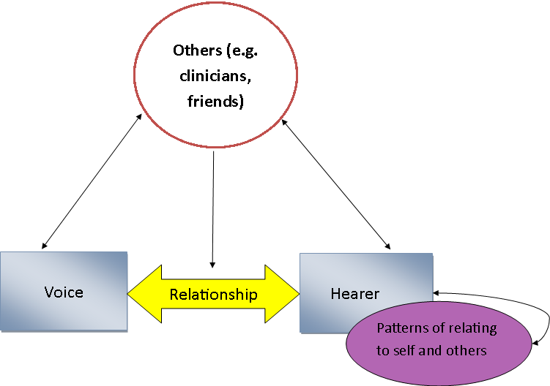
Figure 1 Displaying the interaction between the inter and intra-personal relationships

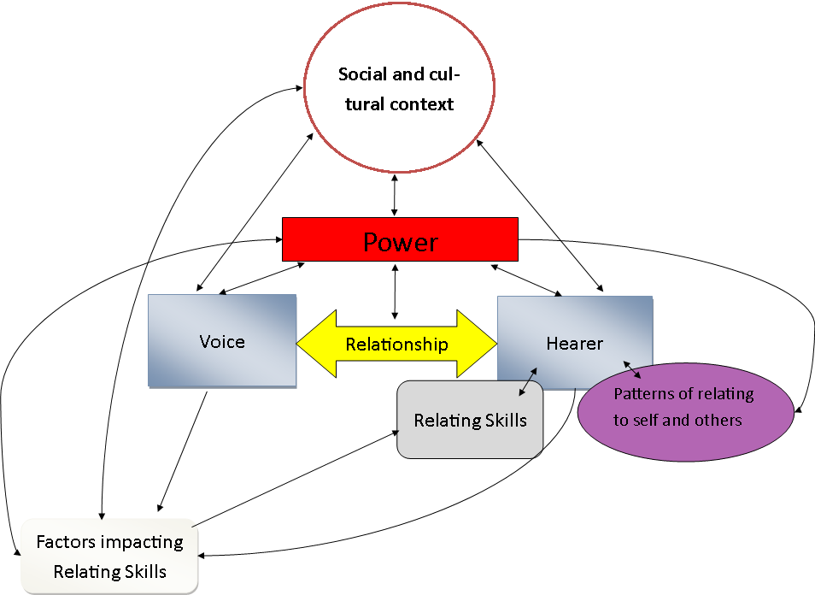
Figure 2 Displays how the themes identified interact with one another

Appendices
Appendices contents
2A Instructions for authors
2B Subthemes not included in the main text related to respectful communication and assertive communication.
2C- Item pool with illustrative quotes.

Appendix 2A
Instructions for authors for Psychosis copied from the website on 2nd March 2020. Please note that the journal uses APA 7th edition for reference lists and in text citation. However, the Psychosis style guide for headings differs from the APA style guide.
Instructions for authors
Thank you for choosing to submit your paper to us. These instructions will ensure we have everything required so your paper can move through peer review, production and publication smoothly. Please take the time to read and follow them as closely as possible, as doing so will ensure your paper matches the journal’s requirements.
For general guidance on every stage of the publication process, please visit our Author Services website.
For editing support, including translation and language polishing, explore our Editing Services website
This journal uses ScholarOne Manuscripts (previously Manuscript Central) to peer review manuscript submissions. Please read the guide for ScholarOne authors before making a submission. Complete guidelines for preparing and submitting your manuscript to this journal are provided below.
Contents
About the Journal
Peer Review
Preparing Your Paper

Structure
Word Limits
Style Guidelines
Formatting and Templates
References
Checklist
Using Third-Party Material
Disclosure Statement
Clinical Trials Registry
Complying With Ethics of Experimentation

Consent
Health and Safety
Submitting Your Paper
Data Sharing Policy
Publication Charges
Copyright Options
Complying with Funding Agencies
Open Access
My Authored Works
Reprints
About the Journal
Psychosis is an international, peer-reviewed journal publishing high-quality, original research. Please see the journal's Aims & Scope for information about its focus and peer-review policy.
Please note that this journal only publishes manuscripts in English.
Psychosis accepts the following types of article: Research Articles, First Person Accounts, Brief Reports, Opinion Pieces, Letters to Editor and Book Reviews.
Peer Review
Taylor & Francis is committed to peer-review integrity and upholding the highest standards of review. Once your paper has been assessed for suitability by the editor, it will then be double blind peer reviewed by independent, anonymous expert referees. Find out more about what to expect during peer review and read our guidance on publishing ethics.
Preparing Your Paper
All authors submitting to medicine, biomedicine, health sciences, allied and public health journals should conform to the Uniform Requirements for Manuscripts Submitted to Biomedical Journals, prepared by the International Committee of Medical Journal Editors (ICMJE).
Structure
Your paper should be compiled in the following order: title page; abstract; keywords; main text introduction, materials and methods, results, discussion; acknowledgments; declaration of interest statement; references; appendices (as appropriate); table(s) with caption(s) (on individual pages); figures; figure captions (as a list).
Word Limits
Please include a word count for your paper.
The maximum word length for an Article in this journal is 6000 words (this limit includes tables, references and figure captions).
The maximum word length for a First Person Account is 3500 words.
The maximum word length for a Brief Report is 1500 words.
The maximum word length for an Opinion Piece is 1500 words.
The maximum word length for Letters to Editor is 400 words.
The maximum word length for a Book Review is 1000 words.

Style Guidelines
Please refer to these quick style guidelines [see beneath] when preparing your paper, rather than any published articles or a sample copy.
Any spelling style is acceptable so long as it is consistent within the manuscript.
Please use double quotation marks, except where “a quotation is ‘within’ a quotation”. Please note that long quotations should be indented without quotation marks.
Formatting and Templates
Papers may be submitted in Word format. Figures should be saved separately from the text. To assist you in preparing your paper, we provide formatting template(s).
Word templates are available for this journal. Please save the template to your hard drive, ready for use.
If you are not able to use the template via the links (or if you have any other template queries) please contact us here.
References
Please use this reference guide when preparing your paper.
An EndNote output style is also available to assist you.

Checklist: What to Include
Author details. Please ensure everyone meeting the International Committee of Medical Journal Editors (ICMJE) requirements for authorship is included as an author of your paper. All authors of a manuscript should include their full name and affiliation on the cover page of the manuscript. Where available, please also include ORCiDs and social media handles (Facebook, Twitter or LinkedIn). One author will need to be identified as the corresponding author, with their email address normally displayed in the article PDF (depending on the journal) and the online article. Authors’ affiliations are the affiliations where the research was conducted. If any of the named co-authors moves affiliation during the peer-review process, the new affiliation can be given as a footnote. Please note that no changes to affiliation can be made after your paper is accepted. Read more on authorship.
Should contain a structured abstract of 200 words.
You can opt to include a video abstract with your article. Find out how these can help your work reach a wider audience, and what to think about when filming.
Between 5 and 6 keywords. Read making your article more discoverable, including information on choosing a title and search engine optimization.
Funding details. Please supply all details required by your funding and grant-awarding bodies as follows:
For single agency grants
This work was supported by the [Funding Agency] under Grant [number xxxx].
For multiple agency grants
This work was supported by the [Funding Agency #1] under Grant [number xxxx]; [Funding Agency #2] under Grant [number xxxx]; and [Funding Agency #3] under Grant [number xxxx].
Disclosure statement. This is to acknowledge any financial interest or benefit that has arisen from the direct applications of your research. Further guidance on what is a conflict of interest and how to disclose it.
Data availability statement. If there is a data set associated with the paper, please provide information about where the data supporting the results or analyses presented in the paper can be found. Where applicable, this should include the hyperlink, DOI or other persistent identifier associated with the data set(s). Templates are also available to support authors.
Data deposition. If you choose to share or make the data underlying the study open, please deposit your data in a recognized data repository prior to or at the time of submission. You will be asked to provide the DOI, pre-reserved DOI, or other persistent identifier for the data set.
Supplemental online material. Supplemental material can be a video, dataset, fileset, sound file or anything which supports (and is pertinent to) your paper. We publish supplemental material online via Figshare. Find out more about supplemental material and how to submit it with your article.
Figures. Figures should be high quality (1200 dpi for line art, 600 dpi for grayscale and 300 dpi for colour, at the correct size). Figures should be supplied in one of our preferred file formats: EPS, PS, JPEG, GIF, or Microsoft Word (DOC or DOCX). For information relating to other file types, please consult our Submission of electronic artwork document.
Tables. Tables should present new information rather than duplicating what is in the text. Readers should be able to interpret the table without reference to the text. Please supply editable files.
Equations. If you are submitting your manuscript as a Word document, please ensure that equations are editable. More information about mathematical symbols and equations.
Units. Please use SI units (non-italicized).
Using Third-Party Material in your Paper
You must obtain the necessary permission to reuse third-party material in your article. The use of short extracts of text and some other types of material is usually permitted, on a limited basis, for the purposes of criticism and review without securing formal permission. If you wish to include any material in your paper for which you do not hold copyright, and which is not covered by this informal agreement, you will need to obtain written permission from the copyright owner prior to submission. More information on requesting permission to reproduce work(s) under copyright.
Disclosure Statement
Please include a disclosure statement, using the subheading “Disclosure of interest.” If you have no interests to declare, please state this (suggested wording: The authors report no conflict of interest). For all NIH/Wellcome-funded papers, the grant number(s) must be included in the declaration of interest statement. Read more on declaring conflicts of interest.
Clinical Trials Registry
In order to be published in a Taylor & Francis journal, all clinical trials must have been registered in a public repository at the beginning of the research process (prior to patient enrolment). Trial registration numbers should be included in the abstract, with full details in the methods section. The registry should be publicly accessible (at no charge), open to all prospective registrants, and managed by a not-for-profit organization. For a list of registries that meet these requirements, please visit the WHO International Clinical Trials Registry Platform (ICTRP). The registration of all clinical trials facilitates the sharing of information among clinicians, researchers, and patients, enhances public confidence in research, and is in accordance with the ICMJE guidelines.
Complying With Ethics of Experimentation
Please ensure that all research reported in submitted papers has been conducted in an ethical and responsible manner, and is in full compliance with all relevant codes of experimentation and legislation. All papers which report in vivo experiments or clinical trials on humans or animals must include a written statement in the Methods section. This should explain that all work was conducted with the formal approval of the local human subject or animal care committees (institutional and national), and that clinical trials have been registered as legislation requires. Authors who do not have formal ethics review committees should include a statement that their study follows the principles of the Declaration of Helsinki.
Consent
All authors are required to follow the ICMJE requirements on privacy and informed consent from patients and study participants. Please confirm that any patient, service user, or participant (or that person’s parent or legal guardian) in any research, experiment, or clinical trial described in your paper has given written consent to the inclusion of material pertaining to themselves, that they acknowledge that they cannot be identified via the paper; and that you have fully anonymized them. Where someone is deceased, please ensure you have written consent from the family or estate. Authors may use this Patient Consent Form, which should be completed, saved, and sent to the journal if requested.
Health and Safety
Please confirm that all mandatory laboratory health and safety procedures have been complied with in the course of conducting any experimental work reported in your paper. Please ensure your paper contains all appropriate warnings on any hazards that may be involved in carrying out the experiments or procedures you have described, or that may be involved in instructions, materials, or formulae.
Please include all relevant safety precautions; and cite any accepted standard or code of practice. Authors working in animal science may find it useful to consult the International Association of Veterinary Editors’ Consensus Author Guidelines on Animal Ethics and Welfare and Guidelines for the Treatment of Animals in Behavioural Research and Teaching. When a product has not yet been approved by an appropriate regulatory body for the use described in your paper, please specify this, or that the product is still investigational.
Submitting Your Paper
This journal uses ScholarOne Manuscripts to manage the peer-review process. If you haven't submitted a paper to this journal before, you will need to create an account in ScholarOne. Please read the guidelines above and then submit your paper in the relevant Author Centre, where you will find user guides and a helpdesk.
Please note that Psychosis uses Crossref™ to screen papers for unoriginal material. By submitting your paper to Psychosis you are agreeing to originality checks during the peer-review and production processes.
On acceptance, we recommend that you keep a copy of your Accepted Manuscript. Find out more about sharing your work.
Data Sharing Policy
This journal applies the Taylor & Francis Basic Data Sharing Policy. Authors are encouraged to share or make open the data supporting the results or analyses presented in their paper where this does not violate the protection of human subjects or other valid privacy or security concerns.
Authors are encouraged to deposit the dataset(s) in a recognized data repository that can mint a persistent digital identifier, preferably a digital object identifier (DOI) and recognizes a long-term preservation plan. If you are uncertain about where to deposit your data, please see this information regarding repositories.
Authors are further encouraged to cite any data sets referenced in the article and provide a Data Availability Statement.
At the point of submission, you will be asked if there is a data set associated with the paper. If you reply yes, you will be asked to provide the DOI, pre-registered DOI, hyperlink, or other persistent identifier associated with the data set(s). If you have selected to provide a pre-registered DOI, please be prepared to share the reviewer URL associated with your data deposit, upon request by reviewers.
Where one or multiple data sets are associated with a manuscript, these are not formally peer reviewed as a part of the journal submission process. It is the author’s responsibility to ensure the soundness of data. Any errors in the data rest solely with the producers of the data set(s).
Publication Charges
There are no submission fees, publication fees or page charges for this journal.
Colour figures will be reproduced in colour in your online article free of charge. If it is necessary for the figures to be reproduced in colour in the print version, a charge will apply.
Charges for colour figures in print are £300 per figure ($400 US Dollars; $500 Australian Dollars; €350). For more than 4 colour figures, figures 5 and above will be charged at £50 per figure ($75 US Dollars; $100 Australian Dollars; €65). Depending on your location, these charges may be subject to local taxes.
Copyright Options
Copyright allows you to protect your original material, and stop others from using your work without your permission. Taylor & Francis offers a number of different license and reuse options, including Creative Commons licenses when publishing open access. Read more on publishing agreements.
Complying with Funding Agencies
We will deposit all National Institutes of Health or Wellcome Trust-funded papers into PubMedCentral on behalf of authors, meeting the requirements of their respective open access policies. If this applies to you, please tell our production team when you receive your article proofs, so we can do this for you. Check funders’ open access policy mandates here. Find out more about sharing your work.
Open Access
This journal gives authors the option to publish open access via our Open Select publishing program, making it free to access online immediately on publication. Many funders mandate publishing your research open access; you can check open access funder policies and mandates here.
Taylor & Francis Open Select gives you, your institution or funder the option of paying an article publishing charge (APC) to make an article open access. Please contact openaccess@tandf.co.uk if you would like to find out more, or go to our Author Services website.
For more information on license options, embargo periods and APCs for this journal please go here.
My Authored Works
On publication, you will be able to view, download and check your article’s metrics (downloads, citations and Altmetric data) via My Authored Works on Taylor & Francis Online. This is where you can access every article you have published with us, as well as your free eprints link, so you can quickly and easily share your work with friends and colleagues.
We are committed to promoting and increasing the visibility of your article. Here are some tips and ideas on how you can work with us to promote your research.
Article Reprints
You will be sent a link to order article reprints via your account in our production system. For enquiries about reprints, please contact the Taylor & Francis Author Services team at reprints@tandf.co.uk. You can also order print copies of the journal issue in which your article appears.
Queries
Should you have any queries, please visit our Author Services website or contact us here.
Updated 18-05-2018

Taylor & Francis quick layout guide
These general article layout guidelines will help you to format your manuscript so that it is ready for you to submit it to a Taylor & Francis journal. Please also follow any specific Instructions for Authors provided by the Editor of the journal, which are available on the journal pages at www.tandfonline.com. Please also see our guidance on putting your article together, defining authorship and anonymizing your article for peer review.
We recommend that you use our templates to prepare your article, but if you prefer not to use templates this guide will help you prepare your article for review.
If your article is accepted for publication, the manuscript will be formatted and typeset in the correct style for the journal.
Article layout guide
Font: Times New Roman, 12-point, double-line spaced. Use margins of at least 2.5 cm (or 1 inch). Guidance on how to insert special characters, accents and diacritics is available here.
Title: Use bold for your article title, with an initial capital letter for any proper nouns.
Abstract: Indicate the abstract paragraph with a heading or by reducing the font size. Check whether the journal requires a structured abstract or graphical abstract by reading the Instructions for Authors. The Instructions for Authors may also give word limits for your abstract. Advice on writing abstracts is available here.
Keywords: Please provide keywords to help readers find your article. If the Instructions for Authors do not give a number of keywords to provide, please give five or six. Advice on selecting suitable keywords is available here.
Headings: Please indicate the level of the section headings in your article:
- First-level headings (e.g. Introduction, Conclusion) should be in bold, with an initial capital letter for any proper nouns.
- Second-level headings should be in bold italics, with an initial capital letter for any proper nouns.
- Third-level headings should be in italics, with an initial capital letter for any proper nouns.
- Fourth-level headings should be in bold italics, at the beginning of a paragraph. The text follows immediately after a full stop (full point) or other punctuation mark.
- Fifth-level headings should be in italics, at the beginning of a paragraph. The text follows immediately after a full stop (full point) or other punctuation mark.
Tables and figures: Indicate in the text where the tables and figures should appear, for example by inserting [Table 1 near here]. You should supply the actual tables either at the end of the text or in a separate file and the actual figures as separate files. You can find details of the journal Editor’s preference in the Instructions for Authors or in the guidance on the submission system. Ensure you have permission to use any tables or figures you are reproducing from another source.
Please take notice of the advice on this site about obtaining permission for third party material, preparation of artwork, and tables.
Running heads and received dates are not required when submitting a manuscript for review; they will be added during the production process.
Spelling and punctuation: Each journal will have a preference for spelling and punctuation, which is detailed in the Instructions for Authors. Please ensure whichever spelling and punctuation style you use, you apply consistently.
Format-free submission
An increasing number of Taylor & Francis journals allow format-free submission, which means that, as long as your article is consistent and includes everything necessary for review, you can submit work without needing to worry about formatting your manuscript to meet that journal’s requirements. The ‘Instructions for authors’ for your chosen journal will tell you whether it operates format-free submission.

Appendix 2 B

Respectful Communication
The concept of respectful communication was discussed by three voice hearers and five clinicians. There appeared to be differences in the language used to indicate when respectful communication took place. One participant defined respectful communication as
Communication that respects the other, but also respects the self. It respects the view you have and the extent to which that view could and should be heard, but to communicate your view in a respectful manner (C03).
One of the participants (not included in the numbers above) appeared to use the word respect as a synonym for acknowledging an upward social comparison related to a power differential. They discussed feeling subordinate to their voices as the voice was older than them and they were brought up to have “respect” for their elders (VH06). For the other participants who discussed respectful relationships (and synonyms for this e.g. “mutual respect”, C05) and respectful communication a power differential was not evident in circumstances where this communication took place. In fact several participant equate “mutual respect” (C05) or “respectful” (VH01) relationship as relationships based on equality. The data indicates that one of the defining factors of a respectful communication or a respectful relationship is not one based only on the voice hearer respecting the voice. The data appears to indicate that one of the pre-requisites for respectful communication to take place is communication which indicates respect; coming from the voice and voice hearer to each other, or coming from the voice hearer to the voice and the voice hearer to the self.

Communication Style
Linked to the notion of respectful communication was the communication style used by the hearer. The communication style that the hearer used appeared to be linked to their typical responses to power differentials (passive or adversarial/aggressive). For example, “passive response[s] will often maintain the sense of powerlessness” (C03). Several participants described that assertiveness was communicated non-verbally, and verbally in both content and paralinguistic features. Two clinicians described that their therapeutic approaches primarily focused on the development of assertive communication skills (Participant PIN removed to preserve anonmymity). One clinician related the use of communication style to acknowledging the vulnerability of the voice which they thought may result in a “softer voice tone” and “slow calm dialogue” (C11). Using an assertive communication style was seen as a key method in facilitating negotiation and compromise and one clinician described that this is at the “core of what we are trying to do” (C10).

Critical Appraisal

Rohan Morris*
Doctorate in Clinical Psychology
Division of Health Research, Lancaster University

*Corresponding author information: Dr Rohan Morris, r.morris1@lancaster.ac.uk, Lancaster University, Furness College, Department of Clinical Psychology, Division of Health Research, LA1 4YW, UK +44 (0)1524 592691

Overview
This critical appraisal will explore the limitations of this project, my personal and professional responses to the research topic, the challenges that I have experienced whilst conducting this research, and areas for future research. This chapter firstly provides a summary of the main findings from the research chapter. Secondly, I describe my epistemological position, reflecting on my journey with this research and choice of analysis. Thirdly I reflect on the notion of inductive methods and reflect on publication biases and my personal biases. Fourthly, I discuss some of the terminology in this thesis particularly highlighting the differences between Chapter 1 and Chapter 2. Some of the barriers to conducting this research are then discussed. This chapter is concluded with a consideration of the contributions that this research has made and future directions for research.

Summary of findings
This research explores the most important aspects of the Voice and Hearer Relationships (VHR) and explores how these impact on the VHR. In-depth interviews were conducted with clinicians (n=8) and voice hearers (n=7). Four themes were identified: (1) Power, Powerlessness and Patterns of relating; (2) The interaction between relationships; (3) Factors which influence the application of relational skills; (4) Skills that help develop the relationship.

My epistemological position and journey with this research

The double reflective model applied to my research
“The value of knowledge is subordinate to its uses in thinking… and where retrospect… is of value [is] in the solidity, security, and fertility it affords our dealings with the future” (Dewey, 1916, p.178).
This section of the critical analysis will reflect on my journey with this research whilst making reference to how this fits with and highlights my epistemological position. I align myself with Pragmatism specifically the epistemological position highlighted by Dewey (1933/1986). This school of thought suggests that inquiry is the means by which uncertainty is resolved. Doubt can be used “for the purposes of inquiry…to guide action in tentative conjectures” (Dewey, 1916, p.174). Dewey critiqued the position that places philosophy as disconnected from environment. Rather Pragmatism asserts that “ideas and theories are not rational fulcrums to get us beyond culture, but rather function experimentally within culture and are evaluated on situated, pragmatic bases” (Hildebrand, 2018, para. 3). Dewey (1933/1986) proposed a model which suggests that there are five steps to (inquiry) understanding a problem: 1) Problem recognition, 2) Problem reflection, 3) Proposing a solution, 4) Assess the proposed solution, 5) Take action. Dewey (1909) defined reflection as “Active, persistent, and careful consideration of any belief or supposed form of knowledge in the light of the grounds that support it, and the further conclusions to which it lends” (p.6). Morgan (2014) has adapted the model of inquiry proposed by Dewey (1933) to highlight how this model is applied dynamically to the research context. Morgan (2014) highlights that the steps outlined by Dewey are not a linear process but, involve the reformulation of research questions and research design throughout the inquiry process, which results in moving backwards and forwards between steps. Herein I detail my research process and use figures to highlight how the model proposed by Morgan (2014) was applied. Steps 1-3 are displayed in Figure 1. As a consequence of these steps I reformulated my research question and research problem. After redefining my research problem, I identified a potential research method and study design (Steps 4-8; Figure 2). After reflecting on the study design and research method I changed the study design and identified an appropriate analysis method (Steps 9-11; Figure 3).
FIGURE 1
I originally became interested in relational approaches to voice hearing when I heard about the AVATAR study several years ago (Leff et al., 2013). At the time I was quite interested in the integration of technology into health care and this seemed like an interesting advance. My interests changed slightly and I became more interested in approaches that engaged the voice (rather than an avatar) in dialogue. I originally wanted to conduct a feasibility study of this approach and I started doing a scope of available papers with the plan to conduct a literature review in the area (Step 1). I found two papers on the topic, with no studies looking at acceptability or effectiveness beyond case studies reported in these papers. Not too long afterwards I came across Perona-Garcelon, Escudero-Pérez, et al., (2015), where they describe the development of the DAIMON measure. I considered that a barrier to conducting an acceptability study of the voice dialogue approach is that there is no appropriate outcome measure to assess changes in relationship (Step 2). I considered the work of Leudar and Thomas (2000) which indicates that the VHR has similar qualities to other interpersonal relationships. I started to read items from assessments of voice hearing and noticed that all assessments in the English language focused on negative aspects of the relationship (Step 3). I thought about the idea that if all that was assessed was the negative aspects of these relationships it does not tell me why the relationship endures or what is helpful about that relationship. This brought me to the conclusion that the research problem was that there is a lack of tools assessing a breadth of the VHR (Step 4) and decided that I could make a contribution in this area (Step 5).
FIGURE 2
As I read through articles and guidelines for measure development, I noted that to my knowledge, very few measurement studies adhered to best practice, which led me to conduct the review within chapter one. I decided to conduct qualitative research using inductive methods as I did not want to base items for the newly developed measure on the existing literature. I considered that approach to be flawed for several reasons. The literature is typically only concerned with negative aspects of the VHR and people with lived experience are not often involved in the development of item pools. Consequently, if I was to draw on items from another measure, it is feasible that salient aspects of the relationship would have been omitted. Therefore I decided on adhering to guidelines for measure development which suggest qualitative research should form the development of an item pool (Step 6).
I considered (and received advice) about how feasible it is to go through all the recommended steps for measure development for a DClinPsy thesis. I also considered whether or not to base the measure and consequently the topic guide around the theory proposed by Perona-Garcelon, Pérez-Álvarez, et al., (2015) which suggests that if voices do reflect dissociated ‘I’ positions then dialogue with voices should follow rules of pragmatics (Step7).
Upon reflection, I decided that imposing a conceptual framework on the topic guide and analytical procedure, would have resulted in deriving less information about what participants think are the most important aspects of the VHR. I reflected on the advantages and limitations of various analytical approaches (see Choice of analysis) and decided to perform a Thematic Analysis. Furthermore, I decided that the research proposed was too large in scope for a DClinPsy thesis (Step 8). Consequently, I amended the research design and partitioned the research into distinct phases (Step 9) which I considered would allow me to fulfil the objectives of taking steps towards addressing the research problem and completing my DClinPsy (Step 10).
FIGURE 3

Choice of analysis
I decided to conduct a Thematic Analysis which is preferable in circumstances where “there are no strong theoretical perspectives to drive the analysis” (Howitt, 2010, p.165). I did not want to code data according to a set a priori theoretical framework (e.g. Framework Analysis; Ritchie & Lewis, 2003). I also considered utilising an analytical approach to develop theory (e.g. Grounded Theory; Glaser & Strauss, 1967) inappropriate as numerous relational conceptual frameworks already exist (Heriot-Maitland et al., 2019). I sought to derive shared meaning (themes) from the corpus of all transcripts, an approach used in Thematic Analysis. I consider that factors which are ‘typically’ important within the relationship need to be described and typified so that they can be operationalised within a measure. This aim also negates utilising an Interpretative Phenomenological Analysis approach, which seeks to identify individual meaning from experience (Smith et al., 2009) or a Narrative Analysis as this “focuses on the way individuals present their accounts of themselves” (Burck, 2005 p.252).

Deductive versus inductive methods: Publication and researcher bias
Objectivity in human research is a fallacy (Bowden & Green, 2010) and subjectivity is more marked in qualitative research (Morgan, 2014).
Thematic analyses often refer to the themes ‘emerging’ from the data is if it were something that themes did on their own without the active involvement of the researcher. Howitt, (2010, p.164).
This active involvement of the researcher means that the researcher invariably influences every stage of the research process. I refer to using inductive methods, that is to say the data collected has not been purposefully coded according to any a priori determined framework or theoretical perspective. However, topic guides were based on previous research and consultation with an expert in the field of Voice Dialogue (Dr Rufus May). Topic guides were updated iteratively as new topics were discussed by participants. However, to claim that this was an entirely inductive piece of research would be erroneous.
Being (overly) influenced by the literature has notable limitations. It is evident from Chapter 1, service user participation in research is typically minimal. Consequently, their voice may be absent from the literature and their experiences not reflected in the topic guides. The field of psychosis is heavily influenced by disease model (biological) conceptualisations and psychological therapeutic approaches which lend themselves more favourably to being manualised and examined in Randomised Controlled Trials (e.g. NICE, 2014). These conceptualisations will have influenced me and the topic guide.
During interviews after it had been established that participants believed that there was a relationship between the voice and hearer, I would ask “What do you think are the most important things in someone’s/your relationship with their/your voice?”. Exploring participant response to this question typically took more time than any other question. I wanted this to be the case, as this provided participants with the opportunity to tell me about their perceptions without being overly influenced by the topic guide. More often than not, without prompting participants discussed various different aspects of the topic guide. This offered me some reassurance that despite the topic guide being influenced by publication biases and my personal biases the topics within it were salient to participant’s experiences.
My own personal experiences also influence the research process. I have had two experiences of note of hearing voices. When I was 17 years old I was taken into A&E because I was stuck in a loop of a conversation repeatedly saying “No” to a voice telling me to kill myself. A nurse who came to assess me said something along the lines of “let’s hope that he’s just seen something traumatic tonight”, the inference being that if I had not, then that was an indication of a substantial mental problem. To me at the time it was quite clear what was happening; I had been deliberating about killing myself. The thoughts about it felt all-consuming and I spent a large proportion of my time trying to make a decision. I see this as my mind’s way of helping me to make a choice. I had another experience a couple years later of another voice. I was working a full-time job, studying for my degree full-time and refurbishing a house. This voice was laughing critically at my attempts to refurbish a staircase. It was employing the same critical tactics that I often employ in an attempt to motivate myself to ‘do better’. I interpreted this as an indication that I was sleeping too little and needed to be kinder to myself. I took a night off work got a good night’s sleep and the voice stopped.
Even though it was for a brief period of time I developed a relationship with those voices. They helped me to take an outside perspective on what was happening at the time and provided me with something that felt external to me to be oppositional with. For me, the brief and very limited dialogue I had with the first voice was a transformational point in the difficulties I was having with my mental health, it helped me make a choice that I wanted to live.
My experience of seeing the benefits of understanding the function and interpreting the meaning behind the voices has likely had an influence on this research. The themes identified in this research concur with my experiences of: the possibility of clinicians having a detrimental effect on relationships with voices, understanding the function as a means to derive some benefit (relationally or otherwise) from voices, assertive dialogue as a useful skill in the VHR; and voices’ critical comments reflecting thoughts about the self. Although these are notions supported by the literature, quotes from voice hearers and quotes from clinicians, my personal experience has likely influenced the interviews and analysis.

A note on terminology and language
In Chapter 1 I refer to auditory hallucinations as a consequence of psychotic disorder and I apply diagnostic categories as part of the inclusion criteria. However, in Chapter 2 I use the terminology voices and do not apply any exclusion criteria according to diagnoses. In Chapter 1 I thought it essential to draw clear distinctions between hallucinations as a consequence of functional psychosis and non-functional psychosis experiences as these likely have distinct aetiology and in some circumstances a distinct phenomenology (e.g. Lewy Bodies; Eversfield & Orton, 2018). Furthermore, I considered it key to differentiate between ‘psychotic symptoms’, and sub-psychotic experiences or psychosis-like experience. Recent reviews have been conducted of the tools used to assess these sub-clinical phenomena (respectively Addington et al., 2015; Lee et al., 2016). These reviews highlight that different assessment tools are typically used for sub-clinical hallucinations. Consequently, I use the term psychotic disorder in Chapter 1 to clearly differentiate the review from those focusing on sub-clinical hallucinations.
Chapter 2 is concerned with relationships with voices, however Chapter 1 does not seek to differentiate assessments of verbal and non-verbal auditory hallucinations. Therefore the term auditory hallucination is used instead.

Barriers encountered to conducting this research
It took 13 months from start to finish for ethical approval. I believe that this was because I sought to apply for all of the phases proposed in Chapter 4- Research Protocol as part of one ethics application. This resulted in a large number of documents that needed to be reviewed (e.g. nine different consent forms). In retrospect I should have had more modest ambitions for a DClinPsy thesis project which would have facilitated completion in a more timely fashion.
One of the main difficulties when conducting this research has been in terms of the analysis. The research aim (To explore the most important aspects of the voice hearer relationship and how these affect the relationship) and the research objective (To develop an item pool for a measure of relationships) have not always felt perfectly aligned throughout the analytical process. For example, participants discussed how perceptions of power can influence their ability to apply relating skills. This is obviously a salient part of the relationship to participants, but poses difficulty when transferring this notion to items for a measure and any scoring system that is developed for these items. Nonetheless, it was necessary to ensure that the analysis contained within Chapter 2 forms part of a standalone piece of research, with concepts that are most important to participants being highlighted in adequate detail. The consequence of this is that concepts which were coded in the analysis, which form part of the item pool, are not considered within the write-up. To circumvent any concerns about rigour or interpretation, items are provided with illustrative quotes (Appendix 2C). Whilst this deviates from my initial plan of utilising themes as subscales and sub-themes and nodes to form the basis of items, this approach benefits from allowing both the aim and objective of this research to be met.

Contributions of this research to knowledge and future directions of the research

Developing the Voice-Hearing Experiences And Relationships Scale
The overarching aim of this research was to develop a broad assessment of people’s relationships with their voices: the Voice-Hearing Experiences And Relationships Scale (V-HEARS). Such an assessment tool could feasibly have several practical uses, it could: be used as a pre and post outcome measure in studies exploring the efficacy of relational approaches to voices; provide an indication of who is most likely to respond to relational approaches; be used to explore changes in the VHR during therapy; and provide clinicians with an indication of salient aspects of the relationship to consider within their therapeutic work.
The protocol outlined in Chapter 4 provides an indication of how the work to construct this measure could proceed. This protocol suggests four phases to the research the first of which is described in Chapter 2. This method of measure development adheres to the guidelines outlined by Boateng et al., (2018) and would perform favourably on boxes 1 and 2 of the COSMIN Risk of Bias checklist (Mokkink et al., 2018).

Contributions of this research to understanding of the voice and hearer relationship
Perona-Garcelán, Pérez-Álvarez, et al., (2015) propose that voices constitute different I- positions which are dissociated from each other. This theory suggests that dialogue with voices follow rules of pragmatics which suggests six basic functions of verbal communication: referential, emotive, conative, poetic, phatic, and metalingual (Jakobson, 1987). Leudar et al., (1997) and Leudar and Thomas (2000), demonstrated that some of these functions are present in people’s interactions with their voices. The current study supports these findings with voice hearer’s reporting receiving: directives which serve the referential function (e.g. “[the voice] basically encouraged me to pretty severe self-harm” VH05), the emotive function (e.g. “They always have like a nasty voice to them, they never say it in a nice way” VH06), the conative function (“[the voice] will sometimes say ‘you look fat today’ VH05), the poetic function in the voices use of humour (See Norrick, 1993 for discussion of the pragmatics of humour), metalingual function ([a voice said] “I’m not this boring voice that says five stock phrases that’s the only thing you hear” VH01) and possibly the phatic function (“[the voice] would always approach me like a friend would... he would be very conversational ask me how I was” VH01).
Mawson et al., (2011) interviewed voice hearers who described that, possibly as a consequence of stigma, some participants sort to “separate voices from their social relationships”, impacting on the VHR (p.267). They noted that other participants were rejecting of other interpersonal relationships in favour of the VHR. This notion is supported by the current study; stigma was reported to be detrimental to the VHR and the VHR could be detrimental to other interpersonal relationships. The current study extends the findings by Mawson et al., (2011), by highlighting that improvement in relationships with voices can lead to improvement with relationships with others and vice-versa. Future investigations may wish to extend the findings from the current study to explore the impact of taking a systems based approaches which seek to reduce stigma (e.g. Open Dialogue; Seikkula et al., 2001) on social relationships and the VHR.
The current study suggests that it is feasible that improving skills in relating could improve the VHR. People with a schizophrenia diagnosis have been shown to perform worse than controls in assessments of social skills (Pinkham et al., 2007). There was no indication from participants that they believed that a global skills deficit underpinned negative aspects of the VHR, in fact this notion was directly challenged by a participant. The current research suggests that there are a collection of factors which affect the voice hearer’s ability to apply relating skills within the VHR. Future investigations may wish to establish if social skills ‘deficits’ are mediated or confounded by factors such as voice power differentials and self-esteem.
Hayward et al., (2018) highlight that power plays a central role within the VHR, this notion is supported by the current research. Voices may mirror other social relationships (Birchwood et al., 2000; Gilbert et al., 2001). The current study supports this notion and suggests that the power differential and relating patterns that exists within the VHR are also present in the hearer’s other relationships. It is feasible that by improving social inequality this could improve the VHR. Current models endorsed by the BPS (Power Threat Meaning; Johnstone & Boyle, 2018) and a report written by the UN Human Rights Council (UNHRC, 2017), suggest that power and powerlessness is a key factor underpinning mental health problems and distress. “The crisis in mental health should be managed not as a crisis of individual conditions, but as a crisis of social obstacles which hinders individual rights” (UNHRC, 2017, p.19).

References
Addington, J., Stowkowy, J., & Weiser, M. (2015). Screening tools for clinical high risk for psychosis. Early Intervention in Psychiatry, 9(5), 345–356. doi:10.1111/eip.12193
Birchwood, M., Meaden, A., Trower, P., Gilbert, P., & Plaistow, J. (2000). The power and omnipotence of voices: subordination and entrapment by voices and significant others. Psychological Medicine, 30(2), 337–344. doi:10.1017/S0033291799001828
Boateng, G. O., Neilands, T. B., Frongillo, E. A., Melgar-Quiñonez, H. R., & Young, S. L. (2018). Best Practices for Developing and Validating Scales for Health, Social, and Behavioral Research: A Primer. Frontiers in Public Health, 6, 149. doi:10.3389/fpubh.2018.00149
Bowden, J.A. & Green, P.J. (2010). Relationality and the myth of objectivity in research involving human participants. In J. Higgs, N. Cherry, R. Macklin, & R. Ajjawi (Eds.), Researching Practice: A discourse on qualitative methodologies. (pp. 105-112). Leiden, Holland: Brill
Burck, C. (2005). Comparing qualitative research methodologies for systemic research: the use of grounded theory, discourse analysis and narrative analysis. Journal of Family Therapy, 27(3), 237–262. doi:10.1111/j.1467-6427.2005.00314.x
Dewey, J. (1909). How we think. London, UK: D.C. Heath & Company
Dewey, J. (1916). Democracy and education: An introduction to the philosophy of education. New York, USA: The Macmillan Company
Dewey, J. (1986). How we think: A restatement of the relation of reflective thinking to the educative process. Carbondale, USA: Southern Illionis University Press. (Originally published 1933)-
Eversfield, C. L., & Orton, L. D. (2018). Auditory and visual hallucination prevalence in Parkinson’s disease and dementia with Lewy bodies: a systematic review and meta-analysis. Psychological Medicine, 1–12. doi:10.1017/S0033291718003161
Gilbert, P., Birchwood, M., Gilbert, J., Trower, P., Hay, J., Murray, B., … Miles, J. N. V. (2001). An exploration of evolved mental mechanisms for dominant and subordinate behaviour in relation to auditory hallucinations in schizophrenia and critical thoughts in depression. Psychological Medicine, 31(6), 1117–1127. doi:DOI: 10.1017/S0033291701004093
Glaser, B.G. & Strauss, A. L. (1967). The Discovery of Grounded Theory. Strategies for Qualitative Research. Chicago, USA: Aldine
Hayward, M., Strauss, C., & Kingdon, D. (2018). Overcoming distressing voices (2nd Ed.). London, UK: Robinson
Heriot-Maitland, C., McCarthy-Jones, S., Longden, E., & Gilbert, P. (2019). Compassion Focused Approaches to Working With Distressing Voices . Frontiers in Psychology . Retrieved from https://www.frontiersin.org/article/10.3389/fpsyg.2019.00152
Hildebrand, D. (2018), "John Dewey", In E.N. Zalta (Ed.), The Stanford Encyclopedia of Philosophy (Winter 2018 Edition), https://plato.stanford.edu/archives/win2018/entries/dewey
Horn, L., & Ward, G. (2004). The Handbook of Pragmatics. Massachusetts, USA: Blackwell Publishing.
Howitt, D. (2010). Introduction to qualitative methods in psychology. Essex, UK: Pearson Education Limited.
Johnstone, L. & Boyle, M. (2018). The power threat meaning framework: Towards the identification of patterns in emotional distress, unusual experiences and troubled or troubling behaviour, as an alternative to functional psychiatric diagnosis. Leicester, UK: British Psychological Society
Lee, K.-W., Chan, K.-W., Chang, W.-C., Lee, E. H.-M., Hui, C. L.-M., & Chen, E. Y.-H. (2016). A systematic review on definitions and assessments of psychotic-like experiences. Early Intervention in Psychiatry, 10(1), 3–16. doi:10.1111/eip.12228
Leff, J., Williams, G., Huckvale, M. A., Arbuthnot, M., & Leff, A. P. (2013). Computer-assisted therapy for medication-resistant auditory hallucinations: proof-of-concept study. British Journal of Psychiatry, 202(6), 428–433. doi: 10.1192/bjp.bp.112.124883
Leudar, I & Thomas, P. (2000). Voices of reason, voices of insanity. London, UK: Routledge.
Leudar, I., Thomas, P., McNally, D., & Glinski, A. (1997). What voices can do with words: pragmatics of verbal hallucinations. Psychological Medicine, 27(4), 885–898.
Mawson, A., Berry, K., Murray, C., & Hayward, M. (2011). Voice hearing within the context of hearers’ social worlds: An interpretative phenomenological analysis. Psychology and Psychotherapy: Theory, Research and Practice, 84(3), 256–272. doi:10.1348/147608310X524883
McCarthy-Jones, S., Trauer, T., Mackinnon, A., Sims, E., Thomas, N., & Copolov, D. L. (2014). A new phenomenological survey of auditory hallucinations: evidence for subtypes and implications for theory and practice. Schizophrenia Bulletin, 40(1), 231–235. doi:10.1093/schbul/sbs156
Mokkink, L. B., de Vet, H. C. W., Prinsen, C. A. C., Patrick, D. L., Alonso, J., Bouter, L. M., & Terwee, C. B. (2018). COSMIN Risk of Bias checklist for systematic reviews of Patient-Reported Outcome Measures. Quality of Life Research : An International Journal of Quality of Life Aspects of Treatment, Care and Rehabilitation, 27(5), 1171–1179. doi:10.1007/s11136-017-1765-4
Morgan, D.L. (2014). Integrating qualitative & quantitative methods: A pragmatic approach. London, UK: Sage publications
National Institute for Health and Care Excellence (2014). Psychosis and schizophrenia in adults: The NICE guideline on treatment and management (CG178). London, England: NICE
Perona-Garcelán, S., Escudero-Pérez, S., Barros-Albarrán, M. D., León-Palacios, M. G., Úbeda-Gómez, J., García-Montes, J. M., … Pérez-Álvarez, M. (2015). Reliability and validity of a new scale for measuring relationships with voices: The DAIMON Scale. Psychosis, 7(4), 312–323. doi:10.1080/17522439.2015.1028429
Perona-Garcelán, S., Pérez-Álvarez, M., García-Montes, J. M., & Cangas, A. J. (2015). Auditory Verbal Hallucinations as Dialogical Experiences. Journal of Constructivist Psychology, 28(3), 264–280. doi:10.1080/10720537.2014.938847
Pinkham, A. E., Penn, D. L., Perkins, D. O., Graham, K. A., & Siegel, M. (2007). Emotion perception and social skill over the course of psychosis: A comparison of individuals “at-risk” for psychosis and individuals with early and chronic schizophrenia spectrum illness. Cognitive Neuropsychiatry, 12(3), 198–212. doi:10.1080/13546800600985557
Ritchie, J. & Lewis, J. (2003). Qualitative research practice: A guide for social science students and researchers. London, UK: Sage publications
Seikkula, J., Alakare, B., & Aaltonen, J. (2001). Open dialogue in psychosis I: An introduction and case illustration. Journal of Constructivist Psychology. doi:10.1080/107205301750433397
Smith, J.A., Flower, P., & Larkin, M. (2009), Interpretative Phenomenological Analysis: Theory, Method and Research. London, UK: Sage
United Nations Human Rights Council (2017). Report of the Special Rapporteur on the right of everyone to the enjoyment of the highest attainable standard of physical and mental health. Geneva, Switzerland: United Nations Human Rights Council

Figures
Figure 1 Steps 1-3 of my research design process

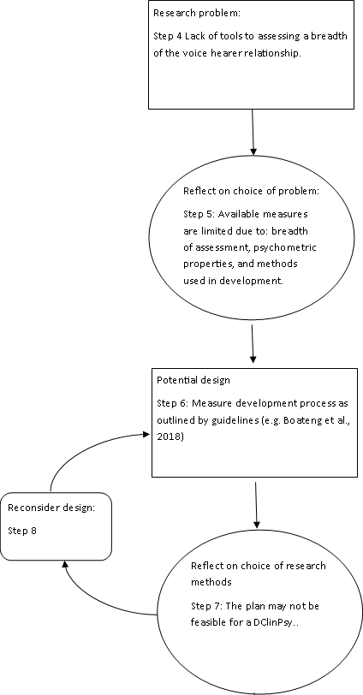
Figure2 Steps 4-8 of my research design process

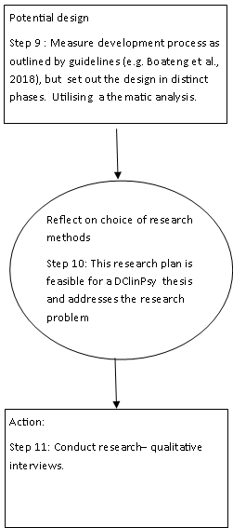
Figure 3 Steps 9-11 of my research design process

Ethics Section

Rohan Morris*
Doctorate in Clinical Psychology
Division of Health Research, Lancaster University

*Corresponding author information: Dr Rohan Morris, r.morris1@lancaster.ac.uk, Lancaster University, Furness College, Department of Clinical Psychology, Division of Health Research, LA1 4YW, UK +44 (0)1524 592691

Protocol

Development of an assessment of relationships with auditory hallucinations: Voice-Hearing Experiences and Relationships Scale (V-HEARS). Research Protocol

Dr Rohan Morris¹, Dr Jayati Das-Munshi², Prof Dawn Edge³, Dr Rufus May⁴, Prof William Sellwood¹
¹ Division of Health Research, Lancaster University
² Department of Health Services & Population Research, Institute of Psychiatry, Psychology & Neuroscience (IoPPN), King’s College London
³ Division of Psychology & Mental Health, University of Manchester
⁴Greater Manchester Mental Health Trust

Background
Auditory Hallucinations (AHs) are common in severe mental health problems. Estimates suggest that 59% of people with a schizophrenia spectrum diagnosis experience the phenomena (Waters et al., 2014). Many clinical samples report distress associated with AHs (e.g. Kumari, Chaudhury & Kumar, 2013), which appears to be a key concept in understanding their emotional impact (Woodward et al., 2014). Distress as a consequence of AHs is associated with higher levels of depression and lower levels of self-esteem (Smith et al., 2006). However, for some people, AHs are not distressing and do not require clinical treatment (van Os, Linscott, Myin-Germeys, Delespaul & Krabbendam 2009). Although AHs can take the form of any type of perceived auditory input they frequently take the form of voices (Woodward et al., 2014).
Several theories have been posited to explain the mechanisms underpinning AHs. These theories can be considered to broadly align with two conceptualisations of AHs: one is considering AHs as perceptual phenomena, and one considering AHs as states of consciousness (Perona-Garcelán, Pérez-Álvarez, García-Montes & Cangas, 2015). Models conceptualising AHs as perceptual phenomena typically suggest that AHs are a consequence of cognitive biases, with some elaborating on this model to suggest specific neuropsychological dysfunction. For example, one cognitive model has conceptualised AHs as dysfunctions in source monitoring which results in failure in the self-recognition of the source of perceived auditory input (e.g. ‘real’ or imagined) and an increased propensity to attribute perceived input to external factors (Bentall, 1990). Further development of this concept has led to one theory suggesting that dysfunctions in self-monitoring leads to a failure to recognise one’s own thoughts and behaviours as belonging to the self (Frith, Blackmore & Wolpert, 2002). It has been noted that there is an inconsistency between the theoretical predicted characteristics of AHs as perceptual phenomena and the phenomenological experience (Jones, 2010). These inconsistencies have led Perona-Garcelán, Pérez-Álvarez, et al., (2015) to conceptualise auditory hallucinations as a state of consciousness.
Models considering AHs as states of consciousness are influenced by the work of Mead (1934) which distinguishes the I and the Me. The Me is physically and temporally situated. However, the I is not temporally and physically situated. The I consists of two elements one internal (internalised view of one’s self) and one external (internalised views of significant others). The two parts of I can take multiple perspective and have dialogue both within and between the internal and external parts. Theories suggesting a dysfunction in the organisation of the I positions have been used to explain the symptoms of psychosis (Lysaker & Lysaker, 2010). A recent theory based on this work has proposed that the voices themselves constitute different I- positions which are dissociated from each other (Perona-Garcelán, Pérez-Álvarez, et al., 2015). This theory suggests that dialogue with voices follow rules of pragmatics (an area of linguistics concerned with “context-dependent aspects of meaning” [Horn & Ward, 2004 p. xi]).
Pragmatic linguist Jakobson (1987) proposed that there were six basic functions of verbal communication: referential, emotive, conative, poetic, phatic, and metalingual. The work of Leudar, McNally and Glinski (1997), demonstrated that some of these functions were present in people’s interactions with their voices. For example, Leudar et al., (1997) found that voice-hearer dialogues often include directives which serve the referential function (by conveying information) and conative function (an expression in the vocative and imperative) proposed by Jakobson (1987). Leudar et al., (1997) found that voices’ interactions were frequently evaluative serving both the referential and emotive function.
Perona-Garcelán, Pérez-Álvarez, et al., (2015) hypothesise that if AHs are states of consciousness then the voice hearer would have a relationship with their voice or different relationships with multiple voices. A meta-synthesis found that a theme emanating from first person accounts of their voices was the relationship that they had developed with their voices (Holt & Tickle, 2014). Benjamin (1989) found that peoples relationships with their voices possess similar qualities to other interpersonal relationships. One ‘cognitive model’ of AHs suggests that the appraisal a person makes of the AH is key to this process (Chadwick & Birchwood, 1994). It seems that that certain types of appraisal of AH voices (e.g. voice malevolence) influence the amount of distress caused by the voices (Mawson, Cohen & Berry, 2010). However, research has also indicated that there are similarities between a person’s relationship with their voices and other social relationships, which is independent of someone’s beliefs about- and appraisals of- their voices (Hayward, 2003). Many other interpersonal/relational factors between voices and the voice-hearer appear to influence distress. For example, the distress associated with hearing voices has also been shown to be linked to a person’s perception of their interpersonal distance from their voices and the voice’s intrusiveness and dominance (Léon-Palacios et al., 2015; Vaughan & Fowler, 2004). If a person perceives their voices as more dominant in their relationship this typically serves to increase scores on assessments of depression and anxiety, but this is also mediated by the persons perception of the voice as malevolent and/or omnipotent (Léon-Palacios et al., 2015).
Theories considering voices as dissociated I-positions (Perona-Garcelán, Pérez-Álvarez, et al., 2015) and dysfunction in the interactions between the I-positions (Lysaker & Lysaker, 2011), hypothesise that improving a person’s relationship with their voices through dialogue may improve their experience of the voices. Similar hypotheses about treating the voice-hearer relationship have also been proposed using cognitive models of AH which suggest that “a negative perceived relationship with a voice also drives negative voice-content”, which in turn results in distress and increases the propensity for clinical treatment (Larøi et al., 2018). There is emerging evidence to indicate that the voice-hearer relationship is an important therapeutic target (e.g. Corstens, Longden, & May, 2012). Several therapeutic approaches have sought to alter the relationship a person has with their voices. These approaches represent a shift away from the cognitive model, which conceptualises voices as cognitions which influence belief, to the consideration of voices within a more social conceptualisation i.e. a distinct entity that a person has a relationship with (Hayward, 2003). Leading on from this research a relational approach (Relating Therapy) to working therapeutically with voices has been developed.
Relating Therapy seeks to: draw parallels between the voice-hearer relationship and other social relationships, enhance awareness of reciprocity within the voice-hearer relationship, and to change a person’s way of relating to their voices using assertiveness training (Hayward, Berry, McCarthy-Jones, Strauss & Thomas, 2014; Hayward, Overton, Dorey & Denney, 2009). Case studies and qualitative interviews indicate that Relating Therapy for hearing voices is acceptable, increases feelings of control, reduces distress and has a positive effect on the voice-hearer relationship (Hayward & Fuller, 2010; Hayward et al., 2009). A Randomised Controlled Trial found that participants receiving Relating Therapy had clinically significant reductions in the distress associated with auditory hallucinations in comparison to treatment as usual (Hayward, Jones, Bogen-Johnston, Thomas & Strauss, 2017).
An alternative relational approach is based on voice dialoguing which was initially developed by H. Stone and S. Stone (1989) as a means of exploring different parts of the self. There are case-studies describing a beneficial effect of the voice dialoguing approach on the relationship a person has with their AHs (Corstens et al., 2012). This approach has been used to facilitate engagement between the voice hearer and voice. Engaging voice and voice hearer, the approach seeks to: increase insight into the function and aetiology of the voice for the voice hearer; facilitate autonomy and assertiveness in the voice hearer’s dialogue with the voice; and increase acceptance of the voice (Corstens et al., 2012). Compassion Focused Therapy (CFT) has adopted similar approaches in the form of ‘Chair work’ (Gilbert, 2010), which is also utilised with Relating Therapy approaches to voices (Hayward, Berry et al, 2014).
Further evidence for using relational approaches can be derived from recent treatments which have been developed using virtual reality technology (Dellazizzo, Potvin, Phraxayavong, Lalonde & Dumais, 2018). These approaches have sought to facilitate dialogue and assertive communication between the voice hearer and virtual reality representations of the voices. These approaches have been found to have a beneficial effect on distress associated with voices, the frequency of the voices and the voice’s omnipotence (Craig et al., 2018; J. Leff, Williams, Huckvale, Arbuthnot & A.P. Leff, 2013) .
Numerous assessments of AHs have been developed (see Frederick & Killeen, 1998; Ratcliff, Farhall, & Shawyer, 2011 for review). Most focus on severity, looking at concepts such as distress, frequency, content and impact on functioning (e.g. Auditory Hallucinations Rating Scale, Hoffman et al., 2003; Psychotic Symptoms Rating Scales, Haddock, McCarron, Tarrier, & Faragher, 1999; The Hamilton Program for Schizophrenia Voices Questionnaire, [HPSVQ] Van Lieshout & Goldberg, 2007). However, despite the relationship a person has with their voice potentially being an important therapeutic target (e.g. Corstens et al., 2012), to date very few measures have focused on the relationship a person has with their voices. The Mental Health Research Institute Unusual Perceptions Schedule (MUPS; Carter, Mackinnon, Howard, Zeegers & Copolov, 1995) is a 365 item measure about hallucinations. Only two of these are related to relationships namely: “whether the subject would miss them and the frequency” (Carter et al., 1995 p.163). Although these items are concerned with the quality of relationship (or feasibly a proxy for the quality of relationship) they do not assess this in any depth.
The Voice Power Differential scale (VPDS; Birchwood, Meaden, Trower, Gilbert & Plaistow, 2000) is a measure devoted to the assessment of relationships. This measure is based on social rank theory (Gilbert & Allan, 1998), where the difference between the hallucination’s and the respondent’s perceived power is assessed. This may be an important factor in relationships with voices as perception of power and control could feasibly impact on the likelihood of someone acting on command hallucinations (Trower et al., 2004). However, this measure assesses a narrow concept of a person’s relationship with their voices; the difference between the perceived social rank (power) of the hallucination and the respondent. Social rank theory provides a model for the development of depression (Gilbert and Allan, 1998). This theory focuses on a narrow aspect of interpersonal relationships specifically drawing on evolutionary perspectives to hypothesise the most pertinent relational concept in the development of depression.
The Beliefs About Voices Questionnaire-revised (BAVQ-r; Chadwick, Lees, & Birchwood, 2000) also assesses a person’s relationship with their voices. This measure draws on a cognitive approach (as opposed to relational approach) to voices (Chadwick & Birchwood, 1994), which identified that a person’s reactions to voices were influenced by the voice’s identity, power and purpose (Chadwick & Birchwood, 1995). Consequently the BAVQ-R measure seeks to assess the malevolence, benevolence and omnipotence of voices. Like the VPDS, this measure assesses power but places a greater focus on the respondents’ perception of the voices’ intent (i.e. malevolent, benevolent) in addition to the respondents’ emotional and behavioural responses to the voice rather than the relationship per se.
Two 40 item measures have been developed looking at the voice’s relationship to the hearer (VTH) and the hearer’s relationship to the voice (HTV) (Vaughan & Fowler, 2004). These measures were based on relating theory (Birtchnell, 2002). Relating theory draws on a similar concept to social rank theory whether or not the person relates from an upper (more dominant) position or lower (more submissive position) (Birtchnell, 2014). Unlike social rank theory, relating theory considers an additional concept ranging from “being closely involved with others to being distinctly separate from others” (Birtchnell, 2014, p.88). The VTH and HTV scales did not display good psychometric properties and it is has been suggested that this was as a consequence of the concepts considered within this measure were “too far-fetched for many participants” (Hayward, 2003, p. 379). To address these short-comings using a combination of items from the VTH and HTV, The Voices and You Scale (VAYS) was developed (Hayward, Denney, Vaughan & Fowler, 2008). This measure also drew on relating theory and considered two constructs related to the upper and lower positions; assessing voice dominance and voice intrusiveness. The VAYS also has two scales related to closeness and distance; hearer dependence on the voice and the emotional distance that the hearer has from the voice.
The VAYS measure has been criticised for only assessing the power and proximity processes; consequently a need was identified for the development of a measure that assesses dialogical processes with the voices (DAIMON; Perona-Garcelán, Escudero-Pérez, et al., 2015). This measure drew upon the work of Leudar et al., (1997), which identified that voices’ words could typically be classified as: directive, evaluative, informative, or asking/answering questions. DAIMON consists of four subscales pertaining to the hearer’s emotional response to interactions, and the interactions when: the hearer addresses the voice, the voice addresses the hearer, and the voices relate to each other. The other measures described in this section are based on conceptualisations of pathological (e.g. social rank theory of depression) or dysfunctional ways of relating (e.g. relating theory which only considers concepts that have a “negative tone” Britchnell, 2014, p.92). However, the DAIMON measure considers other (more positive) aspects of relationship and conversation (e.g. humour). To this end the DAIMON measure could be considered to assess a broader conceptualisation of the voice-hearer relationship than the other measures described. Furthermore, by considering concepts such as humour this allows for dialogical pragmatics such as the poetic function to be assessed (See Norrick, 1993 for discussion of the pragmatics of humour).
There are limitations associated with the DAIMON measure. For example, the authors do not report any involvement of people with lived experience of hearing voices in the development of the item pool (Perona-Garcelán, Escudero-Pérez, et al., 2015), which may mean that important aspects of the voice-hearer relationship are not assessed. Furthermore, the DAIMON measure has only been developed in the Spanish language with a Spanish population and has not been validated or translated for use in other populations, reducing its utility to speakers of other languages.
Improving a person’s relationship with their voices through dialogical/relational approaches has been shown to have a beneficial effect on clinical outcomes (Corstens et al., 2012; Craig et al., 2018; Leff et al., 2013). There are currently plans to conduct a Randomised Controlled Trial of voice dialoguing approaches for hearing voices (Personal communication, Dr Rufus May), and pilot trials have been conducted of Relating Therapy (Hayward et al., 2017). However, there are currently no English language assessments of the impact of the type of verbal communication on the quality of relationship a person has with their voices. An assessment of these constructs may be useful as it could predict who is most likely to respond to the treatment effects of relational approaches to voice hearing, it may also be a useful outcome measure for trials exploring the effects of these interventions. As relational approaches seek to improve the relationship a person has with their voices (not necessarily alter the frequency) traditional assessments may not be adept at picking up the impact of these interventions.

There is clearly an emerging need for new assessments of the relationship a person has with their voices, which assess broader facets of relationship than previous assessment tools (e.g. VAYS) and assess the dialogical pragmatic properties of interactions. There is need for the development of tools exploring aspects of dialogue and relationship to involve people with lived experience throughout the development process. Consequently, whilst involving people with lived experience we seek to develop a new measure which will explore the voice and hearer’s dialogue to facilitate an assessment of the voice hearer relationship. To this end we seek to develop the Voice-Hearing Experiences And Relationships Scale (V-HEARS).

Research Aim and Objectives
Exploring the conversations that people have with their voices will provide an indication about the relationships they have with their voices. This study aims to develop an acceptable, reliable and valid self-report measure of someone’s relationship with their voices by exploring the conversations that they have with their voices. To achieve this aim, this study will use four phases each of which has distinct objectives. In brief the objectives of the four phases consist of
- Collecting information to identify appropriate items for the development of the V-HEARS (development of the item pool).
- Assessing the acceptability, appropriateness, and redundancy of items in the V-HEARS.
- Pre-testing of the V-HEARS.
- Assessing the validity, reliability and factorial structure of the V-HEARS.

Phase 1 Methodology

Study Design
Semi-structured qualitative interviews will be used to explore the key facets of the voice-hearer relationship. Using an inductive approach (see Boateng, Neilands, Frongillo, Melgar-Quiñonez & Young, 2018) these interviews will be used to develop an initial item pool. In line with the recommendation of Kline (1993) we will aim to develop an item pool at least twice as long as the desired length of the scale. One to one semi-structured interviews will be conducted with experts by professional experience and one to one semi-structured interviews will also be conducted with experts by lived experience. Interview topic guides will be based on previous measures for assessment of auditory hallucinations and relationship quality, in addition to consultation with experts in the field of voice dialoguing (e.g. Dr Rufus May).

Participants- Experts by professional experience
In this phase of the research we will aim to recruit 8-10 experts by professional experience. We will aim to recruit professionals who have had in-depth discussions with people who hear voices about their voice hearing experience. We will use purposive sampling to aim to recruit a minimum of 2 (included in the 8-10) people who have had experience of working with relational approaches to voices.

Inclusion and Exclusion criteria for experts by professional experience
Participants who are experts by professional experience will be eligible for inclusion if they have worked in a professional capacity with people who have experienced auditory hallucinations. We will seek to recruit professionals who are likely to have had lengthy discussions about these experiences as part of their job role. To this end, we will seek to recruit from the following professions: clinical psychologists, psychiatrists, psychotherapists and CBT practitioners. Other inclusion criteria applied will be that the professional will have worked in services that support people who hear voices (e.g. Community Mental Health Team, Early Intervention Services) for at least a year or have worked using relational approaches to voices in a research setting for at least a year.

Recruitment- Experts by professional experience
Experts by professional experience will be recruited through contacting local services that work with clients who hear voices (e.g. Early Intervention Service). To recruit professionals with experience of using relational approaches for hearing voices we will: aim to recruit through services which are known to use such approaches to voice hearing (e.g. Rivington Unit, Royal Bolton Hospital), and approach eminent professionals working in the field.

Participants- Experts by lived experience
In this phase of the research we will aim to recruit 8-10 experts by lived experience. We will aim to recruit participants who have experience of hearing voices and/or are currently hearing voices.

Inclusion and Exclusion criteria for experts by lived experience
Participants who are experts by lived experience would be eligible for inclusion if they respond affirmatively to the question “Have you had the experience of hearing things (e.g. voices) that other people could not?”. Participants would be eligible for inclusion if they have experienced verbal auditory hallucinations (i.e. voices) lasting in total for a minimum of four weeks, occurring on at least 50% of the days. We will use purposive sampling to recruit a minimum of two participants who are currently hearing voices (within the last two weeks). Participants would be excluded if they are under the age of 16. Diagnosis will not form part of the inclusion criteria as it is common that people who hear voices may be given non-schizophrenia spectrum diagnoses (e.g. Borderline Personality Disorder).

Recruitment- Experts by lived experience
We will aim to recruit 8-10 experts by lived experience via their NHS care teams, third sector organisations, advertisements posted in public settings (e.g. clinic waiting rooms, websites) and emails to distribution lists. When recruiting via NHS services potential participants will initially be approached via a member of their care team. If the service user provides the research team with their consent they will then be contacted by the principal investigator (RM). Named contacts in third sector organisations (e.g. Hearing Voices Network) will be approached and requested to distribute study advertisements. Study advertisements will request that participants contact the researchers directly if they are interested in participating in the study. If potential participants make direct contact with the research team this will be taken as them providing their consent to contact (i.e. consent to respond to their communication).
Once contact is established, participants will be screened for eligibility. If the potential participant is eligible and in agreement they will be sent a Participant Information Sheet (PIS) by their preferred method of communication (e.g. post or email). Once the participant has agreed to participate in the study they will provide fully informed consent. Interviews will be conducted either at a location convenient to the participant or via the telephone, according to the participant’s wishes and what is practically feasible.

Data Collection
Interviews will be semi-structured following a topic guide (Submitted with application). The a priori defined topic guide will be modified and updated iteratively according to emergent themes identified throughout the concurrent analysis process. Interviews will last for between 45 and 75 minutes. Interviews will be audio recorded and recordings will be transcribed verbatim.

Data Security & Storage
All participants will be assigned a Personal Identifying Number (PIN). At no time will identifying information be stored with study data. Participants will be asked to sign a consent form, which will be stored in a locked cabinet. Audio recordings will be transferred on to the encrypted Lancaster University server behind the university’s firewall, as soon as possible and removed from the dictaphone. Data will only be accessible by logging on to the Lancaster University network by authorised individuals. All identifiable information will be removed from transcriptions and replaced with generic terms (e.g. name of a specific hospital would be replaced with the word ‘hospital’) or pseudonyms. All transcriptions and data files will be password protected to provide additional security.

Analysis
Analysis will be conducted using NVivo (QSR International). Data will be analysed using a thematic analysis approach following the guidelines set out by Braun and Clark (2006). This approach will be used as thematic analysis seeks to draw consistent themes emanating from the corpus of transcripts. Thus providing a greater weighting to concepts discussed more frequently by participants.
The overarching themes generated from the thematic analysis will be used to generate the initial subscales of the V-HEARS measure. Sub-themes identified in the thematic analysis will be used to generate individual items for the V-HEARS.

Ethical Considerations
It is feasible that some of the people who participate in this study will find discussing experiences of hearing voices distressing. The interviews will be conducted by a trainee clinical psychologist (Dr Rohan Morris) who has experience of working therapeutically with delivering treatment programs for people who hear voices, and with conducting qualitative research with people who hear voices as part of the development and evaluation of interventions (Berry, Salter, Morris, James & Bucci, 2018; Bucci et al., 2015; Bucci et al., 2018a; Bucci et al., 2018b). The interviewer will be supervised by qualified clinicians who have experience of working with people who hear voices including clinical psychologists (Prof. William Sellwood & Dr Rufus May) and a consultant psychiatrist (Dr Jayati Das-Munshi). Additionally supervision of the research will be provided by an expert in qualitative research methods (Prof. Dawn Edge).
Prior to conducting the interviews, participants will be made aware of the limits of confidentiality (see Topic Guides) and Dr Rohan Morris has been trained to take the appropriate action in regards to any disclosures of risk. In the event of disclosure of risk Dr Rohan Morris would conduct a brief assessment of risk (e.g. access to means, self-rating of likelihood of risk related action occurring). Dr Rohan Morris would then contact a qualified clinical member of the research team (i.e. Prof William Sellwood, Dr Rufus May, Dr Jayati Das-Munshi) and seek their advice on how to proceed. In the event that none of the qualified clinical members of staff are available the researcher would act according to the steps outlined beneath.
- If the person has been recruited from a mental health service, in the event that there has been a disclosure that is indicative of risk (e.g. suicidal intent, thoughts to harm others) the interviewer would remind the participant of the limits of confidentiality. If feasible, consent will be sought to inform the participant’s care team of the disclosure of risk. If the participant does not consent then the researcher would break confidentiality and inform the care team.
- If the person has not been recruited from a mental health service and there is no known mental health team involved in their care, if there is significant risk disclosed, the interviewer would make contact with the local Rapid Assessment Interface and Discharge team (or their local equivalent), or the local referral service. If the disclosure of risk suggests that the risk is imminent the researcher will accompany the person to present at A & E or if appropriate request that an ambulance attend.
- If the person has not been recruited from a mental health service and there is no known mental health team involved in their care, if there is non-significant or immediate risk disclosed which is likely to result in serious injury or harm to others (e.g. recent non potentially lethal self-harm), the researcher would provide the participant with contact details of third sector organisations (contained within the interview debrief handout) who are likely to be able to support them with their difficulties (e.g. Samaritans). The researcher would also support the participant to contact their G.P. to pass this information on to them.
- If the participant is distressed but there is no clear risk of harm to self or others they will be advised to approach their usual contact (e.g. care-coordinator) to discuss further if required. They will also be sign posted to local sources of support.

Phase 2 Methodology

Study Design
An opportunity sample of experts by lived experience (n=10) and experts by professional experience (n=10) will be asked to complete a questionnaire about the V-HEARS. This questionnaire will be used to assess the face and content validity of the V-HEARS items. It is anticipated that this will take approximately 5 minutes to complete.

Participants

Inclusion and Exclusion Criteria
This phase of the study will seek to recruit participants with lived experience of hearing voices (n=10) and experts with professional experience of working with people who hear voices (n=10). Inclusion and exclusion criteria are the same as for the participants in phase 1, with the exception that participants who have taken part in phase 1 of the research would not be eligible to take part in phase 2. This is due to the recommendation that participants assessing content validity be independent of those that generated the item pool (Boateng et al., 2018).

Recruitment
The same recruitment strategies applied for recruiting experts by professional and lived experience in phase 1 will also be applied in this phase.

Measure
Participants will be asked to complete a questionnaire about the V-HEARS measure. We will request that participants provide information about each item of the V-HEARS. Participants will be asked to rate on a 6 point Likert scale (ranging from “not at all relevant” to “very relevant”) the relevance of each item to the voice hearing experience. Participants will also be asked to rate item redundancy using a 6 point Likert scale (ranging from “this item is about exactly the same thing as another item” to “this item addresses something that no other item does”). Adapted from the assessment of content validity item proposed by Lawshe (1975) participants will be asked to respond to: "Does this item address a concept which is 'essential'/ 'useful, but not essential'/ 'not necessary' to consider in someone’s relationship with their voices?" Participants will be requested to respond to open ended questions asking them to comment on the way each item is worded, and any other comments about each item.
Participants would also be asked to respond to items about the entirety of the V-HEARS. Participants would be requested to indicate what they think about the number of items in the V-HEARS responding on a 6 point Likert scale (ranging from “too short” to “too long”). Participants would be asked to complete an item regarding their willingness to complete the V-HEARS on a 6 point Likert scale (ranging from “I would not be willing to complete the measure” to “I would be willing to complete the measure”. Participants would also be asked to complete open ended questions about the entirety of the V-HEARS: “Are there any other key aspects of the relationship that someone has with their voices that have not be covered here? And if so, what are they?”; “Is there anything that you would change about the measure? If so, what?” ;“Do you have any other comments about the V-HEARS?”.

Analysis
The responses from each of the participants will be examined and the responses to quantitative items will be displayed graphically. The item adapted from Lawshe (1975) will be compared to the Content Validity Ratio and the critical values for content validity proposed by Lawshe (1975). The other items will be assessed for content validity using a weighted Kappa (Cohen, 1968). Such an approach provides an assessment of agreement whilst accounting for agreement as a consequence of chance. This approach also provides ‘weighting’ as a consequence V-HEARS items which are not endorsed at the floor or ceiling of the assessment of content validity are given “partial credit” (Cohen, 1968, p.217). Based on the analyses proposed by Lawshe (1975) and Cohen (1968) we will exclude items that do not demonstrate content validity.
A version of the measure will be developed and the Flesch-Kincaid method (Kincaid, Aagard, O’Hara & Cottrell, 1981) will be used to develop readability scores and an approximate reading age for the V-HEARS.

Phase 3 Methodology

Study Design
As recommended by Boateng et al., (2018) ‘cognitive interviews’ will be conducted with participants (n=6). In these qualitative interviews participants will be asked to complete the V-HEARS whilst vocalising their cognitive processes whilst interpreting the item and deciding upon a response option. Three rounds of cognitive interviews will be conducted (with two participants in each round). After each round of interviews revisions will be made to the V-HEARS and the new version of the measure will be administered to the next round of participants. Cognitive interviews are recommended to assess participant’s comprehension, retrieval of relevant information, judgement about response, and response selection (Ryan, Gannon-Slater & Culbertson, 2012).

Participants

Inclusion and Exclusion criteria
This phase of the study will seek to recruit participants with lived experience of hearing voices (n=6). Inclusion and exclusion criteria are the same as for the participants with lived experience in Phase 1. Unlike Phase 2 participants who have taken part in previous phases of the research would be eligible to take part in this phase of the research.

Recruitment
The same recruitment strategies applied for recruiting experts by lived experience in Phase 1 will also be applied in this phase. Additionally, participants who have taken part in either Phase 1 or 2 of and consented to be contacted about other phases of the study would be approached to take part in this phase.

Data Collection
Several methods have been suggested for conducting cognitive interviews Ryan et al., (2012). This study will utilise the ‘Verbal Probing’ technique in a structured interview following an a priori defined topic guide (Submitted with application). This approach requests that participants provide verbal response to set questions about the V-HEARS items. Interviews will last for approximately 30 minutes. Interviews will be audio recorded to ensure that no pertinent information is missed. However, due to the type of analysis conducted it will not be necessary in this phase to routinely transcribe verbatim the entirety of recordings.

Structured Interview Questions
Participants will respond to questions related to the four areas under assessment (i.e. comprehension, retrieval, judgement about response, and response selection) in the cognitive interview for each item of the V-HEAR. These items will be based around the guidance provided by Willis (1999). To assess comprehension participants will be asked: ‘What does the term (phrase from V-HEARS) mean to you?’, ‘Can you repeat the question I just asked you in your own words?’. To assess retrieval participants will be asked to explain the process by which they used to determine an answer ‘How did you get the answer that you (frequency term [e.g. usually]) respond to your voices in this way?’, ‘How well do you recall this?’. To assess the participant’s judgement about their response participants will be asked to respond to the question ‘How sure are you of your overall answer?’, ‘How hard was this to answer?’. To assess response selection participants will be asked to respond to: ‘What do you think about the response options you had to pick from?’, ‘Is there anything about the way the question or responses are worded that might make you feel reluctant or embarrassed to answer it?’.

Data Security & Storage
All participants will be assigned a personal identifying number. At no time will identifying information be stored with study data. Participants will be asked to sign a consent form, which will be stored in a locked cabinet. Audio recordings will be transferred on to the encrypted Lancaster University server behind the university’s firewall, as soon as possible and removed from the dictaphone. Data will only be accessible by logging on to the Lancaster University network by authorised individuals. All identifiable information will be removed from any transcriptions made and replaced with generic terms (e.g. name of a specific hospital would be replaced with the word ‘hospital’) or pseudonyms. All transcriptions and data files will be password protected to provide additional security.

Analysis
Analysis will be conducted using NVivo (QSR International). Data will be analysed using a Framework analysis approach (Ritchie, Spencer, & O’Connor, 2003). This approach will be used to examine cognitive processes related to the four areas under assessment (i.e. comprehension, retrieval, judgement about response, and response selection). This analysis method will allow for participants responses to be compared to areas which have been identified by previous research as pertinent in measure development (Ryan et al., 2012). Data will be analysed in three rounds comprised of two participants per round i.e. analyses will be conducted after two, four and six participants have been interviewed. After each round of data analysis the V-HEARS will be adapted based on the participant’s responses before it is administered to the next round of participants.

Ethical Considerations
It is feasible that some of the people who participate in this study will find discussing experiences of hearing voices distressing. The steps outlined in the Phase 1 methodology to mitigate against distress will be employed in this phase. Additionally the steps outlined in the Phase 1 methodology in response to disclosure of risk will also be employed in this phase.

Phase 4 Methodology

Study Design
A cross-sectional study design will be used to assess the factorial structure, convergent validity, internal (consistency) reliability, and test re-test reliability of the V-HEARS. In order to assess convergent validity participants will be requested to complete the V-HEARS and other measures assessing related concepts (e.g. distress, content, impact on functioning [assessed by the HPSVQ] and voice dominance and voice intrusiveness [assessed by the VAYS]). To assess test-retest reliability a subset of participants (n=30) will be invited to complete the V-HEARS for a second time within 2 weeks of initially completing the measures.

Participants
This phase would seek to recruit participants with lived experience of auditory hallucinations. The development of the V-HEARS has not yet been undertaken and is dependent on phases 1, 2 and 3 of this proposed study. Consequently, the number of items of the V-HEARS is as yet unknown. Sample size estimates for analysis of the factorial structure will be dependent on the number of items in the V-HEARS. Nunnally (1978) recommends 10 participants per item. This study will seek to adhere to this recommendation. It is estimated that the V-HEARS may have between 18 and 30 items and thus we may seek to recruit between 180 and 300 participants. A subset of 30 participants will be recruited to complete the V-HEARS for a second time in order to assess test re-test reliability.

Inclusion and Exclusion criteria
Participants who are experts by lived experience would be eligible for inclusion if they respond affirmatively to the questions: “Have you had the experience of hearing things (e.g. voices) that other people could not?” “Have you ever asked for help or thought about asking for help with this experience? This may include talking (or thinking about talking) to a health professional about it, talking to family members or looking for support on the internet.” Diagnosis will not form part of the inclusion criteria as it is common that people who hear voices may be given non-schizophrenia spectrum diagnoses (e.g. Borderline Personality Disorder) or may not meet criteria for a diagnosis.
Participants would be excluded if they are under the age of 16. Participants would also be excluded if their experience of auditory hallucinations lasted for less than two weeks, or occurred fewer than five times in their lifetime.

Identifying and approaching study participants
Similar strategies for recruiting participants with lived experience in Phase 1 would be applied in this phase. Participants with lived experience who have participated in phase one or two, and consented to be contacted for other phases of the study, would be contacted about this phase of the research. In this phase we will aim to recruit participants from several mental health NHS Trusts, however, unlike in the other phases one of the trusts which we will aim to recruit from (South London and Maudsley; SLaM) uses a consent for contact scheme. There will be different recruitment processes dependent on whether this scheme is used by the trust.
The consent for contact scheme in operation in SLaM has been approved by the National Information Board for Health and Social Care, (ref ECC 2-08/2010). This scheme allows service users to register their details on a database of people interested in being contacted for clinical research. Access to this register is governed by SLaM’s research and development department and access is granted by the Clinical Record Interactive Search (CRIS) oversight committee. The CRIS oversight committee includes the trusts Caldicott guardian and is chaired by a service user representative. The CRIS tool allows for service users de-identified clinical records to be searched for service users who are likely to meet study criteria. For further information about the CRIS tool including a description of how the data are stored, anonymised, and accessed please see Stewart et al., (2009), Fernandes et al., (2013) and Perera et al., (2016). As these service users have already given their prior consent to be contacted they can be approached regarding the study. However, as is typically operated with this scheme the service users care co-ordinator would be contacted to discuss the appropriateness of approaching their client before any direct contact is made. A different approach will be used in trusts which do not operate a consent for contact scheme. Potential participants will be identified and initially approached via a member of their care team. If the service user provides the research team with their consent they will then be contacted by a member of the research team.

Participants recruited via their care teams or consent for contact schemes
Regardless of whether participants are approached using the consent for contact scheme or via their care team, if the potential participants are agreeable they would receive the same information. Participants can choose to take part in this phase of the study by accessing either paper or electronic versions of study materials. All participants would be: provided with a PIS, asked to complete screening questions for eligibility, and assigned a unique Participant Identifying Number (PIN).

Paper based measures
Participants who opt to complete paper versions of measures will receive a pack which would include, eligibility questions, a PIS, a PIN, measures and a pre-paid return envelope. These packs will be distributed out either via post or the participants care team. Participants will be asked to complete a check box indicating their agreement with an explicit consent statement in line with best practice (British Psychological Society [BPS], 2017). Participants will also be offered the opportunity to provide consent to be re-contacted for the purposes of follow-up. Once responses have been returned participants will be identified using their PIN in order to: link responses with demographic data (i.e. gender and age), and re-contact (those who consent to this) for the purposes of examining test re-test reliability and distributing out lay summaries of findings.

Computer based measures
Participants opting to complete measures electronically will be directed to a web link which will include electronic versions of the PIS, eligibility questions, consent form and measures. Although participants may opt to complete the measures in an electronic format, they can also request to receive paper copies of the PIS. The principal difference between participating electronically and using paper versions of measures is that with electronic methods participants will be asked to confirm their consent by checking boxes. Study data will be collected and managed using the industry standard Research Electronic Data Capture (REDCap) electronic data capture tools hosted at Lancaster University (Harris et al., 2009). REDCap is a secure, web-based application designed to support data capture for research studies, providing 1) an intuitive interface for validated data entry; 2) audit trails for tracking data manipulation and export procedures; 3) automated export procedures for seamless data downloads to common statistical packages; and 4) procedures for importing data from external sources. REDCap has been cited as the system used in excess of 5000 journal articles. Data will be stored on Lancaster University servers which uses security such as encryption, firewalls and monitoring. Data can only be accessed by authorised users connected to the Lancaster University network, the REDCap system monitors data download providing an auditable trial. This study will conform with the BPS (2017) recommendations for conducting internet mediated research.

Measures

Voice-Hearing Experiences And Relationships Scale (V-HEARS)
The development of the V-HEARS will take place in the first three phases of this study. At present little is known about the design of the measure other than it will use self-report. This phase of the study will seek to provide details about the measures factorial structure, reliability and validity.

Voices and You Scale (VAYS; Hayward, Denney, Vaughan & Fowler, 2008)
The VAYS is a self-report 28 item measure which is scored on a 4 point Likert Scale ranging from ‘nearly always true’ to ‘rarely true’. These items have demonstrated internal consistency, test-retest reliability and concurrent validity (with both self-report and interview based assessments) Hayward et al., (2008). The VAYS assesses several components: the voices dominance of the hearer (e.g. “My voice makes me feel useless”); the intrusiveness of the voice (e.g. “My voice tries to accompany me when I go out”); the hearer’s dependence on the voices (e.g. “My voice helps me make up my mind”); and the hearer’s distance from the voice (e.g. “I try to hide my feelings from my voice”).

Hamilton Program For Schizophrenia Voices Questionnaire (HPSVQ; Van Lieshout & Goldberg, 2007)
The HPSVQ is a self-report measure consisting of nine items scored on a 5 point Likert scale. This measure asks participants to consider the experiences that they have had over the previous week. The measure assess frequency, content of the voices, loudness, distress, impact on functioning and impact of the voices on self-appraisal of worthlessness. An example of an item on this measure is “How much do the voices interfere with your daily activities?” responses to this item range from “No interference” to “Extremely interfering”.
The measure has demonstrated internal consistency and test-retest reliability in two independent samples (Kim et al., 2010; Van Lieshout & Goldberg, 2007). The measure has demonstrated concurrent validity with interview based assessments and a stable two factor structure in confirmatory principle component analysis (Kim et al., 2010).

Analysis
Data will be used to assess the factorial structure of the V-HEARS using Principle Component Analysis (PCA). The internal reliability of the subscales identified by the PCA will be assessed by computing Cronbach’s alpha, items serving to substantially reduce the internal reliability of the scales will be dropped. Further, exploration of item redundancy will also be performed in this stage, by looking at collinearity and inter item correlation.
Convergent validity will be evaluated by assessing the correlation between the V-HEARS total score and subscales, with the VAYS and HPSVQ. Test re-test reliability will be assessed by computing the correlation coefficient between scores on the HPSVQ at baseline and follow-up.

Ethical Considerations
The use of self-report measures in the assessment of auditory hallucinations is relatively commonplace (Ratcliff et al., 2011). Self-report assessments are typically reported to be “acceptable to clients and generally easily completed” (Ratcliff et al., 2011, p.531). Furthermore, the study design employed in the development of the V-HEARS will ensure that people with lived experience will have input into the development of the measure. This will give people with lived experience the opportunity to adapt or remove items which may cause distress prior to it being administered. Nonetheless, it is feasible that a small proportion of clients may be distressed by the items. To help mitigate against this, in the PIS participants will be provided of an example of a study item. This will help enable participants to give fully informed consent and make an informed decision about whether they are likely to be distressed by the contents of the studies measures. Furthermore, a debrief information sheet (See Additional documents) will be provided to participants. Participants will be provided with contact details of third sector organisations that support people: with mental health difficulties (e.g. MIND), in crisis (e.g. Samaritans), and with their Hearing voice experience (e.g. Hearing Voices Network). Participants will also be reminded of ways that they can access support via the NHS (e.g. talking to their GP/mental health team) and how they can access support from the NHS in a crisis (e.g. attending A & E, contacting duty workers).

References
Benjamin, L. S. (1989). Is chronicity a function of the relationship between the person and the auditory hallucination? Schizophrenia Bulletin, 15(2), 291–310.
Bentall, R. P. (1990). The illusion of reality: a review and integration of psychological research on hallucinations. Psychological Bulletin, 107(1), 82–95.
Berry, K., Salter, A., Morris, R., James, S., & Bucci, S. (2018). Assessing Therapeutic Alliance in the Context of mHealth Interventions for Mental Health Problems: Development of the Mobile Agnew Relationship Measure (mARM) Questionnaire. J Med Internet Res, 20(4), e90. https://doi.org/10.2196/jmir.8252
Birchwood, M., Meaden, A., Trower, P., Gilbert, P., & Plaistow, J. (2000). The power and omnipotence of voices: subordination and entrapment by voices and significant others. Psychological Medicine, 30(2), 337–344.
Birtchnell, J. (2002). Psychotherapy and the interpersonal octagon. Psychology and Psychotherapy: Theory, Research and Practice, 75(3), 349–363. https://doi.org/10.1348/147608302320365235
Birtchnell, J. (2014). Relating Therapy. British Journal of Psychotherapy, 30(1), 87–100. https://doi.org/10.1111/bjp.12070
Boateng, G. O., Neilands, T. B., Frongillo, E. A., Melgar-Quiñonez, H. R., & Young, S. L. (2018). Best Practices for Developing and Validating Scales for Health, Social, and Behavioral Research: A Primer. Frontiers in Public Health, 6, 149. https://doi.org/10.3389/fpubh.2018.00149
Braun, V., & Clarke, V. (2006). Using thematic analysis in psychology. Qualitative Research in Psychology, 3(2), 77–101. https://doi.org/10.1191/1478088706qp063oa
British Psychological Society (2017) Ethics Guidelines for Internet-Mediated Research. Leicester, UK: The British Psychological Society
Bucci, S., Barrowclough, C., Ainsworth, J., Machin, M., Morris, R., Berry, K., … Haddock, G. (2018). Actissist: Proof-of-Concept Trial of a Theory-Driven Digital Intervention for Psychosis. Schizophrenia Bulletin, 44(5), 1070–1080. http://dx.doi.org/10.1093/schbul/sby032
Bucci, S., Barrowclough, C., Ainsworth, J., Morris, R., Berry, K., Machin, M., … Haddock, G. (2015). Using mobile technology to deliver a cognitive behaviour therapy-informed intervention in early psychosis (Actissist): study protocol for a randomised controlled trial. Trials, 16(1), 404. https://doi.org/10.1186/s13063-015-0943-3
Bucci, S., Morris, R., Berry, K., Berry, N., Haddock, G., Barrowclough, C., … Edge, D. (2018). Early Psychosis Service User Views on Digital Technology: Qualitative Analysis. JMIR Ment Health, 5(4), e10091. https://doi.org/10.2196/10091
Carter, D. M., Mackinnon, A., Howard, S., Zeegers, T., & Copolov, D. L. (1995). The development and reliability of the Mental Health Research Institute Unusual Perceptions Schedule (MUPS): an instrument to record auditory hallucinatory experience. Schizophrenia Research, 16(2), 157–165.
Chadwick, P., & Birchwood, M. (1994). The omnipotence of voices. A cognitive approach to auditory hallucinations. The British Journal of Psychiatry : The Journal of Mental Science, 164(2), 190–201.
Chadwick, P., & Birchwood, M. (1995). The omnipotence of voices. II: The Beliefs About Voices Questionnaire (BAVQ). The British Journal of Psychiatry : The Journal of Mental Science, 166(6), 773–776.
Chadwick, P., Lees, S., & Birchwood, M. (2000). The revised Beliefs About Voices Questionnaire (BAVQ–R). British Journal of Psychiatry, 177(3), 229–232. https://doi.org/DOI: 10.1192/bjp.177.3.229
Cohen, J. (1968). Weighted kappa: Nominal scale agreement provision for scaled disagreement or partial credit. Psychological Bulletin, 70(4), 213-220. https://doi.org/10.1037/h0026256
Corstens, D., Longden, E., & May, R. (2012). Talking with voices: Exploring what is expressed by the voices people hear. Psychosis: Psychological, Social and Integrative Approaches,4 (2),95-104. https://doi.org/10.1080/17522439.2011.571705
Craig, T. K. J., Rus-Calafell, M., Ward, T., Leff, J. P., Huckvale, M., Howarth, E., … Garety, P. A. (2018). AVATAR therapy for auditory verbal hallucinations in people with psychosis: a single-blind, randomised controlled trial. The Lancet Psychiatry, 5(1), 31–40. https://doi.org/10.1016/S2215-0366(17)30427-3
Dellazizzo, L., Potvin, S., Phraxayavong, K., Lalonde, P., & Dumais, A. (2018). Avatar Therapy for Persistent Auditory Verbal Hallucinations in an Ultra-Resistant Schizophrenia Patient: A Case Report. Frontiers in Psychiatry, 9, 131. https://doi.org/10.3389/fpsyt.2018.00131
Fernandes, A. C., Cloete, D., Broadbent, M. T. M., Hayes, R. D., Chang, C.-K., Jackson, R. G., … Callard, F. (2013). Development and evaluation of a de-identification procedure for a case register sourced from mental health electronic records. BMC Medical Informatics and Decision Making, 13, 71. https://doi.org/10.1186/1472-6947-13-71
Frederick, J. A., & Killeen, M. R. (1998). Instruments for assessment of auditory hallucinations. Archives of Psychiatric Nursing, 12(5), 255–263.
Frith, C. D., Blakemore, S., & Wolpert, D. M. (2000). Explaining the symptoms of schizophrenia: abnormalities in the awareness of action. Brain Research. Brain Research Reviews, 31(2–3), 357–363.
Gilbert, P. (2010). Compassion focused therapy: Distinctive features. East Sussex, UK: Routledge.
Gilbert, P., & Allan, S. (1998). The role of defeat and entrapment (arrested flight) in depression: an exploration of an evolutionary view. Psychological Medicine, 28(3), 585–598.
Haddock, G., McCarron, J., Tarrier, N., & Faragher, E. B. (1999). Scales to measure dimensions of hallucinations and delusions: the psychotic symptom rating scales (PSYRATS). Psychological Medicine, 29(4), 879–889.
Harris, P. A., Taylor, R., Thielke, R., Payne, J., Gonzalez, N., & Conde, J. G. (2009). Research electronic data capture (REDCap)--a metadata-driven methodology and workflow process for providing translational research informatics support. Journal of Biomedical Informatics, 42(2), 377–381. https://doi.org/10.1016/j.jbi.2008.08.010
Hayward, M. (2003). Interpersonal relating and voice hearing: to what extent does relating to the voice reflect social relating? Psychology and Psychotherapy, 76(Pt 4), 369–383. https://doi.org/10.1348/147608303770584737
Hayward, M., & Fuller, E. (2010). Relating therapy for people who hear voices: perspectives from clients, family members, referrers and therapists. Clinical Psychology & Psychotherapy, 17(5), 363–373. https://doi.org/10.1002/cpp.672
Hayward, M., Berry, K., McCarthy-Jones, S., Strauss, C., & Thomas, N. (2014). Beyond the omnipotence of voices: further developing a relational approach to auditory hallucinations. Psychosis, 6(3), 242–252. https://doi.org/10.1080/17522439.2013.839735
Hayward, M., Denney, J., Vaughan, S., & Fowler, D. (2008). The voice and you: development and psychometric evaluation of a measure of relationships with voices. Clinical Psychology & Psychotherapy, 15(1), 45–52. https://doi.org/10.1002/cpp.561
Hayward, M., Jones, A.-M., Bogen-Johnston, L., Thomas, N., & Strauss, C. (2017). Relating Therapy for distressing auditory hallucinations: A pilot randomized controlled trial. Schizophrenia Research, 183, 137–142. https://doi.org/https://doi.org/10.1016/j.schres.2016.11.019
Hayward, M., Overton, J., Dorey, T., & Denney, J. (2009). Relating therapy for people who hear voices: a case series. Clinical Psychology & Psychotherapy, 16(3), 216–227. https://doi.org/10.1002/cpp.615
Hoffman, R. E., Hawkins, K. A., Gueorguieva, R., Boutros, N. N., Rachid, F., Carroll, K., & Krystal, J. H. (2003). Transcranial magnetic stimulation of left temporoparietal cortex and medication-resistant auditory hallucinations. Archives of General Psychiatry, 60(1), 49–56.
Holt, L., & Tickle, A. (2014). Exploring the experience of hearing voices from a first person perspective: a meta-ethnographic synthesis. Psychology and Psychotherapy, 87(3), 278–297. https://doi.org/10.1111/papt.12017
Horn, L., & Ward, G. (2004). The Handbook of Pragmatics. Massachusetts, USA: Blackwell Publishing.
Jakobson, R. (1987). Linguistics and poetics. In K. Pomorska & S. Rudy (Eds.), Language in literature (pp. 62–94). Massachusetts, USA: Belknap Press.
Jones, S. R. (2010). Do we need multiple models of auditory verbal hallucinations? Examining the phenomenological fit of cognitive and neurological models. Schizophrenia Bulletin. 36(3), 566-575. https://doi.org/10.1093/schbul/sbn129
Kaymaz, N., Drukker, M., Lieb, R., Wittchen, H.-U., Werbeloff, N., Weiser, M., … van Os, J. (2012). Do subthreshold psychotic experiences predict clinical outcomes in unselected non-help-seeking population-based samples? A systematic review and meta-analysis, enriched with new results. Psychological Medicine, 42(11), 2239–2253. https://doi.org/DOI: 10.1017/S0033291711002911
Kim, S. H., Jung, H. Y., Hwang, S. S., Chang, J. S., Kim, Y., Ahn, Y. M., & Kim, Y. S. (2010). The usefulness of a self-report questionnaire measuring auditory verbal hallucinations. Progress in Neuro-Psychopharmacology & Biological Psychiatry, 34(6), 968–973. https://doi.org/10.1016/j.pnpbp.2010.05.005
Kincaid, J. P., Aagard, J. A., O’Hara, J. W., & Cottrell, L. K. (1981). Computer readability editing system. IEEE Transactions On Professional Communication-24(1), 38–42. https://doi.org/10.1109/TPC.1981.6447821
Kline, P. (1993). The handbook of psychological testing.. The Handbook of Psychological Testing, (2nd Ed). Kentucky, USA: Taylor & Frances/Routledge.
Kumari, R., Chaudhury, S., & Kumar, S. (2013). Dimensions of hallucinations and delusions in affective and nonaffective illnesses. ISRN Psychiatry, 616304. https://doi.org/10.1155/2013/616304
Larøi, F., Thomas, N., Aleman, A., Fernyhough, C., Wilkinson, S., Deamer, F., & McCarthy-Jones, S. (2018). The ice in voices: Understanding negative content in auditory-verbal hallucinations. Clinical Psychology Review. https://doi.org/https://doi.org/10.1016/j.cpr.2018.11.001
Lawshe, C. H. (1975). A Quantitative Approach to Content Validity. Personnel Psychology, 28(4), 563–575. https://doi.org/10.1111/j.1744-6570.1975.tb01393.x
Leff, J., Williams, G., Huckvale, M. A., Arbuthnot, M., & Leff, A. P. (2013). Computer-assisted therapy for medication-resistant auditory hallucinations: proof-of-concept study. British Journal of Psychiatry, 202(6), 428–433. https://doi.org/DOI: 10.1192/bjp.bp.112.124883
León-Palacios, M. de G., Úbeda-Gómez, J., Escudero-Pérez, S., Barros-Albarán, M. D., López-Jiménez, A. M., & Perona-Garcelán, S. (2015). Auditory Verbal Hallucinations: can Beliefs about Voices Mediate the Relationship Patients establish with them and Negative Affect? The Spanish Journal of Psychology, 18, E76. https://doi.org/DOI: 10.1017/sjp.2015.77
Leudar, I., Thomas, P., McNally, D., & Glinski, A. (1997). What voices can do with words: pragmatics of verbal hallucinations. Psychological Medicine, 27(4), 885–898.
Lysaker, P. H., & Lysaker, J. T. (2010). Schizophrenia and alterations in self-experience: a comparison of 6 perspectives. Schizophrenia Bulletin, 36(2), 331–340. https://doi.org/10.1093/schbul/sbn077
Mawson, A., Cohen, K., & Berry, K. (2010). Reviewing evidence for the cognitive model of auditory hallucinations: The relationship between cognitive voice appraisals and distress during psychosis. Clinical Psychology Review, 30(2), 248–258. https://doi.org/10.1016/j.cpr.2009.11.006
Mead, G. H. (1934). Mind, self and society. Chicago, USA: University of Chicago Press.
Norrick, N. R. (1993). Conversational Joking: Humor in Everyday Talk. Indiana, USA: Indiana University Press.
Nunnally, J.C. (1978). Psychometric Theory. New York, USA: McGraw-Hill
Perera, G., Broadbent, M., Callard, F., Chang, C.-K., Downs, J., Dutta, R., … Jackson, R. (2016). Cohort profile of the South London and Maudsley NHS Foundation Trust Biomedical Research Centre (SLaM BRC) case register: current status and recent enhancement of an electronic mental health record-derived data resource. BMJ Open, 6(3), e008721.
Perona-Garcelán, S., Escudero-Pérez, S., Barros-Albarrán, M. D., León-Palacios, M. G., Úbeda-Gómez, J., García-Montes, J. M., … Pérez-Álvarez, M. (2015). Reliability and validity of a new scale for measuring relationships with voices: The DAIMON Scale. Psychosis, 7(4), 312–323. https://doi.org/10.1080/17522439.2015.1028429
Perona-Garcelán, S., Pérez-Álvarez, M., García-Montes, J. M., & Cangas, A. J. (2015). Auditory Verbal Hallucinations as Dialogical Experiences. Journal of Constructivist Psychology, 28(3), 264–280. https://doi.org/10.1080/10720537.2014.938847
Ratcliff, K., Farhall, J., & Shawyer, F. (2011). Auditory hallucinations: a review of assessment tools. Clinical Psychology & Psychotherapy, 18(6), 524–534. https://doi.org/10.1002/cpp.729
Ritchie, J., Spencer, L., & O’Connor, W. (2003). Carrying out Qualitative Analysis. In J. Ritchie & J. Lewis (Eds.), Qualitative Research Practice: A guide for social science students and researchers (pp.219-.262). London, UK: Sage Publications
Ryan, K., Gannon-Slater, N., & Culbertson, M. J. (2012). Improving Survey Methods With Cognitive Interviews in Small- and Medium-Scale Evaluations. American Journal of Evaluation, 33(3), 414–430. https://doi.org/10.1177/1098214012441499
Smith, B., Fowler, D. G., Freeman, D., Bebbington, P., Bashforth, H., Garety, P., … Kuipers, E. (2006). Emotion and psychosis: links between depression, self-esteem, negative schematic beliefs and delusions and hallucinations. Schizophrenia Research, 86(1–3), 181–188. https://doi.org/10.1016/j.schres.2006.06.018
Stewart, R., Soremekun, M., Perera, G., Broadbent, M., Callard, F., Denis, M., Hotopf, M., Thornicroft, G. & Lovestone, S. (2009). The South London and Maudsley NHS Foundation Trust Biomedical Research Centre (SLAM BRC) Case Register: Development and Descriptive Data. BMC Psychiatry. 9, 51.
Stone, H., & Stone, S. (2011). Embracing ourselves: The voice dialogue manual. California, USA: Nataraj Publishing
Trower, P., Birchwood, M., Meaden, A., Byrne, S., Nelson, A., & Ross, K. (2004). Cognitive therapy for command hallucinations: randomised controlled trial. The British Journal of Psychiatry : The Journal of Mental Science, 184, 312–320.
Van Lieshout, R. J., & Goldberg, J. O. (2007). Quantifying self-reports of auditory verbal hallucinations in persons with psychosis. Canadian Journal of Behavioural Science / Revue Canadienne Des Sciences Du Comportement, 39(1), 73-77. https://doi.org/10.1037/cjbs2007006
van Os, J., Linscott, R. J., Myin-Germeys, I., Delespaul, P., & Krabbendam, L. (2009). A systematic review and meta-analysis of the psychosis continuum: evidence for a psychosis proneness-persistence-impairment model of psychotic disorder. Psychological Medicine, 39(2), 179–195. https://doi.org/10.1017/S0033291708003814
Vaughan, S., & Fowler, D. (2004). The distress experienced by voice hearers is associated with the perceived relationship between the voice hearer and the voice. The British Journal of Clinical Psychology, 43(Pt 2), 143–153. https://doi.org/10.1348/014466504323088024
Waters, F., Collerton, D., Ffytche, D. H., Jardri, R., Pins, D., Dudley, R., … Larøi, F. (2014). Visual hallucinations in the psychosis spectrum and comparative information from neurodegenerative disorders and eye disease. Schizophrenia Bulletin, 40 Suppl 4(Suppl 4), S233–S245. https://doi.org/10.1093/schbul/sbu036
Willis, G.B. (1999). Cognitive Interviewing: A “How-To” Guide. North Carolina, USA: Research Triangle Institute
Woodward, T. S., Jung, K., Hwang, H., Yin, J., Taylor, L., Menon, M., … Erickson, D. (2014). Symptom Dimensions of the Psychotic Symptom Rating Scales in Psychosis: A Multisite Study. Schizophrenia Bulletin, 40(Suppl_4), S265–S274. http://dx.doi.org/10.1093/schbul/sbu014

IRAS Form
Please find beneath a copy of the IRAS form. Identifiers of individual services which we had intended to recruit from have been removed. However, it is not feasible (nor a course requirement) to remove identifiers from the specific trusts which we intended to recruit from. This is due to reference to using the Clinical Records Interactive Search tool which was integral to the recruitment strategy and unique to the South London and Maudsley Trust.
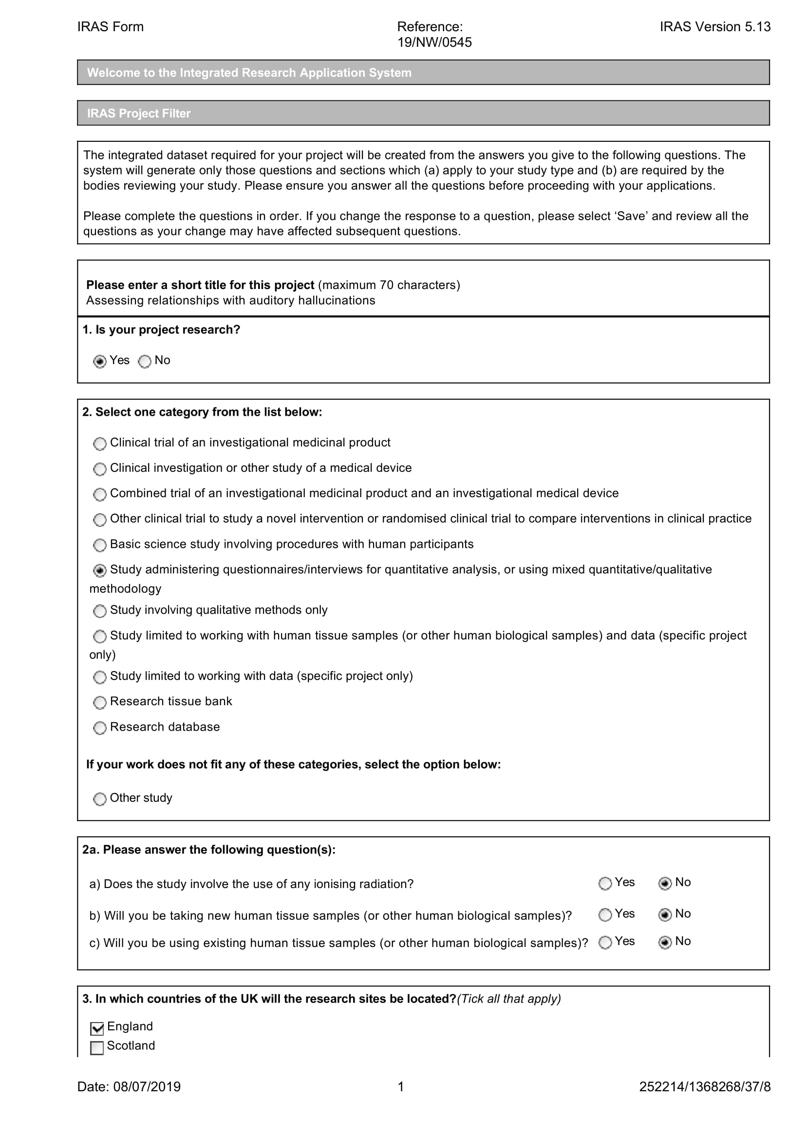

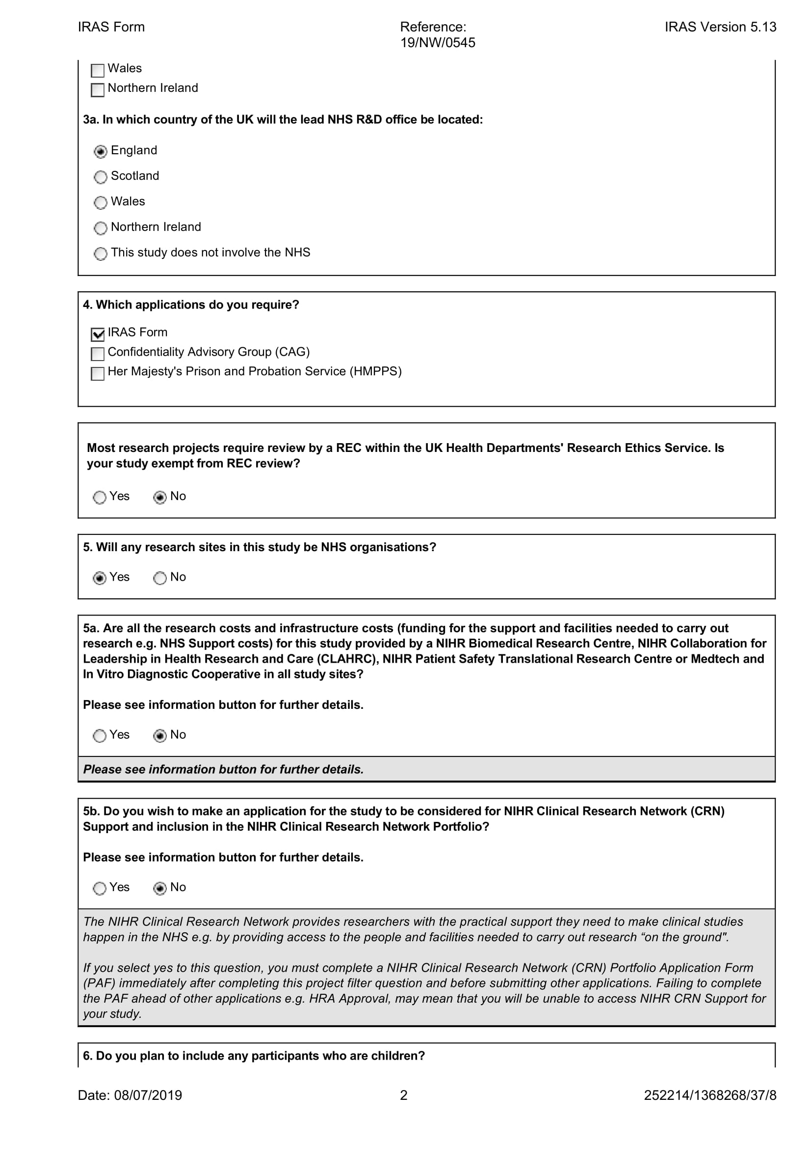
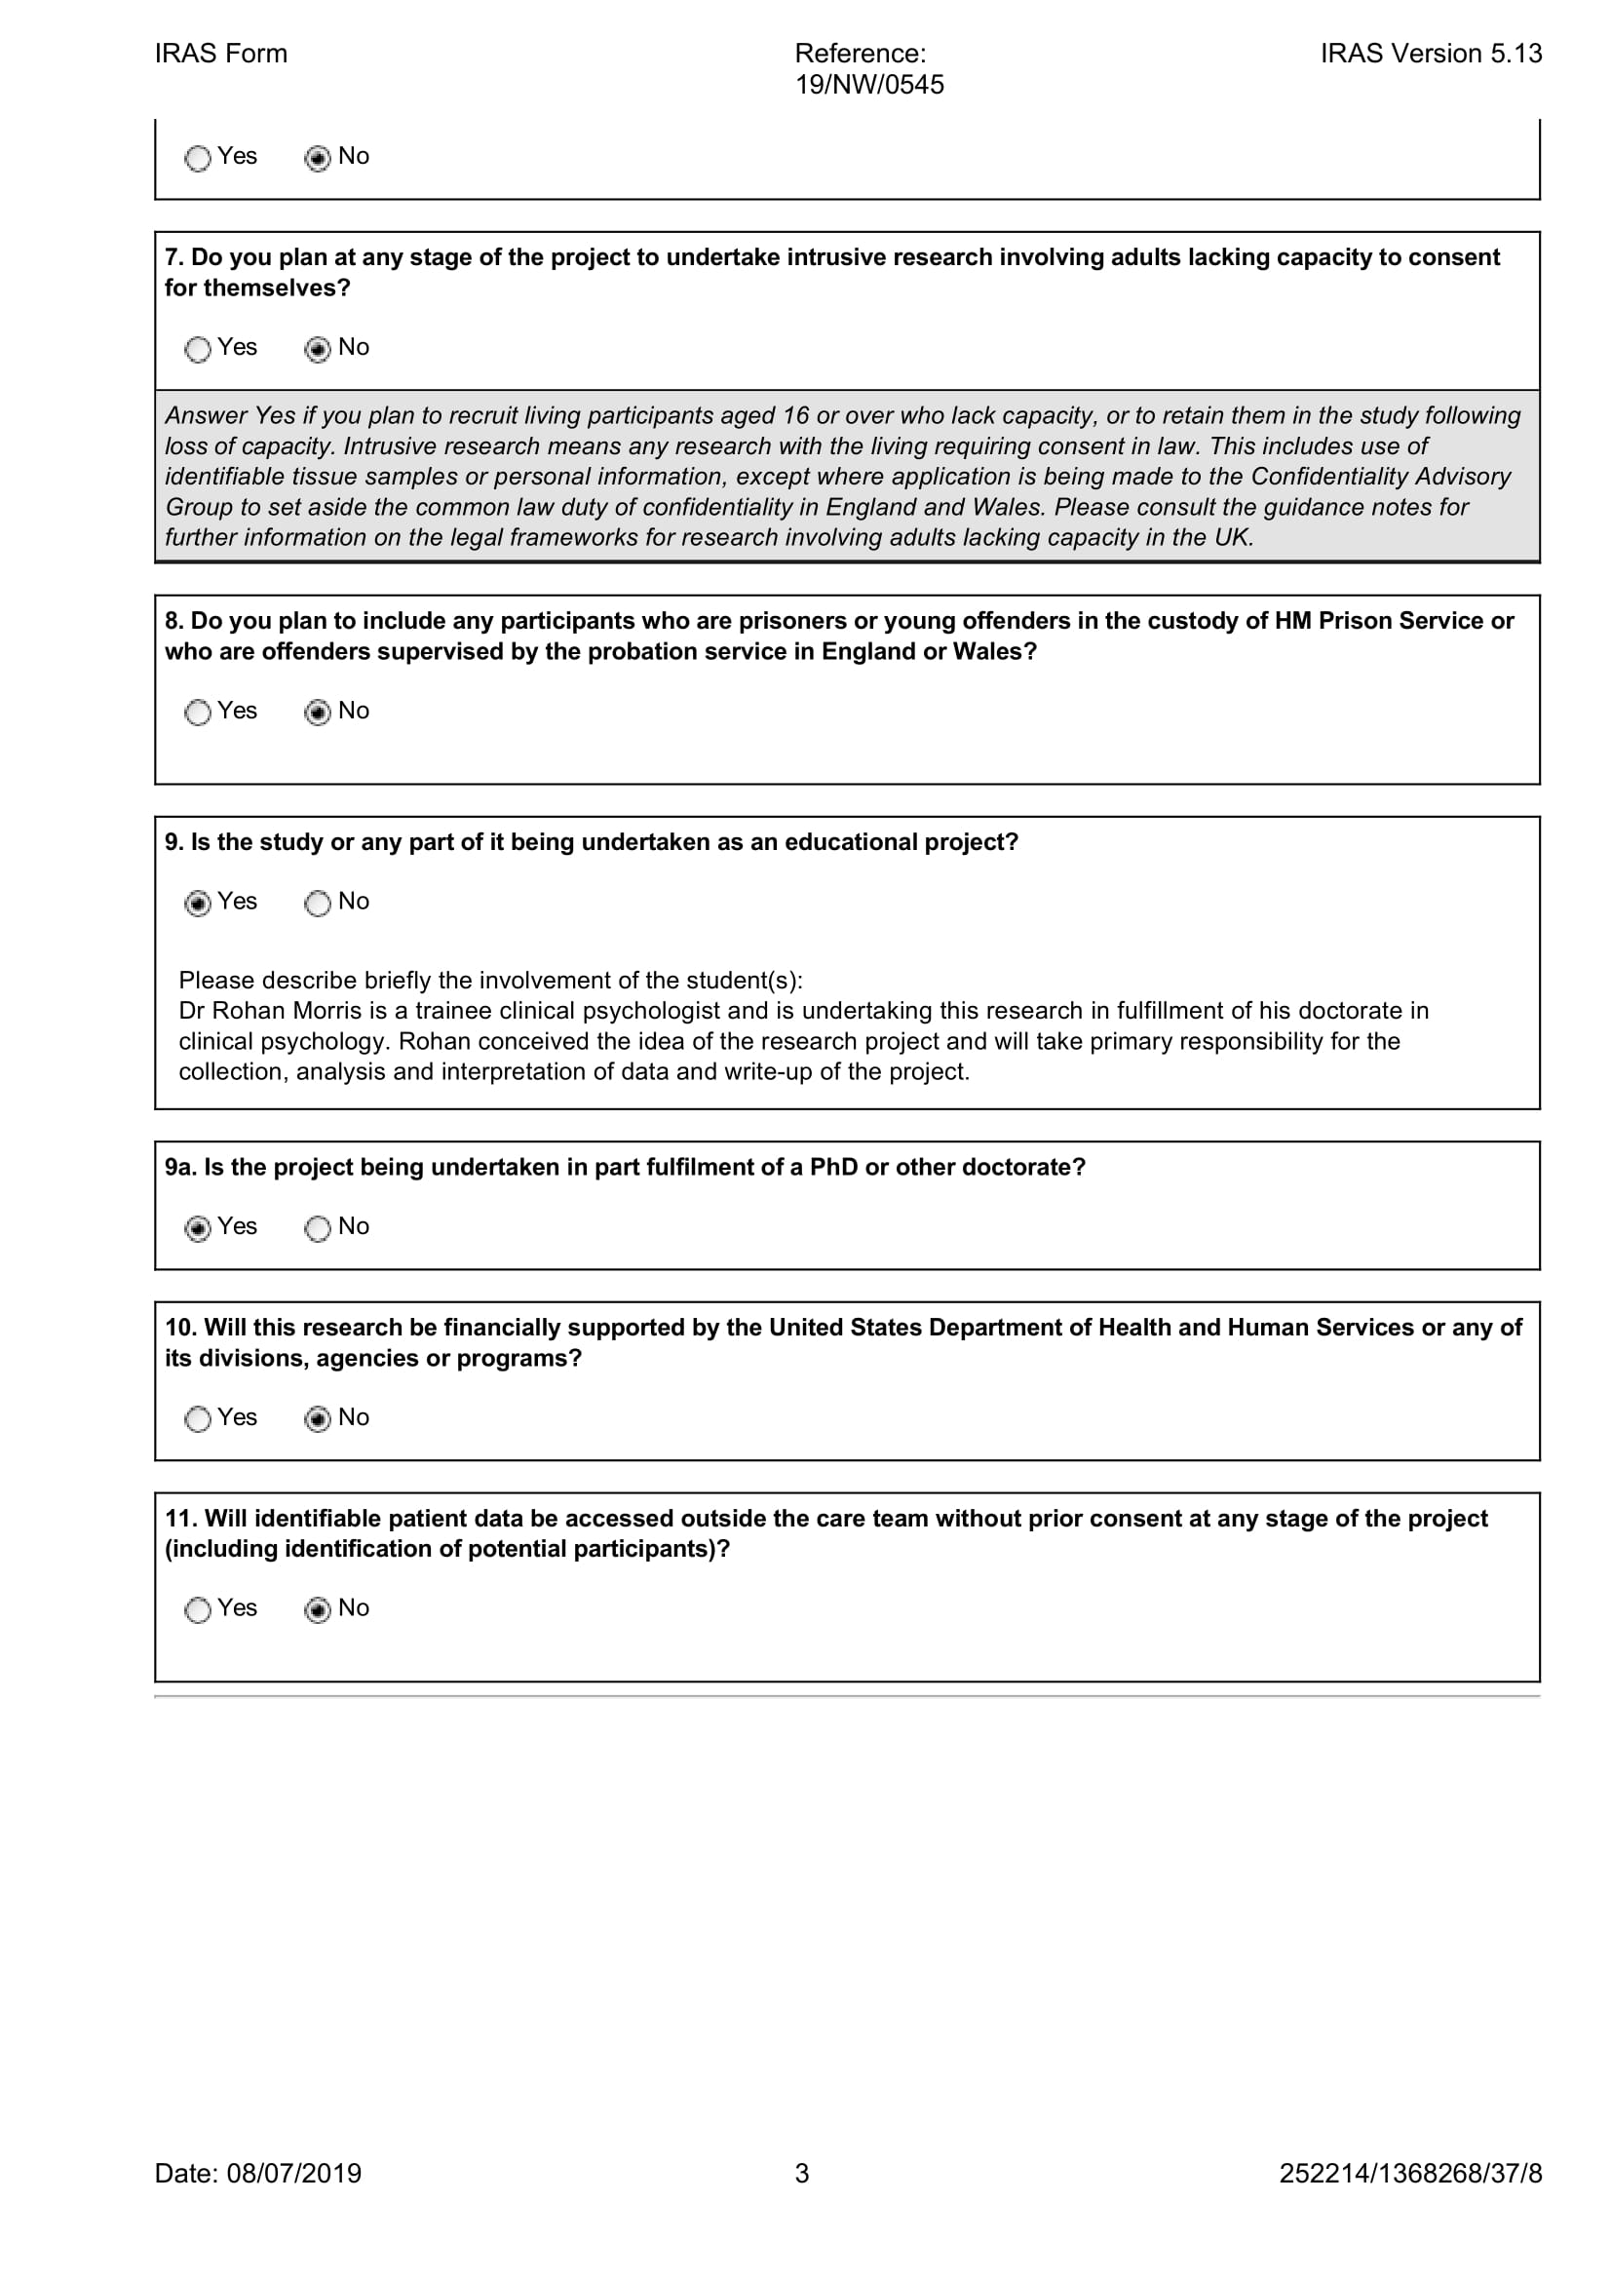
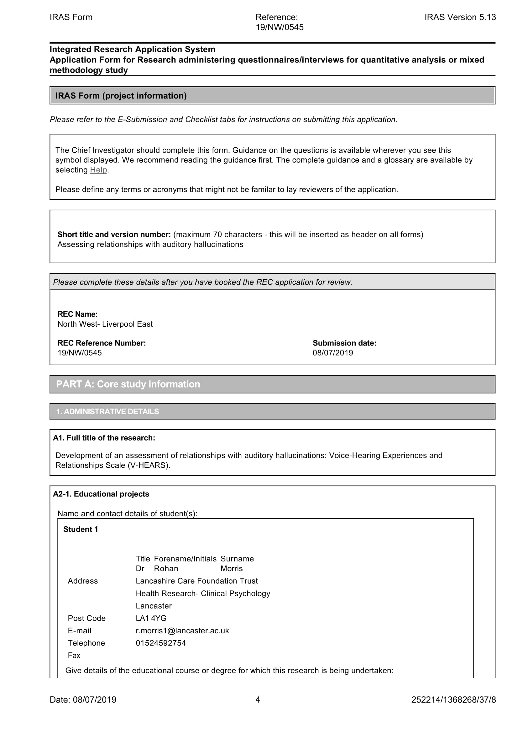
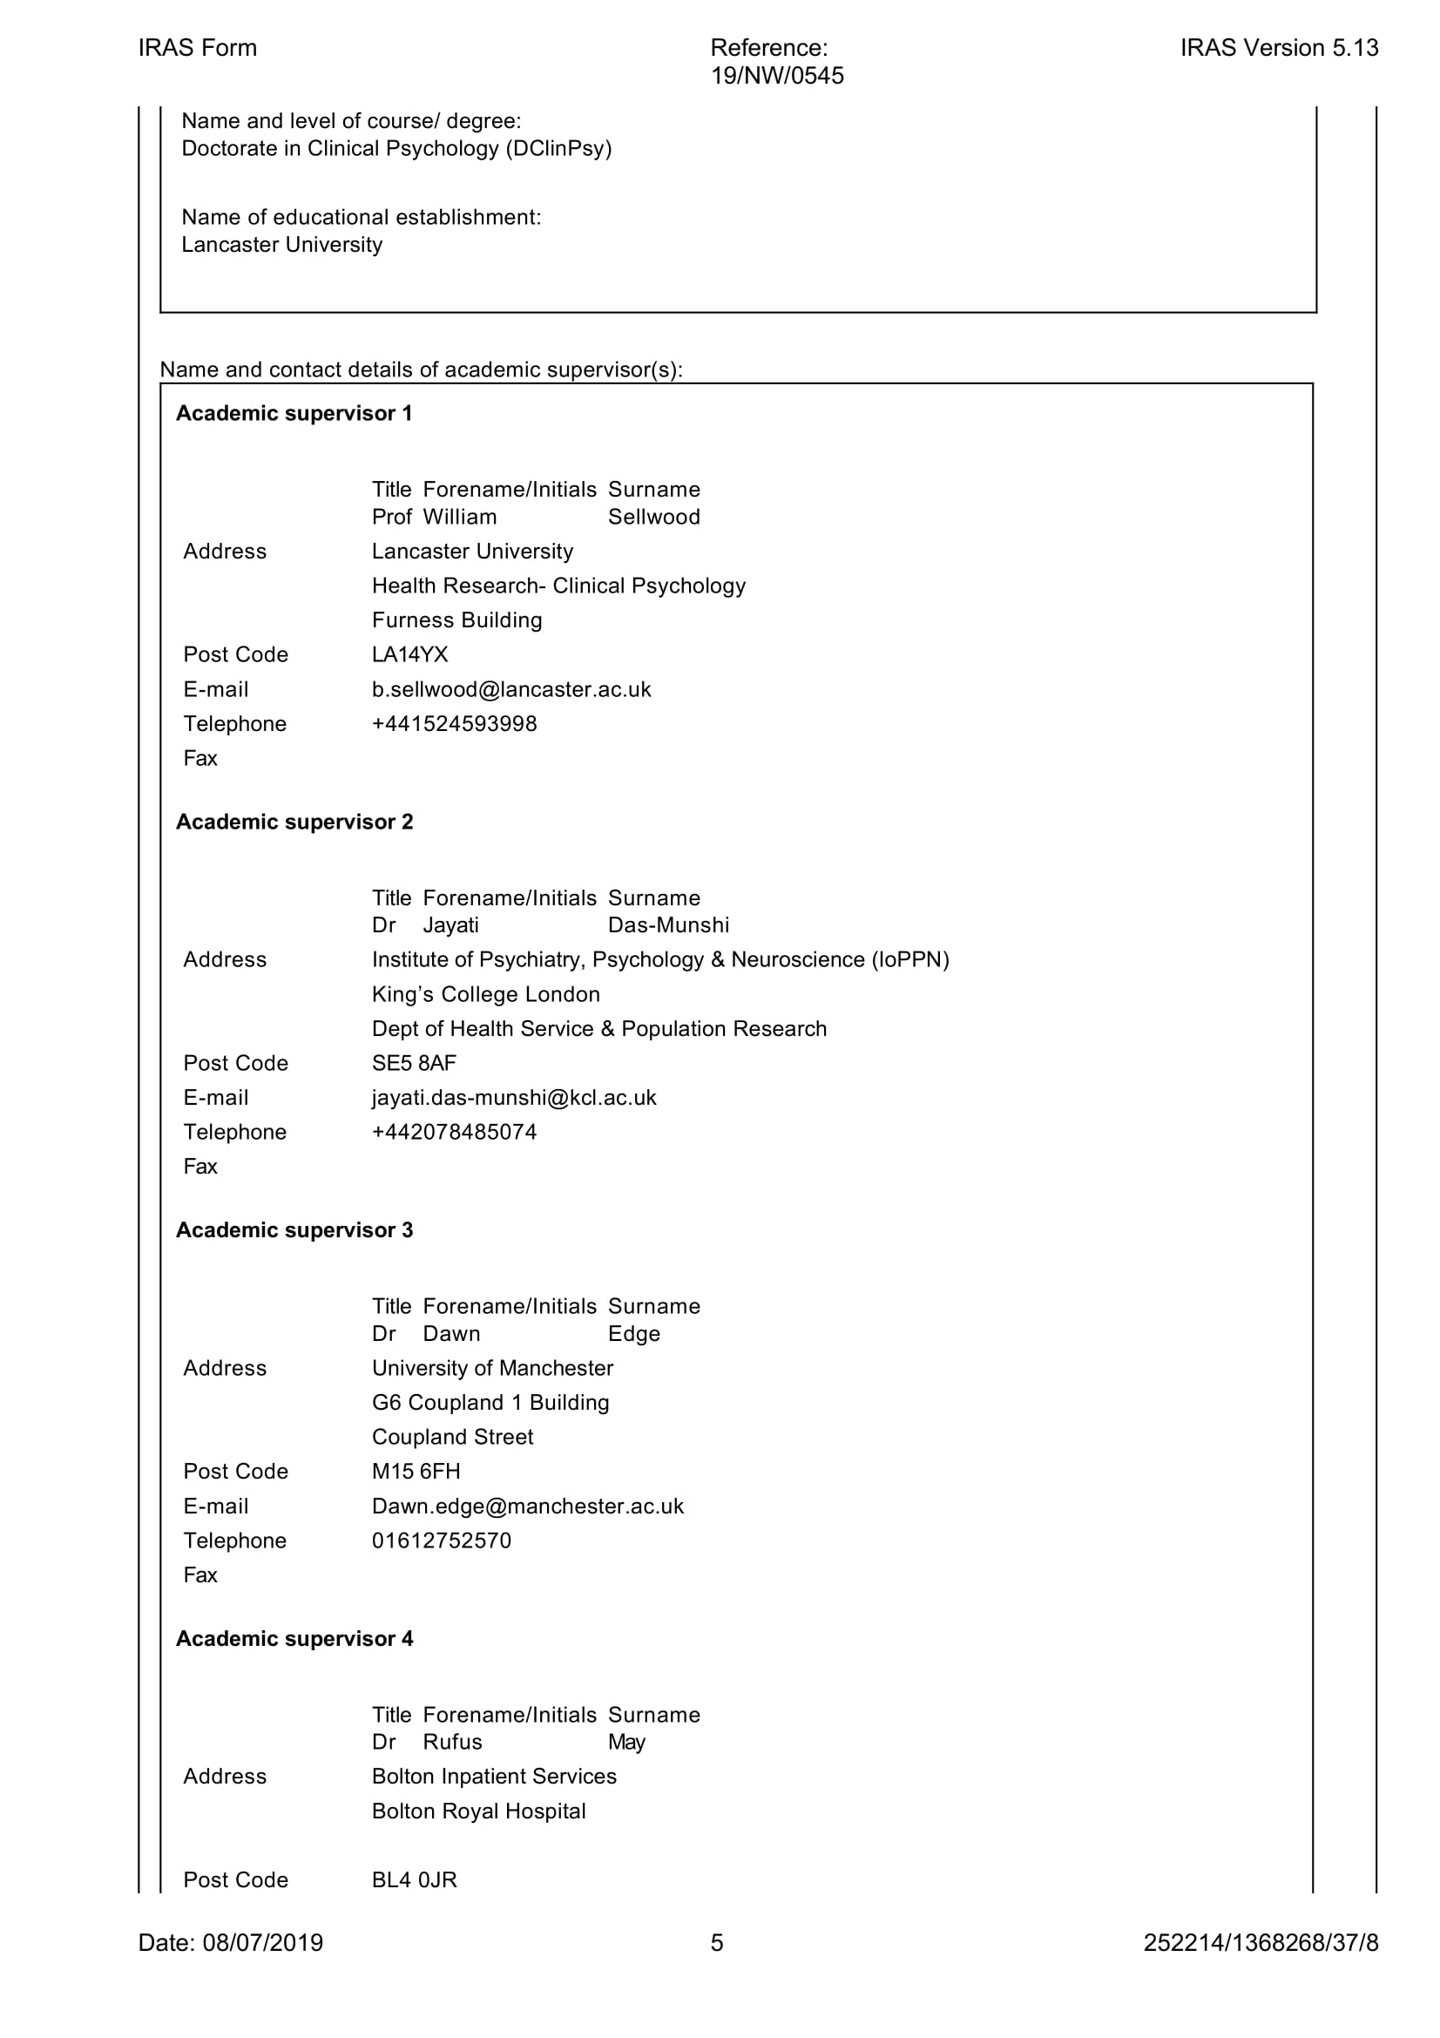
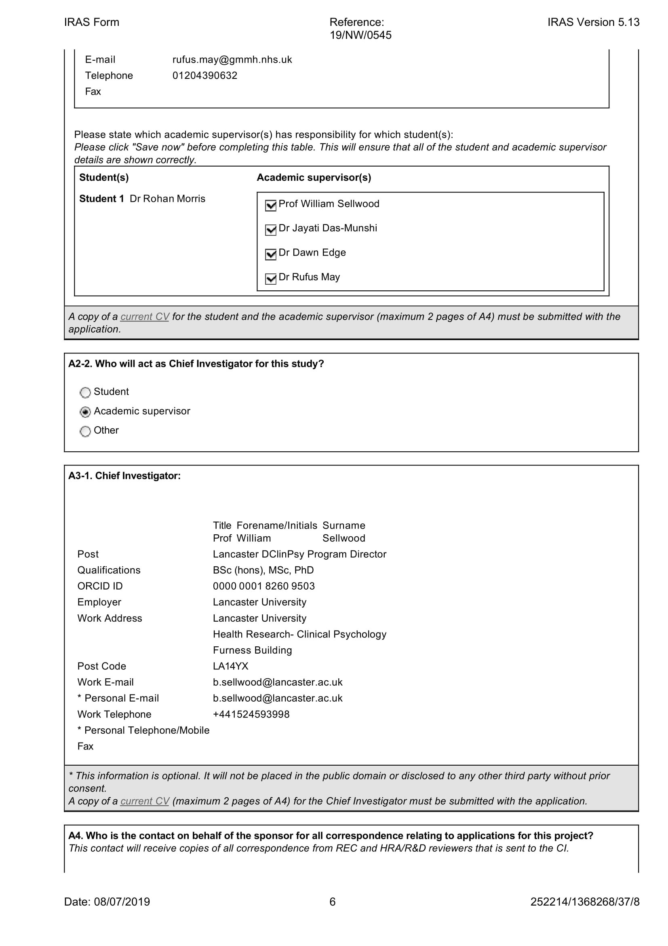
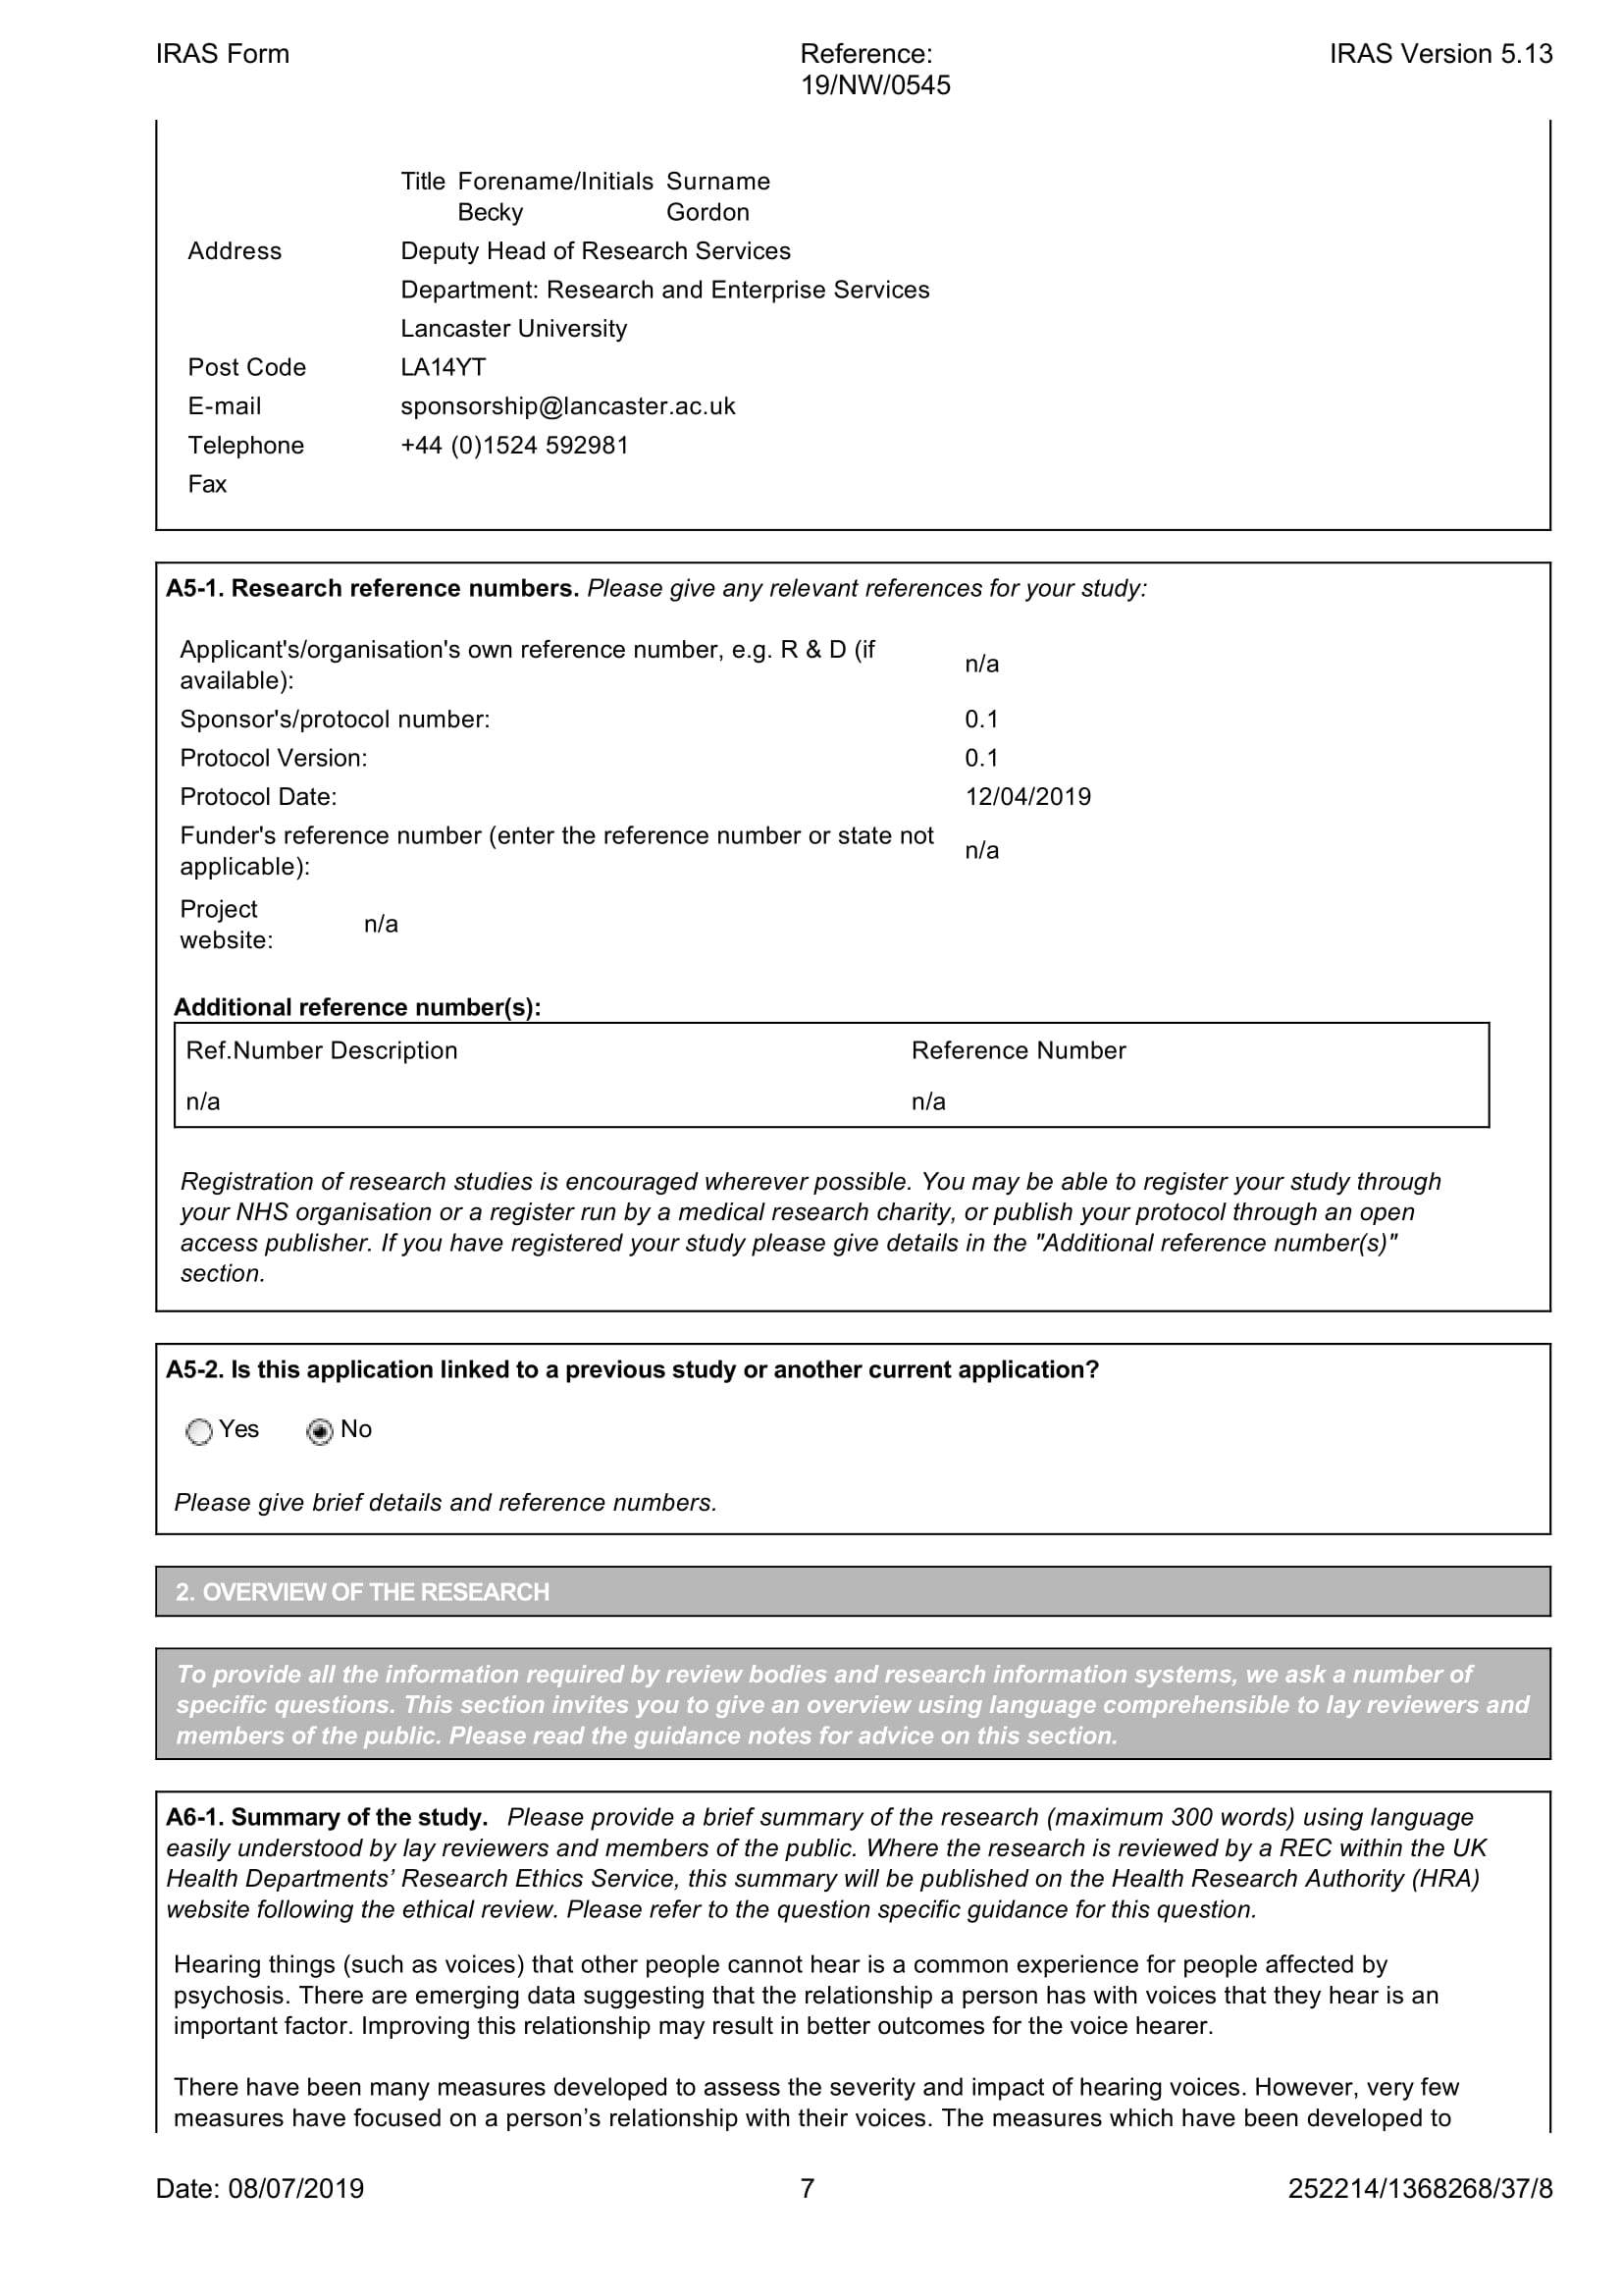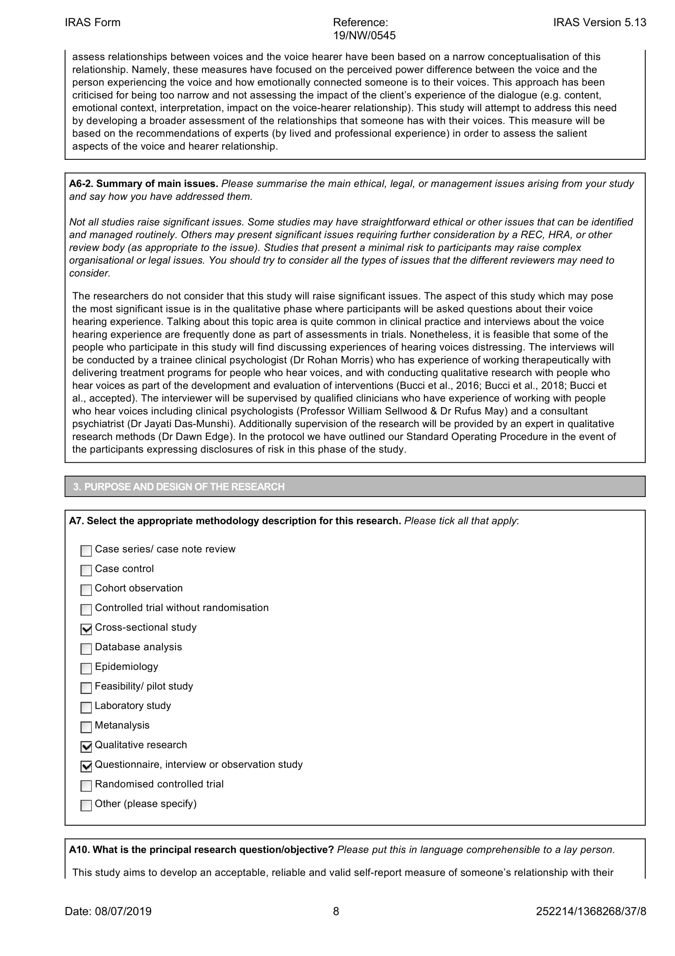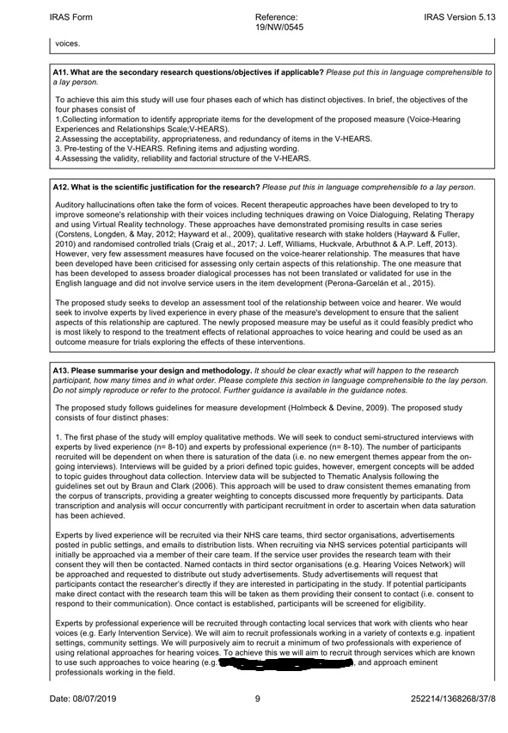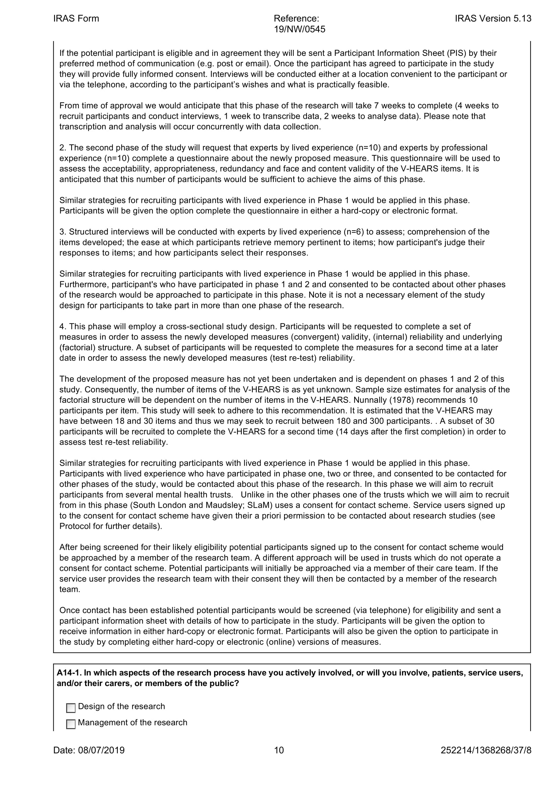
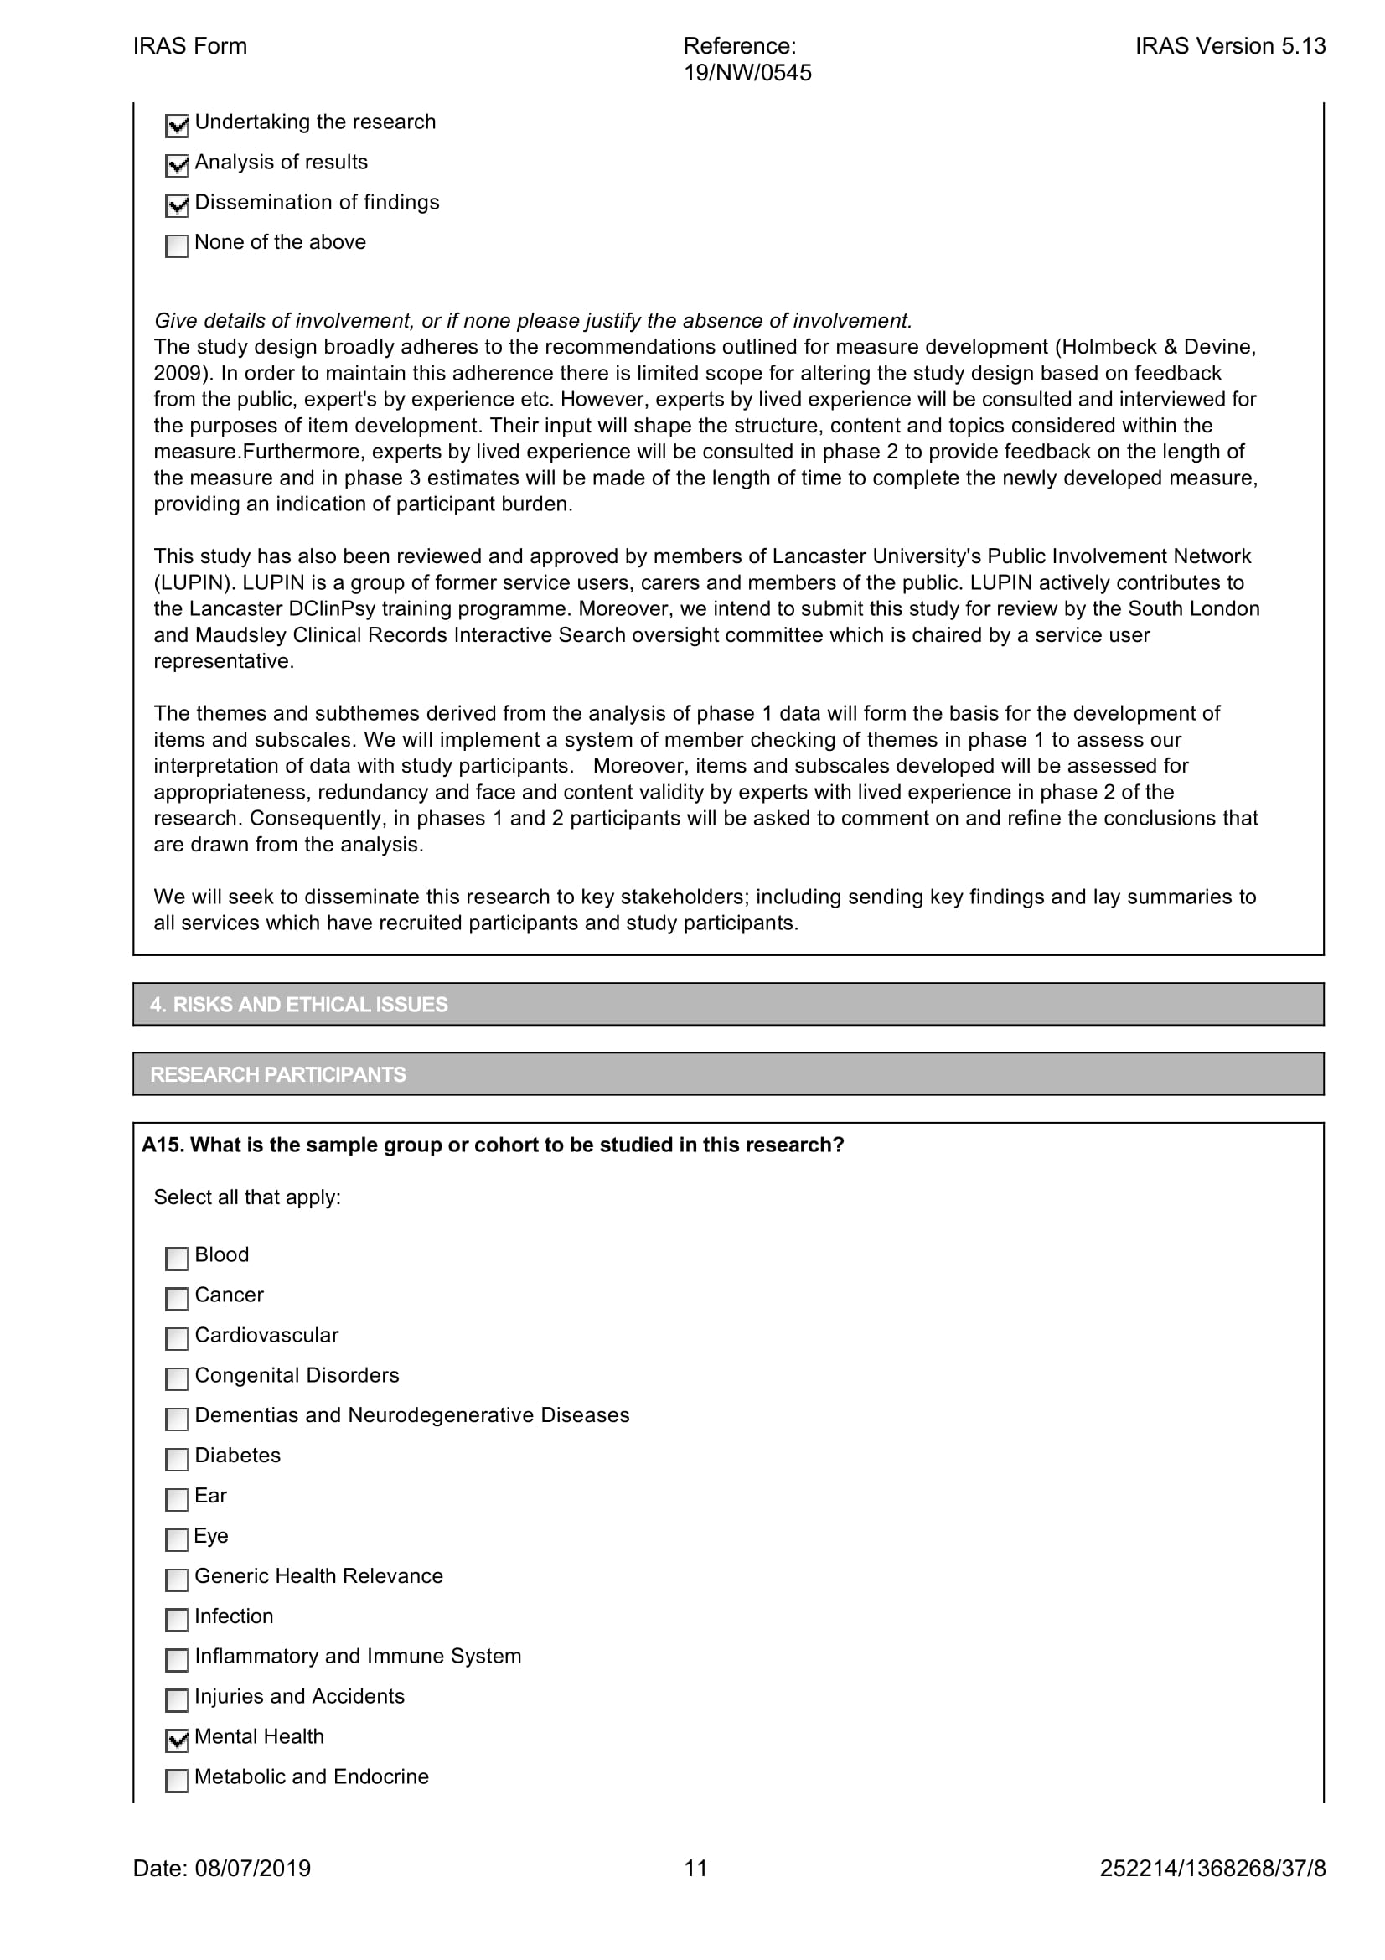

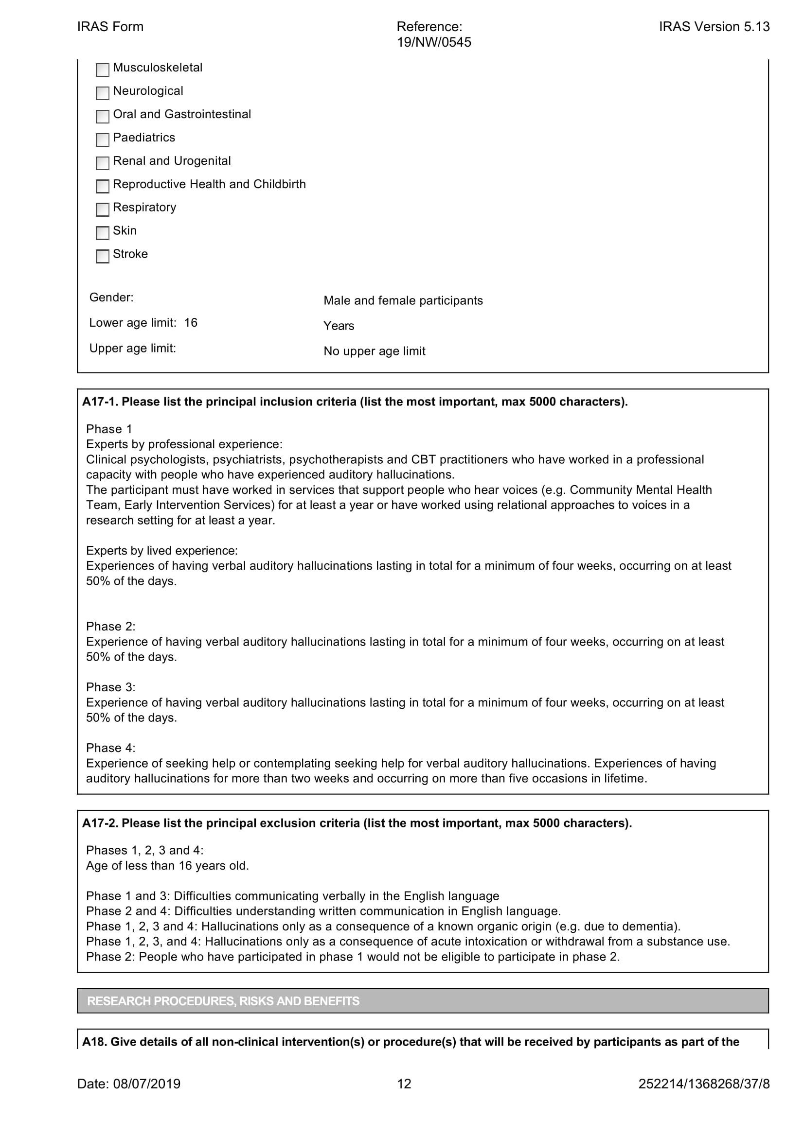
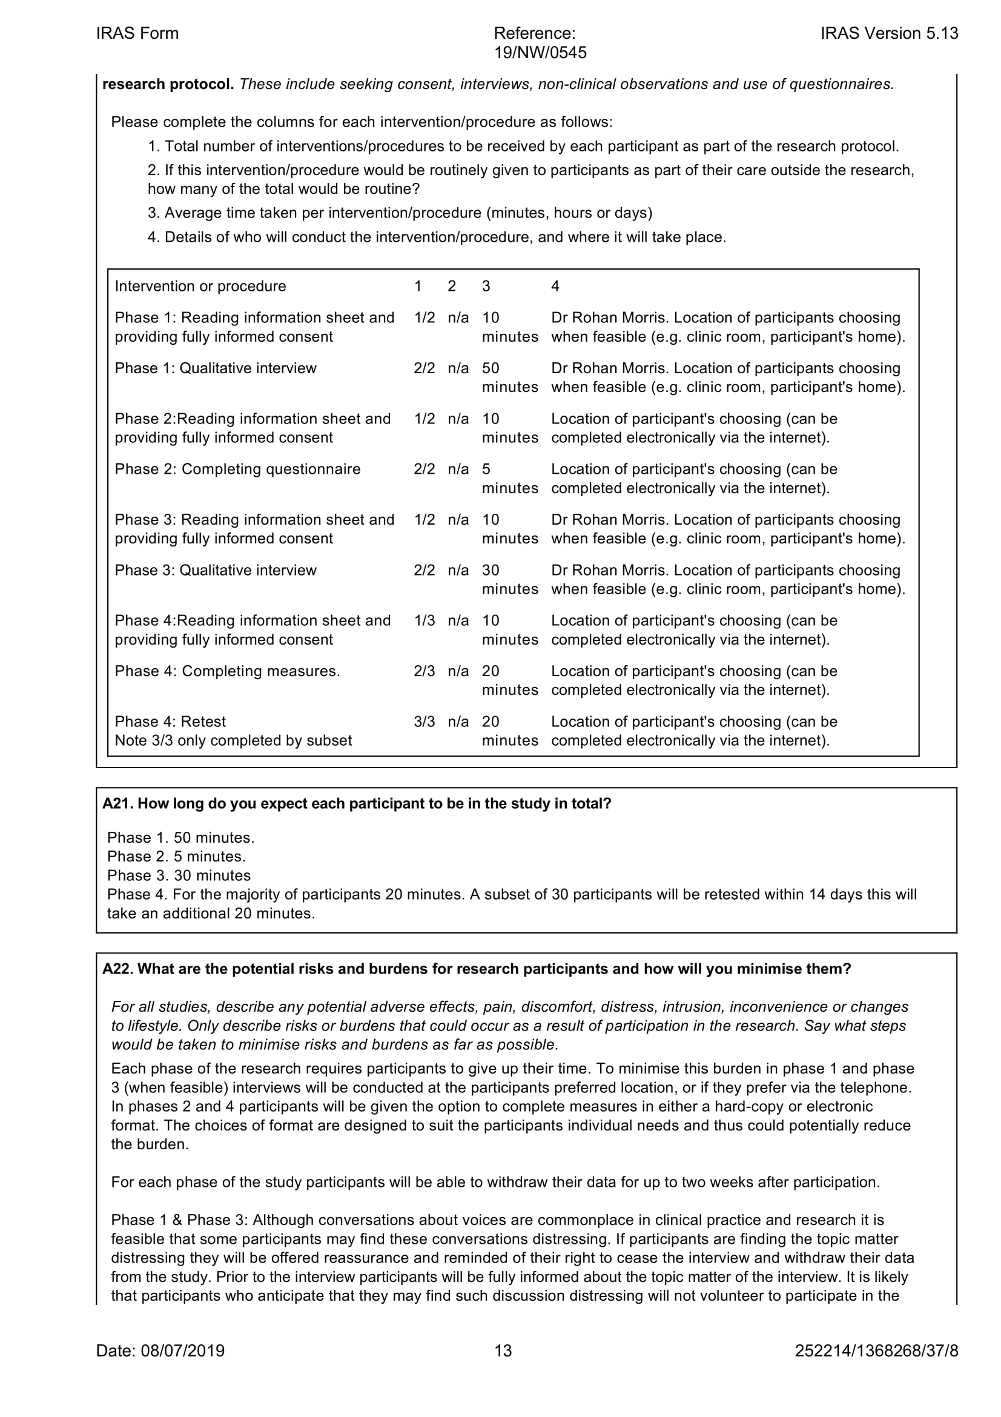
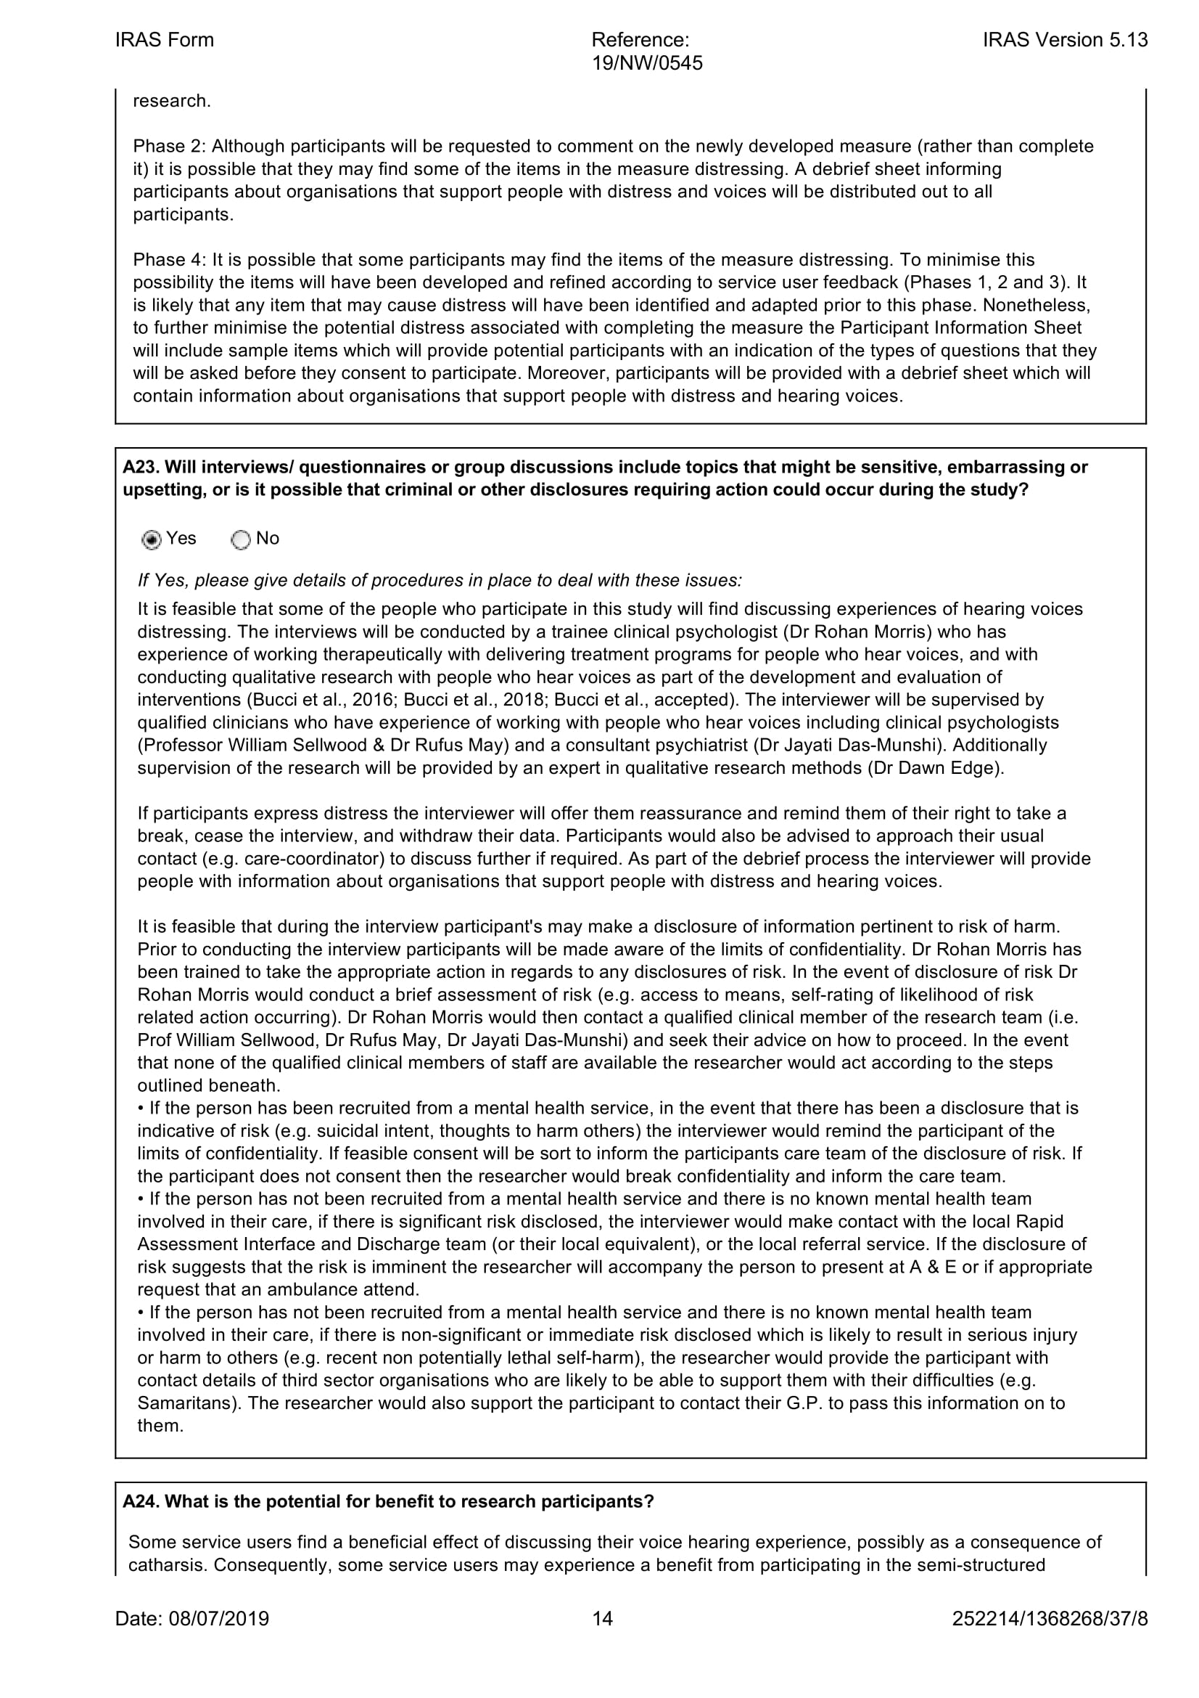
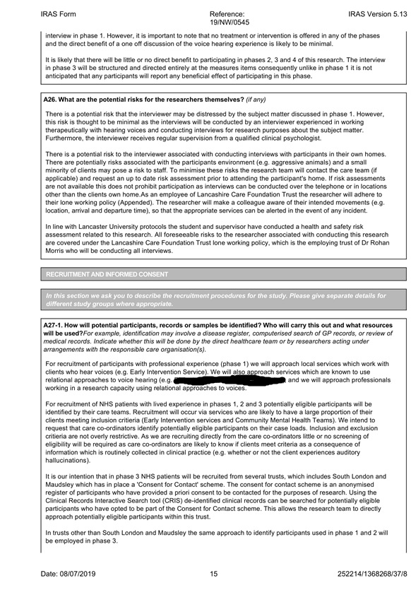
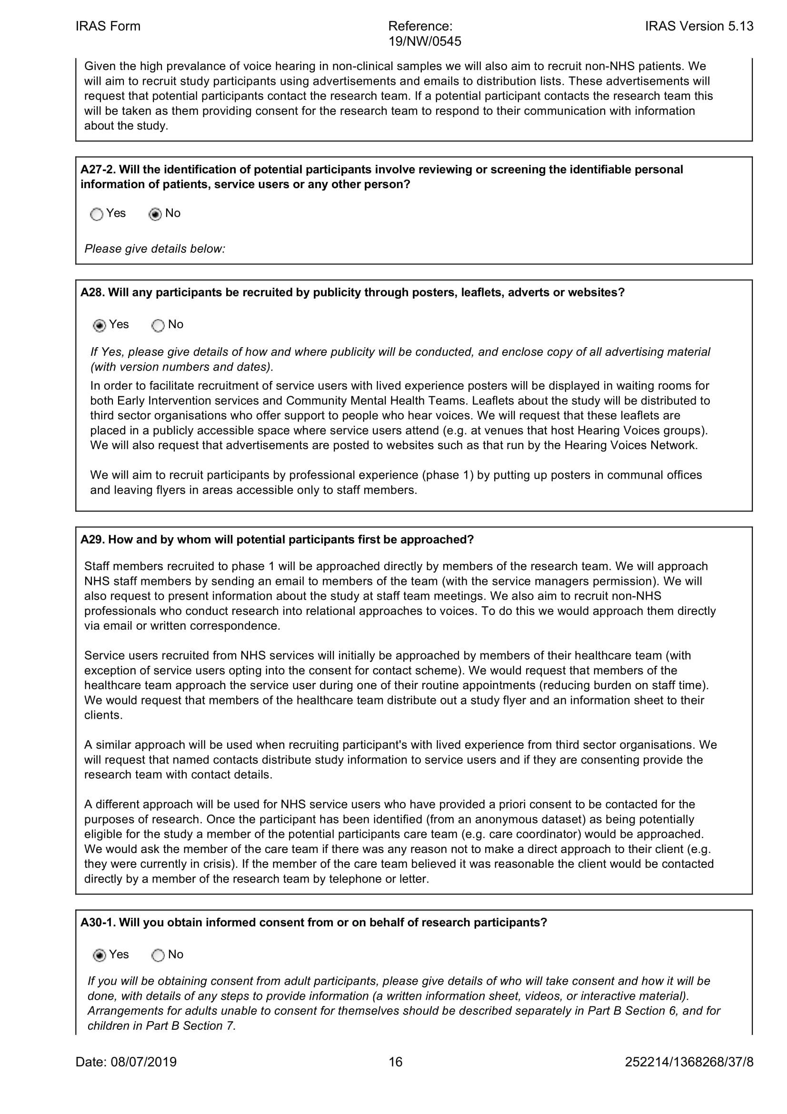
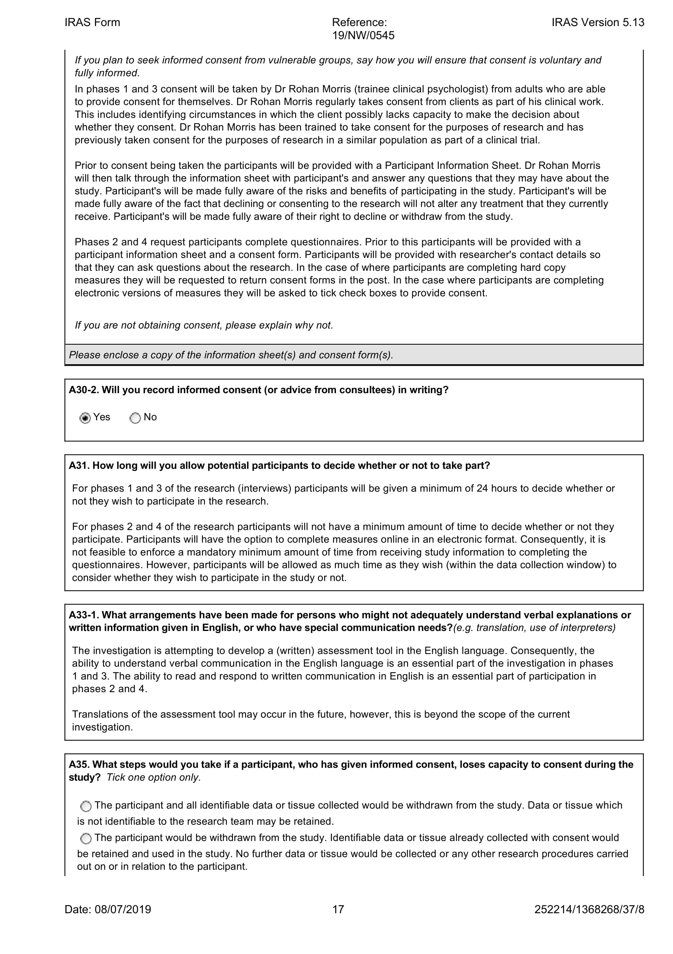
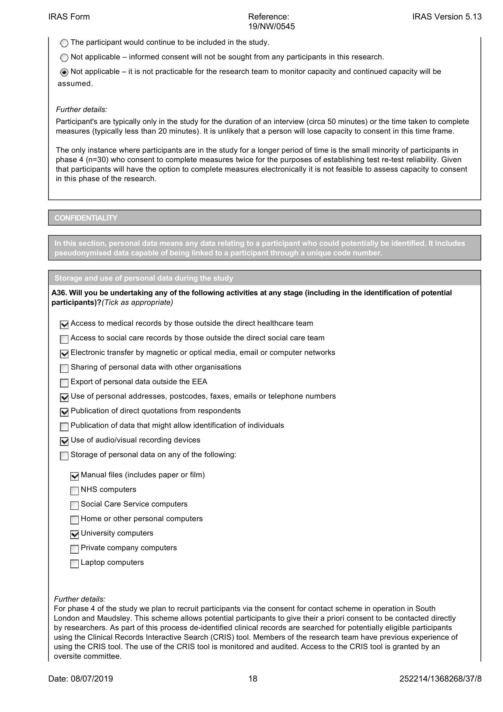
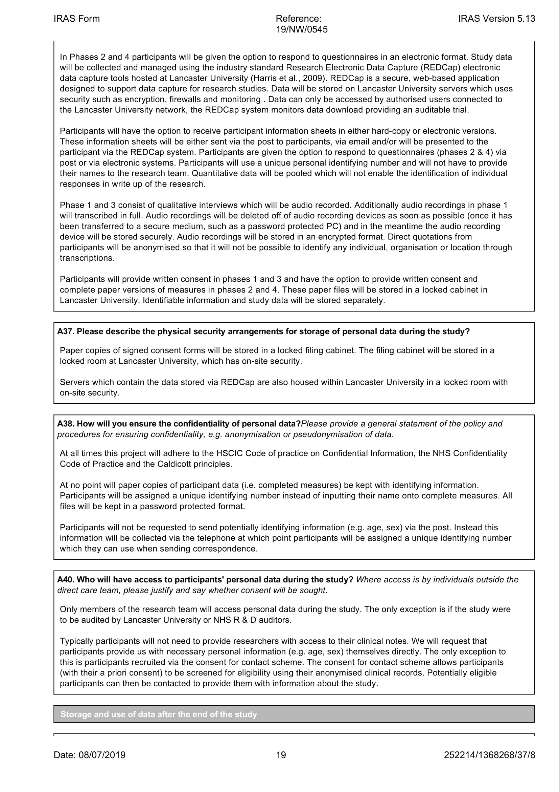
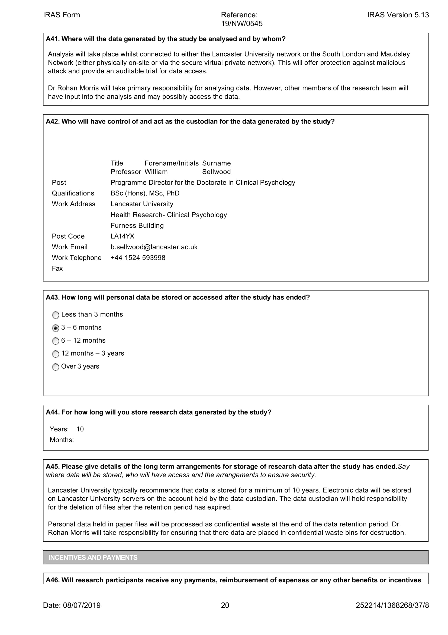
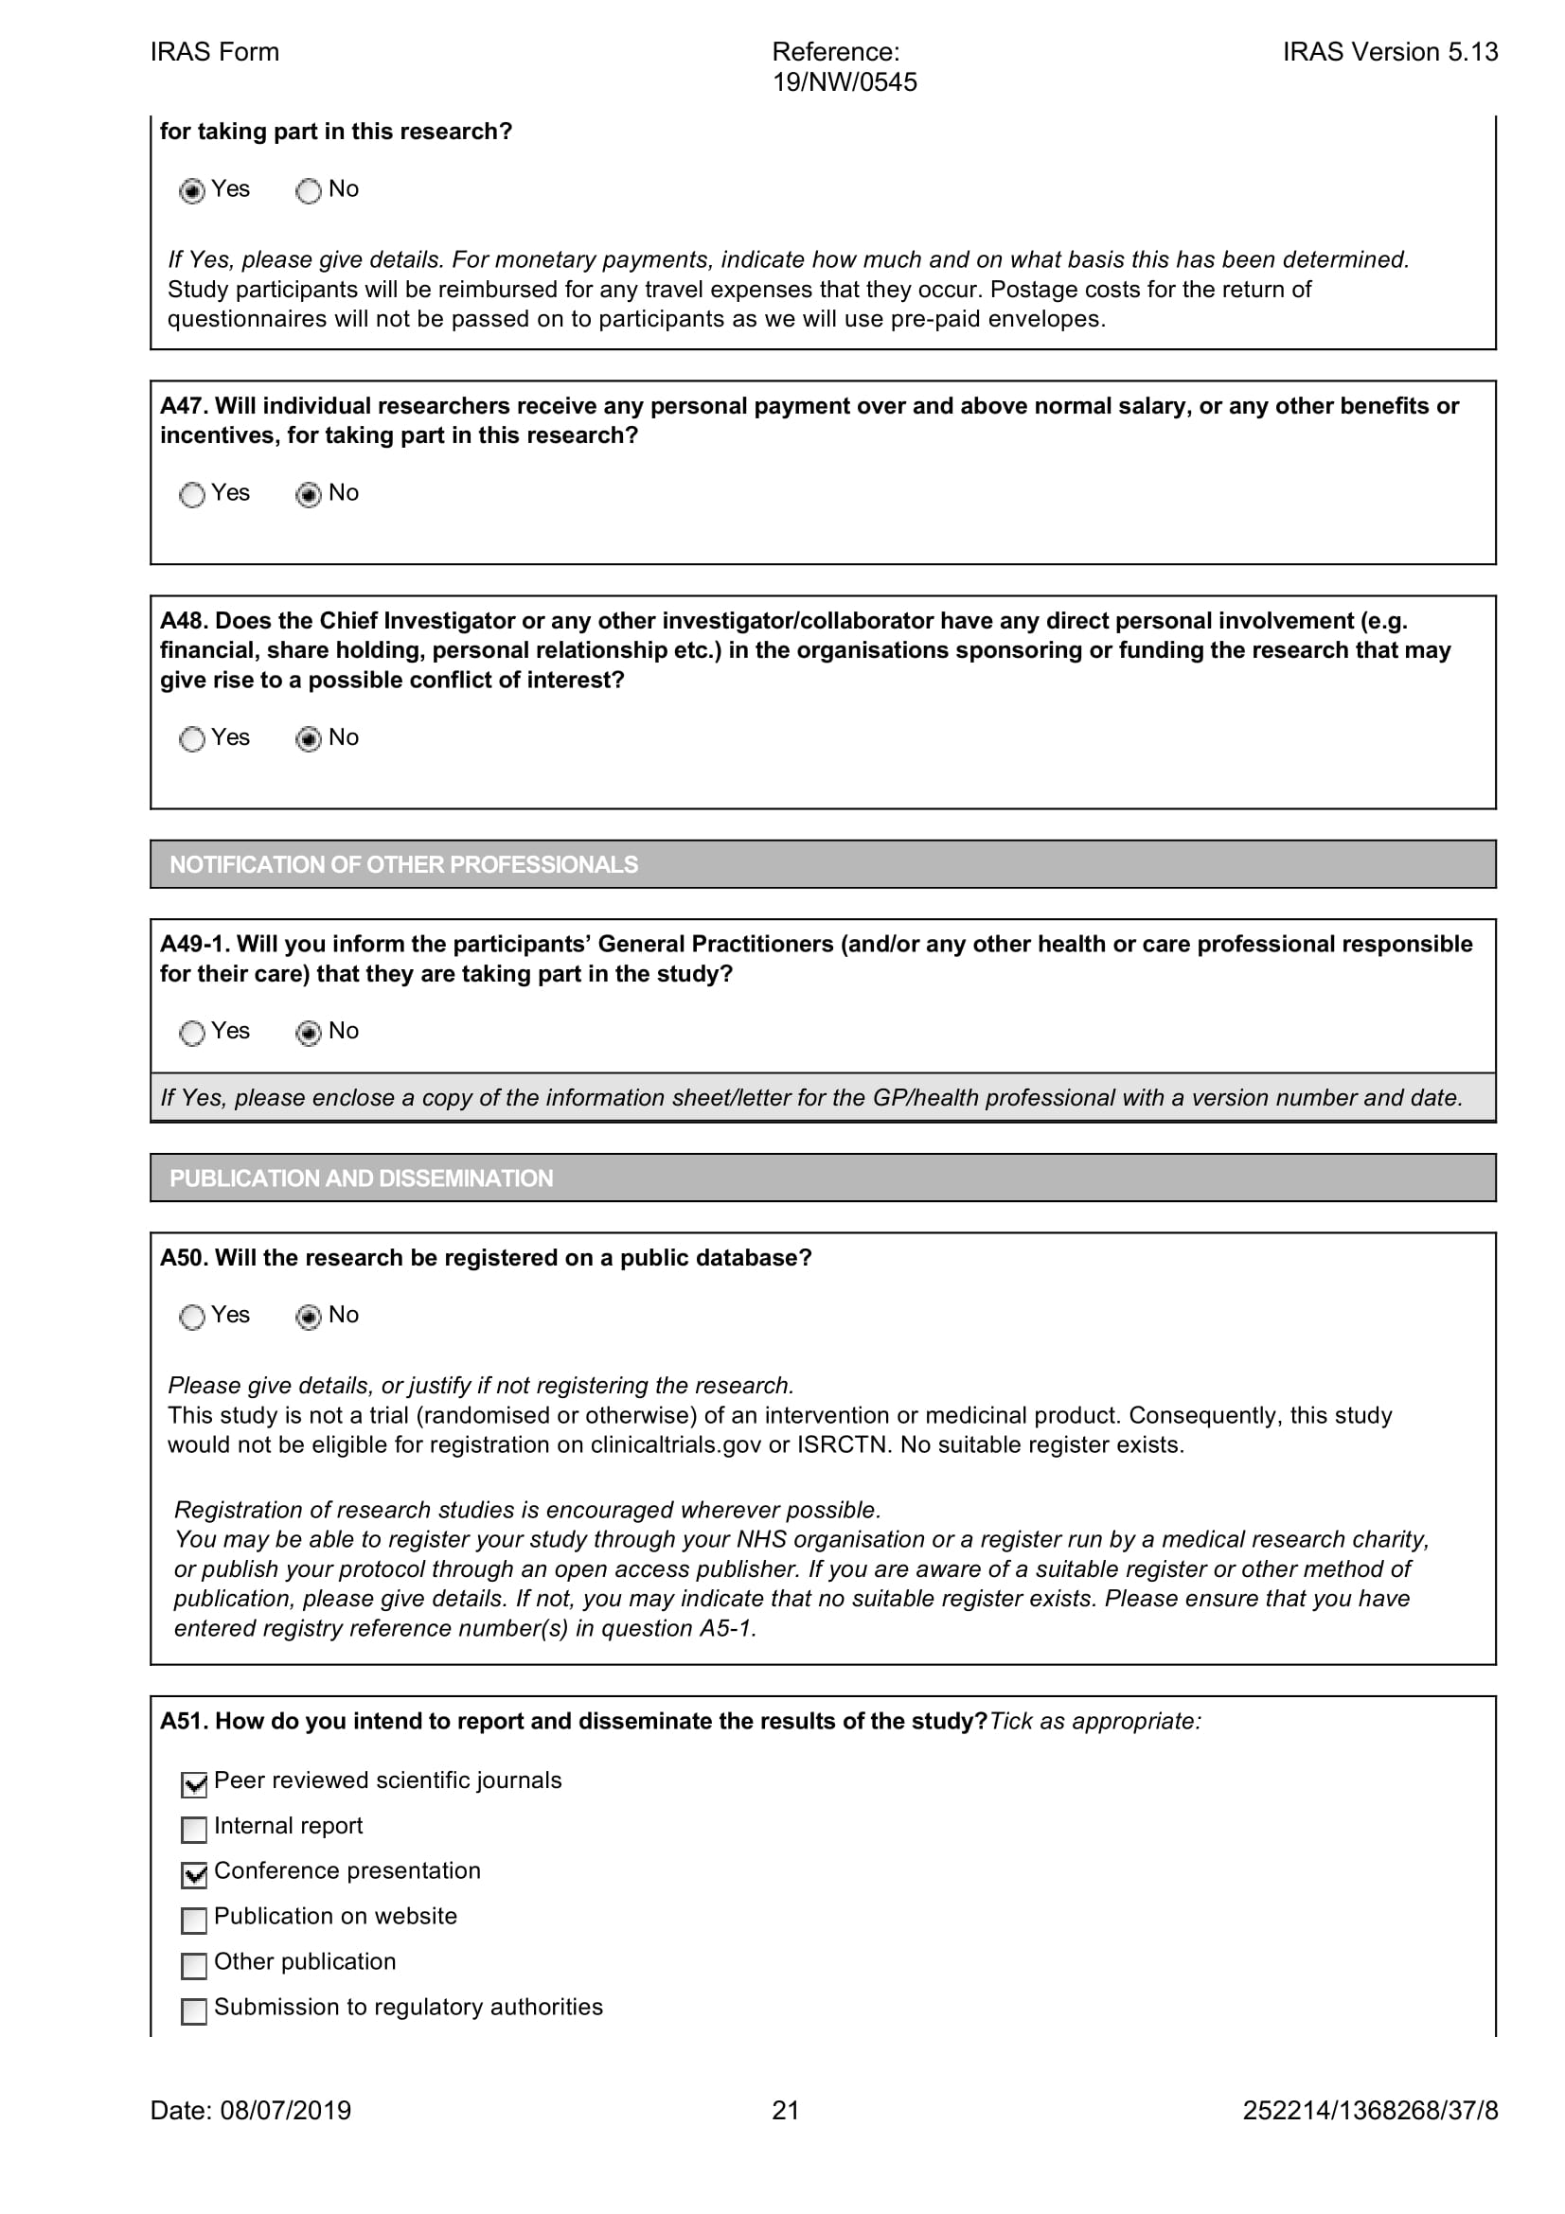
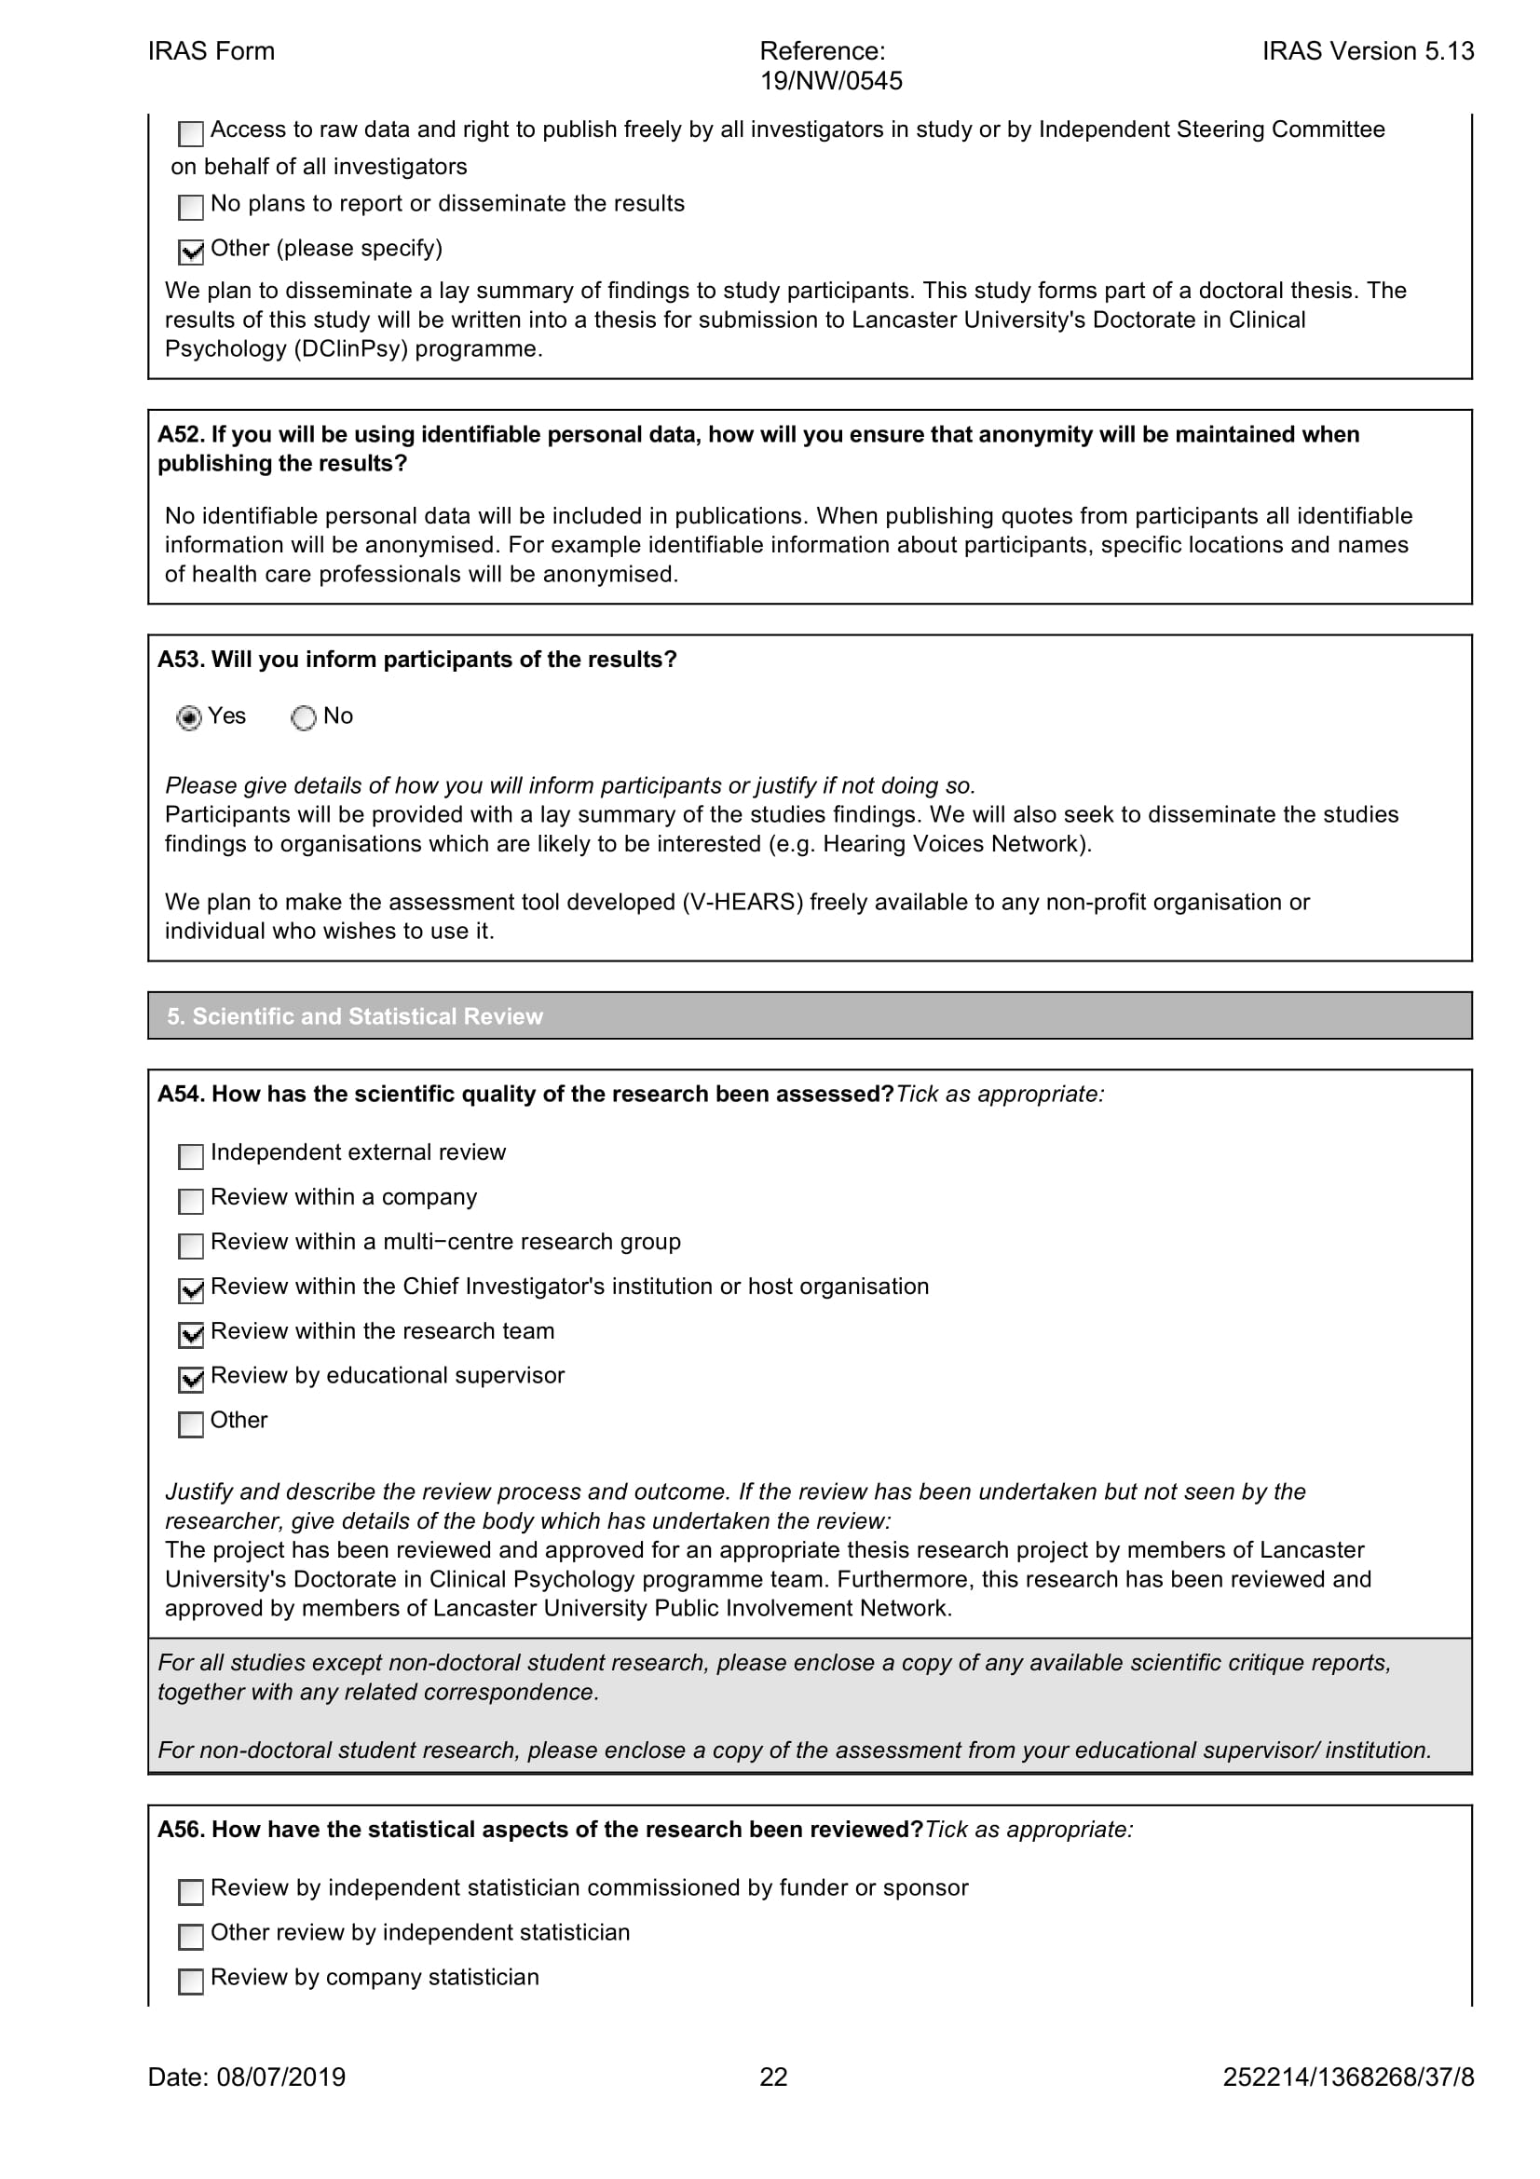
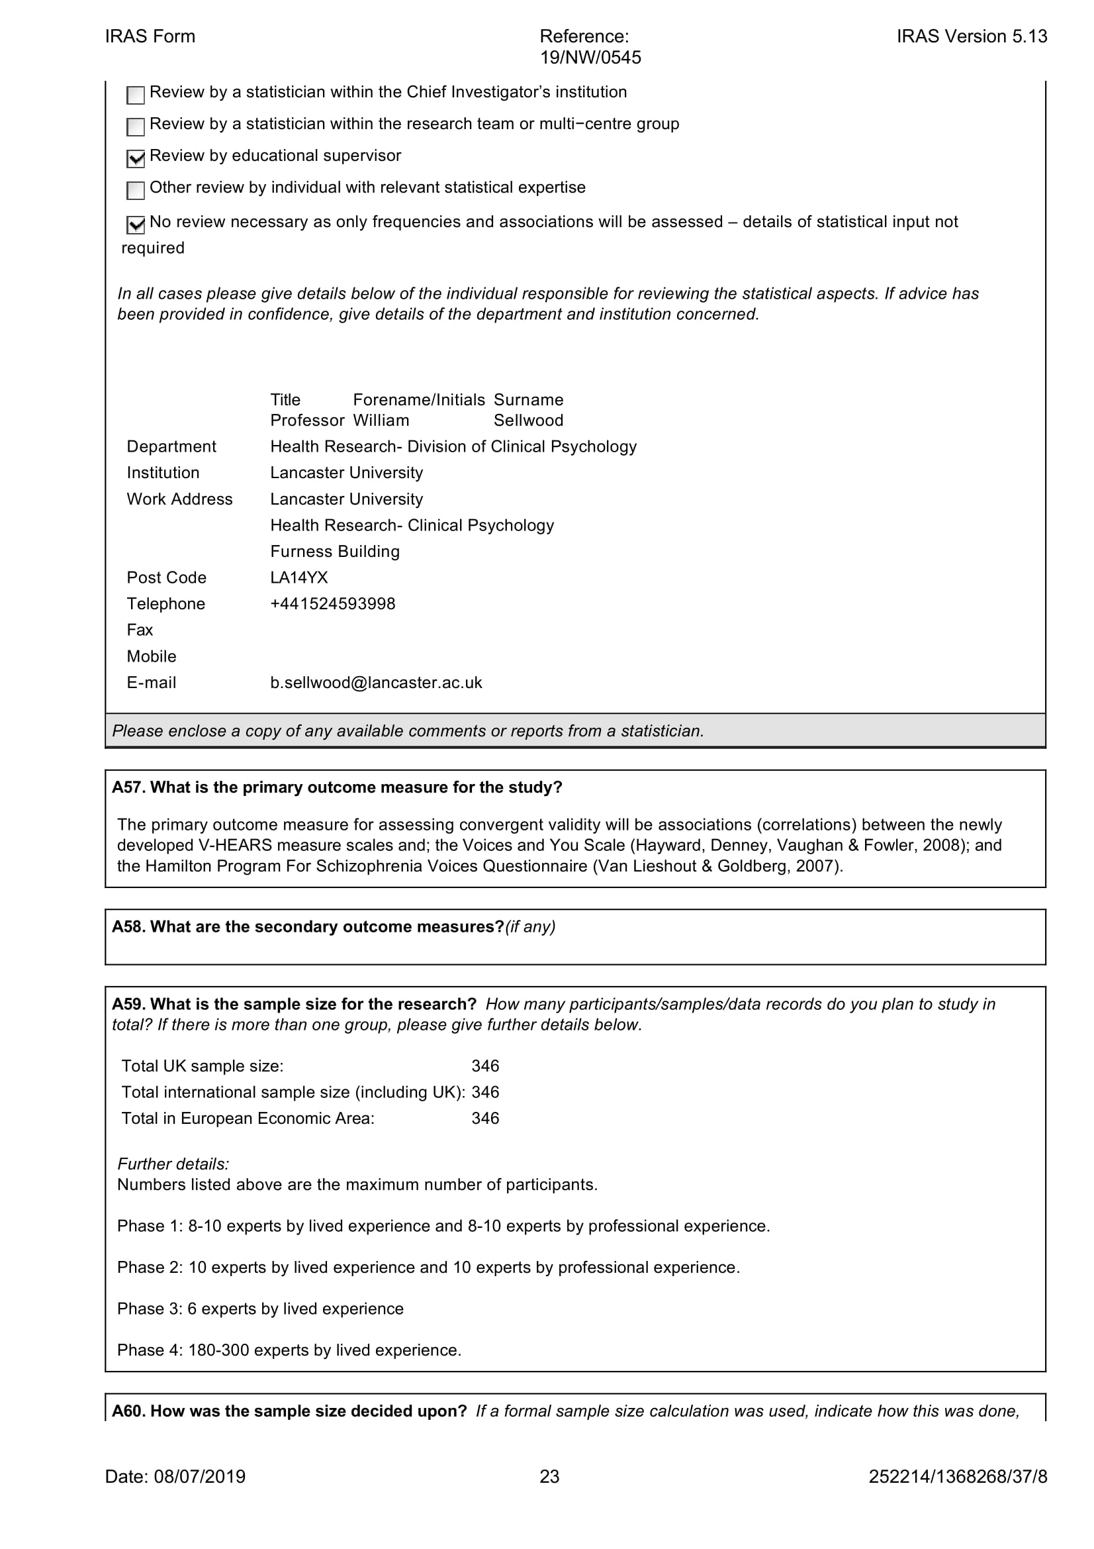
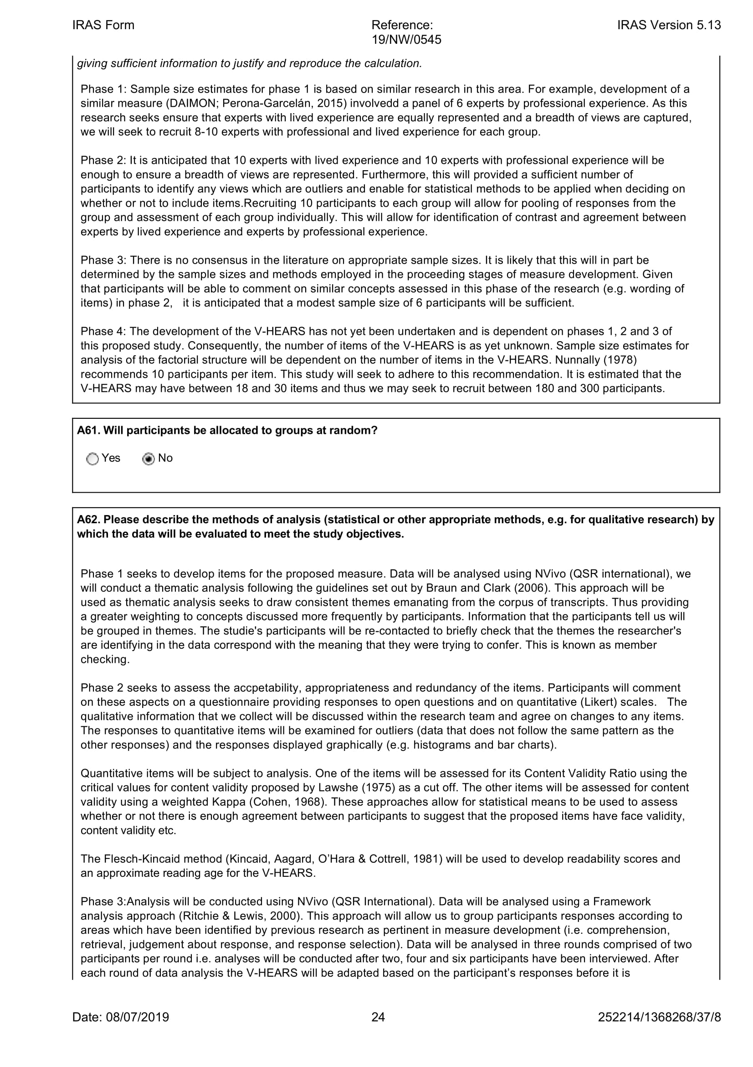
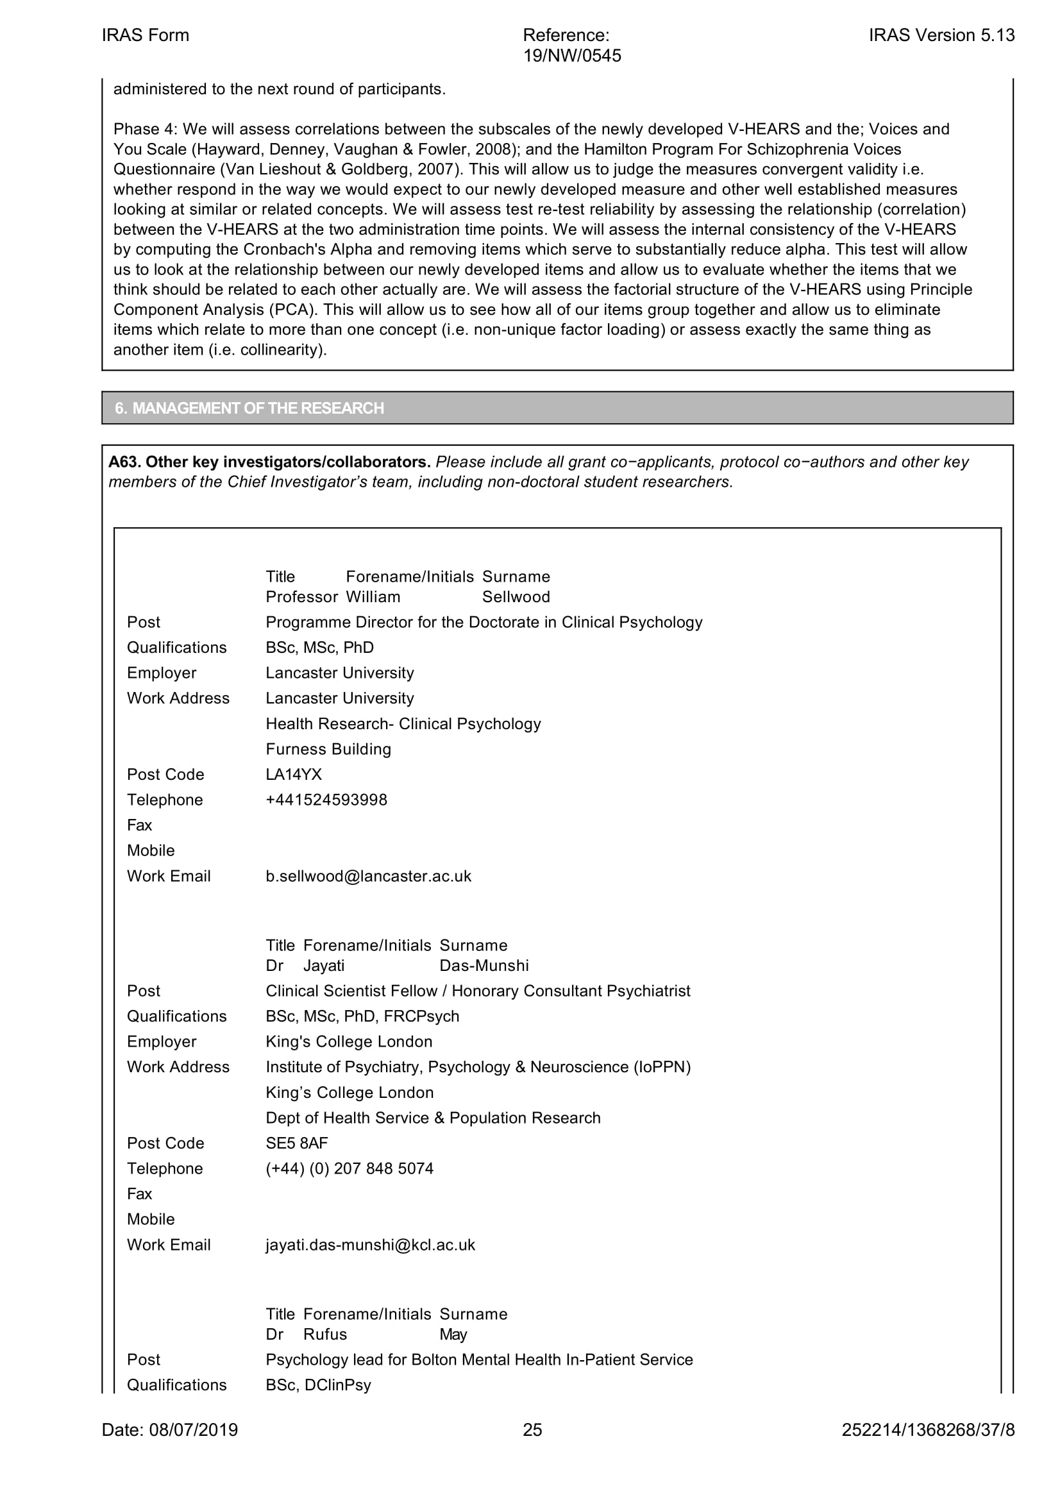
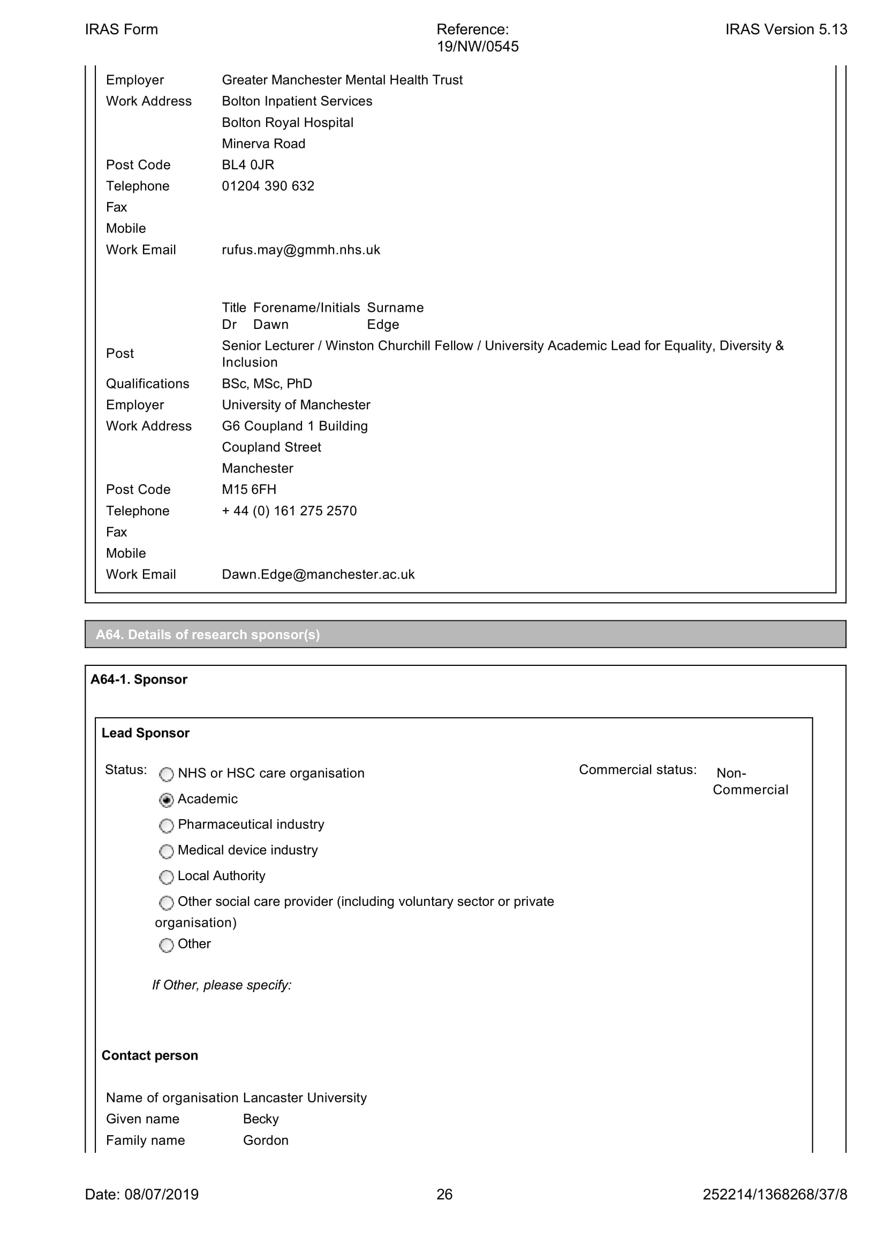
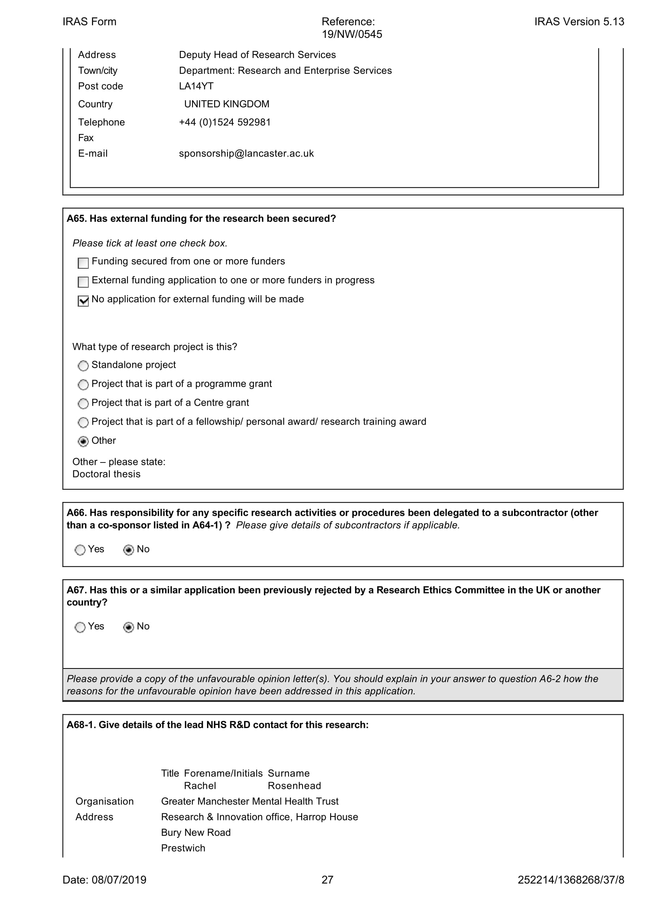
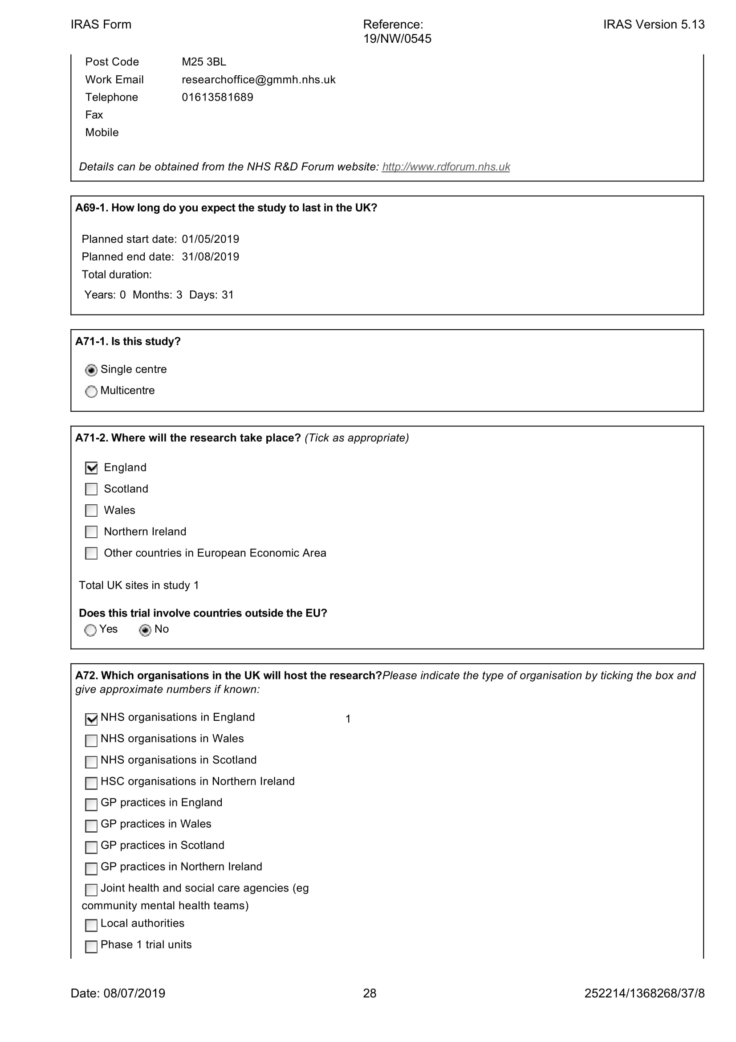
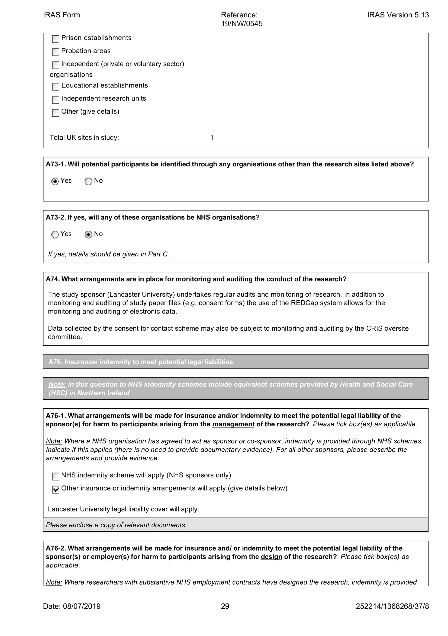
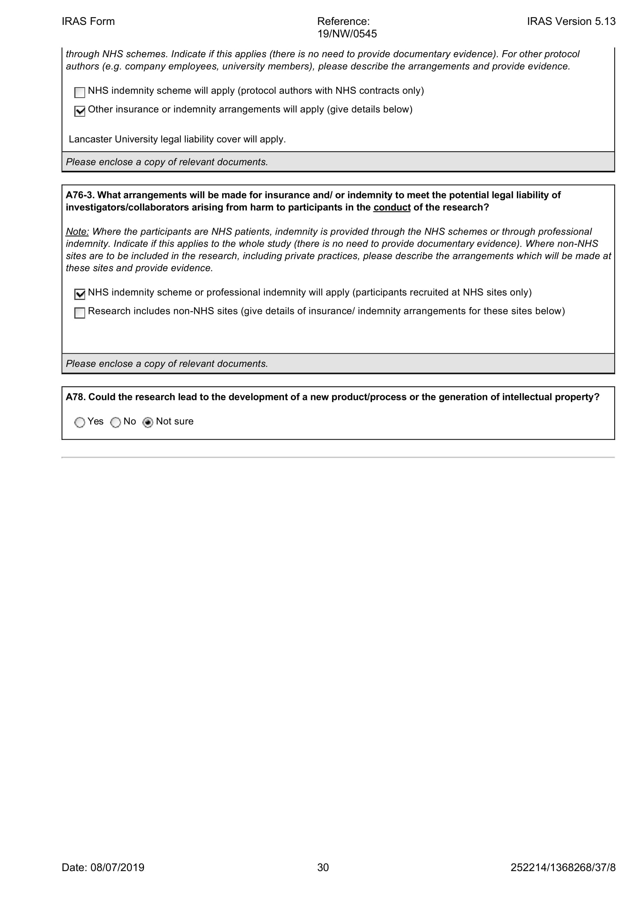
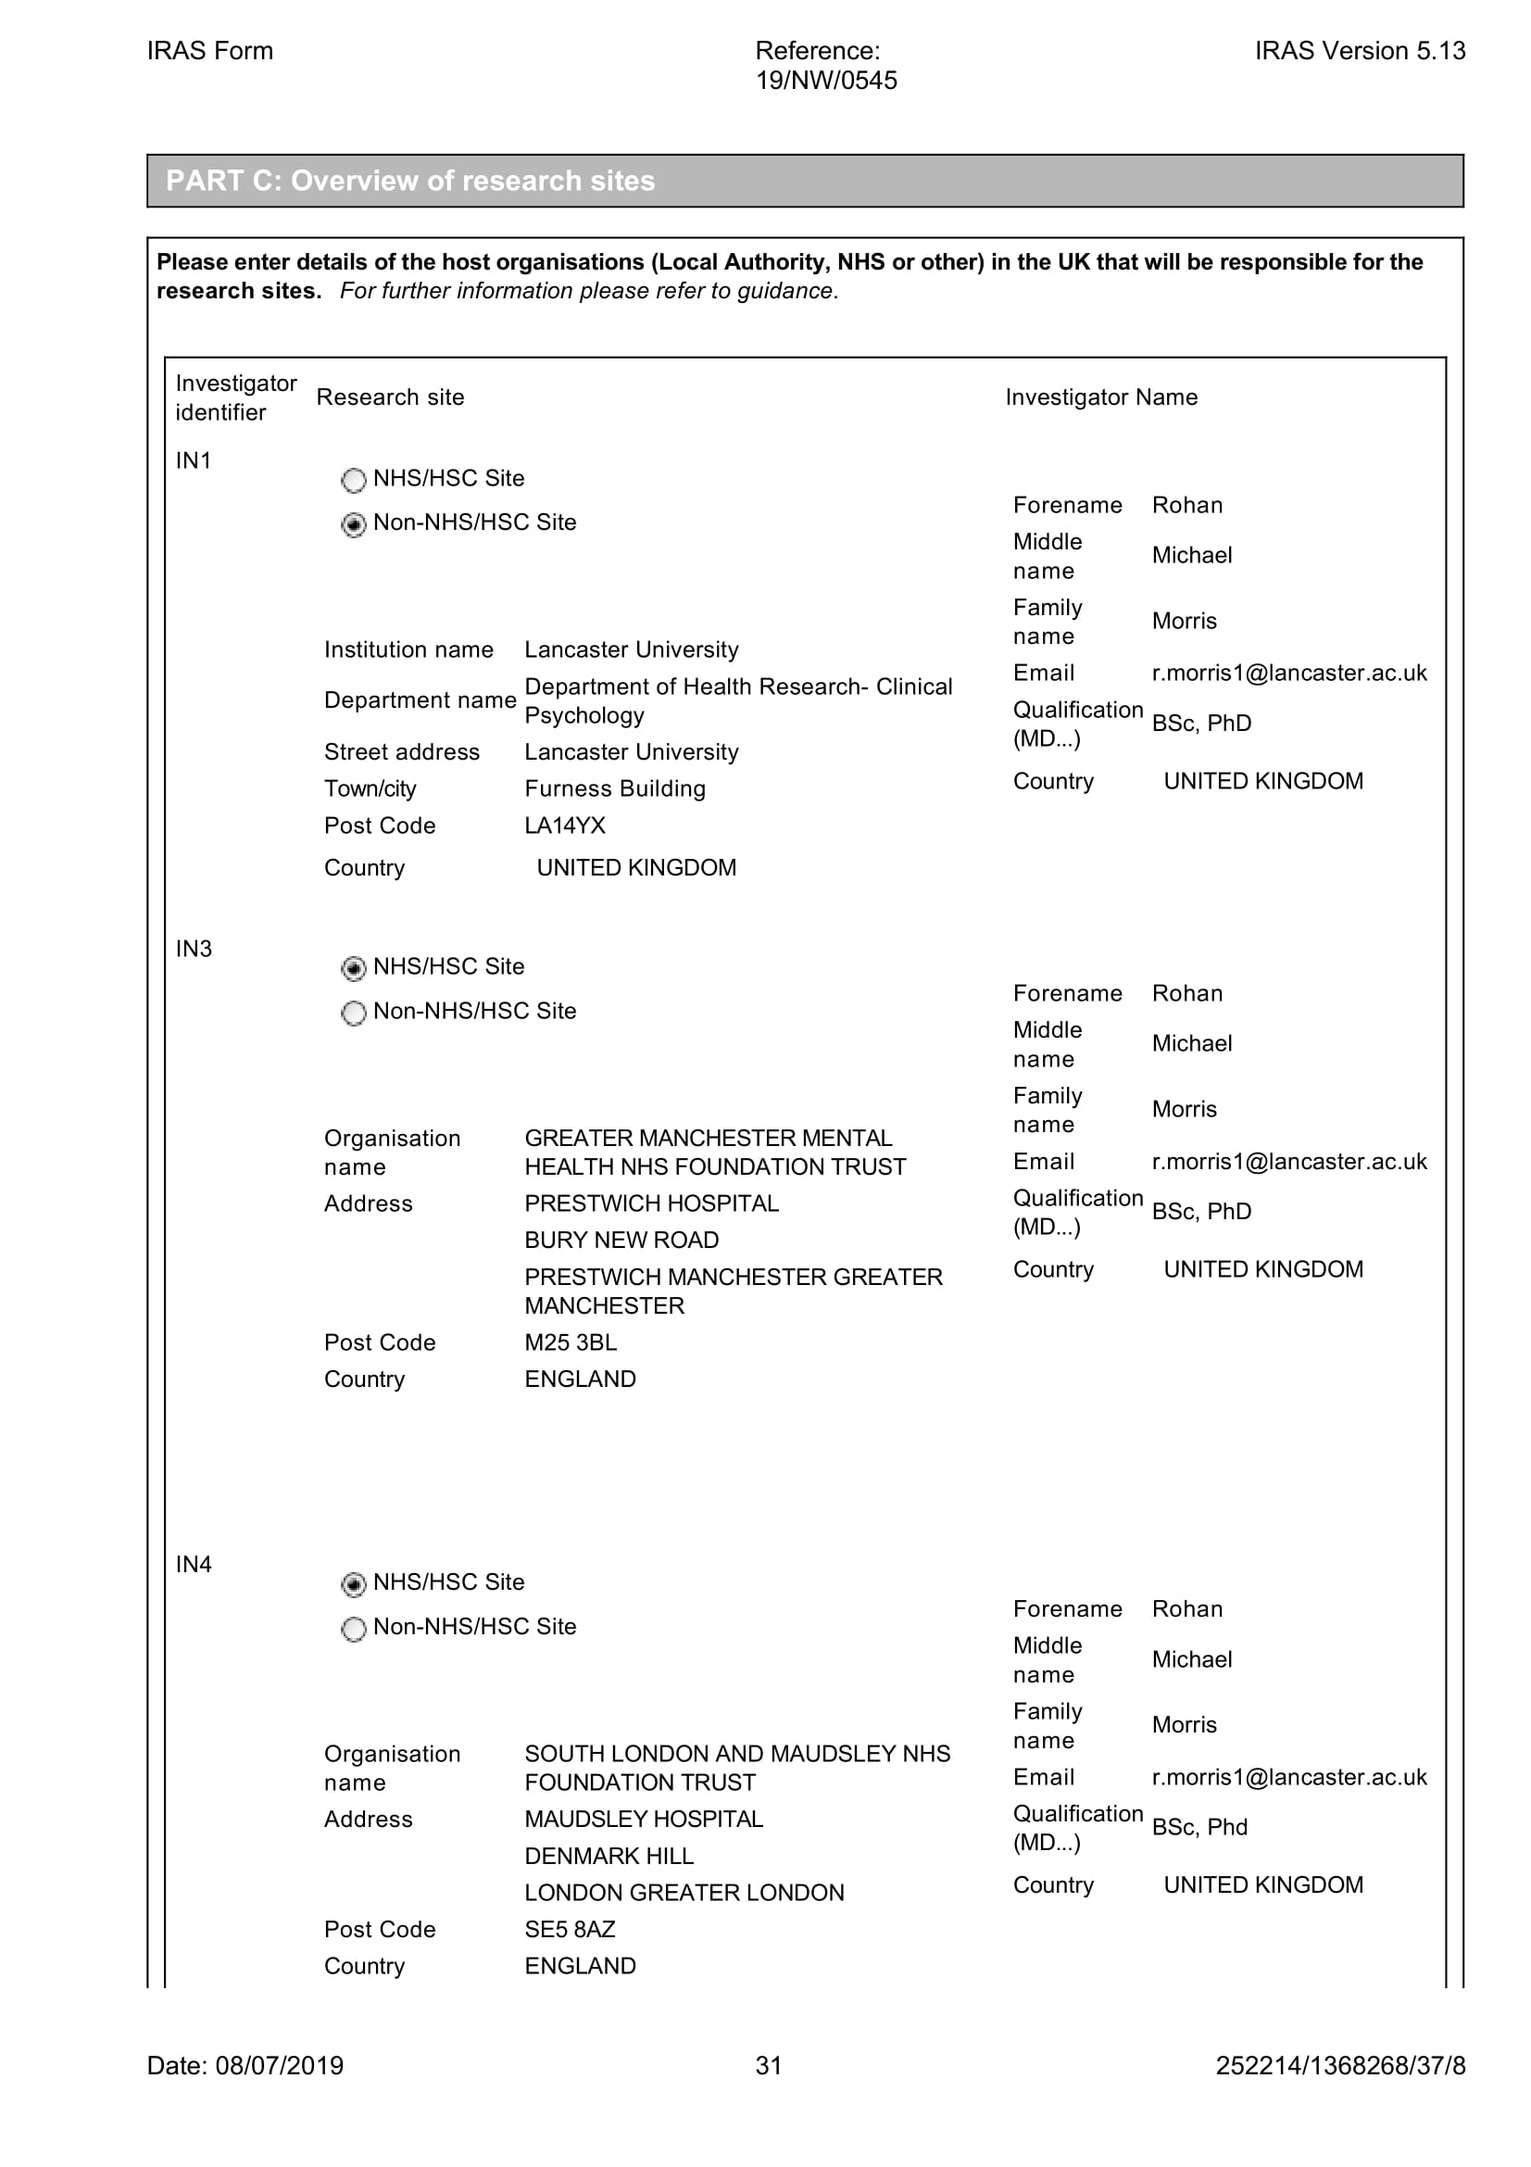
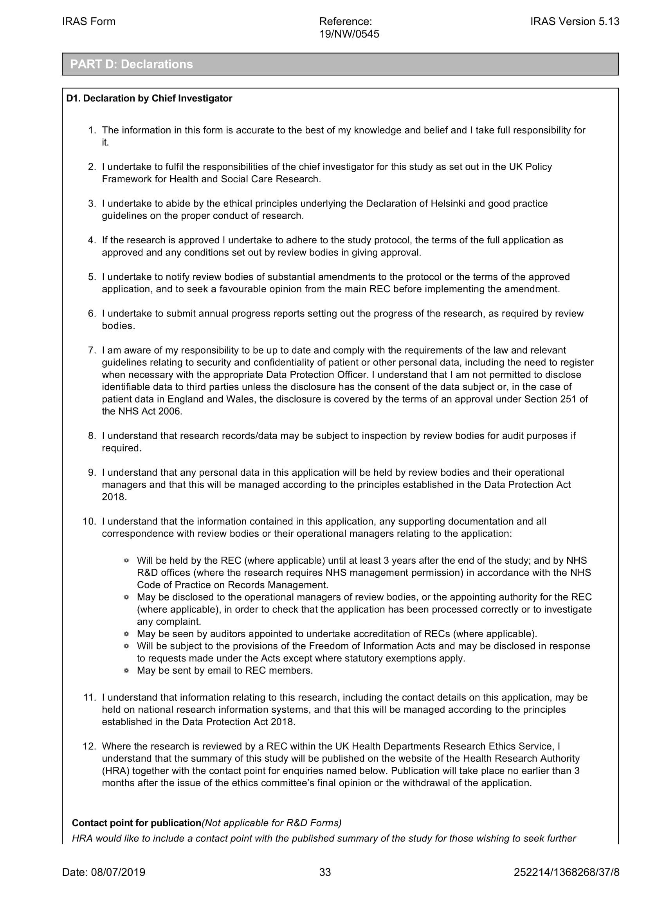
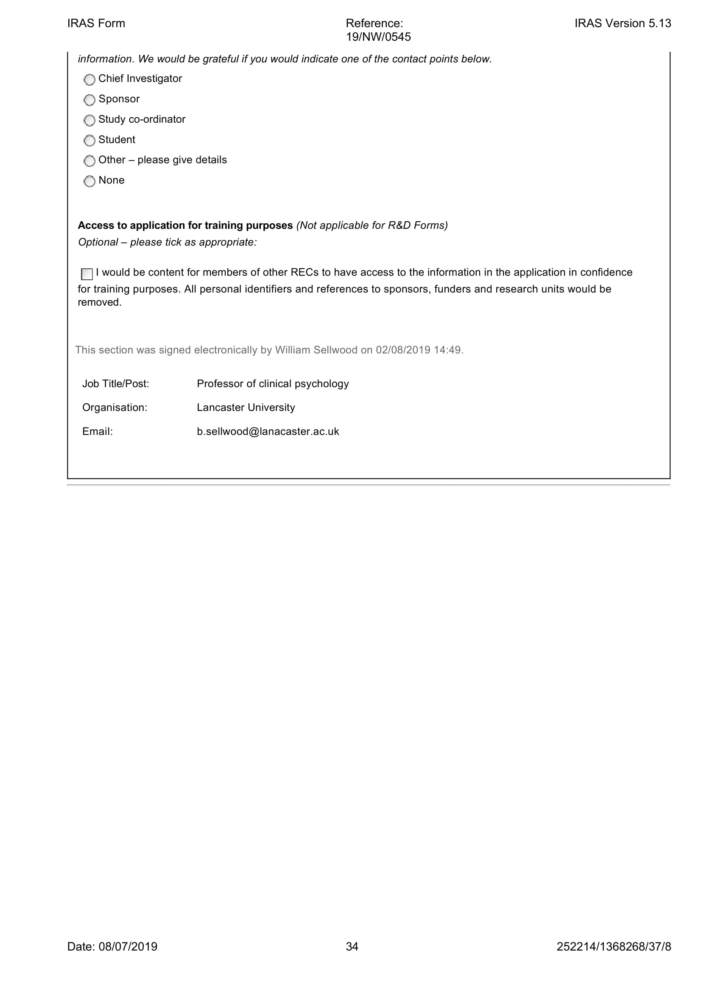
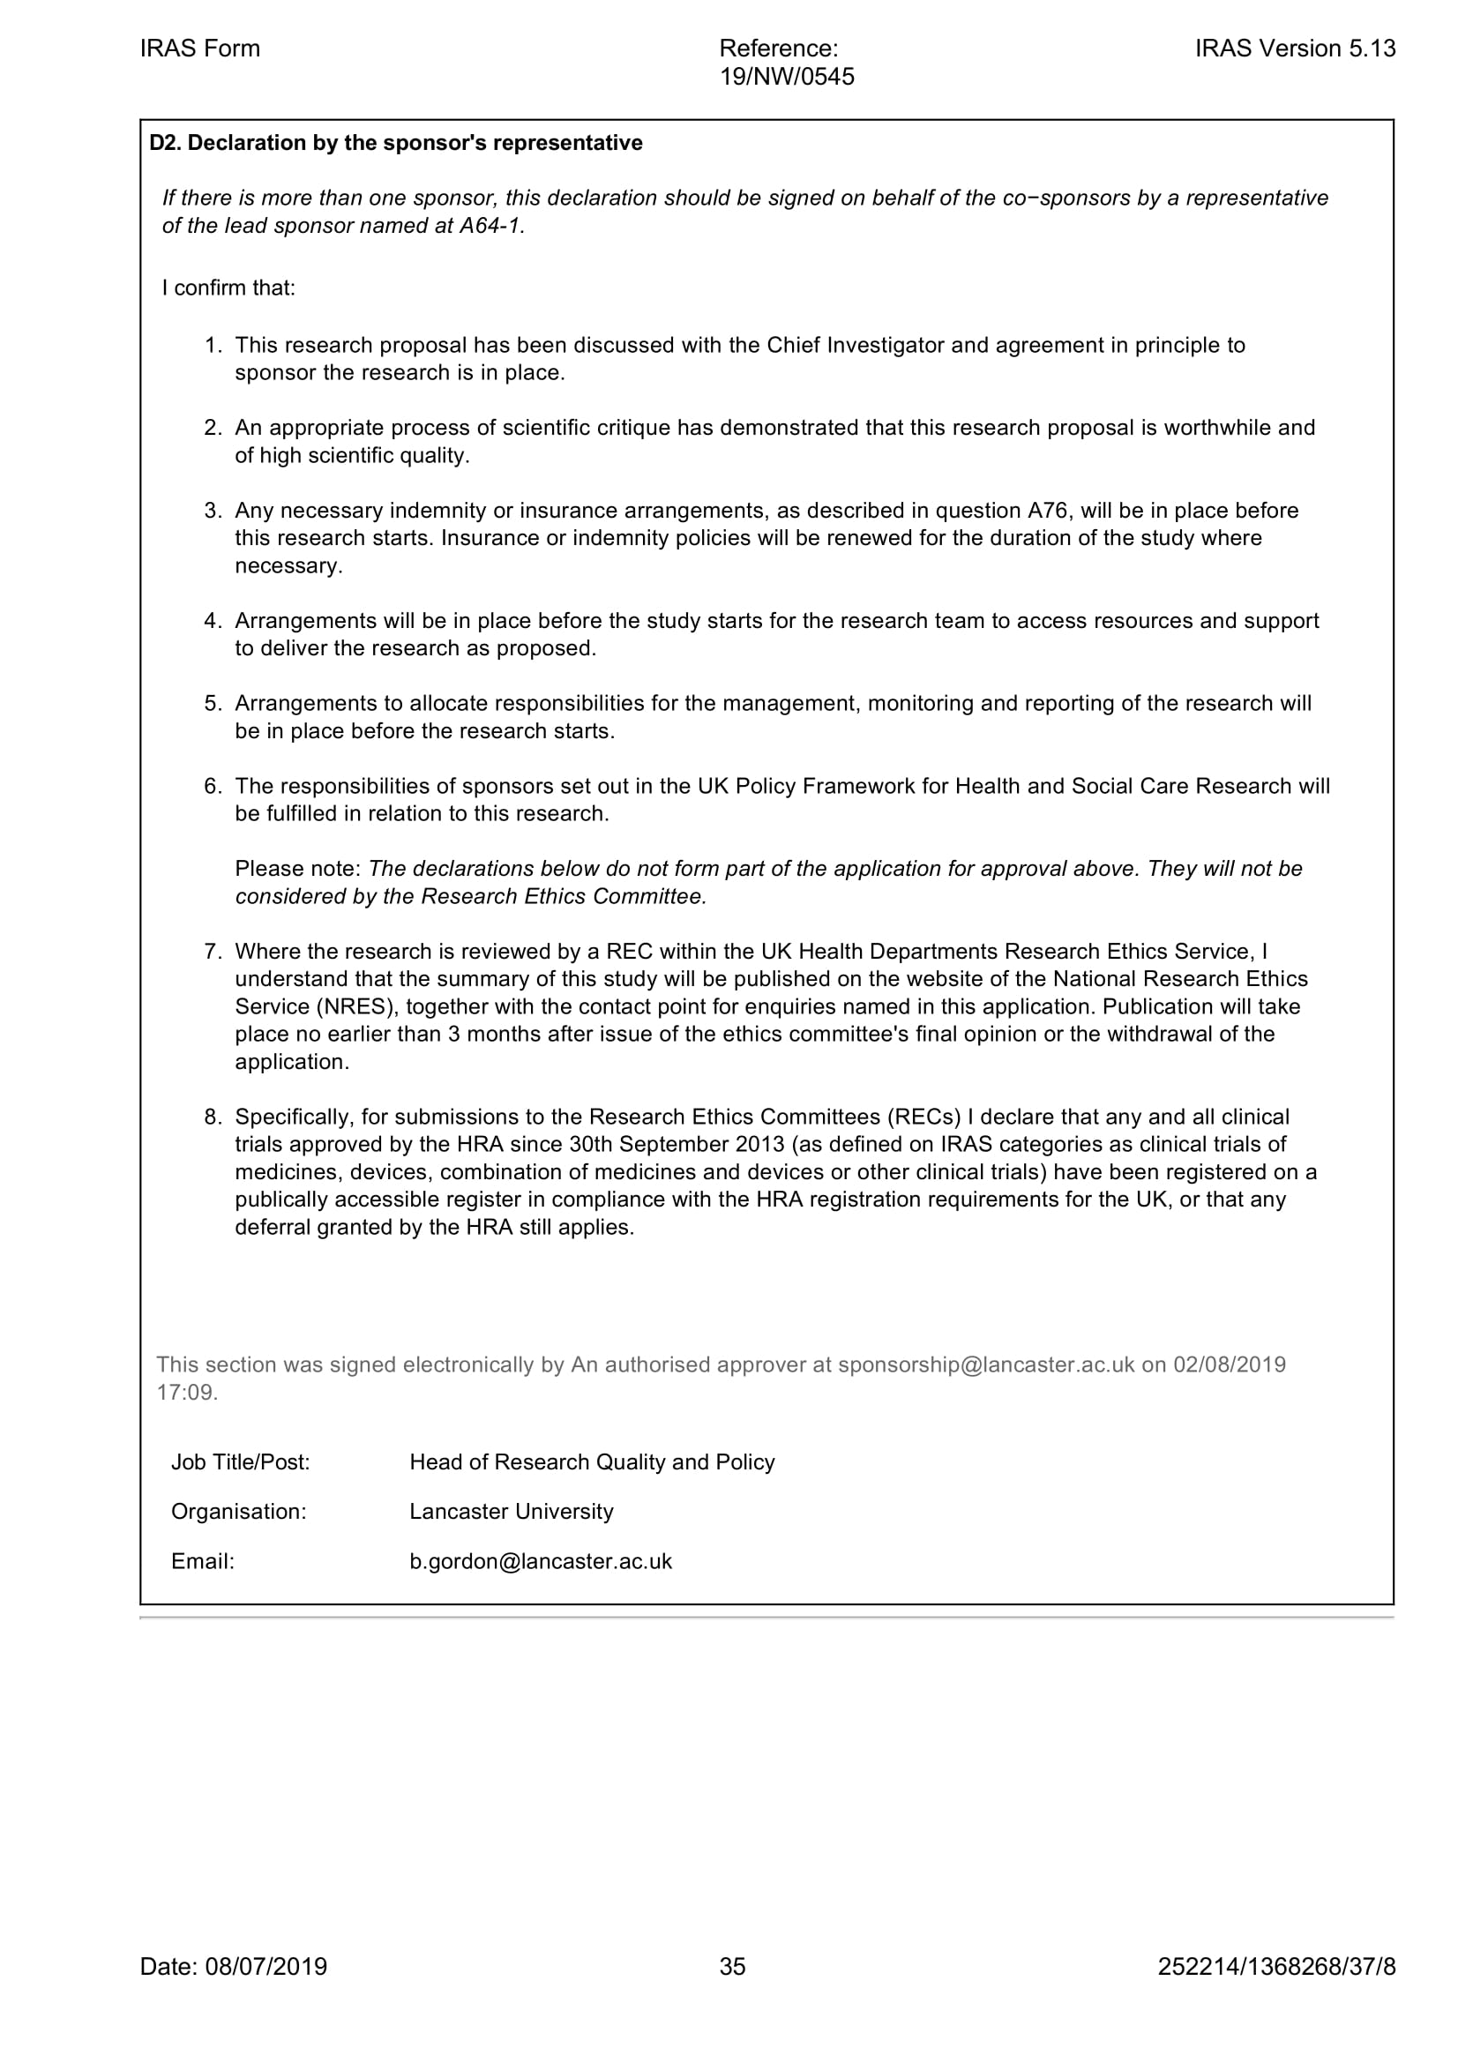
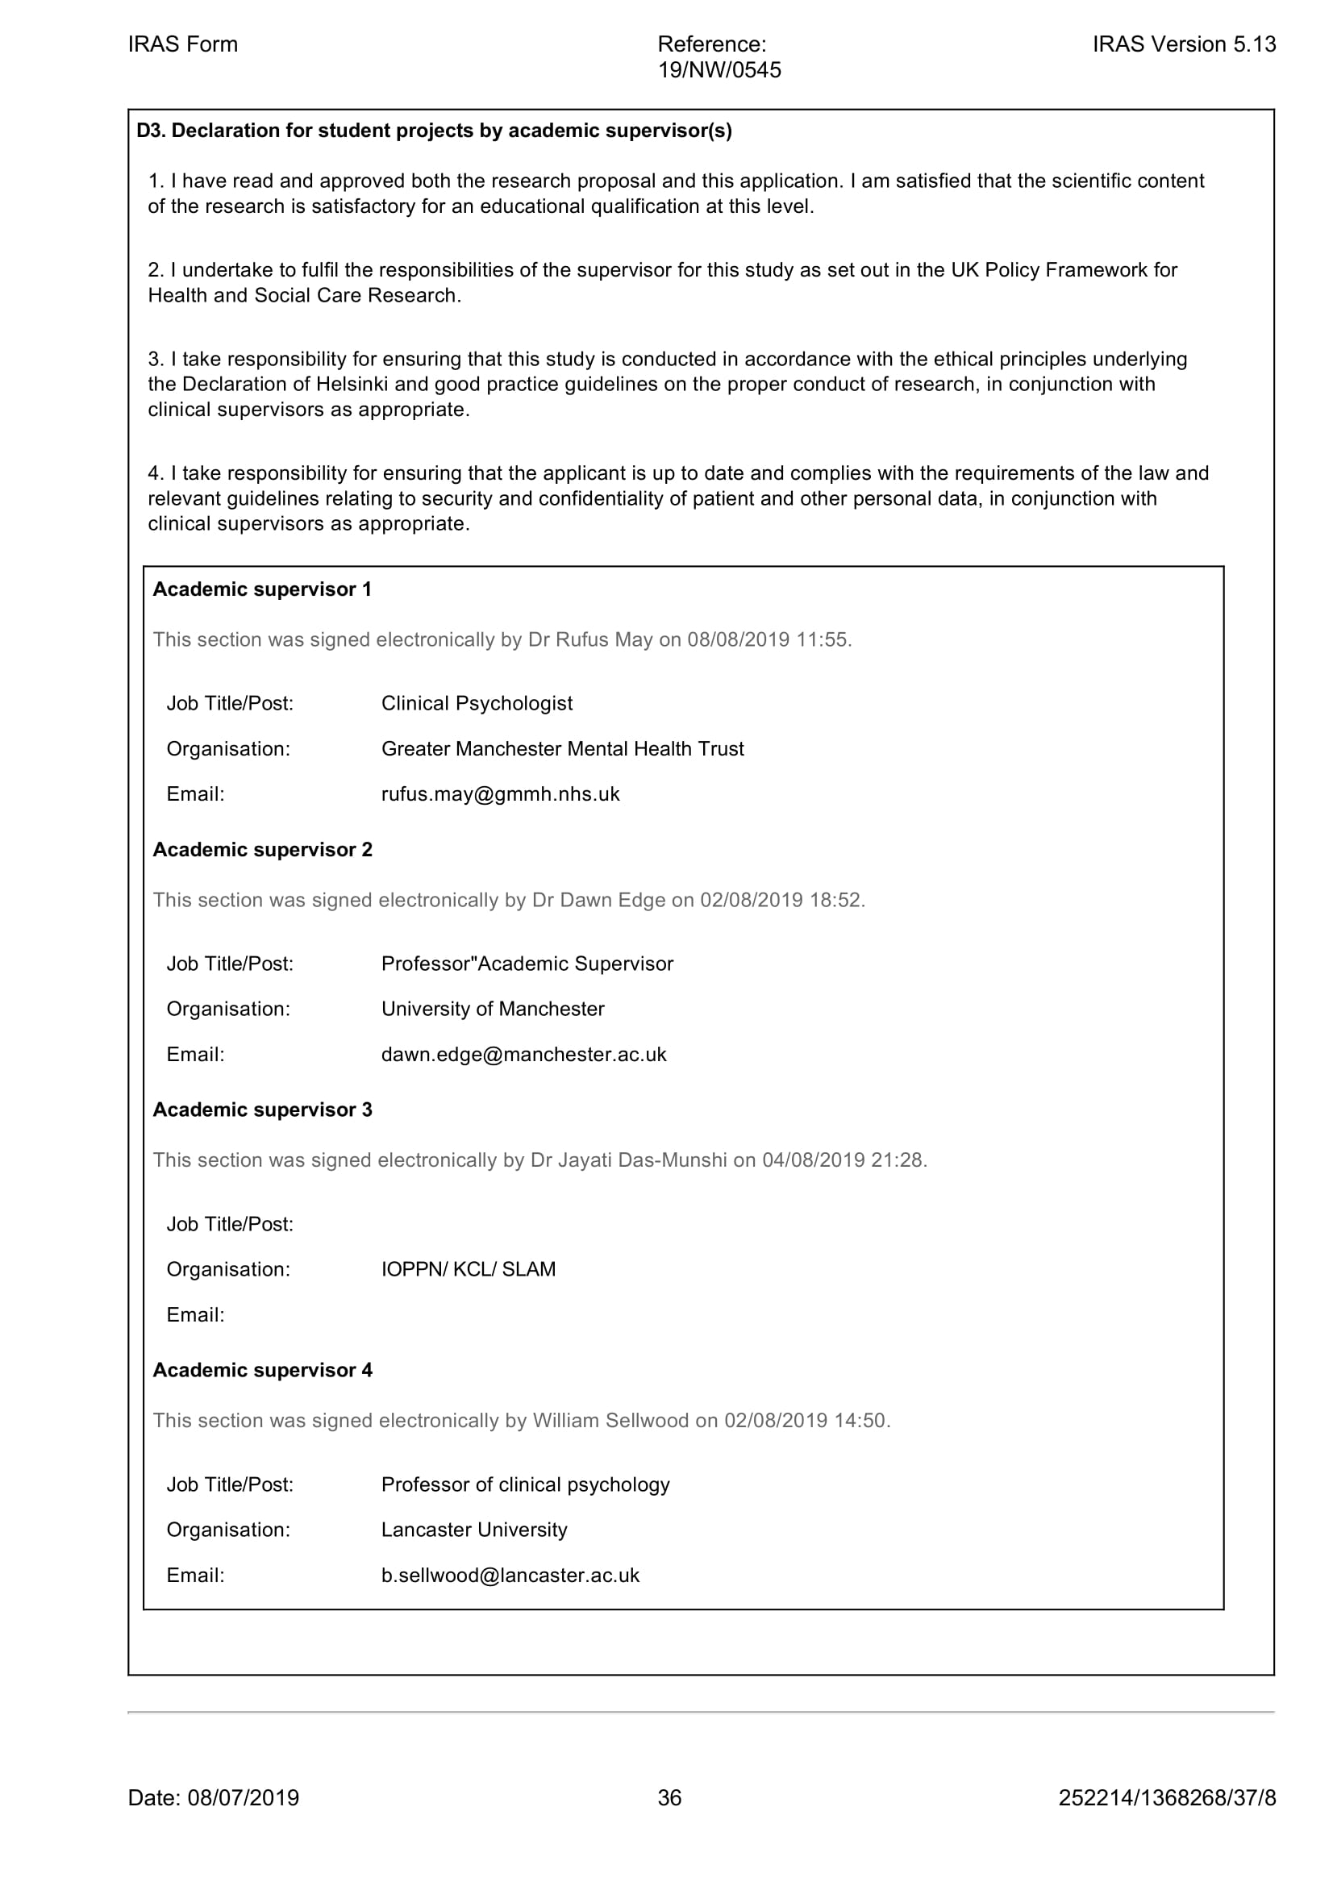

Appendices

Appendix 5A | Participant Information Sheet- voice hearers
Appendix 5B | Participant Information Sheet- clinicians
Appendix 5C | Consent Form- voice hearers
Appendix 5D | Consent Form- clinicians
Appendix 5E | Topic Guide- voice hearers
Appendix 5F | Topic Guide- Clinicians
Appendix 5G | Debrief researcher sheet
Appendix 5H | Debrief participant handout
Appendix 5I | Ethical approval letter
Appendix 5J | Ethics committee correspondence

Appendix 5A- Participant Information Sheet- Voice Hearers

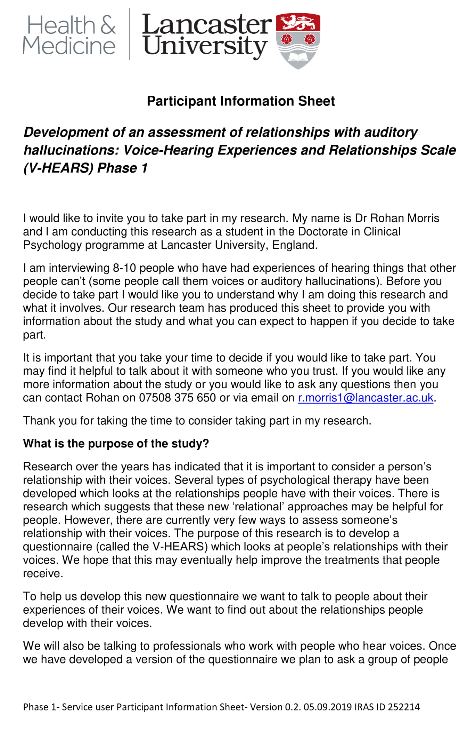
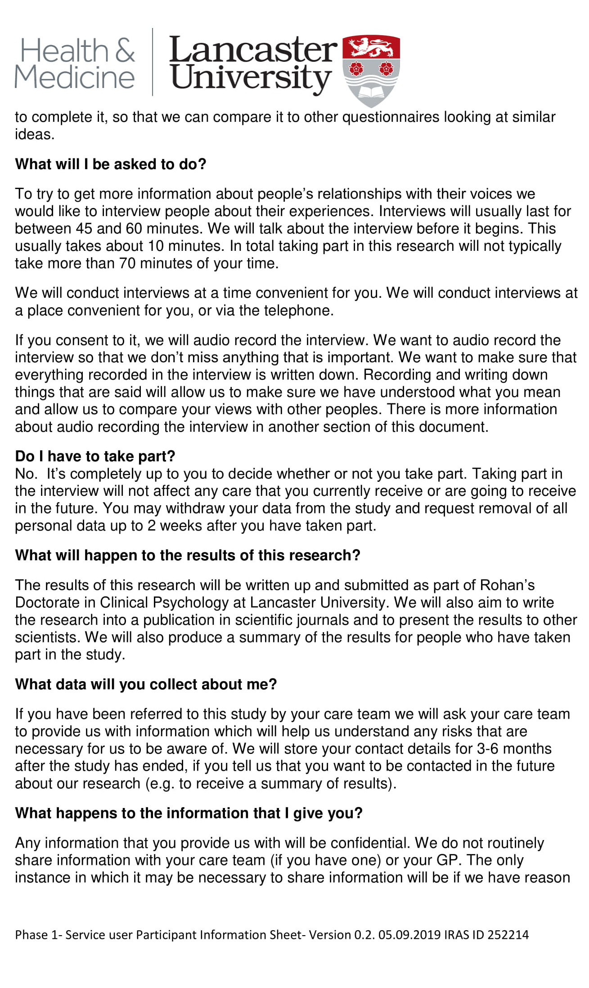
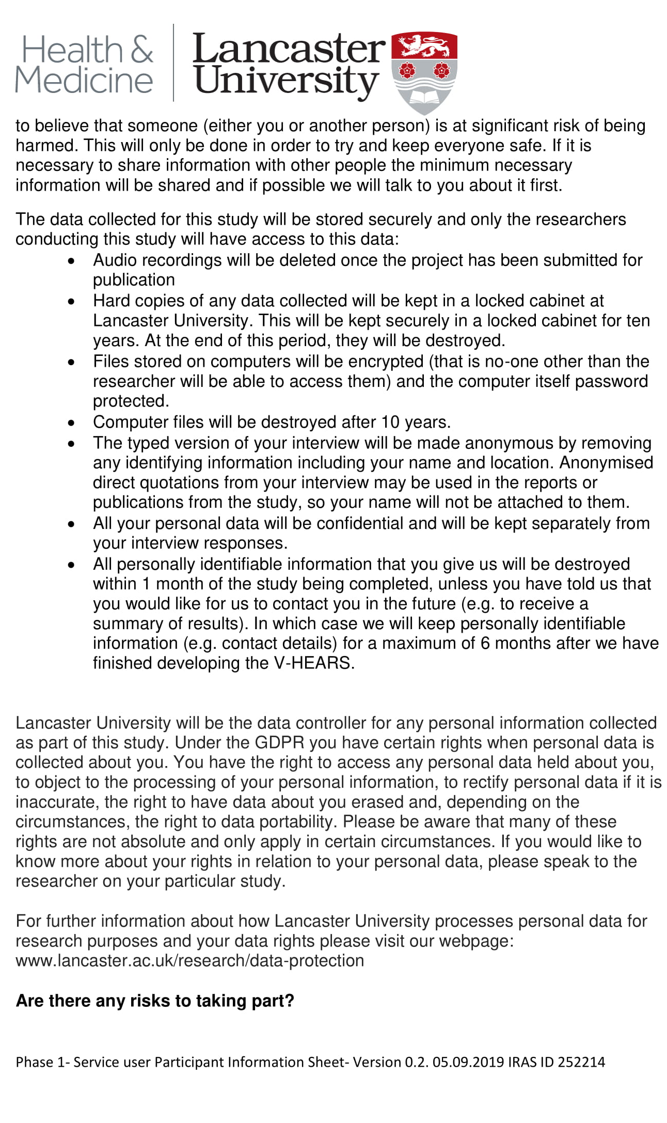
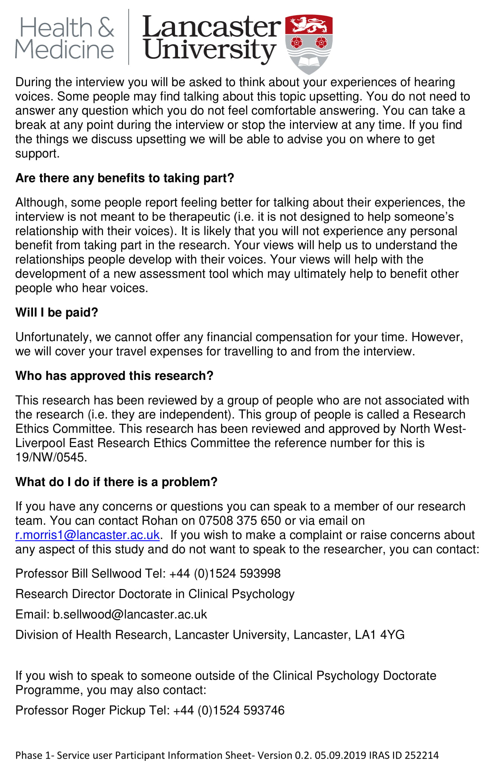

Appendix 5B- Participant Information Sheet- clinicians
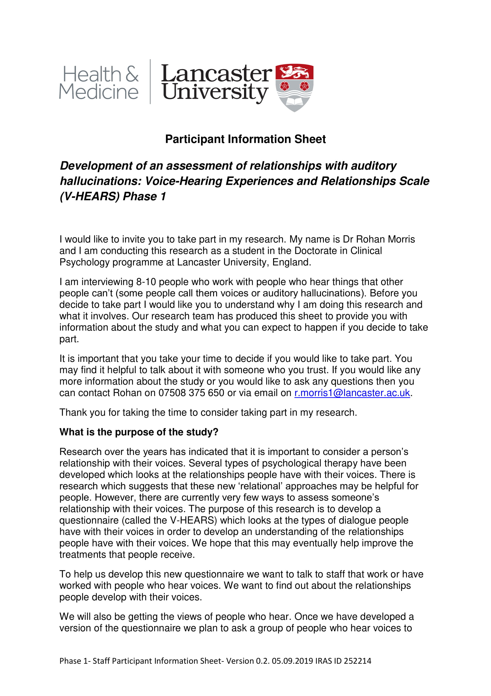
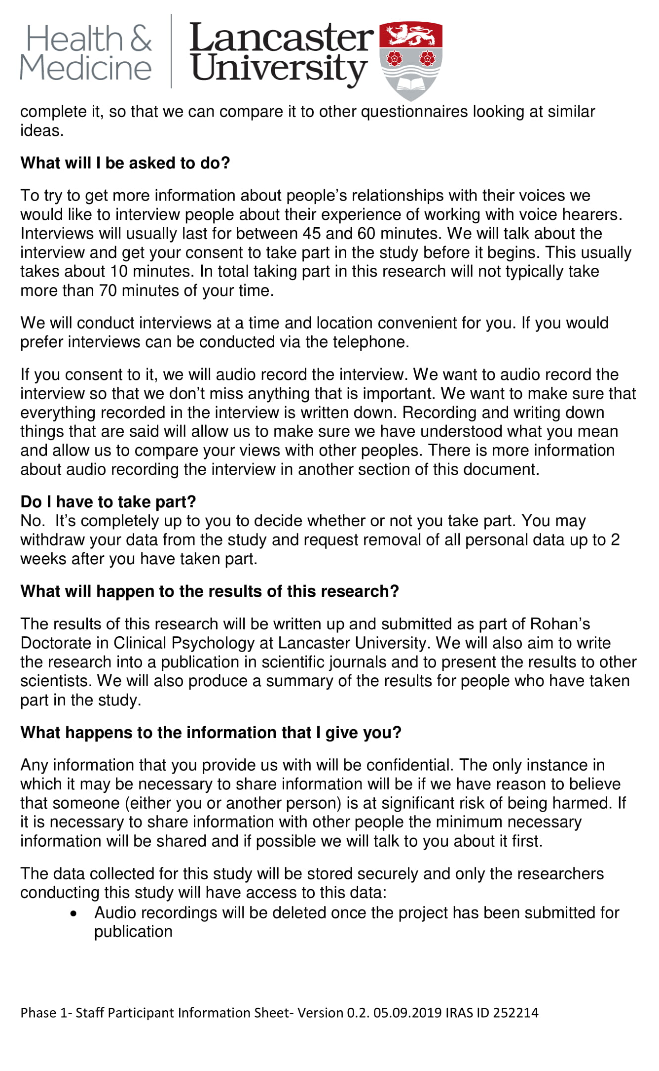
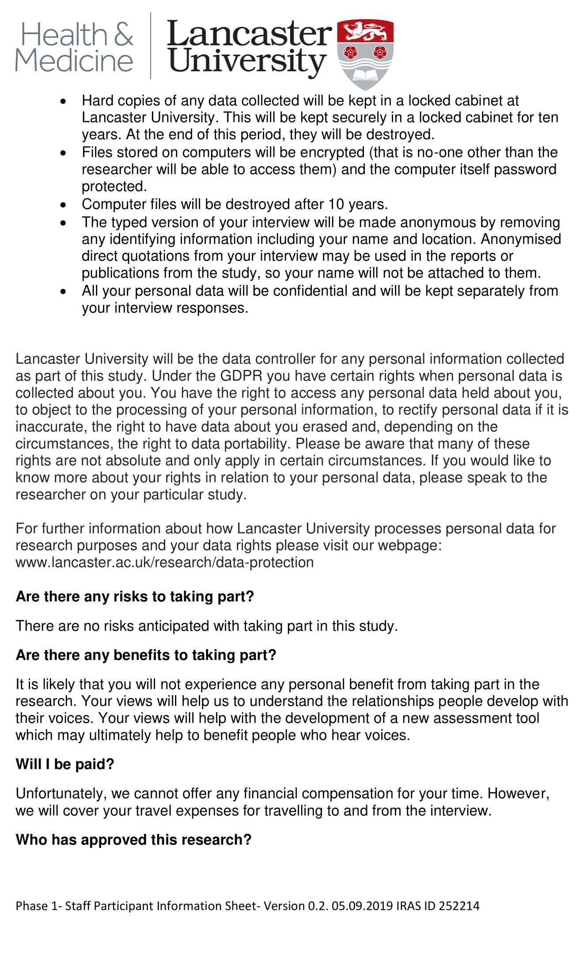

Appendix 5C- Consent Form- voice hearers
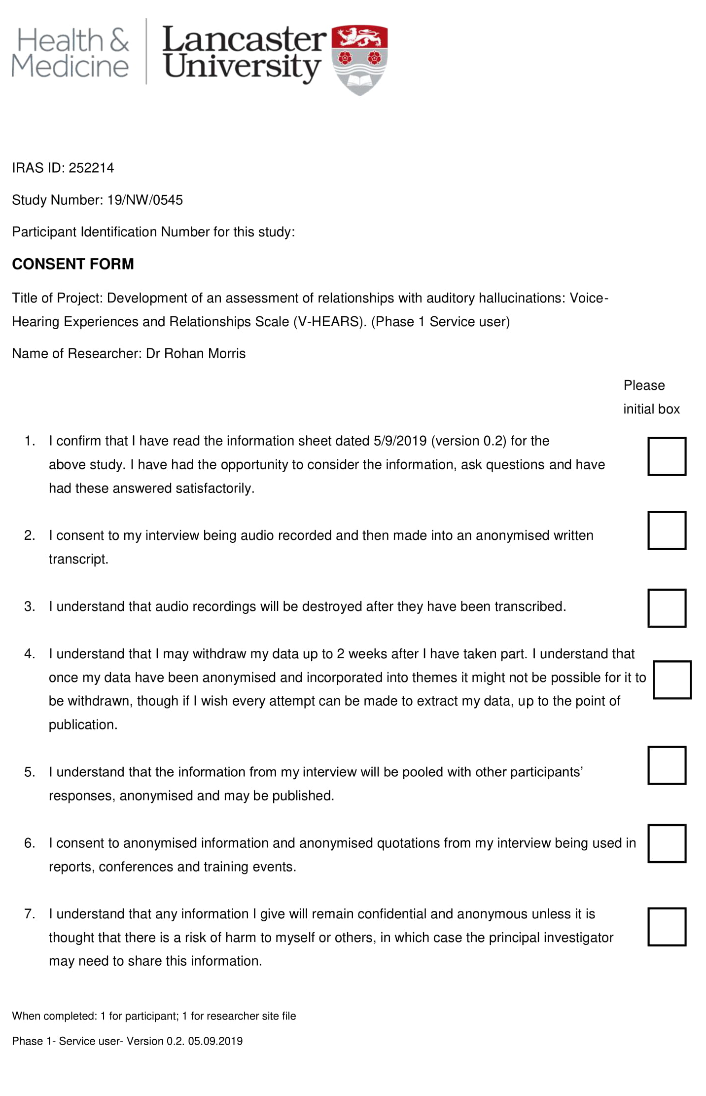
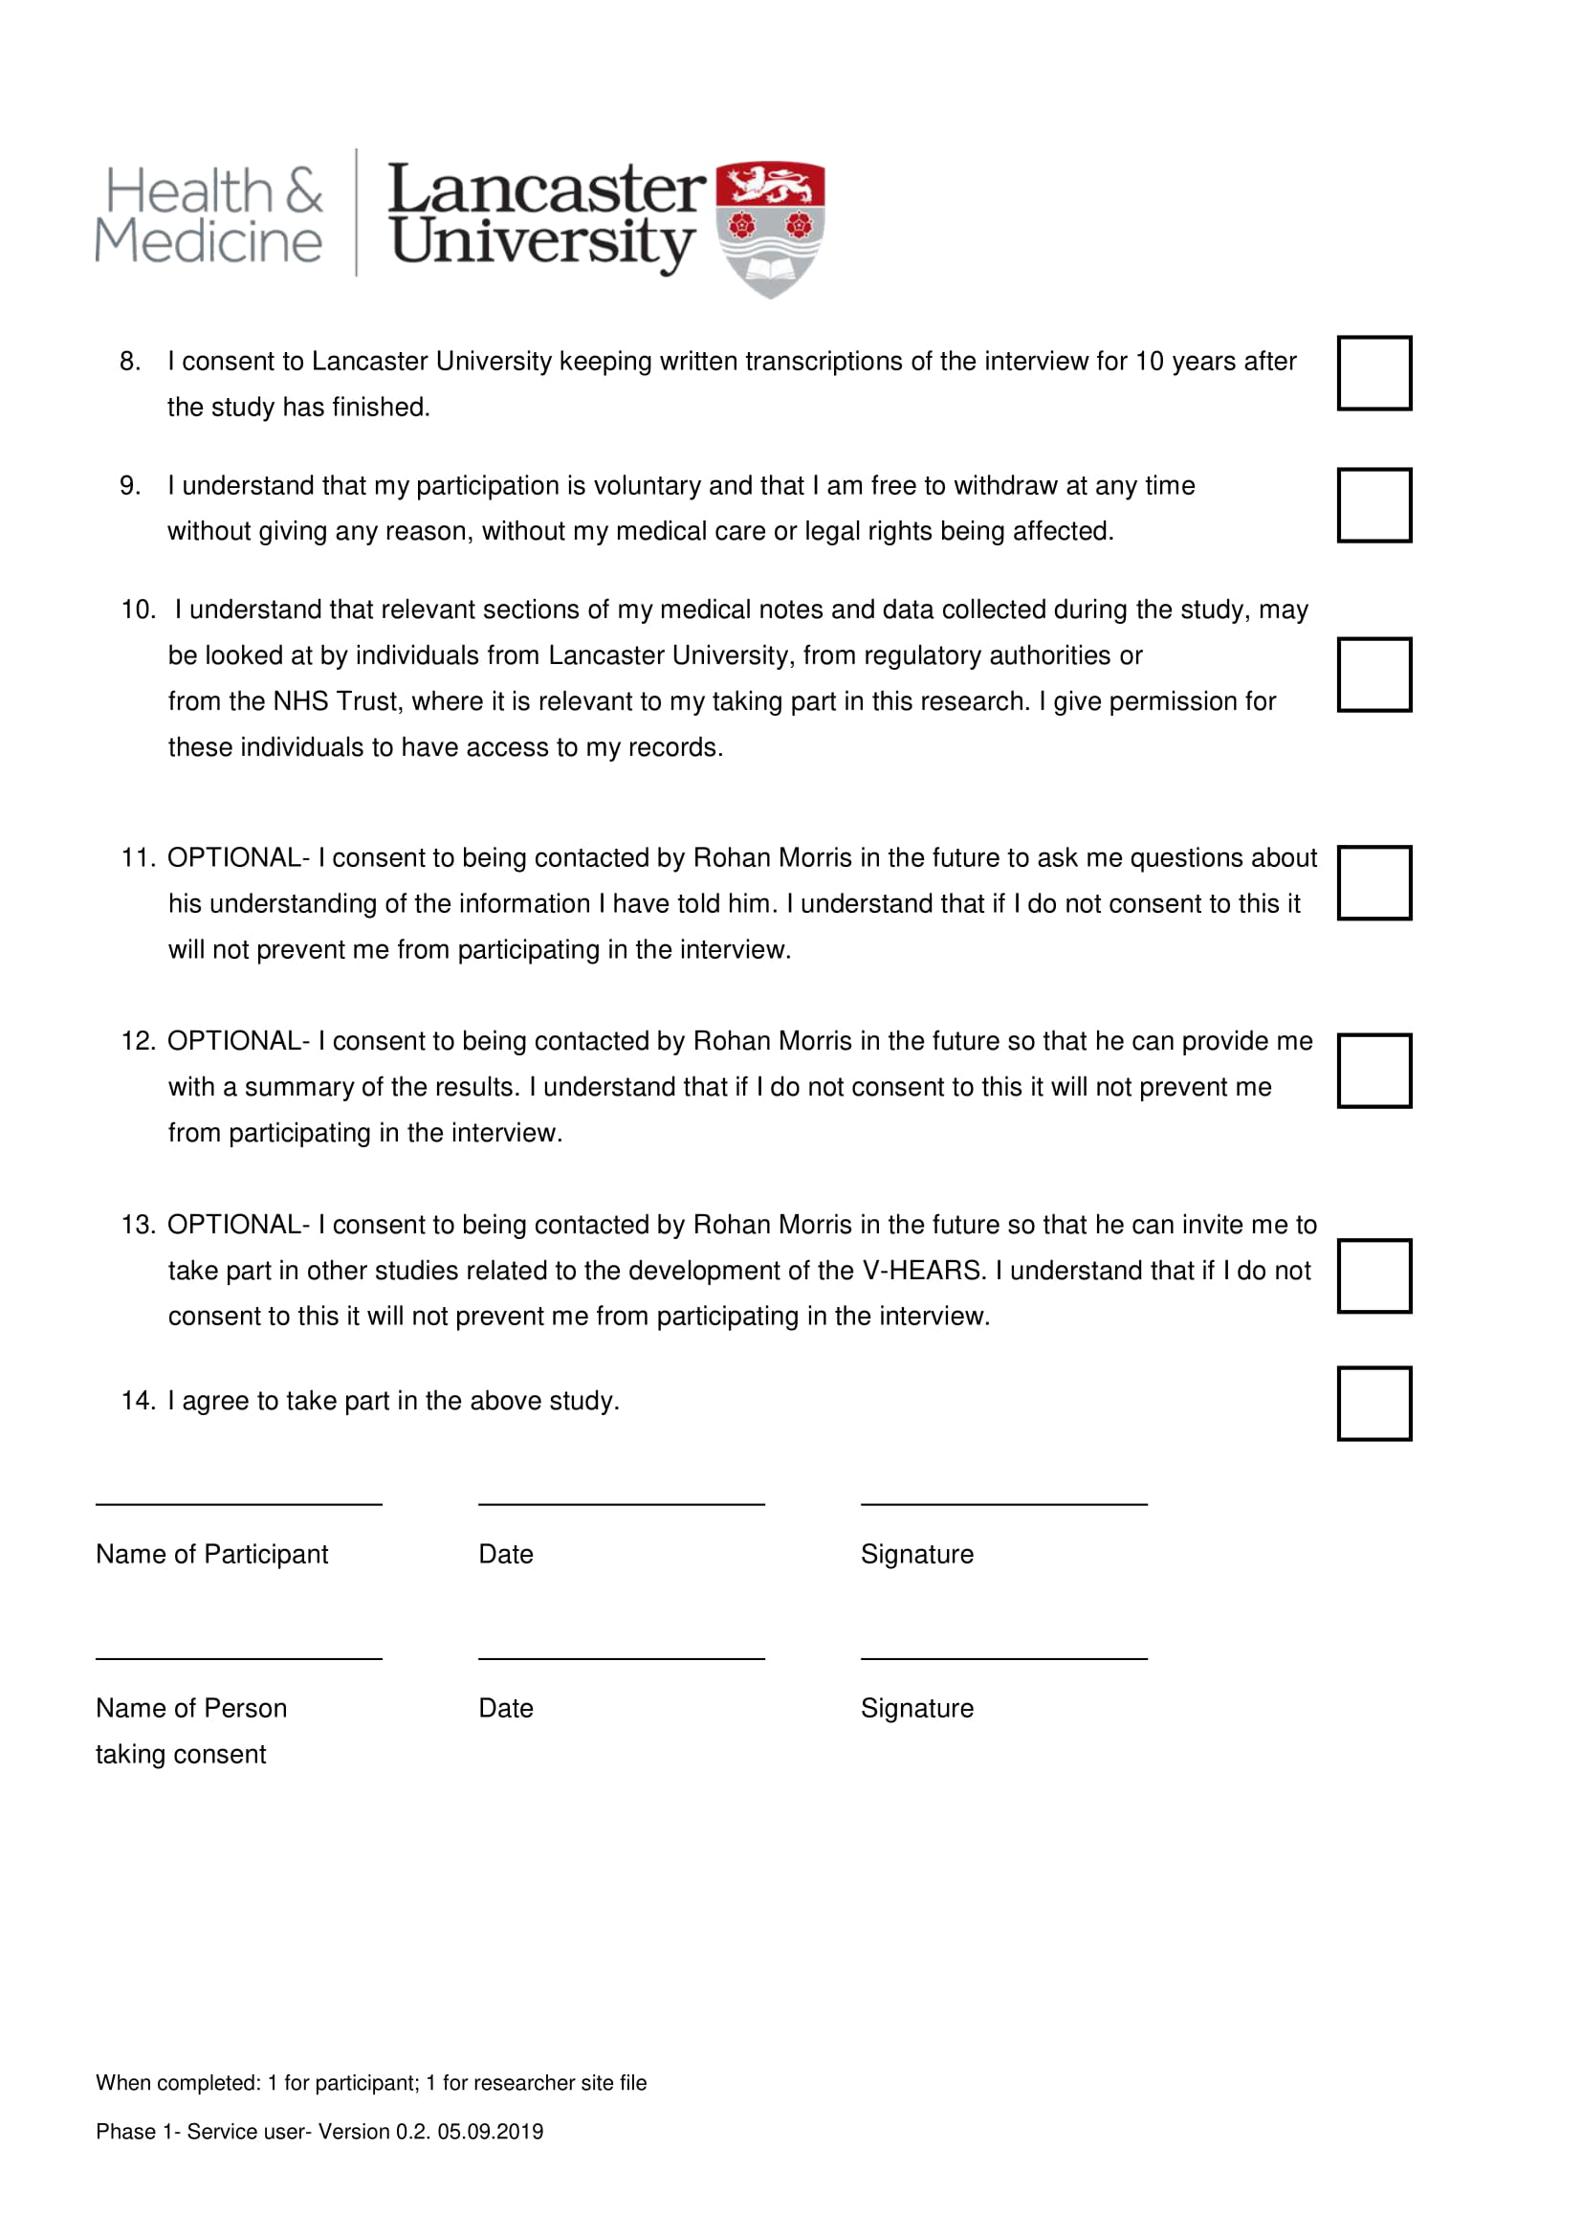

Appendix 5D Consent Form- clinicians
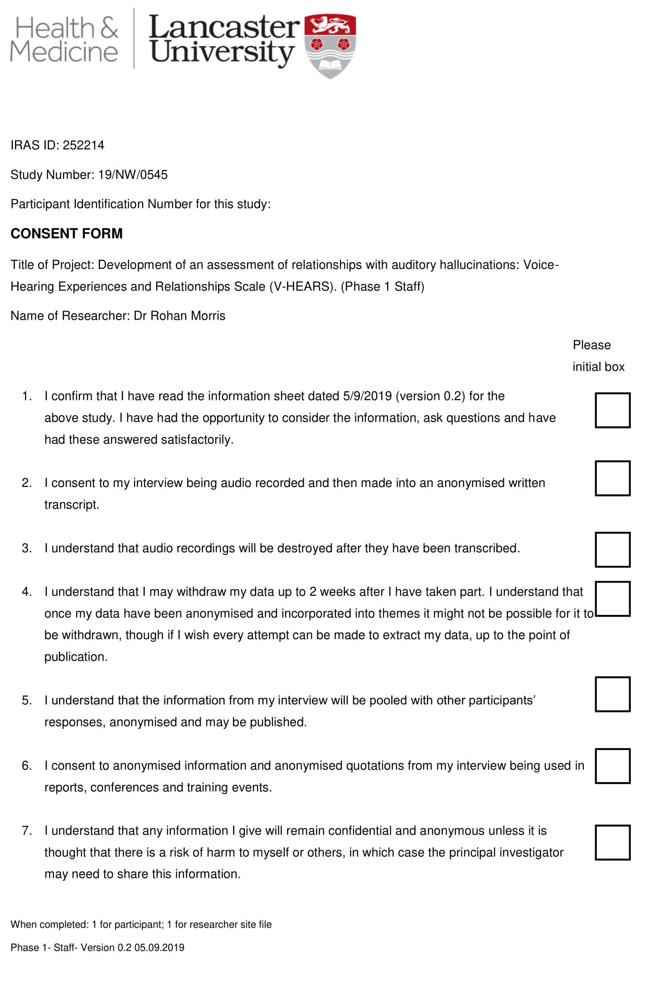
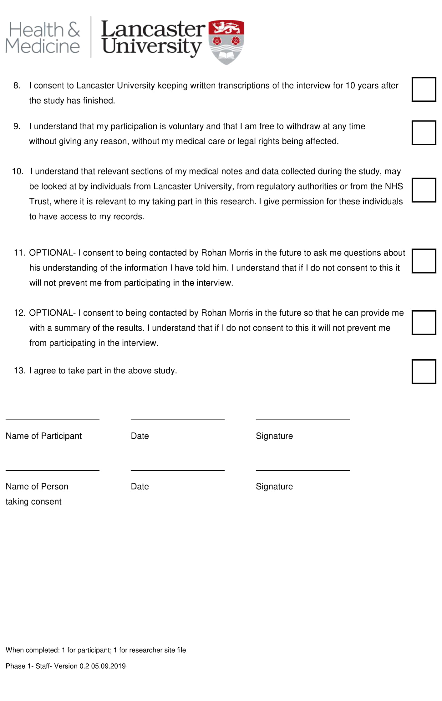

Appendix 5E-Topic Guide- voice hearers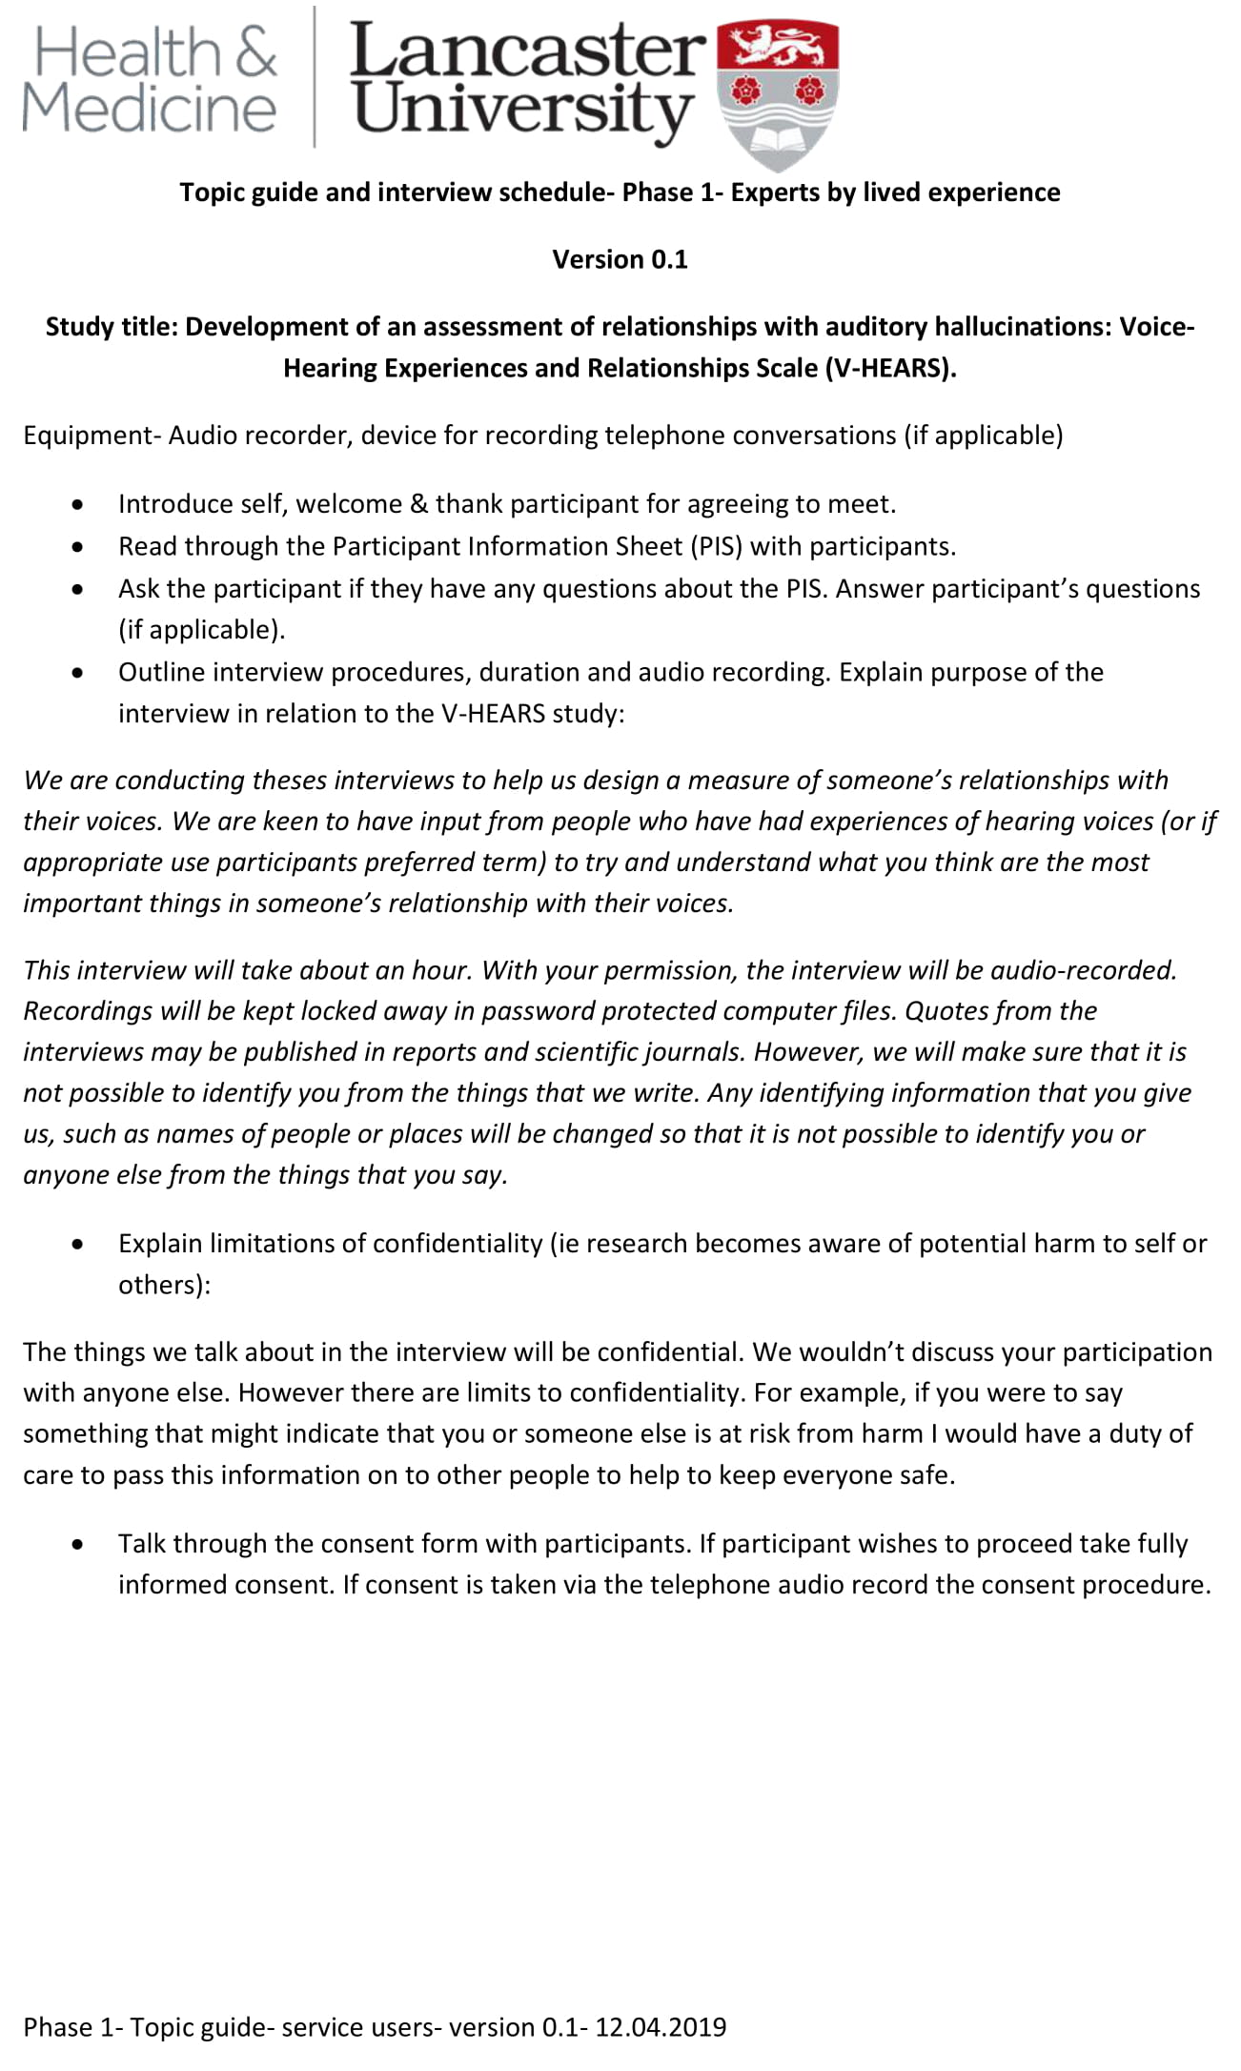
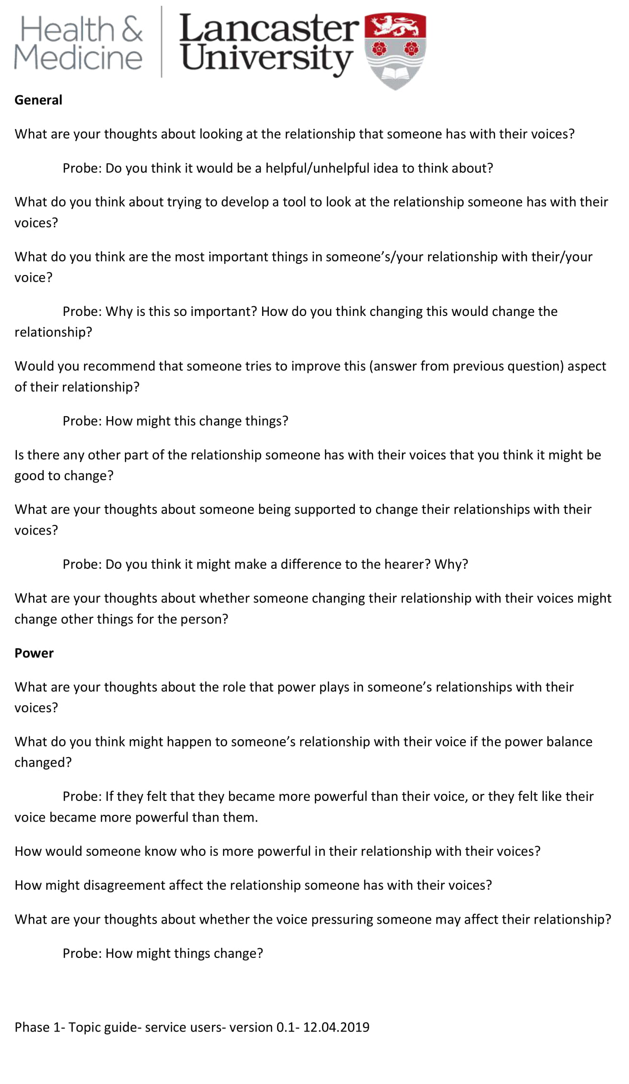
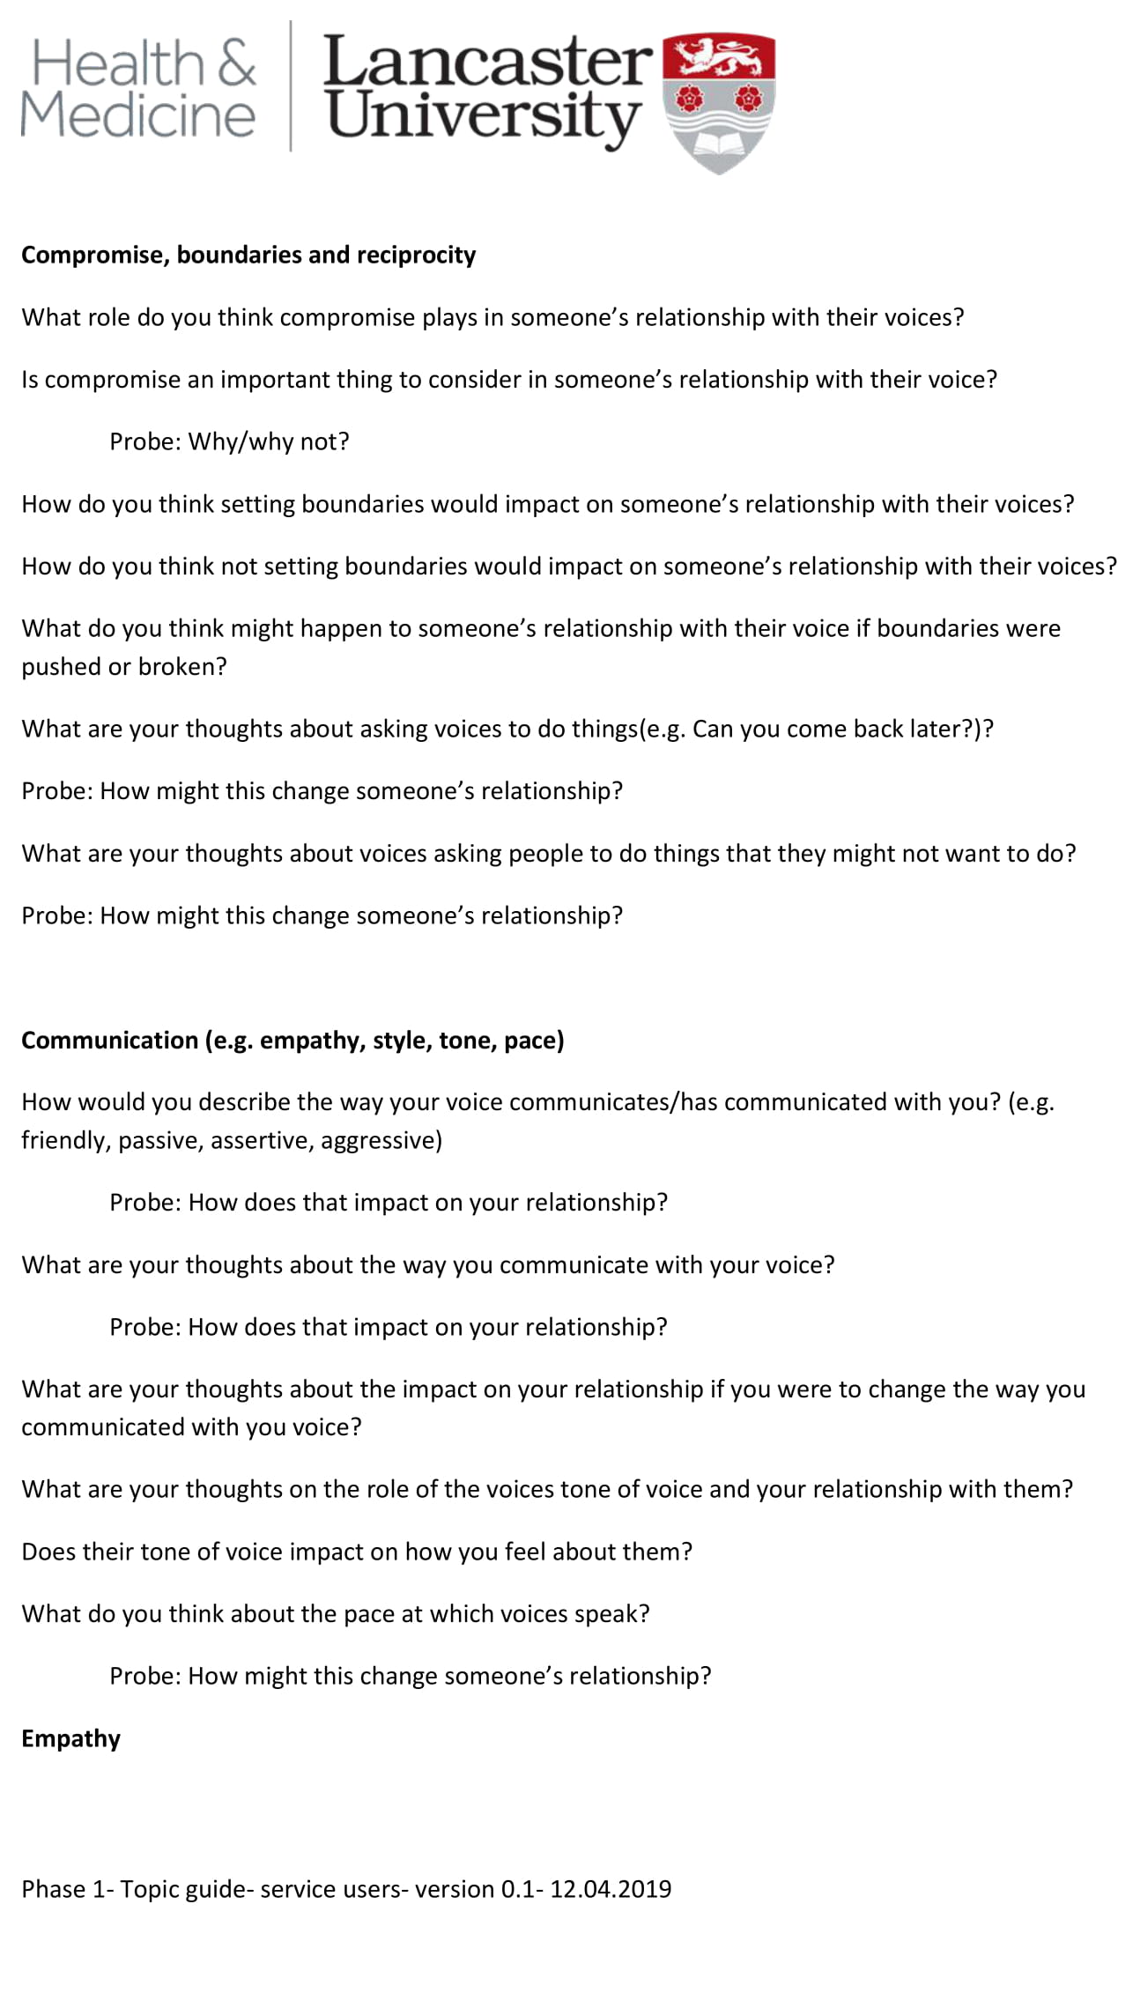
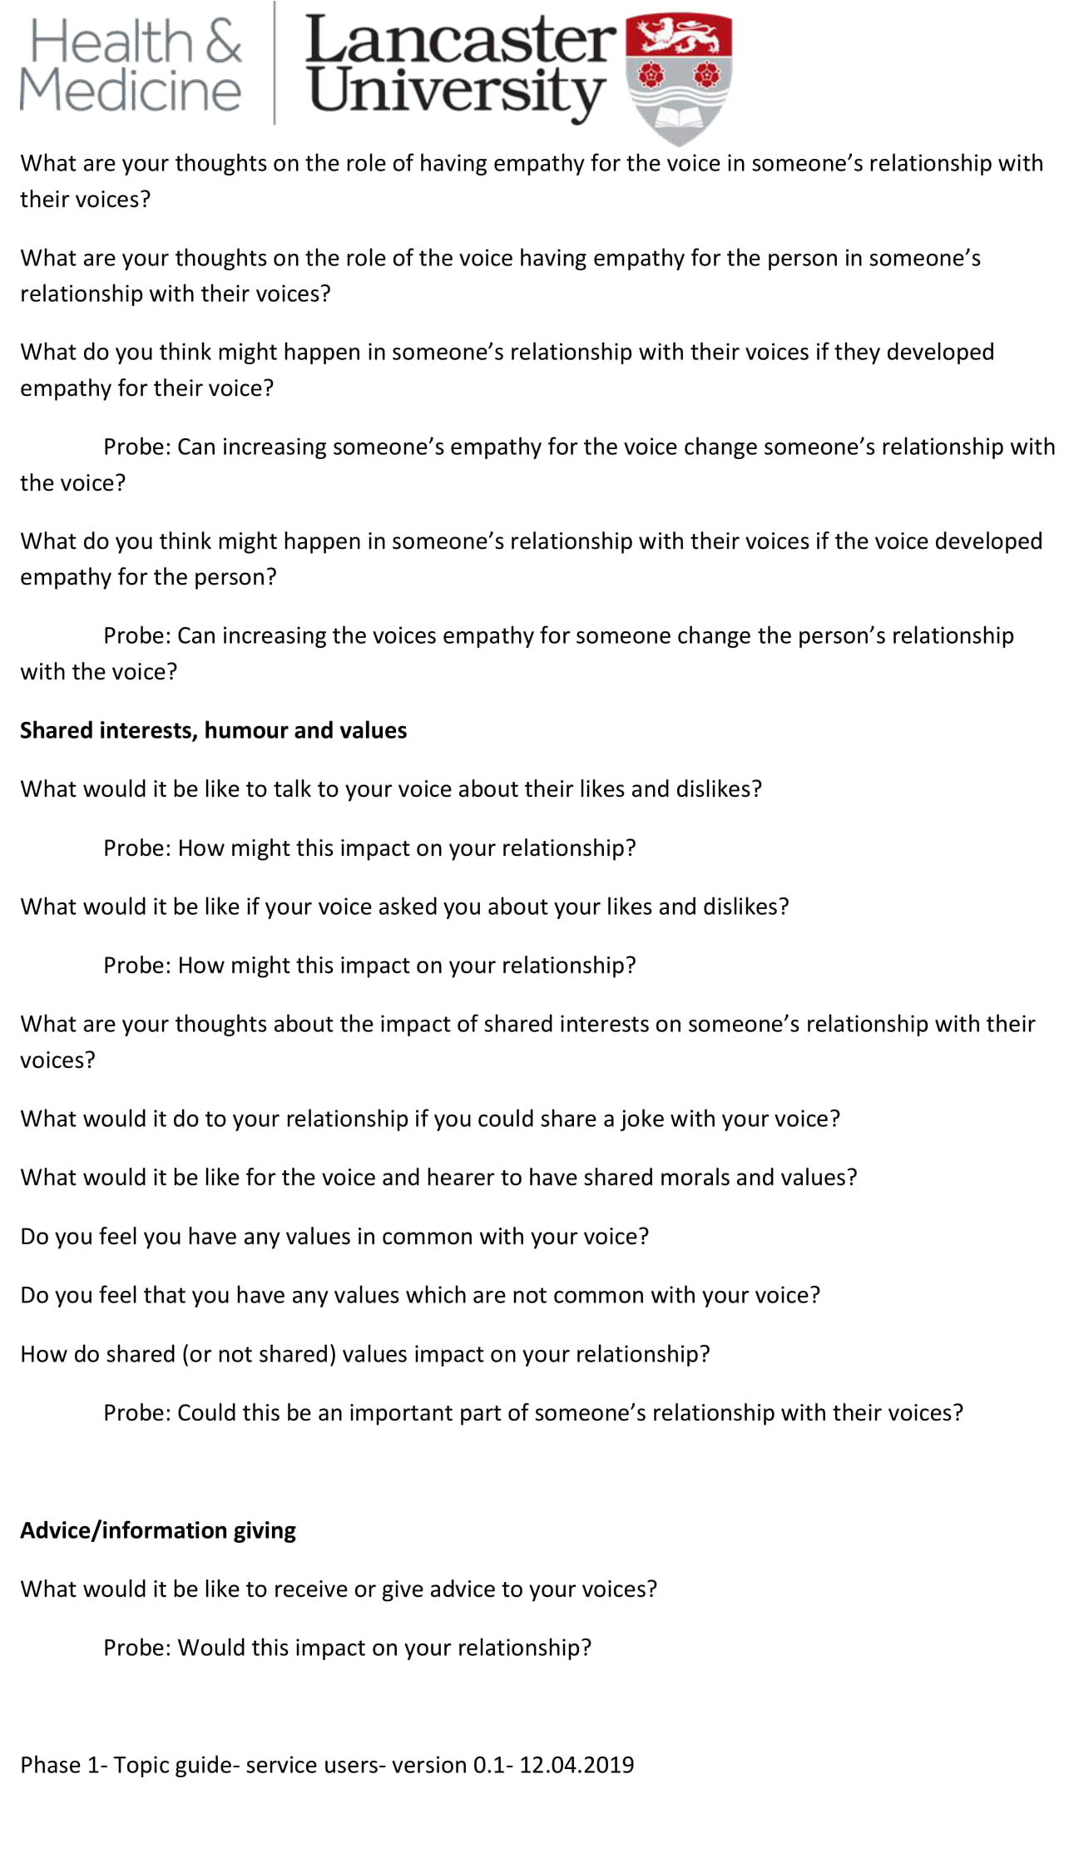
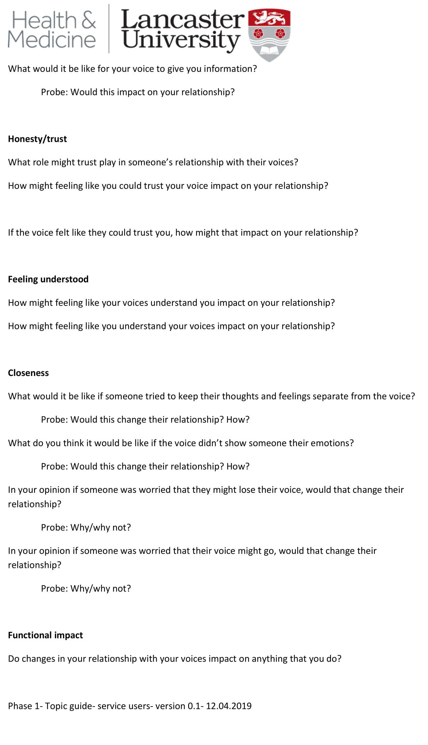
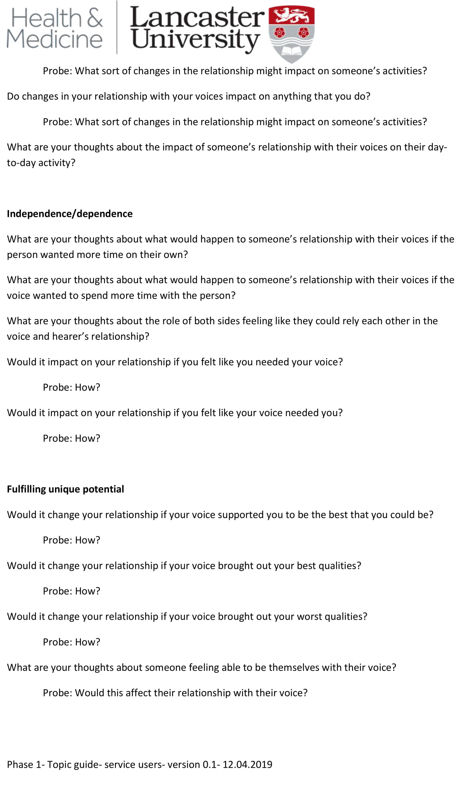
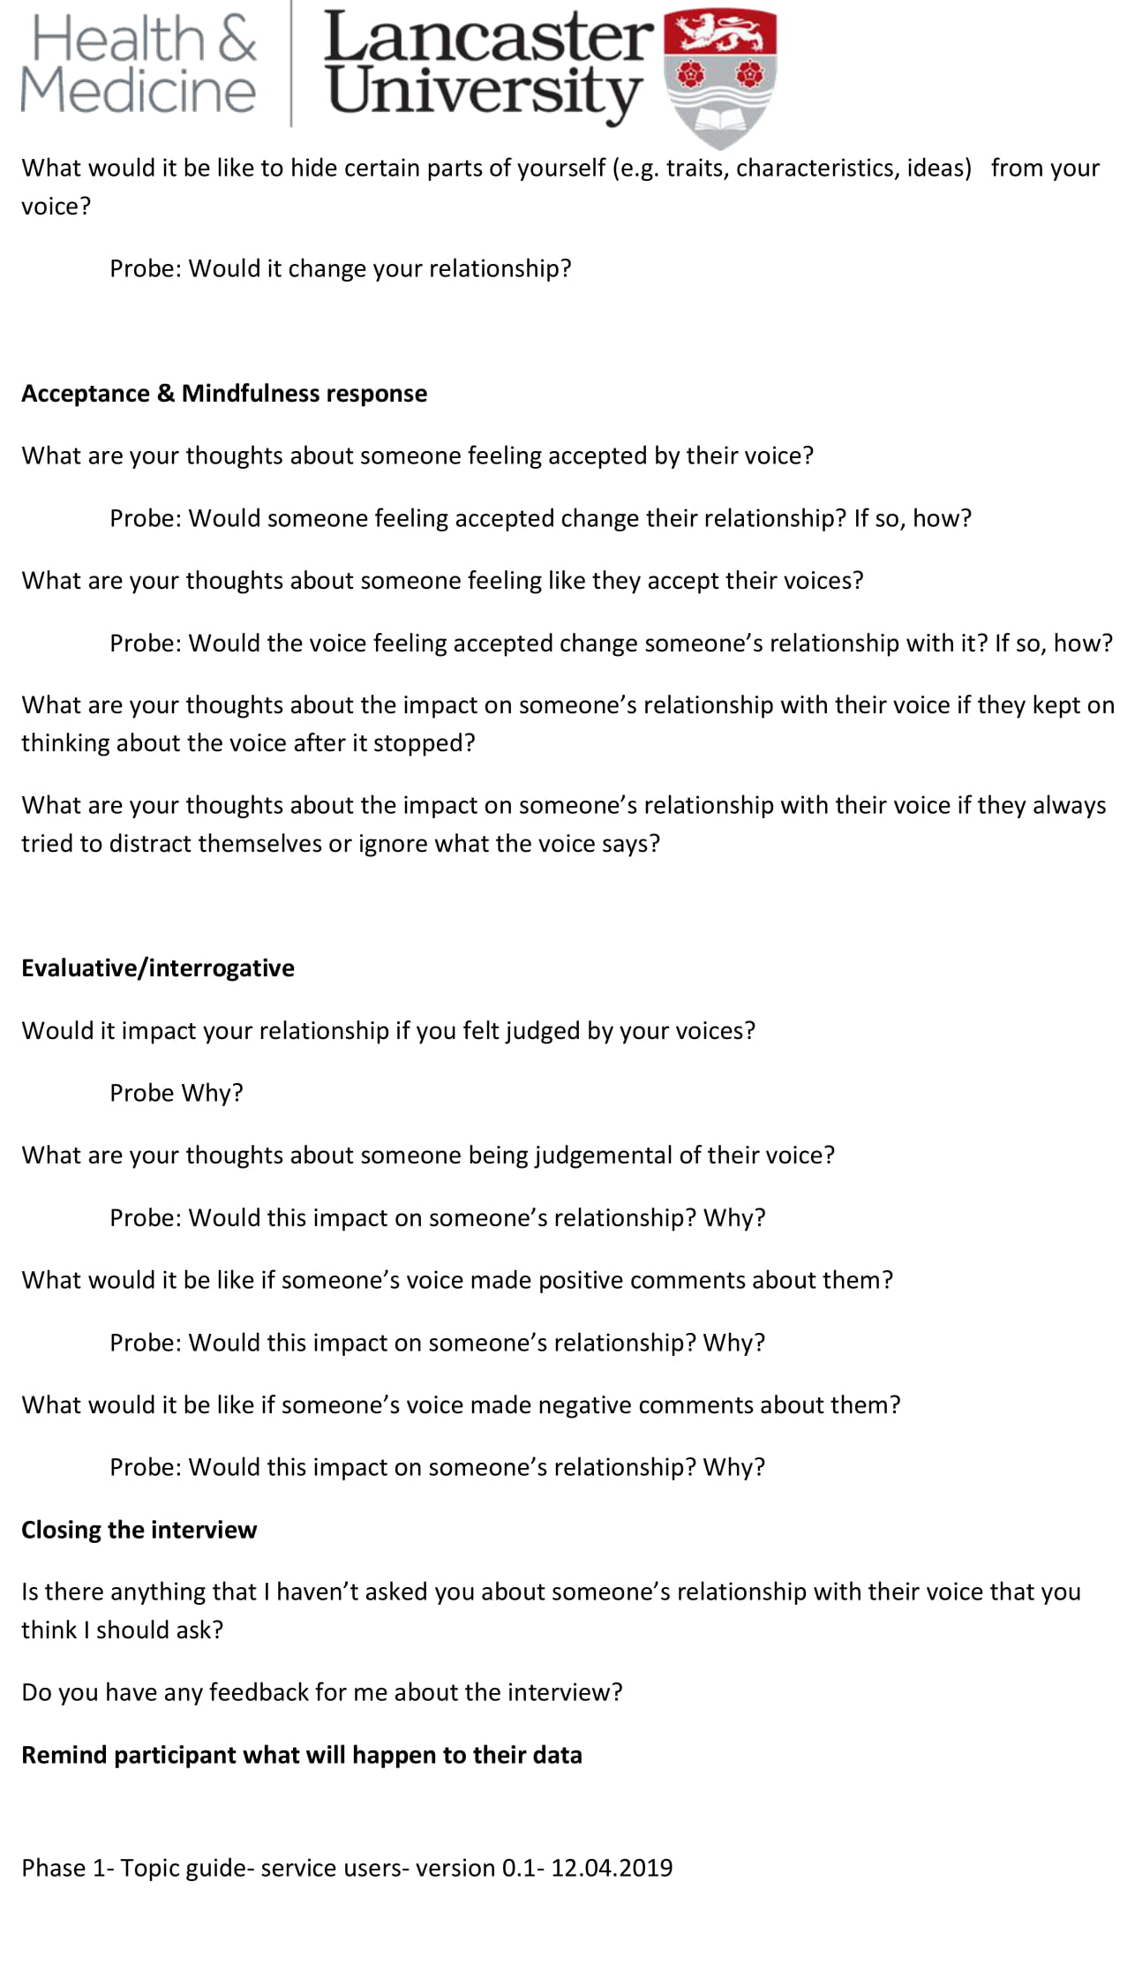

Appendix 5F- Topic guide- Clinicians
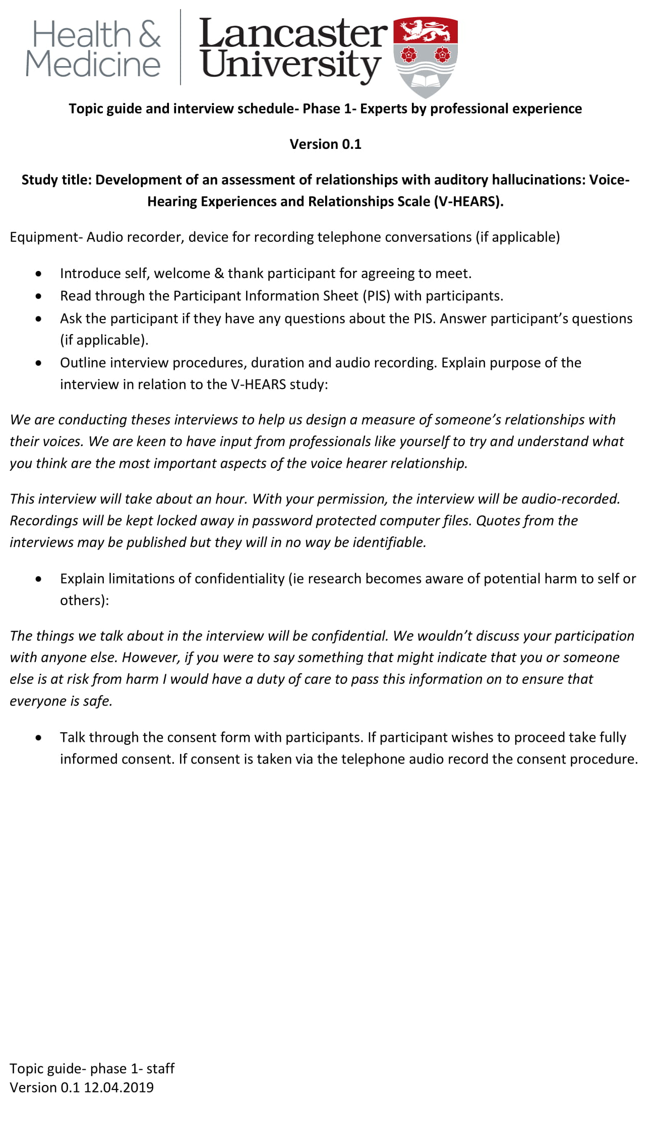
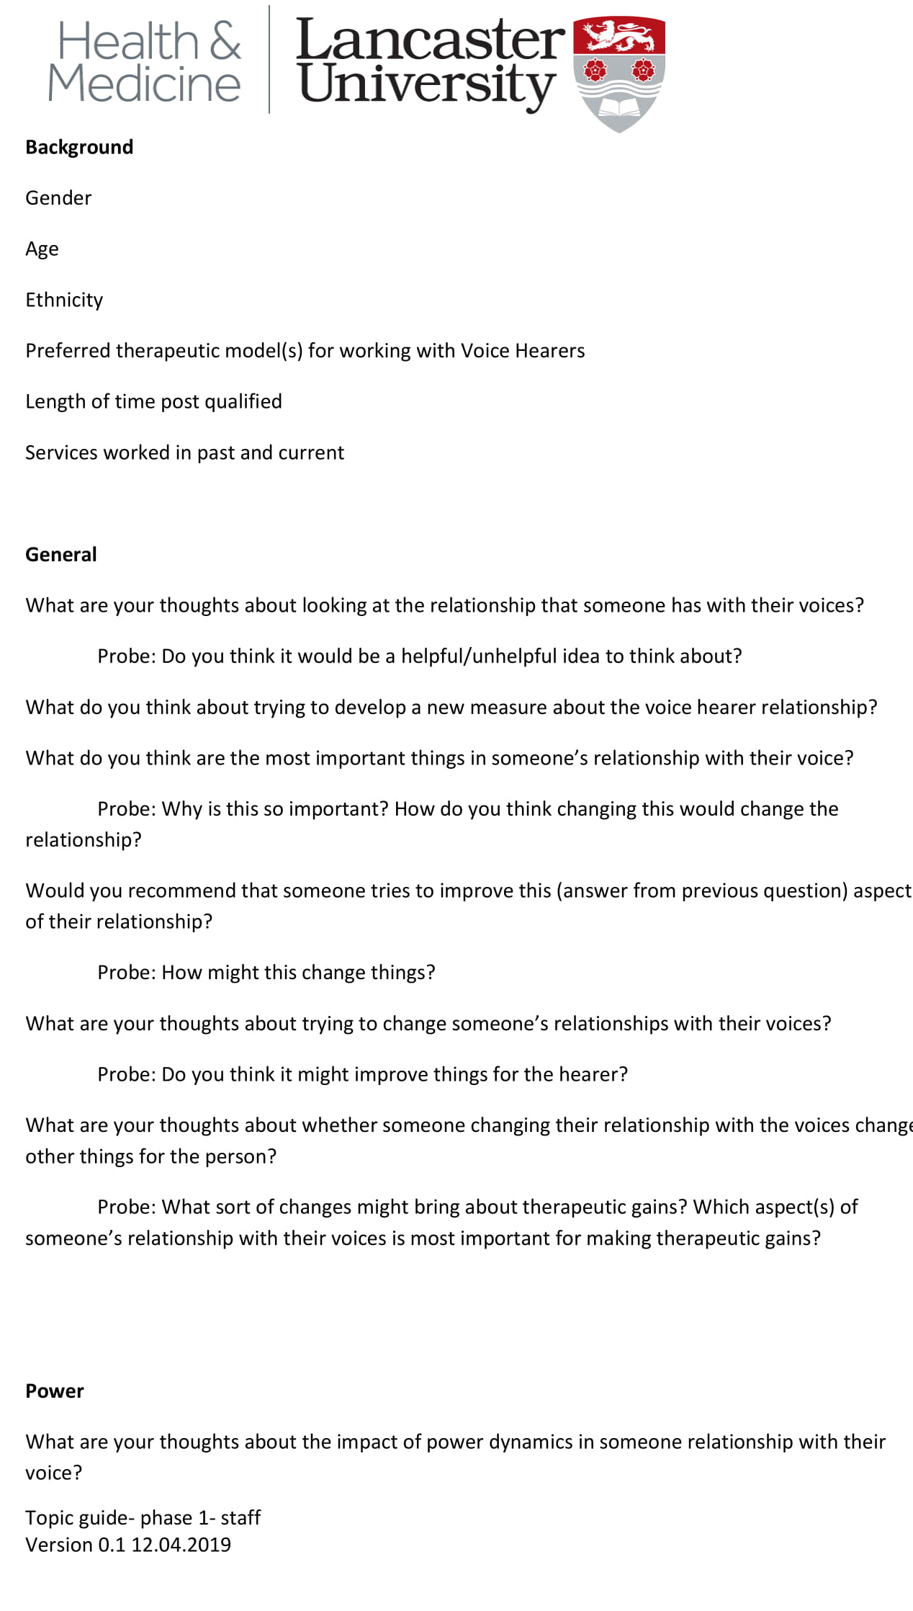
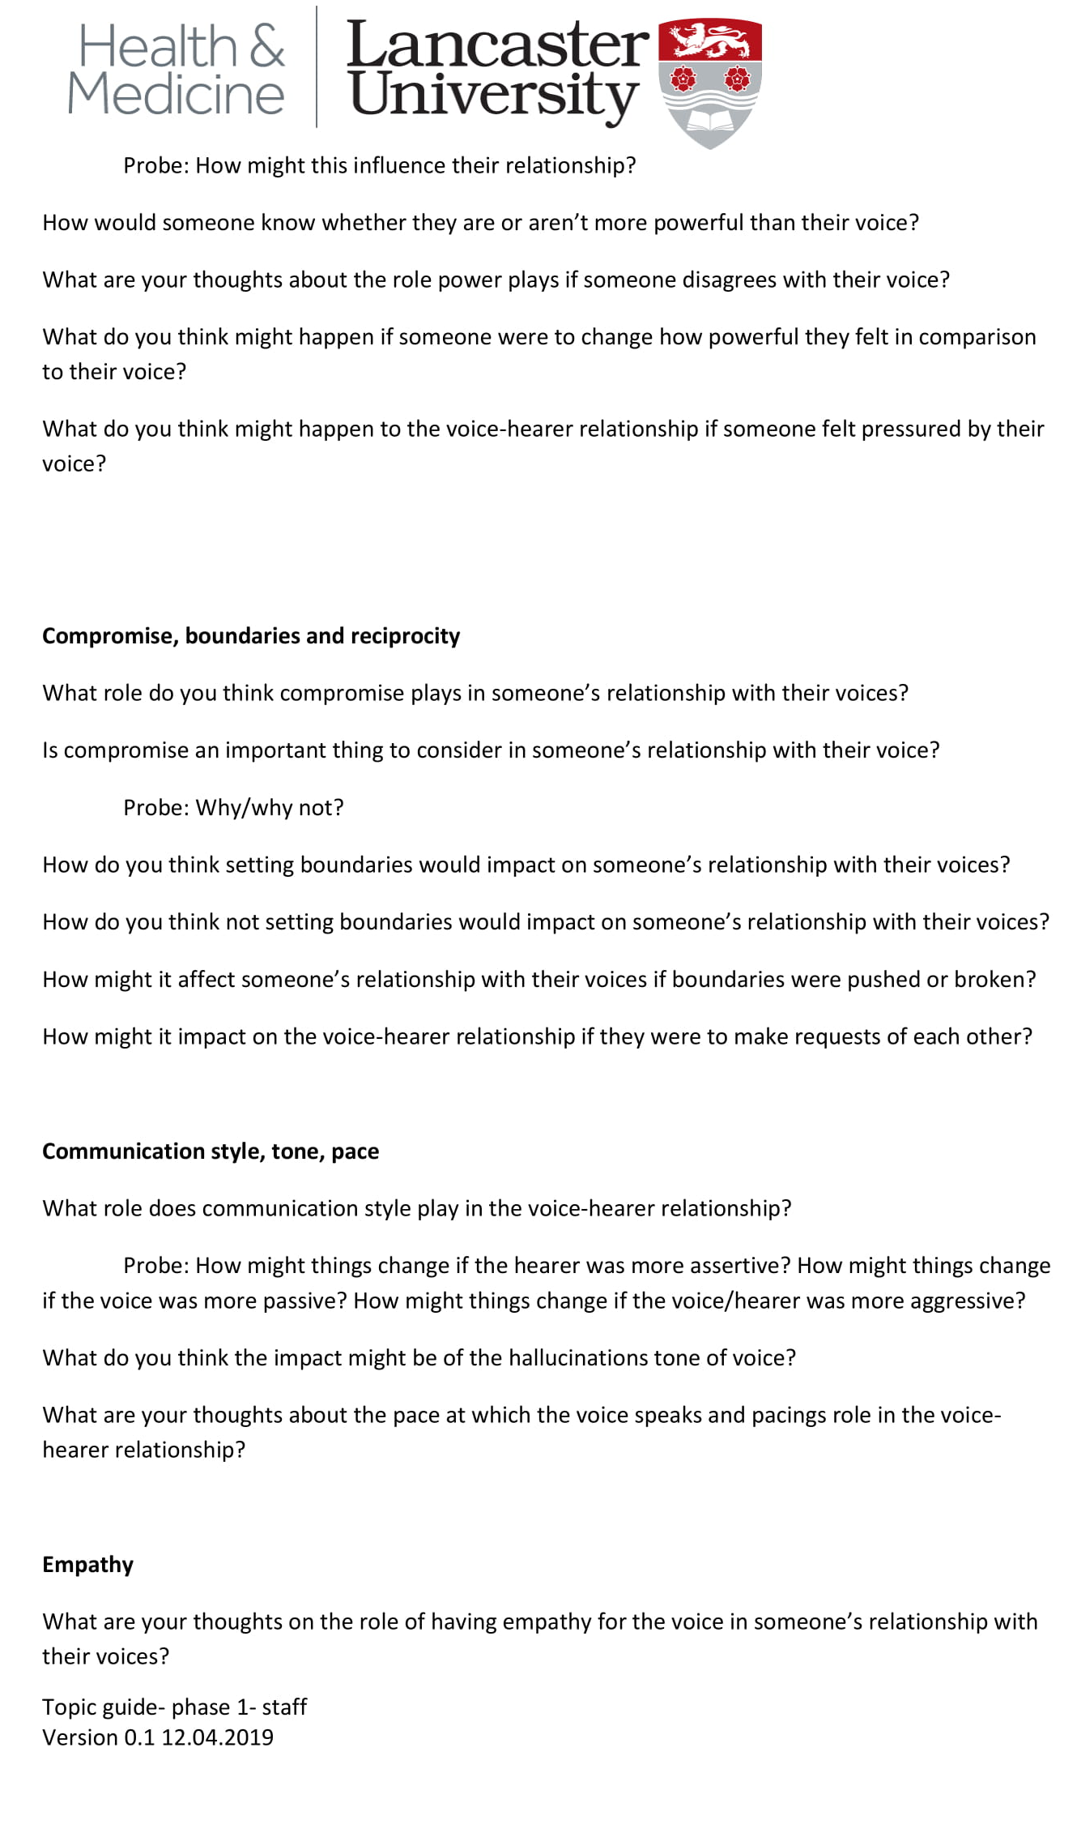
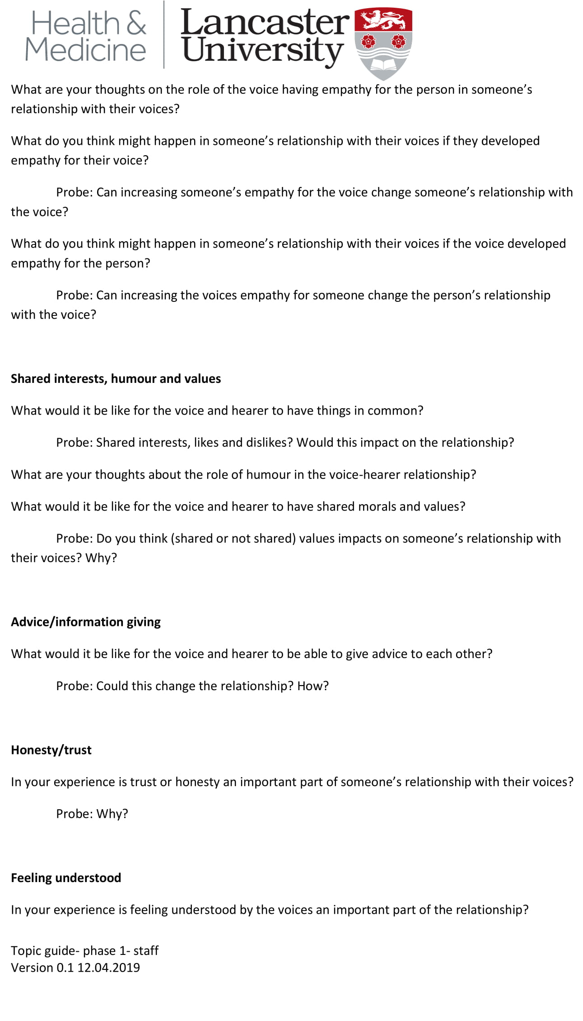
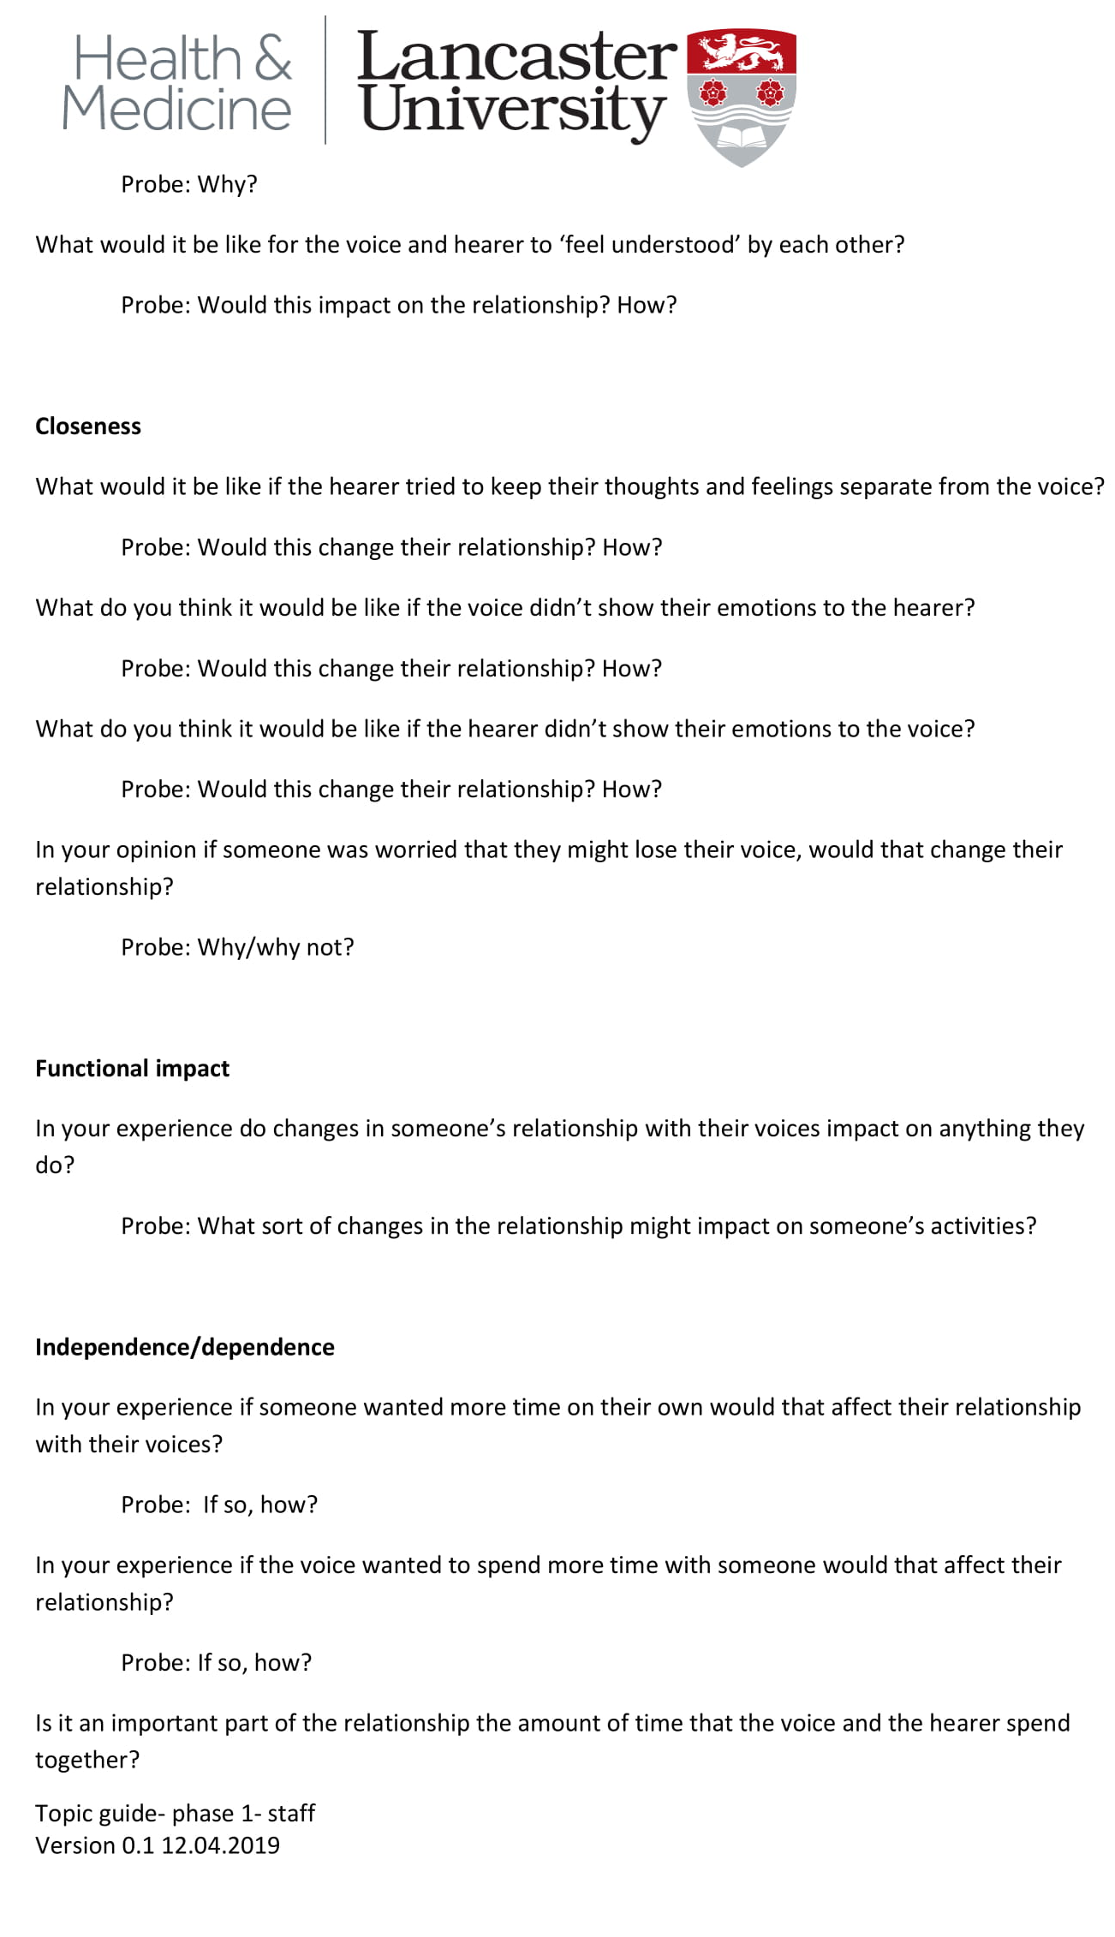
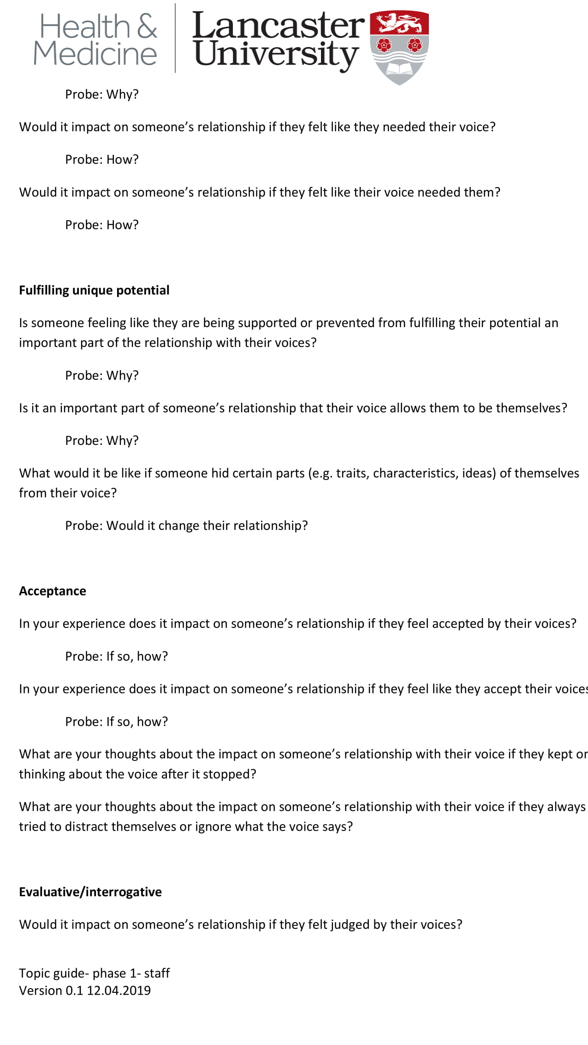
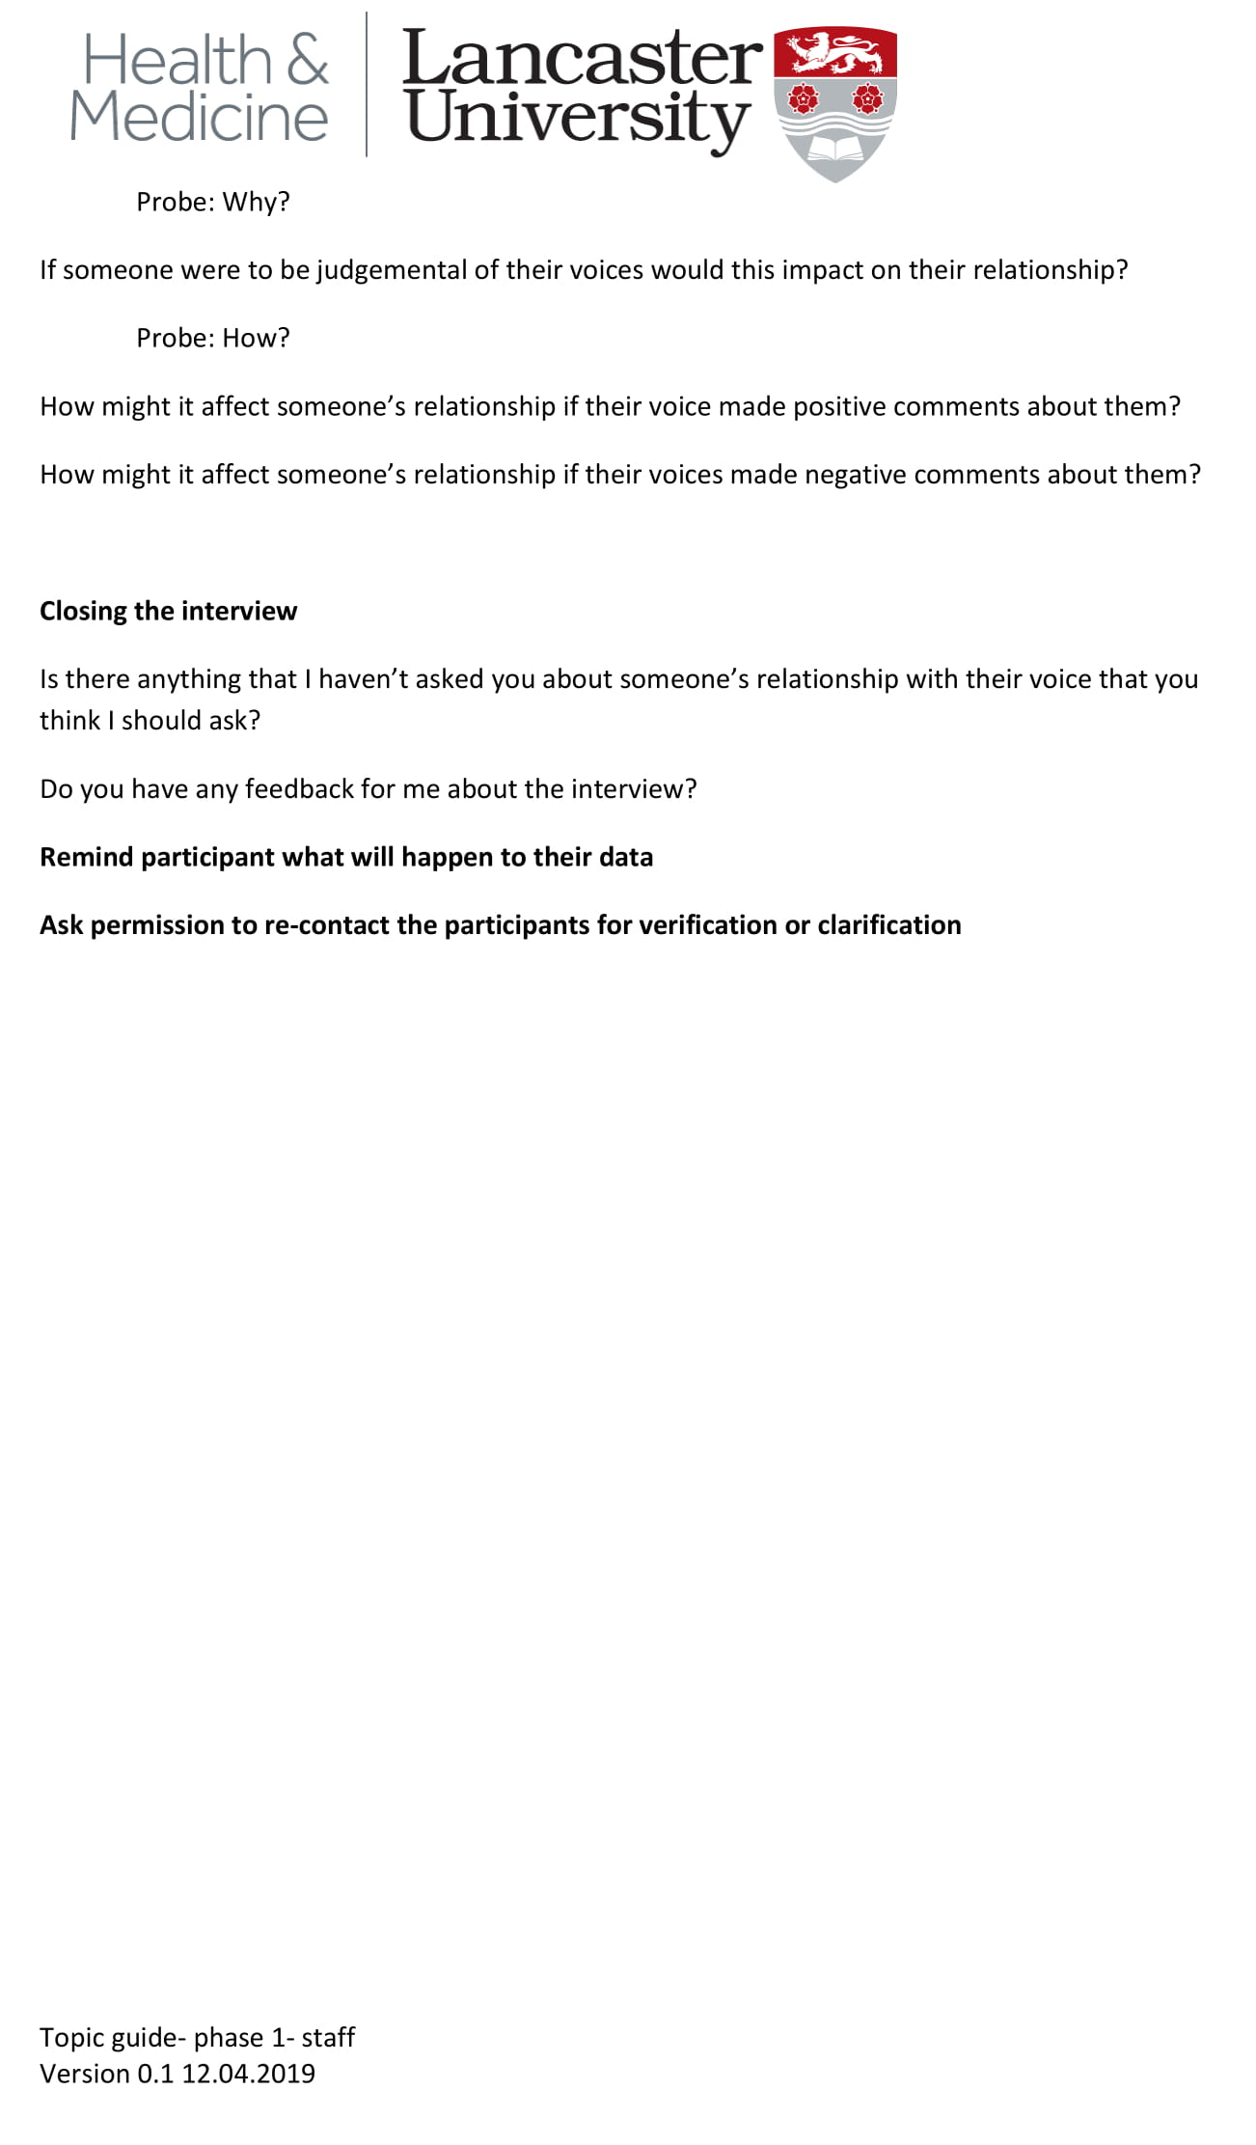

Appendix 5G- Debrief researcher sheet 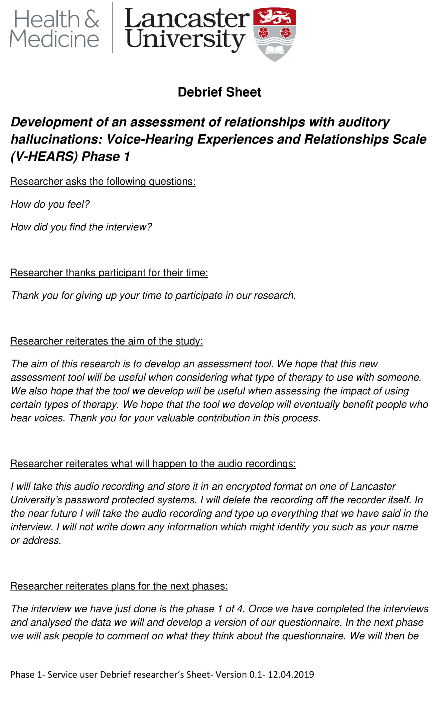
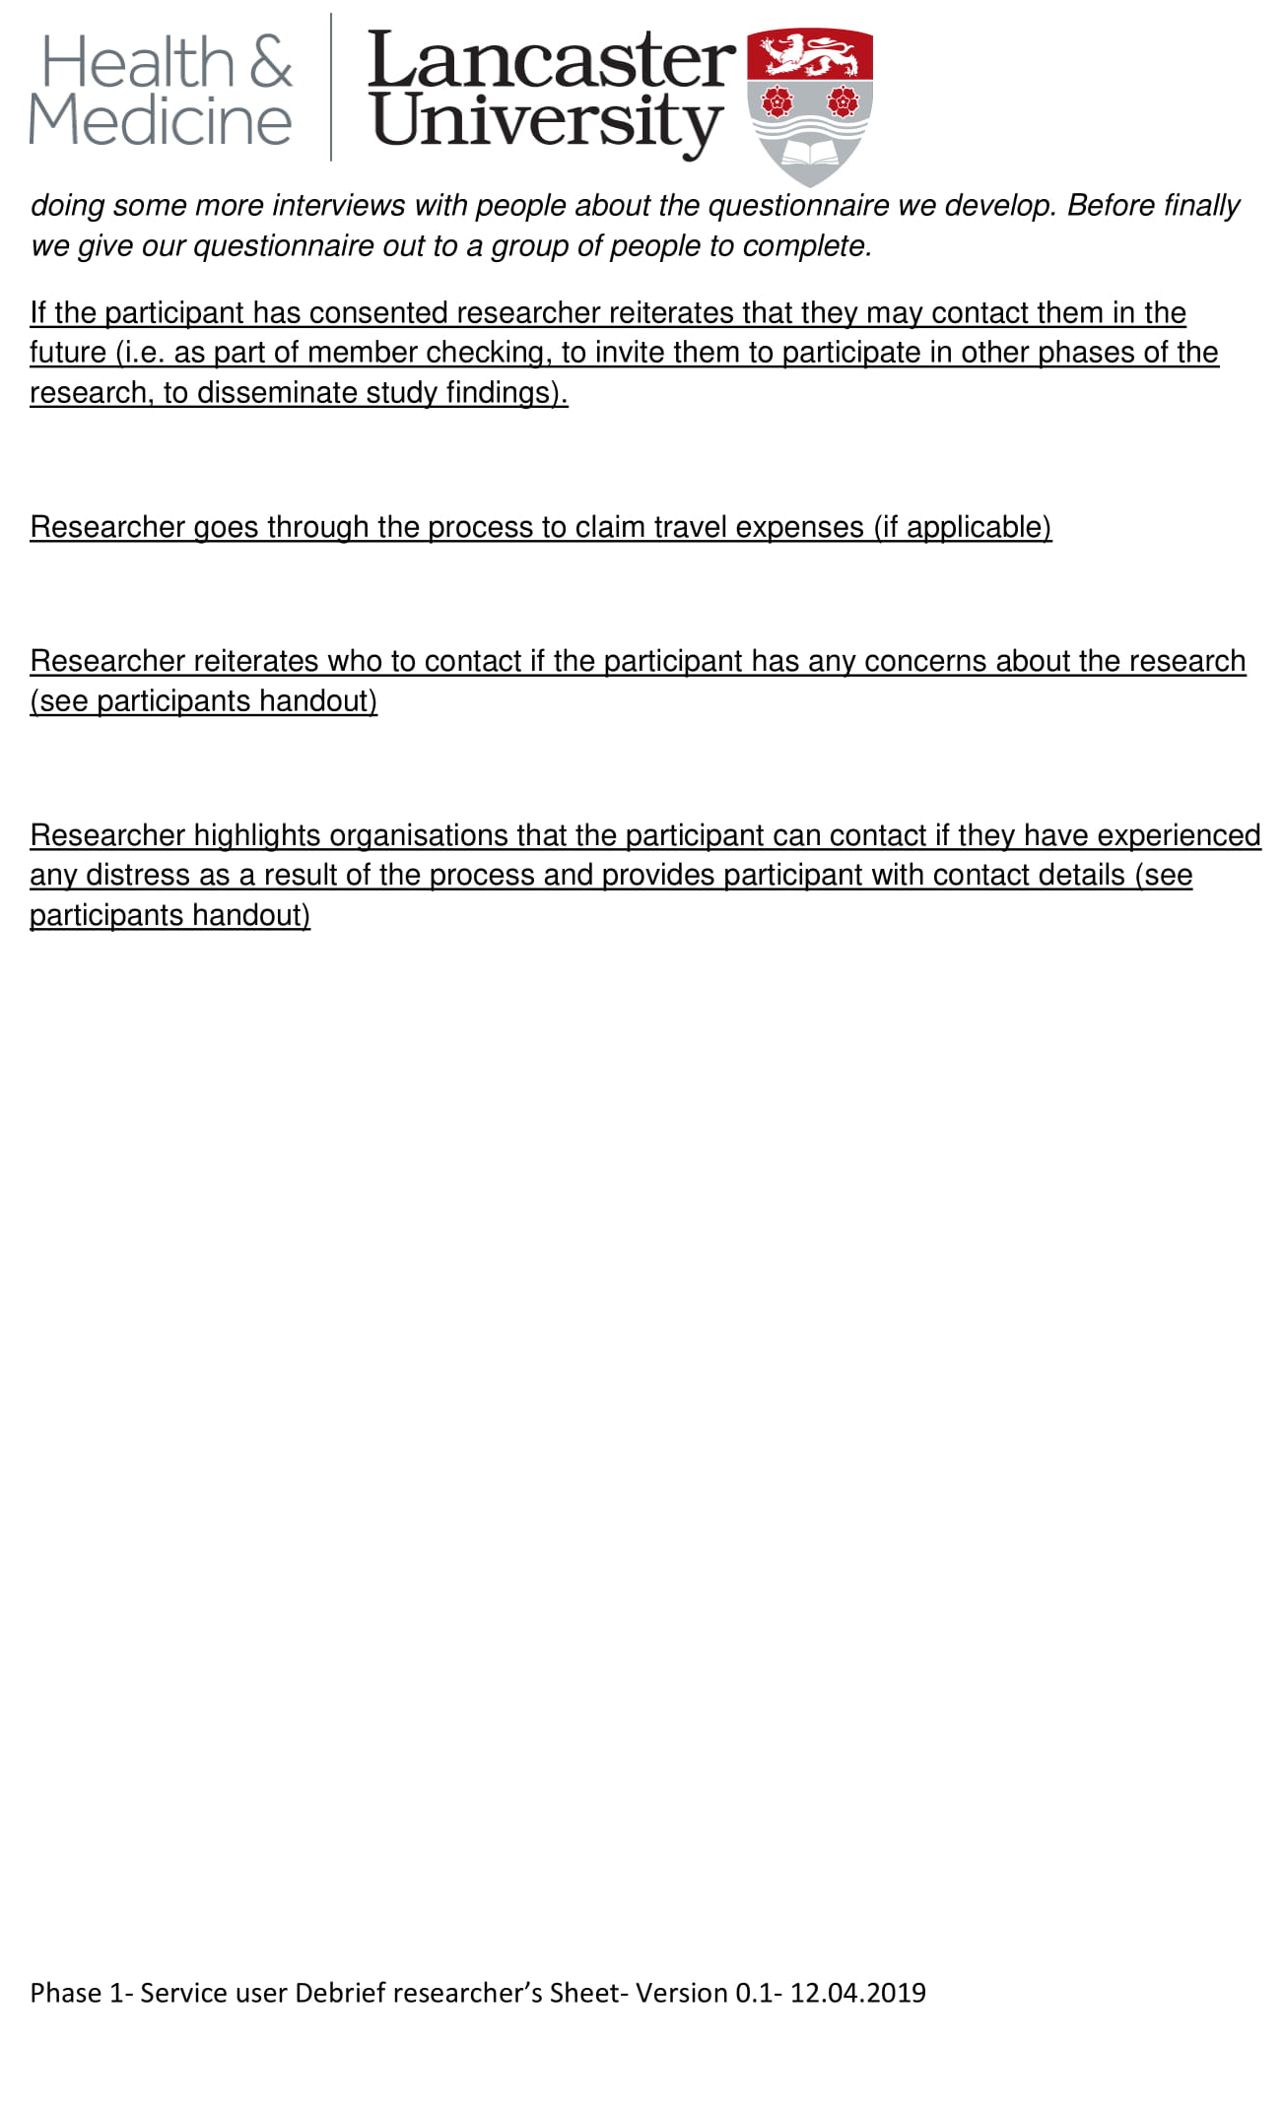

Appendix 5H- Debrief sheet- participant handout 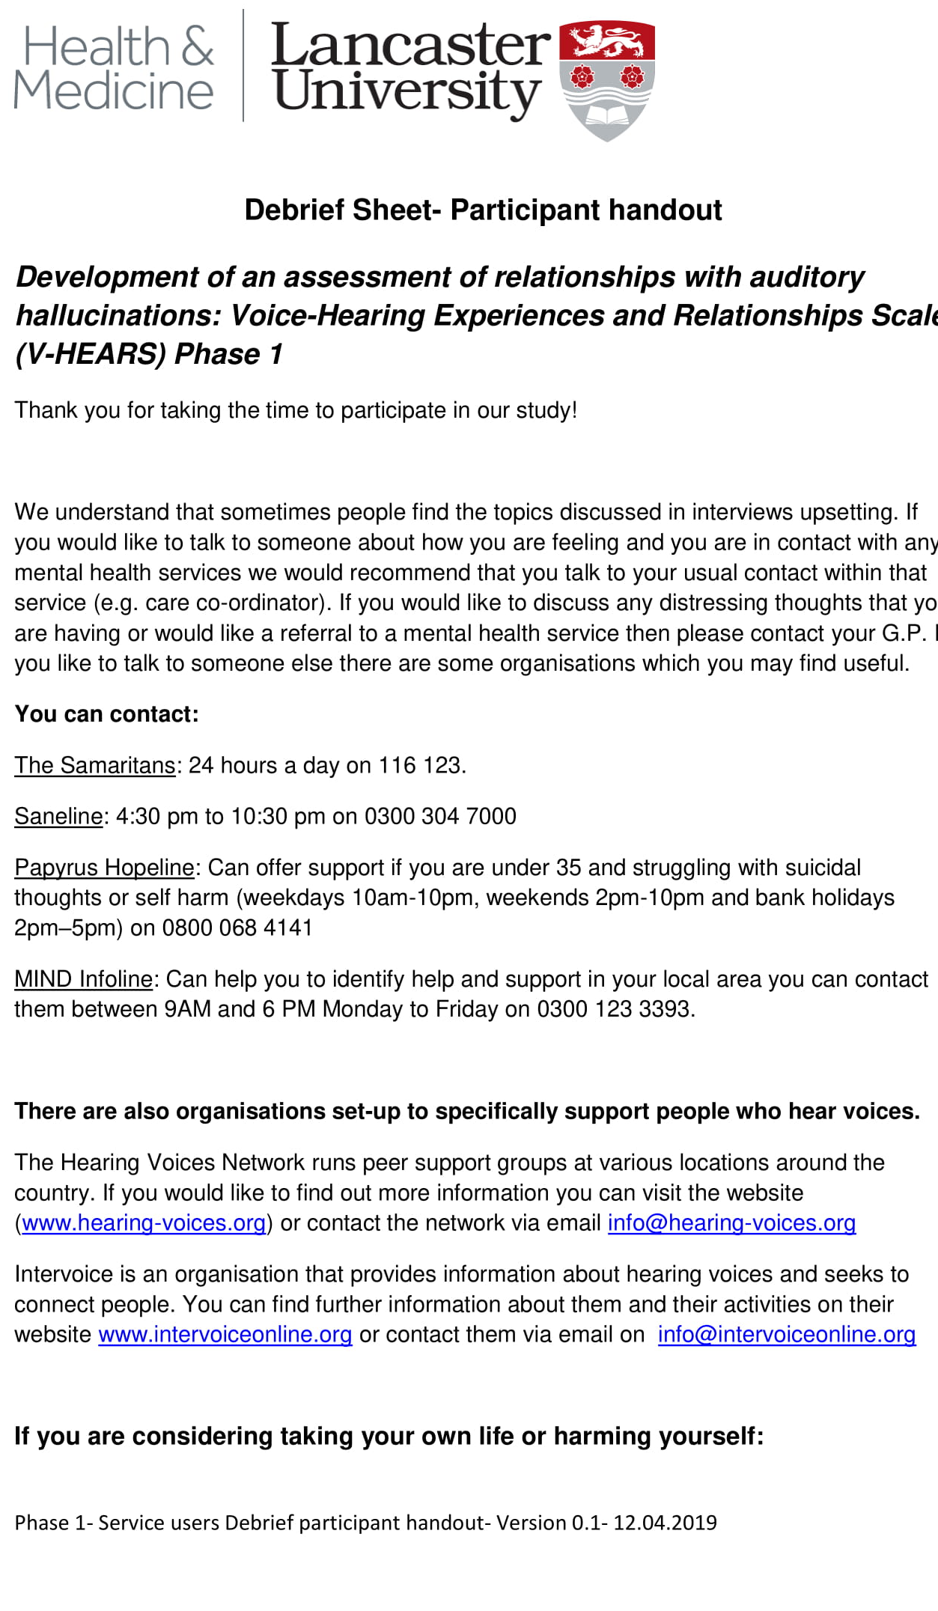

Appendix 5I-Favourable opinion letters REC & HRA

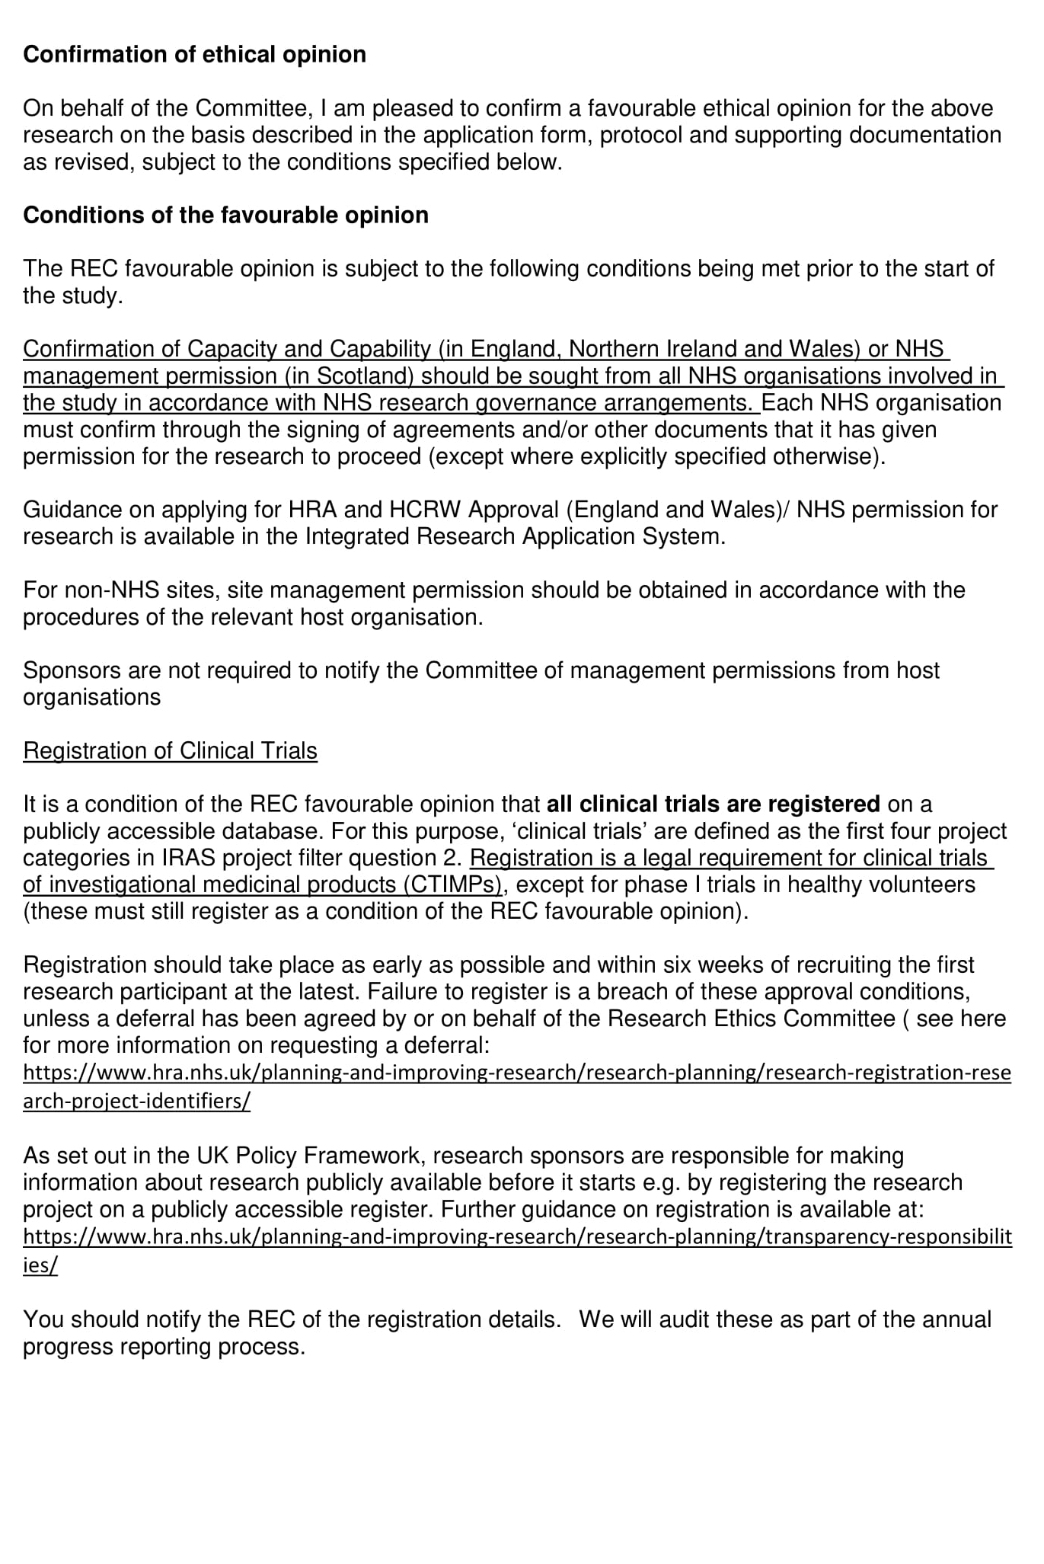

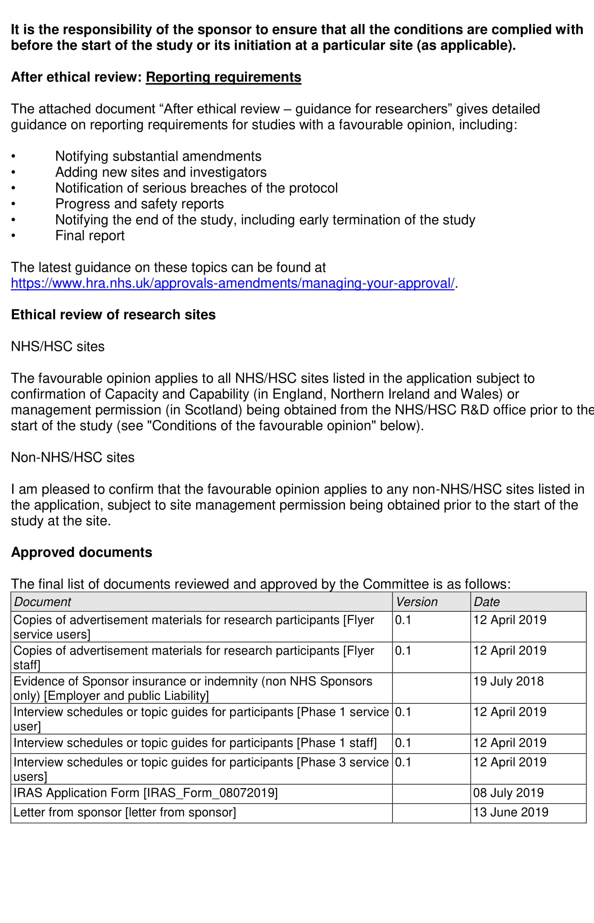
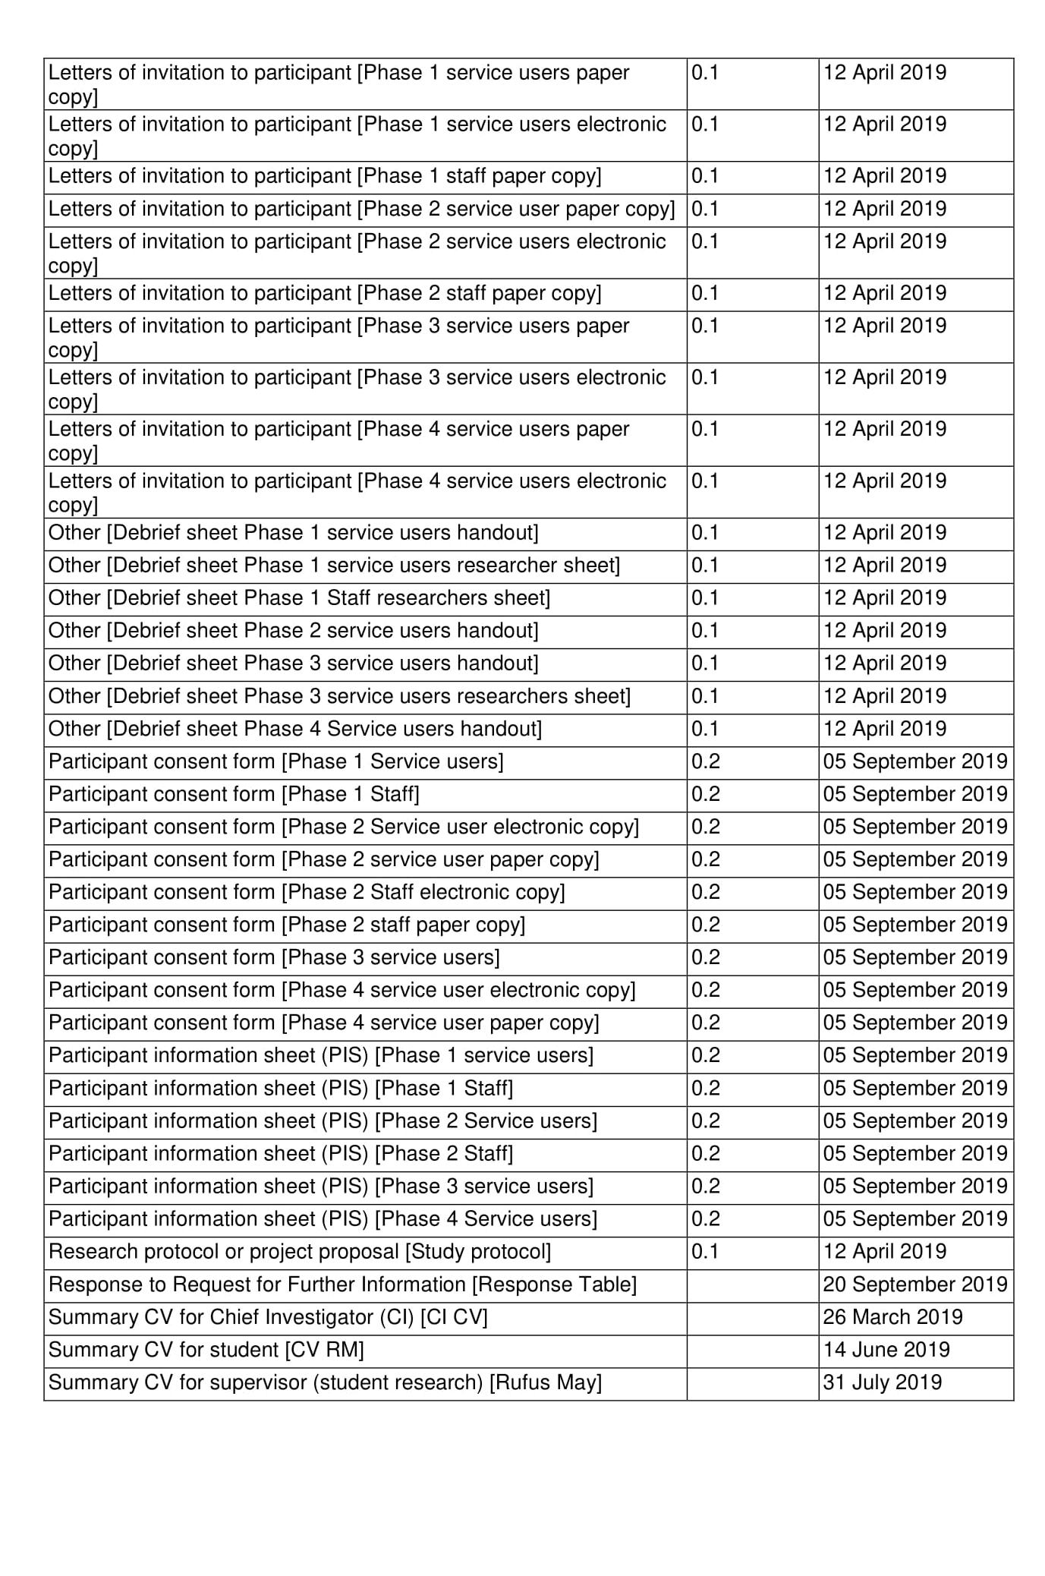
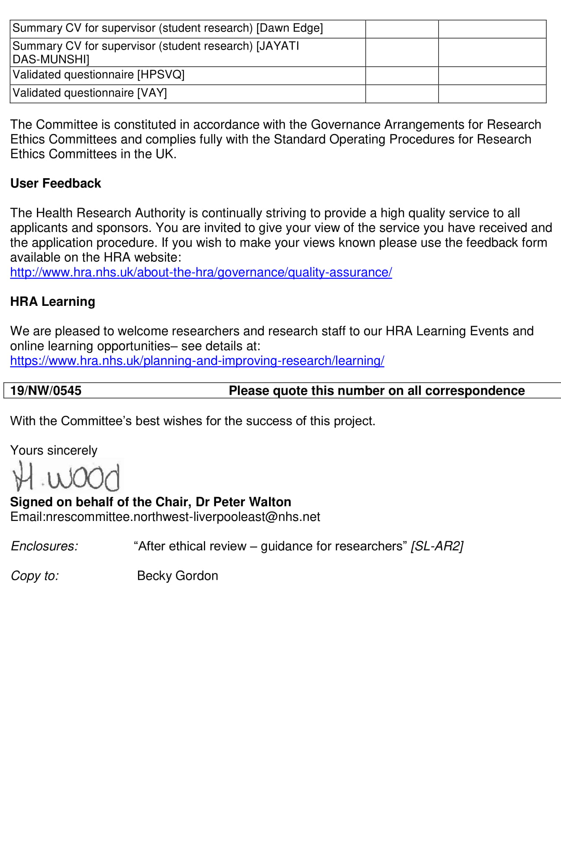
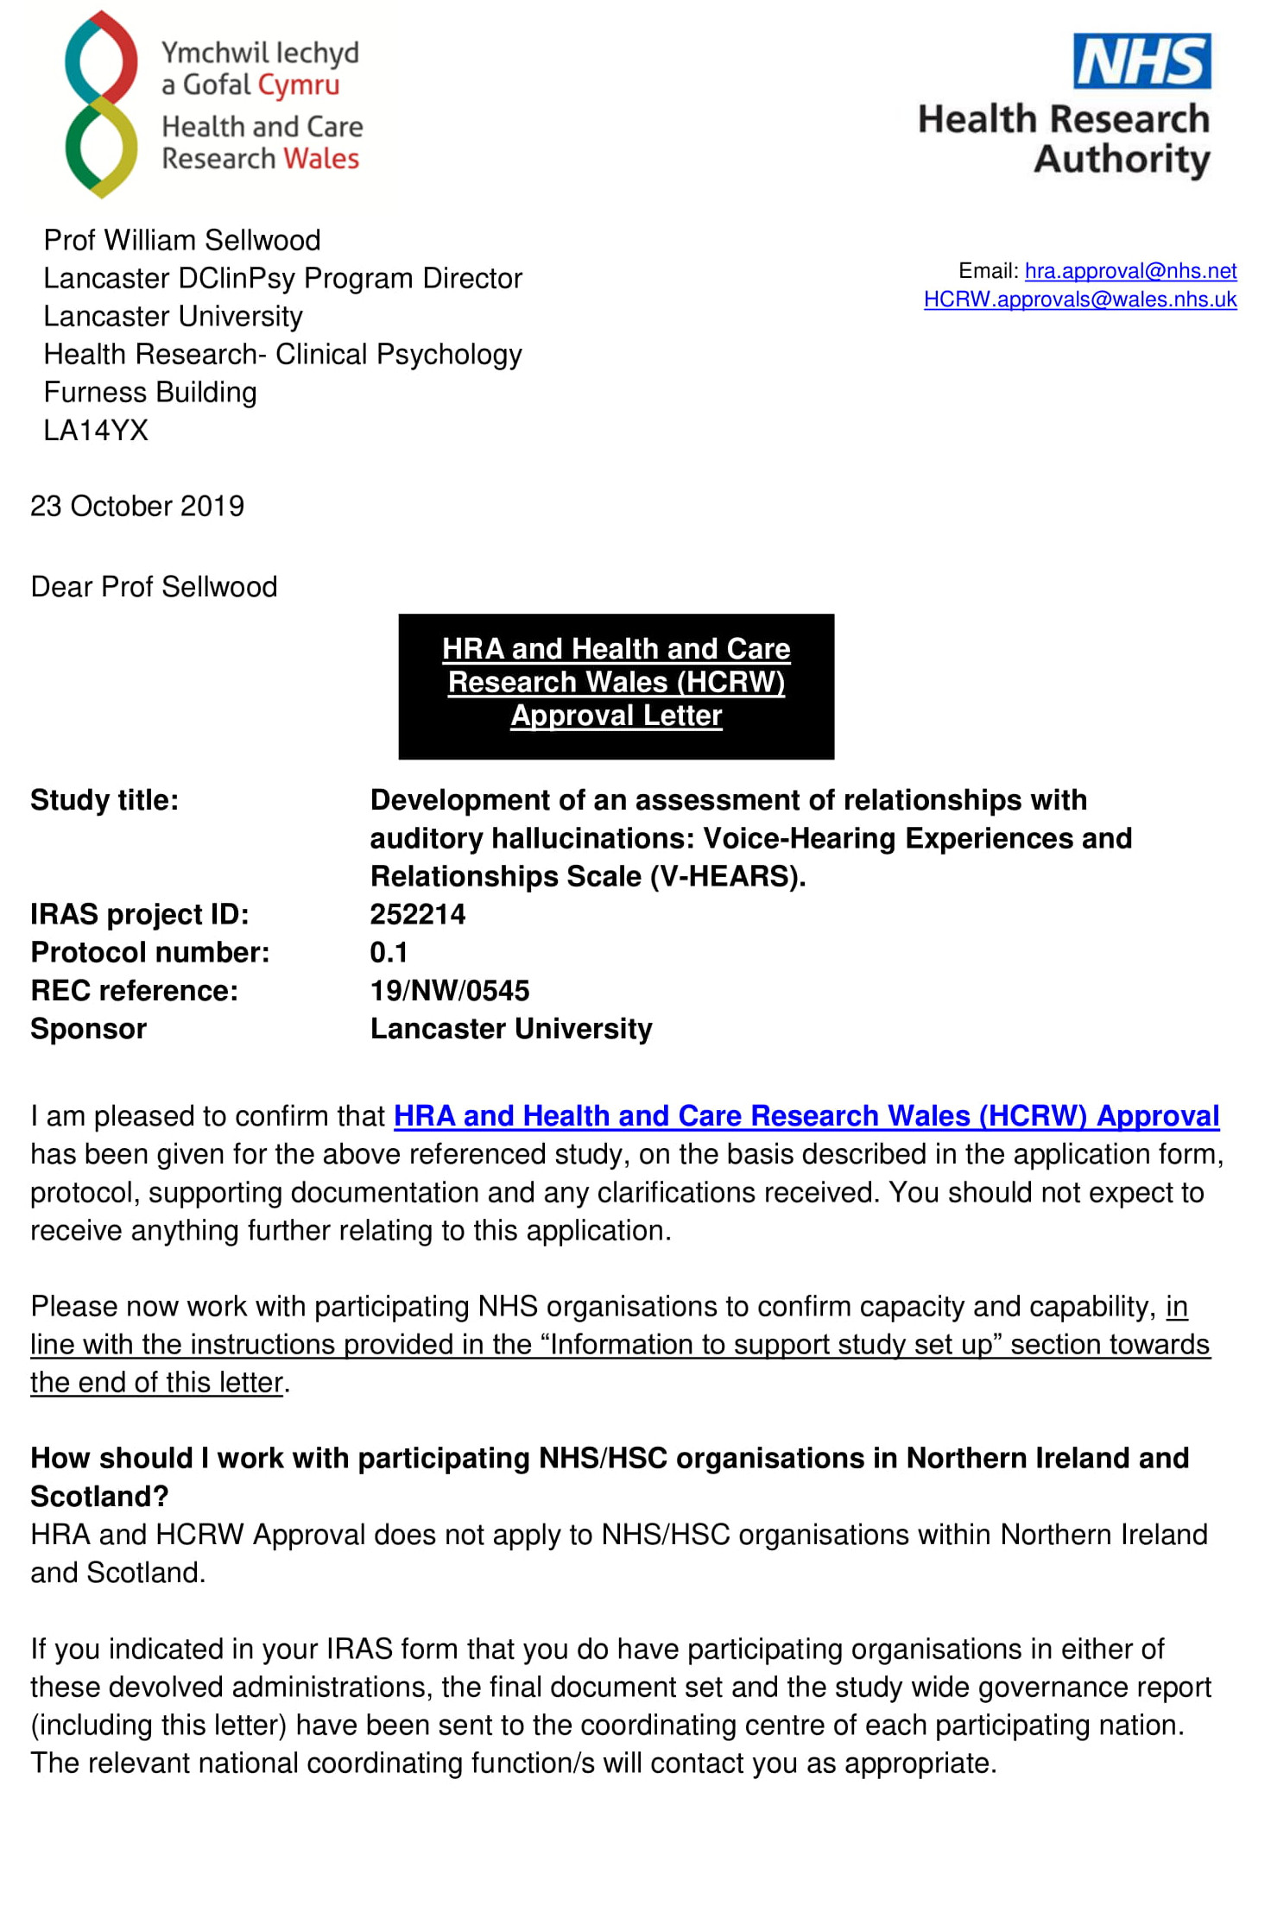
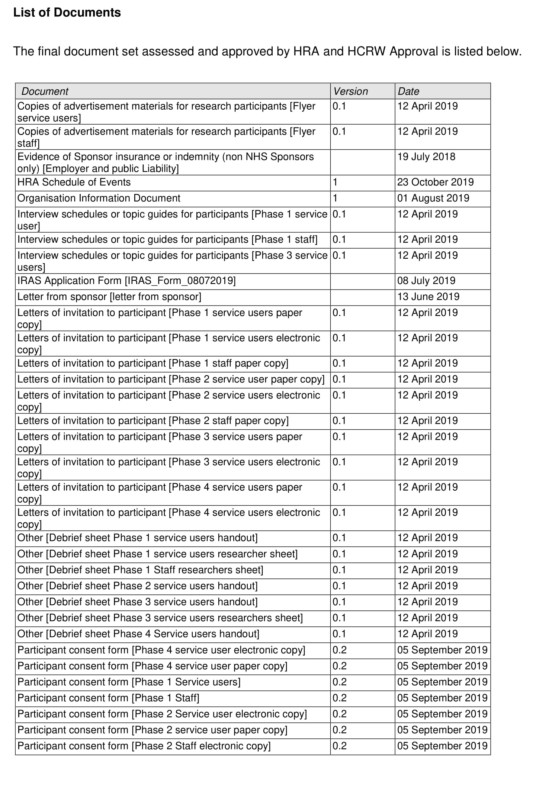
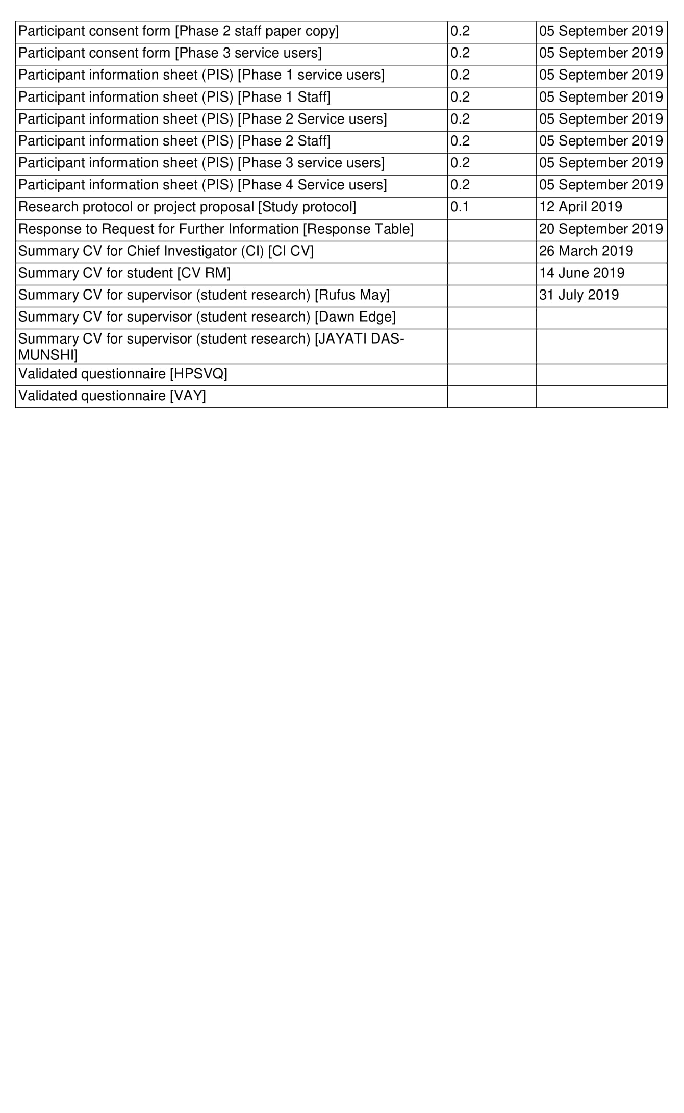

Appendix 5J- Ethics committee correspondence
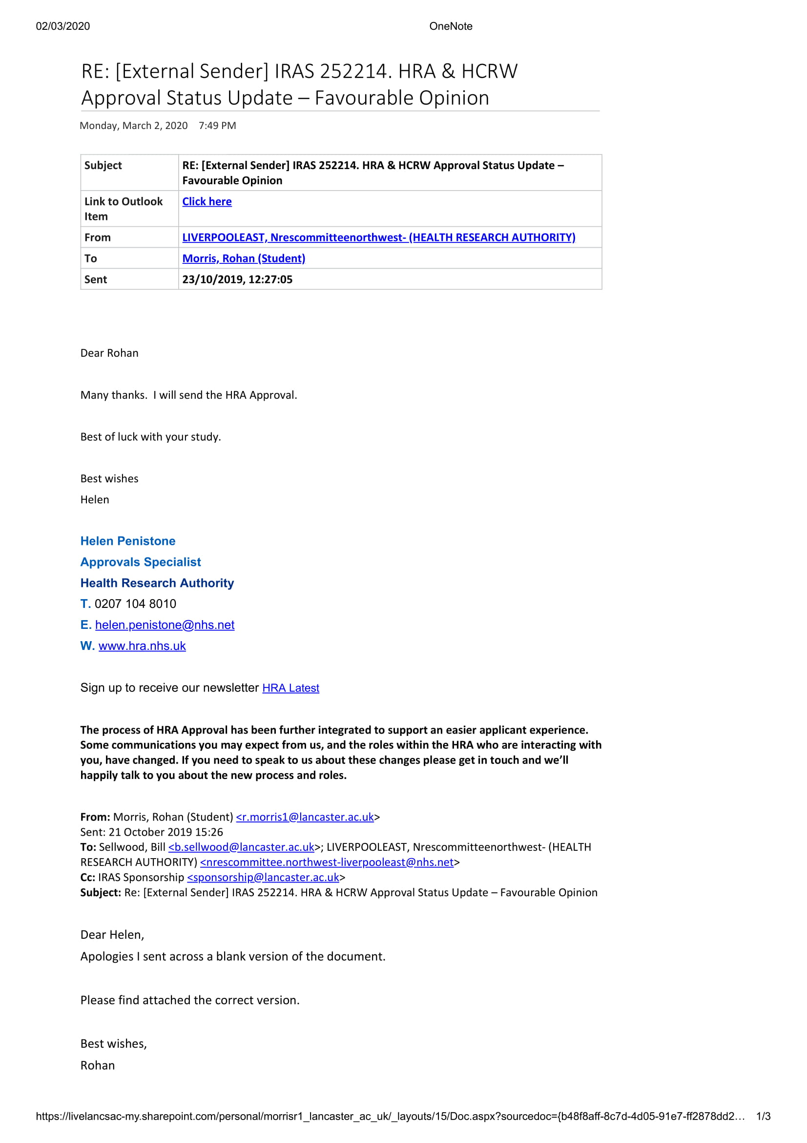
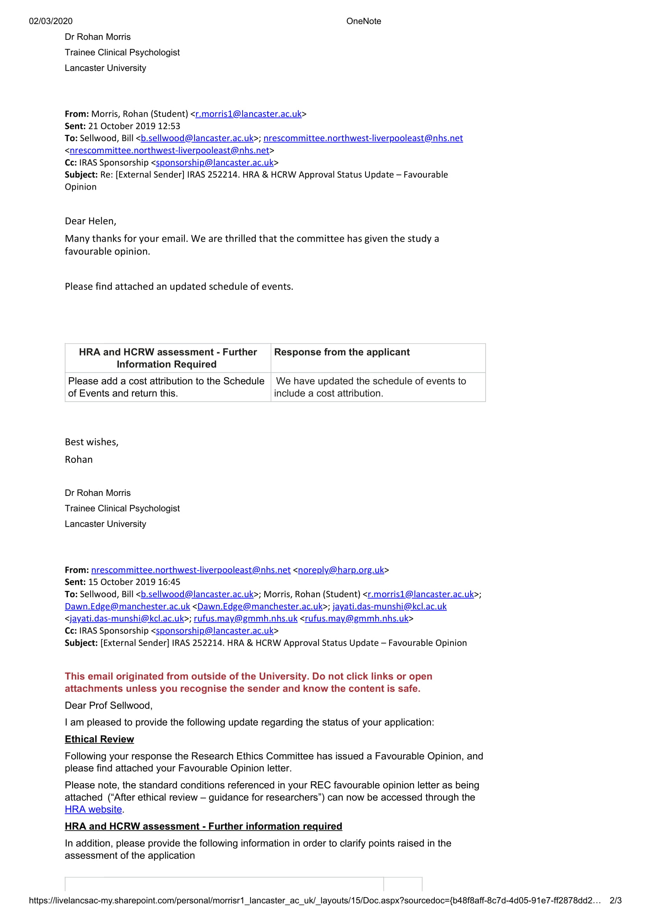
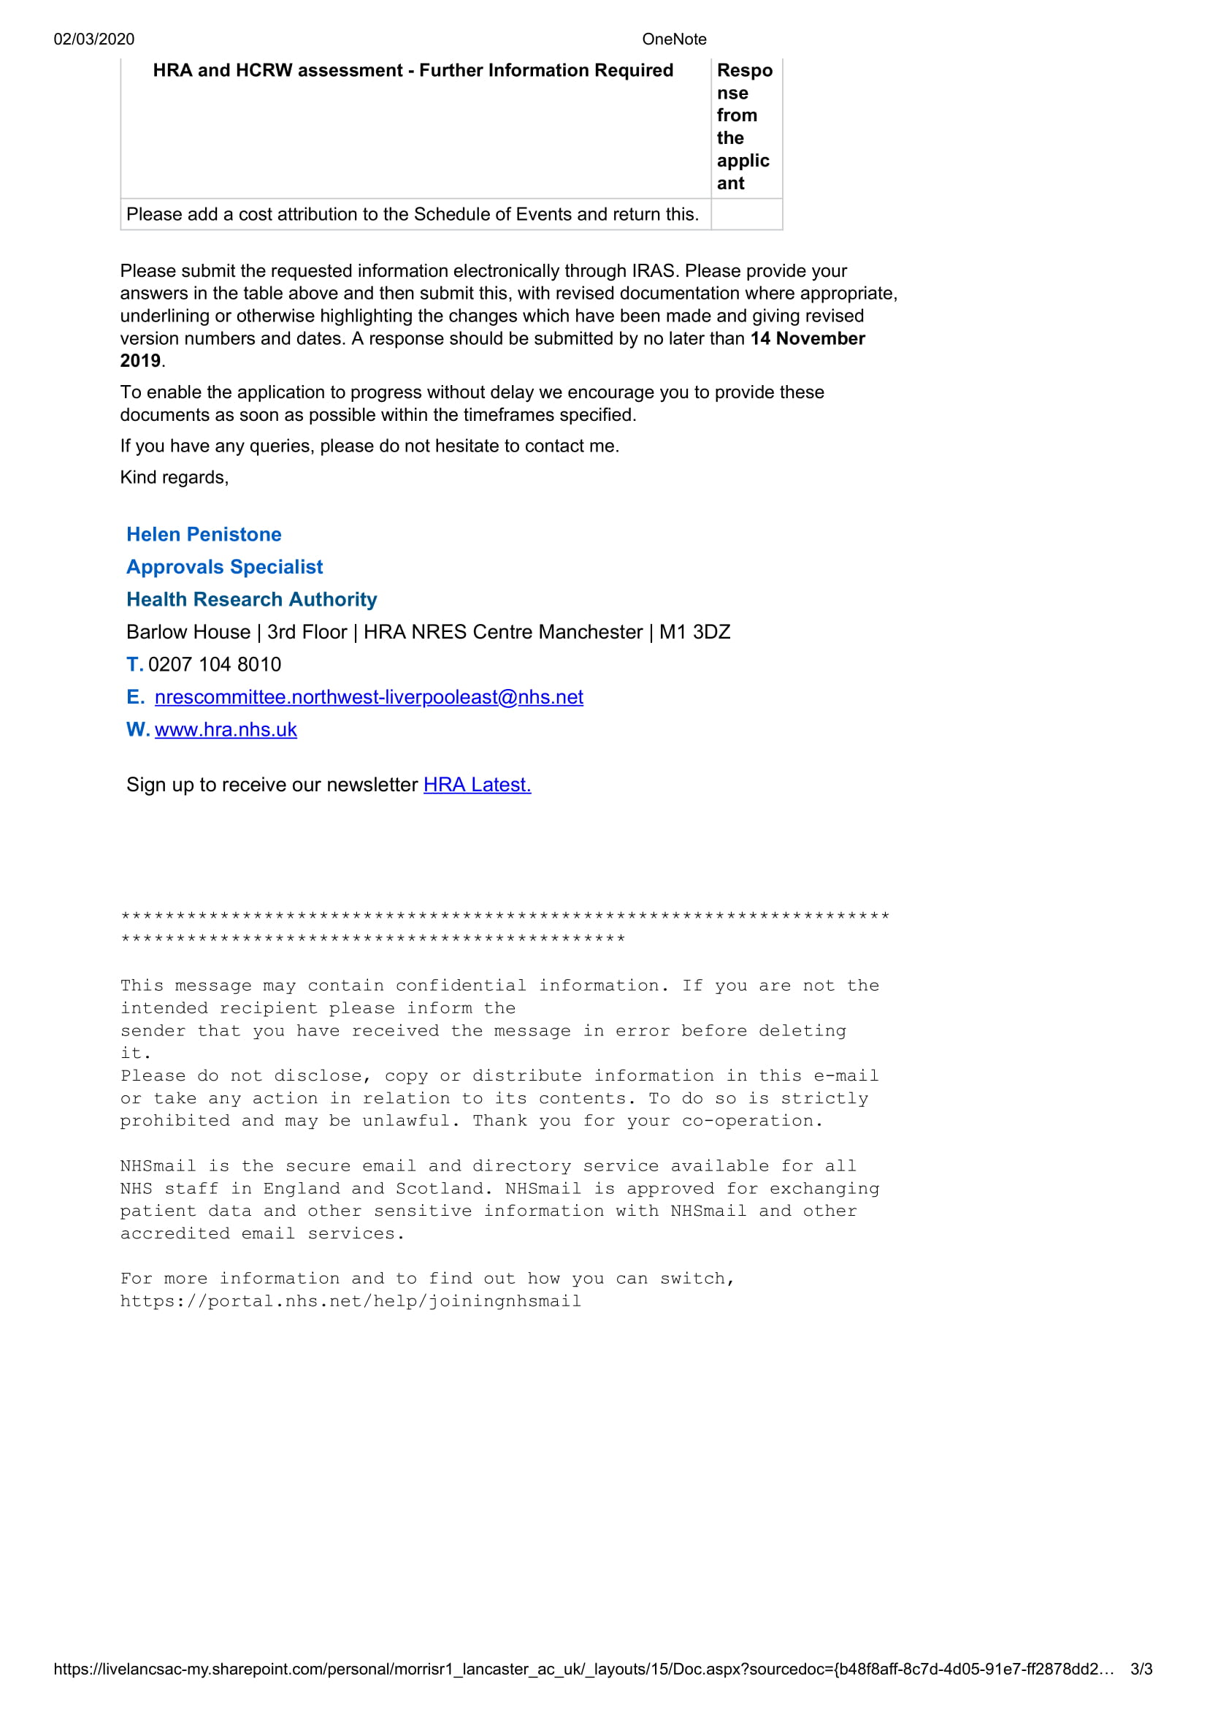

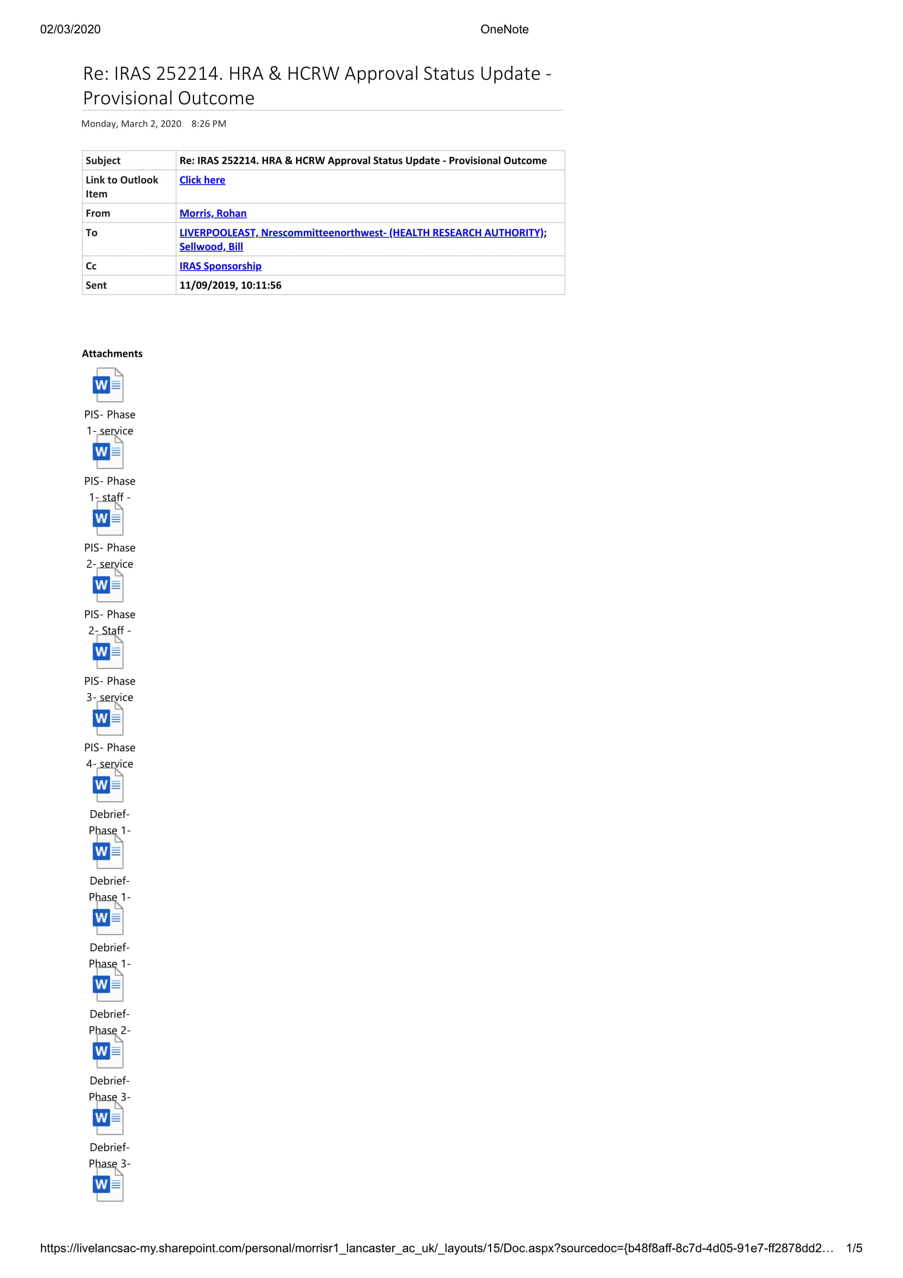
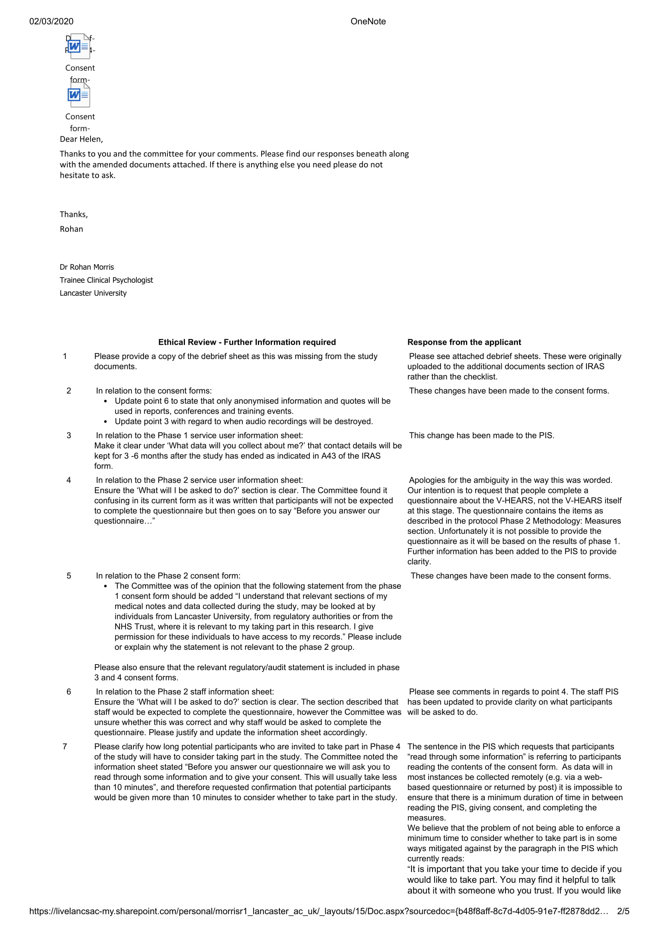
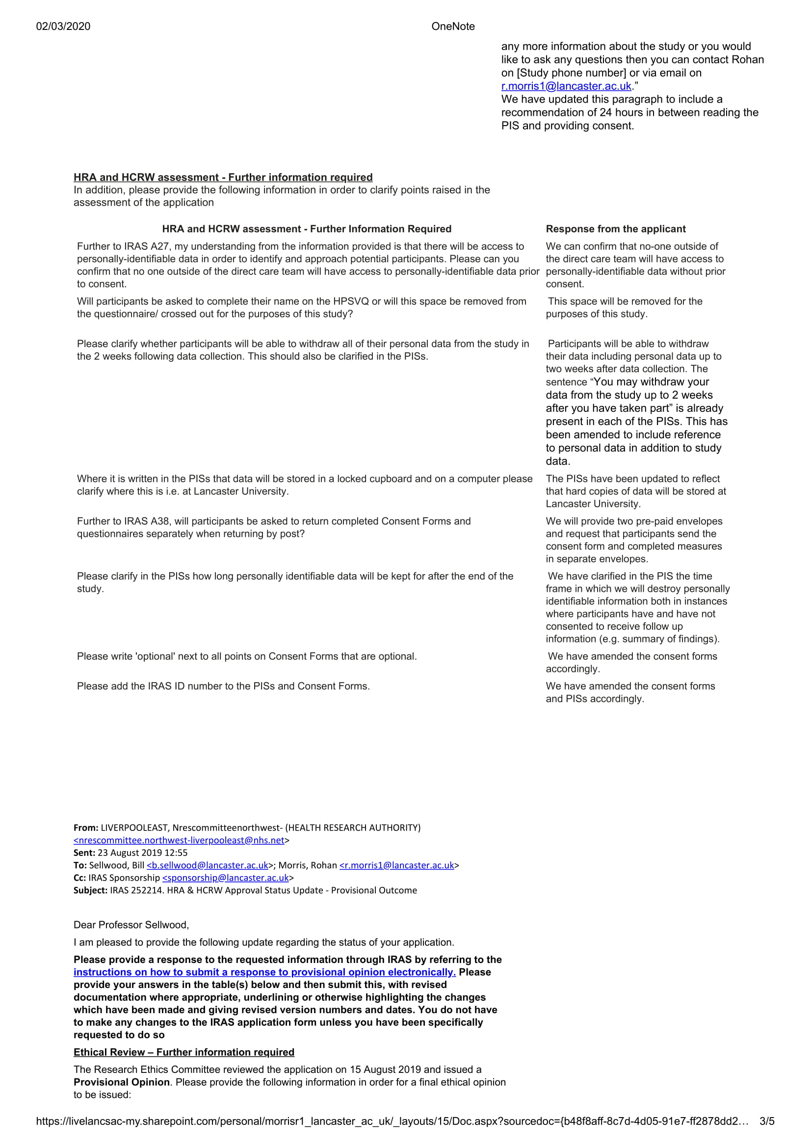
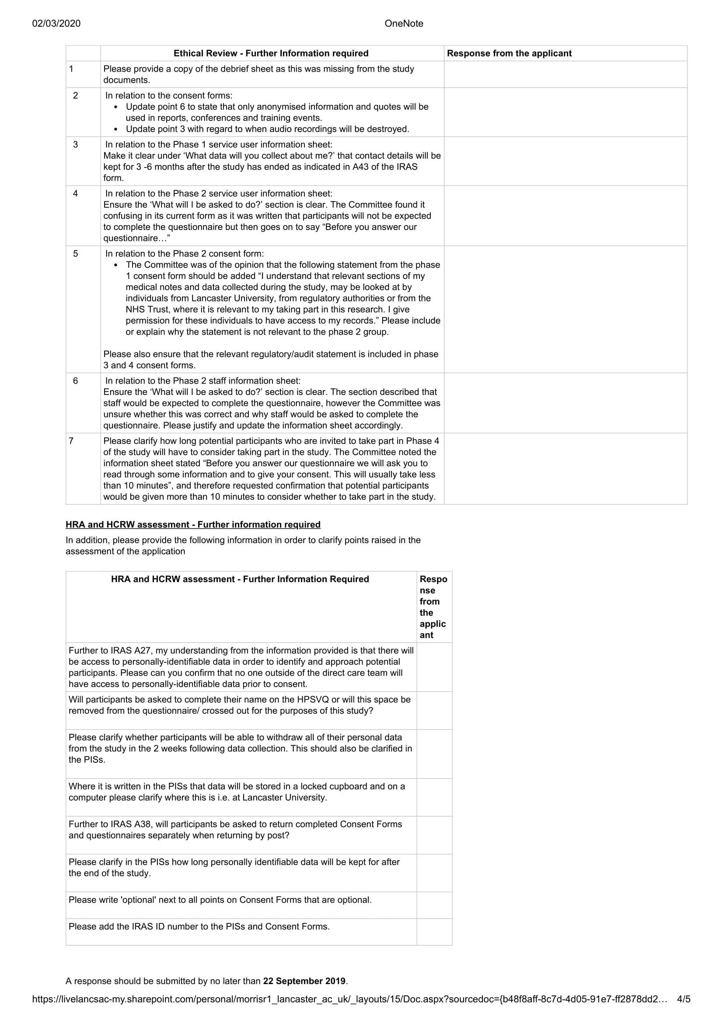
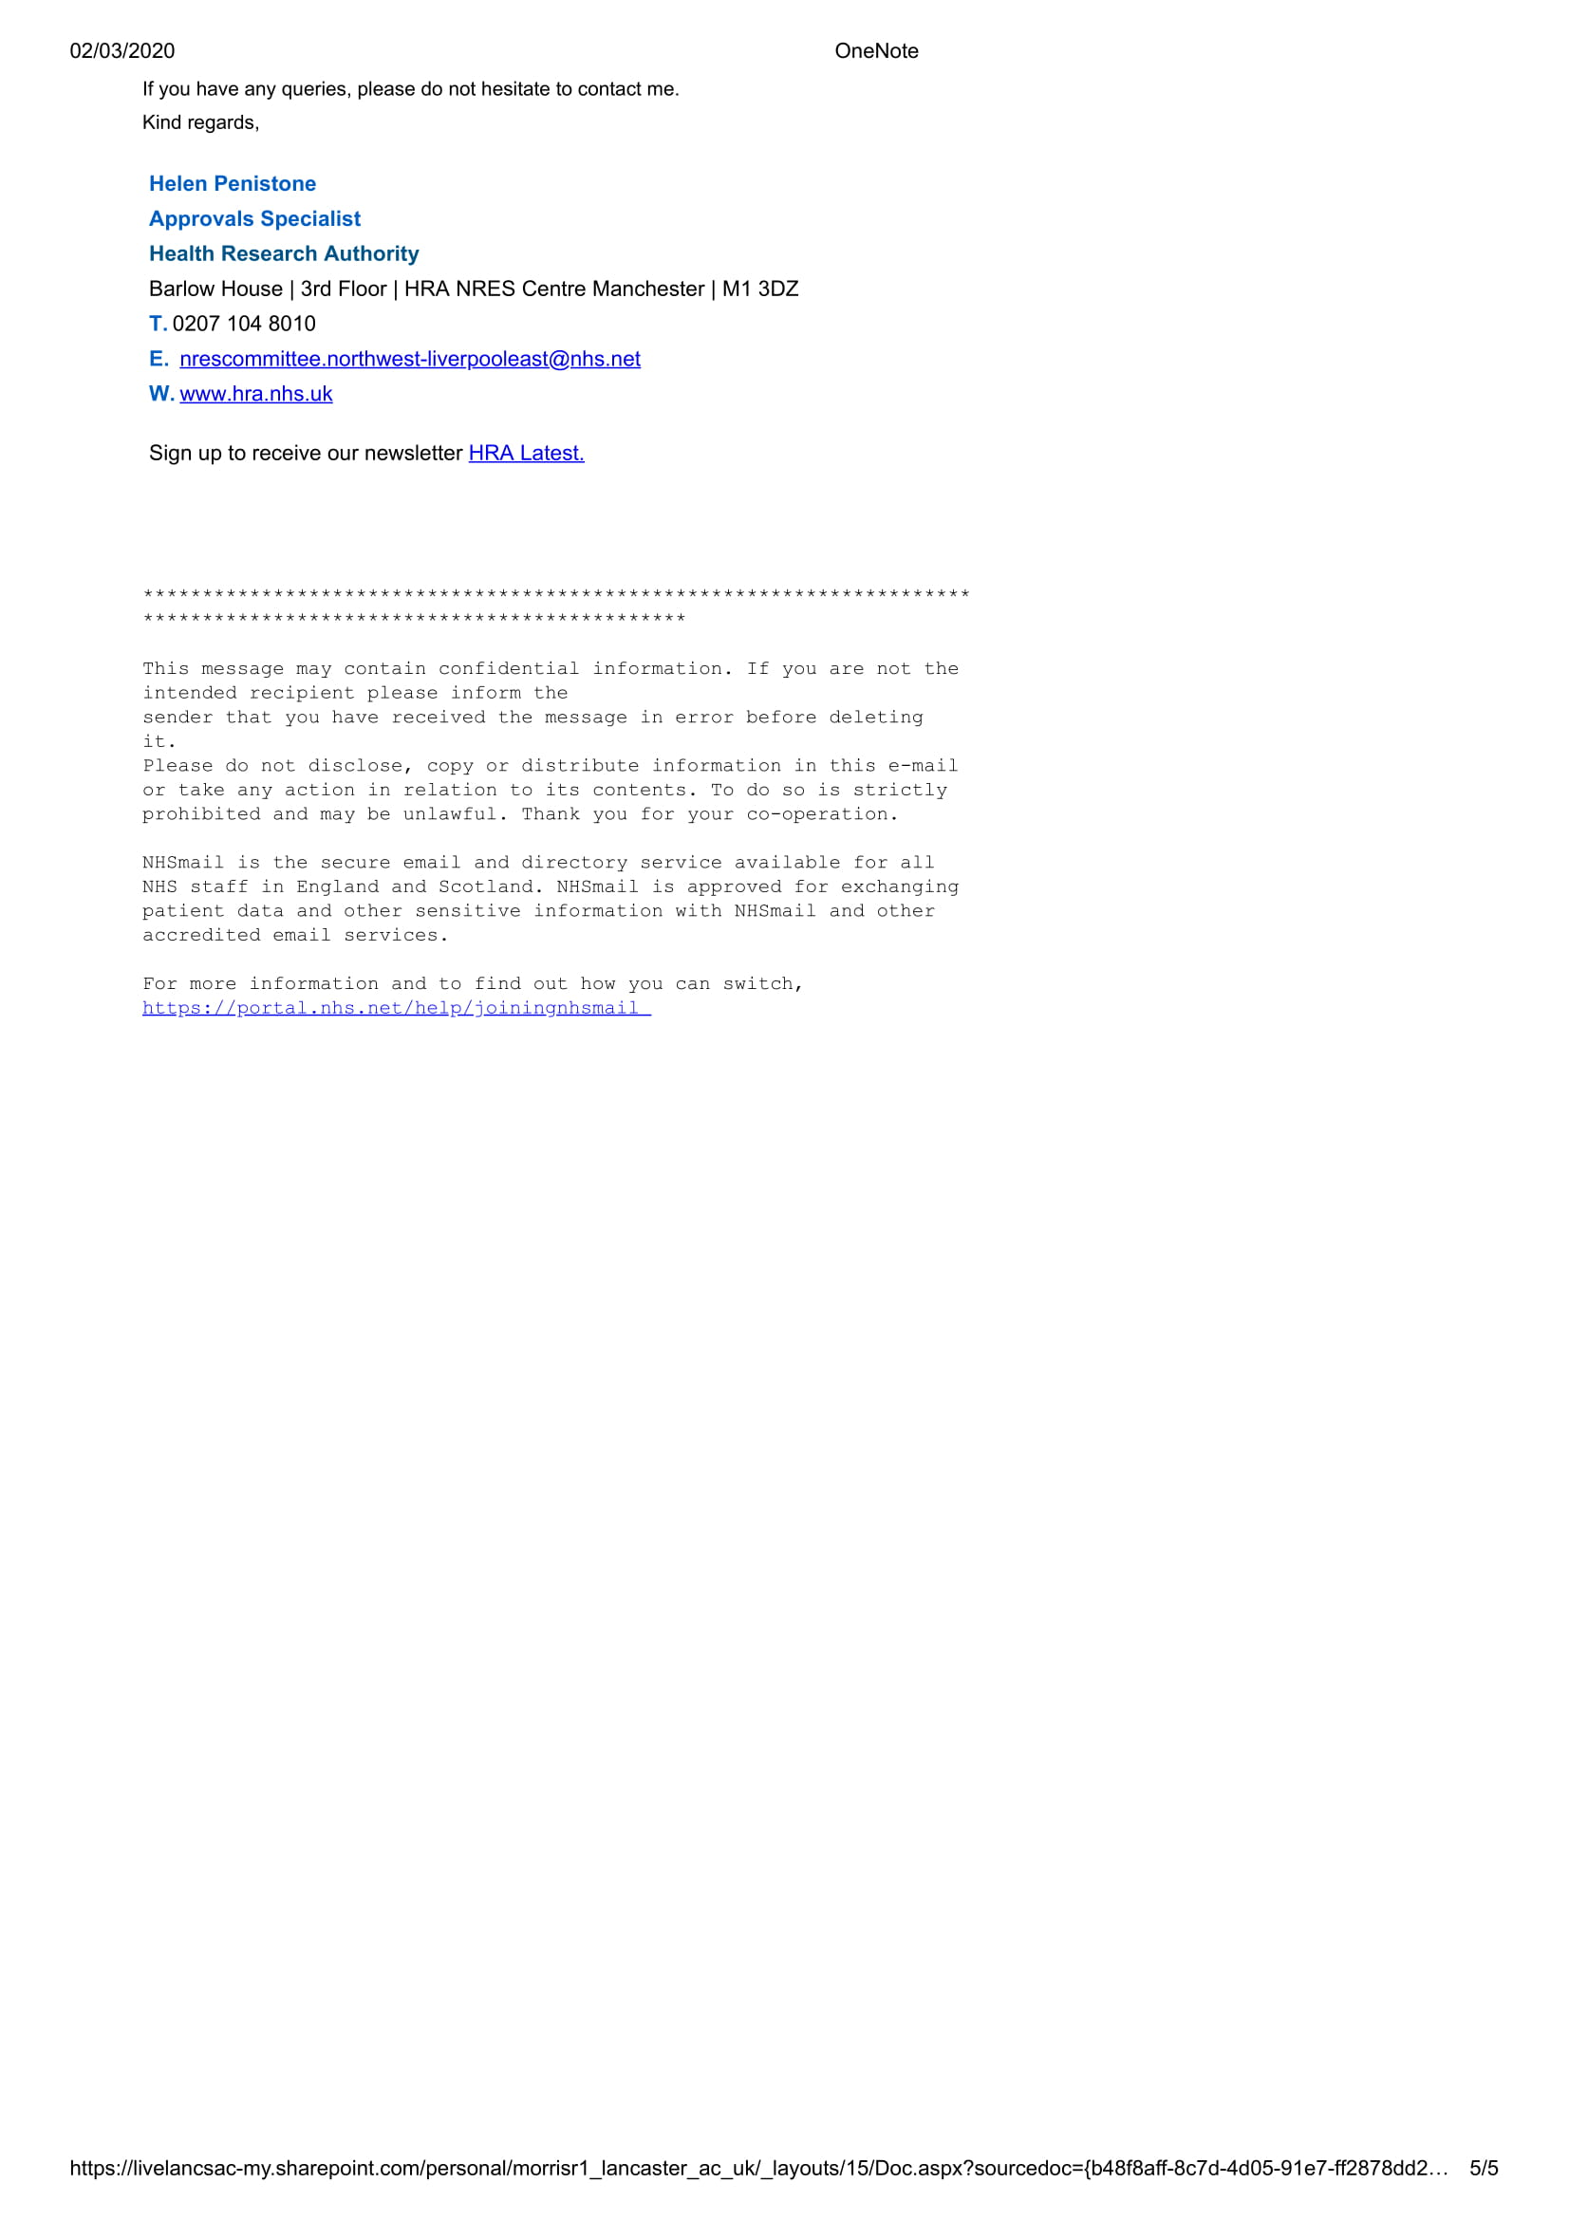
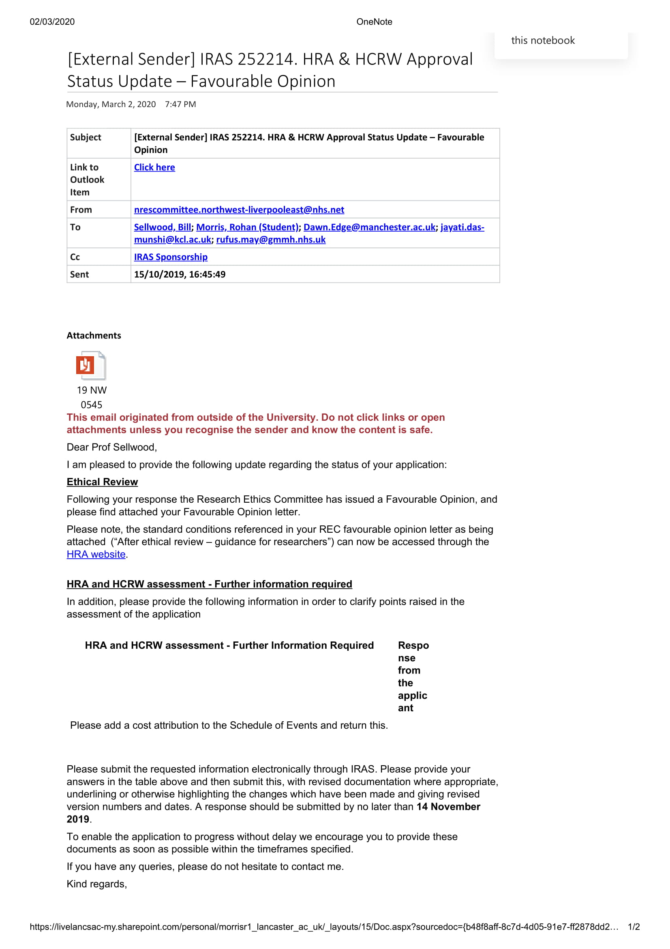

Please appendix 1A for author guidelines.
Please see Chapter 3 for a discussion of the terminology used.
The completed COSMIN checklist is available on request.
In line with the journal recommendations this has been anonymised.
Please appendix 2A for author guidelines.
Mentalization is the ability to understand mental states which under pin behaviour (Bateman & Fonagy, 2010). In this instance it is the hearer’s ability to understand the reasons underpinning what the voice is saying. It is important to note that mentalization could be considered a relational skill and there is a valid argument for its inclusion in Theme 4. It has been included in this section as participants only discussed a reduction in the ability to mentalize as a consequence of the emotional impact of the voices and did not refer to it independently of this.
Although I used the Morgan (2014) adaptation of the 5 step model I number the steps taken sequentially which resulted in an 11 step process.
Pragamatics is an area of linguistics concerned with “context-dependent aspects of meaning” (Horn & Ward, 2004 p. xi) and is distinct from the epistemological position of pragmatism.
https://www.slam.nhs.uk/research/patient-involvement/current-opportunities/consent-for-contact
https://projectredcap.org/resources/citations/

