Neutron reflection from the surface of a liquid ⁴He-³He mixture
O. Kirichekª, N. D. Vasilev^{b}, T. R. Charltonª, C. J. Kinaneª, R. M. Dalglieshª, A. Ganshin^{c}, S. Langridgeª, P. V. E. McClintock^{b}
ª ISIS, STFC Rutherford Appleton Laboratory, Harwell Science and Innovation Campus, Didcot, UK
^{b} Physics Department, Lancaster University, Lancaster, UK
^{c} Laboratory for Elementary Particle Physics, Cornell University, Ithaca, NY, USA
oleg.kirichek@stfc.ac.uk
Abstract. We have used neutron reflection from the liquid surface at ultra-low temperatures to study the surface properties of liquid helium. We measured neutron scattering from the free surfaces of commercially pure ⁴He (0.3 ppm of ³He impurities) and of a ³He-⁴He mixture with a ³He concentration of 0.5% for temperatures in the range from 340mK to 2.2K. We compare the reflected neutron intensity for different temperatures, and we fit a model that describes the collected data. The data are described well by a diffusive ³He layer of a few hundred Angstrom thickness on the bulk ⁴He liquid surface. Even at high temperatures (~2K) there is an increased concentration of ³He atoms near the liquid surface. The distribution does not change very much with temperature. At low temperatures the neutron absorption increases significantly, which might be an indication of the formation of Andreev states. However, the shapes of the curves do not change very much which seems to suggest that the layer formed by the ³He atoms in Andreev states is very thin ~ 10Å. The experimental method, based on neutron reflectometry, opens up new opportunities for the study of the surfaces and interfaces of quantum fluids and solids.
- Introduction
More than four decades ago Andreev predicted theoretically the existence of quantum states of ³He atoms near to the free surface of liquid ⁴He. At low temperatures, even for extremely dilute solutions, a substantial number of ³He atoms are adsorbed at the surface, forming a 2D Fermi liquid [1]. Later on Edwards and Saam developed a more detailed model based on ³He chemical potential calculations [2]. In a liquid ³He/⁴He mixture at zero temperature, if the amount of ³He is only enough to form less than one monolayer, all ³He atoms are adsorbed on the surface and there are none in the bulk. However, for the equivalent of more than one monolayer, the ³He starts to dissolve in the bulk liquid. If more ³He is added, the adsorbed layer on the surface becomes thicker and thicker until it becomes the macroscopically thick upper phase of the phase-separated mixture.
Early experimental surface studies of bulk liquid ³He/⁴He mixtures were mostly based on surface tension measurements [2] and experiments with surface electrons [3]. The surface data may be compared directly with the values derived from theoretical models [1, 2]. However, establishing the relationship between surface tension and the dynamical properties of superfluid helium remains a rather complex task [3]. In some respects, the surface electrons method also provides a rather indirect way of studying the liquid helium surface experimentally, inevitably leading to ambiguities in the interpretation of the data. So, the available experimental data cannot be considered to prove explicitly the validity of existing theories. The large difference in neutron scattering cross section between the ³He and ⁴He isotopes, in combination with neutron reflection, may well be the only technique able to access the length scales of a few hundred Å required to observe the 2D ³He layer [5].
In this paper we present our measurements of small-angle neutron reflection from the free surfaces of commercially pure ⁴He (0.3 ppm of ³He impurities) and of a ³He-⁴He mixture with a ³He concentration of 0.5% over the broad temperature range from 340 mK to 2.2 K. We compare the neutron intensity for different temperatures, and we fit a model that describes the collected data. These experiments were also aimed at developing a new measuring technique for studying ripplons [6] and other surface properties of liquid helium [7] and to answer the question of what the distribution of ³He atoms is near the surface of liquid He [2]. The method exploits the unique combination of neutron reflection and an ultra-low temperature sample environment.
- Neutron reflection experiment
Our experiments were performed on the general-purpose neutron scattering reflectometer CRISP (at ISIS, RAL), designed for investigation of a wide spectrum of interfaces and surfaces [8]. It uses a broad-band neutron time-of-flight method for determination of the wavelength at fixed angles. Typical neutron wavelengths lie in the range 0.5 - 6.5 Å at the source frequency of 50 Hz. The incident beam was well collimated by slits (typical dimensions 30mm wide (horizontal) and up to 10mm in height (vertical)). The details of the experimental set-up are described in Ref. [5]. For providing the cryogenic sample environment we use a Variox^{BL} cryostat, whose lowest temperature of 1.25K is farther reduced by use of a Heliox low temperature inserts to cover the temperature range 0.3K to 2.2K.
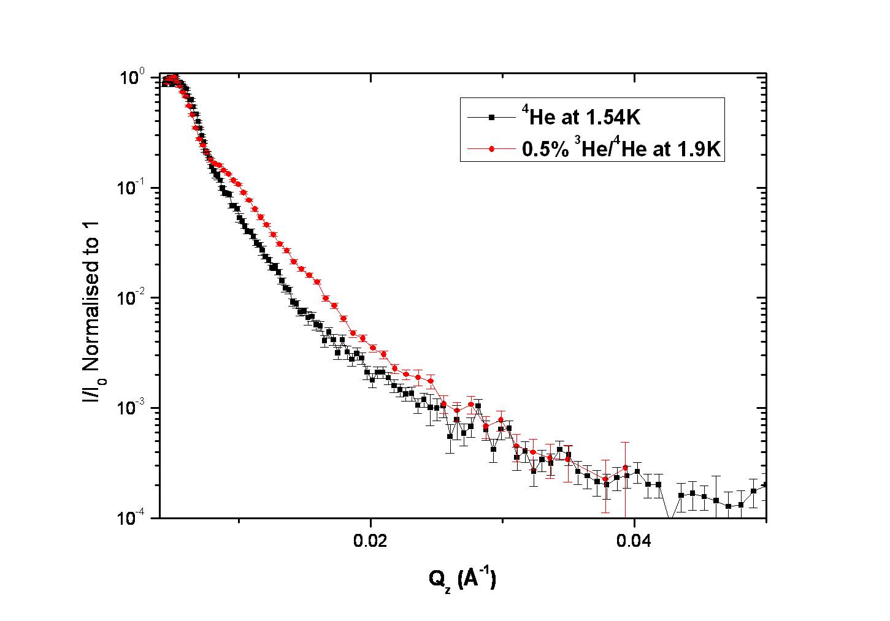
Fig. 1 Normalised neutron reflection as a function of wave vector Qz for commercially pure ⁴He (black points) and for ³He-⁴He with 0.5% ³He concentration (red points).

In the experiment we condense approximately 0.5 mol. of ³He /⁴He mixture gas into the cell at a temperature of 2K. After the reflection signal was detected, the temperature of the cell is adjusted, stabilized and controlled for a sufficient period of time to collect neutron reflection data over a range of values of wave vector Qz perpendicular to the reflecting surface.
- Experimental results and discussion
In Fig. 1 we present our results obtained for the two samples studied: commercial helium with ~ 0.3ppm of ³He (black points) at 1.54 K and the stronger mixture with 0.5% ³He at 1.9K (red points). Neither curve changes very much with temperature in the range 1.5 – 2.2K. The difference between the two curves clearly demonstrates the increased presence of ³He near the surface in case of second sample. In each case, we fit the data with a model that describes the collected data [9]. The reflectivity is calculated from the optical potential using a recursive definition, taking into account multiple reflections [10]. The numerical description of the interface roughness follows that of reference [11]. We found that the data are consistent with there being a diffusive ³He layer of a few hundred Å thickness on the bulk ⁴He liquid surface. Even at high temperatures (~2K) there is an increased concentration of ³He atoms near the surface. The distribution of ³He with respect to distance from the surface is not strongly temperature-dependent.
In Fig. 2 we can see that the neutron absorption increases significantly at low temperatures. This can only be explained in terms of a dramatic increase in ³He atomic concentration near the surface of the liquid, which might in turn be an indication of the formation of Andreev states. The fact that the shapes of the reflectivity curves do not change very much with temperature suggests that the additional ³He layer is very thin ~ 10Å, which agrees well with the concept of Andreev states which are expected to form a 2D Fermi liquid [1].
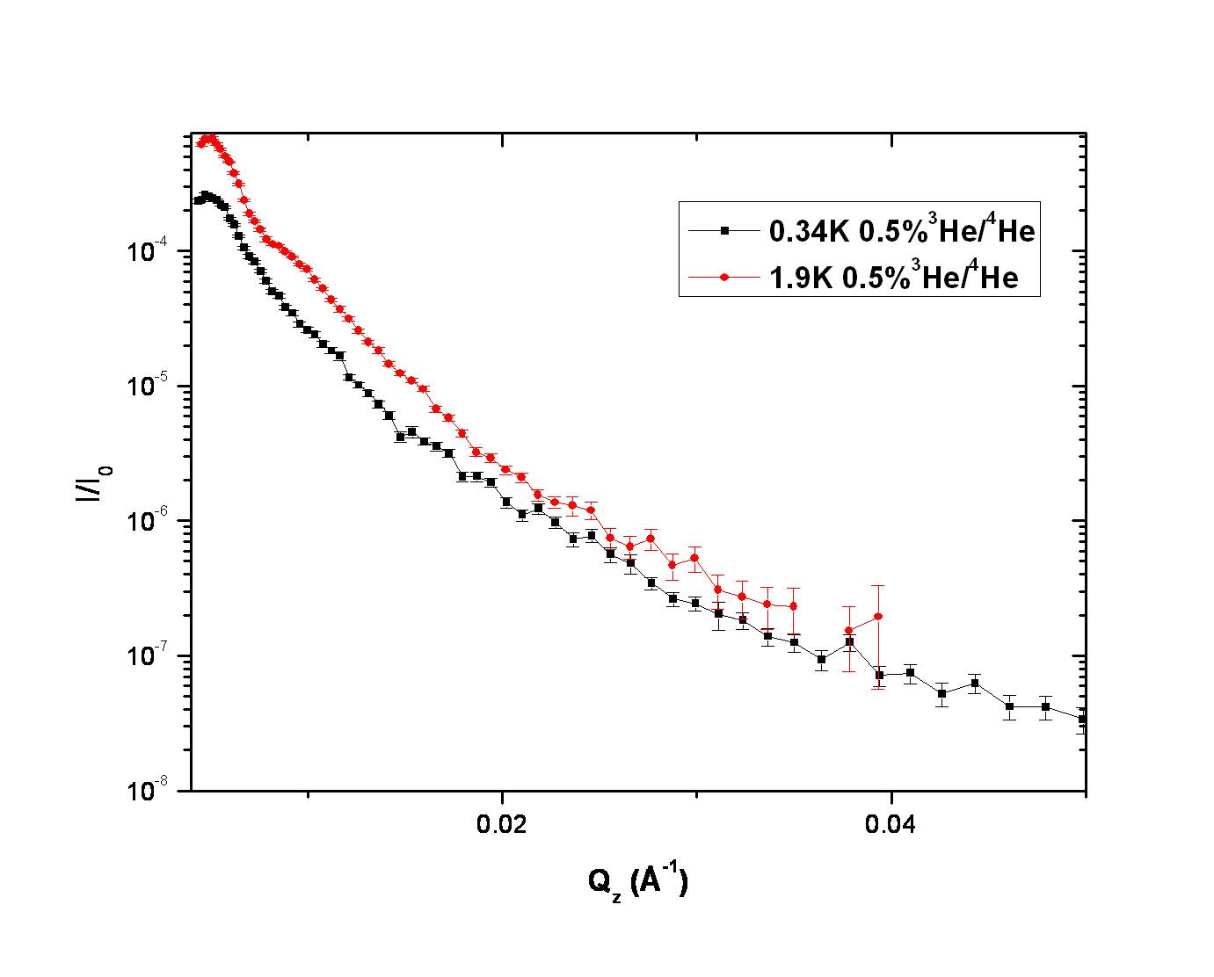
Fig. 2 The neutron reflection signal amplitude as a function of wave vector Qz for ³He-⁴He mixture with 0.5% ³He concentration at temperatures of 1.9K (red points) and 0.34K (black points).
- Conclusions
Our neutron reflectometry experimental data can be described by the formation of a diffusive ³He layer with a thickness of a few hundred Å on the bulk ⁴He liquid surface. Even at high temperatures (~2K) there is an increased concentration of ³He atoms near the liquid surface. The distribution does not change very much with temperature. At low temperatures the neutron adsorption increases significantly which could be an indication of the formation of Andreev states. However, the shapes of the curves do not change very much, which may mean that the ³He layer formed by atoms in Andreev states is very thin ~ 10Å. Our application of neutron reflectometry pens up new opportunities in the study of surfaces of quantum fluids and solids and of interfaces between them. In the future we are planning to apply neutron reflectometry for investigation of the surface properties of superfluid ³He [7] as well as of surface excitations of 3D and 2D Fermi liquids [6].
- Acknowledgements
We thank the ISIS sample environment group for valuable technical assistance. This work was supported by the EPSRC grant EP/F021429/1 “Critical and surface phenomena of quantum fluids”.
References
- Andreev A F 1966 Sov. Phys. JETP 23 939
- Edwards D O and Saam W F 1978 Progress in Low Temperature Physics North-Holland Publ. Comp. VII A 285
- Esel'son B N, Rybalko A S and Sokolov S S 1980 Sov. J. Low Temp. Phys. 6, 544
- Atkins K R and Narahara Y 1965 Phys. Rev. 138 A437
- Charlton T R, Dalgliesh R M, Kirichek O, Langridge S, Ganshin A and McClintock P V E 2008 Low Temp. Phys. 34 316
- Kirichek O, Saitoh M, Kono K and Williams F I B 2001 Phys. Rev. Letts 86 4064
- Shirahama K, Kirichek O I and Kono K 1997 Phys. Rev. Lett. 79 4218
- Penfold J, Ward R C and Williams W G 1987 J. Phys. E 20 1411
- Due to the restrictions applyed by the format of the paper the model fitting results will be published elsewhere
- Parratt L G 1954 Phys. Rev. 95(2) 359
- Nevot L and Croce P 1980 Rev. Phys. Appl. 15 761

