Investigation of Structure and Dynamics in a Photochromic Molecular Crystal by NMR Crystallography

Benjamin L. Dale,¹ Nathan R. Halcovitch,¹ Michael J. G. Peach,¹ John M. Griffin*^{1,2}
¹Department of Chemistry, Lancaster University, Lancaster, LA1 4YB
²Materials Science Institute, Lancaster University, Lancaster LA1 4YB

Abstract
A photochromic anil, N-(3,5-di-t-butylsalicylidene)-4-amino-pyridine, has been studied by single-crystal X-ray diffraction, multinuclear magic-angle spinning NMR and first-principles density functional theory (DFT) calculations. Interpretation of the solid-state NMR data on the basis of calculated chemical shifts confirms the structure is primarily composed of molecules in the ground-state enol tautomer, while thermally-activated cis-keto and photoisomerised trans-keto states exist as low-level defects with populations that are too low to detect experimentally. Variable temperature ¹³C NMR data reveals evidence for solid-state dynamics which is found to be associated with fast rotational motion of t-butyl groups and 180° flips of the pyridine ring, contrasting the time-averaged structure obtained by X-ray diffraction. Comparison of calculated chemical shifts for the full crystal structure and an isolated molecule also reveals evidence for an intermolecular hydrogen-bond involving the pyridine ring and an adjacent imine carbon which facilitates the flipping motion. The DFT calculations also reveal that the molecular conformation in the crystal structure is very close to the energetic minimum for an isolated molecule, indicating that the ring dynamics arise as a result of considerable steric freedom of the pyridine ring and which also allows the molecule to adopt a favourable conformation for photochromism.

- Introduction
The term photochromism refers to the phenomenon of reversible colour changes of substances in response to light. Materials with photochromic properties are of interest due to their potential applications in emerging technologies such as optical data storage^{[1]} optically-controlled gas storage^{[2]} and light-triggered actuators.^{[3]} In many materials, photochromism arises due to structural rearrangement to a metastable bonding configuration upon absorption of photons. Several well-known families of organic molecules exhibit photochromism including azobenzenes, diarylethenes and spiropyrans. However, while photochromism is readily observed in the solution-state, it is much less common in the solid-state, where dense crystal packing does not provide the space required for structural rearrangement. One group of materials that do show solid-state photochromism is N-salicylideneanilines which are often referred to in the literature as ‘anils’. Anil crystals are typically yellow or pale orange at room temperature, and undergo a transition to a darker red state upon exposure to UV light. Subsequent exposure to blue or green light, or increased temperature returns the crystals to their original yellow state.^{[4-6]}
The photochromic property of anil crystals is proposed to arise due to intramolecular proton transfer between the colourless enol and yellow/orange cis-keto isomers, and isomerisation to a dark red trans-keto isomer, as shown in Figure 1. Proton transfer between enol and cis-keto tautomers can be thermally driven, although the trans-keto isomer can only be accessed via photoexcitation. Despite the large number of studies on the photochromic properties of anils there has been considerable debate regarding the structure of the coloured species and the mechanism of photoisomerisation. Precisely characterising the coloured isomers in the solid state is challenging as light penetration is typically limited to a few micrometres and therefore concentrations of the photoisomerised species in macroscopic crystals are very low. Harada et al. addressed this problem by using two-photon irradiation to achieve sufficiently high population of the photoisomerised trans-keto species to detect them by single-crystal X-ray diffraction.^{[7]} The structure of a red-coloured irradiated crystal was found to be a disordered mixture of molecules in cis- and trans-keto states, thereby confirming that the red colour is associated with the presence of the trans-keto isomer. Fujiwara et al. used variable-temperature diffuse reflectance spectroscopy to show that anils are largely composed of the enol isomer at ambient temperature, and the yellow/orange sample colour that is often observed is due to trace amounts of the cis-keto isomer.^{[8]}
In addition to the questions regarding the structures and conversion mechanisms between the different isomeric states, the link between the photochromic properties and the ground-state crystal structure has also been the subject of investigation. Conversion between the cis-keto and trans-keto states is thought to occur via a “pedal motion” similar to molecular motions observed in azobenzenes and stilbenes,^{[9, 10]} and it has been proposed that the inclusion of cavity space around the central imine linkage can promote photoisomerisation.^{[11]} The use of bulky substituent groups has been proposed to stabilise the trans-keto state by imposing steric hindrance to restrict thermal back transfer to the cis-keto or enol states;^{[11, 12]} however, if steric hindrance is too great the absence of sufficient cavity space can inhibit the pedal motion necessary for photochromism.^{[13]} Another important factor in determining the photochromic properties is the dihedral angle between the aromatic rings at either end of the molecule.^{[13, 14]} In general, structures where the two rings are close to co-planar do not exhibit photochromism, whereas those with dihedral angles greater than 30° are photochromic.
In this work we present a NMR crystallographic study of a photochromic crystalline anil N-(3,5-di-t-butylsalicylidene)-4-aminopyridine (1, Figure 2). This compound is strongly photochromic and has an extremely long lifetime of the trans-keto state, previously reported as 460 days.^{[12]} Using a combination of ¹³C, ¹H and ¹⁵N NMR and first-principles density functional theory (DFT) calculations, we are able to fully assign the structure and show that it is composed almost exclusively of molecules in the enol tautomeric form at ambient temperature. We also observe that the structure is highly dynamic, a property which is not evident from single crystal X-ray diffraction (SC-XRD) measurements performed at similar temperatures, and may be relevant to the photochromic properties of the material. Analysis of a UV-irradiated sample shows no evidence of the trans-keto state despite the sample being dark red in appearance, confirming that the strong colour changes observed in photochromic crystals can originate from trace quantities of the excited state. By comparing calculated chemical shifts of the full structure with an isolated molecule, we find evidence for a weak hydrogen bonding interaction that facilitates the flipping motion of the pyridyl group. Furthermore, we find that the molecular conformation in the crystal structure is highly energetically favourable for photoisomerisation to occur, thereby offering an explanation for the photochromic properties.
- Experimental Details

  - Sample preparation
All reagents were obtained from Fluorochem and used without further purification. N-(3,5-di-t-butylsalicylidene)-4-aminopyridine (1) was synthesised following a literature procedure:^{[12]} 1.17 g of 3,5-di-t-butylsalicylaldehyde was melted at 70°C in a round bottomed flask before 0.47 g of 4-aminopyridine was added. The mixture was stirred under reflux at 140°C for approximately 1 h until it turned red and crystals appeared on the side of the flask. Diethyl ether was then added to precipitate the product as yellow crystals which were isolated by filtration. The product was subsequently recrystallized to remove traces of starting material.
  - Single-Crystal X-ray Diffraction
Crystals of 1 were grown by slow evaporation of a concentrated acetone solution to yield small yellow needles. A single crystal was mounted on a Mitegen-loop using Paratone-N oil (the same crystal was used for 100 and 180 K measurements), or was glued to a nylon loop using a small amount of Araldite glue (290 K). The mount was placed on a Rigaku Oxford Diffraction SuperNova diffractometer equipped with an Atlas S2 CCD detector. Using Olex2,^{[15]} the structure was solved with the ShelXT^{[16]} structure solution program using Intrinsic Phasing and refined with the ShelXL^{[17]} refinement package using Least Squares minimisation. The twin law was found using Platon software.^{[18]} CCDC-1865068 – CCDC-1865070 contain the supplementary crystallographic data for this paper. These structures can be downloaded free of charge from https://www.ccdc.cam.ac.uk/.
  - Solid-state NMR
Solid-state NMR experiments were performed on Bruker Avance III HD spectrometers operating at magnetic field strengths of 9.4 and 16.4 T. Spectra are referenced relative to tetramethylsilane (¹³C / ¹H) and CH₃NO₂ (¹⁵N) using the CH₃ (¹H = 1.1 ppm; ¹³C = 20.5 ppm) and NH₃⁺ (¹⁵N = –337.7 ppm) resonances of L-alanine as a secondary reference.
¹³C NMR spectra were recorded at a magic-angle spinning (MAS) rate of 12.5 kHz using cross polarization (CP) to transfer magnetization from ¹H with a contact time of 3 ms. The CP pulse was ramped linearly from 70 – 100% power. ¹H heteronuclear decoupling using two-pulse phase modulation (TPPM)^{[19]} with a pulse length of 4.8 µs and a radiofrequency field strength of 100 kHz was applied during acquisition. Spectra are the sum of 512 transients separated by a recycle interval of 3 s.
The ¹H MAS NMR spectrum was recorded at a MAS rate of 30 kHz using the DEPTH pulse sequence^{[20]} to reduce background signals from the probe. The spectrum is the sum of 16 transients separated by a recycle interval of 3 s.
The ¹H-¹³C HETCOR correlation was recorded at a MAS rate of 11.363 kHz using CP to transfer magnetization from ¹H with a contact time of 500 µs to favour short ¹H-¹³C contacts. The DUMBO pulse sequence^{[21]} with a nutation frequency of 80 kHz was used to provide homonuclear decoupling in the indirect dimension while 100 kHz ¹H TPPM decoupling was applied during acquisition. The spectrum is the sum of 64 transient for each of the 128 t₁ rows. The States-TPPI method^{[22]} was used for sign discrimination in the F₁ dimension.
The ¹⁵N MAS NMR spectrum was recorded at a MAS rate of 12.5 kHz using CP to transfer magnetization from ¹H with a contact time of 8 ms. 100 kHz ¹H TPPM decoupling was applied during acquisition. The spectrum is the sum of 32960 transients separated by a recycle interval of 3 s.
  - DFT calculations
First-principles calculations of NMR parameters were carried out using the CASTEP code^{[23]} employing the gauge-including projector augmented wave (GIPAW) algorithm^{[24]} which allows the reconstruction of the all-electron wave function in the presence of a magnetic field. The CASTEP calculations employed the generalised gradient approximation (GGA) Perdew-Burke-Ernzerhof (PBE) exchange-correlation functional^{[25]} and core–valence interactions were described by ultrasoft pseudopotentials.^{[26]}
Prior to calculation of the NMR parameters, structures were fully geometry optimised using the G06 semi-empirical dispersion correction scheme^{[27]} and allowing all atomic positions to vary. For crystal structures, unit cell parameters were allowed to vary whereas single molecule calculations were carried out in a 20 Å x 20 Å x 20 Å cell with fixed cell parameters to ensure molecules remained isolated from periodic replicas.
Geometry optimisations and NMR calculations were carried out using a planewave energy cut off of 60 Ry and, for crystal structures, a k-point spacing of 0.05 2π Å^{–1} was used. For single molecule calculations, a single k-point at the fractional coordinate (0.25, 0.25, 0.25) was used. The calculations generate the absolute shielding tensor (σ) in the crystal frame. Diagonalization of the symmetric part of σ yields the three principal components, σ_{XX}, σ_{YY} and σ_{ZZ}. The isotropic shielding, σ_{iso}, is given by (1/3)Tr[σ]. The isotropic chemical shift, δ_{iso}, is given by σ_{ref} – σ_{iso}, where σ_{ref} is a reference shielding. Reference shieldings were determined by comparison of experimental chemical shifts for L-alanine with shieldings obtained from a calculation on a fully optimised crystal structure^{[28]} (CSD code LALNIN22). For ¹H and ¹³C, reference shieldings were determined from the y-intercept of a linear fit to the experimental shifts vs calculated shielding, with the gradient of the fit fixed to –1. Calculated shieldings for the three methyl protons were averaged to account for rapid rotation of the methyl group. Respective reference shieldings of 30.2, 168.4 and –154.1 ppm were obtained for ¹H, ¹³C and ¹⁵N.

- Results
The solid-state structure of 1 obtained by SC-XRD at 100 K is shown in Figure 3a. The structure is in good agreement with a previously reported structure obtained at 173 K^{[12]} and shows the molecules as the enol form with an intramolecular OH…N hydrogen bond between the enol group on the salicylidene ring and the nitrogen of the central imine group. The dihedral angle C7-N8-C9-C10 is 42.3°, which is similar to other anil-salicylidenes displaying photochromic properties.^{[13, 29]} In this structure the bulky t-butyl groups on the salicylidene ring prevent close π-stacking or layering of the molecules. The pyridine ring points into a cavity formed by surrounding t-butyl groups and pyridine groups of other molecules. Here there is some indication of a weak intermolecular C-H…N hydrogen bond between the C-H group on the central imine linkage and the nitrogen on the pyridine ring on the adjacent molecule (Figure 3b). The intermolecular C7 – N12 distance is 3.38 Å which is comparable to, but slightly larger than, distances seen in other weakly hydrogen-bonded systems,^{[30]} and the C7-H…N12 bond angle of 147° is less linear than usually observed. It is therefore not clear from the crystal structure alone whether this close contact is indeed a weak hydrogen bonding interaction, or is simply a consequence of the crystal packing imposed by the bulky substituent groups.
To investigate the effect of temperature on the tautomerism within the structure, diffraction data was collected at higher temperatures of 180 and 290 K. With increasing temperature the overall structure is maintained and there is no visible difference in the electron density maps around the O and N8 atoms when the H15 atom is removed from the model between 100 and 180 K (see Supporting Information). There is however, the caveat that the lower quality data at 290 K means small changes in the electron density map would be very difficult to observe, and indeed we no longer see electron density for the O-H groups at these temperatures. To gain further insight into the tautomeric conformation at ambient temperature, a ¹³C CPMAS NMR spectrum was recorded (Figure 4a). This spectrum exhibits two main groups of resonances in the aliphatic and aromatic regions consistent with the chemical environments that are present in the molecular structure. The resonance at 170.0 ppm is within the shift range expected for a carbonyl group and could therefore indicate the presence of C6 in the cis-keto tautomer; however, this chemical shift is also on the upper boundary of the range for imine carbons and so could be consistent with C7 in the enol tautomer.
To help interpret the experimental ¹³C CPMAS NMR spectrum, ¹³C chemical shifts were calculated from first principles. Calculations were first performed on the enol structure following straightforward geometry optimisation of the 100 K single-crystal XRD structure. The structure did not change significantly during geometry optimisation and the enol configuration was maintained with an O-H bond distance of 1.03 Å (see Supporting Information). A cis-keto structure was then constructed by manually moving the enol proton across the hydrogen bond to a distance of 0.8 Å from the imine nitrogen. Structural symmetry constraints were preserved such that all of the enol protons in the unit cell were displaced by the same amount. This structure was then subjected to a full geometry optimisation where the position of the displaced proton was also allowed to vary. The structure converged to a stable state resembling the cis-keto configuration with a N-H bond distance of 1.06 Å and a O…H distance of 1.65 Å (see Supporting Information). Although the precise locations of the hydrogen-bonded protons both structures will to some extent depend upon the approximations made in the DFT calculation (particularly the nature of the functional used), the large difference in proton position between the two optimised structures provides strong evidence that the enol and cis-keto structures correspond to separate local energetic minima. The optimised cis-keto structure was then also subjected to a NMR calculation. Table 1 compares calculated ¹³C chemical shifts for the two structures. The large differences in chemical shifts between the two structures confirm that the optimised structures are not only structurally but also electronically distinct, with the isomerisation of the intramolecular hydrogen bond resulting in reconfiguration of the bonding electrons in the enol/keto ring.
Simulated ¹³C NMR spectra for the enol and cis-keto structures are shown in Figures 4b and 4c, respectively. By comparing the calculated chemical shifts of C6 and C7 it is clear that the experimental data is consistent with the presence of the enol structure. The calculated chemical shift of 170.0 ppm for the C7 imine carbon in the enol structure agrees very well with the experimentally observed value of 170.4 ppm, whereas the C6 carbonyl carbon in the cis-keto structure has a predicted chemical shift of 178.5 ppm, and no intensity is observed at this position in the experimental spectrum. However, comparing the rest of the calculated chemical shifts for the enol structure with the experimental spectrum reveals some remaining discrepancies. In the aliphatic region the simulated spectrum contains eight resonances corresponding to the six crystallographically-distinct CH₃ environments and the two distinct quaternary environments within the t-butyl groups, whereas only four resonances are observed experimentally. A likely explanation for this is that at ambient temperature the t-butyl groups are undergoing fast rotation around the quaternary carbon such that the three CH₃ carbons within each group are exchange averaged. Such rotation has a low energy barrier and is commonly observed in solid materials containing t-butyl groups.^{[31-33]} This would result in the observation of two CH₃ resonances and two quaternary resonances, which is consistent with the total number of aliphatic resonances observed in the spectrum.
Considering the aromatic region, the number of peaks observed is also inconsistent with the number of sites expected from the crystal structure. The aromatic and imine carbons in the structure total 12 crystallographically-distinct sites, whereas only 9 resonances are observed in the region 119 – 170 ppm, together with a broad component centred around 117 ppm. It is also possible that motional averaging is present in this region of the spectrum; however, while fast rotational motion of the t-butyl groups can lead to exchange averaging of sites within the groups, this motion should not result in exchange averaging of sites external to these groups. To investigate the possible influence of dynamics on the aromatic carbons, variable temperature experiments were carried out in the range 258 – 303 K. An expansion of the aromatic region is shown in Figure 5a. At 285 K the broad feature at 117 ppm splits into two separate resonances at 115.0 and 120.5 ppm. As the temperature is reduced further, the resonance at 150.7 ppm also splits into two separate resonances at 150 and 150.8 ppm. This behaviour is consistent with the presence of a motional process which causes exchange averaging of the two pairs of carbon resonance at ambient temperature. At the lowest temperature of 258 K, the rate of the motional process is reduced sufficiently such that the exchange averaging is removed and all 12 expected resonances are observed in the aromatic region. We note that even at the lowest temperature of 258 K the motional averaging of the t-butyl groups was still observed, indicating that (as expected) the energy barrier for this process is lower than for the process involving the aromatic carbons.
The first principles calculations now enable the location of the motional process within the structure to be identified through a comparison of the calculated and experimental chemical shifts for the enol structure given in Table 1. This is most easily visualised by comparing the experimental spectrum with the simulated spectrum based on the calculated ¹³C NMR parameters shown in Figure 5b. The simulation shows that the motionally averaged pairs of resonances correspond to C11 and C13, and C10 and C14 in the pyridyl group. Exchange averaging within these pairs of resonances is indicative of rotational motion of the pyridyl group around the C-N imine bond axis. We note that the SC-XRD crystal structures obtained at 180 and 290 K show slightly enlarged thermal ellipsoids for the pyridyl carbons but the pyridyl ring remains well defined with dihedral angles of 41 - 42° and no evidence of disorder out of the plane of the ring (see Supporting Information). Together, the NMR and SC-XRD results strongly suggest that the origin of the motional process is 180° flipping of the pyridyl ring around the imine bond axis, whereby the duration for which the ring resides in the crystallographic conformation is very long compared to the timescale of the flipping process. At 9.4 T, the separation of the C10 and C14 resonances is 535 Hz and coalescence occurs at between 285 and 303 K, showing that the ring flipping motion takes place on the millisecond timescale in this temperature range. Similar ring flipping processes have been observed in a number of organic materials containing aromatic rings,^{[34-38]} although they are difficult to detect by XRD alone which is sensitive only to the time-averaged structure. However, inspection of the crystal structure does provide some insights into the possible origin of the ring flipping dynamics. As shown in Figure S3, the structural cavity in which the pyridyl ring is located has a diameter of approximately 4.6 Å, which is larger than the ring diameter of 4.1 Å, thereby providing sufficient steric freedom to allow the 180° flipping motion. In addition to the size of the cavity, the groups that define it may also facilitate the activation of the ring flipping process. One side of the cavity is formed by the methyl groups of nearby t-butyl groups and the other side is made up of pyridyl rings from adjacent molecules. It is feasible that the fast dynamics and inherent flexibility of the t-butyl groups may facilitate the activation of the flipping of the pyridyl ring, while the close intermolecular proximity to other pyridyl rings in the structure favours a cooperative motion for the flipping process.
To investigate whether the photochromic properties of 1 are detectable by NMR, a powder sample was irradiated with a 365 nm UV lamp. During UV irradiation, the sample was gently ground in a pestle and mortar in order to maximise light exposure of the crystallites in the powdered sample. Following this procedure the sample colour changed from pale yellow to deep orange (see Supporting Information), showing that the photochromic transition to the trans-keto isomer had taken place. However, a ¹³C CPMAS NMR spectrum of this sample recorded at ambient temperature (shown in Supporting Information) revealed no discernible differences with the spectrum of the non-irradiated sample in Figure 4a, and no evidence of a carbonyl resonance indicative of either the cis- or trans-keto isomers was observed. This confirms that the strong colouring observed in photochromic crystals arises due to a trace quantity of photoisomerised defects which are difficult to observe by quantitative methods such as NMR spectroscopy.
To obtain information about the proton environments in the enol structure, a ¹H MAS NMR spectrum was recorded (Figure 6a). In this spectrum the hydrogen-bonded enol proton H15 is clearly observed at 12.9 ppm, while the 18 t-butyl protons are motionally averaged into two sharp resonances at 0.1 and 1.7 ppm. The aromatic region contains three partially resolved features but the resolution is not sufficient to make a full assignment. To obtain higher resolution, a ¹H-¹³C HETCOR spectrum was recorded with homonuclear decoupling (Figure 6b). From the correlations observed in this spectrum, it is possible to fully assign the aromatic and imine protons, thereby completing the ¹H resonance assignment. Experimental and calculated ¹H chemical shifts are shown in Table 1. Considering the enol proton H15, the calculated chemical shift of 14.8 ppm is somewhat overestimated compared to the experimental value of 12.9 ppm, although this is consistent with other studies of systems where a tendency for GIPAW to overestimate the chemical shift of hydrogen-bonded protons has been observed.^{[39, 40]} Indeed, the chemical shifts of hydrogen-bonded protons are highly sensitive to the position within the hydrogen bond, and any small inaccuracy in this position due to either inherent DFT approximations or finite temperature effects^{[39]} can result in a measurable deviation from the experiment. Considering the aromatic protons, the experimental and calculated chemical shifts show good overall agreement. However, it is interesting to note that the calculated chemical shift of the imine proton is also slightly overestimated by 0.7 ppm. This could be related to the fact that it is in close proximity to, and possibly involved in a weak hydrogen-bond with the pyridyl nitrogen N12. A ¹⁵N CPMAS NMR spectrum of 1 is shown in Figure 6c. The spectrum shows two resonances in agreement with the two nitrogen environments in the crystal structure. The calculated chemical shifts (Table 1) show sufficient agreement to make a confident assignment. The difference of 7.4 ppm between calculated and experimental ¹⁵N chemical shift for the imine nitrogen is within the typical accuracy expected for this nucleus.^{[41]}
With the structure fully assigned, the combination of the experimental data and NMR calculations can be used to gain insight into the nature of the close intermolecular C7-H7…N12 contact between the imine carbon and the pyridyl ring. One method for investigating the possible presence of weak-hydrogen bonding interactions is to compare calculated chemical shifts for full crystal structures and isolated molecules where any influence of intermolecular hydrogen bonds is removed.^{[30, 42-45]} To this end, a NMR calculation was performed on an isolated molecule extracted from the optimised crystal structure. Table 2 lists the calculated shifts for H7 and N12 as well as those for H15 and N8 which are involved in a strong intramolecular hydrogen bond. The chemical shifts of H15 and N8 which are involved in an intramolecular hydrogen bond differ by only 0.2 and 1.6 ppm, respectively, when the molecule is removed from the periodic structure, as would be expected for environments which are largely influenced by the intramolecular structure and are not involved in intermolecular interactions. In contrast, for H7 the crystal–molecule chemical shift change is 0.7 ppm, while the N12 chemical shift increases by 19.3 ppm. These relatively large changes are consistent with the magnitude of calculated crystal–molecule chemical shift changes observed for other weakly hydrogen-bonded systems^{[30]} and therefore suggest that the close C-H…N proximity does correspond to an intermolecular hydrogen bonding interaction rather than simply being a consequence of the crystal packing.
- Discussion
The NMR crystallographic characterisation of 1 reveals a structure that is predominantly composed of molecules in the enol form at room temperature and that it is highly dynamic, with fast rotation of the t-butyl groups and millisecond timescale 180° flipping of the pyridyl rings. The flipping motion of the ring is facilitated by the fact that the structural cavity in which it resides offers sufficient space for the flipping motion to occur. Furthermore, the chemical properties of the ring create two pivots at either end around which the ring can rotate: one end of the ring is covalently bonded to the imine linkage, and directly opposite on the other side of the ring another pivot is formed by the intermolecular weak hydrogen bond between the pyridyl nitrogen and an adjacent imine C-H group.
One obvious question is whether the dynamic processes present in the material are connected to its photochromic properties. Indeed, the fact that the pyridyl ring is situated in a structural cavity and has sufficient steric freedom to be structurally mobile may facilitate the pedal motion required for the transition to the trans-keto state. This effect has been tested by Staehle et al. who synthesised a set of anil derivatives with bulky end groups to promote steric freedom around the central anil rotor.^{[36]} The rotor design was found to facilitate rotation of the anil ring within the central linkage and was linked to the strong solid-state photochromic activity of the materials. An additional consideration is the effect of the dihedral angle between the rings in the anil linkage. A number of systematic studies of anil derivatives have shown that this has a strong influence on the photochromic activity and in general dihedral angles of 30° - 40° are favourable for photochromism to occur.^{[13, 29]} Considering the structure of 1, the C7-N8-C9-C10 angle of 42.3° is close to this range and is therefore consistent with the strong photochromic properties of this material. To investigate the role of the crystal packing in dictating the dihedral angle in 1, an isolated molecule from the optimised crystal structure was subjected to a geometry optimisation with all atomic positions allowed to vary. This approach does not necessarily lead to a global energetic minimum geometry, but removes any steric effects due to the crystal packing. As shown in Figures 7a and 7b, the optimisation procedure on the single molecule resulted in only a very small change to the molecular conformation and the C7-N8-C9-C10 angle to 37.3°. This shows that the crystal packing in 1 does not significantly alter the dihedral angle in this material and instead the cavity surrounding the pyridyl ring is large enough to allow it to adopt a conformation that is very close to its molecular energy minimum. This provides further evidence of the large degree of steric freedom of the pyridyl ring and indicates that the absence of steric torsion on the anil group is beneficial for photochromic properties.
A final consideration is whether there is any link between the crystal structure and the unusually long half-life of the trans-keto state (460 days^{[12]}). The orange colour observed upon UV irradiation arises due to the formation of trans-keto isomers as defects within the ground-state enol crystal structure.^{[7]} In addition to the change in geometry of the photoisomerised molecule, this may result in localised distortion or rearrangement of the surrounding crystal lattice. While the precise nature of the structural changes that take place upon photoisomerisation is unknown, it is possible to investigate the structure of the trans-keto isomer itself through a geometry optimisation of a single molecule. Interestingly, the geometry of an optimised trans-keto isomer, shown in Figure 7c, differs significantly from the enol isomer in that it is almost coplanar with a very small dihedral angle of 1.9°. The long half-life of the trans-keto state implies a relatively large energy barrier to relaxation to the enol isomer, suggesting that the local structure is unhindered in undergoing some significant and stabilised rearrangement. These localised structural changes could be aided by the dynamic nature of the crystal structure that is evident from the NMR measurements. However, the void space surrounding the pyridine group could also be central in allowing for the aforementioned structural rearrangement to take place without imposing significant strain on the surrounding crystal lattice.
- Conclusions
In conclusion, through the use of a combination of SC-XRD, solid-state NMR and first-principles DFT calculations, we have confirmed that the structure of 1 adopts the enol form at ambient temperature and any population of the cis-keto tautomer is at a trace level that is below the limits of detection. Despite being a crystalline solid, the structure is highly dynamic with rotational molecular processes taking place at both ends of the molecule. These processes comprise fast rotation of the t-butyl groups and 180° flipping of the pyridyl ring which sits within a structural cavity with a high degree of steric freedom. The presence of a weak intramolecular hydrogen bond facilitates the flipping motion of the pyridyl ring and the cavity in which the ring resides allows a dihedral angle which is favourable for photochromism to occur. In addition, it is likely that the steric freedom of the pyridine ring also allows it to undergo the large change in dihedral angle required upon photoexcitation to the trans-keto isomer, which may explain the unusually long half-life of the photoisomerised state in this material.
This work has demonstrated the utility of NMR crystallography for the study of photochromic compounds as it reveals structural properties that are not observable by diffraction alone and provides insight into the link between the molecular level structure and the macroscopic colour changing properties. With knowledge of the structural properties and dynamic phenomena that have been characterised for this highly photochromic compound, it should be possible to “build” similar structural features directly in to other systems in the design of new materials with photochromic properties.

- Acknowledgements
Lancaster University is thanked for provision of the NMR, XRD and HEC facilities, and for partially funding this research. Characterisation facilities were part funded by the European Regional Development Fund (ERDF) under the Collaborative Technology Access Program (cTAP). We acknowledge support from CCP-NC, funded by EPSRC (EP/M022501/1), and the UKCP consortium, funded by EPSRC (EP/P022561/1). We are grateful to the UK Materials and Molecular Modelling Hub for computational resources, which is partially funded by EPSRC (EP/P020194). We thank Lancaster University's Widening Participation Coordinating Group for funding a Summer Bursary for B. L. D. The research data supporting this publication can be accessed at https://dx.doi.org/10.17635/lancaster/researchdata/245.

- References
[1] S. Kawata, Y. Kawata, Chem. Rev. 2000, 100, 1777.
[2] B. J. Furlong, M. J. Katz, J. Am. Chem. Soc. 2017, 139, 13280.
[3] M. Irie, Bull. Chem. Soc. Jpn. 2008, 81, 917.
[4] E. Hadjoudis, I. M. Mavridis, Chem. Soc. Rev. 2004, 33, 579.
[5] K. Amimoto, T. Kawato, J. Photochem. Photobiol. C 2005, 6, 207.
[6] H. Eugene, D. C. Spyros, M. M. Irene, Curr. Org. Chem. 2009, 13, 269.
[7] J. Harada, H. Uekusa, Y. Ohashi, J. Am. Chem. Soc. 1999, 121, 5809.
[8] T. Fujiwara, J. Harada, K. Ogawa, J. Phys. Chem. B 2004, 108, 4035.
[9] K. Saito, Y. Yamamura, K. Kikuchi, I. Ikemoto, J. Phys. Chem. Solids 1995, 56, 849.
[10] Y. Ueda, N. Nakamura, H. Chihara, J. Phys. Soc. Jpn. 1988, 57, 4063.
[11] J. Kohei, S. Akiko, U. Hidehiro, O. Yuji, Bull. Chem. Soc. Jpn. 2009, 82, 50.
[12] M. Sliwa, S. Létard, I. Malfant, M. Nierlich, P. G. Lacroix, T. Asahi, H. Masuhara, P. Yu, K. Nakatani, Chem. Mater. 2005, 17, 4727.
[13] H. Sugiyama, H. Uekusa, CrystEngComm 2018, 20, 2144.
[14] K. Johmoto, T. Ishida, A. Sekine, H. Uekusa, Y. Ohashi, Acta Cryst. B 2012, 68, 297.
[15] O. V. Dolomanov, L. J. Bourhis, R. J. Gildea, J. A. K. Howard, H. Puschmann, J. Appl. Crystallogr. 2009, 42, 339.
[16] G. Sheldrick, Acta Cryst. A 2015, 71, 3.
[17] G. Sheldrick, Acta Cryst. C 2015, 71, 3.
[18] A. Spek, Acta Cryst. D 2009, 65, 148.
[19] A. Bennett, E., C. Rienstra, M., M. Auger, K. V. Lakshmi, R. G. Griffin, J. Chem. Phys. 1995, 103, 6951.
[20] D. G. Cory, W. M. Ritchey, J. Magn. Reson. 1988, 80, 128.
[21] B. Elena, G. de Paëpe, L. Emsley, Chem. Phys. Lett. 2004, 398, 532.
[22] D. Marion, M. Ikura, R. Tschudin, A. Bax, J. Magn. Reson. 1989, 85, 393.
[23] M. D. Segall, J. D. L. Philip, M. J. Probert, C. J. Pickard, P. J. Hasnip, S. J. Clark, M. C. Payne, J. Phys.: Condens. Matter 2002, 14, 2717.
[24] C. J. Pickard, F. Mauri, Phys. Rev. B 2001, 63, 245101.
[25] J. P. Perdew, K. Burke, M. Ernzerhof, Phys. Rev. Lett. 1996, 77, 3865.
[26] J. R. Yates, C. J. Pickard, F. Mauri, Phys. Rev. B 2007, 76, 024401.
[27] S. Grimme, J. Comput. Chem. 2006, 27, 1787.
[28] C. C. Wilson, D. Myles, M. Ghosh, L. N. Johnson, W. Wang, New J. Chem. 2005, 29, 1318.
[29] H. Fukuda, K. Amimoto, H. Koyama, T. Kawato, Org. Biomol. Chem. 2003, 1, 1578.
[30] A.-C. Uldry, J. M. Griffin, J. R. Yates, M. Pérez-Torralba, M. D. Santa María, A. L. Webber, M. L. L. Beaumont, A. Samoson, R. M. Claramunt, C. J. Pickard, S. P. Brown, J. Am. Chem. Soc. 2008, 130, 945.
[31] P. A. Beckman, C. Paty, E. Allocco, M. Herd, C. Kuranz, A. L. Rhiengold, J. Chem. Phys. 2004, 120, 5309.
[32] F. G. Riddell, S. Arumugam, K. D. M. Harris, M. Rogerson, J. H. Strange, J. Am. Chem. Soc. 1993, 115, 1881.
[33] S. P. Brown, I. Schnell, J. D. Brand, K. Müllen, H. W. Spiess, J. Mol. Struct. 2000, 521, 179.
[34] X. Helluy, A. Sebald, J. Phys. Chem. B 2003, 107, 3290.
[35] J. P. S. Mowat, S. R. Miler, J. M. Griffin, V. R. Seymour, S. E. Ashbrook, S. P. Thompson, D. Fairen-Jimenez, A. M. Banu, T. Duren, P. A. Wright, Inorg. Chem. 2011, 50, 10844.
[36] I. O. Staehle, B. Rodríguez-Molina, S. I. Khan, M. A. Garcia-Garibay, Cryst. Growth. Des. 2014, 14, 3667.
[37] F. G. Riddell, M. Bremner, J. H. Strange, Magn. Reson. Chem. 1994, 32, 118.
[38] M. Wendeler, J. Fattah, J. M. Twyman, A. J. Edwards, C. M. Dobson, S. J. Heyes, K. Prout, J. Am. Chem. Soc. 1997, 119, 9793.
[39] A. L. Webber, B. Elena, J. M. Griffin, J. R. Yates, T. N. Pham, F. Mauri, C. J. Pickard, A. M. Gil, R. Stein, A. Lesage, L. Emsley, S. P. Brown, Phys. Chem. Chem. Phys. 2010, 12, 6970.
[40] J. M. Griffin, A. J. Berry, D. J. Frost, S. Wimperis, S. E. Ashbrook, Chem. Sci. 2013, 4, 1523.
[41] J. D. Hartman, R. A. Kudla, G. M. Day, L. J. Mueller, G. J. O. Beran, Phys. Chem. Chem. Phys. 2016, 18, 21686.
[42] J. R. Yates, T. N. Pham, C. J. Pickard, F. Mauri, A. M. Amado, A. M. Gil, S. P. Brown, J. Am. Chem. Soc. 2005, 127, 10216.
[43] J. Schmidt, A. Hoffmann, H. W. Spiess, D. Sebastiani, J. Phys. Chem. B 2006, 110, 23204.
[44] L. Mafra, S. M. Santos, R. Siegel, I. Alves, F. A. A. Paz, D. Dudenko, H. W. Spiess, J. Am. Chem. Soc. 2012, 134, 71.
[45] A.-C. Poppler, E. K. Corlett, H. Pearce, M. P. Seymour, M. Reid, M. G. Montgomery, S. P. Brown, Acta Cryst. C 2017, 73, 149.

Table 1. Calculated and experimental chemical shifts for the enol structure of 1.
 | ¹³C |  | ¹H |  | ¹⁵N
site | δ_{iso}^{exp} | δ_{iso}^{calc} | δ_{iso}^{exp} | δ_{iso}^{calc} | δ_{iso}^{exp} | δ_{iso}^{calc}
1 | 136.7 | 136.0 | - | - | - | -
2 | 127.5 | 128.6 | 6.3 | 6.1 | - | -
3 | 140.0 | 138.7 | - | - | - | -
4 | 130.5 | 129.7 | 6.2 | 5.7 | - | -
5 | 119.0 | 116.9 | - | - | - | -
6 | 158.0 | 159.8 | - | - | - | -
7 | 170.4 | 170.0 | 8.6 | 9.3 | - | -
8 | - | - | - | - | –93.3 | –100.7
9 | 157.3 | 155.0 | - | - | - | -
10 | 115.2 | 115.1 | 6.8^{c} | 6.5 | - | -
11 | 150.9 | 150.2 | 7.1^{b} | 6.7 | - | -
12 | - | - | - | - | –74.5 | –71.5
13 | 150.0 | 149.1 | 7.1^{b} | 7.5 | - | -
14 | 120.6 | 120.1 | 6.8^{c} | 6.9 | - | -
15 | - | - | 12.9 | 14.8 | - | -
1_{q} | 36.0 | 33.7 | - | - | - | -
1_{m} | 30.2 | 25.0ª | 1.7 | 1.4ª | - | -
3_{q} | 33.9 | 31.0 | - | - | - | -
3_{m} | 31.9 | 28.3ª | 0.1 | –0.3ª | - | -
ªValues determined by averaging calculated shifts within one t-butyl group under the assumption of fast motional exchange. ^{b,c}Values determined from an ambient temperature HETCOR experiment, where shifts are averaged due to 180° ring flipping dynamics.
Table 2. Calculated chemical shifts, δ_{iso}^{calc,molecule}, for an isolated molecule of 1 extracted from the optimised crystal structure, and difference with the calculated shift for the crystal structure, Δδ_{iso}^{crystal – molecule}.
 | ¹H |  | ¹⁵N
site | δ_{iso}^{calc,molecule} | Δδ_{iso}^{crystal – molecule} | δ_{iso}^{calc,molecule} | Δδ_{iso}^{crystal – molecule}
H7 | 8.6 | 0.7 | - | -
N12 | - | - | –52.2 | –19.3
H15 | 14.6 | 0.2 | - | -
N8 | - | - | –102.3 | 1.6

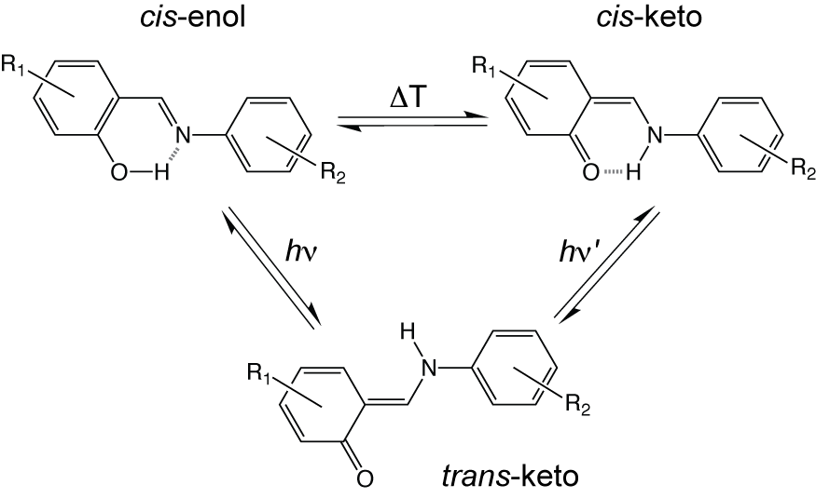
Figure 1. Scheme showing temperature- and light-induced structural changes in N-salicylideneanilines.
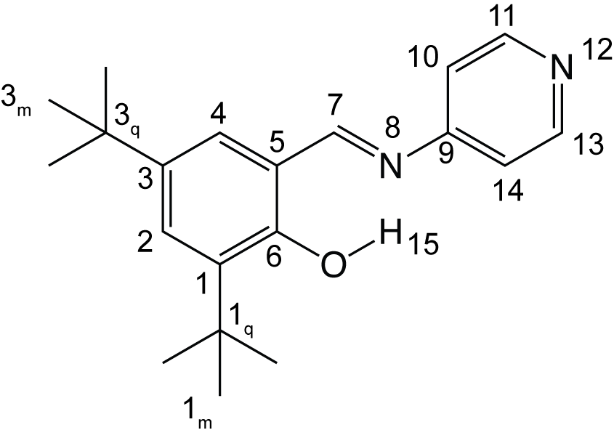
Figure 2. Chemical structure of N-(3,5-di-t-butylsalicylidene)-4-aminopyridine (1) and numbering scheme used in this work.
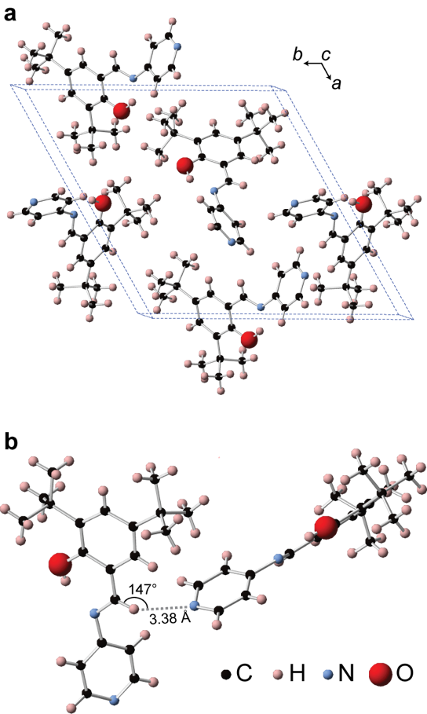
Figure 3. (a) Crystal structure of 1 obtained at 100 K showing the packing of molecules within the unit cell. (b) An expanded view of the crystal structure showing close intermolecular contact between the pyridyl nitrogen and imine carbon indicative of a weak hydrogen bond.
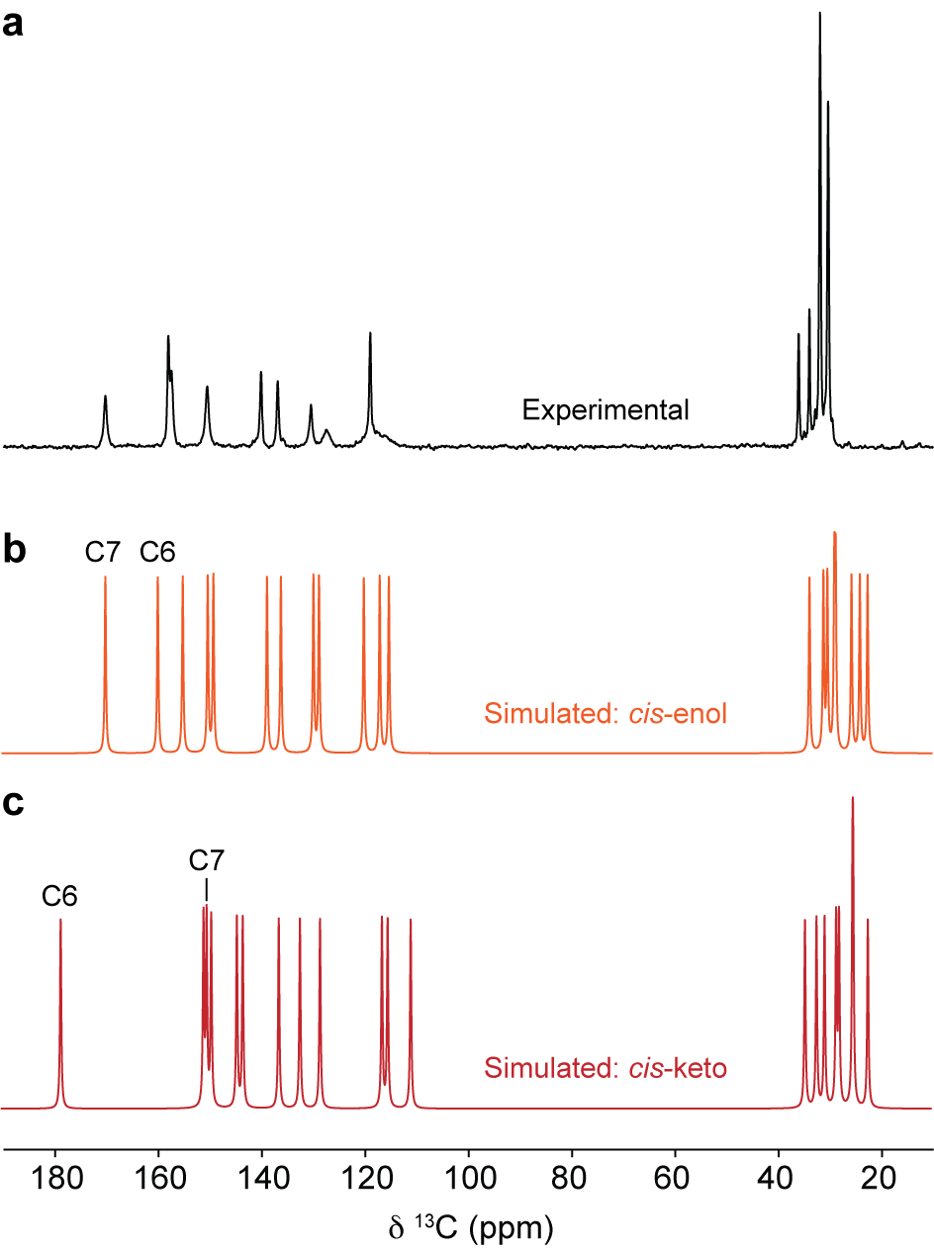
Figure 4. (a) ¹³C CPMAS NMR spectrum of 1 recorded at 9.4 T and processed with exponential line broadening of 20 Hz. (b) Simulated ¹³C NMR spectrum for the enol and (c) the cis-keto structure of 1.

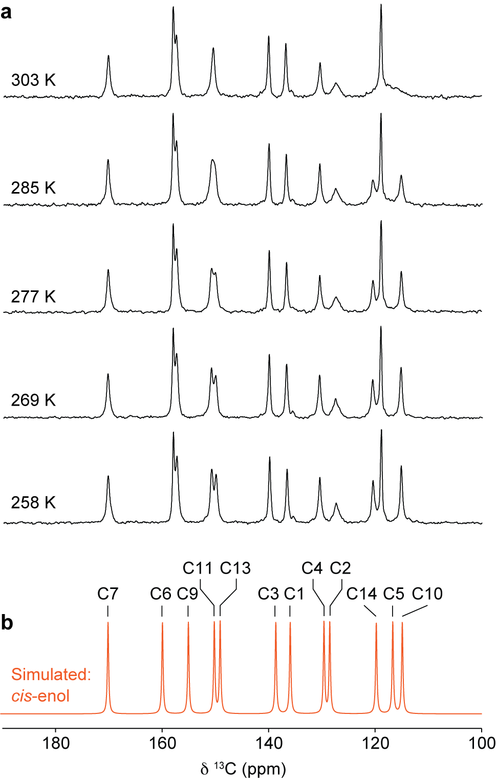
Figure 5. (a) Aromatic regions of variable-temperature ¹³C CPMAS NMR spectra of 1 recorded at 9.4 T and processed with exponential line broadening of 20 Hz. (b) Simulated ¹³C NMR spectrum based on calculated NMR parameters for 1 in the enol structure.

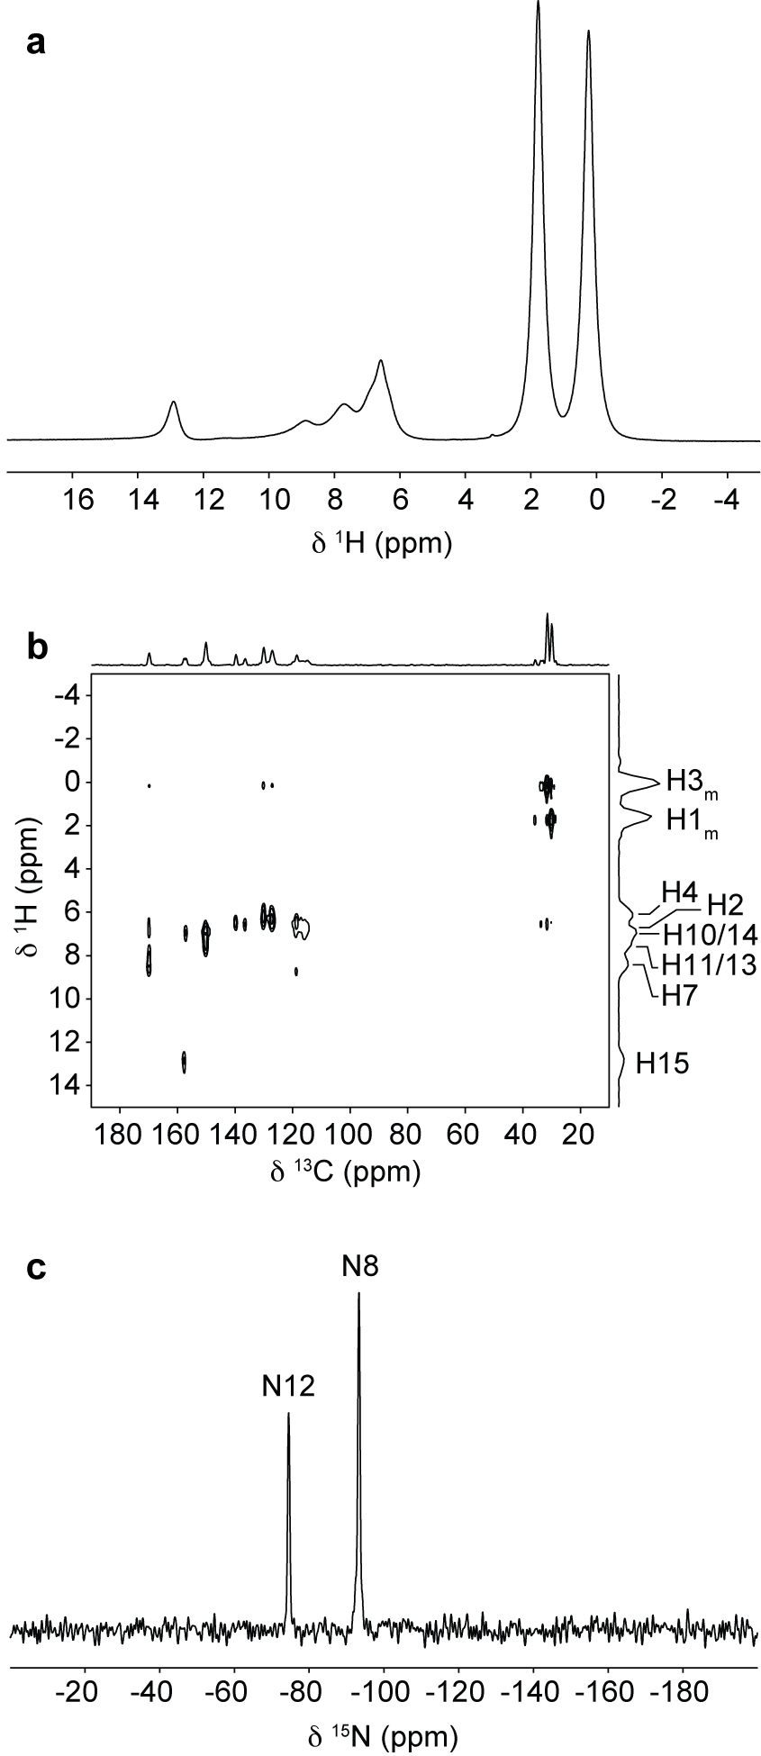
Figure 6. (a) ¹H MAS NMR spectrum of 1 recorded at 16.4 T. (b) ¹H-¹³C HETCOR spectrum of 1 recorded at 9.4 T. Exponential line broadening of 50 Hz was applied in the F₂ dimension. (c) ¹⁵N CPMAS NMR spectrum of 1 recorded at 16.4 T.

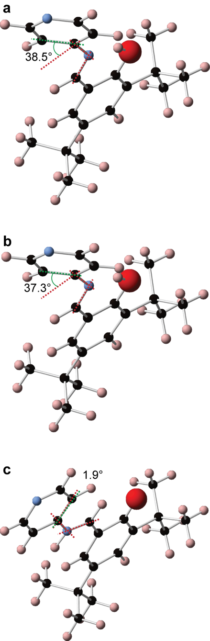

Figure 7. Structures showing the difference in dihedral angle between (a) the fully-optimised enol crystal structure, (b) a fully-optimised enol single molecule and (c) a fully optimised trans-keto single molecule.

Graphical Abstract
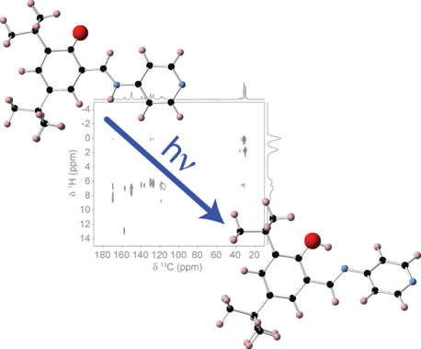
NMR crystallography is used to provide insight into the structure and dynamics of a photochromic molecular solid. The material is found to be highly dynamic with a structure that facilitates the light-driven structural transition and stabilises the photoisomerised metastable state.

