Visual Experiential Learning in MOOCs: The Vili Project

Chryssoula Themelis & Julie-Ann Sime
Centre for Technology-Enhanced Learning,
Educational Research Department, Lancaster University, U.K.
C.Themelis1@lancaster.ac.uk J.Sime@lancaster.ac.uk

Abstract
Video is ubiquitous, two thirds of knowledge on the internet is now in video format and YouTube statistics (“Statistics”, 2015) reveal that, since March 2014, there has been a 40% increase in the number of people engaging with video - either producing it or viewing the content. Videographics (the use of visual images) and infographics (the visual representations of data) are areas of increasing importance. Forbes Insights (“Executives embrace non-text world”, 2010) highlight that executives and business people prefer using non-text formats for a wide range of goals. Visual thinking strategies, video storytelling and Vlogs (video diaries/blogs) for reflection are also on the rise. The National Commission on Writing (2006, p.15) says "Thinking on the screen" is as important as "thinking on paper" in the 21st century. Virtual worlds, virtual agents and chatbots have also become widely used. This under-researched area is rising in importance and competence in video and visual thinking is crucial for communication in education and business.
In Higher Education(HE), the EU is lagging behind the rest of the world in modernisation and internationalisation, e.g. in the UK the bienniel UCISA Technology Enhanced Learning survey (2014) found that Massive Open Online Courses (MOOCs) have made little impact on HE however, video recording of lectures is increasing. Video technologies are being increasingly used in online learning and particularly in MOOCs. MOOCs have enormous potential for opening up education and making it accessible to all irrespective of institutional boundaries, national borders, or educational context. The need for competences in video/visual thinking is increasing and especially useful for supporting dyslexic learners.
This research aims to improve the performance and efficiency of online education and training by developing the competences of educators in Higher Education and vocational training by delivering a MOOC on video/visual literacies. This paper discusses initial findings of this research which examines current practice and understanding of video/visual thinking strategies in Higher Education and vocational training.
Using an informed grounded theory methodology, an analysis of interview data is combined with a review of literature to develop an innovative theory that encapsulates both current practice and ideas from existant literature on theory and practice.
Data has been gathered by interviewing 20 experts, with more than 5 years experience, in teaching online with video, videographics/infographics, visual thinking strategies or in virtual worlds. Data has been analysed using informed grounded theory to generate a new theory of praxis in video/visual literacies.
Pedagogical materials are being developed based on this new theory with a mosaic of case studies that show how to improve knowledge representation or construction exploiting the potential of visual/video thinking strategies. Open educational resources are also being developed and will be evaluated and refined through two MOOCs on video/visual thinking strategies.
The research is original and interdisciplinary as it draws on literature from multiple disciplinary fields (e.g. psychology, sociology, education) as well as from practice in multiple sectors including Higher Education, business and vocational training.
The potential impact on Higher Education, vocational training and business is increased competences of educators in communication through video/visual literacies, and support for the development and use of MOOCs within Europe through open educational resources and the development of a MOOC on video/visual literacies.
Author for Correspondence: j.sime@lancaster.ac.uk
http://www.lancaster.ac.uk/educational-research/people/julie-ann-sime

http://www.lancaster.ac.uk/fass/centres/tel/

Acknowledgement
The research discussed in this paper has been partially funded by the ERASMUS+ Programme of the European Union under agreement number 2016-1-UK01-KA203-024462. Partners in the ViLi project are: Lancaster University (convener, UK), CARDET (Cy), Danube University Krems (At), and Wide Services (Gr). For further information see: https://www.viliproject.eu/
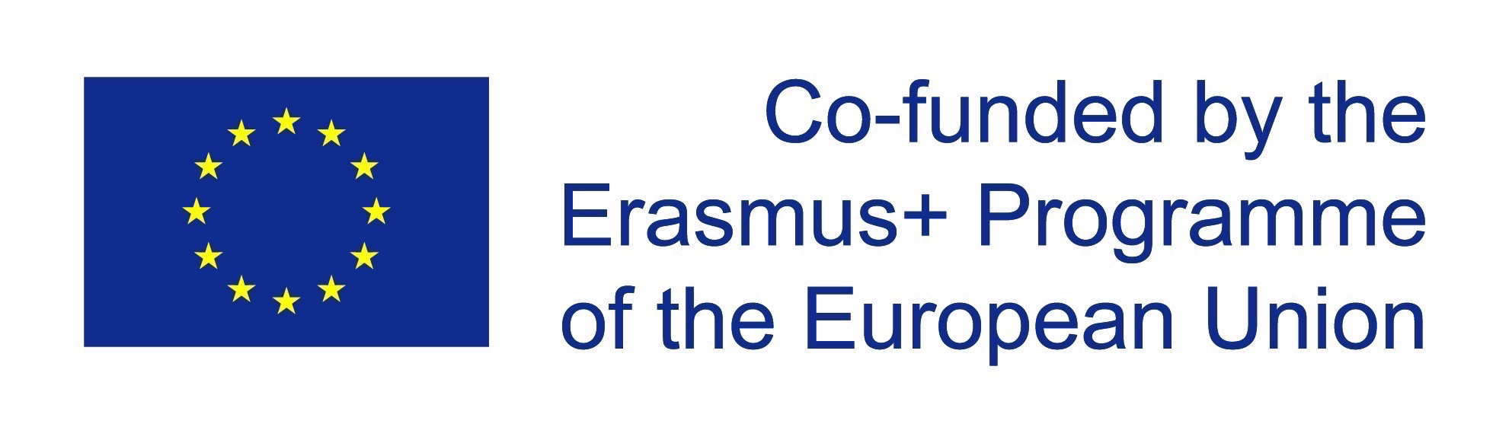
Disclaimer: The contents of this publication are the sole responsibility of Lancaster University and can in no way be taken to reflect the views of the National Agency and the Commission.

