New Tracheostomy Device Concept: An Additive Manufacturing Challenge in Reducing Late Clinical Complications

ULMEANU Mihaela-Elena, University POLITEHNICA of Bucharest, Bucharest, Romania, mihaela.ulmeanu@upb.ro
ULMEANU Liviu, Emergency University Hospital of Bucharest, Bucharest, Romania, liviu_ulm@yahoo.com
DOICIN Cristian-Vasile, University POLITEHNICA of Bucharest, Bucharest, Romania, cristian.doicin@cont-edu.pub.ro
RENNIE Allan E.W., Lancaster University, Lancaster LA1 4YW, United Kingdom, a.rennie@lancaster.ac.uk
LUPEANU Elena, National Institute of Gerontology and Geriatrics "Ana Aslan", Bucharest, Romania, elenalupeanu@yahoo.com

Abstract

The application of additive manufacturing technologies for the development of invasive airway devices may enhance the quality of life of tracheostomy patients. The current research is intended to reduce clinical long-term complications that appear in the frequent use of classic tracheostomy tubes in airway management. The development of a bespoke tracheostomy device aims to improve functional ability, social anxiety and overall patient satisfaction. The study was conducted in four stages: preconception, patient specific design, additive manufacturing of the new endotracheal tube prototype and testing. Using patient specific data a new concept was designed with appropriate CAD software, while implementing the findings from deploying functional analysis. Starting with a cuffed tracheostomy tube for needs analysis, three new CAD models were generated. The initial functional prototypes were developed, with the main innovations brought to the tracheal fixing system, neck plate and obturator, and were enabled by the advantages of additive manufacturing technologies. Initial tests were undertaken on an explanted pigs’ trachea with the aim of identification of any surgical technique or concept shape related problems. The current research presents an integrated approach for developing a new tracheostomy device concept, fabricated using AM technologies. The advantages of AM were used to enable the design and manufacture of customised, unique features that target the reduction of late clinical complications of tracheostomy tube users.

Keywords: endotracheal tube, patient specific design, additive manufacturing, functional analysis

Introduction

Sobotta (2011) describes the tracheostomy as a surgical opening in the anterior wall of the trachea, also known as a tracheal stoma, made with the aim of facilitating ventilation. As presented by Morris and Afifi (2010) a tracheostomy can be temporary or permanent and leads, in both cases, to respiration bypassing the upper airways. Wilkinson et al (2014) shows that in the majority of cases (95.8%), the airway is managed using an endotracheal (tracheostomy) tube, immediately prior to tracheostomy. Tracheostomy tubes are available in a large variety of sizes and styles, as shown in research conducted by Morris and Afifi (2010), Wilkinson et al (2014), De Leyn et al (2007) and Fikkers et al (2013). Fisher et al (2014), De Leyn et al (2007) and NHS (2007) conclude that the main categories include cuffed or un-cuffed, single or dual cannula and continuous or fenestrated tracheostomy tubes. Morris and Afifi (2010), Wilkinson et al (2014) and Apfelbaum et al (2013) state that in order to select the best tube for a particular patient, physicians with specific training must accurately understand and set the primary goals.
The complications associated with tracheostomies and placement of a tracheostomy tube can be grouped into three main categories by their main causes: failed surgical procedures; tube misplacement; and improper postoperative stoma and tube care. Timeframe related complications can be immediate, early and late. As presented by Sobotta (2011), Wilkinson et al (2014), NHS (2007) and Muralidhar (2008) the most numerous and frequent complications occur later, after the tracheostomy procedure is conducted. Amongst these, the most significant, noted in the literature research cited above, are: cuff leak, trachea-esophageal fistula and trachea-innominate fistula, due to overinflating/ underinflating of the cuff; dislodgement of tracheostomy tube, due to poor airway management protocols; obstruction of tracheostomy tube and obstruction of permanent stoma mucus plugs or thick secretions, mostly due to humidity deficit in the airways; stoma infections, due to poor positioning or post-operative care; stomal stenosis, stomal granulation tissue, tracheomalacia, tracheal stenosis, mediastinitis, tracheocele; tracheoinnominate hemorrhage, due to improper positioning or poor choice of the tube. Research conducted by Morris and Afifi (2010), NHS (2007), Apfelbaum et al (2013) and NCEPOD (2009) shows that less frequent long-term complications may also include vertebral erosion pneumonia and sometimes, even death.
Morris and Afifi (2010), Wilkinson et al (2014), Fisher et al (2014) and De Leyn et al (2007) conclude that in some cases, current designs of tracheostomy tubes facilitate and maintain the occurrence and, sometimes, worsen the evolution of complications.
The current study presents the development of a new tracheostomy device concept proposed for the reduction of long-term clinical complications of temporary and permanent tracheostomies. Given the importance of personal anatomical features for the outcome of such surgical procedures, as presented in their research by Santos et al (2012) and Zenikos et al (2012), various authors who developed the Wohlers (2015) report consider additive manufacturing (AM) the most appropriate technology to utilise for the proposed research.

Methods

Ulrich and Eppinger (2012) claim that the design processes commence with the preconception phase. For this specific phase, the authors developed a structured procedural approach which is made up of four stages: 1. Identification of challenges in airway management by usage of an endotracheal tube; 2. Identification of specific late clinical complications and their causes, strictly related to the design of the endotracheal tube; 3. Definition of the needs that arise from prior identified causes; 4. Function definition of the endotracheal tube.

Challenges and complications that influence the design of an endotracheal tube

The idea behind this procedural approach was that patients with a tracheostomy encounter many challenges due to specific complications. The tracheostomy tube concept must perform all the identified functions in order to satisfy the needs generated by late complications, thus reducing airway management related challenges (Fig 1).

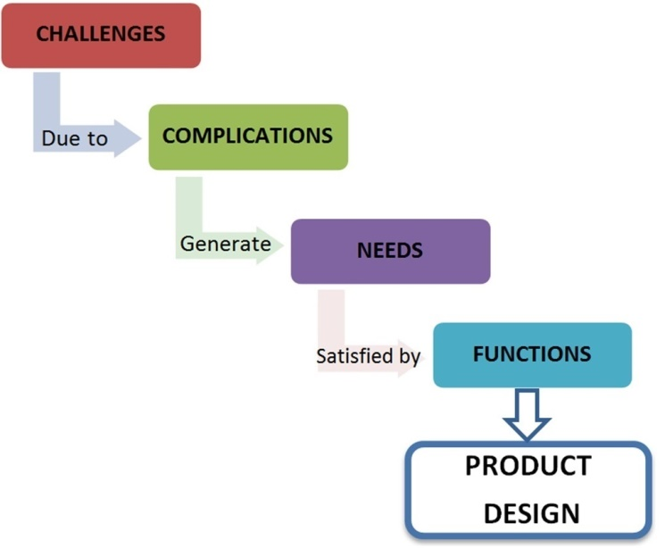
Fig 1. Structured procedural approach for product design of TrachyLight

To validate dimensions and anatomical feature proportions of the concept, the models are developed for a real patient. Hereafter, the new tracheostomy device concept is referred to as TrachyLight (TL). Research conducted by Morris and Afifi (2010), Fisher et al (2014), De Leyn et al (2007), Fikkers et al (2013), NHS (2007), Apfelbaum et al (2013), Muralidhar (2008), NCEPOD (2009) and Engoren (2004) identify the main challenges involved in the airway management of patients with a fitted endotracheal tube in the following areas: communication; swallowing and nutrition; stoma care; tracheostomy tube management; suction; and humidification. NHS (2007) shows that in relation to tracheostomy tube design, the difficulties in communication can occur when the type and the size of the tube are not chosen properly for the anatomical specificities and condition of the patient.
Commonly, speaking valves are required to improve communication. Morris and Afifi (2010), Fikkers et al (2013) and Apfelbaum et al (2013) show in their research that speaking valves can be safely used with un-cuffed tracheostomy tubes or with a fully deflated cuff.
Swallowing difficulties can occur due to compression of the oesophagus from an inflated cuff, as presented by De Leyn et al (2007), Fikkers et al (2013), NHS (2007), Apfelbaum et al (2013) and Engoren (2004). Swallowing may also be difficult for the patient if an improper tube is used or the tube is poorly positioned or fixed. In the same time, stoma care needs to be undertaken in order to reduce the risk of infection. Stomas are a potential route for respiratory tract infection and potential site of peristomal infection. Fikkers et al (2013), NHS (2007) and Apfelbaum et al (2013) conclude that in order to avoid these risks, some tracheostomy tubes are designed with soft flanges such that a dressing between the tube and the skin is not always required. Tracheostomy tube management involves: individual assessment of the most appropriate tube; care, change and removal protocols; compliance with manufacturing recommendations for each type of tube. Research conducted by Fisher et al (2014) and NHS (2007) shows that improper usage of inner cannulae was shown to reduce the lumen of the outer tracheostomy tube, thus increasing respiratory effort. Suctioning is of great importance for patients that are unable to cough and cannot eliminate secretions in a natural way. Some complications of the current procedure involve tissue damage and hypoxia, mainly due to the shape of the tube and misuse of equipment. According to research undertaken by Morris and Afifi (2010), Fisher et al (2014), Fikkers et al (2013), Engoren (2004) and Ham (2010) the lack of proper humidification in tracheostomy patients has been also shown to cause a series of complications from thick secretions, loss of ciliary action, deterioration of pulmonary function and increased risk of infection. Moreover, heated systems can result in water vapours cooling and collecting in the tubing. The weight of different humidification systems can pull on tracheostomy masks causing increased risk of airway obstruction when a cuffed tube is in situ. Thus, a proper design must ensure safe positioning of the tube.
The aforementioned challenges develop due to either individual or common late complications. Amongst these, the authors identify the most important as being: stoma, trachea and respiratory tract infections; haemorrhage; stoma and tracheal stenosis; thick, tenacious, crusted secretions; excessive sputum production; impaired pulmonary function; pressure sores; irritated/ damaged airway mucosa; aspiration and swallowing problems; tracheostomy tube occlusion and displacement; cuff leaks; formation of granulation tissue.
Considering the principles of needs analysis, described by Ulrich and Eppinger (2012), and the complications reported by physicians and patients, the main identified needs that require focus in terms of tracheostomy tube design are stated. Thus, the tracheostomy tube must: 1. Diminish or prevent the risk of infection; 2. Facilitate wound healing; 3. Be positioned and fixed properly; 4. Maintain correct position after fitting; 5. Be compliant with patient anatomy; 6. Provide/allow proper humidification of airway; 7. Be minimally invasive over the trachea; 7. Allow proper guidance for suction equipment. The functional expression of these needs was analysed with technical functional analysis (TFA) and translated into specific targeted functions.
A customized tracheostomy tube might reduce some of the aforementioned long-term clinical complications associated with the design of these devices. With AM technologies being more and more available to the medical industry, in terms of capabilities, materials, applications and costs, the authors consider a viable option to be research into the design and manufacture process for a new tracheostomy device.

Technical Functional Analysis (TFA)

To identify the main functions of the product, Technical Functional Analysis was undertaken, in correspondence with the stages mentioned by Ulrich and Eppinger (2012) in their research. The main function of the tracheostomy tube is to ensure and maintain an access stoma (hole) through the trachea, allowing a constant airflow and pressure throughout the breathing and deglutition process.
Function Analysis System Technique (FAST) was deployed, as a tool of TFA, in order to properly identify the main functions of the tracheostomy tube (Fig 2).
FAST was deployed to determine the four level functions of an endotracheal tube used in current surgical practice. Four levels of functions were sufficient for the current research study, but if necessary the analysis could be more detailed. Each individual function must be materialised into the final CAD concept as a particular element or shape. TFA has several other stages for cost and value evaluation of products. Further research of the endotracheal tube concept will consider such analysis by integrating all other states of existence.

Computer Aided Design of TrachyLight concept models

Given the large variety of tracheostomy tubes and their diverse applications, the redesign process was undertaken starting with a properly defined existing tube (Fig 3). The customization of the proposed concept was made according to a male patients’ anatomy.

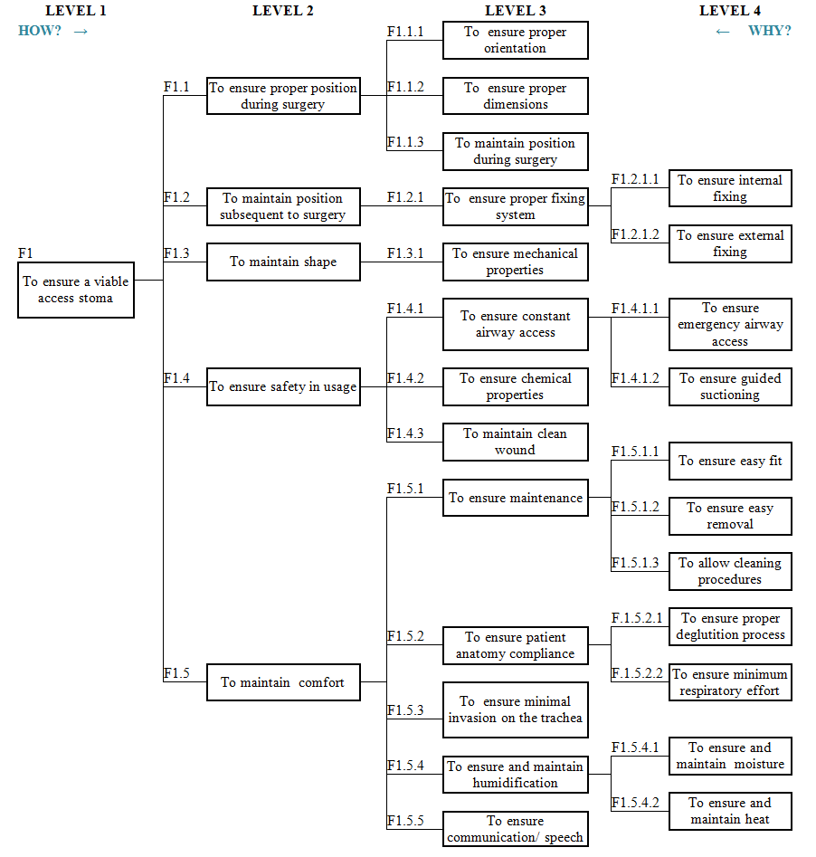
Fig 2. FAST analysis for usage of the tracheostomy tube

The patient was selected considering that he should fit into the average of the following criteria: tracheal width, which was set according to restrictions provided by Chunder et al (2010) and Brodsky et al (1996); gender frequency tracheostomy occurrence, selected in accordance with research conducted by Wilkinson et al (2014) and Brodsky et al (1996); average demographics (age – excluding infants and children under 16, height, weight), criteria discussed in their research by Morris and Afifi (2010), Wilkinson et al (2014), De Leyn et al (2007), Fikkers et al (2013) and NHS (2007); principal diagnosis (respiratory disease), described in their research by Morris and Afifi (2010), Wilkinson et al (2014), Fikkers et al (2013) and Apfelbaum et al (2013). The average values were those mentioned in specialist literature.
A 68 year old male patient was submitted to the emergency room showing acute respiratory failure and other symptoms. An emergency Computer Tomography (CT) procedure was performed to establish the cause. It was established that the upper airway of the patient was partially obstructed due to a hypopharyngeal tumoral mass that was pushing against all surrounding tissue structures causing difficulties in breathing.
Upper airway intubation was not a viable option due to the shape and position of the tumor. The patient was respiratory stabilised using an emergency tracheostomy. He was fitted with a cuffed, single lumen tracheostomy tube with an internal diameter of 7 mm and a guiding obturator (Fig 3). Once the stoma was established, artificial ventilation was not necessary.

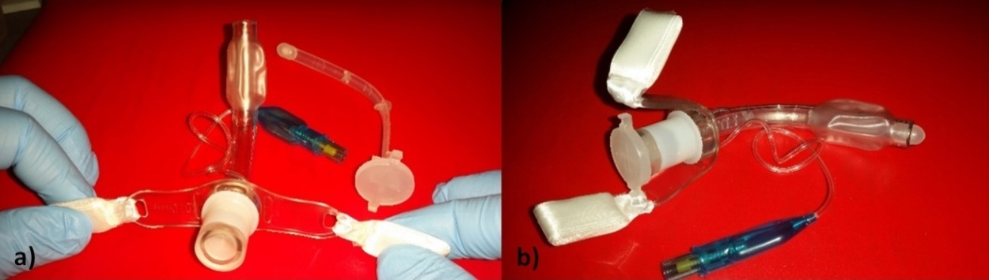
Fig 3. Cuffed tracheostomy tube with a size of ID 7mm: a) front view; b) lateral view (Courtesy of the Emergency University Hospital of Bucharest, Emergency Room)

A cuffed tracheostomy tube was taken as a starting point for the needs analysis. The design process for the TrachyLight concepts was targeted at fulfilling the specific identified functions. Three main components, each tackling a group of functions, were designed: 1. The body of the tube, measured from the connector with the mechanical ventilators up to the trachea anterior wall; 2. The tracheal fixing system; 3. The neck plate. The obturator and adapter did not undergo any modifications.
For the design of the TrachyLight body tube, the following functions were taken into consideration for compliance: F1.1.1 To ensure proper orientation; F1.1.2 To ensure proper dimensions; F1.1.3 To maintain position during surgery; F1.2.1.2 To ensure external fixing; F1.3 To maintain shape; F1.4.1 To ensure constant airway access; F1.5.2 To ensure patient anatomy compliance.
In order to determine the exact dimension of a tracheostomy tube body several criteria need to be taken into consideration, apart from the anatomical dimensions of the patient. Amongst the specific criteria, some can be mentioned as follows: the position and nature of the respiratory impairment, position of the incision point, type of surgical incision and curvature of the tracheostomy tube used. According to Sobotta (2011), Morris and Afifi (2010) and Muralidhar (2008) the most common site of a tracheostomy is between the 2nd and 4th or 3rd and 5th tracheal rings. Within this area, different types of incision can be used in order to ensure the proper stoma. Airway management protocols must be used throughout the intervention and post-operative care, precisely as described by Fikkers et al (2013), NHS (2007) and Apfelbaum et al (2013). For the 68 year old male, the tomography showed that the hypopharyngeal tumoral mass was partially obstructing the larynx, thus the surgical procedure was undertaken between the 3rd and 5th tracheal rings. For the curvature of the tracheal tube, several design recommendations are noted from the research of Sobotta (2011) and Roe (1962) and a curvature of 60⁰ was assigned (Fig 4). As an added feature, the body of the tube can be manufactured with a length adaptor (Fig 4). The step was set at 3 mm between two consecutive cylindrical elements, creating a supplementary length of 18 mm. Accurate position of the cylindrical element ensures the orientation of the endotracheal tube during and after surgery. In connection with the neckplate it also ensures fixation and maintenance of the position during and after surgery. The internal diameter of the TrachyLight tube is 7 mm, the same as those used by surgeons in the surgical theatre. The adaptor was designed with a 15 mm external diameter, so that it connects with all general types of tubing from ventilators, humidifiers and speaking valves. Thus, the adaptor caters to the following functions: F1.5.4 To ensure and maintain humidification; F1.5.5 To ensure communication and speech.

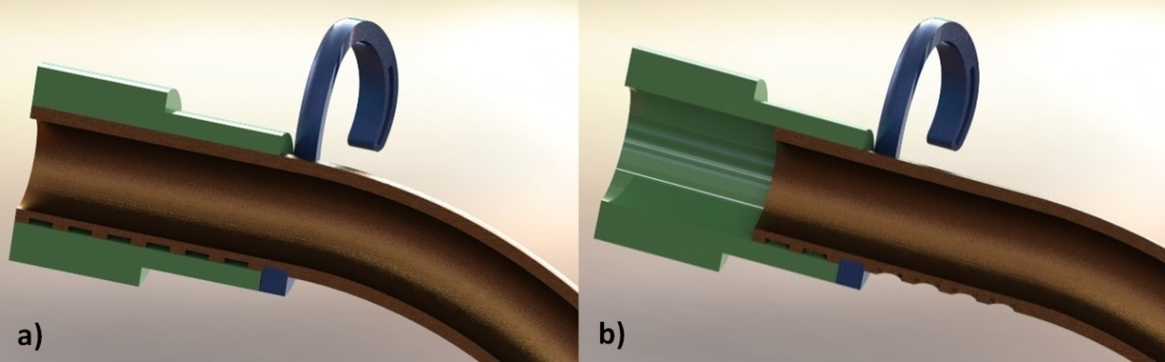
Fig 4. Detail of the length adjustment feature (3mm step) for two different soft tissue dimensions: a) 21 mm; b) 33 mm (sagittal section view)

The TrachyLight concept was designed with a new tracheal fixing system by taking into consideration the following functions: F1.1 To ensure proper positioning during surgery; F1.2.1.1 To ensure internal fixing; F1.5.1 To ensure maintenance; F1.5.2.1 To ensure proper deglutition process; F1.5.2.2 To ensure minimum respiratory effort; F1.5.3 To ensure minimal invasion on the trachea; F1.5.4.1 To ensure and maintain moisture; F1.5.4.2 To ensure and maintain heat.
Considering the aforementioned functions, the innovative fixing system that was proposed consists of a spherical/toroidal surface (Fig 5).

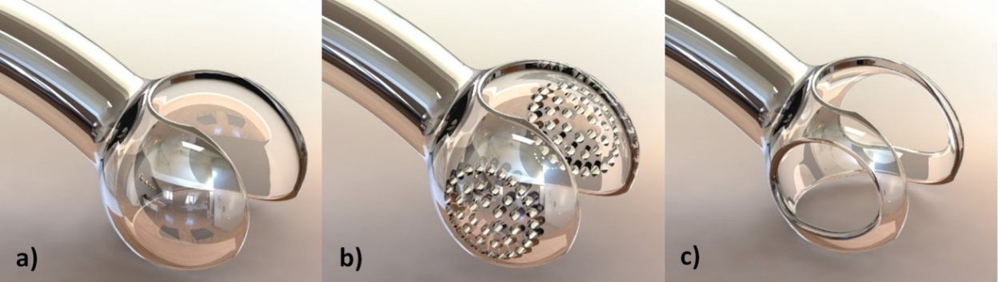
Fig 5. Main three concepts for the spherical surface tracheal fixing system: a) SFS 1 - full lateral gripping elements; b) SFS 2 - lateral gripping elements with model driven micro-perforations; c) SFS 3 - structural shaped lateral gripping elements

The dimensions of the sphere were compliant with the patient’s anatomy. Studies undertaken by Chunder et al (2010) and Brodsky et al (1996) have shown that the average tracheal width for women is 17 mm (range = 13-25 mm) and for men is 22mm (range = 13-25 mm). The age range for the patients was 13 to 82 years. Situated within the average, the patients’ CT shows he has a 20 mm tracheal width. For accuracy, the measurements were taken both in the sagittal and transversal plane from data series and details. Thus, three different concepts were proposed for the spherical fixing system (Fig. 6) and were presented to surgeons for feedback and validation. The first spherical fixing system (SFS 1) was designed with full spherical lateral gripping elements. The second concept of the fixing system (SFS 2) presents lateral gripping elements with model driven micro-perforations for extra grip. The third concept (SFS 3) was designed with structural shaped lateral gripping elements in order to reduce the overall weight of the concept. All three concepts were designed for a 20 mm diameter (tracheal width on both sagittal and transversal plane). In order to mimic the effects produced by a cuffed tracheostomy tube, the spherical surface fixing system can be manufactured with the upper surface of the sphere covered. Thus, a half closed sphere will totally disconnect the upper airway.
The neck plate was designed in accordance with the following functions: F1.2.1.2 To ensure external fixing; F1.3 To maintain shape; F1.4.3 To maintain clean wound; F1.5.1 To ensure maintenance; F1.5.2 To ensure patient anatomy compliance. The overall dimensions of the neck plate are 18.5 mm by 37 mm, with a thickness of 2 mm. The arch of the part (Fig 6) follows the anatomical shape of the patients’ neck and is guided by a circle of 28 mm radius. Three concepts of the neck plate were developed (Fig 6) to fulfil the functions identified previously.

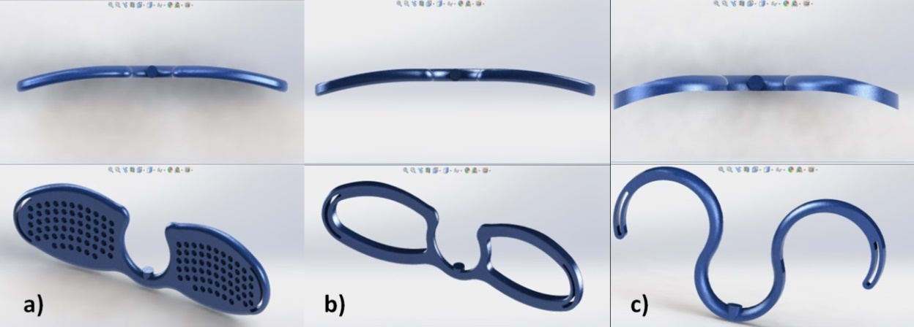
Fig 6. Main three concepts of neck plate: a) NP 1; b) NP 2; c) NP 3

All the concepts have a common cylindrical section in the middle that fits perfectly on the outer diameter of the body tube. Also, an embossed cylinder was provided in order to orient and fix the neck plate onto the tracheostomy tube. Once in place, the shape of the neck plate indicates the orientation of the tube subsequent to surgery. It makes adjusting the TrachyLight easy and comfortable at any moment. The first concept of the neck plate (NP1) offers the most support, whilst providing skin ventilation through custom made curve driven perforations. These perforations can have any shape in a specific dimensional limit, without affecting the structural integrity of the part. Sideways NP1 is provided with appropriate slots for fixing with an ordinary neck strap. The second concept of the neck plate (NP2) is designed for medium support and has a light weight construction. Prolonged contact with skin will not cause any complications due to the wireframe structure. The shape of the third neck plate concept (NP3) ensures minimal skin contact whilst ensuring light support for patients that have a healed stoma. These patients often need to wear a tracheostomy tube for longer periods of time. The neck plate is the most adaptable component of the TrachyLight, as long as it maintains several mandatory features: the fixing and contact cylinder and the side slots.
A fully functional concept of the TrachyLight was assembled in SolidWorks, using the following components: 15mm adaptor, SFS 3 and NP 3 (Fig 7). Any combination of the designed components is possible as they are interchangeable and adaptable with standard medical devices used in care and management of tracheostomies.

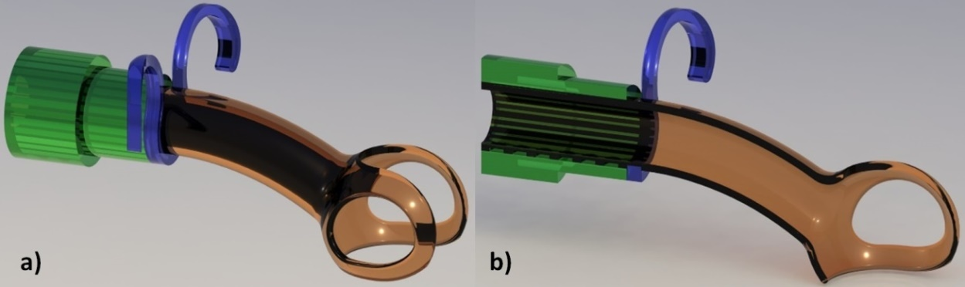Fig 7. New tracheostomy device concept (ID 7 mm): a) Isometric view; b) Section view through the sagittal plane
Results and Discussions

Manufacturing of TrachyLight prototypes using 3SPTM technology

The TrachyLight concepts were manufactured with an industrial additive manufacturing machine from EnvisionTECH, the Ultra 3SP™. The used *.stl files had the following input parameters: deviation tolerance 0.00332345 mm; angle tolerance 0.5 degrees; output as binary; metric unit system. The print job was designed with Perfactory™ software and loaded on the machines built-in computer. Seven components were included in one build operation, as follows: three concepts of the tracheostomy tube with the different spherical surface tracheal fixing system, six parts of neck plate (two of each concept) and one 15 mm adaptor (Fig 8). The voxel size depth was set to 50 µm. The entire batch was printed in 10 hours and 35 minutes. In order to fully cure the parts, they were placed in a UV curing unit. All the parts were sprayed with a silicone based solution for a better surface finish and left 12 hours to rest. After all post-processing and secondary treatments were finished, the parts were paper dried and fitted together in order to assess assembly functionality.
The TrachyLight concept prototypes, manufactured using the 3SP technology, are presented in Fig 8. The assembly of the three neck plate concepts with the other three tube concepts was done randomly.

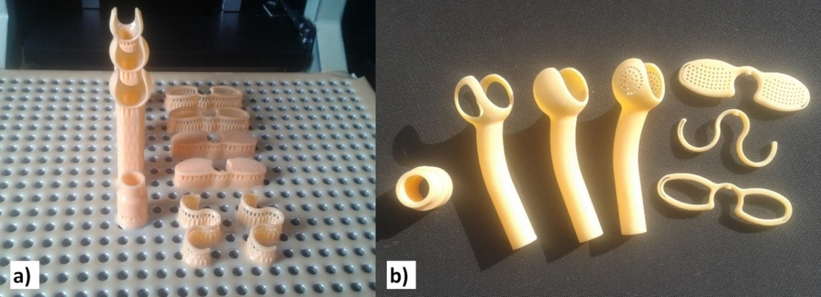
Fig 8. TrachyLight concept prototypes manufactured with 3SP technology: a) prototypes with supports on the build platform of the machine; b) post processed prototypes

Functional tests

Functional tests were required in order to identify any surgical technique and concept shape related problems. An emergency room suture kit was used to perform the surgical procedure (Fig 9a). The prototypes were tested on a pigs’ trachea of 20 mm diameter (Fig 9b) in order to identify any functional issues. A window type incision was used to access the tracheal lumen (Fig 9c), as it is the most common method employed, presented in the research conducted by Wilkinson et al (2014). The tests were conducted by a surgeon in an appropriate medical facility. The following criteria were assessed: ease of insertion, ability to orient during the procedure, ability to maintain position subsequent to the procedure, compliance with the shape of the trachea, existence of appropriate pressure on the trachea. During the surgical procedure, it was observed that the LightTrachy tube could be inserted with ease. The concept with SFS3 was the easiest to be inserted into the trachea, due to the lateral shavings of the sphere. The surgeon concluded that if a different type of incision was used in the surgical procedure, the TrachyLight concepts could have some issues with insertion. The orientation was made instinctively, due to the shape of the spherical fixing system and the presence of the cylindrical fixing element on the lower side of the prototype. After insertion of the TrachyLight in the trachea, the shape of the fixing system made it quite easy to be snapped into position. The orientation was once again checked visually with the cylindrical elements. Position was maintained due to the shape of the spherical fixing system and the 60⁰ angle of the tube body.

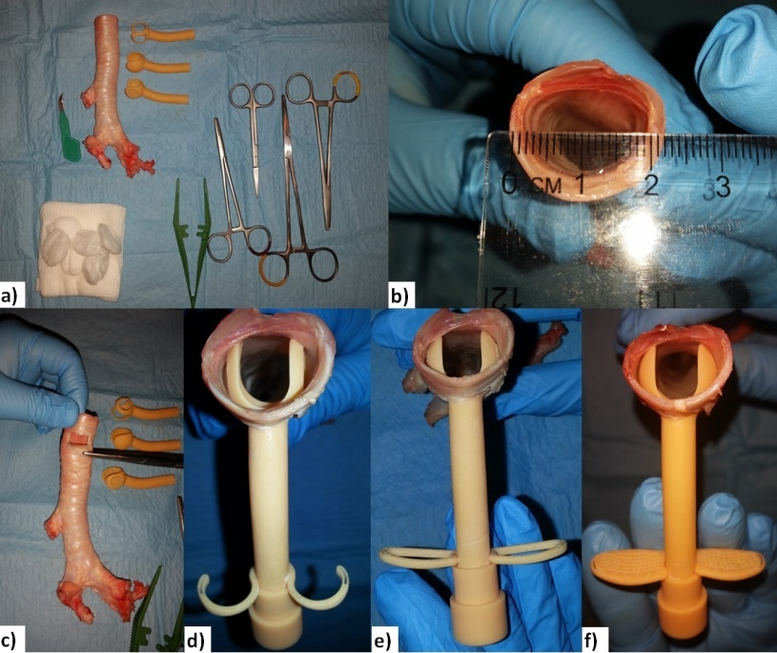
Fig 9. Functional tests on an explanted pigs’ trachea: a) materials; b) 20mm trachea; c) fenestrated window; d) fit test for SFS 3 & NP3; e) fit test for SFS 2 & NP 2; f) fit test for SFS 1 & NP1

The pressure on the contact surface meant the trachea maintained a slightly tense position, with no bulges or deformations of the trachea (Fig 9 d, e, f). It was concluded that the slight tension was due to the fact that the concepts were not designed in compliance with the anatomy of this specific trachea. Out of the three concepts, SFS 3 presented minimal impact over the tracheal lumen. The most stable concepts were SFS 1 and SFS 2, both gripping securely onto the tracheal wall. Taking this into consideration, the authors will conduct future studies regarding the optimal shape of the fixing system. Concepts with a toroidal surface will be developed, as the contact surface with the trachea would be wider, thus generating more stability. It was also observed that for fitting and fixing the neck plates and the adaptor, the tube needs to be secured in place with one hand. In this particular instance, the shape of the neck plate concepts became an advantage, due to the clip-on feature.

Recommendations and feedback

The CAD concepts generated, along with the prototypes and the results of the functional tests, were sent to a team of medical/surgical specialists for initial feedback.
Some suggestions were made for future studies, amongst which can be mentioned: 1. The wall of the trachea must always overpass the diameter of the devices’ central cavity diameter; for this reason, special care must be given to the insertion, fixation and maintenance of the device in the proper position; 2. An easy removal must be ensured at all times and some concerns were stated in relation to the bulbous end if used together with a different type of incision; 3. The shape of the neck clips could be further improved; specialists choose concept model no. 3 as a more “appealing” solution; 4. In vivo concept testing is strongly recommended after the final bio-compatible material is chosen.
The main contributions brought about by the TrachyLight can be summarised as follows: improvement of the deglutition process; limited invasion of the trachea; customised features with patient anatomy compliance; ease of orientation, fixation and overall fitting; and controlled pressure on the tracheal lumen. Depending on the final manufacturing material, the TrachyLight will be impregnated with an antibiotic solution. Due to the porous surface roughness, an inherent feature of AM technology, the antibiotic will be absorbed deeply into the material structure of the device.
After undergoing the present research, several conclusions were made: 1. For short-term users of the TrachyLight, it is better that the devices are available in several standardised dimensions of the tube and spherical fixing system. The CAD model can be parameterised with appropriate software tools and the device could be manufactured in a large scale production; 2. For long term or permanent users of the TrachyLight device, it is best that the design process should take into consideration the specific dimensions and shapes of the patients’ trachea informed by CT data.
In this context, some recommendations are given for possible adaptation of the TrachyLight device for permanent tracheostomy and laryngectomy patients: the spherical fixing system is intended to be manufactured from biocompatible rubber-like material to facilitate removal by the patient themself; an easy guiding system should be designed to allow the patient to insert the TrachyLight safely and in a proper position; an ergonomic tracheostomy shield is considered for customisation. These recommendations constitute a basis for future research.

Conclusions

The current research presents an integrated approach for developing a new tracheostomy device concept, fabricated using AM technologies. The advantages of AM were used to enable the design and manufacture of customised, unique features that target the reduction of late clinical complications of tracheostomy tube users. The proposed structured approach covered the following research areas: identification of challenges and complications in airway management for tracheostomy patients; definition of specific needs; identification of targeted functions of the new tracheostomy device concept; development of CAD models for several concepts that fulfill the identified functions; manufacture of the first prototypes of the new tracheostomy device concept; deployment of functional tests on a pig’s trachea; evaluation and feedback from a team of medical specialists; recommendations for usage of the new tracheostomy device concept. The research results were encouraging, thus future research will be undertaken for further development of the TrachyLight concepts.
Future research includes designing an ergonomic adaptable shield to improve speech, device and stoma protection, and physical appearance when the TrachyLight is not connected to ventilation equipment. Cleaning or sterilisation will be considered when choosing the material for manufacturing the final TrachyLight device. All the medical practitioner feedback was taken into consideration and will be given special attention when designing and testing the final prototype. In vivo tests will be conducted in a rigorously designed and managed experiment.

Acknowledgment

This work has been funded by University Politehnica of Bucharest, through the “Excellence Research Grants” Program, UPB – GEX 2017, Identifier: UPB- GEX2017, Ctr. No. 50/ 2017 (BIOSHIELD)”.

References

Apfelbaum, JL., Hagberg, CA., Caplan, RA., Blitt, CD., Connis, RT. and Nickinovich, DG. (2013), ‘Practice Guidelines for Management of the Difficult Airway’, An Updated Report by the American Society of Anesthesiologists, Task Force on Management of the Difficult Airway, Anesthesiology, 118 (2), 251-270

Brodsky, JB., Macario, A. and Mark, JBD. (1996), ‘Tracheal Diameter Predicts Double-lumen Tube Size: A Method for Selecting Left Double-Lumen Tubes’, Anesthesia & Analgesia, 82, 861-864

Chunder, R., Nandi, S., Guha, R. and Satyanarayana, N. (2010), ‘A morphometric study of human trachea and principal bronchi in different age groups in both sexes and its clinical implications’, Nepal Medical College Journal, 12(4), 207-214

De Leyn, P., Bedert, L., Delcroix, M., Depuydt, P., Lauwers G. and Sokolov Y. (2007) ‘Tracheotomy: clinical review and guidelines’, Eur J Cardiothorac Surg, 32(3): 412-421

Engoren, M., Arslanian-Engoren, C. and Fenn-Buderer, N. (2004), ‘Hospital and Long-term Outcome After Tracheostomy for Respiratory Failure’, CHEST Journal, 125(1), 220-227

Fikkers, BG., Breedveld, P., Delwig, H., Dongelmans, D., van der Hoeven JG. and Spijkstra, JJ. (2013), ‘Tracheostomy on the intensive care unit for adult patients’, Protocol elaborated collaboration with the committee “Guidelines Tracheostomy”, 1-20

Fisher, DF., Chenelle, CT., Marchese, AD., Kratohvil, JP. and Kacmarek, RM. (2014), ‘Comparison of Commercial and Noncommercial Endotracheal Tube-Securing Devices’, Respiratory Care; 59(9): 1315-1323

Ham, ST. (2010), Mapping the Medical Device Development Process, California Polytechnic State University

Morris, LL. and Afifi, MS. (2010), Tracheostomies – The complete guide, Springer Publishing Company, ISBN 978-08261-0518-9

Muralidhar K. (2008), ‘Tracheostomy In ICU: An Insight into the Present Concepts’, Special Article, Indian Journal of Anaesthesia, 52(1): 28-37

NCEPOD (2009), Adult Tracheostomy: Patterns and problems with tracheostomy in UK hospitalised adults, Protocol

NHS (2007), Caring for the patient with a tracheostomy: Best Practice Statement, NHS Quality Improvement Scotland, ISBN 1-84404-453-X

Roe, BB. (1962), ‘Bedside tracheostomy’, Surgery Gynecology and Obstetrics Journal, 115, 239-241

Santos, ICT., Gazelle, GS., Rocha, L. and Tavares, JM., (2012), ‘Medical device specificities: opportunities for a dedicated product development methodology’, Expert Review of Medical Devices, 9(3), 299-311

Sobotta (2011), Atlas of Human Anatomy, Vol. 3: Head, Neck and Neuroanatomy, Editors Paulsen F. and Waschke J., 15th Ed., Elsevier Urban & Fischer, ISBN 978-0-7234 -3733-8

Ulrich, K. and Eppinger, S., (2012), Product Design and Development, 5th Edition McGraw Hill Education, New York, USA

Wilkinson, KA., Martin, IC., Freeth, H., Kelly, K. and Mason, M. (2014), On the Right Trach? A review of the care received by patients who underwent a tracheostomy, National Confidential Enquiry into Patient Outcome and Death, ISBN 978-0-9926184-1-4

Wohlers T. (2015), Wohlers Report 2015: Additive Manufacturing State of the Industry Annual Worldwide Progress Report, Wohlers Associates, Inc., Colorado, USA

Zenikos, S., Makover, J., Yock, P., Brinton, TJ., Kumar, UN., Denend, L. and Krummel, TM. (2012), Biodesign – The process of Innovating Medical Technology, Cambridge University Press, 6th Edition, ISBN 978-0-521-51742-3

