Digital Literary Geography and The Difficulties of Locating ‘Redgauntlet Country’

Christopher Donaldson, Sally Bushell, Ian N. Gregory, Joanna E. Taylor, and Paul Rayson

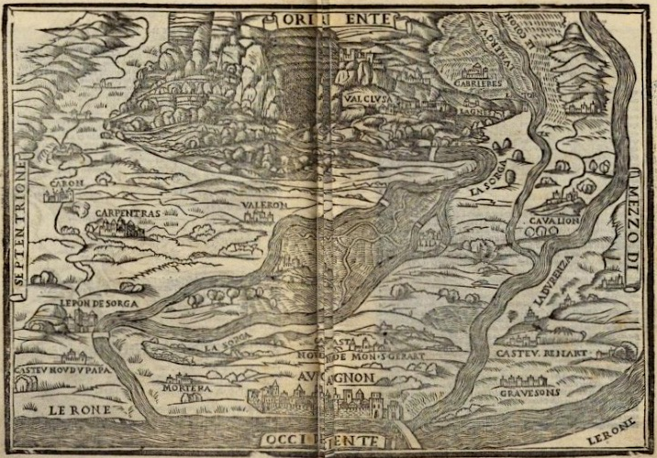

Figure 1. Vellutello’s map, from Le Volgari Opere del Petrarcha (Venice: Giovanni Antonio & fratelli da Sabbio, 1525); rpt. Il Petrarcha con l’espositione d’Alessandro Vellutello (Venice: Vivaldi, 1528) <https://archive.org/details/bub_gb_MMEQXEC3AJMC> [accessed 11 August 2016]

The making of maps has long been integral to humanities scholarship. One needs but look to the pictorial map Alessandro Vellutello designed to accompany his commentary on Petrarch’s Canzoniere in 1525 to confirm this (Figure 1). The recent proliferation of digital geospatial technologies, however, has yielded an array of new affordances for the integration of mapping in humanities research. Whether through tools such as MapTiler, plugins such as Neatline, platforms such as Historypin, or mobile applications such as SHARC (to say nothing of the products of software giants such as Google and ESRI), a growing number of scholars across the humanities are implementing digital mapping resources in their work. In some instances, the application of these resources has initiated the development of new subfields. (The rise of historical Geographical Information Systems over the past two decades is a significant case in point.) In other instances, the use of these resources has created new possibilities for well-established areas of interest. Within literary studies, the chief focus of this symposium, one key example of the latter development is the digital enhancement of the study of literary geography.
Artefacts such as Vellutello’s map affirm the long history of scholarly preoccupations with the geographies of literary works. When it comes to Scottish literature, however, one needs not look quite so far into the past. One thinks of the maps in the novels of Robert Louis Stevenson and John Buchan, to be sure; but there are also key examples of geographically informed works of Scottish critical enquiry. Take Robert Chambers’s Illustrations of the Author of Waverley (1822): a classic piece of literary detective work, which offers its reader insights into the locations and landmarks that (at least ostensibly) inspired the settings of Sir Walter Scott’s novels. Admittedly, Chambers’s book does not actually contain a map, but its seminal investigation into the localities of the Waverley novels has proved foundational for dozens of subsequent mappings of Scott’s narratives—not least the maps of ‘Scott-Land’ that appear in William Sharp’s Literary Geography (1904). More recently, the investigations of writers such as Chambers and Sharp have found a substantial digital counterpart in projects such as Palimpsest: Literary Edinburgh, whose LitLong web-tool allows users to explore the metropolitan geographies of Scott’s fictions in relation to hundreds of other literary accounts of Edinburgh past and present.
The Palimpsest project’s digitally collated corpus facilitates examinations of the literary ‘strata’ that have accumulated over Edinburgh, and which have, in turn, contributed to and conditioned the city’s cultural history. In this way, Palimpsest’s LitLong tool accords with the outputs of cognate digital mapping projects that aim to investigate the histories of places defined by similar types of cultural over-layering. In the main, such projects focus on literary cityscapes—notably, London. Examples include The Grub Street Project, a collaborative ‘digital edition’ which compiles texts, maps, and images to curate the social, commercial, and artistic networks of London’s eighteenth-century literary culture; Romantic London, which uses the Maps Marker Pro plugin to geo-locate extracts and illustrations from early nineteenth-century literary and topographical works about London over an interactive version of Richard Horwood’s plan of the city (completed 1792–1799); and Mapping Emotions in Victorian London, a crowdsourcing project hosted on Historypin, which uses emotionally coded extracts from eighteenth- and nineteenth-century novels to explore the historical affective geography of the English metropolis.
Our research complements these mapping projects, but is distinct from them in that it is principally concerned with applying Geographic Information Systems (GIS) technology to explore the cultural history of a non-metropolitan landscape: the English Lake District. GIS are a powerful and flexible form of geospatial technology that shares much in common with virtual globe platforms, such as Google Earth. But unlike most other comparable technologies, GIS are also a type of information system that is intended to facilitate the integration, analysis, and visualisation of ‘large amounts of both spatial and temporal data, from multiple […] sources’. Primarily, our work with GIS focuses on a historical corpus of writing about the greater Lakes region, which for our purposes includes the entirety of the modern county of Cumbria. Collectively, this corpus comprises nearly 100 works written between the early seventeenth century and the beginning of the twentieth century. The earliest items in the corpus are extracts from Michael Drayton’s chorographical poem Poly-Olbion (1622). The most recent item is the twenty-second edition of Adam and Charles Black’s popular ‘shilling’ Lakeland guidebook (1900). Arranged between these two titles is a diverse collection of accounts of the Lake District and its adjacent environs. In some instances, these appear as selections from works that are only partly concerned with the Lake District, such as Thomas Pennant’s A Tour in Scotland, and Voyage to the Hebrides (1774). For the most part, however, the corpus contains works reproduced in their entirety. Amongst the latter one finds not only the writings of Robert Southey, Samuel Taylor Coleridge, and William and Dorothy Wordsworth, but also an assortment of lesser-known gems, including James Plumptre’s comic play The Lakers (1798), Catherine Hutton’s epistolary novel Oakwood Hall (1819), and John Ruskin’s juvenile poem Iteriad (completed 1830–1832).
Our work with this corpus has informed a series of recent and forthcoming research outputs that demonstrate the possibilities of using GIS to examine historical accounts of the Lake District. Much of our current research, though, is devoted to addressing the limitations of applying GIS in literary- and cultural-historical research. One key issue to which we are responding is the inability of technologies such as GIS (which require the positioning of features in geographical space) to accommodate the equivocal ontological status of literary settings: namely, their ability to be at once coextensive with real-world locations but without thereby being reducible to those locations. Consider, returning to the Waverley novels, a work such as Scott’s Redgauntlet (1824). Readers may be surprised to encounter Scott’s novel in this context: Redgauntlet is not invoked as regularly as it once was in literary surveys of the Lake District. Yet, in being primarily set between the English and Scottish sides of the Solway Firth (that intertidal border between the two kingdoms), the novel is indisputably a part of the cultural legacy of the greater Lakes region.
A counterfactual history of a failed Jacobite uprising (supposedly hatched some 20 years after the Battle of Culloden), Redgauntlet offers insights into a less frequently examined aspect of the Lakeland’s history, including the region’s connections with the uprisings of ’15 and ’45 and, more distantly, with the Wars of Scottish Independence. But in setting Redgauntlet along the Solway Scott was not only realising the imaginative possibilities of the Firth as a subject for historical fiction; he was exploiting the fictional potential of this dynamic coastal landscape. This is, of course, a long-celebrated aspect of Scott’s art. As Stuart Kelly has noted, when ‘Scott started writing poetry’ he did so not only by wringing stories from the names of specific locations, but also by pinning his narratives to them. ‘William of Deloraine’s midnight ride’, in The Lay of the Last Minstrel, is, as Kelly avers, ‘specific down to the names of fields’: he ‘passes the site of the Teviot River, a hazel-lined avenue near Goldiland’s peel tower, Borthwick Water, the Moat-hill, the town of Hawick, and the tower of Hazeldean, Horsley Hill, the old Roman road, Minto Crags, Riddell, the Ale River, Bowden Moor, and Hallidon Hill’; this is, as Kelly affirms, ‘poetry as toponomy’. These are all actual places, and Scott’s invocation of them did much to entice readers such as Chambers and Sharp to search out the world behind his works.
This certainly is not to suggest that Scott was beyond populating the world with fictional places, or even transposing or renaming locations in order to suit his needs. The playfully named Abbey of Kennaquhair (‘ken na’ where’), a key setting in both The Monastery (1820) and The Abbot (1820), is perhaps the best known example of this sort of toponymic trickery. But one of Scott’s first engagements with the landscape of the Solway, the ballad ‘Annan Water’ (from the Minstrelsy of the Scottish Border), is equally illustrative. The River Annan, in which the rider perishes in Scott’s version of the poem, is one of the Solway’s principal tributaries. But as Scott acknowledges in a headnote, his source for the ballad—Allan Ramsay’s Tea-Table Miscellany—calls it ‘Allan Water’, which is a river in Perthshire. Scott, in this case, seems to have shifted the poem’s setting to the Solway in order to suit his border idiom.
When Scott returned to the Solway some twenty years later in Redgauntlet, he set about playing similar tricks. Redgauntlet is—fantastically—a novel of geographical dissimulation. Like the shifting sands of the Solway, many of the key locations named in the novel are not what (or even where) they at first seem to be. Shepherd’s Bush, Mount Sharon, Brokenburn, Fairladies House, and Crackenthorpe’s Inn: each of these places, notionally set along the shores of the Solway, is a key setting in Redgauntlet. But you will struggle to find any of them on a map. This fact has long bedevilled tourists, including the author of an article printed in the Saturday Review in 1870. The reader of Redgauntlet, the article asserts, will find Scott guilty of ‘some slight inaccuracy in geography’; yet, the author concludes, ‘allowing for a little tampering with distances, all the features of the country will be found answering to his descriptions’. Redgauntlet, in this reading, may be geographically elusive—even illusive—but its narrative is locally distinctive nonetheless. This is an opinion implicit in many later works of tourist literature, including John Hartley’s 1963 pocket-guide The English Solway. Hartley prominently advertises the region as ‘Redgauntlet Country’, but does so without giving more than a passing notice to the novel. He only mentions it once. This is of course because the fictional places of Scott’s novel are of limited use to a writer like Hartley, who is concerned with directing tourists to actual locations. Nevertheless, like the Saturday Review article, Hartley’s guidebook thus indirectly draws attention to a significant point: namely, that although the fictional places named in Redgauntlet imbue the Solway with literary significance, they neither answer to nor wholly satisfy the reader’s demands for empirical verification.
Read in this way, Scott’s Redgauntlet can be appreciated historically and geographically as a highly self-aware work of literary art. At the same time, however, this aspect of the novel raises important questions about the limitations of mapping as a framework for literary analysis. The fictional status of many of the key settings in Redgauntlet is especially relevant in this regard, since these non-places remind us that, even in geographically referential literary works, the correspondence between setting and actual location is rarely, if ever, straightforward. One can, of course, naively use a gazetteer to identify the locations to which the setting of Scott’s novel seems to refer, and one can visualise the distribution of those locations in a GIS or virtual globe (Figure 2). Such an exercise is not without its merits, since it can enrich our understanding of the geographical coding of the novel: calling attention, for example, to its thematically charged contrasting of Edinburgh, as a place of modernity, with the Solway, as a place out of synch with the progress of time. Equally, however, such an exercise (whether it is performed manually or digitally) uncritically ignores the fundamental difference between literary settings and real world locations. It is insufficient to assume a simple relationship between the setting of a literary work and an actual location, even when the former demonstrably refers to the latter. This is because, to follow the thought of J. Hillis Miller, literary settings cannot take ‘referential reality’ in actual places; literary settings are fundamentally phenomenon created through language, and they exist (insofar as they do exist) only in the mind.

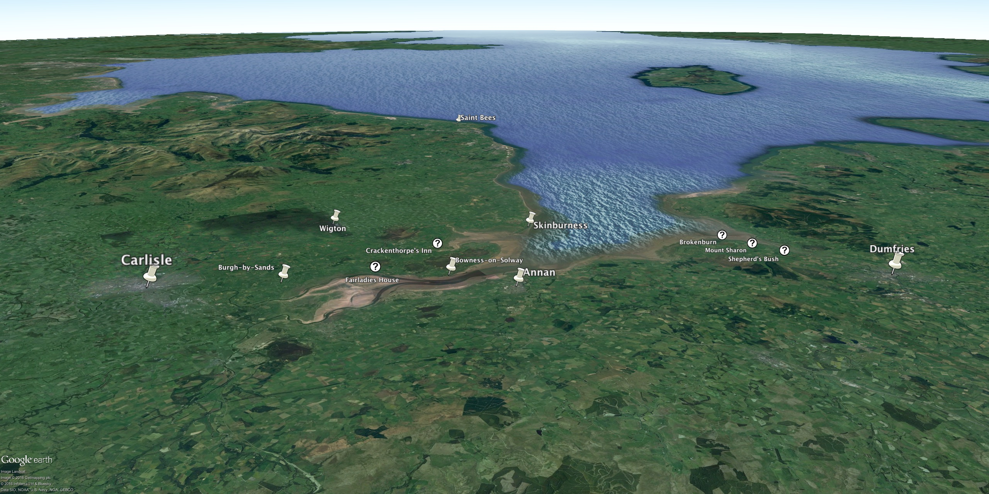
Figure 2. Google Earth plotting of actual and fictional Solway locations mentioned in Redgauntlet (actual locations marked by pins; fictional locations marked by question marks); view overlooking the Solway southwest towards the Isle of Man. Source: 54° 58’ 52.08”N and 2°51’46.33”W. Google Earth. 11 August 2016.

For the individual interested in the mapping of literary works (whether through GIS or through other technologies) this realisation constitutes something of an aporia. But we would like to suggest that this aporia is actually a source of productive tension, and that it is more enabling than disabling. The mapping of literary settings is valuable specifically because it helps to highlight those aspects of literary works that challenge or even defy straightforward geographical representation. Mapping, to put the point another way, can be critically productive because it directs attention to how a literary setting exceeds real world geography, and, in doing so, helps us better to interpret that setting’s significance. In the case of Redgauntlet, for instance, our inability to pinpoint several of the locations that comprise the novel’s Solway setting is meaningful since it underscores the fact that these locations are remote and obscure enough to harbour radical adherents to the ‘lost’ Jacobite cause two decades after Culloden. Geographical distance from the nation’s metropolitan centre is here significantly conflated with temporal distance. The Solway in Redgauntlet is chiefly a place of remnants and the remainders of the past; it is, to use John Sutherland’s apt phrase, ‘a country left over by history’.
But this is not the only way mapping can be valuable as a methodology for literary criticism. Mapping can, after all, also be critically productive because it facilitates the comparative analysis of literary works that happen to take reference from a common geography. This is especially true of mapping aided by technologies such as GIS. One of the chief benefits of GIS technology is its capacity to integrate information from different sources. Every item of data in a GIS is assigned geographic coordinates that link it to a location or region. Although, as noted above, this poses limitations for dealing with literary settings, it can nevertheless guide considerations of the different accounts that accumulate in particular places or around particular areas. This process of comparative geographical analysis allows one to reflect on how geographical reference is mobilised across a range of different sources to specific artistic and ideological ends. For instance, where a region (such as the Solway) is strongly associated with a specific author or a prominent literary work (such as Scott’s Redgauntlet), we can use GIS to explore how other authors and artists either reinforce or undermine these associations. Returning to our Lake District corpus, for instance, it is significant that the works that discuss the Solway do so in ways that complement Scott’s thematisation of the Firth in Redgauntlet. Consider, for example, the account of the Solway included in Ruskin’s Iteriad:
How high beat our hearts as that land we surveyed,
Where so often the banner of freedom hath played;
Where Bruce to the battle his followers hath led,
Where Wallace hath fought, in whose cause he hath bled,
When freedom and glory arose in their breast,—
To death, or to conquest, how swiftly they prest,
And liberty’s banner, and liberty’s brand,
Broad, bloody, and bare, it forsook not their hand.
Now shifting the scene, much delighted we gaze
On the far-spreading shore, with its capes and its bays.
Till our wandering eyeballs were fixed, at last,
On the firth of the Solway that wide sandy waste.
The tide, it was out, and the quicksands they lay
A smooth and inviting, but treacherous way[.]
Ruskin was, of course, steeped in Scott’s works from his youth; and here we find him viewing the Solway in a way that parallels the presentation of the Firth in Scott’s novel. Like Scott, Ruskin conjures up associations of the Solway’s tumultuous past: hence, the references to Wallace and Bruce catalogued in his couplets. Like Scott, moreover, Ruskin draws our attention to how the violent past of this seemingly placid region finds it correlate in the perils concealed by the ‘smooth and inviting’ appearance of the sands. In both of these respects, Ruskin’s lines exemplify a trend that can be traced through our corpus, where the Solway repeatedly figures as either a site of past conflict or as a place of beauty shadowed by the potential of hidden danger.
But whether one maps literary works in order to explore their represented worlds or to collate multiple accounts of a common geography, the critical value of the mapping experiment lies as much in the process as in the product. The latter allows us to draw comparisons between texts collocated on the completed map, but the former provokes interpretation where the literary location proves un-mappable. Insofar as even a completed map is a prompt to interpretation, we are reminded that literary maps are a means not an end; they are, when used well, instigators to new and further inquiry.
Lancaster University

Acknowledgements: The research leading to these findings has received funding from the Leverhulme Trust, as part of the Geospatial Innovation in the Digital Humanities research project, and from the European Research Council (ERC) under the European Union’s Seventh Framework Programme (FP7/2007–2013): ERC grant Spatial Humanities: Texts, GIS, Places [agreement number 283850].
Maptiler <https://www.maptiler.com>; Neatline <http://neatline.org>; Historypin <https://www.historypin.org>; SHARC <https://thesharcproject.wordpress.org>; Google <https://www.google.co.uk/maps>; ESRI <http://www.esri.com> [all accessed 11 August 2016].
Palimpsest: Literary Edinburgh <http://www.ed.ac.uk/literatures-languages-cultures/english-literature/research-activities/palimpsest>; Litlong: Edinburgh <http://litlong.org> [both accessed 11 August 2016].
The Grub Street Project <http://grubstreetproject.net/>; Mapping Romantic London <http://www.romanticlondon.org/>; Maps Marker Pro <https://www.mapsmarker.com/>; and Mapping Emotions in Victorian London <https://www.historypin.org/en/victorian-london/geo> [all accessed 11 August 2016].
Our research into the Lake District’s cultural history has developed across a series of interrelated projects at Lancaster University. The first of these was the Mapping the Lakes project (2007–2008) <http://www.lancaster.ac.uk/mappingthelakes/>, which received support from the British Academy to explore the integration of GIS in an examination of two early Lake District tours. The success of this pilot study paved the way for the Spatial Humanities: Texts, GIS, Places project (2012–2016) <http://www.lancaster.ac.uk/fass/projects/spatialhum.wordpress/>; and, more recently, our current project: Geospatial Innovation in the Digital Humanities: A Deep Map of the English Lake District (2015–2018) <http://wp.lancs.ac.uk/lakesdeepmap/> [all websites accessed 11 August 2016].
Google Earth <https://www.google.com/earth/> [accessed 11 August 2016].
Douglas Richardson, ‘Geohistories’, in GeoHumanities: Art, History, Text at the Edge of Place, ed. by Michael Dear, Jim Ketchum, Sarah Luria, and Douglas Richardson (Abindgon: Routledge, 2011), pp. 209–14: p. 210.
The boundaries of the Lake District National Park were established in the mid twentieth century. Before this time, particularly during the span of history represented in our corpus, writing about the Lake District often included accounts of (what are now commonly considered to be) the peripheries of the region. The county of Cumbria—which was formed in the early 1970s by merging the old counties of Cumberland and Westmorland with the Hundred of Lonsdale North of the Sands (historically part of Lancashire)—therefore constitutes the ideal focus area for our research.
Similar claims can, of course, be made about Waverley (1814)—crucial sections of which are set around Carlisle, Penrith, and Ullswater—and for Guy Mannering (1816), which though principally set on the Scottish side of the Solway, features a number of key scenes in Cumberland.
Stuart Kelly, ‘Show me the way to Tillietudlem’, Five Imaginary Scottish Places, BBC Radio 3, 1 June 2015 <http://www.bbc.co.uk/programmes/b05xqtp0> [accessed 11 August 2016].
‘The Scenery of Redgauntlet’, The Saturday Review (3 September 1870), 300–301.
J. Hillis Miller, Topographies (Stanford: Stanford University Press, 1995), p. 21.
John Sutherland, The Life Walter Scott: A Critical Biography (Oxford: Blackwell, 1995), p. 268.
John Ruskin, Iteriad; or, Three Weeks Among the Lakes, ed. by James S. Dearden (Newcastle upon Tyne, 1969), pp. 88–89; ll. 315–28.
On the influence of Scott on Ruskin’s perception of the Solway, see Fiona Stafford, ‘The Roar of the Solway’, in Nicholas Allen, Nick Groom, and Jos Smith, eds. Coastal Works: Cultures of the Atlantic Edge (Oxford: Oxford University Press, forthcoming 2017).

