Co-designing playful urban park experiences for promoting community public health

Emmanuel Tsekleves¹, Andy Darby², Adrian Gradinar³

¹Imagination Lab, Design, LICA, Lancaster University, LA1 4YW, UK, e.tsekleves@lancaster.ac.uk
²Highwire Centre for Doctoral Training, Lancaster University
³The Creative Exchange, LICA, Lancaster University

Keywords: health promotion, salutogenic design for healthy communities, co-design

Abstract
Urban green spaces such as parks are key contributors to peoples’ health and wellbeing. Users often underutilise such spaces in terms of undertaking casual physical activities and are recognised as having the most to gain from participating in their use and development. The Active Parks project aimed to co-design a concept for a playful and interactive ‘health trail’ in an urban green space to explore the effects of playful interactive experiences on the casual physical activity of park users. In this paper we present the co-design research methodology followed and the main findings of the co-designed prototypes developed and tested in different urban spaces.

Introduction
Urban green spaces, like parks, have a proven track record in delivering better health and wellbeing outcomes and creating a sense of community (OpenSpace, 2010). A key challenge though is motivating sedentary and older park users to adopt more active lifestyles through casual physical exercise.

The Active Parks project aimed at bringing together local residents, the Lancaster City Council and NHS Lancashire Public Health to work together to co-design an interactive and playful ‘health trail’ in the park (Ryelands Park in Lancaster) to promoting public health.

The paper is divided in several sections. After the presentation of the related work, a discussion on the co-design methodology employed in the project is offered. This is followed by a presentation and discussion of the outcomes of the co-design process. The proof-of-concept prototyping and main project findings are presented next.

Related Work
Studies have investigated and reported the importance and benefits of urban green spaces to the wellbeing and social inclusion of local residents (Plane and Klodawsky, 2013; Irvine et al., 2013). Others have found a significantly lower prevalence of cardiovascular risk factors among park users (Tamosiunas et al., 2014; Maas et al., 2009).

Additional studies have found a positive association between green spaces and physical activity levels (Mytton et al., 2012; Koohsari et al., 2015). However the literature suggest that there is a need and a lack of park activities designed specifically to encouraging physical activity and socialization opportunities (Fan et al., 2011; Koohsari et al., 2015), particularly age-friendly active living initiatives for older adults, promoting the health advantages of green spaces to older people (Pleson et al., 2014).

Playful design, the mapping of playful experiences from games to other non-game context experiences, has gained interest in recent years (Walsh et al 2010).
A number of physical-digital urban games have been developed, which offer playful experiences. These focus on encouraging exploitation and discovery of urban spaces in a leisurely and playful manner by connecting the digital (mobile phones with GPS/NFC technologies) with the physical world (e.g. building, city landmarks) reporting positive results in increasing people engagement with such experiences (Rashid et al., 2006; Vogiazou et al 2006).

There is a body of research evidence as reported in (Staempfli, 2007; Proyer, 2014a; Proyer, 2014b), which suggests that playfulness can contribute to healthy ageing, via its higher levels of cognitive functioning in the ageing process, its relations to positive emotions, wellbeing, intrinsic life goals, or coping with stress. Furthermore, playfulness, via its link to promoting an active way of life (as a health-oriented behaviour), might also be associated with greater levels of physical activity (Proyer, 2014b).

Playful design has not been explored as widely though in engaging older and sedentary people with physical activity. There is a great potential, therefore, to go beyond user-centred design and explore how more participatory design methodologies, such as co-design can create playful experiences that encourage sedentary and older people in taking casual physical activity (Bekker et al., 2010) in public urban spaces, such as in parks.

Research Methodology
The Active Parks project brought together the Friends of Ryelands Park – a local group of volunteers looking after the park-, local residents, Lancaster City Council, Age UK and Lancashire NHS, with designers and researchers from Lancaster University.

A co-design process (Sanders and Stappers, 2008) was employed that included several ‘co-design’ workshops with local residents to share their experiences of using the park, and to help come up with ideas. The co-design approach was adopted in appreciation of its emphasis on end-users being experts in their own experience, as co-design foregrounds local knowledge and values within the design process and in doing so making a successful design outcome more likely. Furthermore, co-designing with the recipients of the intervention is a transformative process as participants have a much higher stake in its design, making and ultimately use.

Two co-design workshops and a public information day session took place at Ryelands Park in Lancaster, UK. The first co-design workshop participants (n=9) were drawn from the district and included members of the stakeholder group, the Friends of Ryelands Park. Age range: 40 to 70 years of age. In the Public Information Day session participants (n=25) were drawn from across the wider Lancashire region with many never having visited Ryelands Park prior to the event. A number of participants were very familiar with Ryelands Park and visited regularly and a larger number were familiar with it but did not visit often, preferring other parks in the district. The second co-design workshop participants (n=9) were again drawn from across the district and included members of the stakeholder group. Age range: 15 to 70 years of age.

The objective of the first workshop was to establish the values and goals of that community, in order to better understand the issues that might motivate or impede the engagement in physical activity, as well as to highlight habits and preferences of that community. The activities carried in the co-design workshop were used to enable that discovery and empower the community to express their views (see Figure 1). This first workshop could be placed in the ‘fuzzy front end’ of the design process where the design problem and the brief are redefined.

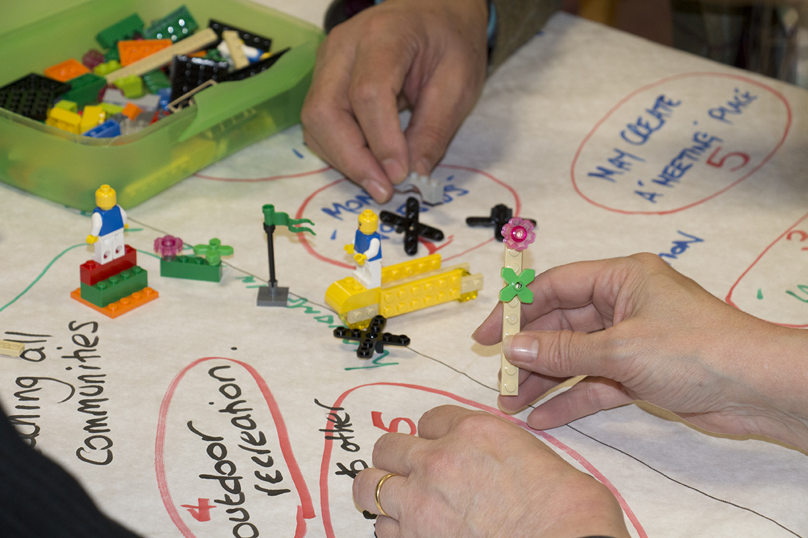
Figure 1: Employing creative toolkits, such as Lego Serious Play, at the 1st co-design workshop

While the previous workshop focused on exploring issues, broadening the understanding the design problem, the second workshop focused mainly converging or synthesizing all the knowledge generated before into design solutions. It also included a session aimed at elaborating plans/models of these ideas (prototypes) using creative tools (see Figure 2).

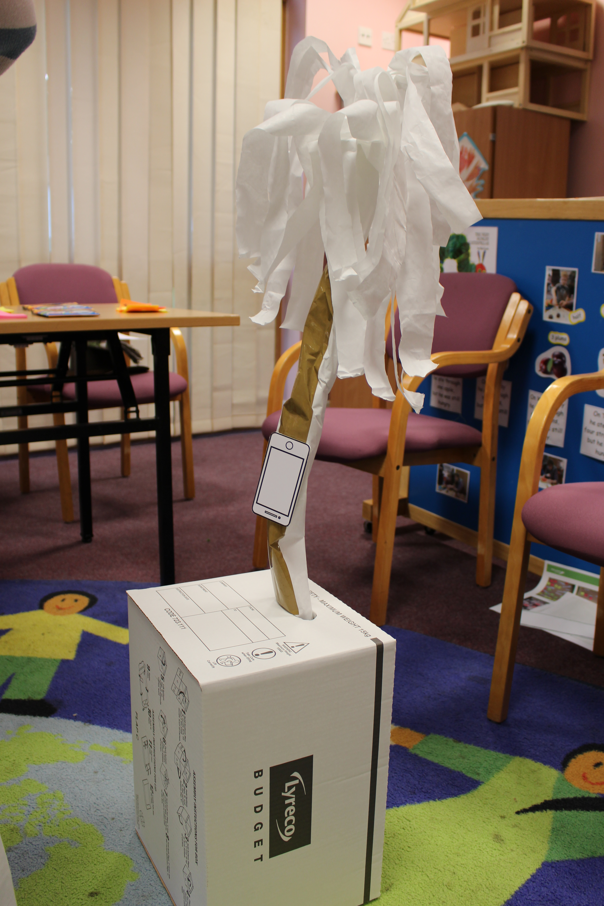
Figure 2: Prototyping session during the 2nd co-design workshop

Co-designing a playful health trail
The co-design activities carried out identified key values for the project. Those issues highlighted the importance that the co-designed interactive trail followed those values and enabled the local community to engage in exercise in a playful manner, helping to bridge the generation gap, and that it was accessible to everyone. The data also showed that the park was seen as a place not only for doing exercise, but also as a meeting place for social activities. The walking trail was seen as a way to enable those social encounters and to further develop a sense of community. Participants identified that the walking trail could be something the community would be proud to showcase, building interest in the park and motivating the uptake of exercise.

However, there were also negative issues identified during the workshops regarding the current use of the park. Those issues were centred around a perception of lack of security for people using the parks, for example, risk for children because of traffic around the park, problems related to dogs such as fouling and dogs being walked unleashed. The participants also reported on a perception that vandalism could be a barrier for projects being implemented. There were also issues raised included the lack of facilities such as toilets and a café, That was seen as a deterrent for people taking up more physical activities in the park.

The design proposition presented in this paper is the result of the co-design process carried out in this project. The data from the first workshop and the community event in the park was analysed by the co-designers during the second workshop.

The data was grouped and themes emerged and finally synthetised into
a shared vision: ‘A community space with fun and activities safe for everyone to enjoy.’ This vision was the guiding force behind the ideas generated and the rapid prototypes created by the end of the second workshop. Each of the three groups came up with ideas for interactive physical activities to be conducted in Ryelands Park.

The proposed health trail combined physical and digital interactions with objects built in the park to make visits to the park more fun and active. The ideas generated through the co-design workshops included a large physical-digital xylophone style activity, where one exercises by moving around it to create music; a mobile phone generated zombie chase activity incorporating physical challenges in the park; a park discovery and exercise activity, where set challenges invite you to physically explore the park through interactive, enjoyable and playful stories.

Proof-of-concept Prototyping
It was not possible to develop a proof-of-concept prototype for the whole co-designed trail within the timescale and budget allocated for this project. Instead, the team chose to develop only the concept of the interactive xylophone, because it could address all the principles and values established in the workshops. The interactive xylophone has both physical and digital elements; it is a playful and fun with the potential to incorporate games; it enables exercise that complement walks by requiring users to stretch and bend as they reach for notes; and it has also the potential to be a social activities because besides from individual play, users can also play in groups.

These ideas were then aggregated into one co-design proposition for an interactive and playful walking trail, parts of which were realized into two proof-of-concept digital prototypes to illustrate the possibilities and explore further how it could be used and implemented in the park.

Both prototypes were built at large scale and employed conductive technology. The first prototype was constructed with a mobile Near Field Communication (NFC) interface and a conductive touch interface based on a MaKeyMaKey microcontroller. The shape of the prototype was left as simple as possible in order to minimise the time spent in construction and maximise the time spent in developing usability and interactive aspects of the interface.

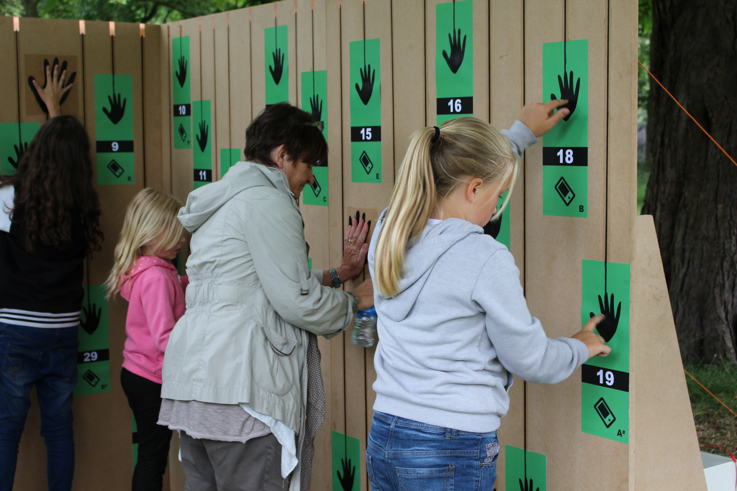
Figure 3: Interacting with the 1st version of the prototype using the touch interface.

Two walls made of plywood and fixed together in a 90º angle, forming a corner, served as base for the interface. On the walls printed pieces of paper containing the graphic of a mobile and a hand, indicated where the users had to touch or tap with their mobiles. Conductive paint was used to paint the graphics of the hands and lines that linked the interface in the front of the prototype to the back where all the wires were connected to the digital devices. The touch interface allowed people to play the prototype like a music instrument (see Figure 3). For the mobile interface, users could choose to play freestyle or to follow the mobile instructions that indicated which numbers to tap next (see Figure 4). Using this function with the mobile phone, users could play the notes for “Twinkle, Twinkle Little Star”

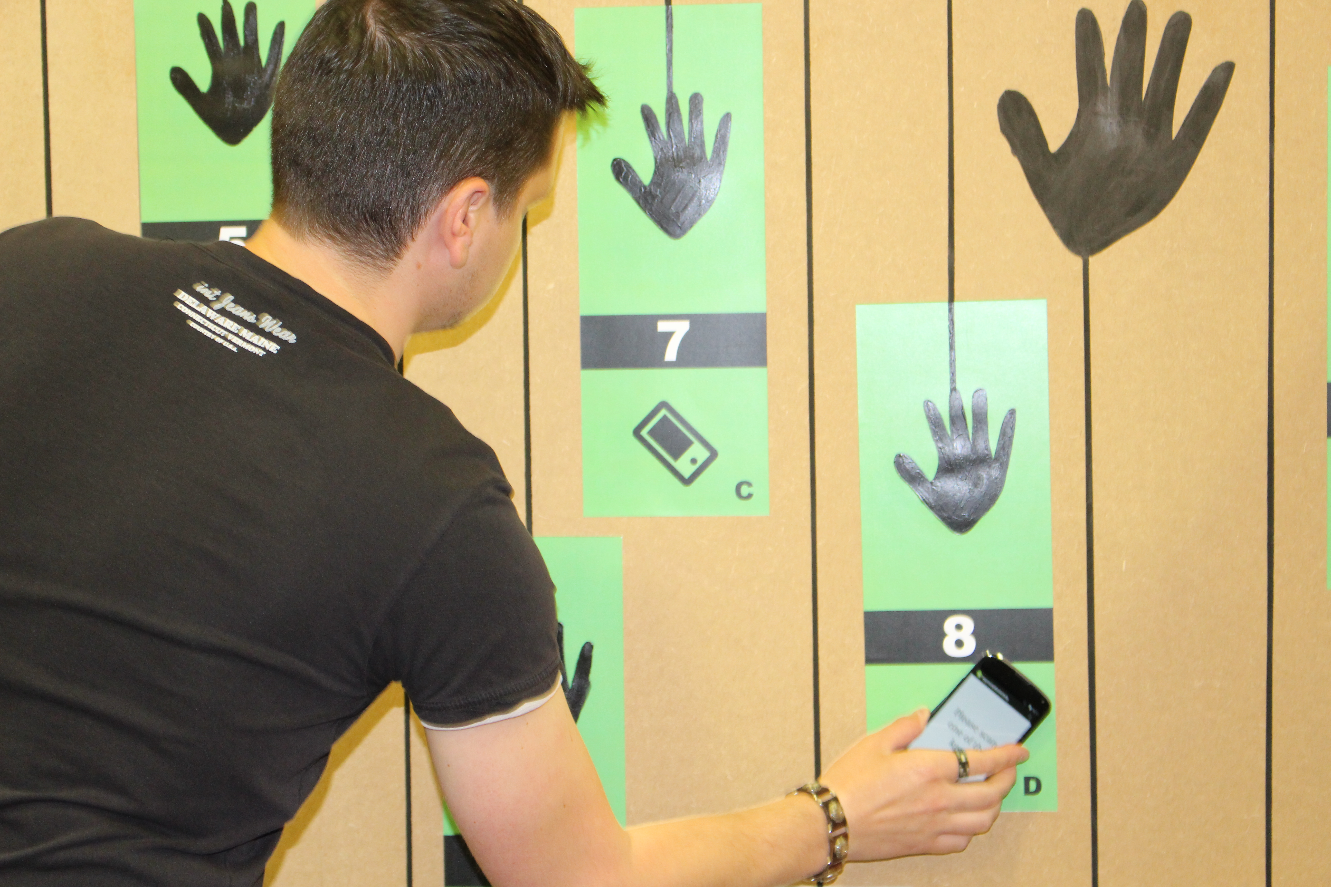
Figure 4: Interacting with the 1st version of the prototype using the mobile NFC interface.

The second prototype was developed based on the feedback received from the testing of the first prototype. This time the NFC interface was dropped and only the conductive touch interface was used. The conductive paint proved not to be robust enough for the prototype and even after it was treated with fixatives the paint was rubbing of by the end of the testing. The team decided to use copper as an alternative conductive material.
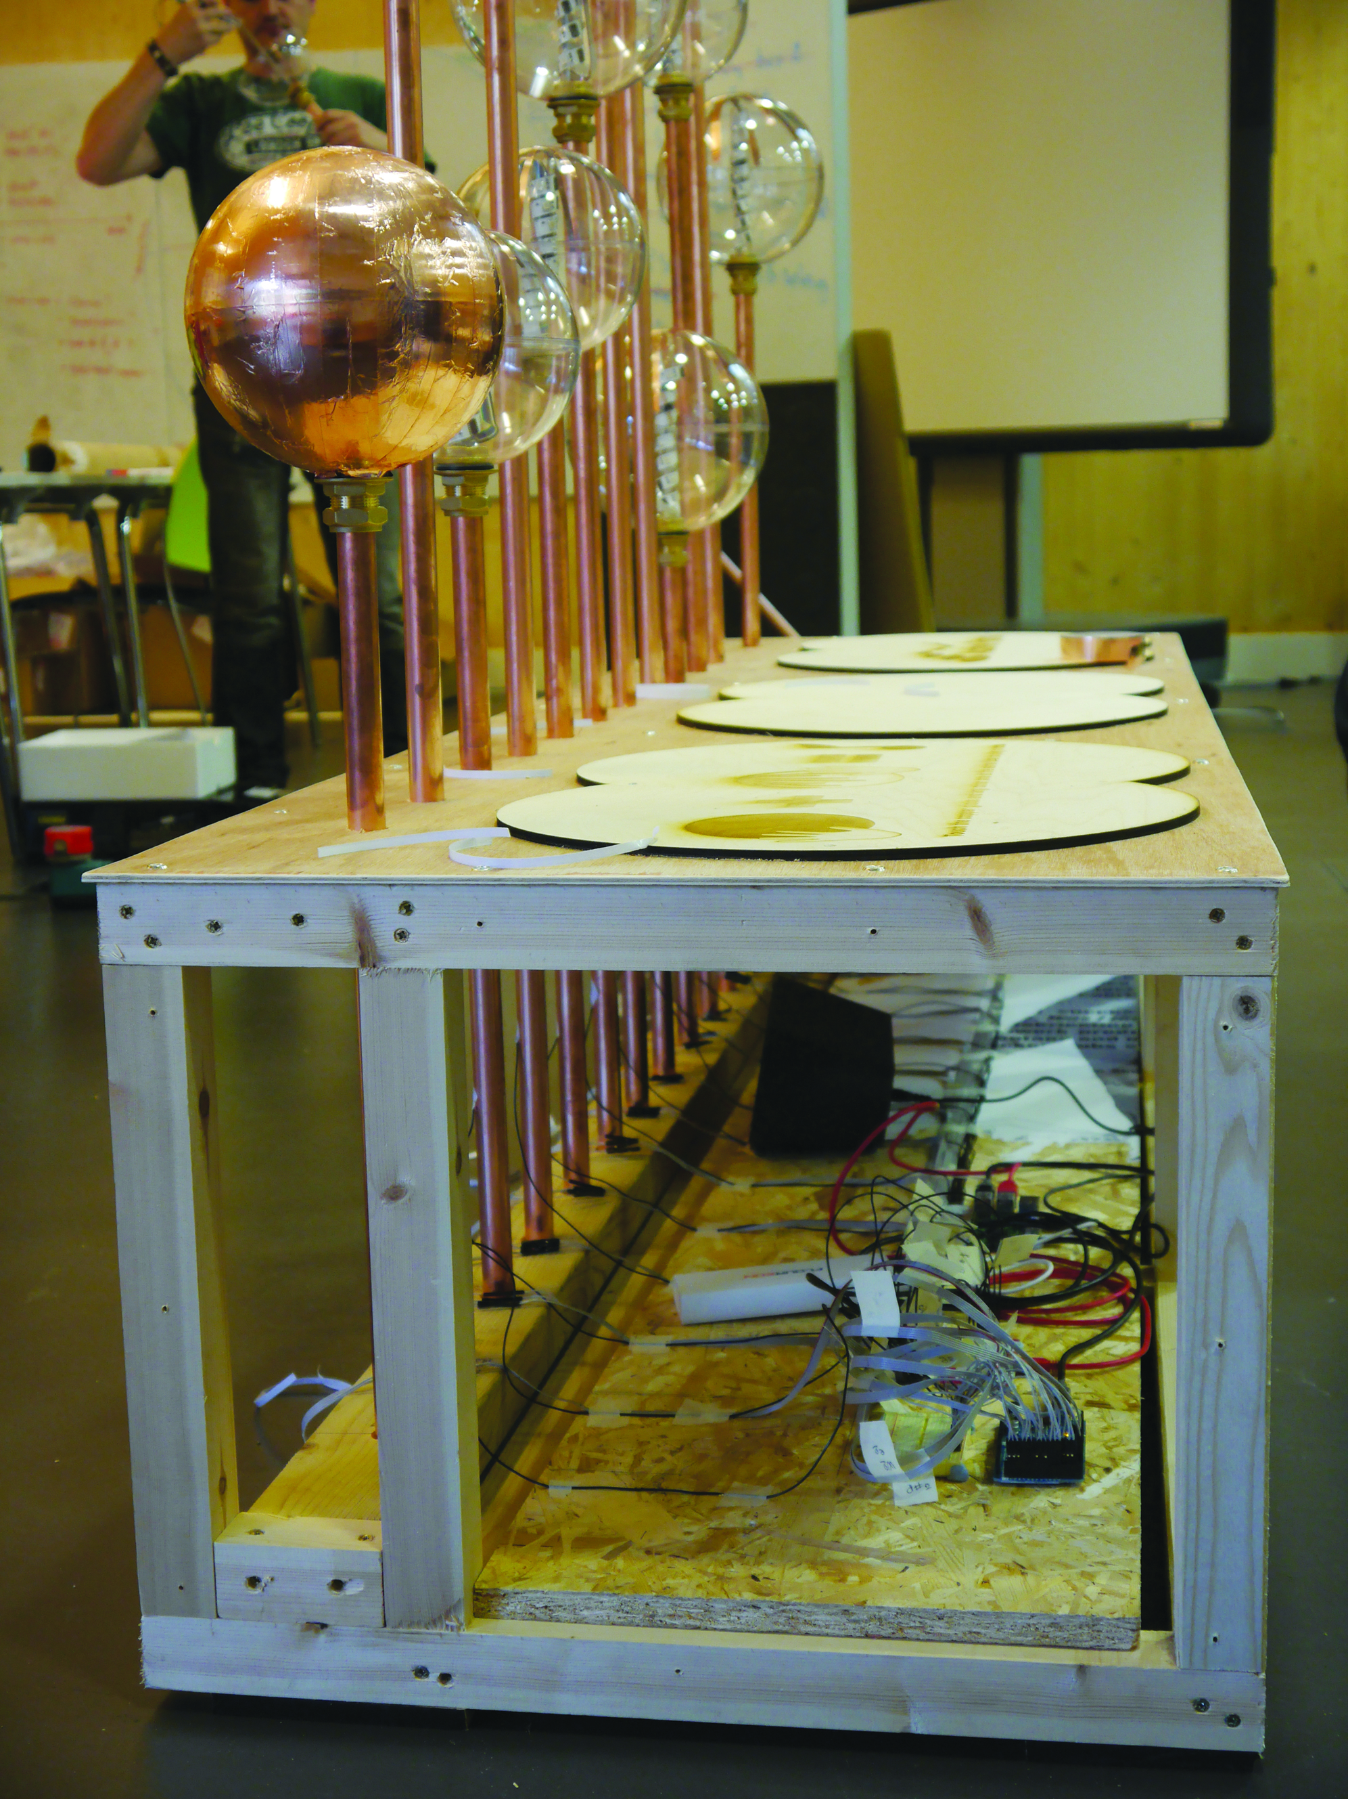
Figure 5: The digital technology embedded within the 2nd version of the prototype.

The form of the prototype gained more attention this time and a free standing structure was designed and built incorporating a wooden frame as the base, 13 copper pipes for conductivity and to case the wires and 13 acrylic globes cover with some copper tape used as the touch elements. To the digital elements of the first prototype, LED lights were added and they provided visual feedback in addition to sound when users touched the interface (see Figure 5).
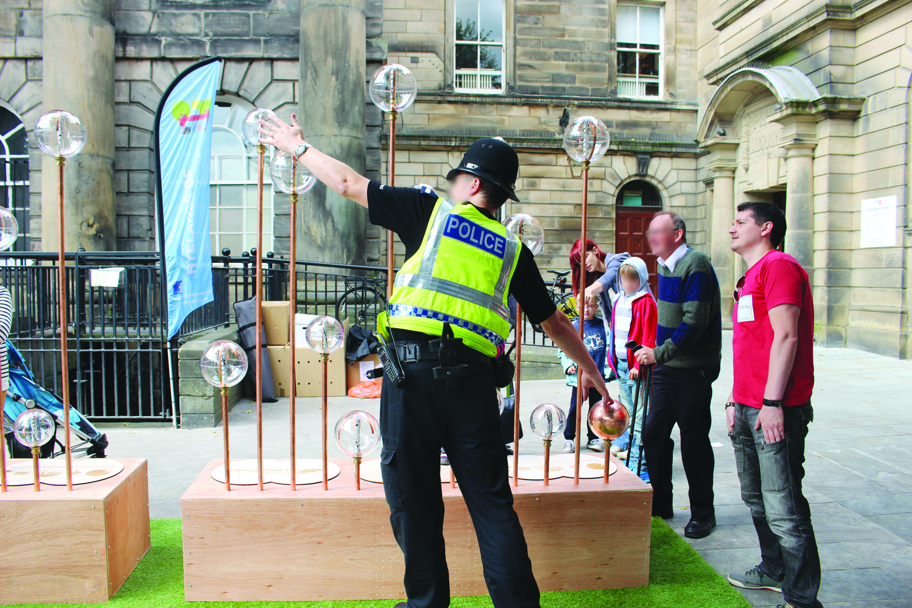
Figure 6: Interacting with the 2nd version of the prototype.

Following the lessons learnt from the first prototype, interactions were designed to be fun when people played together and when people had to exert themselves by stretching and reaching for certain notes. The design aimed to enhance the possibilities of cooperation. For example, the placement of the globes required that some users had to play together with other in order to reach some notes (see Figure 7).

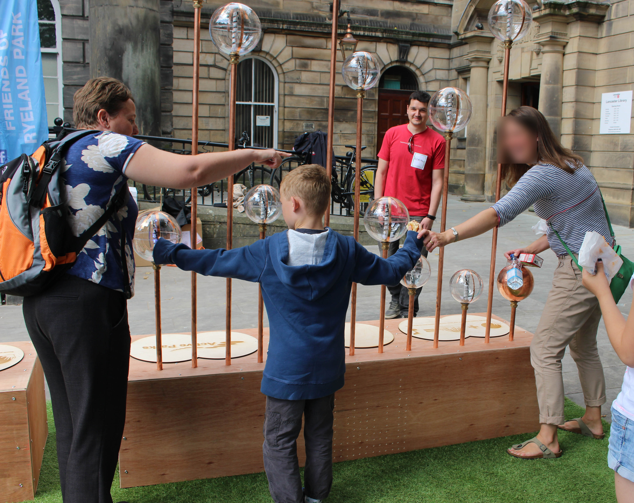
Figure 7: Facilitating collaboration to reaching all notes in version 2 of the prototype.

Findings
Both prototypes were tested in the summer of 2014 in the park and town center. During testing they received over 500 unique user engagements and ample feedback (see Figure 8).

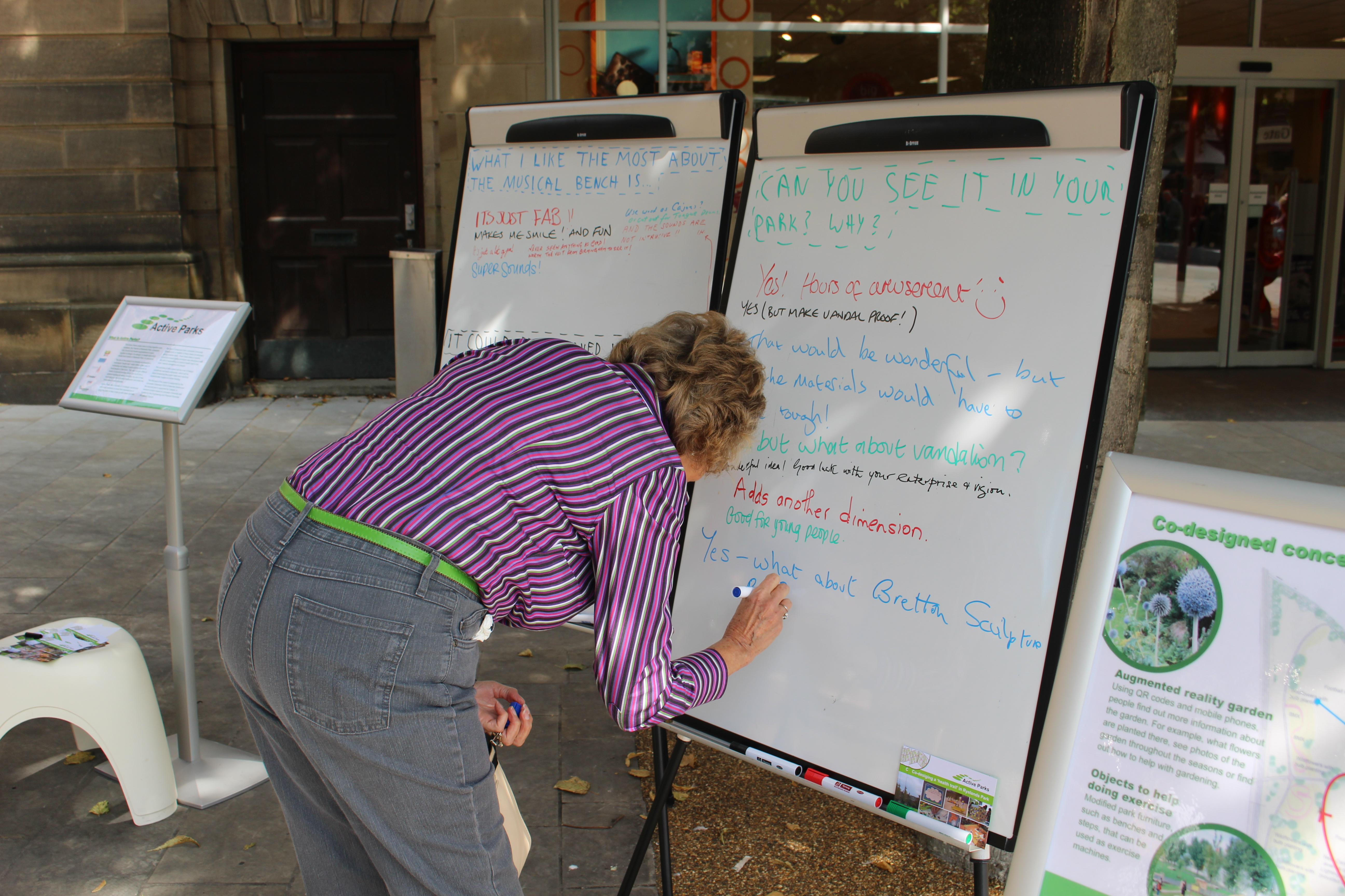
Figure 8: Users providing feedback on the prototypes.

The first prototype tested both a conductive interface and an NFC based interface, the lack of responsiveness with a phone as an NFC reader made the experience cumbersome, participants preferred the immediate feedback of the conductive approach (see figure 9). Users who had not previously met explored the prototype together linking hands to create conductive human chains (see figure 10).

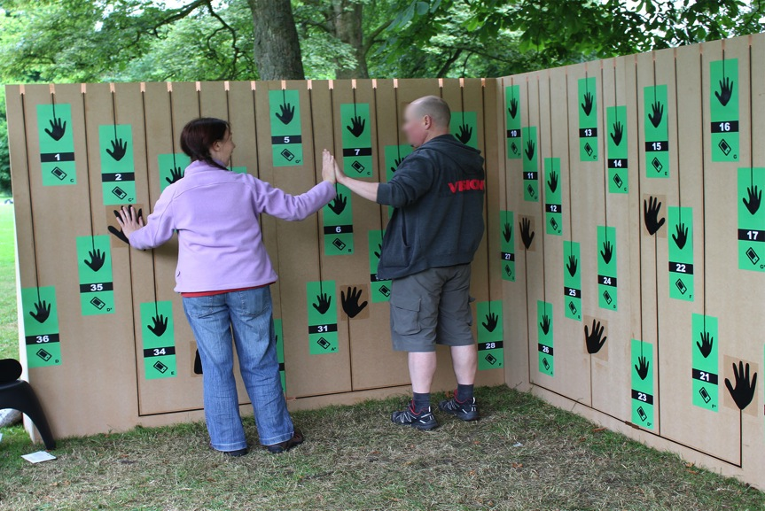
Figure 9: The first version of the interactive xylophone prototype trialed in the park.

The second prototype developed the concept to include motivating feedback from lights and a new physical design that acted as a bench, light source and activity in the park space (see figure 11). The design was recognised as being inclusive, safe and communal by users. The playful interaction acted as a leveller with even accomplished musicians finding the musical element challenging but fun. The aesthetic was viewed as surprising and novel.

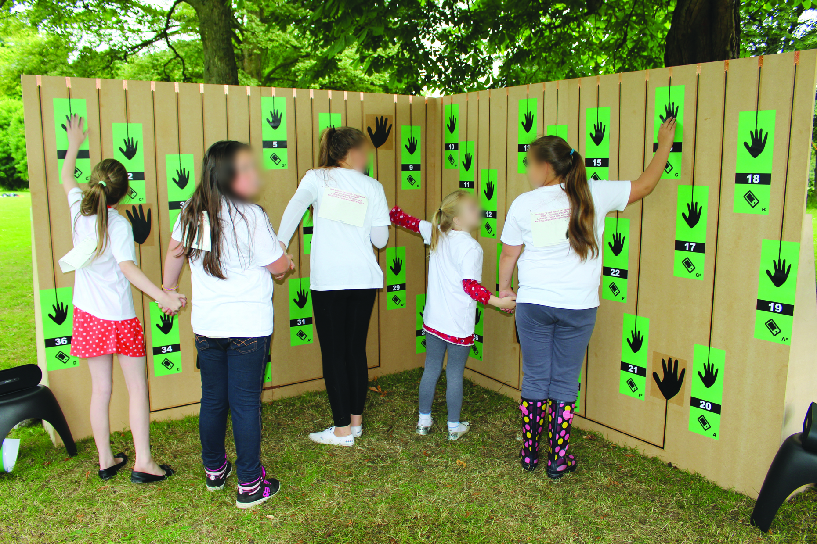
Figure 10: Users interacting with version 1 of the prototype by linking together hands to create conductive human chains.

Collecting feedback from both prototype user-testing revealed that playfulness is ageless and a key factor to encouraging park users to exercise. The prototypes provided a focus for intergenerational bridging, which made exercising more fun and a collaborative effort. It was noticed that older, sedentary and people with mobility issues where amongst the keenest of groups to engage with the prototype and its concept.

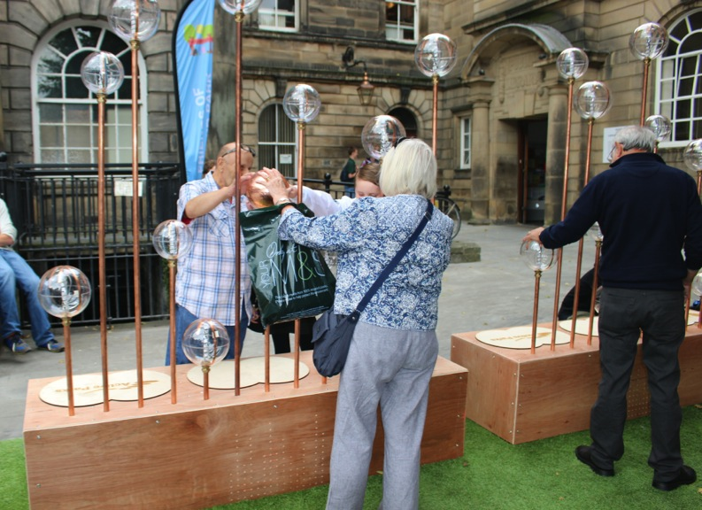
Figure 11: The second version of the interactive xylophone prototype trialed in the town center.

It was gathered that playful interactions aimed at public health and exercise in public spaces could offer significant benefits to park users. Developing this approach would facilitate connectedness between people and across ages. When the exercises are incorporated within a playful large-scale environment it was noticed people increasing their physical exertion. Such experiences can be made more enjoyable through multisensorial interactions that involve touch, audio and vision.

Conclusion
The Active Parks project was successful in developing an engaging concept that indicated the potential of playful interactions for health outcomes. The next steps of the project will continue to explore this kind of interaction and the development of other elements of the interactive health trail. The project team is currently planning to conduct a pilot with the relevant NHS partners to investigate the health outcomes of such intervention for public health.

Acknowledgements
We thank all community members who took part in the various workshops and events organised by the Active Parks project, the Friends of Ryelands Park, Lancaster City Council, NHS Lancashire Public Health and our funders, the FASS-Enterprise Centre and the Catalyst research project at Lancaster University, funded by the EPSRC.

References
Bekker, T., Surm, J., Eggen, B. (2010) Designing playful interactions for social interaction and physical play. Personal and Ubiquitous Computing Journal. 14. 385-396

Eryn Pleson, Laura M. Nieuwendyk, Karen K. Lee, Anuradha Chaddah, Candace I. J. Nykiforuk, & Donald Schopflocher. (2014). Understanding Older Adults’ Usage of Community Green Spaces in Taipei, Taiwan. International Journal of Environmental Research and Public Health, Vol 11, Iss 2, Pp 1444-1464 (2014),1444-1464

Fan, Y., Das, K., & Chen, Q. (2011). Neighborhood green, social support, physical activity, and stress: Assessing the cumulative impact. Health & Place,17(6), 1202-1211

Irvine, K., Warber, S., Devine-Wright, P., & Gaston, K. (2013). Understanding Urban Green Space as a Health Resource: A Qualitative Comparison of Visit Motivation and Derived Effects among Park Users in Sheffield, UK. International Journal Of Environmental Research And Public Health, 10(1), 417-442.

Koohsari, Mavoa, Villanueva, Sugiyama, Badland, Kaczynski, . . . Giles-Corti. (2015). Public open space, physical activity, urban design and public health: Concepts, methods and research agenda. Health and Place, 33, 75-82.

Maas J., van Dillen S.M., Verheij R.A., Groenewegen P.P. Social contacts as a possible mechanism behind the relation between green space and health. Health Place. 2009;15:586–595

Mytton, O., Townsend, N., Rutter, H., & Foster, C. (2012). Green space and physical activity: An observational study using Health Survey for England data.Health and Place, 18(5), 1034-1041.

OpenSpace (2010) Research Report: Community green: using local spaces to tackle inequality and improve health. http://www.openspace.eca.ac.uk/.

Plane, Jocelyn, & Klodawsky, Fran. (2013). Neighbourhood amenities and health: Examining the significance of a local park. Social Science & Medicine,99, 1-8.

Proyer, R. (2014a). Perceived functions of playfulness in adults: Does it mobilize you at work, rest, and when being with others? Revue Europeenne De Psychologie Appliquee, 64(5), 241-250.

Proyer, R. (2014b). Playfulness over the lifespan and its relation to happiness. Zeitschrift Für Gerontologie Und Geriatrie, 47(6), pp. 508-512.

Rashid O, Bamford W, Coulton P (2006) PAC-LAN : Mixed-Reality Gaming with RFID- Enabled Mobile Phones. 4:1–17.

Sanders, E and Stappers, P. (2008) Co-creation and the new landscapes of design. Co-Design 4, 1, 5-18

Staempfli, Marianne B. (2007) Adolescent playfulness, stress perception, coping and well being. Journal of Leisure Research, Vol 39(3), pp. 393-412

Tamosiunas, A., Grazuleviciene, R., Luksiene, D., Dedele, A., Reklaitiene, M., Baceviciene, J., . . . Nieuwenhuijsen, A. (2014). Accessibility and use of urban green spaces, and cardiovascular health: Findings from a Kaunas cohort study.Environmental Health, 13, Environmental Health, 2014 Mar 19, Vol.13.

Vogiazou Y, Raijmakers B, Geelhoed E, et al. (2006) Design for emergence: experiments with a mixed reality urban playground game. Pers Ubiquitous Comput 11:45–58.

Walsh R, Boberg M, Arrasvuori J, et al. (2010) Introducing game and playful experiences to other application domains through personality and motivation models. 2010 2nd Int IEEE Consum Electron Soc Games Innov Conf 1–8.

See http://imagination.lancs.ac.uk/activities/Active_Parks

