Britain’s wasted resources: time for Plan B?

Jim Taylor
Department of Economics
Management School
Lancaster University

email: jim.taylor@lancaster.ac.uk

January 2013

Britain’s wasted resources: time for Plan B?

The likely impact of a demand expansion on the UK’s output and employment is seriously disputed. Expert forecasters cannot agree about how much spare capacity there is. The Office for Budget Responsibility (OBR), for example, estimates that the gap between actual output and potential output is currently less than 3%. The Bank of England takes a similar view whereas Oxford Economics, an independent forecaster, estimates that the output gap was 5.4% at the end of 2012. A recent detailed analysis of the UK economy by economists at the Centre for Business Research at Cambridge University goes even further. It concludes that the output gap is nearer to 10% (Martin and Rowthorn 2012).

The importance of an accurate measure of spare capacity stems from its role in determining whether a demand expansion will work. The more spare capacity there is, the greater the chance that a demand expansion will lead to an increase in output and employment rather than to an increase in prices. Additionally, the more spare capacity there is, the greater the chance that an increase in economic activity will lead to a substantial cut in the budget deficit by reducing the welfare bill as unemployment falls (Bouis et al. 2012).

The Treasury, the OBR and the Bank of England are all pessimistic about the likely impact of a demand expansion since they believe that the economy would quickly run into capacity constraints. The OBR, for example, assumes that “potential output growth has been extremely depressed in the UK since the financial crisis” (OBR 2012, p. 8). Similarly, the Bank of England’s Monetary Policy Committee has argued that “the weak growth in productivity over the past three years largely reflects weak underlying productivity growth” (Bank of England 2011, p.43). Others, such as Oxford Economics (2012) and Martin and Rowthorn (2012), disagree.

In its October Economic Outlook for October 2012, Oxford Economics argued that “there is a larger output gap [than estimated by the OBR] and that there is more scope for the public finances to improve as the economy recovers. Therefore, fiscal policy may have been tightened by more than was necessary [since 2010]”. Martin and Rowthorn (2012, p.8) argue that “there is ample spare capacity to meet higher demand”.

Who is right? Is the supply-side pessimism of the OBR and the Bank of England justified? Is there much greater scope for a demand expansion than the pessimists are willing to concede? This is not an academic question since the livelihood of a very large number of workers and their families is at stake. Given the persistence of the recession, it is appropriate to take a closer look at why there is so much disagreement between the experts about whether a demand expansion would be effective in raising output and creating more jobs. We need to know whether it is the supply-side pessimists or the demand-side optimists who are making the right call.

The current recession: conflicting signals from the labour market and the goods market
To answer the question about how much spare capacity there is in the UK economy, we need to take a closer look at how the current recession differs from previous recessions. The first point to note is that the drop in output has been more severe and has persisted for far longer than all previous recessions in the past forty years (see Figure 1). This includes even the very deep recession during the first Thatcher government of the early 1980s when output fell by nearly 5 percentage points in a year and unemployment rose to over 3 million and stayed there for the next four years.

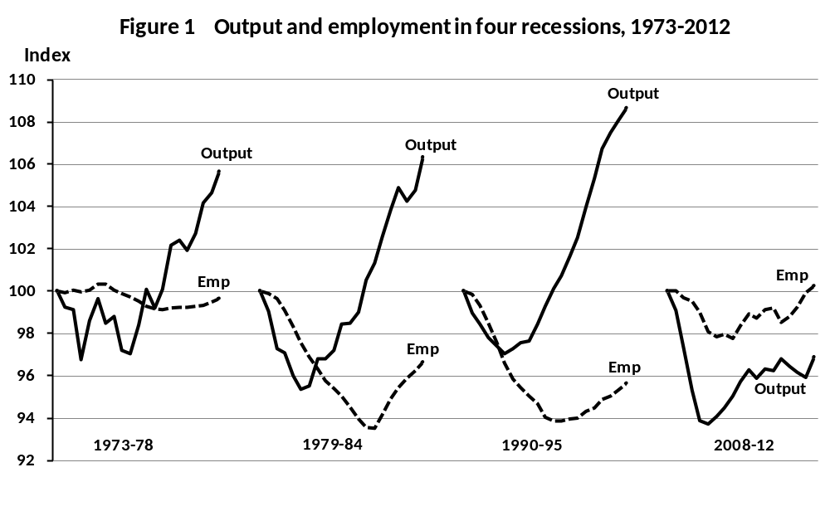
In previous recessions, output has recovered to its pre-recession level within 3 years of the start of the downturn. In the current double-dip recession, which began in early 2008, output has still not reached its pre-recession level after five years and there is little chance of it doing so before 2015 (OBR 2012, Treasury 2012). National output will still be well below its long-run trend even in 2015. The years of austerity have a long way to go under current policies, according to recent forecasts (Treasury 2012).

Another, even more puzzling, fact about the current recession is that the adverse impact on the labour market has been far less severe than many experts had previously predicted. In March 2012, for example, the OBR predicted that the unemployment rate would rise from 8.2% to 8.7% by the third quarter of 2012, whereas it actually fell to 7.8% (OBR 2012, p.7). Employment growth has also confounded the forecasters. Employment fell only slightly after the 2008 downturn and had recovered to its pre-recession level by 2012. Despite stagnant output growth, employment increased by 700 thousand (2 percentage points) between 2010 and 2012 (see Figure 1).

Why has employment recovered while output has not? The overall increase in employment is not all that it seems at first sight. Firstly, more than half of the additional jobs have been for part-time, not full-time, workers. For women, nearly three-quarters of the extra jobs have been for part-time workers (see Table 1).

Table 1 Changes in part-time and full-time employment, 2010(Q1) to 2012(Q3)

 | Change in full-time employment  (thousands) | Change in part-time employment  (thousands) | Change in total employment  (thousands) | Change in part-time as a %  of change in total employment
Men | 284 | 233 | 517 | 45.1
Women | 59 | 162 | 221 | 73.3
Total | 343 | 395 | 738 | 53.5
Note: PT workers includes self-employed in this table.
Source: Office for National Statistics (http://www.ons.gov.uk/ons/dcp171766_254591.pdf).

Secondly, workers are not working as many hours as they would like. According to the Office for National Statistics (2012), one in ten workers wanted to work more hours than they were offered during 2012; and between 2008 and 2012, the number of workers who wanted to work more hours increased by one million. Moreover, one in four part-time workers would prefer to work longer hours and many temporary workers would like to have a permanent job (Patterson 2012).

The number of part-time workers who could not find a full-time job, for example, increased by 726 thousand (from 685,000 to 1,411,000) between 2008 and 2012; and the number of temporary workers who could not find a permanent job increased by 312 thousand (from 343,000 to 655,000) over the same period (see Table 2 and Figure 2). Hence, although employment increased by 700 thousand between 2010 and 2012, a high proportion of this increase was for part-time and temporary workers.

Table 2 Temporary and part-time employees who could not find a permanent job

 | Total workers  (thousands) | Could not find a full-time or permanent job  (thousands) | % of total
Part-time employees
2008 (Q2) | 7338 | 685 | 9.3
2010 (Q1) | 7567 | 1064 | 14.1
2012 (Q3) | 7939 | 1411 | 17.8
Temporary employees
2008 (Q2) | 1407 | 343 | 24.3
2010 (Q1) | 1477 | 506 | 34.3
2012 (Q3) | 1615 | 655 | 40.5
Source: Office for National Statistics (http://www.ons.gov.uk/ons/dcp171766_254591.pdf).

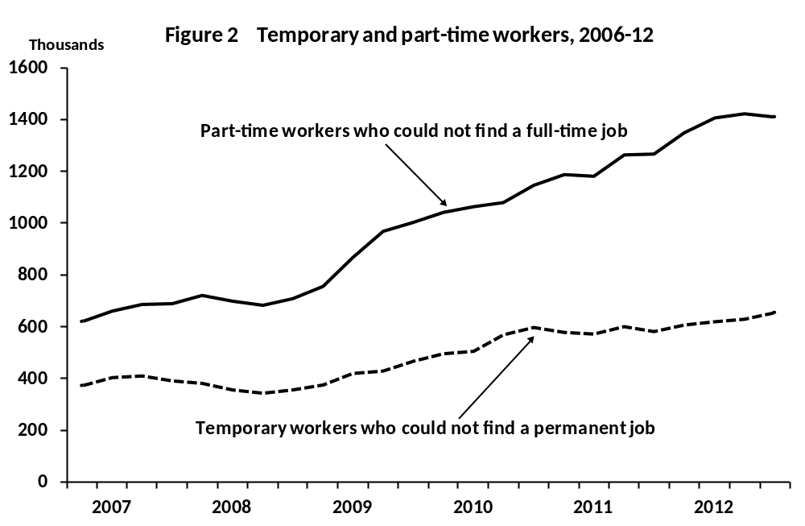
Source: Office for National Statistics (http://www.ons.gov.uk/ons/dcp171766_254591.pdf).

The drop in labour productivity: underemployment or structural change?
A consequence of the drop in output at the same time that employment has regained its pre-recession level is that labour productivity has fallen further and further behind its long-run trend as the recession has progressed. This could mean either that firms could be producing far more output with their existing workforce or that the long-run trend in labour productivity has suffered from a severe structural break (see Figure 3).
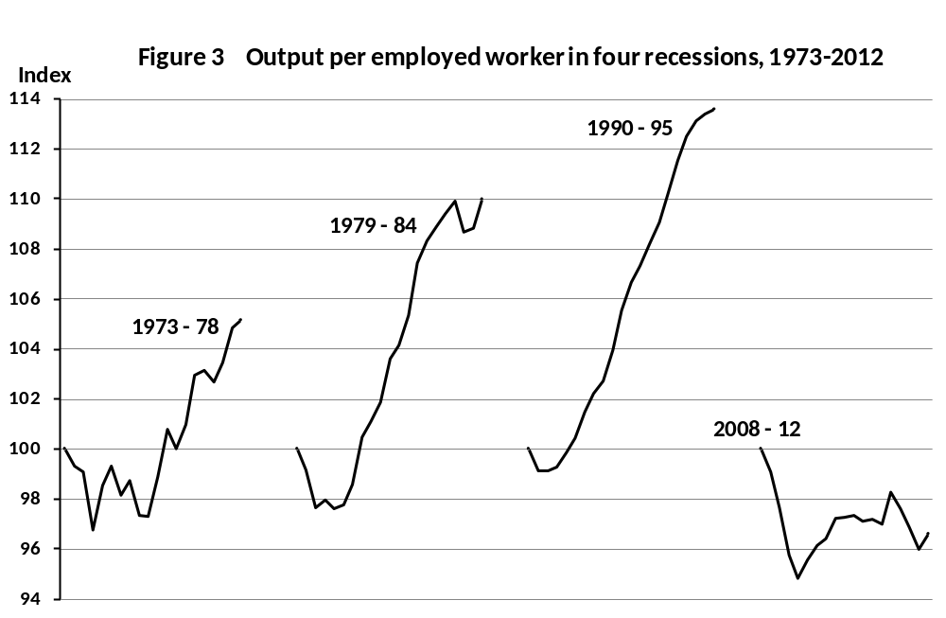
Note: Each of the four ‘business cycles’ starts at a peak in GDP per worker. The fourth cycle (starting in the first quarter of 2008) covers only the phase to date.
Source: Office for National Statistics, Statistical Bulletins (various).

In previous recessions, labour productivity has dipped sharply as the recession has begun to bite but has then quickly regained its long-run trend. This was even the case following the very heavy recession of the early 1980s. Large chunks of the UK’s manufacturing sector were scrapped prematurely due to the sharp reduction in demand resulting from the tough deflationary budgets of 1980-81. But even so, labour productivity quickly regained its long-run trend. Employers temporarily ‘hoard’ labour during recessions so that output can be increased more rapidly when demand recovers.

The underutilisation of employed labour comes from two sources. First, workers are not working as many hours as they would like, as is the case currently in the UK (ONS 2012). Second, the productivity of workers is substantially below the level it would be if employers could sell more output. Workers are underemployed because of depressed demand for the goods and services that they could potentially produce (Martin 2011).

There are several reasons why employers may decide to hold onto their workers during recessions. First, firms do not want to lose skilled and experienced workers if demand is expected to recover (Nickel 1978; Martin and Rowthorn 2012). Second, keeping workers on during periods of slack demand can help to build morale and good relations with workers over the longer term. Third, a large proportion of a firm’s workforce is fixed, not variable, and workers cannot easily be laid off. A minimum number of workers may be required if a firm is to continue its operations. Fourth, workers may be willing to trade a wage cut for job protection. Fifth, workers may take a cut in hours (or forgo wage rises) during periods of slack demand. Finally, employment laws may make laying-off workers expensive unless a firm declares bankruptcy.

For all these reasons, recessions are characterised by the underemployment of employed workers. There is no agreement between the experts, however, about how much labour hoarding there currently is in the UK economy. The OBR view is that labour hoarding only accounts for a very small part of the sharp drop in labour productivity (OBR 2012). According to the Bank of England’s Monetary Policy Committee, employers would not be taking on more workers if they already had significant amounts of underemployed labour on their books (Bank of England 2011).

The basis of the OBR’s view that there is little labour hoarding in the UK is that underlying productivity growth has been severely and permanently damaged by the 2007 financial crisis. Not only has there been an adverse impact on the financial sector itself, the financial crisis has also led to credit rationing for small and medium-sized firms. This capital shortfall has prevented firms from expanding their productive capacity. The OBR does not therefore accept that the low level of labour productivity indicates the existence of substantial labour hoarding.

Martin and Rowthorn (2012) disagree fundamentally with the OBR view that there is little labour hoarding. They show convincingly that only a very small proportion of the fall in labour productivity can be accounted for by a change in the structure of the economy resulting from the financial crisis. They also show that the adverse effects on labour productivity of a shift in jobs away from high to low productivity sectors have been minimal.

Furthermore, there is no evidence of large-scale scrapping of plant and machinery as happened in the manufacturing sector during the recession of the early 1980s. Indeed, productivity in manufacturing soon surpassed its pre-recession peak and grew strongly through 2009-11 (see Figure 4). Low productivity growth in the UK is therefore predominantly a service sector problem. Productivity in services was still below its pre-recession peak even after five years of recession (see Figure 4).

No hard evidence has yet been found to show that productive capacity in the service sector has been seriously affected by the 2007 financial crisis. Indeed, economists at the Bank of England have recently argued that given the low level of productivity in the UK economy “productivity growth could rise sharply if output growth picks up” (Hughes and Saleheen 2012, p.145). This suggests that Bank of England economists have more recently been revising their views about the extent of labour hoarding (and hence spare capacity) in the UK economy.

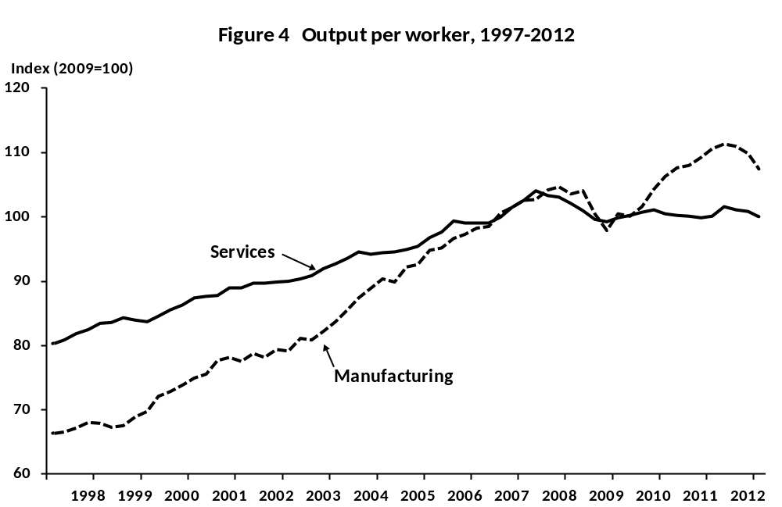

The likelihood that low productivity in the UK is a consequence of labour hoarding is supported by international trends in labour productivity. Employers in the USA, for example, are less reluctant to shed labour during recessions than UK employers. The drop in labour productivity following the 2007 financial crisis was consequently much smaller in the USA than in the UK despite a very similar drop in output (Hughes and Saleheen 2012, p.145). The German experience has been similar to the UK. Jobs were protected in the early part of the recession through government sponsored short-time working schemes. This resulted in a sharp drop in labour productivity and a subsequent rise in labour hoarding (Möller 2010).

How much spare capacity is there?
Since there is no concrete evidence that the current recession has led to a sudden halt in underlying productivity growth, it is necessary to be sceptical about the OBR’s estimate of spare capacity. The OBR, for example, is unable to produce any convincing evidence that the productive potential of the UK economy was severely dented by the 2007 financial crisis. Economists at the Bank of England have also been unable to validate the OBR’s views (Hughes and Saleheen 2012).

The extent to which the OBR’s estimate of spare capacity may severely understate its true level can be illustrated by comparing it with an estimate based on extrapolating past trends (see Figure 5). Spare capacity is calculated by expressing the difference between actual output and capacity output as a percent of capacity output. The OBR’s estimate of spare capacity assumes that capacity output has been unchanged since the start of the recession. The upper estimate assumes a continuation of the long-run trend in capacity output and is calculated by fitting linear segments to output peaks. The lower (OBR-based) estimate is 3% and the upper (trend-based) estimate is 12%. There is therefore a substantial discrepancy between the two estimates depending on the assumption made about the impact of the financial crisis on the UK’s productive potential.

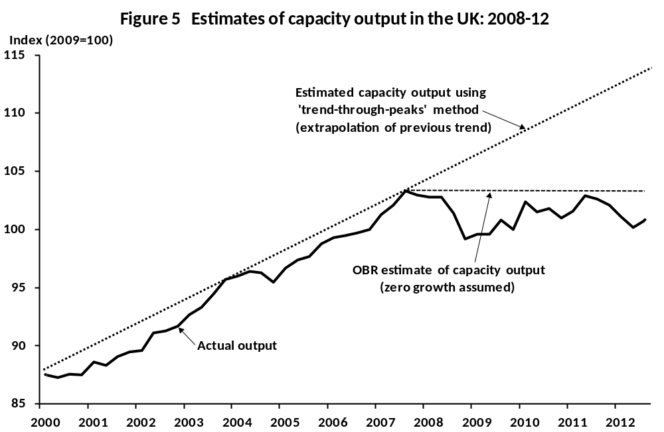

It seems highly likely that the OBR is wrong to assume that there has been no growth in productive potential since the 2007 financial crisis. This not only assumes that technological progress has come to a stop because of the recession, which seems most unlikely, but also denies the likelihood that productivity has been held down because of substantial labour hoarding. Even if productive potential has been increasing at only half its previous rate, there would still be substantial spare capacity in the economy.

What next?
The existence of large amounts of spare capacity in the UK economy implies that a demand expansion could be achieved without any serious inflationary consequences. An obvious starting point would be to increase public spending on infrastructure projects since there is absolutely no doubt that the construction sector has plenty of spare capacity. This is clear from recent quarterly surveys by the Royal Institute of Chartered Surveyors (RICS). There is no evidence, for example, that the sector suffers from a shortage of skilled labour. Only 3% of respondents to the latest survey at the end of 2012 indicated that a shortage of skilled labour was a problem. This compares with 89% of respondents who stated that access to finance was a problem and 66% who stated that insufficient demand was a problem.
The lesson from the RICS survey is crystal clear. The banking sector has a critical role to play but this must be supported by an injection of demand generated by direct government action to improve the UK’s physical infrastructure.

How long do we have to wait for the coalition to wake up and bring this prolonged and deep recession to an end?

REFERENCES
Bank of England (2011), Inflation Report, August. http://www.bankofengland.co.uk/publications/Documents/inflationreport/ir11aug.pdf
Bouis, R., Cournede, B. and Christensen, A. (2012), ‘Implications of output gap uncertainty in times of crisis’, Economics Department Working Papers No.977, OECD, Paris. http://search.oecd.org/officialdocuments/publicdisplaydocumentpdf/?cote=ECO/WKP(2012)54&docLanguage=En
HM Treasury (2012), Forecasts for the UK economy: a comparison of independent forecasts, November. (http://www.hm-treasury.gov.uk/d/201212forecomp.pdf)
Hughes, A. and Saleheen, J. (2012) ‘UK labour productivity since the onset of the crisis – an international and historical perspective’, Bank of England Quarterly Bulletin, Vol. 52, Number 2, pp.138-146.
Martin, B. (2011), ‘Is the British Economy supply constrained? A critique of productivity pessimism’, Centre for Business Research, University of Cambridge, July. http://www.cbr.cam.ac.uk/pdf/BM_Report.pdf
Martin B. and Rowthorn, R. (2012), Is the British economy supply constrained/ A renewed critique of productivity pessimism, Centre for Business Research, University of Cambridge, May. (http://www.cbr.cam.ac.uk/pdf/BM_Report3.pdf)
Möller. J. (2010), ‘Germany’s job miracle in the world recession – shock-absorbing institutions in the manufacturing sector’, Applied Economics Quarterly, Vol. 61, pp.9-28.
Nickell, S. (1978), ‘Fixed Costs, Employment and Labour Demand Over the Cycle’, Economica, Vol.45, 329-345.
Office for Budget Responsibility (2012) Economic and fiscal outlook, December. http://budgetresponsibility.independent.gov.uk/economic-and-fiscal-outlook-december-2012/
Office for National Statistics (2012), People in work wanting more hours increases by 1 million since 2008, 28 November. (www.ons.gov.uk/ons/dcp171776_289024.pdf)
Oxford Economics (2012), ‘Have the advanced economies suffered a permanent loss of output?’ Economic Outlook, Volume 36, Issue 4, pages 5-13. (http://web.oxfordeconomics.com/FREE/PDFS/UKMFEAT1_1012.PDF)
Patterson, P. (2012), The productivity conundrum, explanations and preliminary analysis, Office for National Statistics, 16 October. http://www.ons.gov.uk/ons/dcp171766_283259.pdf

