Variable Fused Deposition Modelling – Concept Design and Tool Path Generation

H. BROOKS¹, A.E.W. RENNIE¹, T.N. ABRAM¹, J. McGOVERN¹ & F. CARON²
¹Lancaster Product Development Unit, Engineering Department, Lancaster University, UK
²IUP Génie Mécanique et Productique, UFR Sciences et Techniques, Université de Bretagne Occidentale, France

ABSTRACT
Current Fused Deposition Modelling (FDM) techniques use fixed diameter nozzles to deposit a filament of plastic layer by layer. The consequence is that the same small nozzle, essential for fine details, is also used to fill in relatively large volumes. In practice a Pareto-optimal nozzle diameter is chosen that attempts to maximise resolution while minimising build time. This paper introduces a concept for adapting an additive manufacturing system, which exploits a variable diameter nozzle for the fused deposition of polymers. The variable nozzle allows the print resolution and the build speed to become independent variables which may be optimised. The paper discusses a concept design for the variable diameter nozzle to be fitted to a RapMan 3D printer and the software used to generate the tool paths for the extrusion head. The methodology involves the use of existing software solutions to gather basic data from STL files and generate the tool paths. A method for integrating the data and the deposition system is proposed. The challenges and possibilities of the technology are discussed as well as future research.

KEYWORDS: FDM, Extruder, Variable, Tool path generation

1. INTRODUCTION

  - Fused Deposition Modelling

Fused deposition modelling (FDM) is a common additive manufacturing (AM) method for creating polymer parts. FDM builds parts additively by depositing a small bead of molten plastic through an extrusion head onto a work platform. The nozzle (or platform) moves via computer control to lay down a plastic pattern on the platform. Complete parts are built by laying down successive patterns one layer at a time [1].

While the lead time to produce AM parts via FDM is relatively short, the per unit manufacturing time is much longer than conventional mass production techniques. This is partly due to the fact the extrusion head, which has a small diameter nozzle, has a low volumetric deposition rate [2]. In conventional FDM the nozzle diameter is small to maximize the resolution of each layer.

Three main options exist to increase the build rate: i) increase the speed of the horizontal movements; ii) minimize the material of the part; or iii) increase the diameter of the nozzle.

This paper introduces a concept for adapting an existing AM system which employs a variable diameter nozzle for the fused deposition of polymers. The variable nozzle allows the print resolution and the build speed to become independent variables which may be optimised.

  - Literature Review

Research into FDM can be split into three main categories: novel applications, materials and system improvements [3, 4]. The vast majority of system improvements are software based and are related to tool path generation, slicing algorithms and part orientation optimization [5-7]. The basic mechanical system used for FDM has changed little since its inception in the 1980’s and consists of three Cartesian linear actuators, an extruder(s) and temperature controls [1]. Multiple extrusion heads are used to deposit different materials and some research has been carried out for printing multi-material parts [8].

Very little research work has been published on the advancement of FDM extruder technology. Tseng patented two novel deposition techniques called adaptive filament deposition (AFD) and planar layer deposition (PLD) for the freeform fabrication of metals and ceramics [9, 10].

AFD utilizes a conical spindle inside a deposition head to vary the volumetric flow rate of liquids through the extrusion orifice. After leaving the orifice the liquid jet is cooled by the ambient air temperature and becomes a filament. Retracting the spindle away from the orifice allows higher flow rates which in turn increases the filament size. PLD utilizes adjustable planar nozzles and rollers to deposit uniform thickness layers of material. The most notable feature of PLD is the fact that the whole layer can be deposited in one pass. Yang et al patented a variable nozzle similar to PLD which allows layers to be deposited in a single pass [11].

Both of these deposition techniques are not well suited to the printing of engineering plastics and require significant alterations to conventional FDM systems. It is also unknown whether these deposition techniques can practically rival the levels of detail achieved by conventional FDM.

Due to the lack of research on FDM extruder design, and the current limitations imposed by constant diameter nozzles, the authors believe variable diameter nozzles to be a worthwhile research topic.

2. VARIABLE FUSED DEPOSITION MODELLING (VFDM)

2.1 Impacts on horizontal resolution

FDM nozzles utilize circular orifices to take advantage of the axisymmetric properties in the horizontal plane. The benefit of this is that the nozzle does not need to be kept normal to the extrusion path. The disadvantage is that all angles will have radii greater than or equal to the radius of the nozzle as shown in Figure 1.

Error
r
θ
Extrusion path
Modelled geometry

Figure 1: Geometric error due to circular nozzle

The geometric error can be calculated using Equation 1 below:

$Error=\frac{r}{sin\left(\frac{θ}{2}\right)}−r$ (1)

Where r = radius of the extrusion orifice and θ = angle of modelled geometry.

Figure 2 shows the relationship between the geometric error and the intended angle for normalized nozzle radii. The bottom line represents a radius of one unit while the middle and top line represent radii two and three times larger respectively. As can be seen on the graph the error is small for large angles but grows significantly for angles less than 60°. For 60° angles the error is at least equal to the orifice radius.

Figure 2: Graph showing minimum geometrical error of an angle printed with a circular nozzle

In practice, extrusion paths like the one shown in Figure 1 are prevented by the tool path generation software due to the overlapping projections of the nozzle path as it enters and exits the corner. To verify this statement, an isosceles triangle with a 15° vertex was printed in the horizontal plane on a Dimension 1200 BST FDM machine. The slicing and tool paths were generated using Stratasys’ proprietary software Catalyst®EX. According to Equation 1, the calculated minimum error is 0.67 mm while the measured error was 3.87 mm. Therefore it is evident that the errors associated with printing high aspect ratio features have been highly underestimated and the need for small diameter nozzles is even greater.

VFDM allows for a larger diameter orifice to be used for infill, where geometric error is less important, and smaller diameters for the exterior shell where high resolution is desirable. The authors believe that by using this process it is possible to improve the quality of FDM parts while increasing build speed.

2.2 Impacts on extrusion time

For large parts, with a high percentage of infill, the extrusion time during a build is a function of the nozzle diameter and the geometry of the part.

For the purposes of an example, consider a 30, 60, 90° triangle which is 1 unit thick and has dimensions as defined in Figure 3.

60°
30°
1 unit
2 units
√3 units

Figure 3: Plan view geometry of 30, 60, 90 triangle for extrusion time saving analysis

Assuming the part is 100% solid and the nozzle diameters, feed rate and layer thicknesses are known, it is possible to calculate the extrusion time as a function of part volume (Equation 2).

$Extrusiontime=\frac{volume}{D×f×l}$ (2)

Where volume = the volume of the part (mm³), D = the nozzle diameter of the part (mm), f = nozzle feed rate (mm/s) and l = layer thickness.

If the nozzle is able to use a small diameter for the outer shell(s) and a larger diameter for the infill then Equation 2 becomes:

$Extrusiontime=\frac{volume_{shell\left(s\right)}}{D1×f×l}+\frac{volume_{infill}}{D2×f×l}$ (3)

Where volume_{shell(s)} = volume of the outer layer(s) of the part, volume_{infill} = volume of the inside of the part, D1 = small nozzle diameter, D2 = large nozzle diameter.

Using the following parameters, D1 = 0.5 mm, D2 = 1.0 mm, f = 25 mm/s, and l = 0.5, a graph was created showing the extrusion times for the 30, 60, 90° triangular prism over a range of volumes and variable nozzle diameter configurations. Configuration A (the steepest line) shows the extrusion time required if only a nozzle of diameter 0.5 mm is used. Configuration D (the shallowest line) shows the extrusion time for a fixed 1.0 mm nozzle. C and B show the extrusion times for parts with one and two layer thick shells respectively.

Figure 4: Graph showing the extrusion times as a function of part volume for different nozzle configurations

As can be seen by the small difference between configurations B, C and D, the amount of time required to add high resolution outer shells is insignificant for large volume builds. In the case of the 30° vertex, replacing the 1.0 mm nozzle with the 0.5 mm nozzle reduces the theoretical error from 1.43 mm to 0.72 mm. In practice, due to the way the tool paths are calculated, the improvements in resolution will be far greater.

It should be noted here that the same extrusion time savings could be made by utilising two separate extrusion heads with different fixed diameter nozzles. However, the problem with this solution is the time taken to switch extrusion heads and the extra room required on the positioning rack. This problem is magnified for machines with multiple material capabilities.

2.3 Concepts for VFDM

Possible concepts for VFDM nozzles can be placed into two main categories: continuously variable nozzles (CVNs) and discretely variable nozzles (DVNs).

CVNs allow much more freedom in choosing the print resolution and build speed and allow for the possibility of size changes whilst printing. The main disadvantage of CVNs is the mechanical complexity and the necessary design compromises that result. Possible solutions reviewed by the authors include mechanical irises, sliding jaws and smart materials.

All CVN solutions analyzed required that the orifice be an approximation of a circle. This increases the error relative to a circle of the same area and may result in orthotropic extrusion properties. For example think of a square moving in a direction parallel with its sides, and then imagine the square moving diagonally. Obviously the track will be wider for the diagonal movement. Another difficulty in designing a CVN is scaling down the actuating mechanisms to a size desirable for typical FDM applications. The design and build of CVNs is likely to be the topic of future research by the authors.

DVNs are mechanically simpler than CVNs and are therefore relatively simple to manufacture at the sub-millimetre scales required. Possible solutions to DVNs are interchangeable nozzles and multiple stage nozzles. Interchangeable nozzles could sit in a carousel and automatically change via computer control. This concept was abandoned due to the difficulties associated with the nozzles into and out of the polymer flow stream. The multiple stage nozzle works by moving nested inserts inside the nozzle. The multiple stage nozzle was found to be relatively easy to implement while allowing circular orifices and uninterrupted polymer flow.

The design for a two stage nozzle is presented in the next section.

2.4 Two stage nozzle design

The two stage nozzle consists of an inner and outer nozzle each with fixed orifice diameters. The inner nozzle is actuated by a solenoid, and in its lowest position is nested firmly against the inner surface of the outer nozzle, restricting the flow through the smaller orifice. When the inner nozzle is lifted a secondary melt chamber is formed which allows multiple polymer flow streams to coalesce before leaving the larger orifice as shown in Figure 5.

Small bead
Outer nozzle
Inner nozzle
Polymer filament
Melting chamber

a)

Polymer filament
Inner nozzle
Outer nozzle
Large bead
Melting chambers

b)

Figure 5: Two stage nozzle with a) small diameter orifice and b) large diameter orifice

This concept achieves many of the objectives of VFDM but also has a number of significant drawbacks. Assuming the outer shell of each layer is deposited first, there will be a small delay required before the infill can start as the secondary chamber must be filled with molten polymer. The second major drawback is that polymer in the secondary chamber is likely to be pushed out as the inner nozzle moves back into the lower position. This not only wastes material but will add extra build time as the nozzle moves to a designated discharge point.

Notwithstanding these problems it is expected that the two stage nozzle will reduce the build time for large solid high resolution parts. The following section describes how the nozzle is integrated into a RapMan 3.0 3D printer from Bits from Bytes (BfB) [12].

3. TWO STAGE NOZZLE DESIGN

3.1 RapMan 3D printers

The RapMan 3.0 is a FDM machine based on the open source RepRap project and is shown in Figure 6. The low cost and open structure of the RapMan makes it highly suitable for research related modification.
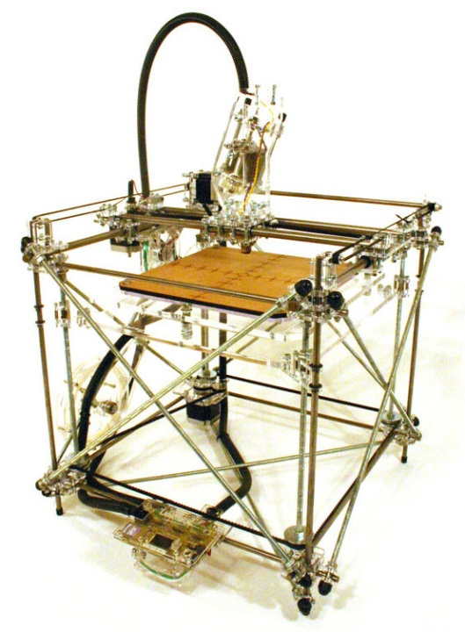
z
x
y
Extruder
Build platform

Figure 6: Unmodified RapMan 3.0 from Bits for Bytes

The VFDM extruder is designed to replace the original RapMan extruder with minimal changes. The standard RapMan heating system will be changed from a fixed resistance wire and fire cement configuration to a removable aluminium block which contains two power resistors. One of the power resistors is connected to the RapMan control board along with a thermistor for temperature control. The other power resistor is connected to an external circuit to enable a base heating load giving greater temperature control via the thermistor, see Figure 7.

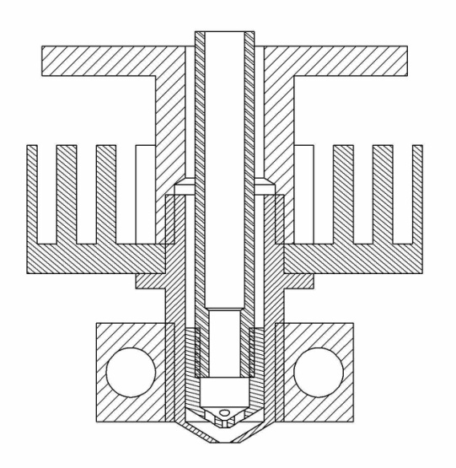
Heat-sink
Heating block
Outer nozzle
Inner nozzle
Attachment flange
Filament guide
Power resistor cavities

Figure 7. Two stage nozzle and heating assembly.

The filament guide also acts as the connection between the solenoid and the inner nozzle. The filament feed mechanism will be moved slightly to allow the solenoid to be positioned directly above the inner nozzle.

The RapMan uses open source software, Skeinforge, to generate the required G-code from .STL files. The next section describes the software tool chain used in the proof of concept printing.

4. TOOL PATH GENERATION

It is the authors’ intention to develop an advanced tool path generation algorithm in parallel with future developments in VFDM. The tool path generation described in this paper is a more basic method which will be used for testing the two stage nozzle concept.

4.1 Standard printing procedure

A summarized standard procedure for printing parts on a RapMan machine is as follows:
- Generate an STL file from a CAD program.
- Upload the STL file into Bits from Bytes Axon (Skeinforge).
- Generate the G-code with the .bfb extension.
- Upload the .bfb file onto an SD card.
- Insert the SD card into the RapMan card reader and run the file.

The standard input file to most FDM systems is the stereolithography or STL file. STL files describe the surface geometry of parts by using a triangular mesh [13]. The BfB Axon program is a user friendly front-end to the more complicated but versatile Skeinforge open source software. Skeinforge is a tool chain composed in Python script that allows the user to control many of the parameters that generated the tool path G-code. G-code is the common name given to the computer numeric control programming language adopted by many automated machine tools [14]. While generic G-code generators exist, many manufacturing technologies use machine specific G-codes which require post processing in order to be used in other machines. The RapMan uses its own form of G-code which is, amongst other things, differentiated by the extension .bfb.

The next section describes how the Skeinforge settings were adjusted for the two stage nozzle and how the BfB G-code was subsequently altered to allow for the nozzle mode changes.

4.2 Printing procedure for the two stage nozzle

The STL file (or equivalent) is produced in CAD software via the usual method. Once the STL file is loaded into the BfB Axon software, the Skeinforge program can then be accessed by clicking on the advanced settings button. In the Skeinforge program it is possible to alter the infill large diameter nozzle. In practice this requires setting the Infill solidity (ratio) so that the paths are spaced further apart, whilst simultaneously setting the Infill width over thickness (ratio) to make the bead width wider. For example: if the layer thickness is 0.25 mm, the width of the shell is 0.25 mm and the desired width of the infill tracks is 0.5 mm, then Infill solidity (ratio) should equal 0.5 and the Infill width over thickness (ratio) should equal 2 (i.e. 0.25 mm x 2 = 0.5 mm). A number of fill patterns can be used, however for 100% solid parts it is better to use rectangular or line fill options.

It is also possible to change the number of shells desired. This is more important for parts with sloped sides than parts with vertical sides.

Once the settings have been changed in Skeinforge it is possible to produce the .bfb G-code file in BfB Axon. The .bfb file can then be loaded in a module of Skeinforge called Skeinview and analysed to see if the settings had the correct effect. Once the G-code with the correct path spacing is created it is necessary to alter the code manually to introduce steps required for the two stage nozzle. This involves adding an extruder delay between the shell and infill depositions to allow the secondary melt chamber to fill up. The extruder flow rate and temperature may also be changed at this point. Once the infill is complete, extra lines of code are required to move the head to the designated purge point, after which the extruder may return to the original flow rate and temperature settings.

Finding the code lines where the machine changes from extruding the shell to the infill is currently done by viewing the code line-by-line in Skeinview. While this manual manipulation of the G-code is acceptable for a proof of concept trial, the process will ideally be automated for future versions of VFDM.

5. FUTURE WORK

The next step in the development of the two stage nozzle is to run print tests to determine usable print profiles for common FDM polymers. This will allow VFDM parts to be built and the performance characteristics to be compared with conventional FDM.

In order for VFDM to reach its full potential the current barriers to CVNs need to be overcome. This is a matter of ongoing research by the authors. In parallel with this research is development of VFDM tool path generation algorithms which in combination with variable layer slicing programs could drastically reduce build times while improving build accuracy and surface finish.

6. CONCLUSIONS

This paper presented a concept for variable fused deposition modelling. The major findings are as follows:
- The theoretical benefits for horizontal accuracy were derived in terms of generic circular nozzles. The potential improvement in accuracy for convex angles less than 60° is considerable.
- The time savings in extrusion time for a solid 30, 60 90° triangle prism was calculated as a function of volume for different build strategies.
- A concept design for a two stage nozzle was provided along with methodology to generate the G-code for manufacture.
- Future work was discussed with the aim of improving the design of continuously variable nozzles and tool path generation.

By making clear the advantages of VFDM and providing the methodology for a detailed concept, it is hoped that further research will be stimulated in this area.

REFERENCES

[1] S.S. Crump, 'Apparatus and Method for Creating Three-Dimensional Objects', United States Patent, US 5,121,329, 1989.
[2] N. Hopkinson and P. Dickens, 'Analysis of rapid manufacturing—using layer manufacturing processes for production', Proceedings of the Institution of Mechanical Engineers, Part C: Journal of Mechanical Engineering Science, 2003, 217, pp.31-39.
[3] S.H. Ahn, et al., 'Anisotropic material properties of fused deposition modeling ABS', Rapid Prototyping Journal, 2002, 8, pp.248-257.
[4] I. Zein, et al., 'Fused deposition modeling of novel scaffold architectures for tissue engineering applications', Biomaterials, 2002, 23, pp.1169-1185.
[5] P.M. Pandey, et al., 'Real time adaptive slicing for fused deposition modelling', International Journal of Machine Tools and Manufacture, 2003, 43, pp.61-71.
[6] K. Thrimurthulu, et al., 'Optimum part deposition orientation in fused deposition modeling', International Journal of Machine Tools and Manufacture, 2004, 44, pp.585-594.
[7] D. Chakraborty, et al., 'Extruder path generation for Curved Layer Fused Deposition Modeling', Computer-Aided Design, 2008, 40, pp.235-243.
[8] W.K. Chiu and S.T. Tan, 'Multiple material objects: from CAD representation to data format for rapid prototyping', Computer-Aided Design, 2000, 32, pp.707-717.
[9] A.A. Tseng, 'Adaptable Filament Deposition System and Method for Freeform Fabrication of Three-Dimensional Objects', United States Patent, US 6,251,340 B1, 2000.
[10] A.A. Tseng and M. Tanaka, 'Advanced deposition techniques for freeform fabrication of metal and ceramic parts', Rapid Prototyping Journal, 2001, 7, pp.6-17.
[11] D.Y. Yang, et al., 'Method for Manufacturing a Three-Dimensional Model by Variable Deposition and Apparatus Used Therein', United States Patent, US 6,505,089 B1, 2000.
[12] Bits from Bytes. Available: http://www.bitsfrombytes.com/ [Acessed 31/05/2011].
[13] C.K. Chua, et al., Rapid Prototyping: Applications and Principles, 2nd Edition ed. Singapore: World Scientific Publishing Co. Pte, Ltd., 2003.
[14] E. Oberg, et al., Machinery's handbook. New York, USA: Industrial Press, Inc., 1996.

