The Application of ChatGPT in Students’ Essay Writing (Brasov, Romania May 30-June 1)
Research-based Language Teaching Methodology to be submitted by 15 Jan, 2025
https://caslar8.unitbv.ro/
file:///P:/Conferences/2025/Romania%20May30-1June.pdf
organizing team: caslar8@unitbv.ro
Zhiqi Gzhiqi.gong@yahoo.com
Monday123! 20 hours before to check in, hotel: 27 May-1 June gmail, airticket: uni email
Return: Direct Aeroport near Hotel Palace
Abstract:
This empirical study explores the application of ChatGPT in students’ essay writing, assessing its impact on essay quality, student engagement, and students’ perceptions and suggestions on the learning experiences in this AI-assisted writing mode. The study collected quantitative data through pre-test and post-test assessments and qualitative insights from students’ reflective accounts and interviews. Thirty-five advanced-level students in a Chinese-degree program participated. Thematic analysis identified key themes related to students' perceptions, including benefits, challenges, and recommendations for effective ChatGPT integration. The quantitative findings revealed a significant improvement in essay scores, with students who actively engaged with ChatGPT achieving higher results than those with minimal interaction. Qualitative analysis indicated that students valued ChatGPT’s support in generating ideas, providing useful information, offering suitable level of vocabulary and idiomatic expressions, and fostering critical thinking skills by giving the right prompts and selecting the right information. However, students also identified limitations, noted as information overloading, mechanical responses, occasional inaccuracies, and a lack of cultural nuance. Based on these insights, students recommended a more structured approach to ChatGPT use, emphasizing the importance for precise prompts, critical engagement, a well-defined role for AI in the writing process. They also advocated for ChatGPT’ integration into the curriculum, enabling students to focus on more creative and imaginative aspects of writing. This research contributes to the field of AI-assisted language learning by offering practical recommendations for the effective integration of generative AI into teaching, learning, and research contexts.
Summary:
This study explores the application of ChatGPT in students’ essay writing, revealing improved essay quality, enhanced student confidence, and valuable language support. While students appreciated ChatGPT’s guidance, they noted its limitations, including mechanical responses and inaccuracies. The study highlights ChatGPT’s potential as a transformative educational tool, emphasizing the need for critical engagement and structured integration into language education curricula.
Key words: ChatGPT, essay writing, language learning, empirical study
Introduction
ChatGPT, a generative Artificial Intelligence (AI) tool, has introduced significant changes across various academic disciplines, including language education. With its unprecedented ability to generate text and facilitate automated conversations, ChatGPT has the potential to transform not only how students learn but also how they perceive the learning process. As established in the literature, the widespread and inevitable adoption of ChatGPT is poised to play a dominant role in language education, review. If effectively integrated, AI tools can accelerate language education, enhance professional development for educators, support educational research, and refine pedagogical approaches by overcoming language barriers.
Despite its growing prominence, educators are still at the early stages of understanding how students integrate ChatGPT into their actual writing process while ensuring academic integrity, such as avoiding plagiarism. The use ChatGPT in academic writing remains a contentious issue. While some scholars advocate for its adoption as a tool to generate ideas, enhance writing quality, and improve efficiency, others raise concerns about its potential to diminish students’ analytic skills and promote misconduct. Some universities have even imposed bans on its use. Critics argue that an overreliance on ChatGPT may hinder critical thinking, encourage intellectual complacency, and discourage students from engaging deeply with their work. Others view it as a potential threat to education, fearing that it could lead to a decline in rigorous academic activities and foster dependency among both students and teachers.
Many existing on the role of ChatGPT in education rely on theoretical discussions and systematic reviews, with limited empirical evidence to substantiate these claims. This study seeks to addresses this gap by examining how students use ChatGPT in their essay writing, analysing its advantages and limitations, and amplifying students’ perspectives on its practical application. Through this investigation, the study aims to provide valuable insights into the implications of AI-assisted writing in higher education.
Literature review
Recently literature acknowledges the potential for ChatGPT in language teaching across multiple aspects (Huang et al, 2022), including language input as a learning resource (Baskara, and Mukarto, 2023), interactions as a language learning partner (Mill et al, 2024), tailored communicative activities to suit individual learners’ learning styles (Barrot, 2024), and feedback provision (Su et al., 2023, Tai et al., 2023, and Dai et al., 2023). These studies highlight the advantages of ChatGPT in transforming language education.
Language input and learning partners
For language input as learning resource and a language learning partner, ChatGPT can generate realistic dialogues with authentic language use examples (George & George, 2023). It supplies vocabulary, sentence patterns, and structures to assist students in writing, offering a novel approach to language learning. Students can input text and have it continued in a conversational manner, meeting their writing needs, and allowing for additional practice. In a systematic review of 25 empirical studies, Huang et al. (2022) identified pedagogical applications of ChatGPT as interlocutors, assimilation tools, transmission aids, as helplines, and recommendation systems. These applications enhance students’ social presence through affective, open, and coherent communication.
Mollick & Mollick (2023) identified seven potential roles for AI in learning: AI‐tutor (personalized instruction), AI‐coach (reflection on learning), AI‐mentor (feedback on learning), AI‐teammate (identification of alternative viewpoints), AI‐tool (efficiency in learning), AI‐simulator (practice and application), and AI‐student (students as teachers of AI). While AI can function as language partners, the authors caution about AI's unbalanced knowledge, accuracy, and fidelity. Mills, et al (2024) designed an AI companion to assist students writing revealing that students who enjoyed using AI also valued writing more and reported increased efficacy.
ChatGPT as writing partners have been explored for scaffolding students’ argumentative writing (Guo et al., 2022). AI in literacy and language education supports personalized learning experiences, provides differentiated feedback, and fosters engagement (Huang et al., 2022). Lo (2023) found that access to AI language programs improved vocabulary acquisition, especially with specialised expressions. Bedington et al., (2024) emphasized ChatGPT’s dialogic interface, which enables humans to refine prompts iteratively, enhancing the effectiveness of writing for specific audiences, purposes, and contexts.
Tailored communicative activities
ChatGPT personalizes language learning experiences by tailoring communicative activities to learners’ proficiency levels and styles” (Barrot, 2024, p2). These adaptive features allow students to progress at their own speed and engage in human-like conversations to receive guidance. Personalization fosters self-reflection and autonomy, enabling students to align learning with their individual goals and preferences. Real-time responses further enhance engagement, allowing students to delve into specific areas or seek clarification as needed.
In a synthesis study, Kasneci et al. (2023) identified ChatGPT’s capabilities in understanding learner prompts, generating instructional exercises, scoring academic performance, improving student engagement and interaction, and personalising learning experiences. It could recommend tutorials, foster academic discussions, answer questions, encourage emotional expression, and provide emotional support. Additionally, it aids learners in analysing authentic writing logic, breaking down texts, and providing relevant commentary (Baidoo-Anu & Ansah, 2023; Kohnke et al., 2023).
ChatGPT also assists with meaningful writing samples (Barrot, 2023), adjusts text difficulty levels (Bonner et al., 2023), offers structural writing advice (Imran & Almusharraf, 2023), and facilitates guided writing (Kohnke et al., 2023). It can analyse language features, diagnose errors, and evaluate essays to enhance communicative competence.
Moreover, ChatGPT can provide meaningful writing samples (Barrot, 2023), adjust the difficulty level of texts matching leaners’ proficiency level (Bonner et al., 2023), offer advice regarding various structural aspects of a text and translate it (Imran & Almusharraf, 2023), and facilitate guided writing (Kohnke et al., 2023). To be more concrete, ChatGPT can analyse language features, diagnose errors, and evaluate essays. ChatGPT functions tailored communicative activities to suit individual learners’ learning styles.
Feedback Provision
Beyond serving as a tutoring tool, ChatGPT also functions as an effective feedback mechanism. Barrot (2023) finds that automated writing corrective feedback (AWCF) tools, such as Grammarly, enhance students’ overall writing accuracy and metalinguistic awareness. By providing personalized feedback, AWCF facilitates self-directed learning, reducing the burden on teachers while supporting students in writing, revising, and self-improvement (Almusharraf & Alotaibi, 2023).
ChatGPT provides human-like expert assistance to students in idea generation, organization, accuracy and vocabulary selection (Tai et al., 2023). Dai et al. (2023) highlighted that ChatGPT’s instant corrective feedback on grammar, syntax, lexical choices, and coherence enables immediate application, benefiting students with time constraints. This real-time feedback not only enhances motivation but also allows learners to track progress and accelerate language mastery. Additionally, ChatGPT provides topic suggestions, structuring outlines, and refining drafts, assisting students across different stages of writing (Barrot, 2023).
Halaweh (2023) reported that ChatGPT provides instant feedback by analysing content, grammar, vocabulary, and coherence in students’ writing, helping to refine their writing skills. Furthermore, ChatGPT can facilitate adaptive assessments by adjusting task difficulty based on students' responses, adjusting the complexity of questions and prompts based on students' previous answers, ensuring a more personalized and targeted evaluation.
From a language tutor’s perspective, providing feedback on students’ writing is often time-consuming and does not always yield immediate improvements. Research has explored the quality of generative AI feedback compared to human feedback. Steiss et al. (2024) analysed 400 instances of feedback—half generated by human raters and half by ChatGPT—on the same essays. Their findings showed that human raters provided higher-quality feedback in terms of clarity, accuracy, supportive tone, and emphasis on critical aspects for improvement. In contrast, AI-generated feedback excelled in delivering criteria-based evaluations text, including organization, language use and recommending corrections, logically organizing content, adding appropriate supporting details and conclusion. The study generated important implications for balancing the strengths and limitations of ChatGPT and human feedback for assessing student essays (Ohio University, 2023; Fitria, 2023).
ChatGPT in essay writing
AI has the potential to transform academic writing pedagogy by complementing conventional instructional methods. Professor Rodney Jones, in a British Council report, emphasized that when using generative AI as a collaborator, the writing process is automatically recorded. Engaging in iterative conversations with AI allows students to critique AI-generated outputs, refine prompts, and document their writing journey, reinforcing a step-by-step learning process (Edmett et al., 2023).
Han et al. (2023) analysed 213 students’ interactions with ChatGPT in South Korea. Via quantity survey and quality interview, the results revealed that the students generally held positive experiences, particularly feedback. The usefulness of dialogic feedback process is backed by feedback theories of Barrot (2023) and Winstone and Carless (2020), and the study strengthened the theoretical foundations underpinning the use of ChatGPT. While students found AI useful for revision, it was also noted as less effective in supporting the entire writing process.
Alharbi (2023) systematically reviewed 104 studies on AI-powered writing assistance, highlighting the growing application of these tools and their overall usefulness in writing education. The study identified four key affordances: (a) evaluating writing outcomes, (b) providing corrective feedback, (c) supporting translating, and (d) assisting with drafting. Similarly, Lee et al. (2023) introduced a learner-generated-context-based approach, allowing students to create personalized digital learning environments. Such support enables students to construct clear writing outlines—essential for ensuring logical progression and coherence in writing. A well-structured piece of writing is not only about individual sentences or paragraphs but also about how they interconnect within the overall text. ChatGPT aids in maintain structure, style, and flow, ensuring consistency throughout the text (Sol and Heng).
Regarding scoring, Hsiao and Chang (2023) conducted an 18-week online language course integrated with AI-powered tools. AI scored students’ writings, provided suggestions on grammar and spelling, and analysed the usage and frequency of lexical choices in authentic writing. The study revealed that AI-enhanced academic performance significantly. However, even though AI helps with the linguistic feature, language tutors fear that the imposition in pre-decided pattern in AI may limit students’ creativity (Yan, 2023). ChatGPT challenges language tutors to refine pedagogical practices by integrating interactive, AI-assisted writing activities. Language tutors must devise innovative strategies, including human-AI co-writing tasks, to foster engagement and originality.
While previous studies highlight the impacts of generative AI on academic writing, empirical classroom-based research remains limited. There is a notable gap in understanding how students integrate AI into their writing processes (Yan, 2023), with minimal systematic research on AI’s role in real-world writing processes (Barrot, 2023).To bridge this gap, this study adopts a naturalistic, exploratory approach, examining how university students utilize ChatGPT for academic writing. Investigating students’ AI-assisted writing processes will provide educators with insights to adapt their teaching strategies in response to AI’s growing influence.
Currently, empirical evidence on ChatGPT’s impact on writing remains scarce. An up-to-date study is necessary to explore the contemporary use of generative AI (GenAI) in academic writing. This study examines how students leverage ChatGPT to support their writing, analysing perceived benefits, challenges, and pedagogical considerations. By presenting empirical evidence on ChatGPT’s role in writing education, this study demonstrates that integrating ChatGPT into academic writing can yield positive outcomes when instructors provide appropriate guidance. It also confirms that the dialogic nature of ChatGPT can enhance student engagement in writing when adequately structured and supported.
Given the limited understanding of students’ engagement with ChatGPT in writing, a phenomenological lens could provide deeper insights into their experiences with AI-assisted writing. Therefore, the following research questions guided the present study:
- What are the benefits and limitations for students to co-write with ChatGPT in their essay writing?
- What do students perceive the AI-assisted learning experience, and what improvements do they suggest?
The study
This study was conducted during the autumn semester of 2024 at a higher education institution in the UK. The course lasted 12 weeks in the first semester, with essay writing constituting 10% of the final grade as part of coursework assessment. Students had the choice of whether to use ChatGPT or any other AI writing tools. Those who opted to use ChatGPT were categorized as the experimental group (EG), while those who chose not to use AI-assisted tools were placed in the control group (CG). Disclosure, transparency, and reflection on AI use were mandatory components of the assignment submission for the EG, while students in the CG could ask language partners and native speakers to help revising their essays. This setup ensured that students had flexibility in planning, researching, drafting, reviewing, and editing their work while maintaining academic integrity.
In class, students were introduced how to ChatGPT as a tool for idea generation, word choice refinement, structural assistance, and critical engagement with AI-generated content. They were encouraged to explore ChatGPT’s functionalities to support their writing process. Classroom activities included discussions on writing integrity, critiques of AI-generated writing, and hands-on practice integrating ChatGPT into academic writing through prompt revision and selective use of AI-generated information. For students in the CG, they also learned how to use the tool for other purposes such as for reading or speaking.
Given the exploratory and experimental nature of co-writing with ChatGPT, this study sought to examine its role in academic writing within a structured educational environment.
Participants
The study involved thirty-seven advanced-level Chinese-degree university students from two groups. One group is composed of final-year students who just returned from their residence abroad study in China, and the other group of students had not been to China yet but reached advanced level by either having stayed in China for a long period of time with parents or passed GCSE exams. Their Chinese proficiency levels are HSK4, which is equivalent to European framework B2.
Methods
A triangulated mixed-method approach was employed, incorporating both quantitative and qualitative data. The quantitative component involved pre- and post-test scores to measure academic writing improvements, while qualitative data were collected from students' reflective accounts and interviews. This approach enabled both a statistical evaluation of writing performance and an in-depth exploration of students’ perceptions and experiences with AI-assisted learning.
A funnel approach was adopted, which is a method starting by exploring a broad topic or area of interest, gradually narrowing focus down to more specific questions and details, similar to how a funnel narrows at the bottom, allowing researchers to delve deeper into a particular aspect of the research subject.
The study followed a phenomenological research design, focusing on how students engaged with ChatGPT at various stages of the writing process, including brainstorming, revising, and editing. By using a mixed-methods intervention, the research provided a comprehensive understanding of students’ experiences, capturing their reflections on self- and peer feedback in classroom assessments. The study was conducted in three stages: pre-test, training and intervention, and post-test discussion.
A thematic analysis was conducted on students’ written work, self-reflections, and interviews, emphasizing the observation of patterns and the deeper meaning behind students’ experiences. The study explored how students used ChatGPT for brainstorming, organizing ideas, and addressing both global issues (e.g., argument development, structure, coherence) and local issues (e.g., syntax, diction, grammar). Additionally, the study examined students' ethical and practical concerns regarding AI-assisted writing. Although some students utilized other AI writing tools, such as YouWrite and Grammarly, ChatGPT was the most frequently used tool.
Data collection
Quantitative data collected for the study were primarily through pre and post-tests of writing. The evaluation criteria in the rubrics included content, organization, grammar, and vocabulary. Essays were evaluated using the university’ writing rubrics, with two researchers independently marking and average scores. When discrepancy arose, the language tutor was involved in the discussion until agreement was reached. For all write-ups, Cohen’s Kappa was found to be more than 0.8, indicating a strong inter-rater reliability.
Qualitative data for the study were collected through students’ reflective journals and interviews, focusing on obtaining views about and experiences of using ChatGPT and students were also encouraged to share their screenshots supporting their viewpoints. This process is aligned with an interpretive phenomenological design that focuses on exploring participants’ lived experiences and how they construct meaning of their own experiences.
Students’ conversational screenshots with ChatGPT and their in-class and outside class writing drafts could demonstrate their interactions with AI as well as the changes they made upon contemplating the responses from the chatbot. Students’ self-reflections and the informal interviews and further shed light on their perceptions on using or not using ChatGPT. Multiple sources of data helped to understand students’ perceptions, and engagement with AI tools. Triangulation of the data also helped the researchers understand students’ rationale for and practices of integrating, discounting, and reflecting on the chatbot’s output into their writing
Phenomenological qualitative research like this provides in-depth understanding and insights into participants’ experiences. Furthermore, the incorporation of data collected from multiple and diverse sources for triangulation adds to insights into participants’ experiences, which helps strengthen the credibility of the study. In the reflective accounts, students discussed their writing process, the advantages of using ChatGPT, the disadvantages, what and how they would like to use it, and how they integrated AI (or not) in their writing process.
Data analysis
Given the exploratory nature of the research – which included seeking to understand different people’s conceptualisations of using ChatGPT– a thematic analysis approach was taken which allowed us to organise the data, identify patterns and themes, and offer a degree of interpretation.
An inductive approach to analysing the survey and interview responses, with the themes linked to the participant responses themselves. This method is used over a theoretical thematic analysis – rather than coding the data into a pre-existing framework of themes and sub-themes (codes) – rather, we identified codes and then themes were identified, coded and analysed, and then the team revisited the coding and the data throughout the process (McDonagh and Sanders, 2024).
Thematic analysis was used to analyse essays, reflective journals and interview transcriptions, identifying patterns multiple data sources. Interview data were transcribed verbatim, and initial notes were taken with the research questions in mind. Nvivo software was used to facilitate data organization and analysis. During the first cycle of coding, the first researcher reviewed the data and applied in vivo coding to generate initial, descriptive codes using participants’ voices, and then clustered and grouped the pattern codes into four emerging themes. A second researcher independently reviewed the codes and validated the final themes. Statistical analyses were conducted to compare pre-test, post-test, and delayed post-test scores for both EG and CG.
By analysing students’ evolving writing processes, reflections, and interviews, this study provides empirical insights into how AI tools like ChatGPT shape academic writing. Findings contribute to discussions on the pedagogical integration of AI and offer recommendations for effective AI-assisted writing instruction.
Findings
After data collection, numerical analysis of the respondents’ aggregate responses as well as individual views were captured through more in-depth reflection that participants provided. Several themes emerged from the end-of-semester informal interviews as well, and the major themes are listed in Table 1:
Table 1 Themes and patterns of data analysis

Themes | Patterns
Advantages | Generating ideas and structures
 | Providing useful information
 | Expanding vocabulary and idiomatic expressions
 | Developing critical thinking skills
Limitations | Overloaded information
 | Lack of personal touch and cultural nuances
 | Inaccuracies
Perceptions &  Suggestions | Positive  Integrate it with curriculum  Use it selectively and critically

Finding 1 Improvement in academic writing:
To verify the effectiveness of AI for using academic writing skills, the researchers analysed EC and CC students in the pre-test and post-test.
Table 1
Group Test Mean (Pre) SD (Pre) t df Sig. (2-tailed) Effect Size (Cohen's d)
EG Pre 61.00 3.03 0.45 11 0.66 0.25
CG Pre 59.71 2.06
Table 1 illustrates that t(11)=0.45, p=0.66: The p-value is greater than 0.05, which means there is no statistically significant difference in Pre-Test scores between the EG and CG. Cohen's d = 0.25, indicating a small effect size, and the difference between the groups is minimal. There is no significant difference in Pre-Test scores between EG and CG. Both groups were comparable at the start of the study.
Table 2 Independent Sample T-Test in Pre-test and Post-test of EC and CC for C5
Group Mean (Pre) Mean (Post) t df Sig. (2-tailed) Effect Size (Cohen's d)
EG 60.23 68.15 -5.23 11 0.0002 1.45
CG 59.85 66.92 -4.12 10 0.0015 1.20
Table 2 illustrates that for EG, there is a significant increase in scores from pre to post test, p= 0.0002. The effect size is large, d=1.45, indicating an impact of the intervention. For the CG, there is also a significant increase in scores from pre to post, p=0.0015. The effect size is large, d=1.20, but slightly smaller than the EG.
Table 3 Pre-test scores between EG and CG for Chinese 6
Group Test Mean (Pre) Mean (Post) t df Sig. (2-tailed) Effect Size (Cohen's d)
EG Pre 60.50 69.25 -7.89 11 < 0.001 1.85
EG Post 60.50 69.25 -7.89 11 < 0.001 1.85
CG Pre 59.80 66.90 -5.45 10 < 0.001 1.50
CG Post 59.80 66.90 -5.45 10 < 0.001 1.50

It can be seen from the table above that for the EG, there is no significant difference between the two groups in the pre-test. For the EG, there is a significant increase in scores from pre-test to post-test, t(11)=−7.89, p<0.001, and the effective size is large d=1.85, indicating a strong impact of the intervention. There is also a significant increase in scores from pre-test to post-test, t(10)=−5.45, p<0.001, and the effect size is large d=1.50, but slightly smaller than the EG. Therefore, both the EG and the CG showed significant improvements from Pre-Test to Post-Test. The EG had a larger effect size, suggesting that the intervention may have had a stronger impact compared to the control condition. The differences among the EG mean scores for the pre-test, post-test, and post-test indicate the trajectory of improvement in students’ writing skills.
Finding 1 Benefits of using ChatGPT:
Students reported several key benefits of using ChatGPT, including idea generation, access to useful information, vocabulary and idiomatic expansion, and the development of critical thinking skills. For instance, in response to the essay topic “Beauty is Everywhere,” one student reflected:
“Often with tasks like this one, I find it hard to get started. I spent a long time wondering what would be best to write about because there were too many options. I asked ChatGPT, which provided me with an outline covering nature, humans, and the arts. I found the natural world the most beautiful and decided to write about that” (S1).
Generating ideas and structuring arguments are often the initial challenges students face in academic writing. When students struggle with where to begin, ChatGPT serves as a guide, helping them formulate and articulate ideas, thoughts, claims, and arguments. By offering multiple options, ChatGPT enables students to select a familiar area upon which to develop their ideas. This process helps them organize their thoughts and maintain focus on a single topic, ultimately increasing engagement, motivation, and ownership of their learning.
Once ideas are formed, students require supporting information. For example, one student asked ChatGPT for details on nature and received relevant insights instantly:
“Several points were given about nature: the natural wonders of the world, biodiversity, and the changing seasons. These ideas stood out and inspired me to incorporate my own examples to illustrate the points” (S2).
Another student, writing about the topic of heroes, chose Mao Zedong, the founder of the People’s Republic of China, and asked ChatGPT for more information:
“Apart from the opening paragraph, ChatGPT provided details on his extraordinary courage and wisdom during challenging times, his strategies, philosophies, and impact. It would take me ages to find this information in the library, and ChatGPT provided it much faster and with broader knowledge than a Google search” (S3).
With the information needed in hand, students reported feeling more confident in their writing, and continue to exemplify the ideas with their own experiences and understandings. As a student noted “The way I obtained information from ChatGPT saved my time and sped up my writing process” (S4, Refection). Students appreciated the way to get information from ChatGPT as a strong impetus. For students who typically spend hours in the library searching for materials, ChatGPT offered a valuable alternative. A student doing joint degree of history and modern languages shared: “Normally, I spend an entire morning or even a whole day in the library looking for sources. With ChatGPT, I can obtain the necessary information swiftly. Now, I don’t have to physically go to the library, searching from one bookshelf to another” (S4, Interview). This student clarified that she did not use ChatGPT to generate entire essays but rather as a research tool, asking specific questions to quickly access relevant information. Another student echoed this sentiment:
“Initially, my mind was blank. I knew Mao was a great historical figure, but I needed precise details about what he did and when. With ChatGPT’s information, I only need to double-check facts and identify areas that required further exploration” (S6, Reflection).
With the necessary information obtained, students could focus on structuring their ideas, ensuring logical flow and coherence, and ultimately enhancing the quality of their essays.
Another benefit that students reported is expanding vocabulary and idiomatic expressions. Mastering vocabulary and idiomatic expressions is crucial for effective written communication. However, students often struggle with the semantic complexity, multiple meanings, and cultural references of idioms and phrasal verbs. One student reflected:
“I knew what I wanted to say, but I had limited vocabulary to express myself. I asked ChatGPT about the topic of beauty, and it immediately provided 25 idioms related to different aspects of beauty in life. It was so helpful. The tool also suggested advanced sentence structures and vocabulary I might not have thought of, enhancing the overall richness of my essay” (S7).
Similarly, another student noted:
“ChatGPT boosted the quality of my essay by listing several idioms relevant to my topic” (S8).
Choosing the right words and idioms can be particularly daunting for language learners due to their arbitrary nature and the lack of direct translations in other languages. Students appreciated ChatGPT’s ability to suggest customized vocabulary and idioms that suited their specific writing needs.
Beyond generating ideas and providing content, ChatGPT also played a role in fostering critical thinking skills. With abundant information at their disposal, students had to critically select, refine, and develop their arguments using appropriate vocabulary and idioms. While ChatGPT alleviated anxiety by providing relevant material, students still needed to evaluate its usefulness to craft a compelling essay. As one student reflected:

“ChatGPT acted as a supportive guide, enhancing my confidence and efficiency in crafting a thoughtful, engaging essay” (S1).

The process of selecting information, vocabulary, and idioms required students to make deliberate decisions about what to include, how to explain key points, and which evidence to use for support. One student explained: “ChatGPT not only provided information I didn’t know before, but it also encouraged me to analyse the topic from multiple perspectives (S4, Interview). Another student observed that while ChatGPT’s responses were somewhat generic, they motivated her to conduct further research and refine her writing strategies: “Although the information ChatGPT provided was broad, it pushed me to explore my topic in more depth and learn additional writing techniques” (S5, Reflection).
By selecting and adapting ChatGPT’s suggestions, students explored creative angles they might not have considered otherwise, further strengthening their critical thinking skills.

Finding 2 Limitations of using ChatGPT:
While students appreciate the benefits of ChatGPT, they also encounter several limitations, including information overload, overly general and mechanical responses, lack of personal touch and cultural nuances, and occasional inaccuracies. Some students admitted that the information provided was "too much to digest," responses were too broad, the tone felt mechanical, and, at times, the content was inaccurate.
Over-loaded information: The most obvious limitation that students reported as information overloaded. Although ChatGPT provides valuable information, students often find it overwhelming, with excessive details, sophisticated language, and poetic expressions. As one student reflected:
“I know beauty is everywhere, but which aspects should I comment on, so I asked ChatGPT (screenshot 1)”
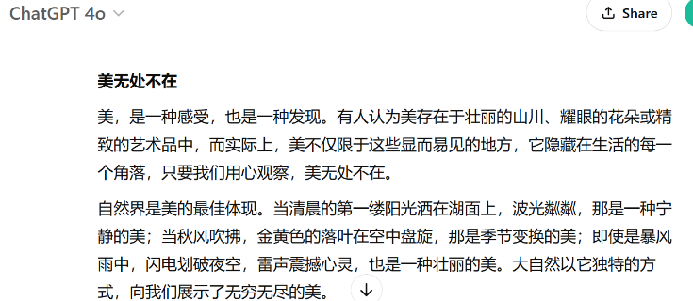
Figure 1 Screenshot 1
“This is too poetic. More than half of the words are new to me. I cannot understand it, let alone use it. So I refined my prompt”.
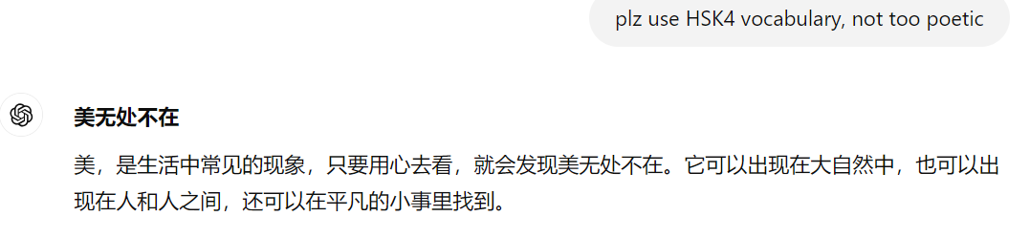
Figure 2 Screenshot 2
“This is much better. It tells me to find beauty in nature, in people and in everyday life. From here, I can develop my essay based on my own understanding and examples”.
To navigate this challenge, students must refine their prompts or ask follow-up questions to obtain more relevant information. Selecting the most appropriate vocabulary is also crucial in ensuring their writing aligns with their own language proficiency. ChatGPT can assist by restructuring texts to enhance readability and coherence, but students must actively shape the responses to suit their needs.
Another limitation students noted was that ChatGPT-generated responses were often too generic and formulaic. For example, a student found that ChatGPT followed English writing conventions that did not align with Chinese text formatting. Additionally, the adjectives it suggested for The Person I Respect Most were overly broad, failing to capture the depth of the student’s intended expression: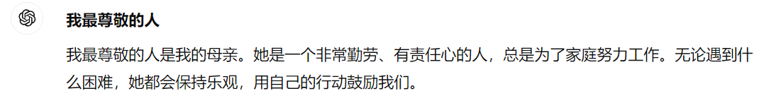
Figure 3 Screenshot 3
“First, in Chinese, there should be a space for two characters at the beginning of each paragraph, but ChatGPT does not leave spaces. Secondly, the adjectives used to describe Mom are ‘hardworking勤劳’, ‘responsible有责任心’, ‘optimistic乐观’, ‘encouraging鼓励’, are too generic. They could apply to anyone, so I have to add specific examples to illustrate my points”.
To address this, students need to provide more precise instructions and integrate their own examples to support their arguments. As one student explained:
“ChatGPT gave me a long list including natural beauty, inner beauty, and physical beauty. However, all were too mechanical, and I couldn’t relate them to my everyday life. I used my own knowledge and experiences to focus on inner beauty, allowing for a more nuanced and personal approach in my essay.” (S7)
Moreover, ChatGPT sometimes generates superficial responses that lack supporting evidence, which can discourage students from deeper exploration. As one student pointed out: "ChatGPT tells me to find beauty everywhere, but its responses are just abstract ideas. Nothing is concrete or tied to real-life experiences. It doesn’t provide moving or touching stories like the ones in my textbook." (S4)
Lack of personal touch and cultural nuances:
Students also noted that ChatGPT lacks the cultural sensitivity and nuances necessary for effective language learning. Its responses often feel formulaic or robotic, missing the depth of cultural expressions.
For instance, a student wanted to compare Eastern and Western philosophy by generating a dialogue between two great philosophers. When ChatGPT created an image for this scenario, Aristotle was depicted wearing sandals—a detail the student found inappropriate for a formal discussion with Confucius. The student attempted to correct this by asking: “Could you put shoes on Aristotle?”, However, ChatGPT then generated an image where both philosophers were wearing sandals. Frustrated, the student clarified: “Could you put shoes on both of them?”. This time, Confucius had shoes, but they were women’s shoes. (Figure 4) (Figure 5) (Figure 6)
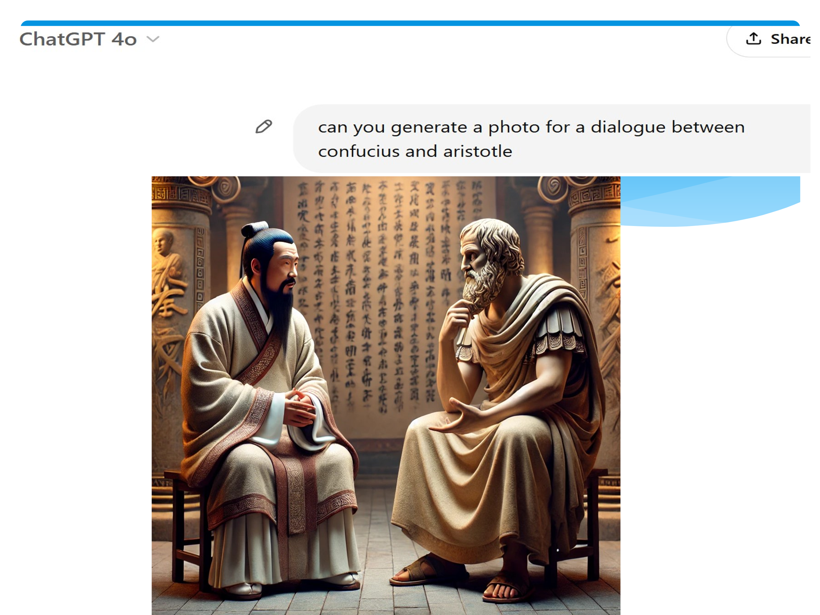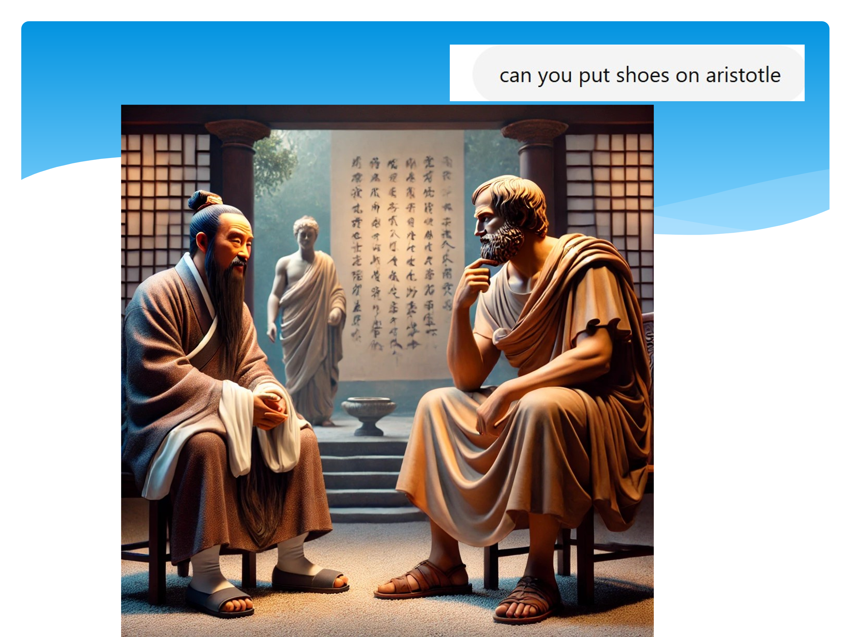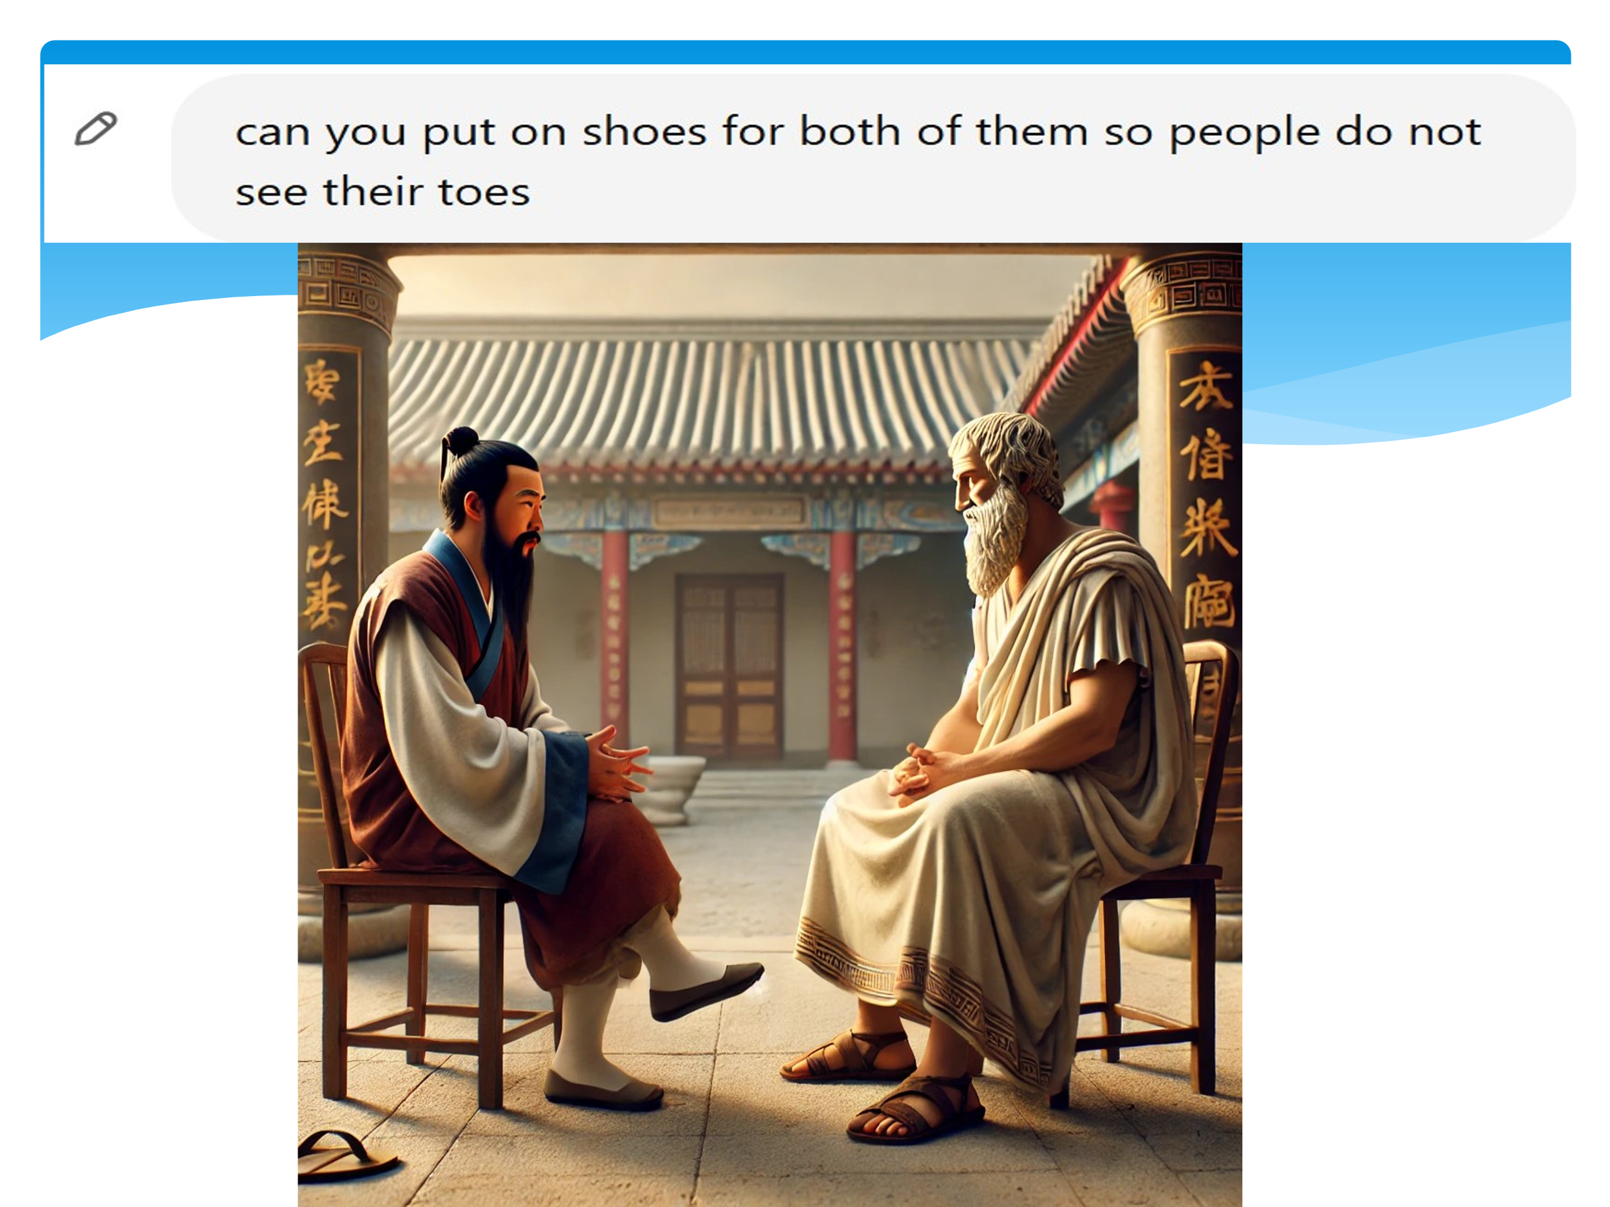
(Figure 4) (Figure 5) (Figure 6)
This example illustrates that AI tools, while useful, lack the cultural awareness that human beings naturally possess. Students must remain mindful of these limitations and apply their own cultural understanding to refine AI-generated content.
Another challenge students faced was the occasional inaccuracy in ChatGPT's responses. These inaccuracies, particularly in language usage and citations, can be misleading. For instance, when one student asked ChatGPT about where to find beauty, the response included: “… a good sentence in a book, a sunset on your way home … are the beauty of (小确幸-- a little joy in life)”.
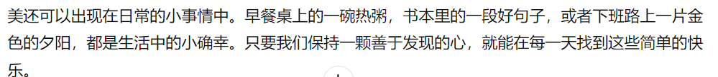
Figure 7 Screenshot 7
“小确幸 is not a standard expression in Mandarin Chinese. If I used it blindly, it would be misleading. I need to distinguish between 小确幸 (a small happiness) and 小庆幸 (a small sense f relief), to use the correct term” (S3).
“ChatGPT helped me find several quotes to support my arguments. However, some were slightly inaccurate or paraphrased, so I had to verify them before including them in my essay” (S8).
These examples emphasize the importance of critical thinking and cross-referencing AI-generated content with reliable sources. While ChatGPT can assist in research and writing, it cannot replace thorough fact-checking and independent analysis. Despite its many advantages, ChatGPT has several limitations that students must navigate. Information overload, overly general and mechanical responses, lack of cultural nuance, and occasional inaccuracies can all impact its effectiveness as a learning tool. To maximize its potential, students need to actively refine their prompts, supplement AI-generated content with personal insights, and critically evaluate the accuracy of its outputs. Ultimately, ChatGPT serves as a useful tool, but human judgment and cultural awareness remain essential for effective learning and communication.
Finding 3 Student perceptions of using or not using ChatGPT:
Students from both EG and CG have positive attitudes towards using ChatGPT. While students in EG believe it can be used for both practice and assessment, students in CG prefer to use it for practice only. Students in both groups come to an agreement that the process of working with ChatGPT is like having a conversation that opens new perspectives, making it a collaborative partner in the creative process of developing and refining ideas.
Students find the practical advantages of ChatGPT not only improved their efficiency of writing essays but also promoted positive feelings about writing. For example,
“Using AI tools to assist me in writing my essay has been an enriching experience. It helped me structure my ideas and organise my thoughts, ensuring clarity and coherence throughout the writing process” (S1).
“ChatGPT provides me with additional perspectives to consider when writing and gives me insights into what points I need to strengthen. With more angles around the topic, I can choose which to use to expand and add my own experience to illustrate the point. AI did help in the process, making writing more efficient and allowed me to write more skilfully. However, AI did have its limitations, and it certainly did not replace the skills necessary to create effective communication. I very much enjoyed using AI and will continue to use it selectively in my studies” (S10).
ChatGPT can be a valuable tool for essay writing. The partnership with ChatGPT can be enriching, as it often offers perspectives that students have never thought of or considered. Even though some responses given by ChatGPT may not be relevant or not accurate, students must be able to distinguish between what is factual and what is not, and the final touch must be the students not the machine.
When asked about their views on the impact of ChatGPT to assist their writing, students spoke in terms of speed, brainstorming and corrections.
“When I asked it help me generate ideas, ChatGPT immediately tells me to write it from three perspectives, as if a lecturer is available next to you who knows all the answers” (S2)
“It is actually better than a native speaker language partner in terms of the amount of information it provided” (S3)
Most students seemed to be happy about how the information that ChatGPT provided that focused information on the given topic.
“When you ask for information, you can get it, or more than what you need. This saved my searching time to get ideas and information”. (S1)
“I did not use it before, and this was my first time. I think it is a useful tool. When I write, I usually have no idea where to start. With ChatGPT, I can immediately have several points to start with. I enjoy using it”. (S4)
In their comments on the impact of ChatGPT for feedback, they claimed that ChatGPT made it easier to stay focused on the topic when writing.
“After I put down my draft and gave it instructions of modifying my draft to make it more concise, it showed me an updated version with absolutely correct grammar with coherence in content”. (S2)
Students also mentioned that through feedback, they could add their own examples related to the main idea, use proper signposts, and write strong conclusions. More collaboration between the students and ChatGPT was also highlighted.
“When I asked GPT to give me some guidance to write about beauty, the response was surprisingly good, too good for me to use, because I do not understand the meaning though most of the words look familiar to me”. (S2)
“What is more, ChatGPT provided me with idioms. I checked the meaning of the idioms and made sure that it is correct to use in my context. I used some and felt they enhanced the quality of my essay” (S3)
When talking about the impact of ChatGPT on grammar, students highlighted ChatGPT as a reliable source of grammar, a tool for improving accuracy in sentence structure and obtaining explanations for language errors.
“I’ve been using Grammarly, so after ChatGPT provided me with some new information, I still use Grammarly to make sure that I understand the meaning of what ChatGPT has provided before I use it in my essay. (S3)
“I think instructions on how to design prompts will be useful. It can help use directly ask the questions and get the answers that we need. It can save a lot of time and to avoid drifting away”.
It is revealed from reflective journals and interviews that the reasons for the students in the CG who did not use ChatGPT or used it a little bit are mainly to avoid plagiarism or not want to be controlled by it or not want to limit their own thoughts.
“I wrote my essay plan without the help of ChatGPT as I believed it would have limited me or influenced me to write without thinking independently. I tried to limit my use of AI as I did not want to run a risk of plagiarism” (S5).
“ChatGPT does not understand my commands, for example, I asked it to reduce my work to within the word count and instead it made too many modifications to my writing, so I did this independently” (S6).
Finding 4 Students’ suggestions
Integrate ChatGPT into curriculum
Taking both benefits and limitations of using ChatGPT into consideration, students recommend introducing ChatGPT into language learning. Universities can provide trainings for students to familiarize themselves with the updated technology and thus enhance students' competence in incorporating ChatGPT into their learning practice.
“I would recommend all language students utilize AI for assistance in generating ideas and checking linguistic aspects, because it helps to improve the richness of essays and learn more new words and idiomatic expressions” (S3).
“Since it is such a powerful tool, why not to make it part of our course. If lecturers tell us the percentage, e.g., no more than 30% produced by ChatGPT, we can figure out where to use ChatGPT and where not to prevent us from its overuse” (S4).
It could be beneficial for students to use it but be cautious not to let it overtake students’ own voice and ideas.
“Some of the lecturers do not encourage us to use ChatGPT, and I heard some universities even ban it to avoid plagiarism. I do not think it is necessary. Students are learners. We want to learn. We know what to do and what not to do. It is a tool after all (S7)”.
“Part of the assignments can be using ChatGPT, with clear instructions of what can be done with it and what not. It is the fourth revolution which will come to our everyday life, anyway, can’t avoid it” (S8).
Addressing students’ needs and supporting resources by providing digital skills and digital literacy training, language tutors can effectively harness the potential of ChatGPT to enhance language teaching practices.
Using it selectively and critically
Students suggest welcoming ChatGPT but using it critically, giving several prompts step by step in more and more detail, “Engaging with the tool and use your own knowledge and skills to refine what it produces” “The dialogue between me and ChatGPT enhances the coherence of my essay, and over time, teaches me how to write”.
From their own writing experience, students gave detailed suggestions of “jotting down your own ideas first, give them to ChatGPT, it will refine your work in a structured way.” “The key lies in providing precise instructions. The clearer your instructions are, the better results you will get”. “You can phrase like please rephrase it with the following words, please rephrase it for clarity, coherence and conciseness, ensuring each paragraph is coherently connected with next paragraph”. “The first response might not be exactly what you want, but since it is the dialogue between you and ChatGPT, you need to be cooperative. You need to refine your instructions by adding more information, just like you are having a conversation with a friend. It is the interaction that improves the results. The interactive approach can transform a challenging task into a manageable one”.
Students also recommend that “Start your conversation with ChatGPT by giving some background information and tell what language level you need and instruct it with what need”.
For AI tools to be beneficial in supporting language learning, the user must ensure that their understanding of any grammar and vocabulary used by AI is supported by further study to guarantee that the meaning is not compromised, and learning is not hindered, as a students suggested “Starting by creating a plan that outline your main points and the structure of the essay. This will help keep your content focused and logical” (S9). Another student also suggested “Starting by having a plan for the overall content, then write a first draft based on your ideas. After completing this draft, you can begin using AI to enhance the content” (S10).
It is important to approach AI as a tool for improvement, not a replacement. Essays generated entirely by AI tend to feel impersonal and generic, lacking the depth and originality that come from personal thought and creativity. Moreover, relying too heavily on AI can hinder students’ learning process. Writing is a skill that develops through practice, and using AI without engaging students’ own ideas may prevent growth in this area.
While AI can be convenient, it is not always entirely reliable. The suggestions it provides may not always be accurate or appropriate for the context of students’ essays. Therefore, students suggest that “AI should be used critically – take suggestions as guidance but always evaluate their relevance and quality” (S11). “First develop your own ideas and draft, and then leveraging AI to polish your work, you can produce essays that are both well-written and uniquely yours” (S12).
To maximise the benefits of using AI, students suggest going through the ideas generated by AI and then adapt the ideas to fit the topic at hand. Moreover, when some concepts were proven to be too broad, students could choose the ideas they are familiar with and with the experience or examples to support the ideas. Then select the necessary vocabulary and grammar structures that students have learned to use them properly. Finally, using AI tools to initiate an array of ideas allows students to gain momentum when beginning to write their essays. The initial ideas generated could provide students with a starting point in which they could work out which vocabulary and grammar structures would be suited best to complete their essays.
Discussion
The study investigated the intervention-based empirical study on the impact of ChatGPT on students’ academic writing. Conducted as a mixed methods intervention study, the study’s findings were on expected lines. The significant positive impact coupled with students’ positive perception of the same can add a fresh perspective to the literature on the use of generative AI. They strengthen and further theories of ChatGPT as a useful tool that can be harmoniously integrated into students’ writing. This mixed methods intervention study assessed the impact of ChatGPT as an assistant in essay writing, which comprised the first research question. In addition, it also captured students’ views on the impact of ChatGPT on their writing skills, which was the focus of the second research question.
Regarding the first research question “What are the benefits and limitations for students to co-write with ChatGPT in their essay writing?
It is interesting to find that AI is used in a variety of different ways by students. Some used for generating ideas, some used for vocabulary and idioms, and some used for polishing the whole essay.
The findings on how ChatGPT aids idea generation align with Gayed et al.’s (2022), Guo et al.’s (2022) and Marzuki et al.’s (2023) research results, and this study confirms assertions in the education literature that ChatGPT does help in generating ideas. Furthermore, ChatGPT can be used for brainstorming (Lingard, 2023) in that when appropriately presented with a central topic or query, ChatGPT can, in a rapid manner, suggest viewpoints from different angles which are particularly helpful in the brainstorming process. ChatGPT is also able to simplify and clarify intricate concepts by providing clear and concise explanations, potentially supporting nonnative English speakers in connecting fragmented ideas to form an initial framework for their academic writing. Ti and Nikolov’s (2022) study report negative perceptions related to organization, with which the current study disagrees. The reasons for this kind of perception may have to do with students’ ability to ask appropriate questions. Su et al. (2023) both review ChatGPT’s benefits and challenges for writing, pointing out that ChatGPT can offer a wide range of context-specific writing assistance such as idea generation, outlining, content improvement, organization, editing, proofreading, and post-writing refection.
Apart from generating ideas, this study also reveals ChatGPT provides useful information they need, which saves students’ time and efforts. It also helps students understand a topic better because it can explain things in an easy-to understand way. ChatGPT can provide relevant information that goes beyond time, place, and cultural differences. In a way, ChatGPT strengthens the role of a teacher as a facilitator because many time-consuming tasks such as finding relevant information can be easily performed by ChatGPT. ChatGPT can offer immediate access to a vast amount of information presented in a personalized manner, but it also raises questions about the potential influence of these interactions on students’ ability to critically evaluate such information (Kasneci et al., 2023).
In addition, ChatGPT helps expanding idiomatic expressions. Wang and Guo (2023) discuss ChatGPT supporting students with learning grammar and vocabulary, and this study confirms this assertion. AI helped L2 learners write with fewer grammatical errors and more lexical diversity. This is consistent with Yan’s (2023) research that AI tools usually suggest appropriate transitional words or phrases to connect ideas, making sure there is coherence between sentences and paragraphs in the text. They also suggest sentence rewriting if there is anything unclear that can lead to multiple Interpretations, ensuring an academic text is grammatically correct, coherent, and appropriately styled can be a challenging task. Advanced AI chatbots, including ChatGPT, can be useful tools employed by non-native English speakers to help refine their academic writing.
The application of ChatGPT has successfully attracted students' attention leading to more practice. One reason might be that students need to revise prompts a couple of times before they get a response that they need. In this way, students were actively engaged in trying different prompts to get an ideal answer, including in generating ideas and structures. Students reported that it accelerates writing process, building up their confidence and promoting positive feelings about writing.
Regarding critical thinking skills, this research echoes Guo and Lee’s (2023) study results. They asked university students to develop critical thinking skills by discussing and writing an essay with ChatGPT and their results revealed the significant effectiveness of ChatGPT-based learning for enhancing perceived critical thinking skills. These findings also showed the effectiveness of ChatGPT for developing critical thinking and explicit reasoning skills in English argumentative writings, echoing Deng and Yu’s (2023) observations of chatbot-based learning.
The growth of knowledge and active engagement in AI provides fertile ground for the cross-application of critical skills. Analytical, synthetic, and problem-solving skills acquired can be applied in various situations. Knowledge, and engagement in AI, although specific, act as catalysts for the development of broader cognitive and critical skills. AI, treated as a field of study and application, provides a platform to refine the ability to think critically, thereby contributing to a more reflective and analytical approach in problem-solving and information evaluation overall.
All the above advantages unveiled ChatGPT’s robust support for active learning, as it not only enabled high autonomy in applying learning strategies but also effectively guided students in utilising their autonomy effectively. Hence, researchers and practitioners may use ChatGPT to support active learning.
limitations
Another overwhelming opinion that emerged from the study is that ChatGPT improves grammatical accuracy, which is in line with the claims by Ohio University (2023) and Wang and Guo (2023). Tough it is an expected finding that strengthens results reported in Grammarly studies (Fitriana & Nurazani, 2022), the highlight here is the attention paid by students to the explicit metalinguistic feedback (Kohnke et al., 2023). According to Su et al., (2023), this AI tool is a useful proofreading aid that can detect grammatical inaccuracies, elaborate and clarify the meaning of sentences, enhance conciseness and lexical choice, and improve tone.
1 Overloaded information: Rudolph et al. (2023) pointed it out that irrespective of students’ ability to use language accurately to ask questions, ChatGPT can provide information. This study finds that to ask the right questions makes a difference.
2 As for the claims of ChatGPT as mechanical, context may play a role. Students know what the essay is about and thus the emphasis of writing should be on human agency and human decision-making in the writing process. Even though ChatGPT can generate a large amount of information, it is the human insight, human knowledge, and human voice to the writing that counts. In an essay generated by ChatGPT, the language is very technical and does not seem to flow smoothly. In addition, the ideas are presented in a very concise, bullet-point style, which is often seen in computer-generated texts.
ChatGPT, still requires extensive oversight and prompting to ensure the posts are focused, effective, and responsibly representative of the organization. Also vocabulary and idioms often carry cultural connotations that are challenging for language learners to grasp. Perhaps AI tools need to use supplementary materials, such as video clips or cultural anecdotes, to help learners understand the origins and proper usage of these expressions. This contextual enrichment fosters a deeper appreciation for the language (Martínez & Pérez, 2021).
3 For writing instructors, it’s especially important to affirm each writer’s voice, expertise and experience, to help students feel, see, and know that what they have to say is, ultimately, more meaningful than what generative AI has to say and to help students consider ways to work with AI in the writing process while not surrendering their agency and their unique perspectives (Bedington, 2024).
The more students use AI, the less they interact with human, which could be disadvantage for students’ growth. Students used to interact with peers, language partners, and lecturers, but now they play with AI more. But if students play with AI on the topic of their essay, and then chat with peers and friends, they learn more about the topic of their essay. As a student reflected, “Two of my flatmates are Chinese, and we often chat in the kitchen when cooking or in the common room when having a coffee. After I know how to have a dialogue with ChatGPT, I keep asking and revising my questions more. When I realize I spend more time with my laptop than with my friends, I share with them the interesting things I have got from ChatGPT, and that is more fun” (S13).
ChatGPT-generated texts may lack emotional depth and a distinct writing voice, crucial aspects of human writing quality. This vulnerability of ChatGPT can serve as an indicator for teachers to distinguish between AI-generated and human-produced texts, offering an opportunity for writing teachers to assist learners in expressing their true selves and harnessing their rhetorical power (Barrot, 2024). ChatGPT lacks a distinct writing voice as it fails to incorporate personal experiences. It also lacks rhetorical flexibility because it tends to follow a rigid template in organizing ideas (Barrot, 2023).
Language learning is a social activity that allows learners to interact with a diverse group of people, exposing them to authentic language usage and cultural insights. Overreliance on ChatGPT for language learning may lead to social isolation in the learning process. Learners who exclusively interact with the AI may miss out on the rich and dynamic learning experiences that come from engaging with other people. This isolation can result in learners’ lack of fluency in navigating the unpredictability and spontaneity of human interactions (Barrot, 2023).
I think a good essay involves personal experience, which AI is not able to provide without fully copying the work. I included my experience of my dog, family, and school which enabled me to develop the text and create better content. I do feel that a good essay comes from the heart and including personal style is very important to writing. (S7).
OpenAI acknowledges the tendency for tools to respond with answers that sound reasonable but are wrong, including explaining a topic inaccurately, a problem that has been deemed difficult to fix. AI can produce models of language not experiential knowledge. They are not designed to be scholarly – to check academic references and ensure that evidence is grounded in fact. In human terms, they are essentially inexperienced, unthinking and amoral. They have no ability to reflect on what they have written, to judge whether it is accurate and decent (Sharples, 2022).
The finding of inaccuracy appears to contradict AlAfnan et al.’s (2023) study which claimed that ChatGPT could provide accurate and reliable instructional contents, and support their application of the target knowledge in communication and writing. In this study, students report that ChatGPT responses may not always be accurate or reliable, particularly for the subtle meanings of vocabulary. Furthermore, ChatGPT may generate incorrect or even fabricated information, and such issue can be problematic for students who rely on ChatGPT to inform their learning. The possible explanation for this discrepancy could be the context. AlAfnan et al.’s (2023) study is on understanding, analysing, and crafting, while this study is on language learning. Future researchers may delve into the exact effectiveness of Understanding, Analysing, and Crafting in enhancing ChatGPT-based logic learning outcomes by encouraging learners to apply these strategies with higher frequency. This way, researchers can gain a more comprehensive understanding of the effectiveness of all the five logic learning strategies in the ChatGPT-based setting. A possible solution to the issue of inaccuracy could be to double check with another AI tool, as a students suggested, “I used Pleco along with ChatGPT, as it allowed me to make the writing more personal, as well as consolidate knowledge of new vocabulary and grammar points” (S8).
As for the second research question “How do students perceive the AI-assisted learning experience and what improvements do they suggest?”
This study demonstrates that most students have an overall positive attitude towards using ChatGPT. This finding is consistent with the literature on students’ views on the impact of ChatGPT and other AI-driven tools on their writing (Marzuki et al., 2023; Yan, 2023). The overall positive attitude can be explained by the enthusiasm for using ChatGPT in the writing process.
The essay scores triangulated the reflection, showing students’ relatively less application of ChatGPT. This finding suggests ChatGPT’s current limitations in providing the right information both in terms of relevance and quantity. Considering the importance of using the right materials to support students’ arguments in essays, the limitations of ChatGPT at current stage deserved particular attention. Language instructors and students should be mindful of these limitations when implementing ChatGPT-based language learning, and this is in line with Zhang, Zou and Cheng (2023) in application to their teaching strategies.
Positive impact on writing skills
Although the students expressed different needs and utilization of ChatGPT, they all conveyed that they all have enjoyed using it for their writing.
Though the CG and the EG students demonstrated improved writing skills, the EG’s performance was significantly better than their CG peers across post-test. The findings are consistent with those reported by researchers who focused on the impact of AI-driven tools on students’ writing skills (Marzuki et al., 2023; Zhao, 2022). Many existing studies utilized these tools for formative purposes and found similar results (Rudolph et al., 2023). Thus, the employment of generative AI only strengthens those claims.
The positive impact was evident in students’ achievements in terms of generation of focused ideas, better connection among ideas and sentences, and improved grammatical accuracy, which were also claimed by previous researchers (Allagui, 2023; Kohnke et al., 2023; Su et al., 2023; Wang & Guo, 2023). The post-test results in this study add to the generalizability of the positive impact claims (Rose et al., 2020). In fact, the literature on post-test highlights the sustainability of the impact and retention of writing skills (Rezai et al., 2022).
The continued positive impact could be a result of various factors. First, explanation of how to use ChatGPT was given to the students before they actually used it, as advised by researchers who undertook similar interventions (Mathur & Mahapatra, 2022). Second, students were engaged in ChatGPT, which have been proven effective strategies in writing (Mathur & Mahapatra, 2022). Third, the metalinguistic explanations as part of the corrective feedback could have made a difference, as claimed by many previous researchers (Kohnke et al., 2023). Fourth, the instant and personalized nature of the obtained feedback could have strongly impacted the continued positive impact (Gayed et al., 2022). Fifth, self-correction was made easy (Dai et al., 2023).
2 Using it selectively and critically
Students long for training of how to effectively use ChatGPT, because the effectiveness of logic learning strategies was related to the depth and complexity of ChatGPT-created learning materials. According to the interviewees, in-depth understanding and real-world application of knowledge of logic required exercising based on appropriate questions.
Instructors can provide students with opportunities to work with ChatGPT in the form of guided experiences (e.g., writing assignments for credits or in the form of self-explorations, or both). Students can work out what is useful and what is not during their writing process. With structured guidance and specific requirements for assignments, and through students’ reflective accounts, students would develop their own literacies on AI-assisted essay writing. As a student commented that “I can use it in ways that help my writing but that do not do the writing for me. Use ChatGPT to generate ideas at the start of my writing and to make sure everything is coherent at the end of a project”.
Students’ suggestions shed light on ChatGPT as a useful educational tool that can provide knowledge and scaffoldings as a teaching assistant and as a personal tutor, and interact with students as a learning partner (Deng & Yu, 2023). This finding evidenced the expectations of previous synthesis studies on ChatGPT (e.g., Baidoo-Anu & Ansah, 2023) about its strong affordance of creating and presenting varying instructions based on learners’ individual needs.
Students themselves can think carefully and critically about when to use it and when not and think about whose voices and perspectives are silenced in the process. In the writing process, students can think about what they want to say and why they use certain words. By doing so, students gain a deep appreciation for why to choose certain words and phrases in their essay writing. Students were actively involved in editing and in decision-making of what was appropriate, and this would be a useful tool to use if students ever found themselves stuck for ideas in the writing process.
The study illustrates the potential of ChatGPT as a pedagogic tool for writing. It can be integrated into the regular teaching of academic writing skills in institutions of higher education. A major factor that needs mentioning is the teacher’s attitude towards ChatGPT and their ability to use it in a constructive manner in a large size classroom. The latter one includes self-and student training. It is true that many webinars and workshops on the use of ChatGPT are being conducted for teachers working in Global South countries like India. However, without proper reflective planning and an analysis of the need for shunning traditional feedback strategies, the use of ChatGPT may not be as impactful. Tus, teacher education programs need to orient teachers towards utilizing ChatGPT in their writing classrooms.
The current empirical study contributes to several areas of research on essay writing. First, it demonstrates the usefulness of utilizing ChatGPT for essay writing. Second, the mixed methods intervention design employed for the study is useful, particularly reflection worked well in the research.
By critically selecting and using the materials provided by ChatGPT, students can acquire new knowledge and better skills. In the rapidly evolving educational landscape where technology has become deeply integrated, students constantly try and find better or more efficient ways for better learning outcomes. AI tools can open students’ eyes for more angles, more perspectives and decide what to use to make their arguments more convincing and their essays more coherent.
The findings are mainly based on the tests and students’ perceptions. There are several limitations in this study. Firstly, the participants in this study are advanced language proficiencies. Future research can investigate the impact of ChatGPT to different populations, including lower level of language proficiency. Second, the study mainly used ChatGPT as an intervention, more investigation is required to compare more intervention means to discover which has stronger effects.
The integration of ChatGPT presents an opportunity for students to harness the transformative power of this technological revolution, emphasizing the importance of fostering students’ critical AI literacy to promote their authorial voice and learning in AI-human collaboration.
The findings of the research shed light on the possibilities that ChatGPT offers in the context of language education, including generating ideas, structuring essays, immediate feedback, and opportunities for professional development for language tutors. The study highlights a few of the challenges, including unacceptable cultural concepts, and cultural appropriateness. In addition, the study discusses the implications for training, curriculum design, and pedagogical practices that are necessary to successfully implement ChatGPT in language education. In the end, the purpose of this research is to contribute to a better understanding of the potential benefits and challenges associated with the implementation of AI-based conversational agents such as ChatGPT in language learning. The findings are intended to provide information to educational stakeholders regarding the possibilities and limitations of incorporating such technologies into language teaching practices, thereby facilitating the making of informed decisions and promoting the effective integration of technology in language learning contexts.
Sue, Lin, and Lai (2023) made it explicit, “Instead of banning students from using chatbots as writing assistants, training on the effective and ethical use of ChatGPT is essential, where teachers and learners need to be guided on asking effective questions, on ways of using ChatGPT as a thinking aid and reference for personal development (p10).
Conclusion
The findings of the study demonstrate that interactions facilitated by ChatGPT during the process of writing has a direct positive impact on student learning. It positively influences how students seek relevant information, how they revise their prompts, how they further explore with other AI tools, and how they make improvements in their academic writing. It enables students to broaden their vision on specific tasks, develops their critical judgements, and facilitates their integrating skills, combining their imagination and the available resources.
Methodologically, using students’ reflective accounts is a highlight of the research design for this study for conducting educational experiments, as students can give detailed description of their thoughts during the writing process. This method can be a significant addition to the application of ChatGPT in academic writing literature. Tough it is still an experiment, it has empirically investigated the impact of ChatGPT on students’ academic writing skills.
According to the findings of the study, the implementation of ChatGPT in educational settings demonstrates significant potential benefits for both students and teachers. These benefits include the creation of assessments, the enhancement of pedagogical practices, the generation of academic outlines, and the generation of themes for texts. On the other hand, certain restrictions, including risks to academic integrity, biased evaluations, factual inaccuracies, and an overreliance on AI, need to be appropriately addressed.
This study recommends that more language instructors embrace the use of AI tools such as ChatGPT into assignments and projects, because students can focus more time on the creative aspects of projects while also being able to spot the shortcomings of these tools in the writing process. The experience with AI technology will be extremely helpful in students career as they have learned the ethics and limitations of it. AI will continue to evolve so quickly—we need to commit ourselves to exploring and critically
Now that students have explored the advantages and disadvantages of using AI, they can develop a critical, reflective engagement with AI that considers the affordances and limitations of the systems. AI can help brainstorm and generate ideas, organize information, draft the structure of the essay, and edit it with correct grammar patterns, and provide idiomatic use of vocabulary. Students can be encouraged to further the exploration and usage of AI in contextual and nuanced ways so that each person can find ways in which AI can help them.
Language instructors and students can put efforts together to explore and research how AI can be better used in teaching and learning of language in general and in essay writing in particular. We need to explore and practice more with student-AI co-writing, which is helpful for language instructors to develop pedagogy and for students to develop AI skills which will be useful for their future careers. Language instructors could integrate experience and expertise with AI skills as much as possible. Further research can explore how to use AI proficiently and insightfully, particularly with what kind of prompts that can integrate human insights, experience and expertise.
Recognizing its subtle functions and how students use it will be vital for creating supportive, inclusive, and effective learning environments. The study also provides educators, policymakers, and academics with a comprehensive understanding of ChatGPT's role in supporting students, allowing them to make more educated decisions about AI integration in higher education.
References
Alharbi, W. (2023). AI in the foreign language classroom: A pedagogical overview of automated writing assistance tools. Education Research International. https://doi.org/ 10.1155/2023/4253331, 2023.
Almusharraf, N., & Alotaibi, H. (2023). An error-analysis study from an EFL writing context: Human and automated essay scoring approaches. Technology, Knowledge and Learning, 28(3), 1015–1031. https:// doi.org/10.1007/s10758-022-09592-z.
Baskara, R., Mukarto, M. (2023). Exploring the Implications of ChatGPT for Language Learning in Higher Education. Indonesian Journal of English Language Teaching and Applied Linguistics, 7(2), 343358.
Baidoo-Anu, D., & Ansah, L. O. (2023). Education in the era of generative artificial intelligence (AI): Understanding the potential benefits of ChatGPT in promoting teaching and learning. Journal of AI, 7(1), 52–62. https://dergipark.org.tr/en/pub/jai/issue/77844/1337500.
Barrot, J. S. (2023). ChatGPT as a Language Learning Tool: An Emerging Technology Report, Technology, Knowledge and Learning, https://doi.org/10.1007/s10758-023-09711-4.
Barrot, J. S. (2023). Using ChatGPT for second language writing: Pitfalls and potentials. Assessing Writing, 57, 100745. https://doi.org/10.1016/j.asw.2023.100745
Bonner, E., Lege, R., & Frazier, E. (2023). Large language model-based artifcial intelligence in the language classroom: Practical ideas for teaching. Teaching English with Technology, 23(1), 23–41. https://doi.org/10.56297/BKAM1691/ WIEO1749.
Bedington, A., Halcomb, E. F., McKee, H. A., Sargent, T., & Smith, A. (2024). Writing with generative AI and human-machine teaming: Insights and recommendations from faculty and students. Computers and Composition, 71, 102833. https://doi.org/10.1016/j.compcom.2024.102833
Deng, X., & Yu, Z. (2023). A meta-analysis and systematic review of the effect of chatbot technology use in sustainable education. Sustainability, 15(4), 2940. https:// doi.org/10.3390/su15042940.
Kasneci, E., Sessler, K., Bannert, K. S., Dementieva, M. D., and Kasneci, G. (2023). ChatGPT for good? On opportunities and challenges of large language models for education. Learning and Individual Differences, 103, 102274.
Fitria, T. N. (2023). Augmented Reality (AR) and Virtual Reality (VR) Technology in Education: Media of Teaching and Learning: A Review. International Journal of Computer and Information System (IJCIS), 4(1), 14–25. https://doi.org/10.29040/ijcis.v4i1.102
George, A. S., & George, A. H. (2023). A Review of ChatGPT AI’s Impact on Several Business Sectors. Partners Universal International Innovation Journal, 1(1), 9–23.
Guo, Y., & Lee, D. (2023). Leveraging ChatGPT for enhancing critical thinking skills. Journal of Chemical Education, 12, 4876–4883. https://doi.org/10.1021/acs. jchemed.3c00505.
Guo, K., Wang, J., & Chu, S. K. W. (2022). Using chatbots to scaffold EFL students’ argumentative writing. Assessing Writing, 54, 100666. https://doi.org/10.1016/j.asw.2022.100666.
Halaweh, M. (2023). ChatGPT in education: Strategies for responsible implementation. Contemporary Educational Technology, 15(2), p421. https://doi.org/10.30935/cedtech/1303
Han, J., Yoo, H., Kim, Y., Myung, J., Kim, M., Lim, H., Kim, J., Lee, T., Hong, H., Ahn, S., & Oh, A. (2023). RECIPE: How to Integrate ChatGPT into EFL writing education. arXiv:2305.11583. https://doi.org/10.48550/arXiv.2305.11583.
Hsiao, J. C., & Chang, J. S. (2023). Enhancing EFL reading and writing through AI-powered tools: Design, implementation, and evaluation of an online course. Interactive Learning Environments, 1–16. https://doi.org/10.1080/10494820.2023.2207187.
Huang, W., Hew, K., & Fryer, L. (2022). Chatbots for language learning—Are they really useful? A systematic review of chatbot-supported language learning. Journal of Computer Assisted Learning, 38(1), 237–257.
Imran, M., & Almusharraf, N. (2023). Analysing the role of ChatGPT as a writing assistant at higher education level: A systematic review of the literature. Contemporary Educational Technology, 15(4), ep464. https://doi.org/10.30935/ cedtech/13605 .
Kasneci, E., Seßler, K., Küchemann, S., Bannert, M., Dementieva, D., Fischer, F., … Kasneci, G. (2023). ChatGPT for good? On opportunities and challenges of large language models for education. Learning and Individual Differences, 103, Article 102274. https://doi.org/10.1016/j.lindif.2023.102274
Kohnke, L., Moorhouse, B. L., & Zou, D. (2023). ChatGPT for language learning and teaching. RELC Journal. https://doi.org/ 10.1177/003368822311628.
Kuhail, M. A., Alturki, N., Alramlawi, S., & Alhejori, K. (2023). Interacting with educational chatbots: A systematic review. Education and Information Technologies, 28 (1), 973–1018. https://doi.org/10.1007/s10639-022-11177-3.
Lee, D., Kim, H.-H. & Sung, S.-H. (2023). Development research on an AI English learning support system to facilitate learner-generated-context-based learning. Educational Technology Research and Development, 71, 629–666. https://doi.org/10.1007/s11423-022-10172-2.
Lingard, L. (2023). Writing with ChatGPT: An illustration of its capacity, limitations & implications for academic writers. Perspectives on Medical Education, 12(1), 261–270. https://doi.org/10.5334/pme.1072
Lo, S. (2023). Neural machine translation in EFL classrooms: Learners’ vocabulary improvement, immediate vocabulary retention and delayed vocabulary retention. Computer Assisted Language Learning, https://doi.org/10.1080/09588221.2023.2207603.
Martínez, R., & García, P. (2021). The role of culture in teaching English idioms. Journal of Applied Linguistics, 29/1, 22–39.
McDonagh, L., and Sanders, E. C. (2024). ‘You almost feel like you’ve got a friend, somebody who’s backing you up’: exploring the building blocks of trust within a relational pedagogy approach to academic development. International Journal for Academic Development, 1-13. http://orcid.org/0009-0008-6494-4795.
Mills, N., Hok, H., Dressen, A., and Veillas, Q. (2024). The design and evaluation of an interactiveAI companion for foreign language writing. ACTFL, 1-30. DOI: 10.1111/flan.12790.
Mollick, E.R., & Mollick, L. (2023). Assigning AI: Seven approaches for students with prompts. The WhartonSchool Research Paper. https://papers.ssrn.com/sol3/papers.cfm?abstract_id=4475995
Ohio University. (2023). ChatGPT and teaching and learning. https://www.ohio.edu/center-teaching-learning/resources/chatgpt.
Shaikh, S., Yayilgan, S. Y., Klimova, B., & Pikhart, M. (2023). Assessing the usability of ChatGPT for formal English language learning. European Journal of Investigation in Health Psychology and Education, 13(9), 1937–1960. https://doi.org/10.3390/ejihpe13090140.
Sharples, M. (2022). Automated essay writing: an AIED opinion. International Journal of Artificial Intelligence in Education, 32:1119–1126. https://doi.org/10.1007/s40593-022-00300-7.
Steiss, J., Tate, T. P., Graham, S., Cruz, J., Hebert, M., Wang, J., Moon, Y., Tseng, W., Warschauer, M., & Olson, C. (2024). Comparing the quality of human and ChatGPT feedback on students’ writing. Learning and Instruction. https://doi.org/10.1016/j.learninstruc.2024.101894
Su, Y., Lin, Y., & Lai, C. (2023). Collaborating with ChatGPT in argumentative writing classrooms. Assessing Writing, 57, 100752. https://doi.org/10.1016/j.asw.2023.100752.
Tai, A. M. Y., Meyer, M., Varidel, M., Prodan, A., Vogel, M., Iorfno, F., & Krausz, R. M. (2023). Exploring the potential and limitations of ChatGPT for academic peer-reviewed writing: Addressing linguistic injustice and ethical concerns. Journal of Academic Language and Learning, 17(1), T16–T30.
Turnitin (2020). How Teachers Can Prepare for AI-Based Writing. Turnitin blog article, May 21, 2020. https://www.turnitin.com/blog/how-teachers-can-prepare-for-ai-based-writing.
Wang, M., & Guo, W. (2023). The potential impact of ChatGPT on education: Using history as a rearview mirror. ECNU Review Education. https://doi.org/10.1177/20965311231189826.
Yan, D. (2023). Impact of ChatGPT on learners in a L2 writing practicum: An exploratory investigation. Education and Information Technologies, 28, 1–25. https://doi.org/10.1007/s10639-023-11742-4.
Zhang, R., Zou, D., and Cheng, G. (2025). ChatGPT affordance for logic learning strategies and its usefulness for developing knowledge and quality of logic in English argumentative writing, System, 128, 1-29.

ChatGPT in writing file://nask.man.ac.uk/home$/Downloads/s40561-024-00295-9.pdf

