A compartmental modelling methodology to support strategic decision making for managing the elective hospital waiting list; application in England’s NHS

Abstract

Waiting list models can support improved strategic management of elective hospital care through estimating possible performance impacts resulting from different demand and capacity related interventions. Single-compartment models have previously been used to model the referral ‘inflow’ and treatment ‘outflow’ onto a waiting list, with some also considering the outflow of patients reneging from the waiting list before treatment. The conceptual simplicity of these models promotes scalability through aligning to various waiting list problems and routine data sources. However, these single-compartment models are only able to model waiting list size, and not waiting times. To address this, we extend the single-compartment model with reneging to consider a multi-compartment model, where each compartment represents the number of individuals awaiting treatment for progressively longer periods of time. This problem is formulated in discrete time and solved through a series of difference equations. Open-source code for implementing the model is made freely available. To illustrate the versatility of the methodology, the model is calibrated using routine data for the total England NHS waiting list as of year-end 2023 and used to project various scenarios over the following two years to year-end 2025. Model validation is performed through backtesting (running the model on past unseen data), with 0.4% and 4.7% MAPE attained on six and twelve month windows respectively.

Keywords: waiting list; waiting times; elective care; planned care; compartmental modelling.

Highlights

- Ensuring sustainable waiting times for elective treatment is important for health outcomes, patient experience and the functioning of the wider healthcare system and economy.

- Models can be a key asset to support healthcare planners and decision-makers in the effective strategic management of hospital waiting lists.

- Of the current literature, there is a deficit in strategic-use waiting list models that are scalable to different settings and scenarios, configurable on routine data, and sufficiently sophisticated to consider waiting times.

- This study addresses that gap through development of a versatile compartmental modelling methodology whose configuration and solution are through a series of difference equations.

- An example application to England’s national waiting list is provided, demonstrating how the model can be calibrated, validated, and thereafter used to investigate various strategic ‘what-if’ scenarios.

1. Introduction

Long elective waiting times are a problem for many hospitals and healthcare systems around the world [1,2]. While non-elective (emergency care) treatment is often performed immediately, patients along the elective (planned care) treatment route can face waits extending to many months and years. This can be difficult for patients, who must live with their conditions over such periods of time. Waiting patients can require additional healthcare contacts, like the extra physiotherapy required to support those awaiting joint replacement [3]. Long waits can also lead to conversion to the (more costly) emergency treatment route, as has been found for patients awaiting elective gallbladder removal [4]. As well as exposing patients to these risks of harm, negative consequences of long waits also extend to healthcare providers, who must fund this additional maintenance healthcare activity, and to the wider economy, given the effect of ill health on unemployment [5]

In many countries, the COVID-19 pandemic has exacerbated these problems. With hospitals allocating significant numbers of beds for COVID-19 emergency presentations and closing beds due to infection control measures, this has reduced the capacity available for elective treatments [6]. In England’s National Health Service (NHS), the national waiting list has increased by 66% from 4.57 million before the pandemic (February 2020) to 7.6 million by the end of 2023 [7]. Numbers waiting over 12 months for treatment have gone up 183-fold from 1,845 to 337,450 over the same period. This appears to have prompted more people to seek private treatment, with self-funded admissions reaching record levels [8].

Modelling the elective waiting list can provide useful strategic insight to hospital and healthcare planners through consideration of demand- and supply-side interventions within ‘what-if’ scenario analyses. Through varying levels of future elective demand, one can assess the longer-term impact of any referral reduction strategies (through enhanced conservative management of the health problem, for instance) on waiting list size and waiting times, or can simply seek to quantify the uncertainty in what is an inherently uncontrollable process. Through varying levels of future elective capacity, the effect on waiting list size and waiting times can be projected; facilitating an assessment of whether any additional elective investment is worthwhile, given its performance impact versus that expected from other possible management strategies considered for the wider hospital and healthcare system (e.g., for improving emergency department or cancer care). While recognising model assumptions and limitations, what-if scenario analysis such as this has nonetheless proved valuable in a number of healthcare settings, from outpatient clinics [9], to emergency departments [10], critical care [11], and the complex discharge ‘step down’ pathway [12].

In the strategic sense considered here, the elective hospital waiting list model is constructed using the following components:
- Referrals. These arrive at the acute hospital from the patient’s General Practitioner (GP), following a consultation in which the GP recommends acute consultant-led elective treatment. Referrals are on the waiting list until they are removed either through treatment or without treatment (renege).
- Capacity. The capability of the acute hospital to reduce the waiting list through elective treatments over a given period of time. At an operational level, this depends on the throughputs of the constituent elective pathway activities, such as outpatient clinics, diagnostics, beds and operating theatre slots. At a strategic level, these activities are bundled into an overall capacity to perform elective ‘treatments’.
- Treatments. Removals from the waiting list due to elective treatment. The number of treatments in a given period is bounded above by capacity. Note that treatment is taken to mark the first definitive treatment (e.g., hip replacement surgery) and not any follow-up activity (e.g., check-ups with the consultant).
- Reneges. Removals from the waiting list without treatment, such as due to death, relocation, patient choice, opting for private care, or becoming inoperable due to elapsed waiting time. In England’s NHS, this is sometimes referred to as ‘ROTT’ – Removals Other Than Treatment.
- Waiting list size. The number of open referrals on the waiting list at a given point in time that are yet to renege or be treated.
- Waiting times. The duration of time from GP referral until a given point in time for referrals on the waiting list (i.e., referrals that are yet to renege or be treated).

It is important to note the difference between strategic and operational consideration of the waiting list problem. The latter – for guiding day-to-day decision making, often at the patient level and over the relatively near timeframe – is out of scope of this study. This can require detailed modelling exercises bespoke to the pathway under consideration, typically involving queueing models built around the various consultation, diagnostic and treatment activities particular to that pathway and through use of granular local data for model calibration. While this type of modelling can provide a much richer description of the pathway dynamics, such as in identifying bottlenecks and specific resource deficits, it represents a level of complexity (arguably) unrequired for consideration to matters of wider longer-term strategy and policy, such as those exemplified in the abovementioned demand-side and supply-side what-if scenarios. Additionally, the bespoke understanding, data, and modelling required for supporting operational application inevitably limits scalability, i.e. the ease with which the model can be used across different settings. An advantage of working at the strategic level is the lesser need to consider pathway idiosyncrasies and the commoner availability of aggregate level data.

In this paper, a strategic consideration of the elective waiting list problem is facilitated through a compartmental stocks-and-flows model, in which the stocks (or ‘compartments’) are used to represent different durations of waiting time. The model represents the continual process of patients joining, on referral, the first compartment and progressing sequentially in one direction through the remaining compartments, in line with their increasing waiting time. Patients may at any time be removed from the waiting list (i.e., any of the compartments) through treatment or other reasons, according to the configured capacity and reneging properties. The model may be applied at various modelling granularities, such as individual hospitals or specialties or aggregations thereof, and may be calibrated in various ways (e.g., statistical estimates, medical opinions, scenario generation) in projecting the effect on future waiting lists and waiting times of any scenario the user wishes to consider.

The remainder of this paper is structured as follows. Section 2 provides a brief introduction to compartmental stocks-and-flows modelling and a review of applications to modelling hospital waiting lists. Section 3 then presents a compartmental modelling methodology to facilitate strategic consideration of the waiting list problem (which is implemented in open-source code). Once the methodology is described, its successful (or otherwise) application will depend crucially on the model specification, validation and usage in investigating the strategic scenarios of interest. These three aspects are respectively demonstrated for an example application of the methodology – to projecting the consultant-led England national elective waiting list for two years from year-end 2023 – in Section 4 (setting, data and calibration), Section 5 (model validation) and Section 6 (scenario analysis). Finally, some implications of the work are discussed in Section 7.

2. Literature review

The modelling approach proposed in this paper is based on a stocks-and-flows methodology, making use of the concept of the stocks (or ‘compartments’) to indicate the duration of time that patients have spent awaiting treatment. In the discrete-time case of a single compartment model (i.e., only one stock), this simply means that the value of the stock at time T, denoted $S_{T}$, is calculated from the starting stock level at time 0, denoted $S_{0}$, by repeated use of the equation $S_{t}=S_{t-1}+I_{t}-O_{t}$ for $t∈\left\{1,2,…,T\right\}$, where $I_{t}$ and $O_{t}$ are the inflows from and outflows to the outside world in the time interval $t-1$ to t. If the model has more than one stock, the same logic applies to each stock, augmented to include flows between the stocks alongside the flows into and out of each stock directly with the outside world.

Stocks-and-flows models are often used to provide a mechanistic representation of a problem, and have accordingly been widely used in epidemiology, in approximating the progression of disease within populations where the stocks represent the disease states that individuals may pass through. Perhaps the most common, and basic, of these is the Susceptible-Infected-Removed (SIR) variant, which models the flow of individuals between the state of being susceptible to the disease, infected by the disease (and symptomatic/contagious), and either recovered (and immune) or deceased [13]. This type of model has been used for various communicable diseases such as tuberculosis [14], dengue fever [15], and, more recently, COVID-19 [16]. Transitions between states and time spent in each state is governed by parameters relating to transmissibility and illness duration. While typically formulated and solved in continuous time through differential equations, these models can also be approached in discrete time, through difference equations [17].

An early example of the use of stocks-and-flows models for hospital waiting lists is described by Worthington [18], with separate stocks used to distinguish between waiting lists for outpatient activities and waiting lists for inpatient activities. Transitions between stocks were used to represent GP referrals to the consultant, outpatient activity (for treatment or assessment), and daycase and inpatient treatment. This work focussed on the operational management of waiting lists, and hence separate models were built for separate consultants to reflect the independent nature of specialists’ waiting lists.

Vissers et al [19] describe an operations management view of the waiting list problem, at the heart of which is a single stock model which is referred to as an ‘input-output’ model. They demonstrate their approach by using it to predict future waiting lists for cataract treatments at a regional level in the Netherlands. More recently, and focusing on the impact of COVID-19, Wood [20] uses a single stock model for investigating the strategic management of NHS waiting lists post COVID-19 (Figure 1). In this case, flows into and out of the single stock represent referrals and completed treatments, where a treatment could be completed by a single outpatient appointment, a daycase treatment, an inpatient admission, or combinations thereof. Early validation tests on the model showed that it was also essential to add a further outflow, referred to as ‘reneging’, to represent patients leaving the waiting list for reasons other than completion of their treatment. In the scenarios considered, this was estimated to be a fraction r of the waiting list at each time step. The model was then used to project the impact on the total number of patients waiting for treatment for various hospital trusts for a range of possible future scenarios involving different levels of future demand (new referrals) and capacity (treatments).

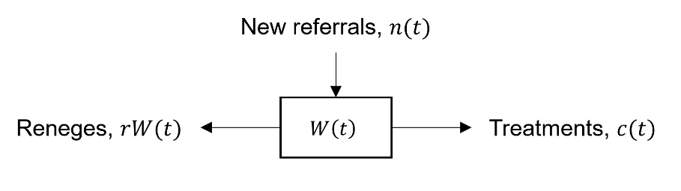

Figure 1. Schematic of the waiting list problem as modelled by Wood [2022].

More recently, Shah et al [21] have also used a single compartment “stocks-and-flows model” to conceptually represent the waiting list problem, incorporating a statistical approach (vector autoregression with exogenous variables) to estimate model parameters. Model accuracy is not reported and (like other single-stock setups) there is no consideration to waiting times, only waiting list size.

Beyond compartment-based methodologies, Discrete Event Simulation (DES) models have been applied to the waiting list problem. Here, the modelling currency shifts from compartments (through which individuals flow) to the individuals themselves (and the events they experience). While this type of mechanistic modelling has been able to link to routine data, accounting for reneging and (some general concept of) referral priority and projecting waiting times as well as waiting list size [22], the complexity of calibrating such models has prohibited scalable application.

To summarise the current state of the literature: there are examples in which detailed stocks-and-flows models are developed and used with bespoke data for bespoke problems of a more operational nature [18]; there are examples of simpler but scalable compartment-based mechanistic [19,20] and statistical [21] models which can be calibrated through routine data and used for strategic problems, but which lack the requisite detail to consider waiting times; and there are examples of non-compartmental DES-based mechanistic models which have the necessary sophistication to consider waiting times but lack scalability [22]. Hence, where there is a deficit is in strategic-use models that are scalable to different settings and scenarios, configurable on routine data, and sufficiently sophisticated to consider waiting times. That is the gap which this current paper intends to address. It should be noted that, through considering the one-way flow of patients through ‘compartments’ representing increasing (waiting) time, the proposed model bears some similarity with the ‘tunnel state’ conceptualisation of Markov models. This device is well known in disease modelling where, for example, death rates may greaten with state transitions according to increasing time.

3. Methodology, model and solution

In this section, we first outline a compartmental modelling based methodology designed to enable decision makers to predict the likely consequences of a range of demand- and supply-side strategic scenarios that would be common considerations in the effective management of an elective waiting list. Fundamental requirements of the methodology are that it provides predictions of future waiting list sizes and of future waiting times for different sets of scenario assumptions. We then specify the particular model developed for this purpose, followed by its solution method.

3.1 Methodology

The requirement to predict future waiting times as well as future waiting lists is achieved by:
- Splitting the total waiting list stock (as in the single compartment model) into multiple compartments to distinguish patients on the waiting list according to the number of months for which they have already been on the waiting list.
- Specifying future monthly reneging rates according to patients’ waiting times.
- Specifying future monthly treatment capacities according to patients’ waiting times.

Hence, in the methodology, any particular scenario is defined in terms of:
- Starting size and structure of the waiting list, defined in terms of the numbers of patients who have already been on the waiting list for 0, 1, 2, …, M-1, M+ months.
- Future monthly referral rates of new patients joining the waiting list.
- Future monthly reneging rates, and how these are allocated between patients who have already been on the waiting list for 0, 1, 2, …, M-1, M+ months.
- Future monthly treatment capacity rates, and how these are allocated between patients who have already been on the waiting list for 0, 1, 2, …, M-1, M+ months.

The specification of these for the example application considered in this paper – to projecting the England national elective waiting list – will be presented later, in Section 4.

3.2 Model

Patient waiting time is modelled as the one-way progression through various compartments representing an increasing duration of elapsed time since referral (Figure 2). New referrals join the waiting list at rate $n(t)$ during the $t$-th time interval (units of the time interval could be days, weeks or months – in our application it is months, as described further in Section 4.1). Specifically, new referrals join the initial compartment, where $W_{0}(t)$ represents the number of patients waiting between zero and a single unit of the time interval, at the end of the $t$-th time interval. The value of $W_{0}(t)$ equals the number of new referrals in that time interval $n(t)$, less a proportion $r_{0}$ of those which renege during the time interval $r_{0}n(t)$, less those that have been treated subject to treatment capacity $c_{0}(t)$. This parameterisation follows as a multi-compartment generalisation of Wood [20], which has been summarised in Section 2. Thus:

$W_{0}\left(t\right)=n\left(t\right)-c_{0}\left(t\right)-r_{0}n(t)$ Eqn. (1)

If newly referred patients are not treated or do not renege within the $t$-th time interval, they transfer into the next compartment at the $t$+1-th time interval (since they will have waited between one and two units of the time interval). Events proceed at the next compartment in a similar way, although here the inflow is not the new referrals (i.e., $n(t)$) but the number in the previous compartment at the end of the preceding time interval (i.e., $W_{0}\left(t-1\right)$):

$W_{1}\left(t\right)=W_{0}\left(t-1\right)-c_{1}\left(t\right)-r_{1}W_{0}\left(t-1\right)$ Eqn. (2)

Generalising Eqn. (2) gives:

$W_{m}\left(t\right)=W_{m-1}\left(t-1\right)-c_{m}\left(t\right)-r_{m}W_{m-1}\left(t-1\right)$ Eqn. (3)

where $m∈\left\{1,2,…,M-1\right\}$. That is, there are $W_{m}\left(t\right)$ patients waiting between $m$ and $m+1$ units of the time interval, at the end of the $t$-th time interval. Finally, for the last compartment, representing all waits greater than a multiple of M time intervals, it is necessary to additionally account for those waiting patients who neither renege nor are treated and therefore remain in the compartment:

$W_{M}\left(t\right)=W_{M-1}\left(t-1\right)+W_{M}\left(t-1\right)-c_{M}\left(t\right)-r_{M}\left(W_{M-1}\left(t-1\right)+W_{M}\left(t-1\right)\right)$
Eqn. (4)

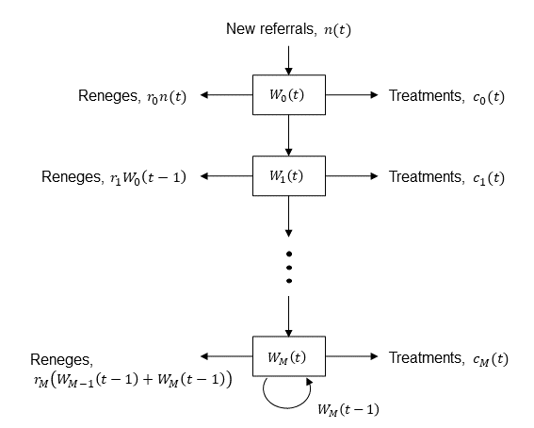

Figure 2. Schematic of the waiting list problem as modelled, with parameters as defined in Section 3.2.

3.3 Solution

Where $t=T$ is the time of the latest data, or the time from which projections are sought, the future numbers waiting $W_{m}\left(t\right)$ can be estimated given the calibrated reneging parameters $r_{m}$ and future values for referrals $n\left(t\right)$ and treatment capacity $c_{m}\left(t\right)$ where $m∈\left\{0,1,…,M\right\}$ and $t>T$. The waiting time projections $W_{m}\left(t\right)$ – for the future numbers of patients waiting between $m$ and $m+1$ units of time at the end of the $t$-th time interval – can simply be determined through stepwise calculation using the recurrence relations given by Eqns. (1,3,4), i.e., first calculate the $W_{m}\left(t\right)$ for $t=T+1$, and then use these results to calculate the $W_{m}\left(t\right)$ for $t=T+2$, and so on. All that is required are the calibrated reneging parameters $r_{m}$ (covered later, in Section 4.2) and whatever values for referrals $n\left(t\right)$ and treatment capacity $c_{m}\left(t\right)$ are considered as part of the hypothetical scenario(s) to be modelled. The values of these input parameters are specified by the model user to represent the particular scenario that he or she is interested to investigate. Examples of how these input parameters can be set are given later, in Section 4.2 for the reneging parameters and Section 6 for referrals and treatment capacities.

4. Example application

For the purposes of providing a demonstration of the methodology and the sorts of predictions it is capable of making, the following example application assumes that decision makers are interested in the strategic management of the overall consultant-led England national waiting list, and want to predict the likely consequences of a scenario in which (with reference to the scenario specification of Section 3.1):
- Starting size and structure of the waiting list is as of the end of 2023, based on publicly available data published by NHS England [7].
- Future monthly referral rates of new patients through 2024-2025 are based on a time-series forecast using the latest 24 months of national referral data (2022-2023) published by NHS England [7], including 80% prediction bands.
- Future monthly reneging rates through 2024-2025, and their allocation between patients waiting 0, 1, 2, …, 11, 12+ months, are assumed to take the mean values observed over the last 12 months (2023) using data published by NHS England [7].
- Future monthly treatment capacity rates through 2024-2025 are based on a time-series forecast using the latest 24 months of national treatment completion data (2022-2023) published by NHS England [7], including 80% prediction bands, with their allocation between patients waiting 0, 1, 2, …, 11, 12+ months determined by the mean proportions observed over the last 12 months (2023) using data published by NHS England [7].

In terms of scenario, the methodology is versatile to other future referrals and treatment capacity rate trajectories: the time-series forecasts described above serve only as examples, as does the choice of future reneging rates. In terms of the setting and data, the methodology is generalisable to any elective wait list problem provided the underlying assumptions remain sufficiently valid and where data exists to calibrate the specified parameters. Application of the model to analyse other NHS settings is particularly straightforward, given the equivalent structure of the publicly available data when filtered to a specific hospital and/or specialty [7]. Further guidance on the practicalities of model application is provided in Section 7.

4.1 Data

Monthly consultant-led elective wait time data has been published for all acute hospitals in England since 2007 [7]. This data is published monthly, typically on the second Thursday of each month. The data is published by NHS England and is an ‘accredited official statistics’, meaning that it has “been independently reviewed by OSR [Office for Statistics Regulation] and confirmed to comply with the standards of trustworthiness, quality and value in the Code of Practice for Statistics” [23]. Notwithstanding, it is possible that data quality issues are present, and, accordingly, “revisions are published periodically (usually every six months)” [7].

The data includes the number of new referrals within the month (i.e., the $n\left(t\right)$); the number of waiting patients at the end of the month, disaggregated by weeks spent waiting (i.e., the $W_{m}\left(t\right)$); and the number of completed treatments within the month, disaggregated by weeks spent waiting upon treatment (i.e., the $c_{m}\left(t\right)$). Referral priority is not covered in the dataset. Reneges are not provided in this dataset but can be inferred – using an equivalent approach to that of Wood [20] – as the difference between the change in waiting list size from the previous month and new referrals minus completed treatments (if there is no reneging then the difference in waiting list size should be explained by the difference in new referrals and completed treatments). Data is available at both a hospital trust and specialty level, and thus can be geographically aggregated to a regional and national level and aggregated to a total-specialty level. No historical data past month-end December 2023 (the latest available data as of the time of the study) is used in the analysis.

Given the monthly nature of this source data, a time interval of one month is used for all analyses. This ensures the satisfaction of a critical modelling assumption introduced in Section 3.2: that any waiting patient that is not treated or does not renege in the time interval can be assumed to exit that compartment and present at the next compartment at the next time interval. This assumption of the compartments ‘resetting’ each month permits the modelling to be undertaken with the available public data: there would otherwise be insufficient information to support model calibration. For consistency, the aforementioned weekly data for time spent waiting (both at the end of the considered time interval and for treatments within) must be converted to monthly data, and this is done by pro-rata assuming a proportionate split among month boundaries.

An example of the processed data used for model calibration, using source data covering the period to year-end 2023, is available at: https://github.com/nhs-bnssg-analytics/waitlist-multi-compartment-model.

4.2 Parameterisation

Wait time pooling

The threshold for pooling waiting times is set at twelve months for all analysis in the example considered in this study. That is, $M=12$: the modelling considers monthly waiting time up to twelve months, with all greater durations combined.

Reneging parameters

The reneging parameters of the model $r_{m}$ ($m∈\left\{0,1,…,M\right\}$) are estimated through rearranging Eqns. (1,3,4) and using the known historical values for $n\left(t\right)$, $c_{m}\left(t\right)$, and $W_{m}\left(t\right)$ with the data described in Section 4.1. For the example considered here, as in Wood [20], the model reneging parameters are not determined from the single most recent month’s value (or the time from which projections are sought), but, to mitigate the effects of volatility and seasonal variation, are calculated from the mean of the most recent twelve months’ data. So, where $t=T$ is the time of the latest data (or the time from which projections are sought):

$r_{0}=\frac{1}{12}\sum_{t=T-11}^{T}{max⁡\left(\frac{n\left(t\right)-c_{0}\left(t\right)-W_{0}\left(t\right)}{n\left(t\right)},0\right)}$ Eqn. (5)

$r_{m}=\frac{1}{12}\sum_{t=T-11}^{T}{max⁡\left(\frac{W_{m-1}\left(t-1\right)-c_{m}\left(t\right)-W_{m}(t)}{W_{m-1}\left(t-1\right)},0\right)}$ Eqn. (6)

$r_{M}=\frac{1}{12}\sum_{t=T-11}^{T}{max⁡\left(\frac{W_{M-1}\left(t-1\right)+W_{M}\left(t-1\right)-c_{M}\left(t\right)-W_{M}\left(t\right)}{W_{M-1}\left(t-1\right)+W_{M}\left(t-1\right)},0\right)}$ Eqn. (7)

Given that data up to month-end December 2023 is used in this study, the $r_{m}$ ($m∈\left\{0,1,…,M\right\}$) are calibrated using data from January 2023 to December 2023 inclusive. The zero-flooring is applied in case any of the calculated monthly renege rates are below zero, which has been observed to occur on occasions due to suspected source data quality issues. Any negative reneging from the initial compartment is credited to the referrals of the same month, to account for known under-reporting of this in the source data (this is discussed further in Section 7). If so desired, a more flexible specification of reneging rates could readily be incorporated by allowing the model to specify reneging rates that change as time moves forward.

Capacity parameters

Obtaining future wait time estimates for a given scenario using the above model (Section 3.2) requires – alongside new referrals $n(t)$ – the treatment capacity for each compartment for each future time period, i.e., $c_{m}\left(t\right)$ is required for each $m∈\left\{0,1,…,M\right\}$ and $t>T$. This is not straightforward, since it is not intuitively known how many patients will or should be treated from the $M$ wait time compartments (in practice this could well vary based on the total treatment capacity available and the numbers of patients within each compartment). For the example considered here, we assume that scenarios of interest only set total treatment capacities $C\left(t\right)=\sum_{m=0}^{M}{c_{m}(t)}$, with allocations of capacity to the $M$ wait time compartments made in accordance with past behaviour. Specifically, we assume no difference in the relative probabilities of patients being ‘selected’ for treatment across the M compartments, i.e., total capacity will affect the overall magnitude of treatments but not the relative chances of selection for treatment for patients of different waiting times.

While not an intrinsic model parameter (and thus not featuring in the model as described in Section 3.2), for this example we reintroduce the $c_{m}\left(t\right)$ as a function accounting for the past allocations of total treatment capacity between the compartments. We determine the proportion $p_{m}$ of compartment inflow which is treated within the month. As with the reneging parameters, this is calculated over the most recent twelve months to account for any volatility:

$p_{0}=\frac{1}{12}\sum_{t=T-11}^{T}{\frac{c_{0}\left(t\right)}{n\left(t\right)}}$ Eqn. (8)

$p_{m}=\frac{1}{12}\sum_{t=T-11}^{T}{\frac{c_{m}\left(t\right)}{W_{m-1}\left(t-1\right)}}$ Eqn. (9)

$p_{M}=\frac{1}{12}\sum_{t=T-11}^{T}{\frac{c_{M}\left(t\right)}{W_{M-1}\left(t-1\right)+W_{M}\left(t-1\right)}}$ Eqn. (10)

where $m∈\left\{1,2,…,M-1\right\}$ and $t=T$ is the time of the latest data (or the time from which projections are sought). To determine the $c_{m}\left(t\right)$, $m∈\left\{0,1,…,M\right\}$, for each future month $t>T$, under a given scenario, we first define:

$γ\left(t\right)=p_{0}n\left(t\right)+\sum_{m=1}^{M-1}{p_{m}W_{m-1}\left(t-1\right)}+p_{M}\left(W_{M-1}\left(t-1\right)+W_{M}\left(t-1\right)\right)$ Eqn. (11)

such that:

$c_{0}(t)=C(t)\frac{p_{0}n\left(t\right)}{γ(t)}$ Eqn. (12)

$c_{m}(t)=C(t)\frac{p_{m}W_{m-1}\left(t-1\right)}{γ(t)}$ Eqn. (13)

$c_{M}(t)=C(t)\frac{p_{M}\left(W_{M-1}\left(t-1\right)+W_{M}\left(t-1\right)\right)}{γ(t)}$ Eqn. (14)

where $m∈\left\{1,2,…,M-1\right\}$ and $t>T$.

Under this formulation, only one value is required for treatment capacity (as well as for new referrals), for each future month, for each scenario in question. If so desired, a more flexible specification of capacity allocations can readily be incorporated to allow the user to specify different divisions of total capacity across waiting times.

Estimated parameters

Figure 3 shows the compartment-level reneging and capacity rates over time, alongside the corresponding parameter values (red lines) used for the modelling, i.e., those calculated through Eqns. (5-7) and Eqns. (8-10) respectively. These are considered further in regard of model validation (Section 5) and the scenario results (Section 6.2).

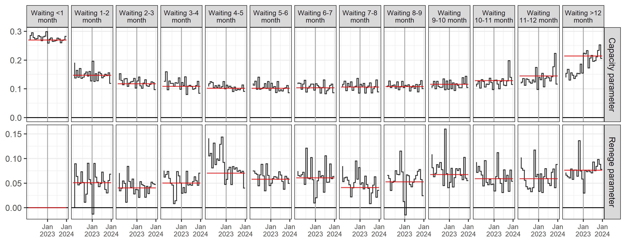

Figure 3. Compartment-level capacity and reneging rates over time, inferred from the historical data according to the formulae in Section 4.2. The red lines are the actual parameters used for this example application, which are the mean values over the 12-month calibration windows (January 2023 to December 2023 inclusive).

5. Model validation and accuracy

Model validation is an important step in the modelling process, in helping to ascertain the level of confidence that the user may place on model outputs. The validity of a model depends very much upon its intended use, which in this case is to aid the strategic management of hospital waiting lists. As such, we envisage the model being used to predict future waiting list size and waiting times for scenarios in which management wish to decide future capacity levels in the light of likely future levels of demand, future reneging rates and how the capacity is allocated across waiting times. The model has the potential to be applied (i.e., is valid) for at any level of granularity in the NHS, and in other health systems where waiting lists can be characterised in a similar way.

One way to obtain a view on the level of accuracy that might be expected for a given model application is through ‘backtesting’, i.e., applying the model retrospectively and comparing the model predictions with what actually happened. For the example waiting list problem presented in Section 4, we approach this by assessing how different the total waiting list size and projected numbers $W_{m}\left(t\right)$within each compartment $m∈\left\{0,1,…,M\right\}$ for each future month $t>T$ differ from the corresponding actual values. We do this over a recent period of time and calibrate the capacity and reneging parameters using data only up to the start of that period, not within it. We assume no error in the referrals and capacity levels, i.e., they follow the actual observed values. This therefore demonstrates the performance of the model for a case where the user has correctly described the referral and total capacity levels.

This is performed over the most recent 6- and 12-month periods, i.e., the periods of such duration up to and including December 2023. To do this, the model parameters (the $r_{m}$ and $p_{m}\left(t\right)$ for each $m∈\left\{0,1,…,M\right\}$ ) are calibrated using only the twelve months of data available immediately prior to those periods. The model is run using the actual monthly referrals $n\left(t\right)$ and total treatments $C(t)$ over the backtest periods, and projections for the waiting list size are compared with the actual data. Accuracy is assessed through Mean Absolute Percentage Error (MAPE), with figures also provided for Mean Absolute Error (MAE).

This leads to a MAPE of 0.4% on the projected total wait list size for the 6-month backtest and 4.7% for the 12-month backtest (Figure 4). In terms of MAE, the corresponding figures are 26,178 and 332,807 respectively, which should be contextualised against a waitlist whose mean size was 7.27m and 7.12m over those two periods. The considerable difference in accuracy between the 6- and 12-month backtests is attributable to both a greater impact of changing behaviour exhibited in these parameters over time as well as possible data quality issues, as now described. The wider 12-month backtest window involves calibrating the parameters on the preceding 12-month period, which, as can be seen in Figure 3, is more greatly exposed to trending parameters over time than would be a shorter backtest window (this may be explained by changes in the ways patients are selected for treatment and how patients renege from the waiting list). With regard to data quality, the longer 12-month backtest window appears to straddle spikes in the renege parameter at and shortly before January 2023, which may be caused by data quality issues in the source data (such issues are discussed further in Section 7).

With regard to compartment-level accuracies, the weakest accuracy scores are for wait times in excess of 12 months (22% and 27% MAPE respectively for the 6- and 12-month backtest windows). The reason for this is that the values of both the capacity and reneging parameters have been increasing over at least the last year for this compartment (Figure 3, right-most panels). Hence, the estimated model parameters are underestimating the true volumes of patients being removed from this compartment in the backtest windows, both due to higher treatment selection chances and higher reneging. This not only explains the higher error scores but also why these errors associate with a serial overestimation of numbers in this compartment (Figure 4, right-most panels). One explanation for the increasing chance of treatment selection from the final compartment (i.e., the increasing value of the capacity parameter per the upper-right panel of Figure 3) is the NHS’s efforts to reduce above-one-year treatment waits, following the publication of such guidance in February 2022 [24].

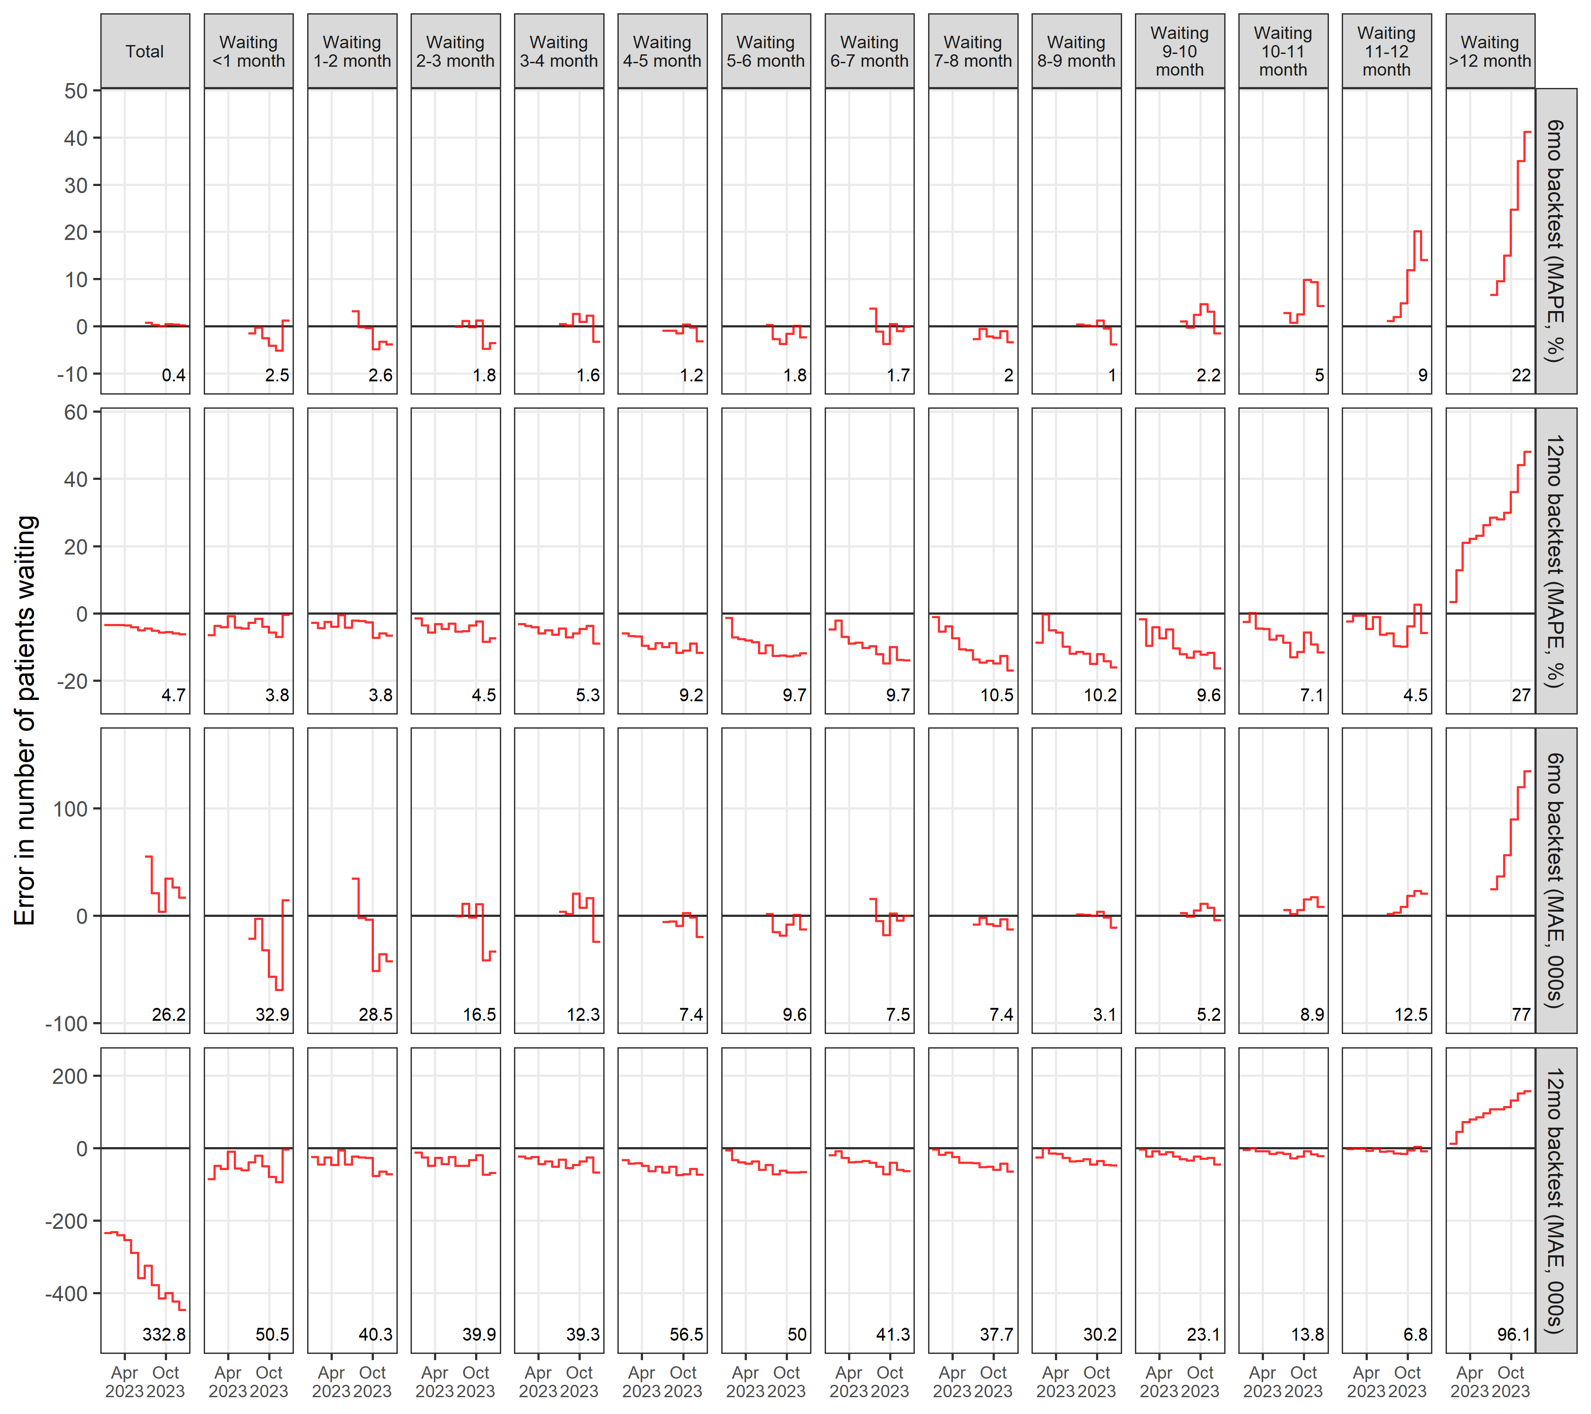

Figure 4. Error in projected wait list size, over the most recent 6- and 12-month periods within the dataset (i.e., to December 2023 inclusive). Mean Absolute Percentage Error (MAPE) and Mean Absolute Error (MAE) are indicated in the lower-right of each figure panel.

6. Scenario analysis

In this section we continue to use the example application described in Section 4 to demonstrate the potential of the compartmental modelling methodology to make projections of future waiting lists and waiting times for a set of example scenarios.

6.1 Scenarios

The model makes predictions based on scenarios defined in terms of future monthly values of new referrals $n\left(t\right)$ and treatment capacities $C\left(t\right)$ where $t>T$. These values can be forecast into the future based on historical data for these variables. Specifically, 24-month forecasts are obtained through application of the TBATS forecasting model [25] to the past 24 months actual data for these variables.

Forecasts, on application to the total national waiting list (i.e., the modelling granularity considered here, as mentioned in Section 4), are provided in Figure 5. As can be seen, sufficient evidence of trend and seasonal variation was detected in treatment capacities but not referrals. Results for a total of nine scenarios are modelled and presented in Section 6.2, based on combinations of the central estimates (‘expected’ scenarios) and upper (‘high’ scenarios) and lower (‘low’ scenarios) 80% prediction limits for the referrals and treatment capacity forecasts.

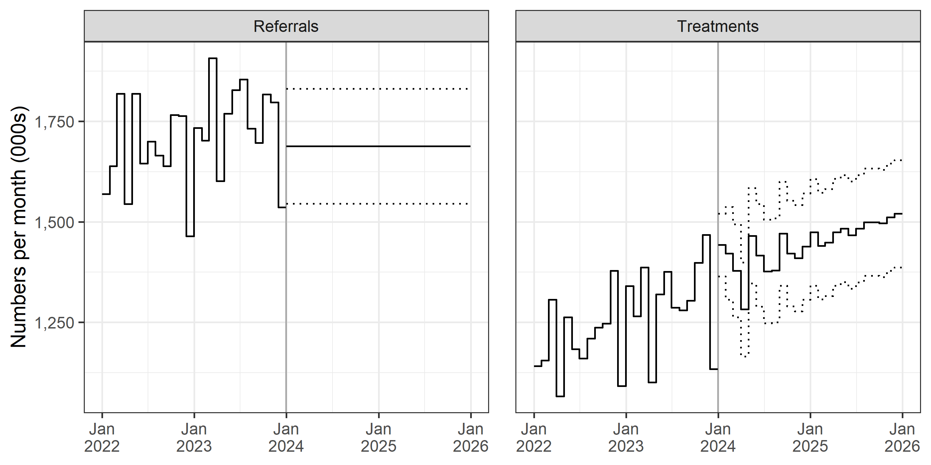

Figure 5. Forecasted new referrals and treatment capacity by TBATS method, showing the projections on which the nine scenarios are based: central estimate (solid line, ‘expected’ scenarios) and 80% upper (‘high’ scenarios) and lower (‘low’ scenarios) prediction limits (dotted lines). The actual data is to the left of the vertical line.

6.2 Results

Modelled results for the nine scenarios are provided in Figure 6 showing total waiting list size and waiting time compartment sizes for the 24-month projection horizon. The effects of the most extreme scenarios – i.e., high referrals and low capacity (red dotted lines) or low referrals and high capacity (green solid lines) can be seen in all the graphs, with the more immediate impacts on the compartments representing lower wait times. This stands to reason as any new referrals will first increase the numbers of patients in the shorter waiting time compartments before possibly moving on to the longer waiting time compartments. Results show that meeting the different levels of referrals and capacity could have a significant impact on the total wait list and its composition. The total wait list could fall to 1.26m under the most optimistic scenario and could rise to 8.51m under the most pessimistic scenario, by the end of the two-year projection period.

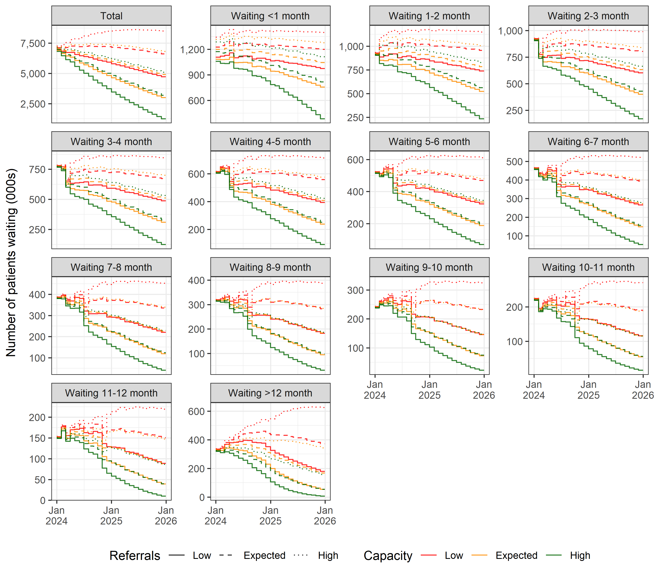

Figure 6. Projected national wait list size for England over all specialties for the nine considered scenarios.

Figure 7 presents the same projections as in Figure 6 but in an alternative way – showing projections of four quantiles of the wait time distributions (<12, <9, <6 and <3 months); noting that, in all of these, greater metric values correspond ostensibly to better performance, i.e., greater percentages of waiting patients waiting less than the stated durations. Taking first the 12-month threshold (upper panel), projected results appear essentially indistinguishable by the referral scenario over the first 12 months. This is because it takes 12 months for any referral to no longer feature in the numerator (i.e., the number of waiting patients waiting under 12 months), and thus to significantly alter the value of the metric. This is very different to results for the 3-month threshold (lower panel), in which the referrals make a noticeable difference in the initial months. Moreover, at least initially, higher referrals appear to produce better performance. The reason for this prima facie counterintuitive behaviour is that the new referrals increase the numerator as much as the denominator, thus inflating the metric. Soon enough, as the wait time of these new referrals increases, they drop out of the numerator and so depress the metric value – hence, why, for any given capacity scenario, the dotted line (high referrals) ultimately becomes lower than the dashed line (expected referrals), which is itself lower than the solid line (low referrals). This happens for all four thresholds, but – as would be expected – occurs sooner within the projection period for lower thresholds.

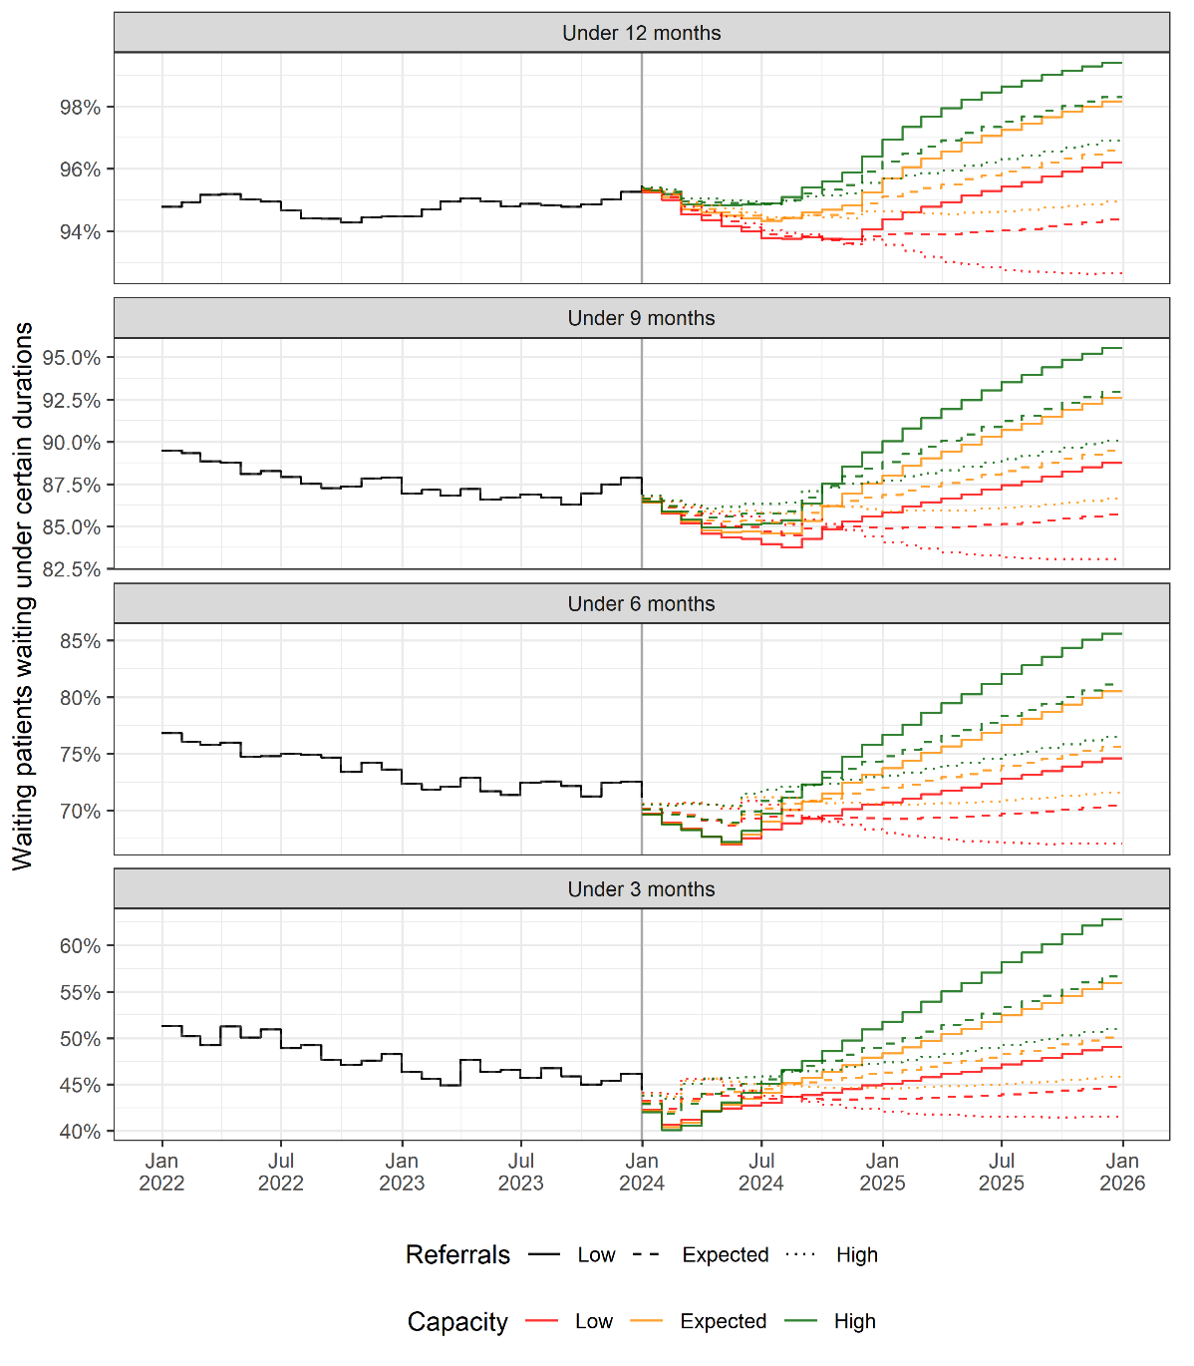

Figure 7. Projected quantiles of the national wait time distribution for England over all specialties.

The projections show that while, ultimately, more capacity leads to better performance (i.e., for a given threshold and referral scenario, the green line will always exceed the orange line, which will always exceed the red line), for lower thresholds the opposite appears to occur within the initial months. The reason for this is due to the differences in how patients are selected from the waiting list. As can be seen from Figure 3, the capacity parameter (Section 4.2) differs across the wait time compartments, with higher chances of selection for treatment inferred for low and high waits. Given this: with more capacity, those of waits under the 3-month threshold are disproportionately more likely to be selected for treatment, thus reducing the numerator disproportionately more than the denominator, and so depressing the metric value. For the larger 12-month threshold, it is proportionately less likely for a sub-12-month-wait patient to be selected for treatment (given the relatively large value of the capacity parameter for the final compartment) and so the numerator reduces less than the denominator, leading to the relatively better performance conferred through the higher metric value. Note that, as previously mentioned (Section 5), the increasing chance of treatment selection from the final compartment (Figure 3, upper-right panel) is likely explained by NHS efforts to reduce above-one-year treatment waits [24]. Note also the higher (albeit not increasing) chances of treatment selection for lesser waits (i.e., from the lower-order compartments) – this is due to the quicker treatment of patients whose referrals are categorised as ‘urgent’.

7. Discussion

This study and the model developed through this study have helped address a deficit in the waiting list modelling literature concerning strategic-use models that are scalable to different settings and scenarios, configurable on routine data, and sufficiently sophisticated to consider waiting times, and not just waiting list size (Section 2). This builds upon the previous literature which has either concerned detailed modelling of waiting times within bespoke projects, or more scalable modelling based on routine data but considering only waiting list size. We now provide some final comments on the overall approach, a discussion of practical implications, and some suggested further research opportunities.

7.1 Overall approach

This paper has shown how a compartmental modelling methodology can be used to develop a strategic hospital waiting list model capable of projecting future waiting lists and waiting times based on:
- Starting size and structure of the waiting list, defined in terms of the numbers of patients who have already been on the waiting list for 0, 1, 2, …, M-1, M+ months.
- Future monthly referral rates of new patients joining the waiting list.
- Future monthly reneging rates, and how these are allocated between patients who have already been on the waiting list for 0, 1, 2, …, M-1, M+ months.
- Future monthly treatment capacity rates, and how these are allocated between patients who have already been on the waiting list for 0, 1, 2, …, M-1, M+ months.

The precise form and calibration of any particular application of the model will depend on the data and parameter assumptions, which is described for our application in Section 4. It is then important for the intended user to carry out the appropriate validation checks on the model, as demonstrated here in Section 5. If shown to be of acceptable accuracy, the user is then able to apply the model to investigate possible future scenarios (to the degree of accuracy indicated by the validity tests), as considered here in Section 6.

7.2 Practical implications

The compartmental model developed and demonstrated in this paper is designed to represent the key dynamics of the strategic elective waiting list problem, and so can potentially be used to model the waiting list of any country and at any granularity provided the assumptions outlined in Sections 3.1 and 3.2 are deemed appropriate. In practice, prospective users should carefully inspect their waiting list problem to check adherence to the model assumptions prior to model use and should use their understanding of any identified ‘gaps’ to contextualise and/or caveat the model outputs.

The model is implemented in an R script, which is freely available at the following repository: https://github.com/nhs-bnssg-analytics/waitlist-multi-compartment-model. For the purposes of the England NHS application considered here, the part of the script in which data is loaded is specifically edited to input a processed ‘minimum calculation dataset’ resulting from the original publicly available source data [7]. A bespoke ‘webscraper’ script (also available at the aforementioned repository) has been developed to perform this task. This R script takes the latest available source data from the NHS website and processes it into a format suitable for modelling. Within the main model implementation script, the user may configure the modelling granularity in terms of the hospital trust and specialty combinations to model (more than one combination can be added and modelled on any single run of the script). The user is also required to define the lengths of the calibration window (Sections 4), backtest window (Section 5) and projection horizon (Section 6). Finally, the user may override the forecasting algorithm and manually provide his or her own future monthly values for new referrals and treatment capacities, via a spreadsheet input file. Alternatively, given coding in open-source R, the user may readily modify the script itself. For instance, changing the forecasting algorithm from TBATS to ARIMA could be done through editing just one line of code.

Upon application of the model, the user should remain vigilant to the various sources of possible model error. We consider these forthwith in respect of four areas: modelling granularity; data and processing; model calibration; and scenario analysis.

In regard of modelling granularity, overall accuracy may be impacted by the heterogeneity of patients and congruency of processes within the chosen trust and specialty coverage. Greater similarity in these aspects would reasonably be expected for lower-level applications of the model, such as to a particular hospital trust and specialty. The greater diversity of patients and processes captured in higher-level applications – such as to the England national waiting list as considered here – could mean the resulting parameter estimates are less representative for particular patient subgroups whilst still remaining overall representative when averaged. Typically, such matters are a necessary compromise when pitching model use toward higher-level strategic and policy questions. While not considered here, it may be that this issue could be addressed through aggregating the outputs of multiple lower-level applications of the model, i.e., running the model separately over all hospital trusts and specialties of interest, and summing up the resulting compartmental-level projections for numbers waiting.

In regard of data and processing, accuracy could be affected by underlying data quality issues in the source data and any approximations or treatments necessary to process the source data into the format required by the model. For instance, in the England NHS application considered here, there is a known source data quality issue with under-reporting of new referrals causing negative reneging (Section 4.2) and a suspected data quality issue yielding spikes in the renege parameters around the turn of 2023 (Section 5). In the data processing step, there is also a known issue in how data for time spent waiting is approximated, in converting this from weekly data at source into the monthly units required for the modelling (Section 4.1). Users may be required to take such processing steps in order to ensure the appropriate model inputs, and should therefore remain aware of the possible limitations caused.

Model calibration and scenario analysis are somewhat related aspects, with the former using an analysis of historic data to indicate future behaviours whilst the latter can be used to introduce a wider set of possibilities. In regard of model calibration, accuracy is essentially affected by how well the calibrated capacity and reneging parameters reflect conditions beyond the calibration period and into the projection period. As we have seen from Section 5, any fundamental change in reneging behaviour or how capacity is allocated over time can have a profound impact. While, to a large degree, these future changes are unknown, there may, depending on the setting and circumstances, be more appropriate calibration methods other than simply taking the mean over the calibration period, as done here (Section 4.2). For instance, if there is considerable volatility in the monthly values, then taking the median would reduce the influence of outliers. If there is a compelling trend over the calibration period, then a time-series prediction could be a better model of future behaviour than a constant (mean or median) value. Generally, given the potential for changing waiting list dynamics, we would suggest that the parameters are re-estimated from the latest data whenever the model is run, and that caution should be taken when seeking to model the waiting list over periods of significantly differing characteristics where a given parameterisation may be insufficiently representative throughout. Regarding the choice of $M$, the ‘last’ compartment for which all patients waiting $>M$ months are combined, a balance should be struck here, given that higher values will provide better discrimination for longer-waiting patients, but may lead to volatile calibrations for the reneging and capacity parameters if there is insufficient data at such wait durations.

Investigators may alternatively wish to take a scenario analysis approach to these parameters, in exploring different calibrations for different scenarios under consideration, in a similar way to how the referrals and capacity projections were set up and modelled (Section 6). In regard of the referrals and capacity projections, the accuracy of model outputs is of course dependent on how well the corresponding scenario inputs reflect the scenario being investigated. If, as examined here, the scenario is essentially a ‘do nothing different’ scenario, then, as done here, one can simply utilise time-series approaches to project out a trend. Clearly, this is naïve, and there is little guarantee that past trends and behaviour will carry forward. Alternatively, bespoke scenarios can be defined based on specific intelligence. For instance, if it is known that investments will be made to enhance primary and community care provision, then it may reasonably be expected that referrals into secondary care would be lower. Or, if ongoing industrial action is expected, then a bespoke scenario involving reduced treatment capacity levels could be modelled. Scenarios may also be used to ‘stress test’ the waiting list to determine how robust it may be to unforeseen events. For instance, a pandemic could be modelled by defining a scenario in which there is a short but dramatic restriction to capacity to take account of temporarily heightened non-elective demands on acute resources and infection control measures.

7.3 Further research

There is considerable scope for further investigation in this domain. From an impact perspective, there is much opportunity given the longer waiting lists prompted by COVID-19 and the recent research starting to highlight the knock-on effects of long waits on other parts of the health service [26,27] and wider economy [28]. From a methodological perspective, this area remains underserved with only a limited number of modelling techniques having been applied to problems in this domain. The compartmental modelling methodology developed here may provide a useful foundation for future investigators to build on. One such development option is to explicitly account for referral priority. Notwithstanding scalability implications (given bespoke priority schemes in use for different specialties) and data limitations at least for the application considered here (Section 4.1), referral priority could be incorporated through including set(s) of M additional compartments for each priority class considered, with treatment selection rates following a similar parameterisation approach to the capacity parameters as described in Section 4.2. Another option could be in moving from discrete-time difference equations to a continuous-time formulation and differential equation solution. Alternatively, researchers may wish to consider Discrete Event Simulation (DES) methods, whose individual-level ‘tracking’ of patients conveniently permits priority assignment, but whose aforementioned calibration complexities have – at least to date – restricted scalable model application to multiple settings and scenarios. The literature would also be improved through a side-by-side comparison of these different modelling approaches, with a comprehensive review of practicalities, pros and cons.
References

[1] Hurst, J., & Siciliani, L. (2003). Tackling excessive waiting times for elective surgery: a comparison of policies in twelve OECD countries. https://doi.org/10.1787/108471127058.

[2] Viberg, N., Forsberg, B. C., Borowitz, M., & Molin, R. (2013). International comparisons of waiting times in health care–Limitations and prospects. Health policy, 112(1-2), 53-61. https://doi.org/10.1016/j.healthpol.2013.06.013.

[3] Wall, C., Johnson, T., & de Steiger, R. (2020). Symptom management for patients awaiting joint replacement surgery. Australian journal of general practice, 49(7), 444-446. https://doi.org/10.31128/ajgp-03-20-5286.

[4] Sobolev, B., Mercer, D., Brown, P., FitzGerald, M., Jalink, D., & Shaw, R. (2003). Risk of emergency admission while awaiting elective cholecystectomy. Cmaj, 169(7), 662-665.

[5] Tinson, A., Major, A., & Finch, D. (2022). Is poor health driving a rise in economic inactivity?. The Health Foundation. https://www.health.org.uk/news-and-comment/charts-and-infographics/is-poor-health-driving-a-rise-in-economic-inactivity.

[6] Van Ginneken, E., Siciliani, L., Reed, S., Eriksen, A., Tille, F., & Zapata, T. (2022). Addressing backlogs and managing waiting lists during and beyond the COVID-19 pandemic. Eurohealth, 28(1), 35-40.

[7] National Health Service England (2024). Referral to Treatment (RTT) Waiting Times. https://www.england.nhs.uk/statistics/statistical-work-areas/rtt-waiting-times/.

[8] Private Healthcare Information Network (2023). PHIN Private market update: September 2023. https://www.phin.org.uk/news/phin-private-market-update-september-2023.

[9] Jun, J. B., Jacobson, S. H., & Swisher, J. R. (1999). Application of discrete-event simulation in health care clinics: A survey. Journal of the operational research society, 50, 109-123. https://doi.org/10.1057/palgrave.jors.2600669.

[10] Baril, C., Gascon, V., & Vadeboncoeur, D. (2019). Discrete-event simulation and design of experiments to study ambulatory patient waiting time in an emergency department. Journal of the Operational Research Society, 70(12), 2019-2038. https://doi.org/10.1080/01605682.2018.1510805.

[11] Griffiths, J. D., Knight, V., & Komenda, I. (2013). Bed management in a critical care unit. IMA Journal of Management Mathematics, 24(2), 137-153. https://doi.org/10.1093/imaman/dpr028.

[12] Onen-Dumlu, Z., Harper, A. L., Forte, P. G., Powell, A. L., Pitt, M., Vasilakis, C., & Wood, R. M. (2022). Optimising the balance of acute and intermediate care capacity for the complex discharge pathway: Computer modelling study during COVID-19 recovery in England. Plos one, 17(6), e0268837. https://doi.org/10.1371/journal.pone.0268837.

[13] Kermack, W. O., & McKendrick, A. G. (1927). A contribution to the mathematical theory of epidemics. Proceedings of the royal society of london. Series A, Containing papers of a mathematical and physical character, 115(772), 700-721. https://doi.org/10.1098/rspa.1927.0118.

[14] Side, S. (2015). A susceptible-infected-recovered model and simulation for transmission of tuberculosis. Advanced Science Letters, 21(2), 137-139. https://doi.org/10.1166/asl.2015.5840.

[15] Chanprasopchai, P., Tang, I. M., & Pongsumpun, P. (2018). SIR model for dengue disease with effect of dengue vaccination. Computational and mathematical methods in medicine, 2018(1), 9861572. https://doi.org/10.1155/2018/9861572.

[16] Cooper, I., Mondal, A., & Antonopoulos, C. G. (2020). A SIR model assumption for the spread of COVID-19 in different communities. Chaos, Solitons & Fractals, 139, 110057. https://doi.org/10.1016/j.chaos.2020.110057.

[17] Allen, L. J. (1994). Some discrete-time SI, SIR, and SIS epidemic models. Mathematical biosciences, 124(1), 83-105. https://doi.org/10.1016/0025-5564(94)90025-6.

[18] Worthington, D. (1991). Hospital waiting list management models. Journal of the Operational Research Society, 42, 833-843. https://doi.org/10.1057/jors.1991.164.

[19] Vissers, J. M., Van Der Bij, J. D., & Kusters, R. J. (2001). Towards decision support for waiting lists: an operations management view. Health Care Management Science, 4, 133-142. https://doi.org/10.1023/A:1011409711828.

[20] Wood, R. M. (2022). Supporting COVID-19 elective recovery through scalable wait list modelling: Specialty-level application to all hospitals in England. Health Care Management Science, 25(4), 521-525. https://doi.org/10.1007/s10729-022-09615-2.

[21] Shah, S. A., Robertson, C., & Sheikh, A. (2024). Effects of the COVID-19 pandemic on NHS England waiting times for elective hospital care: a modelling study. The Lancet, 403(10423), 241-243. https://doi.org/10.1016/S0140-6736(23)02744-7.

[22] Howlett, N. C., & Wood, R. M. (2022). Modeling the recovery of elective waiting lists following COVID-19: scenario projections for England. Value in Health, 25(11), 1805-1813. https://doi.org/10.1016/j.jval.2022.06.016.

[23] Office for Statistics Regulation (2024). Accredited official statistics. https://osr.statisticsauthority.gov.uk/accredited-official-statistics/.

[24] National Health Service England (2022). Delivery plan for tackling the COVID-19 backlog of elective care. https://www.england.nhs.uk/coronavirus/publication/delivery-plan-for-tackling-the-covid-19-backlog-of-elective-care/.

[25] De Livera, A. M., Hyndman, R. J., & Snyder, R. D. (2011). Forecasting time series with complex seasonal patterns using exponential smoothing. Journal of the American statistical association, 106(496), 1513-1527. https://doi.org/10.1198/jasa.2011.tm09771.

[26] Gibbs, N. K., Griffin, S., Gutacker, N., Villaseñor, A., & Walker, S. (2024). The Health Impact of Waiting for Elective Procedures in the NHS in England: A Modeling Framework Applied to Coronary Artery Bypass Graft and Total Hip Replacement. Medical Decision Making, 0272989X241256639. https://doi.org/10.1177/0272989X241256639.

[27] James, C., Denholm, R., & Wood, R. (2024). The cost of keeping patients waiting: retrospective treatment-control study of additional healthcare utilisation for UK patients awaiting elective treatment. BMC Health Services Research, 24(1), 556. https://doi.org/10.1186/s12913-024-10931-2.

[28] Office for National Statistics (2023). Rising ill-health and economic inactivity because of long-term sickness, UK: 2019 to 2023. https://www.ons.gov.uk/employmentandlabourmarket/peoplenotinwork/economicinactivity/articles/risingillhealthandeconomicinactivitybecauseoflongtermsicknessuk/2019to2023.

