Estimating Spatio-temporally Continuous GEDI Aboveground Biomass Density During 2015-2020 from Multi-Source Data Using Machine Learning and Deep Learning
Xia Wang, Yihang Zhang, Peter M. Atkinson, and Kerong Zhang
Abstract—Accurate estimation of forest aboveground biomass density is essential for quantifying terrestrial carbon exchange. NASA’s Global Ecosystem Dynamics Investigation (GEDI) LiDAR mission has ushered in a new era of high-quality aboveground biomass density (AGBD) estimation from space. Owing to GEDI’s LiDAR data collection, one of the GEDI AGBD products are presented as 1 km spatial discontinuity grids, limiting practical application. This study proposes a method based on machine learning and deep learning to estimate spatio-temporally continuous GEDI AGBD and its associated uncertainty (standard error) during 2015-2020 using multi-source optical, SAR, LiDAR, topographic, and climatic data. MODIS vegetation continuous field (VCF) was used as an indicator to select unchanged GEDI AGBD samples in 2020 for each year from 2015 to 2020, resulting in 1,800–2,400 samples per year. The selected annual training samples were then used to estimate annual spatially continuous GEDI AGBD and uncertainty. Experiments in China’s Han River Basin demonstrated that integrating all available datasets resulted in a more accurate spatial continuous GEDI AGBD map in 2020 compared to use any single dataset. Convolutional neural network (CNN) considering spatial neighboring information (CNN_spatial) outperformed 1-D CNN and four benchmark machine learning methods of extreme learning machines (ELM), generalized regression neural network (GRNN), support vector regression (SVR) and random forest (RF) with an R² of 0.8232 and RMSE of 27.7557. Using the unchanged GEDI AGBD training samples resulted in more accurate GEDI AGBD maps (R²>0.82) during 2015-2020 than using the training samples from 2020 alone. From 2015 to 2020, 2.16% of AGBD pixels in Han River Basin experienced a relatively significant increase, while 1.24% showed a relatively significant decrease. Compared with the ESA_CCI and China’s AGBD products, our estimates achieve better accuracy relative to the field plot data. The proposed method offers a solution to generate high-quality spatio-temporally continuous GEDI AGBD in large-scale complex forest landscapes.
Index Terms—GEDI, aboveground biomass, deep learning, machine learning, Han River Basin.

INTRODUCTION
C
ONSIDERING the global impact of rising carbon dioxide on climate change, governments and organizations, including the Reducing Emissions from Deforestation and Degradation-plus (REDD+) program, have reached an international consensus to preserve and enhance forest biomass stocks worldwide [1]. Forest aboveground biomass (AGB) is the primary carbon store in the forest ecosystem, and changes caused by anthropogenic activities and climate change affect carbon exchange in the terrestrial system [2]. Therefore, timely AGB estimates at regional and national scales are urgently required to support forest management and policy development.
Ground data provide accurate AGB estimates at local scales but are often costly to collect. When combined with ground observations, remote sensing has become an alternative data source for accurate AGB estimation in recent decades, owing to its continuous and repetitive observation capabilities [3, 4]. As listed in Table I, since Ruesch and Gibbs [5] released the first global biomass map with 1 km spatial resolution in 2008, many satellite-driven global AGB products ranging from 30 m to 1000 m have been developed by integrating remote sensing images and field inventory samples [6, 7]. These global AGB products play an important role in providing wall-to-wall estimates of the carbon cycle in the forest ecosystem, particularly for remote regions. Among various global AGB products, the 1 km spatial resolution aboveground biomass density (AGBD) map retrieved from NASA’s GEDI LiDAR mission represents a new era of AGB inference [8, 9].
Estimating GEDI AGBD map is based directly on the vegetation canopy vertical structure extracted from the LiDAR footprints, which is currently considered the most accurate and efficient way to quantify AGB from space [10, 11]. In the past, LiDAR data from ICESat Geoscience laser altimeter system (GLAS) and airborne laser scanner were commonly used as the training samples to predict AGB. More recently, the ICESat-2 provides an efficient way to estimate wall-to-wall AGB maps with machine learning and deep learning methods by integrating Landsat and Sentinel-1 images [12-14]. However, ICESat and ICESat-2 were not originally designed for forest AGB measurement [15]. For the GEDI LiDAR footprint, it was designed particularly for fine-resolution observations of forest vertical structure and has been utilized for wall-to-wall AGB estimation with machine learning and deep learning methods by integrating multi-source data, such as Sentinel-2 and Sentinel-1 images [16, 17], Landsat images [18, 19], ICESat-2 and NISAR data [20], ALOS-2 PALSAR-2 [21] and TanDEM-X data [22]. Compared to optical and synthetic aperture radar (SAR) satellite sensor images, LiDAR is more sensitive to vegetation vertical structure and doesn't suffer from saturation caused by AGB accumulation during forest growth [20]. Given the global coverage and particularly design for forests 3D structure, the global product of NASA’s GEDI AGBD map (see Table I) is expected to have higher accuracy and wider application than many previous AGB products [9]. Unfortunately, the GEDI AGBD map is presented only as spatial discontinuity grids at a spatial resolution of 1 km in 2020, as well as the 25 m footprints of GEDI AGBD collected from 2019 to 2024, and spatio-temporally continuous AGBD estimation is lacking.
The GEDI L4B AGBD grid is produced by averaging all available high-quality GEDI L4A raster AGBD footprints, thereby reducing the uncertainty associated with individual GEDI AGBD footprint estimates. With the GEDI AGBD grids in 2020, the wall-to-wall estimation of spatially continuous AGBD maps by integrating optical and SAR satellite sensor images is of great interest. Among optical satellite sensor images, the Moderate Resolution Imaging Spectroradiometer (MODIS) is used widely for AGB estimation due to its fine temporal resolution [23, 24]. MODIS vegetation indices, including the widely used Normalized Difference Vegetation Index (NDVI) and leaf area index (LAI), are advantageous for estimating AGB stocks in various forest types [23, 25-27]. Additionally, the MODIS vegetation continuous field (VCF) product offers a tree canopy cover percentage layer for all forest types, serving as a potential indicator for AGB estimation [27]. However, optical satellite sensor images are not sensitive to vegetation vertical structure and saturate quickly when estimating AGB accumulation from forest growth.
Compared to optical satellite sensor images, SAR images have the capability to penetrate cloud cover and mitigate the impact of AGB saturation to some extent [28]. The C and X bands of Sentinel-1 and TerraSAR are considered too short to penetrate tree canopy cover [29], while the longer L-band SAR of ALOS PALSAR is widely used for AGB estimation [30]. As listed in Table I, the global AGB maps of ESA Biomass_CCI in 2010, 2017 and 2018 were estimated mainly from ALOS PALSAR images, and Sentinel-1 images were used for gap-filling [31]. However, forest cover and urban impervious surfaces have similar backscattering features in the PALSAR and PALSAR-2 images because of the complex building orientations in cities [32-34].
Table I
Summary of satellite-driven global aboveground biomass products.
Name | Spatial resolution | Temporal coverage | Satellite data | Auxiliary data | Estimation model | Affiliation | Reference
Aboveground live woody biomass density | 30 m | circa 2000 | Landsat-5/7 | Field inventory, ICESat LiDAR, tree canopy cover | Random forest | World Resources Institute | Harris, et al. [37]
Global ESA_CCI Biomass | 100 m | 2007, 2010, 2015-2022 | ALOS-1 and ALOS-2, Sentinel-1 | ICESat LiDAR, land cover, DEM, canopy density and height | Semi-empirical model | European Space Agency (ESA) | Santoro, et al. [31]
Globally harmonized AGBC map | 300 m | 2010 | MERIS, Spaceborne optical and SAR | Various forest aboveground biomass maps, land covers, tree cover | Harmonization approach | University of Wisconsin-Madison | Spawn, et al. [35]
Global wall-to-wall forest AGB map | 1000 m | 2004 | MODIS, GLAS | Field inventory, DEM, land cover, climatic data | Random forest | Chinese Academy of Sciences | Hu, et al. [7]
GEDI L4B Gridded AGBD | 1000 m | 2019-2021 | GEDI LiDAR footprints | Field inventory, airborne laser | Mean of AGBD footprint | University of Maryland | Dubayah, et al. [8]
GEDI L4A Raster AGBD | 25 m | 2019-2024 | GEDI LiDAR footprints | Field inventory, airborne laser | AGBD footprint estimation | University of Maryland | Dubayah, et al. [8]

Associated strengths and weaknesses exist inevitably for both optical and SAR images, but they are naturally synergistic with each other for AGB estimation [3, 35]. Most satellite-driven AGB retrieval methods can only estimate spatially continuous AGB for the data collection time of training samples. Thus, these methods are unsuitable for generating time-series AGB maps, essential for accurately monitoring of net carbon changes in forest ecosystems [36, 37]. Given the limitations of estimating and specializing GEDI AGBD over time using data from the satellite sensors mentioned above, this study’s main goals are to:
- evaluate the performance of machine learning and deep learning regression methods in estimating spatially continuous GEDI AGBD by integrating multi-source remote sensing data;
- compare the effectiveness of GEDI AGBD estimation using three distinct datasets: PALSAR-2, MODIS vegetation indices, and topography and climate data;
- analyze the spatio-temporal dynamics of AGB and carbon in a complex forest landscape, using GEDI AGBD data, with a focus on the Han River basin in China.
To achieve these objectives, we’ve developed a comprehensive methodological framework to generate high-quality, spatio-temporally continuous GEDI AGBD estimates and their corresponding standard errors. Our overarching aim is to propel the utilization and impact of GEDI AGBD data in practical applications. The remainder of this paper is organized as follows: Section II introduces the study areas and dataset. The methodology and results are presented in Section III and Section IV respectively. Section V provides a discussion. Conclusions are summarized in Section VI.

II. Study area and data

Study area and field plots
The study area, the Han River Basin, is located in central China (Fig. 1(a)) and serves as the largest tributary of China's Yangtze River. The elevation ranges from 0 m to 3500 m. The climate is characterized as a northern subtropical monsoon, with annual average temperature ranging from 12°C to 16°C and an average annual precipitation of 804 mm [38]. Danjiangkou Reservoir, serving as the source of China’s South-to-North Water Transfer Middle Route Project, is situated within the Han River Basin and acts as one of the designated experimental areas for China’s Six Key Forestry & Ecological Programs. Therefore, forest is the dominant land cover in the western and central mountain regions of the Han River Basin (Fig. 1(b)), and there has been a substantial increase in forest restoration activities, such as reforestation and afforestation, in recent decades [39, 40]. According to a report on the global land cover change from 1982 to 2016, the Han River Basin stands out as one of the most notable forest restoration among China and the worldwide, owing to the successful forest management and protection polices [41]. Therefore, quantifying the spatio-temporal dynamic of AGB in China’s Han River Basin, against the backdrop of substantial forest restoration, is a matter of significant interest.
The extensive forest cover in the Han River Basin not only delivers vital ecosystem services but also serves as a source of high-quality water for the South-to-North Water Transfer Middle Route Project. Due to the synergistic influence of climate, topography and forest protection policies, the forest landscape in the Han River Basin is complex. It primary consists of evergreen forest, such as arborvitae (Fig. 1(c)) and Masson pine (Fig. 1(e)), as well as deciduous broadleaf forest, predominantly comprised of chestnut (Fig. 1(d)) and mixed forest of arborvitae and chestnut (Fig. 1(f)). As depicted in Fig. 1(g), various forests within the Han River Basin exhibit distinct NDVI dynamics, and they hold significantly varying aboveground forest biomass stocks. However, to the best of our knowledge, there have been few studies on forest biomass and carbon stocks in the Han River Basin, and a precise estimation of AGB in this area is lacking.
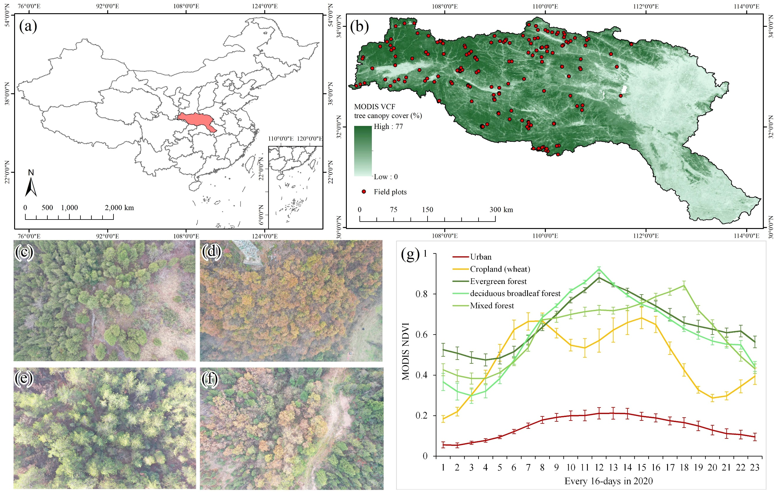
Fig. 1. Study area and field plots. (a) Geolocation of China’s Han River basin; (b) MODIS VCF tree canopy cover image in 2020 and spatial distribution of 182 field plots used for calculating reference above-ground biomass density (AGBD) in China’s Han River basin; UAV true color image of (c) arborvitae forests and (d) chestnut forests in December 2020 at Danjiangkou, Hubei; (e) Masson pine forests and (f) mixed forests (arborvitae and chestnut) in December 2020 at Nanzhang; (g) MODIS NDVI dynamics of various typical land covers in the Han River basin, China.

As shown in Fig. 1(b), a total of 182 field plots were collected to calculate AGBD in the Han River Basin around 2017. Most plots (>80%) were surveyed during the growing season (May–October) of 2017 and 2018, while the remainder were collected in 2015 and 2016. Each plot was rectangular, with dimensions of either 30 m × 40 m or 20 m × 60 m, corresponding to an area of 1,200 m² (0.12 ha). For each plot, the dominant tree species, geographic coordinates, slope, elevation, and topography were recorded. Within each plot, all trees with a diameter at breast height (DBH) > 5 cm and canopy height > 2 m were measured, including their species, DBH, and height. Total AGB per plot was calculated as the sum of the species-specific AGB values for all trees, using the allometric equations developed for China’s tree species [42]. The plot-level AGB estimates (0.12 ha) were converted finally to AGBD units (Mg/ha).
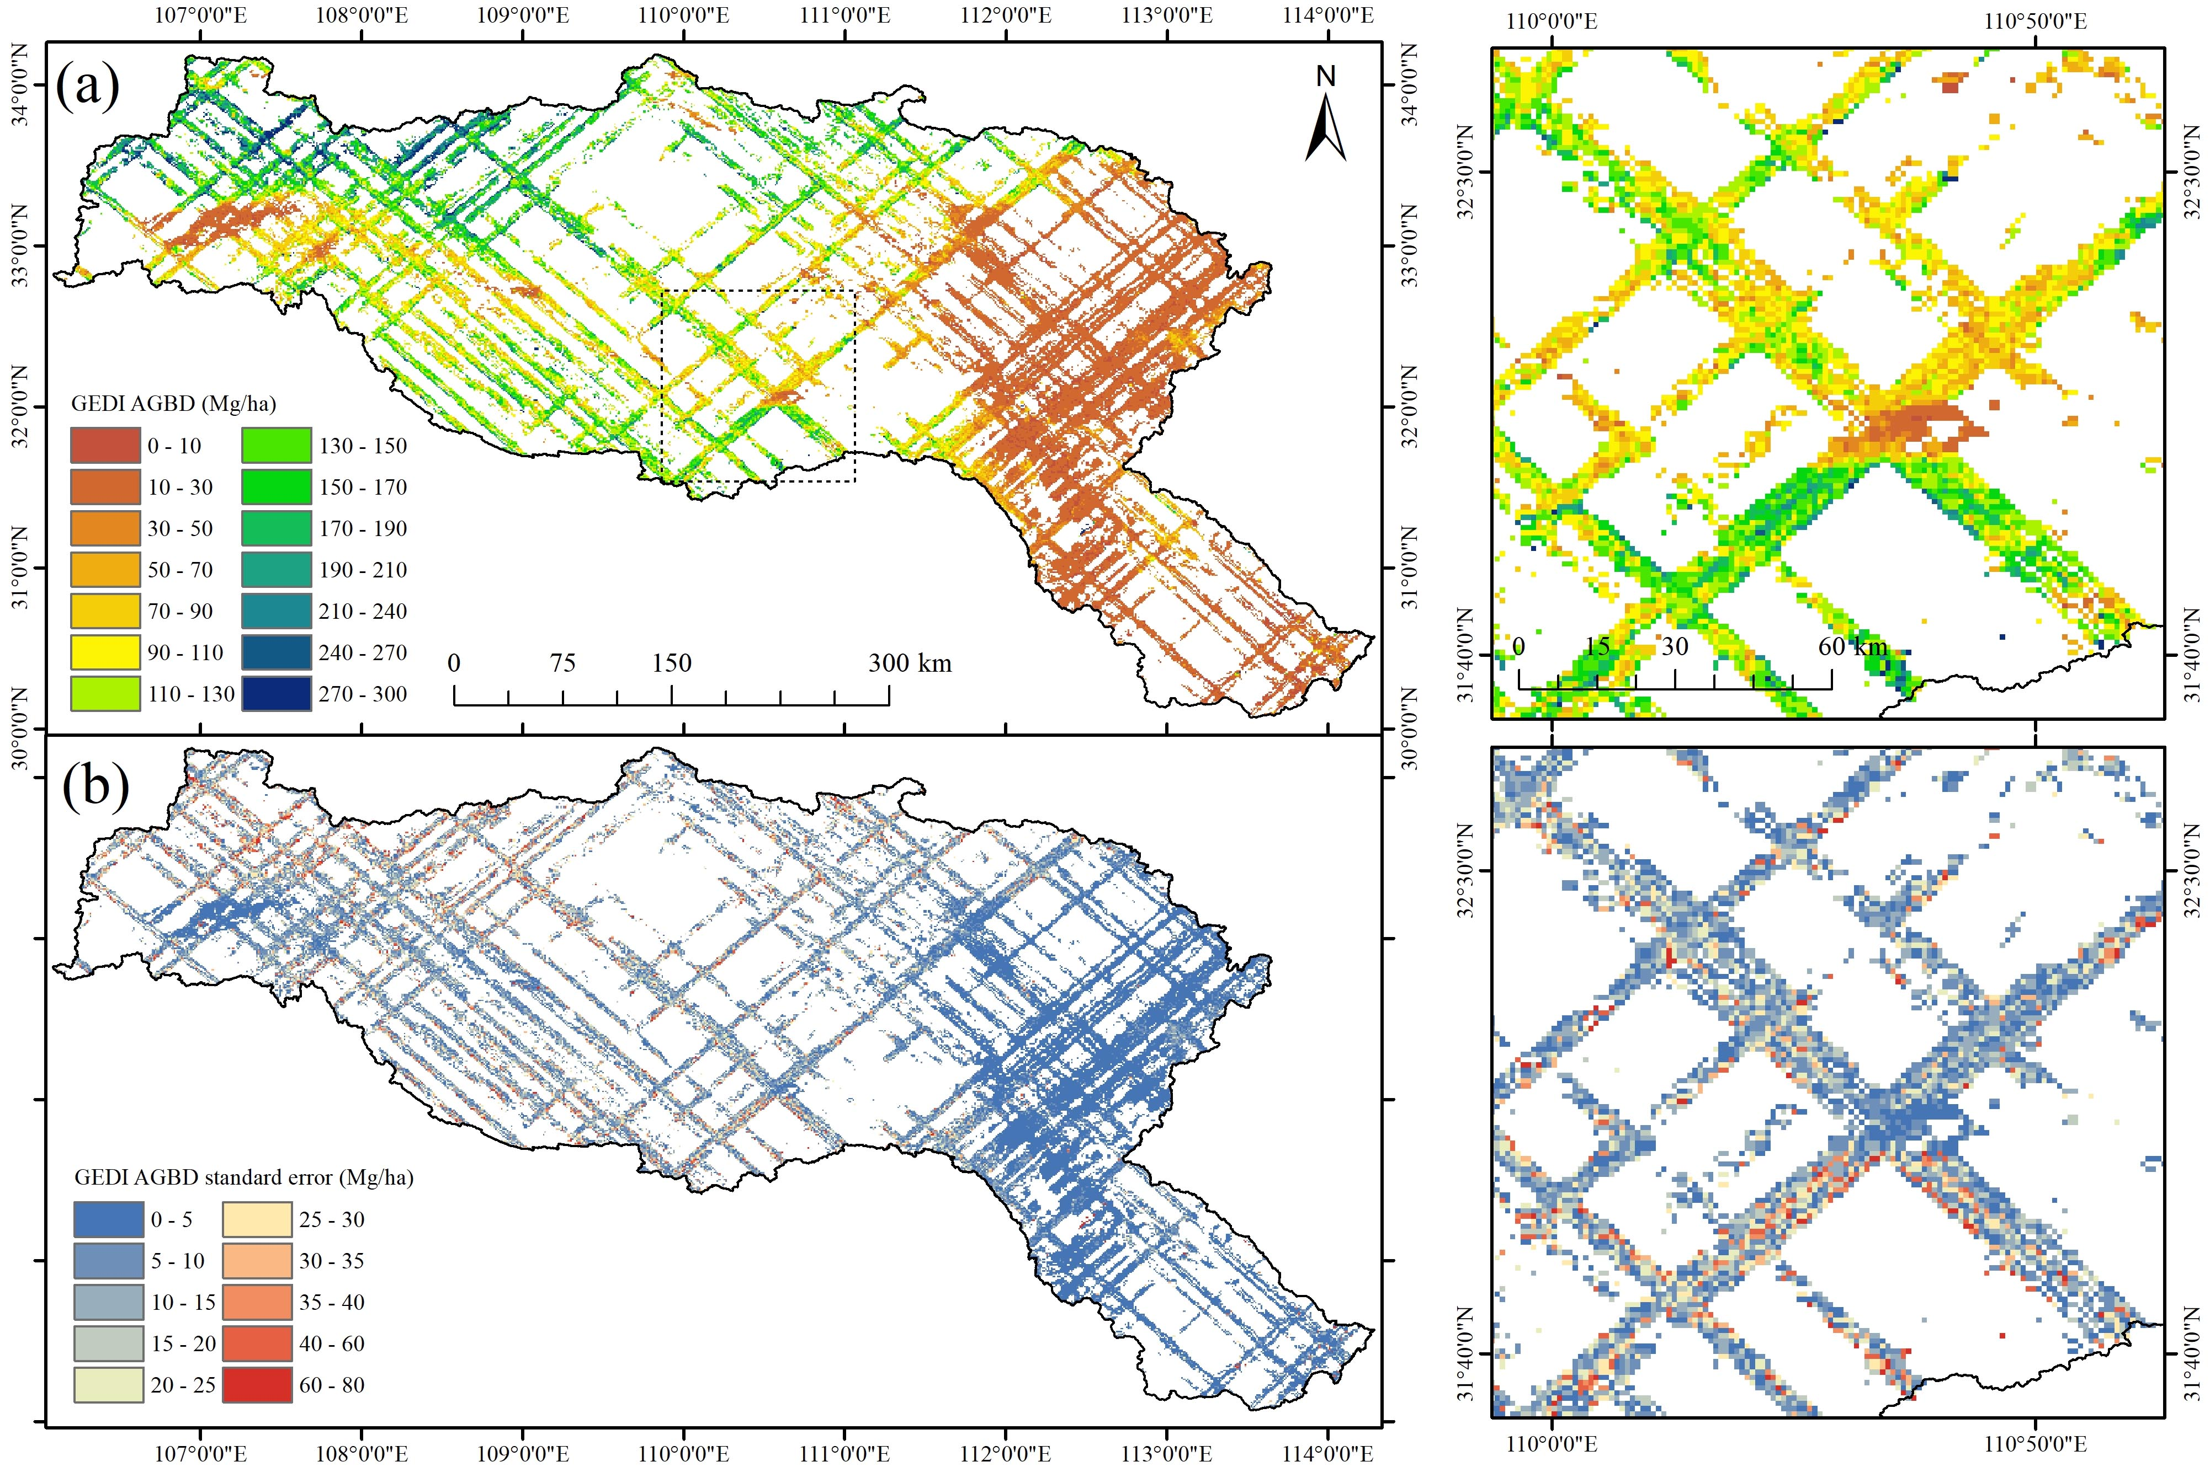
Fig. 2. GEDI AGBD grids and standard error for the year 2020 in China’s Han River basin. (a) GEDI AGBD grids; (b) Standard error of GEDI AGBD grids.

Datasets
The proposed method utilized three types of remote sensing data, namely PALSAR-2, MODIS indices, and topography and climate data (as shown in Table II), to provide covariates for estimating spatio-temporally continuous GEDI AGBD and its standard error for the years 2015-2020 in China’s Han River Basin. Yearly ALOS-2 PALSAR-2 L-band HH and HV polarization images since 2015 were employed for the L-band SAR image. The ALOS-2 PALSAR-2 HH and HV polarization data are initially presented as digital number (DN) values and need to be converted into backscatter coefficients $γ\left(dB\right)$ (Equation 1).
$γ\left(dB\right)=10×\log_{10}{DN}^{2}+C$, (1)
where C is the absolute calibration factor, which consistently equals to -83 for PALSAR-2. In addition to HH and HV, the difference and ratio between these polarizations were employed as covariates in this research.
The MOD13Q1 vegetation index product was used to supply MODIS NDVI and EVI images at 16-day intervals. The yearly mean images complied from 23 MODIS NDVI and EVI images for each year within the period from 2015 to 2020 were used as the covariates. For the array of potential products available through MODIS, this study incorporated five specific ones: vegetation continuous field (VCF), net primary production (NPP), gross primary product (GPP), leaf area index (LAI), and fraction of photosynthetically active radiation (FPAR). Notably, the yearly mean images of GPP, LAI, and FPAR were used as the covariates of the regression models. The tree canopy cover map (Fig. 1(b)) contained in the yearly MODIS VCF product (MOD44B) was used as one of the covariates to provide forest cover information. The yearly MODIS NPP product from MOD17A3HGF and 8-day MODI GPP product from MOD17A2H were used to provide vegetation carbon and water cycle information. The 8-day MODIS LAI and FPAR product from MOD15A2H was used to provide information related to vegetation growth and photosynthesis. As for GPP, LAI and FPAR, the covariates were constructed using the annual mean images generated from the yearly 8-day MODIS products.
Table II
Summary of the datasets used to estimate spatio-temporally continuous AGBD and its uncertainty.
Dataset type | Variable source | Spatial resolution | Frequency | Product name
PALSAR-2 | HH, HV, HH-HV, HH/HV | 25 m | Yearly | PALSAR/PALSAR-2 mosaic
MODIS vegetation indices | NDVI, EVI, VCF, NPP, GPP, LAI, FPAR | 250-500 m | NDVI and EVI: 16 days,  VCF and NPP: yearly,  GPP, LAI and FPAR: 8 days | NDVI and EVI: MOD13Q1, VCF: MOD44B, NPP: MOD17A3HGF,  GPP: MOD17A2H,  LAI and FPAR: MOD15A2H
Topography and climate data | DEM, Slope, LST, ET | 30-1000 m | DEM and Slope: 2000,  LST and ET: 8 days | DEM and Slope: STRM, LST: MOD11A1, ET: MOD16A2
GEDI AGBD and standard error grids | AGBD | 1000 m | Yearly | GEDI L4B AGBD (version 2)

The western Han River Basin is characterized by mountainous terrain, with forest covers closely tied to the distribution of topography. Therefore, SRTM DEM and Slope were employed as covariates to provide terrain information. Additionally, the 8-day MODIS land surface temperature (LST) product and evapotranspiration (ET) product were used to provide climate information, in which the yearly mean images of 46 MODIS LST and ET for each year from 2015 to 2020 were employed as covariates.
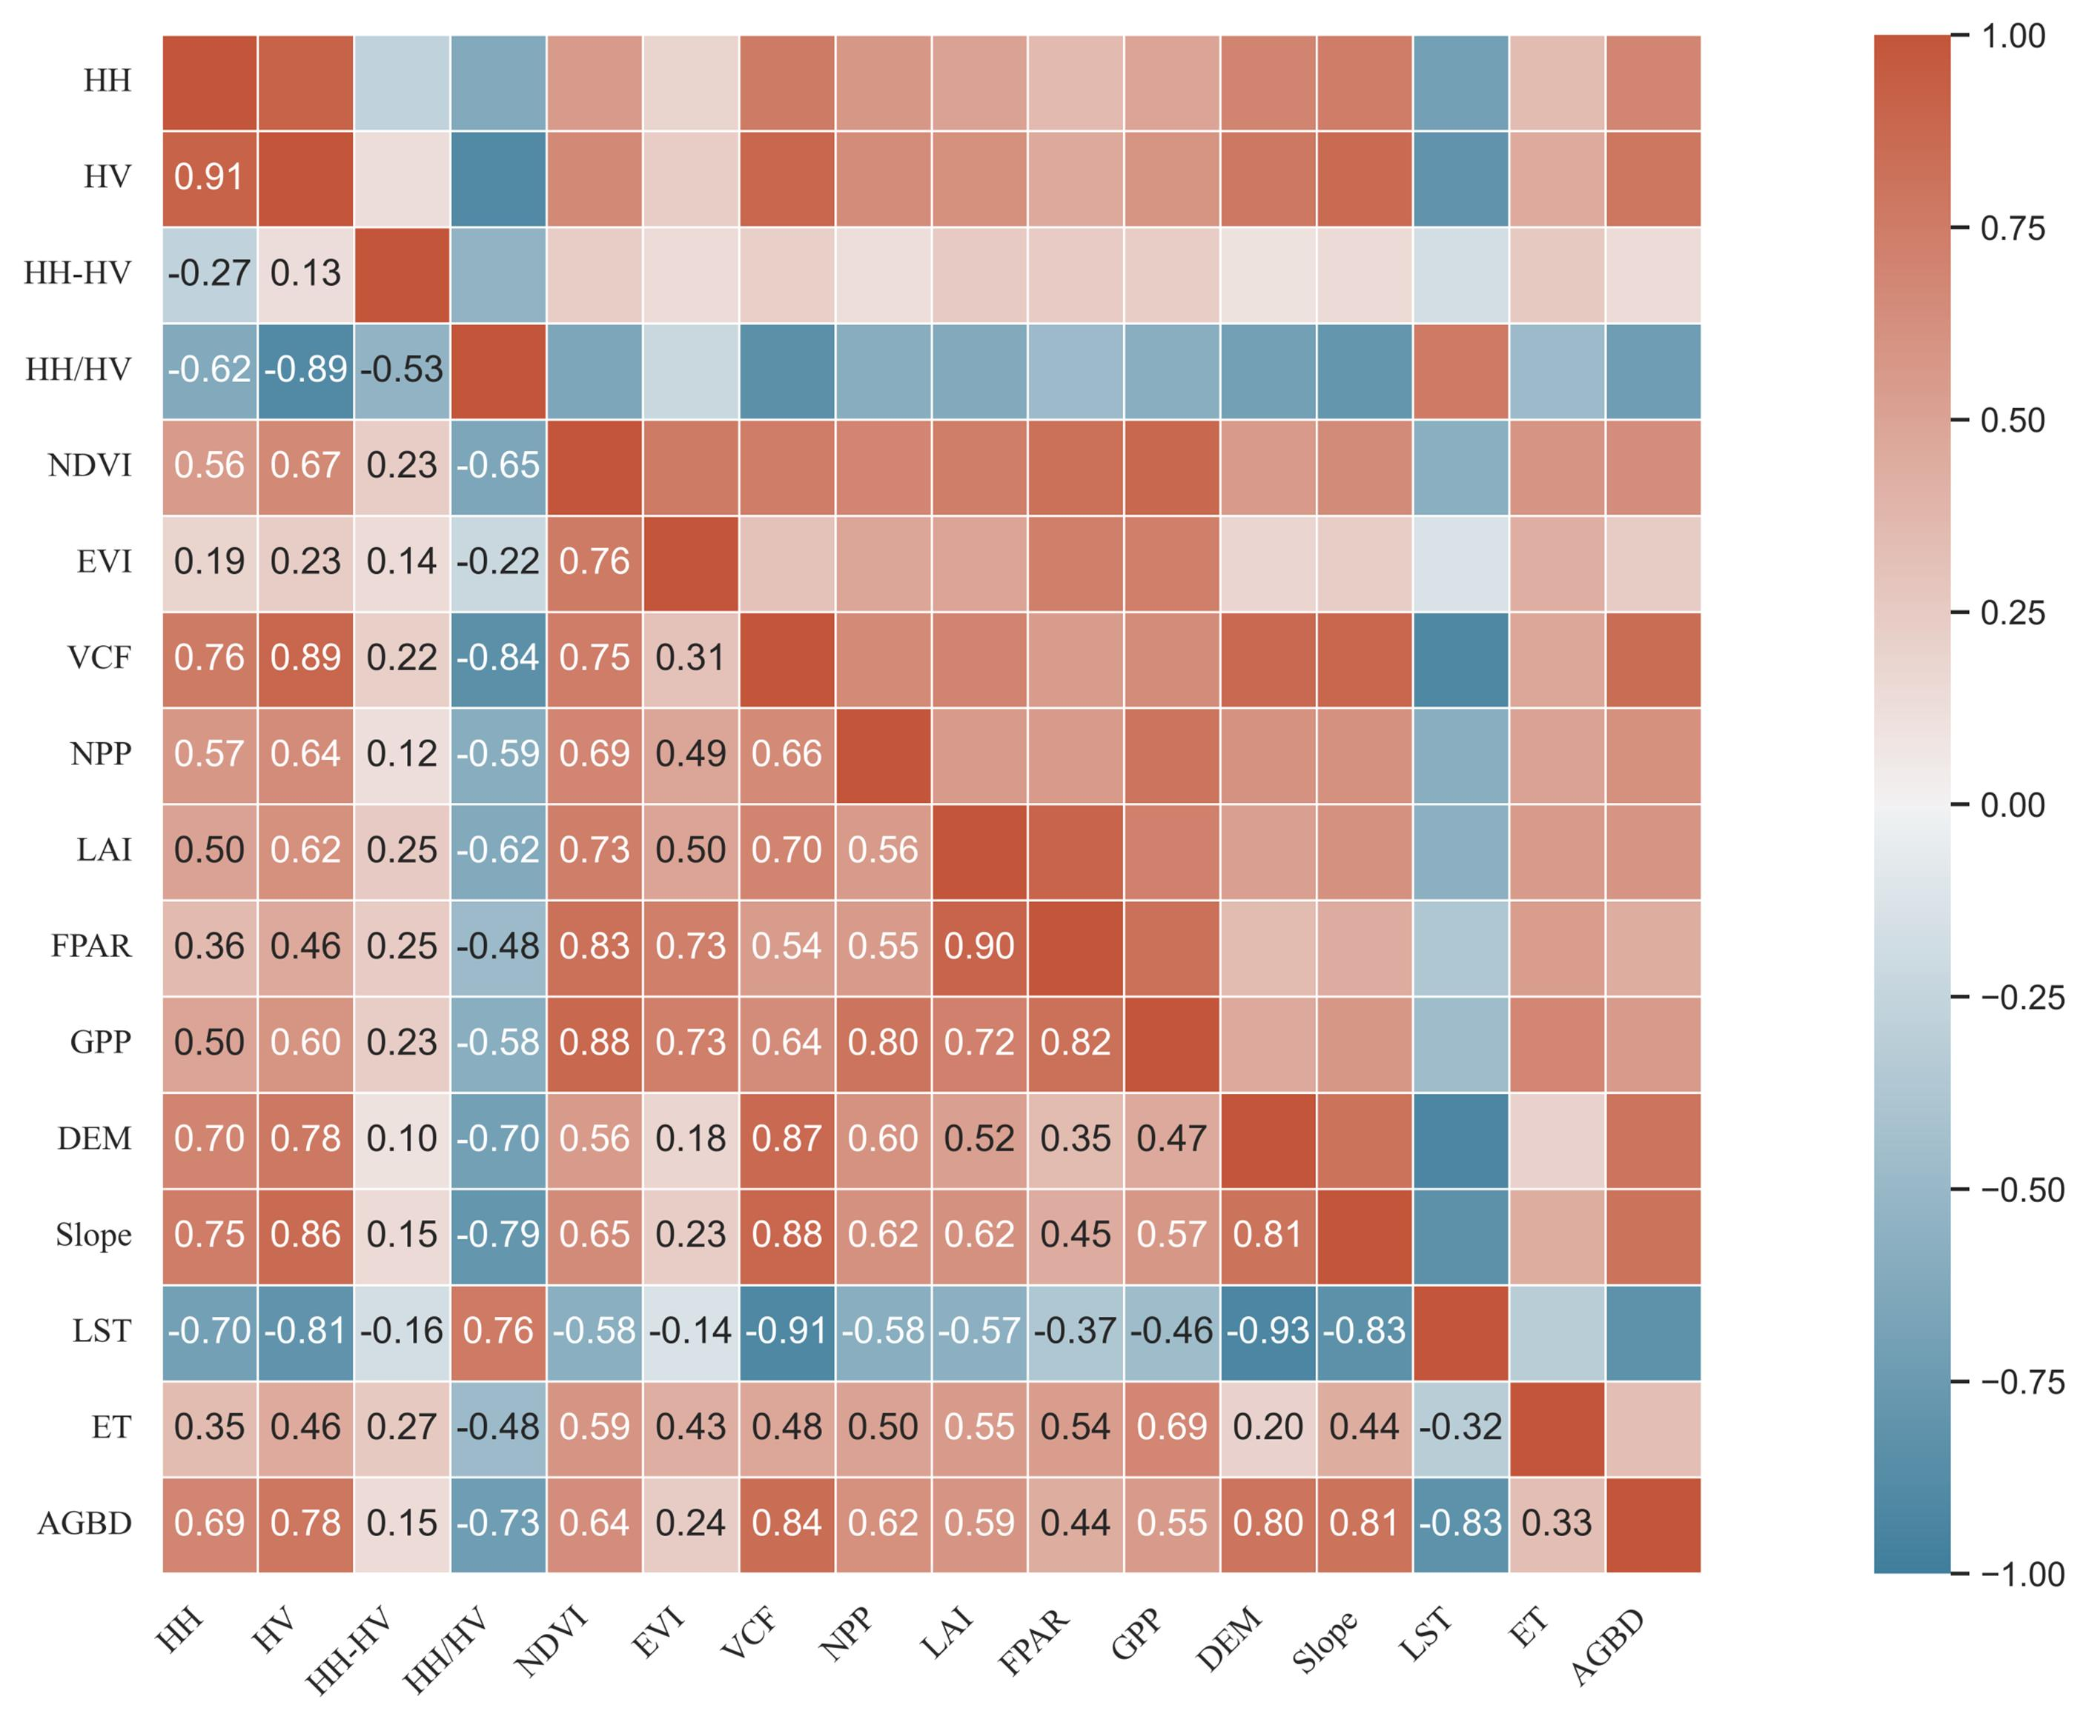
Fig. 3. Correlation coefficients map between multiple variables.
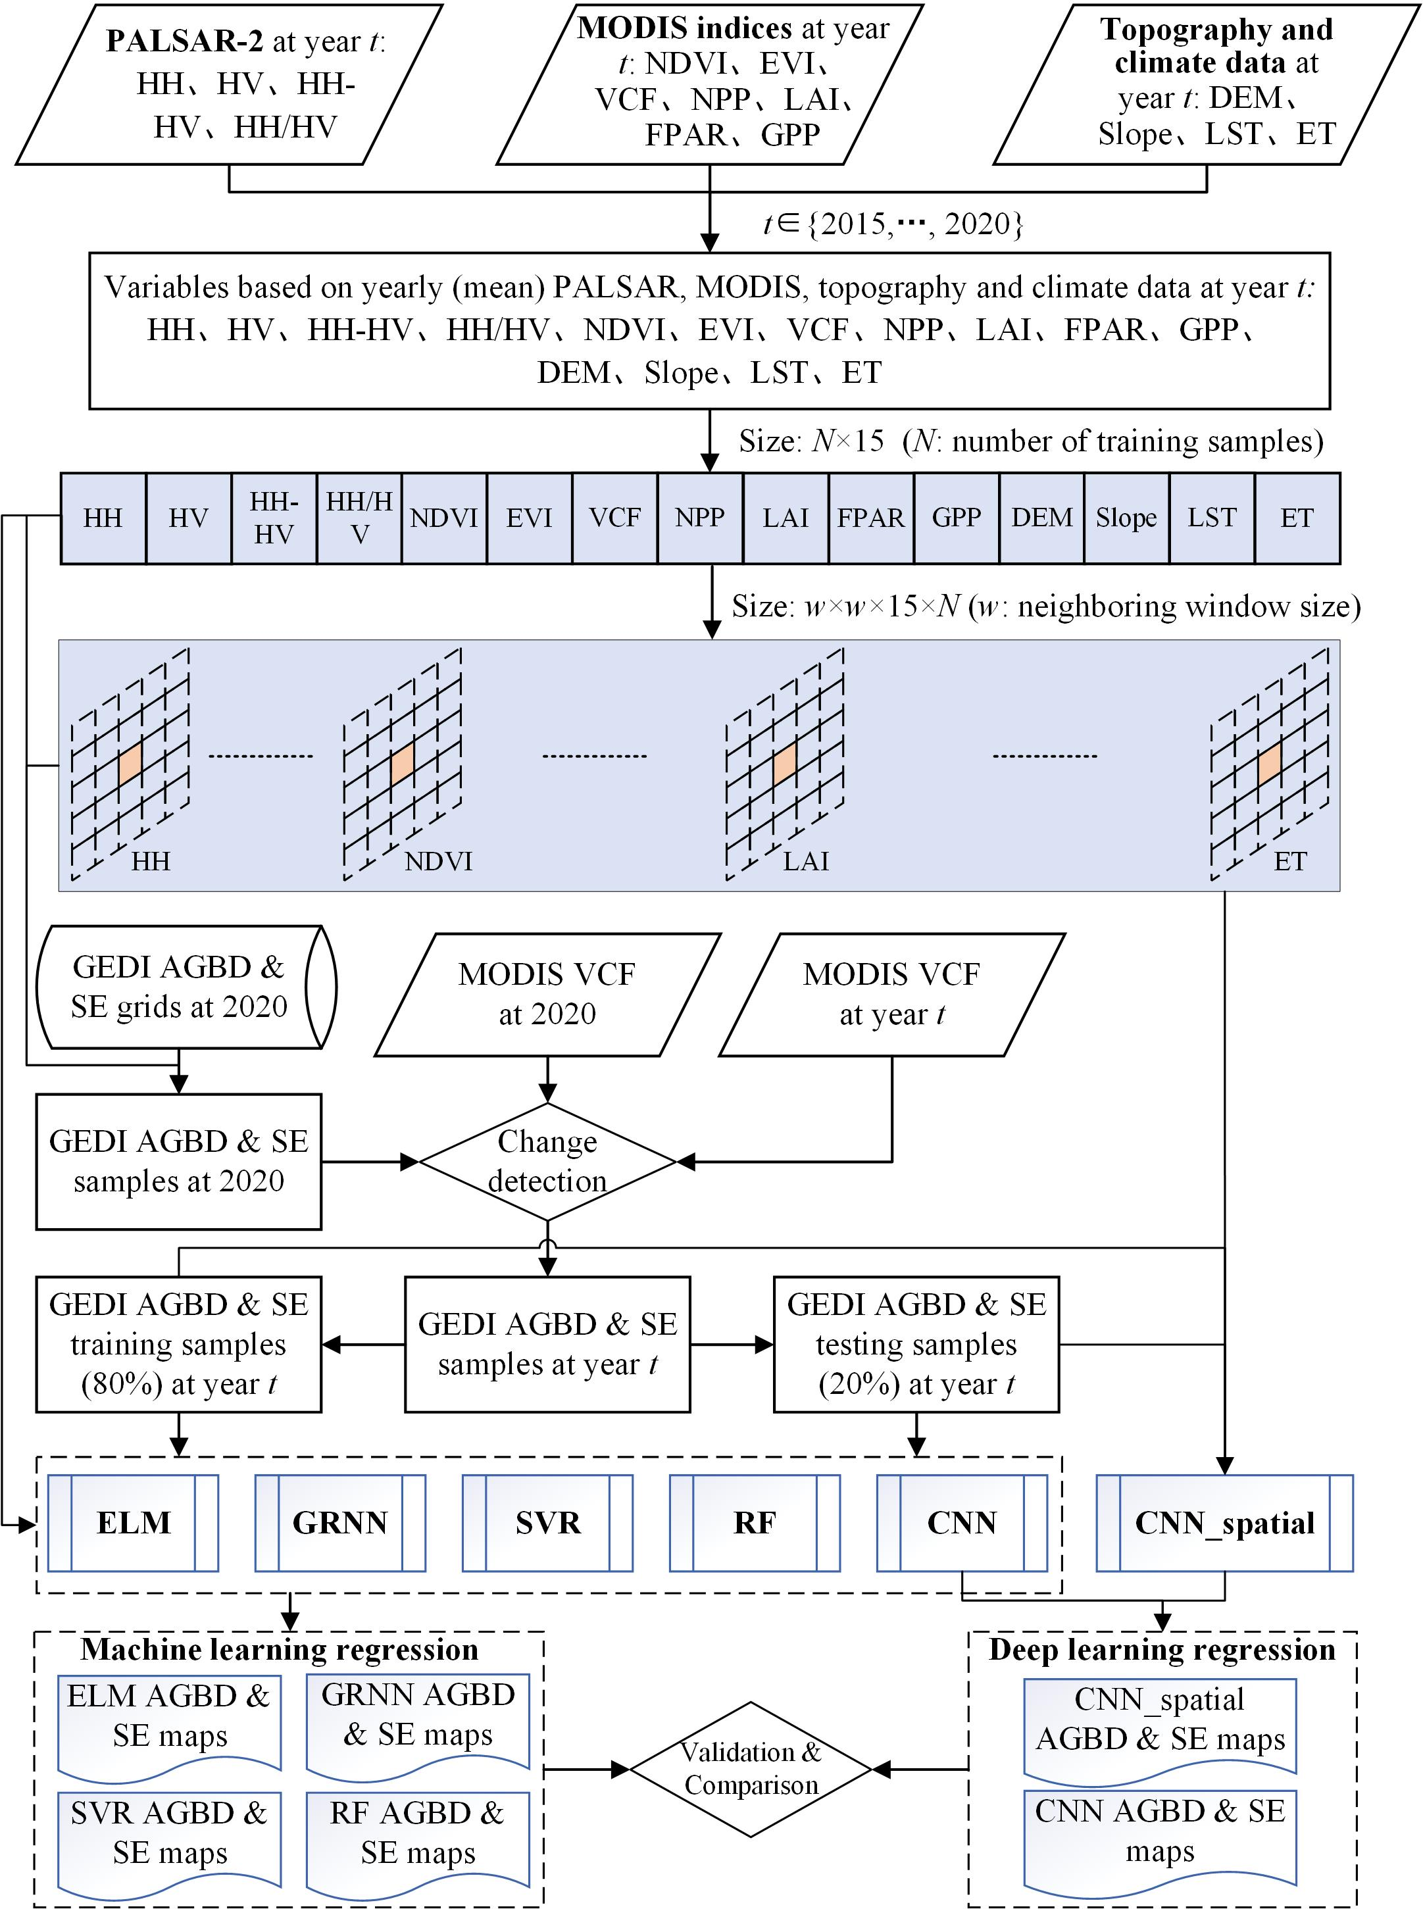
Fig. 4. Flowchart of the proposed method.
The 1 km spatial resolution GEDI L4B AGBD (version 2) product was used in this study. It was generated from the 25 m GEDI LiDAR grids collected from April 2019 to August 2021, alongside additional field inventory data. As depicted in Fig. 2(a), numerous gaps are evident in the GEDI AGBD grids. The standard error, represented as uncertainty in Fig. 2(b), from the mean aboveground biomass density in the GEDI L4B AGBD grids product was also used here for high-quality data selection and predicting uncertainty. In the GEDI AGBD and standard error grids maps, we randomly selected 8000 sample pixels for use as training data in the subsequent machine learning and deep learning regression models and an additional 2000 sample pixels were designated as validation data, in which the ratio of training to validation samples was maintained at 1:4. Table II provides a summary of all satellite sensors and the corresponding extracted data used as covariates, along with details on spatial and temporal resolution.
A correlation coefficient map (Fig. 3) was generated to illustrate the relationships among the 15 covariates and GEDI AGBD (Table II) used in the following machine learning and deep learning regression models. When assessing correlations between the covariates and the dependent variable (GEDI AGBD), MODIS VCF shows the strongest positive correlation (0.84), followed by Slope (0.81) and DEM (0.80). Interestingly, AGBD exhibits negative correlations with HH/HV (–0.73) and LST (–0.83), likely because forests with high AGBD tend to have lower HH/HV and LST values compared to non-forest areas. Overall, a clear relationship between GEDI AGBD and the input variables is observed in Fig. 3, with all correlation coefficients exceeding 0.15 and most of them greater than 0.5. Among the covariates, the strongest positive inter-correlation (0.91) occurs between HV and HH, while the strongest negative correlation (–0.93) is found between LST and DEM, indicating a robust inverse relationship. Each covariate contributes unique information and cannot be substituted by others.

III. Methodology
With the training samples extracted from GEDI AGBD and standard error grids, we developed a method based on machine learning and deep learning regression models to estimate spatio-temporally continuous GEDI AGBD and its associated uncertainty using PALSAR-2, MODIS and topography and climate data throughout the period from 2015 to 2020. According to Table II, the training and prediction processes in the regression models encompassed a total of 15 covariates: four PALSAR-2 polarizations (HH, HV, HH-HV, and HH/HV), seven MODIS indies (NDVI, EVI, VCF, NPP, GPP, GPP, LAI, LAI, and FPAR), and four topography and climate data (DEM, Slope, LS and ET). The GEDI AGBD grids were employed as the dependent variable, representing the variable that we aimed to estimate. The 8000 GEDI AGBD training samples and 2000 validation samples from the year 2020 were utilized for machine learning and deep learning regression models to estimate a spatial continuous GEDI AGBD map in 2020. However, it is worth noting that training and validation samples are not accessible for the years from 2015 to 2019. To address this, we developed a method (as illustrated in Fig. 4) for estimating spatio-temporal GEDI AGBD maps from 2015 to 2020.

Change detection of GEDI AGBD samples
The tree canopy cover data in MODIS VCF showed a strong correlation with the aboveground biomass of various forest types, including primary and secondary forests [27]. In this research, we also observed a significant association between AGBD derived from the GEDI AGBD grids and the MODIS VCF in the Han River Basin, indicated by a coefficient of determination (R²) of 0.70 (p < 0.001) as shown in Fig. 5.
The tree canopy cover data from MODIS VCF at various time pints served as an indicator to select unchanged GEDI AGBD samples from 2015 to 2019. Each of the GEDI AGBD samples from 2020 corresponds to a pixel x₂₀₂₀ in the MODIS VCF image in 2020 and a pixel x_{i} in the MODIS VCF image for a specific year during 2015-2020. Rather than directly utilizing individual VCF pixels at two different time points to identify unchanged samples, we employed a neighborhood system centered on pixels x_{i}(2020) and x_{i}(t) to offer more robust and reliable information regarding VCF change. The neighborhood system is composed of w × w pixels centered at pixel x_{i}(t). The choice of unchanged GEDI AGBD samples at year t is then expressed as (Equation 2 and Equation 3).
$Sample\left(x_{i}\left(t\right)\right)=\left\{\begin{aligned}Sample(x_{i}(2020)), if \left|{VCF}_{x_{i}(2020)}^{N}−{VCF}_{x_{i}(t)}^{N}\right|≤theta \\ Changed, otherwise\end{aligned}\right.$ (2)
${VCF}_{x_{i}(t)}^{N}=\frac{\sum_{j∈N}{VCF\left(x_{i}(t,j)\right)}}{w∗w}, t∈[2015,2016,⋯,2020]$ (3)
Fig. 5. Relationship between the GEDI AGBD grids and MODIS VCF tree canopy cover.
in which $x_{i}(t)$ is the location of pixel $x_{i}$ at time t. ${VCF}_{x_{i}(t)}^{N}$ represents the tree canopy percentage value in the MODIS VCF image for the neighborhood system N centered at pixel $x_{i}(t)$, and it can be calculated with equation (3). w is the radius of neighborhood system N. $Sample(x_{i}(t))$ is the GEDI AGBD of the sample at the location of pixel $x_{i}$ at time t.
Based on equations (2) and (3), as shown in Fig. 6, if the difference between the mean tree canopy percentage value for the neighborhood system surrounding pixel $x_{i}$ at time t and 2020 is smaller than the specified threshold theta (for example, 3% in this research, selected from the range of 0-10%), and then $Sample(x_{i}(t))$ is deemed sufficiently similar to $Sample(x_{i}(2020))$. Ideally, the value of ‘theta’ could be set to 0, but it can be stringent overly to search for a sufficient number of samples from the training data collected in 2020. Conversely, if the value of ‘theta’ is set too high, it will result in the inclusion of numerous suboptimal samples, consequently increasing the computational cost of nonlinear regression models. However, when the difference between the two time points is substantial, $Sample(x_{i}(t))$ is regarded as having undergone significant changes in comparison to $Sample(x_{i}(2020))$, and the sample in 2020 is not inherited.
The Change detection method for GEDI AGBD samples is applicable to all years within the 2015-2020 period. If we narrow our focus on 2020, the VCF difference indicated in equation (2) would be 0, resulting in the application of all samples to the year 2020. Furthermore, both the training samples (8000) and validation samples (2000) would be chosen for the period from 2015 to 2020 using equations (2) and (3).
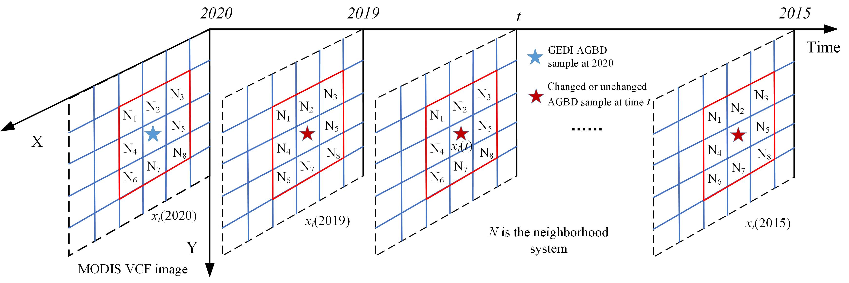
Fig. 6. Illustration of the selection of GEDI AGBD samples during 2015-2020, where the radius w is set to 3.

GEDI AGBD estimation with machine learning and deep learning regression models
With the above collected GEDI AGBD grids samples for each year during 2015-2020, nonlinear regression methods based on machine learning and deep learning are employed to estimate the spatially continuous GEDI AGBD maps. To be specific, the estimation of GEDI AGBD in year t using nonlinear regression can be formulated as:
$Agbd(t)=NLregression([Sample\left(x_{i}\left(t\right),train\right),i=1,2,⋯M])$, (4)
in which $Agbd(t)$ is the spatially continuous AGBD map in year t. $NLregression(∙)$ is the nonlinear regression model. M is the number of training samples in year t and generated from the above change detection approach. $[Sample\left(x_{i}\left(t\right),train\right),i=1,2,⋯M]$ refers to the selected training dataset, which includes 15 covariates of HH, HV, HH-HV, HH/HV, NDVI, EVI, VCF, NPP, GPP, GPP, LAI, LAI, and FPAR, DEM, Slope, LS and ET. The corresponding GEDI AGBD grids are the dependent variable. After fitting the training model based on the training samples with the use of equation (4), the model was then employed to predict the spatially continuous GEDI AGBD map, denoted as $Agbd(t)$, with the input of 15 covariates for the year t. In the subsequent experiment, the covariates from each type of dataset were individually tested, and the outcomes of combing all 15 covariates were subsequently compared.
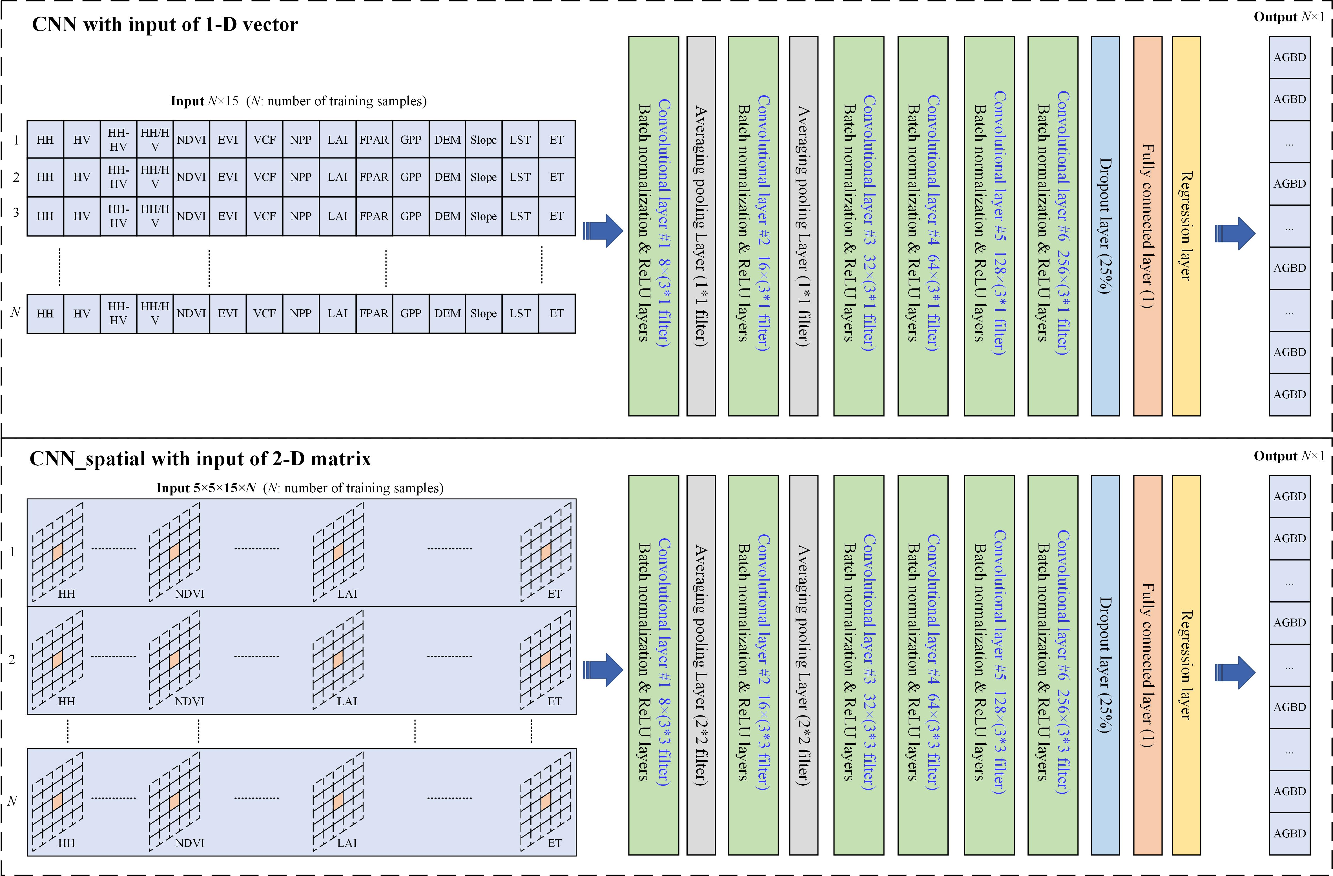
Fig. 7. Architecture of the CNN and CNN_spatial regression networks.
To construct the nonlinear regression model of $NLregression(∙)$ shown in equation (4), a range of machine learning and deep learning methods can be employed [43]. In this study, the machine learning focuses on commonly employed methods, including extreme learning machines (ELM) [44], generalized regression neural network (GRNN) [45], support vector regression (SVR) [46], and random forest (RF) [47]. Deep learning is based on the convolutional neural network (CNN) for regression [48]. The machine learning and deep learning methods were carried out using MATLAB R2022a on a system equipped with an Intel (R) Core (TM) i9-9880H CPU and an NVIDIA GeForce GTX 1650 GPU with 16 GB of memory. More information about the methods is briefly listed as follows:
  - ELM: As a single hidden layer feedforward neural network, ELM consists of the input layer, hidden layer and output layer, which are fully connected to one another [44]. ELM acquires the optimal solution by randomly generating the connection weights between the input and hidden layer. The number of hidden neurons is set to 100.
  - GRNN: As a radial neural network, GRNN consists of an input layer, a pattern layer, a summation layer, and an output layer [45]. It has advantages in converging to the optimal regression surface with more sample size accumulation and can provide robust prediction results with small sample data. The spread of radial basis functions is set to 0.1.
  - SVR: Based on the statistical learning theory, SVR aims to establish a regression model as a decision function and calculates the loss by specifying the minimum error [46]. It is an approximate implementation of structural risk minimization by introducing linear and nonlinear kernel functions. The Gaussian kernel function is used here.
  - RF: As a nonlinear ensemble method, RF builds a certain number (e.g., 200) of random individual decision regression trees for the bootstrap sample and then predicts the result by averaging all the predictions of the individual regression trees [47]. It holds the superiority of having interpretable results and surviving the common overfitting issue when dealing with high dimensional covariate.
  - CNN: As a feed-forward artificial neural network, CNN follows the method of gradient descent and extracts image features from training data using a small number of convolution kernel parameters. Based on the concatenated pooling layer, CNN can achieve the goals of compressing the dimension of data and weakening overfitting issue, and then improve the fault tolerance rate and learn the deeper features of the multi-source data. CNN is widely used to provide solutions for classification and segmentation problems in remote sensing, and it also can be adjusted to solve regression issue. As shown in Fig. 7, we built two CNN regression networks to estimate AGBD in this study. With the same 1-D input data as the four machine learning methods, the first 1-D CNN model is built with six 1-D convolutional layers, two averaging pooling layers, one dropout layer, one fully connected layer and one regression layer. Moreover, to consider the spatial dependence of AGBD distribution, not only the single pixel value for each covariate but also its spatial neighborhoods within a neighboring window system (for example, w = 5, which was chosen from the range of 3-11 by considering the tradeoff between the accuracy and computation time) are used as the 2-D input data of the CNN model, which is denoted as CNN_spatial. As shown in Fig. 7, the 2-D convolutional layers and averaging pooling layers are used in the CNN_spatial model. The Deep Learning Toolbox in MATLAB R2022a was used to complete the building of CNN and CNN_spatial models, and many parameters used the default values.
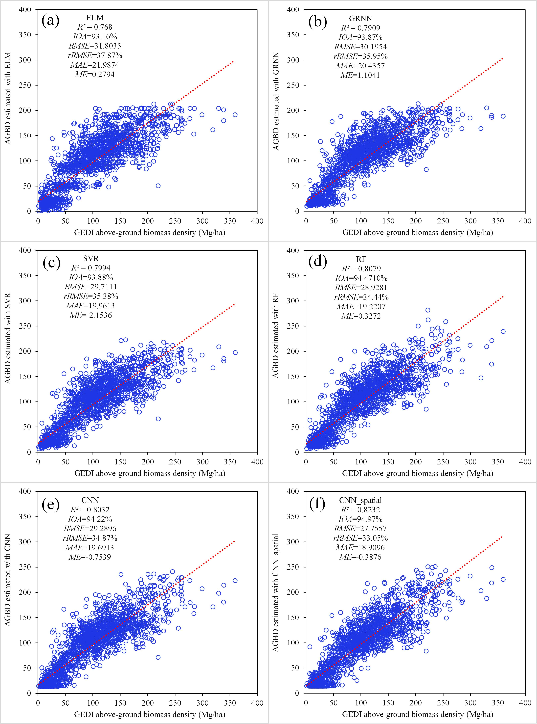
Fig. 8. Accuracy assessment of six metrics (R², IOA, RMSE, rRSME, MAE, ME) and scatterplots for the six results based on the 2000 validation samples. (a) ELM regression result; (b) GRNN regression result; (c) SVR regression result; (d) RF regression result; (e) CNN regression result and (f) CNN_spatial regression result.

Uncertainty of the spatio-temporally continuous GEDI AGBD
The uncertainty in the spatial continuous GEDI AGBD map for year t primarily arises from the uncertainty associated with the training samples extracted from the original GEDI AGBD grids. In fact, each dependent variable within the GEDI AGBD training samples comprises an AGBD value along with its corresponding standard error. The AGBD value of a training sample can vary within a range of ± one standard error, and when performing nonlinear regression estimation based on the training samples, it’s crucial to account for the influence of this standard error. Assuming that all AGBD values of the training samples for the year t are adjusted by adding the corresponding ± one standard error, the estimation of spatially continuous GEDI AGBD map is represented by equation (5) and equation (6).
$Agb(t, +SE)=NLregression([Sample\left(x_{i}\left(t\right),train(+SE)\right),i=1,2,⋯M])$, (5)
$Agb(t, −SE)=NLregression([Sample\left(x_{i}\left(t\right),train(−SE)\right),i=1,2,⋯M])$, (6)
where the $train(+SE)$ and $train(−SE)$ are training samples with GEDI AGBD values adding and subtracting one standard error, respectively. $Agb(t, +SE)$ and $Agb(t, −SE)$ are the AGBD maps estimated with training samples $train(+SE)$ and $train(−SE)$. Based on AGBD maps estimated with equations (4), (5) and (6), the standard error for the spatial continuous GEDI AGBD map $Agb(t)$ in Section 3.2 can be expressed by equation (7).
$SEagb\left(t\right)=0.5×(\left|Agb\left(t\right)−Agb(t, +SE)\right|+\left|Agb\left(t\right)−Agb(t, −SE)\right|)$, (7)
in which $SEagb\left(t\right)$ is the standard error map associated with the estimated spatial continuous GEDI AGBD map $Agb(t)$, and it can be calculated for all the estimated AGBD maps during 2015-2020.

D. Accuracy assessment and comparison
The Accuracy assessment of the spatially continuous GEDI AGBD maps generated by different methods was based on the randomly selected 2000 validation samples for each year within 2015-2020, as well as the reference AGBD collected from the 182 field plots around 2017. Six accuracy metrics were employed to assess the generated AGBD maps: coefficient of determination (R²) (equation (8)), index of agreement (IOA) (equation (9)), root mean square error (RMSE) (equation (10)), relative root mean square error (rRMSE) (equation (11)), mean absolute difference (MAE) (equation (12)) and mean error (ME) (equation (13)).
$R^{2}=1−\frac{\sum_{i}^{N}{{({\hat{y}}_{i}−y_{i})}^{2}}}{\sum_{i}^{N}{{(y_{i}−\overline{y})}^{2}}}$, (8)
$IOA=\left[1−\frac{\sum_{i}{{\left({\hat{y}}_{i}−y_{i}\right)}^{2}}}{\sum_{i}{{\left(\left|\overline{y}−y_{i}\right|+\left|{\hat{y}}_{i}−y_{i}\right|\right)}^{2}}}\right]×100\%$, (9)
$RMSE=\sqrt{\frac{1}{N}\sum_{i}^{N}{{({\hat{y}}_{i}−y_{i})}^{2}}}$, (10)
$rRMSE=\frac{RMSE}{\overline{y}}×100\%$, (11)
$MAE=\frac{1}{N}\sum_{i}^{N}{\left|{\hat{y}}_{i}−y_{i}\right|}$, (12)
$ME=\frac{1}{N}\sum_{i}^{N}{({\hat{y}}_{i}−y_{i})}$, (13)
in which ${\hat{y}}_{i}$ and $y_{i}$ are the reference AGBD value and the corresponding predicted AGBD value for validation sample i, respectively. N is the number of validation samples, and $\overline{y}$ is the mean value of the reference GEDI AGBD for all the validation samples.
To compare our estimated AGBD with both global and locally developed AGBD maps, two benchmark products were used. The first is a locally developed AGBD product for China, which provides annual estimates at a 1 km spatial resolution from 2002 to 2021 [49]. The second is the global ESA_CCI biomass product, available at a spatial resolution of 100 m for the years 2007, 2010, and 2015–2022 [31]. Using 182 field plots collected around 2017 as reference data, we selected the AGBD maps from Chen, et al. [49] and ESA_CCI product in 2017 for comparison.

IV. Results
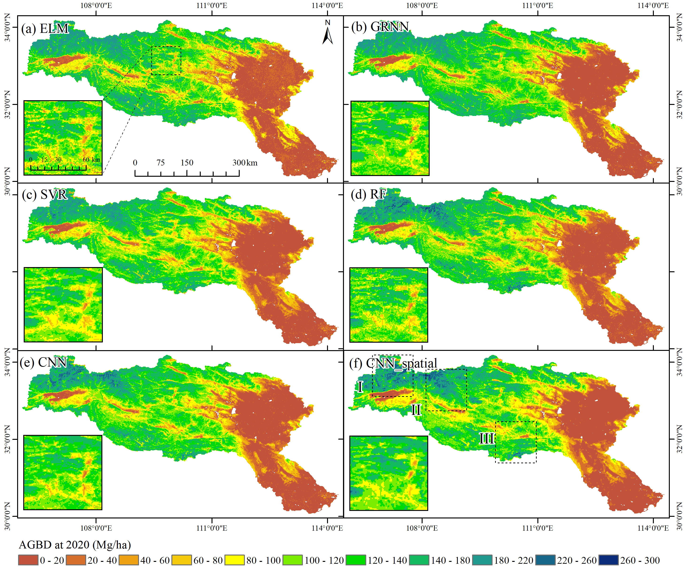
Fig. 9. Spatially continuous GEDI AGBD maps in China’s Han River basin in 2020 produced by different methods. (a) ELM regression result; (b) GRNN regression result; (c) SVR regression result; (d) RF regression result; (e) CNN regression result; (f) CNN_spatial regression result. The three boxes in Fig. 9(f) show the geolocation of the zoomed areas in the following Fig. 10.

GEDI AGBD maps estimated by different methods
The spatially continuous GEDI AGBD maps for the year 2020 estimated by four machine learning methods (i.e., ELM, GRNN, SVR, and RF) and two deep learning methods (i.e., CNN and CNN_spatial) are presented here. In particular, the results’ accuracy assessments are listed in Fig. 8, and Fig. 9 shows the spatial distribution of different results. Additionally, Fig. 10 offers three zoomed areas of the six resultant AGBD maps, facilitating a comprehensive comparison of the estimated GEDI AGBD maps obtained through different methods.
Fig. 9 displays scatterplots and accuracy assessments of the six resultant AGBD values against the reference samples extracted from GEDI AGBD grids. As indicated by Fig. 8, ELM exhibits the lowest accuracy when compared to the other methods. GRNN and SVR exhibit similar levels of accuracy, while RF achieved the highest accuracy among the four machine learning methods. CNN demonstrates superior accuracy compared to ELM, GRNN, and SVR, although it falls slightly short of the accuracy achieved by RF. Crucially, CNN_spatial attains the best accuracy among the four machine learning methods and the deep learning method of CNN, as supported by the following evaluation metrics: R² = 0.8232, IOA = 94.97%, RMSE = 27.7557, rRSME = 33.05%, MAE = 18.9096, and ME = -0.3876.
As depicted in Fig. 9, the GEDI AGBD maps resulting from the six nonlinear regression methods showcase comparable spatial distributions, albeit with differences in spatial details. The ELM result tends to underestimate the high AGBD values in the forests of northwest mountains while overestimating the low AGBD values in the forests of the southeastern mountain and urban areas, as illustrated in Fig. 9(a). These patterns are further highlighted in the zoomed areas shown in Fig. 10. Both GRNN and SVR show improved estimates of low AGBD values in southeastern mountains and urban areas, but they continue to face challenges in accurately representing high AGBD values in the forests of the northwest mountain, as observed in Figs. 8(b-c) and Fig. 10. In comparison with the other three machine learning regression methods, RF demonstrates enhancements in the estimates of both high and low AGBD values within mountain forests (see Fig. 9(d) and Fig. 10). The CNN result exhibit similarities to that of RF (see Fig. 9(e)), but CNN model tends to represent more areas with high AGBD values (see Fig. 10). Nonetheless, CNN_spatial (see Fig. 9(f) and Fig. 10) demonstrated a notable advantage in accurately estimating both high and low AGBD values within mountain forests and urban areas, closely resembling the reference GEDI AGBD grids.
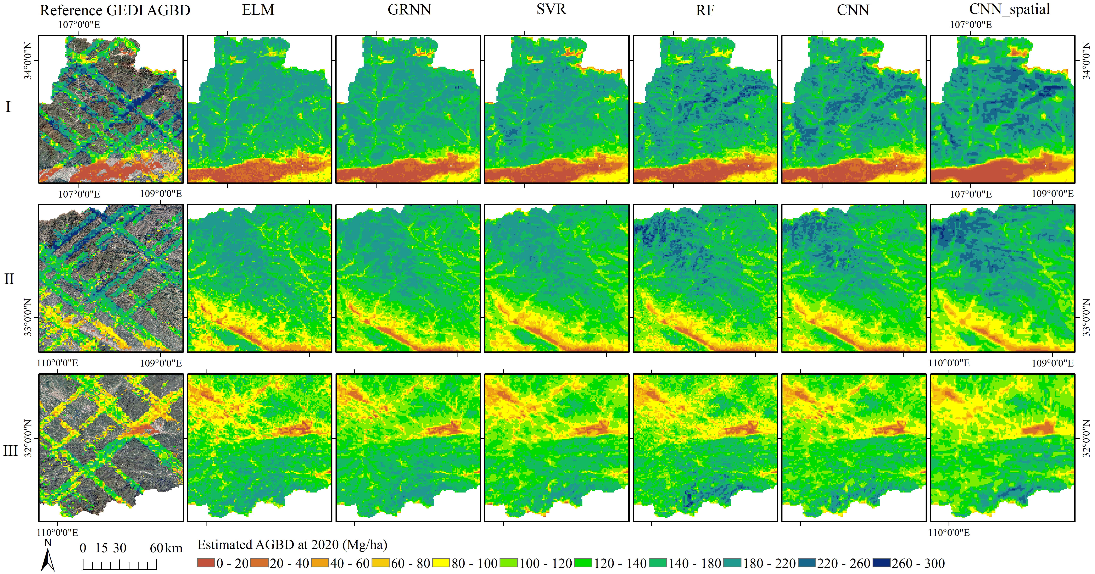
Fig. 10. Three zoomed areas of the spatial continuous GEDI AGBD maps produced by different methods in Fig. 9.
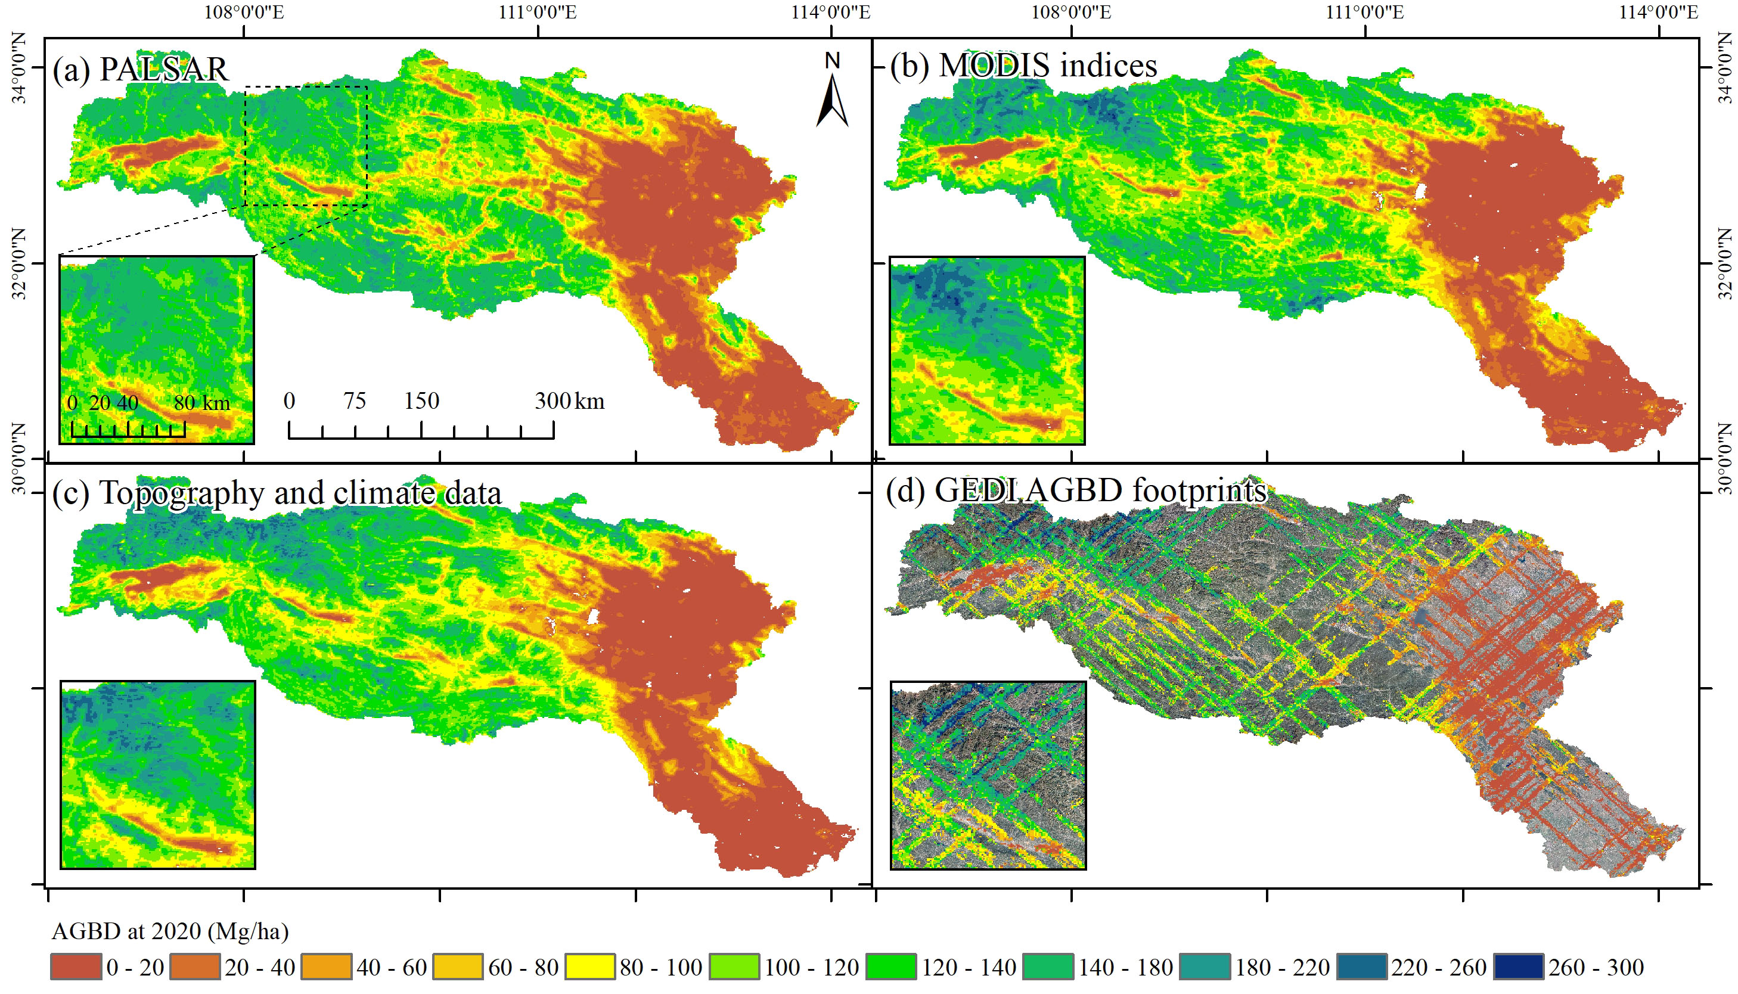
Fig. 11. Spatially continuous GEDI AGBD maps for China’s Han River basin in 2020 produced by CNN_spatial regression with different types of input datasets. (a) CNN_spatial regression result with PALSAR-2 (HH, HV, HH-HV and HH/HV) covariates; (b) CNN_spatial regression result with MODIS NDVI, EVI, VCF, NPP, GPP, LAI and FPAR covariates; (c) CNN_spatial regression result with DEM, Slope, LST and ET covariates; (d) GEDI AGBD grids and Landsat true colour image circa 2020.

GEDI AGBD maps estimated with different datasets
Fig. 12. Importance ranking of 15 covariates in the RF regression.
Table III
Accuracy assessment of GEDI AGBD produced by different methods with three types of input datasets.
Dataset | Index | Best value | ELM | GRNN | SVR | RF | CNN | CNN_spatial
PALSAR-2 (HH, HV, HH-HV, HH/HV) | R² | 1 | 0.6273 | 0.6608 | 0.6931 | 0.6886 | 0.7027 | 0.7377
PALSAR-2 (HH, HV, HH-HV, HH/HV) | IOA | 100% | 87.51% | 87.98% | 89.52% | 90.29% | 90.64% | 91.95%
PALSAR-2 (HH, HV, HH-HV, HH/HV) | RMSE | 0 | 40.2884 | 38.6686 | 36.9814 | 36.8825 | 35.985 | 33.7998
PALSAR-2 (HH, HV, HH-HV, HH/HV) | rRMSE | 0% | 47.97% | 46.04% | 44.03% | 43.91% | 42.84% | 40.24%
PALSAR-2 (HH, HV, HH-HV, HH/HV) | MAE | 0 | 27.4611 | 26.8028 | 24.6776 | 25.5312 | 24.5198 | 22.8996
PALSAR-2 (HH, HV, HH-HV, HH/HV) | ME | 0 | 0.0158 | 1.0101 | -4.9405 | -0.388 | -0.1532 | 0.2435
MODIS indices (NDVI, EVI, VCF, NPP, LAI, FPAR, GPP) | R² | 1 | 0.7312 | 0.7480 | 0.7576 | 0.7651 | 0.7668 | 0.7828
MODIS indices (NDVI, EVI, VCF, NPP, LAI, FPAR, GPP) | IOA | 100% | 91.72% | 92.17% | 92.03% | 93.01% | 92.87% | 93.66%
MODIS indices (NDVI, EVI, VCF, NPP, LAI, FPAR, GPP) | RMSE | 0 | 34.2146 | 33.1556 | 32.9857 | 31.9874 | 31.923 | 30.7687
MODIS indices (NDVI, EVI, VCF, NPP, LAI, FPAR, GPP) | rRMSE | 0% | 40.74% | 39.48% | 39.27% | 38.09% | 38.01% | 36.63%
MODIS indices (NDVI, EVI, VCF, NPP, LAI, FPAR, GPP) | MAE | 0 | 23.8677 | 23.2196 | 22.5024 | 21.8044 | 21.8586 | 20.9998
MODIS indices (NDVI, EVI, VCF, NPP, LAI, FPAR, GPP) | ME | 0 | 0.298 | 0.5055 | -4.5298 | -0.1535 | -1.5593 | -0.0612
Topography and climate data (DEM, Slope, LST, ET) | R² | 1 | 0.7566 | 0.7574 | 0.7698 | 0.7778 | 0.7818 | 0.8011
Topography and climate data (DEM, Slope, LST, ET) | IOA | 100% | 92.76% | 92.68% | 92.63% | 93.54% | 93.61% | 94.21%
Topography and climate data (DEM, Slope, LST, ET) | RMSE | 0 | 32.5839 | 32.5034 | 31.9331 | 31.146 | 30.8365 | 29.4491
Topography and climate data (DEM, Slope, LST, ET) | rRMSE | 0% | 38.80% | 38.70% | 38.02% | 37.08% | 36.71% | 35.06%
Topography and climate data (DEM, Slope, LST, ET) | MAE | 0 | 22.1525 | 22.2022 | 21.5369 | 20.6368 | 20.6987 | 19.9384
Topography and climate data (DEM, Slope, LST, ET) | ME | 0 | 0.4006 | 0.3050 | -2.6535 | 0.2127 | -0.2682 | -1.1092

To establish a benchmark comparison, we used six nonlinear regression techniques to generate GEDI AGBD maps for the year 2020. These maps were produced using covariates selected from three distinct datasets. Fig. 11 illustrates the outcome when employing four PALSAR-2 covariates as input for the CNN_spatial model, resulting in a spatially continuous GEDI AGBD map for 2020. However, it is important to note that this PALSAR-2-derived model exhibited the lowest accuracy, as detailed in Table III. Specifically, it tended to overestimate AGBD in regions with low tree canopy cover while underestimate AGBD values in regions with a higher tree canopy cover percentage. Additionally, it significantly underestimated AGBD in densely forested areas within the northern mountain regions and overestimated AGBD in urban areas with impervious surfaces. Comparatively, the results obtained from MODIS indices (Fig. 11 (b)) and topography and climate data (Fig. 11 (c)) showed substantial improvements in estimating AGBD values for both high and low AGBD regions within mountain forests. Notably, the results based on topography and climate data exhibited superior accuracy when compared to those using MODIS indices (Table III). As summarized in Table III, it becomes apparent that the outcomes generated by ELM, GRNN, SVR, RF, and CNN generally exhibited a similar trend to that of the CNN_spatial model. However, it is worth highlighting that the GEDI AGBD map produced by incorporating covariates from all three datasets demonstrated superior accuracy when compared to maps generated using a single dataset type.
The RF regression model offers the ability to assess variable importance ratio by incorporating an out-of-bag estimation of feature importance within the ensemble. To examine the variable importance used in this study, Fig. 12 presents the importance ranking for the 15 covariates in the RF regression model, which is used to estimate spatially continuous GEDI AGBD in 2020. Consistent with the accuracy trend observed for the three types of datasets shown in Table III, the PALSAR-2 covariates (HH, HV, HH-HV and HH/HV) exhibit the lowest importance ratio among the three types of covariates, followed by MODIS indices (NDVI, EVI, VCF, NPP, LAI, FPAR, GPP), while the topography and climate data (DEM, Slope, LST, ET) hold the highest importance ratio. Among the 15 covariates, the most crucial one is LST, while the least important is the HH/HV. Furthermore, LST, DEM, LAI, ET and NPP covariates exhibit higher importance ratios compared to the other covariates. It is intriguing to note that despite the high correlation between MODIS VCF and GEDI AGBD (see Fig. 4), the importance ratio of MODIS VCF in the RF regression model remains at a moderate level in comparison with the other covariates.

Spatio-temporally continuous GEDI AGBD maps during 2015-2020
Utilizing the unchanged training samples selected for each year from 2015 to 2020, we produced spatio-temporally continuous GEDI AGBD maps and an AGB net change map for the period from 2015 to 2020, employing the most efficient method of CNN_spatial (see Fig. 13). With the training samples from 2020, a straightforward approach involves using all of them to predict the GEDI AGBD map for each year from 2015 to 2020. This approach is employed for comparison with the results derived from the selected unchanged training samples. Table IV displays the corresponding accuracy assessments for various years. The results for all years from 2015 to 2020, which are based on the selected unchanged training samples, achieve higher levels of accuracy in comparison to those obtained by directly using training data from 2020. This observation highlights the superiority of the proposed method in accurately estimating time-series GEDI AGBD.
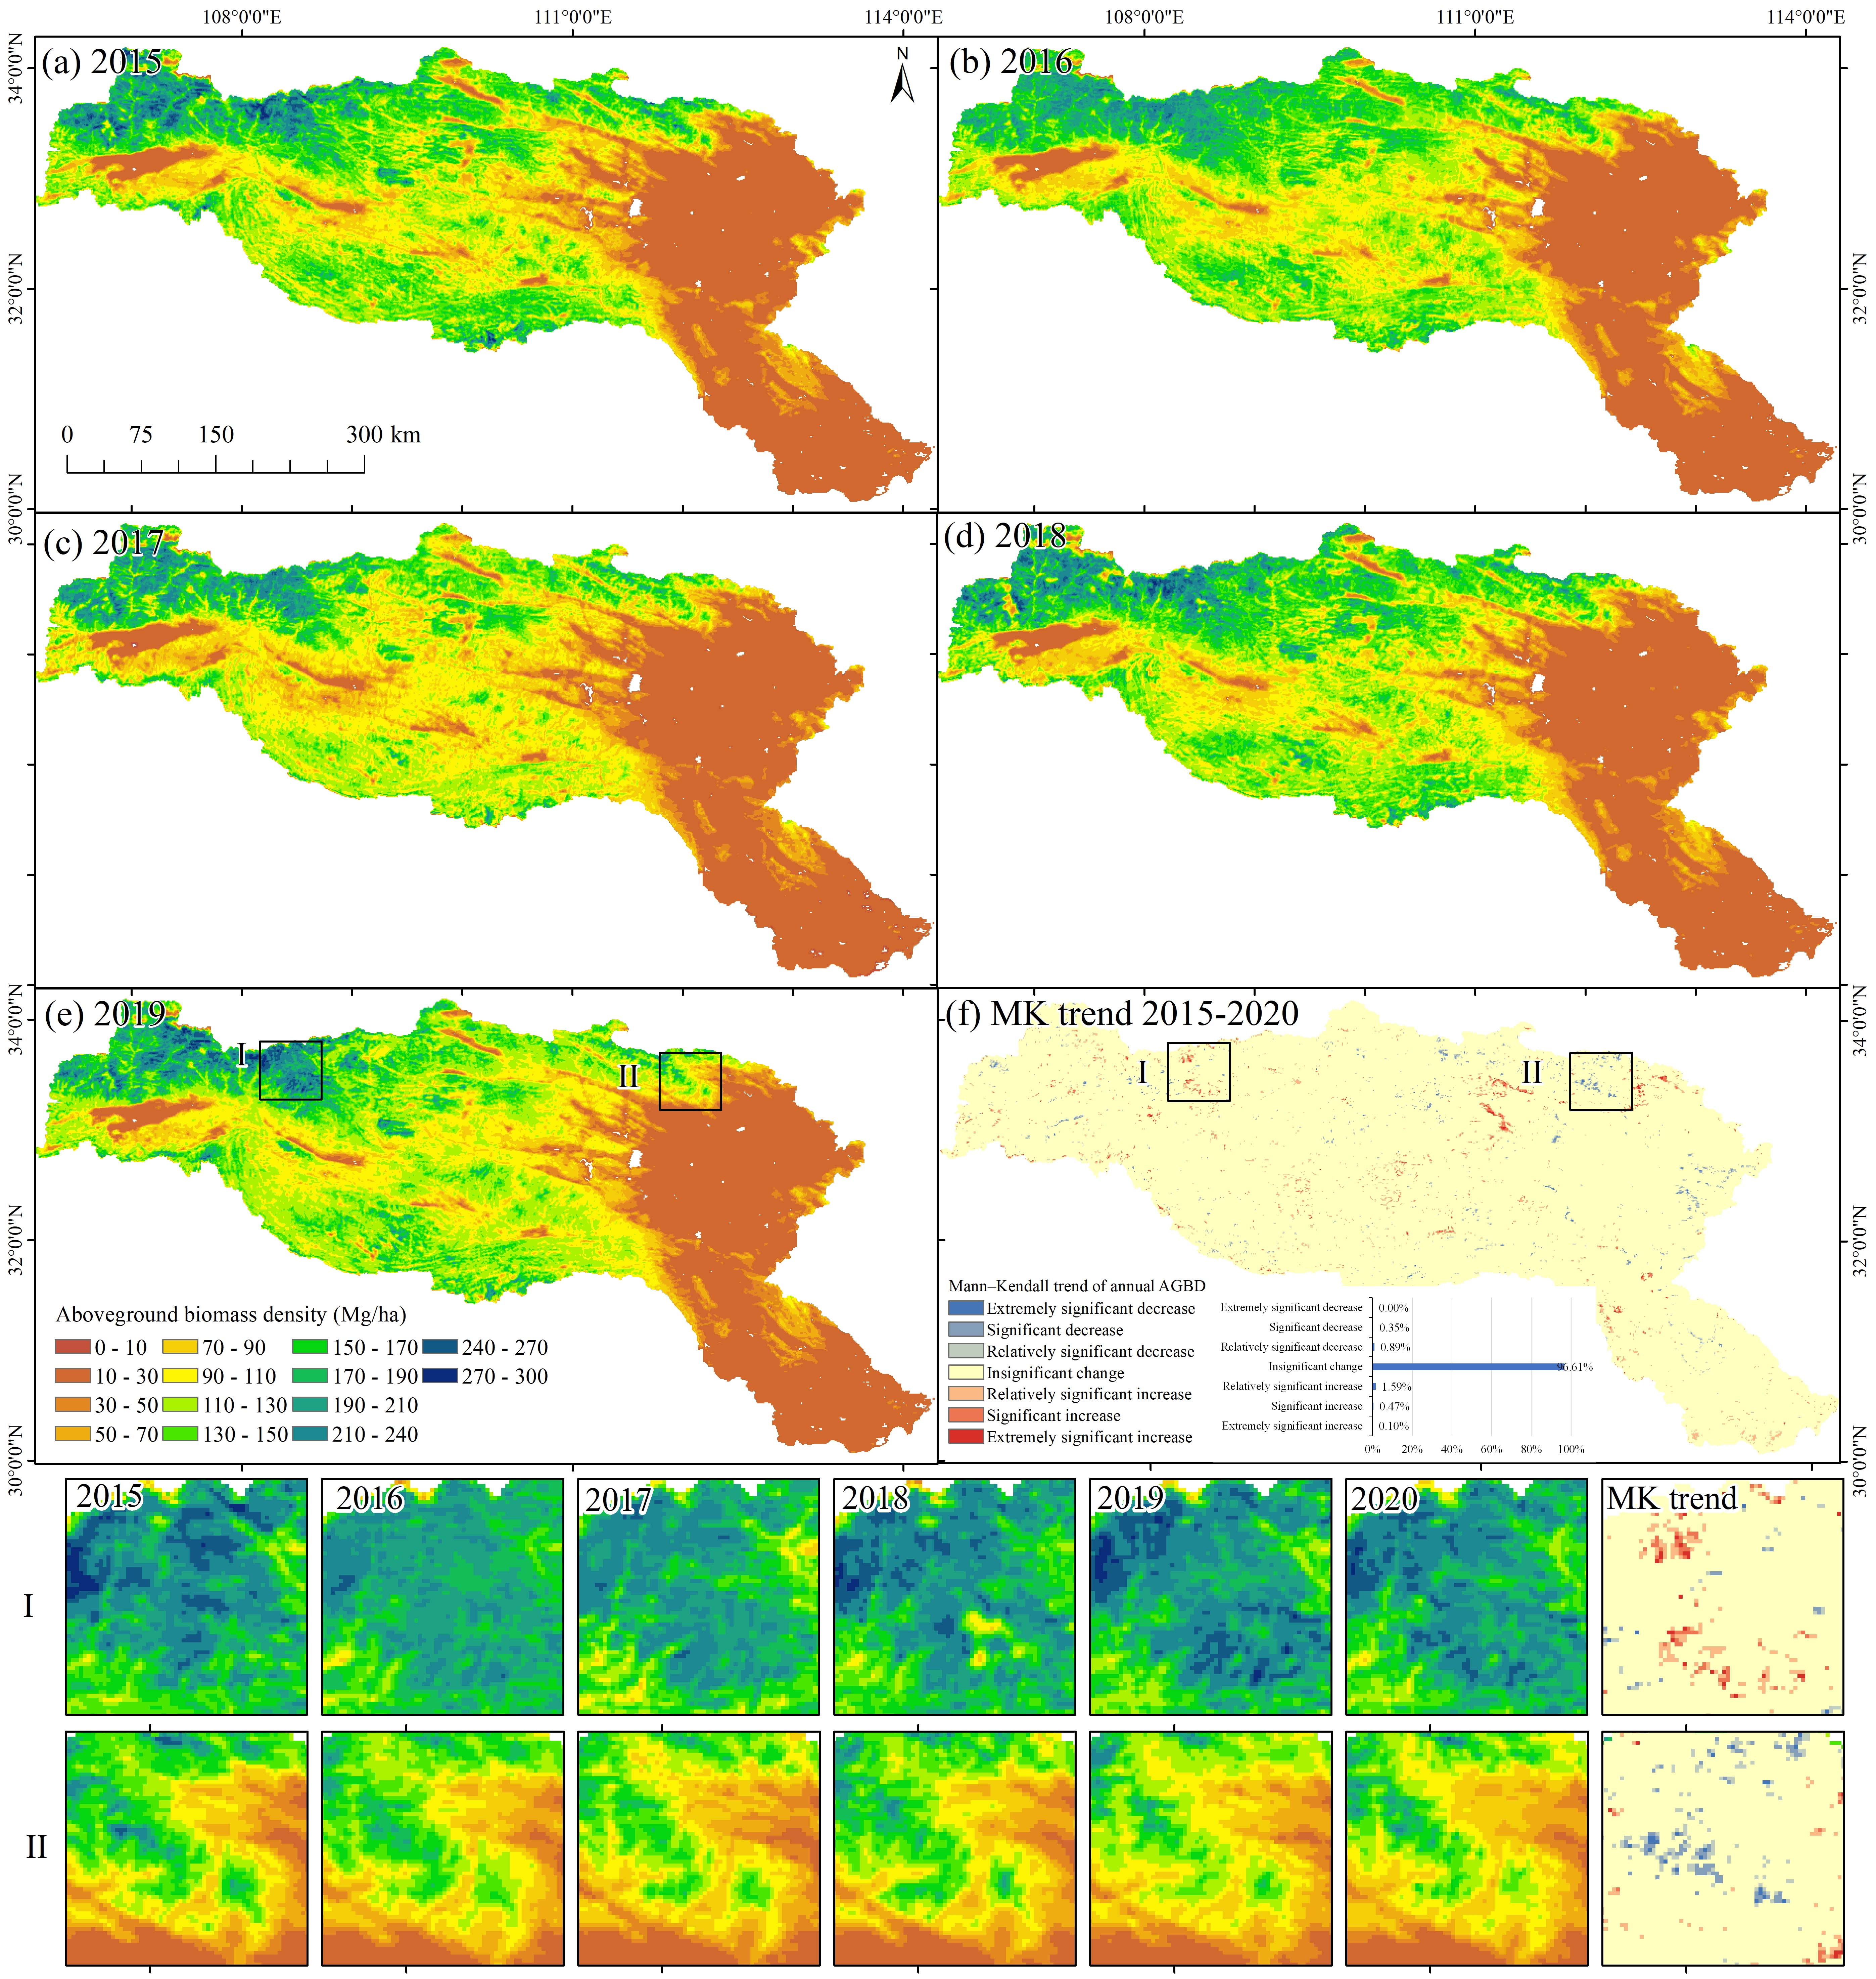
Fig. 13. Spatio-temporally continuous GEDI AGBD maps and Mann-Kendall (MK) trend analysis of AGBD during 2015-2020. (a) GEDI AGBD map in 2015; (b) GEDI AGBD map in 2016; (c) GEDI AGBD map in 2017; (d) GEDI AGBD map in 2018; (e) GEDI AGBD map in 2019; (f) MK trend map of annual AGBD during 2015-2020. The last two rows are zoomed areas of estimated GEDI AGBD maps and AGBD MK trend maps during 2015-2020.
The annual GEDI AGBD maps shown in Fig. 13 exhibit a comparable spatial distribution and overall range of change. Even though the unchanged training and validation samples differ across the years from 2015 to 2020, as indicated in Table IV, the annual GEDI AGBD maps consistently exhibit similar accuracy levels, with R² values exceeding 0.82 in all cases. Notably, the annual GEDI AGBD maps also offer insights into the annual dynamics of AGBD from 2015 to 2020. For instance, the zoomed areas of I and II show consistent AGBD increment during this period. The regions with high AGBD also exhibit significant changes from 2015 to 2020, as exemplified in zoomed area I. The Mann-Kendall (MK) trend map of the annual GEDI AGBD, as shown in Fig. 13(f), reveals several hot-spots with significant increases and decreases in AGBD. From 2015 to 2020, more than 96% pixels of the Han River Basin exhibited insignificant changes in AGBD. Only about 1% of pixels showed significant increases or decreases at the 95% confidence interval, while the percentage would be 3.4% when focusing on relatively significant change with 90% confidence interval. Overall, 2.16% of AGBD pixels experienced a relatively significant increase, while 1.24% showed a relatively significant decrease. As shown in Fig. 13(f), the AGBD MK trend of increases were observed in the northern, western and central regions of the Han River Basin, while AGB decreases were primarily observed in the southern, northwestern and northeastern areas.
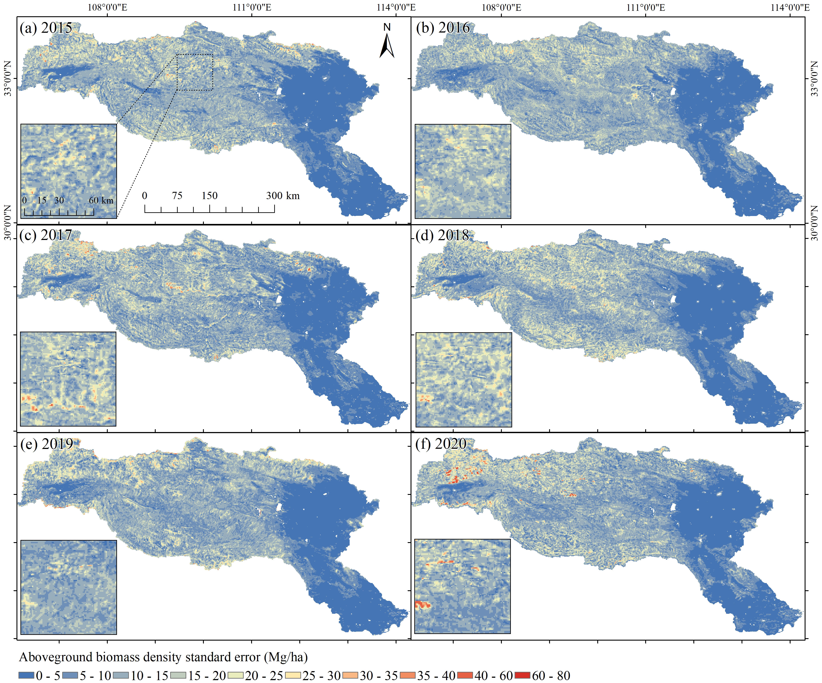
Fig. 14. Standard error of annual GEDI AGBD maps estimated by CNN_spatial regression during 2015-2020. (a) Standard error of GEDI AGBD in 2015; (b) Standard error of GEDI AGBD in 2016; (c) Standard error of GEDI AGBD in 2017; (d) Standard error of GEDI AGBD in 2018; (e) Standard error of GEDI AGBD in 2019; (f) Standard error of GEDI AGBD in 2020.
Table IV
Accuracy assessment of GEDI AGBD maps during 2015-2020 estimated by CNN_spatial based on unchanged samples in each predicting year and existing samples in 2020.
Index | 2015 |  | 2016 |  | 2017 |  | 2018 |  | 2019
Index | 2020 samples | 2015 samples | 2020 samples | 2016 samples | 2020 samples | 2017 samples | 2020 samples | 2018 samples | 2020 samples | 2019 samples
R² | 0.7815 | 0.8209 | 0.8441 | 0.8656 | 0.8118 | 0.832 | 0.7742 | 0.8437 | 0.8003 | 0.8252
IOA | 93.84% | 94.97% | 95.68% | 96.31% | 93.95% | 95.30% | 93.47% | 95.69% | 93.70% | 94.87%
RMSE | 32.1600 | 29.7162 | 26.1871 | 24.1947 | 26.8579 | 25.0657 | 32.5237 | 27.0563 | 22.2194 | 27.3639
rRMSE | 37.57% | 33.55% | 37.33% | 34.49% | 45.75% | 42.69% | 40.16% | 33.41% | 47.82% | 39.39%
MAE | 21.4000 | 19.3557 | 17.1676 | 15.3093 | 16.1459 | 14.4957 | 21.2246 | 17.8047 | 22.2194 | 17.0156
ME | 1.7700 | 0.3318 | 2.0963 | 0.6116 | -0.8549 | 0.3845 | 0.3197 | 0.8695 | 11.0781 | -0.6626

Uncertainty of estimated GEDI AGBD and carbon dynamic
The original GEDI AGBD grids in 2020 (Fig. 2(a)) come with a corresponding standard error map (Fig. 2(b)), which could be employed to create training samples for predicting the uncertainty of the estimated GEDI AGBD maps during 2015-2020. Following the procedure outlined in Section 3.3, we generated standard error maps for the annual GEDI AGBD from 2015 to 2020 (Figs. 13(a)-(f)). While the standard error map exhibits variation from 2015 to 2020, the AGBD values, on the whole, remain within the range of 40 Mg/ha. Furthermore, the spatial distribution of standard errors closely aligns with the estimated AGBD maps: areas with higher the AGBD values correspond to larger standard errors.
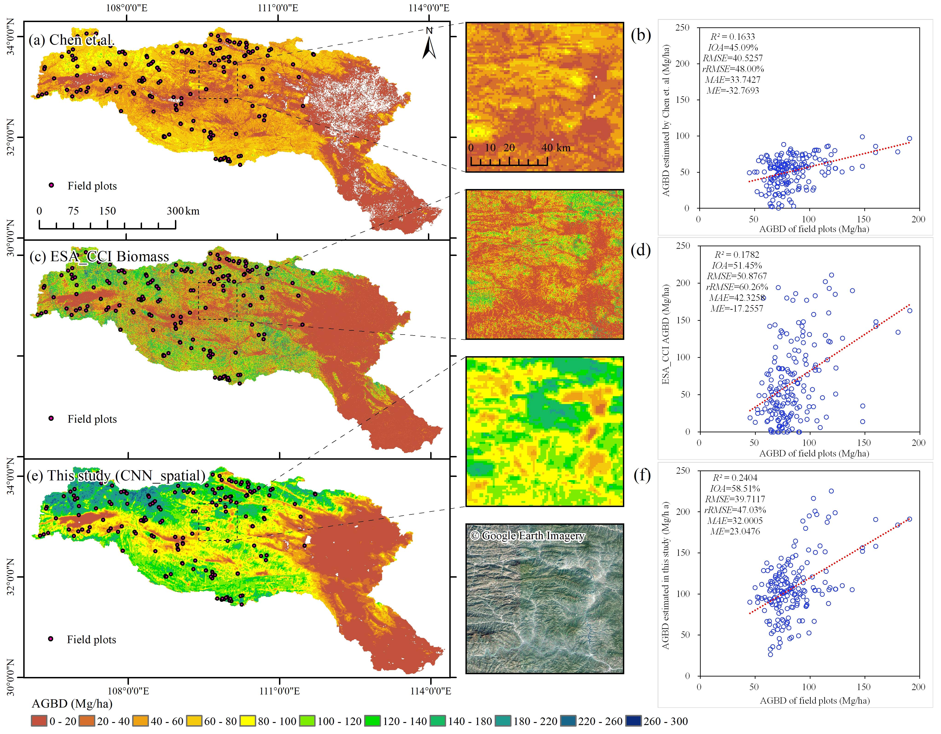
Fig. 15. Comparison with global and local AGBD products and validation using field plot data around 2017. (a)-(b) AGBD map for 2017 estimated by Chen, et al. [49] and its accuracy assessment with corresponding scatterplot based on 182 field plots. (c)-(d) ESA_CCI AGBD map for 2017 and its accuracy assessment with scatterplot. (e)-(f) AGBD map for 2017 estimated by CNN_spatial in this study and its accuracy assessment with scatterplot.
Utilizing the annual standard error maps shown in Fig. 14 and the estimated GEDI AGBD maps from Fig. 13 during 2015-2020, we conducted calculations to determine the uncertainty of AGB and the associated changes in carbon content, encompassing increases, decreases, and net change over this period. In practical applications, AGB estimation contains numerous uncertainties, and addressing the primary sources of uncertainty can enhance the robustness and statistical interpretability of the results [24, 36, 50]. Following the incorporation of standard errors into each of the estimated GEDI AGBD maps and the subsequent conversion of the adjusted AGBD values to AGB stock, it is observed that the Han River Basin experienced a net increase of 2.776 ± 0.376 × 10⁷ Mg AGB from 2015 to 2020. Through the conversion of dry biomass into carbon stock using a factor of 0.49, it is determined that the aboveground biomass in the Han River Basin exhibited a carbon net increase of 1.388 ± 0.188 × 10⁷ MgC. Consequently, AGB in the Han River Basin can be characterized as a carbon sink during the period from 2015 to 2020. This observation aligns well with the previous findings related to vegetation greening [41] and the increasing trend in biomass/carbon [49] in the core regions of the Qinling Mountains.

Comparison with global and local AGBD products and validation using field plots
A comparison with global and local AGBD products, along with validation using field plot data around 2017, is presented in Fig. 15. The three AGBD maps exhibit similar spatial distribution patterns across the Han River Basin but differ notably in their AGBD ranges and spatial details. For the AGBD map estimated by Chen, et al. [49] (Fig. 15(a)-(b)), AGBD values were generally underestimated relative to the field plot data (ME = -32.7693), resulting in the worst accuracy among the three estimates. Compared with AGBD map estimated by Chen, et al. [49], the ESA_CCI AGBD product (Fig. 15(c)–(d)) shows improved accuracy and a reduced underestimation bias (ME = –17.2557), although visible noise and residual underestimation remain. In contrast, the AGBD map generated in this study (Fig. 15(e)–(f)) effectively mitigates the underestimation issue and achieves the best accuracy relative to the field plot data. It is noted that an overestimation bias (ME = 23.0476) can also be observed in our estimates. Compared with the field plot data, the global and local AGBD products, as well as our estimates, exhibit relatively lower-than-expected accuracy. This discrepancy may be attributed to the limited spatial extent of the field plots, which is considerably smaller than the pixel sizes of the AGBD products used in this study. In addition, the complex mountainous terrain of the Han River Basin introduces further uncertainties in field plot data collection and geolocation.

V. Discussion

AGB mapping with machine learning and deep learning
Nonlinear regression techniques from the fields of machine learning and deep learning are employed commonly for the wall-to-wall mapping of AGB and canopy height with GEDI/ICESat-2 LiDAR data [17, 51-53]. In this research, for the estimation of spatially continuous GEDI AGBD maps in 2020, two deep learning methods (i.e., CNN and CNN_spatial) demonstrated superior performance compared to the majority of the four machine learning methods (i.e., ELM, GRNN, SVR, and RF). Specifically, ELM displayed the lowest accuracy, SVR demonstrated slightly better performance than GRNN, while RF outperformed all four machine learning methods. The performance of CNN was comparable to that of RF, and CNN_spatial achieved the highest accuracy among all machine learning and deep learning methods. In the field of AGB mapping using machine learning methods, RF has been the preferred choice due to its consistent and superior performance compared to many other methods [12, 19, 54], and our results further underscore the effectiveness of RF in AGB mapping. In the comparison between RF and CNN, Narine, et al. [13] found similar performance in AGB mapping with ICESat-2 and Landsat. Additionally, Fayad, et al. [51] demonstrated that CNN-based approaches were comparable to RF in estimating canopy heights and wood volume from GEDI waveforms. These two findings are consistent with the results of this study. Nevertheless, the exceptional performance of the CNN_spatial model in this study will make it a compelling candidate for estimating AGB and canopy height in future applications.

AGB mapping with multi-source remote sensing data
Given the considerable uncertainty that still surrounds AGB estimation, multi-source remote sensing data is extensively employed for the spatially continuous mapping of AGB at both local and global scales [17, 53, 55-58]. In this research, we have shown that incorporating covariates from all three datasets results in superior accuracy compared to single dataset mapping. Notably, PALSAR-2 alone yielded the lowest accuracy, followed by the MODIS indices dataset, and the topography and climate dataset. Zhao, et al. [58] demonstrated that PALSAR data alone provides less accurate AGB estimation compared to optical satellite images from Landsat. However, combining these two datasets can significantly enhance overall performance. Tang, et al. [53] and Fararoda, et al. [55] both discovered that the integration of PALSAR, MODIS, topography, and climate data proved advantageous for AGB estimation in extensive regions of China and India, respectively. These findings align with our results; however, due to the coarse spatial resolutions, exceeding 10 km, of several climate data elements such as precipitation and soil moisture, we did not incorporate them in this study.

Uncertainty sources of spatio-temporally continuous GEDI AGBD mapping
The results demonstrated the efficiency and accuracy of the spatio-temporally continuous GEDI AGBD generated by the proposed method. However, the mapping process still contains some uncertainties, which are mainly coming from two aspects. First, the most significant source of uncertainty arises from the training samples extracted from the original GEDI AGBD grids. Section 3.3 aims to quantify this uncertainty by incorporating the original standard error of GEDI AGBD grids into the AGB estimation process, and the resulting uncertainty maps are shown in Fig. 14. Second, while Figure 2 demonstrates a high correlation between MODIS VCF and AGB in China's Han River Basin, it does not ensure that all selected training samples accurately capture the AGB dynamics over time. This is because even when a forest canopy displays the same MODIS VCF tree canopy percentage values at two different times, the vertical structure of the forest can still change due to forest degradation and small-scale forest disturbances [59-62], especially within a 1 km × 1 km pixel.

Potential improvements and future research
In this study, we exclusively utilized deep learning methods to address the AGB estimation problem, in which the network structure of the CNN benchmark method was customized to our specific needs. Compared with the four machine learning methods, we observed an improvement for the CNN and CNN_spatial methods in estimating spatially continuous GEDI AGBD maps. Despite CNN’s exceptional performance in handling classification and segmentation problems compared to various machine learning methods [63], its improvement in addressing regression issues is comparatively less comprehensive [64-66]. One potential solution to improve CNN’s regression performance in estimating AGBD is integrating it with the long short-term memory (LSTM) neural network. This is because the CNN-LSTM hybrid model possesses the ability to capture long-term and non-linear dynamics of time-series data [66]. On the other hand, while various remote sensing datasets have been used as input for AGB estimation, additional datasets, like precipitation and soil moisture, could also be used to enhance spatio-temporal GEDI AGBD estimation [3, 7, 34, 35]. Finally, our AGBD estimates show an overestimation bias relative to the field plot data, which may be attributed to uncertainties in the GEDI AGBD product [67, 68]. In future work, it would be valuable to calibrate the GEDI AGBD values using field plot observations [67]. With the calibrated GEDI AGBD as independent variable, the proposed method is expected to produce more accurate spatio-temporally continuous AGBD estimates.

VI. Conclusions
NASA’s GEDI is a new era of LiDAR, but the GEDI Gridded AGBD product is presented only as spatial discontinuity grids at a spatial resolution of 1 km circa 2020, lacking spatio-temporally continuous estimates. In this study, utilizing the GEDI AGBD and standard error grids, we developed a method based on machine learning and deep learning regression to estimate spatio-temporally continuous GEDI AGBD and its associated uncertainty from 2015 to 2020 using available PALSAR-2, MODIS, and topography and climate data. Experiments in China’s Han River Basin demonstrated integrating all three datasets for spatially continuous GEDI AGBD estimation achieved greater accuracy than the result based on any single dataset. RF outperforms the other three machine learning methods in GEDI AGBD mapping. However, the most accurate GEDI AGBD map was achieved by CNN_spatial, with the evaluation metrics: R² = 0.8232, IOA = 94.97%, RMSE = 27.7557, rRSME = 33.05%, MAE = 18.9096, and ME = -0.3876. The MODIS VCF-based unchanged training sample selection procedure generated more accurate results in predicting the GEDI AGBD map for the year of interest than directly using training samples in 2020. The estimated annual GEDI AGBD maps during 2015-2020 exhibited similar spatial distributions and overall change ranges, all with R² values greater than 0.82. The Mann–Kendall (MK) trend map of annual GEDI AGBD indicates that more than 96% of the Han River Basin exhibited insignificant changes in AGBD. Approximately 2.16% of pixels showed a relatively significant increase, while 1.24% exhibited a relatively significant decrease. Compared with the ESA_CCI and China’s AGBD products, the AGBD map generated in this study effectively mitigates the underestimation issue and achieves the highest accuracy relative to the field plot data. The proposed method has great potential for spatio-temporally GEDI AGBD estimation in large-scale, complex forest landscapes. The annual spatially continuous GEDI AGBD and uncertainty maps from 2015 to 2020 are freely available at https://doi.org/10.5281/zenodo.17390979.

References
[1] J. S. Sperry, M. D. Venturas, H. N. Todd et al., “The impact of rising CO2 and acclimation on the response of US forests to global warming,” Proc. Natl. Acad. Sci. U.S.A., vol. 116, no. 51, pp. 25734-25744, 2019/12/17, 2019.
[2] S. Cooper, A. Okujeni, D. Pflugmacher et al., “Combining simulated hyperspectral EnMAP and Landsat time series for forest aboveground biomass mapping,” Int. J. Appl. Earth Obs. Geoinf., vol. 98, pp. 102307, 2021/06/01/, 2021.
[3] Y. Su, Q. Guo, B. Xue et al., “Spatial distribution of forest aboveground biomass in China: Estimation through combination of spaceborne lidar, optical imagery, and forest inventory data,” Remote Sens. Environ., vol. 173, pp. 187-199, 2016/02/01/, 2016.
[4] G. M. Foody, D. S. Boyd, and M. E. J. Cutler, “Predictive relations of tropical forest biomass from Landsat TM data and their transferability between regions,” Remote Sens. Environ., vol. 85, no. 4, pp. 463-474, 2003/06/15/, 2003.
[5] A. Ruesch, and H. K. Gibbs, “New IPCC Tier-1 Global Biomass Carbon Map For the Year 2000,” Carbon Dioxide Information Analysis Center, Oak Ridge National Laboratory, Oak Ridge, Tennessee, 2008.
[6] L. Duncanson, J. Armston, M. Disney et al., “The Importance of Consistent Global Forest Aboveground Biomass Product Validation,” Surv. Geophys., vol. 40, no. 4, pp. 979-999, 2019/07/01, 2019.
[7] T. Hu, Y. Su, B. Xue et al., “Mapping Global Forest Aboveground Biomass with Spaceborne LiDAR, Optical Imagery, and Forest Inventory Data,” Remote Sens., vol. 8, no. 7, 2016.
[8] R. Dubayah, J. Armston, S. P. Healey et al., “GEDI launches a new era of biomass inference from space,” Environ. Res. Lett., vol. 17, no. 9, pp. 095001, 2022/08/18, 2022.
[9] L. Duncanson, J. R. Kellner, J. Armston et al., “Aboveground biomass density models for NASA’s Global Ecosystem Dynamics Investigation (GEDI) lidar mission,” Remote Sens. Environ., vol. 270, pp. 112845, 2022/03/01/, 2022.
[10] M. A. Wulder, J. C. White, R. F. Nelson et al., “Lidar sampling for large-area forest characterization: A review,” Remote Sens. Environ., vol. 121, pp. 196-209, 2012/06/01/, 2012.
[11] P. Kacic, F. Thonfeld, U. Gessner et al., “Forest Structure Characterization in Germany: Novel Products and Analysis Based on GEDI, Sentinel-1 and Sentinel-2 Data,” Remote Sens., vol. 15, no. 8, pp. 1969, 2023.
[12] M. Liu, and S. Popescu, “Estimation of biomass burning emissions by integrating ICESat-2, Landsat 8, and Sentinel-1 data,” Remote Sens. Environ., vol. 280, pp. 113172, 2022/10/01/, 2022.
[13] L. L. Narine, S. C. Popescu, and L. Malambo, “Synergy of ICESat-2 and Landsat for Mapping Forest Aboveground Biomass with Deep Learning,” Remote Sens., vol. 11, no. 12, 2019.
[14] K. Tiwari, and L. L. Narine, “A Comparison of Machine Learning and Geostatistical Approaches for Mapping Forest Canopy Height over the Southeastern US Using ICESat-2,” Remote Sens., vol. 14, no. 22, 2022.
[15] E. T. A. Mitchard, T. R. Feldpausch, R. J. W. Brienen et al., “Markedly divergent estimates of Amazon forest carbon density from ground plots and satellites,” Global Ecol. Biogeogr., vol. 23, no. 8, pp. 935-946, 2014/08/01, 2014.
[16] L. Chen, C. Ren, B. Zhang et al., “Improved estimation of forest stand volume by the integration of GEDI LiDAR data and multi-sensor imagery in the Changbai Mountains Mixed forests Ecoregion (CMMFE), northeast China,” Int. J. Appl. Earth Obs. Geoinf., vol. 100, pp. 102326, 2021/08/01/, 2021.
[17] Y. Shendryk, “Fusing GEDI with earth observation data for large area aboveground biomass mapping,” Int. J. Appl. Earth Obs. Geoinf., vol. 115, pp. 103108, 2022/12/01/, 2022.
[18] H. B. Kashongwe, D. P. Roy, and D. L. Skole, “Examination of the amount of GEDI data required to characterize central Africa tropical forest aboveground biomass at REDD+ project scale in Mai Ndombe province,” Sci. Remote Sens., vol. 7, pp. 100091, 2023/06/01/, 2023.
[19] M. Liang, L. Duncanson, J. A. Silva et al., “Quantifying aboveground biomass dynamics from charcoal degradation in Mozambique using GEDI Lidar and Landsat,” Remote Sens. Environ., vol. 284, pp. 113367, 2023/01/01/, 2023.
[20] C. A. Silva, L. Duncanson, S. Hancock et al., “Fusing simulated GEDI, ICESat-2 and NISAR data for regional aboveground biomass mapping,” Remote Sens. Environ., vol. 253, pp. 112234, 2021/02/01/, 2021.
[21] H. Padalia, A. Prakash, and T. Watham, “Modelling aboveground biomass of a multistage managed forest through synergistic use of Landsat-OLI, ALOS-2 L-band SAR and GEDI metrics,” Ecol. Inf., vol. 77, pp. 102234, 2023/11/01/, 2023.
[22] C. Choi, M. Pardini, J. Armston et al., “Forest Biomass Mapping Using Continuous InSAR and Discrete Waveform Lidar Measurements: A TanDEM-X/GEDI Test Study,” IEEE J. Sel. Top. Appl. Earth Obs. Remote Sens., vol. 16, pp. 7675-7689, 2023.
[23] X. Li, H. Du, F. Mao et al., “Estimating bamboo forest aboveground biomass using EnKF-assimilated MODIS LAI spatiotemporal data and machine learning algorithms,” Agric. For. Meteorol., vol. 256-257, pp. 445-457, 2018/06/15/, 2018.
[24] S. S. Saatchi, N. L. Harris, S. Brown et al., “Benchmark map of forest carbon stocks in tropical regions across three continents,” Proc. Natl. Acad. Sci. U.S.A., vol. 108, no. 24, pp. 9899-9904, 2011/06/14, 2011.
[25] l. G. Maire, C. Marsden, Y. Nouvellon et al., “MODIS NDVI time-series allow the monitoring of Eucalyptus plantation biomass,” Remote Sens. Environ., vol. 115, no. 10, pp. 2613-2625, 2011/10/17/, 2011.
[26] E. Yan, G. Wang, H. Lin et al., “Phenology-based classification of vegetation cover types in Northeast China using MODIS NDVI and EVI time series,” Int. J. Remote Sens., vol. 36, no. 2, pp. 489-512, 2015/01/17, 2015.
[27] J. A. Anaya, E. Chuvieco, and A. Palacios-Orueta, “Aboveground biomass assessment in Colombia: A remote sensing approach,” For. Ecol. Manage., vol. 257, no. 4, pp. 1237-1246, 2009/02/20/, 2009.
[28] S. Englhart, V. Keuck, and F. Siegert, “Aboveground biomass retrieval in tropical forests — The potential of combined X- and L-band SAR data use,” Remote Sens. Environ., vol. 115, no. 5, pp. 1260-1271, 2011/05/15/, 2011.
[29] O. Cartus, M. Santoro, U. Wegmüller et al., “Sentinel-1 Coherence for Mapping Above-Ground Biomass in Semiarid Forest Areas,” IEEE Geosci. Remote Sens. Lett., vol. 19, pp. 1-5, 2022.
[30] J. M. B. Carreiras, M. J. Vasconcelos, and R. M. Lucas, “Understanding the relationship between aboveground biomass and ALOS PALSAR data in the forests of Guinea-Bissau (West Africa),” Remote Sens. Environ., vol. 121, pp. 426-442, 2012/06/01/, 2012.
[31] M. Santoro, O. Cartus, N. Carvalhais et al., “The global forest above-ground biomass pool for 2010 estimated from high-resolution satellite observations,” Earth Syst. Sci. Data, vol. 13, no. 8, pp. 3927-3950, 2021.
[32] J. Dong, X. Xiao, S. Sheldon et al., “Mapping tropical forests and rubber plantations in complex landscapes by integrating PALSAR and MODIS imagery,” ISPRS J. Photogramm. Remote Sens., vol. 74, pp. 20-33, 2012/11/01/, 2012.
[33] Y. Zhang, F. Ling, G. M. Foody et al., “Mapping annual forest cover by fusing PALSAR/PALSAR-2 and MODIS NDVI during 2007–2016,” Remote Sens. Environ., vol. 224, pp. 74-91, 2019/04/01/, 2019.
[34] W. Shen, M. Li, C. Huang et al., “Annual forest aboveground biomass changes mapped using ICESat/GLAS measurements, historical inventory data, and time-series optical and radar imagery for Guangdong province, China,” Agric. For. Meteorol., vol. 259, pp. 23-38, 2018/09/15/, 2018.
[35] S. A. Spawn, C. C. Sullivan, T. J. Lark et al., “Harmonized global maps of above and belowground biomass carbon density in the year 2010,” Sci. Data, vol. 7, no. 1, pp. 112, 2020/04/06, 2020.
[36] A. Baccini, W. Walker, L. Carvalho et al., “Tropical forests are a net carbon source based on aboveground measurements of gain and loss,” Science, vol. 358, no. 6360, pp. 230-234, 2017/10/13, 2017.
[37] N. L. Harris, D. A. Gibbs, A. Baccini et al., “Global maps of twenty-first century forest carbon fluxes,” Nat. Clim. Change, vol. 11, no. 3, pp. 234-240, 2021/03/01, 2021.
[38] W. Liu, G. Liu, and Q. Zhang, “Influence of Vegetation Characteristics on Soil Denitrification in Shoreline Wetlands of the Danjiangkou Reservoir in China,” CLEAN – Soil, Air, Water, vol. 39, no. 2, pp. 109-115, 2011/02/01, 2011.
[39] W. Qi, H. Li, Q. Zhang et al., “Forest restoration efforts drive changes in land-use/land-cover and water-related ecosystem services in China’s Han River basin,” Ecol. Eng., vol. 126, pp. 64-73, 2019/01/01/, 2019.
[40] X. Wang, Y. Zhang, and K. Zhang, “Automatic 10 m Forest Cover Mapping in 2020 at China&rsquo;s Han River Basin by Fusing ESA Sentinel-1/Sentinel-2 Land Cover and Sentinel-2 near Real-Time Forest Cover Possibility,” Forests, vol. 14, no. 6, 2023.
[41] X.-P. Song, M. C. Hansen, S. V. Stehman et al., “Global land change from 1982 to 2016,” Nature, vol. 560, no. 7720, pp. 639-643, 2018/08/01, 2018.
[42] Y. Luo, X. Wang, Z. Ouyang et al., “A review of biomass equations for China's tree species,” Earth Syst. Sci. Data, vol. 12, no. 1, pp. 21-40, 2020.
[43] J. Muro, A. Linstädter, P. Magdon et al., “Predicting plant biomass and species richness in temperate grasslands across regions, time, and land management with remote sensing and deep learning,” Remote Sens. Environ., vol. 282, pp. 113262, 2022/12/01/, 2022.
[44] G.-B. Huang, Q.-Y. Zhu, and C.-K. Siew, “Extreme learning machine: Theory and applications,” Neurocomputing, vol. 70, no. 1, pp. 489-501, 2006/12/01/, 2006.
[45] D. F. Specht, “A general regression neural network,” IEEE Trans. Neural Networks, vol. 2, no. 6, pp. 568-576, 1991.
[46] C.-C. Chang, and C.-J. Lin, “LIBSVM: A library for support vector machines,” ACM Transactions on Intelligent Systems and Technology, vol. 2, no. 3 %J ACM Trans. Intell. Syst. Technol., pp. Article 27, 2011.
[47] L. Breiman, “Random Forests,” Machine Learning, vol. 45, no. 1, pp. 5-32, 2001/10/01, 2001.
[48] J. Pyo, H. Duan, S. Baek et al., “A convolutional neural network regression for quantifying cyanobacteria using hyperspectral imagery,” Remote Sens. Environ., vol. 233, pp. 111350, 2019/11/01/, 2019.
[49] Y. Chen, X. Feng, B. Fu et al., “High-resolution maps of above- and belowground woody biomass in China from 2003 to 2020,” Earth Syst. Sci. Data, vol. 2022, pp. 1-34, 2022.
[50] L. Xu, S. S. Saatchi, Y. Yang et al., “Changes in global terrestrial live biomass over the 21st century,” Sci. Adv., vol. 7, no. 27, pp. eabe9829, 2021.
[51] I. Fayad, D. Ienco, N. Baghdadi et al., “A CNN-based approach for the estimation of canopy heights and wood volume from GEDI waveforms,” Remote Sens. Environ., vol. 265, pp. 112652, 2021/11/01/, 2021.
[52] L. L. Narine, S. Popescu, A. Neuenschwander et al., “Estimating aboveground biomass and forest canopy cover with simulated ICESat-2 data,” Remote Sens. Environ., vol. 224, pp. 1-11, 2019/04/01/, 2019.
[53] Z. Tang, X. Xia, Y. Huang et al., “Estimation of National Forest Aboveground Biomass from Multi-Source Remotely Sensed Dataset with Machine Learning Algorithms in China,” Remote Sens., vol. 14, no. 21, 2022.
[54] S. Nandy, R. Srinet, and H. Padalia, “Mapping Forest Height and Aboveground Biomass by Integrating ICESat-2, Sentinel-1 and Sentinel-2 Data Using Random Forest Algorithm in Northwest Himalayan Foothills of India,” Geophys. Res. Lett., vol. 48, no. 14, pp. e2021GL093799, 2021/07/28, 2021.
[55] R. Fararoda, R. S. Reddy, G. Rajashekar et al., “Improving forest above ground biomass estimates over Indian forests using multi source data sets with machine learning algorithm,” Ecol. Inf., vol. 65, pp. 101392, 2021/11/01/, 2021.
[56] X. Tian, M. Yan, C. van der Tol et al., “Modeling forest above-ground biomass dynamics using multi-source data and incorporated models: A case study over the qilian mountains,” Agric. For. Meteorol., vol. 246, pp. 1-14, 2017/11/15/, 2017.
[57] X. Wang, C. Liu, G. Lv et al., “Integrating Multi-Source Remote Sensing to Assess Forest Aboveground Biomass in the Khingan Mountains of North-Eastern China Using Machine-Learning Algorithms,” Remote Sens., vol. 14, no. 4, 2022.
[58] P. Zhao, D. Lu, G. Wang et al., “Forest aboveground biomass estimation in Zhejiang Province using the integration of Landsat TM and ALOS PALSAR data,” Int. J. Appl. Earth Obs. Geoinf., vol. 53, pp. 1-15, 2016/12/01/, 2016.
[59] K. Kronseder, U. Ballhorn, V. Böhm et al., “Above ground biomass estimation across forest types at different degradation levels in Central Kalimantan using LiDAR data,” Int. J. Appl. Earth Obs. Geoinf., vol. 18, pp. 37-48, 2012/08/01/, 2012.
[60] Y. Zhang, G. M. Foody, F. Ling et al., “Spatial-temporal fraction map fusion with multi-scale remotely sensed images,” Remote Sens. Environ., vol. 213, pp. 162-181, 2018/08/01/, 2018.
[61] Y. Zhang, F. Ling, X. Wang et al., “Tracking small-scale tropical forest disturbances: Fusing the Landsat and Sentinel-2 data record,” Remote Sens. Environ., vol. 261, pp. 112470, 2021/08/01/, 2021.
[62] Y. Zhang, X. Wang, X. Li et al., “Monitoring monthly tropical humid forest disturbances with Planet NICFI images in Cameroon,” Agric. For. Meteorol., vol. 341, pp. 109676, 2023/10/15/, 2023.
[63] E. Maggiori, Y. Tarabalka, G. Charpiat et al., “Convolutional Neural Networks for Large-Scale Remote-Sensing Image Classification,” IEEE Trans. Geosci. Remote Sens., vol. 55, no. 2, pp. 645-657, 2017.
[64] F. Zhang, X. Tian, H. Zhang et al., “Estimation of Aboveground Carbon Density of Forests Using Deep Learning and Multisource Remote Sensing,” Remote Sens., vol. 14, no. 13, pp. 3022, 2022.
[65] H. Tamiminia, B. Salehi, M. Mahdianpari et al., “Comparison of Machine and Deep Learning Methods to Estimate Shrub Willow Biomass from UAS Imagery,” Can. J. Remote Sens., vol. 47, no. 2, pp. 209-227, 2021/03/04, 2021.
[66] T. Bao, S. A. R. Zaidi, S. Xie et al., “A CNN-LSTM Hybrid Model for Wrist Kinematics Estimation Using Surface Electromyography,” IEEE Trans. Instrum. Meas., vol. 70, pp. 1-9, 2021.
[67] A. Nazir, N. P. Hanan, Q. Yu et al., “Enhancing GEDI above ground biomass density estimates in contrasting forests of Pakistan,” For. Ecol. Manage., vol. 587, pp. 122747, 2025/07/01/, 2025.
[68] U. Khati, M. Lavalle, and G. Singh, “The Role of Time-Series L-Band SAR and GEDI in Mapping Sub-Tropical Above-Ground Biomass,” Frontiers in Earth Science, vol. Volume 9 - 2021, 2021-October-29, 2021.

This research was supported by the National Natural Science Foundation of China (32401372, 31922060, 42271400, 32130069), the Joint Funds of the Hubei Provincial National Natural Science Foundation of China (2025AFD167), the Hubei Provincial Natural Science Foundation of China for Distinguished Young Scholars (2022CFA045), the Key Research Program of Frontier Sciences, Chinese Academy of Sciences (ZDBS-LY-DQC034), the Youth Innovation Promotion Association CAS (Y2022091) and the Young Top-notch Talent Cultivation Program of Hubei Province. (Corresponding authors: Yihang Zhang, Kerong Zhang) X. Wang and K. Zhang are with the Key Laboratory of Aquatic Botany and Watershed Ecology, Wuhan Botanical Garden, Chinese Academy of Sciences, Wuhan 430074, China, and also with the Hubei Key Laboratory of Wetland Evolution & Ecological Restoration, Wuhan Botanical Garden, Chinese Academy of Sciences, Wuhan 430074, China. K. Zhang is also with the Danjiangkou Wetland Ecosystem Field Scientific Observation and Research Station, the Chinese Academy of Sciences & Hubei Province, Wuhan 430074, China (e-mail: wangxia@wbgcas.cn, kerongzhang@wbgcas.cn). Y. Zhang is with the Key Laboratory of Monitoring and Estimate for Environment and Disaster of Hubei province, Innovation Academy for Precision Measurement Science and Technology, Chinese Academy of Sciences, Wuhan 430077, China (e-mail: zhangyihang@apm.ac.cn). P. M. Atkinson is with the Lancaster Environment Center, Faculty of Science and Technology, Lancaster University, Lancaster LA1 4YQ, UK (e-mail: pma@lancaster.ac.uk).

