Characterizing tropical evergreen forest disturbances and post-disturbance recovery using time-series Landsat canopy openings
Yihang Zhang, Xia Wang, Xiaodong Li, Wenqiong Zhao, Xinyan Zhong, Bingjie Yu, Yun Du, Peter M. Atkinson
T
Abstract—Tropical evergreen forests, among the most diverse and complex forest ecosystem, host an extraordinary variety of plants and animal species, underscoring the importance of monitoring their spatio-temporal dynamics. Despite substantial advances in tracking tropical forest disturbances with Landsat images, understanding of post-disturbances recovery, particularly small-scale disturbances, remains limited. Here, by enhancing the subtle signal caused by small-scale disturbances, we propose a method (i.e., framework) to simultaneously monitor tropical evergreen forest disturbances and post-disturbance recovery using annual maximal Landsat canopy openings. A baseline evergreen forest cover map was automatically generated by integrating median Normalized Difference Fraction Index (NDFI) and maximal self-referenced NDFI (rNDFI) images. Utilizing the baseline map and long-term spatio-temporally filtered annual maximal rNDFI images, three additional thematic maps were produced: first forest disturbance year, inter-annual forest disturbance frequency, and post-disturbance forest recovery. For the study areas of Brazil Mato Grosso, the Democratic Republic of the Congo Kasaï and Indonesia Kalimantan Tengah, the results demonstrated that the proposed framework not only detected more forest disturbance events, particularly enhancing the small-scale disturbances, but also predicted forest disturbances more accurately than the Global Forest Change (GFC) forest loss and Joint Research Centre (JRC) Tropical Moist Forest (TMF) deforestation and degradation products. The generated inter-annual forest disturbance frequency and post-disturbance forest recovery maps exhibit high accuracies, with the R², MAE and RMSE in the ranges 0.82-0.95, 0.47-1.15 and 1.33-2.88, respectively, which are more accurate than the benchmark results extracted from JRC TMF product. Our results are more sensitive to the inter-annual canopy opening and recovery of small-scale disturbances due to smallholder clearing and selective logging than JRC TMF. This research offers an effective framework for addressing the existing knowledge gap on post-change dynamics after forest disturbances and the net carbon change of tropical evergreen forests.

Index Terms—tropical forests, evergreen forest, forest disturbances, forest recovery, Landsat.

INTRODUCTION
ropical evergreen forests are the most diverse and complex forest ecosystems [1, 2]. ~17% of tropical forests have been significantly logged for agriculture, forestry and timber harvesting [3-6] over the past three decades, in which most of them are tropical moist evergreen (also including semi-evergreen) forests [7]. Monitoring changes in tropical evergreen forests is, therefore, crucial for preserving global biodiversity, mitigating global climate-change, sustaining ecosystem services [5, 7-10]. Due to their extensive coverage, frequent revisit period, and consistent long-term data collection, remote sensing satellite sensor images have been widely used for monitoring tropical forest change at both local and global scales [6, 7, 11-14].
For the mapping of tropical forest disturbances, various remote sensing images with different spatial and temporal resolutions have been used [15-22]. NOAA AVHRR and MODIS images have the advantage of providing fine temporal resolution (i.e., every 1-2 days) phenological information for monitoring forest cover change. Hansen and DeFries [23] first used 8-km NOAA AVHRR images during 1982-1999 and a regression tree method to monitor long-term forest cover changes. Song, et al. [24] quantified annual global-scale land cover change, including forest cover change, from 1986 to 2016 using NOAA AVHRR vegetation continuous filed (VCF) data. Chen, et al. [25] evaluated the global forest cover change and its uncertainty with MODIS VCF data since 2000. However, the spatial resolutions of AVHRR and MODIS images are too coarse, which will lead to serious mixed pixel problems when representing forest cover changes, particularly in detecting forests disturbances with spatial size smaller than 1 ha.
Compared to AVHRR and MODIS images, satellite sensor images with medium spatial resolutions of 10-30 m (i.e., Landsat, Sentinel-2 and Sentinel-1) have been used more widely for assessing forest cover change at both local and global scales [6, 19, 26]. Because of data availability constraints, Sentinel-2 and Sentinel-1 images cannot be used to track forest cover changes prior to 2014 or 2015. For long-term (i.e., two to three decades) forest cover changes mapping, the Landsat series (i.e., Landsat-4/5/7/8/9) provides the optimal data source. For example, as one of the most important product provided by Global Land Analysis & Discovery (GLAD), the Global Forest Change (GFC) product mapped annual global forest loss year by using Landsat images since 2000 [6]. On the other hand, Du, et al. [11] mapped annual global forest gain (AGFG) from 1983 to 2021 based on the time-series Landsat normalized burn ratio (NBR) index and an algorithm for Landsat-based detection of trends in disturbance and recovery (LandTrendr). However, the forest gain map from AGFG does not capture tree regrowth following GFC annual forest loss, making it unsuitable for monitoring post-disturbance recovery.
Compared to the substantial advances in mapping tropical forest disturbances with Landsat images, our knowledge of recovery after these disturbances (post-disturbance recovery) remains limited. In practice, understanding post-disturbance recovery is crucial for estimating net forest cover changes and the mitigation of global climate change [27, 28]. Methods for tracking tropical forest disturbances and post-disturbance recovery with Landsat images can be summarized in two main categories: forest cover classification methods and time-series index trajectory methods.
Forest cover classification methods initially employ supervised classification approaches on annual Landsat images to generate binary forest cover maps, after which forest disturbances and subsequent recovery are tracked using the resulting time-series binary maps over the observation period. Carreiras, et al. [29] monitored the recovery of secondary forest following disturbances from 1985 to 2010 in an Amazonian study site by classifying annual Landsat images into the categories of forest, secondary forest and non-forest. Silva Junior, et al. [30] mapped the secondary forest age in Brazil from 1985 to 2018, including secondary forest recovery following disturbances, by using the annual Brazilian land cover dataset (MapBiomas Collection 4.1). A long-term tropical moist forests (TMF) change product developed by the European Commission Joint Research Centre (JRC) [7] quantified the annual deforestation, degradation and recovery of moist evergreen and semi-evergreen forests in the tropics since 1990 by using the generated annual thematic forest cover maps with six classes. The accuracy of monitoring forest disturbance and following recovery using forest cover classification relies heavily on the quality of time-series classification. However, generating high-quality, spatially continuous long-term forest cover classification maps remains a challenging task [25, 31, 32].
Time-series index trajectory methods segment long-term continuous Landsat spectral and index values into distinct temporal trajectories by identifying time-series breakpoints or vertices. This allows forest disturbances and subsequent recovery to be identified through analyzing changes along these temporal trajectories [33, 34]. Various spectral indices have been used together with LandTrendr to track forest disturbances and regrowth based on long-term vegetation indices extracted from Landsat images [34], such as the indices of NBR, Normalized Difference Vegetation Index (NDVI) and Normalized Difference Moisture Index (NDMI). Kennedy, et al. [35] applied LandTrendr to monitor the forest disturbance and regrowth within a local study site using Landsat TM and ETM+ images during 1985-2008. Hua, et al. [36] used LandTrendr to monitor the long-term dynamics of forest disturbances and recovery in Jiangxi Province, China with time-series Landsat images. Huang, et al. [37] used the LandTrendr and random forest regression to detect forest disturbance and recovery for forest age estimation during 2004-2019 in China’s Zhejiang province with all available Landsat images. The Vegetation Change Tracker (VCT) method was also utilized to monitor forest disturbance and recovery based on time-series Landsat forest probability index maps [38]. Zhao, et al. [39] monitored long-term post-disturbance forest recovery in the Greater Yellowstone ecosystem from 1984 to 2010 using VCT and annual Landsat images. Shen, et al. [40] monitored spatio-temporal variation in disturbance and recovery for plantation forests in northern Guangdong Province from 1986 to 2015 using VCT and annual Landsat images. Both LandTrendr and VCT time-series index trajectory methods are effective in tracking most large-scale forest disturbances and subsequent recovery. In general, the performance of time-series index trajectory methods depends strongly on the availability of Landsat images. A greater number of cloud-free images typically leads to more accurate results. By contrast, the performance of time-series index trajectory methods can be unreliable if only one or two Landsat images are available per year. Persistent cloud cover, particularly in tropical regions, results in significant data gaps in the Landsat archive, especially before 1999, when only Landsat-4/5 images were available [41, 42]. More importantly, it may be challenging for LandTrendr and VCT to track small-scale forest disturbances and recovery [21, 26]. This is because small-scale forest disturbances and recovery, such as selective logging and smallholder clearing, produce weak spectral signals, which are often under-fitted or overlooked in the time-series segmentation of these methods.
Considerable attention has been given to monitoring large-scale tropical forest disturbances using the above methods. However, research on the wall-to-wall tracking of small-scale forest disturbances and post-disturbance recovery in the tropics remains limited. DeVries, et al. [42] developed a robust approach based on the Breaks For Additive Season and Trend (BFAST) method and time-series Landsat images to monitor small-scale tropical forest disturbances driven by small-holder agriculture expansion. Zhang, et al. [26] proposed a deep learning method to track annual small-scale forest disturbances for tropical evergreen forests by fusing Landsat-7/8 and Sentinel-2 images from 2016 to 2019. Slagter, et al. [18] employed time-series Sentinel-2 and Sentinel-1 images and a deep learning method to monitor drivers of small-scale tropical forest disturbances in three local regions within the Amazon and Congo rainforests. With the Norway’s international Climate and Forest Initiative (NICFI) Planet images, Zhang, et al. [21] developed a monthly forest disturbance monitoring method based on the self-referenced Hue index and spatio-temporal filtering to track humid tropical selective logging and smallholder clearing in Camerron. Owing to factors such as small-scale canopy openings, rapid post-disturbance vegetation growth, and the cloudy, rainy climate, monitoring long-term small-scale tropical forest disturbances with satellite sensor images remains challenging. The lack of studies tracking the subsequent recovery process after such disturbances is even more pronounced. In practical terms, monitoring the status of the prevalent small-scale tropical forest recovery after disturbances is vital for estimating net forest losses. While tropical forest disturbances are a major carbon source, post-disturbance recovery acts as a carbon sink, offsetting some of the carbon dioxide emissions from disturbances. Therefore, tracking post-disturbance recovery is essential for guiding forest conservation and recovery efforts, promoting sustainable land-use practices, and playing a significant role in mitigating climate change [43, 44].
Given the limited research on small-scale tropical forest disturbances and subsequent recovery, it is crucial to track simultaneously both disturbances and the ensuing recovery processes. In this research, by enhancing the subtle signal caused by small-scale forest disturbances, we proposed a method (i.e., framework) to simultaneously monitor annual disturbances and the following recovery in the tropical evergreen forests. The framework is based on the long-term Normalized Difference Fraction Index (NDFI) images extracted from all accessible Landsat images from 1984 to 2023. NDFI was designed particularly for monitoring the tropical forest degradation caused by selective logging and forest fires with Landsat images [12, 13]. While NDFI is effective in monitoring forest cover changes with various spatial sizes, its ability to detect the subtle signals generated by small-scale forest disturbances and subsequent recovery efforts remains limited. This is because changing environmental conditions and phenological variations affect the performance of time-series Landsat NDFI. In addition, remaining small and thin clouds in NDFI often result in false positives in forest disturbance detection.
The annual maximal self-reference NDFI (rNDFI) index and spatio-temporally filtering were, therefore, developed to enhance canopy opening signals of small-scale forest disturbances in NDFI images and to reduce false positives in tropical forest disturbances, respectively. Based on the integration of NDFI and rNDFI images, the proposed method first aims to generate automatically a baseline evergreen forest cover map at the beginning of observation. An intra-annual spatio-temporal filter is designed specifically for the annual maximal rNDFI images to eliminate false positives (i.e., noise pixels) of tropical forest disturbances caused by clouds and outliers in the Landsat image time-series. The thematic maps of annual forest disturbance year, inter-annual forest disturbance frequency, and post-disturbance forest recovery are generated from the filtered long-term annual maximal rNDFI and baseline evergreen forest cover map. In this way, an efficient framework is proposed for the simultaneous monitoring of tropical forest disturbances and subsequent recovery by introducing Landsat canopy openings. This approach is expected to address the current knowledge gap on small-scale forest disturbances, post-disturbance dynamics, and the net carbon changes in tropical evergreen forests.
The remainder of this paper is orgainised as follows: The study areas and dataset are presented in Section II. The proposed method is introduced in Section III. Validation samples are described in Section IV. Section V presents the results, and section VI provides a discussion. Conclusions are summarized in Section VII.

Study areas and dataset
Three typical study areas from each of the rainforests in the Amazon Basin, Congo Basin and Borneo were used to validate the performance of the proposed method in characterizing tropical forest disturbances and post-disturbance recovery. The study areas are located near the Equator and belong to the southern hemisphere countries of Brazil, the Democratic Republic of the Congo (DRC) and Indonesia (Fig. 1(a)). Rainforests in the three study sites have experienced significant loss over the past three decades [6, 7], while evidence also indicates that the abandoned deforested lands are undergoing recovery [28]. Hence, the three study areas are well-suited for evaluating the effectiveness of characterizing tropical evergreen forest disturbances and post-disturbance recovery.
Mato Grosso, located in the southern Amazon Basin (Fig. 1(a)), was selected as the first study area. As the third largest state in Brazil, it has an area of 9.03×10⁵ km², equaling to the total area of Germany and France. Mato Grosso is covered mainly by rainforests, wetlands and savanna plains. Due to the large-scale deforestation caused by commodity-driven cropland expansion (i.e., soybean cultivation) [45, 46] and forest degradation caused by forest fires and extreme seasonal drought [7, 47], the rainforests in Mato Grosso have become prominent hotspots of forest loss [6, 15, 22]. In contrast, many local and global forest protection policies implemented in Mato Grosso have reduced forest logging rates while also enhancing post-disturbance forest recovery.
Kasaï, located in the central-west region of DRC, was selected as the second study area in the Congo rainforest (Fig. 1(c)). Kasaï is covered predominantly by rainforest in the northern and central-eastern parts and savanna plain in the west-southern region. It has a typical tropical climate with the northern region experiencing more rainfall and the southern region being relatively dry. In the DRC Kasaï, forest loss was dominated by the smallholder clearing [48]. Compared to the large-scale deforestation in the Amazon rainforest, it is more difficult to track the small-scale forest disturbances, as the satellite observation windows are short due to the fast regrowth of post-disturbance vegetation and forest [21].
Kalimantan Tengah, located in the south region of Borneo, was selected as the third study area. As the largest state in Indonesia, Kalimantan Tengah has a land area of 1.53 ×10⁵ km² and more than 90% of its land is covered by rainforest, while the peatland swamps, mangroves and rivers are widespread in the southern coastal area. Owing to the wet equatorial climate, Kalimantan Tengah experiences an eight-months rainy season, with annual precipitation ranging from 2,776 to 3,393 mm and an average of 145 rainy days per year. The monitoring of tropical forest disturbance and recovery in this study area is, therefore, challenging because of the frequent clouds. Unlike the deforestation for cropland expansion in Brazil Mato Grosso and DRC Kasaï, the dominant driver of forest loss in Borneo, including the Indonesia Kalimantan Tengah, is the expansion of oil palm plantations [3, 49].
As depicted in Fig. 2, all available Landsat images from 1984 to 2023 were utilized for the three study areas. From 1984 to 1998, the time-series was dominated by Landsat-5 TM images with an annual number of around 500 in Amazon Mato Grosso. The average annual number of Landsat-5 images in the DRC Kasaï is around 50, and that in the Indonesia Kalimantan Tengah is in the range between 100 and 200. There were no available Landsat-4/5 images in Kasaï and Kalimantan Tengah for some years from 1984 to 1988. From 1999 to 2012, the addition of Landsat-7 images nearly doubled the number of Landsat images compared to previous years in the three study areas. However, there were limited number of Landsat-5 TM images in the years 2002 and 2012, respectively. From 2013 to 2023, although Landsat-5 TM images were unavailable, the addition of Landsat-8 resulted in many more scenes of Landsat images per year than those during 1999-2012. Furthermore, the addition of Landsat-9 in 2022 and 2023 led to an increase of approximately 1000, 200 and 300 scenes of Landsat-9 OLI-2 images per year in Mato Grosso, Kasaï and Kalimantan Tengah, respectively. In summary, 52,048, 7,070 and 12,272 scenes of Landsat series satellite sensor images were used from 1984 to 2023 in Mato Grosso, Kasaï and Kalimantan Tengah, respectively. Stable evergreen forest samples in the three study areas were extracted from the annual ESA land-cover CGLS-LC100 dataset from 2015 to 2019 [50], and they were used to determine the threshold values for evergreen forest cover segmentation at the beginning of observation.
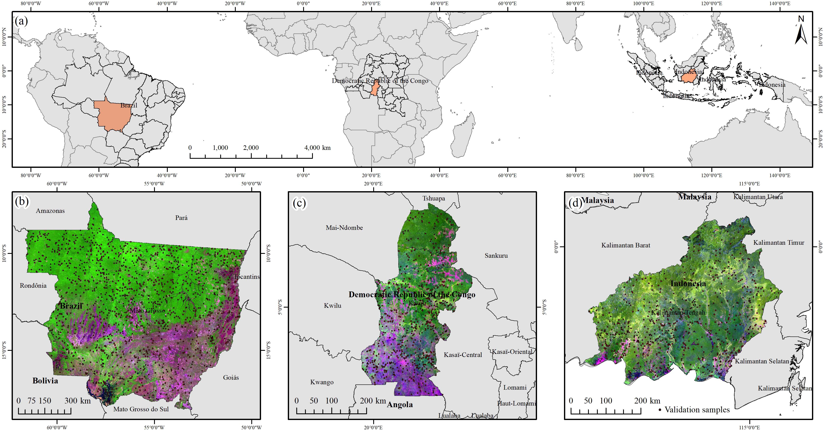
Figure 1. Geolocation of the three study areas and spatial distribution of the validation samples. (a) Geolocation of the three study areas in the tropics; (b) Study area in the Brazilian state of Mato Grosso; (c) Study area in the DRC state of Kasaï; (d) Study area in the Indonesia state of Kalimantan Tengah. The background images in (b)-(d) are the median Landsat-5 false colour (R-G-B: 5, 4, 3 bands) images during 1984-1985, 1984-1990 and 1988-1990, respectively. The black points indicate the random validation samples in the three study areas.
TABLE I
A detailed list of abbreviations in the proposed method.
Abbreviations | Full names
NDFI | Normalized Difference Fraction Index
rNDFI | self-referenced Normalized Difference Fraction Index
SMA | spectral mixture analysis
GV | green vegetation
NPV | non-photosynthetic vegetation
$${rNDFI}^{st}$$ | spatio-temporal filtered self-reference Normalized Difference Fraction Index
EFC | evergreen forest cover
FDY | forest disturbance year
FDF | inter-annual forest disturbance frequency
PFR | post-disturbance forest recovery
CGLS-LC100 | ESA Copernicus Global Land Service 100 m land-cover dataset
GFC | Maryland global forest change (product)
JRC TMF | Joint Research Centre (JRC) tropical moist forests (TMF) change (product)

Methodology
To achieve the goal of characterizing tropical forest disturbances and post-disturbance recovery with long-term Landsat images, the proposed methodology has four main parts: 1) calculating NDFI images with spectral mixture analysis; 2) generating self-referenced NDFI (rNDFI) images from all available NDFI images; 3) estimating spatio-temporal filtered annual maximal rNDFI from time-series rNDFI; 4) mapping forest disturbances and post-disturbance recovery with spatio-temporal filtered annual maximal rNDFI images. The proposed method is described in the following sub-sections. Moreover, the full names of key abbreviations used in the proposed method are listed in Table I.

Calculating NDFI with spectral mixture analysis
The spectral mixture analysis (SMA) model was used to deal with the mixed pixel issue in the Landsat images. SMA assumes that the reflectance value of each Landsat pixel is a linear mixture of the pure endmembers of soil, shade, cloud, green vegetation (GV) and non-photosynthetic vegetation (NPV), such that:
$ρ_{i,b}=\sum_{k=1}^{n}{f_{k,i}×E_{k,b}}+ε_{i,b}$, (1)
$\sum_{k=1}^{n}{f_{k.i}}=1$, (2)
where $ρ_{i,b}$ and $ε_{i,b}$ are the spectral reflectance and residual error of pixel i in band b. $E_{k,b}$ refers to the mean spectral reflectance value of endmember k in band b. $f_{k,i}$ is the fraction value for k^{th} endmember in pixel i, and the sum of fraction values for all endmembers is equal to 1 (equation (2)). Five types of endmembers of GV, NPV, Soil, Shade and Cloud extracted from the reference Landsat spectral reflectance images were used in the three study areas. For the 'Shade' endmember, all wavelength values were set to zero in the Landsat images. According to the reference endmembers suggested by in Souza, et al. [13] and Bullock, et al. [12], the GV, NPV, Soil, and Cloud endmembers were assigned the following values of [0.05 0.09 0.04 0.61 0.30 0.10], [0.14 0.17 0.22 0.30 0.55 0.30], [0.20 0.30 0.34 0.58 0.60 0.58], and [0.90 0.96 0.80 0.78 0.72 0.65] for the blue, green, red, NIR, SWIR1, and SWIR2 bands of Landsat images, respectively. The cloud endmember was used to further exclude pixels contaminated by clouds that were not identified by FMask in Landsat images.
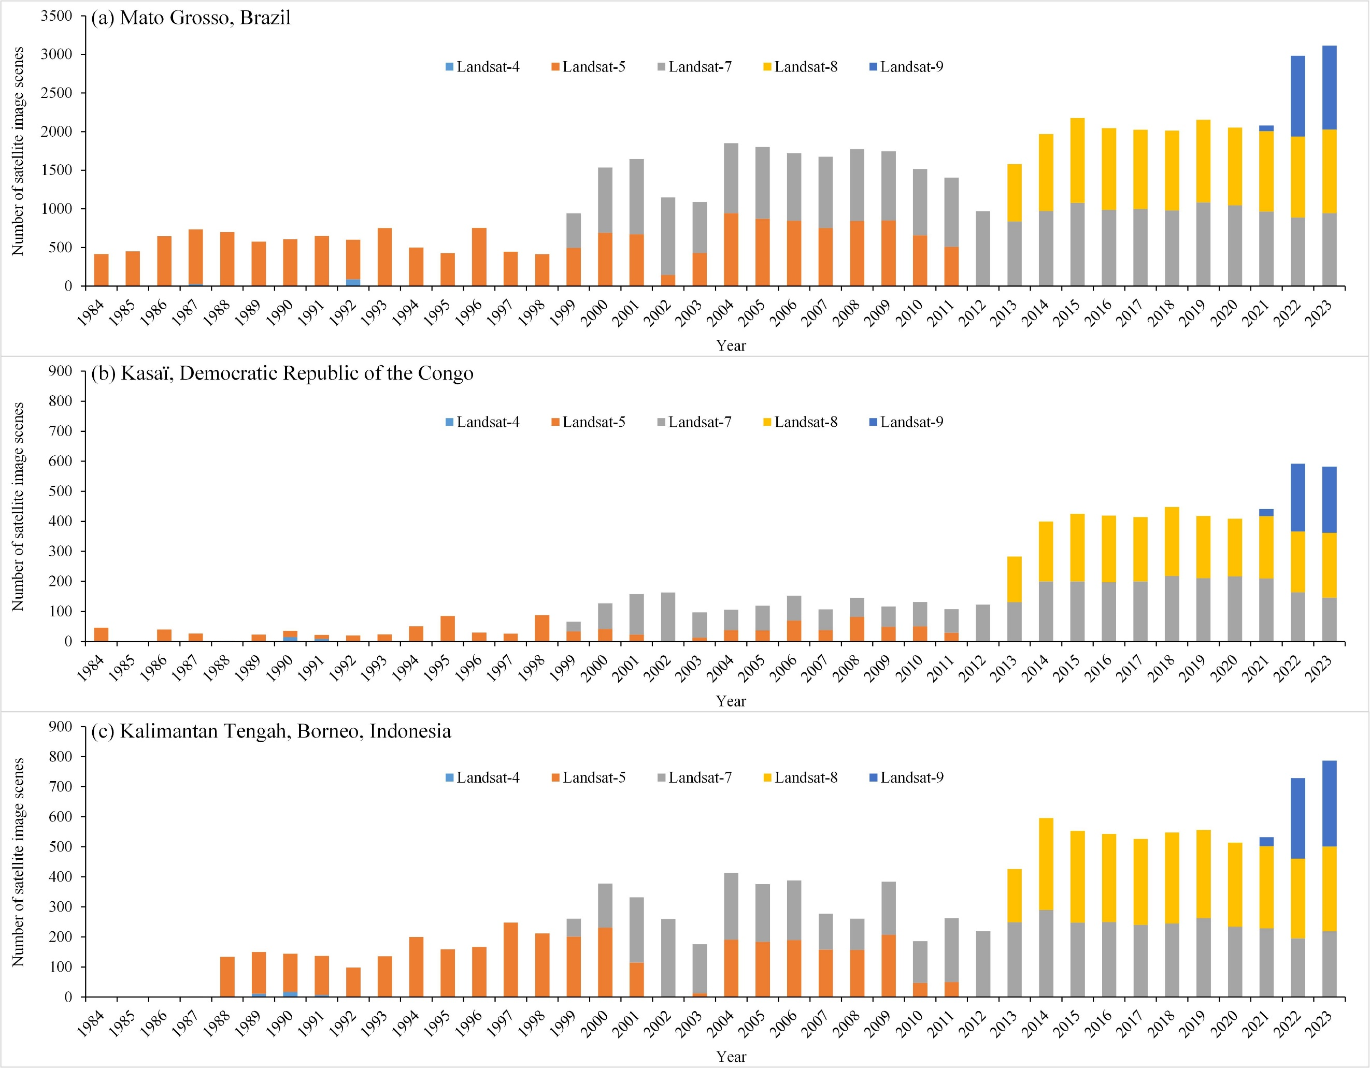
Figure 2. Time-series of the available numbers of Landsat-4/5/7/8/9 images used in this research from 1984 to 2023 for the three study areas.
With the aforementioned endmembers of GV, NPV, Soil, Shade, and Cloud, the fraction maps of different endmembers were calculated using the SMA model in equations (1) and (2) for each Landsat image. Generally, dense tropical forests exhibit larger fractions of GV and smaller fractions of Soil, NPV, and Shade. By contrast, disturbed areas tend to show higher fractions of Soil and NPV, with smaller proportions of GV and Shade [12]. NDFI developed by Souza, et al. [13] was then used to accentuate the distinction between disturbed and non-disturbed tropical forests, and it is expressed as:
$NDFI=\frac{f_{Shade}^{GV}-(f_{NPV}+f_{Soil})}{f_{Shade}^{GV}+(f_{NPV}+f_{Soil})}$, (3)
$f_{Shade}^{GV}=\frac{f_{GV}}{1-f_{Shade}}$, (4)
where $f_{GV}$, $f_{NPV}$, $f_{Soil}$ and $f_{Shade}$ refer to the estimated fraction values of GV, NPV, Soil and Shade endmembers using above SMA model. As listed in equation (4), $f_{Shade}^{GV}$ is the shade-normalization of GV fraction $f_{GV}$. In theory, intact dense forests tend to have higher NDFI values (0 to 1), while degraded and disturbed forests have lower NDFI values (-1 to 0). Complete clearance (i.e., deforestation) of the forest results in a value approaching -1, similar to the NDFI value of non-forest regions, such as soil and water bodies. More importantly, NDFI can detect forest degradation resulting from selective logging and forest fires, with corresponding NDFI values ranging from -1 to 0 [13].

Self-referenced NDFI
While the efficiency of NDFI has been demonstrated for monitoring tropical forest disturbances and degradation, its use for the detection of forest cover change may face two main challenges. Firstly, NDFI values can vary between scenes due to the influence of different atmospheric conditions and variations in illumination/terrain-related geometries across various Landsat images. Secondly, numerous small-scale forest disturbances and subsequent recovery activities, such as selective logging and smallholder clearing, may exhibit NDFI values similar to those of the closed forest canopy. Consequently, detecting small-scale forest cover changes with NDFI becomes challenging.
A self-referencing operation was employed here to eliminate gradual variation caused by environmental changes in the time-series NDFI images. Moreover, this process aims to enhance the NDFI spectral signal of locally abrupt alterations caused by small-scale canopy openings in the evergreen forests [10, 21, 26]. The self-referenced NDFI is expressed as:
$\text{rNDFI}=\left\{\begin{aligned}\text{NDFI}\left(median,r\right)-\text{NDFI, if NDFI>}\text{T}\text{/2} \\ 1-NDFI, otherwise\end{aligned}\right.$, (5)
where rNDFI is the self-referenced NDFI. Negative values were set to 0 and values exceeding 1 were capped at 1 to ensure that rNDFI remains bounded between 0 and 1. T is a threshold used to segment evergreen forests from NDFI imagery, which is automatically estimated in the following sections. Each pixel in $\text{NDFI}\left(median,r\right)$ is calculated as the median value of its neighboring window system with a radius of r. As a tradeoff between computational cost and the ability to detect individual canopy openings, r was set to 300 m in this study. This implies that it can effectively detect canopy openings with a width smaller than 600 m (20 Landsat pixels). For rNDFI, canopy openings caused by forest disturbances and non-vegetation land covers will exhibit large values (i.e., ≥0.2), while forested areas will have values close to zero. In general, rNDFI based only on the difference between $\text{NDFI}\left(median,r\right)$ and NDFI can enhance the spectral signal of small-scale canopy openings. But it will fail to maintain the completed large-scale canopy openings of bare soil patches with a width larger than 2×r [21]. By contrast, initial NDFI can identify large-scale canopy openings of bare soil, in which the corresponding NDFI values of bare soil are always below a certain value [12, 13]. In this case, as listed in equation (5), rNDFI is equal to the difference between $\text{NDFI}\left(median,r\right)$ and NDFI if the corresponding NDFI value of a pixel is larger than T/2, which refers to the upper NDFI value for non-forest covers; otherwise, it will be assigned as the difference between 1 and NDFI. rNDFI generally behaves inversely to NDFI: higher rNDFI values and lower NDFI values both indicate canopy disturbance. Compared with NDFI, a key advantage of rNDFI is its enhanced sensitivity to the spectral signals of small-scale forest disturbances and post-disturbance recovery.
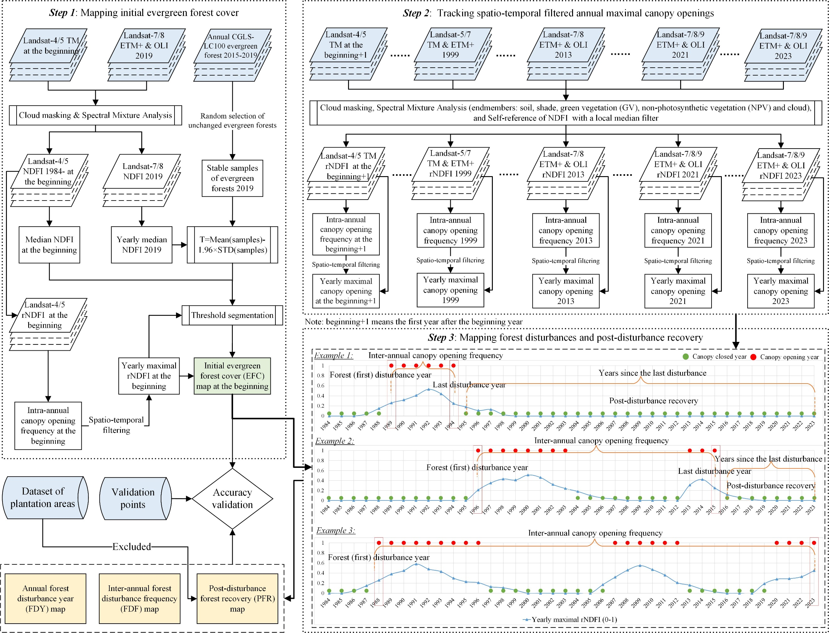
Figure 3. Flowchart of the proposed methodology.

Spatio-temporal filtering of annual maximal rNDFI
For a given year, there will be numerous Landsat rNDFI images, each recording different stages of canopy opening events caused by forest disturbances or recovery. To track all of these canopy change events, the annual maximal rNDFI image, defined as rNDFI(max, y), are calculated from the entire time-series rNDFI images in a given year y. Even if there are a few canopy opening events in the time-series rNDFI images, the annual maximal rNDFI(max, y) will still record the largest canopy opening stage. However, the remaining clouds, registration errors, and spectral outliers in the time-series rNDFI images may lead to many false positives of canopy openings in the rNDFI(max, y). In general, compared to canopy openings caused by real forest disturbances and recovery, false positives of canopy opening are typically ephemeral and present in only a few images of the time-series rNDFI. Therefore, a spatio-temporal filter was designed for the rNDFI(max, y) to eliminate the false positives of canopy opening, and the modified annual maximal rNDFI image is expressed as:
${\text{rNDFI}}_{i}^{st}\text{(max, }\text{y}\text{)}=\left\{\begin{aligned}{rNDFI}_{i}(max, y), if Fico(i,y)≥3 \\ 0, otherwise\end{aligned}\right.$, (6)
in which ${\text{rNDFI}}_{i}^{st}\text{(max, }\text{y}\text{)}$ is the spatio-temporally filtered annual maximal rNDFI for pixel i in a given y. Fico(i,y) is the frequency of intra-annual canopy openings for pixel i in a given year y. ${\text{rNDFI}}_{i}^{st}\text{(max, }\text{y}\text{)}$ will be equal to ${rNDFI}_{i}(max, y)$ if the corresponding Fico(i,y) is no less than a threshold value of 3 when the data source is from two Landsat sensors. Moreover, it can also be adjusted to 2 or 4 when employing one or three Landsat sensors [21, 51]. Fico(i,y) can be expressed as:
$Fico(i,y)=\sum_{t∈y}{{CO}_{t}(i,y)}$, (7)
${CO}_{t}(i,y)=\left\{\begin{aligned}1, if {rNDFI}_{t}(i,y)≥φ/2 \\ 0, otherwise\end{aligned}\right.$, (8)
where ${CO}_{t}(i,y)$ is the binary canopy opening for pixel i at time t in year y. As listed in equation (8), ${CO}_{t}(i,y)$ is set to 1 if its ${rNDFI}_{t}(i,y)$ value is no less than $φ/2$, otherwise it will be set to 0. $φ$ serves as a threshold value (i.e., 0.2) for segmenting binary canopy openings from annual maximal rNDFI images. As ${rNDFI}_{t}(i,y)$ represents the time-series elements of the annual maximal rNDFI image ${rNDFI}_{i}(max, y)$, a relatively small value, such as $φ/2$ (i.e., 0.1), is expected to track most of the canopy openings within a given year.

Forest disturbances and post-disturbance recovery mapping
Based on the above NDFI and spatio-temporal filtered annual maximal rNDFI images, as shown in the steps 1-3 of Fig. 3, the proposed method aims to characterize tropical forest disturbances and post-disturbance recovery by producing and analyzing four thematic maps: (I) initial evergreen forest cover map, (II) first forest disturbance year map, (III) inter-annual forest disturbance frequency map and (IV) post-disturbance forest recovery map.
- Initial evergreen forest cover (EFC) mapping
The baseline for characterizing tropical forest disturbances and post-disturbance recovery from the beginning to the end of observation is the EFC map at the beginning year. Numerous NDFI and rNDFI images can be generated using all available cloud-masked Landsat-4/5 images at the beginning year. Due to the limited availability of Landsat-5 images from 1984 to 1990 (see Fig. 2), Landsat-4/5 images from 1984 to 1985 were utilized to generate the wall-to-wall EFC map for 1985 in the Brazil Mato Grosso, while Landsat-4/5 images from 1984 to 1990 were used to estimate wall-to-wall EFC maps for 1990 in DRC Kasaï and Indonesia Kalimantan Tengah, respectively. Specifically, mapping EFC at the beginning year is based on the integration of yearly median NDFI and spatio-temporally filtered annual maximal rNDFI, expressed as:
$EFC(i,y)=\left\{\begin{aligned}1, if {NDFI}_{median}(i,y)≥T{\text{ \& rNDFI}}_{i}^{st}\text{(max,y)≥φ}&&&&&& \\ 0, otherwise\end{aligned}\right.$, (9)
in which $EFC(i,y)$ is the binary value of EFC for pixel i in a given year y, and it is set to 1 if ${NDFI}_{median}(i,y)$ is no less than T and ${\text{rNDFI}}_{i}^{st}\text{(max,y)}$ is no less than $\text{φ}$ (i.e., 0.2, annual maximal canopy openings segmentation threshold); otherwise is set to 0.
The key to mapping EFC is the determination of threshold T. By integrating the yearly median NDFI and CGLS-LC100 land cover maps, an automatic method was used here to estimate the threshold T. Firstly, an unchanged EFC map in 2019 was created by compiling a set of annual EFC maps extracted from the CGLS-LC100 land cover maps from 2015 to 2019. Secondly, 1000 stable samples of evergreen forests were selected randomly from the unchanged EFC map. Thirdly, the yearly median NDFI image was calculated from all available Landsat-7/8 images in 2019. Based on the yearly median NDFI image and randomly selected stable samples of evergreen forests in 2019, the threshold T can be estimated as:
$T=NDFI(samples,mean)-1.96×NDFI(samples,std)$, (10)
where $NDFI(samples,mean)$ and $NDFI(samples,std)$ are the mean and standard error values. They are calculated from the yearly median NDFI values of all stable evergreen forest samples. To reduce the negative influence of the spatial resolution gap between ESA land cover maps and Landsat NDFI images, a few selected stable evergreen forests samples with small yearly median NDFI values (i.e., ≤0) will be deleted.
- First forest disturbance year (FDY) mapping
Based on the EFC map at the beginning year, FDY is defined as the first canopy opening (i.e., forest loss) year of evergreen forest from the beginning to the end year of the observation period P (i.e., 2023 in this research). Assume that the forest disturbance year map is ${FDY}_{i}$, and each pixel i in ${FDY}_{i}$ is assigned as the first loss year of EFC and expressed as:
${FDY}_{i}=O_{i}^{y}(first), ∀ y∈P$, (11)
where $O_{i}^{y}$ is the binary vector of canopy opening for pixel i during the observation period P. $O_{i}^{y}(first)$ represents the first canopy opening year for the initial EFC pixel. Specifically, as an element in $O_{i}^{y}$, $o_{i}^{y}$ is generated from the spatio-temporally filtered annual maximal rNDFI image of ${\text{rNDFI}}_{i}^{st}\text{(max,}\text{y}\text{)}$ in year y (see equation (6)) and the annual maximal canopy openings segmentation threshold of $\text{φ}$. Therefore, the calculation of annual maximal binary canopy opening $o_{i}^{y}$ for a given year y is defined as:
$o_{i}^{y}=\left\{\begin{matrix}1, if {\text{rNDFI}}_{i}^{st}\text{(max, }y\text{)}≥\text{φ} \\ 0, otherwise\end{matrix}\right.$. (12)
- Inter-annual forest disturbance frequency (FDF) mapping
After the first disturbance in evergreen forests, further canopy openings (i.e., disturbances) are likely to continue to occur in subsequent years until the end of the observation period P. In this section, the inter-annual FDF is defined and calculated to monitor the yearly maximal canopy openings (i.e., disturbances) frequency from the first disturbance years to the end of the observation period P. Based on the annual maximal binary canopy opening vector $O_{i}^{y}$, the inter-annual FDF is expressed as:
${FDF}_{i}=\sum_{y∈P}{O_{i}^{y}}$, (13)
in which ${FDF}_{i}$ is the inter-annual forest disturbance frequency for pixel i from the start to end year of the observation period P. The calculation of $O_{i}^{y}$ is based on equation (12).
- Post-disturbance forest recovery (PFR) mapping
In general, a process of vegetation/forest recovery is highly likely to occur if there are no further disturbances to the disturbed land [28]. PFR is, therefore, defined as the years since the last disturbance (i.e., canopy opening), which is also the closed post-disturbance canopy recovery from the year of the last canopy opening to the end of the observation period P. The longer the time since the last disturbance, the higher the PFR level. The key to PFR mapping is the calculation of the years since the last canopy opening year of a disturbed EFC pixel. It can be obtained from the time-series binary canopy opening vector $O_{i}^{y}$ and expressed as:
${PFR}_{i}=P-O_{i}^{y}(last), ∀ y∈P$, (14)
in which ${PFR}_{i}$ is the number of PFR years for pixel i from the start to the end year of observation period P. $O_{i}^{y}(last)$ is the last canopy opening year for the initial EFC pixel.
Tropical PFR may include industrial plantation areas, such as oil palm, rubber and coconut, especially in southeast Asia (i.e., including the study area of Indonesia Kalimantan Tengah in this research). For the forest ecosystem, the planting of single-tree species like oil palm after deforestation poses a significant ecological challenge, or potential disaster [52]. Therefore, in the above generated PFR map, industrial plantations were excluded finally. Specifically, three dataset of the global smallholder and industrial oil palm plantations map [49], and the global coconut palm plantations map [53] and the Spatial Database of Planted Trees (SDPT) were used to define industrial plantation areas. They were excluded in the final PFR map. Unlike the first forest disturbance map and the inter-annual forest disturbance frequency map, the PFR map is based on forest cover at the end of the observation period. Therefore, only the most recent industrial plantations (i.e., 2023) need to be considered to exclude unexpected forest recovery.
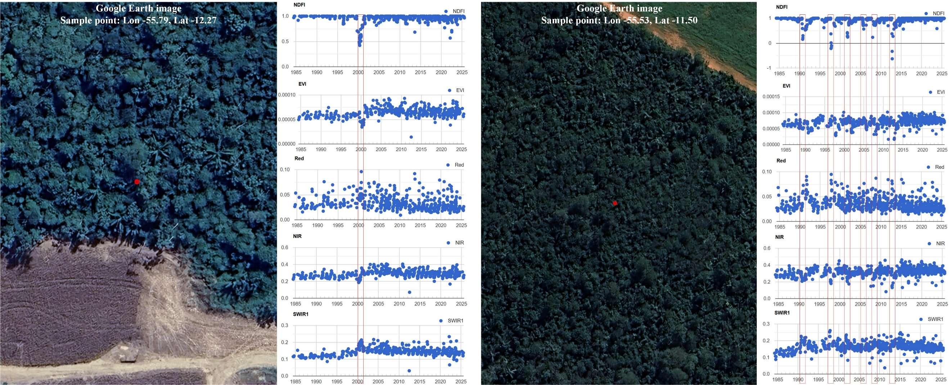
Figure 4. Two examples illustrating the visual determination of class and disturbance/recovery years for validation samples based on time-series Landsat indices and spectral bands. Red points in the Google Earth images indicate the locations of the validation samples. The two fine-resolution Google Earth images were collected around 2023-2024.

Comparison of forest disturbances and post-disturbance recovery
To provide comparisons of the tropical evergreen forest disturbances and post-disturbance recovery tracked by the proposed methods in three study areas, the GFC forest loss and JRC TMF products were used. The GFC forest loss product recorded the first loss year of baseline forest cover in 2000 by using Landsat images since 2000 [6]. More information about this product can be found at https://storage.googleapis.com/earthenginepartners-hansen/GFC-2023-v1.11/download.html. The JRC TMF product (TMF 2022) can be used to provide annual tropical evergreen and semi-evergreen forest cover changes (i.e., annual deforestation, degradation and post-disturbance recovery) based on Landsat images since 1985 [7]. More information about the product can be found at https://forobs.jrc.ec.europa.eu/TMF/data.

Validation samples
In the study area of Mato Grosso, as shown in Fig. 1(b), 1,360 randomly selected samples were utilized to evaluate the effectiveness of the proposed method. For the study areas of Kasaï and Kalimantan Tengah (Figs. 1(c) and (d)), the numbers of randomly selected validation samples are both 630. Specifically, the accuracies of the EFC maps and the first FDY maps were evaluated based on the overall accuracy, producer's accuracy and user's accuracy. Moreover, the stratified random sampling method [54, 55] was used to provide an unbiased estimate of the accuracy and area for EFC and FDY. In particular, for the initial EFC map in Brazil Mato Grosso (Fig. 1(b)), 1060 sample points were selected randomly for evergreen forests and 300 sample points for non-evergreen forests. Among the 1060 sample points of evergreen forests, 760 sample points were identified as disturbed evergreen forests (each disturbance year from 1986 to 2023 included 20 sample points), while the remaining 300 sample points were assigned for undisturbed evergreen forests. Moreover, for DRC Kasaï and Indonesia Kalimantan Tengah (Figs. 1(c) and (d)), the numbers of randomly selected validation samples are both 630, in which 480 sample points were selected randomly for evergreen forests and 150 sample points for non-evergreen forests. 330 samples among the 480 evergreen forest samples were identified as evergreen forest with forest disturbances (i.e., each year from 1991 to 2023 included 10 sample points), while the remaining 150 sample points were evergreen forests with no disturbances. Finally, the FDY map, inter-annual FDF map and PFR map were validated in terms of the R², mean absolute error (MAE), mean error (ME) and root mean square error (RMSE) using the sample points of disturbed evergreen forests.
TABLE II
Accuracy assessment and comparison of the Evergreen forest cover (EFC) maps produced by median Normalized Difference Fraction Index (NDFI) images and the integration of median NDFI and maximal rNDFI images for the three study areas.
 | Method | Overall accuracy | Producer’s accuracy |  | User’s accuracy |  | Area (×10⁵ km²)
 | Method | Overall accuracy | Evergreen forests | Other land covers | Evergreen forests | Other land covers | Evergreen forests
Brazil Mato Grosso | Median NDFI | 98.06%±0.39% | 99.52%±0.33% | 96.07%±0.77% | 97.19%±0.57% | 99.33%±0.47% | --
Brazil Mato Grosso | NDFI & rNDFI | 98.34%±0.34% | 99.52%±0.33% | 96.72%±0.63% | 97.67%±0.47% | 99.33%±0.47% | 5.35±0.031
DRC Kasaï | Median NDFI | 94.80%±0.92% | 99.30%±0.49% | 86.86%±2.23% | 93.03%±1.24% | 98.60%±0.99% | --
DRC Kasaï | NDFI & rNDFI | 96.36%±0.72% | 99.30%±0.49% | 91.17%±1.64% | 95.21%±0.98% | 98.67%±0.94% | 0.62±0.007
Indonesia Kalimantan Tengah | Median NDFI | 98.22%±0.47% | 99.92%±0.05% | 72.97%±5.61% | 98.21%±0.49% | 98.46%±1.08% | --
Indonesia Kalimantan Tengah | NDFI & rNDFI | 98.94%±0.44% | 99.92%±0.05% | 84.37%±5.87% | 98.96%±0.46% | 98.67%±0.94% | 1.42±0.067

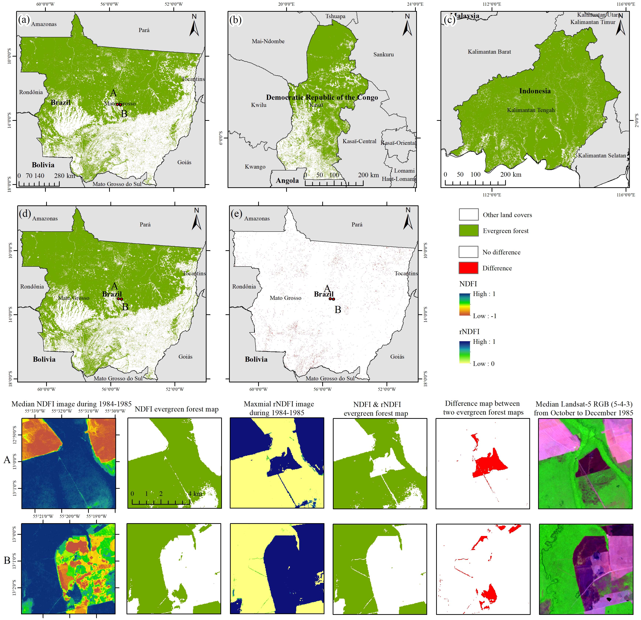
Figure 5. Evergreen forest cover (EFC) maps for the three study areas. (a) EFC map in Brazil Mato Grosso generated from median NDFI and maximal rNDFI images during 1984-1985; (b)-(c) EFC maps in DRC Kasaï and Indonesia Kalimantan Tengah generated from median NDFI and maximal rNDFI images during 1984-1990, respectively; (d) EFC map in Mato Grosso generated from median NDFI during 1984-1985; (e) Difference map between (a) and (d), while zoomed areas A and B are used to indicate the EFC difference.
Each validation sample was visually interpreted and assigned to one of three categories: (1) no loss of evergreen forest, (2) evergreen forest loss, or (3) other land cover. As shown in Fig. 4, for samples classified as evergreen forest loss, the first disturbance year, inter-annual disturbance frequency, and years since the last disturbance were visually determined. This assessment used all available time-series Landsat imagery since 1984, along with very fine–resolution imagery (e.g., 1–2 m) from Google Earth, to determine the class and disturbance/recovery years for each sample. For samples labeled as evergreen forest in the initial year (1985–1990), the Landsat vegetation indices (e.g., EVI and NDFI) and spectral bands (red, near-infrared, and short-wave infrared) were required to remain consistently high with minimal seasonal variation; otherwise, the sample was reclassified as other land cover. If both spectral and index values remained stable without seasonal variation throughout the period, the sample was classified as no loss of evergreen forest. Conversely, if a sample exhibited a clear and sustained decline in spectral and index values since 1985, it was classified as evergreen forest loss, and the first loss year, inter-annual disturbance frequency, and years since the last loss were recorded. Very fine–resolution imagery from Google Earth was also used to confirm forest cover, particularly for samples classified as no loss of evergreen forest and post-disturbance forest recovery.
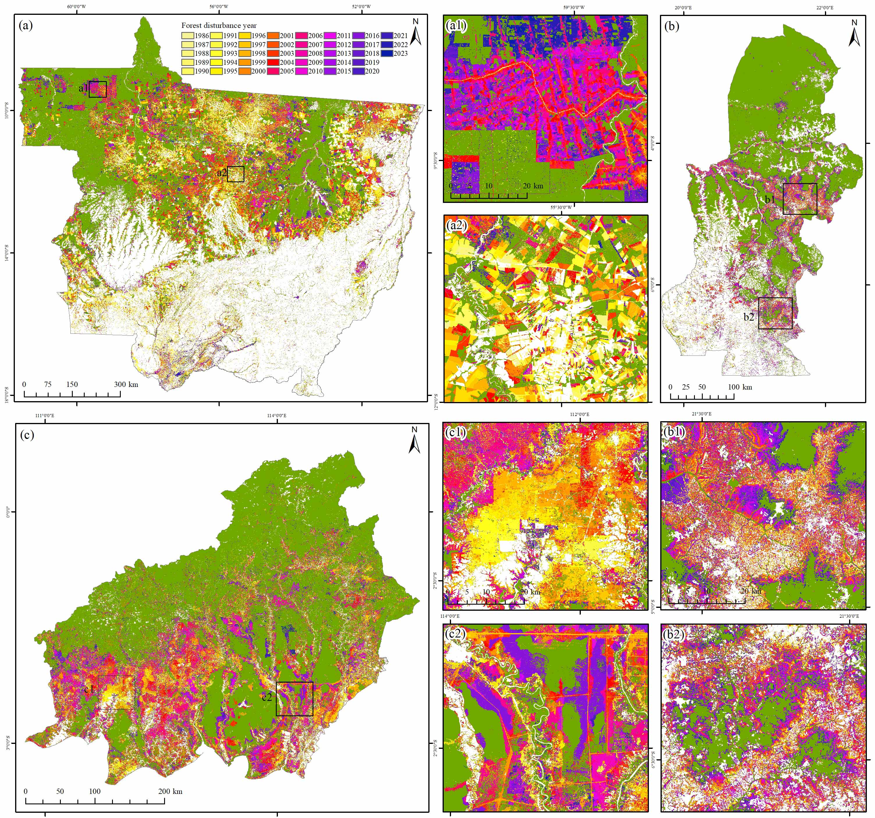
Figure 6. First forest disturbance year (FDY) maps for the three study areas. (a) First FDY in Brazil Mato Grosso from 1986 to 2023; (a1)-(a2) Two zoomed areas for (a); (b)-(c) First FDY in DRC Kasaï and Indonesia Kalimantan Tengah from 1991 to 2023, respectively; (b1)-(b2) Two zoomed areas for (b); (c1)-(c2) Two zoomed areas for (c).

Experimental results

Evergreen forest cover maps
Due to the limited data availabilities of Landsat-4/5 images (Fig. 2) and extremely frequent cloud covers in the tropics, it is unlikely that spatially continuous EFC maps can be produced in a single year from 1984 to 1990, especially for the DRC Kasaï and Indonesia Kalimantan Tengah. Therefore, the initial EFC map in Brazil Mato Grosso was generated based on Landsat TM during 1984-1985, while those of DRC Kasaï and Indonesia Kalimantan Tengah were based on the Landsat TM during 1984-1990. The threshold T values used to segment evergreen forests in equation (10) were determined automatically as 0.795, 0.816 and 0.927 using the 1000 stable evergreen forest samples and median NDFI images in Mato Grosso, Kasaï and Kalimantan Tengah, respectively. Initial EFC maps, as shown in Fig. 5, were produced finally for Brazil Mato Grosso in 1985 (Fig. 5(a)), and DRC Kasaï and Indonesia Kalimantan Tengah in 1990 (Figs. 5(b)-(c)). Using Brazil Mato Grosso as an example, comparisons between the EFC maps generated from median NDFI and integration of median NDFI and maximal rNDFI are depicted in Figs.4(d)-(e) and the last two rows of Fig. 5. Moreover, Table II provides an accuracy assessment and comparison of different EFC maps in the three study areas, and unbiased area estimates of the areas of evergreen forest are also provided.
TABLE III
Accuracy assessment and comparison of the first forest disturbance year (FDY) maps generated by the proposed method, Global Forest Change (GFC) forest loss product and Joint Research Centre (JRC) tropical moist forests (TMF) deforestation and degradation products for the three study areas. Unbiased Ares of forest disturbances were also estimated by the stratified random sampling method.
Study areas | Methods | Overall accuracy | Producer’s accuracy |  |  | User’s accuracy |  |  | Area (×10⁵ km²)
Study areas | Methods | Overall accuracy | Disturbed EFC | No disturbances | Disturbed EFC |  | No disturbances |  | Disturbed EFC
Brazil Mato Grosso | GFC forest loss | 78.39%±0.81% | 48.40%±1.83% | 98.48%±0.59% | 95.53%±1.34% |  |  | 74.02%±0.76%
Brazil Mato Grosso | JRC deforestation | 86.13%±0.78% | 68.15%±1.72% | 98.16%±0.53% | 96.13%±1.09% |  |  | 82.15%±0.85%
Brazil Mato Grosso | JRC degradation | 66.19%±0.93% | 27.36%±1.65% | 92.20%±1.09% | 70.13%±3.21% |  |  | 65.46%±0.62%
Brazil Mato Grosso | JRC deforestation & degradation | 86.97%±0.90% | 80.53%±1.45% | 91.28%±1.14% | 86.08%±1.60% |  |  | 87.50%±0.84%
Brazil Mato Grosso | This research | 98.50%±0.33% | 98.51%±0.59% | 98.49%±0.36% | 97.76%±0.54% |  |  | 99.00%±0.41% | 3.72±0.03
DRC Kasaï | GFC forest loss | 92.26%±1.15% | 53.94%±3.15% | 100%±0.00% | 100%±0.00% |  |  | 91.49%±0.70%
DRC Kasaï | JRC deforestation | 91.70%±1.18% | 53.80%±3.17% | 99.36%±0.36% | 94.45%±2.98% |  |  | 91.41%±0.77%
DRC Kasaï | JRC degradation | 90.59%±1.20% | 52.85%±3.08% | 98.21%±0.75% | 85.65%±5.24% |  |  | 91.16%±0.48%
DRC Kasaï | JRC deforestation & degradation | 94.90%±0.91% | 79.45%±2.31% | 98.03%±0.75% | 89.05%±3.77% |  |  | 95.94%±0.42%
DRC Kasaï | This research | 97.82%±0.60% | 93.40%±3.07% | 98.72%±0.27% | 93.64%±1.35% |  |  | 98.67%±0.66% | 0.16±0.01
Indonesia Kalimantan Tengah | GFC forest loss | 85.40%±1.12% | 62.96%±2.68% | 97.17%±0.95% | 92.09%±2.46% |  |  | 83.35%±1.04%
Indonesia Kalimantan Tengah | JRC deforestation | 83.37%±1.08% | 53.86%±2.77% | 98.84%±0.60% | 96.05%±1.97% |  |  | 80.34%±1.05%
Indonesia Kalimantan Tengah | JRC degradation | 83.85%±1.13% | 57.80%±2.75% | 97.50%±0.89% | 92.38%±2.54% |  |  | 81.51%±1.05%
Indonesia Kalimantan Tengah | JRC deforestation & degradation | 93.12%±0.97% | 86.69%±1.95% | 96.50%±1.05% | 92.84%±2.01% |  |  | 93.26%±0.96%
Indonesia Kalimantan Tengah | This research | 98.93%±0.49% | 98.08%±1.08% | 99.37%±0.31% | 98.79%±1.08% |  |  | 99.00%±0.31% | 0.52±0.01

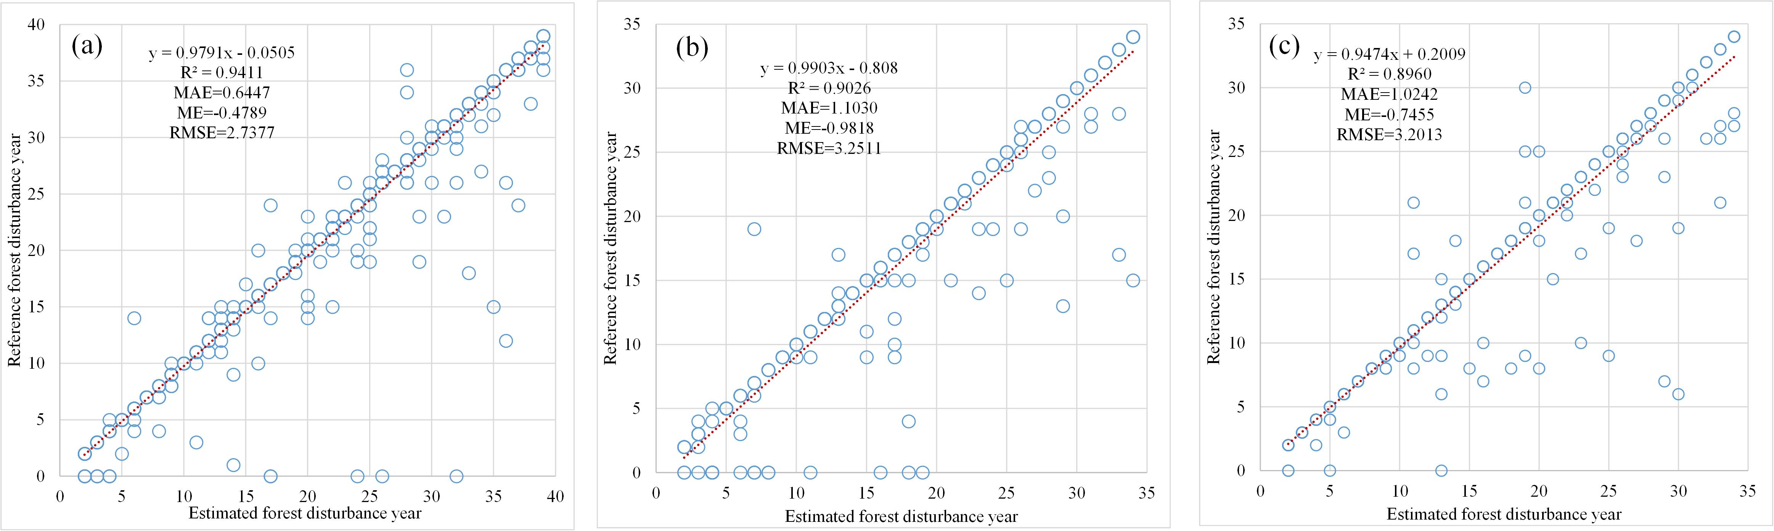
Figure 7. Scatterplots between the predicted and reference forest disturbance years for the validation samples in three study areas. (a) 760 samples in Brazil Mato Grosso; (b) 330 samples in DRC Kasaï; (c) 330 samples in Indonesia Kalimantan Tengah.

The EFC map generated from the median NDFI image retained most of the spatial details of evergreen forest cover. However, some forest logging events that occurred in the latter half of the observation period may have been omitted. As shown in Fig. 5(e), sporadic red pixels (indicating differences between the two EFC maps in Fig. 5(a) and Fig. 5(d)) are widely distributed across the study area. Specifically, in the two zoomed areas of A and B, it is evident that certain EFC patches generated from the median NDFI image have undergone logging, as confirmed by comparison with Landsat-5 RGB images acquired between October and December. The maximal rNDFI images can capture accurately canopy openings resulting from forest logging. By integrating the median NDFI and maximal rNDFI images, the EFC map can exclude precisely the logged areas. A similar trend can also be observed in Table II, where the EFC maps generated by integrating the median NDFI and maximal rNDFI images exhibited greater accuracies in all three study areas than those based solely on the median NDFI images. For example, the overall accuracy of the EFC maps in Indonesia Kalimantan Tengah increases from 94.80%±0.92% to 96.36%±0.72%, which demonstrates the superiority of the proposed method in mapping accurate EFC maps in the tropics.

First forest disturbance year maps
Based on the above generated initial EFC maps and spatio-temporally filtered annual maximal rNDFI images, annual FDY maps were produced for each of the three study areas in Fig. 6. The annual FDY map in Brazil Mato Grosso (Fig. 6(a)) recorded the first disturbance year of each pixel in the initial EFC map from 1986 to 2023, while those of DRC Kasaï and Indonesia Kalimantan Tengah were from 1991 to 2023. Scatterplots between the predicted and reference first disturbance years for the validation samples of disturbed evergreen forests of three study areas are shown in Fig. 7. Moreover, a comparison of annual FDY maps generated by the proposed method, the GFC forest loss product and the JRC TMF deforestation and degradation products are depicted in Fig. 8 and Table III. In Fig. 8, the fraction of forest disturbances produced by different methods in the three study areas means the percentage of total disturbed pixels (i.e., Landsat forest disturbances occurred at different years) with each of the 1 km × 1 km grid cells.
As shown in the result of Brazil Mato Grosso (Fig. 6), numerous forest disturbances with shapes of rectangles or polygons that occurred before 2000 were primarily concentrated in the central area of the EFC map (see Fig. 6(a2)). On the other hand, new forest disturbances occurred after 2010 were widespread in the west-northern and central-eastern regions (see Fig. 6(a1)). For the result of DRC Kasaï (Fig. 6(b)), forest disturbances that occurred in central-south regions were mostly presented as stripes with numerous irregular small-scale plaques (i.e., smallholder clearing) (Figs. 6(b1)-(b2)). Most of the newly disturbed forests (i.e., disturbed from 2011 to 2023) were located outermost of the stripes. As depicted in Fig. 6(c), forest disturbances occurred across almost all parts of Indonesia Kalimantan Tengah, and most of them have a different pattern compared to those in Brazil Mato Grosso and DRC Kasaï. In the south-central regions, most of the forest disturbances occurred from 1995 to 2010 and presented as large-scale irregular plaques, while numerous small-scale selective logging roads were found in the northern regions. Based on the validation samples of disturbed evergreen forests, As shown in Fig. 7, the predicted disturbance years in Brazil Mato Grosso (Fig. 7(a)) present the largest R² of 0.94 and the smallest MAE, ME and RMSE of 0.64, 0.48 and 2.74, respectively, while those of DRC Kasaï and Indonesia Kalimantan Tengah (Fig. 7(b)-(c)) also have an R² of around 0.90. Some of the predicted disturbance years have later detection years than the reference disturbance years. This discrepancy may be attributed to the utilization of a spatio-temporal filter to eliminate false positives.
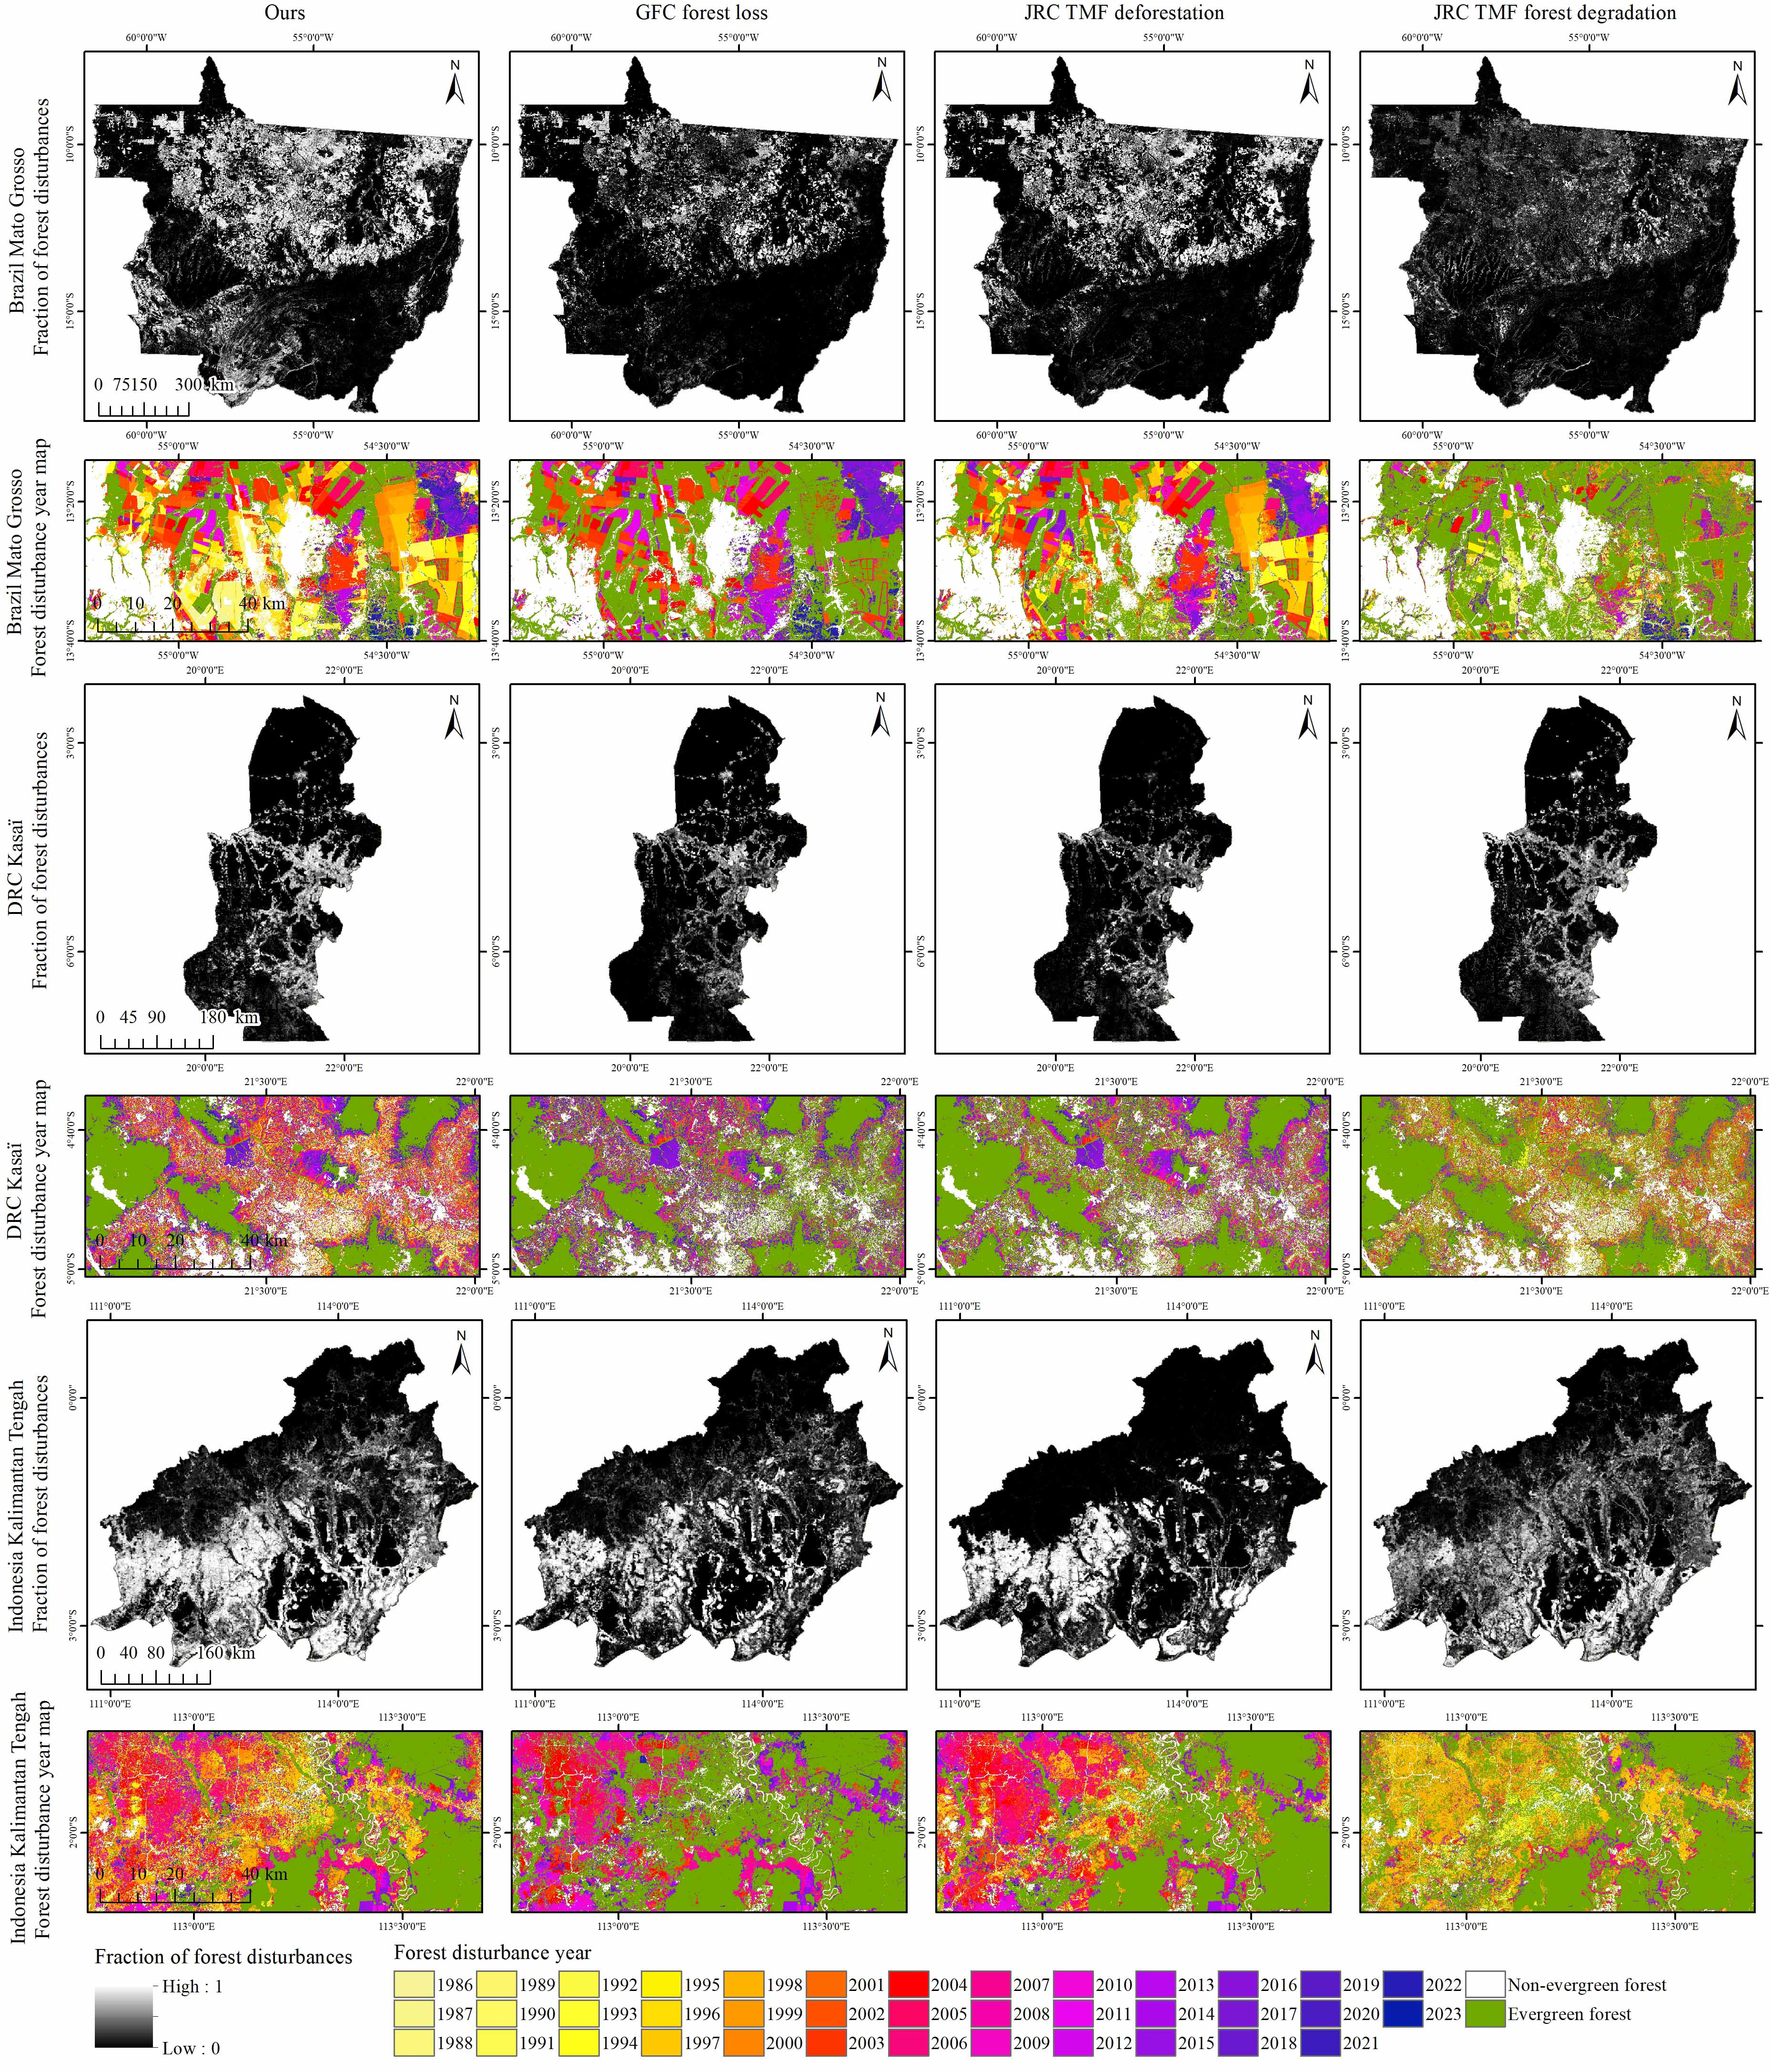
Figure 8. Comparison of forest disturbance year (FDY) maps generated by the proposed method, GFC forest loss product and JRC TMF deforestation and degradation products for the three study areas, in which the first, third and fifth columns are the fraction maps of total forest disturbances within each of the 1 km × 1 km grid cells.
As shown in Fig. 8, most of the forest disturbances in the GFC forest loss and JRC TMF deforestation and degradation products can be found in the result of our proposed method. The proposed method is able to detect more forest disturbances than any of them by comparing the fraction maps of total forest disturbances. The annual forest disturbances tracked by the proposed method provide more small-scale disturbance events and are more similar to the combination of JRC TMF deforestation and degradation. This may be due to the fact that the NDFI and rNDFI used in the proposed method has the ability to track both deforestation and forest degradation. As listed in Table III, annual forest disturbances generated from JRC TMF deforestation & degradation have higher accuracies (i.e., overall accuracies ranging from 86.97%±0.90% to 94.90%±0.91%) than those of GFC forest loss, JRC TMF deforestation and JRC TMF degradation products. The proposed method produced the highest accuracies in all three study areas, in which the corresponding overall accuracy ranges from 97.82%±0.60% to 98.93%±0.49%. This demonstrates the superiority of the proposed method for mapping long-term annual forest disturbances in the tropics.
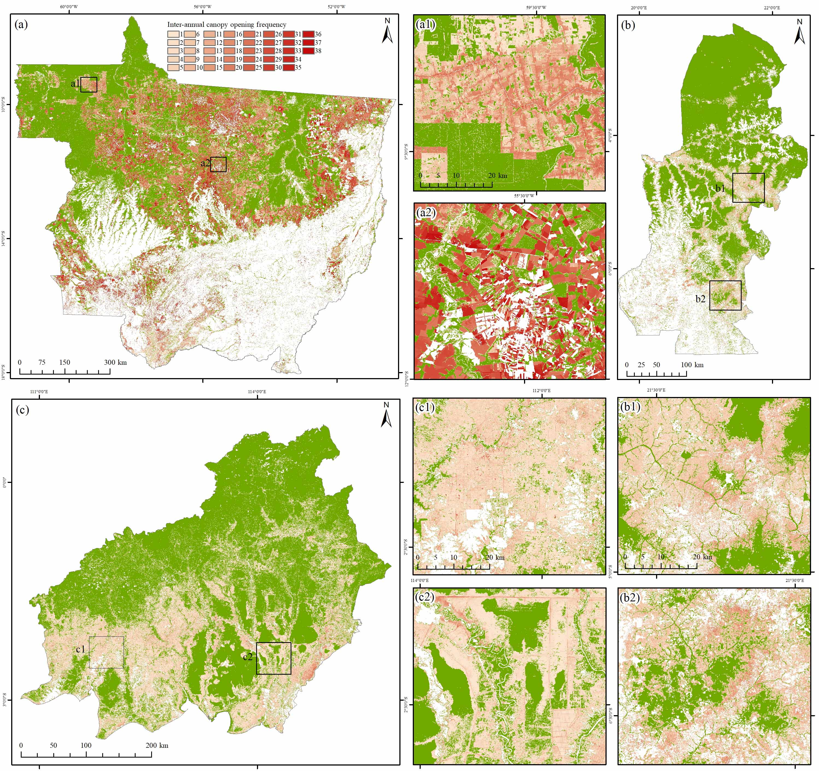
Figure 9. Inter-annual forest disturbance frequency (FDF) maps for the three study areas. (a) Inter-annual FDF map in Brazil Mato Grosso from 1986 to 2023; (a1)-(a2) Two zoomed areas for (a); (b) Inter-annual FDF map in DRC Kasaï from 1991 to 2023; (b1)-(b2) Two zoomed areas for (b); (c) Inter-annual FDF map in Indonesia Kalimantan Tengah from 1991 to 2023; (c1)-(c2) Two zoomed areas for (c).

Map of inter-annual forest disturbance frequency
The annual FDY map does not provide information about whether further disturbances will occur after the initial disturbances. To address this limitation, FDF is proposed to represent the frequency of inter-annual canopy openings (i.e., forest disturbances), and the FDF maps are shown in Fig. 9. Moreover, a comparison of inter-annual FDF maps generated by the proposed method and JRC TMF product for the three study areas is shown in Fig. 10. Fig. 11 shows the scatterplots and accuracies of the predicted inter-annual canopy opening frequencies for the three study areas.
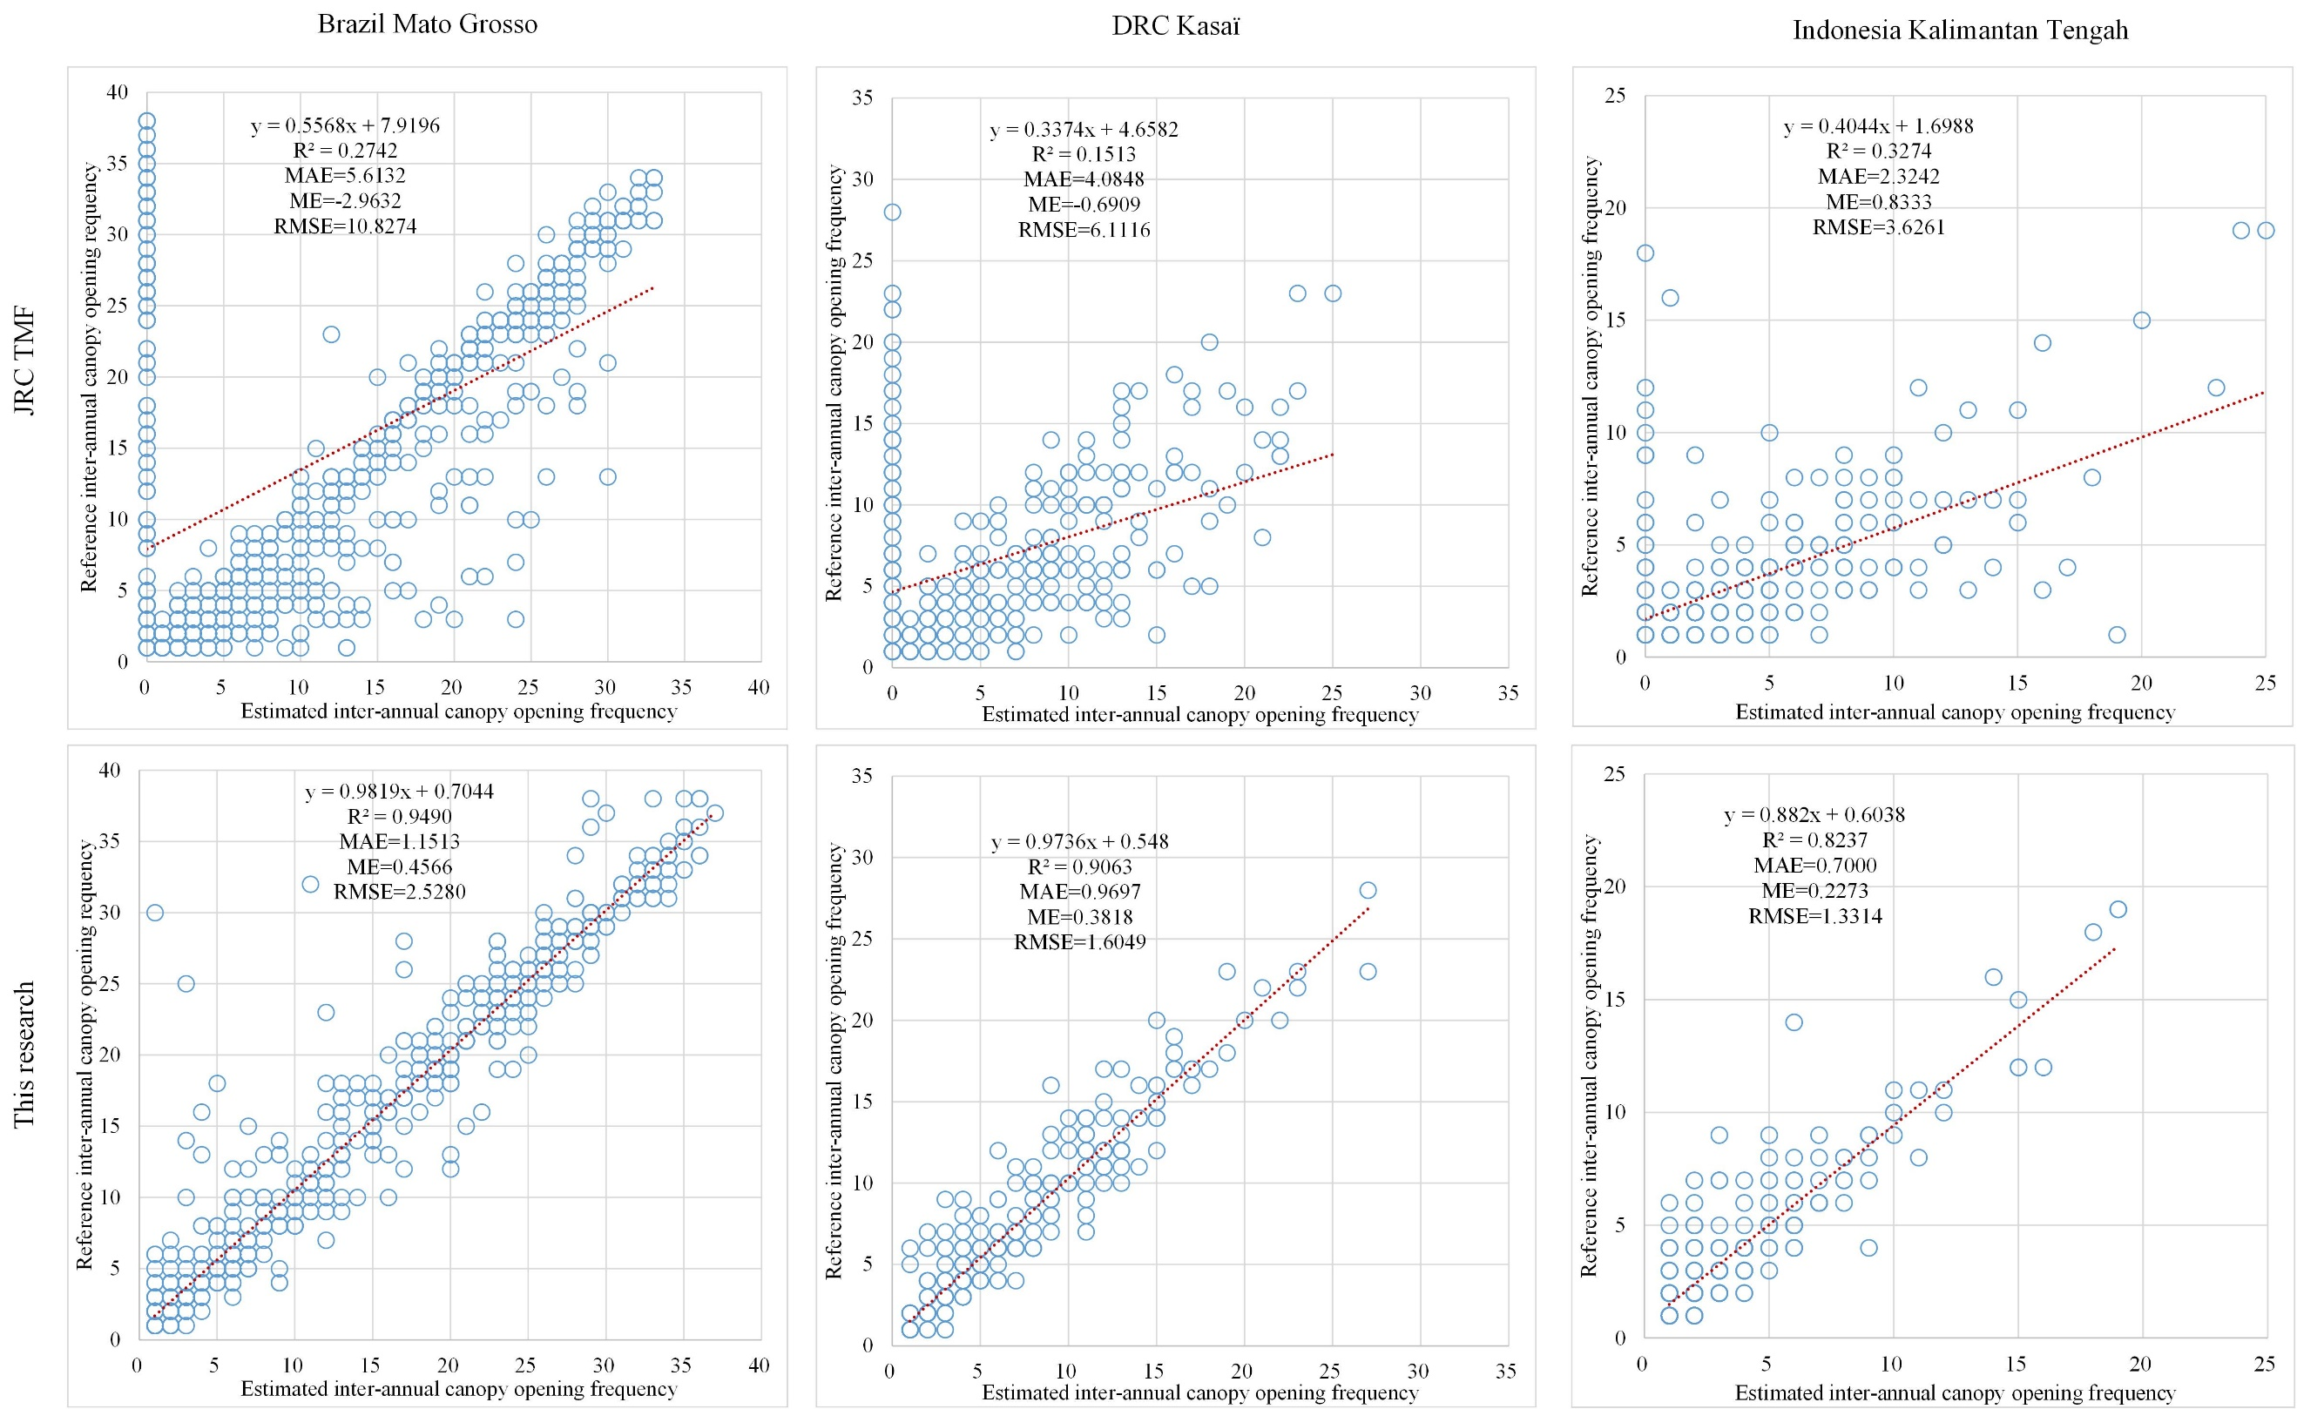
Figure 11. Scatterplots between the predicted and reference inter-annual canopy opening frequency of the JRC TMF and this research for the validation samples in Brazil Mato Grosso (760 samples), DRC Kasaï (330 samples) and Indonesia Kalimantan Tengah (330 samples).
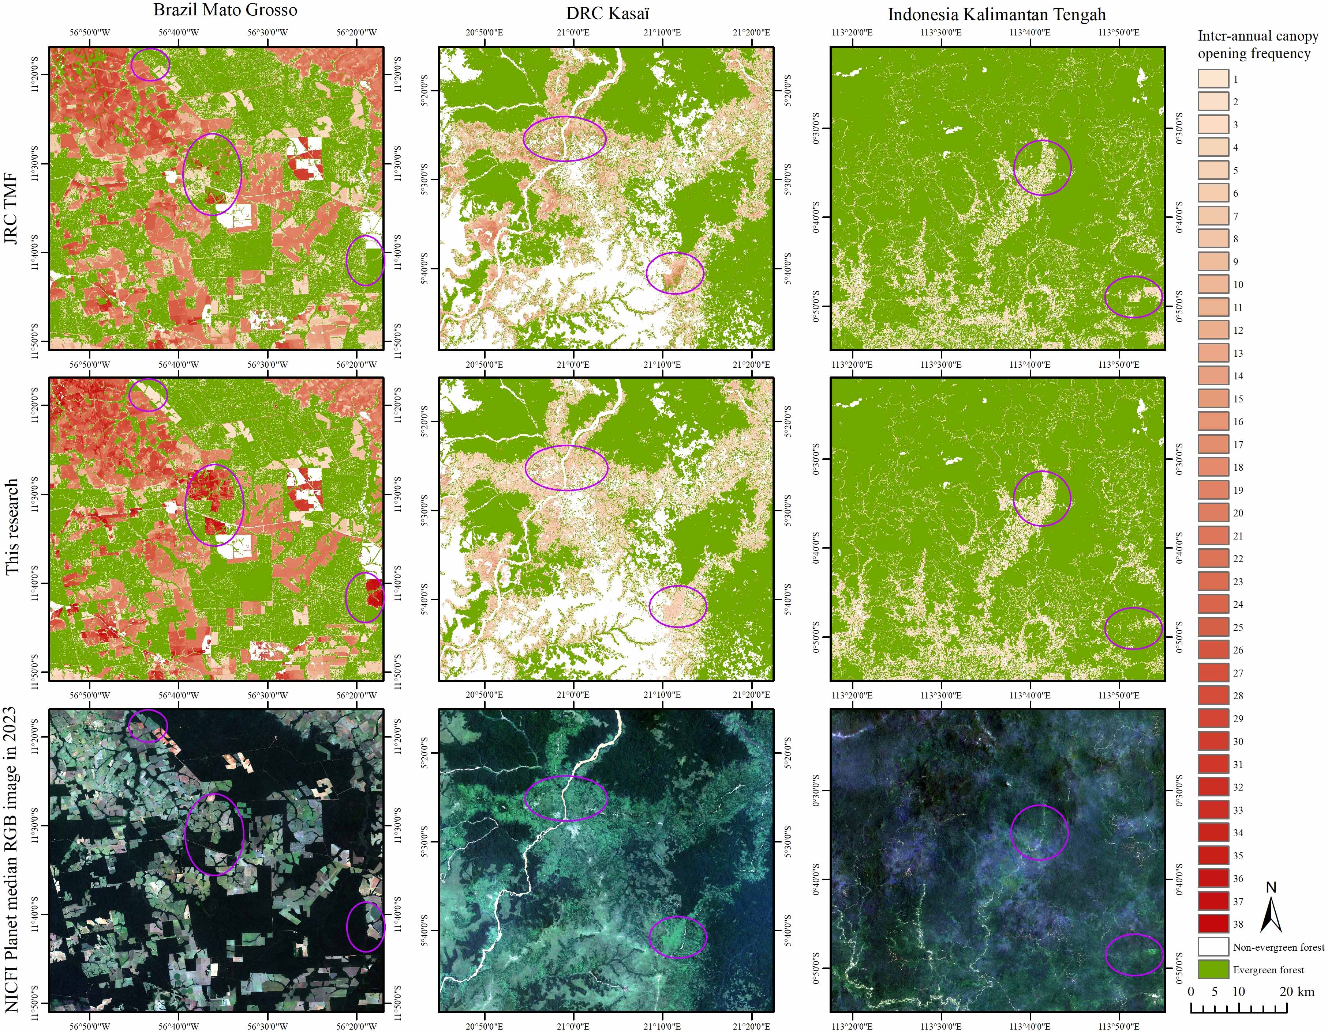
Figure 10. Comparison of inter-annual FDF maps generated by the proposed method and JRC TMF product. The bottom row shows NICFI Planet median RGB images in 2023.
As shown in Fig. 9, the overall FDF from the beginning year to the end of observation in Brazil Mato Grosso are larger than those of DRC Kasaï and Indonesia Kalimantan Tengah. This may relate to the Landsat images availability shown in Fig. 2, but the main reason for this is the different forms of post-disturbance land cover/use. The presence of large values of inter-annual canopy opening frequency indicates that the deforested areas were not remaining for natural vegetation/forest recovery, which is evident in Brazil Mato Grosso. Instead, anthropogenic activities such as agricultural planting, urban expansion, and secondary deforestation frequently opened the canopy of the corresponding regrowing vegetation/forest. Inter-annual canopy opening frequency with small spatial sizes in DRC Kasaï resulted predominantly from smallholder clearing, and the relatively small frequencies indicated that most of the deforested land in this region was not used persistently for agriculture. In northern Indonesia Kalimantan Tengah, the widespread small-scale selective logging roads have small inter-annual canopy opening frequencies, which also can be observed for areas of large-scale deforested land in the southern regions. This may because the large-scale oil palm plantations after deforestation in the southern regions also belong to evergreen forests, and the inter-annual canopy opening frequencies remained low.
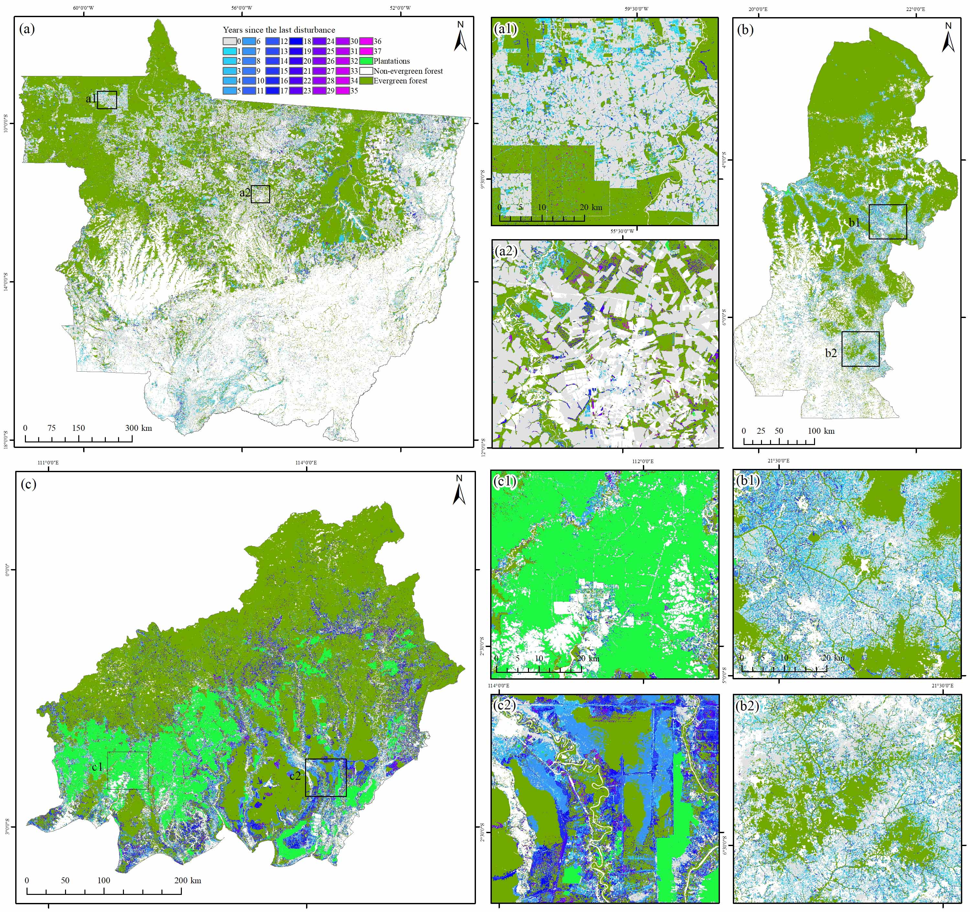
Figure 12. Post-disturbance forest recovery (PFR) maps for the three study areas. (a) PFR (i.e., years since the last disturbance) map in Brazil Mato Grosso from 1986 to 2023; (a1)-(a2) Two zoomed areas for (a); (b) PFR map in DRC Kasaï from 1991 to 2023; (b1)-(b2) Two zoomed areas for (b); (c) PFR map in Indonesia Kalimantan Tengah from 1991 to 2023; (c1)-(c2) Two zoomed areas for (c).
The JRC TMF product provides not only the tropical humid FDY maps for deforestation and degradation, but also the annual disturbance counts since 1982 (https://forobs.jrc.ec.europa.eu/TMF/data). The comparisons between the inter-annual FDF maps generated by JRC TMF and this research are depicted in Figs. 9 and 10. They indicates that the inter-annual FDF of the proposed method match well with those of the JRC TMF in Brazil Mato Grosso and Indonesia Kalimantan Tengah. Some commission and omission of canopy openings (i.e., purple ovals) can be seen in the JRC TMF by comparing them with the NICFI Planet RGB image. However, for the DRC Kasaï, the canopy opening frequencies of JRC TMF are slightly larger than those of our proposed method. This may be because the JRC TMF product was designed based on annual forest cover classification, and even if disturbed land has a closed canopy it may not be classified immediately as forest regrowth. Moreover, some omission of small-scale canopy openings (i.e., purple ovals) can also be seen in the JRC TMF result of DRC Kasaï. However, by observing the NICFI Planet RGB images (i.e., purple ovals), the proposed method is more sensitive to the small-scale canopy spatio-temporal dynamics of disturbed forests, in which the omission of small-scale canopy openings improved a lot. Based on the validation samples of disturbed evergreen forests in three study areas, Fig. 11 depicts the scatterplots and accuracy assessments between the reference and predicted inter-annual canopy opening frequencies. The R², MAE, ME and RMSE of the proposed method are in the range between 0.82-0.95, 0.70-1.15, 0.23-0.46 and 1.33-2.53, respectively. They are more accurate than those of the JRC TMF results (i.e., 0.15-0.33, 2.32-5.61, (-0.69)-2.96 and 3.63-10.83, respectively) in all three study areas. This means that high accuracies were achieved by the proposed method in tracking the inter-annual FDF in the tropics.
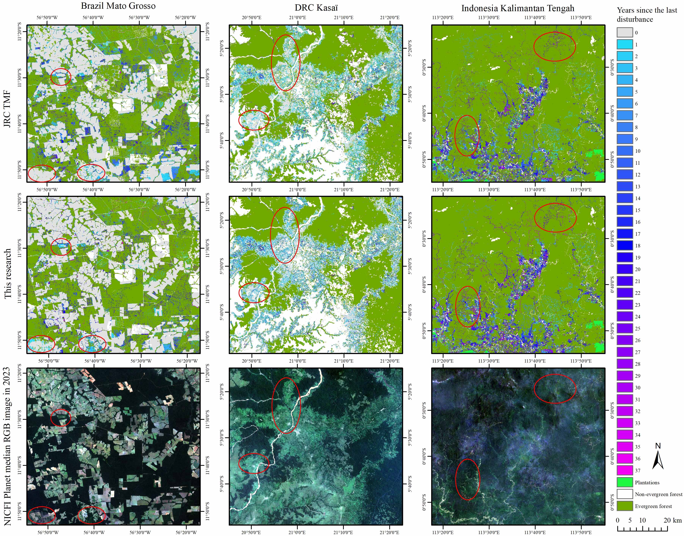
Figure 13. Comparison of post-disturbance forest recovery (PFR) maps generated by the proposed method and JRC TMF deforestation and degradation products for the three study areas. The bottom row shows NICFI Planet median RGB images in 2023.

Map of post-disturbance forest recovery
After a disturbance event in evergreen forests, a process of recovery is likely to occur if there are no further disturbances. However, as depicted in Fig. 9, subsequent disturbances were prevalent following the initial disturbances, and the crucial step in assessing PFR is to identify the most recent disturbance year. Fig. 12 illustrates the maps of PRF (i.e., years since the last disturbance) in the three study areas for all initial disturbances (i.e., Fig. 6). All plantation areas (i.e., oil palm, rubber, coconut and so on) after deforestation were excluded in the PFR maps, since plantation growing is the antithesis of real PFR.
PFR likely occurred in deforested areas characterized by a low frequency of inter-annual canopy opening, in which most of these recovered areas appeared along the boundaries of previously disturbed forest areas, especially in Brazil Mato Grosso. As shown in Fig. 12, most of the years since the last disturbance in Brazil Mato Grosso are zero and many of the disturbed forests in DRC Kasaï have a recovery year around 5 years, while those in Indonesia Kalimantan Tengah have a larger recovery years around 10. This means that post-disturbance forest recovery in DRC Kasaï and Indonesia Kalimantan Tengah was greater than that in Brazil Mato Grosso. Moreover, small-scale forest disturbances, such as smallholder clearing in DRC Kasaï and selective logging in Indonesia Kalimantan Tengah, have relatively larger recovery years than those of larger-scale disturbances in Brazil Mato Grosso. This means PFR is strongly linked to the spatial scale of disturbance.
As shown in Fig. 13, with the above-mentioned annual binary disturbance (i.e., disruption) maps, we generated the JRC TMF PFR maps for the three study areas. Although the years since the last disturbance in the JRC TMF PFR maps share a similar trend as those in this research, many omissions of PFR events (i.e., purple ovals) can be found in the results of JRC TMF by comparing them with the NICFI Planet RGB image, especially for many PFR smallholder clearing events in DRC Kasaï and Brazil Mato Grosso. Moreover, for selective logging in Indonesia Kalimantan Tengah (i.e., purple ovals), the proposed method can represent more spatial details than those of JRC TMF. This illustrates that the proposed method is more sensitive to the forest recovery of small-scale disturbed land than the JRC TMF product. Fig. 14 depicts the scatterplots and accuracy assessments between the reference and estimated years since the last disturbance. The R², MAE, ME and RMSE of the proposed method are in the range between 0.86-0.89, 0.47-1.05, (-0.36)-(-0.13) and 1.71-2.88, respectively. They are more accurate than those of the JRC TMF results (i.e., 0.26-0.36, 1.75-4.31, (-2.82)-(-0.95) and 4.34-7.75, respectively) in all three study areas. This means that high accuracy was achieved by the proposed method in tracking PFR in the tropics.

discussion

Spatial patterns of forest disturbances and post-disturbance recovery
Global forest disturbances are attributed to several factors, including commodity production, forestry activities, cropland expansion, wildfires, and urbanization [3], each shaping distinct disturbance and recovery patterns. As the transition zone between tropical rainforest and savanna, the Brazil Mato Grosso experiences forest loss primarily driven by commodity production (such as soy, palm oil, wood fiber, and beef) and cropland expansion, as well as wildfires and drought. Selective logging is also a significant driver of forest disturbances in Brazil Mato Grosso and Indonesia Kalimantan Tengah [13, 22, 56]. Unlike other drivers, selective logging does not lead to a change in land cover in tropical forests but targets, only areas with a small spatial size, typically less than 1 ha [21, 57]. Smallholder clearing in the Congo Basin, including the DRC Kasaï, was found to be the dominant driver of forest loss [48]. In Indonesia, including the Kalimantan Tengah, the land generated from the deforestation of old tropical forests is used mainly for oil palm plantations [3, 58]. In Fig. 15, we showcase several examples illustrating six typical forest disturbances and post-disturbance recovery processes in the three study areas.
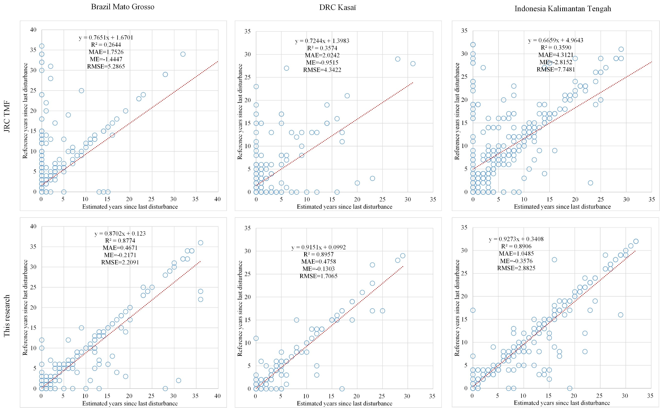
Figure 14. Scatterplots between the estimated and reference years since the last disturbance of the JRC TMF and this research for the validation samples in Brazil Mato Grosso (760 samples), DRC Kasaï (330 samples) and Indonesia Kalimantan Tengah (330 samples).
Compared to many large-scale forest disturbances, PFR following selective logging tends to remain at a relatively higher level. This is because selective logging is often followed by abandonment, which allows for the natural recovery of secondary forests [59]. As shown in the second column of Fig. 15, most of the smallholder clearings have a PFR year no less than one. In the case of urban expansion, forest disturbances typically occur around cities and spread radially, resulting in medium-sized deforested areas and the majority having PFR years of zero. In the case of cropland expansion, forest disturbances typically lead to large-sized deforested areas, with the majority of the PFR years being zero (i.e., no recovery). In the case of drought and forest fires, they typically result in larger spatial sizes of forest disturbance. These forest disturbance events are also classified as forest degradation [13, 22]. As shown in the fifth column of Fig. 15, the PFR is rapid and remains at a consistently high level. For the forest loss driver of oil palm plantations, the spatial sizes of logging are always larger than many other drivers and the corresponding PFR stays at an extremely high level, due to deforested land being planted with evergreen forests of oil palm immediately. However, single-tree species plantations like oil palm after deforestation pose a significant ecological challenge, or even a potential disaster. Thus, clearly, oil palm plantations after forest disturbance should not be regarded as PFR.

Carbon stock and potential of post-disturbance recovery
In general, if there are no further disturbances to the already disturbed land, a process of vegetation/forest recovery is highly likely to occur [28]. In this research, the estimated number of years since last disturbance was considered a good indicator of the age of secondary forest regrowth [28]. Based on the number of years since the last disturbance shown in Fig. 12 and the Chapman–Richards forest growth model [60], the carbon stock of post-disturbance forest recovery can be estimated. The secondary forest regrowth carbon accumulation functions [28] based on the Chapman–Richards forest growth model have been predicted for the Amazon Basin, Central Africa and Borneo, respectively. The selected three study areas within the three tropics can use the modelled secondary forest regrowth carbon accumulation functions to estimate the carbon stock of post-disturbance forest recovery by 2023. However, it is expected that more accurate estimations of the carbon sink may be achieved by using local functions of forest regrowth carbon accumulation for each of the study areas.
Compared to the old mature forests, secondary forests dominated by young ages contain much greater carbon sink potential [28, 43, 61-63]. As depicted in Fig. 12, most post-disturbance recovered forests are less than 10 years old, indicating that lots of young secondary forests were generated by post-disturbance forest recovery. These young forests are expected to exhibit a much faster carbon accumulation rate and greater carbon sink potential in the coming decades of growth than old forests. It is expected to quantify the maximum technical carbon sink potentials of post-disturbance forest recovery in future years, which is critical for mitigating global climate change [43, 62, 63].
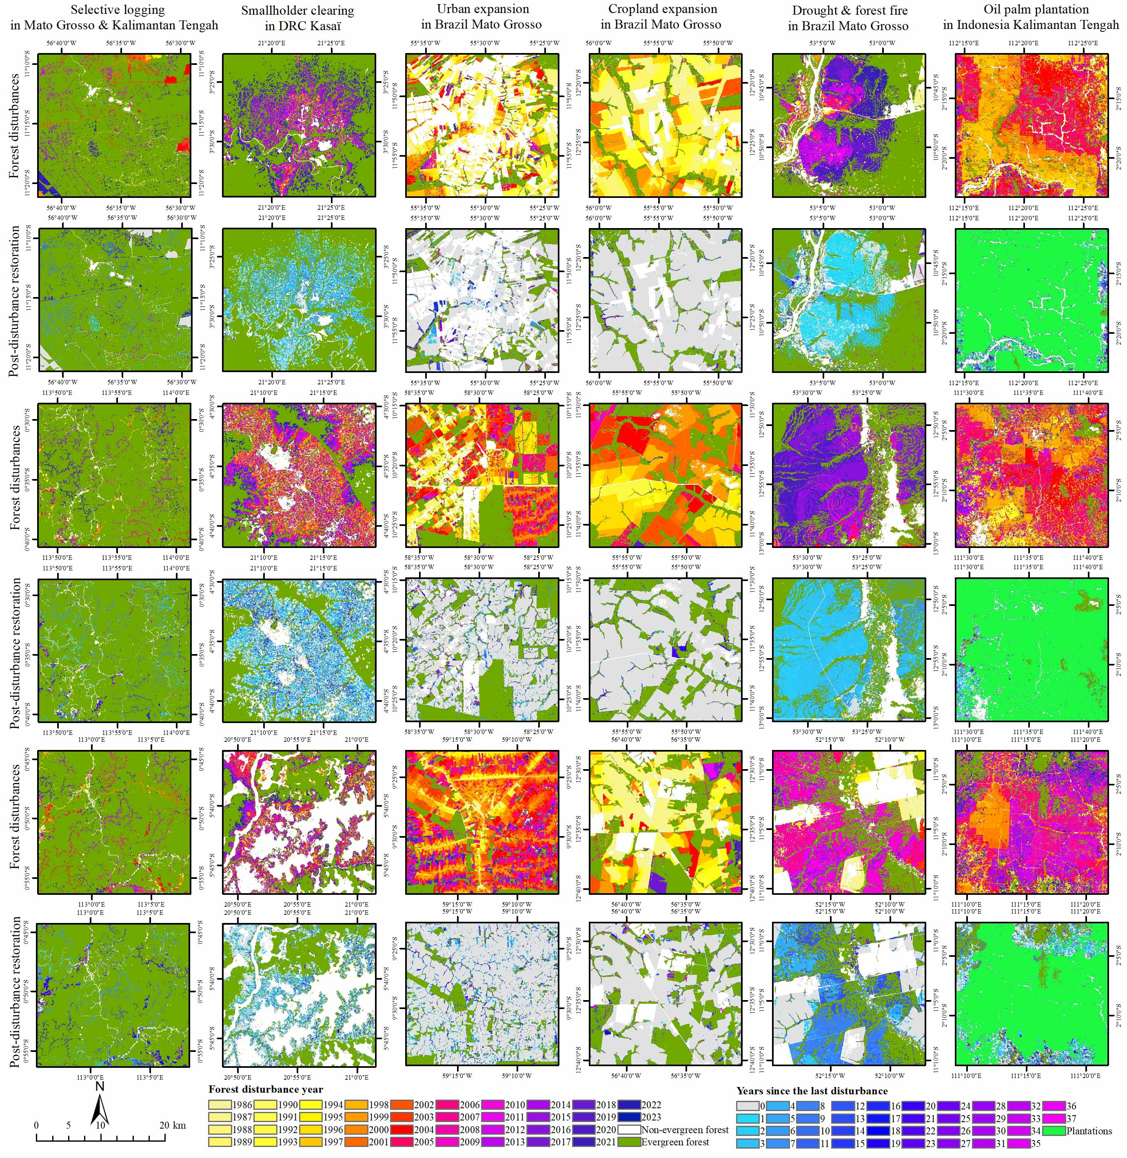
Figure 15. Examples used to illustrate six typical spatial patterns of forest disturbances and post-disturbance recovery.

Comparison of other self-referenced vegetation indices with rNDFI
Compared with the widely used vegetation indices of NDVI [64] and EVI [65], the NBR and Hue indices are less susceptible to atmospheric effects such as haze or smoke. Moreover, they exhibit greater sensitivity to canopy openings caused by forest disturbances [10, 21, 34]. To further reduce illumination and topography effects and enhance inter-comparability, a self-referencing approach was applied to normalize NBR [10, 26, 66] and Hue [21] for monitoring tropical forest disturbances. In general, self-referenced vegetation indices, including rNBR and rHue, require only two or three spectral bands to track forest disturbances and remain sensitive to residual clouds in remote sensing imagery. Given the increasing spatial heterogeneity and heterogeneous surfaces in tropical regions, more comprehensive spectral information is required for effective forest disturbances monitoring.
The NDFI was originally developed to detect sub-pixel canopy damage from forest degradation [13]. It has been shown to improve the detection of tropical forest canopy disturbance events when fraction images derived from SMA model are used as inputs [12]. Unlike rNBR and rHue, the self-referenced NDFI (rNDFI) leverages all available spectral bands to improve the tracking of tropical forest disturbances. Moreover, rNDFI can mitigate residual cloud effects by introducing the endmember of cloud. Recognizing the strong potential of NDFI for monitoring forest cover change, particularly deforestation forest degradation [12], we developed rNDFI in combination with a spatio-temporal filtering to further enhance the detection of small-scale disturbances in tropical forests, as well as post-disturbance forest recovery.

Timely detection of forest disturbances and post-disturbance recovery
Similar to the forest cover change monitoring products of GFC [6] and JRC TMF [7], as well as the LandTrendr tool [34], the proposed method aims to detect forest disturbances and post-disturbance recovery in tropical regions on an annual basis. In general, the proposed method provides more reliable information over longer observation periods, since several years are required to assess a disturbance or recovery event. In practice, forests are constantly affected by various natural and anthropogenic disturbances, such as logging, fires, storms, and insect outbreaks, which lead to different recovery processes depending on the disturbance drivers [3, 67]. Therefore, timely (i.e., near real-time) detection of forest disturbances and post-disturbance recovery plays a critical role in advancing our understanding of forest ecosystem dynamics, carbon cycling, and climate change mitigation [16, 21, 51, 68, 69].
For the proposed method, it can be further improved to track forest disturbances and recovery at shorter temporal intervals, such as monthly or even near real-time [21]. However, the accuracy of such timely detection is often constrained by data gaps, outliers and remaining clouds/shadows in Landsat images, particularly in tropical regions [70]. A promising solution is to integrate multi-source satellite sensor images, such as Landsat, Sentinel-2, Sentinel-1 and PALSAR, into the framework of the proposed method to enhance the timeliness and reliability of forest disturbance and recovery detection [71]. In this case, developing a new approach for estimating NDFI from SAR data (i.e., Sentinel-1 and PALSAR) is of particular interest. In addition, advanced spatio-temporal filtering [21] should be explored to further reduce the false positives caused by outliers and remaining clouds/shadows in different satellite sensor images. Further methodological advancements in the proposed method are necessary to overcome the trade-off between the accuracy and timeliness of forest disturbance and recovery monitoring [70].

Limitations and advances
The yearly maximal rNDFI is effective in capturing canopy openings caused by forest disturbances, it may also yield false positives due to the presence of any remaining clouds in the Landsat images. Based on the principle that moving clouds or image outliers are unlikely to appear in the same locations over a long period [19, 21, 51], a spatio-temporal filter was developed to eliminate false positives. The use of spatio-temporal filter entails a trade-off, as it may also lead to the elimination of some genuine forest disturbances, particularly when the available number of Landsat images is insufficient. In future research, a general method should be developed to solve the trade-off issue. Second, the inter-annual forest disturbance frequency is based on the yearly maximal canopy opening. However, if there are no available Landsat images in a certain year or available Landsat images are within the vegetation growth season, no canopy opening will be tracked by the proposed method. This will result in an underestimation of the inter-annual FDF. Third, in PFR mapping, it is challenging to differentiate between naturally regenerated secondary forests and planted trees, such as oil palms, which can obscure the assessment of natural recovery [28]. Generally, genuine post-disturbance recovery requires tree species diversity to facilitate the real recovery of the forest ecosystem functions [52]. Therefore, we excluded most of the plantation areas extracted from many available data sources in the resultant PFR maps. The plantation areas dataset was updated in 2022, so it is acknowledged that some new plantation growth after 2022 may not be masked out in our results. In future research, the plantation areas dataset should be updated and used to increase the accuracy of PFR mapping further. Fourth, by comparing with the forest disturbances tracked by this research, GFC and JRC TMF, it is evident that forest disturbances of ours and GFC include both deforestation and forest degradation as raised by JRC TMF. However, due to the significant controversy over the definition of tropical forest degradation [7, 12, 22], tropical deforestation and degradation were not separated in the proposed method. Nonetheless, it is of great interest to distinguish between deforestation and degradation in tropical forest disturbances. Lastly, the determination of evergreen forest cover segmentation threshold T in equations (9)-(10) is based on a global automatic estimation. Given the substantial spatial heterogeneity and species diversity of tropical forests [72], the threshold T may vary across different local regions. In future work, it would be appropriate to conduct a more localised automatic estimation of threshold T for evergreen forest cover in different regions, especially when the study area is large.
In addition to the GFC [6] and JRC TMF [7] products, which are based on the traditional forest cover classification methods, several newly developed deep learning approaches can also serve as comparisons for our monitoring of forest disturbances and post-disturbance recovery. For example, a deep learning model has been developed to monitor small-scale tropical forest disturbances and types using time-series Sentinel-1/2 data [18]. A U-Net deep learning model was introduced to map tropical forest disturbances (i.e., degradation) caused by logging, fire, and road construction using Planet NICFI imagery [22]. An extended deep convolutional neural network (DCNN) was proposed to identify forest disturbances from very high-resolution satellite sensor images [73]. Although deep learning approaches achieve high accuracy, they are typically designed for very high-resolution imagery and limited to local or regional applications. In contrast, both the proposed method and the traditional forest cover classification techniques used to generate the GFC and JRC TMF products exhibit stronger generalization capabilities and can be applied across tropical regions. In future work, integrating deep learning models into the proposed framework would be of great interest to further enhance the capability of tracking forest disturbances and post-disturbance recovery.

Conclusion
With all available Landsat images, this research proposed a framework to characterize tropical evergreen forest disturbances and post-disturbance recovery using annual maximal Landsat canopy openings. The results in the three study areas demonstrate that the proposed method can generate a more accurate initial EFC map by integrating median NDFI and maximal rNDFI images. Compared to the GFC forest loss and JRC TMF deforestation and degradation products, the proposed method not only tracked more small-scale disturbance events, but also predicted annual forest disturbances more accurately. The predicted FDY realized an R² of more than 0.90 and the overall accuracy of the disturbed forests and no disturbance ranged from 97.82%±0.60% to 98.93%±0.49% in the three study areas. The generated inter-annual FDF and PFR maps exhibit high accuracies, with the R², MAE and RMSE in the range between 0.82-0.95, 0.47-1.15 and 1.33-2.88, respectively, more accurate than those of the JRC TMF product. Moreover, the results of the proposed method are more sensitive to canopy spatio-temporal dynamics and recovery of small-scale disturbances than the JRC TMF product. It can represent more spatial details of FDF and PFR that arise due to smallholder clearing and selective logging. Meanwhile, it is of great interest to estimate the carbon sink of secondary forests by using the generated PFR (i.e., years since the last disturbance) map. The proposed method offers an effective framework for simultaneously monitoring disturbances and post-disturbance recovery of tropical forests, thereby addressing the existing knowledge gap regarding post-change and carbon dynamics after forest disturbances.

References
[1] X. Xiao, Q. Zhang, S. Saleska et al., “Satellite-based modeling of gross primary production in a seasonally moist tropical evergreen forest,” Remote Sens. Environ., vol. 94, no. 1, pp. 105-122, 2005/01/15/, 2005.
[2] R. Condit, P. S. Ashton, P. Baker et al., “Spatial Patterns in the Distribution of Tropical Tree Species,” Science, vol. 288, no. 5470, pp. 1414-1418, 2000/05/26, 2000.
[3] P. G. Curtis, C. M. Slay, N. L. Harris et al., “Classifying drivers of global forest loss,” Science, vol. 361, no. 6407, pp. 1108-1111, 2018/09/14, 2018.
[4] K. F. Davis, H. I. Koo, J. Dell’Angelo et al., “Tropical forest loss enhanced by large-scale land acquisitions,” Nat. Geosci., vol. 13, no. 7, pp. 482-488, 2020/07/01, 2020.
[5] J. Barlow, G. D. Lennox, J. Ferreira et al., “Anthropogenic disturbance in tropical forests can double biodiversity loss from deforestation,” Nature, vol. 535, no. 7610, pp. 144-147, 2016/07/01, 2016.
[6] M. C. Hansen, P. V. Potapov, R. Moore et al., “High-Resolution Global Maps of 21st-Century Forest Cover Change,” Science, vol. 342, no. 6160, pp. 850-853, 2013/11/15, 2013.
[7] C. Vancutsem, F. Achard, J. F. Pekel et al., “Long-term (1990–2019) monitoring of forest cover changes in the humid tropics,” Sci. Adv., vol. 7, no. 10, pp. eabe1603, 2021.
[8] P. Mayaux, P. Holmgren, F. Achard et al., “Tropical forest cover change in the 1990s and options for future monitoring,” Philosophical Transactions of the Royal Society B: Biological Sciences, vol. 360, no. 1454, pp. 373-384, 2005/02/28, 2005.
[9] B. Mackey, C. F. Kormos, H. Keith et al., “Understanding the importance of primary tropical forest protection as a mitigation strategy,” Mitigation Adapt. Strategies Global Change, vol. 25, no. 5, pp. 763-787, 2020/05/01, 2020.
[10] A. Langner, J. Miettinen, M. Kukkonen et al., “Towards Operational Monitoring of Forest Canopy Disturbance in Evergreen Rain Forests: A Test Case in Continental Southeast Asia,” Remote Sens., vol. 10, no. 4, 2018.
[11] Z. Du, L. Yu, J. Yang et al., “Mapping Annual Global Forest Gain From 1983 to 2021 With Landsat Imagery,” IEEE J. Sel. Top. Appl. Earth Obs. Remote Sens., vol. 16, pp. 4195-4204, 2023.
[12] E. L. Bullock, C. E. Woodcock, and P. Olofsson, “Monitoring tropical forest degradation using spectral unmixing and Landsat time series analysis,” Remote Sens. Environ., vol. 238, pp. 110968, 2020/03/01/, 2020.
[13] C. M. Souza, D. A. Roberts, and M. A. Cochrane, “Combining spectral and spatial information to map canopy damage from selective logging and forest fires,” Remote Sens. Environ., vol. 98, no. 2, pp. 329-343, 2005/10/15/, 2005.
[14] M. Decuyper, R. O. Chávez, M. Lohbeck et al., “Continuous monitoring of forest change dynamics with satellite time series,” Remote Sens. Environ., vol. 269, pp. 112829, 2022/02/01/, 2022.
[15] Y. Wang, G. Ziv, M. Adami et al., “Mapping tropical disturbed forests using multi-decadal 30 m optical satellite imagery,” Remote Sens. Environ., vol. 221, pp. 474-488, 2019/02/01/, 2019.
[16] X. Tang, E. L. Bullock, P. Olofsson et al., “Near real-time monitoring of tropical forest disturbance: New algorithms and assessment framework,” Remote Sens. Environ., vol. 224, pp. 202-218, 2019/04/01/, 2019.
[17] M. Hirschmugl, H. Gallaun, M. Dees et al., “Methods for Mapping Forest Disturbance and Degradation from Optical Earth Observation Data: a Review,” Curr. For. Rep., vol. 3, no. 1, pp. 32-45, 2017/03/01, 2017.
[18] B. Slagter, J. Reiche, D. Marcos et al., “Monitoring direct drivers of small-scale tropical forest disturbance in near real-time with Sentinel-1 and -2 data,” Remote Sens. Environ., vol. 295, pp. 113655, 2023/09/01/, 2023.
[19] J. Reiche, A. Mullissa, B. Slagter et al., “Forest disturbance alerts for the Congo Basin using Sentinel-1,” Environ. Res. Lett., vol. 16, no. 2, pp. 024005, 2021/01/20, 2021.
[20] X. Tang, E. L. Bullock, P. Olofsson et al., “Can VIIRS continue the legacy of MODIS for near real-time monitoring of tropical forest disturbance?,” Remote Sens. Environ., vol. 249, pp. 112024, 2020/11/01/, 2020.
[21] Y. Zhang, X. Wang, X. Li et al., “Monitoring monthly tropical humid forest disturbances with Planet NICFI images in Cameroon,” Agricultural and Forest Meteorology, vol. 341, pp. 109676, 2023/10/15/, 2023.
[22] R. Dalagnol, F. H. Wagner, L. S. Galvão et al., “Mapping tropical forest degradation with deep learning and Planet NICFI data,” Remote Sens. Environ., vol. 298, pp. 113798, 2023/12/01/, 2023.
[23] M. C. Hansen, and R. S. DeFries, “Detecting Long-term Global Forest Change Using Continuous Fields of Tree-Cover Maps from 8-km Advanced Very High Resolution Radiometer (AVHRR) Data for the Years 1982–99,” Ecosystems, vol. 7, no. 7, pp. 695-716, 2004/11/01, 2004.
[24] X.-P. Song, M. C. Hansen, S. V. Stehman et al., “Global land change from 1982 to 2016,” Nature, vol. 560, no. 7720, pp. 639-643, 2018/08/01, 2018.
[25] H. Chen, Z. Zeng, J. Wu et al., “Large Uncertainty on Forest Area Change in the Early 21st Century among Widely Used Global Land Cover Datasets,” Remote Sens., vol. 12, no. 21, pp. 3502, 2020.
[26] Y. Zhang, F. Ling, X. Wang et al., “Tracking small-scale tropical forest disturbances: Fusing the Landsat and Sentinel-2 data record,” Remote Sens. Environ., vol. 261, pp. 112470, 2021/08/01/, 2021.
[27] S. Brown, and D. Zarin, “What Does Zero Deforestation Mean?,” Science, vol. 342, no. 6160, pp. 805-807, 2013/11/15, 2013.
[28] V. H. A. Heinrich, C. Vancutsem, R. Dalagnol et al., “The carbon sink of secondary and degraded humid tropical forests,” Nature, vol. 615, no. 7952, pp. 436-442, 2023/03/01, 2023.
[29] J. M. B. Carreiras, J. Jones, R. M. Lucas et al., “Land Use and Land Cover Change Dynamics across the Brazilian Amazon: Insights from Extensive Time-Series Analysis of Remote Sensing Data,” PLoS One, vol. 9, no. 8, pp. e104144, 2014.
[30] C. H. L. Silva Junior, V. H. A. Heinrich, A. T. G. Freire et al., “Benchmark maps of 33 years of secondary forest age for Brazil,” Sci. Data, vol. 7, no. 1, pp. 269, 2020/08/14, 2020.
[31] J. Dong, X. Xiao, S. Sheldon et al., “A comparison of forest cover maps in Mainland Southeast Asia from multiple sources: PALSAR, MERIS, MODIS and FRA,” Remote Sens. Environ., vol. 127, pp. 60-73, 2012/12/01/, 2012.
[32] Y. Qin, X. Xiao, J. Dong et al., “Improved estimates of forest cover and loss in the Brazilian Amazon in 2000–2017,” Nat. Sustainability, vol. 2, no. 8, pp. 764-772, 2019/08/01, 2019.
[33] R. E. Kennedy, W. B. Cohen, and T. A. Schroeder, “Trajectory-based change detection for automated characterization of forest disturbance dynamics,” Remote Sens. Environ., vol. 110, no. 3, pp. 370-386, 2007/10/15/, 2007.
[34] R. E. Kennedy, Z. Yang, and W. B. Cohen, “Detecting trends in forest disturbance and recovery using yearly Landsat time series: 1. LandTrendr — Temporal segmentation algorithms,” Remote Sens. Environ., vol. 114, no. 12, pp. 2897-2910, 2010/12/15/, 2010.
[35] R. E. Kennedy, Z. Yang, W. B. Cohen et al., “Spatial and temporal patterns of forest disturbance and regrowth within the area of the Northwest Forest Plan,” Remote Sens. Environ., vol. 122, pp. 117-133, 2012/07/01/, 2012.
[36] J. Hua, G. Chen, L. Yu et al., “Improved Mapping of Long-Term Forest Disturbance and Recovery Dynamics in the Subtropical China Using All Available Landsat Time-Series Imagery on Google Earth Engine Platform,” IEEE J. Sel. Top. Appl. Earth Obs. Remote Sens., vol. 14, pp. 2754-2768, 2021.
[37] Z. Huang, X. Li, H. Du et al., “An Algorithm of Forest Age Estimation Based on the Forest Disturbance and Recovery Detection,” IEEE Trans. Geosci. Remote Sens., vol. 61, pp. 1-18, 2023.
[38] C. Huang, S. N. Goward, J. G. Masek et al., “An automated approach for reconstructing recent forest disturbance history using dense Landsat time series stacks,” Remote Sens. Environ., vol. 114, no. 1, pp. 183-198, 2010/01/15/, 2010.
[39] F. Zhao, R. Meng, C. Huang et al., “Long-Term Post-Disturbance Forest Recovery in the Greater Yellowstone Ecosystem Analyzed Using Landsat Time Series Stack,” Remote Sens., vol. 8, no. 11, 2016.
[40] W. Shen, M. Li, and A. Wei, “Spatio-temporal variations in plantation forests’ disturbance and recovery of northern Guangdong Province using yearly Landsat time series observations (1986–2015),” Chin. Geogr. Sci., vol. 27, no. 4, pp. 600-613, 2017/08/01, 2017.
[41] C. Ernst, P. Mayaux, A. Verhegghen et al., “National forest cover change in Congo Basin: deforestation, reforestation, degradation and regeneration for the years 1990, 2000 and 2005,” Global Change Biol., vol. 19, no. 4, pp. 1173-1187, 2013/04/01, 2013.
[42] B. DeVries, J. Verbesselt, L. Kooistra et al., “Robust monitoring of small-scale forest disturbances in a tropical montane forest using Landsat time series,” Remote Sens. Environ., vol. 161, pp. 107-121, 2015/05/01/, 2015.
[43] V. H. A. Heinrich, R. Dalagnol, H. L. G. Cassol et al., “Large carbon sink potential of secondary forests in the Brazilian Amazon to mitigate climate change,” Nat. Commun., vol. 12, no. 1, pp. 1785, 2021/03/19, 2021.
[44] L. Poorter, D. M. A. Rozendaal, F. Bongers et al., “Functional recovery of secondary tropical forests,” Proc. Natl. Acad. Sci. U.S.A., vol. 118, no. 49, pp. e2003405118, 2021/12/07, 2021.
[45] P. Potapov, S. Turubanova, M. C. Hansen et al., “Global maps of cropland extent and change show accelerated cropland expansion in the twenty-first century,” Nat. Food, vol. 3, no. 1, pp. 19-28, 2022/01/01, 2022.
[46] L. E. O. C. Aragão, B. Poulter, J. B. Barlow et al., “Environmental change and the carbon balance of Amazonian forests,” Biol. Rev., vol. 89, no. 4, pp. 913-931, 2014/11/01, 2014.
[47] A. Tyukavina, P. Potapov, M. C. Hansen et al., “Global Trends of Forest Loss Due to Fire From 2001 to 2019,” Front. Remote Sens., vol. 3, 2022-March-15, 2022.
[48] A. Tyukavina, C. Hansen Matthew, P. Potapov et al., “Congo Basin forest loss dominated by increasing smallholder clearing,” Sci. Adv., vol. 4, no. 11, pp. eaat2993, 2018.
[49] A. Descals, S. Wich, E. Meijaard et al., “High-resolution global map of smallholder and industrial closed-canopy oil palm plantations,” Earth Syst. Sci. Data, vol. 13, no. 3, pp. 1211-1231, 2021.
[50] M. Buchhorn, M. Lesiv, N.-E. Tsendbazar et al., “Copernicus Global Land Cover Layers—Collection 2,” Remote Sens., vol. 12, no. 6, 2020.
[51] M. C. Hansen, A. Krylov, A. Tyukavina et al., “Humid tropical forest disturbance alerts using Landsat data,” Environ. Res. Lett., vol. 11, no. 3, pp. 034008, 2016/03/01, 2016.
[52] K. Vu Ho, G. Kröel-Dulay, C. Tölgyesi et al., “Non-native tree plantations are weak substitutes for near-natural forests regarding plant diversity and ecological value,” For. Ecol. Manage., vol. 531, pp. 120789, 2023/03/01/, 2023.
[53] A. Descals, S. Wich, Z. Szantoi et al., “High-resolution global map of closed-canopy coconut palm,” Earth Syst. Sci. Data, vol. 15, no. 9, pp. 3991-4010, 2023.
[54] P. Olofsson, G. M. Foody, S. V. Stehman et al., “Making better use of accuracy data in land change studies: Estimating accuracy and area and quantifying uncertainty using stratified estimation,” Remote Sens. Environ., vol. 129, pp. 122-131, 2013/02/15/, 2013.
[55] S. V. Stehman, “Estimating area and map accuracy for stratified random sampling when the strata are different from the map classes,” Int. J. Remote Sens., vol. 35, no. 13, pp. 4923-4939, 2014/07/03, 2014.
[56] G. P. Asner, D. E. Knapp, E. N. Broadbent et al., “Selective Logging in the Brazilian Amazon,” Science, vol. 310, no. 5747, pp. 480-482, 2005/10/21, 2005.
[57] M. G. Hethcoat, D. P. Edwards, J. M. B. Carreiras et al., “A machine learning approach to map tropical selective logging,” Remote Sens. Environ., vol. 221, pp. 569-582, 2019/02/01/, 2019.
[58] Y. Xu, L. Yu, W. Li et al., “Annual oil palm plantation maps in Malaysia and Indonesia from 2001 to 2016,” Earth Syst. Sci. Data, vol. 12, no. 2, pp. 847-867, 2020.
[59] M. Huang, and G. P. Asner, “Long-term carbon loss and recovery following selective logging in Amazon forests,” Global Biogeochemical Cycles, vol. 24, no. 3, 2010/09/01, 2010.
[60] F. J. Richards, “A Flexible Growth Function for Empirical Use,” J. Exp. Bot., vol. 10, no. 2, pp. 290-301, 1959.
[61] C. C. Smith, J. Barlow, J. R. Healey et al., “Amazonian secondary forests are greatly reducing fragmentation and edge exposure in old-growth forests,” Environ. Res. Lett., vol. 18, no. 12, pp. 124016, 2023/11/09, 2023.
[62] R. L. Chazdon, E. N. Broadbent, D. M. A. Rozendaal et al., “Carbon sequestration potential of second-growth forest regeneration in the Latin American tropics,” Sci. Adv., vol. 2, no. 5, pp. e1501639, 2016.
[63] C. C. Smith, F. D. B. Espírito-Santo, J. R. Healey et al., “Secondary forests offset less than 10% of deforestation-mediated carbon emissions in the Brazilian Amazon,” Global Change Biol., vol. 26, no. 12, pp. 7006-7020, 2020/12/01, 2020.
[64] J. W. Rouse Jr, R. H. Haas, D. Deering et al., “Monitoring the vernal advancement and retrogradation (green wave effect) of natural vegetation,” Prog. Rep. RSC, 1974.
[65] R. H. Waring, N. C. Coops, W. Fan et al., “MODIS enhanced vegetation index predicts tree species richness across forested ecoregions in the contiguous U.S.A,” Remote Sens. Environ., vol. 103, no. 2, pp. 218-226, 2006/07/30/, 2006.
[66] T. A. Lima, R. Beuchle, A. Langner et al., “Comparing Sentinel-2 MSI and Landsat 8 OLI Imagery for Monitoring Selective Logging in the Brazilian Amazon,” Remote Sens., vol. 11, no. 8, 2019.
[67] B. Hérault, and C. Piponiot, “Key drivers of ecosystem recovery after disturbance in a neotropical forest,” For. Ecosyst., vol. 5, no. 1, pp. 2, 2018/02/09, 2018.
[68] C. Potter, P.-N. Tan, M. Steinbach et al., “Major disturbance events in terrestrial ecosystems detected using global satellite data sets,” Global Change Biol., vol. 9, no. 7, pp. 1005-1021, 2003/07/01, 2003.
[69] M. G. Turner, “Disturbance and landscape dynamics in a changing world,” Ecology, vol. 91, no. 10, pp. 2833-2849, 2010/10/01, 2010.
[70] E. L. Bullock, S. P. Healey, Z. Yang et al., “Timeliness in forest change monitoring: A new assessment framework demonstrated using Sentinel-1 and a continuous change detection algorithm,” Remote Sens. Environ., vol. 276, pp. 113043, 2022/07/01/, 2022.
[71] S. Frolking, M. W. Palace, D. B. Clark et al., “Forest disturbance and recovery: A general review in the context of spaceborne remote sensing of impacts on aboveground biomass and canopy structure,” J. Geophys. Res.: Biogeosci., vol. 114, no. G2, 2009/06/01, 2009.
[72] R. Pillay, M. Venter, J. Aragon-Osejo et al., “Tropical forests are home to over half of the world’s vertebrate species,” Frontiers in Ecology and the Environment, vol. 20, no. 1, pp. 10-15, 2022/02/01, 2022.
[73] D. E. Kislov, K. A. Korznikov, J. Altman et al., “Extending deep learning approaches for forest disturbance segmentation on very high-resolution satellite images,” Remote Sensing in Ecology and Conservation, vol. 7, no. 3, pp. 355-368, 2021/09/01, 2021.

This work was supported in part by the National Natural Science Foundation of China (42271400 and 32401372), the Hubei Provincial Natural Science Foundation of China for Distinguished Young Scholars (2022CFA045), the Joint Funds of the National Natural Science Foundation of China (U24A20587), the Joint Funds of the Hubei Provincial National Natural Science Foundation of China (2025AFD167), the Key Research Program of Frontier Sciences, Chinese Academy of Sciences (ZDBS-LY-DQC034), the Young Top-notch Talent Cultivation Program of Hubei Province, and the joint Postdoctoral Program of China Scholarship Council and Lancaster University during 2021–2023. (Corresponding authors: Y.Z., email: zhangyihang@apm.ac.cn; X.L., email: lixiaodong@whigg.ac.cn) Y. Zhang, X. Li, W. Zhao, X. Zhong, B. Yu, Y. Du are with the Key Laboratory of Monitoring and Estimate for Environment and Disaster of Hubei Province, Innovation Academy for Precision Measurement Science and Technology, Chinese Academy of Sciences, Wuhan 430077, China. W. Zhao, X. Zhong and B. Yu are also with the University of Chinese Academy of Sciences, Beijing 100049, China. X. Wang is with the CAS Key Laboratory of Aquatic Botany and Watershed Ecology, Wuhan Botanical Garden, Chinese Academy of Sciences, Wuhan 430074, China; P. M. Atkinson is with the Lancaster Environment Central, Faculty of Science and Technology, Lancaster University, Lancaster, LA1 4YQ, U.K;

