**Supplementary material**

**Effect of supplementing commercially available and locally prepared carbon materials in anaerobic digestion – Focusing on enhanced performance and potential mechanisms**

Tinku Casper D’ Silva1,2,3*, Noémi N. Horváth-Gönczi4,5, Ottó Ribár5, Sameer Ahmad Khan1, Ram Chandra1,†, Virendra Kumar Vijay1, Zoltán Bagi5, Kornél L. Kovács5, Bhushan P. Gandhi3, Kirk T. Semple3

1Biogas Production, Enrichment, and Bottling Laboratory, Centre for Rural Development and Technology, Indian Institute of Technology Delhi, New Delhi – 110 016, India

2Kerala State Council for Science, Technology and Environment – National Transportation Planning and Research Centre (KSCSTE-NATPAC), Govt. of Kerala, Thiruvananthapuram, Kerala – 695 011, India

3Lancaster Environment Centre, Library Avenue, Lancaster University, Lancaster LA1 4YQ, UK

4Vertus Energy AG, 1010 Wien, Austria

5Department of Biotechnology, University of Szeged, 6726 Szeged, Hungary

*\*Corresponding authors:*  [casperdsilva23@gmail.com](mailto:casperdsilva23@gmail.com) (Tinku Casper D’ Silva),

**Methodology for preparation of pyrochar and hydrochar**

*Slow pyrolysis*

A muffle furnace was used for producing the PC. The substrate materials were weighed and kept inside crucibles of 150 mL in triplicates. The pyrolysis was carried out at 500 ℃ for a residence time of 1 h with a heating rate of 8.33℃/min. More details regarding the muffle furnace and operating conditions are well explained in Sahoo et al. (2021). The applied temperature and residence time were optimized earlier for the slow pyrolysis of anaerobic digestate from AD-treating lignocellulosic wastes (leaves, agricultural wastes, and cattle dung) in the literature (Ghysels et al., 2020; Miliotti et al., 2020; Hübner et al., 2015). The residence time of 1 h was also considered to make the results comparable with the HTC experiment. The electrical energy required for this slow pyrolysis experiment was 2 kWh (recorded from the energy meter). The biochar received after the pyrolysis experiment was collected and dried at the ambient temperature before being utilized further for biomethane potential experiments.

*Hydrothermal carbonization*

A hydrothermal reactor of 2 L working volume was used for the HTC processing of the digestate. The slurry mixture containing solid and liquid digestate was maintained at 15 %TS inside the HTC reactor, and the lid was tightly closed. A biomass-to-water ratio of 1:6 is essential for HTC (Kambo & Dutta, 2015; 2014). The reactor was subjected to severe conditions: temperature of 220 ℃ and pressure of 24 bar for 60 min. A constant temperature of 220 ℃ and a time duration of 1 h was optimized earlier to be the best for carbon and nutrient recovery with maximal volatile solubilization to the liquid from HTC of anaerobic digestate from the AD treating lignocellulosic biomass and food wastes together (Stutzenstein et al., 2018). The reason for setting the temperature at 220℃ and 1 h residence time was also because it was reported in the literature that high energy potential was achieved for the digestate-derived hydrochar when the temperature is at least 200 ℃ temperature and 1 h residence time (Magdziarz et al., 2021). In addition, increasing the temperature beyond 220℃ releases phenolic compounds from the feedstock (specifically organic fraction of municipal solid wastes) that are detrimental to the AD process (Ghasemzadeh et al., 2022). The set temperature and residence time give a severity factor of 5.31, calculated according to Overend and Chornet (1987). The input energy required for the process was 2.2 kWh (recorded from the energy meter). After cooling, the thermally treated slurry was taken out. The solid and liquid portions were manually separated using a two-layered cloth. The solid portion was then sun-dried for 2 days and was tightly packed in a sealed polyethylene pouch. The liquid portion (process water) was collected in an air-tight polyethylene bottle and was stored at -20 ℃ for further analysis.

**References**

Ghasemzadeh R, Abdoli MA, Bozorg-Haddad O, Pazoki M. Optimizing the effect of hydrochar on anaerobic digestion of organic fraction municipal solid waste for biogas and methane production. J Environ Health Sci Eng 2022;20:29–39. https://doi.org/10.1007/s40201-021-00751-5.

Ghysels S, Acosta N, Estrada A, Pala M, De Vrieze J, Ronsse F, et al. Integrating anaerobic digestion and slow pyrolysis improves the product portfolio of a cocoa waste biorefinery. Sustain Energy Fuels 2020;4:3712–25. https://doi.org/10.1039/D0SE00689K.

Hübner T, Mumme J. Integration of pyrolysis and anaerobic digestion – Use of aqueous liquor from digestate pyrolysis for biogas production. Bioresour Technol 2015;183:86–92. https://doi.org/10.1016/j.biortech.2015.02.037.

Kambo H, Dutta A. Hydrothermal carbonization (HTC): an innovative process for the conversion of low quality lignocellulosic biomass to hydrochar for replacing coal. Proceedings of the 9th annual green energy conference (IGEC-IX), Tianjin, China: 2014, p. 25–8.

Kambo HS, Dutta A. A comparative review of biochar and hydrochar in terms of production, physico-chemical properties and applications. Renewable and Sustainable Energy Reviews 2015;45:359–78. https://doi.org/10.1016/j.rser.2015.01.050.

Magdziarz A, Mlonka-Mędrala A, Sieradzka M, Aragon-Briceño C, Pożarlik A, Bramer EA, et al. Multiphase analysis of hydrochars obtained by anaerobic digestion of municipal solid waste organic fraction. Renew Energy 2021;175:108–18. https://doi.org/10.1016/j.renene.2021.05.018.

Miliotti E, Casini D, Rosi L, Lotti G, Rizzo AM, Chiaramonti D. Lab-scale pyrolysis and hydrothermal carbonization of biomass digestate: Characterization of solid products and compliance with biochar standards. Biomass Bioenergy 2020;139:105593. https://doi.org/10.1016/j.biombioe.2020.105593.

Overend RP, Chornet E. Fractionation of lignocellulosics by steam-aqueous pretreatments. Philosophical Transactions of the Royal Society of London Series A, Mathematical and Physical Sciences 1987;321:523–36. https://doi.org/10.1098/rsta.1987.0029.

Sahoo SS, Vijay VK, Chandra R, Kumar H. Production and characterization of biochar produced from slow pyrolysis of pigeon pea stalk and bamboo. Clean Eng Technol 2021. https://doi.org/10.1016/j.clet.2021.100101.

Stutzenstein P, Bacher M, Rosenau T, Pfeifer C. Optimization of Nutrient and Carbon Recovery from Anaerobic Digestate via Hydrothermal Carbonization and Investigation of the Influence of the Process Parameters. Waste Biomass Valorization 2018;9:1303–18. https://doi.org/10.1007/s12649-017-9902-4.

**Fig.S1** Linear relationship between biochar dosage and total solids concentration

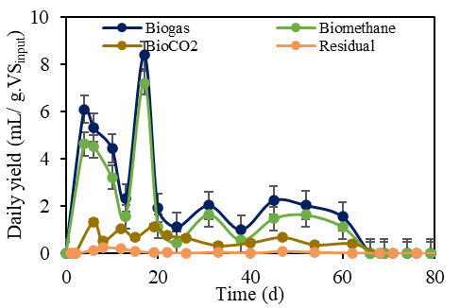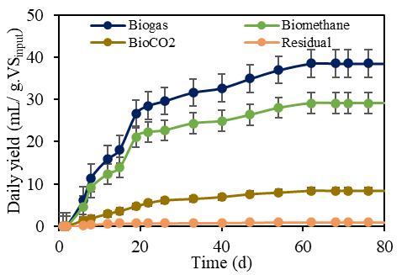

(a)

(b)

**Fig.S2 (a, b)** Daily and cumulative biogas production yield and composition obtained the reactor fed with process water

**Fig.S3** Cumulative yield of H2S concentration in the reactor fed with process water

**Fig.S4** FTIR peaks of anaerobic digestate, PC and HC

**Table S1.** Characteristics of process water and liquid digestate

|  |  |  |
| --- | --- | --- |
|  | Process water | Liquid digestate |
| pH | 5.13 ± 0.23 | 6.84 ± 0.17 |
| EC (ms/cm) | 8.64 ± 1.45 | 2.34 ± 0.35 |
| TDS (mg/L) | 5.87 ± 1.11 | 1.34 ± 0.41 |
| TVA (mg/L) | 7650 ± 640 | 440 ± 110 |
| TA (mg/L as CaCO3)) | 2170 ± 430 | 5630 ± 870 |