**Aqueous secondary formation substantially contributes to hydrophilic organophosphate esters in aerosols**

Shaojun Lv1,2 #, LeLe Tian1,3, #, Shizhen Zhao1,2, *, Kevin C Jones4, Duohong Chen5, Guangcai Zhong1,2, Jun Li1,2, Buqing Xu1, Ping’an Peng1,2, Gan Zhang1,2, *

1 State Key Laboratory of Advanced Environmental Technology, Guangzhou Institute of Geochemistry, Chinese Academy of Sciences, Guangzhou 510640, China

2 Guangdong-Hong Kong-Macao Joint Laboratory for Environmental Pollution and Control, Guangzhou Institute of Geochemistry, Chinese Academy of Sciences, Guangzhou, 510640, China.

3 University of Chinese Academy of Sciences, Beijing 100049, China

4 Lancaster Environmental Centre, Lancaster University, Lancaster LA1 4YQ, UK

5 Environmental Key Laboratory of Regional Air Quality Monitoring, Ministry of Ecology and Environment, Guangdong Environmental Monitoring Center, Guangzhou 510308, China

# These authors contributed equally: Shaojun Lv and LeLe Tian

*These authors jointly supervised this work: Shizhen Zhao ([zhaoshizhen@gig.ac.cn](mailto:zhaoshizhen@gig.ac.cn)) and Gan Zhang ([zhanggan@gig.ac.cn](mailto:zhanggan@gig.ac.cn))

# Abstract

Chemicals of emerging concern (CECs), like organophosphate esters (OPEs), are toxic substances threatening human and wildlife health. Yet the atmospheric transformation of CECs remains poorly understood. Here we combine field measurements and partitioning models to reveal that OPEs could be enhanced by aqueous-phase processes in aerosols. We show that hydrophobic OPEs are absorbed favorably into the organic phase, whereas hydrophilic OPEs preferably partition into the aqueous phase. We provide field evidence that enhanced aqueous secondary formation of OPEs occurs in winter, and its magnitude is strongly dependent on aerosol water content. We suggest that dissolved inorganic salts and transition metals in aerosols positively impact on the formation of particle-bound hydrophilic OPEs, by facilitating aqueous partitioning and/or oxidation. Our findings highlight the important role of aqueous oxidation chemistry for the fate of CECs in the atmosphere, urging better consideration of transformation products in future risk assessment and chemical management.

# Introduction

Chemicals of emerging concern (CECs) are known to pose serious threats to the health of organisms worldwide and are thus subject to the Stockholm Convention and the European REACH (Registration, Evaluation, Authorization and Restriction of Chemicals) framework.1, 2 These hazardous chemicals have physicochemical properties that allow them to persist in the environment and undergo transformation processes, which leads to various transformation products (TPs), some even more toxic than their parent compounds.2 Apart from pesticides, a number of toxic TPs are not considered as part of chemical risk assessment in the European REACH regulation, despite their widespread presence worldwide.3 However, the formation and transformation mechanisms of CECs in the complex real atmosphere remains poorly understood, hampering sufficient consideration given to the atmospheric TPs generated from their parent CECs, in the existing framework of risk assessment and regulation.

Organophosphate esters (OPEs), as a group of CECs, are of increasing concern following the ban on polybrominated diphenyl ether flame retardants (PBDEs) by the Stockholm Convention in 2009. OPEs have become replacements for PBDEs, with the global consumption of OPEs increasing nearly a hundredfold from 2011 to 20194, 5. OPEs in the atmosphere occur in gaseous and particulate adsorbed states, and the gas-to-particle partitioning determines the environmental fate of OPEs, including transport, deposition and degradation6. Levels of OPEs in the air have been reported to be increasing in recent years, preferentially partitioning to the particle phase7, 8. Several empirical models based on vapor pressure (${\text{p}}_{\text{L}}^{\text{°}}$) and the octanol-air partition coefficient (KOA) have been used to predict the partitioning of CECs, but differences in physicochemical properties complicate the interpretation of their results. For instance, most non-polar or less polar chemicals (e.g., PBDEs) are poorly water-soluble and can be reasonably estimated by all models9. However, the majority of highly polar OPEs have been observed to become very enriched on particles, contradicting predictions that suggest them to be mostly in the gas phase10, 11.

Particle-bound OPEs are generally believed to be dominated by the partitioning of primary OPEs, which originate from the volatilization, abrasion and leaching of OPE-containing products during their production, use and waste disposal12. However, recent studies have detected OPEs as TPs formed by oxidation of organophosphate antioxidants (OPAs) in indoor dust and airborne particles, suggesting a possible secondary formation of OPEs13, 14. Meanwhile, laboratory and modelling studies have demonstrated a large contribution of OPA oxidation to OPE contamination15, 16. In the atmosphere, numerous oxidants and particulate components have complex influences on the uptake kinetics of organic gases and secondary organic aerosol (SOA) formation17. Yet, the occurrence and contribution of secondary formation of OPEs in the ambient atmosphere remain largely unknown. As with many other CECs, such gaps impede a complete understanding of the atmospheric fate of OPEs and hinder effective policy-making to reduce ecosystem and health risks.

In this study, intensive field observations in the Pearl River Delta (PRD) are combined with theoretical predictions (detailed in the Methods), to elucidate the partitioning behavior and formation pathway of OPEs. We report that the significant gap between the measured and estimated particle-phase fraction of OPEs partially results from their aqueous-phase processes in both summer and winter. Moreover, we reveal the potential impact of the ‘salting-in’ effect on the aqueous partitioning of OPEs in summer. We provide observational evidence for enhanced aqueous formation of highly polar OPEs (with higher solubility) in winter. Finally, we perform source apportionment of OPEs and analyze δ13C isotopic fingerprinting of molecular tracers in four of China’s megacities, which further confirm the increasing importance of aqueous secondary formation for OPEs in the atmosphere.

# Results and discussion

**Dynamics of OPE chemical composition over the PRD in China**

We analyzed 11 OPEs in both gas and particle phases at nine urban sites of the PRD during summer (June to July) and winter (January to February) in 2018 (Supplementary Fig. 1). The OPE compounds are classified as alkyl-OPEs (i.e., triethyl phosphate (TEP), tris(2-butoxyethyl) phosphate (TBEP), tris(2-ethylhexyl) phosphate (TEHP), tripropyl phosphate (TPrP)), aryl-OPEs (i.e., triphenyl phosphate (TPhP), tricresyl phosphate (TCP), 2-ethylhexyl diphenyl phosphate (EHDPP)), and halo-OPEs (i.e., tris(1,3-dichloro-2-propyl) phosphate (TDCPP), tris (2-chloroethyl) phosphate (TCEP), tris (2-chloroisopropyl) phosphate (TCPP), tris(2,3-dibromopropyl) phosphate (TDBPP)). Detailed descriptions of the measurements are provided in the Methods.

The campaign-mean concentration of total atmospheric OPEs (∑11OPE in the gas and particle phases) is 16 ± 12 ng m-3 in the PRD region, which was significantly higher than those reported in other regions (Supplementary Table 1)11, 18, 19. The halo-OPEs comprised the major fraction of total OPEs in the atmosphere, followed by the aryl-OPEs and the alkyl-OPEs (Fig. 1a). TDBPP, which has been phased out of markets in many countries due to its high toxicity, accounted for only 11% of ∑11OPE. Notably, three chlorinated OPEs (Cl-OPEs, i.e., TDCPP, TCEP and TCPP) comprised, on average, 73% of ∑11OPE in the PRD region, which was comparable to other urban areas in China (Supplementary Fig. 2)11, 18, 19. Such high Cl-OPE fractions in China are probably explained by their high usage and resistance to degradation20.

We observed distinct seasonal differences in both OPE concentration and composition (Fig. 1a and Supplementary Table 2). First, the concentrations of gaseous and particulate OPEs in summer were much higher than those in winter, signifying that higher air temperature favors the release of OPEs from surface sources, such as the OPE-containing products, soils, water bodies and landfills21. Second, larger amounts of OPEs tend to accumulate in the particle phase than gas phase, especially in winter. Third, in summer, the alkyl-OPEs, aryl-OPEs and halo-OPEs accounted for, on average, 1.1%, 15.4% and 83.6%, respectively, of the total OPE mass in the gas phase, and a similar pattern was observed in the particle phase (1.7%, 9.7% and 88.6%, respectively). However, in winter, while the mass fractions of alkyl-OPEs (16.2%) and aryl-OPEs (46.7%) in the gas phase were nearly twice as high as those in the particle phase (7.7% and 20.9%, respectively), the halo-OPE fraction in the gas phase (37.1%) was half that in the particle phase (71.4%).

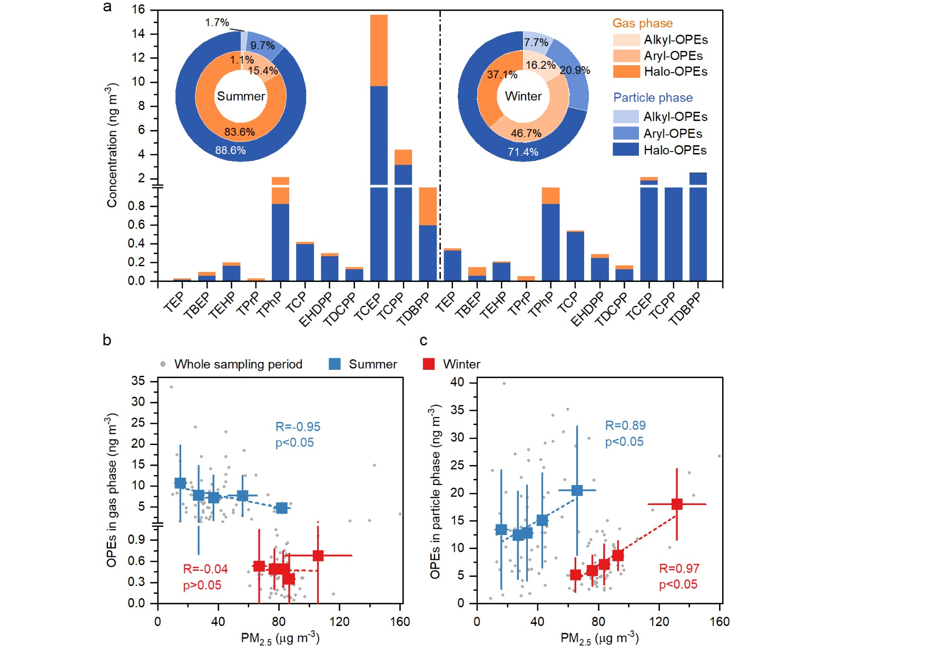

**Fig. 1** **Composition profiles of OPEs and variation of OPEs as a function of PM2.5.** **(a)** Concentrations and relative contributions of alkyl-OPEs (i.e., TEP, TBEP, TEHP and TPrP), aryl-OPEs (i.e., TPhP, TCP and EHDPP) and halo-OPEs (i.e, TCEP, TCPP, TDCPP and TDBPP) in gas phase and particle phase during summer and winter. Relationships between the mass concentrations of PM2.5 and ∑11OPEs in **(b)** gas phase and **(c)** particle phase in summer and winter. The square boxes and the error bars represent the mean values and standard deviation, respectively. The grey dots represent the concentration of total OPEs in the whole sampling period.

We further investigated the relationship between particulate matter ≤ 2.5 μm (PM2.5) and OPEs (Fig. 1b, c). The concentration of gaseous OPEs decreased with PM2.5 loading (R=-0.95, p<0.05), and the particle-bound OPEs were positively correlated with PM2.5 (R=0.89, p<0.05) in summer, implying that the uptake of gaseous OPEs by aerosol is an important pathway for the formation of particle-bound OPEs. This is supported by the similar pattern of composition in the gas phase and particle phase, as mentioned earlier. However, no significant correlation was found between the gaseous OPEs and PM2.5 in winter (R=-0.04, p>0.05), even though the particle-bound OPEs remained correlated well with PM2.5 (R=0.97, p<0.05). The nitrate (NO3-) fraction in winter accounts for nearly half of the water-soluble inorganic constituents, which was two times higher than that in summer (Supplementary Fig. 3). It can be inferred that SOA formation in winter would be driven by the increasing aerosol liquid water (ALW), since NO3- is more hygroscopic than sulfate (SO42-)22. This was further supported by the higher secondary organic carbon (SOC) mass fraction observed in winter (55%) than that in summer (42%). As shown in Supplementary Fig. 4, SO42- was positively correlated with relative humidity (RH) in winter (R=0.63, p<0.05), whereas in summer, it displayed a negative correlation with RH (R=-0.56, p<0.05) and positively correlation with atmospheric oxidants (Ox, the total concentration of ozone (O3) and nitrogen dioxide (NO2), i.e., Ox=O3+NO2) (R=0.79, p<0.05). These different seasonal characteristics lead us to hypothesize that winter PM2.5, containing a large fraction of hygroscopic ions, may have enhanced the formation of secondary species, which is consistent with previous studies23, 24, 25. We therefore investigated in detail the role that gas-to-particle partitioning and formation processes play in the fate of OPEs in the atmosphere.

**Gas-to-particle partitioning of OPEs**

As shown in Supplementary Table 3, most highly polar OPEs (≥10-7 atm and log KOA<8.5), like TEP, TPrP, TCEP and TCPP, have high water solubility, ranging from 52 to 1.12×104 mg L-1, which are considered to be hydrophilic OPEs. Comparatively, the water solubility of less polar OPEs (<10-7 atm and log KOA≥8.5), like TBEP, TEHP, aryl-OPEs and TDCPP, is 3 to 6 orders of magnitude lower than that of hydrophilic OPEs, and they can be thus regarded as hydrophobic OPEs. Herein, we applied the equilibrium absorptive partitioning theory to model the absorptive partitioning into the organic phase26. The predicted particle-phase fraction of OPEs (Fp,t) was calculated from the corresponding gas-to-particle partitioning coefficient (KOM) and the mass concentration of organic matter (OM) in aerosols (detailed in the Methods). The measured particle-phase fraction of OPEs (Fp,m) was calculated using the concentrations of OPEs in gas (Cg) and particle phase (Cp) (detailed in the Methods). Fp,t with different ${\text{p}}_{\text{L}}^{\text{°}}$ data sets span the gray-shaded region in Fig. 2a and 2b, of which the upper and lower limits are calculated using activity coefficients (ξ) corresponding to 0.3 and 3.0, respectively27.

We found that the diversity of partitioning behaviors of OPEs is not determined by their functional groups, but is largely influenced by different physicochemical properties (Fig. 2a, b). The average Fp,m of hydrophobic OPEs in both seasons are almost close to thermodynamic equilibrium partitioning, within the uncertainties of the measurements and calculations. This suggests that hydrophobic species have a greater tendency to associate with OM in PM2.5. However, the mean Fp,m of hydrophilic OPEs was much higher than their Fp,t, indicating that they did not preferentially partition into the organic phase of aerosols or gas phase, consistent with the previous results obtained from KOA-based models7, 10. This phenomenon was previously explained, in part, by the influence of equilibrium sampling artifacts such as gas-phase absorption onto filters9. However, the deviation caused by measurement uncertainties has been suggested to be much lower than the gap between theoretical and observed values28, suggesting that OPEs may undergo other unknown mechanisms besides the sorption of OPEs onto a filter’s water film.

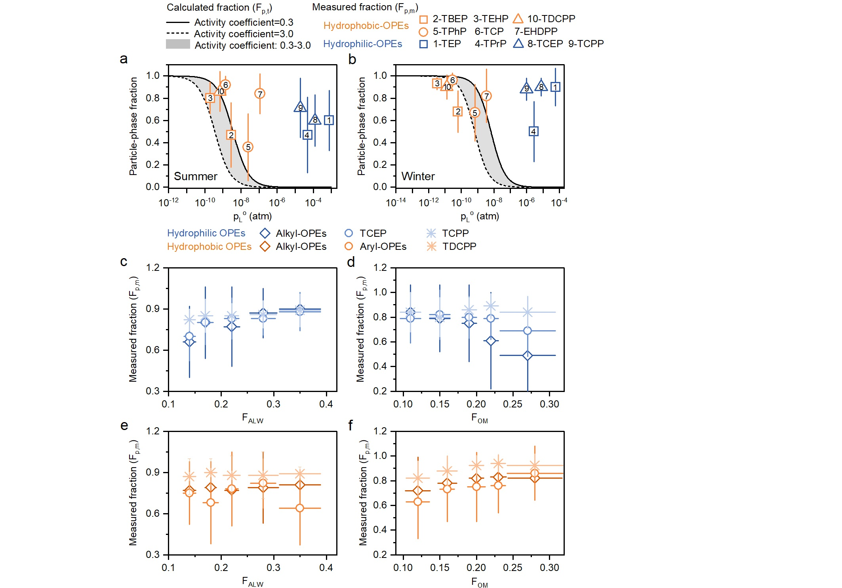

**Fig. 2 Modelling and observation of the gas-to-particle partitioning of hydrophilic and hydrophobic OPEs (a, b)** Comparison between the measured (Fp,m) and the calculated particle-phase fraction (Fp,t) of hydrophilic and hydrophobic OPEs by Pankow’s absorptive theory in summer and winter; Fp,t as a function of sets spans the gray-shaded region, where the upper and lower limits are calculated using activity coefficients (ξ) corresponding to 0.3 and 3.0, respectively. Measured particle-phase fraction of **(c, d)** hydrophilic **(e, f)** hydrophobic OPEs as a function of mass fraction of aerosol liquid water (FALW) and organic matter (FOM) in PM2.5. The error bars in **(a-f)** represent the standard deviation of the measured fraction values.

The absorbing phase in PM2.5 is generally not a single organic phase, as it contains a substantial fraction of compounds that are highly hydrophilic and could form a concentrated solution in particles. Assuming that aerosols have a single phase, the total concentration of aerosols could be underestimated by 4 to 22% or even more29. The aqueous-phase adsorption of gaseous organics has been suggested to be an important formation pathway for SOA, which depends on their bulk solubility30, 31. To investigate the different phase partitioning of OPEs, we estimated the concentration of ALW and OM in particles (Methods). A substantial increase in the Fp,m of hydrophobic OPEs was associated with an elevated OM mass fraction in aerosols (FOM) rather than the ALW loading (Fig. 2e, f). The mass fraction of nonpolar organics partitioning into the aqueous phase is negligible compared to that in the organic phase, despite the ALW being 2 to 3 times higher than the total aerosol dry mass32, 33. In contrast, the Fp,m of hydrophilic OPEs positively responds to the increase in ALW mass fraction (FALW), but shows insignificant relationships with FOM (Fig. 2c, d). This signifies that the partitioning of hydrophilic OPEs is very likely driven by the aqueous phase rather than organic phase; this is consistent with an observation in the southeastern U.S., where the partitioning of water-soluble organics was highly dependent on ALW34. It has also been suggested that gaseous water-soluble organics could have a stronger potential to partition in the aqueous phase compared to the organic phase33.

To further investigate the aqueous absorption of OPEs, we calculated the field-derived effective Henry’s law coefficient (KH,e, mol m-3 atm-1) from measurement-based data (details in the Methods), which can be employed to describe the partitioning of gases to the aqueous phase. The KH,e of the OPEs in both seasons (1012–1014 mol m-3 atm-1) is 5–12 orders of magnitude larger than the estimated Henry’s law coefficient in highly dilute solution (KH,w, mol m-3 atm-1) obtained from the Estimation Programs Interface (Supplementary Table 4). The difference (∆log KH) between the measured log KH,e and the recommended log KH,w of hydrophobic OPEs has a strong dependence on log KOA (R=0.81, p<0.05) and log KOW (R=0.93, p<0.05) describing the partitioning capability of organics from gas phase to organic phase and from aqueous phase to organic phase, respectively (Supplementary Fig. 5). This further suggests that the organic phase may be more favorable for the absorption of hydrophobic OPEs. By contrast, the ∆log KH of hydrophilic OPEs was not significantly correlated with both log KOA and log KOW (p>0.05), indicating little effect of organic-phase absorption on the partitioning of hydrophilic OPEs. The ∆log KH of hydrophilic OPEs is stable at approximately 6 and is comparable to or even greater than that of the carbonyl compounds (3–7) reported by Shen et al.35. Since the aerosol containing water-soluble compounds is more hypersaline than pure water, the interactions among water, organic and inorganic species in aerosol have been identified to be partially responsible for the enhanced partitioning to the condensed phase35, 36. Nevertheless, although there is no seasonal difference in the ∆log KH of hydrophilic OPEs, the Fp,m values of most hydrophilic OPEs in winter are highly underestimated compared to those in summer (Fig. 2a, b).

**Enhanced aqueous secondary formation of hydrophilic** **OPEs in winter**

As discussed before, aqueous-phase processing might have imposed significant impacts on the formation of hydrophilic OPEs with a mean mass fraction of 72% in the total OPEs during the field campaign. Compared to TEP and TPrP, TCEP and TCPP have been demonstrated to be more stable OPEs in the atmosphere37, 38. Therefore, we selected TCEP and TCPP to further investigate the aqueous-phase formation pathways of hydrophilic OPEs. The concentrations of TCEP and TCPP in particle phase exhibit significant correlations with ALW (R=0.80, p<0.05) in winter (Supplementary Fig. 6a). They also tend to increase with the increase of 2-methylglyceric acid (2-MGA), which is a tracer used to investigate the multiphase formation mechanisms of SOA39. However, no significant correlation was observed in summer (p>0.05) (Supplementary Fig. 6b), although the mass fractions of TCEP and TCPP in the hydrophilic OPEs exceeded 90% both in summer and winter. Therefore, the secondary formation of hydrophilic OPEs seems to take place preferentially in winter. A plausible mechanism for OPE formation in the atmosphere may be the oxidation of OPAs15. We observed a significant correlation between Ox and particle-bound TCEP and TCPP (R=0.42–0.79, p<0.05) in winter but no significant correlation in summer (Fig. 3a, b). This is consistent with previous laboratory studies on O3 oxidation or photo-transformation of tris(2-chloroethyl) phosphite (TCEPi) on cover glass and dust15, 40. Although reports on the environmental occurrence and transformation behaviors of tris(2-chloropropyl) phosphite (TCPPi) are scarce, the correlation coefficient between TCPP and TCEP (R2=0.61, p<0.05) was higher than that of other OPEs (Supplementary Fig. 7), indicating that these two hydrophilic OPEs, with similar structures and physicochemical properties, may have similar sources or formation pathways. However, a higher concentration of ALW was observed in winter, particularly at the Guangzhou site, while the Ox concentration in winter was lower than that in summer (Supplementary Fig. 8), implying that the enhanced secondary OPE formation in winter may be influenced not only by oxidants but also by aqueous-phase processes in aerosols.

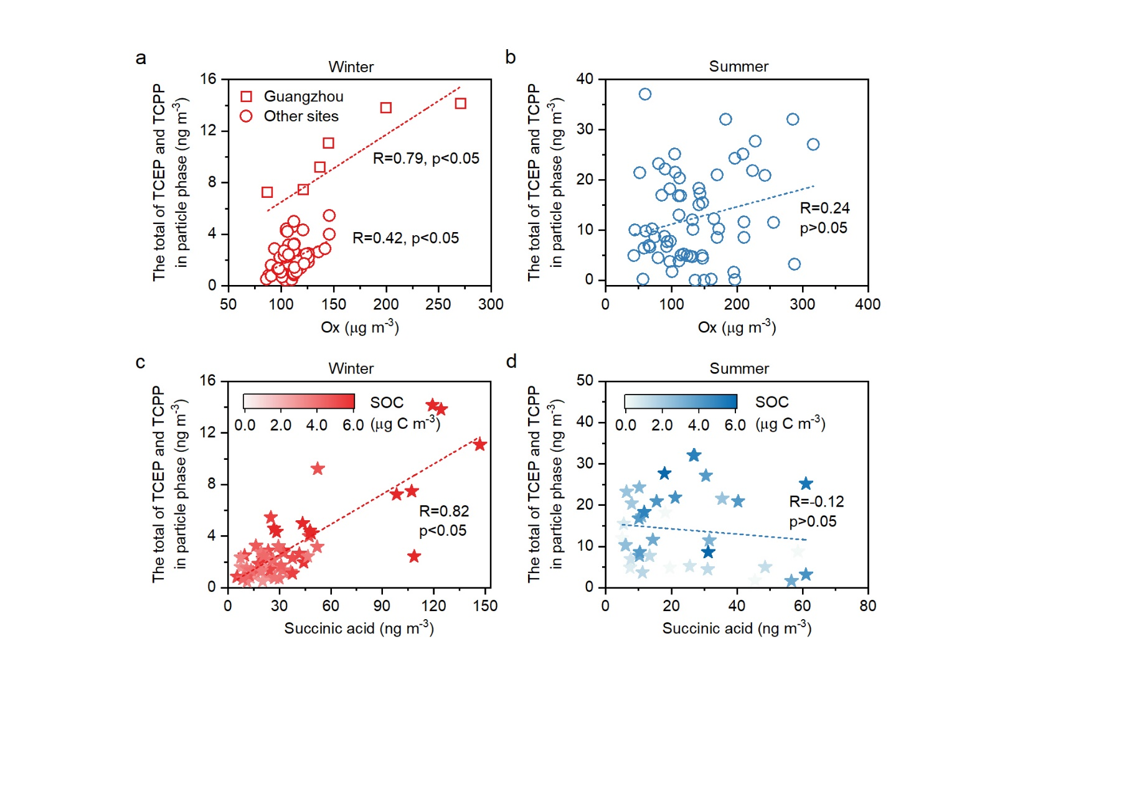

**Fig. 3** **Relationships between hydrophilic OPEs in PM2.5 and secondary formation tracers.** Correlations between the total concentration of TCEP and TCPP in particle phase and the concentration of **(a, b)** Ox and **(c, d)** succinic acid in winter and summer. The spots in **(c, d)** are colored according to the secondary organic carbon (SOC) concentrations.

Aqueous-phase processes including the absorption of precursors and aqueous oxidation may play a key role in the secondary formation of hydrophilic OPEs in winter. Firstly, the concentration of succinic acid, which can be formed in the aqueous phase from lower molecular weight species via radical-radical reactions of carboxylic acids41, was higher in winter than that in summer (Supplementary Fig. 8). A highly positive correlation between the concentrations of hydrophilic OPEs and succinic acid in the particle phase was also evident in winter (R=0.82, p<0.05) (Fig. 3c). Secondly, the total concentrations of particle-bound TCEP and TCPP in winter tended to elevate with increasing SOC mass, whereas they showed much weaker relationships in summer (Fig. 3d). The SNA (comprising SO42-, NO3- and ammonium (NH4+)) levels in winter were higher (22±8.1 μg m-3) than those in summer (8.5±5.7 μg m-3). At high SNA concentrations and increasing RH, aerosols may contain more water and become less viscous (Supplementary Fig. 9), favoring the accumulation of precursors and oxidants on the aerosol surface and ultimately facilitating the aqueous-phase reaction to form OPEs. Thirdly, the contribution of the condensation of gas-phase oxidation products could be excluded in winter, as the total mass of TCEP and TCPP in the gas phase did not show significant correlation with Ox (R≤0.30, p>0.05), and their PM2.5-bound mass was not significantly correlated with Fp,m (R=0.11, p>0.05) (Supplementary Fig. 10a, c). Moreover, their precursors (i.e., TCEPi and TCPPi) exhibit physicochemical properties (e.g., log KOA, log KOW and water solubility) similar to those of OPEs (Supplementary Table 3 and Table 5), implying that hydrophilic precursors may be as dominated by aqueous partitioning as hydrophilic OPEs. The water solubility of their precursors is 3 to 6 orders of magnitude higher than that of hydrophobic OPAs, indicating that these hydrophilic precursors are more likely to partition into the aerosol aqueous phase, followed by aqueous oxidation. Recently, laboratory studies have suggested that the transformation of OPAs may be influenced by a number of key factors, including O3 level, reactive oxygen species (ROS) and RH. For example, Liu et al. provided experimental evidence that OPA concentrations decreased significantly with increasing O3 levels, accompanied by a high formation yield of the corresponding OPEs15. Similarly, Zhang et al. revealed that the heterogeneous transformation of OPAs in dust was accelerated in the presence of ROS and elevated RH40. Consequently, the aqueous oxidation of precursors is likely the dominant process responsible for the secondary formation of hydrophilic OPEs in winter.

Transition metal elements (e.g., Fe and Mn) dissolved in the aqueous phase might play a crucial role in SOA formation, as they are expected to enhance the oxidative potential of O3 by producing the ROS via Fenton chemistry42. The concentrations of Fe and Mn in winter were approximately twice as high as those in summer (Supplementary Fig. 8). The particle-bound TCEP and TCPP in winter were highly correlated with Fe and Mn (R=0.53–0.79, p<0.05), especially at the Guangzhou site with higher ALW mass, while a weaker correlation was observed in summer (R≤0.42, p<0.05) (Supplementary Fig. 6c to 6f), consistent with the aforementioned relationships between hydrophilic OPEs and Ox. The increases of transition metal elements and ALW possibly led to an enhanced conversion of gaseous oxidants to the condensed phase43, thereby promoting the aqueous oxidation formation of hydrophilic OPEs. This finding is in line with the conclusion of an experimental study that the oxidation of trimethyl phosphite with hydrogen peroxide (H2O2) in the presence of Fe salts occurs much faster than in the absence of an Fe-ions catalyst44. Further laboratory investigations into the role of Fe-salts and Mn-salts aqueous chemistry in the secondary formation of OPEs, along with additional field measurements, are therefore suggested.

**Gas-particle partitioning and salting-in effect in summer**

In contrast to traditional persistent organic pollutants, aqueous-phase partitioning of gaseous hydrophilic OPEs may contribute more to the particle-bound OPEs in summer. The PM2.5-bound TCEP and TCPP in summer were highly correlated with Fp,m (R=0.62, p<0.05), while their gaseous mass was not significantly correlated with Ox (p>0.05) (Supplementary Fig. 10b, d). This is consistent with the similar fraction characteristics of OPEs in gas and particle phases during summer (Fig. 1a), pointing to the partitioning of gaseous OPEs onto particles. The Henry’s law-type partitioning of hydrophilic organics can be enhanced by the ‘salting-in’ effect36, which is defined as the negative slope (KS) of the linear relationship between the salt concentration in aqueous phase and the logarithm of the ratio of KH,w and KH,e (log (KH,w/KH,e)). In Supplementary Fig. 11, the log (KH,w/KH,e) values of TCEP and TCPP were regressed against the molality of SO42- in ALW (, mol kg-1 ALW), since SO42- has been recognized as the major factor for the salting effect of polar species28, 35, 36. The KS for TCEP and TCPP were observed to be significantly negative in summer (p<0.05), with values of -0.06 and -0.09, respectively, which fall within a similar range to that of carbonyl compounds and polyols tracers28, 35. The ‘salting-in’ effect was associated with the hydrophilic interactions, such as hydrogen bonding and water replacement, resulting in a decrease in Gibbs free energy or increase in entropy36, 45. The enhanced partitioning of gaseous hydrophilic OPEs in summer might therefore be partially attributed to the ‘salting-in’ effect. However, the positive KS values and weak correlations indicate that such an effect is not obvious in winter, likely due to competition from other formation pathways, such as aqueous oxidation.

**Contribution of secondary formation to hydrophilic OPEs**

To further confirm the importance of secondary formation to hydrophilic OPEs, we performed positive matrix factorization (PMF) to investigate the potential sources of hydrophilic OPEs in four megacities in China with active aqueous oxidation. Fig. 4 shows the locations of the sampling sites in a time averaged map of SO42- production from aqueous sulfur dioxide (SO2) oxidation. A six-factor solution was achieved (Methods and Supplementary Fig. 12, 13). The first factor is characterized by a high abundance of TEHP (55%) and TPhP (83%), which was attributed to be the electronic and lubricant products emission5. The second factor was dominated by TCEP (80%) and was identified as building construction emission11. The third factor showed a high abundance of TCPP (86%) and TDCPP (62%), and was identified as plastics and interior decoration emissions5, 46. Herein, the first, second and third factors are collectively referred to as production and use of OPEs. The fourth factor contains high loadings of metals (i.e., Sb, Pb, Cd and As; 40%–72%) that are associated with traffic and industrial sources47. The fifth factor was dominated by the abundance of TDBPP (80%), phthalic acid (72%) and levoglucosan (82%). TDBPP, a widely used flame retardant additive for textiles, became obsolete in markets in many countries and has been considered unused since 1970 due to its carcinogenicity and genotoxicity7. Previous studies suggested phthalic acid as an indicator of waste disposal emission and levoglucosan as an indicator of combustion emission48. Thus, the fifth factor was identified as waste disposal and incineration sources. Given that high fractions of secondary formation tracers (i.e., NO3-, SO~~4~~2-, NH4+ and 2-MGA; 53–81%) were distinguished in the sixth factor, it was assigned as a secondary formation source39, 49.

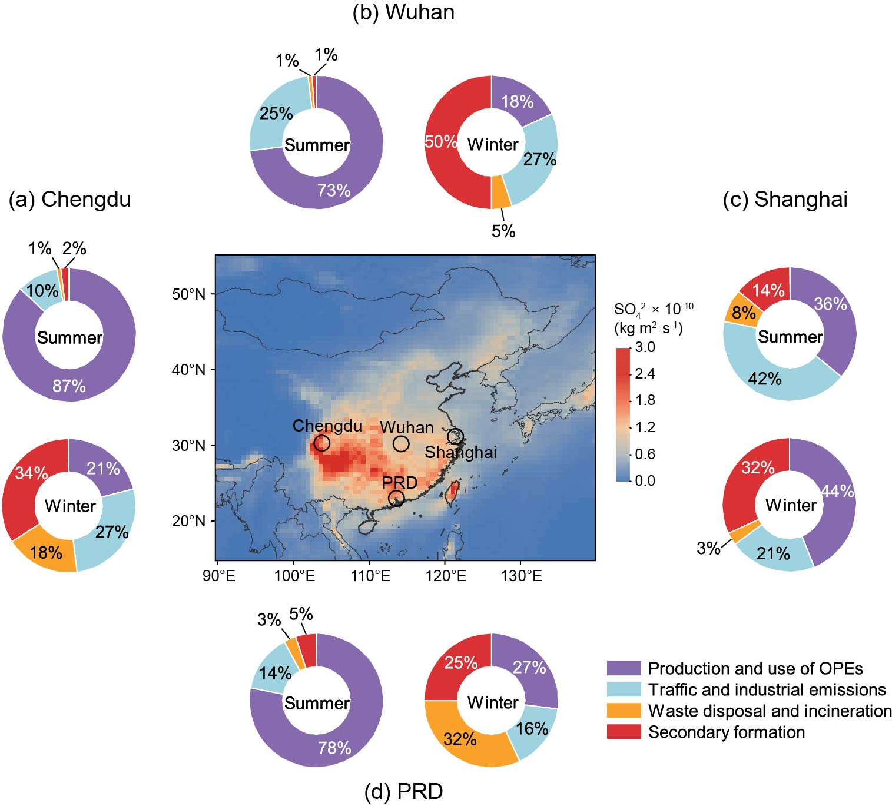

**Fig. 4 Sources of hydrophilic OPEs in PM2.5.** The relative contribution from production and use of OPEs, traffic and industrial emissions, waste disposal and incineration, and secondary formation sources to the mass concentrations of hydrophilic OPEs in **(a)** Chengdu, **(b)** Wuhan, **(c)** Shanghai and **(d)** the Pearl River Delta region (PRD) during summer and winter. Markers on the map show the measurement locations. The map is color-coded for the annual mean (January to December 2018) of sulfate (SO42-) production from aqueous sulfur dioxide (SO2) oxidation. The data were obtained from Modern-Era Retrospective analysis for Research and Applications version 2 (MERRA-2) observations (<https://giovanni.gsfc.nasa.gov/giovanni/>). The base map of China and coastline boundaries in the map are originated from Meteolnfo free vector map data (http://meteothink.org/downloads/index.html).

As shown in Fig. 4, production and use of OPEs is the dominant contributor to hydrophilic OPEs in summer (36–87%) across all urban sites, likely due to enhanced OPE release from product surfaces under warmer conditions. The mixed source of traffic and industrial emissions contributes 10–42% in summer and 16–27% to hydrophilic OPEs in winter, highlighting their substantial impact on hydrophilic OPE levels. There was no significant seasonal difference in Wuhan and the PRD region, whereas Chengdu and Shanghai showed the opposite trend between summer and winter. Moreover, waste disposal and incineration emissions explain 3–32% of hydrophilic OPEs in winter, which is 3 to 10 times higher than that in summer (1–8%). The comparison among cities illustrates that the PRD and Chengdu are significantly affected by waste disposal and incineration emissions in winter.

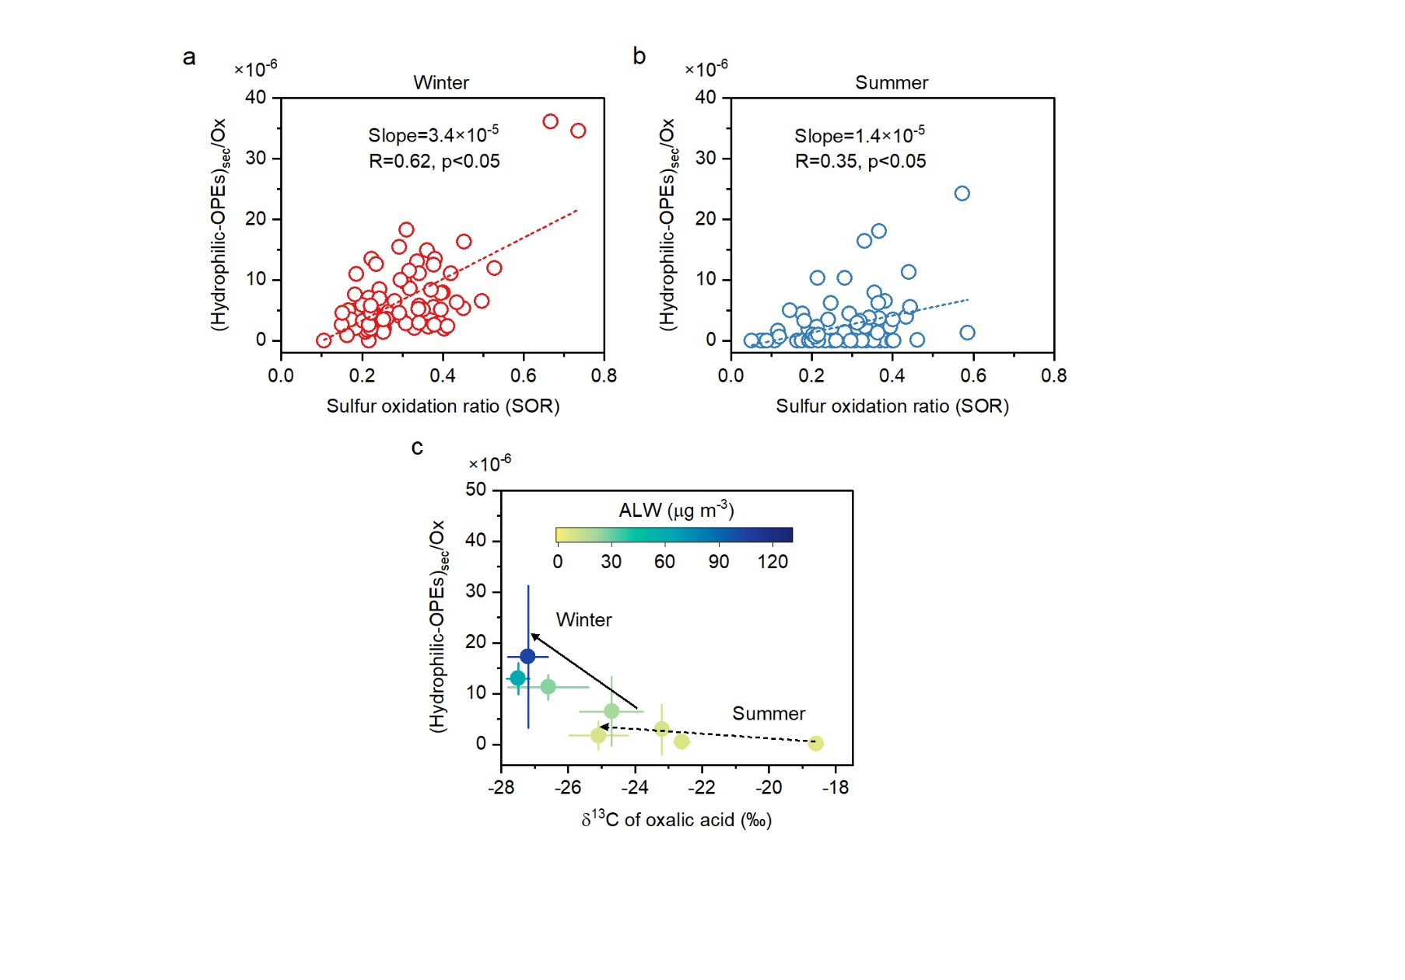

**Fig. 5** **Variation of the secondary hydrophilic OPEs to Ox ratio ((hydrophilic-OPEs)sec/Ox) as a function of sulfur oxidation ratio (SOR) and δ13C of oxalic acid.** **(a, b)** Correlations between (hydrophilic-OPEs)sec/Ox and SOR in winter and summer. **(c)** Relationships between (hydrophilic-OPEs)sec/Ox and δ13C of oxalic acid in winter and summer for Guangzhou, Chengdu, Wuhan and Shanghai. The spots in **(c)** are colored by aerosol liquid water (ALW) concentrations. The mass concentrations of secondary hydrophilic OPEs were obtained from the positive matrix factorization (PMF) model results.

More evidence supports the enhanced aqueous secondary formation of hydrophilic OPEs in winter. Firstly, the contribution of secondary formation shows a significant increase from summer (1–14%) to winter (25–50%). This means that an enhanced secondary formation of OPEs likely occurred in winter across China. Secondly, the sulfur oxidation ratio (SOR, SOR=nSO42-/(nSO42-+nSO2), where n represents the molar concentration), an indicator of atmospheric oxidation processes50, is highly correlated with secondary hydrophilic OPEs to Ox ratio ((hydrophilic-OPEs)sec/Ox) in winter (R=0.62, p<0.05), while a weaker correlation is observed in summer (R=0.35, p<0.05) (Fig. 5a, b). Thirdly, we examined the relationship between δ13C fingerprints of oxalic acid and (hydrophilic-OPEs)sec/Ox in Guangzhou, Chengdu, Wuhan and Shanghai. The compound-specific δ13C of oxalic acid is generally used as a tracer to differentiate various atmospheric chemical processes51. As illustrated in Fig. 5c, with increasing ALW, the higher generation of hydrophilic OPEs occurred with oxalic acid becoming more depleted in δ13C in winter. On the contrary, (hydrophilic-OPEs)sec/Ox remains low regardless of the δ13C reduction during summer. This is consistent with previous in situ observations of substantial water-soluble organic aerosols formed through secondary aqueous processes in megacities of China, especially in winter51. Taken together, these observations provide evidence for the growing importance of aqueous oxidation processes triggered by the elevated ALW in winter.

**Atmospheric implications**

The large contribution of aqueous-phase processes, including aqueous uptake and secondary formation of atmospheric OPEs, emphasized in this study, has important implications for accurate assessment and effective control of OPEs. Previous field and model studies focused on the partitioning behavior of OPEs between the gas and organic phase, but ignored the abundant aqueous phase in aerosols, resulting in the failure of KOA-based models to accurately estimate the partitioning of hydrophilic OPEs (e.g., TCEP and TCPP)9, 52. Based on our observations, we reveal two distinct partitioning mechanisms of OPEs, characterized by the partitioning of hydrophobic species to the organic phase and the aqueous uptake of hydrophilic species, respectively. As for the sources of OPEs, the chemical management of OPEs generally pays more attention to the direct emission from OPEs used in commercial products, but does not consider the indirect contribution from OPAs15, 16, 53. Our findings support the hypothesis that aqueous-phase oxidation of OPAs is a key pathway for hydrophilic OPE formation in the atmosphere.

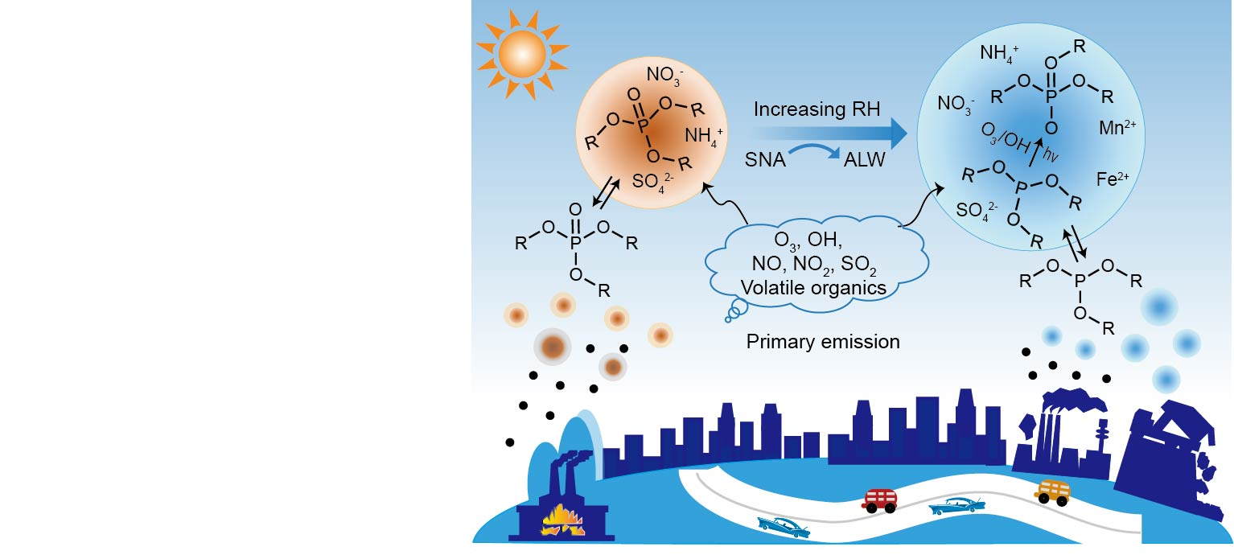

**Fig. 6** **Conceptual diagram depicting the secondary formation of hydrophilic OPEs with increasing relative humidity (RH) and aerosol liquid water (ALW).** The left formation scheme illustrates the potential formation pathway of hydrophilic OPEs in summer, which is dominated by the partitioning of gas-phase OPEs emitted from primary sources. The right reaction scheme shows the secondary formation of hydrophilic OPEs via aqueous-phase oxidation of organophosphite antioxidants (OPAs), which is driven by high ALW triggered by increasing RH and SNA (comprising SO42-, NO3- and NH4+) concentrations in winter.

As shown in Fig. 6, we illustrate two prominent effects of aqueous-phase processing on OPE formation in the atmosphere. First, particle-bound OPEs in summer are mainly driven by the gas-to-particle partitioning of gaseous contaminants emitted from primary sources. The high salt concentration (e.g., SO42-) in the aqueous phase can promote the Henry’s law-type partitioning process of OPEs via the ‘salting-in’ effect. Second, aqueous-phase reactions of OPAs and oxidants dominated TCEP and TCPP formation under polluted conditions during winter. Specifically, OPE precursors, such as TCEPi, first uptake into the aerosol aqueous phase through gas-to-particle partitioning, and subsequently undergo aqueous oxidation with O3/O2 to form TCEP. In the presence of abundant SNA in aerosols and increasing RH, enhanced ALW formation can facilitate the aqueous uptake of OPAs and oxidants, leading to greater OPEs production in winter. In addition, the high fraction of Fe and Mn dissolved in the aqueous phase can enhance the oxidative potential of O3 by generating ROS via Fenton chemistry, which may also be important for OPE formation. Therefore, these aqueous-phase processes can form an important, yet overlooked, driving force for OPE formation, especially with global warming and changes in atmospheric pollutants. Numerous studies have suggested that global warming can accelerate photochemical reactions to enhance O3 formation54, 55. An increasing surface O3 level has been observed in the PRD, YRD and BTH regions, resulting in enhanced SOA formation56, 57. Additionally, the ammonia-rich atmosphere in China, together with the slower decline rate of NOx emissions and the effective sulfur emission control, has led to an increase in ALW and decreased aerosol viscosity, facilitating the aqueous-phase chemistry processes across China17, 22. Moreover, the rapid transition of energy structure from coal to natural gas in China is also expected to drive aerosols to be more hygroscopic, since natural gas combustion can generate three times more water vapor than coal burning51.

In addition to aerosol water, cloud/fog droplets are also important media for aqueous-phase reactions, where dissolved inorganic and organic gases are oxidized by various oxidants (e.g., singlet oxygen, O3 and hydroxyl radical)30, 31. These cloud/fog processes are generally accompanied by a liquid water content several orders of magnitude higher than ALW content, which has been demonstrated to enhance the formation of secondary species through accelerating aqueous-phase oxidation24, 58. Given that clouds cover nearly 70% of the Earth and the cloud/fog events frequently occur in winter59, 60, the role of cloud/fog chemistry in OPE formation should be undertaken for a better understanding of the atmospheric fate of OPEs. Note that the aqueous-phase processes in aerosol water or cloud/fog droplets are likely influenced by many factors. For example, transition metal elements (e.g., Fe, Mn) may catalyze OPE precursor oxidation via Fenton-like reactions in aquatic environment.61 Recent evidence shows that O3-driven Fenton chemistry occurs four orders of magnitude faster on aqueous microdroplets than in bulk water42. A regional study further suggests that Mn catalysis contributes up to 92.5% of SO42- yields in North China’s haze episodes,62 highlighting the importance of metal-mediated pathways. While our results provide field evidence for the aerosol aqueous-phase formation of OPEs and its dependence on aerosol compositions, more laboratory-controlled studies are needed to better understand the factors influencing these aqueous-phase processes.

This study is limited by the scarcity of data on OPA production and use, as well as the technical challenges in measuring OPAs in aerosols, especially for TCPPi. Despite the high global production volume of total OPAs (up to 100,000 tons per year)15, data on the production and application of individual OPA (e.g. TCPPi) remain unavailable. Moreover, the absence of reported environmental concentrations of TCPPi is a key limitation, which may reflect analytical challenges rather than its absence in the environment. TCEPi, including but not limited to it, has been detected in dust and soil but not in airborne fine particles, likely due to its rapid transformation in the atmosphere13, 14, 20. To address these gaps, future studies urgently need to establish a comprehensive database of OPA production and application and refine environmental monitoring methods for OPAs to further understand the secondary formation mechanism of OPEs in the atmosphere. While previous laboratory studies and our field observations provide insights into OPE formation mechanisms, upcoming research should prioritize integrating field measurements and laboratory simulations to better investigate aqueous-phase secondary formation pathways.

Our work provides important insights into the atmospheric fate of CECs and relevant air pollution control strategies, including but not limited to OPEs. First, CECs with different physicochemical properties show diverse gas-to-particle partitioning behaviors (e.g., organic- and aqueous-phase uptake), which should be considered in modeling studies to improve prediction accuracy. Second, failing to account for the aqueous secondary formation of CECs from parent chemicals could lead to an underestimation of the contribution of indirect sources and introduce uncertainties in risk assessment. Finally, a comprehensive and mechanistic understanding of CEC transformation processes would assist in improving TPs risk assessment and effectively addressing their hazards in chemical development and production, motivating refinements in future chemicals management policies.

# Methods

**Sampling information**

Sampling campaigns were conducted in nine cities in the PRD region (Supplementary Fig. 1): Guangzhou, Zhuhai, Shenzhen, Dongguan, Huizhou, Zhongshan, Jiangmen, Foshan and Zhaoqing. The PRD region, as one of the representative megacity clusters, is the base of electronics and manufacturing industries in China, where high OPE concentrations have been observed63. In addition, active atmospheric chemical processing results in frequent O3 pollution in the PRD region56. Thus, these emission hotspots and strong atmospheric oxidation capacity provide a representative environment for the atmospheric transformation of OPEs. A total of 162 paired air samples were collected across 12 cities in China, comprising 126 samples from nine cities in the PRD region and 36 samples from three additional cities (Chengdu, Wuhan, and Shanghai). Each paired sample consisted of a quartz fiber filter (QFF, Whatman, 203 mm×254 mm) for particle-phase collection and a polyurethane foam (PUF, 14 cm in diameter, 7.5 cm in thickness, and 0.02 g cm-3 in density) plug for gas-phase collection, using a high-volume active air sampler (Minya Instruments Co., Guangzhou, China). Sampling was conducted over 24-hour periods during summer (June–July 2018) and winter (January–February 2018), with 28 samples collected per city in the PRD region and 24 samples per city in the other three locations. To ensure data quality, four field blanks (24 PUF blanks and 24 QFF blanks) were collected at each sampling site to account for potential contamination during sampling.

Each QFF was baked at 450 ℃ for 8 hours and PUF was precleaned separately with acetone and dichloromethane before sampling. All samples were freeze-dried, packed, and stored at -20 ℃. The concentrations of PM2.5 were calculated by gravimetric method. The meteorological parameters (RH and temperature) and the trace gas concentrations of O3, NOx and SO2 were obtained from the corresponding official environmental monitoring stations at each sampling site, where trace gases were monitored using Thermo Scientific Environmental Instruments (models 49i, 42i and 43i-TLE, respectively).

**Chemical analysis and quality control**

OPEs in gas- and particle-phase samples were determined using Soxhlet extraction combined with multi-segment column purification, and instrumental analysis7. QFFs and PUFs were spiked with TnBP-d27 and TDCPP-d15 as recovery surrogates and Soxhlet extracted for 24 hours with dichloromethane (DCM). The extracts were reduced and concentrated in a volume of 0.5-1 mL through rotary evaporation and solvent-exchanged into hexane. Multilayer silica gel was applied to purify the sample extract and then eluted with 20 mL of DCM and acetone (1:1, v/v). The eluted solution was concentrated under nitrogen to a volume of 200 μL and spiked with TCEP-d12 as an internal standard prior to instrumental analysis. Analysis of OPEs was performed using Agilent 7890 gas chromatograph coupled to an Agilent 5975C mass selective detector (Agilent 7890/5975 GCMS), operated in electron impact ionization under selected ion monitoring (SIM) mode with a DB-5MS column (30 m × 0.25 mm × 0.25 μm). The bulk components in PM2.5 including water soluble ions (i.e., SO42-, NO3-, Cl−, NH4+, K+, Na+, Ca2+ and Mg2+), organic tracers (e.g., levoglucosan, phthalic acid, succinic acid and 2-methylglyceric acid), metal elements (e.g., Fe, Sb, Cu, Pb and As), organic carbon (OC) and elemental carbon (EC), were measured for each filter sample. Detailed analytical methods of these compositions are given in the Supplementary Method 1.

For quality control, field blanks, procedural blanks and surrogate-spiked recoveries were analyzed with each batch of samples to assess potential background contamination and instrumental performance. The reference ions for 11 OPEs and the corresponding labeled standards used in SIM mode on a Shimadzu GCMS-QP2010 and retention times (RT, min) are given in Supplementary Table 6. The instrumental detection limits (IDLs) and method detection limits (MDLs) of the target OPEs are provided in Supplementary Table 7. The average recovery rates of surrogates in samples were 86±21% for TnBP-d27, and 51±11% for TDCPP-d15. The detailed blank concentrations, including field and procedural blanks, were shown in Supplementary Table 8. The concentrations reported here are corrected for field blanks and recoveries.

**Compound-specific** **δ13C of oxalic acid**

The PM2.5 filter was extracted with ultrapure water for three times and then concentrated to dryness. Subsequently, the extracts were derivatized with 10% boron trifluoride (BF3) in 1-butanol in a water bath at 100 ℃ for about 1 hour, and then extracted with n-hexane. The δ13C values of oxalic acid derivatives were analyzed using a gas chromatograph connected to an isotope ratio mass spectrometry (GC ISO-Link2/IRMS, Thermo Fisher Scientific). The δ13C values of free oxalic acid were estimated by an isotopic mass balance method, based on the measured values and the δ13C of derivatizing agent (1-butanol, δ13C =-30.21‰). During derivatization, the isotopic fraction was found to be less than 0.73‰ in our previous studies64. The difference in δ13C of oxalic acid in replicate analyses was less than 1.0‰.

**Calculations of partitioning coefficients**

For each OPE compound, the theoretical partition coefficient (KOM) for absorptive uptake into the organic phase is calculated according to26:

where R (8.2×10-5 m3 atm mol-1 K-1) is the ideal gas constant and T (K) is the ambient temperature. WOM (set at 200 g mol-1 for all samples65) denotes the average molecular weight of the absorbing phase. ξ is the activity coefficient of the compound in the absorbing phase. ${\text{p}}_{\text{L}}^{\text{o}}$ (atm) is the vapor pressure of the pure compound at the average ambient temperature. The particle-phase fraction of OPEs (Fp,t) based on Pankow’s absorptive theory is determined as26:

where KOM is calculated by the equation 1 and COM is the mass concentration of OM in aerosol (COM=OC×1.866). The measured particle-phase fraction (Fp,m) is calculated by the mass concentrations of OPEs in gas and particle phases (Cg and Cp, ng m-3) as follows:

$${\text{F}}_{\text{p,m}}\text{=}\frac{{\text{C}}_{\text{p}}}{{\text{C}}_{\text{g}}\text{+}{\text{C}}_{\text{p}}}\text{ (3)}$$

The measurement-based effective Henry’s law coefficient (KH,e, mol m-3 atm-1) is calculated according to Qin et al.28:

where Cg (ng m-3) and Cp (ng m-3) are gas- and particle-phase concentrations of OPEs, respectively. ρw (g cm-3) is the density of water. R and T are the ideal gas constant and ambient temperature, respectively. ALW (μg m-3) is the aerosol water content driven by inorganic (ALWi) and organic components (ALWo). The ALWi was estimated using the ISORROPIA-II model, which was run in the metastable mode with meteorological parameters (T and RH) and the concentrations of inorganic ions (Na+, K+, NH4+, Ca2+, Mg2+, Cl−, NO3−, and SO42−)17. We excluded the data corresponding to RH>95% and RH<40%, as extreme RH values can introduce high uncertainties in ALWi prediction67, 68. The ALWo is calculated using the following equation17:

where COM (μg m-3) is the mass concentration of OM; ρw and ρorg are the density of water (ρw = 1.0 g cm−3) and OM (ρorg = 1.4 g cm−3), respectively; and κorg is the hygroscopicity parameter for organic aerosol composition (κorg = 0.06)69.

The salting effects have been suggested to be an important factor for the Henry’s law-type partitioning process of organic compounds28, 35. The salting effects can be described using the following equation35:

where KH,w and KH,e are the Henry’s law coefficients of the OPEs in pure water and in aerosol aqueous phase containing salts, respectively. KS is the salting constant or Setschenow constant, where a negative value indicates a ‘salting-in’ effect, while a positive value means a ‘salting-out’ effect. Csalt is the concentration of salt in mol kg-1 ALW.

**PMF model**

Source apportionment of OPEs at the study sites was performed using a positive matrix factorization (PMF) model based on multivariate factor analysis. PMF has been widely used for source apportionment research of atmospheric pollutants. In this study, the mass concentration of the measured organic species and inorganic ions, along with their associated uncertainty, were analyzed by PMF v5.0. The basic calculation formula of PMF is as follows:

$${\text{X}}_{\text{ij}}\text{=}\sum_{\text{m=1}}^{\text{n}}{{\text{G}}_{\text{im}}{\text{F}}_{\text{jm}}\text{+}{\text{E}}_{\text{ij}}}\text{ (7)}$$

where Xij represents the concentration of the j-th component of the i-th sample, n represents the number of factors, Gim represents the contribution rate of the m-th factor for the i-th sample, Fjm represents the fingerprint matrix of the main sources, that is, the content of the j-th component in the m-th factor, and Eij is the residual matrix, representing the difference between the measured values and the model-estimated values.

Twenty-two species were input into PMF, including hydrophilic OPEs (the total of TCEP and TCPP), seven OPE species (i.e., TBEP, TEHP, TPhP, TCEP, TCPP, TDCPP and TDBPP), phthalic acid (PA) and levoglucosan (Levo.), eight metals (i.e., Zn, Sb, Pb, Cd, As, Cu, V and Mn), and four secondary formation tracers (2-MGA, NO3-, SO42- and NH4+). Firstly, hydrophilic OPEs was set as a total variable and species weights were adjusted according to S/N, residual analysis, observed/predicted concentration correlation and the Q values (Qtrue/Qexp) to determine the optimal source apportionment solution.

After iterative testing from two to eight factors in the preliminary runs, the six-factor solution was selected, as it yielded a Qtrue/Qexp ratio of 5.4, corresponding to a relatively stable variation in d(Qtrue/Qexp)/dN (Supplementary Fig. 12a). The scaled residuals for almost all species ranged between -3 and 3, indicating that outliers did not influence the solution. As shown in Supplementary Fig. 12b, the observed and PMF-predicted concentrations of hydrophilic OPEs were in good agreement (R2=0.96, p<0.05). The factor profiles for the six-factor constrained run of the PMF analysis are shown in Supplementary Fig. 13. To evaluate the stability of the six-factor solution, bootstrapping (BS), displacement (DISP) and bootstrap combined with displacement (BS-DISP) were performed. As shown in Supplementary Table 9 and Table 10, BS results of each factor were all above 90, and the DISP summary showed no observed drop of Q, and no error and no swaps for dQmax=4 either. BS-DISP is a hybrid approach with combination of the BS and DISP methods, showing 96% cases accepted. These uncertainty assessments confirm that the six-factor solution is both stable and reliable.

# Data availability

The data underlying the findings of this study are deposited and are available in the Figshare digital repository (https://doi.org/10.6084/m9.figshare.28541693). The aerosol aqueous-phase sulfate production data from Modern-Era Retrospective analysis for Research and Applications version 2 (MERRA-2) used in this paper are openly available at <https://giovanni.gsfc.nasa.gov/giovanni/>. The base map of China and coastline boundaries in the map are originated from Meteolnfo free vector map data (http://meteothink.org/downloads/index.html). The administration boundaries in the map are originated from map products of National Geomatics Center of China (<https://cloudcenter.tianditu.gov.cn/administrativeDivision>; Map review Number: GS(2024)0650).

# References

1. Rodgers TFM, Giang A, Diamond ML, Gillies E, Saini A. Emissions and fate of organophosphate esters in outdoor urban environments. *Nat. Commun.* **14**, 1175 (2023).

2. Liu Q*, et al.* Uncovering global-scale risks from commercial chemicals in air. *Nature* **600**, 456-461 (2021).

3. Zahn D*, et al.* Should Transformation Products Change the Way We Manage Chemicals? *Environ. Sci. Technol.* **58**, 7710-7718 (2024).

4. Wang X, Zhu Q, Yan X, Wang Y, Liao C, Jiang G. A review of organophosphate flame retardants and plasticizers in the environment: Analysis, occurrence and risk assessment. *Sci Total Environ.* **731**, 139071 (2020).

5. Tian YX, Chen HY, Ma J, Liu QY, Qu YJ, Zhao WH. A critical review on sources and environmental behavior of organophosphorus flame retardants in the soil: Current knowledge and future perspectives. *J. Hazard Mater.* **452**, 131161 (2023).

6. Yaman B, Dumanoglu Y, Odabasi M. Measurement and Modeling the Phase Partitioning of Organophosphate Esters Using Their Temperature-Dependent Octanol-Air Partition Coefficients and Vapor Pressures. *Environ. Sci. Technol.* **54**, 8133-8143 (2020).

7. Zhao S*, et al.* Probing Legacy and Alternative Flame Retardants in the Air of Chinese Cities. *Environ. Sci. Technol.* **55**, 9450-9459 (2021).

8. Zhang W*, et al.* Spatial and temporal distribution of organophosphate esters in the atmosphere of the Beijing-Tianjin-Hebei region, China. *Environ. Pollut.* **244**, 182-189 (2019).

9. Okeme JO, Rodgers TFM, Jantunen LM, Diamond ML. Examining the Gas-Particle Partitioning of Organophosphate Esters: How Reliable Are Air Measurements? *Environ. Sci. Technol.* **52**, 13834-13844 (2018).

10. Wu Y, Venier M, Salamova A. Spatioseasonal Variations and Partitioning Behavior of Organophosphate Esters in the Great Lakes Atmosphere. *Environ. Sci. Technol.* **54**, 5400-5408 (2020).

11. Zhao A*, et al.* Pollution profiles, influencing factors, and source apportionment of target and suspect organophosphate esters in ambient air: A case study in a typical city of Northern China. *J. Hazard Mater.* **444**, 130373 (2023).

12. Wei G-L*, et al.* Organophosphorus flame retardants and plasticizers: Sources, occurrence, toxicity and human exposure. *Environ. Pollut.* **196**, 29-46 (2015).

13. Liu R, Mabury SA. Organophosphite Antioxidants in Indoor Dust Represent an Indirect Source of Organophosphate Esters. *Environ. Sci. Technol.* **53**, 1805-1811 (2019).

14. Liu X*, et al.* Novel Organophosphate Esters in Airborne Particulate Matters: Occurrences, Precursors, and Selected Transformation Products. *Environ. Sci. Technol.* **54**, 13771-13777 (2020).

15. Liu Q*, et al.* Oxidation of commercial antioxidants is driving increasing atmospheric abundance of organophosphate esters Implication for global regulation. *One Earth* **6**, 1202-1212 (2023).

16. Chen R, Xing C, Shen G, Jones KC, Zhu Y. Indirect Emissions from Organophosphite Antioxidants Result in Significant Organophosphate Ester Contamination in China. *Environ. Sci. Technol.* **57**, 20304-20314 (2023).

17. Lv S*, et al.* Gas-to-Aerosol Phase Partitioning of Atmospheric Water-Soluble Organic Compounds at a Rural Site in China: An Enhancing Effect of NH3 on SOA Formation. *Environ. Sci. Technol.* **56**, 3915-3924 (2022).

18. Rauert C, Schuster JK, Eng A, Harner T. Global Atmospheric Concentrations of Brominated and Chlorinated Flame Retardants and Organophosphate Esters. *Environ. Sci. Technol.* **52**, 2777-2789 (2018).

19. Hao Y*, et al.* Novel brominated and organophosphate flame retardants in the atmosphere of Fildes Peninsula, West Antarctica: Continuous observations from 2011 to 2020. *J. Hazard Mater.* **440**, 129776 (2022).

20. Gong X*, et al.* Organophosphite Antioxidants in Mulch Films Are Important Sources of Organophosphate Pollutants in Farmlands. *Environ. Sci. Technol.* **55**, 7398-7406 (2021).

21. Wang Y, Bao M, Tan F, Qu Z, Zhang Y, Chen J. Distribution of organophosphate esters between the gas phase and PM2.5 in urban Dalian, China. *Environ. Pollut.* **259**, 113882 (2020).

22. Lv S*, et al.* Nitrate-Enhanced Gas-to-Particle-Phase Partitioning of Water- Soluble Organic Compounds in Chinese Urban Atmosphere: Implications for Secondary Organic Aerosol Formation. *Environ. Sci. Technol. Lett.* **10**, 14-20 (2023).

23. Liu T, Clegg SL, Abbatt JPD. Fast oxidation of sulfur dioxide by hydrogen peroxide in deliquesced aerosol particles. *Proc. Natl. Acad. Sci. USA* **117**, 1354-1359 (2020).

24. Wang J*, et al.* Fast sulfate formation from oxidation of SO2 by NO2 and HONO observed in Beijing haze. *Nat. Commun.* **11**, 2844 (2020).

25. Wang J*, et al.* Aqueous production of secondary organic aerosol from fossil-fuel emissions in winter Beijing haze. *Proc. Natl. Acad. Sci. USA* **118**, e2022179118 (2021).

26. Pankow JF. An Absorption-Model of Gas-Particle Partitioning of Organic-Compounds in the Atmosphere. *Atmos. Environ.* **28**, 185-188 (1994).

27. Zhao Y*, et al.* Insights into Secondary Organic Aerosol Formation Mechanisms from Measured Gas/Particle Partitioning of Specific Organic Tracer Compounds. *Environ. Sci. Technol.* **47**, 3781-3787 (2013).

28. Qin C*, et al.* Gas-particle partitioning of polyol tracers at a suburban site in Nanjing, east China: increased partitioning to the particle phase. *Atmos. Chem. Phys.* **21**, 12141-12153 (2021).

29. Erdakos GB, Pankow JF. Gas/particle partitioning of neutral and ionizing compounds to single- and multi-phase aerosol particles. 2. Phase separation in liquid particulate matter containing both polar and low-polarity organic compounds. *Atmos. Environ.* **38**, 1005-1013 (2004).

30. McNeill VF. Aqueous Organic Chemistry in the Atmosphere: Sources and Chemical Processing of Organic Aerosols. *Environ. Sci. Technol.* **49**, 1237-1244 (2015).

31. Ervens B, Turpin BJ, Weber RJ. Secondary organic aerosol formation in cloud droplets and aqueous particles (aqSOA): a review of laboratory, field and model studies. *Atmos. Chem. Phys.* **11**, 11069-11102 (2011).

32. Liao H, Seinfeld JH. Global impacts of gas-phase chemistry-aerosol interactions on direct radiative forcing by anthropogenic aerosols and ozone. *J. Geophys. Res.:Atmos.* **110**, D18208 (2005).

33. Carlton AG, Turpin BJ. Particle partitioning potential of organic compounds is highest in the Eastern US and driven by anthropogenic water. *Atmos. Chem. Phys.* **13**, 10203-10214 (2013).

34. Hennigan CJ, Bergin MH, Russell AG, Nenes A, Weber RJ. Gas/particle partitioning of water-soluble organic aerosol in Atlanta. *Atmos. Chem. Phys.* **9**, 3613-3628 (2009).

35. Shen H, Chen Z, Li H, Qian X, Qin X, Shi W. Gas-Particle Partitioning of Carbonyl Compounds in the Ambient Atmosphere. *Environ. Sci. Technol.* **52**, 10997-11006 (2018).

36. Waxman EM, Elm J, Kurten T, Mikkelsen KV, Ziemann PJ, Vokamer R. Glyoxal and Methylglyoxal Setschenow Salting Constants in Sulfate, Nitrate, and Chloride Solutions: Measurements and Gibbs Energies. *Environ. Sci. Technol.* **49**, 11500-11508 (2015).

37. Liu Y, Liggio J, Harner T, Jantunen L, Shoeib M, Li S-M. Heterogeneous OH Initiated Oxidation: A Possible Explanation for the Persistence of Organophosphate Flame Retardants in Air. *Environ. Sci. Technol.* **48**, 1041-1048 (2014).

38. Wang Y*, et al.* Organophosphate di- and tri-esters in indoor and outdoor dust from China and its implications for human exposure. *Sci. Total Environ.* **700**, 134502 (2020).

39. Lin Y-H*, et al.* Epoxide as a precursor to secondary organic aerosol formation from isoprene photooxidation in the presence of nitrogen oxides. *Proc. Natl. Acad. Sci. USA* **110**, 6718-6723 (2013).

40. Zhang Q*, et al.* Organophosphite Antioxidants and Novel Organophosphate Esters in Dust from China: Large-Scale Distribution and Heterogeneous Phototransformation. *Environ. Sci. Technol.* **57**, 4187-4198 (2023).

41. Tan Y, Lim YB, Altieri KE, Seitzinger SP, Turpin BJ. Mechanisms leading to oligomers and SOA through aqueous photooxidation: insights from OH radical oxidation of acetic acid and methylglyoxal. *Atmos. Chem. Phys.* **12**, 801-813 (2012).

42. Gu AY, Musgrave C, Goddard WA, III, Hoffmann MR, Colussi AJ. Role of Ferryl Ion Intermediates in Fast Fenton Chemistry on Aqueous Microdroplets. *Environ. Sci. Technol.* **55**, 14370-14377 (2021).

43. Qin X*, et al.* Persistent Uptake of H2O2 onto Ambient PM2.5 via Dark-Fenton Chemistry. *Environ. Sci. Technol.* **56**, 9978-9987 (2022).

44. Barton DHR, Hill DR, Hu B. Catalysis of the oxidation of triphenylphosphine and of trimethyl phosphite by hydrogen peroxide in the presence of Fe-III compounds. *Tetrahedron Letters* **38**, 1711-1712 (1997).

45. Sadeghi R, Jahani F. Salting-In and Salting-Out of Water-Soluble Polymers in Aqueous Salt Solutions. *J. Phys. Chem. B* **116**, 5234-5241 (2012).

46. Yin H, Liang J, Wu D, Li S, Luo Y, Deng X. Measurement report: Seasonality, distribution and sources of organophosphate esters in PM2.5 from an inland urban city in Southwest China. *Atmos. Chem. Phys.* **20**, 14933-14945 (2020).

47. Charron A*, et al.* Identification and quantification of particulate tracers of exhaust and non-exhaust vehicle emissions. *Atmos. Chem. Phys.* **19**, 5187-5207 (2019).

48. Wang X, Leung CW, Cai Z, Hu D. PM2.5-Bound Organophosphate Flame Retardants in Hong Kong: Occurrence, Origins, and Source-Specific Health Risks. *Environ. Sci. Technol.* **57**, 14289-14298 (2023).

49. Li R*, et al.* Source apportionment of PM2.5 in Shanghai based on hourly organic molecular markers and other source tracers. *Atmos. Chem. Phys.* **20**, 12047-12061 (2020).

50. Han Y*, et al.* Enhanced Production of Organosulfur Species during a Severe Winter Haze Episode in the Guanzhong Basin of Northwest China. *Environ. Sci. Technol.* **57**, 8708-8718 (2023).

51. Xu B*, et al.* Large contribution of fossil-derived components to aqueous secondary organic aerosols in China. *Nat. Commun.* **13**, 5115 (2022).

52. Wang Y, Bao M, Tan F, Qu Z, Zhang Y, Chen J. Distribution of organophosphate esters between the gas phase and PM2.5 in urban Dalian, China. *Environ. Pollut.* **259**, 113882 (2020).

53. Shi J, Xu C, Xiang L, Chen J, Cai Z. Tris(2,4-di-tert-butylphenyl)phosphate: An Unexpected Abundant Toxic Pollutant Found in PM2.5. *Environ. Sci. Technol.* **54**, 10570-10576 (2020).

54. Xie F*, et al.* Improved Global Surface Temperature Simulation using Stratospheric Ozone Forcing with More Accurate Variability. *Sci. Rep.* **8**, 14474 (2018).

55. Wong S, Wang WC, Isaksen ISA, Berntsen TK, Sundet JK. A global climate‐chemistry model study of present‐day tropospheric chemistry and radiative forcing from changes in tropospheric O3 since the preindustrial period. *J. Geophys. Res.:Atmos.* **109**, D11 (2004).

56. Wang W*, et al.* Long-term trend of ozone pollution in China during 2014-2020: distinct seasonal and spatial characteristics and ozone sensitivity. *Atmos. Chem. Phys.* **22**, 8935-8949 (2022).

57. Liu Y*, et al.* Increasing surface ozone and enhanced secondary organic carbon formation at a city junction site: An epitome of the Yangtze River Delta, China (2014-2017). *Environ. Pollut.* **265**, 114847 (2020).

58. Herrmann H*, et al.* Tropospheric Aqueous-Phase Chemistry: Kinetics, Mechanisms, and Its Coupling to a Changing Gas Phase. *Chemical Reviews* **115**, 4259-4334 (2015).

59. King MD, Platnick S, Menzel WP, Ackerman SA, Hubanks PA. Spatial and Temporal Distribution of Clouds Observed by MODIS Onboard the Terra and Aqua Satellites. *Ieee Transactions on Geoscience and Remote Sensing* **51**, 3826-3852 (2013).

60. Cai SY*, et al.* Important Role of Low Cloud and Fog in Sulfate Aerosol Formation During Winter Haze Over the North China Plain. *Geophys. Res. Lett.* **51**, e2023GL106597 (2024).

61. Qiu H, Geng J, Ren H, Ding L, Xu K, Zhang Y. Aquatic transformation of phosphite under natural sunlight and simulated irradiation. *Water Research* **109**, 69-76 (2017).

62. Wang W*, et al.* Sulfate formation is dominated by manganese-catalyzed oxidation of SO2 on aerosol surfaces during haze events. *Nat. Commun.* **12**, 1993 (2021).

63. Xie YN*, et al.* Nitrate-dominated PM2.5 and elevation of particle pH observed in urban Beijing during the winter of 2017. *Atmos. Chem. Phys.* **20**, 5019-5033 (2020).

64. Xu B*, et al.* Compound-Specific Radiocarbon Analysis of Low Molecular Weight Dicarboxylic Acids in Ambient Aerosols Using Preparative Gas Chromatography: Method Development. *Environ. Sci. Technol. Lett.* **8**, 135-141 (2021).

65. Williams BJ, Goldstein AH, Kreisberg NM, Hering SV. In situ measurements of gas/particle-phase transitions for atmospheric semivolatile organic compounds. *Proc. Natl. Acad. Sci. USA* **107**, 6676-6681 (2010).

66. Malm WC, Hand JL. An examination of the physical and optical properties of aerosols collected in the IMPROVE program. *Atmos. Environ.* **41**, 3407-3427 (2007).

67. Hennigan CJ, Izumi J, Sullivan AP, Weber RJ, Nenes A. A critical evaluation of proxy methods used to estimate the acidity of atmospheric particles. *Atmos. Chem. Phys.* **15**, 2775-2790 (2015).

68. Guo H*, et al.* Fine particle pH and the partitioning of nitric acid during winter in the northeastern United States. *J. Geophys. Res.:Atmos.* **121**, 10355-10376 (2016).

69. Gunthe SS*, et al.* Cloud condensation nuclei (CCN) from fresh and aged air pollution in the megacity region of Beijing. *Atmos. Chem. Phys.* **11**, 11023-11039 (2011).

# Acknowledgments

This work is supported by the National Natural Science Foundation of China (42107120 to S.Z. and 42030715 to G.Z.), the Alliance of International Science Organizations (ANSO-CR-KP-2021-05 to G.Z.), the Guangdong Basic and Applied Basic Research Foundation (2023B0303000007 to P.P., 2023B1515020067 to S.Z. and 2023A1515111185 to S.L.), the Youth Innovation Promotion Association of CAS (2022359 to S.Z.), and the Tuguangchi Award for Excellent Young Scholar GIG (TGC202204 to S.Z.). We sincerely thank the volunteers who contributed to the fieldwork.

# Author contributions

S.Z. and G.Z. designed the research; S.L. analyzed the field data and led the writing; L.T. conducted the experiments; D.C. provided the field data including meteorological parameters (RH and temperature) and trace gas concentrations (O3, NOx and SO2). K.J., G.Z., J.L., B.X. and P.P. contributed significant comments and editing of the paper.

# Competing interests

The authors declare no competing interests.

# Figure Legends/Captions



**Fig. 1** **Composition profiles of OPEs and variation of OPEs as a function of PM2.5.** **(a)** Concentrations and relative contributions of alkyl-OPEs (i.e., TEP, TBEP, TEHP and TPrP), aryl-OPEs (i.e., TPhP, TCP and EHDPP) and halo-OPEs (i.e, TCEP, TCPP, TDCPP and TDBPP) in gas phase and particle phase during summer and winter. Relationships between the mass concentrations of PM2.5 and ∑11OPEs in **(b)** gas phase and **(c)** particle phase in summer and winter. The square boxes and the error bars represent the mean values and standard deviation, respectively. The grey dots represent the concentration of total OPEs in the whole sampling period.



**Fig. 2 Modelling and observation of the gas-to-particle partitioning of hydrophilic and hydrophobic OPEs (a, b)** Comparison between the measured (Fp,m) and the calculated particle-phase fraction (Fp,t) of hydrophilic and hydrophobic OPEs by Pankow’s absorptive theory in summer and winter; Fp,t as a function of sets spans the gray-shaded region, where the upper and lower limits are calculated using activity coefficients (ξ) corresponding to 0.3 and 3.0, respectively. Measured particle-phase fraction of **(c, d)** hydrophilic **(e, f)** hydrophobic OPEs as a function of mass fraction of aerosol liquid water (FALW) and organic matter (FOM) in PM2.5. The error bars in **(a-f)** represent the standard deviation of the measured fraction values.



**Fig. 3** **Relationships between hydrophilic OPEs in PM2.5 and secondary formation tracers.** Correlations between the total concentration of TCEP and TCPP in particle phase and the concentration of **(a, b)** Ox and **(c, d)** succinic acid in winter and summer. The spots in **(c, d)** are colored according to the secondary organic carbon (SOC) concentrations.



**Fig. 4 Sources of hydrophilic OPEs in PM2.5.** The relative contribution from production and use of OPEs, traffic and industrial emissions, waste disposal and incineration, and secondary formation sources to the mass concentrations of hydrophilic OPEs in **(a)** Chengdu, **(b)** Wuhan, **(c)** Shanghai and **(d)** the Pearl River Delta region (PRD) during summer and winter. Markers on the map show the measurement locations. The map is color-coded for the annual mean (January to December 2018) of sulfate (SO42-) production from aqueous sulfur dioxide (SO2) oxidation. The data were obtained from Modern-Era Retrospective analysis for Research and Applications version 2 (MERRA-2) observations (<https://giovanni.gsfc.nasa.gov/giovanni/>). The base map of China and coastline boundaries in the map are originated from Meteolnfo free vector map data (http://meteothink.org/downloads/index.html).



**Fig. 5** **Variation of the secondary hydrophilic OPEs to Ox ratio ((hydrophilic-OPEs)sec/Ox) as a function of sulfur oxidation ratio (SOR) and δ13C of oxalic acid.** **(a, b)** Correlations between (hydrophilic-OPEs)sec/Ox and SOR in winter and summer. **(c)** Relationships between (hydrophilic-OPEs)sec/Ox and δ13C of oxalic acid in winter and summer for Guangzhou, Chengdu, Wuhan and Shanghai. The spots in **(c)** are colored by aerosol liquid water (ALW) concentrations. The mass concentrations of secondary hydrophilic OPEs were obtained from the positive matrix factorization (PMF) model results.



**Fig. 6** **Conceptual diagram depicting the secondary formation of hydrophilic OPEs with increasing relative humidity (RH) and aerosol liquid water (ALW).** The left formation scheme illustrates the potential formation pathway of hydrophilic OPEs in summer, which is dominated by the partitioning of gas-phase OPEs emitted from primary sources. The right reaction scheme shows the secondary formation of hydrophilic OPEs via aqueous-phase oxidation of organophosphite antioxidants (OPAs), which is driven by high ALW triggered by increasing RH and SNA (comprising SO42-, NO3- and NH4+) concentrations in winter.