Title page
Title
Factors associated with the place of death of persons with advanced dementia: A systematic review of international literature with meta-analysis

Author names and affiliations
RiYin Tay^{1,2,3}, Joyce YS Tan², BinYan Lim^{2,4}, Allyn YM Hum^{2,,5}, Jane Simpson⁶, Nancy Preston¹
¹International Observatory on End of Life Care, Lancaster University, Lancaster, UK
²The Palliative Care Centre for Excellence in Research and Education, Singapore
³Dover Park Hospice, Singapore
⁴Alice Lee Centre for Nursing Studies, National University of Singapore, Singapore
⁵Department of Palliative Medicine, Tan Tock Seng Hospital, Singapore
⁶Division of Health Research, Lancaster University, Lancaster, UK

Corresponding author
Name: RiYin Tay
Mailing address: Dover Park Hospice
TTSH Integrated Care Hub, 1 Tan Tock Seng Link
Singapore 307382
Email: riyin_tay@doverpark.sg
Phone number: 65082794
Word count
Abstract: 264
Main text: 5746 (the editorial office allowed a word count up to 15% over the preferred limit)
Tables and figures: 6 (3 tables, 3 figures)

Abstract
Background
Many individuals with advanced dementia die in hospital, despite preferring home death. Existing evidence of factors affecting their place of death is inconsistent. To inform policies/practices for meeting needs/preferences, systematically establishing the evidence is pertinent, particularly given the exponential rise in advanced dementia prevalence.

Aim
To identify factors influencing where people with advanced dementia die.

Design and data sources
This systematic review with meta-analysis was registered on PROSPERO (CRD42022366722). Medline, CINAHL, PsycINFO, SocINDEX and a grey literature database, Overton, were searched on 21/12/2022, supplemented by hand-searching/citation tracking. Papers reporting quantitative data on factors associated with place of death in advanced dementia were included and appraised using QualSyst. Data were analysed using random effects with the certainty of evidence determined using the GRADE criteria.

Results
Thirty-three papers involving >5 million individuals (mean age: 89.2 years) were included. Long-term care setting deaths were relatively common but hospice deaths were rarer. Marriage’s association with home death underscores social networks’ importance, while younger age’s and male gender’s associations with hospital death demonstrate patients’ and families’ interdependency. Pneumonia/COPD’s opposing effects on hospital deaths with cancer/functional impairment highlight the challenges of advanced dementia care. Unlike hospital/nursing home bed availability’s lack of effect, capitated funding (fixed-amount-per-patient-per-period) decreased hospital death likelihood.

Conclusion
This comprehensive review of place of death determinants highlight the profound challenges of advanced dementia end-of-life care. Given that bed capacity did not affect place of death, a capitation-based, integrated palliative care model would appear more likely to meet patients’ needs in a resource-constrained environment.

Key words
Dementia, palliative care, end-of-life care, place of death, systematic review, meta-analysis

Key statements
What is already known about the topic?
- For people with advanced dementia, dying at the usual place of residence such as home is particularly challenging, with many dying in hospital.

- Existing evidence has found that age, sex/gender, marital status, educational level and healthcare resource availability influence the place of death in advanced dementia, although the evidence is disparate and conflicting and a comprehensive review does not currently exist.

- To meet the needs and preferences of the increasing number of people with advanced dementia in a budget-constrained environment, using meta-analysis to obtain a collective, comprehensive understanding of the place of death determinants for informing resource prioritisation in policy and practice is needed.

What this paper adds?
- Place of death in advanced dementia is influenced by 10 individual (age, gender, ethnicity), illness-related (pneumonia, COPD, cancer, functional status), and environmental factors (marital status, urbanisation level, funding mechanism).

- Contrary to previous evidence in advanced cancer, hospital/nursing home bed availability had no effect on place of death in advanced dementia, except when non-hospital deaths were combined for comparison.

- Collectively, the results highlight the interdependency between people with advanced dementia and their families, the importance of social networks, and the profound challenges of advanced dementia end-of-life care in different settings due to its protracted, unpredictable nature.

Implications for practice, theory or policy
- Shifting end-of-life care from the hospital to the community in advanced dementia involves more than increasing/decreasing nursing home/hospital bed capacity.

- To meet the specific needs and preferences of the increasing number of people with advanced dementia and their families appropriately while ensuring sustainability, integrating palliative care into the healthcare system, with a funding mechanism that incentivises care coordination such as capitation, is recommended.

- The conceptual model developed in this review could inform resource prioritisation in policy and practice and highlights the importance, in future studies, of separately examining a variable’s subcategories to avoid masking important conceptual differences.

Background
In international death and dying indices, place of death is often used as a quality indicator, with death at home perceived as high quality due to its association with comfort, familiarity and meeting preferences.⁽¹⁻⁵⁾ One conceptual model developed mostly in people with advanced cancer has theorised that place of death is influenced by a complicated network of 17 illness-related, individual and environmental factors. Low functional status, home death preference, use of homecare and its intensity, living with someone and extended family support are home death facilitators.⁽¹⁾ However, it is unknown if these factors also apply to other life-limiting conditions, such as advanced dementia, where home and particularly hospice deaths are often rare,⁽⁶⁻⁹⁾ and many individuals die in hospital.⁽⁸⁾

Receiving care and dying at the usual residence, such as home, is particularly challenging for people with advanced dementia for a number of reasons.⁽⁵⁾ Its protracted cognitive and functional decline often renders people with advanced dementia uncommunicative and totally dependent on their caregivers for a prolonged period of time.⁽¹⁰⁻¹²⁾ Moreover, as physical/mental health worsens with disease progression and approaching death,^{(5, 13)} care at home may become unsustainable.⁽¹³⁾ Coupled with an unpredictable trajectory that makes it challenging for family caregivers and healthcare professionals to know when death is imminent,^{(10-12, 14)} distressing care setting transitions⁽¹⁵⁾ at the end of life may ensue,⁽¹⁶⁾ worsening behavioural/psychological/physical symptoms.⁽¹⁵⁾ Moreover, without the ability to articulate their preferences, family caregivers often assume decision-making responsibilities in the absence of established advance care plans.⁽¹⁷⁾ The quality of end-of-life care and death of people with advanced dementia is, therefore, shaped by both the patients’ and their families’ care needs and preferences,⁽¹⁸⁾ with environmental factors potentially having a greater effect on their place of death compared to other life-limiting conditions or stages. Although individuals with mild to moderate dementia dying from other life-limiting comorbid chronic conditions face many similar challenges, their disease trajectory is not as prolonged, with some cognitive and functional abilities still retained. As such, people with advanced dementia is a distinct subpopulation with unique needs and challenges.

Existing epidemiological evidence has found that sociodemographic and economic variables, such as age, sex/gender, marital status and educational level, as well as environmental factors, such as healthcare resource availability, influence where people with advanced dementia die.^{(7-9, 19, 20)} Results, however, appear inconsistent with variable factors examined and place of death operationalised differently.^{(7, 9, 19, 20)} A systematic way of pulling the disparate evidence together is required for a collective, comprehensive conclusion to be established with certainty and confidence.⁽²¹⁾

Although two relevant narrative syntheses in mixed dementia stages have been undertaken,^{(5, 22)} no relevant systematic reviews in advanced dementia using meta-analysis exist nor are prospectively registered on PROSPERO. By pooling the numerical data of multiple studies together statistically, meta-analysis increases the power and precision of the cumulative estimates produced.^{(21, 23)} Despite the lack of contribution from qualitative findings, the quantifiable overall effect indicating the various factors’ relative influence could inform resource prioritisation in a budget-constrained health and social care environment.^{(21, 23)} While a meta-analysis in different life-limiting conditions exists,⁽²⁴⁾ results may not be generalisable due to advanced dementia’s unique needs/challenges and preferences.⁽¹⁸⁾ Though advanced dementia subgroup analysis was performed in another review in non-malignant conditions, limited meaningful collective insights were generated due to the paucity of evidence.⁽²⁵⁾ With end-of-life hospitalisations in advanced dementia negatively impacting social and clinical outcomes,^{(11, 26)} and hospital deaths being considerably more expensive than home deaths from the health system’s perspective,⁽²²⁾ health and social care systems globally could come under significant strain,⁽²⁷⁾ as advanced dementia prevalence rises exponentially with the ageing global population.⁽²⁸⁾ Undertaking a systematic review of their place of death determinants using meta-analysis is therefore a clinically relevant and significant public health priority.^{(18, 22)} Though oversimplifying the complex and context-dependent death and dying experiences with just where people die is controversial,^{(24, 29, 30)} its easy comprehensibility,⁽³⁾ and wide and international recognition as a quality indicator ^{(2, 3)} has the potential to inform policies and practices, so that people with advanced dementia have the same opportunity to die at the place of their choosing, thereby improving the quality of and family’s satisfaction with end-of-life care and death.^{(1, 24, 31)}

Review question
What are the factors associated with the place of death in people with advanced dementia?

Aims and objectives
The aim is to identify factors affecting where people with advanced dementia die. As place of death is varied, with multiple comparison permutations possible, hospital with its distinctly acute nature was compared against other places individually and collectively. Although comparing home death against all other places collectively could be of interest given its preferred status for most individuals,^{(5, 32)} the number of studies examining this outcome was small unlike the comparison between long-term care setting and home death.^{(6-8, 33-37)} Hence, the following specific outcomes were examined in this meta-analysis:
- Home, long-term care setting, hospice (separately) versus hospital death
- Long-term care setting versus home death
- Hospital versus all other places of death

Methodology and methods
Study design
As the nature and volume of existing relevant evidence were mostly observational/epidemiological with qualitative research still emerging,⁽³⁸⁻⁴¹⁾ a quantitative, aggregative review approach using meta-analysis was employed for synthesis.⁽²¹⁾ The numerical analysis was supplemented by a critical narrative summary of the review’s and included studies’ strengths/limitations and between-study heterogeneity.⁽²¹⁾ The comprehensive yet simple, evidence-based place of death determinant conceptual model in advanced cancer provided the theoretical framework for conceptualising and organising the factors found⁽¹⁾ (Supplementary file 1).

To enhance transparency, this systematic review was registered with PROSPERO (CRD42022366722) and is reported in accordance with the Preferred Reporting Items for Systematic Reviews and Meta-Analyses (PRISMA) guidelines.^{(42, 43)}

Eligibility criteria
The criteria for assessing relevance was developed based on the PICO (population, intervention, comparator/control, outcome) framework using the review question’s key concepts⁽⁴⁴⁾ (Table 1).
Table 1. Inclusion and exclusion criteria for assessing the eligibility of papers retrieved.
Inclusion | Exclusion
The study population of interest included people who were at the advanced stage of dementia - defined as the stage where almost all functional and cognitive capacities have been lost because of dementia disease progression, corresponding to the severe, last or end-stage of dementia-severity rating scales.  Papers were included if:  - The study population included people assessed to be at the severe stage of a dementia-severity classification system such as Stage 3 of the global Clinical Dementia Rating (CDR),⁽⁴⁵⁾ Stage 6-7 of the Global Deterioration Scale (GDS),⁽⁴⁶⁾ or Stage 6-7 of the Functional Assessment Staging Test (FAST);⁽⁴⁷⁾  - The authors explicitly reported that the study population included people with advanced (or its equivalent such as severe, end-stage, late-stage) dementia;  - People with advanced dementia were identified based on any mention of dementia on death certificates (not just the underlying cause of death as they may/frequently die from associated complications such as pneumonia). Despite not being the underlying cause that initiated the train of events leading to death, the person’s dementia could still be assumed to be sufficiently advanced as dementia is usually only included on death certificates when deemed clinically significant - which is more likely when it is relatively severe.^{(48, 49)} This is also a recommended method for analysing mortality statistics due to changes in coding rules governing underlying cause of death selection.^{(50, 51)} | Papers where the study population of interest  included people who were:  - Simply stated as people with dementia without the stage being specified, or the dementia severity was uncertain and/or could not be ascertained;  - People with dementia and comorbid cancer or other life-limiting conditions such as end-stage lung, heart or renal failure, where the comorbid condition was the main life-limiting illness rather than dementia, and the stage of dementia was mild, moderate, unspecified or mixed.
In studies with mixed diagnoses or stages, subgroup analyses in advanced dementia were performed. | Dementia or dementia severity was solely examined as an explanatory variable for place of death without subgroup analysis performed.
Quantitative data from primary research examining the associations between predisposing variables and place of death - defined as the place where an individual was at the moment of death regardless of duration spent - were reported. | Place of death was examined for its association with ensuing issues post-death instead of predisposing factors.
Published in English or Chinese. | Preferences/attitudes about place of death rather than the actual place of death was examined; place of death was not the outcome, or examined as a composite outcome e.g. unplanned transfer to and/or death in hospital.
Primary research data were not reported or duplicate data were reported.

Qualitative research, editorials, commentaries, opinion pieces, case reports, study protocols, that did not contain the numerical data needed for meta-analysis.

Search strategy
Four health and social science-related electronic databases - Medline, CINAHL (Cumulative Index to Nursing and Allied Health Literature), PsycINFO, and SocINDEX - were searched via EBSCO on 21/12/2022 from inception.⁽⁵²⁾ Other sources included a grey literature database (Overton) and hand-searching references of relevant reviews and included papers with their citations tracked using Google Scholar. Five key geriatric/palliative care journals were also hand-searched with subscription to their email notification service to identify relevant papers potentially omitted due to electronic database indexing errors or time lag.^{(21, 52)}

The search strategy consisting of subject headings and key words related to key concepts – advanced, dementia, and place of death – and a validated, sensitive palliative-care based search filter was developed in consultation with a faculty librarian.⁽⁵³⁾ Subject headings were adapted according to the electronic databases used, while the same key words were used for all databases. Search terms within concept were combined using the Boolean operator “OR” before being combined across concepts using “AND”. No date and language restrictions were set (Supplementary file 2). Papers were manually screened for eligibility in relation to language. The search’s sensitivity test, using seven key papers expected to be retrieved from a scoping search, was 100%.⁽²¹⁾

Assessment of relevance
Papers retrieved were imported into the reference management software EndNote and de-duplicated.⁽⁵⁴⁾ All titles/abstracts (R.Y.T. and J.Y.S.T.) and full texts (R.Y.T. and J.Y.S.T. or B.Y.L.) were screened by two reviewers independently using the eligibility criteria. The inter-rater reliability was close to 90% with discrepancies discussed and resolved through consensus without requiring a third party for arbitration. Reasons for excluding papers at full text screening were recorded for reporting.^{(21, 55)}

Quality assessment
A generic, reliable, structured, standardised 14-item tool developed from a review of published critical appraisal tools for quantitative studies - QualSyst⁽⁵⁶⁾ - was used to obtain an overview of the included papers’ quality.^{(21, 56)} Although Cochrane has a recommended evaluative framework for meta-analysis, its design for appraising interventions is unsuitable for this review of largely observational studies.^{(57, 58)}

Each item is scored from 0 to 2 (criterion unmet to met) with the summary score obtained by dividing the total score assigned by the total applicable score.⁽⁵⁶⁾ All included papers were evaluated by two reviewers independently (R.Y.T. and J.Y.S.T.) with the papers’ strengths/weaknesses/biases annotated to provide additional insights.⁽²¹⁾ Disagreements were similarly discussed and resolved through consensus.

Papers were not excluded on the basis of a low score as this could be due to inadequate reporting⁽²¹⁾ with the data still potentially relevant.⁽⁵⁹⁾ The recommended exclusion thresholds were used to determine the papers’ risk of bias instead.⁽⁵⁶⁾ To avoid serious weaknesses from being concealed within a composite score, the causes of bias and their impact on the study and review findings were additionally considered.⁽⁶⁰⁻⁶²⁾ Studies were downgraded from the initial category assigned if zero-scoring items had direct consequence for the review findings.

≥75% Low risk of bias
55% to 74% some concerns
<55% high risk of bias

Besides providing an overview of the included papers’ quality, the scoring was used to determine the pooled data’s overall risk of bias - one of the domains for evaluating the certainty of evidence.

Data extraction
Data including study/study population characteristics, data collection/analysis methods, independent variables examined, place of death categories/comparisons, results of place of death and its determinants, QualSyst score and risk of bias category were extracted onto a structured, standardised, bespoke form that was informed by related reviews and methodological textbooks.^{(1, 21, 23, 24)} This was pilot-tested with two key papers retrieved from the scoping search (Supplementary file 3).

Each paper’s data were extracted onto a separate form.⁽⁶³⁾ Papers whose study populations overlapped were noted to avoid double-counting participant characteristics.⁽⁶⁴⁾ Due to time constraints, data were only extracted by R.Y.T. but their completeness and accuracy were checked against all the papers by J.Y.S.T. with disagreements discussed and resolved through consensus.⁽⁶³⁾

The extracted data were then entered into an Excel database to facilitate data analysis.⁽⁶³⁾ Data were organised by outcomes so that variables investigated in more than one study that could potentially be pooled could be easily identified.

Data analysis
The study and population characteristics were described using descriptive statistics and tabulated with the QualSyst scores.

All independent variables examined in all included studies were considered for meta-analysis, but only those examined in more than one paper for the same outcome with homogenous categorisation and data type reported were pooled using Review Manager (RevMan). Assuming there was between-study heterogeneity with different effect sizes underlying different studies, a random effects model was initially run using generic inverse variance data type as comparative effect measures such as odds ratios (OR) were more commonly reported than detailed place of death data.⁽⁶⁵⁾ If unavailable, binary outcome data were used for computation when appropriate.^{(6, 9, 19, 33, 37, 66-69)} When heterogeneity was non-substantial (I²<50%), a fixed effect model was run for comparison to account for the less weight given to larger studies in random effects.^{(23, 65)} Similar results were obtained, so random effects model results were reported for consistency.

For studies with overlapping study populations examining the same variable for the same outcome,(36, 70-72), (73, 74), and (8, 9, 19, 20, 33) only one set of results was pooled - unless the data needed belonged to a non-overlapping subset.⁽¹⁹⁾ The studies’ risk of bias, sample size, data type and availability determined the dataset to be pooled.^{(9, 19, 20, 33, 36, 73)}

Sensitivity and subgroup analyses
Sensitivity analyses excluding studies that differed from the rest in definition (hospital deaths excluded deaths in palliative care units),^{(6, 67, 75-78)} operationalisation (hospital bed availability per-1000⁽²⁰⁾ versus per-10,000 persons⁽⁸⁾), and direction of association^{(8, 36)} were performed to check the robustness of the results.^{(23, 65)} Except for cancer’s and pneumonia’s effects on long-term care setting vis-à-vis hospital death, similar results were obtained.

As some variables with inconsistent results were examined by a limited number of studies, only two subgroup analyses – by region - were performed to investigate causes of inconsistency/heterogeneity.^{(23, 65)} Subgroup analysis by studies’ risk of bias was considered but not undertaken as sensitivity analyses removed the study/studies with high risk of bias.

Each pooled variable’s certainty of evidence was systematically assessed using the GRADE (Grades of Recommendation, Assessment, Development and Evaluation) criteria⁽⁶¹⁾ (Supplementary file 4), and automatically generated as high/moderate/low/very low using the GRADEpro GDT software.⁽⁶¹⁾ For pooled results that appeared large, effect size was also considered - values >2.0 or <0.5 (for odds/risks reduction) were deemed large if there were at least two studies consistently demonstrating an effect of this magnitude.⁽⁶¹⁾

Meta-analysis results were presented using forest plots and tabulated according to the place of death determinant conceptual model’s three main domains.^{(21, 23)} The numerical analysis was supplemented by a critical narrative summary, and a model for advanced dementia was developed by mapping statistically significant factors with moderate or high certainty of evidence onto the original model.

Results
Of the 1126 unique papers retrieved, 34 met the criteria for inclusion after title/abstract and full text screen, but one had to be excluded as the data required were not reported;⁽⁷⁹⁾ hence, 33 papers involving more than five million individuals with advanced dementia were included in the review (Figure 1).

Despite overlaps in some studies’ populations, the papers were considered as separate⁽¹⁾ as different variables were examined with different sets of data contributed.^{(36, 70-74)}
Identification of studies via databases and registers
Identification of studies via other methods

Records identified from:
Grey literature - Overton (n = 6)
Hand searching references of key papers/reviews (n = 14)
Citation tracking (n = 11)
Hand searching key journals (n= 1)

Records identified from searching databases on 21/12/2022 (n = 1688):
Medline (n = 720)
CINAHL (n = 418)
PsycINFO (n = 427)
SocINDEX (n = 123)
Records removed before screening:
Duplicate records removed
(n = 594)

Identification

Records excluded
(n = 967)
Titles/abstracts screened
(n = 1094)

Reports not retrieved
(n = 0)
Reports sought for retrieval
(n = 32)

Reports not retrieved
(n = 2)
Reports sought for retrieval
(n = 127)
Screening

Reports excluded: 28
No subgroup analysis or dementia/its severity examined as an explanatory variable (n = 7)
Outcome not place of death (n = 5)
Primary research data not reported/duplicate data reported (n = 5)
Dementia severity could not be ascertained (n = 5)
Not research examining factors associated with place of death (n = 4)
Not in English/Chinese (n = 1)
Incorrect population (n = 1)
Full text assessed for eligibility
(n = 32)

Reports excluded: 96
No subgroup analysis or dementia/its severity examined as an explanatory variable (n = 45)
Not examining factors associated with place of death (n = 18)
Outcome not place of death (n = 17)
Dementia severity could not be ascertained (n = 12)
Primary research data not reported/duplicate data reported (n = 2)
Review of qualitative studies (n = 1)
Data required not reported (n = 1)
Full text assessed for eligibility
(n = 125)

Papers included in review
(n = 33)

Included

Figure 1. PRISMA flowchart.
Note. From “The PRISMA 2020 statement: An updated guideline for reporting systematic reviews,” by M.J. Page, J.E. McKenzie, P.M. Bossuyt, I. Boutron, T.C. Hoffmann, C.D. Mulrow, et al., 2021, BMJ, 372:n71. (doi: 10.1136/bmj.n71. For more information, visit: http://www.prisma-statement.org/).⁽⁴³⁾
Study characteristics
Most papers were from North America [US (n = 11), Canada (n = 4)], nine were from Europe and five from Asia-Pacific [Japan (n = 4), Australia (n = 1)]. Four were multi-national - one involved 14 nations, the rest 3-5 European countries (Table 2).

All were observational in nature, employing a cohort/cross-sectional study design. Except for two papers collecting study-specific data through interviews,^{(80, 81)} the others used secondary data from national registries/death certificates, clinical/administrative databases or previous studies’ survey data. Two papers employed propensity score matching - a technique used in observational studies to balance between-group confounders in their methodology.^{(77, 82)}

Sample sizes ranged from 135 to 2,778,592. Place of death was examined as the primary aim in more than half of the papers (n = 19). Most were not confined to a particular setting (n = 21). Of those that were, nursing home was the most common (n = 7) followed by primary care (n = 3).

No papers reported underpinning their studies within a theoretical framework.

Risk of bias of studies
Less than half were at high risk of bias (n = 13); most were at low risk or had some concerns (Table 2, Supplementary file 5).

The majority had clear objectives, used appropriate analytic methods such as multivariate regression to control for confounders – albeit insufficiently – with estimates of variance reported; however, power was infrequently calculated possibly due to studies’ population-based nature. Study design, missing data, study sample characteristics and/or results reporting also often lacked detail or were not reported explicitly. Conclusions made were also only partially supported by results in some.

The main causes of high risk of bias were selection and measurement biases. The former was due to dementia being underreported as a cause of death on death certificates^{(83, 84)} or the reliance on voluntary registration/participation.⁽⁸⁵⁾ The latter was due to recall bias or inappropriate indicators used for measuring variables as national registries lacked individual-level data.^{(85, 86)} Grouping and examining different places of death as one category also resulted in information loss and increased risk of Type 1 error.⁽⁸⁷⁾ Additionally, the places of death compared in regression analyses were unclear in some papers.^{(68, 76)}

Study population characteristics
The review population’s mean age was 89.2 years. Except for one paper with 96.8% males due to sampling from veterans,⁽⁸⁸⁾ male prevalence ranging from 26.3% to 45.8% reflected global population statistics.⁽²⁸⁾ Despite dementia being many papers’ focus, only six reported dementia aetiology^{(7, 19, 33, 36, 49, 67)} - unspecified dementia was the most common (48.4%-78.2%), followed by Alzheimer’s (7.4%-46.4%), then vascular dementia (5.3%-11.0%) (Table 2).

Table 2. Overview of study characteristics, study population and place of death.
Reference  Country | Aims/objectives | Study design  Setting  QualSyst score -  Risk of Bias (ROB) | Eligibility criteria  Sample size | Data source and collection | Age (years if mean/median)  % males | Dementia aetiology | Place of death (%)
 |  |  |  |  |  |  | Home | Hospital | Long term care (LTC) | Hospice and/or others
Beattie et al. (2022)⁽⁴⁹⁾  England | Determine if Mental Capacity Act (2007) resulted in changes in place of death of heart failure patients with/without dementia. | Population-based observational study  All settings  77% - Low ROB | Inclusion:  All heart failure deaths ≥65 years registered in England from 2001 to 2018  Exclusion: Nil  Sample size:  8199  Pre-Act: 3929  Post-Act: 4270 | Anonymised individual-level death certificate data registered from 2001 to 2018. | Pre-Act mean (SD): 87.1 (6.2)  Post Act mean (SD): 88.1 (6.0)  Overall: Not reported.  Males: 32.8% | Unspecified: 78.2%  Alzheimer's: 13.5%  Vascular: 8.3% | Pre-Act  4.2 | 47.6 | 48.0 | Not reported
 |  |  |  |  |  |  | Post-Act  10.0 | 50.4 | 38.8 | Not reported
 |  |  |  |  |  |  | Total  7.5 | 49.2 | 42.8 | Hospice: 0.3  Others: 0.3
Cohen et al. (2021)⁽⁸⁸⁾  US | Compare the end-of-life care of decedent veterans with moderately severe/severe dementia who are represented by professional guardians (PG) with those who are not. | Retrospective cohort study  Nursing home (NH)  64% - High ROB  Downgraded from some concerns | Inclusion:  NH residents from a national cohort of veterans ≥65 years who died between 2011 and 2013 with moderately severe/severe dementia - dependence in ≥1 ADL, score of ≤7 on the Brief Interview for Mental Status, or ≥4 on the Cognitive Performance Scale (a dementia disability level significant enough to eclipse other conditions).  Exclusion:  Persons with family guardians; or missing covariate data (excluded as potential matches).  Sample size:  1085  With PG: 217  Control: 868 | Department of Veteran Affairs electronic medical record and administrative databases, provider and insurance databases, and the Minimum Data Set (a federally-mandated instrument containing detailed US NH residents’ admission and quarterly information). | With PG, mean (SD): 82.9 (7.3)  Control, mean (SD): 82.4 (7.3)  Males:  96.8% | Not examined |  | With PG  25.8 | 74.2
 |  |  |  |  |  |  |  | Control  29.3 | 70.7
 |  |  |  |  |  |  |  | Total  28.6 | 71.4
Cross et al. (2020)⁽¹⁹⁾  US | Assess place of death trends and the associated demographic and geographic factors among patients with Alzheimer’s disease-related dementias (ADRD) in the US. | Cross-sectional study  All settings  77% - Low ROB | Inclusion:  All natural deaths between 2003 and 2017 for which ADRD was the underlying cause of death recorded on the death certificates.  Exclusion:  Deaths due to accident, suicide, self-inflicted injury, homicide, pending investigation, not determined, or with unknown place of death.  Sample size:  For assessing trends, N = 2778592 (2003 to 2017)  For examining place of death determinants, N= 1064812 (2013 to 2017) | Aggregated and individual-level de-identified death certificate data from epidemiological research and national mortality databases. | Age <65: 1.1%  65-74: 5.3%  75-84: 27.2%  85+: 66.3%  Males: 30.9% | Alzheimer's: 46.4%  Vascular: 5.3%  Unspecified: 48.4% | 18.4 | 10.1 | 58.4 | Hospice: 4.5  Others: 8.6
Dasch et al. (2018)⁽⁶⁾  Germany – North Rhine Westphalia-Lippe | Describe the place of death of persons with dementia in Germany using death certificate data and investigate its association with specific comorbidities. | Population-based epidemiological cross-sectional study  All settings  68% - High ROB  Downgraded from some concerns | Inclusion:  All persons ≥65 years who died of a natural cause in 2011 with dementia recorded as the cause of death on death certificate.  Exclusion: Nil  Sample size: 1646 | 2011 death certificate data | Mean (SD): 86.3 (6.9)  Median (IQR): 86.7 (82.0-90.7)  Males: 32.7% | Not examined | 19.9 | 28.7 | 49.5 | Hospice: 1.3 (including 0.4% in hospital palliative care unit)
Ding et al. (2020)⁽⁶⁶⁾  Australia | Compare palliative care needs of people imminently dying with dementia receiving specialist palliative care in the community with those in inpatient and determine their associations. | Observational study  All settings  68% - Some concerns | Inclusion:  All people receiving specialist palliative care principally for dementia from the Australian Palliative Care Outcomes Collaboration (PCOC) registered services with the last episode of care ending with death occurring between 2013 and 2018.  Exclusion: Nil  Sample size: 3361 | De-identified PCOC data which included patients’ symptoms, complexity of palliative care problem, ADLs, functional status, and clinical condition/stability (phase changes) (on admission, then daily for inpatient; on admission and each subsequent contact for community settings) assessed using validated instruments by trained clinical staff. | Age <65: 2.5%  65-85: 32.9%  >85: 64.6%  Males: 40.3% | Not examined | Home and LTC:  61.3 | 38.7
Houttekier et al. (2010)⁽⁷⁾  Europe – Belgium, the Netherlands, England, Wales, Scotland. | Describe and compare the place of death of older people with dementia in Belgium, the Netherlands, England, Wales and Scotland,  compare the place of death of dementia with cancer and other life-limiting conditions, examine if cross-national variation in place of death in dementia can be explained by patient characteristics, social support and healthcare input in different countries. | Cross-sectional (not stated)  All settings  64% - Some concerns | Inclusion:  All 2003 deaths ≥65 years in Belgium, the Netherlands, England, Wales and Scotland.  Exclusion: Nil  Sample size: 30281 | 2003 death certificate data from the database of a European collaborative research project - “Dying Well in Europe”. | Age 65-74: 5.9%  75-84: 34.4%  85+: 59.7%  Males: 27.7% | Alzheimer's: 22.9%  Vascular and others: 77.1% | Belgium  11.4 | 22.7 | 65.9 | Hospice: 0
 |  |  |  |  |  |  | Netherlands  3.8 | 2.8 | 92.3 | 0.5
 |  |  |  |  |  |  | England  3.7 | 36.0 | 59.7 | 0.3
 |  |  |  |  |  |  | Wales  3.2 | 46.3 | 50.2 | 0.1
 |  |  |  |  |  |  | Scotland  5.0 | 33.9 | 60.8 | 0.4
 |  |  |  |  |  |  | Total  4.5 | 27.4 | 67.5 | 0.3
Houttekier et al. (2014)⁽³³⁾  Belgium | Examine the incidence and determinants of hospital death in people with dementia dying from pneumonia in Belgium using 2008 death certificate data. | Epidemiological study  All settings  68% - Some concerns | Inclusion:  All 2008 deaths with both dementia and pneumonia recorded as causes of death on death certificates.  Exclusion:  Deaths in places other than LTC setting, hospital or home.  Sample size: 1409 | 2008 death certificate data | Age <65: 1.0%  65-74: 6.1%  75-84: 40.2%  85+: 52.7%  Males: 45.8% | Alzheimer's: 33.9%  Vascular: 8.3%  Unspecified: 57.8% | 5.8 | 47.2 | 47.0
MacNeil Vroomen et al. (2020)⁽³⁵⁾  Norway | Assess the impact of the 2012 Coordination Reform on location of death for the total population aged ≥65 with/without dementia using population-level data. | Interrupted time series analysis using repeated cross-sectional, data.  All settings  68% - High ROB  Downgraded from some concerns | Inclusion:  All deaths ≥65 years at time of death from 2006 to 2017  Exclusion: Nil  Sample size: 61940 | 2006 to 2017 National-level aggregated mortality/death certificate data from national death registry. | Not examined/reported. | Not examined | Pre-reform  4.6 | 8.2 | 86.0 | Others: 1.2
 |  |  |  |  |  |  | Post-reform  4.2 | 6.7 | 87.9 | 1.2
 |  |  |  |  |  |  | Total  4.4 | 7.3 | 87.1 | 1.2
MacNeil Vroomen et al. (2021)⁽³⁴⁾  The Netherlands | Evaluate the effectiveness of the 2015 Dutch LTC reform in increasing home deaths without an increase in hospital deaths for the total population aged ≥65 and by dementia status. | Interrupted time-series analysis using repeated cross-sectional, data.  All settings  86% - Low ROB | Inclusion:  All deaths ≥65 years at time of death from 2012 to 2017  Exclusion: Nil  Sample size: 81373 | 2012 to 2017 National-level aggregated death certificate data from national death registry. | Not examined  Males: 31.5% | Not examined | Pre-reform  5.0 | 1.8 | 91.5 | Others: 1.8
 |  |  |  |  |  |  | Post-reform  6.5 | 2.1 | 89.3 | 2.1
 |  |  |  |  |  |  | Total  5.8 | 2.0 | 90.2 | 2.0
Martinsson et al. (2020)⁽⁶⁷⁾  Sweden | Investigate whether quality of end-of-life care for patients with dementia is associated with age, gender and place of death. | National register study  Hospital and NH  45% - High ROB | Inclusion:  Deaths from dementia in hospitals or NH from March 2012- February 2015 reported to the Swedish Register of Palliative Care (SRPC).  Exclusion:  Unexpected deaths or deaths with unknown expectedness.  Sample size: 16462 | SRPC database containing Sweden’s end-of-life care quality data obtained using a questionnaire, and national death registry data. | Age 41-64: 0.6%  65-84: 31.1%  85-110: 68.4%  Males: 32.5% | Alzheimer's: 28.9%  Other/unspecified: 71.1% |  | 5.9 | 94.1
Miller, Lima, Looze et al. (2012)⁽⁷³⁾  US | To understand how the policy of disallowing simultaneous hospice care and skilled nursing facility (SNF) care access influences the end-of-life care of NH residents with advanced dementia, the aim is to compare hospice use (including prevalence of late referrals) and sites of death between residents who did and did not receive SNF care in the last 90 days of life, as well as to examine the independent effect of hospice enrolment on the likelihood of hospital death for residents with SNF care. | Cross-sectional (not stated)  NH  82% - Low ROB | Inclusion:  Residents who died in 2006 with advanced dementia – a documented dementia diagnosis in the records closest to death or in claims made in the last 12 months of life, and a Cognitive Performance Scale score of ≥5.  Exclusion:  Residents enrolled in a health maintenance organisation in the last year of life (no SNF and hospital claims data).  Sample size:  39092  With hospice: 11329  Without hospice: 27763 | Resident-level data: Claims and assessment data (Minimum Data Set) from insurance and provider databases.  NH facility-level data: Online Survey, Certification, and Reposting (OSCAR) database.  County-level data:  Area Resource File. | Age <75: 9.3%  75-84: 34.3%  85+: 56.7%  Males: 36.8% | Not examined |  | With hospice  0.5 | 99.5
 |  |  |  |  |  |  |  | Without hospice  20.0 | 80.0
 |  |  |  |  |  |  |  | Total  14.4 | 85.6
Miller, Lima and Mitchell (2012)⁽⁷⁴⁾  US | Examine how hospice use and its timing were associated with treatments received by and quality of end-of-life care (pain, dyspnoea, and hospital death) of NH residents with advanced dementia receiving skilled nursing care near the end of life. | Retrospective cohort, cross-sectional study  NH  64% - Some concerns | Inclusion:  Residents with advanced dementia who died in 2006 with skilled nursing care received in the last 90 days of life, had at least 2 assessments after skilled nursing care admission with one assessed post hospice admission if used (for determining symptom persistence), and NH stay and hospice care use (if used) ≥8 days (due to the week-long look-back period for outcomes).  Exclusion:  Residents enrolled in a health maintenance organisation in the last year of life (no claims made), or receiving hospice care before skilled nursing care.  Sample size:  4344  No hospice: 3258  Hospice concurrent with skilled nursing: 381  Hospice post skilled nursing: 705 | Resident-level data:  Assessment data from the Minimum Data Set, claims and enrolment data from provider and insurance databases.  NH-level data:  Online Survey, Certification, and Reporting (OSCAR) database  County-level data:  Area Resource File  Data from the three levels were merged. | Age <85: 46.2%  85+: 53.8%  Males: 35.2% | Not examined |  | No hospice  21.3 | 78.7
 |  |  |  |  |  |  |  | Hospice concurrent with skilled nursing  2.4 | 97.6
 |  |  |  |  |  |  |  | Hospice after skilled nursing  0.4 | 99.6
 |  |  |  |  |  |  |  | Total  16.3 | 83.7
Miranda et al. (2018)⁽⁷⁵⁾  Belgium, Italy, Spain | Compare the quality of primary palliative care in Belgium, Italy and Spain for older people who died non-suddenly with mild or severe dementia using a core set of 9 validated quality indicators (Qis) covering 8 important palliative care domains. | Mortality follow-back study  Primary care setting  73% - High ROB  Downgraded from some concerns | Inclusion:  General Practitioner (GP)-registered deaths ≥65 years with mild or severe dementia as judged by the GP.  Exclusion:  Sudden deaths  Sample size: 489 | Data from standardised registration forms (patient characteristics, 17 QIs measuring palliative care processes and outcomes) filled in weekly by GPs participating in the European Sentinel Network Monitoring End-of-Life care using medical records. Based on data quality and usability, 9 QIs were selected for evaluation.  Belgium and Spain: 2013 to 2014 data; Italy: June 2013 to May 2015 data. | Mean (SD) for:  Belgium: 85.8 (6.7)  Italy: 87.9 (6.7)  Spain: 88.5 (4.7)  Males: 30.7% | Not examined |  | Belgium  14.8
Italy
18.0
Spain
27.7
Total
16.9
Nakanishi et al. (2020)⁽⁷⁰⁾  Japan | Examine the association between home palliative care availability and dying at home in conditions requiring palliative care in Japan, after controlling for hospital bed and primary care physician availability. | Population-based, cross-sectional study  All settings  86% - Low ROB | Inclusion:  Japanese residents, ≥18 years who died in 2016 with a condition needing palliative care recorded as the underlying cause of death.  Exclusion:  Place of death indicated as ‘other place’ or ‘unspecified’ on death certificates.  Sample size: 106475 | Death certificate data from national mortality database, which is linked with regional healthcare statistics to obtain healthcare resource availability data. | Not reported for the subgroup of people with dementia. | Not examined. | 15.0 | 51.9 | 33.1
Nakanishi et al. (2018)⁽³⁶⁾  Japan | Examine changes in places of dementia-related death following the implementation of the National Dementia Plan in April 2013 in Japan. | Observational study  All settings  73% - Some concerns | Inclusion:  Japanese residents ≥65 years who died of Alzheimer’s disease, vascular or other dementias, or senility between October 1996 and September 2016.  Exclusion:  Persons with ‘other place’ or ‘unspecified’ place of death, or missing data.  Sample size: 960423 | Death certificate data from national statistics | Mean (SD): 90.9 (6.6)  Males: 26.3% | Alzheimer's: 7.4%  Vascular/others: 11.0%  Senility: 81.6% | 1996  59.1 | 31.2 | 8.8 | Intermediate care facility:  0.8
 |  |  |  |  |  |  | 2016  15.6 | 41.4 | 33.5 | 9.5
 |  |  |  |  |  |  | Total  24.8 | 45.3 | 23.0 | 6.9
Orth et al. (2021)⁽⁸⁹⁾  US | Identify the relationships between NH and market characteristics and end-of-life care and outcomes for NH residents dying with dementia, and examine end-of-life care and outcome variations among mild, moderate and severe dementia. | Cross-sectional study  NH  82% - Low ROB | Inclusion:  Residents with dementia who died in 2017 in NHs or hospitals within 8 days of NH discharge (reflecting a care complexity level that can still be adequately addressed by NHs), not comatose, ≥65 years at death.  Exclusion: Nil  Sample size: 59397 | Resident-level data:  National data from the Minimum Data Set, as well as provider and insurance databases.  NH and market characteristics: LTC facility comparator file, Area Health Resources file, and state NH staffing requirement and payment policies. | Mean (SD): 86.6 (8.1)  Males: 27.3% | Not examined |  | 6.4 | 93.6
Penders et al. (2017)⁽⁷⁶⁾  Belgium, Italy, Spain | Compare treatment aim at the end of life, specialist palliative care utilisation, communication about end-of-life issues, end-of-life care setting transitions and place of death of persons dying with mild or severe dementia between three countries (Belgium, Italy and Spain) that have some form of palliative care integration in the healthcare system with GPs being the primary end-of-life care providers. | Cross-sectional, retrospective study  Primary care setting  50% - High ROB | Inclusion:  All patients of GPs participating in the European Sentinel Network Monitoring End-of-life care study who died at age ≥65 in 2009 and 2010 in Belgium and Italy, and in 2010 and 2011 in Spain, and were judged by their GPs to have had mild or severe dementia.  Exclusion: Nil  Sample size: 789 | Data collected as part of the epidemiological end-of-life care surveillance study. Participating GPs were interviewed using a questionnaire within 1 week of patients’ death. | Not reported for the subgroup of people with severe dementia. | Not examined. | Belgium  12.0 | 18.0 | 69.0 | Hospice: 1.0
 |  |  |  |  |  |  | Spain  52.0 | 21.0 | 25.0 | 1.0
 |  |  |  |  |  |  | Italy  56.0 | 27.0 | 17.0 | 0
 |  |  |  |  |  |  | Total  36.4 | 22.2 | 40.8 | 0.6
Pinzon et al. (2013)⁽⁹⁰⁾  Germany – Rhineland-Palatinate state | Compare the preferred and actual places of death, symptom prevalence, and quality of care of dying persons with and without dementia in Germany. | Cross-sectional study - secondary analysis of data from the Establishment of Hospice and Palliative Care Services in Germany (EPACS) survey conducted from September 2008 to January 2009.  All settings  59% - High ROB  Downgraded from some concerns | Inclusion:  Random sampling of bereaved family caregivers of persons who died from May to August 2008 with a primary residence in Rhineland-Palatinate state.  Exclusion: Nil  Sample size: 310 | Decedent’s sociodemographic, underlying disease in the 4 weeks leading up to death, place of death preferences (decedents’ and families’), actual place of death, presence and severity of 16 symptoms from the Hospice and Palliative Care Evaluation (HOPE) checklist 2 days before death, and  quality of care 4 weeks before death were collected from bereaved family caregivers. | Mean: 85.6  Males: 34.2% | Not examined. | 42.4 | 26.2 | 26.9 | Hospice: 3.2  Others: 1.3
Quinn et al. (2021)⁽⁷⁸⁾  Ontario, Canada | Describe and compare palliative care delivery in the last year of life between terminal non-cancer illness (chronic organ failure and dementia) and cancer. | Population-based cohort study  All settings  68% - High ROB  Downgraded from some concerns | Inclusion:  Adults (≥18 years) who died of cancer or common non-cancer terminal illnesses and received physician-delivered palliative care in the last year of life between 2010 and 2017.  Exclusion:  Patients with ≥2 palliative care services received in the year before their last year of life (indicating prior engagement), or with first palliative care received in the last 7 days of life (duration might be insufficient for facilitating home death).  Sample size: 14033 | Health administrative databases linked to clinical databases using patient-level encoded identifiers from a non-profit research institute. | Median (IQR): 88 (83-92)  Males: 35.9% | Not examined. | Home, LTC, hospice: 75.0 | 14.1 |  | Others: 11.0
Reyniers et al. (2015)⁽⁸⁾  Belgium, Canada (excluding Quebec), Czech Republic, England, France, Hungary, Italy, Mexico, the Netherlands, New Zealand, Spain, South Korea, US, Wales | Examine place of death and its association with sociodemographic, social support, residential and health care system factors of older people who died from dementia in European and non-European countries, across 4 continents, as well as cross-national variations in place of death after controlling for these confounders. | Part of the International Place of Death study.  Cross-sectional (not stated)  All settings  64% - Some concerns | Inclusion:  Deaths in 2008 or the most recent available year that are ≥65 years with dementia as the underlying cause of death.  Exclusion: Nil  Sample size: 264604 | A year’s of death certificate data from the 14 countries. Datasets from different counties were integrated into 1 international database.  Except for US (2007) and Spain (2010), 2008 data were collected from 2011 to 2013. | Reported for individual countries, not reported for entire study population.  Age 65-79: From 13.5% (France) to 44% (Czech Republic)  80-89: From 46.3% (Mexico) to 57.4% (Spain)  90+: From 5.9% (Czech Republic) to 37.3% (Canada).  Males: From 27.1% (the Netherlands) to 39.0% (Czech Republic). | Not examined. | Belgium  11.2 | 21.6 | 66.7 | Others: 0.5
 |  |  |  |  |  |  | Netherlands  3.8 | 1.6 | 93.1 | Others: 1.5
 |  |  |  |  |  |  | England  5.0 | 31.7 | 61.7 | Hospice: 0.1  Others: 1.5
 |  |  |  |  |  |  | Wales  4.2 | 43.1 | 48.9 | Hospice: 0.1  Others: 3.7
 |  |  |  |  |  |  | France  27.2 | 35.9 | 34.0 | Others: 2.9
 |  |  |  |  |  |  | Italy  42.2 | 32.1 | 19.5 | Others: 6.2
 |  |  |  |  |  |  | Spain  46.1 | 33.6 | 20.1 | Others: 0.2
 |  |  |  |  |  |  | Hungary | 62.3 |  | Others: 37.7
 |  |  |  |  |  |  | Czech Republic  10.6 | 27.5 | 61.5 | Others: 0.4
 |  |  |  |  |  |  | New Zealand  4.5 | 14.3 | 76.6 | Hospice: 0.3  Others: 4.4
 |  |  |  |  |  |  | US  15.3 | 13.2 | 62.6 | Hospice: 2.9  Others: 6.0
 |  |  |  |  |  |  | Canada  3.4 | 32.3 | 59.4 | Others: 4.9
 |  |  |  |  |  |  | Mexico  69.3 | 26.2 |  | Others: 4.5
 |  |  |  |  |  |  | South Korea  20.5 | 73.6 | 5.5 | Others: 0.4
Shega et al. (2008)⁽⁸⁰⁾  Chicago, US | Evaluate the impact of hospice enrolment on terminal care and describe the end-of-life symptom burden of community-dwelling patients with dementia through interviewing bereaved family caregivers. | Retrospective, observational study using mortality follow-back survey  Community-dwelling, primary care setting  50% - High ROB | Inclusion:  Primary caregivers of community-dwelling patients with dementia receiving primary care at the University of Chicago outpatient geriatric clinics who died between February 2000 and December 2001 were invited to participate 2-6 months after patients' death.  Exclusion: Nil  Sample size:  135  Hospice enrolees: 58  Non-hospice enrolees: 77 | Caregivers were telephone interviewed using a structured survey adapted from the validated Toolkit of Instruments to Measure End-of-Life Care. Data included demographics, patients’ preferred and actual place of death, caregiver satisfaction with care, assessment of pain and of the most bothersome symptom in the last 2 weeks of life, and hospice enrolment status. | Hospice enrolees: 85.98  Non-hospice enrolees: 84.57  *Not specified if it's mean.  Males: 31.9% | Not examined. | Hospice enrolees  76.0 | 7.0 | 12.0 | Others: 5.0
 |  |  |  |  |  |  | Non-hospice enrolees  38.0 | 45.0 | 14.0 | 3.0
 |  |  |  |  |  |  | Total  54.1 | 28.9 | 13.3 | 3.7
Sleeman et al. (2014)⁽⁹⁾  England | Examine place of death trends in dementia in England, and the individual and regional factors associated with place of death over a 10-year period. | Population-based cross-sectional study  All settings  77% - Some concerns  Downgraded from low ROB. | Inclusion:  All deaths in England from 2001 to 2010, ≥60 years with dementia either as the underlying or contributory cause of death.  Exclusion:  Deaths with ‘unknown’ or ‘other’ place of death.  Sample size: 388899 | 2001 to 2010 National mortality data comprising death certificate information. Mortality data were linked with area level statistics. | Mean (SD): 85.5 (7.0)  Males: 33.1% | Not examined. | 4.8 | 39.6 | 55.3 | Hospice: 0.3
Sloane et al. (2008)⁽⁸¹⁾  Four US states– Florida, Maryland, North Carolina, and New Jersey. | Compare the dying experience and palliative care provision of LTC residents with dementia and their families with those without dementia, and between NH and residential care assisted living (RC-AL) facility residents with dementia. | Cross-sectional, retrospective study  LTC setting – NH and RC-AL facilities.  36% - High ROB | Inclusion:  Staff and family caregivers of residents who spent 15 of the last 30 days of life in a stratified random sample of NH or RC-AL from the 4 states, and died within 3 days of leaving the facility were invited to participate 8 weeks after resident's death.  Staff should have either provided/supervised direct care; while family would be the one most involved in care and had visited/spoken to a staff at least once during resident’s last month of life.  Exclusion:  Residents with uncertain dementia status.  Sample size: 422 | From July 2002 to January 2005, staff and family were interviewed on essential domains relating to end-of-life experience and palliative care provision.  To achieve a balanced sample size across facility size and type, sample accrual period was the shortest for NH and longest for <16-bed RC-AL. | Mean (SD): 86.5 (7.8)  Males: 31.3% | Not examined. |  | RC-AL residents  13.9 | 84.4 | Others: 1.7
 |  |  |  |  |  |  |  | NH residents  6.9 | 92.7 | 0.4
 |  |  |  |  |  |  |  | Total  9.8 | 89.2 | 1.0
Stall et al. (2019)⁽⁶⁹⁾  Ontario, Canada | Describe the frequency of and sex-specific differences in burdensome interventions and antibiotic therapy among deceased NH residents with advanced dementia. | Population-based cohort study  NH  68% - High ROB  Downgraded from some concerns | Inclusion:  Residents ≥66 years with advanced dementia who died between June 2010 and March 2015, had ≥1 assessment completed in the 1-4 months before death, and a minimum of 30-day NH stay before death.  Exclusion: Nil  Sample size: 27243 | Minimum Data Set data (clinical information on admission, quarterly and after any substantial health change) from LTC facility database were linked with provincial and claims databases (demographic, prescription medication, physician service, hospital and emergency department utilisation information) using unique encoded identifiers at a non-profit research institute. | Median (IQR): 88 (83-92)  Males: 28.9% | Not examined |  | Females  11.8 | 88.2
 |  |  |  |  |  |  |  | Males  18.1 | 81.9
 |  |  |  |  |  |  |  | Total  13.6 | 86.4
Teno et al. (2021)⁽⁹¹⁾  US | To understand how alternative payment models (Medicare Advantage, Accountable Care Organisations) that incentivise healthcare quality (lower healthcare spending) impact end-of-life care intensity for persons with dementia compared to a fee-for-service model (traditional Medicare) that incentivises volume and care intensity, the objective is to examine the association between payment model and hospitalisation (last 30 days of life), invasive mechanical ventilation use (the hospitalisation closest to death), and in-hospital death among Medicare decedents with dementia residing in a NH in the last months of life. | Retrospective cohort study using secondary data analysis  NH  77% - Low ROB | Inclusion:  Medicare decedents ≥66 years with a NH stay in the last 3-6 months before death in 2017 and 2018, had mild-severe dementia and impairment in ≥2 ADLs, and can be categorised into the three payment models.  Exclusion: Nil  Sample size: 99185 | National Minimum Data Set (a federally-mandated assessment that contains demographic, clinical information of NH residents), provider and insurance databases (information on payment models, study population characteristics and outcomes). | Not reported for the subgroup of people with severe dementia. | Not examined. | Not reported for the subgroup of people with severe dementia.
MacNeil Vroomen et al. (2015)⁽³⁷⁾  The Netherlands | Examine the personal characteristics associated with location of death for people with dementia. | Cross-sectional study (not stated)  All settings  82% - Low ROB | Inclusion:  2006 deaths ≥65 years at home, in a hospital/psychiatric unit, or NH/elderly care home (LTC); with Alzheimer’s Disease, vascular dementia, or unspecified dementia as the cause of death.  Exclusion: Nil  Sample size: 17814 | Data from the national cause of death registry. | Age 65-74: 5.0%  75-84: 34.3%  85+: 60.7%  Males: 31.4% | Not examined | 4.0 | 4.0 | 92.0
Wammes et al. (2021)⁽⁷¹⁾  Japan | Evaluate whether the National Dementia Plan implemented in April 2013 was associated with a decrease in hospital deaths for persons with dementia based on population-level data using interrupted time-series analysis. | Interrupted time-series analysis using repeated, cross-sectional data allows for secular changes that might have occurred even without the reform to be controlled.  All settings  73% - Some concerns | Inclusion:  2009 to 2016 deaths ≥65 years with dementia recorded as the underlying cause of death on death certificates.  Exclusion: Nil  Sample size: 149638 | National aggregated death certificate data. | Not examined.  Males:  From 2009 to 2016:  34.1%  33.5%  33.1%  32.4%  32.1%  32.3%  32.1%  32.1% | Not examined | Pre-reform  12.1 | 54.9 | 21.7 | Others: 11.3
 |  |  |  |  |  |  | Post-reform  10.9 | 50.0 | 26.7 | 12.4
 |  |  |  |  |  |  | Total  11.3 | 51.8 | 24.9 | 12.0
Wammes et al. (2022)⁽⁷²⁾  Japan | Evaluate the impact of the 2006 Revised Medical Care Act on place of death for the total population in Japan aged ≥65 with and without dementia using population-level data. | Interrupted time series analysis using repeated cross-sectional data is generally unaffected by confounding variables that remain fairly constant over time.  All settings  77% - Some concerns  Downgraded from low ROB | Inclusion:  Japanese ≥65 years at the time of death from 1996 to 2016.  Exclusion: Nil  Sample size: 216442 | National-level aggregated death certificate data. | Not examined.  Males: 33.0% | Not examined | Pre-Act  23.1 | 58.2 | 13.0 | Others: 5.6
 |  |  |  |  |  |  | Post-Act  11.6 | 52.5 | 24.3 | 11.7
 |  |  |  |  |  |  | Total  14.0 | 53.6 | 22.0 | 10.4
Xu et al. (2020)⁽²⁰⁾  US | Examine state and temporal variations in place of death of US older adults who died from dementia, and the associations between place of death and state provision of care facility and public healthcare financing using nationwide death certificates between 2000 and 2014. | Time-series cross-sectional analysis  All settings  73% - Some concerns | Inclusion:  Deaths ≥65 years between 2000 and 2014, with dementia as the underlying cause of death on death certificates.  Exclusion:  Persons with foreign and (?non)-US territory residential status.  Sample size:  Only reported for year 2000 and 2014.  In 2000: 75,442  In 2014: 223,011 | Death certificate data, hospital annual survey data, US Health Ministry annual report (care facility availability data), and a healthcare atlas (public healthcare financing data). | In 2000,  Age 65-74: 6.3%  75-84: 32.8%  85+: 60.9%  In 2014,  Age 65-74: 5.4%  75-84: 25.8%  85+: 68.7%  Males:  In 2000: 29.1%  In 2014: 31.3% | Not examined | 2000  12.4 | 15.6 | 67.9 | Others: 4.1
 |  |  |  |  |  |  | 2014  21.0 | 9.7 | 55.6 | 13.7
 |  |  |  |  |  |  | Total  18.8 | 11.2 | 58.7 | 11.3
Mitchell et al. (2005)⁽⁶⁸⁾  US | Examine the location of dementia-related deaths in older persons across the US and in each state, compare regional differences in location of death between dementia, cancer and other non-traumatic conditions, and examine the associations between site of death and state-level factors such as healthcare delivery system and population characteristics. | Cross-sectional study  All settings  64% - Some concerns | Inclusion:  2001 decedents ≥65 years whose underlying cause of death was dementia, cancer or other non-traumatic causes.  Exclusion:  Persons whose underlying cause of death was trauma i.e. accidents, suicides, homicides, or other “external” causes.  Sample size: 88523 | Nationwide death certificate data from state and national registries. | Age 65-74: 6.0%  75-84: 33.0%  85+: 61.0%  Males: Not examined. | Not examined | 12.7 | 15.6 | 66.9 | Others: 4.7
Earp et al. (2021)⁽⁹²⁾  Calgary in Alberta, Canada. | Evaluate the impact of specialist palliative care timing on hospital-based healthcare resource use in the last 30 days of life in cancer, heart failure, dementia, stroke, chronic obstructive pulmonary disease (COPD), liver disease, neurodegenerative diseases, and renal failure. | Retrospective cohort study  All settings  82% - Low ROB | Inclusion:  Patients ≥18 years who died from cancer, heart failure, dementia, stroke, COPD, liver disease, neurodegenerative diseases or renal failure between 2007 and 2016.  Exclusion: Nil  Sample size: 5010 | The specialist palliative care programme operational databases were linked with regional, provincial and national healthcare databases before being aggregated and de-identified. | Age <61: 0.3%  61-70: 1.9%  71-80: 11.3%  81-90: 48.6%  >90: 37.9%  Males:  34.6% | Not examined. |  | 20.4 |  | 79.6
Quinn et al. (2020)⁽⁷⁷⁾  Ontario, Canada | To examine the impact of palliative care on healthcare use in non-cancer illness, the objective is to measure the association between newly-initiated physician-delivered palliative care in the last 6 months of life and healthcare use in non-cancer illness, and compare it with cancer at a population level. | Population-based matched cohort study using propensity score matching.  All settings  68% - High ROB  Downgraded from some concerns | Inclusion:  Ontario adults ≥18 years who died from cancer, chronic organ failure (heart failure, COPD, end-stage renal disease, cirrhosis, stroke) or dementia between 2010 and 2015.  Exclusion:  Patients with ≥2 palliative care visits in the year before the last 6 months of life (to restrict analysis to patients newly receiving treatment); or receiving palliative care for the first time in the last 7 days of life (timeframe might be too short to effect any changes in outcomes).  Sample size:  25278  Palliative care: 9255  Control: 16023 | Clinical and health administrative databases were linked using encoded identifiers from a non-profit research institute. | Not reported for the subgroup of people with dementia. | Not examined. | Palliative care  Home and LTC:  72.1 | All other places: 27.9
 |  |  |  |  |  |  | Control  83.5 | 16.5
 |  |  |  |  |  |  | Total  79.3 | 20.7
Cassel et al. (2016)⁽⁸²⁾  US -Southern California | Evaluate the non-clinical outcomes of a home-based proactive palliative care programme for advanced chronic illnesses which delivers specialty palliative care concurrently with traditional disease-focussed care. Patients were referred by primary care providers, specialists, case managers or staff from affiliated medical groups based on general and disease-specific criteria, patient’s likelihood of using hospital resources for disease management, their relationship with patients and understanding of the programme. Enrolled patients can continue to see their primary care provider or specialists. | Observational, retrospective study using propensity-score matching  Community setting  45% - High ROB | Inclusion:  Persons who died between 2009-2014, with Medicare Advantage for at least 2 years before death, and had either cancer, COPD, heart failure or dementia.  Exclusion: Enrolled for >18 months before death (data from first 6 months of the 2-year period required for matching), or enrolled in last 30 days of life (timeframe for some of the outcome measures).  Sample size:  368  Programme: 92  Control: 276 | Programme participants’ responses to a survey about their experiences with the programme, costs data from the programme administrative system, billing and claims data, medical records data, and the Social Security Death Index data.  As healthcare utilisation data 2 years before death were required, data collection period spanned from 2007 to 2014. | Programme enrolees, mean (SD): 87.0 (5.9)  Control, mean (SD): 87.0 (6.1)  Males:  34.2% | Not examined. |  | Programme enrolees  5.4 |  | 94.6
 |  |  |  |  |  |  |  | Control  51.1 |  | 48.9
 |  |  |  |  |  |  |  | Total  39.7 |  | 60.3

Place of death of people with advanced dementia and associated factors
Place of death in advanced dementia varied greatly across studies with home deaths ranging from 4.0% in a Dutch paper⁽³⁷⁾ to 54.1% in a US paper.⁽⁸⁰⁾ Moreover, hospital deaths ranged from 2.0% in another Dutch paper⁽³⁴⁾ to 53.6% in a Japanese paper,⁽⁷²⁾ and 73.6% in South Korea.⁽⁸⁾ While long-term care setting deaths were relatively common [from 13.3% in a US paper⁽⁸⁰⁾ to 94.1% in a Swedish paper⁽⁶⁷⁾], it could be as low as 5.5% in South Korea.⁽⁸⁾ Hospice deaths were relatively rare across studies – ranging from 0.3% in England^{(9, 49)} to 4.5% in the US⁽¹⁹⁾ (Table 2).

Of the 33 papers included, data from 20 were pooled. A consolidated summary of all the variables examined, including those that could not be pooled, is in supplementary file 6. Of the 18 variables examined in meta-analysis, sex/gender was the most commonly investigated (n = 12), followed by age and marital status (n = 8 each) (Supplementary file 7).

With seven papers contributing data to 3-6 variables for 2-5 outcomes,^{(6, 7, 9, 19, 33, 36, 37)} data contribution was fairly even overall with no particular paper being overly represented. Although six papers contributed data to only one variable for one outcome,^{(35, 66, 69, 71, 72, 91)} and three contributed data to 8-10 variables - albeit for a particular outcome^{(8, 73, 89)} - on average, each paper contributed data to 3-4 variables.

Outcomes
Only the forest plots of statistically significant results are presented here. The full list is in supplementary file 8. Because of the variability in predictor and outcome examination across studies, the analytic models were not uniform.

- Home versus hospital death
Age and sex/gender were not associated with home or hospital death, unlike marital status. Compared to widows, married persons had higher odds of dying at home versus in hospital [OR (95%CI): 1.54 (1.16-2.05)], while singles [OR (95%CI): 0.71 (0.56-0.90)] and divorcees had lower odds [OR (95%CI): 0.77 (0.65-0.91)]; the latter two’s evidence were less certain with smaller effect sizes (Table 3, Figure 2a).

Pneumonia strongly predicted hospital death when compared to home with moderate certainty [OR (95%CI): 0.32 (0.26-0.39)]. There was also moderate certainty that hospital bed availability was not associated with home or hospital death.
Marital status - Compared to widowed, married individuals had a higher odds of home death [(moderate certainty of evidence (COE)).

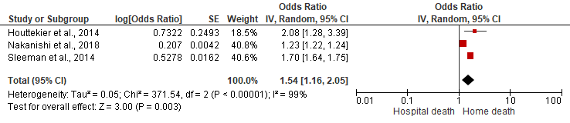

Marital status - Compared to widowed, divorced individuals had a lower odds of home death (low COE).

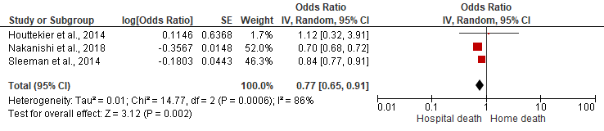

Marital status - Compared to widowed, singles had a lower odds of home death (low COE).

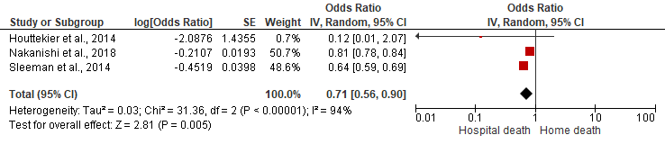

Pneumonia reduced the odds of home death. Fixed effect model produced the same results (moderate COE).

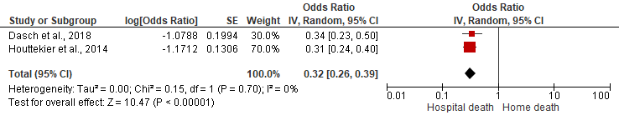

Figure 2a. Forest plots of statistically significant variables predicting home versus hospital death.

- Long-term care setting versus hospital death
Unlike the comparison between hospital and home, age and gender were significant predictors with moderate certainty when hospital was compared to long-term care. Younger persons had lower odds than persons ≥85 years of dying in long-term care [OR (95%CI): 0.58 (0.52-0.65) for age <75; OR (95%CI): 0.67 (0.62-0.73) for age 75-84], while females had higher odds than males [OR (95%CI): 1.57 (1.44-1.72)] (Table 3, Figure 2b). Unlike the association with home death, there was moderate certainty that married individuals were less likely than those with other marital status to die in long-term care [OR (95%CI): 0.74 (0.55-0.98)]. In papers where Black ethnicity was a minority, Black individuals were also less likely than Whites to die in long-term care and the certainty of evidence was high [OR (95%CI): 0.52 (0.33-0.81)].

Except for chronic obstructive pulmonary disease (COPD), other comorbidities were not associated with hospital death. People with advanced dementia and comorbid COPD had higher odds of dying in hospital with the odds of dying in long-term care lowered [OR (95%CI): 0.87 (0.80-0.94)]. However, in sensitivity analysis excluding Dasch et al. (2018) that examined a general end-of-life care population (not just nursing home residents), and separated deaths in hospital palliative care unit from hospital deaths,⁽⁶⁾ cancer became a highly certain, significant predictor of death in long-term care vis-à-vis hospital [OR (95%CI): 1.22 (1.10-1.36)].

As with the comparison to home, pneumonia also increased the odds of dying in hospital and lowered the odds of dying in long-term care [OR (95%CI): 0.56 (0.35-0.90)], but the certainty of evidence was low, and in sensitivity analysis excluding Dasch et al. (2018),⁽⁶⁾ the relationship lost its significance. Though pooled from only two papers with a small effect size,^{(73, 89)} there was high certainty that worse functional status increased the odds of dying in long-term care [OR (95%CI): 1.04 (1.04-1.05)].

Consistent with the lack of association between hospital bed availability and hospital death when compared to home, nursing home bed availability also did not increase the odds of long-term care setting death. Neither did reforms aiming to shift end-of-life care from the hospital to community. Conversely, a capitation-based payment/financing model such as Medicare Advantage, which covers all aspects of medical care compared to a traditional fee-for-service model, appeared promising in increasing the odds of long-term care setting death vis-à-vis hospital with its moderate certainty [OR (95%CI): 1.29 (1.17-1.41)].
Age - With reference to age 85+, age <75 had a lower odds of long-term care setting death [moderate certainty of evidence (COE)).

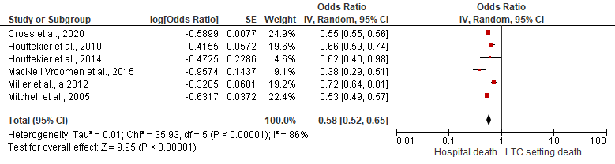

Age - With reference to age 85+, age 75-84 had a lower odds of long-term care setting death (moderate COE).

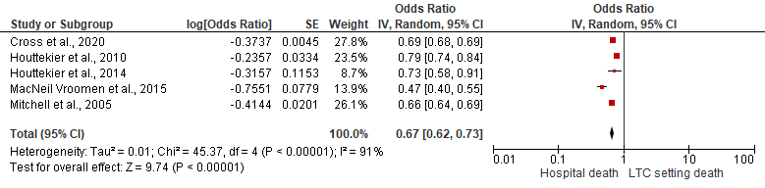

Sex/gender - Compared to males, females had a higher odds of long-term care setting death (moderate COE).

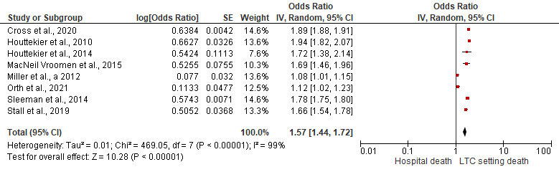

Marital status - Compared to other marital status, married individuals had a lower odds of long-term care setting death (moderate COE).

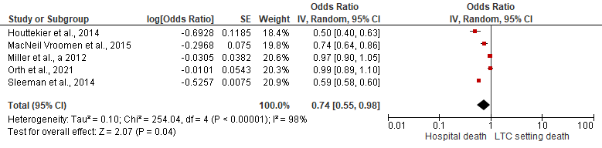

Race – With reference to Whites, Black persons with advanced dementia had a lower odds of long-term care setting death (high COE).

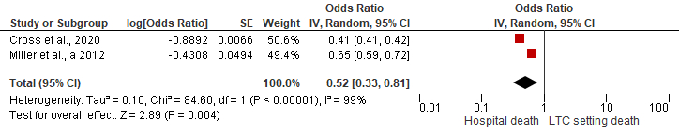

Comorbidities – Cancer did not affect the odds of long-term care setting death (low COE).
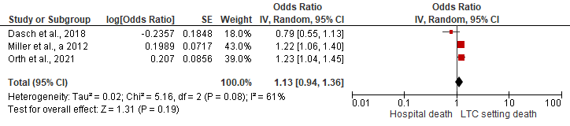

Sensitivity analysis excluding Dasch et al. (2018), cancer increased the odds of long-term care setting death. Fixed effect model produced the same results (high COE).
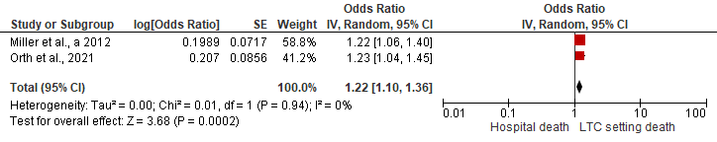

Comorbidities – Chronic obstructive pulmonary disease (COPD) reduced the odds of long-term care setting death. Fixed effect model yielded similar results (high COE).

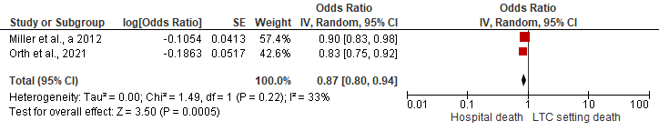

Pneumonia reduced the odds of long-term care setting death (low COE).

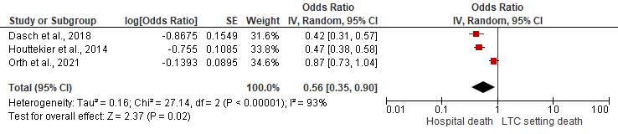

Sensitivity analysis excluding Dasch et al. (2018), pneumonia lost its significance – no longer had an effect on long-term care setting death (low COE).

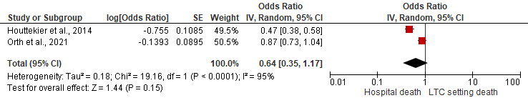

Function - For every unit increase in functional impairment, odds of long-term care setting death increased. Fixed effect model produced the same results (high COE).

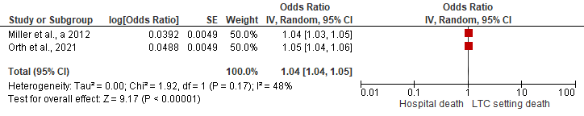

Payment/financing model – Medicare Advantage increased the odds of long-term care setting death compared to a traditional fee-for-service model. Fixed effect model yielded similar results (moderate COE).

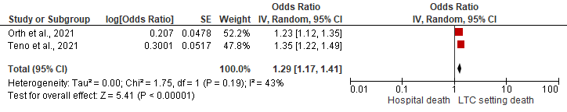

Figure 2b. Forest plots of statistically significant variables predicting long-term care setting versus hospital death.

- Long term care setting versus home death
When long-term care was compared to home, age, gender and marital status were significant with a moderate to high certainty after sensitivity analyses (Table 3, Figure 2c). Consistent with long-term care’s comparison with hospital, younger individuals had lower odds of dying in long-term care than persons ≥85 years [OR (95%CI): 0.45 (0.34-0.60) for age 65-74; OR (95%CI): 0.69 (0.61-0.77) for age 75-84], while females had higher odds than males [OR (95%CI): 1.45 (1.25-1.66)]. As with the comparison between hospital and home, married individuals had higher odds than widows of dying at home and lower odds of dying in long-term care [OR (95%CI): 0.38 (0.23-0.63)], while the opposite effect was observed for singles [OR (95%CI): 1.55 (1.44-1.67)].

Consistent with results separately comparing home and long-term care with hospital, there was moderate certainty that bed availability (hospital and nursing home) was not associated with long-term care setting or home death.

Age – With reference to age 85+, age 65-74 had a lower odds of long-term care setting death [(high certainty of evidence (COE)).

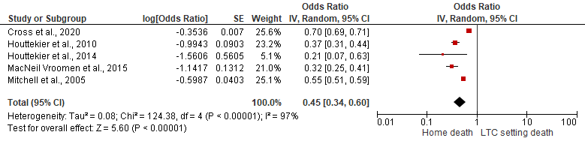

Age – With reference to age 85+, age 75-84 had a lower odds of long-term care setting death (moderate COE).

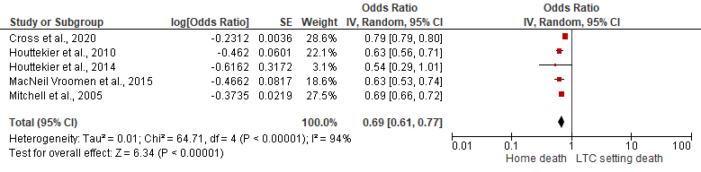

Sex/gender – Compared to males, females had a higher odds of long-term care setting death (moderate COE).

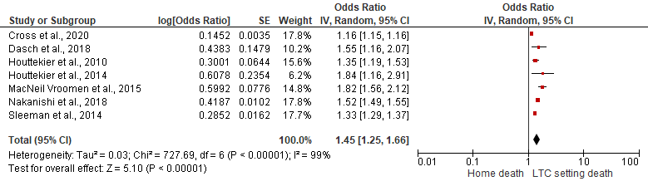

Marital status – With reference to widowed, married individuals had a lower odds of long-term care setting death (moderate COE).

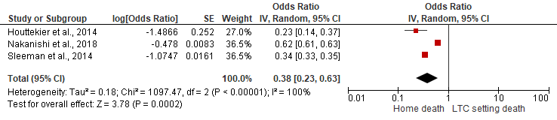

Marital status - With reference to widowed, singles had a higher odds of long-term care setting death (moderate COE).

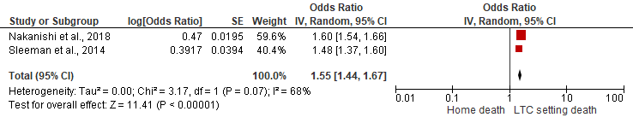
Figure 2c. Forest plots of statistically significant variables predicting long-term care setting versus home death.

- Hospice versus hospital death
In the meta-analysis of all studies examining this outcome,^{(6, 9, 19)} age and gender were not significant - similar to hospital’s comparison with home; however, in subgroup analysis, females were less likely than males to die in hospice in Europe [OR (95%CI): 0.79 (0.70-0.89)], while in the only US study,⁽¹⁹⁾ females were more likely to do so [OR (95%CI): 1.15 (1.13-1.16)] (Table 3, Figure 2d). The low certainty of evidence, however, requires further validation.

Sex/gender - Compared to males, females did not differ in the odds of hospice death [(low certainty of evidence (COE)).

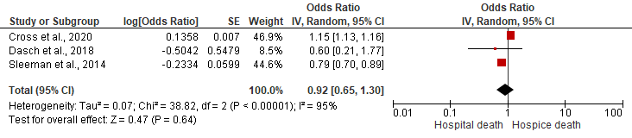

Sensitivity analysis excluding Dasch et al. (2018) yielded similar results (moderate COE).

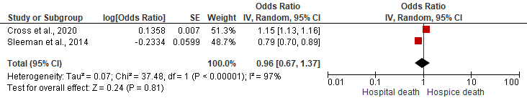

Subgroup analysis of European papers, females had a lower odds of hospice death. Fixed effect model produced the same results (low COE).

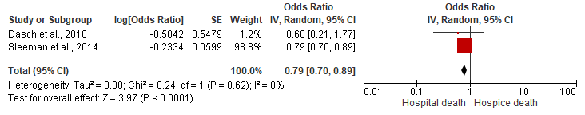
Figure 2d. Forest plots of statistically significant variables predicting hospice versus hospital death.

- Hospital versus all other places of death
When compared to all other places, younger people and males had higher odds of dying in hospital than individuals ≥85 years [OR (95%CI): 1.67 (1.51-1.85) for age <75; OR (95%CI): 1.47 (1.34-1.61) for age 75-84] and females respectively [OR (95%CI): 1.66 (1.60-1.72)] (Table 3, Figure 2e). These moderately certain results are consistent with hospital’s comparison with long-term care.

Except for South Korea,⁽⁸⁾ married individuals were more likely than those with other marital status to die in hospital versus all other places [OR (95%CI): 1.30 (1.09-1.56)]. While this concurs with the hospital and long-term care comparison, it contrasts with the comparison to home, indicating that important differences are masked when diverse categories are combined with research/methodological implications.

In subgroup analyses examining the effect of education, there was moderate certainty that being more highly educated reduced the odds of dying in hospital in the US [OR (95%CI): 0.86 (0.78-0.94)]. However, in some other countries, education increased the odds [OR (95%CI): 1.43 (1.27-1.61)]. There was also moderate certainty that living in cities increased the odds of dying in hospital compared to living in less urbanised areas [OR (95%CI): 1.42 (1.24-1.63)].

Unlike the lack of association demonstrated in other outcomes, hospital bed availability increased the odds of hospital death when compared to all other places [OR (95%CI): 1.11 (1.05-1.18)], while nursing home bed [OR (95%CI): 0.98 (0.97-0.99)] and general practitioner availability reduced the odds [OR (95%CI): 0.98 (0.97-0.98)]. The effect sizes were, however, small.
Age – With reference to age 85+, age <75 had a higher odds of hospital death [moderate certainty of evidence (COE)).

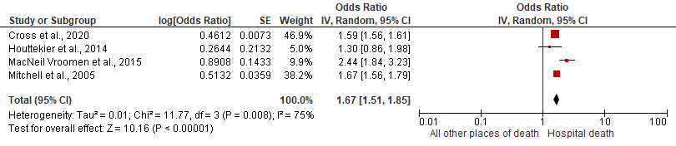

Age - With reference to age 85+, age 75-84 had a higher odds of hospital death (moderate COE).

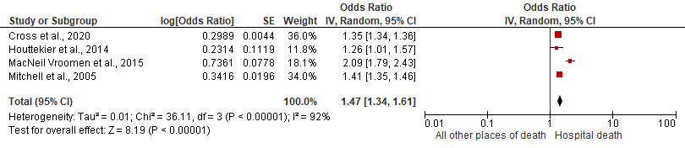

Age - With reference to age 80+, age <80 had a higher odds of hospital death. Fixed effect model yielded similar results (moderate COE).

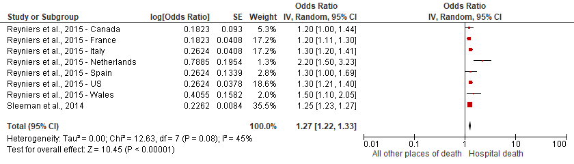

Sex/gender – Compared to females, males had a higher odds of hospital death (moderate COE).
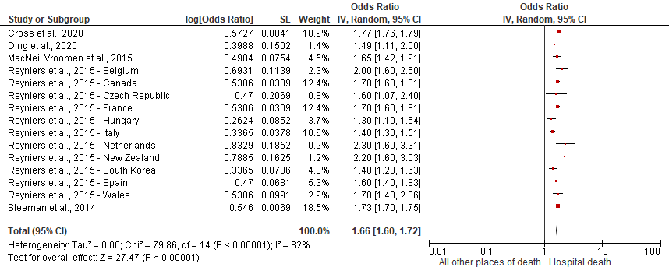

Marital status - With reference to other marital status, married individuals had a higher odds of hospital death (moderate COE).

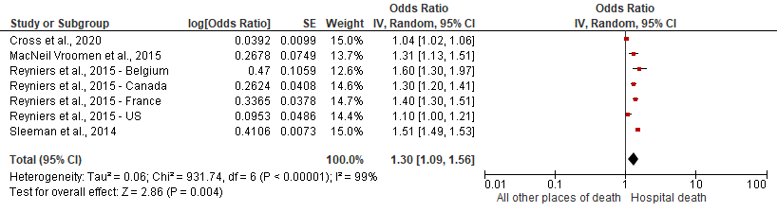

Education – With reference to less than high school, individuals with more than high school education did not differ in the odds of hospital death (low COE).

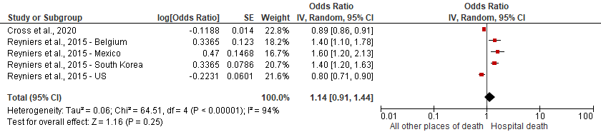

Subgroup analysis of US studies, more than high school education reduced the odds of hospital death (moderate COE).
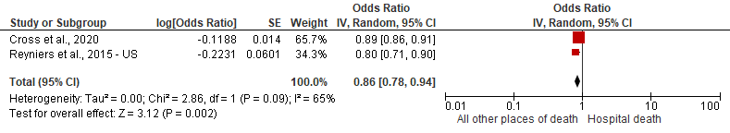

Subgroup analysis of non-US studies, more than high school education increased the odds of hospital death. Fixed effect model produced the same results (moderate COE).
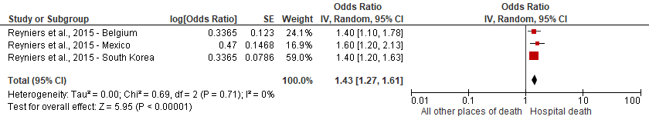

Urbanisation level – With reference to less urbanised or rural area, highly urbanised area increased the odds of hospital death (moderate COE).

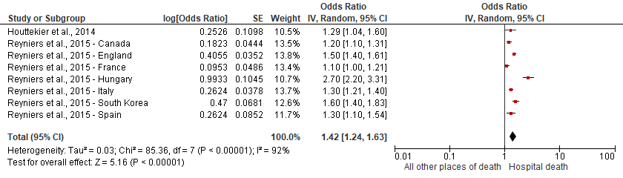

Hospital bed availability increased the odds of hospital death (moderate COE).

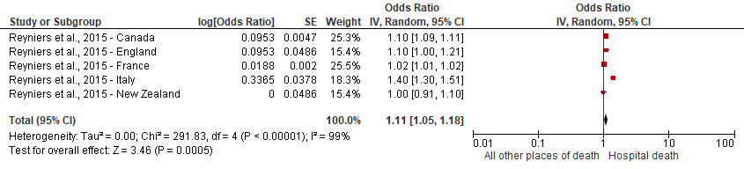

Nursing home bed availability reduced the odds of hospital death (moderate COE).

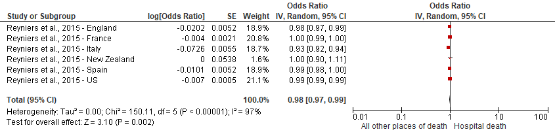

General practitioners availability reduced the odds of hospital death (moderate COE).
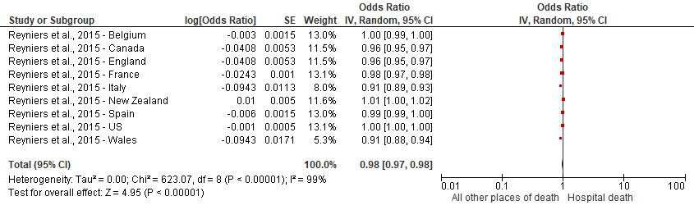

Figure 2e. Forest plots of statistically significant variables predicting hospital versus all other places of death.

Table 3. Results of the meta-analysis of factors associated with the place of death - classified according to the three main categories of the conceptual model by Gomes and Higginson (2006).⁽¹⁾
Variables | Compared to hospital death |  |  |  |  |  |  |  |  | LTC-setting versus home death |  |  | Hospital versus all other places of death
Variables | Home |  |  | LTC-setting |  |  | Hospice
Variables | OR (95% CI) | No. of studies | COE | OR (95% CI) | No. of studies | COE | OR (95% CI) | No. of studies | COE | OR (95% CI) | No. of studies | COE | OR (95% CI) | No. of studies | COE
Illness-related
Pneumonia | 0.32 (0.26-0.39) | 2 | Moderate | 0.64 (0.35-1.17)ª | 2 | Low | NA |  |  | NA |  |  | NA
Comorbidities – stroke | NA |  |  | 0.95 (0.81-1.10)ª | 2 | High | NA |  |  | NA |  |  | NA
Comorbidities - cancer | NA |  |  | 1.22 (1.10-1.36)ª | 2 | High | NA |  |  | NA |  |  | NA
Comorbidities - COPD | NA |  |  | 0.87 (0.80-0.94)ª | 2 | High | NA |  |  | NA |  |  | NA
Comorbidities – cardiac failure | NA |  |  | 0.78 (0.59-1.03) | 2 | Low | NA |  |  | NA |  |  | NA
Comorbidities – renal failure | NA |  |  | 0.87 (0.45-1.67) | 2 | Very low | NA |  |  | NA |  |  | NA
Functional impairment | NA |  |  | 1.04 (1.04-1.05) | 2 | High | NA |  |  | NA |  |  | NA
Individual factors
Age 65-74 or <75* or <85** (ref: ≥85) | 1.16 (0.89-1.51) | 5 | Moderate | 0.58 (0.52-0.65)* | 6 | Moderate | 1.36 (0.61-3.04)** | 2 | Very low | 0.45 (0.34-0.60) | 5 | High | 1.67 (1.51-1.85)* | 4 | Moderate
Age 75-84 (ref: ≥85) | 0.95 (0.85-1.06) | 5 | Moderate | 0.67 (0.62-0.73) | 5 | Moderate | NA |  |  | 0.69 (0.61-0.77) | 5 | Moderate | 1.47 (1.34-1.61)^{b} | 4 | Moderate
Sex/gender - Females | 1.24 (0.98-1.56)ª | 6 | Moderate | 1.57 (1.44-1.72)ª | 8 | Moderate | 0.96 (0.67-1.37)ª  European: 0.79 (0.70-0.89)^{c} | 2  2 | Moderate  Low | 1.45 (1.25-1.66) | 7 | Moderate | 0.60 (0.58-0.63)^{a, d} | 15e | Moderate
Race - Black (ref: White) | NA |  |  | 0.52 (0.33-0.81) | 2 | High | NA |  |  | NA |  |  | NA
Race - Other races (ref: White) | NA |  |  | 0.52 (0.27-1.01) | 2 | Moderate | NA |  |  | NA |  |  | NA
Education level (ref: <high school education) | NA |  |  | NA |  |  | NA |  |  | NA |  |  | 1.14 (0.91-1.44)  US:  0.86 (0.78-0.94)^{c}  Non-US:  1.43 (1.27-1.61)^{c} | 5e  2  3e | Low  Moderate  Moderate
Environmental factors
Hospital bed availability | 0.94 (0.83-1.06) | 2 | Moderate | NA |  |  | NA |  |  | 1.05 (0.97-1.14) | 2 | Moderate | 1.11 (1.05-1.18)ª | 5e | Moderate
NH bed availability | NA |  |  | 1.07 (0.90-1.27) | 2 | Moderate | NA |  |  | 1.05 (0.99-1.11) | 2 | Moderate | 0.98 (0.97-0.99) | 6e | Moderate
GPs availability | NA |  |  | NA |  |  | NA |  |  | NA |  |  | 0.98 (0.97-0.98) | 9e | Moderate
Urbanisation | NA |  |  | NA |  |  | NA |  |  | NA |  |  | 1.42 (1.24-1.63) | 8e | Moderate
Marital status - Married (ref: widowed or other marital status***) | 1.54 (1.16-2.05) | 3 | Moderate | 0.74 (0.55-0.98)*** | 5 | Moderate | NA |  |  | 0.38 (0.23-0.63) | 3 | Moderate | 1.30 (1.09-1.56)ª*** | 7e | Moderate
Marital status - Divorced (ref: widowed) | 0.77 (0.65-0.91) | 3 | Low | NA |  |  | NA |  |  | 0.82 (0.44-1.55)ª | 2 | Low | NA
Marital status - Single (ref: widowed) | 0.71 (0.56-0.90) | 3 | Low | NA |  |  | NA |  |  | 1.55 (1.44-1.67)ª | 2 | Moderate | NA
Reforms^{f} – Immediately post | NA |  |  | 0.88 (0.49-1.58) | 2 | Very low | NA |  |  | NA |  |  | NA
Reforms^{f} - Quarterly change | NA |  |  | 1.00 (0.93-1.08)  Another reform:  1,02 (0.91-1.14) | 2  2 | Low  Low | NA |  |  | NA |  |  | NA
Payment/financing model - Capitation (ref: fee-for-service) | NA |  |  | 1.29 (1.17-1.41) | 2 | Moderate | NA |  |  | NA |  |  | NA
Note. LTC = long-term care; OR = odds ratio; CI = confidence interval; COE = certainty of evidence; NA = not applicable as the variable was not examined for the particular outcome; COPD = chronic obstructive pulmonary disease; ref: with reference to; NH = nursing home; GP = general practitioner.
ªResults from sensitivity analysis reported.
^{b}When the cut-off was age 80, the results using data pooled from 8 studies^{e} were similar and had a moderate COE. Odds of hospital death for younger persons was 1.27 (95% CI: 1.22-1.33).
^{c}Results from subgroup analysis reported.
^{d}Reciprocal taken to ensure consistency of reporting.
^{e}Different sets of data from different countries in Reyniers et al. (2015) paper⁽⁸⁾ were counted as separate studies in this table.
^{f}Reforms that aim to shift end-of-life care from the hospital to the community. Results for this variable were reported as relative risks instead of odds ratios.

Certainty of evidence
The certainty of evidence was mostly moderate except for hospital’s comparison with long-term care and hospice which was low. Sensitivity and subgroup analyses were able to raise the low/very low certainty of some evidence to moderate most of the time, and to high sometimes (Supplementary file 9).

Discussion of results of meta-analysis and other pertinent variables not pooled
In this comprehensive systematic review of the place of death determinants in advanced dementia, dying in a long-term care setting was more common than other places such as home or hospice. By considering the consistency and certainty of evidence across different outcomes, the original place of death determinant conceptual model developed in a largely advanced cancer population was refined to develop a model for advanced dementia, which consists of 10 moderately to highly certain factors with long-term care setting added as an outcome (Figure 3).

As with cancer, the network of factors influencing where people with advanced dementia die is complicated.⁽¹⁾ Environmental factors such as being married and city living similarly predicted home and hospital death respectively in advanced dementia, but poor functional status’ association was with an outcome that was not in the original model, possibly due to long-term care setting’s relative irrelevance for a cancer population. Although the association of Black ethnic minority with hospital death was common across both populations, other individual factors such as being of a younger age and male gender’s associations with hospital death were only evidenced in advanced dementia.⁽¹⁾ New factors found included illness-related factors such as pneumonia, comorbid COPD and cancer, as well as macrosocial environmental factor such as capitated funding. While pneumonia and COPD were associated with hospital death, cancer was associated with long-term care setting death like functional impairment. Additionally, instead of hospital/nursing home bed availability/capacity, a capitated healthcare financing model decreased the likelihood of hospital death in advanced dementia.

The associations of being married with both home and hospital death under different comparison conditions underscore the important role social networks play in determining if death occurs at the usual place of residence for people with advanced dementia, who are totally dependent on others for care.^{(13, 17)} This is supported by co-residence’s association with home death in data not pooled because of heterogeneity in outcome categorisation.^{(33, 90)} The social networks conferred through marriage and the corresponding level of relationship attachment could facilitate home death, if preferred, but it could also push relatives to request for more aggressive treatment in hospital even at the end of life.^{(17, 93)} In urbanised areas where geographic proximity enhances hospital accessibility, death at usual place of residence is also less likely. This was corroborated by an included study that operationalised urbanisation differently and could not be pooled.⁽⁹⁾

Consistent with the results of other studies,⁽⁹⁴⁻⁹⁶⁾ older age’s and female sex/gender’s associations with long-term care setting death exemplify the interdependent yet conflicting needs and preferences of people with advanced dementia and their families.⁽¹⁸⁾ A related review, however, found an opposite effect for age, possibly due to the different synthesis/analysis approach, and the nature of evidence included.⁽²²⁾ Families may still wish to pursue aggressive treatment in hospital when their relatives are comparatively younger,^{(17, 94)} or to fulfil their male relatives’ (assumed) preferences.^{(97, 98)} Men may also tend to be more aggressive which can be difficult for long-term care staff to manage.⁽⁹⁹⁾ Further research is, however, needed to better understand the gendered nature of dying in long-term care in advanced dementia as sex/gender’s influence remained in some studies even with age and/or marital status adjusted,^{(6, 7, 36)} suggesting that it might not just be an issue of females outliving their spouses.⁽¹⁰⁰⁾ Besides age and gender, other individual factor such as ethnicity could also affect the place of death in advanced dementia. Notwithstanding culture and preferences, the association of Black ethnicity with hospital death possibly reflect inequities and racial disparity in health/social care accessibility and end-of-life treatment intensity.^{(101, 102)}

Illness-related factors illuminate the unique and profound challenges of advanced dementia care in different settings.⁽¹⁰³⁾ Informal caregivers may feel inadequate managing an acute medical condition such as pneumonia at home, while healthcare professionals in long-term care, by virtue of the resources available and their professional training, may feel better equipped.^{(22, 104)} However, in the presence of another debilitating condition which also causes extreme distress/discomfort, such as COPD,^{(105, 106)} the inability to communicate could still complicate care, potentially precipitating hospital admission at the end of life. Despite the need to ascertain pneumonia’s effect in the long-term care setting further, these preliminary results could have implications for the practice of initiating tube feeding in advanced dementia as not only does it not prevent pneumonia,⁽¹⁰⁷⁾ it may even paradoxically increase the chance of hospital death as demonstrated in one study.⁽⁸⁹⁾

Contrary to COPD’s association with hospital death in long-term care residents, comorbid cancer and functional impairment reduced the likelihood of hospital death. With a shorter trajectory and as the model in which palliative care was built on in cancer and functional impairment, staff may be able to predict survival better, and continue care in the facility rather than hospitalise them knowing that the end of life is near.^{(78, 108)} These results accentuate the implications of dementia’s unique disease trajectory on end-of-life care and death.

The profound challenges of advanced dementia care and the implications of its uncertain disease trajectory are further demonstrated by hospital/nursing home bed availability’s moderately certain, consistent lack of association across most outcomes. Changing bed capacity alone may not suffice in meeting the needs and preferences of people with advanced dementia. Infrastructural (such as appropriate storage facilities for those controlled drugs used frequently for symptom relief at the end of life) and specialist support and training for formal and informal caregivers are also vital.^{(22, 89)} In studies that could not be pooled for meta-analysis, specialised dementia units in nursing homes, better staff/facility quality rating,⁽⁸⁹⁾ hospice,^{(73, 74)} and home-based palliative care lowered the odds/risks of dying in hospital,⁽⁷⁷⁾ particularly when initiated early.^{(78, 92)} Palliative care initiated less than a week before death was, however, worse than without.⁽⁹²⁾ Although reverse causality is a possibility - palliative care may be more likely for people hospitalised at the end of life than home-dwelling individuals or long-term care residents - ⁽⁸⁷⁾ the lack of time to explore goals of care/preferences and organise resources is also unlikely to change where people die.^{(78, 92)}

Implications for policy/practice
Despite the small effect sizes pooled from limited studies for some variables, these moderately to highly certain results herald a need for a paradigm shift in the organisation and implementation of advanced dementia palliative care models. Given the unpredictable, protracted disease trajectory and the complexity of advanced dementia end-of-life care, a move is needed away from the traditional prognosis-based generic models to a longer-term, needs-based, person-centred approach to care,⁽¹⁸⁾ particularly if dementia palliative care is to be the standard of care.⁽¹⁰⁹⁾ This is imperative in order to support appropriately and meet the specific needs and preferences of the exponentially increasing number of people with advanced dementia and their families adequately throughout the disease trajectory.⁽¹⁸⁾ To ensure sustainability and economic viability while building capacity and capability in a resource-constrained environment,⁽¹¹⁰⁾ palliative care could be integrated into the healthcare system with all healthcare professionals empowered/equipped with general palliative and dementia care knowledge/skills,^{(18, 78)} funded by a value-based mechanism that encourages care coordination rather than volume/intensity.^{(91, 111)} With the increased odds of long-term care setting death compared to hospital demonstrated in this review, capitated funding that incentivises healthcare providers with savings from spending below a pre-specified benchmark shows potential in this respect when risk-adjusted.^{(91, 112, 113)} Further research is, however, needed to ascertain its effect on home death which is the majority’s preference before scarce resources can be strategically invested to support greater choice regarding place of death in advanced dementia,⁽⁵⁾ thereby optimising dementia palliative care delivery.⁽¹¹⁵⁾

Implications for research
In contrast to analyses comparing each place of death separately, bed availability was a significant predictor when non-hospital deaths were combined for comparison. Although the discrepancy could be due to the different way Reyniers et al. (2015) operationalised hospital bed availability,⁽⁸⁾ results were inconsistent across the different countries examined within the study as well. Discrepant results were also found for marital status. A heterogeneous outcome encapsulating diverse categories based on the assumption that they are more similar than different is unlikely to allow any conclusions to be established definitively.^{(85, 87)} The significant effect seen with general practitioner availability should, therefore, also be interpreted with caution, particularly when the magnitude of effect pooled from one study – albeit from different countries - is small.⁽⁸⁾ Each place of death/variable category should be examined separately whenever data/sample size permits.

[A narrative summary/discussion of some variables not pooled (dementia aetiology’s effect, cross-country differences), education’s effect and a comparison with a meta-analysis in different life-limiting illnesses is provided in supplementary file 10].

Individual factors
Demographic variables
Good social conditions | Home ↑
Ethnic minorities (Blacks) | Hospital ↑  LTC ↓
Age:  Older  Younger | LTC ↑  Hospital ↑
Sex/gender:  Females  Males | LTC ↑  Hospital ↑
Personal variables
Patient’s preferences | Home ↑
Illness-related factors
Non-solid tumours | Hospital ↑
Long length of disease | Home ↑
Low functional status | Home ↑  LTC ↑
Pneumonia | Home ↓
Comorbid cancer (for LTC residents) | LTC ↑
Comorbid COPD | LTC ↓
Environmental factors
Healthcare input
Use of home care | Home ↑
Intensity of home care | Home ↑
Availability of inpatient beds | Hospital ↑
Previous admission to hospital | Hospital ↑
Rural environment/urban environment | Home ↑/hospital ↑
Areas with greater hospital provision | Hospital ↑
Social support
Living with relatives | Home ↑
Extended family support | Home ↑
Being married | Home ↑  LTC ↓
Caregiver’s preferences | Home ↑
Macrosocial factors
Historical trends | Home ↑
Capitated funding | LTC ↑
Place of death of people with advanced dementia

Figure 3. Place of death determinant conceptual model for people with advanced dementia consisting of factors with moderate to high certainty of evidence.
Note. LTC = long-term care; COPD = chronic obstructive pulmonary disease. Black: factors in the original model only - mainly for advanced cancer; Green: specific for advanced dementia; Blue: predictive for both. Adapted from “Factors Influencing Death at Home in Terminally Ill Patients with Cancer: Systematic Review,” by B. Gomes, and I.J. Higginson, 2006, BMJ, 332(7540), p. 515 (https://doi.org/10.1136/bmj.38740.614954.55).⁽¹⁾ Dementia-specific factors could be used to predict the place of death of people with advanced dementia and vice versa; common factors could be applicable for both. Although factors such as socioeconomic status/condition, homecare utilisation/intensity, living with someone, extended family support and cross-national comparisons were explored by some studies in this review, their heterogeneity precluded the conduct of meta-analysis (except education where data were pooled but with inconclusive results). Tumour type, disease duration, patient’s/caregiver’s preferences, and previous healthcare utilisation were not explored by the studies in this review.
Strengths and limitations
As the first systematic review to examine comprehensively factors associated with the place of death in advanced dementia using meta-analysis, this review makes a valuable contribution to the growing end-of-life care literature in advanced dementia for informing service provision and policy. The consistency across different outcomes and the number of sensitivity/subgroup analyses performed, as well as the identification of marital status, age, and sex/gender which were the most commonly examined factors in the 33 included studies lend support to the robustness of the findings. The place of death determinant conceptual model, refined on the basis of these findings, could guide practitioners and policymakers with formulating evidence-based targeted strategies/interventions to help people with advanced dementia die at their preferred place. It may also serve as a potential theoretical framework for underpinning future relevant studies, particularly quantitative, which is sorely lacking at present.

There are, however, several limitations. Included papers were observational, using mainly secondary data, hence, causation cannot be established.⁽⁸⁷⁾ Using secondary data not designed with the study objectives in mind could also cause measurement error,⁽¹¹⁶⁾ and limited the variables which could be examined,⁽¹¹⁶⁾ possibly accounting for the infrequent examination of place of death preferences and their congruence with the actuality. Besides dementia’s diagnostic/prognostic uncertainty,^{(108, 117)} the inconsistency in the prevalence of dementia aetiology reported in this review with current clinical data e.g. Alzheimer’s disease at 60%-80% is the most common followed by vascular dementia^{(118, 119)} also highlights the limitations of using secondary data, particularly death certificates.⁽⁹⁾ As the certifying physician may not be the deceased’s primary doctor, “dementia of the unspecified type” could be the most convenient option without sufficient information and time to ascertain a differential diagnosis.⁽⁸³⁾

Moreover, dementia underreporting on death certificates could under-estimate the study populations, again affecting representativeness.⁽⁹⁾ To mitigate this, papers with study populations identified based on any mention of dementia on death certificates and not just the underlying cause were also included.

As most studies were from the West, results may not be generalisable. Additionally, applying evidence synthesised from varying cultural perspectives to inform the policy and practice of a specific context can be questionable,⁽¹²⁰⁾ particularly for a culturally-dependent, value-laden concept such as place of death.⁽¹²¹⁾ Contextual factors driven by national resources and healthcare policies such as homecare availability, payment systems, caregiver support/leave policies that vary widely across nations were somewhat obscured when data across nations were pooled. To unveil the contextual diversity embedded within the aggregated findings, subgroup analyses by country/region were performed whenever possible to investigate inconsistencies.⁽²³⁾ However, a meta-analysis of countries’ association with place of death could not be performed due to between-study heterogeneity in outcome/variable definition/operationalisation; in this case a narrative summary was provided in supplementary file 10.

Besides between-study heterogeneity in outcome/variable definition/operationalisation limiting the data that could be pooled, the reporting of non-standard data type in RevMan, such as prevalence/proportion ratio, also precluded a study from meta-analysis.⁽⁴⁹⁾ Nevertheless, by making use of the different data types available and taking the effect measures’ reciprocal where possible to establish consistency,⁽²⁴⁾ about two-thirds of the included papers contributed fairly evenly to the meta-analysis. Other pertinent variables not pooled were also discussed narratively.

In addition, given the possibility of urgent care setting transitions immediately preceding death,⁽¹¹⁴⁾ examining an outcome that represents only the moment of death may not provide a holistic picture. The care quality and experiences for a home-dwelling individual hospitalised just before death and someone who has been hospitalised for weeks likely differ despite the same place of death being recorded.⁽¹⁵⁾

Lastly, the synthesis of only quantitative data limited an understanding of the place of death determinants to their strengths of associations.⁽¹²²⁾ Qualitative evidence would be invaluable for contributing the context to understanding the complex, nuanced decision-making processes and factors underpinning choices and circumstances affecting where people die.^{(5, 29, 30, 121)} The quantitative methodology included possibly also accounted for the lack of theoretical frameworks identified.

Conclusion
Collectively, the 10 moderately to highly certain place of death determinants identified in this review highlight the unique challenges of advanced dementia end-of-life care in different settings and the inadequacies of changing bed capacity alone in meeting needs and preferences. Advanced dementia palliative care models need to move beyond prognosis and adopt a longer-term, needs-based approach. For such a care model to be sustainable, palliative care could be integrated into the healthcare system, funded by a mechanism that incentivises care coordination rather than volume/intensity. Capitated funding that increased the odds of long-term care setting death when compared to hospital shows potential in this respect.

The research implications and factors identified would also be invaluable for informing future relevant research which could further investigate the effects of sex/gender, pneumonia, and capitated funding, as well as underexplored but extremely pertinent factors such as preferences. Standardising the operationalisation of outcome and predictors whenever possible is recommended to facilitate comparison and pooling. In particular, different categories, e.g. places of death should not be grouped to avoid masking important differences. More qualitative research is also needed. Finally, the dementia-specific conceptual model developed, although originally developed for a different population, has proved useful for underpinning future relevant studies, and for informing targeted resource prioritisation in policy and practice. It is hoped these findings will progress the global health goal of facilitating people with advanced dementia to die at the place of their choosing.

Declarations
Authorship
All authors meet the criteria for authorship as stated in the International Committee of Medical Journal Editors (ICMJE) authorship guidelines. RiYin Tay, Jane Simpson, and Nancy Preston conceptualised and designed the study; RiYin Tay, Joyce YS Tan, and BinYan Lim screened the studies for eligibility; RiYin and Joyce YS Tan appraised the studies and extracted/checked the data; RiYin Tay, Jane Simpson, and Nancy Preston analysed and interpreted the data; and RiYin Tay drafted the initial version of the manuscript. All authors (RiYin Tay, Joyce YS Tan, BinYan Lim, Allyn YM Hum, Jane Simpson, and Nancy Preston) revised the manuscript critically for important intellectual content and approved the final version of the manuscript to be published.

Funding
This systematic review was produced in partial fulfilment of RiYin Tay’s PhD study in Palliative Care at Lancaster University. Her study is jointly funded by The Palliative Care Centre for Excellence in Research and Education (PalC) and Dover Park Hospice (DPH).

Conflicts of interest
The authors declared no potential conflicts of interest with respect to the research, authorship and/or publication of this article.

Ethics and consent
Ethics approval and consent was not required for a systematic review.

Data sharing
Data not reported in the paper or supplementary material may be available upon request from the corresponding author.

Acknowledgement
The authors would like to acknowledge Mr John Barbrook, the faculty librarian of Lancaster University for his advice on the comprehensiveness of the search strategy; Professor Catherine Walshe for her comments during the initial conceptualisation of the study; and Dr Mervyn Koh for his support of this piece of work.
References
1. Gomes B, Higginson IJ. Factors influencing death at home in terminally ill patients with cancer: Systematic review. Bmj. 2006;332(7540):515-21.
2. Finkelstein EA, Bhadelia A, Goh C, Baid D, Singh R, Bhatnagar S, et al. Cross Country Comparison of Expert Assessments of the Quality of Death and Dying 2021. Journal of pain and symptom management. 2022;63(4):e419-e29.
3. Bhadelia A, Oldfield LE, Cruz JL, Singh R, Finkelstein EA. Identifying Core Domains to Assess the "Quality of Death": A Scoping Review. Journal of pain and symptom management. 2022;63(4):e365-e86.
4. De Roo ML, Miccinesi G, Onwuteaka-Philipsen BD, Van Den Noortgate N, Van den Block L, Bonacchi A, et al. Actual and preferred place of death of home-dwelling patients in four European countries: making sense of quality indicators. PLoS One. 2014;9(4):e93762.
5. Mogan C, Lloyd-Williams M, Harrison Dening K, Dowrick C. The facilitators and challenges of dying at home with dementia: A narrative synthesis. Palliative medicine. 2018;32(6):1042-54.
6. Dasch B, Bausewein C, Feddersen B. Place of death in patients with dementia and the association with comorbidities: a retrospective population-based observational study in Germany. BMC palliative care. 2018;17(1):N.PAG-N.PAG.
7. Houttekier D, Cohen J, Bilsen J, Addington-Hall J, Onwuteaka-Philipsen BD, Deliens L. Place of death of older persons with dementia. A study in five European countries. Journal of the American Geriatrics Society. 2010;58(4):751-6.
8. Reyniers T, Deliens L, Pasman HR, Morin L, Addington-Hall J, Frova L, et al. International Variation in Place of Death of Older People Who Died From Dementia in 14 European and non-European Countries. Journal of the American Medical Directors Association. 2015;16(2):165-71.
9. Sleeman KE, Ho YK, Verne J, Gao W, Higginson IJ. Reversal of English trend towards hospital death in dementia: A population-based study of place of death and associated individual and regional factors, 2001–2010. BMC Neurology. 2014;14:59.
10. Gill TM, Gahbauer EA, Han L, Allore HG. Trajectories of Disability in the Last Year of Life. New England Journal of Medicine. 2010;362(13):1173-80.
11. Mitchell SL, Teno JM, Kiely DK, Shaffer ML, Jones RN, Prigerson HG, et al. The clinical course of advanced dementia. N Engl J Med. 2009;361(16):1529-38.
12. Sampson EL, Candy B, Davis S, Gola AB, Harrington J, King M, et al. Living and dying with advanced dementia: A prospective cohort study of symptoms, service use and care at the end of life. Palliative medicine. 2018;32(3):668-81.
13. Chiao CY, Wu HS, Hsiao CY. Caregiver burden for informal caregivers of patients with dementia: A systematic review. International nursing review. 2015;62(3):340-50.
14. Todd S, Barr S, Roberts M, Passmore AP. Survival in dementia and predictors of mortality: a review. International journal of geriatric psychiatry. 2013;28(11):1109-24.
15. Teno JM, Gozalo PL, Bynum JP, Leland NE, Miller SC, Morden NE, et al. Change in end-of-life care for Medicare beneficiaries: site of death, place of care, and health care transitions in 2000, 2005, and 2009. JAMA: Journal of the American Medical Association. 2013;309(5):470-7.
16. Gozalo P, Teno JM, Mitchell SL, Skinner J, Bynum J, Tyler D, et al. End-of-Life Transitions among Nursing Home Residents with Cognitive Issues. New England Journal of Medicine. 2011;365(13):1212-21.
17. Peacock SC. The experience of providing end-of-life care to a relative with advanced dementia: An integrative literature review. Palliative & Supportive Care. 2013;11(2):155-68.
18. Lewis S, Triandafilidis Z, Curryer C, Jeong SY, Goodwin N, Carr S, et al. Models of care for people with dementia approaching end of life: A rapid review. Palliative medicine. 2023:2692163231171181.
19. Cross SH, Kaufman BG, Taylor DH, Kamal AH, Warraich HJ. Trends and Factors Associated with Place of Death for Individuals with Dementia in the United States. Journal of the American Geriatrics Society. 2020;68(2):250-5.
20. Xu W, Wu C, Fletcher J. Assessment of changes in place of death of older adults who died from dementia in the United States, 2000–2014: a time-series cross-sectional analysis. BMC Public Health. 2020;20(1):765.
21. Aveyard H, Payne S, Preston N. A post-graduate's guide to doing a literature review in health and social care. UK: Open University Press; 2016.
22. Badrakalimuthu V, Barclay S. Do people with dementia die at their preferred location of death? A systematic literature review and narrative synthesis. Age & Ageing. 2014;43(1):13-9.
23. Thomas J, Harden A, Newman M. Synthesis: Combining results systematically and appropriately. In: Gough D, Oliver S, Thomas J, editors. An introduction to systematic reviews London: SAGE Publications Ltd; 2012. p. 179-226.
24. Costa V, Earle CC, Esplen MJ, Fowler R, Goldman R, Grossman D, et al. The determinants of home and nursing home death: A systematic review and meta-analysis. BMC palliative care. 2016;15(1):8.
25. Murtagh F, Bausewein C, Petkova H, Sleeman K, Dodd R, Gysels M, et al. Understanding place of death for patients with non-malignant conditions: A systematic literature review. Final report. : NIHR Service Delivery and Organisation Programme 2012 [Available from: https://www.bl.uk/collection-items/understanding-place-of-death-for-patients-with-non-malignant-conditions-a-systematic-literature-review.
26. Dening KH, Greenish W, Jones L, Mandal U, Sampson EL. Barriers to providing end-of-life care for people with dementia: a whole-system qualitative study. BMJ Support Palliat Care. 2012;2(2):103-7.
27. Aranda MP, Kremer IN, Hinton L, Zissimopoulos J, Whitmer RA, Hummel CH, et al. Impact of dementia: Health disparities, population trends, care interventions, and economic costs. J Am Geriatr Soc. 2021;69(7):1774-83.
28. World Health Organization. Global Dementia Observatory (GDO): World Health Organization; 2023 [Available from: https://www.who.int/data/gho/data/themes/global-dementia-observatory-gdo.
29. Bakitas M, Kryworuchko J, Matlock DD, Volandes AE. Palliative medicine and decision science: the critical need for a shared agenda to foster informed patient choice in serious illness. Journal of palliative medicine. 2011;14(10):1109-16.
30. Minamiguchi Y. Decision-Making about the Place of Death for Cancer Patients: A Concept Analysis. Asia-Pacific journal of oncology nursing. 2020;7(1):103-12.
31. Neergaard MA, Brunoe AH, Skorstengaard MH, Nielsen MK. What socio-economic factors determine place of death for people with life-limiting illness? A systematic review and appraisal of methodological rigour. Palliative medicine. 2019;33(8):900-25.
32. Gysels M, Johnston B, Bausewein C, Petkova H, Murtagh FEM. What influences the place of care and death in people with advanced dementia? European Journal of Palliative Care. 2015;22(2):58-63.
33. Houttekier D, Reyniers T, Deliens L, Van Den Noortgate N, Cohen J. Dying in hospital with dementia and pneumonia: a nationwide study using death certificate data. Gerontology. 2014;60(1):31-7.
34. MacNeil-Vroomen JL, van der Steen JT, Holman R, Monin JK, Buurman BM. Hospital Deaths Increased After Reforms Regardless of Dementia Status: An Interrupted Time-Series Analysis. Journal of the American Medical Directors Association. 2021;22(7):1507-11.
35. MacNeil Vroomen JL, Kjellstadli C, Allore HG, van der Steen JT, Husebo B. Reform influences location of death: Interrupted time-series analysis on older adults and persons with dementia. PloS one. 2020;15(11):e0241132.
36. Nakanishi M, Yamasaki S, Nishida A. In-hospital dementia-related deaths following implementation of the national dementia plan: observational study of national death certificates from 1996 to 2016. BMJ open. 2018;8(12):e023172.
37. MacNeil Vroomen J, Bosmans JE, Holman R, van Rijn M, Buurman BM, van Hout HPJ, et al. Place of death with dementia—Dutch people rarely die in the hospital. Journal of the American Geriatrics Society. 2015;63(9):1961-2.
38. Akunor HS, McCarthy EP, Hendricksen M, Roach A, Hendrix Rogers A, Mitchell SL, et al. Nursing Home Staff Perceptions of End-of-Life Care for Residents With Advanced Dementia: A Multisite Qualitative Study. Journal of Hospice & Palliative Nursing. 2022;24(3):152-8.
39. Bolt S, van der Steen J, Schols J, Zwakhalen S, Meijers J. What do relatives value most in end-of-life care for people with dementia? International journal of palliative nursing. 2019;25(9):432-42.
40. Crowther J, Horton S, Wilson K, Lloyd-Williams M. A UK qualitative study of living and dying with dementia in the last year of life. Palliative Care & Social Practice. 2022:1-11.
41. Halevi Hochwald I, Radomyslsky Z, Danon Y, Nissanholtz-Gannot R. Challenges in home care at the end stage of dementia: Hospice units vs. home care units. A qualitative study. Death studies. 2022;46(7):1667-77.
42. Moher D, Liberati A, Tetzlaff J, Altman DG. Preferred reporting items for systematic reviews and meta-analyses: the PRISMA statement. Ann Intern Med. 2009;151(4):264-9, w64.
43. Page MJ, McKenzie JE, Bossuyt PM, Boutron I, Hoffmann TC, Mulrow CD, et al. The PRISMA 2020 statement: an updated guideline for reporting systematic reviews. BMJ. 2021;372:n71.
44. Cherry G, Dickson R. Defining my review question and identifying inclusion criteria. In: Boland A, Cherry G, Dickson R, editors. Doing a systematic review: A student's guide: London: SAGE; 2013. p. 17-33.
45. Morris JC. The Clinical Dementia Rating (CDR): current version and scoring rules. Neurology. 1993;43(11):2412-4.
46. Reisberg B, Ferris SH, de Leon MJ, Crook T. The Global Deterioration Scale for assessment of primary degenerative dementia. The American journal of psychiatry. 1982;139(9):1136-9.
47. Sclan SG, Reisberg B. Functional Assessment Staging (FAST) in Alzheimer's Disease: Reliability, Validity, and Ordinality. International Psychogeriatrics. 1992;4(3):55-69.
48. Sibbett RA, Russ TC, Deary IJ, Starr JM. Dementia ascertainment using existing data in UK longitudinal and cohort studies: a systematic review of methodology. BMC Psychiatry. 2017;17(1):239.
49. Beattie JM, Higginson IJ, McDonagh TA, Gao W. Implementation of the Mental Capacity Act: a national observational study comparing resultant trends in place of death for older heart failure decedents with or without comorbid dementia. BMC Medicine. 2022;20(1):1-13.
50. Goldacre MJ, Duncan M, Griffith M, Turner MR. Trends in death certification for multiple sclerosis, motor neuron disease, Parkinson's disease and epilepsy in English populations 1979-2006. J Neurol. 2010;257(5):706-15.
51. Mylne AQ, Griffiths C, Rooney C, Doyle P. Trends in Parkinson's disease related mortality in England and Wales, 1993-2006. Eur J Neurol. 2009;16(9):1010-6.
52. Petticrew M, Roberts H. How to find the studies: The literature search. Systematic reviews in the social sciences: A practical guide: Wiley-Blackwell; 2006. p. 79-124.
53. Rietjens JAC, Bramer WM, Geijteman ECT, van der Heide A, Oldenmenger WH. Development and validation of search filters to find articles on palliative care in bibliographic databases. Palliative medicine. 2019;33(4):470-4.
54. Bramer WM, Giustini D, de Jonge GB, Holland L, Bekhuis T. De-duplication of database search results for systematic reviews in EndNote. J Med Libr Assoc. 2016;104(3):240-3.
55. Booth A, Sutton A, Papaioannou D. Systematic approaches to a successful literature review. 2nd ed: SAGE; 2016.
56. Kmet L, Lee R, Cook L. Standard quality assessment criteria for evaluating primary research papers from a variety of fields 2004 [Available from: https://www.ihe.ca/advanced-search/standard-quality-assessment-criteria-for-evaluating-primary-research-papers-from-a-variety-of-fields.
57. Sterne JAC, Hernán MA, Reeves BC, Savović J, Berkman ND, Viswanathan M, et al. ROBINS-I: a tool for assessing risk of bias in non-randomised studies of interventions. BMJ. 2016;355:i4919.
58. Sterne JAC, Savović J, Page MJ, Elbers RG, Blencowe NS, Boutron I, et al. RoB 2: a revised tool for assessing risk of bias in randomised trials. BMJ. 2019;366:l4898.
59. Majid U, Vanstone M. Appraising Qualitative Research for Evidence Syntheses: A Compendium of Quality Appraisal Tools. Qualitative health research. 2018;28(13):2115-31.
60. Shea BJ, Reeves BC, Wells G, Thuku M, Hamel C, Moran J, et al. AMSTAR 2: a critical appraisal tool for systematic reviews that include randomised or non-randomised studies of healthcare interventions, or both. BMJ. 2017;358:j4008.
61. Guyatt GH, Oxman AD, Schünemann HJ, Tugwell P, Knottnerus A. GRADE guidelines: a new series of articles in the Journal of Clinical Epidemiology. Journal of clinical epidemiology. 2011;64(4):380-2.
62. Viswanathan M, Ansari MT, Berkman ND, Chang S, Hartling L, McPheeters M, et al. Assessing the Risk of Bias of Individual Studies in Systematic Reviews of Health Care Interventions. Methods Guide for Effectiveness and Comparative Effectiveness Reviews. Rockville (MD): Agency for Healthcare Research and Quality (US); 2008.
63. Elamin MB, Flynn DN, Bassler D, Briel M, Alonso-Coello P, Karanicolas PJ, et al. Choice of data extraction tools for systematic reviews depends on resources and review complexity. Journal of clinical epidemiology. 2009;62(5):506-10.
64. Büchter RB, Weise A, Pieper D. Development, testing and use of data extraction forms in systematic reviews: a review of methodological guidance. BMC medical research methodology. 2020;20(1):259.
65. Higgins JPT, Thomas J, Chandler J, Cumpston M, Li T, Page MJ, et al. Cochrane handbook for systematic reviews of interventions version 6.3 (updated February 2022). : Cochrane, 2022; 2022 [Available from: www.training.cochrane.org/handbook.
66. Ding J, Cook A, Qin X, Ho SCH, Johnson CE. Palliative care needs and utilization of specialist services for people imminently dying with dementia: A national population-based study. International journal of nursing studies. 2020;109.
67. Martinsson L, Lundström S, Sundelöf J. Better quality of end-of-life care for persons with advanced dementia in nursing homes compared to hospitals: a Swedish national register study. BMC palliative care. 2020;19(1):N.PAG-N.PAG.
68. Mitchell SL, Teno JM, Miller SC, Mor V. A national study of the location of death for older persons with dementia. Journal of the American Geriatrics Society. 2005;53(2):299-305.
69. Stall NM, Fischer HD, Fung K, Giannakeas V, Bronskill SE, Austin PC, et al. Sex-Specific Differences in End-of-Life Burdensome Interventions and Antibiotic Therapy in Nursing Home Residents With Advanced Dementia. JAMA Network Open. 2019;2(8):e199557-e.
70. Nakanishi M, Ogawa A, Nishida A. Availability of home palliative care services and dying at home in conditions needing palliative care: A population-based death certificate study. Palliative medicine. 2020;34(4):504-12.
71. Wammes JD, Nakanishi M, van der Steen JT, MacNeil Vroomen JL. Japanese National Dementia Plan Is Associated with a Small Shift in Location of Death: An Interrupted Time Series Analysis. Journal of Alzheimer's Disease. 2021;83(2):791-7.
72. Wammes JD, Nakanishi M, van der Steen JT, MacNeil Vroomen JL. The Revised Medical Care Act is associated with a decrease in hospital death for the total Japanese older adult population regardless of dementia status: An interrupted time series analysis. PloS one. 2022;17(3):e0264624.
73. Miller SC, Lima JC, Looze J, Mitchell SL. Dying in US nursing homes with advanced dementia: How does health care use differ for residents with, versus without, end-of-life Medicare skilled nursing facility care? Journal of palliative medicine. 2012;15(1):43-50.
74. Miller SC, Lima JC, Mitchell SL. Influence of hospice on nursing home residents with advanced dementia who received Medicare‐skilled nursing facility care near the end of life. Journal of the American Geriatrics Society. 2012;60(11):2035-41.
75. Miranda R, Penders YWH, Smets T, Deliens L, Miccinesi G, Alonso TV, et al. Quality of primary palliative care for older people with mild and severe dementia: an international mortality follow-back study using quality indicators. Age & Ageing. 2018;47(6):824-33.
76. Penders YWH, Albers G, Deliens L, Miccinesi G, Vega Alonso T, Miralles M, et al. End-of-life care for people dying with dementia in general practice in Belgium, Italy and Spain: A cross-sectional, retrospective study. Geriatrics & Gerontology International. 2017;17(10):1667-76.
77. Quinn KL, Stukel T, Stall NM, Huang A, Isenberg S, Tanuseputro P, et al. Association between palliative care and healthcare outcomes among adults with terminal non-cancer illness: population based matched cohort study. Bmj. 2020;370:m2257.
78. Quinn KL, Wegier P, Stukel TA, Huang A, Bell CM, Tanuseputro P. Comparison of Palliative Care Delivery in the Last Year of Life Between Adults With Terminal Noncancer Illness or Cancer. JAMA Network Open. 2021;4(3):e210677-e.
79. Perrels AJ, Fleming J, Zhao J, Barclay S, Farquhar M, Buiting HM, et al. Place of death and end-of-life transitions experienced by very old people with differing cognitive status: Retrospective analysis of a prospective population-based cohort aged 85 and over. Palliative medicine. 2014;28(3):220-33.
80. Shega JW, Hougham GW, Stocking CB, Cox-Hayley D, Sachs GA, Shega JW, et al. Patients dying with dementia: experience at the end of life and impact of hospice care. Journal of Pain & Symptom Management. 2008;35(5):499-507.
81. Sloane PD, Zimmerman S, Williams CS, Hanson LC. Dying with dementia in long-term care. The Gerontologist. 2008;48(6):741-51.
82. Cassel JB, Kerr KM, McClish DK, Skoro N, Johnson S, Wanke C, et al. Effect of a Home‐Based Palliative Care Program on Healthcare Use and Costs. Journal of the American Geriatrics Society. 2016;64(11):2288-95.
83. Griffiths C, Rooney C. Trends in mortality from Alzheimer's disease, Parkinson's disease and dementia, England and Wales, 1979-2004. Health statistics quarterly. 2006(30):6-14.
84. Wachterman M, Kiely DK, Mitchell SL. Reporting dementia on the death certificates of nursing home residents dying with end-stage dementia. Jama. 2008;300(22):2608-10.
85. Bowling A. Reseach methods in health: Investigating health and health services. 4th ed. England: McGraw-Hill Education 2014.
86. Gilbert N. Research, theory and method (Introduction). In: Gilbert N, editor. Researching social life. London: Sage Publications; 2008. p. 22-34.
87. Wooldridge JM. Introductory econometrics: A modern approach 5th ed: Cengage Learning 2012.
88. Cohen AB, Han L, OʼLeary JR, Fried TR. Guardianship and End‐of‐Life Care for Veterans with Dementia in Nursing Homes. Journal of the American Geriatrics Society. 2021;69(2):342-8.
89. Orth J, Li Y, Simning A, Zimmerman S, Temkin-Greener H. End-of-Life Care among Nursing Home Residents with Dementia Varies by Nursing Home and Market Characteristics. Journal of the American Medical Directors Association. 2021;22(2):320-.
90. Pinzon LCE, Claus M, Perrar KM, Zepf KI, Letzel S, Weber M. Dying with dementia: symptom burden, quality of care, and place of death. Deutsches Arzteblatt international. 2013;110(12):195-202.
91. Teno JM, Keohane LM, Mitchell SL, Meyers DJ, Bunker JN, Belanger E, et al. Dying with dementia in Medicare Advantage, Accountable Care Organizations, or traditional Medicare. Journal of the American Geriatrics Society. 2021;69(10):2802-10.
92. Earp M, Cai P, Fong A, Blacklaws K, Pham TM, Shack L, et al. Hospital-based acute care in the last 30 days of life among patients with chronic disease that received early, late or no specialist palliative care: a retrospective cohort study of eight chronic disease groups. BMJ open. 2021;11(3):e044196.
93. Moore KJ, Davis S, Gola A, Harrington J, Kupeli N, Vickerstaff V, et al. Experiences of end of life amongst family carers of people with advanced dementia: longitudinal cohort study with mixed methods. BMC geriatrics. 2017;17(1):135.
94. Allers K, Hoffmann F, Schnakenberg R. Hospitalizations of nursing home residents at the end of life: A systematic review. Palliative medicine. 2019;33(10):1282-98.
95. Li Q, Zheng NT, Temkin-Greener H. Quality of End-of-Life Care of Long-Term Nursing Home Residents with and without Dementia. Journal of the American Geriatrics Society. 2013;61(7):1066-73.
96. Hoffmann F, Allers K. Dying in hospital among nursing home residents with and without dementia in Germany. Archives of Gerontology & Geriatrics. 2019;82:293-8.
97. Just E, Casarett DJ, Asch DA, Dai D, Feudtner C. Differences in Terminal Hospitalization Care Between U.S. Men and Women. Journal of pain and symptom management. 2016;52(2):205-11.
98. Wong AD, Phillips SP. Gender Disparities in End of Life Care: A Scoping Review. J Palliat Care. 2023;38(1):78-96.
99. Resnick B, Galik E, McPherson R, Boltz M, Van Haitsma K, Kolanowski A. Gender Differences in Disease, Function, and Behavioral Symptoms in Residents with Dementia. West J Nurs Res. 2022;44(9):812-21.
100. Mielke MM, Vemuri P, Rocca WA. Clinical epidemiology of Alzheimer's disease: assessing sex and gender differences. Clinical epidemiology. 2014;6:37-48.
101. Byhoff E, Harris JA, Langa KM, Iwashyna TJ. Racial and Ethnic Differences in End-of-Life Medicare Expenditures. J Am Geriatr Soc. 2016;64(9):1789-97.
102. Ornstein KA, Roth DL, Huang J, Levitan EB, Rhodes JD, Fabius CD, et al. Evaluation of Racial Disparities in Hospice Use and End-of-Life Treatment Intensity in the REGARDS Cohort. JAMA Network Open. 2020;3(8):e2014639-e.
103. Bunn F, Burn AM, Goodman C, Rait G, Norton S, Robinson L, et al. Comorbidity and dementia: a scoping review of the literature. BMC Med. 2014;12:192.
104. Toscani F, van der Steen JT, Finetti S, Giunco F, Pettenati F, Villani D, et al. Critical Decisions for Older People With Advanced Dementia: A Prospective Study in Long-Term Institutions and District Home Care. Journal of the American Medical Directors Association. 2015;16(6):535.e13-20.
105. Hendriks SA, Smalbrugge M, Hertogh CM, van der Steen JT. Dying with dementia: Symptoms, treatment, and quality of life in the last week of life. Journal of pain and symptom management. 2014;47(4):710-20.
106. O'Donnell DE, Milne KM, James MD, de Torres JP, Neder JA. Dyspnea in COPD: New Mechanistic Insights and Management Implications. Advances in therapy. 2020;37(1):41-60.
107. Davies N, Barrado-Martín Y, Vickerstaff V, Rait G, Fukui A, Candy B, et al. Enteral tube feeding for people with severe dementia. The Cochrane database of systematic reviews. 2021;8(8):Cd013503.
108. Mitchell SL, Miller SC, Teno JM, Kiely DK, Davis RB, Shaffer ML, et al. Prediction of 6-month survival of nursing home residents with advanced dementia using ADEPT vs hospice eligibility guidelines. JAMA: Journal of the American Medical Association. 2010;304(17):1929-35.
109. Payne S, Harding A, Williams T, Ling J, Ostgathe C. Revised recommendations on standards and norms for palliative care in Europe from the European Association for Palliative Care (EAPC): A Delphi study. Palliative medicine. 2022;36(4):680-97.
110. Etkind SN, Bone AE, Gomes B, Lovell N, Evans CJ, Higginson IJ, et al. How many people will need palliative care in 2040? Past trends, future projections and implications for services. BMC Med. 2017;15(1):102.
111. Rice N, Smith PC. Capitation and risk adjustment in health care financing: an international progress report. Milbank Q. 2001;79(1):81-113; 2 p preceding VI.
112. Goldfeld KS, Grabowski DC, Caudry DJ, Mitchell SL. Health insurance status and the care of nursing home residents with advanced dementia. JAMA Intern Med. 2013;173(22):2047-53.
113. Stevenson DG, Ayanian JZ, Zaslavsky AM, Newhouse JP, Landon BE. Service use at the end-of-life in Medicare advantage versus traditional Medicare. Med Care. 2013;51(10):931-7.
114. Leniz J, Higginson IJ, Stewart R, Sleeman KE. Understanding which people with dementia are at risk of inappropriate care and avoidable transitions to hospital near the end-of-life: a retrospective cohort study. Age Ageing. 2019;48(5):672-9.
115. van der Steen JT, Radbruch L, Hertogh CM, de Boer ME, Hughes JC, Larkin P, et al. White paper defining optimal palliative care in older people with dementia: A Delphi study and recommendations from the European Association for Palliative Care. Palliative medicine. 2014;28(3):197-209.
116. Saunders M, Lewis P, Thornhill A. Using secondary data. Research methods for business students. 7th ed: Pearson Education Limited; 2015. p. 316-52.
117. Lloyd-Williams M, Mogan C, Dening KH. Identifying palliative care needs in people with dementia. Curr Opin Support Palliat Care. 2017;11(4):328-33.
118. World Health Organization. Dementia key facts World Health Organization 2023 [updated 15/03/2023. Available from: https://www.who.int/news-room/fact-sheets/detail/dementia.
119. Alzheimer's Disease International. Dementia facts & figures: Alzheimer's Disease International; 2023 [Available from: https://www.alzint.org/about/dementia-facts-figures/.
120. Bloomer MJ, Walshe C. Smiles behind the masks: A systematic review and narrative synthesis exploring how family members of seriously ill or dying patients are supported during infectious disease outbreaks. Palliative medicine. 2021;35(8):1452-67.
121. Gomes B, Calanzani N, Gysels M, Hall S, Higginson IJ. Heterogeneity and changes in preferences for dying at home: A systematic review. BMC palliative care. 2013;12:7.
122. Crotty M. The foundations of social research: Meaning and perspective in the research process 1st ed: Routledge; 1998.

